Update to transfusion reaction STIR reporting definitions
Serious Transfusion Incident Reporting: Bulletin no.8
OFFICIAL

Transfusion reaction definitions can vary depending on the Haemovigilance program
For most haemovigilance programs the criteria for reporting are different to those that would prompt clinical review of the patient, where there is a lower threshold for review.
As per the ANZSBT/ACN guidelines for the administration of blood products (2019) a temperature rise of 1 °C or more above baseline and more than 38 °C should prompt interruption of the transfusion and clinical assessment of the patient. This is a common reason for patient review during a transfusion, but other signs and symptoms may also be present with or without fever.
Most haemovigilance programs aim to capture more serious reactions. For example, there would be a higher threshold for change in temperature. Reporting to a haemovigilance system occurs after the patient has been reviewed, the reaction investigated, and a decision has been made on the likelihood of association with the transfusion, the type of reaction and its severity.
STIR has recently reviewed its reporting definitions and compared these with national and international programs. Two reaction types, TACO and DHTR/DSTR, were found to have different reporting criteria. TACO follows the National Blood Authority (NBA) definition timeframe whereby signs and symptoms occur within 6 hours of transfusion (ISBT and SHOT, international haemovigilance programs are within 12 hours). For DHTR/DSTR, STIR recognises that an antibody can be made following transfusion, but unless the patient presents to a health service early for retesting, there may be a delay in detecting and reporting the antibody. Hence, STIR accepts reports of events that are recognised up to three months post transfusion.
The main STIR reporting criteria change is to febrile non-haemolytic transfusion reactions (FNHTRs). Previously the STIR reportable definition was fever > 38.5°C or a change of 1.5°C above baseline. To align with national reporting to the NBA, and other international haemovigilance programs the reporting guidelines have been changed to a temperature of ≥ 39°C and/or 2°C rise from baseline, representing the more serious FNHTRs rather than mild reactions. Mild or moderate reactions should continue to be investigated and managed by the treating health service. If the fever is associated with other serious signs and symptoms, then we would recommend the reaction is reported to STIR.
STIR definition for reporting FNHTRs:
Fever (> 39°C or a change of 2°C above baseline), occurring during or within four hours of the transfusion with one or more of the following:
• chills/rigor
• headache
• nausea/vomiting
If a transfusion reaction is suspected:

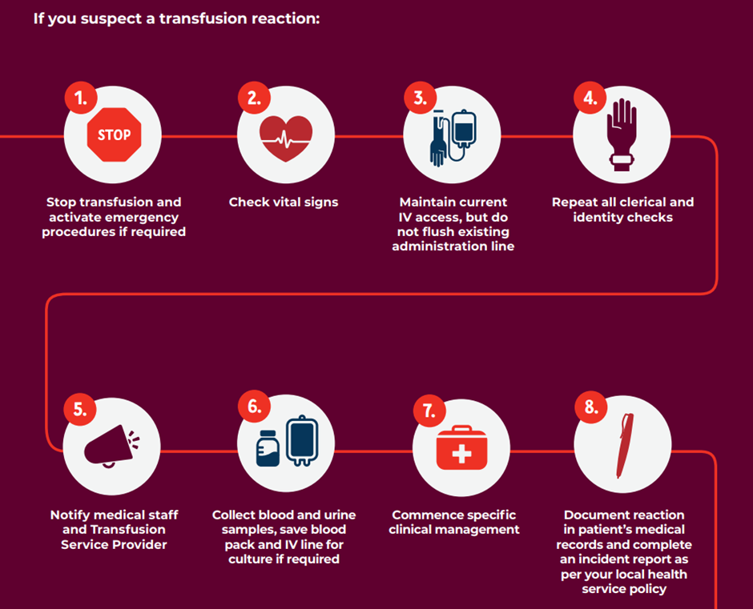
From: Blood Book, Australian Blood Administration Handbook. First edition, March 2020

Abbreviations:
Abbreviation | Definition
STIR | Serious Transfusion Incident Reporting
SHOT | Serious Hazards of Transfusion UK
ISBT | International Society of Blood Transfusion
ANZSBT | Australian and New Zealand Society of Blood Transfusion
ACN | Australian College of Nursing
TACO | Transfusion associated circulatory overload
DHTR | Delayed haemolytic transfusion reaction
DSTR | Delayed serologic transfusion reaction
NBA | National Blood Authority
FNHTR | Febrile non-haemolytic transfusion reaction

To receive this document in another format, phone 03 9694 0102, using the National Relay Service 13 36 77 if required, or email Blood Matters <bloodmatters@redcrossblood.org.au>.
Authorised and published by the Victorian Government, 1 Treasury Place, Melbourne.
© State of Victoria, Australia, Department of Health, September 2022.
ISSN 2652-6212 online (PDF/Word)
Available at Blood Matters <https://www.health.vic.gov.au/patient-care/blood-matters-program >

