Staff home location analysis
2.2 – Sustainable transport in health care
Contents
Introduction 1
Workplaces within metropolitan Melbourne and some regional centres 2
Workplaces within areas with very large postcode boundaries. 2

Introduction
The purpose of a staff home location catchment analysis is to:
- assess the proportion of people living close to work (usually within five kilometres) who may be able to walk or ride to work one or more days a week
- assess the proportion of people travelling long distances to work
- look at areas with larger numbers of staff living near to each other, which may enable some people to carpool to work.
Use the steps in this document to help you perform a staff home location analysis for your organisation.

Workplaces within metropolitan Melbourne and some regional centres
- Request the home postcode data for all staff and contractors working on the site from your organisation’s human resources area.
- Identify all postcodes within or partially within five km of the site and add up the number of staff living within these postcodes.
- Estimate the number of staff living within five km and calculate the percentage of total staff within this area.
- Map the number of staff within each postcode area. This gives a useful visual assessment of the proximity and distribution of staff. This can be outsourced at low cost. Depending on the total number of staff and the range in values, you will need to work out what the appropriate ranges are to use for the legend (see Figure 2 for an example). For example, small sites with less than 50 people may use ranges of ‘1 to 2’, ‘3 to 5’ and so on. For large numbers of staff, the ranges would be greater. The example map (Figure 1) shows there over 20 per cent of staff live within five km of the workplace.

Workplaces within areas with very large postcode boundaries.
- Seek approval to map de-identified address data (where address data does not include names and other identifiable information)
- Map the data with the hospital site at the centre of the map and home location dots ‘generalised’ (so they are not placed on the exact home location) for staff privacy.
- Calculate (as part of the mapping process) the number of staff living within five km and calculate the percentage of total staff within this area.

Figure 1: Example map of staff locations
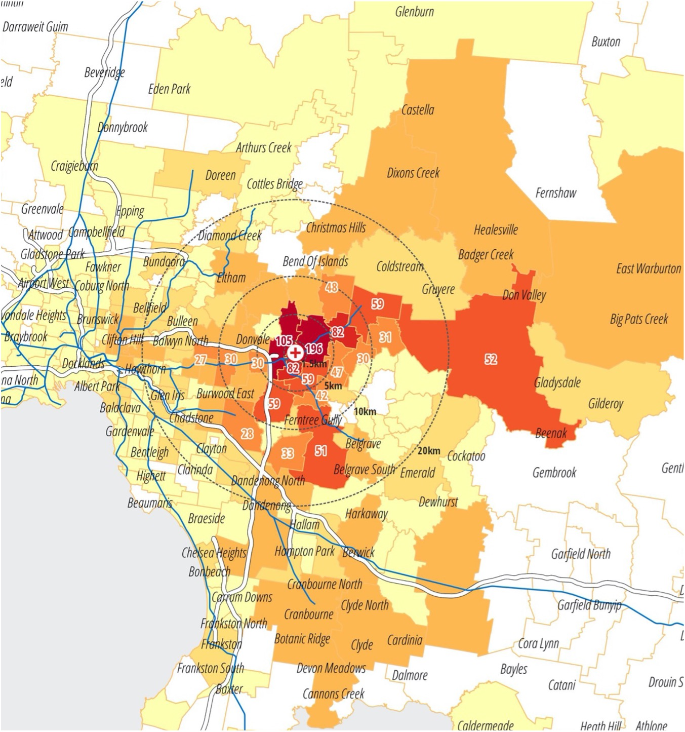
Figure 2: Example map legend
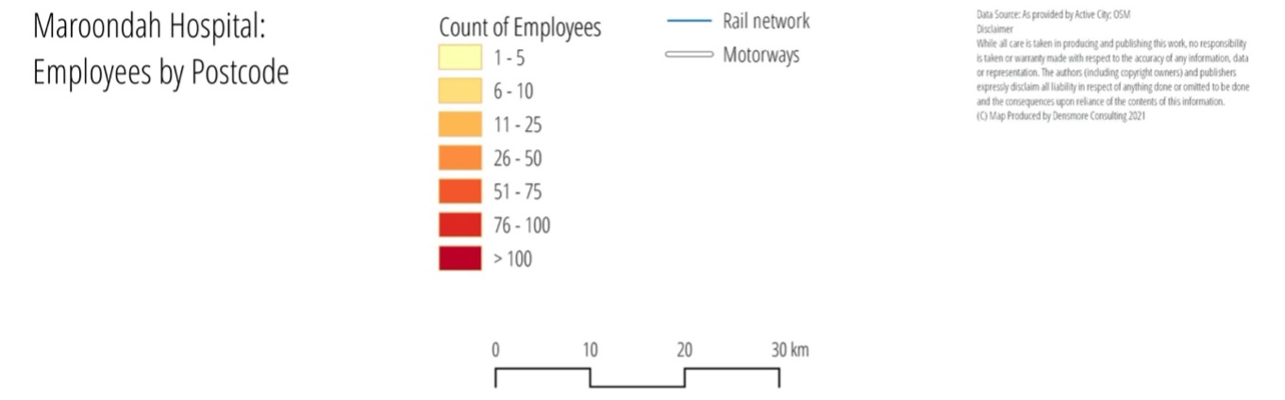

To receive this document in another format, phone 9595 2898, using the National Relay Service 13 36 77 if required, or email sustainability <sustainability@health.vic.gov.au>.
Authorised and published by the Victorian Government, 1 Treasury Place, Melbourne.
© State of Victoria, Australia, Department of Health, August 2022.
Refer to the main reference document ISBN 978-1-76096-951-6 (pdf/online/MS word)
Available at Department of Health website <www.health.vic.gov.au/sustainability>

