Blood Matters report for blood management (or equivalent) committee
August 2022
OFFICIAL

Strategic Plan 2019–22

Goal:

Through a collaborative approach support and enhance best practices in quality care, clinical safety, and blood management (sustainable, responsible, safe and appropriate use), for improved patient outcomes in Victorian health services.

Objectives:
Use innovative and diverse approaches to:
- Promote and support the development of strategies that optimise appropriate use of blood products, alternatives, and person-centred care through national and local governance frameworks and standards
- Foster and strengthen partnerships and stakeholder relationships
- Analyse data and disseminate findings across the sector to raise awareness, influence practice, promote efficiencies, and provide value
- Provide and promote expert knowledge sharing and collaboration across the sector, including specific initiatives, tools and specialised advice.

Blood stewardship
RBC wastage
The Blood Matters Wastage Project began in 2014 to reduce RBC wastage and assist health services to reach national wastage targets set by governments. The Victorian RBC wastage rate was 7.0% in February 2014 and reduced to 1.7% over the course of this project.
The combined efforts of transfusion laboratories and health services has since seen RBC wastage reduce even further, with a record low RBC wastage rate of 1.1% achieved by Victorian health services in April 2022 (See graph 1 below).
The diligent stewardship of these blood and blood products made available by generous donors' is greatly appreciated.

Platelet wastage
Victorian platelet wastage remains consistently above national average. We are investigating local factors which
are influencing our higher wastage and looking to mitigate these factors where possible. We appreciate health
services and transfusion laboratories continuing to monitor inventory levels and ordering practices to help reduce
platelet waste, particularly considering the ongoing platelet shortages. (See graph 2 below)

Graph 1. RBC wastage, Victoria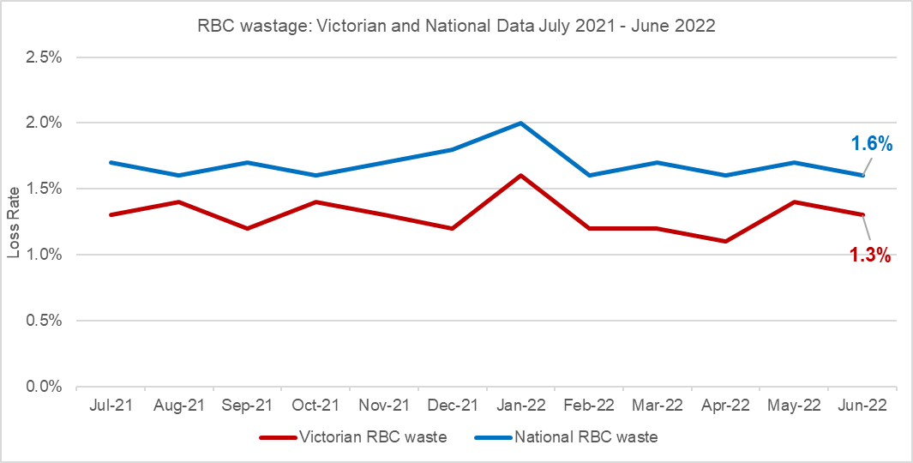

Graph 2. Platelet wastage, Victoria
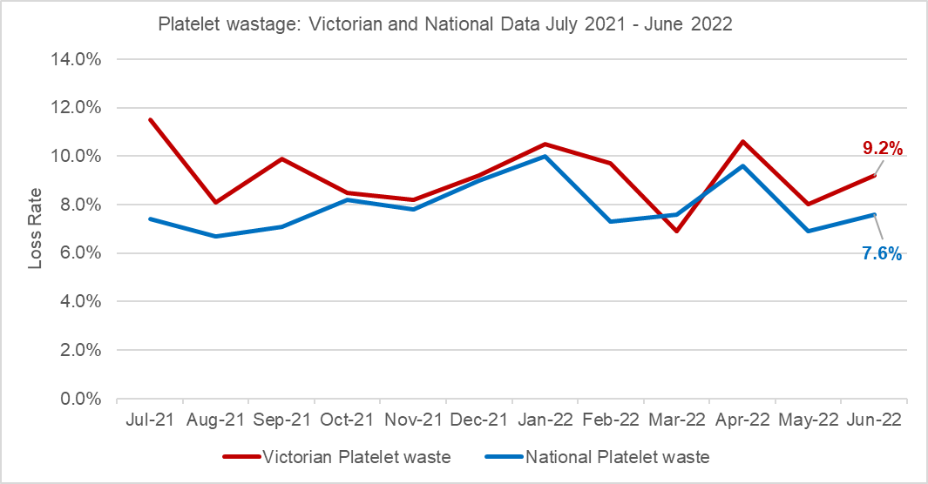

Blood management summit for scientists
The annual blood management summit for scientists, offers scientific and local industry updates for our laboratory colleagues across the blood sector.
We are in the planning phase for the next meeting, to be held in late 2022. Further information will be circulated closer to the date.

Auditing:

Survey of electronic medical record implementation
The 2021 audit was a survey of health services experience of blood management using an electronic medical record (EMR) related to blood management and transfusion practice. The report along with individual health service data will be forwarded to health services in August. The report provides a comprehensive analysis of the data, features aggregate (non-identifiable) data from contributing health services and recommendations for best practice. A copy of the report can be found at: Audit Reports (health.vic.gov.au).

Consent audit
This year the Blood Matters audit is on blood transfusion consent. It consists of two parts: part one is a policy survey, part two a retrospective medical record audit of consent documentation for up to 30 patients who received a blood component transfusion. This audit was last completed in 2012. Data collection is open from 27 June to 12 August.

Serious transfusion incident reporting (STIR) system
STIR continues to receive and validate reports of transfusion reactions, incidents and near miss events related to transfusion from health services. Much of this work is undertaken by the STIR Expert Group, medical, nursing and scientific staff with an interest and knowledge of transfusion. This work is performed in addition to their own workload, and we appreciate their ongoing support and direction.
STIR has recently reviewed its reporting definitions and compared these with national and international programs. As a result, there has been a change to the reporting criteria for febrile non-haemolytic transfusion reactions.
The new reporting criteria for STIR (different to criteria for reporting a reaction within a health service) is:
Fever (> 39°C or a change of 2°C above baseline), occurring during or within four hours of the transfusion with one or more of the following:
• chills/rigor
• headache
• nausea/vomiting
Please note that the threshold for health service management and investigation of patients with a suspected transfusion reaction should remain unchanged. This change is for consistency of nationally recognised reporting of serious reactions only
The 2020-21 annual report is currently under development and will be sent with individual health service reports of investigations received when final.
For any health service in Victoria, Tasmania, Northern Territory or Australian Capital Territory not currently reporting to STIR, please contact Blood Matters at: Bloodmatters@redcrossblood.org.au if you wish to participate.
Blood Matters Project Nurse – Subcutaneous immunoglobulin (SCIg) implementation project
The number of patients having treatment with SCIg is slowly increasing. The current state of SCIg in Victoria:
- 22 sites with active programs
- 387 Victorian patients receiving SCIg (Q3 2021-2022)
- 2269 Victorian patients eligible for SCIg by medical diagnosis (Q3 2021-2022)

Activities:
- June saw the second SCIg forum for the year which had a focus on travelling with SCIg.
- The next SCIg forum will be held on Wednesday 16th November and although the full program has still to be finalised there will be a SCIg program update and opportunity for discussion with a question and answers session.
- Work is continuing to expand services to offer a sustainable model for private patients.
- A mailout to neurologists was undertaken in May. It was aimed at raising awareness of SCIg as a treatment option for patient receiving IVIg for chronic inflammatory demyelinating polyneuropathy (CIDP). Information was provided to assist them initiate discussions with patients.
If you would like more information on SCIg or assistance with commencing a program, or extending your existing program, contact the Blood Matters Project Nurse, Anne Graham via email at: angraham@redcrossblood.org.au
SCIg implementation tools, resources, and health service SCIg contacts available at: Subcutaneous Immunoglobulin (SCIg) access program (health.vic.gov.au)

Blood Matters forums
Currently, the Blood Matters forums for blood management/transfusion nurses/trainers and quality officers continue to be virtual. While we are unable to meet face to face, it is still important to have the opportunity for education, networking and sharing of ideas. The next Forum is our 20-year anniversary celebration being held on 12 August 2022. The final meeting for the year will be in November.

Blood Matters 20-year anniversary
On Friday August 12, Blood Matters will celebrate 20 years since the initial project commenced. As COVID continues the celebrations will be in a mixed format, with limited in person attendance and extended capacity for virtual attendance. The program will look back over the years of Blood Matters, the drivers, changes, people and outcomes. We look forward to sharing this exciting day with you all, either virtually or in person. If you would like to join us virtually and have not registered yet, please contact bloodmatters@redcrossblood.org.au

Blood Matters journal club
In June, the Journal Club looked at Physician autonomy and patient rights: lessons from an enforced blood transfusion and the role of patient blood management, Matteo Bolcato, Aryeh Shander, James P. Isbister, Kevin M. Trentino, Marianna Russo, Daniele Rodriguez & Anna Aprile. We would like to thank Lisa Stevenson and Anissa Ytrupp from Barwon Health for leading for this event.
The next Blood Matters journal club meeting is 6 December 2022. The article and invitation will be sent out closer to the date.

Education
Virtual education sessions have enabled us to reach a larger audience from further afield.
Upcoming virtual events for 2022:
- Five in 5 sessions, 5 topics over 5 days - attend one or all (October 3-7)

The face-to-face enrolled nurse (EN) study day was planned for September, however due to increasing COVID numbers and ongoing limitations regarding events this will be converted to a virtual event.
The EN blood management education will now be series of 3 x 90 minute sessions, covering governance, safe transfusion practice and the practicalities of taking a pre-transfusion blood sample and administering a unit of blood. This series will run from Monday 14 to Wednesday 16 November.
Please contact the Blood Matters team if you have enrolled nurses that would be interested in attending these sessions.
Further information will be sent out closer to the dates.
Please contact Blood Matters Bloodmatters@redcrossblood.org.au if you would like further information or if we can help you to run your education event.
Conferences
Blood 2022
Blood Matters again offered funding to support transfusion professionals and blood bank scientists to attend the Blood Conference. This year Blood 2022 is in Sydney, from 11-14th September. Two applicants have been successful in receiving this support. Congratulations to Anne Kinmonth from the Royal Children’s’ Hospital and Jessica Alford from Goulburn Valley Health.
Blood Matters have had 4 abstracts accepted as posters, 1 accepted as an oral presentation and we have also received an invitation to present on the Victorian SCIg Access Program.
In addition to the usual program there is a Transfusion Professionals study day being held on the Saturday, 10 September. The Transfusion Professionals Day is targeted at nursing professionals involved in transfusion. This is a face-to-face day to encourage networking and knowledge sharing. The program showcases lessons learned by transfusion professionals during the COVID-19 pandemic, and considerations for the introduction of an Electronic Medical Record (EMR) for transfusion and the impact of human factors in transfusion practice.
Learn more and register Transfusion Practitioner Study Day - Blood 2022

Blood Matters staff
Program Manager: Linley Bielby email: lbielby@redcrossblood.org.au - phone 03 9694 0102
Transfusion Nurse: Christine Akers email: cakers@redcrossblood.org.au - phone 03 9694 3523
PBM Education Coordinator: Kaylene Bastin email: kbastin@redcrossblood.org.au - phone 03 9694 3515
Data and Information Managers: Peter Beard/Bridget Glazebrook email: pbeard@redcrossblood.org.au, email: bglazebrook@redcrossblood.org.au - phone 03 9694 0261
Project Nurse (Subcutaneous immunoglobulin implementation project): Anne Graham email: angraham@redcrossblood.org.au - phone 03 9694 0126
Scientist: Raewyn French email: rfrench@redcrossblood.org.au –phone 03 9694 3524
Address: 100–154 Batman Street, West Melbourne, VIC 3003. Fax: 03 9694 0145

To receive this document in another format, phone 03 9694 0102 using the National Relay Service 13 36 77 if required, or email Blood Matters <Bloodmatters@redcrossblood.org.au >.
Authorised and published by the Victorian Government, 1 Treasury Place, Melbourne.
© State of Victoria, Australia, Department of Health, August 2022.
Available at https://www.health.vic.gov.au/patient-care/blood-matters-program

