
Expanding Victoria’s early parenting centre network 2019-24
Strategic framework
OFFICIAL

Expanding Victoria’s early parenting centre network
2019-24
Strategic framework

To receive this publication in an accessible format the Early Parenting Centres Expansion Project team <EPCproject@health.vic.gov.au>.
Authorised and published by the Victorian Government, 1 Treasury Place, Melbourne.
© State of Victoria, Australia, Department of Health November 2019.
Except where otherwise indicated, the images in this publication show models and illustrative settings only, and do not necessarily depict actual services, facilities or recipients of services. This publication may contain images of deceased Aboriginal and Torres Strait Islander peoples.
In this document, ‘Aboriginal’ refers to both Aboriginal and Torres Strait Islander people. ‘Indigenous’ or ‘Koori/Koorie’ is retained when part of the title of a report, program or quotation.
ISBN 978-1-76069-089-2 (PDF/online/MS Word)
ISBN 978-1-76069-088-5 (Print)
Available on the Department of Health < https://www.health.vic.gov.au/maternal-child-health/early-parenting-centres>
Printed by Razer Graphix, Bayswater (1907394)
Contents
Introduction 6
Stakeholder engagement 7
Snapshot of current EPC services 8
Rationale and context for an expanded EPC network 11
An evolving network 11
The need for an expanded EPC network 11
Health reform context 12
Service and infrastructure planning context 13
Child and family services reform context 13
Principles informing the development of an expanded EPC network 15
Goals for the EPC expansion 16
Families who will benefit from the expanded EPC network 17
Issues an expanded EPC network might address 17
Other roles EPCs might play 17
Statewide coverage and catchments 18
How things might be different for families and providers 20
Delivering for diverse populations 20
Developing the statewide system of EPCs 22
Delivering the vision 24
Define the model of care 24
Redevelop and expand existing centres 24
Plan and build new centres 24
Commission new providers 25
Implement system-level enablers and improvements 25
Monitor, report on and evaluate services 25
Indicative timelines for expansion and reform 2019–2024 26
Appendix 1: Text equivalent descriptions of figures 27
Figure 1: Snapshot of current early parenting centre services 27
Figure 2: Child and family service responses 28
Figure 3: Locations of existing and planned new EPCs 28
Figure 4: Key elements for development of the EPC system 29

Introduction
This strategic framework document outlines the significant expansion and reform of Victoria’s publicly funded early parenting centres (EPCs) that will occur over the next four years. It aims to provide a foundation for engagement and collaboration as we move forward with this important initiative for Victorian families.
The document sets out essential information about the context for the expansion initiative and expectations of the expanded EPC network to be developed, together with a broad plan for how this will be implemented. It also identifies a range of key issues that need to be resolved as the initiative progresses.
The Andrews Labor Government’s investment in EPC services is part of its broader 2018 election commitment ‘More help for new mums and dads’. As part of this commitment, the government has provided $135.1 million over four years in the 2019–20 State Budget for the EPC initiative.
Detailed planning for the implementation of this initiative is now well underway. This document supports further discussion with stakeholders in the early child and family service sector – including parents and families, staff, managers and stakeholders of existing EPCs, and those in the broader health and human services sector with an interest in these new developments.
This work builds on recent reviews and planning exercises, as well as service development processes within the existing EPCs.
This document will be complemented over time by other resources that provide more detail on particular aspects of the initiative, including a common model of care, guidelines for the development of EPC facilities and documents to support service commissioning. Further work will also be undertaken on workforce development, an outcomes framework and enhanced information collection and reporting systems.

Stakeholder engagement
The expansion of EPCs across Victoria provides an unprecedented opportunity to create a new statewide service network to provide much-needed support to parents experiencing vulnerability and distress. However, this will only be successful if we involve service providers, parents, families and the wider service system in planning and service design at every stage.
The department will keep key stakeholders up to date on the EPC initiative and invite input through various established forums including the Child and Maternal Health and Parenting Expert Reference Group.
The initiative will continue to draw on the long-established expertise of the EPCs currently operating in Victoria through individual and collective discussions, including the Joint EPC Leadership Forum.
Development of the model of care for the expanded service network is underway and involves a range of collaborative activities and mechanisms, including working directly with parents.
Local consultations in designated locations for new EPCs will also be undertaken later in 2019–20. This will ensure that the new centres are located, designed and staffed in ways that respond to the needs of target populations, and that they are well integrated with other local services for children and families.
Further information and ongoing updates on progress are available on the department’s website < <https://www.health.vic.gov.au/maternal-child-health/early-parenting-centres>.
Inquiries and feedback on this document may be emailed to the department <EPCproject@health.vic.gov.au>.

Snapshot of current EPC services
Victoria’s three publicly funded EPCs provide specialist support for Victorian families with children 0–4 years old. They deliver flexible, targeted services that aim to enhance the parent-child relationship and support parents with strategies for achieving their parenting goals. These goals are often in areas such as sleep and settling, child behaviour, and parent and child health and wellbeing. These services are long-established and highly valued by the community.
EPCs seek to resolve distress and disruption to parenting, and to build capability for sustainable and effective parenting via early intervention. They do this through intensive psychosocial, physical and developmental assessments, parenting education, counselling, skills development and play-based activities, and by modelling effective behaviours. This occurs mainly in structured programs that vary from brief interventions to day-long and multi-day residential stays as well as some longer-term home-based support. A partnership approach to working with parents is central.
In addition, EPCs provide wrap-around care planning, supported referral and community linkages for families with more complex needs and vulnerabilities. They also deliver relevant health promotion to clients to support good long-term physical and mental health.
While core EPC services are open to all parents experiencing such difficulties, some EPCs also deliver some programs specifically targeted to families involved with the child protection system. This includes the Parenting Assessment and Skills Development Services program.
The publicly funded EPCs are complemented by early parenting services provided in several Victorian private hospitals which have dedicated beds for this purpose.

Case study 1
Anna and Paul have a 12-month-old baby with persistent sleep and settling issues. It is their first child, and they were referred to an EPC service by their local Maternal and Child Health Service nurse following their 12-month visit.
The family attends a day program at the centre. Program staff identify that both parents have a high level of anxiety about their baby, who is otherwise healthy and doesn’t have any health or development issues.
The family then has a residential stay, during which it becomes clear that Anna and Paul have a tendency to wake the baby by constantly checking on her.
Staff provide direct feedback and demonstrate a range of alternative strategies that will allow Anna and Paul to feel they can safely care for their child while establishing a regular sleep routine for their child.
An on-site psychologist provides follow-up sessions to help Anna and Paul manage their anxiety. When they are discharged, they are referred back to the Maternal and Child Health Service and advised to see their general practitioner (GP) for further help if they experience ongoing anxiety.

Case study 2
Julie is a single mum with a two-year-old daughter. They have a history of insecure housing and homelessness as a result of family violence perpetrated by her previous partner when Julie was pregnant. Julie and her daughter are referred by their GP to an EPC for support with bonding and child attachment and child behaviour management.
Julie and her daughter are admitted directly to an EPC residential program. During their stay, therapeutic and parenting skill-building sessions address attachment and behaviour issues and build Julie’s confidence to care for her child.
The program also identifies Julie’s social isolation, housing insecurity and history of mental illness as immediate concerns that are impacting on her current parenting capacity and her child’s behaviour.
Julie is discharged with a comprehensive care plan that connects her with a range of housing and mental health supports that she can access in her local community.
A joint home visit by the EPC team and the Maternal and Child Health Service is scheduled for soon after Julie finishes the EPC program to provide follow up support and community connection.

Figure 1: Snapshot of current early parenting centre services
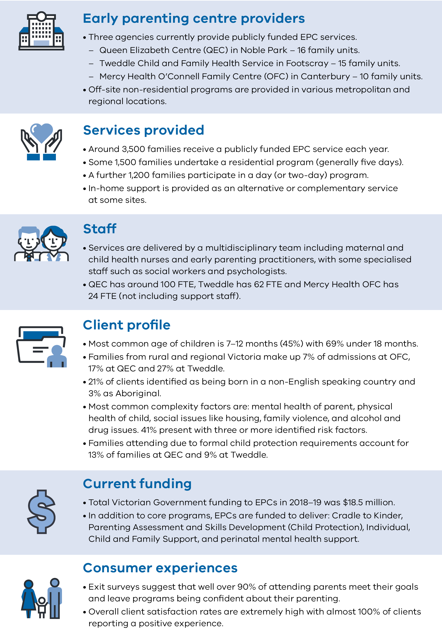

Rationale and context for an expanded EPC network
There is a strong rationale for public investment in early childhood and parenting support. International evidence suggests there is a high level of social and economic benefit from well-structured and delivered programs, especially those focusing on the first 1,000 days of a child’s life.
This adds to neuroscience research highlighting the critical importance of addressing adverse experiences and family-related stressors in infants and children during those early years.
Early parenting support is critical to addressing families’ short-term distress and ability to cope with challenges. It can also be crucial to ensure healthy child development and mitigate long-term problems, including preventing the development of mental health issues and poor social and educational outcomes.
The Royal Commission into Family Violence in Victoria put a spotlight on the vulnerability of families during the perinatal period and the harm to infants and young children associated with family violence.
The current Royal Commission into Victoria’s Mental Health System will provide further impetus to address the relationship between parenting challenges, including parents’ perinatal mental health and child mental health.
The government is responding to this wide body of evidence by investing in a broad package that addresses the needs of new mums and dads, including a strong focus on sleep and settling.
In addition, experience around the world suggests that early parenting intervention and support is much more effective when it is designed as an integral part of the wider service system for child and family health and wellbeing.
To this end, the expansion of EPCs in Victoria will be guided by, and aligned with, service directions in both the health and child and family services systems.

An evolving network
The role of EPCs has evolved over the 100 years they have been operating in Victoria. In recent decades, they have become specialist secondary health services, interfacing with local communities and functioning as respected centres of expert child, family and parenting advice.
While many of the core concerns addressed by EPCs remain constant, the centres have also shifted and strengthened their practice in relation to the growing prevalence of issues such as perinatal mental health, trauma and family violence, and introducing new programs, for example to support the child protection system and to better engage fathers.
EPCs have also responded to the challenge of meeting needs across the state through various outreach and satellite centre arrangements in selected locations. However, this has not been planned as an overall system response and has been limited by available resources.

The need for an expanded EPC network
This strategic framework presents an opportunity to develop a comprehensive network of EPCs as a platform for service delivery in the health and community services system.
The main constraint for EPCs is the lack of growth in capacity, particularly for residential care. Victoria’s population has increased rapidly, and the level of vulnerability of families is also rising. The number of children aged 0–4-years-old who are categorised as vulnerable according to the Australian Early Development Census is estimated to rise from 77,600 in 2016 to 91,200 in 2026.
While our current services have many clear strengths, there are systemic weaknesses that need to be addressed. The expansion of the EPC network is an excellent opportunity to implement improvements and drive positive change. One significant factor is that rising demand within a constrained budget has forced EPCs to accept only clients with a greater number of risk factors. Over time, EPCs have also been influenced by a number of other specific priorities that have involved short-term funding from government and other funders.
Finally, there are significant gaps in EPCs’ ability to define, measure and account for the outcomes they produce.
Notwithstanding the important data EPCs collect and the indications of value that clients place on the care they receive, further work could be done on formulating an agreed set of outcomes and enhancing the capacity to shape this as evidence of effectiveness.

Health reform context
The Department of Health and Human Services’ Health 2040 strategy (2016) sets a broad agenda for the development of the Victorian health system that focuses on:
- better health through skills and support to be healthy and well
- better access to fair, timely care closer to home
- world-class health care every time.
Reform directions relevant to EPCs include an enhanced focus on prevention and early intervention, improved integration of health and social care, and person-centred care with equitable access.
Specific developments within the health system that the EPC expansion needs to consider include:
- maternal and child health developments, including strengthened capacity for home visits within the enhanced maternal and child health program, and the provision of sleep and settling expertise through the maternal and child health phone line, together with a new maternal and child health app, more first-time parent groups, in-home support, and the provision of the baby bundle to all first-time parents
- maternity and paediatric service planning, including links to ante and postnatal education and support, and streamlined pathways for mothers and children likely to be in need of specialist early parenting services
- community hospitals, including a commitment to develop ten sites that will provide accessible and affordable secondary-level clinical care, including a significant focus on child and family health issues
- mental health, including a strengthened focus on perinatal and infant mental health and on trauma-informed care throughout the health and human services system (noting that the Royal Commission into Victoria’s Mental Health System will be a critical influence over coming years)
- quality and safety, including Safer Care Victoria’s implementation of the Targeting zero strategy, which involves improved clinical governance, consumer participation, outcomes monitoring and information sharing, and clinician credentialing.

Service and infrastructure planning context
The government’s Statewide design, service and infrastructure plan for Victoria’s health system is a 20-year vision for sustainable change to support future needs.
The plan is aligned with joined-up planning across public and private health services, local government, primary health networks, Aboriginal community-controlled organisations and other sectors.
Particular opportunities relevant to EPCs include:
- local health precincts and hubs
- family care hubs
- community hospital co-location or integration possibilities
- expansion and diversification of points of care
- networked and virtual health service provision.

Child and family services reform context
The Roadmap for reform: strong families, safe children is a crucial framework for the development of the EPC system. It aims to deliver a coordinated, integrated system that meets the needs of vulnerable families and children.
The Roadmap for reform highlights the need for early intervention, prevention and shared responsibility, as well as more visible and non-stigmatising entry points to services, and proactive connections to support through services and informal networks for people at risk.
Aspects of this phased reform that are particularly relevant to EPCs include:
- an enhanced role for universal services in supporting children and families at all points in the spectrum of vulnerability (progressive universalism)
- better support for Aboriginal children and families incorporating self-determination and self-management
- wrap-around family supports
- new ways to access and navigate between services
- inbuilt capacity and capability to intervene earlier and more effectively
- strong child and family engagement including more focus on families from diverse communities and people with a disability, and support for new dads, grandparents and primary carers
- transformation of child protection and strengthening of home-based care.
Central to the reform is a co-developed vision for Victoria’s future child and family service system. This includes three pathways to support – early help, targeted and specialist support, and continuing care – connected to community and delivered by a service network (see Figure 2 below).
While EPCs are clearly a secondary specialist support service, they need to have strong connections with the universal and primary services that will be their main sources of referral for those on an early help pathway.
At the other end of the system, EPCs need to work closely with agencies providing long-term support, as many EPC clients will have underlying chronic issues that require long-term therapeutic and social support. In addition, EPCs support tertiary child protection services by providing short-term assessment and skill-development services.
The department also recognises that many local government authorities in Victoria are investing considerable time and effort in planning for child and family health and wellbeing.
Existing and emerging local plans in this area will be important in guiding the development of the seven new EPCs to ensure they are coordinated with other services and supports in local and regional communities.

Figure 2: Child and family service responses
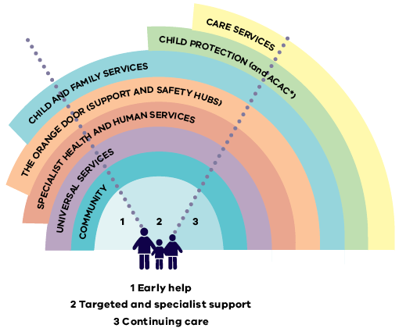

Principles informing the development of an expanded EPC network
The following principles build on existing departmental policies and discussions with EPC key stakeholders. They are intended to inform the planning, establishment and delivery of the expanded EPC network. These principles will be refined as this work progresses.
- Child-centred and family-focused care – dedicated to the wellness and safety of the child, and providing flexible, tailored care that takes into account the critical role and needs of the whole family.
- Integrated and seamless service provision – ensuring that families experience EPC service as part of a single pathway meeting their needs, with smooth transitions, including between health and social care components.
- Prevention and early intervention – promoting positive health and wellbeing, and identifying and responding to the short- and long-term risks of illness or harm at the earliest stage possible.
- Quality care, innovation and accountability – improving the availability and transparent use of data and shared information and evidence to drive quality and service improvement.
- Workforce expertise – developing the EPC workforce to meet diverse and changing client needs, and drawing on expertise in the workforce to continuously improve delivery.
- Equity of access and responsiveness to diverse families – removing barriers to access and actively providing a culturally safe service that responds to the different needs and concerns of Victorians from diverse cultural backgrounds, and with diverse sexuality and gender identities, disabilities and other factors.
- Aboriginal self-determination – modelling and promoting self-determination in decision making regarding care for Aboriginal children and families, and supporting Aboriginal-led service provision.
- Sustainable use of resources – using available resources effectively and efficiently to produce maximum value and benefit for families now and into the future.

What the role of EPCs might look like in the future
As we expand our EPC services to a wider network of centres, there is an unprecedented opportunity to reset and reaffirm the expectation of EPCs as central components in our child and family health and wellbeing system.
The primary purpose of EPCs is to support the best possible foundation for healthy child development.
Because EPCs only see parents and children for a limited time, close linkages with other services that have more enduring relationships with families are very important. EPCs also need to have good relationships with clinical and specialist services that families may need urgently. Current reforms to information sharing in relation to children and family violence will support these relationships.
The proposed statewide EPC network should provide consistent but locally responsive services that are part of a continuum of early help and targeted specialist support. A central plank in this system will be the connection with universal maternal and child health services, which are major referrers to EPCs and often provide the most effective follow-up mechanism. This connection will be strengthened through the rollout of the government’s new funding initiative expanding sleep and settling support in a range of settings.
As the scope and functions of EPCs are further refined, it may also be appropriate to review the naming of these services as early parenting centres, with common branding at a statewide level.

Goals for the EPC expansion
Goals for an expanded EPC network include the following:
- Current EPC services reach around 1 per cent of Victorian families with 0–4-year-olds. The planned expansion will allow for coverage to grow to around 3 per cent, with reach depending on the exact mix and intensity of services.
- Many families who seek EPC support cannot access the residential programs they need. The expansion will increase the number of residential family units from 43 to more than 100 across the state.
- Waiting times are a major concern, with 27 per cent of families waiting more than 30 days to be assessed, and 42 per cent then waiting more than 30 days for admission to a program. The expansion will significantly increase capacity and choice, and redesign service models.
- The current EPC services notionally support families with children 0–4 years old, but 70 per cent of services are provided to families with children younger than 12 months old. The expansion provides an opportunity to increase capacity to support older children and siblings.
- EPCs are currently accessed by many different kinds of families, but there is limited capacity to respond to the specific needs and preferences of all groups. The new and expanded EPCs will be designed to provide more inclusive and tailored responses to population diversity.

Families who will benefit from the expanded EPC network
An expanded EPC service network will support a wider range of families and ensure that people receive early support when they need it. This will include both people experiencing shorter-term stressors and more complex vulnerabilities.
Some families require short-term support to help prevent more serious issues developing later on. We anticipate that EPCs will play a key role at this preventative stage. In addition, some families may have more persistent issues – such as mental health issues or experience of trauma – which may not be immediately obvious but will become apparent during their course of treatment. Finally, the expanded network will continue to ensure that those experiencing significant vulnerability are able to get the help they need.

Issues an expanded EPC network might address
EPCs are specialists in early parenting and should have capacity to provide holistic care, but they are not a one-stop shop. Their primary concerns will continue to be sleep, settling, feeding and attachment, together with parental distress, fatigue and anxiety – all of which may need to be addressed in the context of specific adversities experienced by parents and children.
Building on the efforts of the existing EPCs, an expanded EPC network could address other issues directly or indirectly, including strengthening capability and enhancing capacity to identify, intervene and refer in relation to:
- parent and broader family relationships
- infant, child and parent mental health including history of trauma
- child health and development
- child safety and security
- family violence prevention and early intervention
- drug and alcohol dependency
- issues for children with a disability or chronic condition
- opportunistic health promotion (nutrition, injury prevention)
- role of cultural and gender-based norms on parenting practices.

Other roles EPCs might play
EPCs may also have an important role linking in with a broader range of child and family health and wellbeing supports. This may be in the form of ‘in-reach’ – other support services co-locating or working at the EPC site – or ‘out-reach’ – EPC staff working externally or at other providers’ locations to deliver support services.
This may include EPCs:
- acting as centres of expertise on parenting to provide secondary consultation and advice to a wide range of health and social services in their region, together with training (both on the job and formal) for a range of professional groups
- playing a key role in providing advice and support to maternal and child health services delivering the new outreach sleeping and settling service funded under the government’s ‘More help for Victorian mums and dads’ package
- working with antenatal and maternity services to support parenting education and early identification of potential need for specialised parenting support
- partnering with other providers of early parenting support to support step-up and step-down opportunities
- undertaking community activation using local resources and assets to build community connections and social capital for new parents
- supporting professional and consumer advocacy on parenting issues facing families in local communities
- offering co-location or integration of opportunities for social programs (such as play groups), allied health (such as speech therapy) or broader health promotion activities (such as men’s health for new dads)
- further supporting the child protection system through a wider range of mandated and voluntary programs.
During consultations, the department will seek further advice on the issues that EPCs could address as part of their service delivery to families, and other functions they could deliver into the future as a part of broader service systems and local communities.

Statewide coverage and catchments
Current services are notionally statewide, but some 85 per cent of admissions are from metropolitan Melbourne and heavily skewed to municipalities neighbouring the main facilities of the three centres in Noble Park, Footscray and Canterbury.
An expanded EPC network will work towards the goal of statewide coverage, providing access and a suitable response for children, parents and families wherever they live in Victoria.
Each EPC will be based in a specific locality and will be required to develop good local connections within their surrounding communities. They could also function as a wider regional service provider or, as is the case with the current EPCs, have a footprint in other designated areas.
The expansion might also involve developing a catchment framework for the expanded network in which each centre would have core responsibilities for designated geographical areas, aligned with other relevant catchment areas.
Possible catchments are still to be determined but, in principle, families would be referred to the centre most convenient to where they live, taking into account urgency, specialist care requirements and other issues.
Families can be confident that the core services they receive will be consistent whichever EPC they receive them from, through service planning, a statewide model of care and other planning and service delivery functions.
The potential delivery of outreach or telehealth support services – within budget constraints – to areas without an EPC in close proximity may also be defined on a catchment basis. In addition, the question of whether each of the EPCs would have exactly the same function, or some distinctly different ones, needs to be considered. This will be considered in light of the established expertise of the existing centres, possible sub-specialisation across the network and particular community needs.
These issues will be tested and refined in consultation with local stakeholders in the designated sites and surrounding areas as part of the service design and implementation planning stages of the initiative.
Figure 3: Locations of existing and planned new EPCs
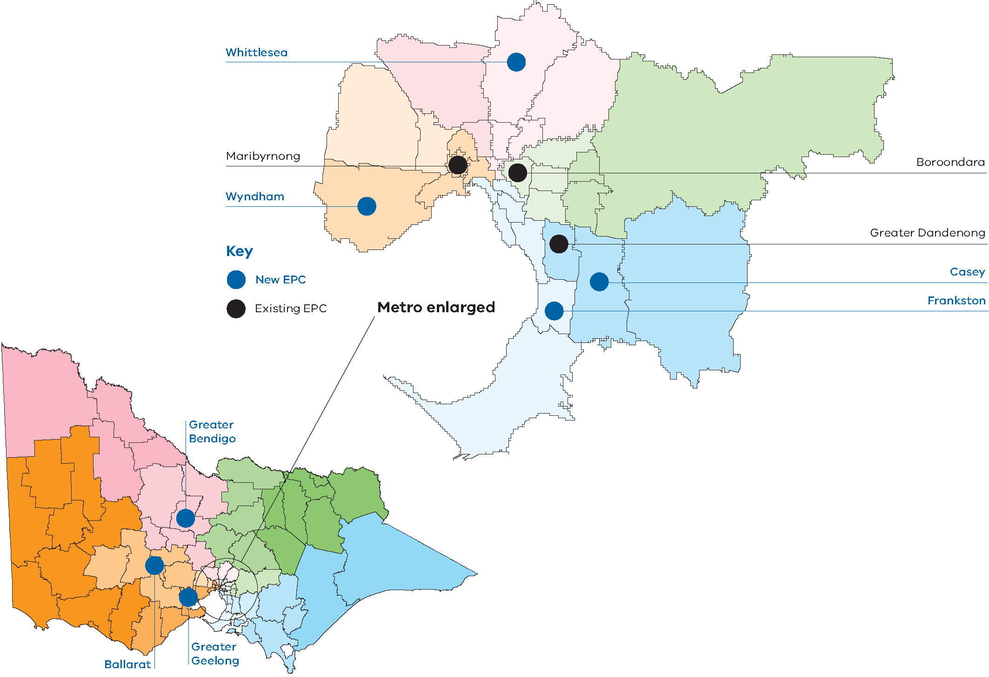

How things might be different for families and providers
The Department of Health and Human Services has commenced an intensive program of collaboration and engagement to develop a common model of care that may form the basis of planning and establishment of the new EPCs. This work will build on the great strengths of the care models and practice frameworks used across existing centres.
While this document does not pre-empt the outcomes of that work, high-level themes and areas for EPC service development may include:
- consistent referral processes, such as a centralised referral point for the network of EPCs, including initial screening for suitability to ensure consistency and streamline access for both families and referring organisations
- greater flexibility within programs to offer variable duration (days/hours) and convenient timing (possibly including weekend programs) – this would help partners/co-parents, wider families and siblings to be more actively involved in programs and maximise the utilisation of the centres
- a stepped-care model with supporting intake processes that allows families to move between lower and higher intensity responses over time, such as moving between (or using a mix of) day programs, residential services, home-based in-reach or telephone follow-up – this would better tailor responses to families’ individual needs
- capacity to provide wrap-around care coordination for more vulnerable families, either as a lead or partner with another service provider
- more substantial post-discharge follow-up options, including home visits and use of digital communication technologies
- telehealth and digital enhancements, such as using online chat or videoconference applications, to build on existing programs and to provide initial support for people on waitlists and to support access for families not living in areas with a physical EPC facility
- consistent child health promotion and prevention embedded into the programs (such as injury prevention and healthy eating)
- looking for opportunities to strengthen early intervention through screening, brief interventions and supported referral for issues such as mental health, family violence and alcohol and other drugs.
EPCs might stream individual families into a number of levels of support needs and then tailor a package of supports and interventions. Particular cohorts such as very young parents and isolated rural parents might be provided with different options.
Consistent with the department’s strategic directions for service development, EPCs will be encouraged to take a strengths-based, capacity-building approach to supporting parents. This means actively involving parents in shaping the programs in which they are participating.

Delivering for diverse populations
The Department of Health and Human Services supports a designing-for-diversity approach that involves systematically assessing the needs of different population groups, and responding to these needs at each stage of planning and design. Establishing the new EPCs provides a good opportunity to demonstrate the value of this approach.
An expanded EPC network should aim to address barriers to access and tailor support for specific cultural and social groups, including the following cohorts:
- Aboriginal and Torres Strait Islander people – there are many factors that make Aboriginal Victorians more likely to experience need for early parenting support. These include community trauma in relation to past child removal practices, continuing child protection involvement with Aboriginal families, prevalence of low birthweight babies, and the experience of family violence. The geographic distribution of the Aboriginal population in Victoria, wider kinship structures, and the lack of cultural safety in some mainstream services are key factors to be considered. There is an opportunity to explore models of EPC delivery by or in partnership with Aboriginal community-controlled organisations.
- Culturally and linguistically diverse people including migrants, refugees and asylum seekers – a wide range of social and cultural issues need to be considered for these groups, including variations in family composition and traditional gender roles, cultural norms for child raising, together with language barriers and different attitudes to seeking help for sensitive relationship-based issues.
- LGBTIQ people – families with same-sex parents, or parents who identify as trans or non-binary, face additional challenges and stigma, particularly when seeking help in group environments. These issues are becoming more prominent as the prevalence of rainbow families is rapidly increasing. EPCs will need to consider how to be accessible and welcoming to such families and examine ways to demonstrate their competence in this area (for example, through Rainbow Tick accreditation).
- People with disability – both children and parents with disability present particular challenges for EPC service delivery, with issues including support for parents of children with challenging behaviours (including those with autism), ensuring facilities meet standards for accessibility, and coordinating with National Disability Insurance Scheme support plans.
The department will be keen to hear the views of diverse stakeholders, particularly parents, service users and providers of associated services, about the aspects of EPC support that are important to them.

Developing the statewide system of EPCs
As the number of EPCs across the state expands, our goal is to ensure the ten services operate as an effective network with shared approaches to delivery, and a collaborative approach to quality and service, across the sector.
The department will work closely with existing and new EPC services to develop this system-wide network capacity, with particular attention to critical issues including workforce planning, development, recruitment and retention.
Providing a suitably qualified workforce at the scale required will take time and effort. Tackling this task as a whole-network approach, and in conjunction with overlapping workforce sectors, will be essential.
We will also focus on referral, intake and assessment pathways, client data collection and reporting (especially in relation to better understanding of outcomes) that will best support individualised, flexible client services.
In order to develop this capacity, the department will consider ways to implement joint planning, monitoring and quality systems across the expanded network. This could build on the liaison structures already established by the three existing EPCs.
The new EPC network will also focus research and evaluation to build the evidence base for innovation and improvement, as well as fostering learning capability through collaborations.
This work will include the development of service innovation designed to embed common practice elements and evidence-based approaches into EPC models.
Figure 4 shows the key elements of the new system.
The department wants to hear from stakeholders, including relevant professional groups and providers of associated services, about how these enabling factors can be best strengthened.

Figure 4: Key elements for the development of the EPC system
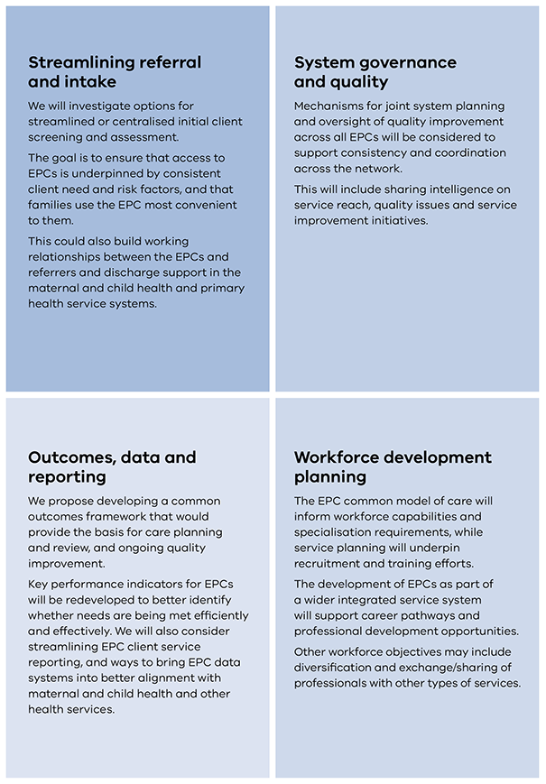

Delivering the vision
The main elements of the roll-out of the initiative are as follows.

Define the model of care
Having a common model of care for the entire network is a critical underpinning for the successful expansion of these services.
This provides an opportunity to build on the extensive work done on various aspects of service improvement by the existing three centres over recent years, as well as good practice from equivalent services in other jurisdictions.
Importantly, this work will draw extensively on collaboration with stakeholders, including families who have experienced EPC services. This includes a strong focus on the requirements and preferences of different population groups, including Aboriginal communities, migrant groups, same-sex and single-parent families, and parents and children with disabilities.
This model of care will help ensure consistent, high-quality services can be tailored to the specific delivery environment and client profile in each centre. It will also inform the design of new facilities.
Another important input will be the concurrent development of a Victorian model of care for sleep and settling to underpin delivery of other key components of the government’s commitments under the ‘More help for new Victorian mums and dads’ initiative.

Redevelop and expand existing centres
An estimated $18 million will be invested in the main Queen Elizabeth Centre and Tweddle sites at Noble Park and Footscray to replace parts of existing buildings, create extra residential units, build spaces to accommodate individualised support, and make other associated improvements to modernise and upgrade facilities.
Masterplanning for these redevelopments is expected to be undertaken in the second half of 2019, with works likely commencing in 2020.
Operational activity will gradually build up after completion of capital works.

Plan and build new centres
The process for establishing new centres will commence with discussions with stakeholders in the designated localities and neighbouring areas. These discussions will identify opportunities and preferences for service sites, and ways they might integrate with other parts of local service systems. Common design guidelines will be created as a starting point for the design of each centre.
Service planning work led by the department in 2019–20 will help shape the delivery profiles of each EPC and how all the centres should work together as a network.
The procurement of suitable land, design and construction is expected to proceed in two tranches, with three or four sites being completed first, and the remainder being completed approximately a year later. Factors including feasibility will determine which centres proceed more quickly.
The expansion project is currently due to be completed by the end of 2024.

Commission new providers
A major step in the expansion initiative will be determining the agencies that are best placed to manage and deliver the seven new EPCs services based in each of the selected local government areas.
No decisions on these providers have been made at this stage.
These decisions will be informed by the regulatory requirements for these services, and the need for robust governance arrangements. Through the commissioning process, we will seek to promote strong local and regional community and service system relationships. We will therefore also consider opportunities for promoting partnerships between different providers and implementing joint governance arrangements.
Further advice on these matters will be provided as the initiative progresses.

Implement system-level enablers and improvements
In parallel with the expansion of the service network, actions at the statewide level will address the key system enablers identified in this framework. A comprehensive EPC network improvement plan will build on the opportunities for improvement that have been identified.
Key elements of this plan may include:
- a streamlined referral, screening and intake system
- a workforce needs and development strategy
- statewide collaborative planning and oversight mechanisms.

Monitor, report on and evaluate services
Assessing the effectiveness and efficiency of EPC services will shape implementation and ongoing improvement. We will therefore seek to ensure that monitoring and evaluation processes capture the outcomes that are most valued by service users.
Critical steps will include:
- defining outcomes and performance indicators for assessing EPC effectiveness
- improving data collection and reporting
- gaining agreement and creating mechanisms for sharing information across the EPC network and with associated services
- consolidating departmental reporting arrangements.
During implementation we will review the best way to achieve data management and reporting, together with opportunities for aligning or integrating with systems used in other child and family health services.

Indicative timelines for expansion and reform 2019–2024
Figure 5 outlines the indicative timelines for the EPC expansion project. Note that these timelines are subject to factors such as land availability and purchasing processes.
Figure 5: Indicative timelines for roll-out of the expanded EPC network
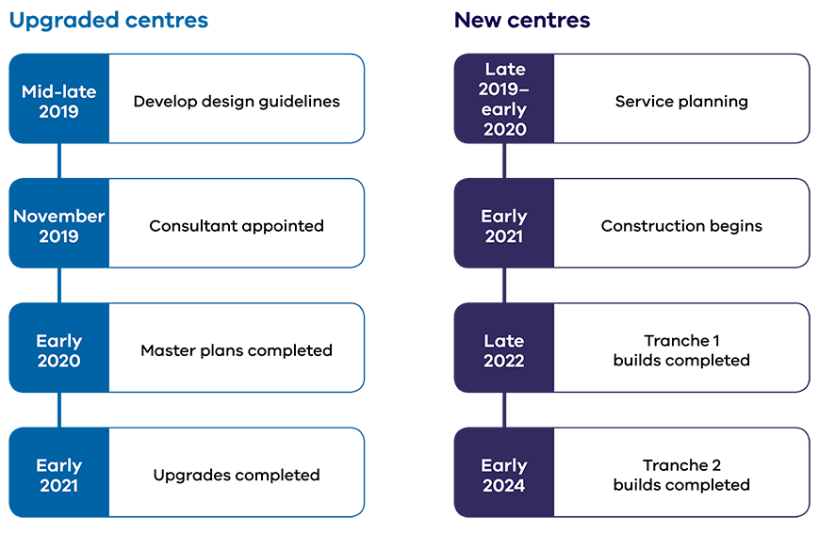

Appendix 1: Text equivalent descriptions of figures

Figure 1: Snapshot of current early parenting centre services

Early parenting centre providers

Three agencies currently provide publicly funded EPC services:
Queen Elizabeth Centre (QEC) in Noble Park – 16 family units.
Tweddle Child and Family Health Service in Footscray – 15 family units.
Mercy Health O’Connell Family Centre (OFC) in Canterbury – 10 family units.
Off-site non-residential programs are provided in various metropolitan and regional locations.

Services provided
Around 3,500 families receive a publicly funded EPC service each year.
Some 1,500 families undertake a residential program (generally five days).
A further 1,200 families participate in a day (or two-day) program.
In-home support is provided as an alternative or complementary service at some sites.

Staff
Services are delivered by a multidisciplinary team including maternal and child health nurses and early parenting practitioners, with some specialised staff such as social workers and psychologists.
QEC has around 100 FTE, Tweddle has 62 FTE and Mercy Health OFC has 24 FTE (not including support staff.

Client profile
Most common age of children is 7–12 months (45%) with 69% under 18 months.
Families from rural and regional Victoria make up 7% of admissions at OFC, 17% at QEC and 27% at Tweddle.
21% of clients identified as being born in a non-English speaking country and 3% as Aboriginal.
Most common complexity factors are: mental health of parent, physical health of child, social issues like housing, family violence, and alcohol and drug issues. 41% present with three or more identified risk factors.
Families attending due to formal child protection requirements account for 13% of families at QEC and 9% at Tweddle.

Current funding
Total government funding to EPCs in 2018–19 was $18.5 million.
In addition to core programs, EPCs are funded to deliver: Cradle to Kinder, Parenting Assessment and Skills Development (Child Protection), Individual, Child and Family Support, and perinatal mental health support.

Consumer experiences
Exit surveys suggest that well over 90% of attending parents meet their goals and leave programs being confident about their parenting.
Overall client satisfaction rates are extremely high with almost 100% of clients reporting a positive experience.

Figure 2: Child and family service responses
The figure shows services arranged in concentric semi-circles, from the centre out:
Community
Universal services
Specialist health and human services
The Orange Door (Support and Safety Hubs)
Child and family services
Child protection (and Aboriginal Children in Aboriginal Care)
Care services.
The semi-circle is divided into three vertical segments representing the three pathways.

Pathway 1 (early help) encompasses:
Community
Universal services
Specialist health and human services
The Orange Door (Support and Safety Hubs)
Child and family services

Pathway 2 (targeted and specialist support) encompasses:
Child protection (and Aboriginal Children in Aboriginal Care)
Care services
Plus, all previous responses

Pathway 3 (continuing care) encompasses all responses.

Figure 3: Locations of existing and planned new EPCs
The figure shows a statewide map with three new centres planned for regional areas at Greater Bendigo, Ballarat and Greater Geelong.
There is a break-out map for the metropolitan area showing existing centres at Maribyrnong, Boroondara and Greater Dandenong, and new centres planned for Wyndham, Whittlesea, Casey and Frankston.

Figure 4: Key elements for development of the EPC system

Streamlining referral and intake
We will investigate options for streamlined or centralised initial client screening and assessment.
The goal is to ensure that access to EPCs is underpinned by consistent client need and risk factors, and that families use the EPC most convenient to them.
This could also build working relationships between the EPCs and referrers and discharge support in the maternal and child health and primary health service systems.

System governance and quality
Mechanisms for joint system planning and oversight of quality improvement across all EPCs will be considered to support consistency and coordination across the network.
This will include sharing intelligence on service reach, quality issues and service improvement initiatives.

Outcomes, data and reporting
We propose developing a common outcomes framework that would provide the basis for care planning and review, and ongoing quality improvement.
We will review key performance indicators for EPCs to better identify whether needs are being met efficiently and effectively. We will also consider streamlining EPC client service reporting, and ways to bring EPC data systems into better alignment with maternal and child health and other health services.

Workforce development planning
The EPC common model of care will inform workforce capabilities and specialisation requirements, while service planning will underpin recruitment and training efforts.
The development of EPCs as part of a wider integrated service system will support career pathways and professional development opportunities.
Other workforce objectives may include diversification and exchange/sharing of professionals with other types of services.

Figure 5: Indicative timelines for roll-out of the expanded EPC network

Upgraded centres
- Mid-late 2019: Develop design guidelines
- November 2019: Consultant appointed
- Early 2020: Master plans completed
- Early 2021: Upgrades completed
- New centres
- Late 2019: Early 2020: Service planning
- Early 2021: Construction begins
- Late 2022: Tranche 1 builds completed
- Early 2024: Tranche 2 builds completed

