An Evaluation of the Geriatric Evaluation and Management program in Victoria
OFFICIAL

An evaluation of the Geriatric Evaluation and Management program in Victoria

To receive this document in another format, phone 03 9096 3538, using the National Relay Service 13 36 77 if required, or <email older people in hospital>.
Except where otherwise indicated, the images in this document show models and illustrative settings only, and do not necessarily depict actual services, facilities or recipients of services.
Authorised and published by the Victorian Government, 1 Treasury Place, Melbourne.
© State of Victoria, Australia, Department of Health, May 2022.
Available at health.vic Geriatric Evaluation And Management<https://www.health.vic.gov.au/patient-care/geriatric-evaluation-and-management>

Contents
Background 6
Methodology 7
Key findings 7
Recommendations 10
Developing a system of care to respond to the needs of older people 11
Next steps 13

Background
There is a steady increase in the proportion of Victoria’s population that is older. And with ageing comes increased need for health care. Since 2011–12, there has been an overall annual growth in acute hospital multiday stays of 0.96 per cent. For those over 65 years of age the rate has been 1.9 per cent. On any given day close to one in three multiday hospital beds are occupied by someone over 75 years of age despite this age group making up only 7 per cent of Victoria’s population.
Caring for older people is now core business for Victorian health services. This means there is a need to not only consider how to respond to increasing demand for care but in rethinking how this care is delivered. While there may be more older people overall, it is the proportion of these who are frail, have multidimensional needs and are vulnerable to harm in hospital that are challenging the efficiency and effectiveness of Victoria’s health service operations, especially in acute care.
In Victoria one of the key services for addressing this demand has been the Geriatric Evaluation and Management (GEM) program. GEM is a part of Victoria’s subacute service system that also includes admitted rehabilitation and palliative care. The primary goal of care is improving the functioning of an older person with multidimensional needs including addressing complex psychosocial problems. Commonly these are associated with medical complexity and other conditions related to ageing such as:
- falls
- incontinence
- reduced mobility
- delirium and depression.

The GEM program has been operating in Victorian health services for more than 20 years. During that time GEM has evolved according to policy directions, local innovation and demand. The Department of Health has undertaken an evaluation of the GEM program to determine whether GEM is optimising value both in terms of improving outcomes for older people with complex health and psychosocial needs and supporting the health service system to meet demand from an ageing population.

Methodology
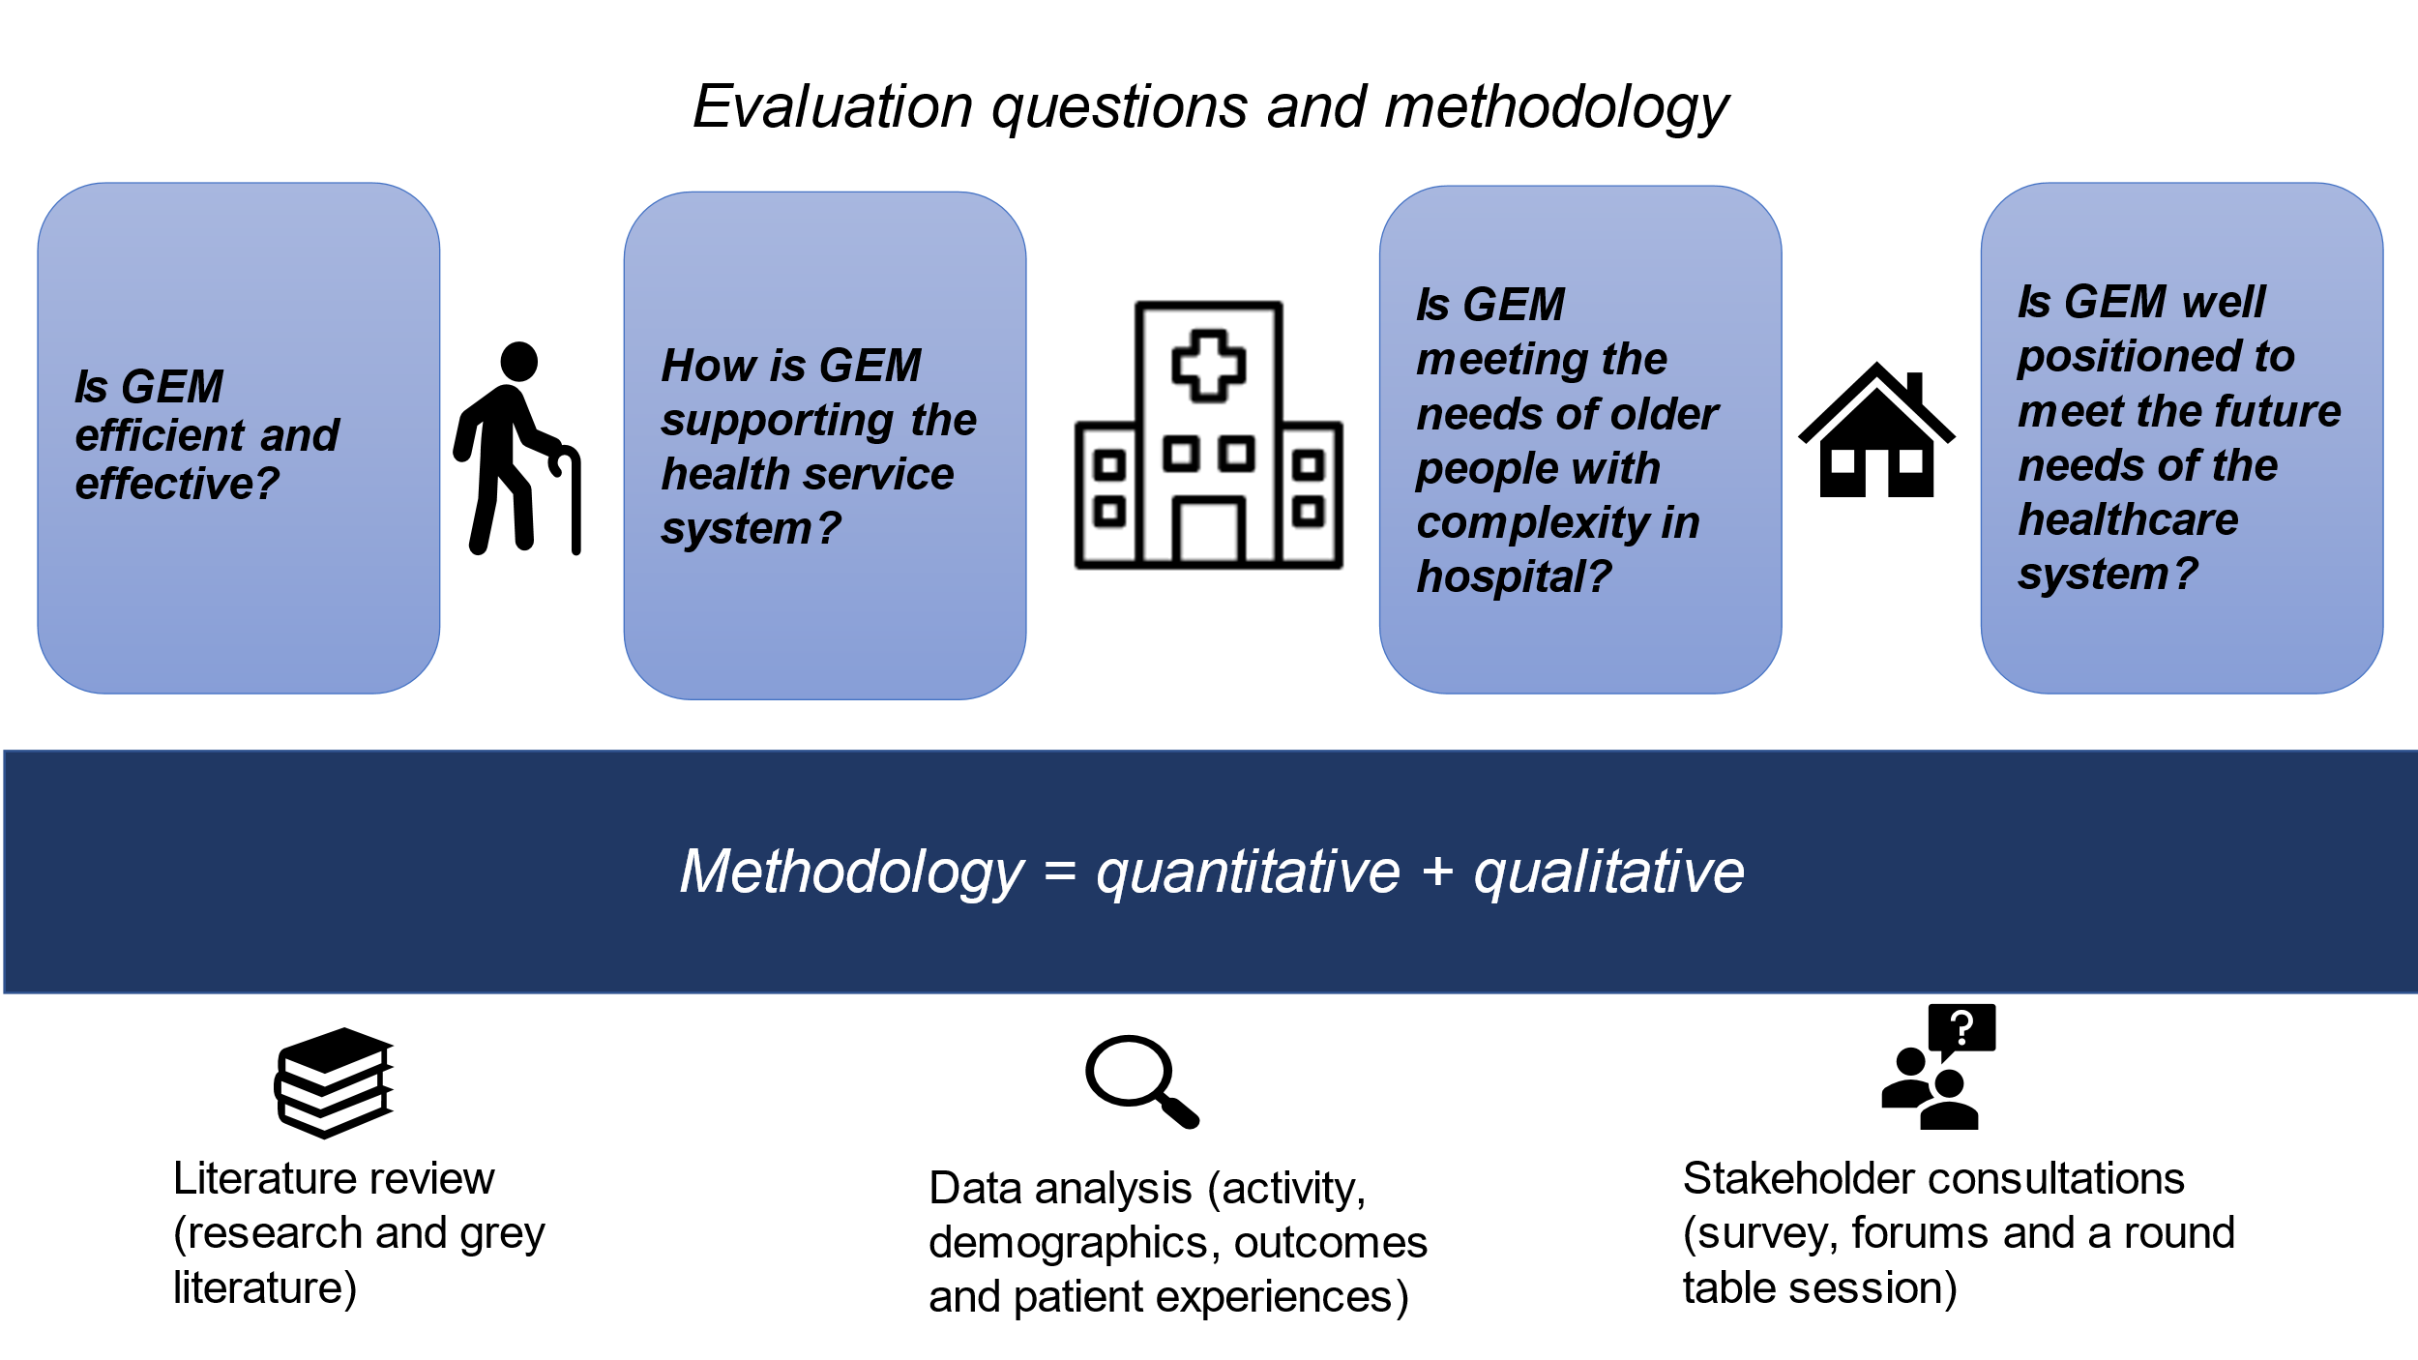
As identified in the diagram above, the evaluation sought to answer four key questions:
- Is GEM efficient and effective?
- How is GEM supporting the health service system?
- Is GEM meeting the needs of older people with complexity in hospital?
- Is GEM well positioned to meet the future needs of the healthcare system?

A mixed methodology approach was used to inform the evaluation. This included a review of the literature relevant to delivering specialist models of care for older people together with a comprehensive consultation with the sector. This included with services that commonly interact with the GEM program. In addition, we gathered was through available health service administrative and other data sources. An advisory group made up of relevant sector and department people oversaw the process.

Key findings
“We foresee GEM becoming more dynamic with the service acting increasingly in an acute and ambulatory space. We would foresee minimal growth in inpatient strategies, however, increasing growth in the outpatient sphere. This would mean more and earlier discharges of patients to their home environment with acute and subacute 'GEM'-based follow-up for management in the community. This would also be paired by increased prospective geriatric interventions to prevent admissions to hospital.” (Participant in the stakeholder consultations)
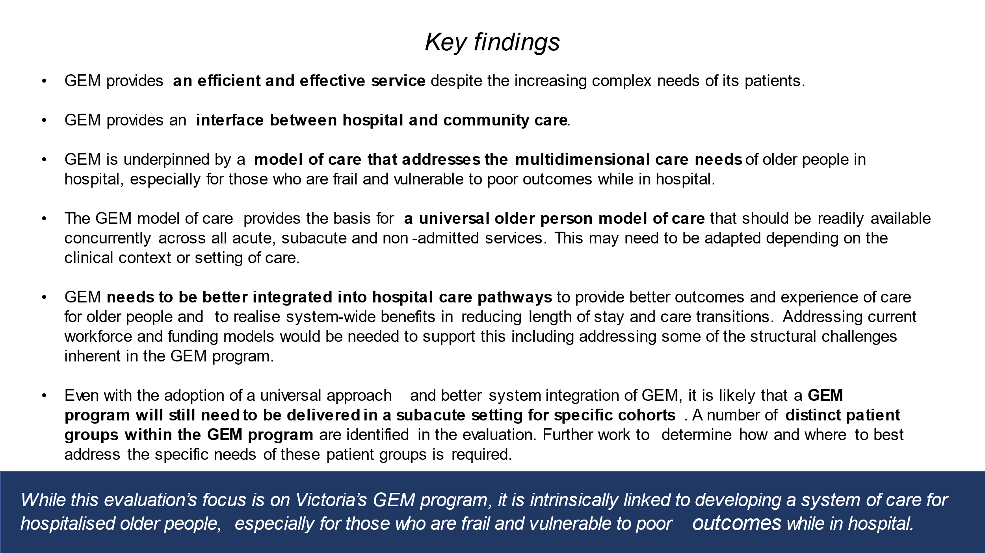

The diagram above identifies the key findings of the evaluation. While the evaluation’s focus is on Victoria’s GEM program, its evolution is intrinsically linked to developing a universal system of care for hospitalised older people, especially for those who are frail and vulnerable to poor outcomes while in hospital. This may need to be adapted depending on the clinical context or setting of care and include a focus on early rehabilitation for patients at risk of functional decline and lengthy stays in hospital. For older patients who would benefit from a coordinated approach to care through a specialist geriatric service, there should be timely access to the GEM model of care, either in specialist units or through hybrid models in the acute care setting.
GEM is a clinical process and model of care underpinned by comprehensive geriatric assessment – a multidisciplinary diagnostic and treatment process that focuses on the multidimensional needs of older people with a view to longer term care planning. This should be widely available to those who will benefit from such an approach early in their care process irrespective of where care is provided. This includes, increasingly, providing this care outside of the hospital through GEM in the Home. Such flexibility in the approach aligns well with GEM, with its strong focus on delivering person-centred care.
Key to this model of care is:
- holistic care provided by a multidisciplinary workforce skilled in the care of older people
- individualised care planning involving the patient and family in the process
- care that is goal-oriented with a focus on therapeutic interventions to improve functional outcomes and address identified needs
- a strong focus on discharge planning to address long-term care and health needs.

The data supported the views expressed through the consultations that GEM provides an efficient and effective service despite its patients becoming increasingly complex.
“The complexity of patients through GEM, in regard to medical acuity, social complexity and behaviours of concern, has increased over the years, which has placed a lot of pressure on the system and on length of stay.” (Participant in the stakeholder consultations)
Around two-thirds of GEM patients were categorised in the hospital datasets as having the highest level of complexity. But the program continues to report increasing functional gains for patients while reducing average length of stay.
A strength of GEM is its role in facilitating system flow, providing an interface between acute hospital care and the community. Through the consultations GEM was identified as having an essential role in facilitating discharge for patients with a wide range of complex medical, functional and psychosocial issues that were not easily managed in acute care. A relatively low unplanned hospital readmission rate of 3 per cent shows the effectiveness of the GEM program.
Despite this, the evaluation identified that GEM, both as a program and a model of care, could be better integrated into hospital care pathways to:
“Provide continuous care rather than the fragmented disjointed care currently provided by ED, then Gen Med, then GEM. Each transition between these is inefficient, poses risks to patients and is a nuisance to them.” (Participant in the stakeholder consultations)
The emergence of co-management and hybrid acute/subacute care models in hospitals demonstrates the value of integrating specialist geriatric care to deliver early intervention and therapy to reduce the risk of harms common for older people in hospital. This would have system-wide benefits for health services while strengthening the interface with primary and community services. It would reduce lengthy stays in hospital and the number of care transitions while improving the experience and outcomes of care for older people and their families.
With adopting a universal approach and better system integration of GEM, it is likely that GEM will still need to be delivered in a subacute setting for certain cohorts. Several distinct patient groups within the GEM program are identified, each with specific care requirements. These include:
- rehabilitation to regain function and independence
- specialist dementia management and addressing behaviours of concern
- complex discharge planning and addressing long-term care decision making
- patients unable to be discharged home or requiring restoration of function following prolonged hospitalisation.

Meeting the increasing complexity of older people’s needs in hospital requires a workforce with the capacity and the skills to address a range of older people’s care needs. Workforce and associated resourcing are highlighted as needing to better align with these patient groups’ needs and with emerging service models to ensure care is effectively and efficiently delivered. The need for more contemporary funding models that incentivise care services to be more effective and efficient was raised through the consultations.
Note that funding was out of scope for this evaluation due to significant work currently being undertaken with refining the subacute classification system and Victoria transitioning to the national funding model.

Recommendations
“It is a vital service that needs to grow, particularly in the acute area. There is engagement from acute care clinicians for the need for geriatric services within acute space and co-managing complex older people.” (Participant in the stakeholder consultations) 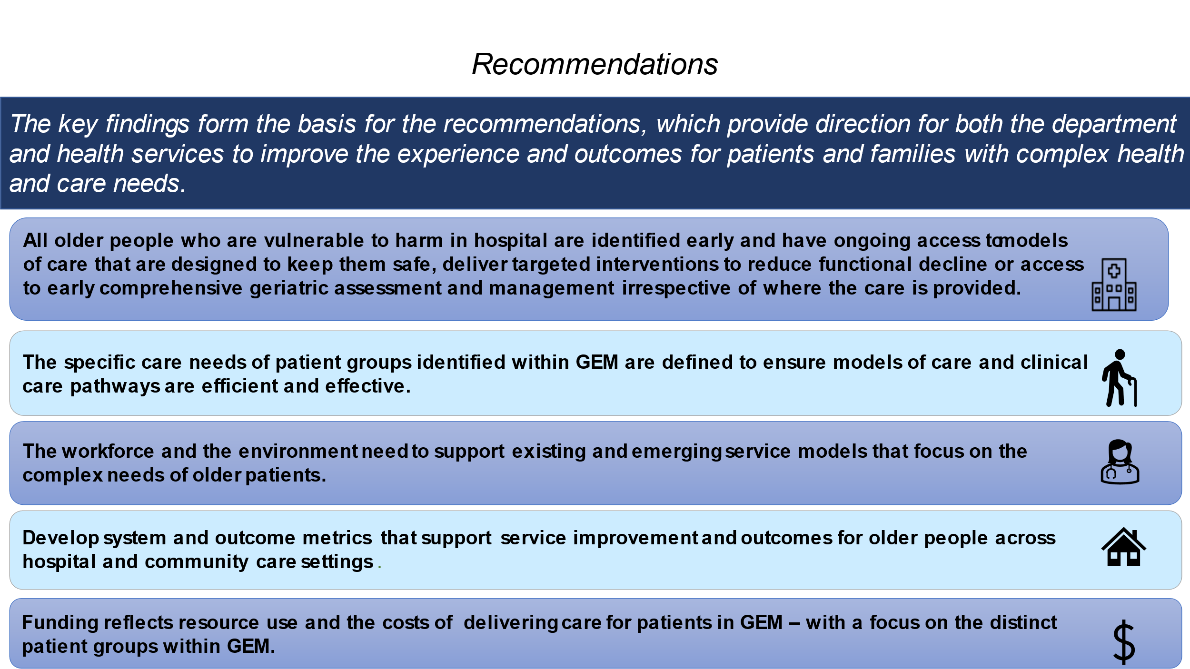
The key findings form the basis for several recommendations, identified in the diagram above. These provide direction for both the department and health services to improve the experience and outcomes for patients and families with complex health and care needs. It should be acknowledged that the recommendations are broader than for the GEM program alone. These recommendations aim to encourage a system response, including supporting provided for older people in hospital or in the community.
This will require systematic identification of the cohort and timely access to the model of care. There will need to be consideration given to designing pathways and tailoring interventions that comprehensively address older patients and health service needs.
This will have implications for health services, requiring them to consider how they organise themselves in terms of workforce and resourcing to support clinical pathways for older people with complex care needs. The department will also need to consider how it can support the health service system to enable these changes.
To progress several the recommendations, the department will engage directly with the sector to consider some key questions:
- What does a universal model of care for older people with complex care needs look like and how it should be introduced?
- What is the role of the GEM program into the future?
- What does best care look like for distinct patient cohorts cared for currently in GEM and what system reforms are required to achieve this?

Based on the key findings several recommendations are made with proposed actions for the department and health services. Broadly, these recommendations are:
- All older people in hospital should receive a universal older person model of care that guides clinical decision making to reduce the risk of avoidable harm, such as the Institute of Healthcare Improvement <‘4Ms’ framework> .
- Older patients at risk of functional decline are identified early and targeted interventions are in place, including early rehabilitation.
- Older patients who would benefit from comprehensive geriatric assessment have early access to this provided in specialist units that deliver a GEM model of care regardless of the care setting, including in a patient’s own home.
- The specific care needs of patient groups identified as requiring a GEM program response are defined to ensure models of care and clinical care pathways are efficient and effective.
- The workforce and the environment support existing and emerging service models that focus on the complex needs of older patients.
- System and outcome metrics are developed that support service improvement and outcomes for older people across hospital and community care settings.
- Funding reflects resource use and the costs of delivering care for patients in the GEM program, with a focus on those distinct patient groups identified and in a range of care settings.

Reform will need to focus more specifically on older people as a cohort, with better targeted interventions and with the workforce and physical environment that can best meet their needs. There are challenges to delivering this reform including:
- early identification of the cohort
- timely access to specialist geriatric care to minimise transfers, reduce harm and facilitate early and effective discharge
- a skilled workforce that can respond concurrently to both acute and complex care needs
- recognising and responding to the specific needs of distinct patient groups within the identified cohort
- providing a culture and environment that reduces functional decline and enables independence and family engagement
- current funding and reporting for the GEM program making it difficult for it to concurrently address an older person’s acute and complex care needs.

Developing a system of care to respond to the needs of older people
“The main difference in the future would be to have Acute Care of the Elderly Units that start from the Emergency Department, provide acute care and then also provide what is currently GEM care, without the patient having to move wards or beds or change teams. Ideally, some members of the team, as appropriate, would also follow individual patients into the community.” (Participant in the stakeholder consultations)
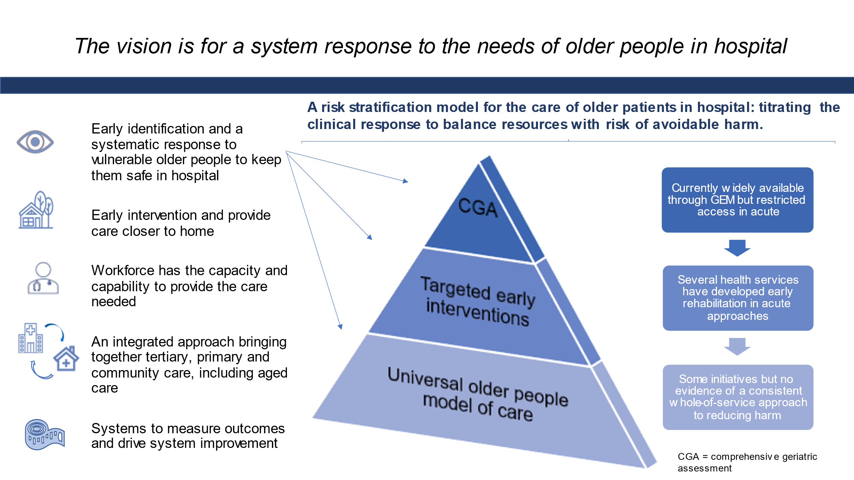

Through the course of this evaluation, it become clear that delivering care that responded to the multidimensional needs of older people had less to do with a program called GEM and more about access to the GEM model of care. Only around 8 per cent of older patients admitted into hospital currently have their care provided through the GEM program. The current structures and funding of GEM make it challenging for the program to provide the system-wide response needed without addressing limitations identified through the evaluation. These include having a workforce that is enabled to deliver the care.
The GEM model of care provides the basis upon which to build a universal model of care to address the complex care needs of hospitalised older people, especially those with geriatric issues that make them vulnerable to adverse outcomes and harm such as functional decline, delirium and falls. The diagram above identifies a model for health services to systematically respond to the needs of older people through risk stratification that balances available resources with targeted interventions based on the level of likely risk of avoidable harm an older person may have while in hospital.
While not all older patients need or would benefit from receiving comprehensive geriatric assessment, delivering care that is designed to reduce the risks of harm and functional decline should be embedded into routine clinical practice. A hierarchy of care is presented based on identified level of risk of a poor outcome associated with hospitalisation. The approach suggests that all older people at risk of harm in hospital should receive a universal model of care to keep them safe. A sub-set of these older people would benefit from early targeted interventions to reduce their risk of functional decline and lengthy stay in hospital. Given resource limitations and benefits, a smaller number of patients should have their care provided in a specialist geriatric service to deliver comprehensive geriatric assessment through interdisciplinary team-based care. Such care should be provided as early as possible in the admission irrespective of the care setting, ideally in the patient’s own home if appropriate.
Some of these service models are already operating in several health services but may not be consistently applied or are underdeveloped. Such local initiatives provide examples that the department could build on.

Next steps
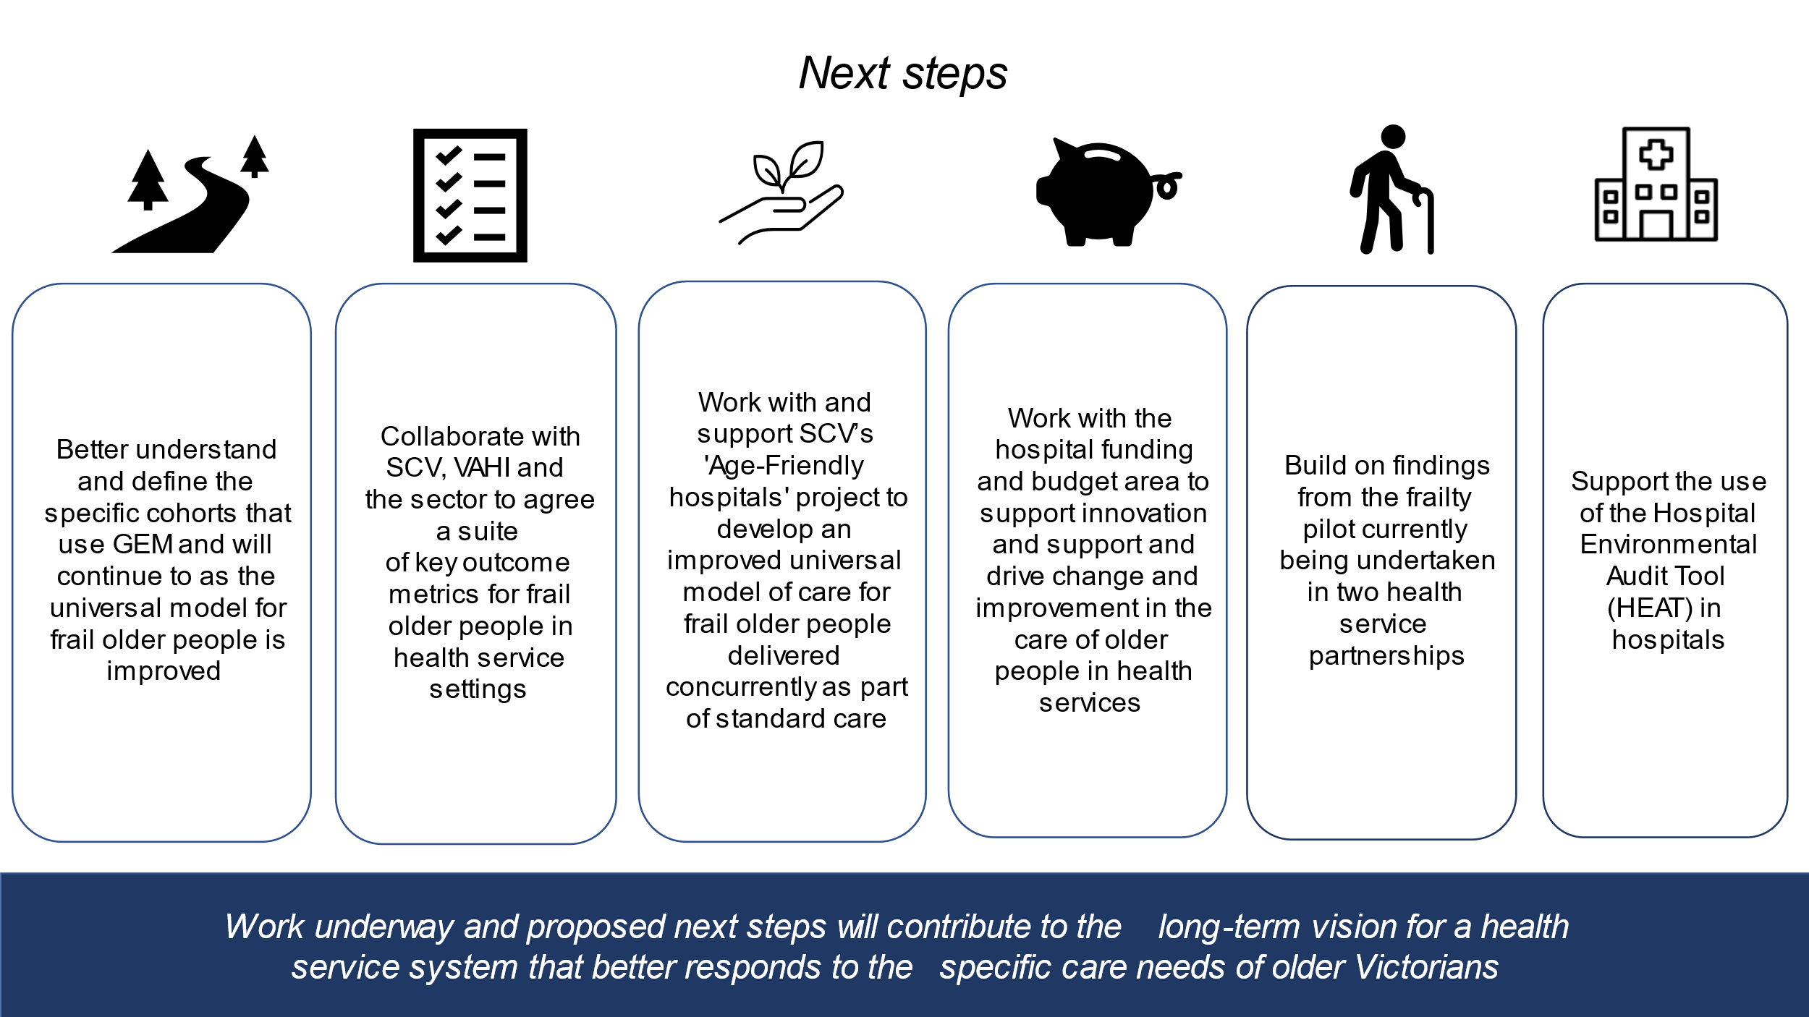

As can be seen in the above diagram, some work to deliver on the recommendations has already begun:
- A frailty screening pilot has started at two health services to see how using the Clinical Frailty Scale can identify older patients in the acute care setting who would benefit from interventions designed to reduce risk of functional decline or harm in hospital to stratify for risk and response.
- Work has begun with the National Ageing Research Institute and clinical experts on developing a model of care and clinical pathways in hospital for patients with severe behaviours associated with their dementia.
- The Health Issues Centre is engaging directly with patients who have received care in a GEM unit to understand their experiences and develop a deeper understanding of their needs and priorities
- Given the expansion of GEM in the Home through the Better at Home Initiative, a review of GEM in the Home service models currently being delivered by Victorian health services is being undertaken to help develop future policy and reforms to help deliver specialist interdisciplinary geriatric care in the community.

The final recommendations do include actions for health services as well as the department. Implementing these recommendations will require collaboration with other areas of the department to deliver the mechanisms to incentivise reforms. Working with the sector will be critical to understanding how best to progress the recommendations.

