

|  |
| --- |
| Transferability of fit testing records |
| 16 March 2022 |

## Updates

To ensure you are aware of the most recent changes, all content updates and the date the document was last updated will be highlighted in yellow text.

|  |  |
| --- | --- |
| **Version/Date** | **Changes** |
| Version 1, 11 October 2021 | This document replaces the previous Fit Test Certificate template to reflect current practice in the sector and includes advice in Appendix 1. |

This document should be read in conjunction with:

* *Establishing a fit testing program guidelines* <https://www.dhhs.vic.gov.au/establishing-a-fit-testing-program-guidelines-doc-covid-19>
* *Victorian Respiratory Protection Program guidelines* <https://www.dhhs.vic.gov.au/victorian-respiratory-protection-program-COVID-19-pdf>

**Introduction**

Healthcare workers (HCWs) are mobile and may work across multiple sites or health services. The Fit Testing Card template (appendix 1) has been created for health services to guide the development of written evidence of respiratory protective equipment (RPE) fit testing results for healthcare workers (HCWs) who have been fit tested as part of their respirator protection program.

The Respiratory Protection Program (RPP) Guidelines state that a copy of the fit test results should be provided to HCWs who have been fit tested. This enables portability of fit testing results and avoids multiple retests unless required by RPP Guidelines, section 5.1 of RPP Guidelines and any associated guidance.

The template is a guide only and can be adapted by a health service including placing the information on an official letterhead or making it available online.

Written evidence, in the form of a certificate, card or other format should be provided to HCWs who can then provide this evidence to other employers, agencies, or universities. A copy of the fit test results should be retained as part of the HCWs personnel record.

The certificate or card is a tool for health services and HCWs to enable a certified process for recognising that the HCW has been fit tested. It confirms that HCWs are using the correct mask, eliminates any confusion about which respirator a HCW should use and verifies the date of the last fit test.

As health services have different approaches to the recording of fit test results (e.g. in the form of a letter, card, certificate, upload to personnel file or some other record), it is suggested that HCWs take a photo of their results so that they have a backup record and can show this to any other health service that they may work in.

## Recording fit testing results

The results of a fit test should be verified by an authorised person. An example is below.

### **Individual healthcare worker’s details:**

|  |  |
| --- | --- |
| Name: |  |
| Occupation: |  |
| Organisation where fit test was conducted: |  |
| Date of fit test: |  |
| Fit Test conducted by: |  |

An authorised person is a person that can verify the internal record of an individual’s fit testing results at the organisation (e.g., occupational hygienist, infectious disease team member, fit tester, RPP administrator, health and safety professional or HR).

Authorised by:

|  |  |
| --- | --- |
| Authorised Person: | Date: |
| Role: | Signature: |

**Consent prior to fit testing**

Before a healthcare worker presents for fit testing, they should be provided with information regarding the fit test process and a copy of a pre-test screening questionnaire (the primary purpose of which is to identify any medical or allergic reactions to materials in the respirators).

For further information and an example of fit test pre-screening questionnaire please refer to *Establishing a fit testing program (27 November 2020):* <https://www.dhhs.vic.gov.au/healthcare-worker-infection-prevention-and-wellbeing-taskforce>

#### Appendix 1: SAMPLE FIT TEST CARD

Please note: It is recommended that the following information is recorded on the fit test card for each healthcare worker fit tested. Health services may format the appearance of the card to their specific requirements.

**Front side of card**



**Rear of card**

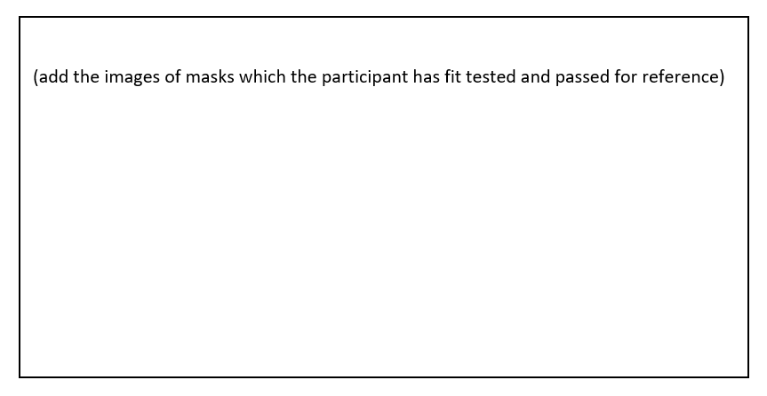

#### Appendix 2: Alternate example of a fit test card

|  |  |  |  |  |
| --- | --- | --- | --- | --- |
| Respirator type | Image of Respirator type | Y = Pass N= Fail  Blank= not tested | Overall Fit Factor >100 | Comments (add comments about fit/mask) |
| 3M AURA 1870+ | 3M Aura Respirator & Surgical Mask 1870+ N95 Single Mask PPE |  |  |  |
| *BYD DE2322*  *(Medium)* | See the source image |  |  |  |
| *Industree Trident P2* |  |  |  |  |
| *3M 1860 (Regular)* |  |  |  |  |
| *BSN 72509-10 Proshield (Regular)* |  |  |  |  |
| *3M Aura 9320A+* |  |  |  |  |
| *Halyard 46727* |  |  |  |  |
| Halyard 46827 (Small) |  |  |  |  |
| *3M 1860s* |  |  |  |  |
| *BSN 72509-09 (Small)* |  |  |  |  |
| *Other: Please specify* |  |  |  |  |

|  |
| --- |
| To receive this document in another format, phone 1300 650 172, using the National Relay Service 13 36 77 if required, or email [Victorian Respiratory Protection Program](mailto:VicRPP@health.vic.gov.au) <[VicRPP@health.vic.gov.au](mailto:VicRPP@health.vic.gov.au)>  Authorised and published by the Victorian Government, 1 Treasury Place, Melbourne.  © State of Victoria, Australia, Department of Health, 16 March 2022  **ISBN** 978-1-76096-703-1 **(pdf/online/MS word)**  Available at [Victorian Respiratory Protection](https://www.health.vic.gov.au/quality-safety-service/victorian-respiratory-protection-program) Program <https://www.health.vic.gov.au/quality-safety-service/victorian-respiratory-protection-program> |