Tobacco control regulator plan on a page
Tobacco control regulator plan March 2018–June 2019

This document summarises the key elements of the Tobacco control regulator plan. The plan provides the context the regulator works within and an overview of its regulatory framework and activities. This is supported by the Better regulatory practice framework: January 2018–June 2019, which provides a process for risk-based and accountable regulatory practice, and improved regulatory performance in the health and human services sector. The regulator plan and framework are available on Regulatory practice framework <https://www.dhhs.vic.gov.au/better-regulatory-practice-framework>.

Outcomes
The Tobacco Control Section contributes to the reduction of the proportion of regular smokers in the Victorian population, including pregnant women, and preventing young people from becoming smokers. The section achieves this by working to introduce more smoke-free areas, eliminating remaining forms of tobacco advertising and promotion and educating key stakeholders of the dangers of smoking.

Who we regulate
The Tobacco Control Section works with local councils to regulate:
- businesses that sell tobacco products
- individuals, businesses and organisations captured by the bans on smoking in certain places, such as outdoor dining areas, enclosed workplaces and at entrances to public hospitals.

Who we work with
The Tobacco Control Section interacts with a broad range of stakeholders to help deliver outcomes, share intelligence, and to identify and act on non-compliance. The groups we work with include local councils whom have the responsibility to directly regulate tobacco retailers and hospitality businesses, as well as peak bodies such as the Municipal Association of Victoria.
Tobacco Act 1987
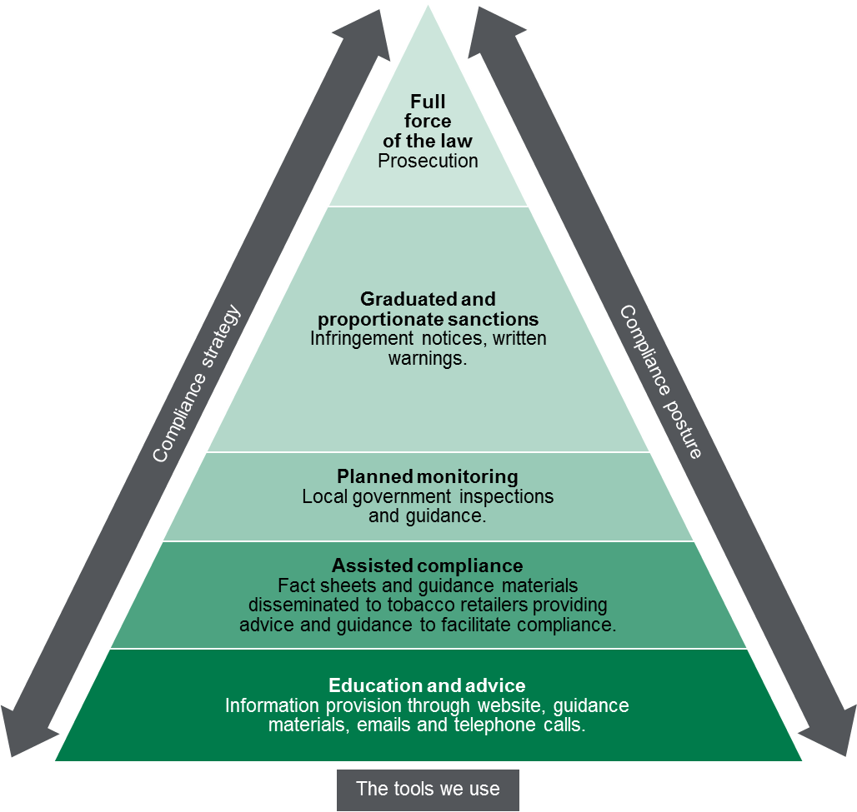

Contribution story
The overall daily rate of smoking prevalence in Victoria is on the decline, currently reported at 11.9 per cent of all Victorians. The Tobacco Control Section works to maintain this decline through collaborating closely on education and smoking cessation with key stakeholders such as Quit Victoria and Victorian Aboriginal community controlled health organisations.
These key engagements help to target education to those with the highest rates of smoking in the community, including Aboriginal Victorians, people suffering from mental illness and people in particular geographic locations. Education regarding the dangers of smoking is continually sustained via Victorian anti-smoking social marketing campaigns integrated across television, radio, print and social media.

Measuring our impacts
The Tobacco Control Section monitors how it contributes to reducing the proportion of regular smokers, preventing young people from smoking, ensuring that workplaces and pubs and clubs are smoke free by reporting on a number of indicators. These include:
- the percentage of test purchases that result in a tobacco sale to a minor
- the overall daily smoking prevalence rate
- the percentage of workplaces and pubs and clubs complying with smoke free environment laws. results of annual planned audits..

Diagram text – regulatory tools
This figure is an enforcement pyramid. The figure seeks to demonstrate that the unit will use the full range of tools available to it in line with the risks that they are seeking to manage. The enforcement pyramid illustrates a graduated and proportionate enforcement approach. The bottom of the pyramid outlines the lighter touch interventions such as education and advice to regulated parties, through to prosecution at the top of the pyramid, where regulated parties deliberately work against intended outcomes and intend to evade compliance obligations.

To receive this publication in an accessible format phone using the National Relay Service 13 36 77 if required, or email Tobacco Control Section <tobacco.policy@dhhs.vic.gov.au>
Authorised and published by the Victorian Government, 1 Treasury Place, Melbourne.
© State of Victoria, Department of Health and Human Services, March 2018.
ISBN 978-1-76069-338-1 (online)
Available at Regulatory practice framework <https://www.dhhs.vic.gov.au/better-regulatory-practice-framework>

