Private hospitals regulator plan on a page
Private hospitals regulator plan March 2018–June 2019

This document summarises the key elements of the Private hospitals regulator plan. The plan provides the context the regulator works within and an overview of its regulatory framework and activities. This is supported by the Better regulatory practice framework: January 2018–June 2019, which provides a process for risk-based and accountable regulatory practice, and improved regulatory performance in the health and human services sector. The regulator plan and framework are available on Regulatory practice framework <https://www.dhhs.vic.gov.au/better-regulatory-practice-framework>.

Outcomes
The Private Hospitals Unit regulates private hospitals, day procedure centres and non-emergency patient transport providers to achieve safe patient care for all patients.
This is achieved through risk-based regulatory frameworks including monitoring and analysing data across all sectors.

Who we regulate
There are currently 172 private hospitals and day procedure centres registered with the Department of Health and Human Services in Victoria.
There are 19 registered non-emergency patient transport providers.

Who we work with
The Private Hospitals Unit interacts with a broad range of stakeholders to help deliver outcomes and share insights, predominantly:
- registered services and licensed providers
- co-regulators such as Drugs and Poisons Regulation
- Australian Health Practitioner Regulation Agency
- peak bodies including Safer Care Victoria.
Health Services Act 1988; the Health Services (Private Hospitals and Day Procedure Centres) Regulations 1988; the Non-Emergency Patient Transport Act 2003 and the Non-Emergency Patient Transport Regulations 2016.
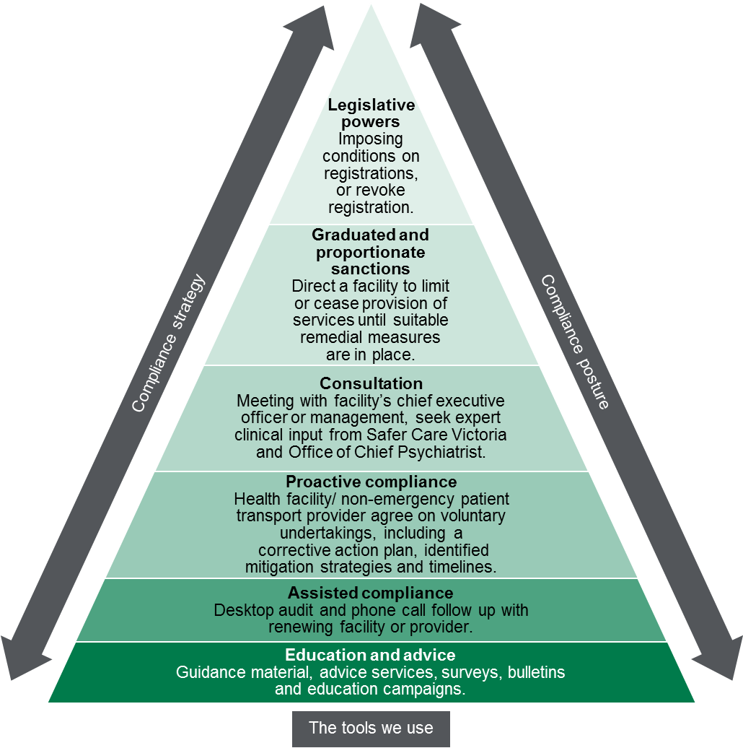

Contribution story
Patient safety can be compromised by a wide range of factors.
The unit is conscious of the critical nature of its’ regulatory role, working to implement the recommendations of ‘Targeting Zero’.

Measuring our impacts
The Private Hospitals Unit monitors how it contributes to protecting patient safety by reporting on a number of indicators.
These include:
- monitoring timeliness and the quality and effectiveness of the inspection process.
- a survey of site visits conducted to identify improvement opportunities.

Diagram text
Figure 1: Regulatory tools
This figure is an enforcement pyramid. The figure seeks to demonstrate that the unit will use the full range of tools available to it in line with the risks that they are seeking to manage. The enforcement pyramid illustrates a graduated and proportionate enforcement approach. The bottom of the pyramid outlines the lighter touch interventions such as education and advice to regulated parties, through to utilising legislative powers at the top of the pyramid, where regulated parties deliberately work against intended outcomes and intend to evade compliance obligations.

To receive this publication in an accessible format phone 03 9096 2164, using the National Relay Service 13 36 77 if required, or email Private Hospitals unit <privatehospitals@dhhs.vic.gov.au>
Authorised and published by the Victorian Government, 1 Treasury Place, Melbourne.
© State of Victoria, Department of Health and Human Services, March 2018.
ISBN 978-1-76069-343-5
Available at Regulatory practice framework <https://www.dhhs.vic.gov.au/better-regulatory-practice-framework>

