Private hospitals regulator plan
March 2018 – June 2019

To receive this publication in an accessible format phone 9096 2164, using the National Relay Service 13 36 77 if required, or email Private Hospitals Unit <privatehospitals@dhhs.vic.gov.au>
Authorised and published by the Victorian Government, 1 Treasury Place, Melbourne.
© State of Victoria, Department of Health and Human Services, March 2018.
ISBN 978-1-76069-342-8 (online)
Available at Regulatory practice framework <https://www.dhhs.vic.gov.au/better-regulatory-practice-framework>

Contents
Introduction 4
Purpose of document 4
Document content 4
Principles 5
Regulator’s context 6
Private hospitals and day procedure centre 6
Non-emergency patient transport 6
Regulatory framework 6
Groups we rely on to undertake our regulatory function 7
Regulatory activities 7
Complementary activities 7
Defining outcomes 8
Risk overview 8
Identified risks 8
Assessing and treating risks 8
Regulatory tools 9
Measuring performance 10
Our contribution story 10
Further evidence we plan to gather to strengthen our contribution story 10
Direct indicators 10
Other sources of evidence to indicate performance 11
Stakeholder engagement 13
Ongoing communications 13
Planned activities 13
Stakeholders 14

Introduction

Purpose of document
The Department of Health and Human Services (the department) administers numerous Acts and regulations aimed at promoting health and wellbeing, and protecting vulnerable clients. It has 11 internal business units and three statutory bodies that are recognised by the Department of Treasury and Finance as regulators of business and not for profit organisations.
An individual regulatory plan has been developed for each of the 11 internal business unit regulators. These documents are developed in line with the conceptual framework outlined in the department’s Better regulatory practice framework <https://www.dhhs.vic.gov.au/better-regulatory-practice-framework>.
In 2016 the Private Hospitals Unit, in consultation with the private hospital and day procedure centre sector developed a Risk Based Regulatory Framework: Private Hospitals 2017. The document was endorsed and published in May 2017 and is available at Risk based regulatory framework for private hospitals 2017 <https://www2.health.vic.gov.au/about/publications/policiesandguidelines/risk-based-regulatory-framework-private-hospitals-2017>. A draft Risk Based Regulatory Framework: Non-Emergency Patient Transport 2017 has being developed in consultation with the non-emergency patient transport sector and published in January 2018.
If you have any feedback on this document or the Risk Based Regulatory Framework: Private Hospitals 2017, please email Private Hospitals Unit <privatehospitals@dhhs.vic.gov.au>.
The regulatory plan provides a higher level combines and compliments the risk-based regulatory frameworks.
This plan is effective until 30 June 2019 and will then be updated:
- every two years – in line with the requirements for Ministers to develop and re-issue Ministerial Statements of Expectations every two years; or
- when key legislative changes are made that will affect regulatory functions and the currency of the regulator plans.

Document content
This regulator plan relates to the Private Hospitals Unit. The structure of the regulator plan document includes:
- outcomes
- risk assessment and risk management strategy
- demonstrating impacts
- stakeholder engagement
    - overview of approach
    - key stakeholders (co-regulators.)
    - key activities.

Principles
In order to achieve the department’s outcomes, the regulators undertake their regulatory roles as informed by better regulatory practice principles. Consistent with better regulatory practice approaches interstate and internationally, the Private Hospitals Unit seeks to apply the following principles:
Table 1: Regulatory practice principles
Principle | Commitment
Collaborative | Where the various departmental regulatory regimes, and those of other agencies, intersect, the regulators will work together to maximise effectiveness and minimise regulatory burden. Regulators will also cooperate and engage with internal and external stakeholders, including our interstate counterparts and those representing various client groups in the community.
Consistent | The regulators will work to provide a consistent experience for key stakeholders and the community. Regulatory responses will be predictable and where possible standardised, following clear processes and delivering consistent results. This will ensure that individuals/organisations are treated fairly, and that the regulators are objective in their decision-making.
Efficient | The regulators will allocate resources in a way that aims to most efficiently achieve outcomes, considering the direct and indirect effects across society. This includes minimising the administrative burden and any adverse impact of regulatory actions on businesses to a level that is justifiable to achieve the community’s outcomes.
Intelligence-led | The regulators will analyse incoming intelligence and data in order to allow them to be responsive and accurate when assessing risk and undertaking compliance activities.
Outcomes-focused | Processes and decision-making will be driven by outcomes, and the regulators will be effective in achieving their regulatory objectives. Progress against outcomes will be measured to ensure continuous improvement.
Proportionate | The work undertaken by regulators should be proportionate to the risk being addressed. The principle of proportionality should guide regulators decisions in relation to the level of resources assigned to manage a particular risk, the regulatory tools used and enforcement activities.
Risk-based | The regulators will be proactive and responsive in identifying, assessing and responding to risk, prioritising and targeting resources toward specific groups or behaviours that pose the greatest risk to the department’s outcomes.
Transparent | The regulators will be open in their decision-making and processes, recording decisions appropriately, including the justification for decisions. The regulators will aim to assist regulated parties understand the decision-making processes, areas of focus and performance. Regulators will follow standard reporting requirements, enabling the department to monitor and oversee the performance of its regulators.

Regulator’s context

Private hospitals and day procedure centre
Private hospitals and day procedure centres are registered to operate and are regulated by the Health Services Act 1988 (the Act), and the Health Services (Private Hospitals and Day Procedure Centres) Regulations 2013 (the Regulations).
The Act sets out the registration scheme and high level patient safety requirements, the Regulations prescribe the health services that can be registered and provide more detailed requirements, including requirements related to patient safety. In addition the National Safety and Quality Health Service Standards (which must be complied with as a condition of registration), set out detailed standards for patient safety and quality of care.

Non-emergency patient transport
Non-emergency patient transport (NEPT) providers are required to comply with the Non-Emergency Patient Transport Act 2003 (the NEPT Act) and the Non-Emergency Patient Transport Regulations 2016 (the NEPT Regulations).
Clinical governance and decision making is defined in the Clinical Practice Protocols 2016 (CPP). Compliance with the Clinical Practice Protocols is a condition on licence.
The main purposes of the Act are to set minimum requirements for NEPT licencing. The Regulations focus on patient rights and safety and prescribe requirements for the provision of NEPT services under the Act. Compliance with legislation is monitored by the department.

Regulatory framework
The overarching key regulatory purpose of the Private Hospitals Unit is to ensure that all patients in private hospitals, day procedure centres and those transported in NEPT receive safe care.

Private hospitals and day procedure centres
Individual private hospital providers vary in size, company structure, ownership structure, geographic location and the type and mix of clinical services they provide. There are 87 private hospitals registered with the Unit in Victoria, with approximately 80% of registered private hospitals located in metropolitan Melbourne and the remaining 20% in rural and regional Victoria.
Day procedure centres also vary in size, ownership structure, geographic location, and the type and mix of clinical services they provide. Day procedure centres are registered according to the number of beds within a facility, ranging from small facilities with three beds, to large facilities with between 20 and 30 beds. There are 88 registered day procedure centres in Victoria.

Non-emergency patient transport
There are 19 registered NEPT providers providing patient transport and/or stand-by services in Victoria. Most NEPT transfers occur between hospitals, or between home and hospital or day procedure centre. Some aged care patients may also be transported to and from specialist health appointments and rehabilitation. The majority of non-emergency patient transports are provided by road, with a small number undertaken by air services.
NEPT is for patients who require clinical monitoring or supervision during transport, but do not require a time critical ambulance response.

Groups we rely on to undertake our regulatory function
The department works with a number of stakeholders to undertake our regulatory role and functions.
The Unit relies on other departmental co-regulators such as Drugs and Poisons Regulation, Radiation Safety and Health Protection, as well as other peak bodies including Safer Care Victoria, the Victorian Agency on Health Information, the Health Complaints Commissioner and the Australian Health Practitioners Regulation Agency, to undertake our regulatory function.
For the private hospital and day procedure centre sector, stakeholders include the registered facilities, peak bodies, and the Australian Health Practitioner Regulation Agency. A full list of stakeholders can be found in the Private Hospitals Stakeholder Engagement Plan.
For the NEPT sector, stakeholders include the licensed providers, peak bodies, Ambulance Victoria and Safer Care Victoria. A full list of stakeholders can be found in the NEPT Stakeholder Engagement Plan.

Regulatory activities
The Unit undertakes the following key regulatory activities:
- Supporting compliance: Available to conduct forums and site inspections, as well as telephone calls and emails as a means to provide information and guidance.
- Monitoring compliance: This includes activities such as monitoring risk indicators and data provided by private hospitals and day procedure centres to screen for potential risks to patient safety and escalating regulatory oversight and activity as required.
  - Responsive intervention and enforcement: The Unit works with private providers to address and resolve issues and may require the providers to submit a corrective action plan to address identified service issues such as drivers of poor performance, identified mitigation strategies, unmet accreditation outcomes, risk assessments, options and timelines for implementation.
Where escalation in regulatory response is required, this will include consultation and potential on site visits with clinical experts through Safer Care Victoria and/or the Office of the Chief Psychiatrist. In addition legislative intervention could be considered.

Complementary activities
Complementary activities include communication with sectors regarding information and activities that may support their work. This would include dissemination of fact sheets, new legislation that may apply to the sectors, educational forums, surveys, and safety and quality issues.

Defining outcomes
This section includes a summary of the outcomes to which the team contributes.
Table 2: Defining outcomes
Regulatory scheme | Outcomes
Regulation of private hospitals and NEPT | That private hospitals, day procedure centres and NEPT providers achieve safe patient care for all patients, through:  - the department’s use of a risk-based regulatory framework to identify, analyse and prioritise risks before selecting appropriate regulatory tools and activities  - escalation of regulatory oversight and activity as required.
Regulation of private hospitals and NEPT | To promote quality improvement for private hospital, day procedure centre and NEPT patients, through:  - improved data oversight and analysis within the risk-based regulatory framework  - work with Safer Care Victoria on patient safety issues.

Risk overview
This section includes a risk assessment and risk management strategy which identifies and prioritises a small number of key risks to the regulators outcomes.
In addition, Appendix 2 of the Risk Based Regulatory Framework: Private Hospitals 2017 <https://www2.health.vic.gov.au/about/publications/policiesandguidelines/risk-based-regulatory-framework-private-hospitals-2017> identifies risk indicators the Private Hospital’s Unit has identified as key operational risks. This list of risk indicators and descriptors is based on the common risk based assessment matrix developed by the national Working Group on Standardising Safety and Quality in Compliance in Private Health facilities.

Identified risks
The key risks that we have identified are:
- A lack of understanding of legislative requirements (cause), resulting in non-compliant systems and processes (event) leading to the increased likelihood of unsafe patient care (harm).
- Poor organisational leadership, governance and/or culture, leading to inadequate clinical governance and oversight, resulting in poor outcomes for patients.
- Inadequate management of environmental issues, leading to a hazardous event, resulting in increased risk of injury or harm to patients.
- Lack of learnings from previous adverse outcomes (cause), resulting in poor systems and quality improvement initiatives (event), resulting in further adverse outcomes for patients (harm).

Assessing and treating risks
The Private Hospitals Unit assesses and responds to risks to patient safety by using the Risk Assessment Tool in Attachment 1: Risk Assessment Tool of the Risk Based Regulatory Framework: Private Hospitals 2017 <https://www2.health.vic.gov.au/about/publications/policiesandguidelines/risk-based-regulatory-framework-private-hospitals-2017>.

Regulatory tools
This section includes an overview of departmental regulation, illustrating tools available to the Private Hospitals Unit when regulating private hospitals, day procedure centres and non-emergency patient transport.
This diagram shows the various compliance tools that are used in regulating private hospitals, day procedure centres and NEPT providers and the power through which to use them under their respective legislation. The Private Hospitals Unit will use the tools available to them to achieve regulatory outcomes; and where they do not have direct access to the most appropriate tool, they will collaborate.
Figure 1: Regulatory tools

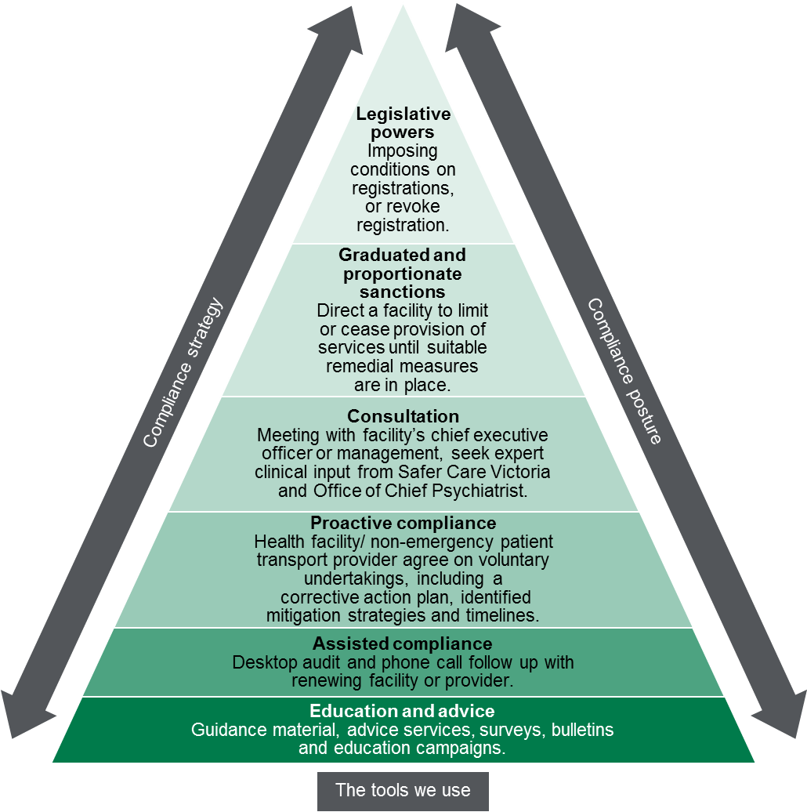

Measuring performance
This section sets out our understanding of how the activities that we undertake, as targeted by the identification and assessment of risk, contribute to our outcomes.

Our contribution story
This section sets out the long-term outcome indicators that we contribute to as part of broader system of influencers. We recognise that we contribute to these outcomes, as part of a system of influences both within DHHS and external to DHHS.

Further evidence we plan to gather to strengthen our contribution story
The Private Hospitals Unit contributes to and influences regulatory outcomes through a combination of consultation with the sector, education and enforcement. We recognise however that other factors also influence regulatory outcomes.
As work with Safer Care Victoria and the Victorian Agency on Health Information progresses, and further work to implement the recommendations of Targeting Zero continues (including the introduction of a new Quality and Safety Bill into Parliament to address a number of the review’s recommendations), the risk indicators and descriptors used in the risk based regulatory frameworks will be reviewed. The addition of new measures and changes in the way current information is analysed, combined with stakeholder consultation, will assist in providing evidence to suggest that our activities are contributing towards identified outcomes.

Direct indicators
In this section, we have outlined a small number of indicators that can be used to guide our activity and evaluate our effectiveness as presented in Table 3 on the following page. To the extent possible, our indicators demonstrate our contributions to the outcomes that we are trying to achieve, rather than simply the activities that we are undertaking.
This section sets out the measures that we will use to indicate success against our outcomes. It is intended that data will be collected to enable these measures to be reported in 2018 -19 and this will inform subsequent targets.

Table 3: Measures used to indicate success against outcomes
Indicator | Target | 2017–18  actual | 2018-19
Quality of inspection process – 80% of survey respondents report that the visit/information/tools were useful to improving the safety and quality of patient care. | N/A | N/A | N/A
Site visit rectification letters are provided to the facility or NEPT provider within ten working days of the inspection. | N/A | N/A | N/A
All rectification activities completed by the facility or provider are in accordance with the nominated timeframe. | N/A | N/A | N/A
At the next scheduled inspection, 100% of facilities could demonstrate implementation of processes/rectification activity highlighted from previous inspection. | N/A | N/A | N/A
All complaints received reviewed and responded to within an appropriate time frame. | N/A | N/A | N/A
80% of providers could demonstrate knowledge of key communications sent by the Private Hospitals Unit in the previous 12 months. | N/A | N/A | N/A

Other sources of evidence to indicate performance
The number of issues identified at regulatory site inspections reduces over time at each registered facility or non-emergency patient transport provider showing improved regulatory compliance.
Trend issues reduce (improve) over time across all inspections e.g. Key elements of poor governance are shown to be less frequent on repeated inspections.

Stakeholder engagement

Ongoing communications
The objectives of Departmental communication varies but in the past has been primarily for regulatory purposes. The Private Hospitals Unit has, over the past two years, gradually increased engagement with both private providers as well as internally within the department.
Objectives for communication with private providers includes, for example, following up on issues of quality, safety and legislative compliance, following up on complaints made to the department about private health services, highlighting emerging issues and risks, and reminding stakeholders about registration renewal obligations (required every two years). The Unit aims, in particular to ensure regulatory compliance is promoted and achieved, while maintaining and nurturing ongoing positive relationships with stakeholders.
Our team undertakes day-to-day operational communication regarding regulatory activities. This includes:
- Monitoring patient safety: On site consultations and site visits with clinical experts from Safer Care Victoria and/or the Office of the Chief Psychiatrist (where required) and responding to and investigating complaints about registered facilities and licensed providers.
- NEPT licensed: Carry out legislative requirements in relation to applications for a licence, licence renewal and licence variation of NEPT providers.
- Private hospital and day procedure centre registration: Carry out legislative requirements in relation to applications for approval in principle, registration, renewal of registration and variation of registration of private hospitals and day procedure centres.

Planned activities
Objectives for communication with private providers includes, for example, following up on issues of quality, safety and legislative compliance, following up on complaints made to the department about private health services, highlighting emerging issues and risks, and reminding stakeholders about registration renewal obligations (required every two years). The Unit aims, in particular to ensure regulatory compliance is promoted and achieved, while maintaining and nurturing ongoing positive relationships with stakeholders.
The Targeting Zero recommendations will require considered and targeted communication and engagement with stakeholders in 2017/18.
In 2017-18, the Unit will also seek stakeholder views on the Unit’s site inspections conducted. This will be completed via a survey and will seek to understand providers feedback on-site inspections and engagement with the department, including additional engagement opportunities.
In April 2016 new NEPT Regulations were made. The Unit will continue communicating with stakeholders to ensure compliance with the new Regulations.

Stakeholders
Table 4: List of key stakeholders – private hospitals
Key stakeholders | Type
Private hospitals | Regulated entities
Day procedure centres | Regulated entities
Australian Health Practitioner Regulation Agency | Co-regulator / education
The Department of Health and Human Services: Drugs and Poisons; Health Protection; Mental Health; Environmental Health Regulation and Compliance | Co-regulators
Safer Care Victoria | Regulatory support
Victorian Agency for Health Information | Regulatory support
Australian Commission on Quality and Safety in Healthcare | Co regulator
Day Hospitals Australia | Peak body
Australian Private Hospitals Association | Peak body
Table 5: List of key stakeholders – non-emergency patient transport
Key stakeholders | Type
Non-emergency patient transport providers | Regulated entities
Ambulance Victoria | Peak body
Hospitals and health service providers | Health services
Universities and colleges | Educational institutions
Ambulance Employees Australia Vic/United voice | Union body

Diagram text
Figure 1: Regulatory tools
This figure is an enforcement pyramid. The figure seeks to demonstrate that the unit will use the full range of tools available to it in line with the risks that they are seeking to manage. The enforcement pyramid illustrates a graduated and proportionate enforcement approach. The bottom of the pyramid outlines the lighter touch interventions such as education and advice to regulated parties, through to imposing conditions on registration, or revoking a registration at the top of the pyramid, where regulated parties deliberately work against intended outcomes and intend to evade compliance obligations.

