Pest control regulator plan on a page
Pest control regulator plan March 2018 – June 2019

This document summarises the key elements of the Pest control regulator plan. The plan provides the context the regulator works within and an overview of its regulatory framework and activities. This is supported by the Better regulatory practice framework: January 2018–June 2019, which provides a process for risk-based and accountable regulatory practice, and improved regulatory performance in the health and human services sector. The regulator plan and framework are available on Regulatory practice framework <https://www.dhhs.vic.gov.au/better-regulatory-practice-framework>.

Outcomes
The Pest Control Team aims to minimise the adverse health impacts associated with the use of pesticides on the Victorian community, pest control operators and the environment by:
- educating pest control operators and the public of the health risks and legislative requirements regarding the use of pesticides
- monitoring compliance of licensed pest control operators with legislative requirements by undertaking routine and targeted inspections
- addressing non-compliance through graduated and proportionate enforcement measures (such as fines).

Who we regulate
The Pest Control Team is responsible for regulating Pest Control Operators. There are approximately 1334 pest control operators currently holding a valid licence to use pesticides in Victoria.

Who we work with
The Pest Control Team interacts with a broad range of stakeholders to help deliver outcomes, share intelligence, and to identify and act on non-compliance. The groups we work with include pest control operators, Environmental Protection Authority, Department of Economic Development Jobs Transport and Resources and the Department of Land, Water and Planning.
Part 7, Division 2 of the Public Health and Wellbeing Act 2008 and Part 8 of the Public Health and Wellbeing Regulations 2009.
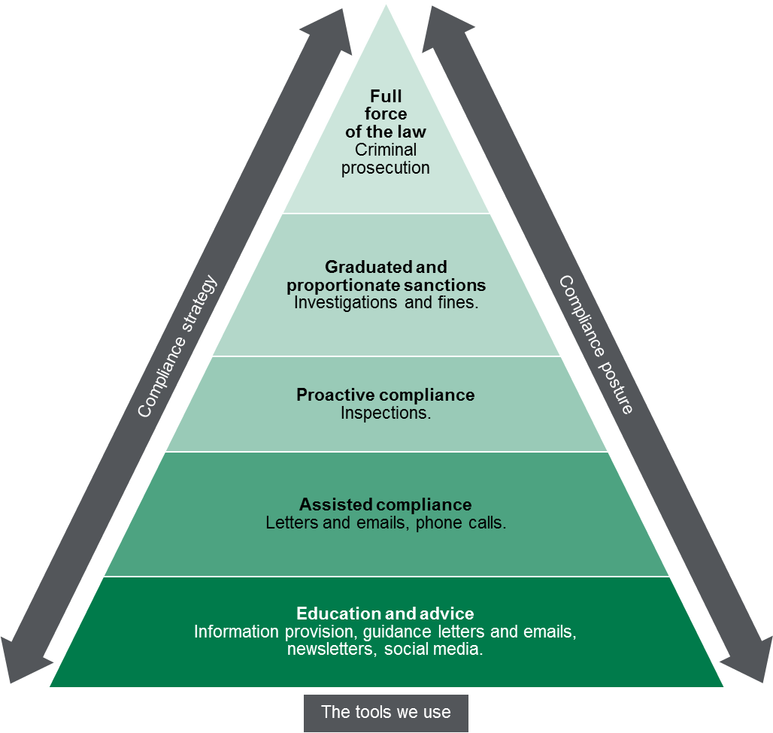

Contribution story
The Pest Control Team administers legislation with the objective of protecting the Victorian community from potential health risks associated with the use of pesticides in commercial and residential situations. It does this through a combination of licensing, by ensuring training in the safe handling and application of pesticides, supporting regulated entities to comply with minimum standards, monitoring compliance, educating the public and investigating legislative breaches. The outcome is increased awareness of the risks associated with the use of pesticides, understanding the purpose of pest control licensing and the steps that people can take to protect their health when using pesticides.
The Pest Control Team recognise that while it influences its regulatory outcomes and objectives, there are other external factors that also contribute to its regulatory outcomes.

Measuring our impacts
The Pest Control Team monitors how it contributes to reducing harm from pesticides by monitoring and reporting on a range of indicators including:
- percentage of license holders that report understanding problems identified during inspection and the actions required to address them
- percentage of attendees at training courses and callers to the 1300 767 469 number, who respond that the information provided was ‘extremely useful’ or ‘very useful’.

Diagram text
This figure is an enforcement pyramid. The figure seeks to demonstrate that the unit will use the full range of tools available to it in line with the risks that they are seeking to manage. The enforcement pyramid illustrates a graduated and proportionate enforcement approach. The bottom of the pyramid outlines the lighter touch interventions such as education and advice to regulated parties, through to criminal prosecution at the top of the pyramid, where regulated parties deliberately work against intended outcomes and intend to evade compliance obligations.

To receive this publication in an accessible format phone 1300 767 469, using the National Relay Service 13 36 77 if required, or email the Pest Control team <pestcontrol@dhhs.vic.gov.au>
Authorised and published by the Victorian Government, 1 Treasury Place, Melbourne.
© State of Victoria, Department of Health and Human Services, March 2018.
ISBN 978-1-76069-333-6 (online)
Available at Regulatory practice framework <https://www.dhhs.vic.gov.au/better-regulatory-practice-framework>

