
Victoria’s Digital Health Maturity Model
OFFICIAL
Contents
The Problem 1
Our approach to assessing digital health maturity 1
The journey and approach to assessment 2
Measuring digital health maturity 4
Independent evaluation of the model 4
Victoria’s digital health roadmap 5

The Problem
In May 2017 the Victorian Auditor-General report, ICT Strategic Planning in the Health Sector, recommended that the department required comprehensive assessment of clinical ICT maturity. This is to ensure investment decisions are directed to addressing the most critical health ICT needs.
“The department’s (digital health) investment decisions have not been informed by a comprehensive understanding of clinical ICT maturity or an inventory of key ICT assets in the sector. As a result, there is limited assurance that scarce government funding has been directed to address the most critical health ICT needs or has been appropriately distributed.”
The department accepted this recommendation and in response, has developed Victoria’s Digital Health Maturity Model (‘the Model’). The Model is tailored to the needs of the Victoria’s public health service providers and aligned to Victoria’s and Australia’s public health care system.

Our approach to assessing digital health maturity
Prior to the Model, Victorian health services used internationally available assessments focussed on hospitals and international context. These models did not provide a comprehensive picture of the components of health service digital maturity. They were not suited to our health services, nor to community health and aged care.
In the absence of an ‘off-the-shelf’ digital maturity model, the department set about defining a model and self-assessment tool. It needed to be practical, and applicable to a range of health care settings.
Following extensive consultation and research, Victoria’s digital health maturity model was documented, comprising nine pillars. This model was piloted in 76 health services. That experience produced a comprehensive maturity model that:
- meets the needs of Victoria’s health service Boards and executives
- considers a validated suite of eHealth enablers
- enables the department to assess ICT capability and clinical ICT maturity

The journey and approach to assessment
In 2018, the department engaged Ernst and Young to co-design a digital health maturity model and assessment tool. The tool was designed to assess Victorian public health services and align with the Australian healthcare system.
The model is built around nine pillars. ‘Governance and stewardship’ sits across the nine pillars.
Figure 1: Overview of the Victoria’s Digital Health Maturity Model
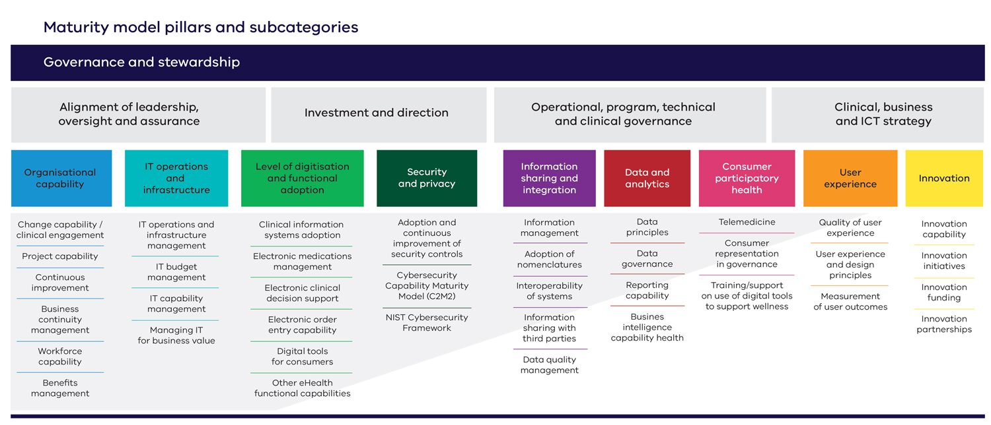
The assessment consists of 40 targeted questions. Approximately 730 data points are collated across the pillars of the model measuring a comprehensive suite of eHealth enablers. Four domains underpin Governance and Stewardship in the model:
Alignment of leadership, oversight and assurance
- Details of the leadership function and integration of digital health within the structure as well as evaluation of the digital health related roles within the organisation.
Investment and direction
- Definition of funding pathways and establishment of alignment between funding decisions and organisational strategy and decision making.
Operational, program, technical and clinical governance
- The governance frameworks are in place. Processes / policies ensuring adequate representation from a range of professions within the organisation.

Clinical, business and ICT strategy
- This section assesses strategic goals across business and clinical outcomes as well as IT and digital health strategy. Adoption of the strategies within the organisation is assessed.

The nine pillars of digital health maturity present:
Organisational capability
- organisation wide capabilities such as project management, workforce enablement, business continuity and change management procedures.
- ongoing business function through continuous improvement cycles and benefits realisation.
IT operations and infrastructure
- the technology in place to support business functions as well as support structures to ensure efficient ongoing operations of the technology in place.
- this includes budget management, IT capability and managing IT for business value.
Level of digitisation and functional adoption
- technology and functionality available, and its level of adoption.
- the range of digital health technologies including electronic health records, departmental systems and administrative systems.
Security and privacy
- cyber security framework and maturity, as well as adoption and continuous improvement of security controls.
Information sharing and integration
- what data is integrated or shared with internal and external applications, including information management and data quality related aspects of the organisation.
- this pillar defines nomenclatures adopted to support interoperability.
Data and analytics
- data principles and associated governance arrangements, reporting and business intelligence capabilities.
Consumer participatory health
- the level of consumer interaction with their data and the organisation, ranging from availability of telehealth through to use of patient portals and access to health information to support wellness.
- consumer representation within appropriate governance.
User experience
- satisfaction of system users within the organisation regarding design, adoption, availability and outcomes of digital health technologies.
Innovation
- mechanisms for innovation within the organisation towards improvement of digital health initiatives. It captures research and funding partnerships.

Measuring digital health maturity
Figure 2: Levels of digital health maturity

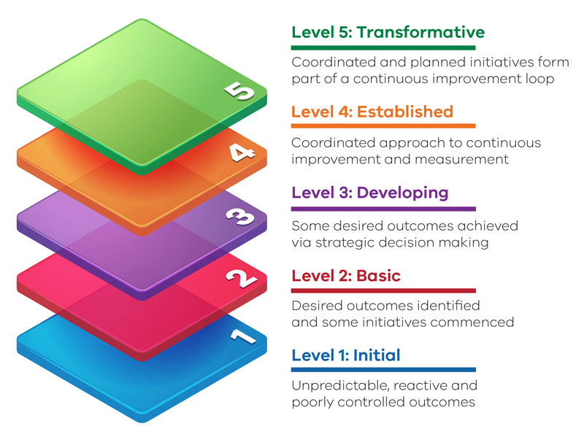

Victorian public health services undertook their first assessment in 2019. 76 health services conducted assessments. The overall level for Victoria's public health system in 2019 was Basic, however a number of health services were trending towards Developing.

Overall scores and those for each pillar were reviewed. For each health service, a maturity objective was identified for each pillar. These objectives varied by peer grouping of health service (large metro, large regional, medium metro/regional, small services). These objectives are intended to be met within five years, by 2024. They represent ambitious but achievable goals, based on the current maturity of health services.

Assessments are now undertaken every second year. The results inform digital health investment planning at both health service and state levels.

Independent evaluation of the model
In 2020, Deakin University was appointed to conduct an independent evaluation of the model. The Deakin team concluded that the model:
- Was the most comprehensive maturity model reviewed
- Is appropriate for Victoria’s health services
- Allows structured and consistent measurement which is valuable to health services to plan for and improve digital maturity, as part of their strategic planning processes

Victoria’s model is a comprehensive digital health maturity model. Health services can complete the assessment independently and they find the assessment report easy to understand. The model is applicable beyond Victoria, and other Australian jurisdictions are considering it closely.

Victoria’s digital health roadmap
Victoria’s digital health roadmap (the Roadmap) is the Victorian Government’s plan for digital health technology over the next five years. It aims to further improve the safety and efficiency of Victoria’s healthcare system, and to keep patients at the centre of care. The Roadmap describes five programs of work to realise this objective:
- Reliable and resilient systems
- Efficient, secure, paper-light health care
- Continuity of care
- Enabling virtual care and care closer to home
- Consumer access and engagement.

The model underpins the Roadmap. Assessments conducted using the model, with reference to the five programs of work, provide the Victorian public health sector with an objective basis for digital health investment planning.
More information about the model can be obtained by contacting VDHMM@health.vic.gov.au

Victorian Auditor-General Report, ICT Strategic Planning in the Health Sector, 2017
VDHMM Fact Sheet, Victorian Department of Health
EY, Victoria’s Digital Health Maturity Model: a progressive framework of digital health technology adoption, August 2021 https://ey.com/en_au/health/growth-in-digital-health-care.html

