
Victorian cancer plan monitoring and evaluation framework: baseline report
The first baseline report against selected measures in the Victorian cancer plan monitoring and evaluation framework

Disclaimer
The information contained in this report has been provided in good faith and reasonable steps have been taken to ensure it is reliable and accurate at the time of publication. However, the Department of Health and Human Services has obtained the data from various data custodians and does not represent or warrant that the content of this report is accurate, authentic or complete or that the information contained in this report is suitable for your needs. The information is provided on the basis that the reader will be solely responsible for assessing the information and its veracity and usefulness. To the extent permitted by law, the State of Victoria excludes liability for any loss caused by use or reliance on this report, even if such information is wrong, incomplete, out of date or misleading.
To receive this publication in an accessible format phone 1300 650 172 using the National Relay Service 13 36 77 if required, or email Cancer Planning <cancerplanning@dhhs.vic.gov.au>.
Authorised and published by the Victorian Government, 1 Treasury Place, Melbourne.
© State of Victoria, Department of Health and Human Services, February 2020
Where the term ‘Aboriginal’ is used it refers to both Aboriginal and Torres Strait Islander people. Indigenous is retained when it is part of the title of a report, program or quotation.
 North symbol from clipart library <http://clipart-library.com/north.html>.

ISBN 978-1-76069-032-8 (pdf/online/MS word)
Available online from Cancer care <https://www2.health.vic.gov.au/about/health-strategies/cancer-care>
(1904241 figures)
Contents
Executive summary 4
Introduction 5
The Victorian monitoring and evaluation framework: measuring our success 5
Purpose of the baseline report 6
How to read this report 7
Structure of the report 7
About the measures 8
Dashboard 10
Baseline report: summary of results 11
Victorian cancer plan monitoring and evaluation framework: measures 12
More about the results of the measures 26
Understanding the data 26
Outcome: Improve cancer outcomes 28
Key result: Decrease incidence of preventable cancers 28
Outcome: Equitable outcomes for all Victorians 69
Key result: Equitably reduce cancer incidence 69
Key result: Equitably reduce cancer deaths 75
Key result: Decrease smoking and harmful alcohol consumption 82
Key result: Fruit and vegetable consumption of adults, adolescents and children 89
Key result: Decrease HPV and viral hepatitis impact 116
Outcome: Detect cancers early 126
Key result: Increase early-stage diagnosis 126
Outcome: Optimal diagnostics and treatment 137
Key result: Increase adherence to Optimal Care Pathways 137
Key result: Increase one- and five-year survival 173
Key result: Improving quality of life 209
Outcome: Best possible experience of care systems 210
Key result: Improve patient experience of health care 210
Key result: Improve patient experience of screening 212
Outcome: Integrated research systems 218
Key result: Innovations and improved evidence of best practice 218
Appendix 1: Measures identified for future reporting 226
Abbreviations 230

Executive summary
A baseline report has been prepared using a set of measures articulated in the Victorian cancer plan monitoring and evaluation framework (2018). This baseline report synthesises key findings to inform development of the 2020–2024 cancer plan and successive plans, to improve cancer outcomes. The report has also assessed specific outcomes of the framework across a cancer continuum of prevention, early detection, treatment, wellbeing and support for people affected by cancer, and research.
The department acknowledges the assistance of data custodians who were approached for their data to be included in this baseline report.

Introduction
Cancer imposes a considerable burden on the Victorian community. In 2017, another 34,557 Victorians were diagnosed with cancer, and 10,955 died from the disease. While significant progress has been made, the number of people being diagnosed continues to increase, with yearly diagnoses expected to reach more than 45,000 by 2028–2032. As the Victorian population ages the incidence of cancer will continue to grow – in fact, one in three men and one in four women will have been diagnosed with cancer by the age of 75.
Victoria’s cancer survival rates have been described as among the best in the world, and more people than ever are now living with or beyond cancer. However, these outcomes are not the same for all. Poorer outcomes have persisted for some cancer types and for people living in some regional areas. Aboriginal Victorians have significantly higher cancer mortality rates than non-Aboriginal Victorians. Reducing the burden of cancer requires a comprehensive approach with a focus on reducing these disparities.
Through the Improving Cancer Outcomes Act 2014, the Victorian Government is committed to preparing a cancer plan for Victoria every four years that outlines the status and burden of cancer in Victoria. The Victorian cancer plan 2016–2020, released in July 2016, is the first cancer plan developed under the Act. To support implementation and monitoring, the plan commits to establishing outcome measures that identify short-, medium- and long-term targets (goals) and to monitor the impacts of efforts to improve cancer outcomes. This outcomes focus is consistent with the approach being promoted across the Victorian Government and aligns with the Department of Health and Human Services’ (the department) outcomes framework architecture.

The Victorian monitoring and evaluation framework: measuring our success
The department aspires to improve cancer outcomes for all and support all Victorians affected by this illness. To help deliver this vision, the department consulted internally and externally with individuals and organisations across the Victorian cancer sector to develop an outcomes framework. This framework, known as the Victorian cancer plan monitoring and evaluation framework, was published in June 2018 and contains 97 measures. The framework is supported by a data dictionary. It is population-outcomes based and provides a transparent and objective approach to monitoring and reporting on the collective impact of the sector to improve cancer outcomes. Reporting will include changes over time and will help identify investment and implementation priorities.
Figure 1 shows the outcomes framework cascading upwards from outcome measures, indicators and key results, which link logistically through to each priority set out in the Victorian cancer plan 2016–2020. Each of the cancer plan priority areas describe the components critical to the success of the goals that have been set to 2040.
The framework enables the department to:
- articulate cancer plan priorities
- focus actions and activities on areas where enduring change is needed most
- assess the impact of cancer services on the lives of Victorians
  - drive future monitoring and reporting.

Purpose of the baseline report
This baseline report is the first report that synthesises the current status of outcome measures from various Victorian data sources, against the department’s outcomes framework (Figure 1). Its purpose is to inform the development of the 2020–2024 cancer plan. As this is the first report, results are not yet available for every measure. Results will be reported in the future as data becomes available.
The baseline report does not provide a review of measure selection and methodology, or improvement of technical documentation of measures. Data presented in this report reflects observations at set points in time. More comprehensive datasets are available for viewing at the referenced data sources.
Figure 1: Outcomes framework logic model
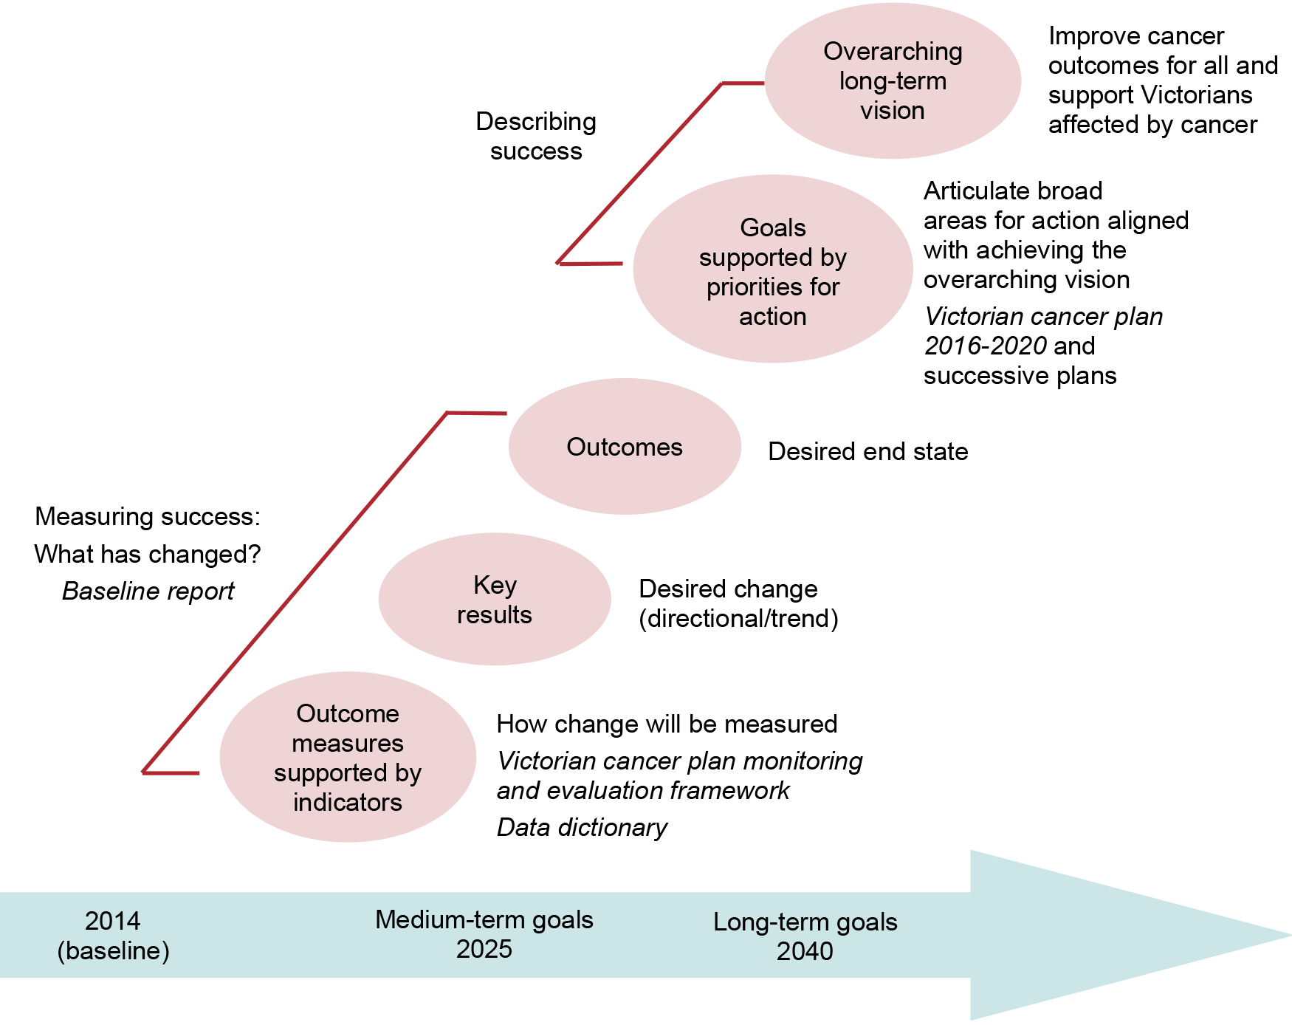

How to read this report

Structure of the report
This baseline report provides information at three different levels of detail.
- The dashboard provides a ‘snapshot’ of how each key result area is tracking.
- The summary report sets out how Victoria is progressing on each measure. This includes a:
    - target – where we want to be (from the baseline year, where appropriate)
    - baseline – where we started from (benchmark)
    - trend (if known).
- More about the results of measures includes more detailed information about each measure, including, where appropriate:
    - a graph or plot showing up to eight years of data (from the baseline year, if available)
    - information about the trend
    - commentary on the result and what may be affecting it.
The Victorian cancer plan monitoring and evaluation framework – data dictionary provides more information on each measure including detailed technical specifications. These include:
- the rationale for inclusion
- definition of the measure (including numerator, denominator and mode of reporting)
- data source(s) and availability (including the baseline year)
- what data breakdowns are available from each data source
  - further information (including planned changes in guidelines, programs and reporting; comparability with other state, national or international data; and links with measures in the Victorian public health and wellbeing outcomes framework outcomes framework).
This baseline report covers the 78 (out of 97) measures articulated in the department’s Victorian cancer plan monitoring and evaluation framework that are currently reportable. Where appropriate, the breakdown for reporting has been age, sex, Aboriginal Victorians, cultural diversity, socioeconomic status (SES), Integrated Cancer Service (ICS) and local government areas (LGAs).
Appendix 1 provides an indicative workplan for the remaining 19 measures that require further work to develop and report. Please note that in preparing this baseline report, the Victorian cancer plan monitoring and evaluation framework – data dictionary (2018) was revised to address minor typographical errors and some emerging inconsistencies between some of the measures themselves and the definition of the measure. Where appropriate, the latter was undertaken in consultation with relevant stakeholders. Go online to access the revised data dictionary (2019) <https://www2.health.vic.gov.au/about/health-strategies/cancer-care>.
In circumstances where the dataset specific to a measure was too large, it was moved to Appendix 2 to assist with readability. Appendix 2 is presented as a separate volume and is available via the link <https://www2.health.vic.gov.au/about/health-strategies/cancer-care>.

About the measures
The 97 measures included in the population-outcomes based Victorian cancer plan monitoring and evaluation framework cover a wide range of the cancer continuum of prevention, early detection, treatment, wellbeing and support for people affected by cancer, and research. They range from population-level measures that have many determinants to system-level measures that reflect the delivery of cancer care and self-reported patient experience of Victoria’s cancer-specific services. Some of the measures are also reported elsewhere, for example in the Victorian public health and wellbeing outcomes framework (2016), and some are currently undergoing development. This means that some of the measures reported for other purposes may have slightly different targets associated with them. In consultation with a wide range of individuals and organisations across the Victorian cancer sector, other measures have been newly developed for reporting against, and the data is examined here for the first time. These differences mean that measuring progress is not straightforward. In addition, the short reporting period and, in some circumstances, changes in survey methodologies means there are limitations with trend analysis. The following provides a guide as to how the assessments set out in this report have been made.

Overall trend
Wherever possible, four years of data are provided. This has been assessed to determine whether the data showed:
- an improving trend (moving in the right direction)
- a deteriorating trend (moving in the wrong direction)
  - a static or unchanging trend.

Traffic light rating
Each measure has been allocated a traffic light rating (red, amber or green). These provide a snapshot of the key message about progress on each measure. The ratings consider:
- the views and expertise of subject matter experts
- how the most recent result compares with targets or with performance in other jurisdictions if comparable with other states is outlined in the data dictionary
- whether the result is improving over time and if so, how quickly
- any other relevant contextual information (for example, departmental policies) in place.

Highlight or commentary
More detailed commentary is provided in ‘More about the results of the measures’, which gives key information to support the intent behind the traffic light rating.

About the traffic light ratings
Green (key message: satisfactory result)
A green rating generally describes situations where the result:
- is at or above a target, and either stable or improving over time
- is not quite at target level but is heading to achieve it soon and actions are in place to support this
- represents a good outcome for all Victorians, or the cancer service system, and appears to be either stable or improving over time.
Amber (key message: desired result not yet evident)
An amber rating generally describes situations where a result has both positive and negative elements,
for example:
- the result is improving over time but is still some way from target
- the result compares well with other jurisdictions but is still not at the desired level
- the result has generally been improving over time, but a recent deterioration needs to be monitored
- the result has deteriorated but for a known reason that is being addressed
- there is little data available to assess progress, but what there is appears reasonably positive
- it is difficult to interpret whether the trend over time represents improved reporting or improved outcomes.
Red (key message: result is of concern)
A red rating generally describes situations where the result may:
- represent a poor outcome or a high level of risk for an undesirably high proportion of the people it relates to
- be consistently deteriorating over time
- be well off target and stable or somewhat deteriorating over time.

Dashboard
This dashboard shows the number of measures in each key result by traffic light rating. Please note that key results where no measures are currently reported are not shown in the dashboard – for example, numbers 3 and 14. ‘Not applicable’ (N/A) is used in circumstances where no data has been identified for specific measures. Some cells have been left intentionally blank.
Key results | Red | Amber | Green | N/A
- Decrease incidence of preventable cancers | 4 | 3 | 1
- Decrease deaths due to cancer |  |  | 3
- Equitably reduce cancer incidence | 1 | 2
- Equitably reduce cancer deaths | 2 | 1
- Decrease smoking and harmful alcohol consumption | 1 | 2 | 1
- Increase healthier eating and active living | 3 | 4 | 2 | 2
- Decrease obesity | 2 | 1
- Decrease ultraviolet (UV) exposure | 1 |  | 1
- Decrease human papillomavirus (HPV) and viral hepatitis | 2 | 3
- Increase early-stage diagnosis |  | 3 |  | 3
- Increase adherence to optimal care pathways | 1 | 8 | 1 | 4
- Increase one- and five-year survival | 1 | 13 | 2 | 2
- Improve patient experience of health care |  |  | 1 | 5
- Improve patient experience of screening |  | 3 | 1
- Innovations and improved evidence of best practice |  | 2 | 1 | 1

Baseline report: summary of results
This section provides a summary result on each measure from the Victorian cancer plan monitoring and evaluation outcomes framework. The table below presents results for the baseline and most recent years and an assessment of the trend for each measure. Note that the seven outcomes broadly align with the five Victorian cancer plan 2016–2020 action areas (page 8 of Victorian cancer plan monitoring and evaluation framework: report – 2018).
Key: Where results are unavailable, the measure has been categorised to indicate the scope of work required to produce a result for the next report. More information is set out in Appendix 1.
Key | Description
Measure not defined | These measures are currently under development, with final development and sign-off unlikely at the time of publication.
No data available | No data was available to report against at the time of publication.
Status to be determined | Work is underway to engage the relevant experts to determine how much work is required.
Trend | Description
▲ | Upward trend – there has been an increase in the value of the measure by more than three per cent between the baseline year and the most recent available data points
▼ | Downward trend – there has been a decline in the value of the measure by more than three per cent between the baseline year and the most recent available data points
■ | The value of the measure has not changed, or changed less than three per cent, between the baseline year and the most recent available data points
 | There is a large difference in the value but statistically there is no difference
N/A | There is not enough information (or in some circumstances there is no data) available to assess the trend over time
Target | From the baseline year
N/S | No set target for this measure

Victorian cancer plan monitoring and evaluation framework: measures

Action: Victorians are supported to reduce risks of cancer

Outcome: Improve cancer outcomes

Key result: Decrease incidence of preventable cancers
Measure # | Description | Unit of measure | Baseline  (year) | Most recent  (year) | Target | Trend
1.1 | Incidence of preventable cancers | Rate (age-adjusted) (per 100,000) | 340  (2014) | 339  (2017) | 50 per cent decrease from baseline to 2040 | ■  No change
1.2 | Lifetime risk of cancer before the age of 85 years | Cumulative risk | 1/2.2  (2014) | 1/2.2  (2017) | N/S | ■  No change
1.3 | Incidence of lung cancer | Rate (age-adjusted, per 100,000) | 42  (2014) | 41  (2017) | N/S | ■  No change
1.4 | Incidence of colorectal cancer | Rate (age-adjusted, per 100,000) | 56  (2014) | 54  (2017) | N/S | ▼  Downward
1.5 | Incidence of melanoma | Rate (age-adjusted, per 100,000) | 38  (2014) | 42  (2017) | N/S | ▲  Upward
1.6 | Incidence of female breast cancer | Rate (age-adjusted, per 100,000) | 126  (2014) | 126  (2017) | N/S | ■  No change
1.7 | Incidence of cancer of the cervix | Rate (age-adjusted, per 100,000) | 6.0  (2014) | 6.3  (2017) | N/S | ■  No change
1.8 | Incidence of liver cancer (primary) | Rate (age-adjusted, per 100,000) | 8.4  (2014) | 7.5  (2017) | N/S | No change

Key result: Decrease deaths due to cancer
Measure # | Description | Unit of measure | Baseline  (year) | Most recent  (year) | Target | Trend
2.1 | Death rate due to cancer | Rate (age-adjusted, per 100,000) | 172  (2010) | 145  (2017) | N/S | ▼  Downward
2.2 | Premature death rate due to cancer | Rate (age-adjusted, per 100,000) | 91  (2010) | 76  (2017) | 25 per cent decrease (2025) | ▼  Downward
2.3 | Number of deaths averted | Number (’000) | N/A | 2,815  (2015-2017) | 10,000 lives saved  (2025) | ▲  Upward

Key result: Increase survivorship quality of life
Measure # | Description | Unit of measure | Baseline  (year) | Most recent  (year) | Target | Trend
3.1 | Long-term quality of life | Measure not defined (refer to Appendix 1) | N/A | N/A | N/S | N/A

Outcome: Equitable outcomes for all Victorians

Key result: Equitably reduce cancer incidence
Measure # | Description | Unit of measure | Baseline  (year) | Most recent  (year) | Target | Trend
4.1 | Rate ratio of preventable cancer incidence between Integrated Cancer Services | Rate ratio  (maximum) | 1.1  (2014) | 1.2  (2017) | N/S | ■  No change
4.2 | Rate ratio of preventable cancer incidence between socioeconomic quintiles | Rate ratio  (maximum) | 1.1  (2014) | 1.1  (2017) | N/S | ■  No change
4.3 | Rate ratio of preventable cancer incidence between Aboriginal and non-Aboriginal Victorians | Rate ratio | 1.5  (2014) | 1.8  (2017) | N/S | No change

Key result: Equitably reduce cancer deaths
Measure # | Description | Unit of measure | Baseline  (year) | Most recent  (year) | Target | Trend
5.1 | Rate ratio of premature death rate due to cancer between Integrated Cancer Services | Rate ratio  (maximum) | 1.2  (2014) | 1.4  (2017) | N/S | ▲  Upward
5.2 | Rate ratio of premature death rate due to cancer between socioeconomic quintiles | Rate ratio  (extreme quintile i.e. lowest to highest) | 1.5  (2014) | 1.7  (2017) | N/S | ■  No change
5.3 | Rate ratio of premature death between Aboriginal and non-Aboriginal Victorians | Rate ratio | 3.0  (2014) | 3.1  (2017) | N/S | ■  No change

Outcome: Prevent cancers

Key result: Decrease smoking and harmful alcohol consumption
Measure # | Description | Unit of measure | Baseline  (year) | Most recent  (year) | Target  (year) | Trend
6.1 | Proportion of adults who smoke daily | Per cent | 13.3  (2015) | 12.4  (2017) | N/S | ▼  Downward
6.2 | Proportion of adolescents 12–17 years who currently smoke | Per cent | 6.0  (2014) | N/A | 4.2  (2025) | N/A
6.3 | Proportion of adults who consume alcohol at lifetime risk of harm | Per cent | 59.2  (2014) | 59.5  (2017) | 53.3  (2025) | ■  No change
6.4 | Proportion of adolescents 12–17 years who consume alcohol at least monthly | Per cent | 34.6  (2014) | 34.7  (2016) | 31.1  (2025) | ▼  Downward

Key result: Increase healthier eating and active living
Measure # | Description | Unit of measure | Baseline  (year) | Most recent  (year) | Target  (year) | Trend
7.1 | Mean daily serves of fruit in adults | Arithmetic average | 1.6  (2011) | 1.5  (2016) | N/S | ■  No change
7.2 | Proportion of adolescents 10–17 years who eat the daily recommended serves of fruit | Per cent | 69.5  (2014) | 67.1  (2016) | N/S | ▼  Downward
7.3 | Proportion of children 4–12 years who eat the daily recommended serves of fruit | Per cent | 73.2  (2013) | 76.7  (2017) | N/S | ▲  Upward
7.4 | Mean daily serves of vegetables in adults | Arithmetic average | 2.3  (2011) | 2.1  (2016) | N/S | ■  No change
7.5 | Proportion of adolescents 10–17 years who eat the daily recommended serves of vegetables | Per cent | 12.8  (2014) | 12.6  (2016) | N/S | ■  No change
7.6 | Proportion of children 4–12 years who eat the daily recommended serves of vegetables | Per cent | 2.9  (2013) | 3.8  (2017) | N/S | ▲  Upward
7.7 | Mean number of times per week that adults eat red meat | No data available (refer to Appendix 1) | No data available (refer to Appendix 1) | No data available (refer to Appendix 1) | N/S | N/A
7.8 | Mean number of times per week that adults eat processed meat | No data available (refer to Appendix 1) | No data available (refer to Appendix 1) | No data available (refer to Appendix 1) | N/S | N/A
7.9 | Proportion adults who are sufficiently physically active | Per cent | 47.0  (2015) | 50.9  (2017) | N/S | ▲  Upward
7.10 | Proportion of adolescents 10–17 years who are sufficiently physically active | Per cent | 26.0  (2014) | 23.3  (2016) | 31.2  (2025) | ▼  Downward
7.11 | Proportion of children 5–12 years who are sufficiently physically active | Per cent | 62.2  (2013) | 59.4  (2017) | N/S | ▼  Downward

Key result: Decrease obesity
Measure # | Description | Unit of measure | Baseline  (year) | Most recent  (year) | Target  (Year) | Trend
8.1 | Proportion of adults who are overweight or obese (measured) | Per cent | 61.0  (2011–12) | 63.3  (2014–15) | 58  (2025) | ▲  Upward
8.2 | Proportion of adults who are overweight or obese (self-report) | Per cent | 50.8  (2015) | 50.8  (2017) | N/S | ■  No change
8.3 | Proportion of children 5–17 years who are overweight or obese (measured) | Per cent | 23.1  (2011) | 30.9  (2015) | 21.9  (2025) | ▲  Upward

Key result: Decrease UV exposure
Measure # | Description | Unit of measure | Baseline  (year) | Most recent  (year) | Target | Trend
9.1 | Proportion of 18–69-year-olds who report getting sunburnt on the weekend | Per cent  (age-adjusted) | 9.4  (2013–14) | 14.3  (2016–17) | N/S | ▲  Upward
9.2 | Proportion of 18–69-year-olds wearing a combination of hats and/or sunscreen with one other key sun protective behaviour | Per cent  (age-adjusted) | 41.3  (2013–14) | 46.3  (2016–17) | N/S | ▲  Upward

Key result: Decrease HPV and viral hepatitis impact
Measure # | Description | Unit of measure | Baseline  (year) | Most recent  (year) | Target | Trend
10.1 | Proportion of adolescents 15 years of age fully vaccinated against HPV | Per cent | 75.2 [Female]  27.9 [Male]  (2013) | 79.7 [Female]  76.3 [Male]  (2017) | N/S | ▲  Upward
10.2 | Notification rate of unspecified hepatitis B | Rate  (per 100,000) | 29.2  (2014) | 26.5  (2018) | N/S | ▼  Downward
10.3 | Notification rate of unspecified hepatitis C | Rate  (per 100,000) | 33.6  (2014) | 28.8  (2018) | N/S | ▼  Downward
10.4 | Proportion of people with hepatitis B diagnosed with liver cancer, whose hepatitis B was diagnosed late | Per cent | 24  (2010–13) | 24  (2014) | N/S | ■  No change
10.5 | Proportion of people with hepatitis C diagnosed with liver cancer, whose hepatitis C was diagnosed late | Per cent | 17  (2010–13) | 15  (2014) | N/S | ■  No change

Outcome: Detect cancers early

Key result: Increase early-stage diagnosis
Measure # | Description | Unit of measure | Baseline  (year) | Most recent  (year) | Target | Trend
11.1 | Proportion of all cancers diagnosed at stages 1 or 2 | Per cent | No data available (refer to Appendix 1) | No data available (refer to Appendix 1) | N/S | N/A
11.2 | Proportion of female breast cancers diagnosed at stages 1 or 2 | Per cent | 84.3  (2014) | 84.8  (2016) | N/S | ■  No change
11.3 | Proportion of colorectal cancers diagnosed at stages 1 or 2 | Per cent | 53.3  (2014) | 55  (2016) | N/S | ▲  Upward
11.4 | Proportion of cervical cancers diagnosed at stages 1 or 2 | Per cent | No data available (refer to Appendix 1) | No data available (refer to Appendix 1) | N/S | N/A
11.5 | Proportion of lung cancers diagnosed at stages 1 or 2 | Per cent | No data available (refer to Appendix 1) | No data available (refer to Appendix 1) | N/S | N/A
11.6 | Proportion of all solid tumours diagnosed at metastatic stage | Per cent | 19.6  (2014) | 18.8  (2016) | N/S | ■  No change

Action: Victorians with cancer have timely access to optimal treatment

Outcome: Optimal diagnostics and treatment

Key result: Increase adherence to optimal care pathways
Measure # | Description | Unit of measure | Baseline  (year) | Most recent  (year) | Target | Trend
12.1 | Median days from diagnosis to start of primary curative treatment | Number  (overall) | 21  (2014) | 22  (2016) | N/S | ■  No change
12.2 | Proportion of patients receiving PET prior to primary treatment where appropriate | Per cent | No data currently available (refer to Appendix 1) | No data currently available (refer to Appendix 1) | N/S | N/A
12.3 | Proportion of patients receiving molecular diagnostics prior to primary treatment where appropriate | Per cent | No data available (refer to Appendix 1) | No data currently available (refer to Appendix 1) | N/S | N/A
12.4 | Proportion of patients with non-metastatic lung, breast, rectal and oesophageal cancers receiving radical radiotherapy as part of their primary treatment | Per cent | 20.4 [lung]  63.6 [breast]  36.2 [colorectal]  32.5 [oesophageal]  (2014) | 23.3 [lung]  64.6 [breast]  39.7 [colorectal]  37.0 [oesophageal]  (2016) | N/S | ▲  Upward
12.5 | Proportion of patients receiving systemic therapy within recommended timelines and where appropriate | Per cent | 41.9  (2014) | 42.2  (2016) | N/S | ■  No change
12.6 | Proportion of cancer-related pancreatectomies (P) and oesophagectomies (O) taking place at appropriate volume facilities | Per cent | P  91.7  O  75.0 | P  89.8  O  76.7 | N/S | ▼  Downward
12.6 |  | Per cent | 2013–14 | 2015–16 | N/S | ▼  Downward
12.7 | Proportion of patients aged less than 40 years referred to fertility preservation treatment as part of their primary treatment | Per cent | No data currently available (refer to Appendix 1) | No data currently available (refer to Appendix 1) | N/S | N/A
12.8 | Proportion of admitted cancer separations with a LOS > 1 who have been coded as having malnutrition | Per cent | 8  (2012) | 12  (2017) | N/S | ▲  Upward
12.9 | Proportion of patients who reported being involved in the decisions about their care and treatment as much as they wanted to | Per cent | N/A | 77.4  (2018) | N/S | N/A
12.10 | Proportion of newly diagnosed patients with evidence of a multidisciplinary treatment plan in the patient records | Per cent | 70  (2014) | 69  (2017) | N/S | ■  No change
12.11 | Proportion of patients with local recurrence of primary tumour within two years of surgical resection or curative radiotherapy of a primary tumour | Per cent | Requires more extensive data validation (refer to Appendix 1) | Requires more extensive data validation (refer to Appendix 1) | N/S | N/A
12.12 | Proportion of patients receiving specialist palliative care within 12 months prior to death | Per cent | 73  (2014) | 77  (2016) | N/S | ▲  Upward
12.13 | Proportion of patients receiving aggressive interventions within 30 days prior to death | Per cent | 10.0 [SACT]  0.2 [Radical radiation]  6.0 [ICU]  (2014) | 11.0 [SACT]  0.2 [Radical radiation]  6.0 [ICU]  (2016) | N/S | ■  No change
12.14 | Proportion of deaths due to cancer that occur in hospitals | Per cent | 72  (2014) | 71  (2016) | N/S | ■  No change

Key result: Increase one- and five-year survival
Measure # | Description | Unit of measure | Baseline  (year) | Most recent  (year) | Target | Trend
13.1 | One-year survival from all cancers | Per cent | 81.7  (2010) | 83.2  (2016) | Double the improvement in one-year survival by 2040 from baseline | ▲  Upward
13.2 | One-year survival from lung cancer | Per cent | 42.1  (2010) | 48.6  (2016) | N/S | ▲  Upward
13.3 | One-year survival from pancreatic cancer | Per cent | 26.9  (2010) | 34.4  (2016) | N/S | ▲  Upward
13.4 | One-year survival from ovarian cancer | Per cent | 76.9  (2010) | 74.4  (2016) | N/S | ▼  Downward
13.5 | One-year survival from colorectal cancer | Per cent | 85.4  (2010) | 86.6  (2016) | N/S | ■  No change
13.6 | One-year survival from brain cancer | Per cent | 50.9  (2010) | 56.1  (2016) | N/S | ▲  Upward
13.7 | One-year survival from oesophagus cancer | Per cent | 48.1  (2010) | 48.4  (2016) | N/S | ■  No change
13.8 | One-year survival from acute myeloid leukaemia | Per cent | 49.2  (2010) | 56.3  (2016) | N/S | ▲  Upward
13.9 | Five-year relative survival from all cancers | Per cent | 67.4  (2010-–2014) | N/A | Double the improvement in five-year survival by 2040 from baseline | N/A
13.10 | Five-year relative survival from lung cancer | Per cent | 17.6  (2010–2014) | N/A | N/S | N/A
13.11 | Five-year relative survival from pancreatic cancer | Per cent | 7.3  (2010–2014) | N/A | N/S | N/A
13.12 | Five-year relative survival from ovarian cancer | Per cent | 41.9  (2010–2014) | N/A | N/S | N/A
13.13 | Five-year relative survival from colorectal cancer | Per cent | 68.1  (2010–2014) | N/A | N/S | N/A
13.14 | Five-year relative survival from brain cancer | Per cent | 25.0  (2010–2014) | N/A | N/S | N/A
13.15 | Five-year relative survival from oesophagus cancer | Per cent | 20.7  (2010–2014) | N/A | N/S | N/A
13.16 | Five-year relative survival from acute myeloid leukaemia | Per cent | 27.7  (2010–2014) | N/A | N/S | N/A
13.17 | Five-year survival from all cancers diagnosed at stages 1 and 2 | Per cent | Currently not ‘all’ cancers at stages 1 and 2 can be reported against this measure (refer to Appendix 1) | Currently not ‘all’ cancers at stages 1 and 2 can be reported against this measure (refer to Appendix 1) | N/S | N/A
13.18 | Five-year survival from all cancers diagnosed at stages 3 and 4 | Per cent | Currently not ‘all’ cancers at stages 3 and 4 can be reported against this measure (refer to Appendix 1) | Currently not ‘all’ cancers at stages 1 and 2 can be reported against this measure (refer to Appendix 1) | N/S | N/A

Key result: Improve quality of life
Measure # | Description | Unit of measure | Baseline  (year) | Most recent  (year) | Target | Trend
14.1 | Health-related quality of life following primary treatment (TBD) | No data available (refer to Appendix 1) | N/A | N/A | N/S | N/A

Action: Wellbeing and support – Victorians with cancer and their families live well

Outcome: Best possible experience of care systems

Key result: Improve patient experience of health care
Measure # | Description | Unit of measure | Baseline  (year) | Most recent  (year) | Target | Trend
15.1 | Proportion of adults admitted to public hospitals due to cancer who report positive overall healthcare experience | Per cent | N/A | 97  (2018) | N/S | N/A
15.2 | Proportion of children and adolescents admitted to hospital due to cancer who report positive healthcare experience (TBD) | Per cent | Status to be determined | Status to be determined | N/S | N/A
15.3 | Proportion of adults admitted to public hospitals due to cancer who report positive transition from care index score | Per cent | Status to be determined | Status to be determined | N/S | N/A
15.4 | Proportion of adults attending emergency departments due to cancer who report positive overall healthcare experience (TBD) | Per cent | Status to be determined | Status to be determined | N/S | N/A
15.5 | Proportion of people attending hospital outpatients due to cancer who report positive healthcare experience (TBD) | Per cent | Status to be determined | Status to be determined | N/S | N/A
15.6 | Proportion of people attending primary care due to cancer who report positive healthcare experience (TBD) | Per cent | Status to be determined | Status to be determined | N/S | N/A

Key result: Improve patient experience of screening
Measure # | Description | Unit of measure | Baseline  (year) | Most recent  (year) | Target | Trend
16.1 | Proportion of women who have a mammogram by BreastScreen Victoria, who rate the service as highly satisfactory | Per cent | 91  (2014) | 93  (2018) | N/S | ■  No change
16.2 | Proportion of women who are rescreened at BreastScreen Victoria within 27 months of first screen | Per cent  (age-adjusted) | 57.7  (2014) | N/A | N/S | N/A
16.3 | Proportion of women who are rescreened for cervical cancer within three months of receiving a 27-month cervical screening register reminder letter | Per cent | 31.9  (2015) | N/A | N/S | N/A
16.4 | Proportion of adults who are rescreened by National Bowel Cancer Screening Program | Per cent | 77  (2014–2015) | 79  (2016–2017) | N/S | ■  No change

Action: Research – Victoria has a strong and integrated research system

Outcome: Integrated research systems

Key result: Innovations and improved evidence of best practice
Measure # | Description | Unit of measure | Baseline  (year) | Most recent  (year) | Target | Trend
17.1 | Number of new enrolments in cancer intervention clinical trials | Number | 1,611  (2014) | 1,605  (2017) | N/S | ■  No change
17.2 | Number of recruiting cancer intervention clinical trials | Number | 271  (2014) | 285  (2017) | N/S | ▲  Upward
17.3 | Number of human research ethics committee approved cancer-related studies | Number | 89  (2014) | 217  (2018) | N/S | ▲  Upward
17.4 | Ratio of eligible patients who receive new SACT medications within 12 months of listing on the PBS to cancer incidence | Status to be determined | Status to be determined | Status to be determined | N/S | N/A
17.5 | Quit ratio of rate of sustained ex-smokers to rate of ever smokers | Ratio | 55.4  (2015) | 59.9  (2017) | N/S | ▲  Upward

More about the results of the measures

Understanding the data

Interpreting survey data
Surveys generally involve systematically gathering information from a representative sample of the population. If the sample selected is a random one, the findings of the survey are generalisable to the population. Confidence intervals are used to reflect the precision of the population estimates. A confidence interval is a range of values within which the ‘true’ score (had every member of the population been surveyed) is expected to lie. By convention, confidence intervals are reported at the 95 per cent confidence level. A narrow confidence interval indicates that the estimate is more precise. A wide confidence interval indicates that the estimate is less precise. In this report, confidence intervals are represented on bar or line graphs as black lines.

Interpreting rates
A rate is a count of the number of events that occur in a defined population at risk of experiencing the event in a given period of time. For example, the number of deaths due to cancer that occur among Victorian residents in a given year is known as the death rate and is expressed in units of deaths per 100,000 population per year. For the purpose of this report an ‘incidence rate’ is the number of new cancers diagnosed in a specified population during a year, usually expressed as the number of new cancers per 100,000 population at risk. All incidence rates are age-standardised.
An age-standardised rate refers to an average of age-specific rate that has been weighted using a standardised population distribution. These rates are used to reflect the overall numbers that would be expected if a population of interest had an age structure identical to the standard population in Australia. They are used to compare cancer rates and trends over time among populations. In this report, the 2001 Australian population is used as a reference to make comparisons over time possible, even though the population might change.
The term ‘prevalence’ is used to describe the number of people alive after a diagnosis of cancer. It is related to incidence and survival: if incidence and survival are both high, prevalence will be high, whereas if incidence and survival are both low, prevalence will be low.
A ratio is used to compare two rates (the ‘rate ratio’) – for example, comparing death rates for women and men at a given age.

Interpreting relative survival rates
Relative survival is a standard approach used by cancer registries to measure survival of people with cancer compared with that of the general population. It is calculated by dividing observed survival by expected survival, where the numerator and denominator have been matched for age, sex and calendar year. A simplified example of how relative survival is interpreted is shown in Figure 2.
Figure 2: Simplified example of how relative survival is calculated
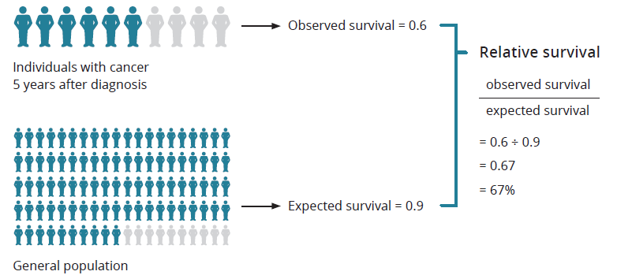

Outcome: Improve cancer outcomes

Key result: Decrease incidence of preventable cancers

Measure 1.1 – Incidence of preventable cancers
In Australia, at least one-third or approximately 37,000 of all cancers are preventable each year if the population avoided exposure to 13 common risk factors know or strongly suspected to cause cancer. Key preventable causal risk factors include tobacco smoking, excessive exposure to UV radiation, poor diet, being overweight, low levels of physical activity, excessive alcohol use and exposure to infections such as human papillomavirus (HPV). It is therefore important to quantify the proportion of Victorian cancer incidence that might be prevented if exposure to those risk factors occurred at levels that minimise cancer risk. For the purposes of this measure, incidence reflects the number of primary tumours rather than the number of people with cancer.
Figure 1.1: Incidence of preventable cancers in Victoria per 100,000 standardised to the 2001 Australian population, by year of diagnosis, 2014 and 2017
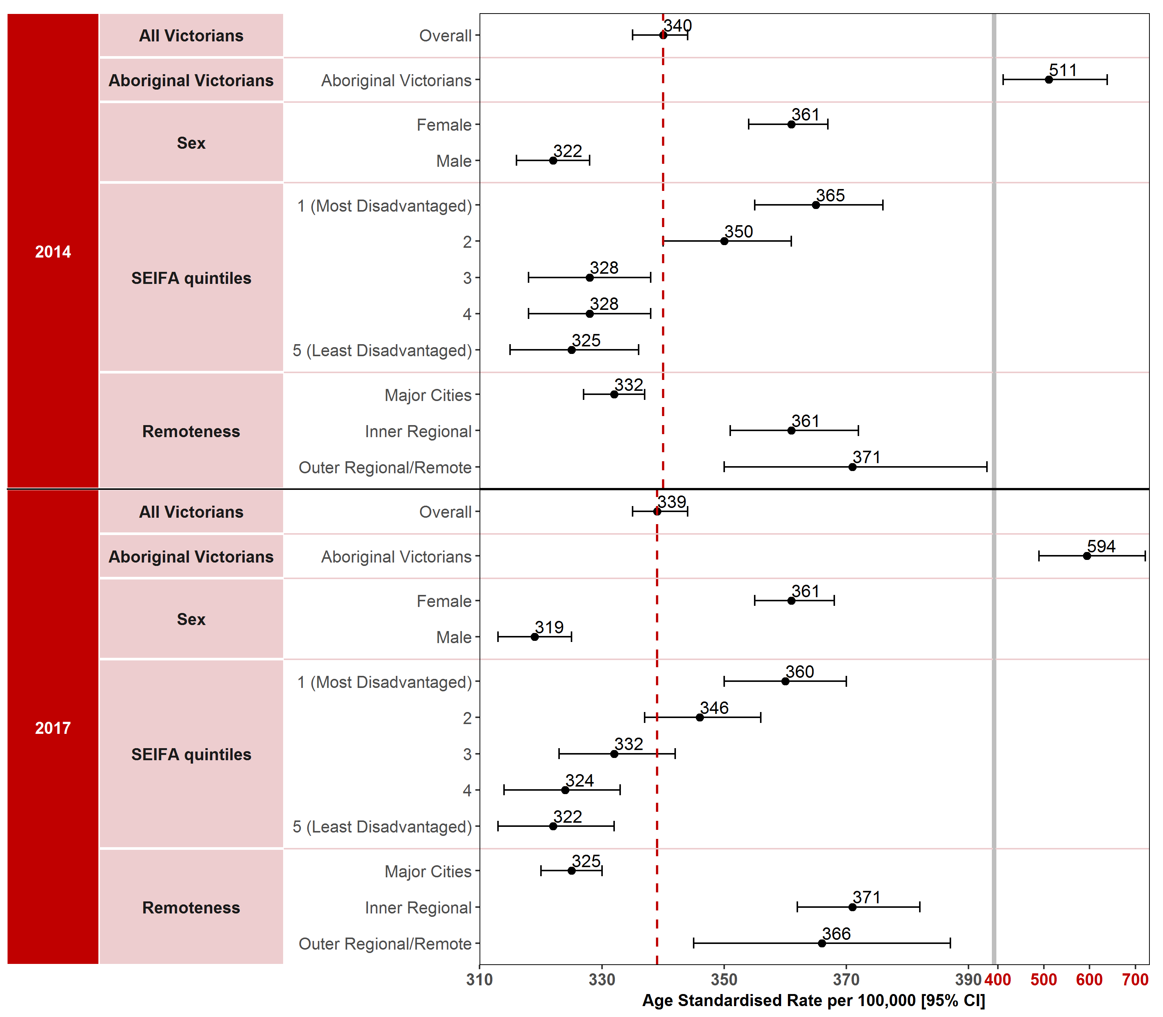
Note: Results by cultural diversity are not presented because the estimated resident population (ERP) does not estimate the population by cultural diversity, hence there is no denominator for this variable. Appendix 2 provides the dataset.
Figure 1.1.1: Incidence of preventable cancers in Victoria per 100,000 standardised to the 2001 Australian population, by ICS and year, 2014 and 2017
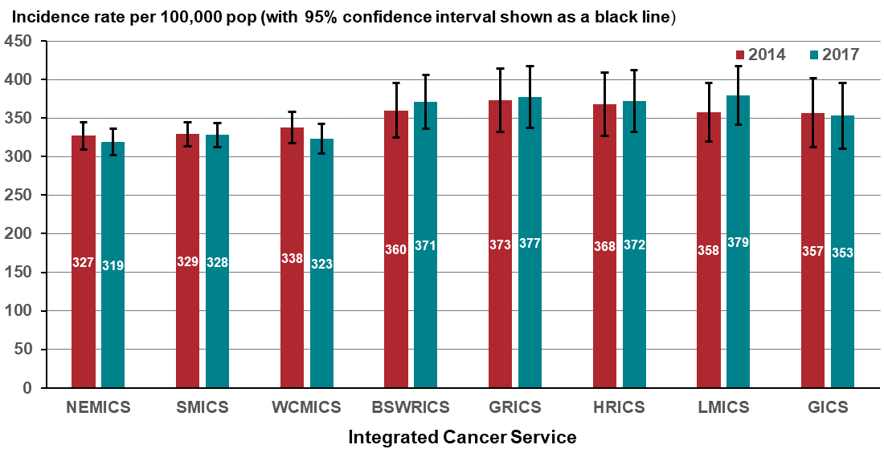
Figure 1.1.2: Incidence of preventable cancers in Victoria per 100,000 standardised to the 2001 Australian population, by Victorian LGA, 2014
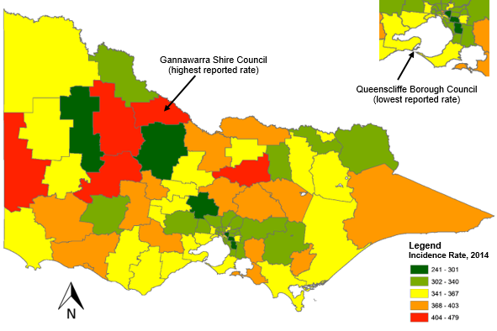
Figure 1.1.3: Incidence of preventable cancers in Victoria per 100,000 standardised to the 2001 Australian population, by Victorian LGA, 2017
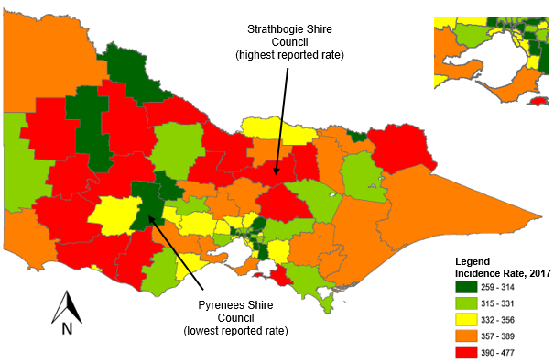
Measure assessment
Traffic light rating: Red (result is of concern)
Overall trend: Static or unchanging
Commentary: Figure 1.1 shows the age-standardised incidence rate overall of preventable cancers combined did not vary between 2014 (339 per 100,000 population) and 2017 (339 per 100,000 population). The incidence rate for males was 322 new cases in per 100,000 males in 2014 decreasing to 319 per 100,000 males in 2017. However, the incidence rate for females for the same period was noticeably higher at 361 new cases per 100,000 females in both 2014 and 2017. This disparity between the sexes may have been the result of population-based screening (for example, the BreastScreen Australia Program) and improvements in technologies and techniques used to identify and diagnose cancers.
Trend data for SES shows that between 2014 and 2017 the age-standardised incidence rate for preventable cancers combined was highest for those living in more socioeconomically disadvantaged areas (SES 1 and 2) compared with those living in the two highest socioeconomic areas (Figure 1.1). Observed differences between 2014 and 2017 by remoteness area show that people living in regional (inner and outer) and remote areas have higher incidence rates compared with Victorians living in major cities (Figure 1.1).
Due to the small number of incident cancer cases reported in Victoria between 2014 and 2017, results of analysis by Aboriginal Victorian status should be interpreted with caution. Nevertheless, the higher Aboriginal Victorian incidence rate, which increased from 511 per 100,000 population in 2014 to 594 per 100,000 population in 2017, may also be related to high prevalence of preventable causal risk factors such as smoking, alcohol consumption and hepatitis B infection, along with lower participation in cancer screening among Aboriginal Victorians.
Figure 1.1.1 shows that metropolitan ICS had lower rates compared with the regional/rural ICSs, which reported an increase in incidence rates over the analysis period, suggesting that the burden of preventable cancers was inequitably distributed across Victoria.
Figures 1.1.2 and 1.1.3 visualise the geospatial distribution of the incidence rate of preventable cancers by LGA and show variations in rates across Victoria between 2014 and 2017. Sixty-two per cent of the 79 Victorian LGAs had higher rates of preventable cancers than the overall rate (340 per 100,000 population) for Victoria in 2014. Gannawarra Shire LGA reported the highest incidence rate (479 per 100,000 population) and Queenscliffe Borough LGA the lowest incidence rate (241 per 100,000 population) in 2014 (Figure 1.1.2). By comparison, 57 per cent of the 79 LGAs had higher incidence rates of preventable cancers than the overall rate (339 per 100,000 population) for Victoria in 2017. Strathbogie Shire LGA reported the highest incidence rate (477 per 100,000 population) and the Pyrenees Shire LGA the lowest (259 per 100,000 population in 2017 (Figure 1.1.3). Overall, most of the 79 LGAs reported slight fluctuations in the incidence rate between 2014 and 2017 but the most significant was the Alpine Shire (rural LGA), which reported a dramatic decrease from 341 per 100,000 population in 2014 to 315 per 100,000 population in 2017.
The target set for this measure is that the proportion of Victorians diagnosed with preventable cancers is halved by 2040 from the baseline. Currently Victoria is not on track to meet this target.

Measure 1.2 – Lifetime risk of cancer before the age of 85 years
Figure 1.2: Lifetime risk of cancer before the age of 85 years by year, 2014 and 2017
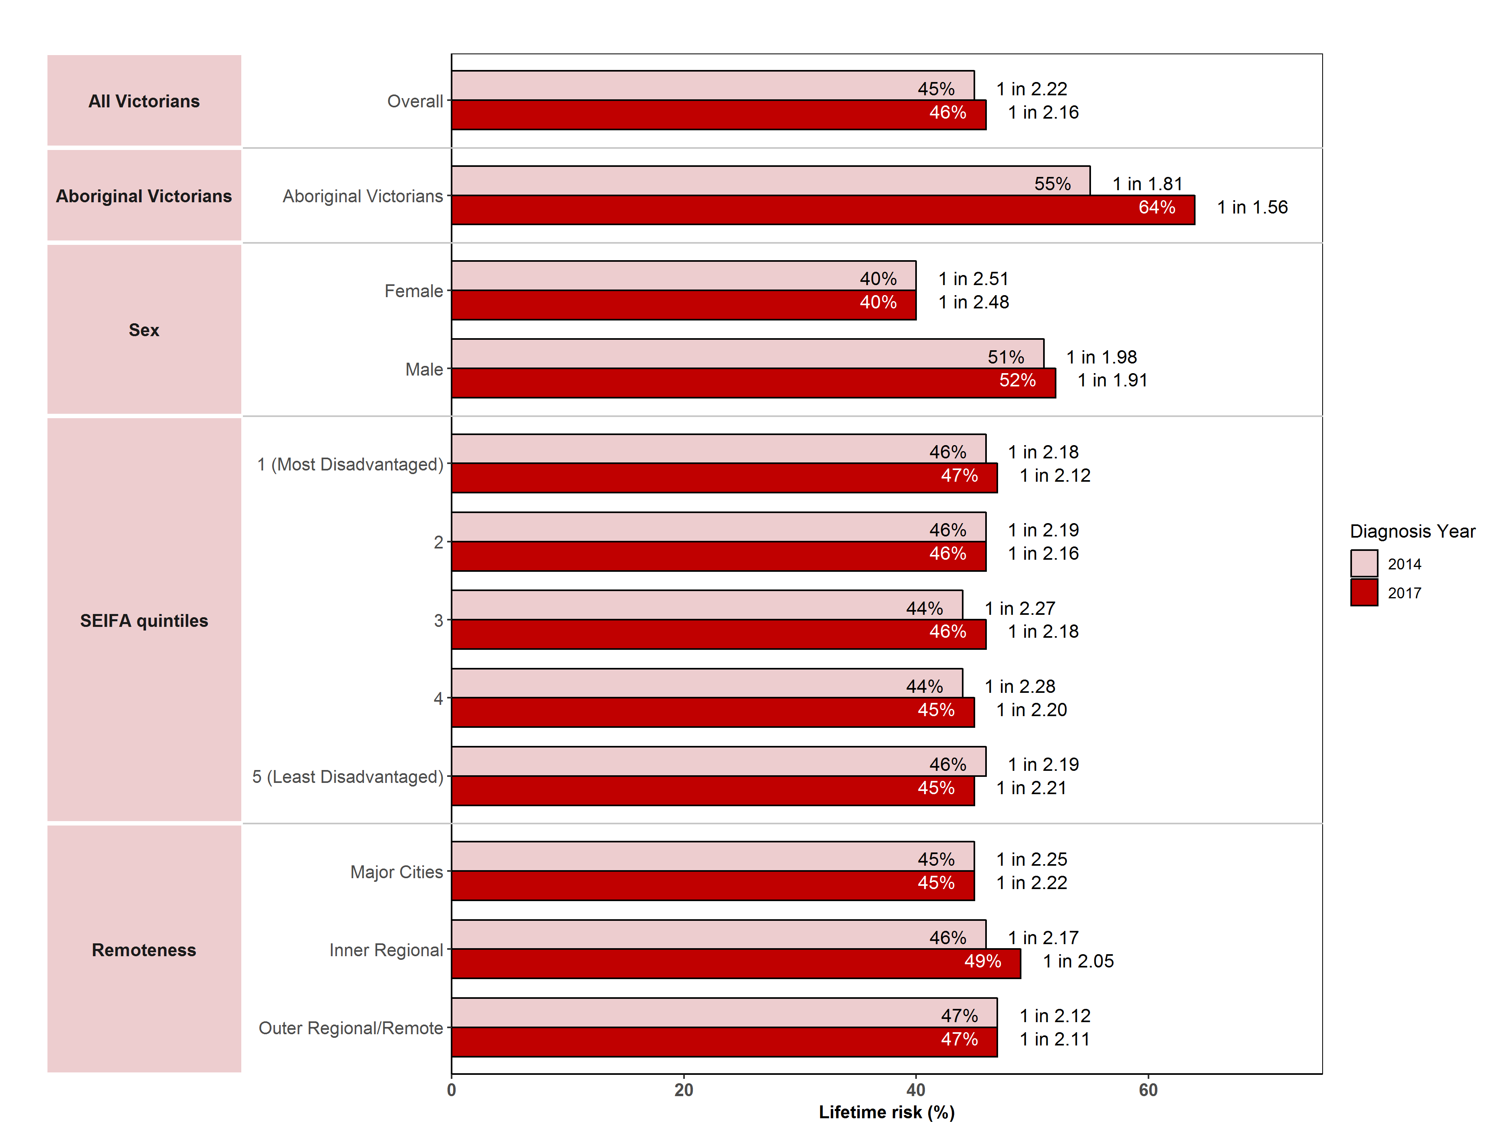
Note: Results by cultural diversity are not presented because the ERP does not estimate the population by cultural diversity, hence there is no denominator for this variable.
Figure 1.2.1: Lifetime risk of developing cancer before the age of 85 years, by ICS and year, 2014–2017
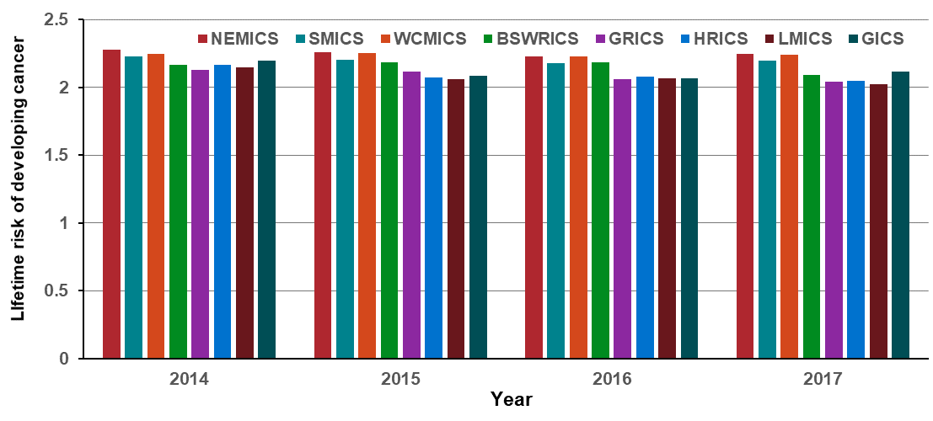
Measure assessment

Traffic light rating: Amber (desired result not yet evident)

Overall trend: Static or unchanging

Commentary: Globally the lifetime risk of developing cancer has been estimated and is publicly available in several countries; however, there is variation between the cut-off age group. The purpose of this measure is to estimate the probability (risk) of developing cancer before the age of 85.
In 2017, it is estimated that the risk of an individual Australian developing cancer by their 85th birthday will be one in two for both males and females. While no target has been set for this measure, Figure 1.2 shows that between 2014 and 2017 the lifetime risk of a Victorian individual developing cancer overall before the age of 85 years was also one in two. Nevertheless, the risk was lower for females, amounting to 40 per cent (2017) compared with 52 per cent for males (2017). The latter is possibly due to increasing age-specific rates of cancers such as prostate and lung cancer in males having an impact on the increasing lifetime risk of developing cancer before the age of 85 years.
Figure 1.2 shows that the lifetime risk of developing cancer for Victorian Aboriginal and Torres Strait Islanders increased from 55 per cent in 2014 to 64 per cent in 2017. The lifetime risk of developing cancer before the age of 85 years did not vary significantly between SES and remoteness (Figure 1.2). Figure 1.2.1 also shows that there was very little variation in the lifetime risk of developing cancer before the age of 85 years between ICSs in the analysis period.

Measure 1.3 – Incidence of lung cancer
Figure 1.3: Incidence of lung cancer in Victoria per 100,000 standardised to the 2001 Australian population, by year of diagnosis, 2014 and 2017
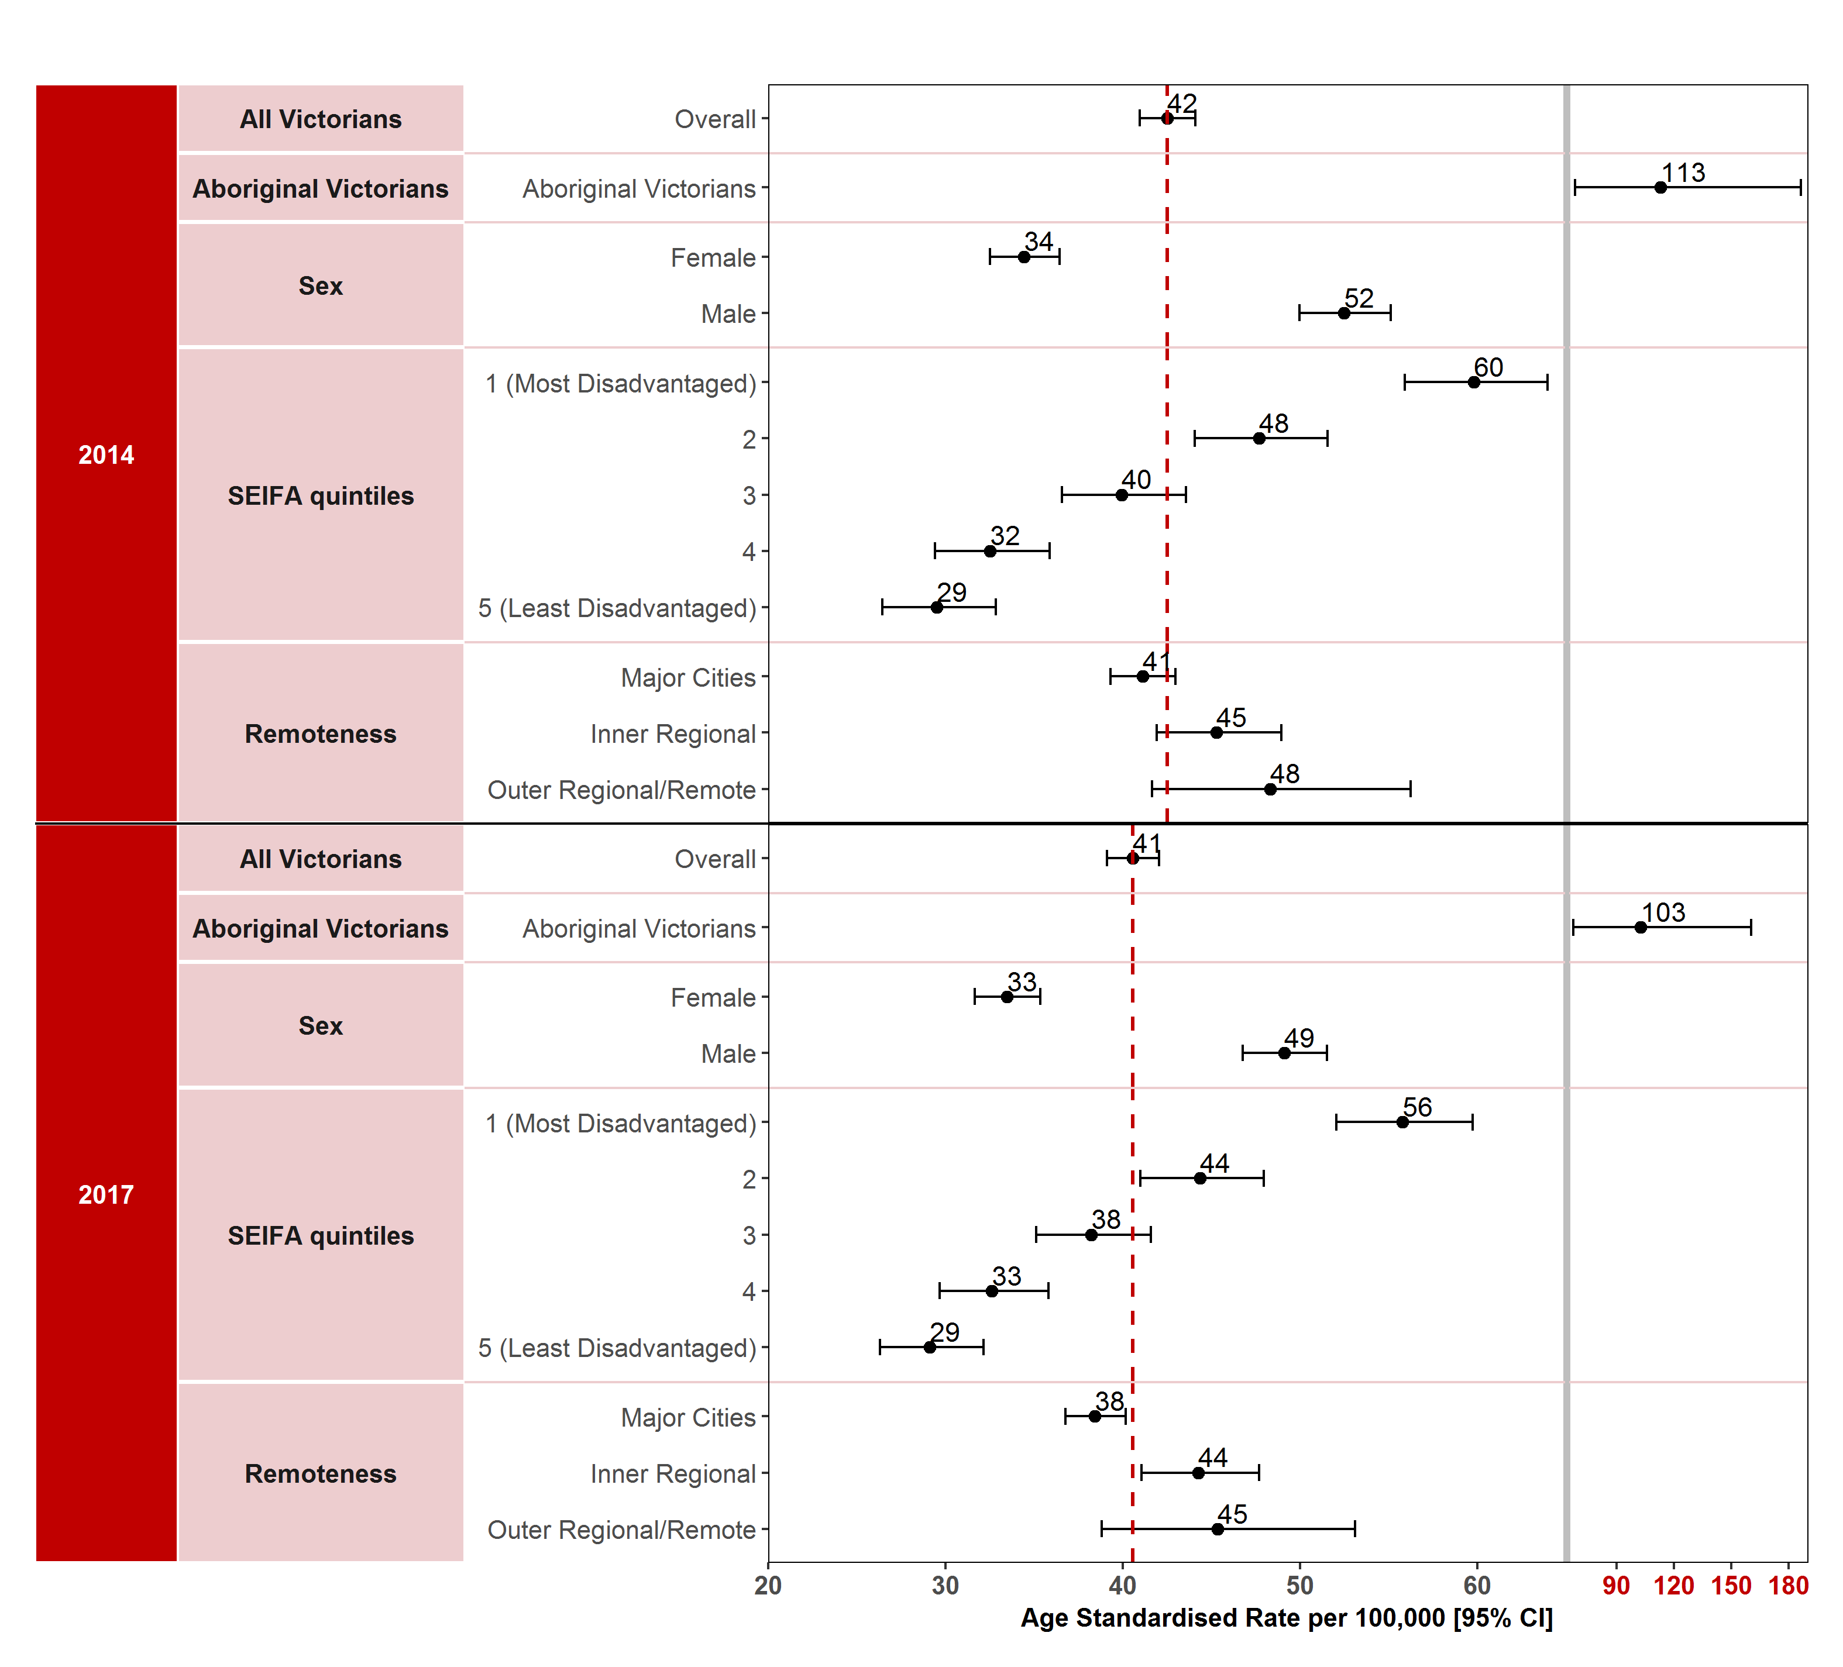

Note: Results by cultural diversity are not presented as the ERP does not estimate the population by cultural diversity, hence there is no denominator for this variable.
Appendix 2 provides the dataset.
Figure 1.3.1: Incidence of lung cancer in Victoria per 100,000 standardised to the 2001 Australian population, by ICS and year, 2014 and 2017
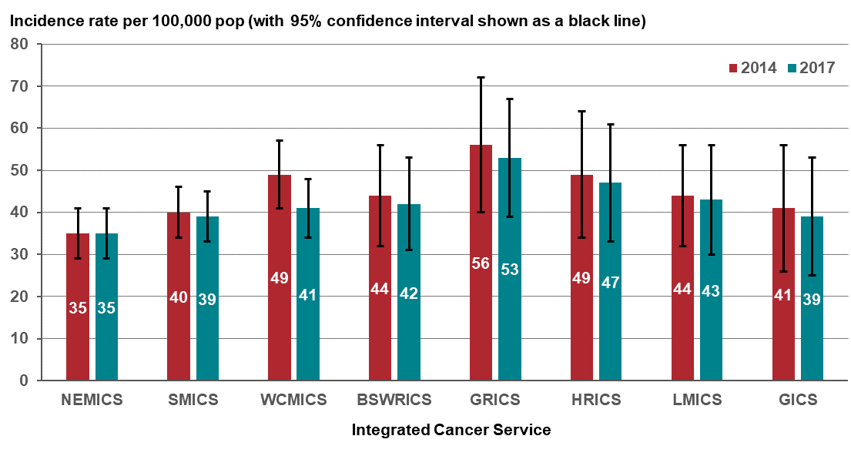
Figure 1.3.2: Incidence of lung cancer in Victoria per 100,000 standardised to the 2001 Australian population, by Victorian LGA, 2014
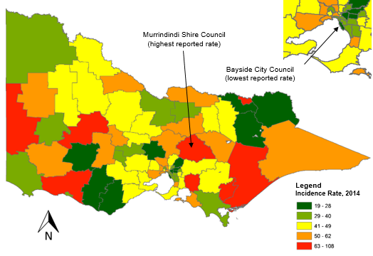
Figure 1.3.3: Incidence of lung cancer in Victoria per 100,000 standardised to the 2001 Australian population, by Victorian LGA, 2017
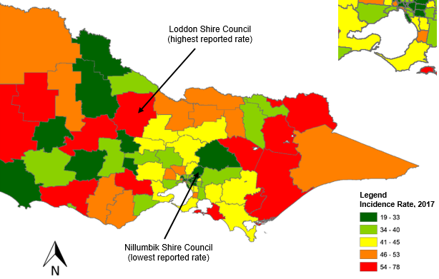
Measure assessment
Traffic light rating: Amber (desired result not yet evident)
Overall trend: Static or unchanging
Commentary: It is well documented that there are several risk factors relating to developing lung cancer. Of these, tobacco smoking has been identified as being the greatest risk factor. Lung cancer has been identified as the leading cause of cancer death and the fifth most common cancer diagnosed in Australia. In Victoria, latest statistics show that lung cancer was the fifth most common new cancer (2,990 new cases) in 2017 and remains the leading cause of cancer death (1,999 deaths, 18 per cent of all cancer deaths). The number of lung cancer diagnoses increased from 2,431 in 2010 to 2,983 in 2017 (from 1,444 to 1,677 in males and from 987 to 1,306 among females).
The age-standardised incidence rate per 100,000 population overall decreased slightly from 42 in 2014 to 41 in 2017. Among males the age-standardised incidence rate decreased from 52 in 2014 to 49 in 2017, but among females overall the age-standardised incidence rate was less than males although it also decreased from 34 in 2014 to 33 in 2017 (Figure 1.3). The different pattern of incidence rates observed between males and females is likely to be attributed to the different trends in cigarette smoking. Smoking uptake increased in the early part of the 20th century and declined in the latter half of that century.
In 2014, the age-standardised lung cancer incidence rate for Aboriginal Victorians was 113 new cases per 100,000 population, which decreased to 103 new cases per 100,000 population in 2017. Low SES was associated with an increased risk for developing lung cancer between 2014 and 2017. The lung cancer incidence rate between Victorians was highest in the most disadvantaged socioeconomic quintile (SES 1) in both 2014 and 2017, decreasing from 60 per 100,000 population to 56 per 100,000 population (Figure 1.3). A similar pattern was observed for remoteness areas, with those Victorians living in the outer regional/remote areas having a higher incidence rate (48 per 100,000 population in 2014 decreasing to 45 per 100,000 population in 2017) compared with those living in major cities (41 per 100,000 population in 2014 decreasing slightly to 38 per 100,000 population in 2017). Figure 1.3.1 shows that incidence rates were lower for metropolitan ICSs such as NEMICS and WCMICS compared with regional/rural ICSs, although both showed a slight in increase between 2014 and 2017. This was contrary to most of the regional/rural ICS, which showed a decreasing gradient in the incidence rate during the study period.
Figures 1.3.2 and 1.3.3 present a geospatial distribution of the incidence of lung cancer by LGA and show variations in rates across Victoria between 2014 and 2017. Fifty-three per cent of the 79 Victorian LGAs had higher incidence rates of lung cancer than the overall rate (42 per 100,000 population) for Victoria in 2014. Murrindindi Shire LGA reported the highest incidence rate (108 per 100,000 population) and Bayside City LGA the lowest incidence rate (19 per 100,000 population) in 2014 (Figure 1.3.2). By comparison, 52 per cent of the 79 LGAs had higher incidence rates of lung cancer than the overall rate (41 per 100,000 population) for Victoria in 2017. Loddon Shire LGA reported the highest incidence rate (78 per 100,000 population) and the Nillumbik Shire LGA the lowest (19 per 100,000 population in 2017 (Figure 1.3.3). Overall, most of the 79 LGAs reported slight fluctuations in the incidence rate of lung cancer between 2014 and 2017 but the most significant was the Murrindindi Shire, which reported a dramatic increase from 108 per 100,000 population in 2014 to 28 per 100,000 population in 2017. One LGA – Horsham Rural City reported the same incidence rate of lung cancer for both 2014 and 2017, which was 50 per 100,000 population and 32 per 100,000 population.
No target has been set for this measure; however, Measure 6.1 ‘Proportion of adults who smoke daily’ shows that in Victoria a continued comprehensive approach to tobacco control is warranted to reduce rates of smoking-related cancer including lung cancer.

Measure 1.4 – Incidence of colorectal cancer
Figure 1.4: Incidence of colorectal cancer in Victoria per 100,000 standardised to the 2001 Australian population, by year of diagnosis, 2014 and 2017
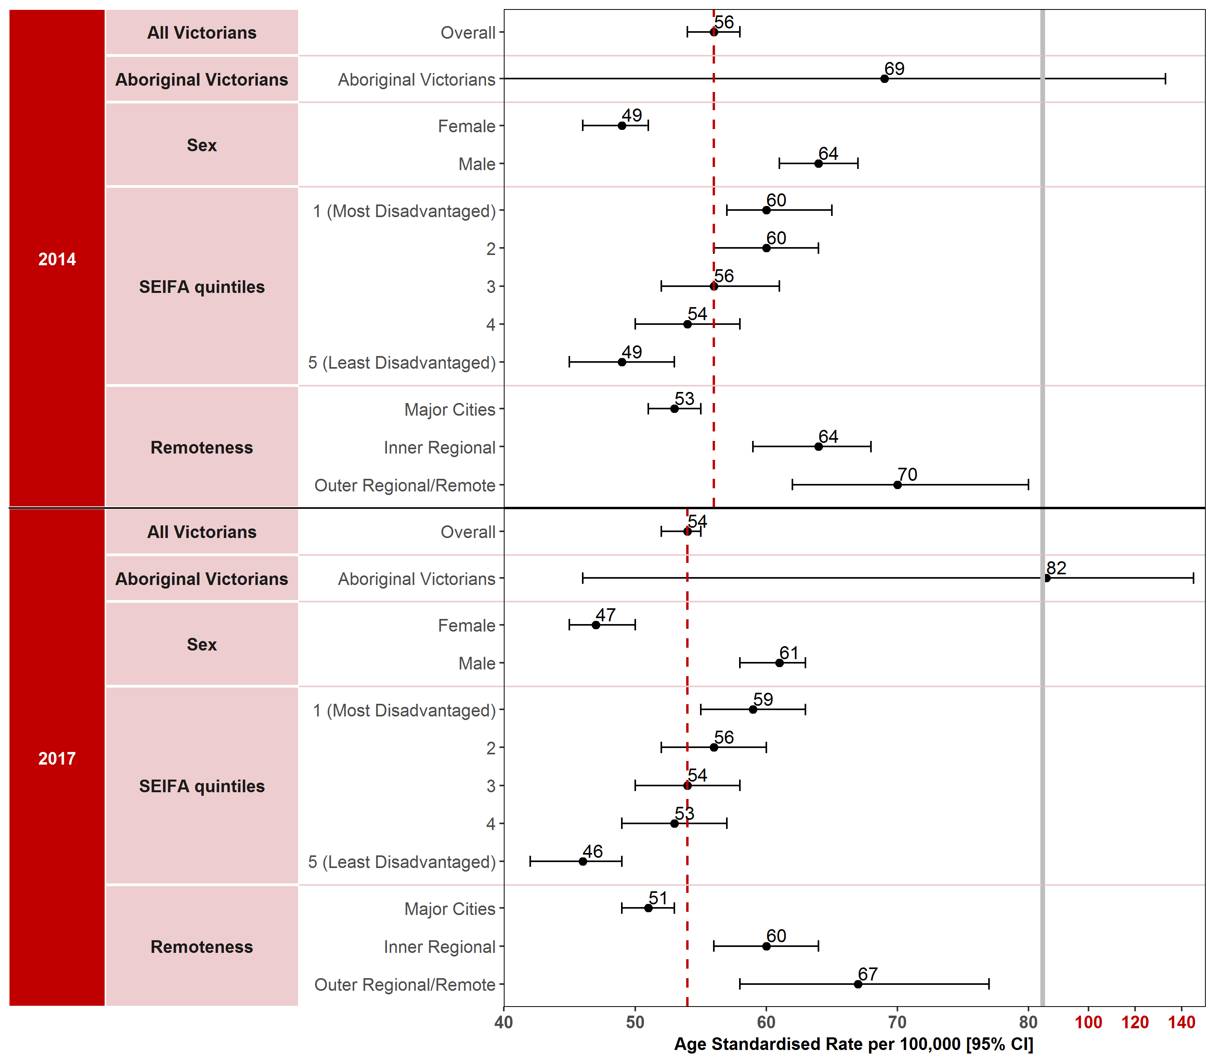
Note: Results by cultural diversity are not presented because the ERP does not estimate the population by cultural diversity, hence there is no denominator for this variable.
Appendix 2 provides the dataset.
Figure 1.4.1: Incidence of colorectal cancer in Victoria per 100,000 standardised to the 2001 Australian population, by ICS and year, 2014 and 2017
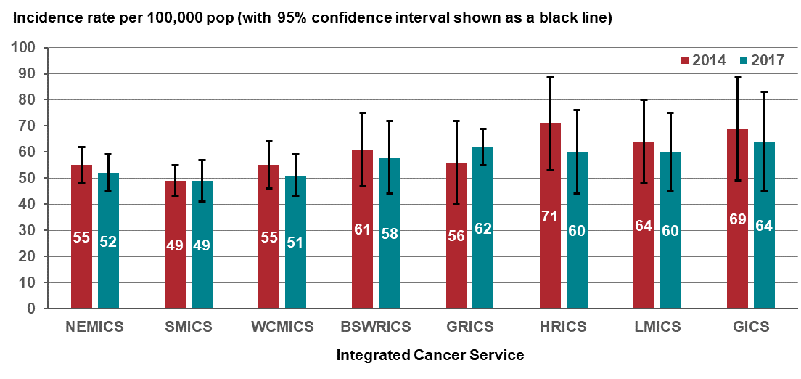
Figure 1.4.2: Incidence of colorectal cancer in Victoria per 100,000 standardised to the 2001 Australian population, by Victorian LGA, 2014
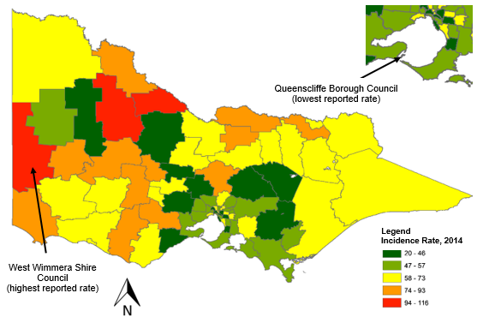
Figure 1.4.3: Incidence of colorectal cancer in Victoria per 100,000 standardised to the 2001 Australian population, by Victorian LGA, 2017
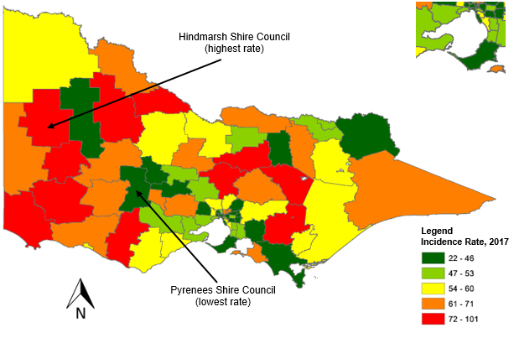
Measure assessment
Traffic light rating: Green (satisfactory result)
Overall trend: Moving in the right direction
Commentary: Colorectal cancer (CRC) (also referred to as bowel cancer) is a common and fatal disease. Globally, CRC incidence shows marked variability and is the third most commonly diagnosed cancer in males and the second in females, with more than 1.8 million new cases estimated to have occurred in 2018 according to the World Health Organization GLOBOCAN database. Rates are much higher in males than females.
In Australia, CRC is the third most common type of newly diagnosed cancer. In 2017 CRC was also the third most common new cancer in Victoria, with 3,910 cases (11 per cent of all cancers) diagnosed. Over the study period (2014–2017) the age-standardised incidence rate fluctuated between 56 and 54 cases per 100,000 people. (Figure 1.4). A higher incidence rate was observed in males (64 per 100,000 population in 2014 falling to 61 per 100,000 population in 2017) compared with females (49 per 100,000 population in 2014 rising to 47 per 100,000 population in 2017).
Low SES was associated with an increased risk for developing CRC between 2014 and 2017. The CRC incidence rate between Victorians was highest in the most disadvantaged socioeconomic quintile (SES 1) in both 2014 and 2017 (Figure 1.4). However, for Victorians living in the outer regional/remote areas the incidence rate was higher (70 per 100,000 population in 2014 falling to 67 per 100,000 population in 2017) compared with those living in major cities (53 per 100,000 population in 2014 falling to 51 per 100,000 population in 2017). Lower incidence rates were also observed for metropolitan ICSs (NEMICS, SMICS and WCMICS) compared with the regional/rural ICSs, although except for GICS, each ICS observed a decrease in the incidence rate for CRC between 2014 and 2017 (Figure 1.4.1).
A geospatial visualisation of the incidence rate of CRC across Victoria by LGA between 2014 and 2017 is presented in Figures 1.4.2 and 1.4.3. Fifty-four per cent of the 79 Victorian LGAs had higher incidence rates of CRC than the overall rate (56 per 100,000 population) for Victoria in 2014. West Wimmera Shire LGA reported the highest incidence rate (116 per 100,000 population) and Queenscliffe Borough LGA the lowest incidence rate (20 per 100,000 population) in 2014 (Figure 1.4.2). By comparison, 47 per cent of the 79 LGAs had higher incidence rates of CRC than the overall rate (54 per 100,000 population) for Victoria in 2017. Hindmarsh Shire LGA reported the highest incidence rate (101 per 100,000 population) and the Pyrenees Shire LGA the lowest (22 per 100,000 population in 2017 – see Figure 1.4.3). Overall, most of the 79 LGAs reported slight fluctuations in the incidence rate of CRC between 2014 and 2017.
No target has been set for this measure, but the declining incidence rate of CRC in Victoria observed between 2014 and 2017 may partially reflect the efficacy of the Australian National Bowel Cancer Screening Program, which was introduced in 2006 and is targeted at those aged 50–74. Other factors, such as screening outside of the national program including colonoscopy, that may have also brought about a decline in overall incidence include improvements in perioperative care to detect and remove precancerous lesions, as well as chemotherapy and radiotherapy. However, as Figure 1.4 shows, disparities exist in some subgroups, particularly Aboriginal Victorians and those living in the most disadvantaged socioeconomic areas (SES 1) having higher incidence rates.

Measure 1.5 – Incidence of melanoma
Figure 1.5: Incidence of melanoma in Victoria per 100,000 standardised to the 2001 Australian population, by year of diagnosis, 2014 and 2017
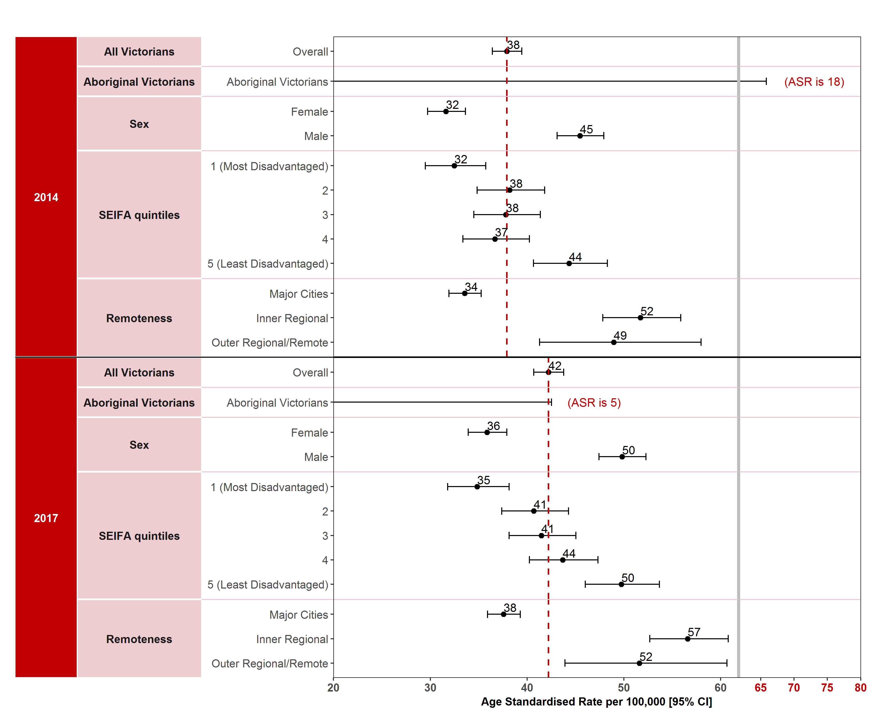

Note: Results by cultural diversity are not presented because the ERP does not estimate the population by cultural diversity, hence there is no denominator for this variable.
Age-adjusted rate for Aboriginal and Torres Strait Islander in 2017 is 5 to account for the very low number of cases.
Appendix 2 provides the dataset.
Figure 1.5.1: Incidence of melanoma in Victoria per 100,000 standardised to the 2001 Australian population, by ICS and year, 2014 and 2017
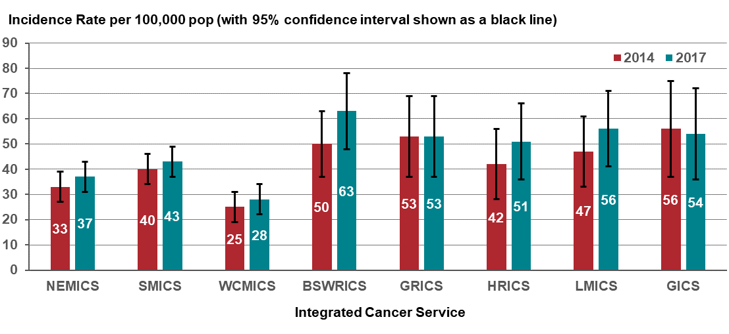
Figure 1.5.2: Incidence of melanoma in Victoria per 100,000 standardised to the 2001 Australian population, by Victorian LGA, 2014
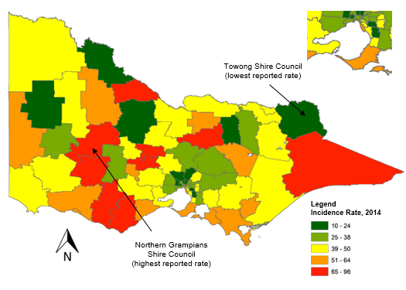
Figure 1.5.3: Incidence of melanoma in Victoria per 100,000 standardised to the 2001 Australian population, by Victorian LGA, 2017
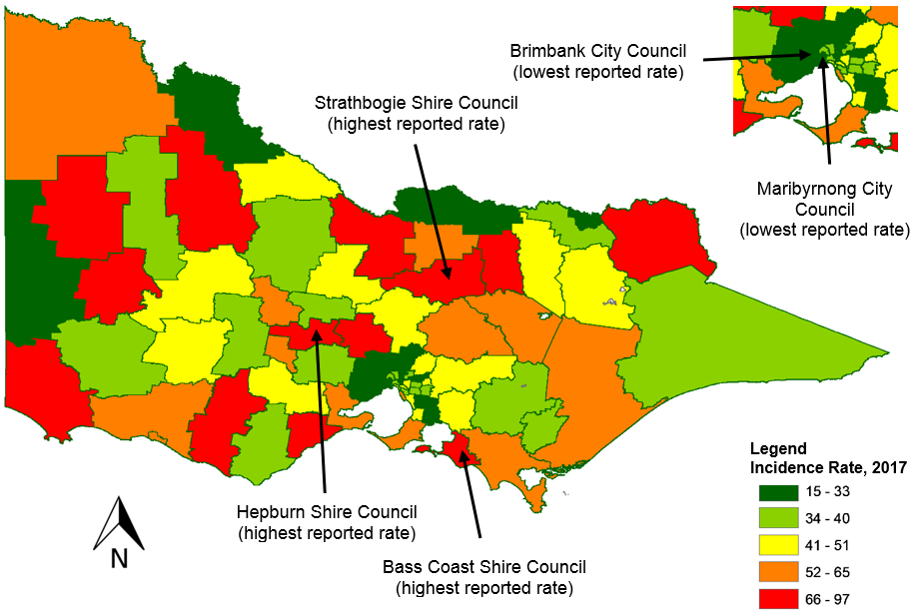
Measure assessment
Traffic light rating: Red (result is of concern)
Overall trend: Not moving in the right direction
Commentary: Melanoma is a type of skin cancer that usually occurs on the parts of the body that have been overexposed to the sun. In 2015, the global incidence of melanoma in 2015 was 351,880 cases (95% CI 281,633–445,036), with an age‐standardised rate of five cases per 100,000 people (95% CI 4–7). Australia is recognised as one of the five world regions with the greatest melanoma incidence. In 2015, melanoma skin cancer was the fourth most commonly diagnosed cancer in Australia. It is estimated that it will remain the fourth most commonly diagnosed cancer in 2019.
In 2016, 2,837 Victorians were diagnosed with melanoma, making it the fifth most common cancer accounting for nine per of all cancer diagnosed. As Figure 1.5 shows, the age-standardised incidence rate per 100,000 people increased steadily from 38 in 2014 to 42 in 2017. Among males, the age-standardised incidence rate increased from 45 in 2014 to 50 in 2017. The age-standardised incidence rate among females also increased from 32 in 2014 to 36 in 2017. From 2010 to 2017, only the melanoma age-standardised rate for Aboriginal Victorians could be calculated for 2010 (43 per 100,000 population) because the number of cases were too low for 2017 (Figure 1.5).
There was a clear association between the age-standardised incidence rate and SES, with lower rates for both 2014 and 2017 observed for SES 1 (most disadvantaged) compared with those for SES 5 (least disadvantaged). In terms of incidence rates by remoteness, lower rates were observed in major cities compared with outer/remote regional areas of Victoria both in 2014 and 2017 (Figure 1.5).
Melanoma incidence rates varied between regions of Victoria when compared between ICS, with lower rates observed in the metropolitan ICSs (NEMICS, SMICS, WCMICS). Except for GICS, all the other ICSs observed an increase in melanoma rates between 2014 and 2017 (Figure 1.5.1).
Figures 1.5.2 and 1.5.3 show a geospatial visualisation of the incidence rate of melanoma across Victoria by LGA between 2014 and 2017. Sixty-one per cent of the 79 Victorian LGAs had higher incidence rates of melanoma than the overall rate (38 per 100,000 population) for Victoria in 2014. North Grampians Shire LGA reported the highest incidence rate (96 per 100,000 population) and Towong Shire LGA the lowest incidence rate (10 per 100,000 population) in 2014 (Figure 1.5.2). By comparison, 53 per cent of the 79 LGAs had higher incidence rates of melanoma than the overall rate (42 per 100,000 population) for Victoria in 2017. Three LGAs (Bass Coast Shire, Hepburn Shire and Strathbogie Shire) reported the highest incidence rate (97 per 100,000 population) and two LGAs (Brimbank City and Maribyrnong City) the lowest (15 per 100,000 population in 2017 (Figure 1.5.3). Overall, most of the 79 LGAs reported slight fluctuations in the incidence rate of melanoma between 2014 and 2017.
Despite no target being set for this measure, overall the age-standardised rate is increasing in Victoria.

Measure 1.6 – Incidence of female breast cancer
Figure 1.6: Incidence of female breast cancer in Victoria per 100,000 standardised to the 2001 Australian population, by year of diagnosis, 2014 and 2017
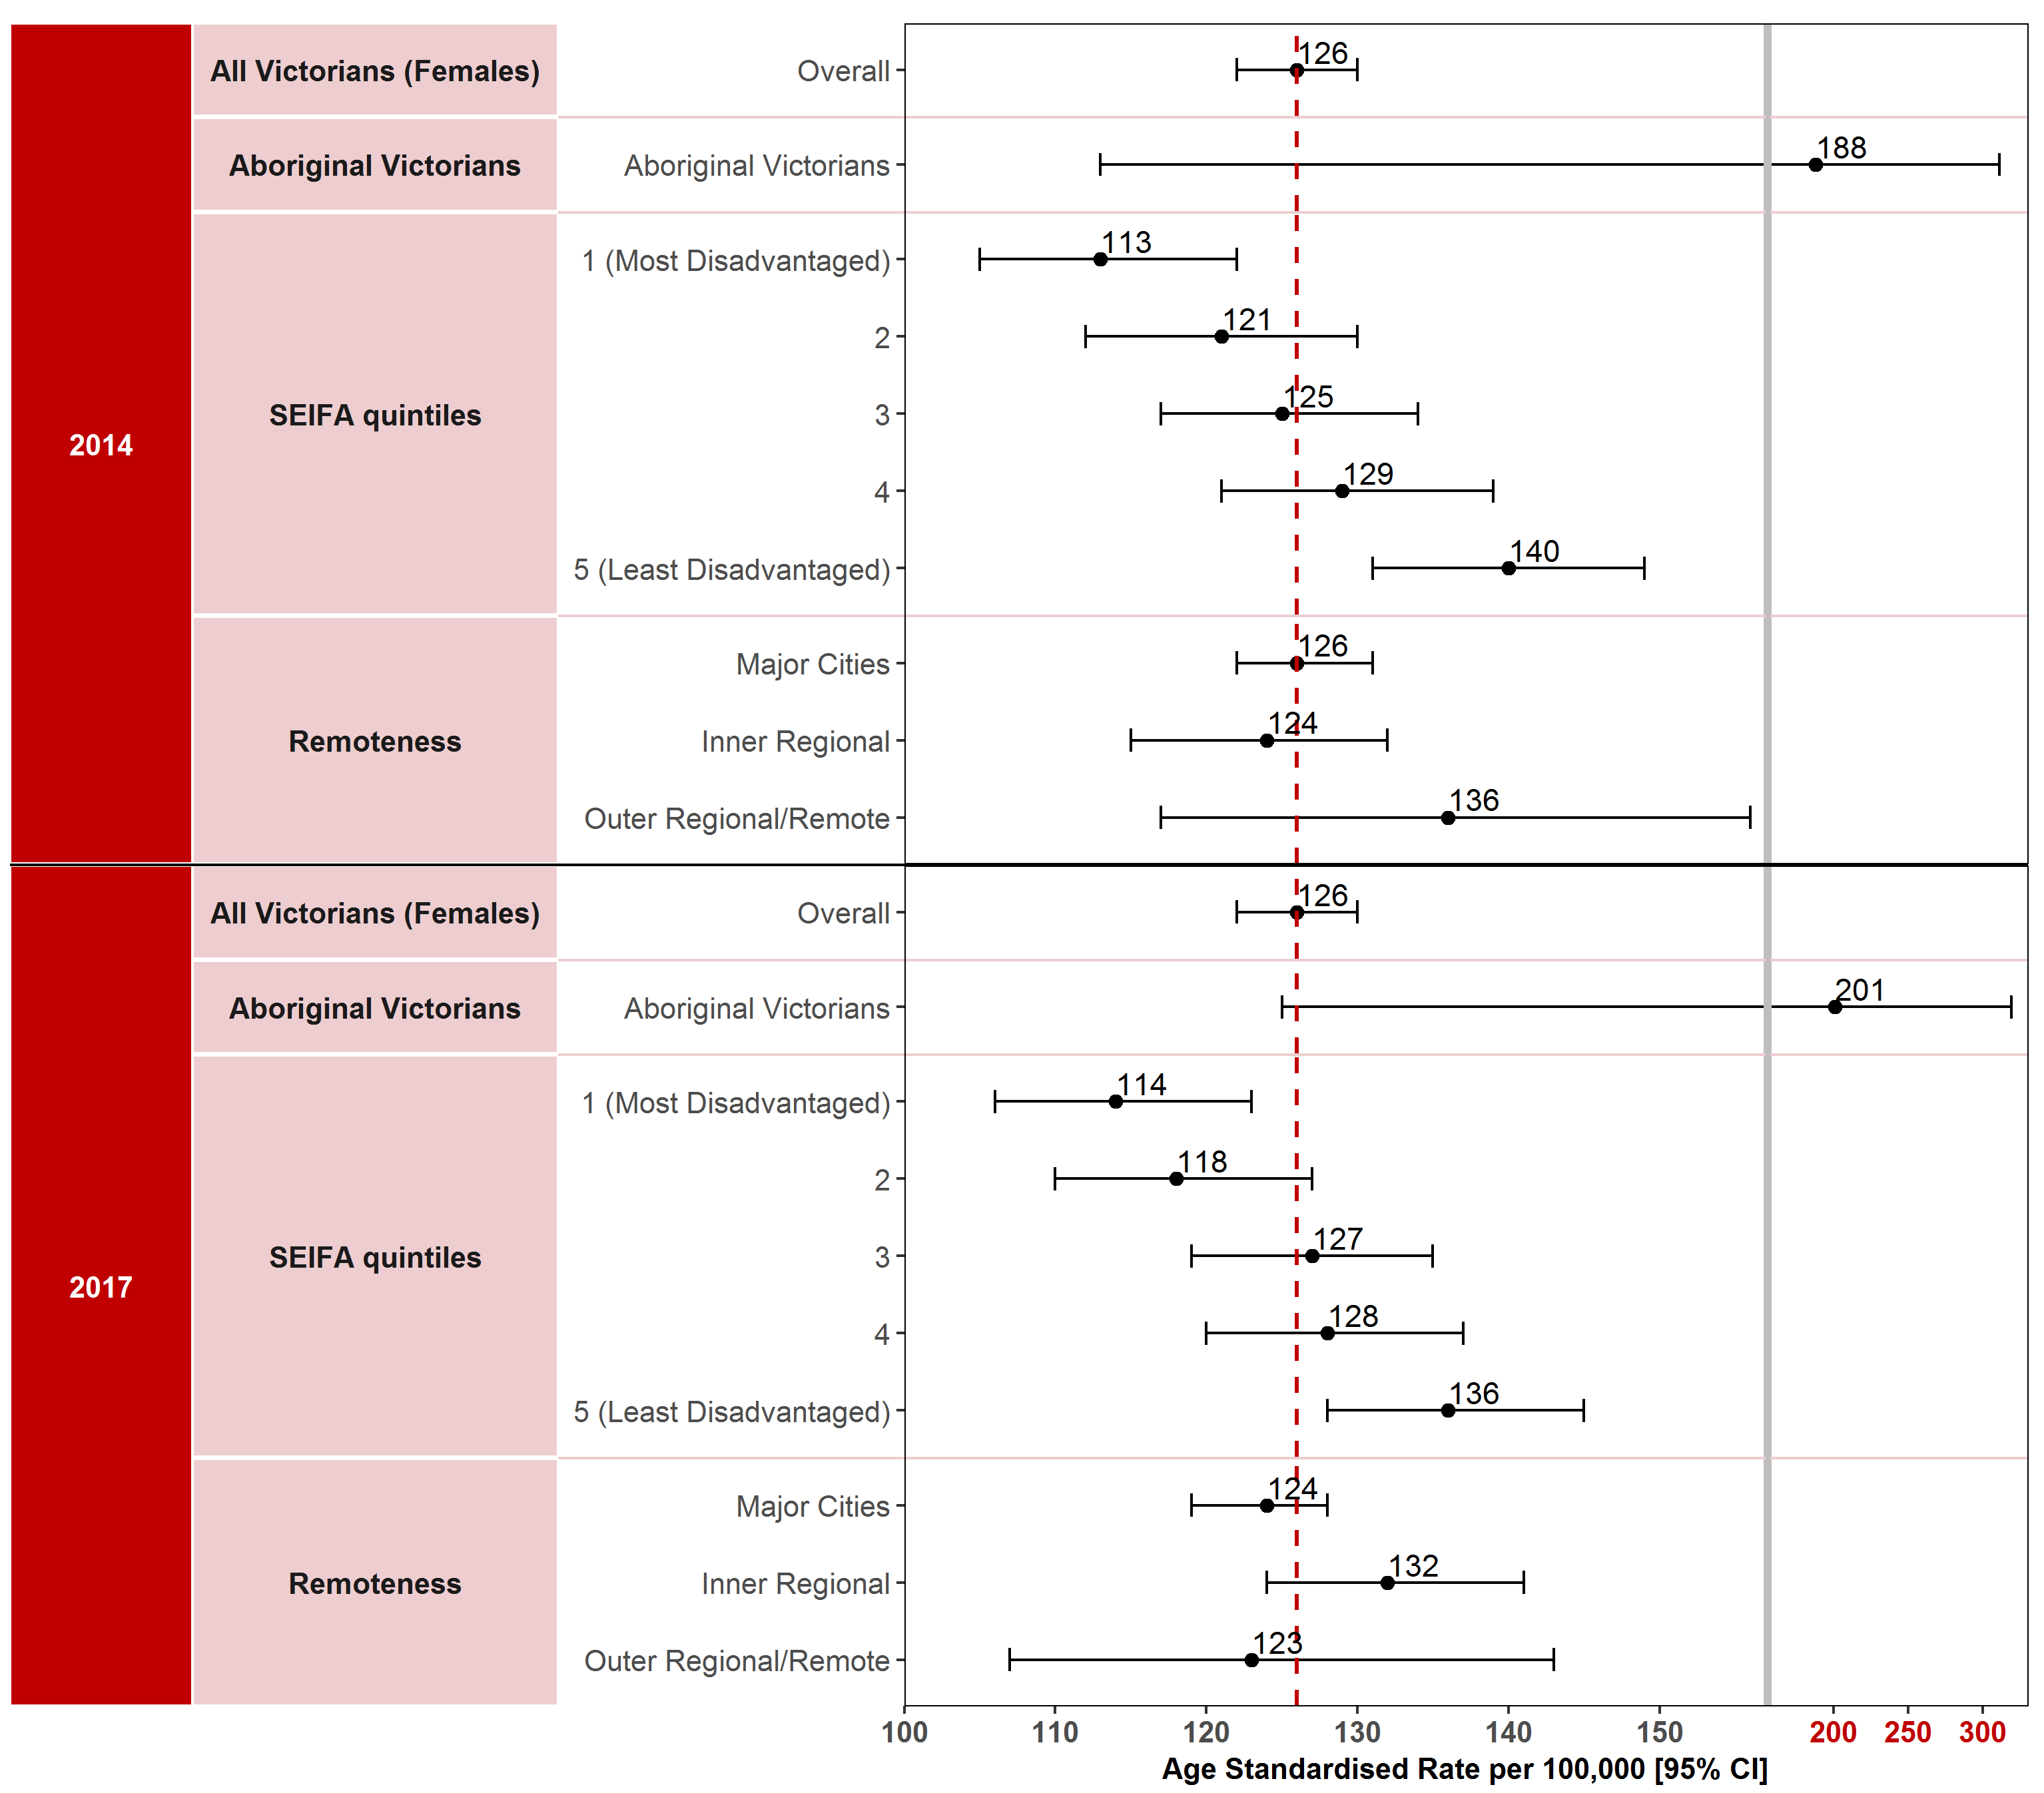
Note: Results by cultural diversity are not presented because the ERP does not estimate the population by cultural diversity, hence there is no denominator for this variable.
Appendix 2 provides the dataset.
Figure 1.6.1: Incidence of female breast cancer in Victoria per 100,000 standardised to the 2001 Australian population, by ICS and year, 2014 and 2017
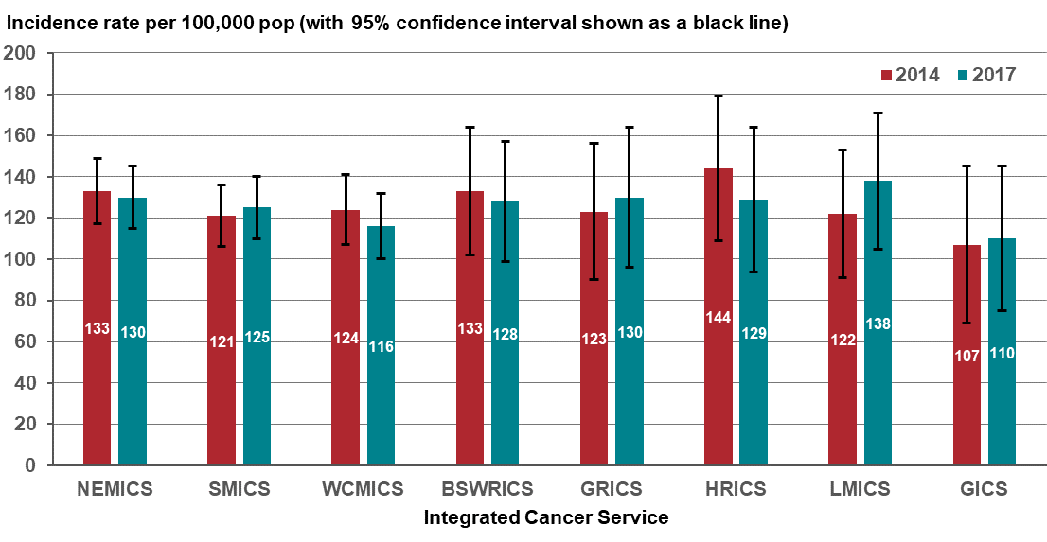
Figure 1.6.2: Incidence of female breast cancer in Victoria per 100,000 standardised to the 2001 Australian population, by Victorian LGA, 2014
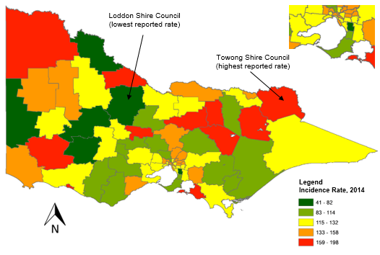
Figure 1.6.3: Incidence of female breast cancer in Victoria per 100,000 standardised to the 2001 Australian population, by Victorian LGA, 2017
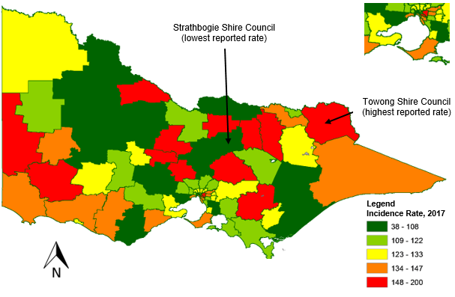
Measure assessment
Traffic light rating: Red (result is of concern)
Overall trend: Not moving in the right direction
Commentary: Breast cancer has been cited as the most common malignancy in women (although it is recognised that it can occur in males) around the world. In 2018 it was estimated via the World Health Organization GLOBOCAN database that there would be approximately 2.1 million newly diagnosed female breast cancer cases, accounting for one in four cancer cases among women. In Australia, this global trend is also reflected in national cancer statistics, with breast cancer also the most common cancer affecting women including Aboriginal and Torres Strait Islander Australians. In 2019, it is estimated that the age-standardised incidence rate will be 68 cases per 100,000 people (1.1 for males and 131 for females). Because of the disproportionate low incidence rate of breast cancer in men, this measure focuses on breast cancer in Victorian females only.
In Victoria, breast cancer is the second most common new cancer and accounts for 29 per cent of all cancers for women. Projected estimates in Victoria indicate there will be a 12 per cent expected increase in incidence rate by 2028–2032 from 2013–2017.
Figure 1.6 shows that the overall age-standardised rate for female breast cancer remained unchanged at 126 per 100,000 population in both 2014 and 2017. Higher incidence rates for Aboriginal Victorian women were observed over the same time period, although caution should be taken when interpreting these figures due to the low numbers of cases for this subgroup (24 cases in 2014 increasing to 26 in 2017 – refer to Appendix 2).
High SES was observed to be associated with an increased risk for developing breast cancer in women between 2014 and 2017. The female breast cancer incidence rate between Victorians was highest in the least disadvantaged socioeconomic quintile (SES 5) during the reporting period, although a decrease was observed in the rates from 140 per 100,000 population in 2014 to 136 per 100,000 population in 2017 (Figure 1.6).
Figure 1.6 shows there was very little variation for those Victorians living in the outer regional/remote areas compared with major cities, although the latter appears to have the slightly higher incidence rates for both 2014 and 2017. There was a similar trend for ICSs across Victoria, which showed little variation, although each of the ICSs recorded an increase in incidence rates for female breast cancer from 2014 and 2017 except for WCMICS and HRICS, which recorded a slight decrease.
The spatial variation of incidence rates of female breast cancer by LGA is presented in Figures 1.6.2 and 1.6.3. Forty-six per cent of the 79 LGAs had higher incidence rates of female breast cancer than the overall rate (126 per 100,000 population) in 2014. Towong Shire LGA reported the highest incidence rate (198 per 100,000 population) and Loddon Shire LGA the lowest incidence rate (41 per 100,000 population) in 2014 (Figure 1.6.2). By comparison, 47 per cent of the 79 LGAs had high incidence rates of female breast cancer than the overall rate (126 per 100,000 population) for Victoria in 2017. Towong Shire LGA reported the highest incidence rate (200 per 100,000 population) and Strathbogie Shire LGA the lowest (38 per 100,000 population) in 2017 (Figure 1.6.3). Overall, most of the 79 LGAs reported very little variation in the incidence rate during the study period. Nevertheless, Strathbogie Shire LGA showed the most significant change, with a decrease in the incidence rate from 172 per 100,000 population in 2014 to 38 per 100,000 population in 2017.
While no target has been set for this measure the overall the age-standardised rate for female breast cancer has increased and is projected to increase.

Measure 1.7 – Incidence of cancer of the cervix
Figure 1.7: Incidence of cancer of the cervix in Victoria per 100,000 standardised to the 2001 Australian population, by year of diagnosis, 2014 and 2017
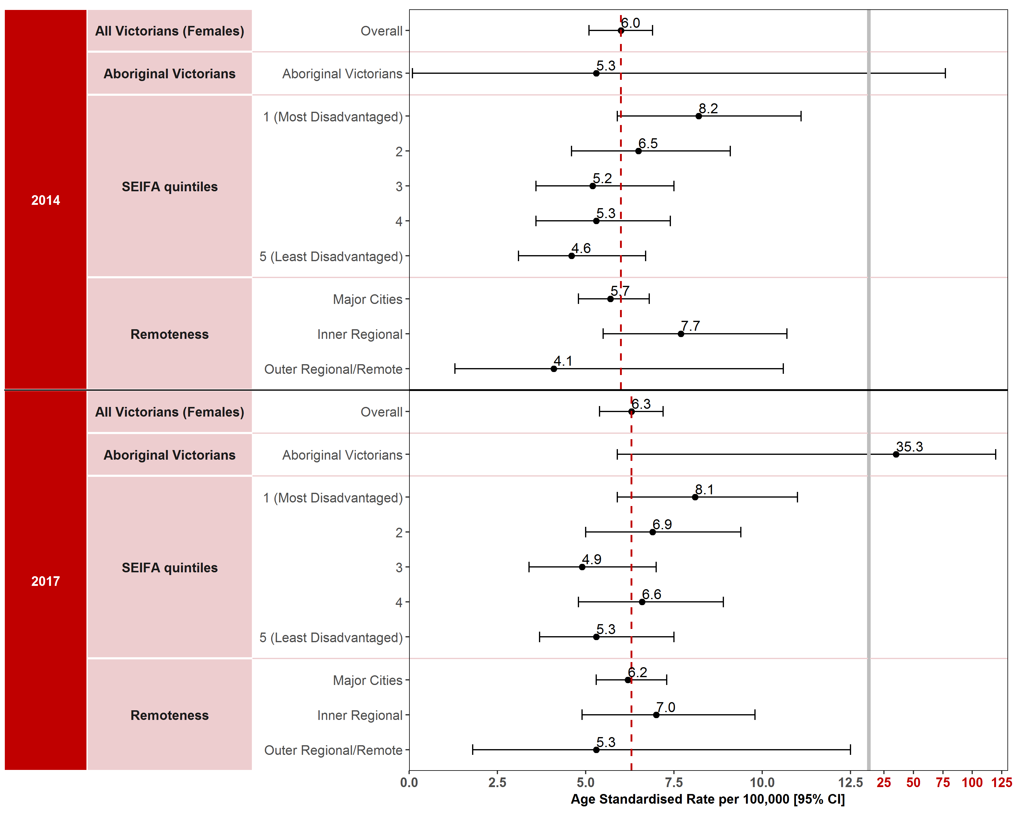
Note: Results by cultural diversity are not presented because the ERP does not estimate the population by cultural diversity, hence there is no denominator for this variable.
Appendix 2 provides the dataset.
Figure 1.7.1: Incidence of cancer of the cervix in Victoria per 100,000 standardised to the 2001 Australian population, by ICS and year, 2014 and 2017
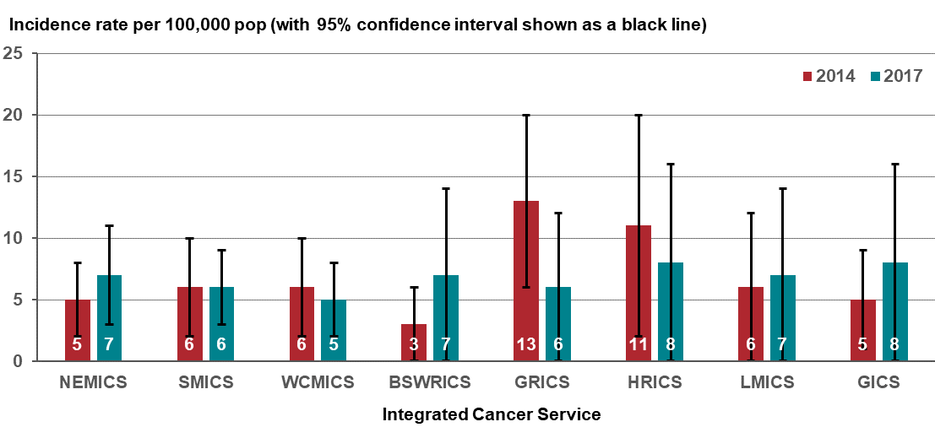
Figure 1.7.2: Incidence of cancer of the cervix in Victoria per 100,000 standardised to the 2001 Australian population, by Victorian LGA, 2014
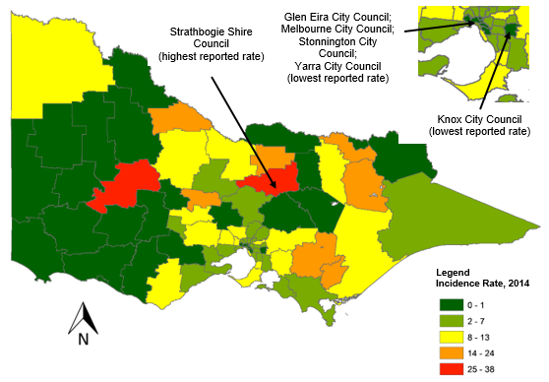
Figure 1.7.3: Incidence of cancer of the cervix in Victoria per 100,000 standardised to the 2001 Australian population, by Victorian LGA, 2017
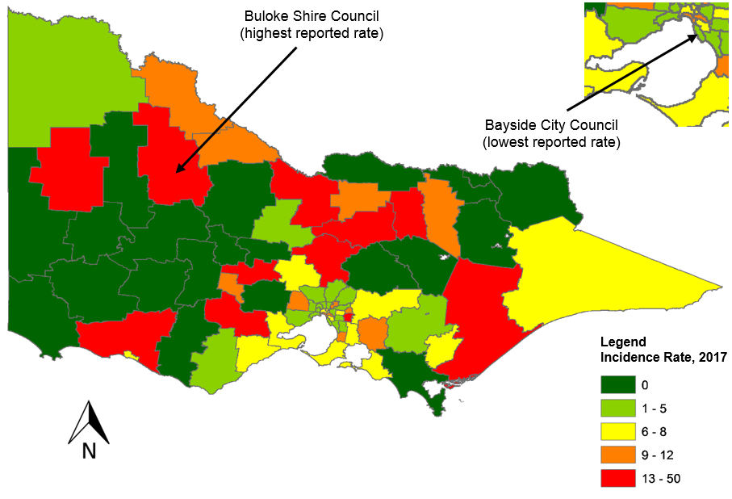
Measure assessment
Traffic light rating: Amber (desired result not yet evident)
Overall trend: Static or unchanging
Commentary: The majority of cancers of the cervix are preventable. Nevertheless, with an estimated 570,000 cases and 311,000 deaths in 2018 globally, this disease ranks as the fourth most frequently diagnosed cancer and the fourth leading cause of cancer death in women. HPV is recognised as the main cause of cervical cancer, with 12 oncogenic types classified as group 1 carcinogens by the International Agency for Cancer Research (IARC) Monographs. In Australia, cervical cancer was the 14th most commonly diagnosed cancer among females in 2015 and in 2019 is estimated to remain the 14th most commonly diagnosed cancer among females. In 2015, the age-standardised incidence rate was 6.9 cases per 100,000 females. This age-standardised incidence rate is estimated to increase to 7.2 cases per 100,000 females in 2019.
In Victoria, the number of annual cervical cancer diagnoses, while low, initially increased from 181 in 2014 to 203 in 2017 - see Appendix 2). The age-standardised incidence rate per 100,000 females remained largely the same in both 2014 and 2017 (6 to 6.3 per 100, 000 female population – see Figure 1.7). There was an association between the age-standardised incidence rate and SES, with higher incidence rates observed for SES 1 (most disadvantaged) compared with SES 5 (least disadvantaged), which largely remained the same between 2014 and 2017. The age-standardised rate for cervical cancer did not differ significantly by remoteness between major cities and outer/remote areas of Victoria during the reporting period (Figure 1.7). Figure 1.7.1 shows that the incidence rates were similar between ICSs across the state; however, care should be taken when interpreting these results because the wide confidence intervals denote low numbers of cervical cancer cases.
Figures 1.7.2 and 1.7.3 visualise the spatial variation of incidence rates of cervix cancer by LGA. Forty-one per cent of the 79 LGAs had higher incidence rates of cervix cancer than the overall rate (6 per 100,000 population) in 2014. Strathbogie Shire LGA reported the highest incidence rate (38 per 100,000 population) and Glen Eira City, Knox City, Melbourne City, Stonnington City and Yarra City LGAs the lowest incidence rate (one per 100,000 population) in 2014 (Figure 1.7.2). However, 24 LGAs reported zero incidence rates in 2014. By comparison, 41 per cent of the 79 LGAs had high incidence rates of cervix cancer than the overall rate (7.5 per 100,000 population) for Victoria in 2017. Buloke Shire LGA reported the highest incidence rate (50 per 100,000 population) and Bayside City LGA the lowest (1 per 100,000 population) in 2017 (Figure 1.7.3). However, there were 14 LGAs (Ararat Rural City, Central Goldfields Shire, Corangamite Shire, Glenelg Shire, Horsham Rural City, Moira Shire, Murrindindi Shire, Pyrenees Shire, Queenscliffe Borough, South Grampians Shire, Towong Shire, West Wimmera Shire, Wodonga Rural City, Yarriambiack Shire) that reported zero incidence rates for both 2014 and 2017. Overall, most of the 79 LGAs reported very little variation in the incidence rate during the reporting period likely due to the low number of cases. Buloke Shire LGA showed the most change, with an increase in the incidence rate from zero per 100,000 population in 2014 to 50 per 100,000 population in 2017. This result should be interpreted with caution due to the low case numbers.
Despite no target being set for this measure and no change in the overall age-standardised incidence rate for cervical cancer observed between 2014 and 2017, it is anticipated that there will be a steady decrease in the future, which will be partly attributed to the effects of HPV vaccination and the National Cervical Screening Program that began in 1991. However, a high participation rate and increased coverage of HPV vaccination will be necessary for the national screening program to achieve its major objective of reducing cervical cancer incidence among Victorian women. Finally, a recently published study estimates that in Australia the age-standardised annual incidence of cervical cancer will decrease to fewer than six new cases per 100 000 women by 2020 (range 2018–22), and to fewer than four new cases per 100,000 women by 2028 (2021–35). These findings indicate that Australia is on-track to be the first country in the world to eliminate cervical cancer by successfully implementing a combined approach to vaccination and screening.

Measure 1.8 – Incidence of liver cancer
Figure 1.8: Incidence of liver cancer (primary) in Victoria per 100,000 standardised to the 2001 Australian population, by year of diagnosis, 2014 and 2017
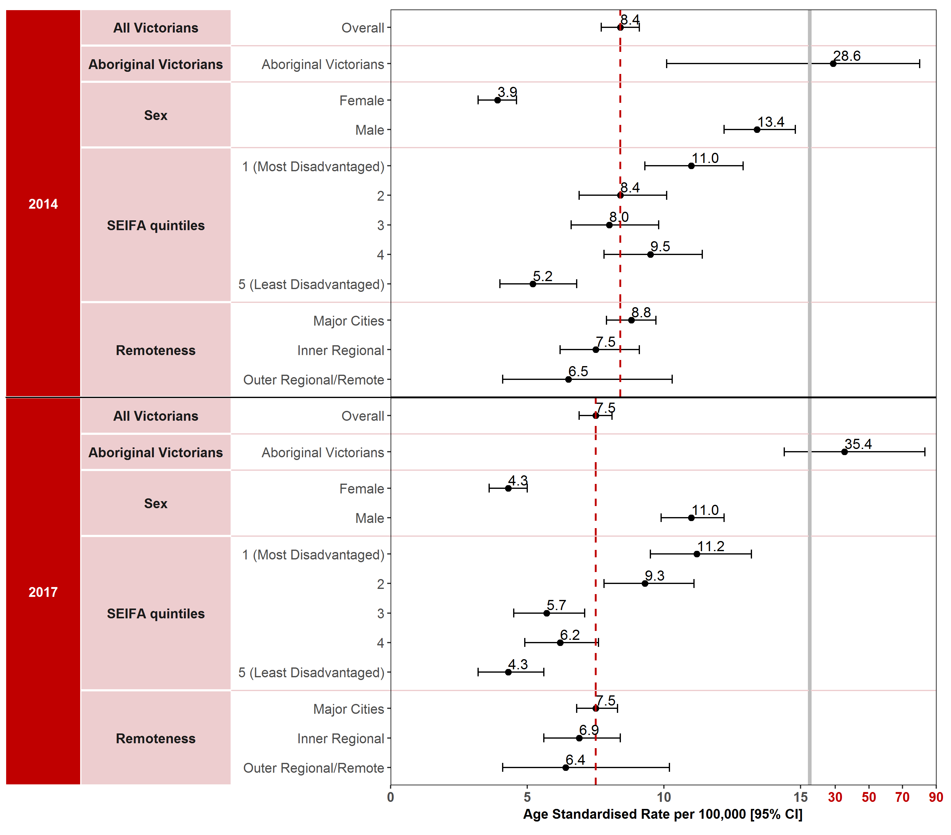
Note: Results by cultural diversity are not presented because the ERP does not estimate the population by cultural diversity, hence there is no denominator for this variable.
Appendix 2 provides the dataset.
Figure 1.8.1: Incidence of liver cancer (primary) in Victoria per 100,000 standardised to the 2001 Australian population, by ICS and year, 2014 and 2017
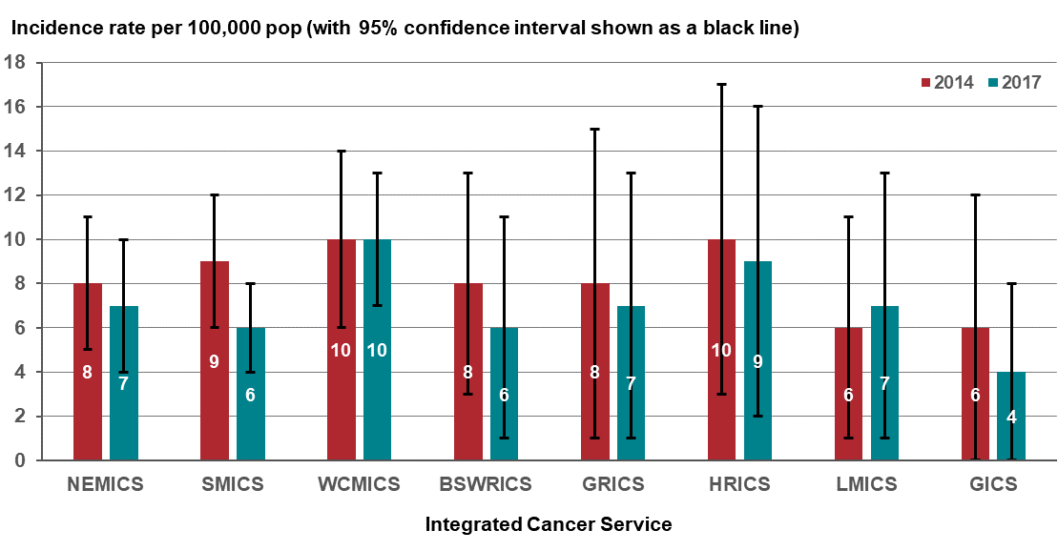
Figure 1.8.2: Incidence of liver cancer (primary) in Victoria per 100,000 standardised to the 2001 Australian population, by Victorian LGA, 2014
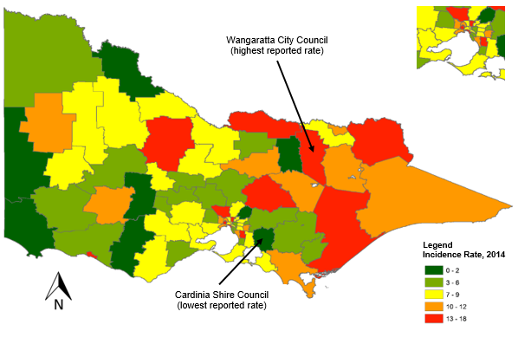
Figure 1.8.3: Incidence of liver cancer (primary) in Victoria per 100,000 standardised to the 2001 Australian population, by Victorian LGA, 2017
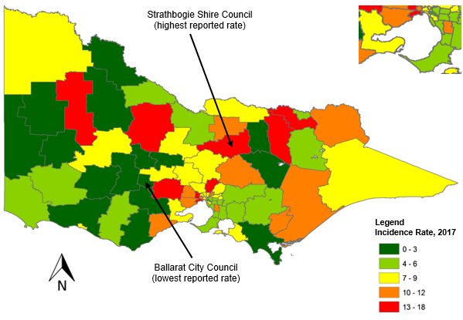

Measure assessment
Traffic light rating: Red (result is of concern)
Overall trend: Static or unchanging
Commentary: Liver cancer can be divided into two types: primary liver cancer and secondary liver cancer (that is, cancer that develops elsewhere in the body and spreads to the liver). Globally primary liver cancer is predicted to be the sixth most commonly diagnosed cancer in 2018. Incidence rates of liver cancer are two to three times higher among men in most world regions. In 2015, liver cancer was identified as the 15th most commonly diagnosed cancer in Australia. It is estimated that it will continue to remain the 15th most commonly diagnosed cancer in 2019. In 2015, the age-standardised incidence rate was 7.6 cases per 100,000 population (12 for males and 3.9 for females). Victoria was observed to following a similar trend in that the age-standardised incidence rate ranging from 8.4 cases per 100,000 population in 2014 to 7.6 per 100,000 population in 2017. In addition, the incidence rate was also higher for males (13.4 per 100,000 population in 2014 falling to 11 per 100,000 population in 2017) compared with females (3.9 per 100,000 population in 2014 rising to 4.3 per 100,000 population in 2017).
For Aboriginal and Torres Strait Islander Victorians, the age-standardised incidence rates for liver cancer have varied over time. An increasing trend was observed in the liver cancer age-standardised incidence rate for Aboriginal Victorians. However, these results should be interpreted with caution because, while incidence appears to have increased from 28.6 per 100,000 population in 2014 to 35.4 per 100,000 population in 2017, the 95 per cent confidence intervals are very wide and overlap (Figure 1.8).
Age-standardised incidence rates for liver cancer were highest in the lowest socioeconomic quintile (SES 1) between 2014 and 2017. Similarly, age-standardised rates for liver cancer were generally higher in major cities (8.8 per 100,000 population in 2014, falling to 7.5 per 100,000 in 2017) compared with areas outside major cities (Figure 1.8). This trend may be related to increases in migration to Victoria from hepatitis B and C endemic areas such as the Asia-Pacific region and sub-Saharan Africa. Figure 1.8.1 shows variation between all the Victorian ICSs, although the low numbers may account for the wide confidence intervals, so they should be interpreted with caution.
The spatial variation of incidence rates of liver cancer by LGA are shown in Figures 1.8.2 and 1.8.3. Sixty-five per cent of the 79 LGAs had higher incidence rates of liver cancer than the overall rate (6 per 100,000 population) in 2014. Wangaratta Rural City LGA reported the highest incidence rate (18 per 100,000 population) and Cardina Shire LGA the lowest incidence rate (one per 100,000 population) in 2014 (Figure 1.8.2). However, 6 LGAs reported zero incidence rates in 2014. By comparison, 42 per cent of the 79 LGAs had higher incidence rates of liver cancer than the overall rate (7.5 per 100,000 population) for Victoria in 2017. Strathbogie Shire LGA reported the highest incidence rate (18 per 100,000 population) and Ballarat City LGA the lowest (one per 100,000 population) in 2017 (Figure 1.8.3). However, there were three LGAs (Benalla Rural City, Pyrenees Shire, West Wimmera Shire) that reported zero incidence rates for both 2010 and 2017. Overall, most of the 79 LGAs reported very little variation in the incidence rate during the reporting period due likely to the low number of cases.
No target has been set for this measure; however, the higher incidence rates in Aboriginal and Torres Strait Islander Victorians suggests that this subpopulation is still a major group among which hepatitis B virus is endemic and hepatitis C is disproportionately common – both chronic hepatitis B and C, if left untreated, are a leading cause of liver cancer. The Victorian hepatitis B strategy and Victorian hepatitis C strategy 2016–20 address the significant public health burden from hepatitis B and hepatitis C (viral hepatitis) including at risk population groups.
Key result: Decrease deaths due to cancer

Measure 2.1 – Death rate due to cancer
Figure 2.1: Global cancer death rate from all cancers combined per 100,000 population for both sexes, 2016
Source: Roser M, Ritchie H 2019, ‘Cancer’. Published online at OurWorldInData.org. Available from: https://ourworldindata.org/cancer
Figure 2.1.1: Victorian death rate for all cancers combined, by sex and year, 2010–2017
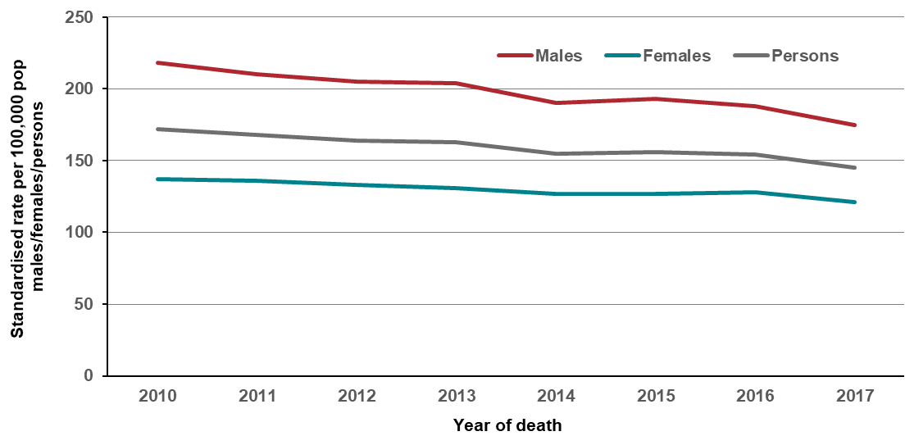
Note: Direct age-standardised rate per 100,000 population, standardised to the 2001 population of Australia
Table 2.1: Victorian death rate for all cancers combined by sex and year, 2010–2017
Sex | 2010 | 2011 | 2012 | 2013 | 2014 | 2015 | 2016 | 2017
Males (ASR) | 218 | 210 | 205 | 204 | 190 | 193 | 188 | 175
(95% CI) | (213–224) | (205–216) | (200–210) | (199–209) | (186–195) | (189–198) | (183–192) | (170–179)
Females (ASR) | 137 | 136 | 133 | 131 | 127 | 127 | 128 | 121
(95% CI) | (133–141) | (132–140) | (129–137) | (128–135) | (123–131) | (124–131) | (125–132) | (118–125)
Persons (ASR) | 172 | 168 | 164 | 163 | 155 | 156 | 154 | 145
(95% CI) | (168–175) | (165–171) | (161–167) | (160–166) | (152–158) | (153–159) | (152–157) | (142–148)
ASR = age-standardised rate
Figure 2.1.2: Forest plots comparing the age-adjusted mortality (death) rates (and 95% confidence intervals) for deaths by all cancers in the baseline year (2010) and the most recent year where mortality data is available (2017), standardised to the 2001 Australian population
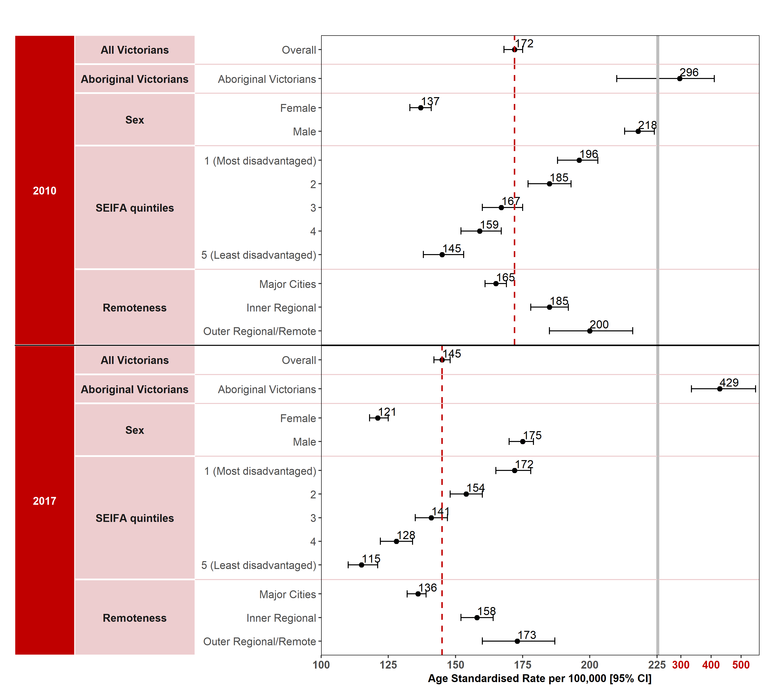
Appendix 2 provides the dataset.
Figure 2.1.3: Victorian death rate for all cancers combined, by LGA, 2010
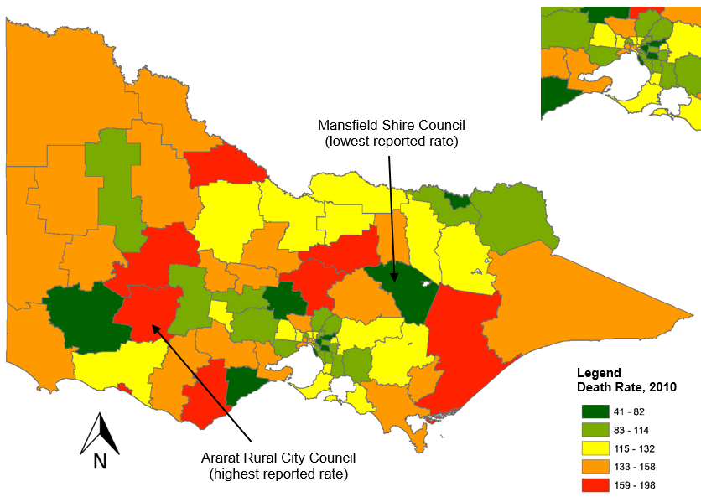
Figure 2.1.4: Victorian death rate for all cancers combined, by LGA, 2017
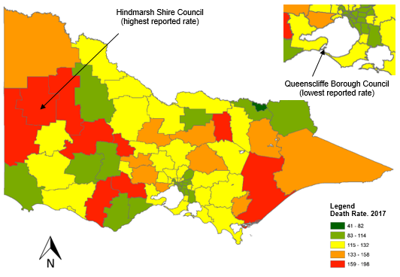
Figure 2.1.5: Victorian death rate for all cancers combined, by ICS by year, 2010–2017
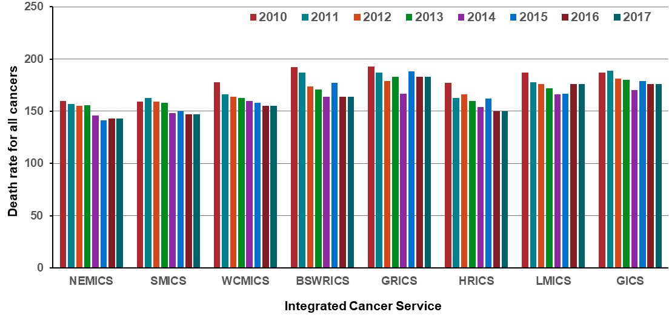

Measure assessment
Traffic light rating: Green (satisfactory result)
Overall trend: Moving in the right direction
Commentary: Cancer remains among the leading causes of death worldwide. Figure 2.1 presents the distribution of all-cancer death rates in 2016 according to world area for both sexes combined. On average, higher income countries tended to fall towards the upper range for death rates; across North America, Europe and Australasia (including Australia), rates in 2016 were typically close to 150 per 100,000 population.
Cancer is a leading cause of disease burden in Victoria (and is broadly similar to other Australian states and territories), with almost 11,000 cancer-related deaths in 2017. From 2010 to 2017, the age-standardised death rate for all cancer combined decreased from 172 (2010) to 145 (2017) per 100,000 population. This pattern was slightly more pronounced in males than females (Table 2.1). The decline reflects earlier detection of cancers through screening, reductions in tobacco use (especially in males) and improvements in treatment. However, by 2028–2032, it is projected that deaths from cancers will increase to more than 13,000 per year. These increases are largely attributable to the growth and ageing of the Victorian population. This accounts for cancer being strongly related to age, with less than one per cent of tumours occurring before age 20 compared with 60 per cent occurring in people older than 65 years.
By comparison, the age-standardised death rate for all cancers combined in this period (2010–2017) was higher among Victorians living in inner regional, outer regional and remote areas and rural local government areas (Figures 2.1.3 and 2.1.4) when compared with people living in major cities, although this is declining. A similar disparity was observed among Victorians living in the lowest SES areas (SES 1). Here the age-standardised death rate for all cancers combined was highest (196 per 100,000 population in 2010 and 172 per 100,000 population in 2017) among Victorians living in the lowest SES areas (SES 1) and lowest (145 per 100,000 population in 2010 and 115 per 100,000 population in 2017) among Victorians living in the highest SES areas (SES 5) (Figure 2.1.2). Figure 2.1.5 shows that the death rate decreased for most ICSs between 2010 and 2017.
The age-standardised death rate was also significantly higher for Aboriginal Victorians than for non-Aboriginal Victorians, having increased from 296 per 100,000 population in 2010 to 429 per 100,000 population in 2017. In addition, Aboriginal death rates were more than twice those for Victorians of other descent between 2010 and 2017 (Figure 2.1.2). Although no target has been set for this measure, the results show there are some Victorian populations that are experiencing a greater burden of disease due to cancer.

Measure 2.2 – Premature death rate due to cancer
Figure 2.2: Global map presenting national ranking of all cancers (combined) as a cause of premature death (below 70 years) in 2015

Source: World Health Organization

Figure 2.2.1: Victorian premature death rate for all cancers combined, by sex and year, 2010–2017
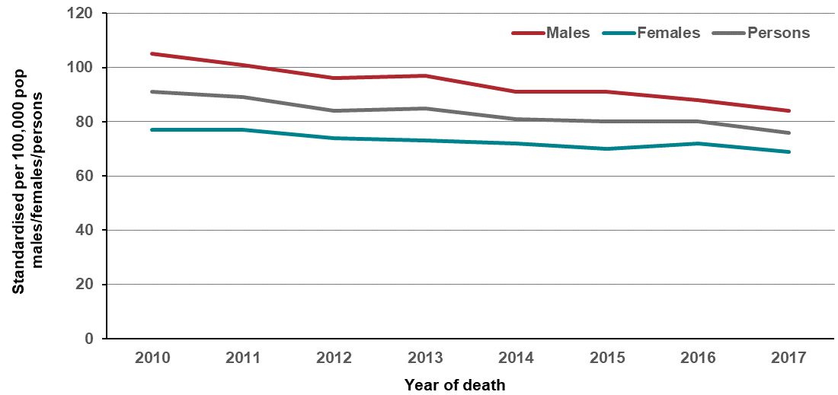
Note: Direct age-standardised rate per 100,000 population, standardised to the 2001 population of Australia
Table 2.1: Victorian premature death rate for all cancers combined, by sex and year, 2010–2017
Sex | 2010 | 2011 | 2012 | 2013 | 2014 | 2015 | 2016 | 2017
Males (ASR) | 105 | 101 | 96 | 97 | 91 | 91 | 88 | 84
(95% CI) | (101–109) | (98–105) | (92-99) | (94–101) | (87-94) | (88-95) | (85-91) | (81-87)
Females (ASR) | 77 | 77 | 74 | 73 | 72 | 70 | 72 | 69
(95% CI) | (74–80) | (74–81) | (71–77) | (70–76) | (69–75) | (67–73) | (69–75) | (66–72)
Persons (ASR) | 91 | 89 | 84 | 85 | 81 | 80 | 80 | 76
(95% CI) | (88–93) | (87–92) | (82–87) | (82–87) | (79–83) | (78–83) | (78–82) | (74–78)
ASR = age-standardised rate
Figure 2.2.2: Forest plots comparing the age-adjusted mortality (death) rates (and 95% confidence intervals) for Victorian premature deaths by all cancers in the baseline year (2010) and the most recent year where mortality data is available (2017), in those younger than 75 years of age at death, standardised to the 2001 Australian population
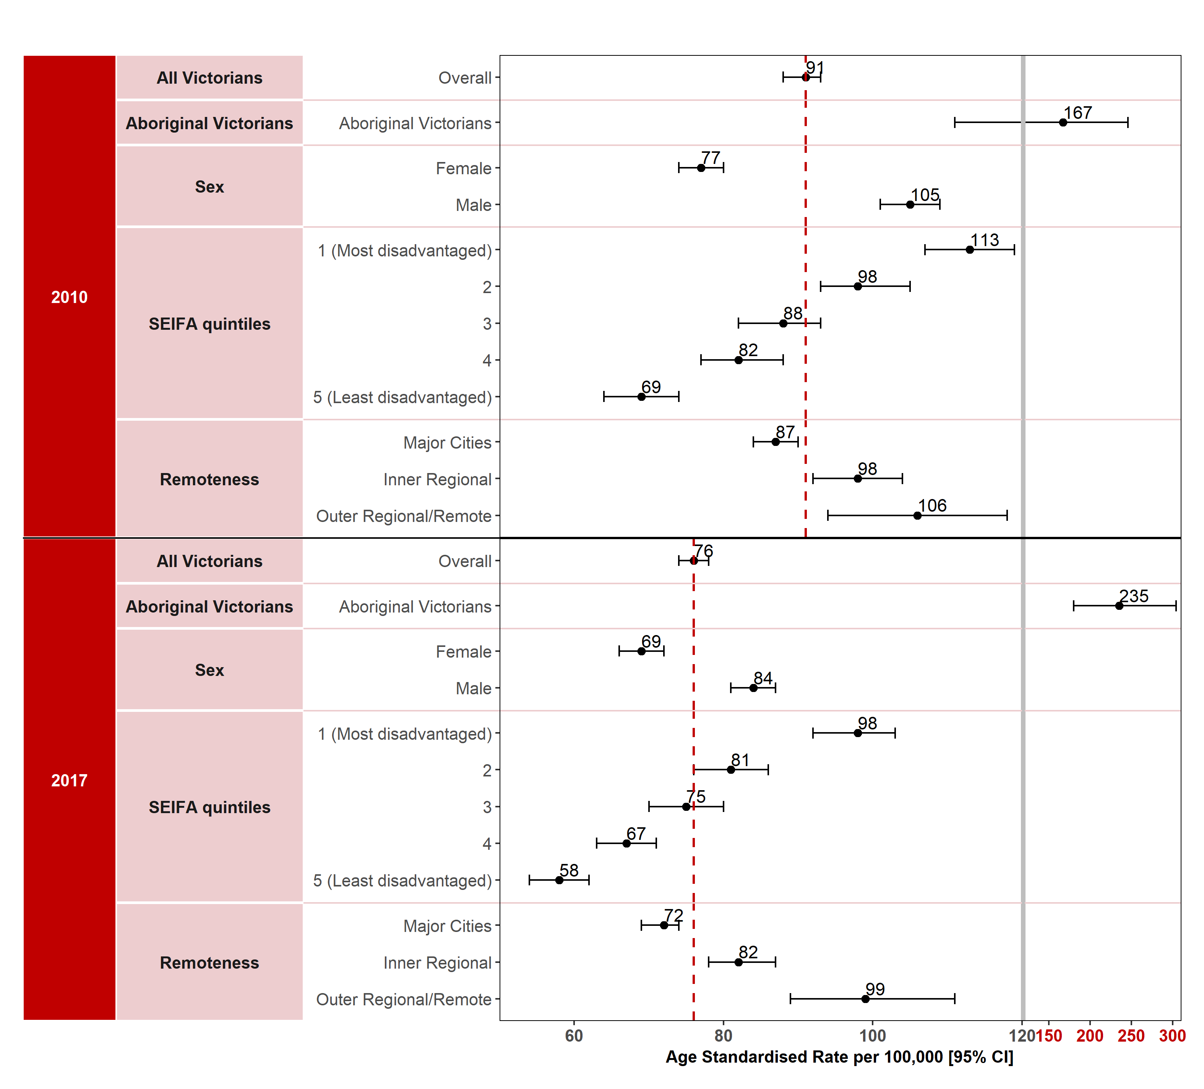
Appendix 2 provides the dataset.
Figure 2.2.3: Victorian premature death rate for all cancers combined, by LGA, 2010
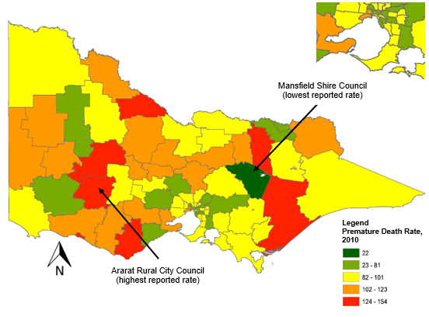
Figure 2.2.4: Victorian premature death rate for all cancers combined, by LGA, 2017
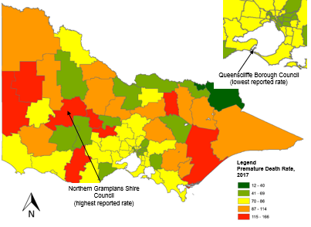
Figure 2.2.5: Victorian death rate for all cancers combined, by ICS by year, 2010–2017
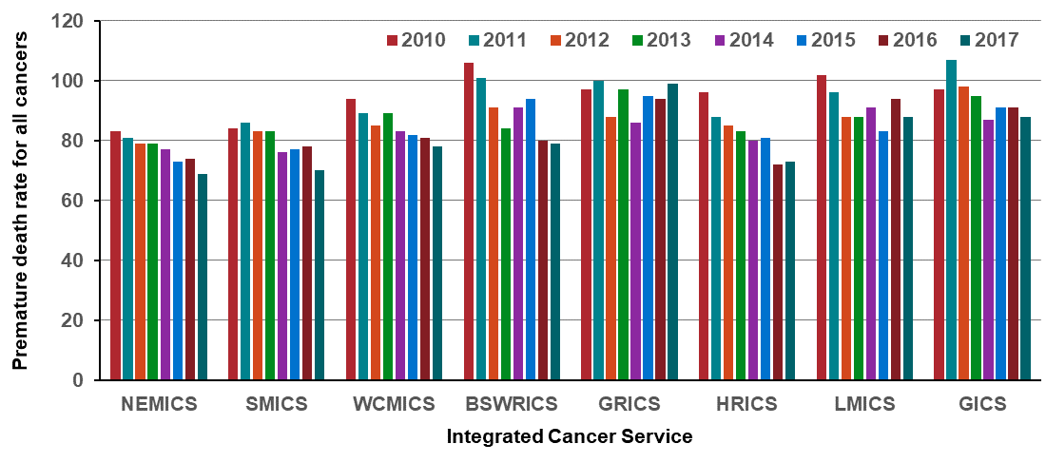

Measure assessment
Traffic light rating: Green (satisfactory result)
Overall trend: Moving in the right direction
Commentary: Globally cancer is expected to rank as the leading cause of death and the single most important barrier to increasing life expectancy in every country of the world in the 21st century. According to World Health Organization estimates in 2015, cancer was identified as the first or second leading cause of death before age 70 years in 91 of the 172 countries including Australia (Figure 2.2).
For the purposes of this report, deaths from cancer among people under 75 years of age are considered premature. Figures 2.2.1, 2.2.2 and Table 2.1 show that overall the premature death rate has changed over time from 91 per 100,000 population in 2010 to 76 per 100,000 in 2017, most likely due to preventive and therapeutic interventions. The mortality rate is steadily decreasing for both genders, although the higher premature death rate for males compared with females may reflect the underlying trend in incidence rates of lung cancer, the leading cause of cancer deaths in Victorian males (Figures 2.2.1 and 2.2.2).
While the premature pattern in death rates is steadily declining in Victoria overall, Figure 2.2.2 shows there has been considerable variation in the rates of decline across SES, with higher premature death rates being associated with the most disadvantaged SES. Variations in remoteness and by LGA between 2010 and 2017 of premature death rates also show the overall the rate was higher in the outer regional/remote Victorian areas compared with major cities (Figures 2.2.3 and 2.2.4). In addition, and of concern, is the increase from 167 per 100,000 population in 2010 to 235 per 100,000 population in 2017 in the age-standardised premature death rate for Aboriginal Victorians. This observation may due to difference in access to and outcome of cancer control activities such as screening, diagnosis, treatment and follow-up. The Victorian death rate for all cancers combined by ICS showed higher rates in the rural/regional ICS compared to the metropolitan ICSs (NEMICS, SMICS and WCMICS) (Figure 2.2.5).
The target for this measure is a 25 per cent decrease in premature deaths due to cancer by 2025 from the baseline year (baseline 2010 = 91, which means the target in 2025 will be 68). Figure 2.2 shows that overall Victoria is moving in the right direction, suggesting that the effectiveness of the health system as it relates to cancer has improved overall outcomes. However, the findings by Aboriginal and SES show that not all Victorians have benefited.

Measure 2.3 – Number of deaths averted based on expected number of deaths
Figure 2.3: Number of deaths averted in Victoria based on expected number of deaths by year, 2015–2017
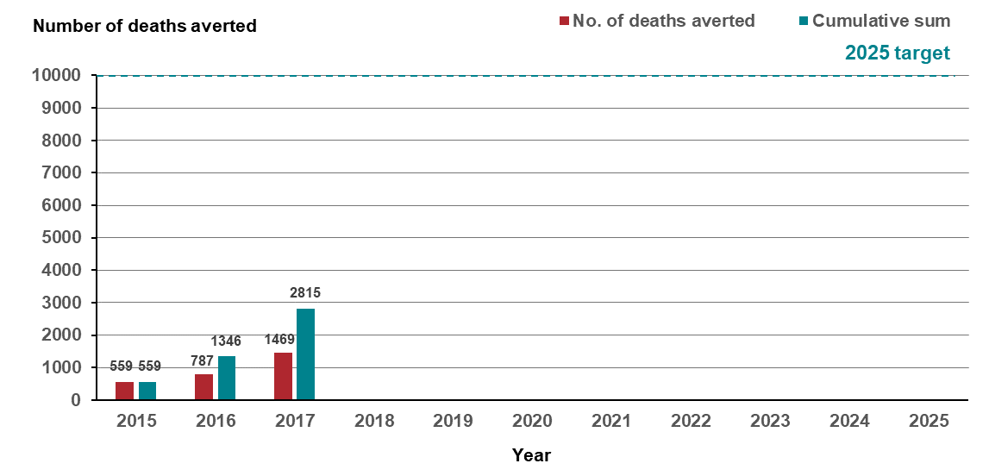
Notes:
At the time of writing, the ERP for 2017 had not been finalised. The ERP for 2016 and years prior to 2016 has been finalised. Results for 2017 may differ in future iterations of this report.
VCR mortality data set was extracted on 11 April 2019.

Measure assessment
Traffic light rating: Green (satisfactory result)
Overall trend: Moving in the right direction
Commentary: In Australia, the number of cancer deaths averted between 2001 and 2010 (based on age and sex-specific death rates for 1997–2000) was 31,557 (95% CI, 30,315–32,796).
Figure 2.3 shows that the number of lives in Victoria that were potentially saved from cancer (or deaths averted) increased from 2015, with a significant increase between 2016 and 2017. At the time of writing this observed increase may be artificial due the Australian Bureau of Statistics (ABS) ERP figure not being finalised due to outstanding mortality data. Nevertheless, this overall increase over this period may be due to the collective efforts of higher screening rates for cancers such as breast, colorectal and cervix, cancer prevention strategies such as effective tobacco control and earlier cancer detection as well as advances in treatment.
The target for this measure is that 10,000 lives are saved by 2025. Despite the limited number of years to report against, Figure 2.3 shows that Victoria is moving in the right direction with 2815 lives saved between 2015–2017.
Key result: Increase survivorship quality of life

Measure 3.1 – Quality of life post active therapy
Measure in development (see Appendix 1).

Outcome: Equitable outcomes for all Victorians

Key result: Equitably reduce cancer incidence

Measure 4.1 – Rate ratio of preventable cancer incidence between Integrated Cancer Services
Figure 4.1: Rate ratio of preventable cancer incidence in ICS of residence compared with the ICS of residence with the lowest adjusted incidence rate, grouped by year of diagnosis, 2014–2017
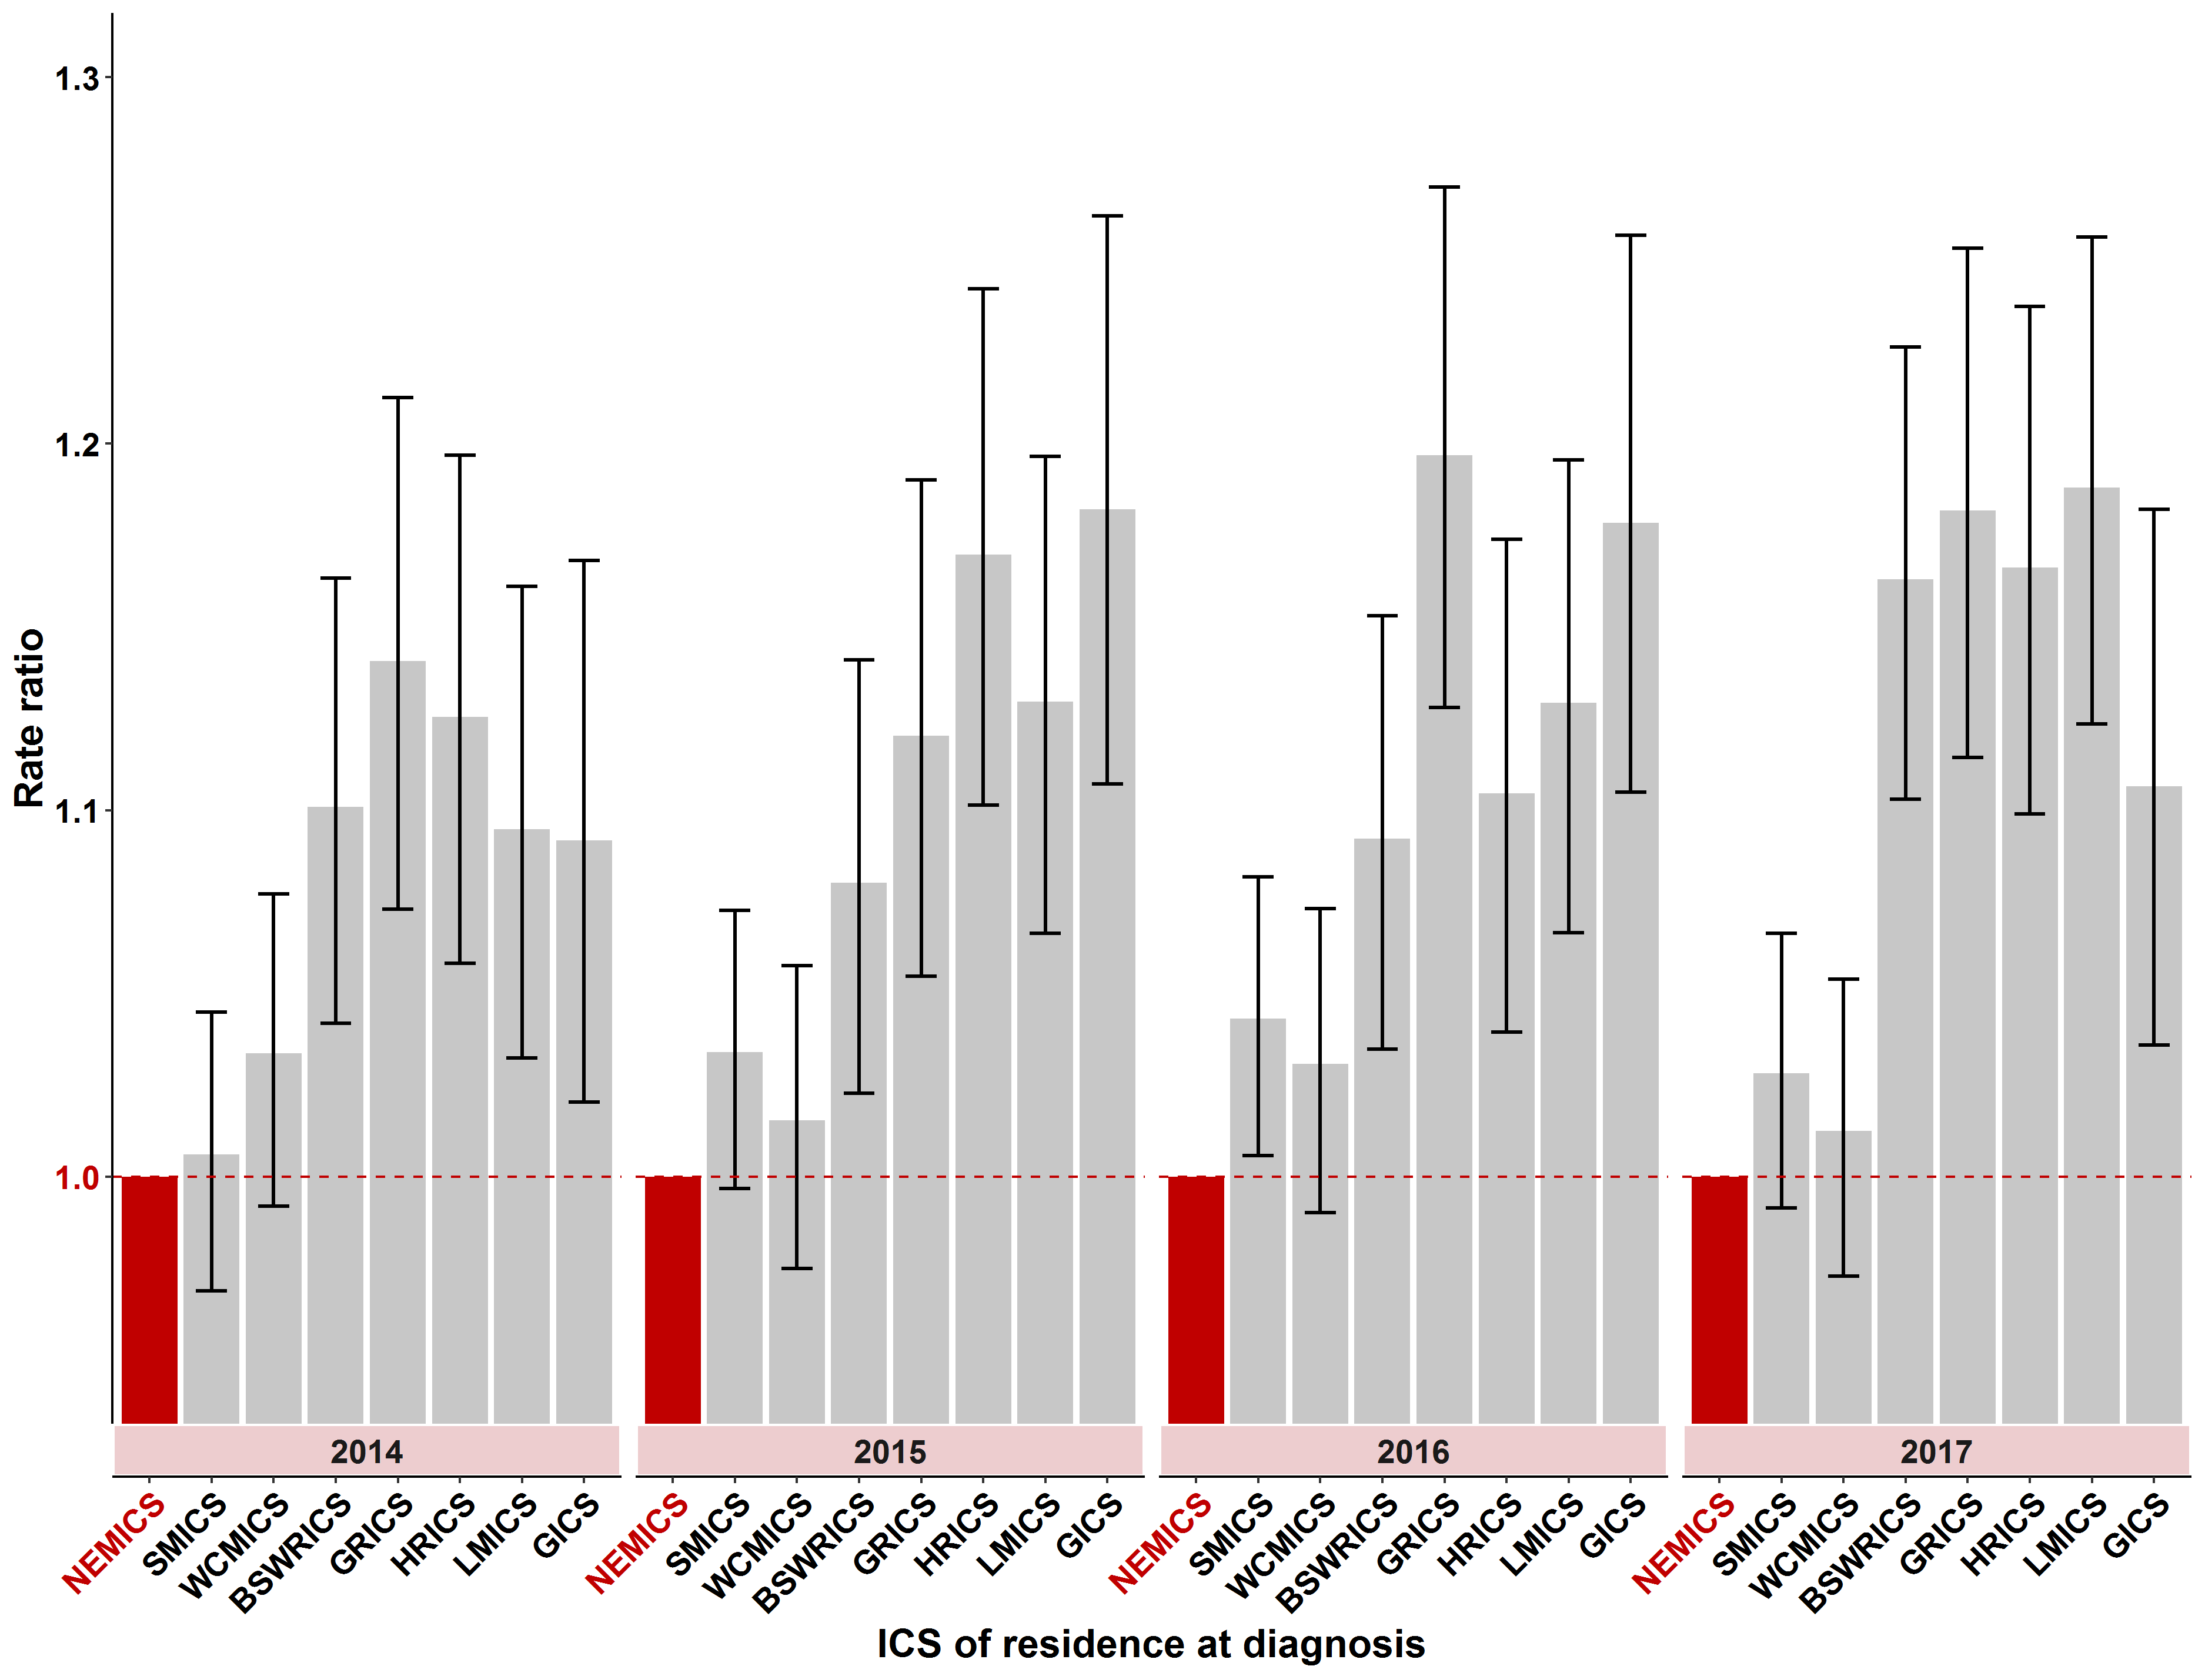
Notes:
Estimated and projected resident population files sourced from the ABS. Note that at the time of preparing results, the ABS had not yet finalised the 2017 ERP.
The baseline ICS for calculating the rate of ratios for each year is the ICS with the lowest adjusted incidence rate for the year of interest and is highlighted in red. A rate ratio greater than one indicates a higher incidence rate than the baseline ICS.
Table 4.1: Rate ratio of preventable cancer incidence in ICS of residence compared with the ICS of residence with the lowest adjusted incidence rate, grouped by year of diagnosis from 2014 to 2017
ICS | 2014  (95% CI) | 2015  (95% CI) | 2016  (95% CI) | 2017  (95% CI)
NEMICS | N/A | N/A | N/A | N/A
SMICS | 1.0  (0.9–1.1) | 1.0  (0.9–1.1) | 1.0  (0.9–1.1) | 1.0  (0.9–1.1)
WCMICS | 1.0  (0.9–1.1) | 1.0  (0.9–1.1) | 1.0  (0.9–1.1) | 1.0  (0.9–1.1)
BSWRICS | 1.1  (1.0–1.2) | 1.1  (1.0–1.2) | 1.1  (1.0–1.2) | 1.2  (1.1–1.3)
GRICS | 1.1  (1.0–1.2) | 1.1  (1.0–1.2) | 1.1  (1.0–1.2) | 1.2  (1.1–1.3)
HRICS | 1.1  (1.0–1.2) | 1.2  (1.1–1.3) | 1.1  (1.0–1.2) | 1.2  (1.1–1.3)
LMICS | 1.1  (1.0–1.2) | 1.1  (1.0–1.2) | 1.1  (1.0–1.2) | 1.2  (1.1–1.3)
GICS | 1.1  (1.0–1.2) | 1.2  (1.1–1.3) | 1.2  (1.1–1.3) | 1.1  (1.0–1.2)

Measure assessment
Traffic light rating: Amber (desired result not yet evident)
Overall trend: Static or unchanging
Commentary: Figure 4.1 and Table 4.1 show there are disparities in cancer outcomes between people living in metropolitan versus non-metropolitan regions, with the rate of preventable cancer incidence between ICS from 2014 to 2017 generally lower in ICSs with large metropolitan areas such as Melbourne compared with those who service regional patients. While no target has been set for this measure, the Department of Health and Human Services recognises and is addressing the need to improve access to cancer treatment within non-metropolitan regions.

Measure 4.2 – Rate ratio of preventable cancer incidence between socioeconomic quintiles
Figure 4.2: Rate ratio of preventable cancer incidence (with confidence intervals) for Victoria in SES quintiles 1–4 (where SES 1 is most disadvantaged) compared with the least disadvantaged SES (quintile 5), grouped by year of diagnosis, 2014–2017
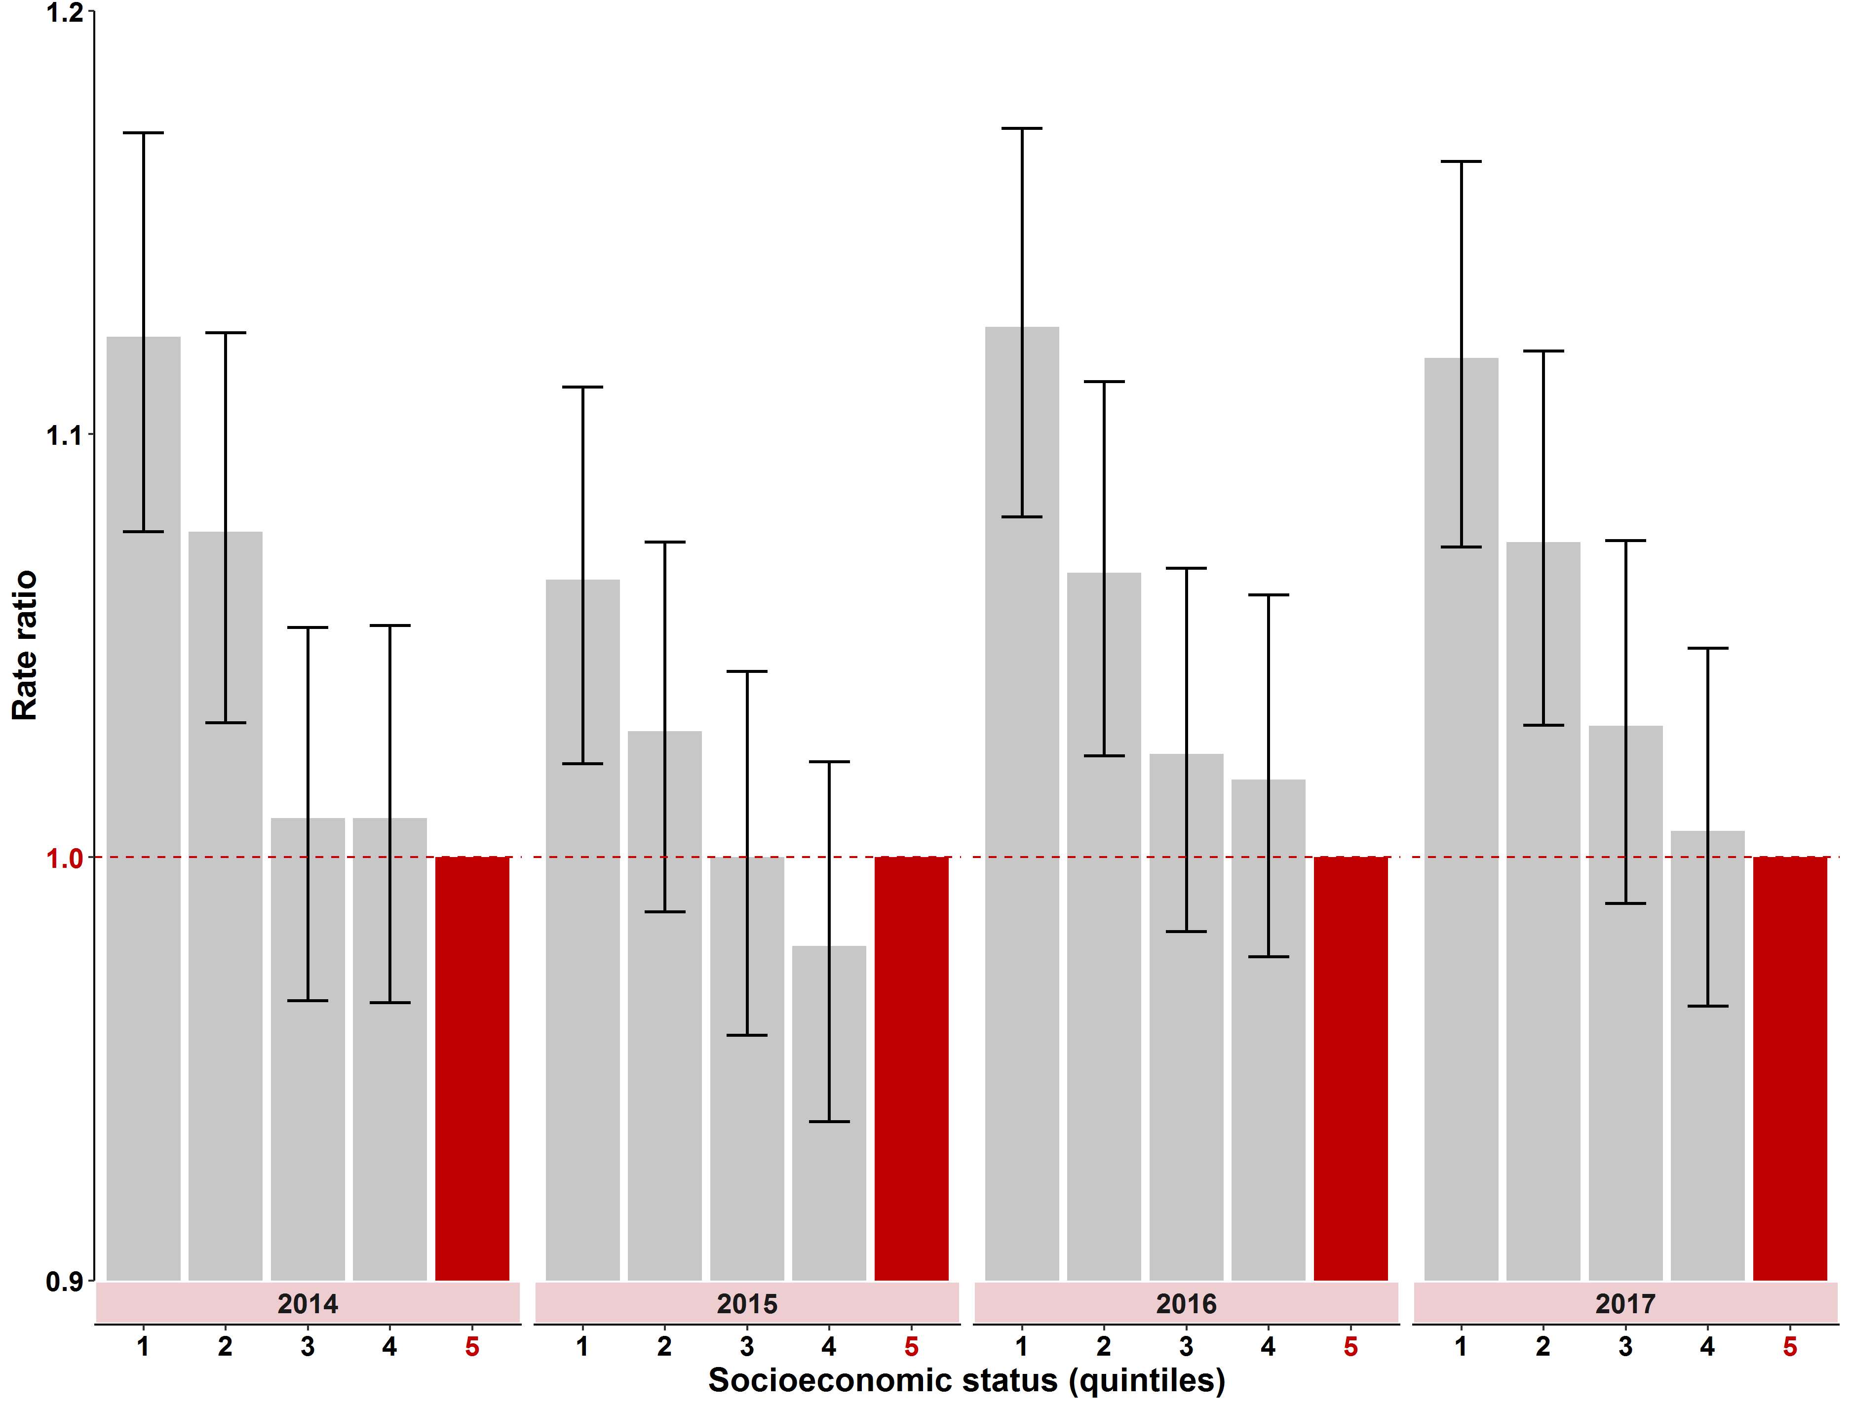

Notes:
Estimated and projected resident population files sourced from the ABS. Note that at the time of preparing results, the ABS had not yet finalised the 2017 ERP.
The baseline socioeconomic status (SES) quintile used for calculating the rate of ratios for each year is quintile 5 (least disadvantaged) and is highlighted in red. A rate ratio greater than one indicates a higher incidence rate than the baseline ICS.
Table 4.2: Rate ratio of preventable cancer incidence (with confidence intervals) for Victoria in SES quintiles 1–4 (where SES 1 is most disadvantaged) compared with the least disadvantaged SES, grouped by year of diagnosis, 2014–2017
SES | 2014  (95% CI) | 2015  (95% CI) | 2016  (95% CI) | 2017  (95% CI)
Quintile 1 (most disadvantaged) | 1.1  (1.0–1.2) | 1.1  (1.0–1.2) | 1.1  (1.0–1.2) | 1.1  (1.0–1.2)
Quintile 2 | 1.1  (1.0–1.2) | 1.0  (0.9–1.1) | 1.1  (1.0–1.2) | 1.1  (1.0–1.2)
Quintile 3 | 1.0  (0.9–1.1) | 1.0  (0.9–1.1) | 1.0  (0.9–1.1) | 1.0  (0.9–1.1)
Quintile 4 | 1.0  (0.9–1.1) | 1.0  (0.9–1.1) | 1.0  (0.9–1.1) | 1.0  (0.9–1.1)
Quintile 5 – (least disadvantaged)  (refer to note below Figure 4.2.1) | N/A | N/A | N/A | N/A

Measure assessment
Traffic light rating: Amber (desired result not yet evident)
Overall trend: Static or unchanging
Commentary: Socioeconomic disparities in incidence have been described for a range of cancers globally across various measures of socioeconomic circumstances. Figure 4.2.1 and Table 4.2 show that the rate of preventable cancer incidence increases as SES decreases. For example, in the period from 2010 to 2017, Victorians who were in the most disadvantaged quintile (first quintile) had a potentially preventable cancer incidence rate that was 1.1 times higher than the potentially preventable cancer incidence for all Victorians. While a target has not been set for this measure, studying the relationship between socioeconomic circumstances and cancer incidence in Victoria may identify opportunities to improve the reach and effectiveness of cancer-related improvement activities.

Measure 4.3 – Rate ratio of preventable cancer incidence between Aboriginal and non-Aboriginal Victorians
Figure 4.3: Rate ratio of preventable cancer incidence (with confidence intervals) for Aboriginal Victorians relative to non-Aboriginal Victorians, by year of diagnosis, 2014–2017
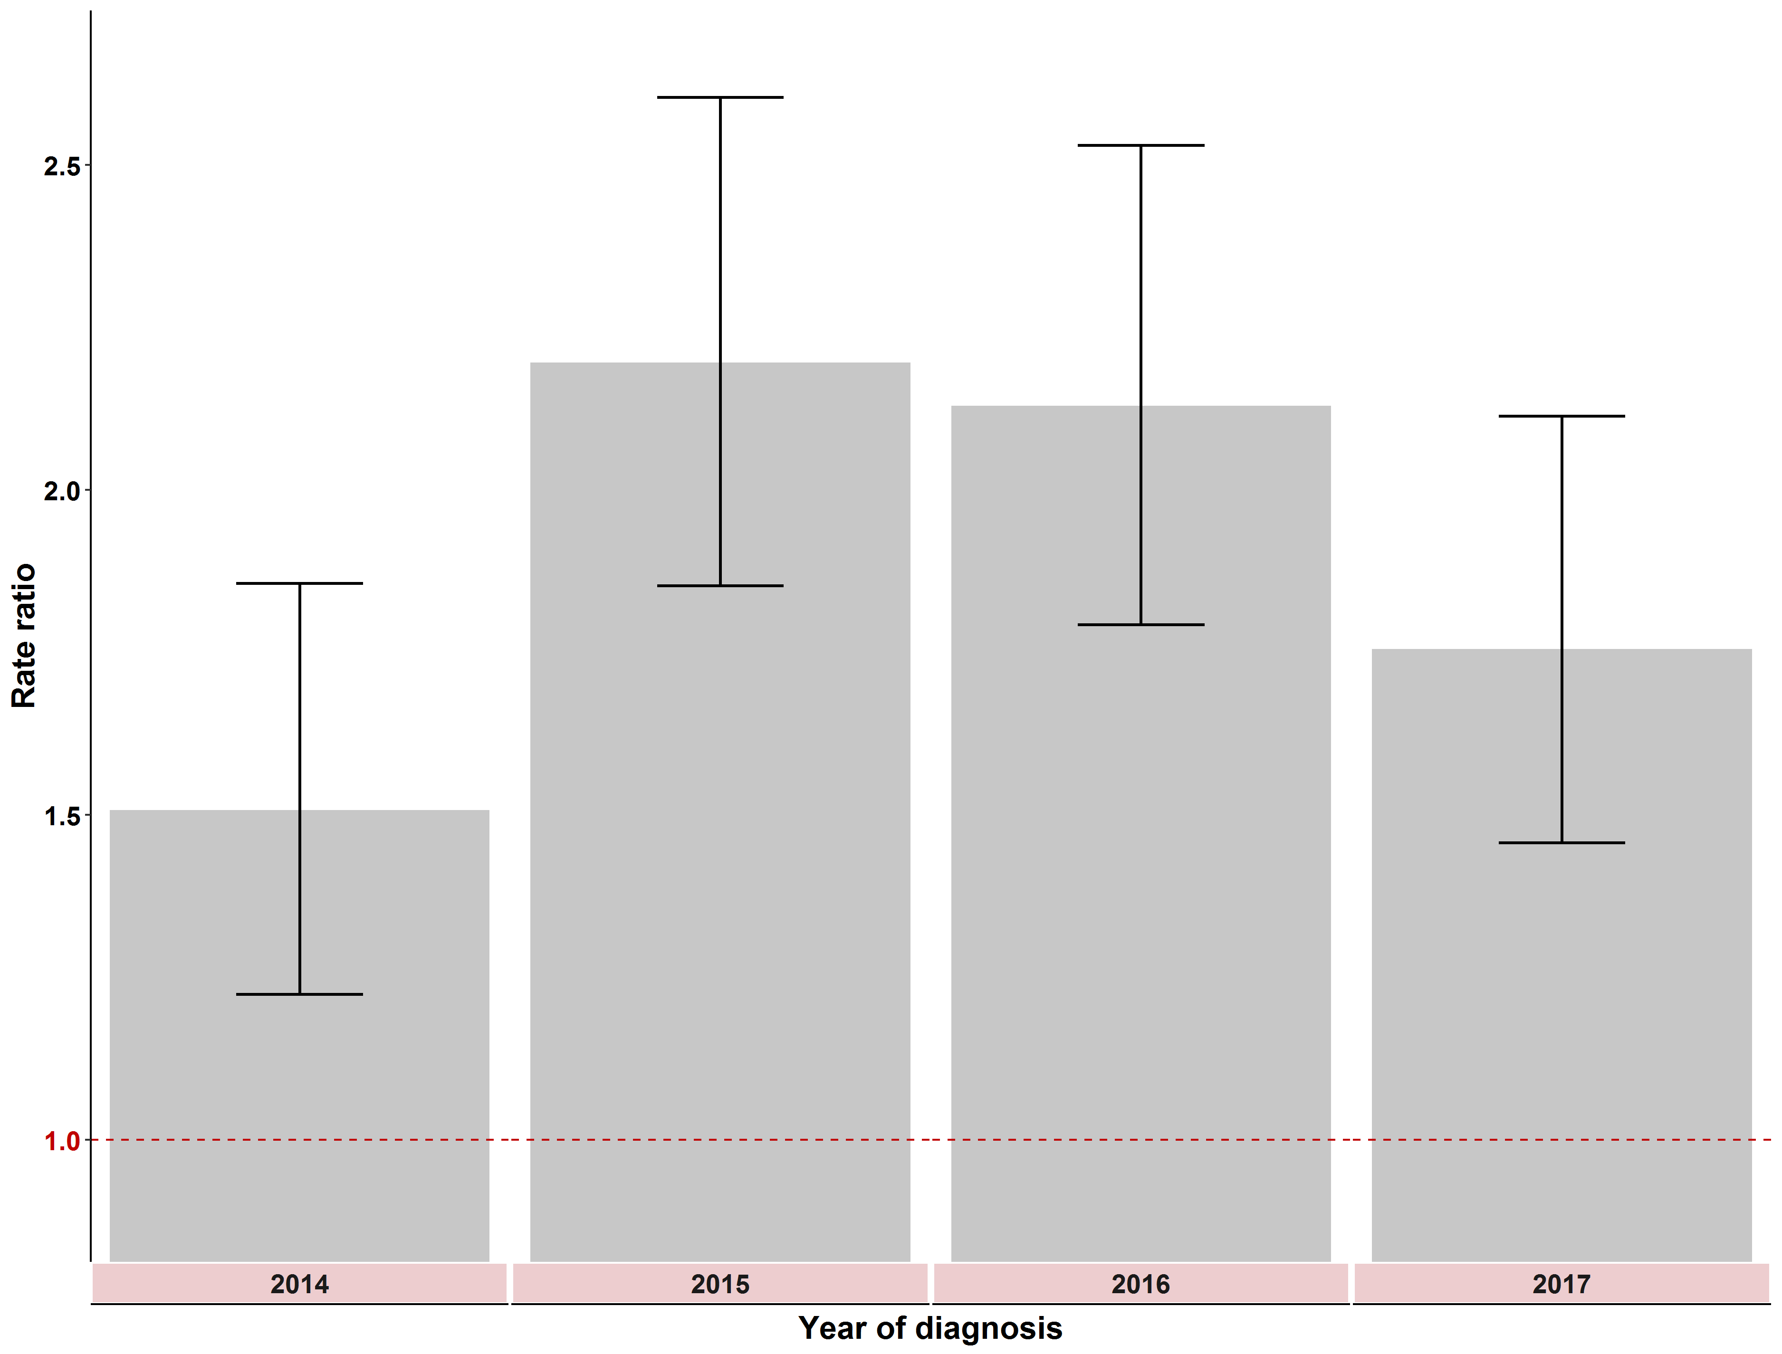
A rate ratio of 1.0 indicates no difference
Notes:
These rate ratios are calculated as the Aboriginal and Torres Strait Islander adjusted incidence rate compared to non- Aboriginal and Torres Strait Islander for each year. A rate ratio greater than one indicates a higher incidence rate for Aboriginal and Torres Strait Islander individuals than non-Aboriginal and Torres Strait Islander individuals.
ERP files were sourced from ABS. Note at the time of preparing this report, the ABS had not yet finalised 2017 ERP. The ERP for the non-Aboriginal population in Victoria was calculated by subtracting the Aboriginal and Torres Strait Islander projected population from the total ERP.
Table 4.3: Rate ratio of preventable cancer incidence (with confidence intervals) between Aboriginal and non-Aboriginal Victorians, by year of diagnosis, 2014–2017
Year | 2014 | 2015 | 2016 | 2017
Result | 1.5 | 2.2 | 2.1 | 1.8
(95% CI) | (1.3–1.7) | (2.0–2.4) | (1.9–2.3) | (1.6–1.9)

Measure assessment
Traffic light rating: Red (result is of concern)
Overall trend: Static or unchanging
Commentary: Reducing the impact of preventable cancer among Aboriginal and Torres Strait Islander people is a crucial aspect in ‘closing the gap’ in health outcomes. Although Aboriginal and Torres Strait Islander people are less likely to have some types of cancer, they are significantly more likely to have cancers that have a poor prognosis, but that are largely preventable, such as lung and liver cancer. In the literature, risk factors for higher incidence of preventable cancers remain prevalent in Aboriginal and Torres Strait Islander people, include smoking, risky drinking and poor diet. Figure 4.3 and Table 4.3 show that between 2014 and 2017 Aboriginal Victorians were between one and a half to over two times more likely to have a high incidence rate of preventable cancer than non-Aboriginal Victorians. While a target has not been set for this measure, it is recognised that to address this disparity, programs (including screening programs) designed to improve equity in cancer outcomes for all Victorians are warranted.

Key result: Equitably reduce cancer deaths

Measure 5.1 – Rate ratio of premature death rate due to cancer between Integrated Cancer Services
Figure 5.1: Rate ratio of premature death (with confidence intervals) due to cancer in ICS of residence compared with the ICS of residence with the lowest premature death rate, grouped by year of diagnosis, 2014–2017
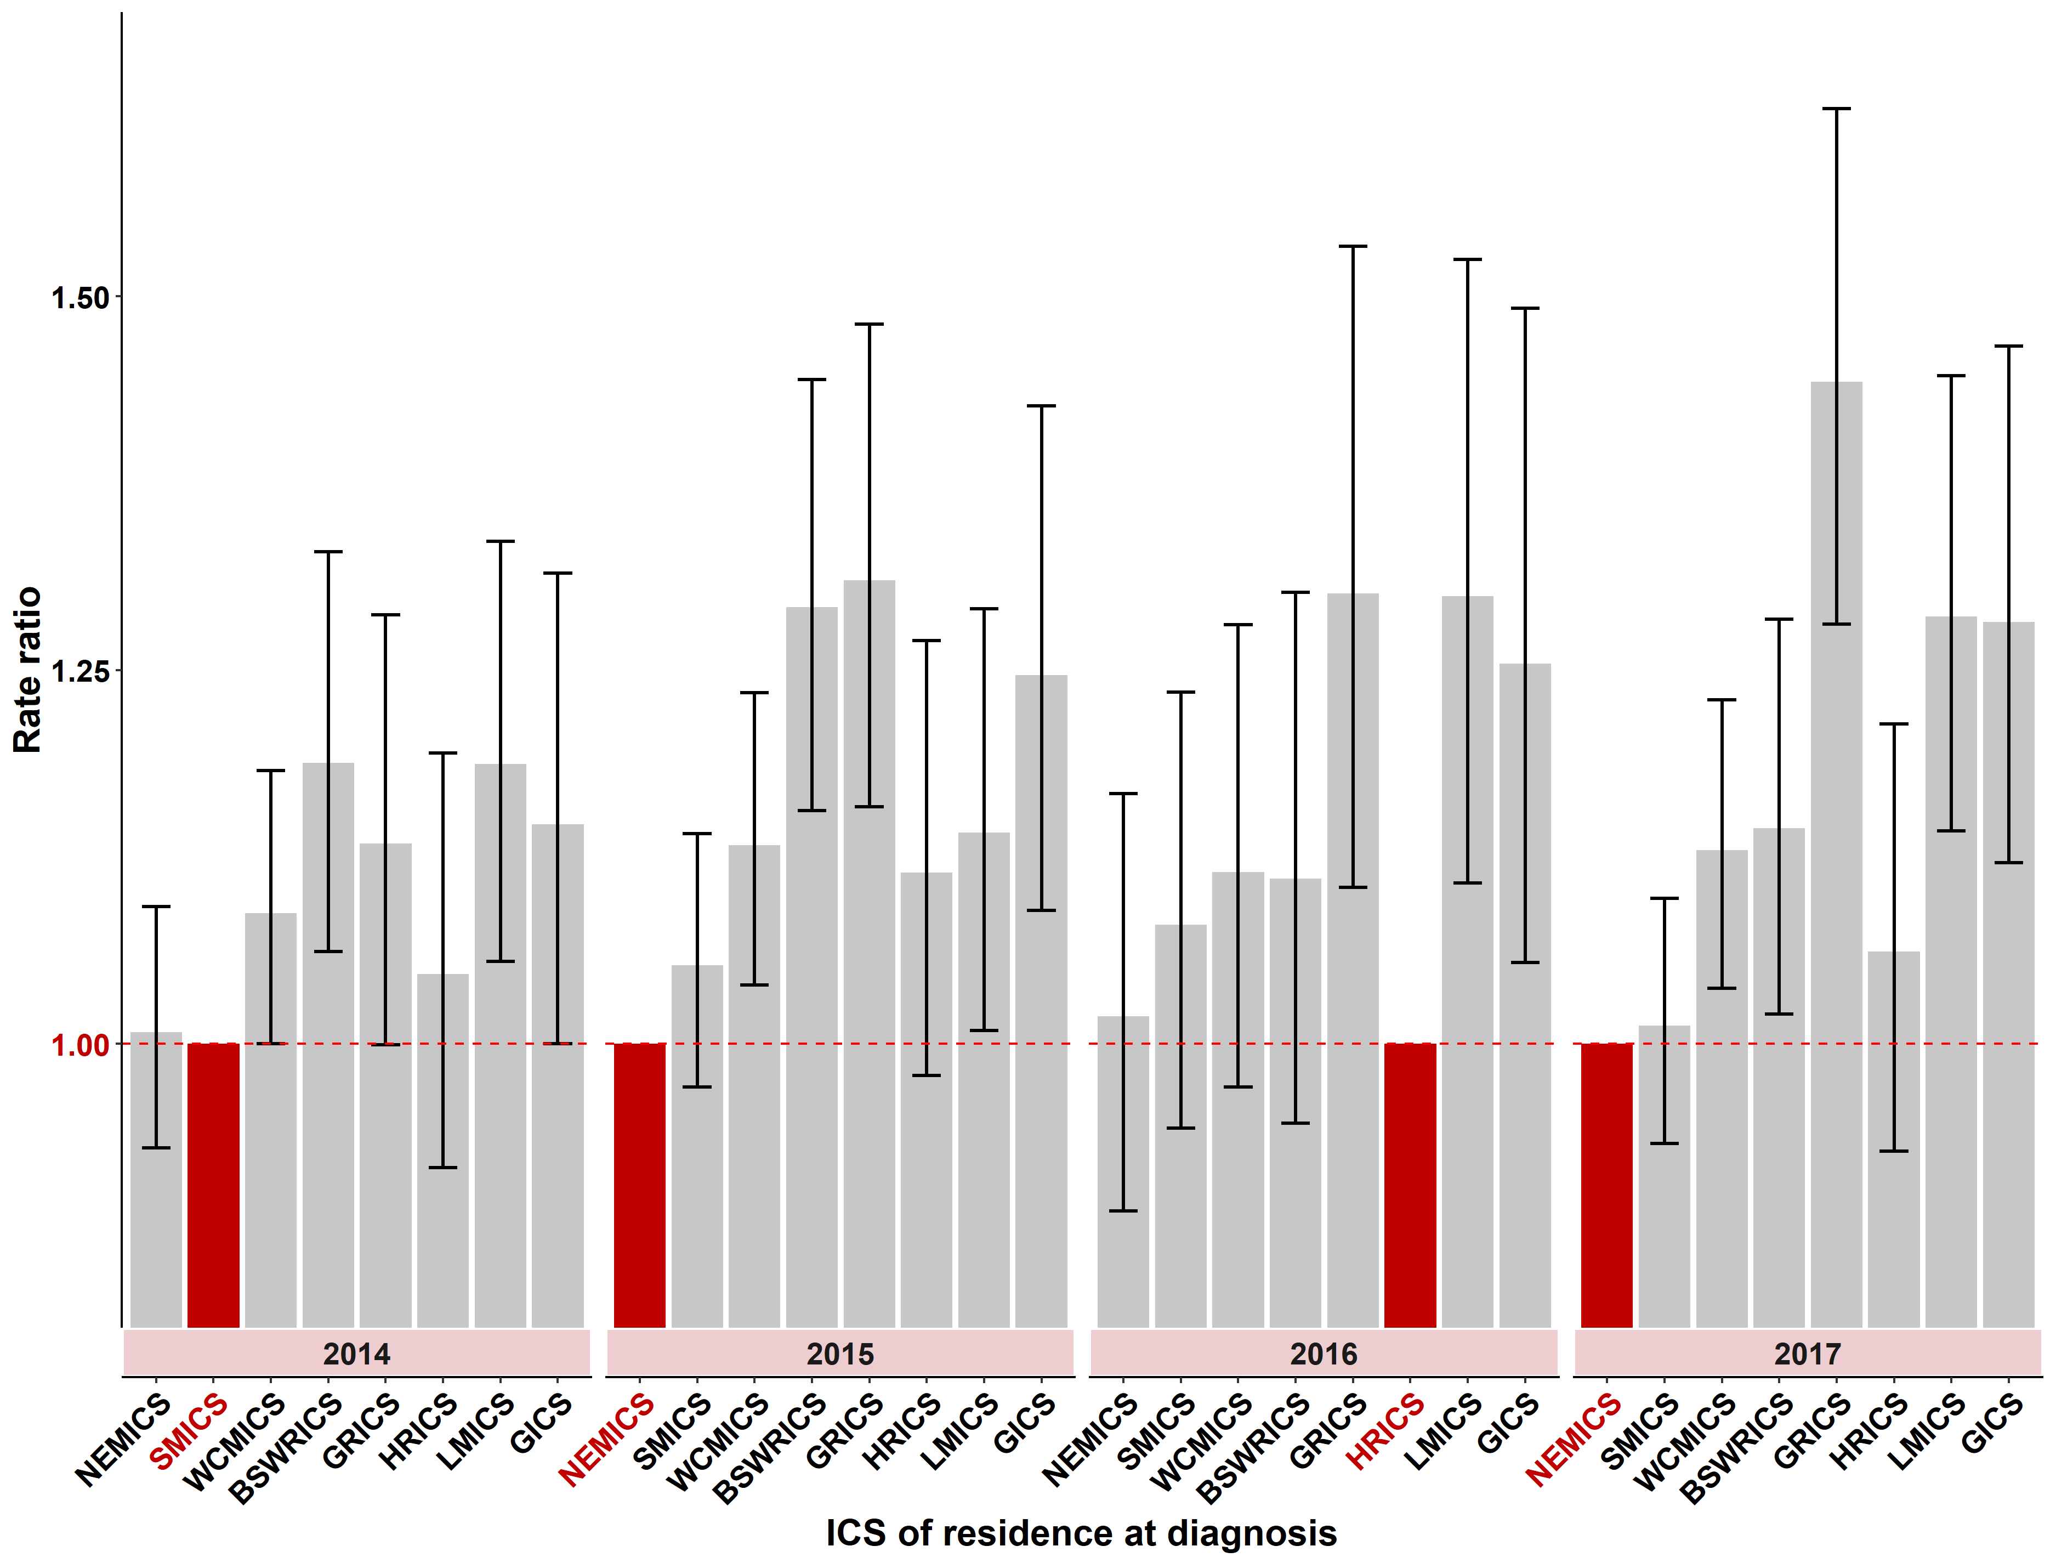

Note: ERP files were sourced from the ABS. Note at the time of preparing this report, the ABS had not yet finalised 2017 ERP.
The baseline ICS for calculating the rate ratios for each year is the ICS with the lowest adjusted incidence rate for the year of interest and is highlighted in red. A rate ratio greater than one indicates a higher incidence rate than the baseline ICS.

Table 5.1: Rate ratio of premature death (with confidence intervals) due to cancer in ICS of residence compared with the ICS of residence with the lowest premature death rate, grouped by year of diagnosis, 2014–2017
ICS | 2014  (95% CI) | 2015  (95% CI) | 2016  (95% CI) | 2017  (95% CI)
NEMICS | 1.0  (0.9–1.1) | Ref Point | 1.0  (0.8–1.2) | Ref Point
SMICS | Ref Point | 1.1  (1.0–1.2) | 1.1  (0.9–1.2) | 1.0  (0.9–1.1)
WCMICS | 1.1  (1.0–1.2) | 1.1  (1.0–1.2) | 1.1  (1.0–1.3) | 1.1  (1.0–1.2)
BSWRICS | 1.2  (1.1–1.3) | 1.3  (1.2–1.4) | 1.1  (1.0–1.3) | 1.1  (1.0–1.2)
GRICS | 1.1  (1.0–1.3) | 1.3  (1.2–1.4) | 1.3  (1.1–1.5) | 1.4  (1.3–1.6)
HRICS | 1.0  (0.9–1.2) | 1.1  (1.0–1.2) | Ref Point | 1.1  (0.9–1.2)
LMICS | 1.2  (1.1–1.3) | 1.1  (1.0–1.3) | 1.3  (1.1–1.5) | 1.3  (1.2–1.4)
GICS | 1.1  (1.0–1.3) | 1.2  (1.1–1.3) | 1.3  (1.1–1.4) | 1.3  (1.2–1.4)
Note: Ref Point = the reference point – that is, the ICS residents with the lowest premature death rate for that particular year

Measure assessment
Traffic light rating: Amber (desired result not yet evident)
Overall trend: Static or unchanging
Commentary: Figure 5.1 and Table 5.1 show that between 2014 and 2017, regional ICSs had populations that were experiencing a greater burden of disease due to cancer, in particular the Gippsland Regional ICS, Loddon Mallee ICS and Grampians ICS, which on average had a higher rate of premature death. No target has been set for this measure; however, what these results show is that initiatives designed to address this disparity faced by Victorians in rural and remote regions who are diagnosed with cancer are warranted.

Measure 5.2 – Rate ratio of premature death rate due to cancer between socioeconomic quintiles
Figure 5.2: Rate ratio of premature death (with confidence intervals) due to cancer in SES quintiles 1–4 (where SES 1 is most disadvantaged) compared with the least disadvantaged SES, grouped by year of diagnosis, 2014–2017
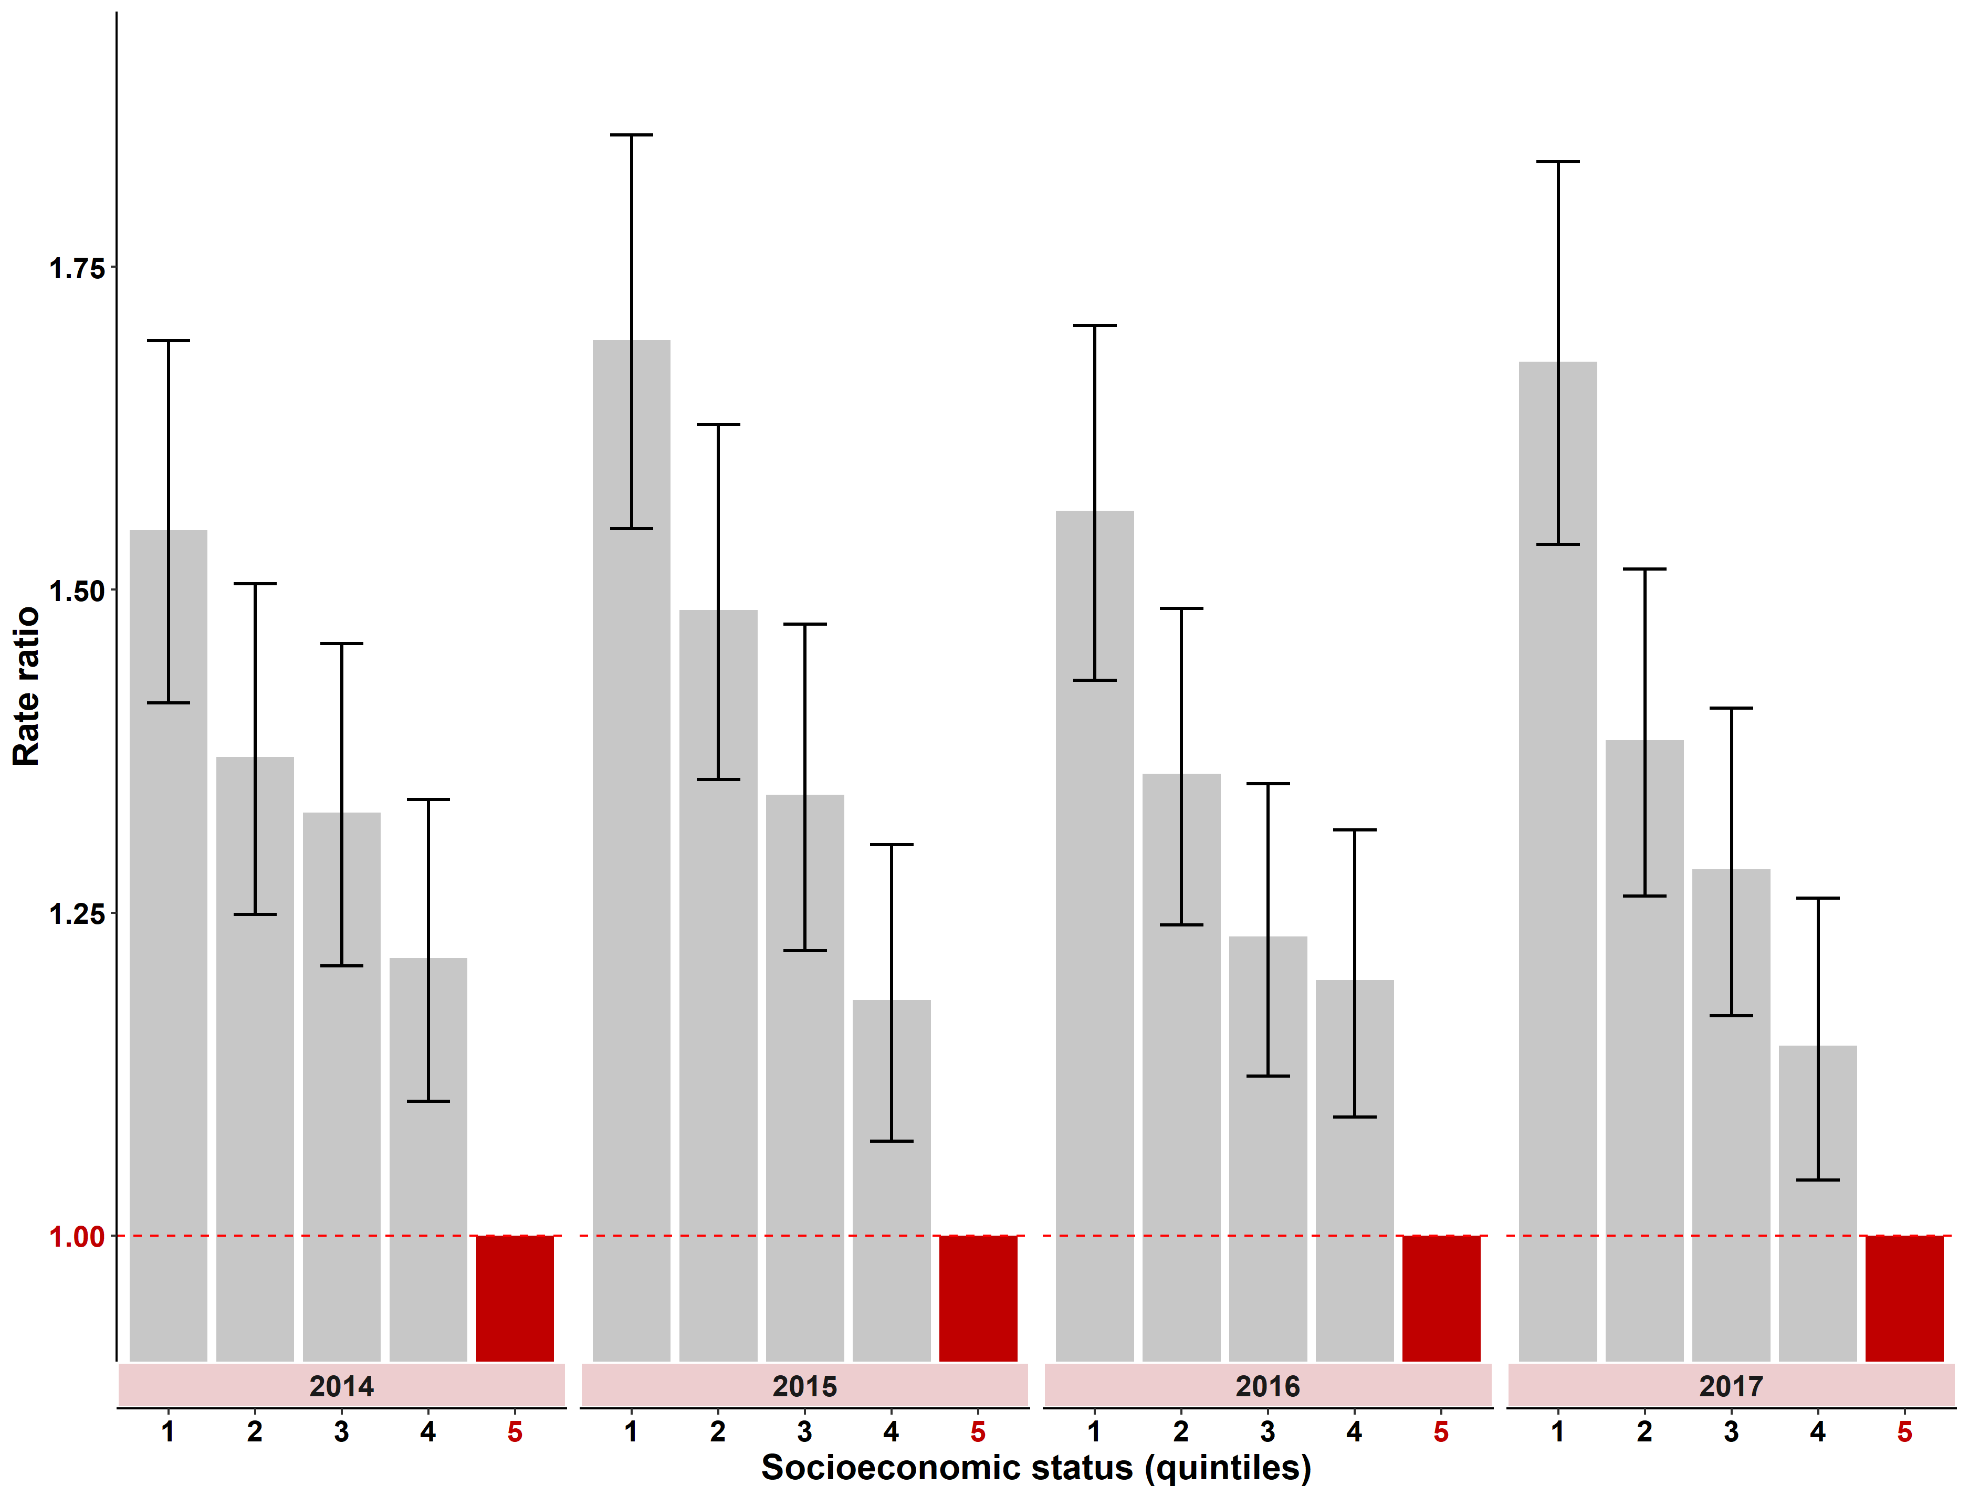

Note: ERP files were sourced from ABS. Note at the time of preparing this report, the ABS had not yet finalised the 2017 ERP.
The baseline socioeconomic status (SES) quintile used for calculating the rate ratios for each year is SES quintile 5 (least disadvantaged) and is highlighted in red. A rate ratio greater than one indicates a higher incidence rate than the baseline SES quintile.

Table 5.2: Rate ratio of preventable cancer incidence (with confidence intervals) for Victoria in SES quintiles 1–4 (where SES 1 is most disadvantaged) compared with the least disadvantaged SES, grouped by year of diagnosis, 2014–2017
SES | 2014  (95% CI) | 2015  (95% CI) | 2016  (95% CI) | 2017  (95% CI)
Quintile 1 (most disadvantaged) | 1.5  (1.4–1.6) | 1.7  (1.6–1.8) | 1.6  (1.5–1.7) | 1.7  (1.6–1.8)
Quintile 2 | 1.4  (1.3–1.5) | 1.5  (1.4–1.6) | 1.4  (1.3–1.5) | 1.4  (1.3–1.5)
Quintile 3 | 1.3  (1.2–1.4) | 1.3  (1.2–1.4) | 1.2  (1.1–1.3) | 1.3  (1.2–1.4)
Quintile 4 | 1.2  (1.1–1.3) | 1.2  (1.1–1.3) | 1.2  (1.1–1.3) | 1.1  (1.0–1.2)
Quintile 5 – refer to note below Figure 5.2 | Ref Point | Ref Point | Ref Point | Ref Point
Note: Ref Point = the reference point – that is, the SES residents with the lowest premature death rate for that particular year

Measure assessment
Traffic light rating: Red (result is of concern)
Overall trend: Static or unchanging
Commentary: Figure 5.2 shows that the rate of premature death rate increases as SES declines. For example, in the period 2014–2017, Victorians who were in the most disadvantaged quintile (first quintile) had a premature death rate that was significantly higher than the other quintiles for all the years reported (Figure 5.2). In 2017 the premature death rate for Victorians living in the lowest socioeconomic quintile (first quintile) was 1.7 times higher compared with the premature death rate for those living in the highest socioeconomic areas (fifth quintile) (Table 5.2). While a target has not been set for this measure, the mix of cancers needs to be carefully considered in the context of “all cancers” because of the disparities that exist in cancer survival and death (including premature death) rates between SES groups reflects the mix of cancers prevalent in each group with very different mortality/survival patterns. For example, lower SES quintiles have higher rates of smoking and lung cancer with higher mortality/lower mortality rates. This is contrary to higher SES quintiles which have higher rates of prostate cancer with higher survival rates. Nevertheless, studying the relationship between socioeconomic circumstances and premature cancer death rate across Victoria may identify opportunities to improve the reach and effectiveness of health improvement activities.

Measure 5.3 – Rate ratio of premature death between Aboriginal and non-Aboriginal Victorians
Figure 5.3: Rate ratio of premature death (with confidence intervals) between Aboriginal and non-Aboriginal Victorians by year, 2014–2017
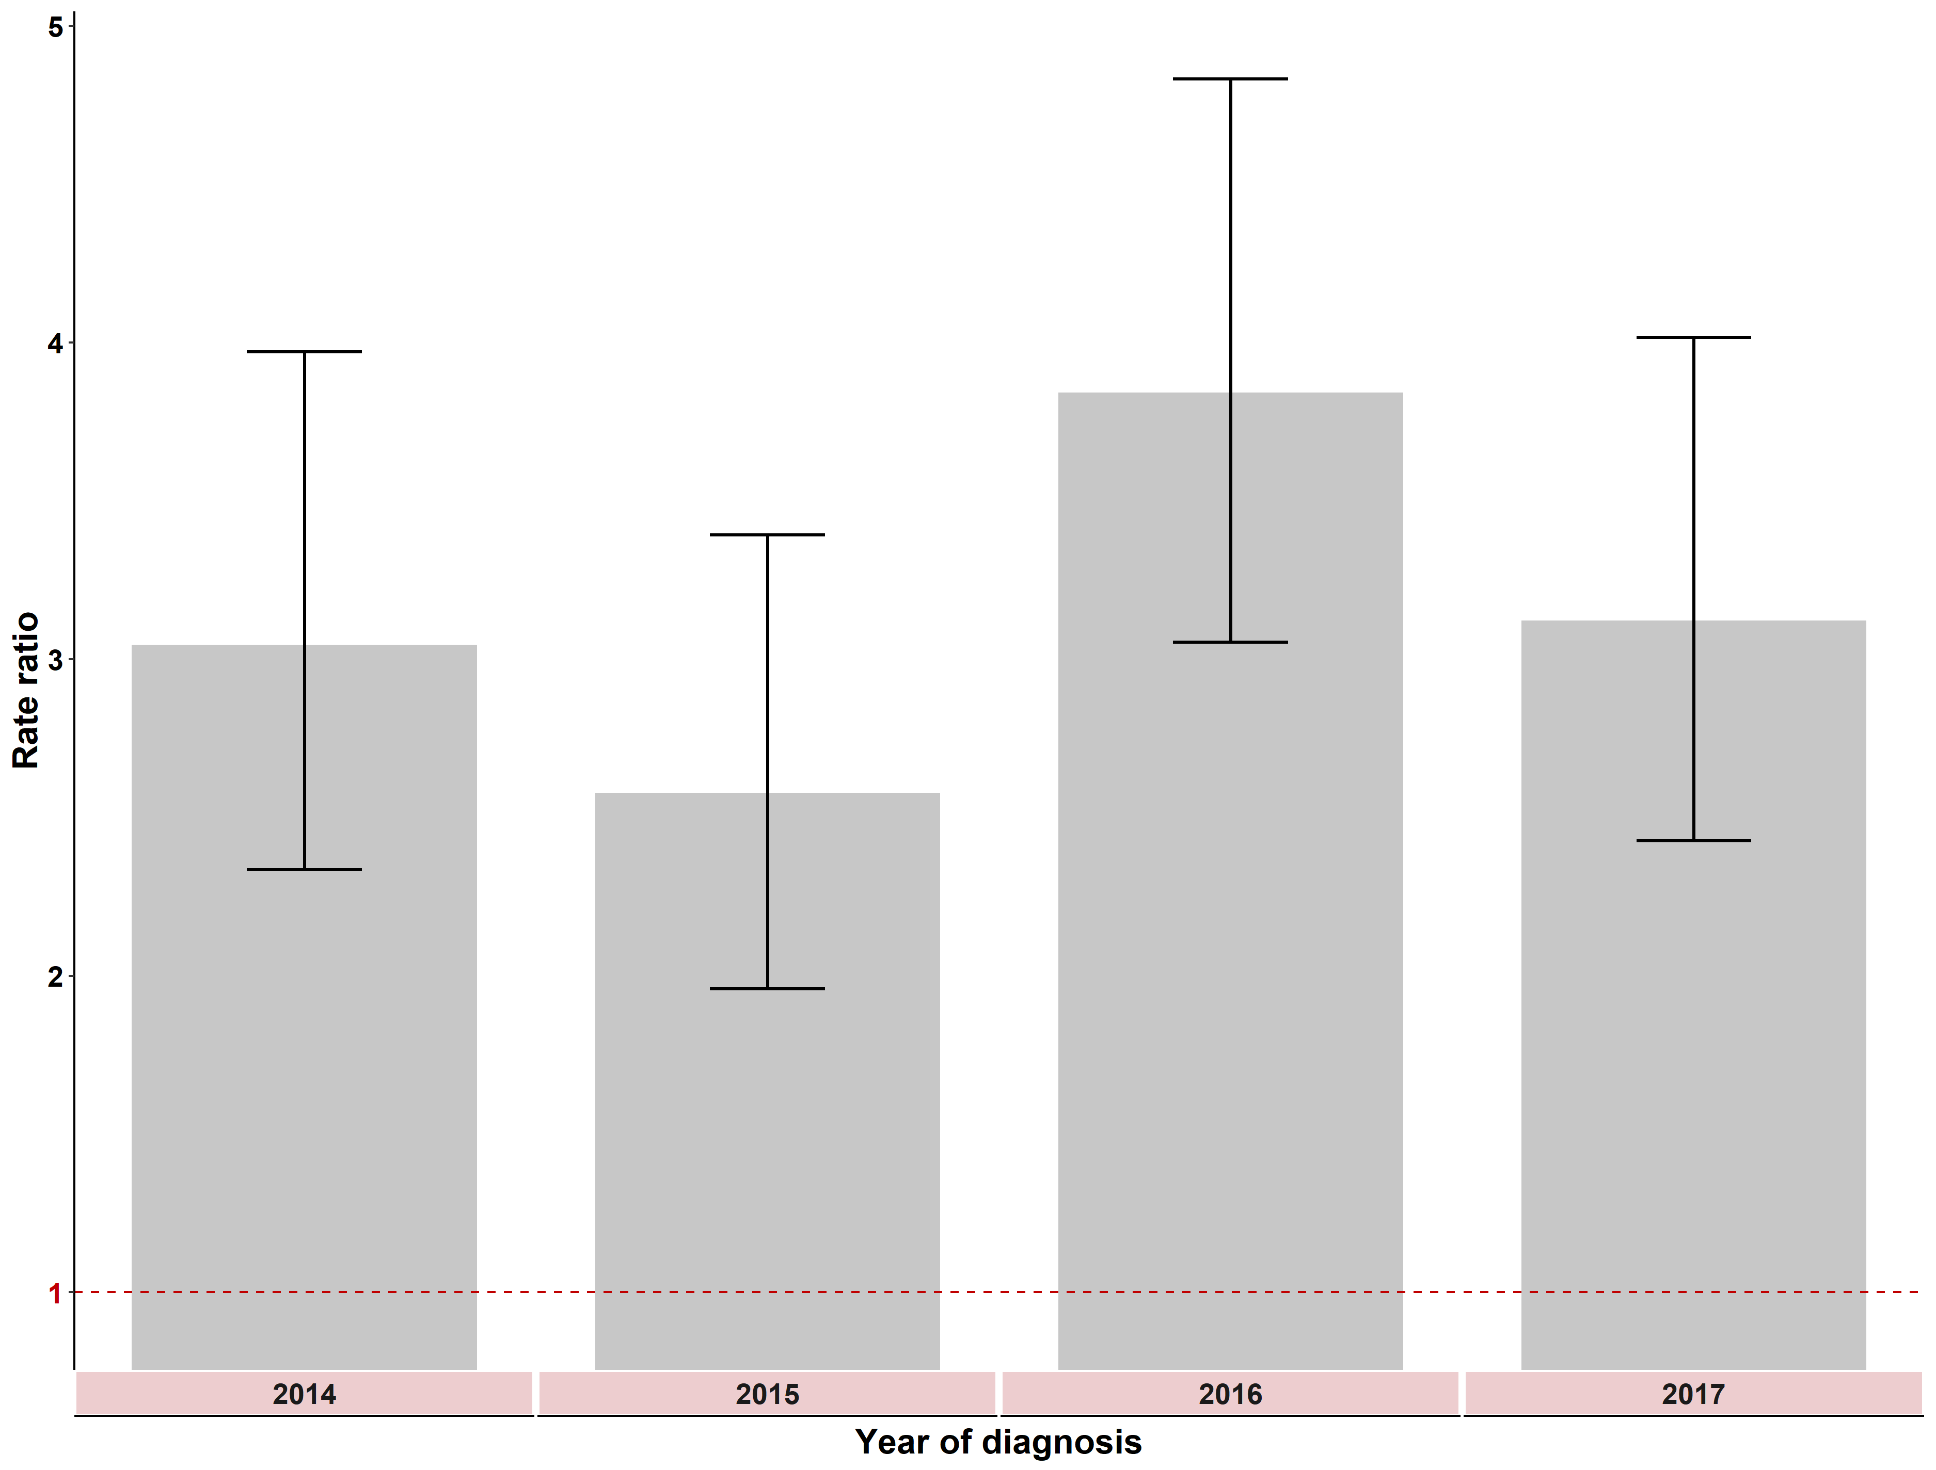

Note: ERP files were sourced from the ABS. Note at the time of preparing this report, the ABS had not yet finalised the 2017 ERP. The ERP for the Non-Aboriginal Victorian population was calculated by subtracting the Aboriginal and Torres Strait Islander projected population from the total ERP.
These rate ratios are calculated as the Aboriginal and Torres Strait Islander adjusted incidence rate compared to non- Aboriginal and Torres Strait Islander adjusted rate for each year. A rate ratio greater than one indicates a higher incidence rate for Aboriginal and Torres Strait Islander individuals than non- Aboriginal and Torres Strait Islander individuals. A rate of 1.0 indicates no difference.
Table 5.3: Rate ratio of premature death (with confidence intervals) between Aboriginal and non-Aboriginal Victorians, by year, 2014–2017
Year | 2014 | 2015 | 2016 | 2017
Result | 3.0 | 2.6 | 3.8 | 3.1
(95% CI) | (2.8–3.3) | (2.3–2.9) | (3.6–4.1) | (2.9–3.4)

Measure assessment
Traffic light rating: Red (result is of concern)
Overall trend: Moving in the wrong direction
Commentary: In 2016, Aboriginal Victorians had a premature death rate that was almost four times higher (3.8) than non-Aboriginal Victorians but decreased in 2017 to 3.1 (Figure 5.3 and Table 5.3). This trend is consistent with national reporting, which has shown that Aboriginal and Torres Strait Islander Australians have a higher premature cancer death rate attributable to screen-detectable and preventable cancers and cancers that are diagnosed at more advanced stages, and often with more complex comorbidities. Compared with non-Indigenous Australians diagnosed with the same cancer, Indigenous Australians are more likely to be doubly disadvantaged and therefore result in poorer health outcomes such as a higher premature death rate because they are usually diagnosed later with more advanced disease, are less likely to have treatment, and often wait longer for surgery than non-Indigenous patients.
Outcome: Prevent cancers

Key result: Decrease smoking and harmful alcohol consumption

Measure 6.1 – Proportion of adults who smoke daily
Figure 6.1: OECD adult population smoking daily, by gender, 2015 (or nearest year)
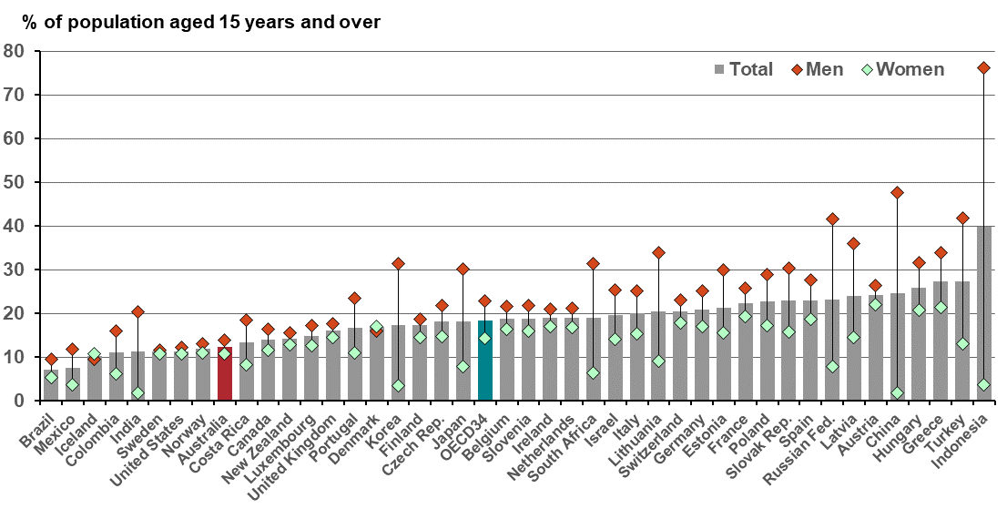
Source: OECD (2019), Daily smokers (indicator). doi: 10.1787/1ff488c2-en.
OCED 34 = the average of 34 OECD countries; Australia is highlighted in red
Note that the proportion of daily smokers is defined as the percentage of the population aged 15 years or older who self-report tobacco smoking daily.
Figure 6.1.1: Proportion of Australian adults (aged 18 years or older) who smoke daily, by state/territory,
2014–15
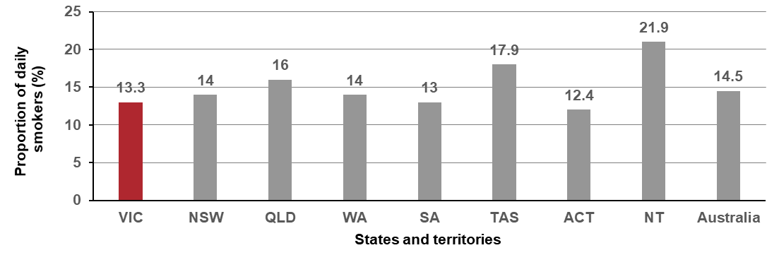
Source: ABS Australian Health Survey 2014–15 (4364.0)
Figure 6.1.2: Proportion of Victorian adults (aged 18 years or older) who smoke daily, by year, 2015–2017
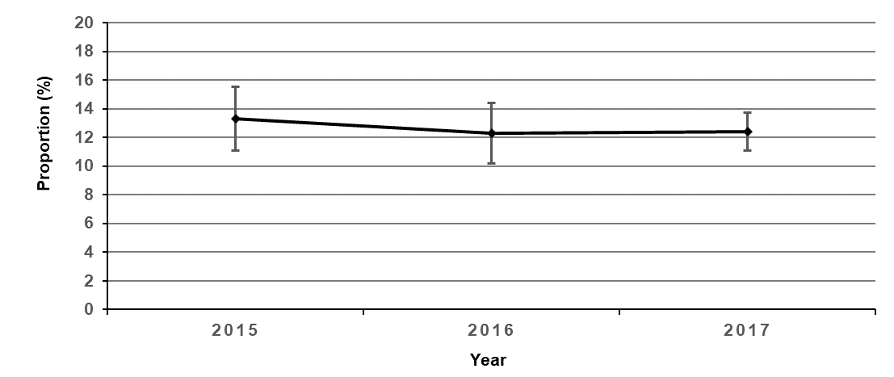
Table 6.1: Proportion of Victorian adults (aged 18 years or older) who smoke daily, by year, 2015–2017
Year | 2015 | 2016 | 2017
Per cent (%) | 13.3 | 12.3 | 12.4
95% CI | (12.2–14.4) | (11.3–13.4) | (11.8–13.1)
Source: Victorian Population Surveys 2015–2017

Measure assessment
Traffic light rating: Amber (desired result not yet evident)
Overall trend: Static or unchanging
Commentary: Tobacco smoking has been identified as the single largest cause of cancer globally and the predominant cause of lung cancer. The risk of developing lung cancer due to tobacco smoking is known to increase with the duration of smoking and the numbers of cigarettes smoked per day.
Figure 6.1 shows that in 2015 Australia had the ninth lowest proportion of daily smokers in the OECD among people aged 15 or older (12.4 per cent), with Indonesia ranking highest at 39.9 per cent. It is important to note that while the data shown in Figure 6.1 is intended to provide a general global overview, it is not directly comparable because adult daily smokers are defined as the population as aged 15 years or older. The data presented for Australian adults in Figure 6.1.1 shows that, in 2014–15, 14.5 per cent of adults aged 18 years or older were daily smokers, which equated to approximately 2.6 million adults. The Northern Territory had the highest rate of daily smokers (21.9 per cent) in 2014–15, followed by Tasmania (17.9 per cent). The Australian Capital Territory had the lowest rate of daily smokers in 2014–15 (12.4 per cent), while Victoria’s was 13.3. per cent. Figure 6.1.2 and Table 6.1 show that proportion of Victorian adults who smoke daily decreased from 13.3 per cent in 2015 to 12.4 per cent in 2017.

Measure 6.2 – Proportion of adolescents 12–17 years who currently smoke
Table 6.2: Proportion of Australian and Victorian adolescents aged 12–17 years (boys and girls) who currently smoke, by age and sex, 2014
Current smokers (Australia) | 12 yrs | 13 yrs | 14 yrs | 15 yrs | 16 yrs | 17 yrs | 12–17 yrs
Males (%) | 1.2 | 1.8 | 3.1 | 5.1 | 10.3 | 13.4 | 5.4
Females (%) | 0.9 | 1.8 | 4.0 | 5.9 | 7.3 | 10.9 | 4.9
Total (%) | 1.1 | 1.8 | 3.5 | 5.5 | 8.8 | 12.1 | 5.1
Current smokers (Victoria)
Males (%) | 1.0 | 2.0 | 3.0 | 5.0 | 10.0 | 13.0 | 6.0
Females (%) | 1.0 | 2.0 | 4.0 | 6.0 | 7.0 | 11.0 | 6.0

Sources:
White V, Williams T 2015. Australian secondary school students’ use of tobacco in 2014. Centre for Behavioural Research
in Cancer, Cancer Council Victoria. Available from: http://www.nationaldrugstrategy.gov.au/internet/drugstrategy/Publishing.nsf/content/school11

Victorian Department of Health and Human Services 2016. Tobacco, alcohol, over-the-counter and illicit substance use among Victorian secondary school students 2014. Available from: https://www2.health.vic.gov.au/about/publications/researchandreports/australian-secondary-students-alcohol-and-drug-survey-victorian-report-2014

Measure assessment
Traffic light rating: Amber (desired result not yet evident)
Overall trend: Could not be calculated due to only one data point
Commentary: Most adults who currently smoke will have started smoking when they were adolescents, therefore preventing tobacco use among young people is an integral part of ending the tobacco epidemic. Table 6.2 shows the proportion of males and females smoking cigarettes in different time periods at each age for Australia and Victoria. Involvement with smoking appears more common as adolescents progress through secondary school both nationally and in Victoria. In Victoria, the proportion of adolescents who were current smokers in 2014 increased from one per cent of 12-year-olds (males and females) to 11 per cent of 17-year-old females and 13 per cent of 17-year-old males. Overall six per cent of all Victorian adolescents 12–17 years were identified as current smokers, which was higher than the population of 12- to 17-year-old secondary school students throughout Australia (5.1 per cent).
Extrapolating these national results to the Australian student population, it is estimated that just under 81,000 of 12- to 17-year-old students in Australia in 2014 had smoked at least one cigarette in the seven days preceding the survey (current smokers). International comparisons of adolescent smoking prevalence show similar figures to Victoria. For example, the Canadian Student Tobacco, Alcohol and Drugs Survey found that in 2014–15, less than 2 per cent of students in grades 6–9 and about 10 per cent of students aged 15–19 were current smokers. Ireland’s Health Behaviour in School-aged Children Survey 2014 reported that eight per cent of 10‒17-year-olds were current smokers, although it should be noted that the latter cannot be directly comparable with national and Victorian data because the Irish study includes 10- and 11-year-olds.
Although no trend data is available for this age group, that six per cent of young Victorian people were classified in 2014 as current smokers requires continued and sustained attention at a population level, particularly because previous research has shown that smoking rates among adolescents increase when there is a reduction in tobacco control activity, including tobacco control advertising campaigns. To make certain that the gains made in ensuring that smoking prevalence among Australian adolescents does not increase from the 2014 baseline, interventions known to reduce adolescents’ involvement with smoking will need to continue. This will be important in ensuring that the target of a 30 per cent decrease in smoking among adolescents by 2025 from the 2014 baseline is reached.

Measure 6.3 – Proportion of adults who consume alcohol at lifetime risk of harm
Figure 6.3: Proportion of Victorian adults (aged 18 years or older) who consume alcohol at lifetime risk of harm, by year, 2014–2017
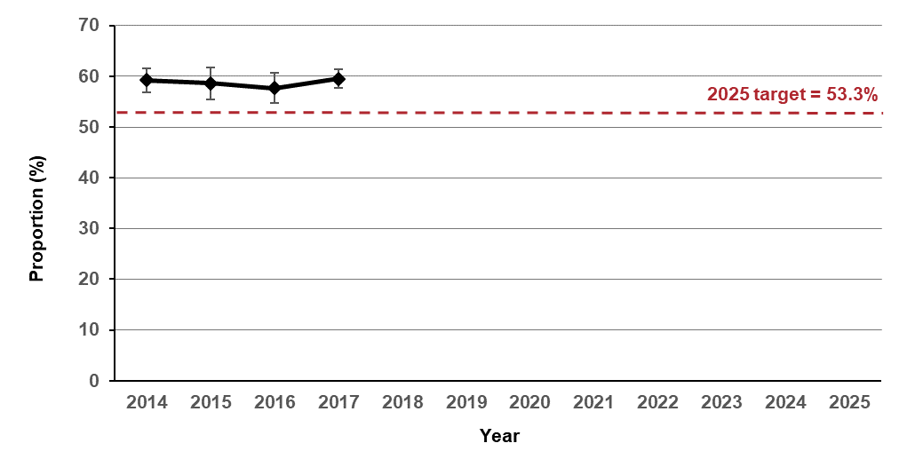
Table 6.3: Proportion of Victorian adults (aged 18 years or older) who consume alcohol at lifetime risk of harm, by year, 2014–2017
Year | 2014 | 2015 | 2016 | 2017
Per cent (%) | 59.2 | 58.6 | 57.7 | 59.5
95% CI | (58.0–60.3) | (57.0–60.2) | (56.3–59.2) | (58.6–60.4)
Source: Victorian Population Health Surveys 2014–2017 (age-standardised to 2011 Victorian population)

Measure assessment
Traffic light rating: Green (satisfactory result)
Overall trend: Moving in the right direction
Commentary: Lifetime risk of alcohol-related harm attempts to measure the risk associated with developing an illness that may include various cancers, namely cancers of the upper aerodigestive tract, liver, colorectal and female breast. For the purposes of this measure, lifetime risky alcohol consumption was determined if alcohol consumption exceeded the 2009 National Health and Medical Research Council (NHMRC) guidelines for reducing health risks associated with alcohol consumption. These guidelines state that, for healthy men and women, ‘drinking no more than two standard drinks on any day reduces the lifetime risk of harm from alcohol-related disease or injury’.
The Victorian public health and wellbeing outcomes framework has a target of a 10 per cent decrease in the number of adults who consume excess alcohol by 2025, from the 2014 baseline of 59.2 per cent (Figure and Table 6.3).
Currently Victoria is on track to meet the 2025 target of 53.3 per cent, with 59.5 per cent of adults reported in 2017 as being at an increased lifetime risk of alcohol-related harm based on the NHMRC’s 2009 guidelines.

Measure 6.4 – Proportion of adolescents 12–17 years who consume alcohol at least monthly
Figure 6.4: Proportion of Victorian adolescents aged 12–17 years (boys and girls) who consume alcohol at least monthly, by year, 2014 and 2016
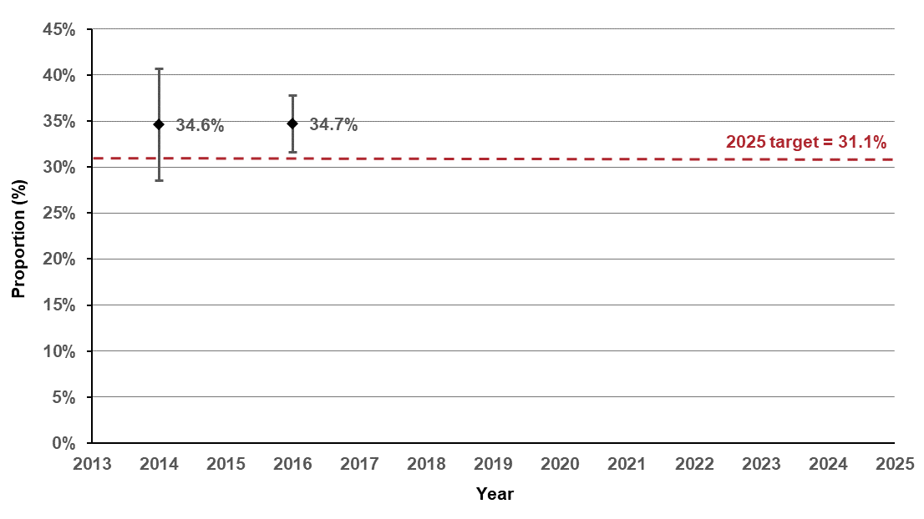
Table 6.4: Proportion of Victorian adolescents aged 12–17 years (boys and girls) who consume alcohol at least monthly, by year, 2014 and 2016
Year | 2014 |  | 2016
Per cent (%) | 34.6 |  | 34.7
95% CI | (31.6–37.7) |  | (33.1–36.2)
Source: Victorian Student Health and Wellbeing Survey, Department of Education and Training, 2016

Measure assessment
Traffic light rating: Red (result is of concern)
Overall trend: Not moving in the right direction
Commentary: The Victorian public health and wellbeing outcomes framework has a target of a 10 per cent decrease in adolescents excessively consuming alcohol by 2025 from a baseline year of 2014. Figure 6.4 shows that adolescents who consume alcohol at least monthly remained steady, from 34.6 per cent in 2014 to 34.7 per cent in 2016. This means that Victoria is not moving in the right direction to meet the 2025 target of 31.1 per cent.

Key result: Fruit and vegetable consumption of adults, adolescents and children

Measure 7.1 – Mean daily serves of fruit in adults
Figure 7.1: Daily fruit consumption among OECD adults, 2015 (or nearest year)
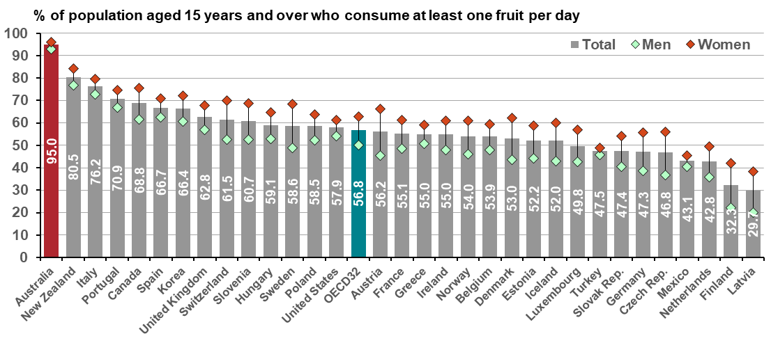
Source: OECD Health Statistics 2017
Note: Data for Australia, Korea and New Zealand are derived from quantity-type questions. Data for the United States include juice made from concentrate; OCED 34 = the average of 34 OECD countries; Australia is highlighted in red
Figure 7.1.1: Australian average daily fruit intake for adults aged 18 years or older, 2014–15
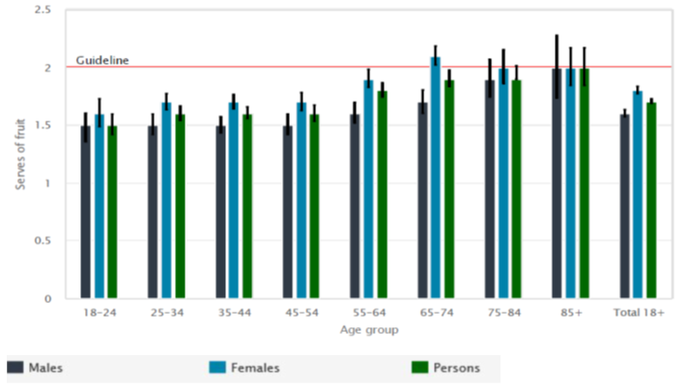
Source: ABS 2015. 4364.0.55.001 National Health Survey: First results 2014–15, Australia, Australian Government, Canberra
Note: Data not age-standardised.
Figure 7.1.2: Mean daily serves of fruit in Victorian adults (aged 18 years or older), by year, 2011–2016
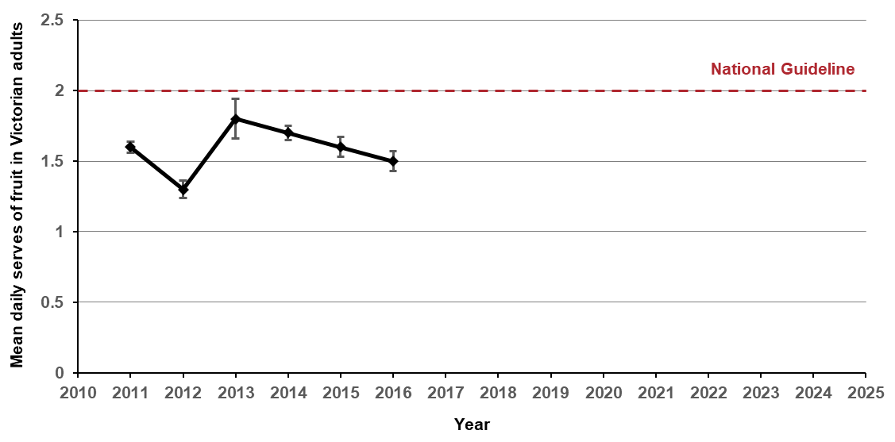
Table 7.1: Mean daily serves of fruit in Victorian adults (aged 18 years or older), by year, 2011–2016
Year | 2011 | 2012 | 2013* | 2014 | 2015 | 2016
Mean | 1.6 | 1.3 | 1.8 | 1.7 | 1.6 | 1.5
(95% CI) | (1.61–1.65) | (1.27–1.33) | (1.68–1.82) | (1.66–1.71) | (1.55–1.62) | (1.48–1.55)
Source: Victorian Population Health Surveys 2011–2016

Measure assessment
Traffic light rating: Amber (desired result not yet evident)
Overall trend: Change in methodology (guideline) introduced in 2013 making it difficult to rate
Commentary: Fruit is high in nutrients that are potentially protective against chronic disease such as cancer. The consumption of fruit plays a key role in helping to maintain a healthy bodyweight. Unhealthy bodyweight (obesity) has been identified as a risk factor for cancer of the bowel, kidney, pancreas, oesophagus, endometrium and breast (in post-menopausal women). An Australian study suggests that two per cent of cancers are attributable to low consumption of fruit and vegetables.
Comparable international data is unavailable on the level of daily fruit intake. However, a 2015 OECD report (Figure 7.1) shows that Australian males and females aged 15 years had the highest proportions reporting daily fruit consumption among the 29 countries of the OECD. Caution is advised when interpreting these findings due to differences in survey methodologies and variation in population ages reported.
Consuming at least two serves of fruit per day is recommended for all Australian adults and forms the basis for this measure. In 2014–15, almost half (49.8 per cent) or 8.8 million Australians aged 18 years or older reported that they consumed two or more serves of fruit per day (the recommended daily intake). The proportion of females meeting the national guideline (55.4 per cent) was higher than the proportion for males (44 per cent). Overall the average daily fruit intake among adult Australians aged 18 years or older was 1.7 serves, which is slightly higher among females (1.8 serves of fruit) compared with males (1.6 serves of fruit). Figure 7.1.1 shows that the average daily fruit intake was similar for the age groups 18–24, 25–34, 35–44 and 45–54 years but increased for the age groups 55–64 and 65–74 years, especially in females.
In Victoria, the significant increase between 2012 and 2013 is most likely in response to new Australian dietary guidelines introduced in 2013 that altered some of the serving sizes and recommendations for fruit consumption based on age and sex (Figure 7.1.1). While no target has been set for this measure, Figure 7.1.2 and Table 7.1 show that the daily fruit consumption for all Victorian adults is not meeting the recommended national guideline.

Measure 7.2 – Proportion of adolescents 10–17 years who eat the daily recommended serves of fruit
Figure 7.2: Proportion of Victorian adolescents aged 10–17 years (boys and girls) who eat the daily recommended serves of fruit, by year, 2014 and 2016
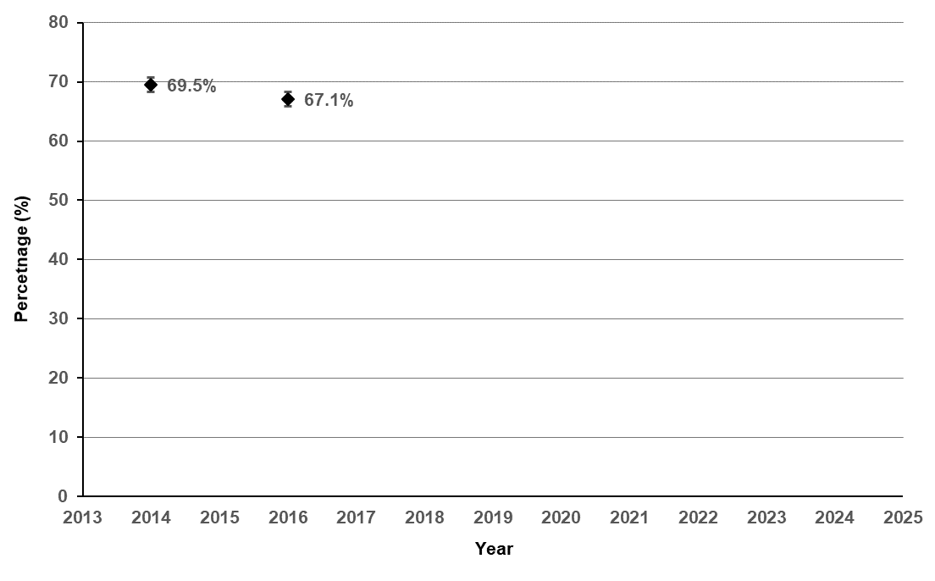
Table 7.2: Proportion of Victorian adolescents aged 10–17 years (boys and girls) who eat the daily recommended serves of fruit, by year, 2014 and 2016
Year | 2014 |  | 2016
Per cent (%) | 69.5 |  | 67.1
95% CI | (68.1–70.8) |  | (66.3–68.0)
Source: Victorian Student Health and Wellbeing Survey 2016
Figure 7.2.1: Proportion of Victorian adolescents aged 10–17 years (boys and girls) who eat the daily recommended serves of fruit, by remoteness area and gender, 2014 and 2016
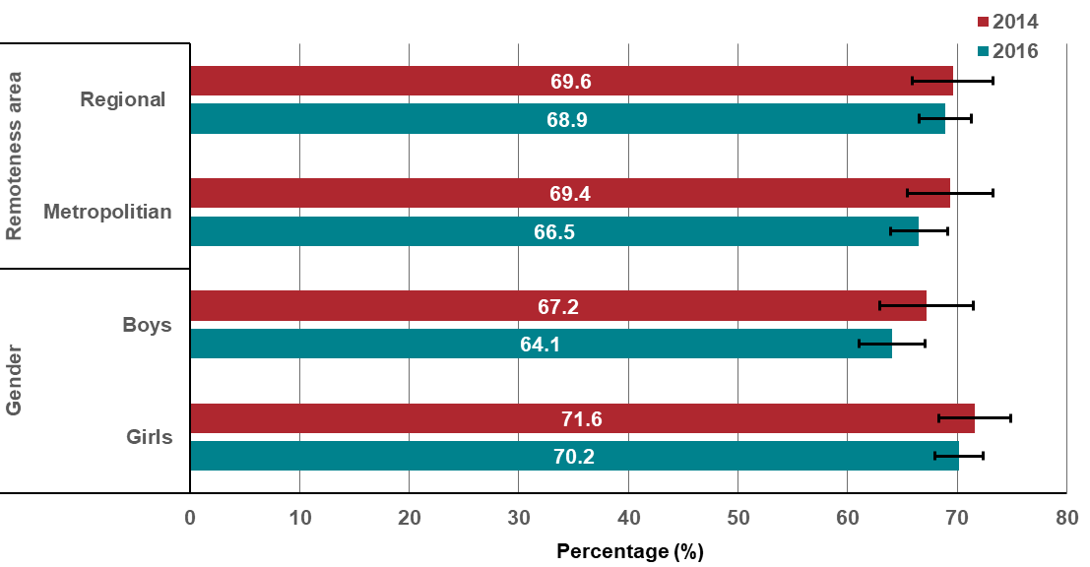
Source: Victorian Student Health and Wellbeing Surveys 2014 and 2016

Measure assessment
Traffic light rating: Red (result is of concern)
Overall trend: Not moving in the right direction
Commentary: High consumption of fruit has been associated with reduced risk of chronic diseases such as cancer. A longitudinal study has suggested that high fruit consumption in adolescence has a beneficial influence on self-rated health in early adulthood. Consuming a minimum of two serves of fruit per day is recommended for all adolescents. While no target has been set, Figure 7.2 and Table 7.2 show that overall the proportion of adolescents aged 10–17 years in Victoria consuming fruit (excluding fruit juice) decreased between 2014 and 2016 among all children and for boys and girls. Both boys and girls reported decreased amounts of fruit consumed (across the two surveys) as recommended in the 2013 Australian dietary guidelines. The proportion of all adolescents living in metropolitan areas consuming fruit also decreased between 2014 and 2016, while the proportion for all adolescents living in Victorian regional areas remained largely unchanged (Figure 7.2.1).

Measure 7.3 – Proportion of children 4–12 years who eat the daily recommended serves of fruit
Figure 7.3: Proportion of children aged 4–12 years who eat the daily recommended serves of fruit, by year, 2013 and 2017
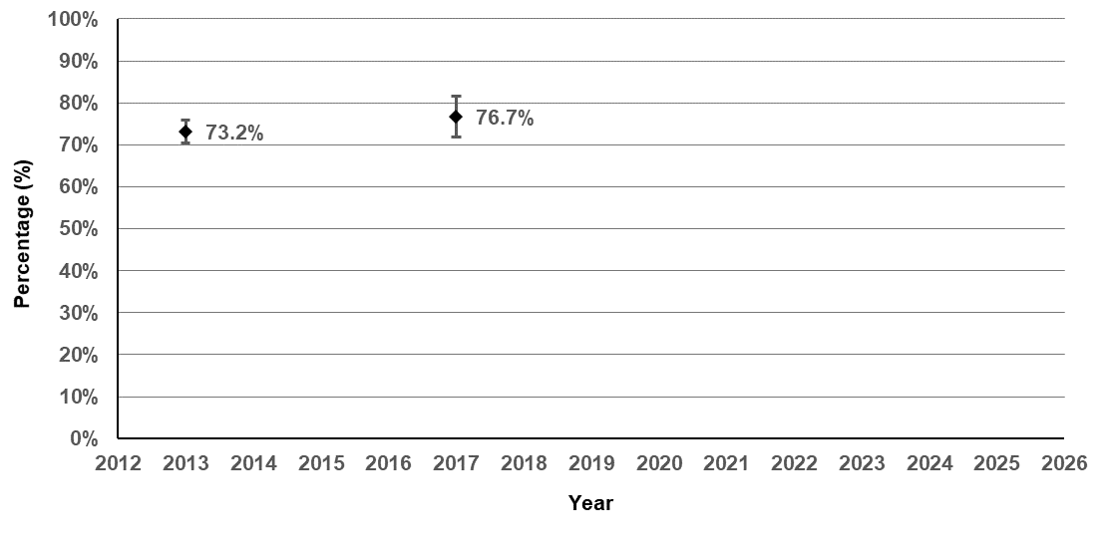
Table 7.3: Proportion of children aged 4–12 years who eat the daily recommended serves of fruit, by year, 2013 and 2017
Year | 2013 |  | 2017
Per cent (%) | 73.2 |  | 76.7
95% CI | (71.7–74.5) |  | (74.2–79.0)

Source: Victorian Child Health and Wellbeing Surveys, 2013 and 2017
Note: The minimum recommended serves of fruit daily is: 2–3 years: 1 serve; 4–8 years: 1½ serves; 9–11 years 2 serves; 12–13 years: 2 serves.
Figure 7.3.1: Proportion of children aged 4–12 years who eat the daily recommended serves of fruit, by gender, age, remoteness areas and SES, 2013 and 2017
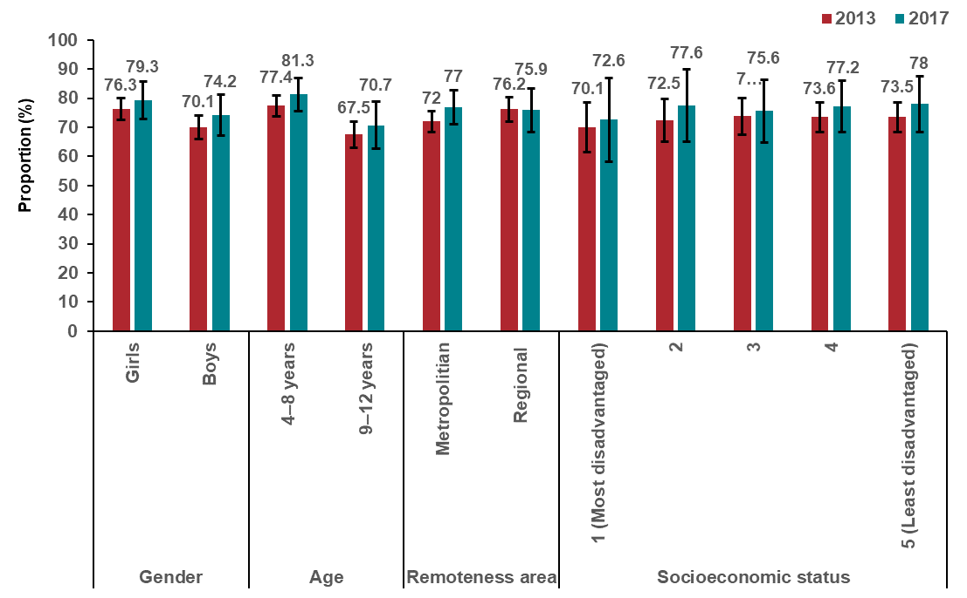
Source: Victorian Child Health and Wellbeing Surveys, 2013 and 2017

Measure assessment
Traffic light rating: Green (satisfactory result)
Overall trend: Moving in the right direction
Commentary: Data from the 2013 and 2017 Victorian Child Health and Wellbeing Surveys show that, among Victorian children aged between four and 12 years, over 70 per cent (Figure 7.3 and Table 7.3) met the recommended daily intake for servings of fruit in accordance with the 2013 Australian dietary guidelines. Both surveys showed a marked difference in consumption by age, with more recently in 2017 only 70.7 per cent of 9–12-year-olds meeting this target compared with 81.3 per cent in the younger age cohort (aged 4–8 years) (Figure 7.3.1). Figure 7.3.1 also shows that there was little variation between the proportion of children aged four to 12 years living in regional areas compared with metropolitan areas who were consuming the daily recommended serves of fruit. However, there was an increasing gradient between SES and daily recommended serves of fruit between 2013 and 2017, with children aged four to 12 years living in least disadvantaged quintiles (Q5) more recently consuming a higher proportion of fruit (78 per cent compared with 72.6 per cent (Q1)).
Although no trend is available for this age group, that in 2017 over 76 per cent of children aged between four- and 12-years met the national dietary guideline for daily fruit intake is encouraging.

Measure 7.4 – Mean daily serves of vegetables in adults
Figure 7.4: Daily vegetable consumption among OECD adults, 2015 (or nearest year)
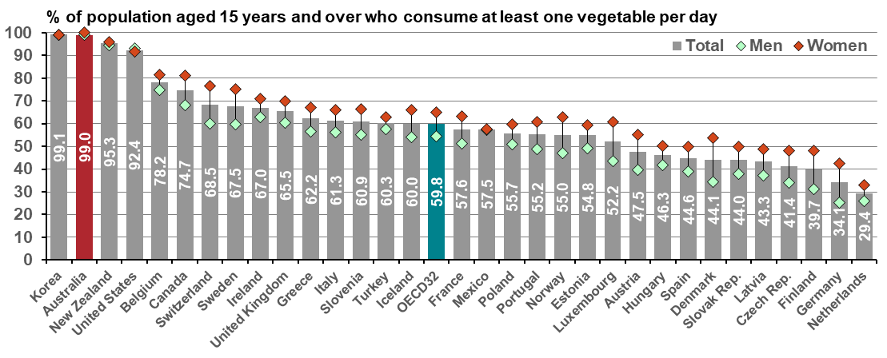
Source: OECD Health Statistics, 2017
Note: Data for Australia, Korea and New Zealand are derived from quantity-type questions. Data for the United States include juice made from concentrate: OCED 34 = the average of 34 OECD countries; Australia is highlighted in red
Figure 7.4.1: Average daily vegetable intake for adults aged 18 years or older, 2014–15
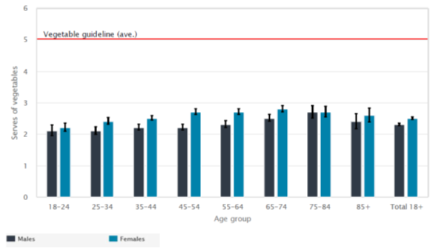
Source: ABS 2015. 4364.0.55.001 National Health Survey: First results 2014–15, Australia, Australian Government, Canberra
Note: Data not age-standardised.
Figure 7.4.2: Mean daily serves of vegetables in Victorian adults, by year, 2011–2016
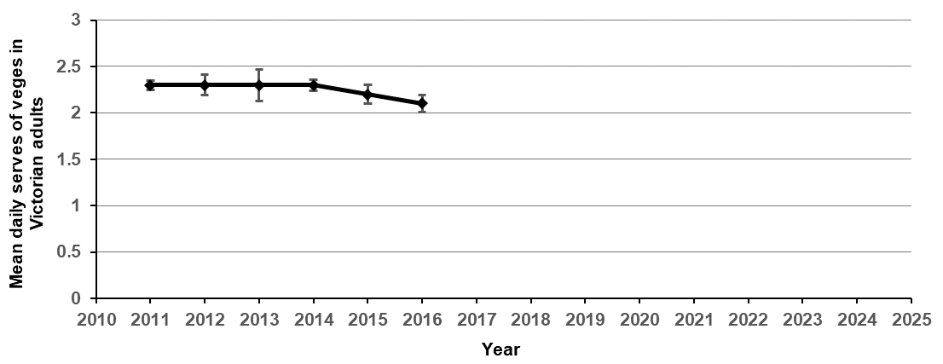
Table 7.4: Mean daily serves of vegetables in Victorian adults, by year, 2011–2016
Year | 2011 | 2012 | 2013 | 2014 | 2015 | 2016
Mean | 2.3 | 2.3 | 2.3 | 2.3 | 2.2 | 2.1
95 % CI | 2.24–2.29 | 2.24–2.35 | 2.19–2.36 | 2.28–2.34 | 2.17–2.27 | 2.07–2.16
Source: Victorian Population Health Surveys 2011–2016

Measure assessment
Traffic light rating: Red (result is of concern)
Overall trend: Not moving in the right direction
Commentary: Fruit and vegetable consumption is internationally accepted as an indicator of a healthy die. A healthy diet that includes vegetable (and fruit) consumption also helps prevent chronic diseases such as cancer as well as their associated risk factors including overweight and obesity.
Comparable international data is not available on the level of daily vegetable intake. However, although the OECD reported in 2015 (Figure 7.4) that Australian males and females aged 15 years or older had the second-highest proportions reporting daily vegetable consumption among 29 countries of the OECD, caution is advised when interpreting these findings due to differences in survey methodologies and variation in population ages reported. For example, in Australia at the national level, data specific to adults is reported for the population aged 18 years or older.
In 2014–15, seven per cent (less than one in 10) of Australians aged 18 years or older met the national guidelines for serves of vegetables (six or more serves for men depending on age, and five (375 grams per day) or more for women). The proportion of females meeting this guideline (10.2 per cent) was higher than for males (3.8 per cent). Overall the average daily vegetable intake of adult Australians aged 18 years or older was 2.4 serves. Average daily vegetable intake was slightly higher among females (2.5 serves) than among males (2.3 serves) and increased with age (Figure 7.4.1). While no target has been set for this measure, Figure 7.4.2 shows that the vegetable consumption across all Victorian adults is decreasing.

Measure 7.5 – Proportion of adolescents 10–17 years who eat the minimum daily recommended serves of vegetables
Figure 7.5: Proportion of adolescents aged 10–17 years who eat the daily recommended serves of vegetables, 2014 and 2016
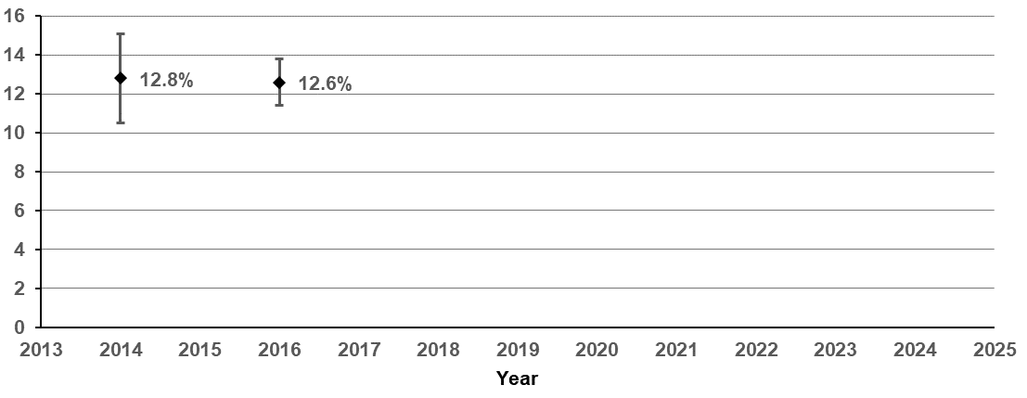
Source: Victorian Child and Adolescent Monitoring System – Department of Education and Training - https://www.education.vic.gov.au/about/research/Pages/vcamsindicator.aspx
Table 7.5: Proportion of adolescents aged 10–17 years who eat the daily recommended serves of vegetables, 2014 and 2016
Year | 2014 |  | 2016
Per cent (%) | 12.8 |  | 12.6
95% CI | (11.8–13.7) |  | (12.0–13.2)
Figure 7.5.1: Proportion of adolescents aged 10–17 years who eat the daily recommended serves of vegetables, by remoteness area and gender, 2014 and 2016
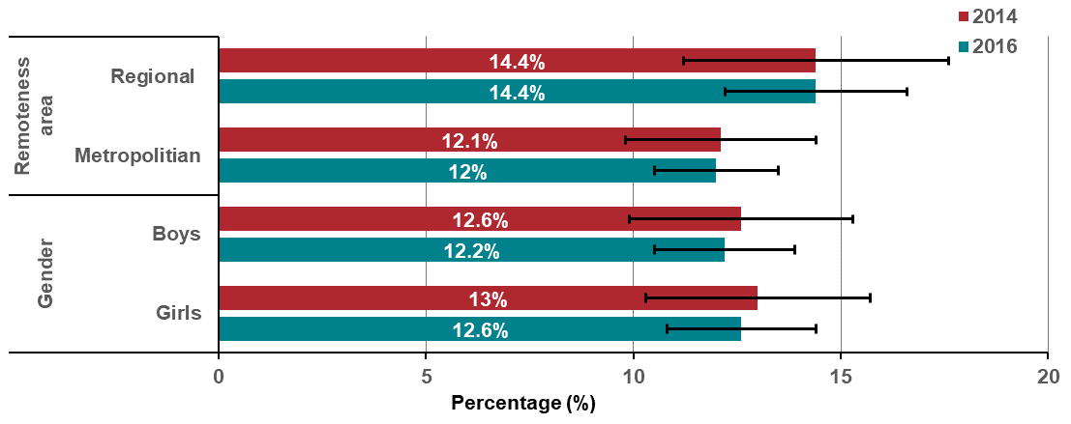
Source: Victorian Child Health and Wellbeing Survey 2016

Measure assessment
Traffic light rating: Amber (desired result not yet evident)
Overall trend: Static or unchanging
Commentary: Consuming vegetables (and fruit) that are high in nutrients is potentially protective against cancers. A longitudinal study has suggested that high vegetable consumption in adolescence has a beneficial influence on self-rated health in early adulthood. Consuming a minimum of five serves of vegetables per day is recommended for all adolescents. Figure 7.5 and Table 7.5 show that the proportion of adolescents aged 10–17 years in Victoria consuming vegetables decreased slightly between 2014 and 2016, among all children and for boys and girls. The proportion of all adolescents living in metropolitan and regional areas consuming vegetables remained static between 2014 and 2016 (Figure 7.5.1).
While no target has been set, overall, this measure shows that the proportion of daily vegetable consumption for adolescents aged 10–17 years who met the dietary guideline for daily vegetable intake is not increasing. However, this observed trend is low, making the promotion of consumption an important health promotion challenge.

Measure 7.6 – Proportion of children 4–12 years who eat the daily recommended serves of vegetables
Figure 7.6: Proportion of children aged 4–12 years who eat the daily recommended serves of vegetables, by year, 2013 and 2017
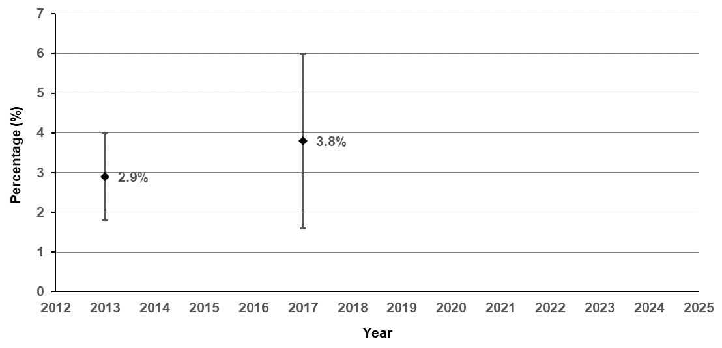
Source: Victorian Child and Adolescent Monitoring System – Department of Education and Training https://www.education.vic.gov.au/about/research/Pages/vcamsindicator.aspx
Note: The minimum recommended serves of vegetables daily is: 2–3 years: 2½ serves; 4–8 years: 4½ serves; 9–11 years 5 serves; 12–13 years: 5–5½ serves.
Table 7.6: Proportion of children aged 4–12 years who eat the daily recommended serves of vegetables, by year, 2013 and 2017
Year |  | 2013 |  | 2017
Per cent (%) |  | 2.9 |  | 3.8
95% CI |  | (2.4–3.5) |  | (2.8–5.0)

Figure 7.6.1: Proportion of children aged 4–12 years who eat the daily recommended serves of vegetables, by gender, age, remoteness area, SES and year, 2013 and 2017
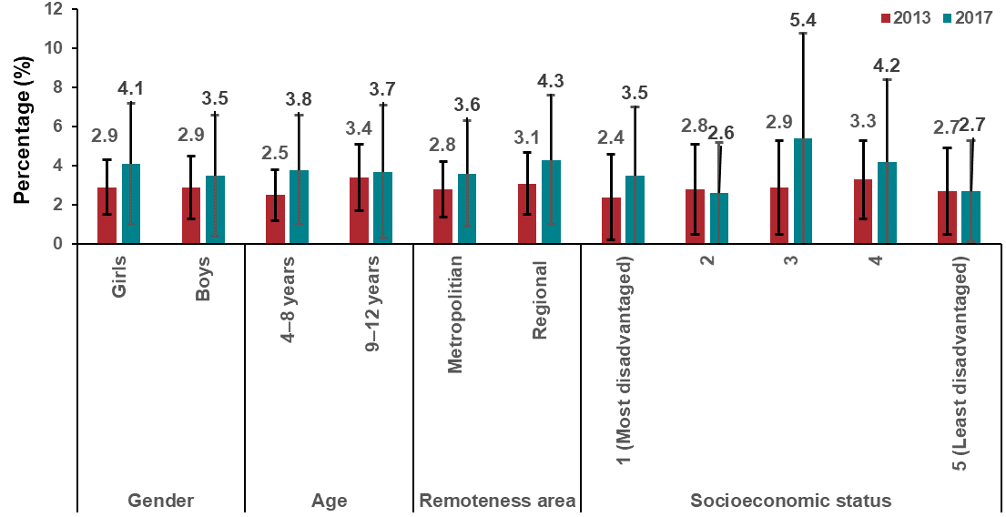

Measure assessment
Traffic light rating: Amber (desired result not yet evident)
Overall trend: Moving in the right direction
Commentary: Data from the 2013 and 2017 Victorian Child Health and Wellbeing Surveys showed an increase in the proportion of Victorian children aged between four and 12 years, who met the recommended amount as set out in the 2013 Australian dietary guidelines (Figure 7.6). There was a marked difference in consumption by age, with only 2.5 per cent of four to eight--year-olds meeting this target compared with 3.4 per cent in the older age cohort (aged 9–12 years) in 2013 which was virtually the same for both cohorts in 2017 (Figure 7.6.1). The proportion of children aged four to 12 years consuming the recommended serves of vegetables and living in regional areas was higher than those living in metropolitan areas (Figure 7.6.1). There was a fluctuating gradient in the proportion of children aged 4-12 years who eat the daily recommended serves of vegetables by socioeconomic status in both 2013 and 2017. However, caution should be taken when interpreting this result because of the wide confidence intervals (Figure 7.6.1).
Although no trend is available for this age group, the observed very low level of compliance with vegetable intake recommendations in both 2013 and 2017 suggest that addressing deficiencies in vegetable consumption should be a primary focus of future nutrition interventions.

Measure 7.7 – Red meat consumption
This measure will be reported in a future report. Refer to Appendix 1.

Measure 7.8 – Processed meat consumption
This measure will be reported in a future report. Refer to Appendix 1.

Measure 7.9 – Proportion of adults who are sufficiently physically active
Figure 7.9: Proportion of adults (18 years and older) who are sufficiently physically active, by year, 2015–2017
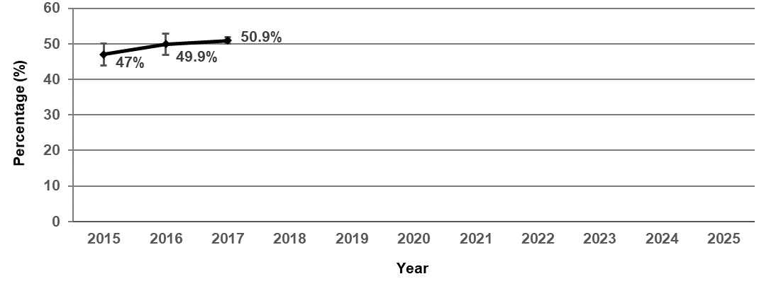
Table 7.9 Proportion of adults who are sufficiently active, by year, 2015–2017
Year | 2015 | 2016 | 2017
Per cent | 47.0 | 49.9 | 50.9
(95% CI) | (45.5–48.6) | (48.4–51.4) | (50.0–51.8)
Source: Victorian Population Health Surveys 2015–2017

Measure assessment
Traffic light rating: Green (satisfactory result)
Overall trend: Moving in the right direction
Commentary: Physical activity helps adults to live longer and protects against some cancers. Current levels of physical inactivity have been attributed to increasing sedentariness of domestic and occupational activities, insufficient physical activity during leisure time, increasing use of passive modes of transport and increased urbanisation.
Approximately half of Victorian adults (18 years and older) are insufficiently physically active. Figure 7.9 and Table 7.9 show that in 2017 50.9 per cent of Victorian adults undertook sufficient physical activity (measured in both sufficient time and sessions) to meet the 2014 national physical activity guidelines compared to 47 per cent in 2015.

Measure 7.10 – Proportion of adolescents 10–17 years who are sufficiently physically active
Figure 7.10: Proportion of Victorian adolescents aged 10–17 who are sufficiently physically active, 2014 and 2016
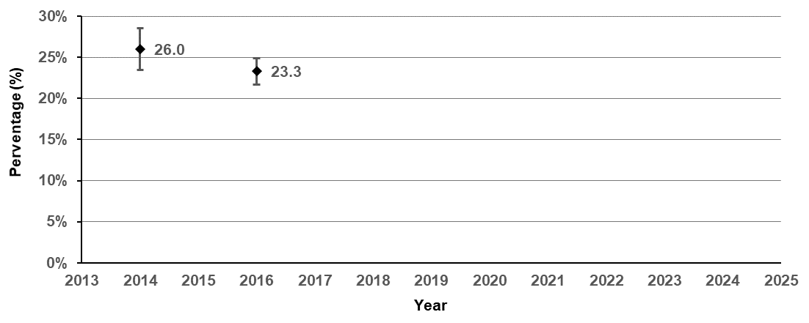
Note: In 2014 the definition of sufficient physical activity changed.
Source: Victorian Student Health and Wellbeing Survey 2016
Table 7.10: Proportion of Victorian adolescents aged 10–17 who are sufficiently physically active, 2014 and 2016
Year | 2014 |  |  | 2016
Per cent (%) | 26.0 |  |  | 23.3
95% CI | (24.8–27.3) |  |  | (22.5–24.1)

Measure assessment
Traffic light rating: Amber (desired result not yet evident)
Overall trend: Difficult to rate due to change in definition
Commentary: Physical activity provides important benefits throughout life. Establishing an active lifestyle such as participating in active recreation and sport during childhood and early adulthood can lay the foundation for lifelong participation in sport and wider physical activity. Children and adolescents who are physically active have better mental, cardio-metabolic and musculoskeletal health and are less likely to gain weight. Childhood obesity has been identified as a risk factor for chronic disease, such as some cancers, in adulthood. For example, a recent meta-analysis reported a statistically significant association between obesity in children aged 12–18 and an increased incidence of some cancers, such as liver, colon and urothelial cancer, in adulthood.
The Victorian public health and wellbeing outcomes framework has a target of a 20 per cent increase by 2025 in adolescents achieving sufficient physical activity based on the 26 per cent 2014 baseline (Figure 7.10 and Table 7.10) and is not on track to be met. In 2016, only 23.3 per cent of Victorian students (Figure 7.10) undertook sufficient physical activity that met the national physical activity guidelines.

Measure 7.11 – Proportion of children 5–12 years who are sufficiently physically active
Figure 7.11: Proportion of children aged 5–12 years who are sufficiently physically active, 2013 and 2017
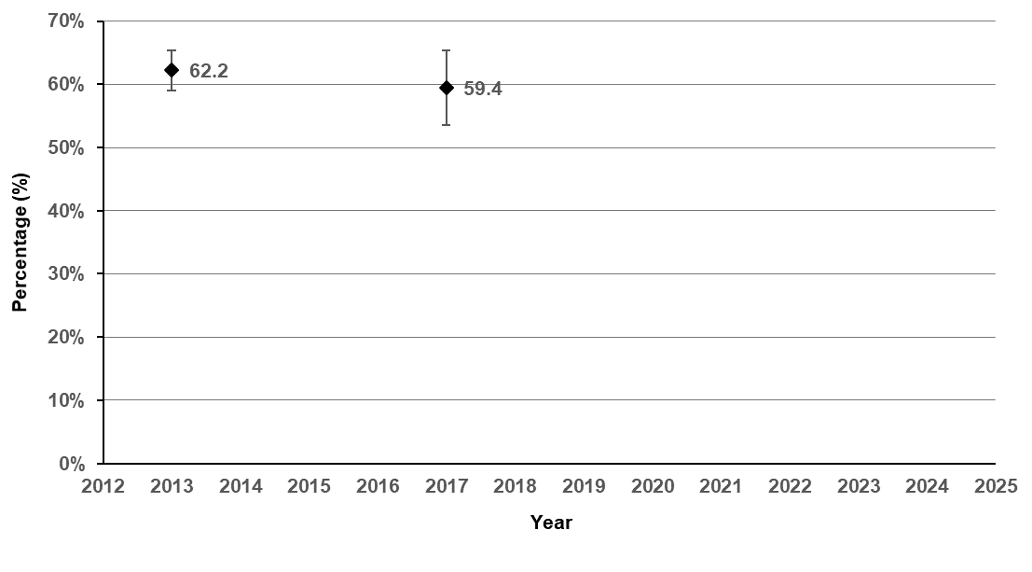
Note: In 2014 the definition of sufficient physical activity changed.
Source: Victorian Child Health and Wellbeing Surveys 2013 and 2017 http://www.education.vic.gov.au/about/research/Pages/vcamsindicator.aspx
Table 7.11: Proportion of children aged 5–12 years who are sufficiently physically active, 2013 and 2017
Year | 2013 |  |  | 2017
Per cent (%) | 62.2 |  |  | 59.4
95% CI | (60.6–63.8) |  |  | (56.4–62.3)

Measure assessment
Traffic light rating: Red (result is of concern)
Overall trend: Not moving in the right direction
Commentary: As noted under Measure 7.10, children and adolescents who are physically active have better mental, cardio-metabolic and musculoskeletal health and are less likely to gain weight, the latter being a risk factor for developing cancer later in life.
A target has not been set for this measure; however, nearly 40 per cent of children are insufficiently physically active according to the most recent data (2017) (Figure 7.11 and Table 7.11).
Key result: Decrease obesity

Measure 8.1 – Proportion of adults who are overweight or obese (measured)
Figure 8.1: Proportion of overweight including obesity among OECD adults (aged 15 or older), 2015 (or nearest year)
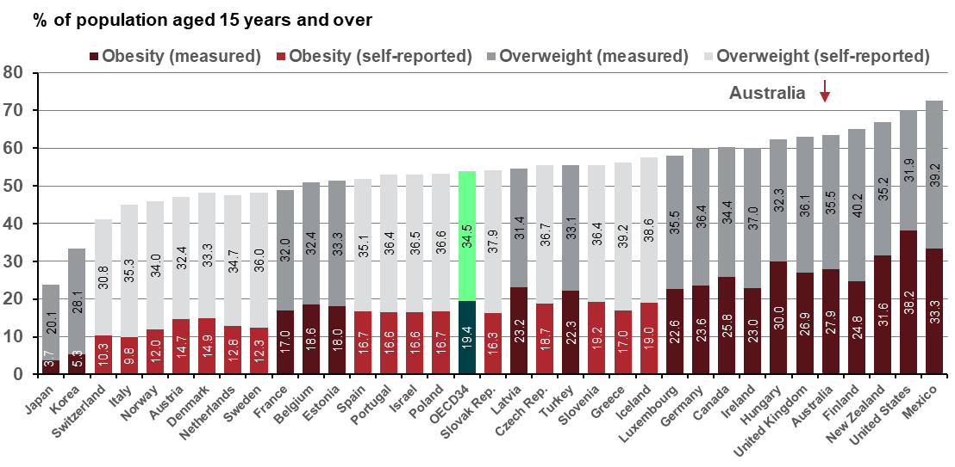
Source: OECD Health Statistics 2017
OECD34 = average of the 34 OECD countries
Figure 8.1.1: Proportion of overweight/obesity (measured) in Australian adults, by state and territory, 2011–12 and 2014–15
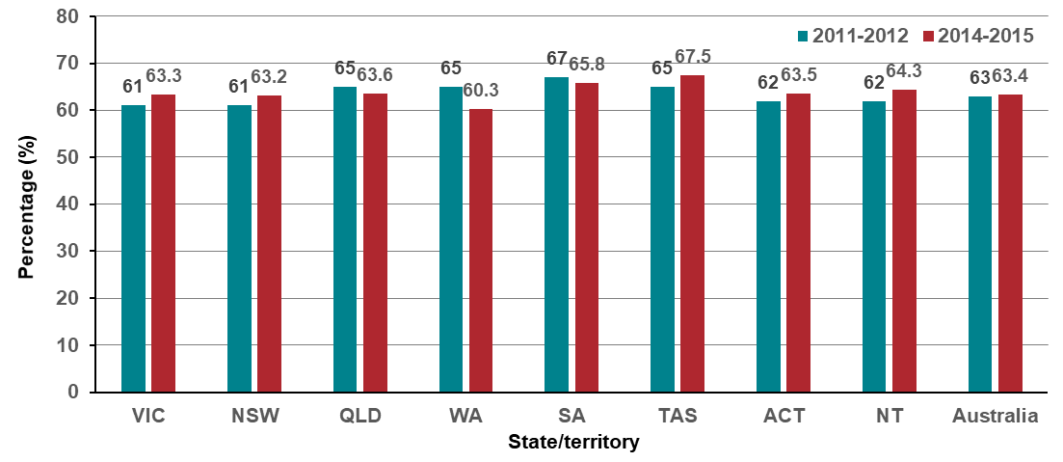
Source: ABS Australian Health Survey 2014–15 (4364.0)
Figure 8.1.2: Proportion of overweight including obesity (measured) among Victorian adults (aged 18 or older), by year, 2011–12 to 2014–15
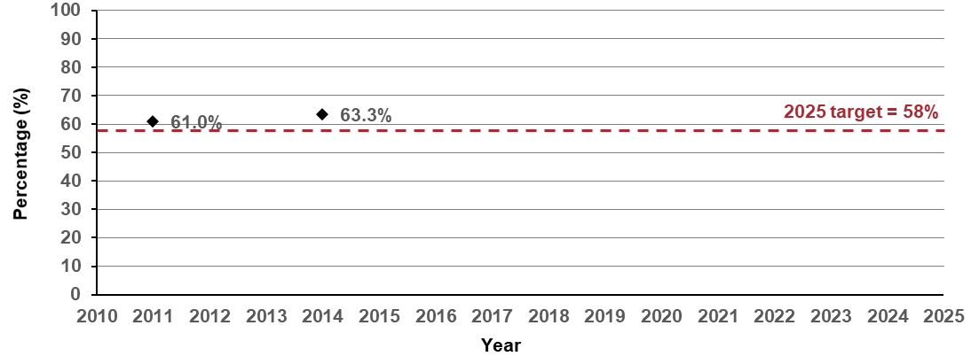
Source: ABS Australian Health Surveys 2011–12 (4364.0.55.001) and 2014–15 (4364.0)

Measure assessment
Traffic light rating: Red (result is of concern)
Overall trend: Not moving in the right direction
Commentary: Overweight and obesity are major risk factors for many chronic diseases including cancer. For the purposes of this measure, overweight and obesity was calculated using the body mass index (BMI), a scale based on height and weight commonly used to define if a person is underweight, normal weight, overweight or obese. In Australia, of the cancers related to body fatness (n = 9,258), 13 per cent (95% CI, 11–16 per cent) could be avoided if those currently overweight or obese had a BMI of 18.5–24.9 kg/m² (normal range).
Figure 8.1 shows that the growing prevalence of overweight and obesity is a major public health concern globally. The results show that more than half of adults aged 15 years or older in OECD countries are overweight or obese (54 per cent). In 2015 most, Australian adults (63.4 per cent – 28 per cent of the population aged 15 or older) were overweight or obese, the fifth highest proportion in the OECD behind Mexico, the United States, New Zealand and Finland (Figure 8.1). Take caution when comparing international with national trends because Australian national data defines adults as aged 18 years or older, affecting the comparability of data.
In Australia, the proportion of men and women aged 18 years or older who are overweight or obese has generally remained static between 2011 and 2015 across all states except Western Australia, which dropped by 4.7 per cent (Figure 8.1.1) possibly in response to the state’s LiveLighter campaign (2011–2018). In Victoria, Figure 8.1.2 shows that the proportions of overweight or obese adults between 2011–12 and 2014–15 were similar. The Victorian public health and wellbeing outcomes framework has a target of a five per cent decrease in prevalence of overweight or obese adults aged 18 years or older by 2025, from the 2011–12 baseline of 61 per cent. Currently, Victoria is not on track to meet the 2025 target of 58 per cent, with 63.3 per cent of adults overweight or obese in 2014–15 (Figure 8.1.2).

Measure 8.2 – Proportion of adults who are overweight or obese (self-report)
Figure 8.2: Proportion of Victorian adults (aged 18 years or older) who are overweight or obese (self-report), by year, 2015–2017
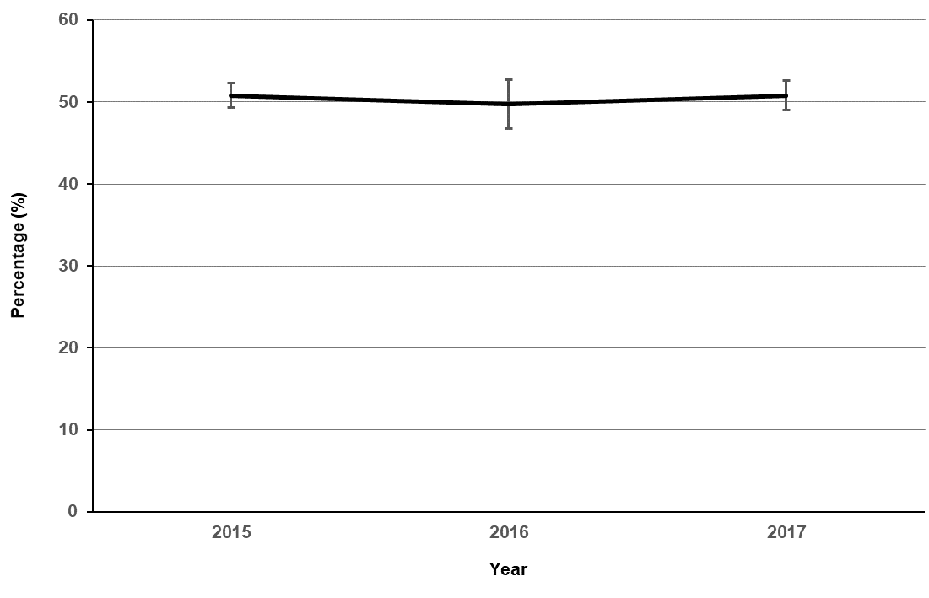
Table 8.2: Proportion of Victorian adults (aged 18 years or older) who are overweight or obese (self-report), by year, 2015–2017
Year | 2015 | 2016 | 2017
Per cent | 50.8 | 49.7 | 50.8
(95% CI) | (47.7–49.2) | (48.2–51.2) | (49.9–51.7)
Source: Victorian Population Health Surveys 2015–2017

Measure assessment
Traffic light rating: Amber (desired result not yet evident)
Overall trend: Static or unchanging
Commentary: A target has not been set for this measure; however, the lack of reduction in the proportion of adults who self-report being overweight and obese is of major concern given the significant risks that this poses to individual health and the burden across the health and social care systems. Figure and Table 8.2 show the proportion of Victorian adults who were overweight or obese was 50.8 per cent in 2015 which was identical in 2017. To add further cause for concern, it is known that self-reported measures significantly underestimate the prevalence of obesity (refer to the data reported under Measure 8.1).

Measure 8.3 – Proportion of children 5–17 years who are overweight or obese (measured)
Figure 8.3: Proportion of Australian children aged 5–17 years who are overweight or obese (measured), by year, 1995 to 2014–15
Source: Australian Institute of Health and Welfare 2017. A picture of overweight and obesity in Australia 2017. Cat. no.PHE 216. AIHW, Canberra.
Figure 8.3.1: Proportion of Victorian children aged 5–17 years who are overweight or obese (measured), by year, 2011–12 and 2014–15
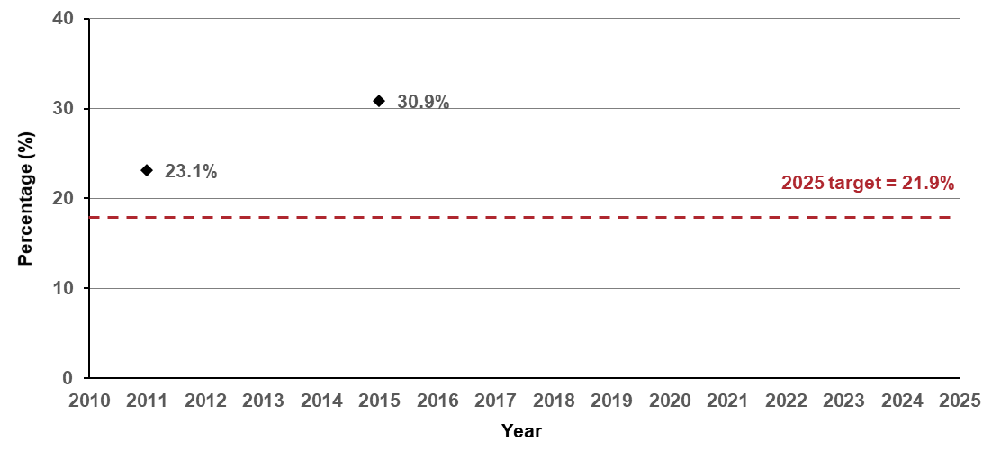
Source: ABS Australian Health Surveys 2011–12 (4364.0.55.001) and 2014–15 (4364.0)

Measure assessment
Traffic light rating: Red (result is of concern)
Overall trend: Moving in the wrong direction
Commentary: The rate of overweight and obesity in children is of significant concern now and for the future, given the lifelong implications including increased risk of obesity-related cancers. At a national level, information dating back to 1995 (Figure 8.3) shows the prevalence of overweight and obesity has risen from 21 per cent in 1995 to 27 per cent in 2014–15. Figure 8.3.1 shows that the childhood rates of overweight and obesity in Victoria jumped from 23.1 per cent in 2012 to 30.9 per cent in 2015, which is well above the current 2018 national average of 24.9 per cent published by the ABS. There is a target in the Victorian public health and wellbeing outcomes framework to reduce the prevalence of overweight and obesity in children and adults by five per cent from the 2011–12 baseline year by 2025. Currently, Victoria is not on track to meet the 2025 target of 21.9 per cent.
Key result: Decrease UV exposure

Measure 9.1 – Proportion of 18–69-year-olds who report getting sunburnt on the weekend
Figure 9.1: Adjusted prevalence estimates for weekend sunburn incidence among Victorian adults (18–69 years) in summers, 2013–14 and 2016–17
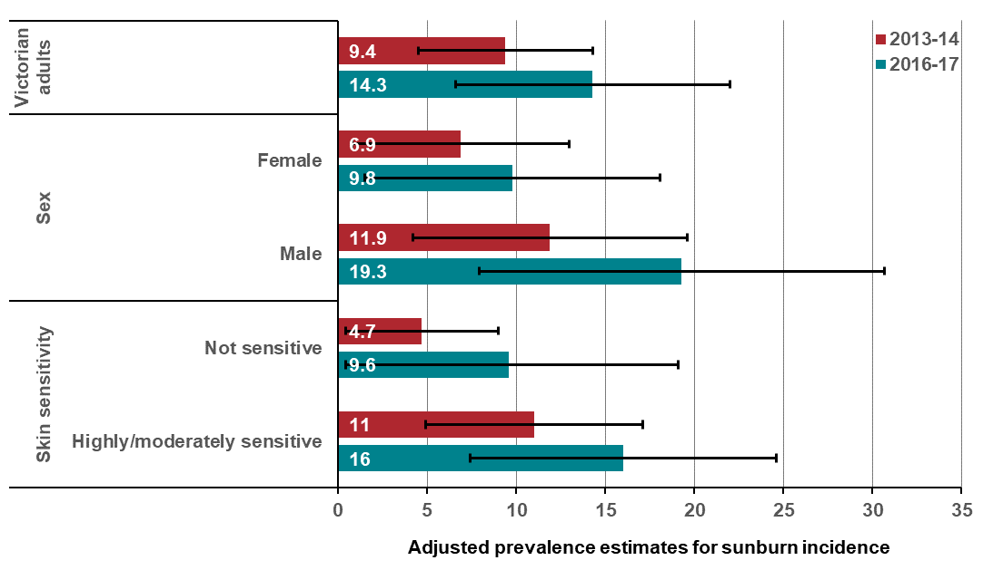
Note: These data were derived from wave 4 (2013-14) and wave 5 (2016-17) of the National Sun Protection Survey, a national cross–sectional survey including a representative sample of Victorians (12–69 years). Respondents were interviewed weekly via the telephone (landline or mobile) about their sun-related attitudes and behaviours during summer. In 2016–17, respondents were interviewed over 13 weeks of summer from December to February. However, in 2013–14, February interviews were not conducted due to budget constraints.
Adjusted prevalence figures for sunburn are estimated from multivariable models adjusting for age, sex, skin sensitivity and mean UV index on summer weekends among city residents indoors and outdoors in Melbourne in 2013–14 (25 November 2013 to 30 January 2014) and 2016–17 (28 November 2016 to 31 January 2017). Table 9.1 in Appendix 2 provides the unadjusted prevalence estimates for the proportion of Victorian adults (18–69 years) who reported getting sunburnt on summer weekends in 2013–14 and 2016–17.
It is important to note that the prevalence figures by state/territory reported nationally are weighted to the ERP determined by the ABS in June 2013 for respondents surveyed in 2013–14 and 2016 for respondents surveyed in 2016–17 and therefore are not comparable to the figures shown above, which are reflective of the Victorian population.

Measure assessment
Traffic light rating: Red (result is of concern)
Overall trend: Moving in the wrong direction. However, it is important to note that an assessment of future trends will possibly necessitate a new baseline, due to the National Sun Protection Survey terminating and other methodologies for monitoring sun protection behaviour being developed.
Commentary: Sunburn is the skin’s reaction to UV radiation from the sun. The long-term effects of repeated bouts of sunburn include an increased risk of skin cancer, including melanoma (the most dangerous type of skin cancer). Figure 9.1 shows that overall there was an increase in the proportion of Victorian adults 18–69-year-olds who reported getting sunburnt on the weekend from 9.4 per cent in 2013–14 to 14.3 per cent in 2016–17. Males in particular were more likely to report getting sunburnt on the weekend compared with females from 11.9 per cent in 2013–14 to 19.3 per cent in 2016–17. While no target has been set for this measure, the increase in the proportion of 18–69-year-olds who reported getting sunburnt on the weekend may be in part related to low or ineffective use of sun protection (application of sunscreen, using shade and wearing a hat, long-sleeved clothing and sunglasses) and inadequate application of sunscreen.

Measure 9.2 – Proportion of 18–69-year-olds wearing a combination of hats and/or sunscreen with one other key sun protective behaviour
Figure 9.2: Adjusted prevalence estimates of two or more sun protective behaviours among Victorian adults (18–69 years) in summers, 2013–14 and 2016–17
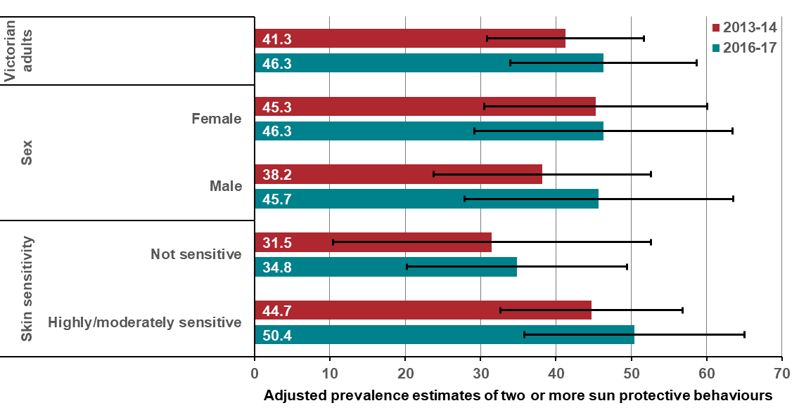

Note: These data were derived from wave 4 (2013-14) and wave 5 (2016-17) of the National Sun Protection Survey, a national cross–sectional survey including a representative sample of Victorians (12–69 years). Respondents were interviewed weekly via the telephone (landline or mobile) about their sun-related attitudes and behaviours during summer. In 2016–17, respondents were interviewed over 13 weeks of summer from December to February. However, in 2013–14, February interviews were not conducted due to budget constraints.
It is important to note that the prevalence figures by state/territory reported nationally are weighted to the ERP as determined by the ABS in June 2013 for respondents interviewed in 2013–14 and June 2016 for respondents interviewed in June 2016 and therefore are not comparable to the figures shown above, which are reflective of the Victorian population.
Table 9.2 in Appendix 2 provides the unadjusted prevalence estimates of two or more sun protective behaviours among Victorian adults (18–69 years) in summers 2013–14 and 2016–17.

Measure assessment
Traffic light rating: Green (satisfactory result)
Overall trend: Moving in the right direction. However, it is important to note that an assessment of future trends will possibly necessitate a new baseline, due to the National Sun Protection Survey terminating and other methodologies for monitoring sun protection behaviour being developed.
Commentary: Figure 9.2 shows a pattern of improvement that was evident in the use of two or more sun protective behaviours to reduce exposure to UV radiation over both time periods for Victorian adults. Respondents with highly/moderately sensitive skin more commonly reported using two or more sun protective behaviours in both survey years than respondents with skin that is not sensitive. However, there were improvements in use of two or more sun protective behaviours among all demographic groups. This increase in the use of multiple sun-protective behaviours when outdoors suggests that Victorian adults are generally adopting more sun protective measures, while the increase in sunburn prevalence indicates the choice of sun protection (an over-reliance on sunscreen) is not providing sufficient protection from UV radiation. The increase in sun protection may, however, indicate the benefits of implementing state-funded campaigns (such as globally recognised SunSmart – one of Victoria’s longest running and most successful skin cancer prevention programs) and the implementation of government policy articulated in the Skin cancer prevention framework 2013–17.

Key result: Decrease HPV and viral hepatitis impact

Measure 10.1 – Proportion of adolescents 15 years of age fully vaccinated against HPV
Figure 10.1: HPV three-dose vaccination coverage for all females turning 15 years of age, by state/territory and year, 2013–2017
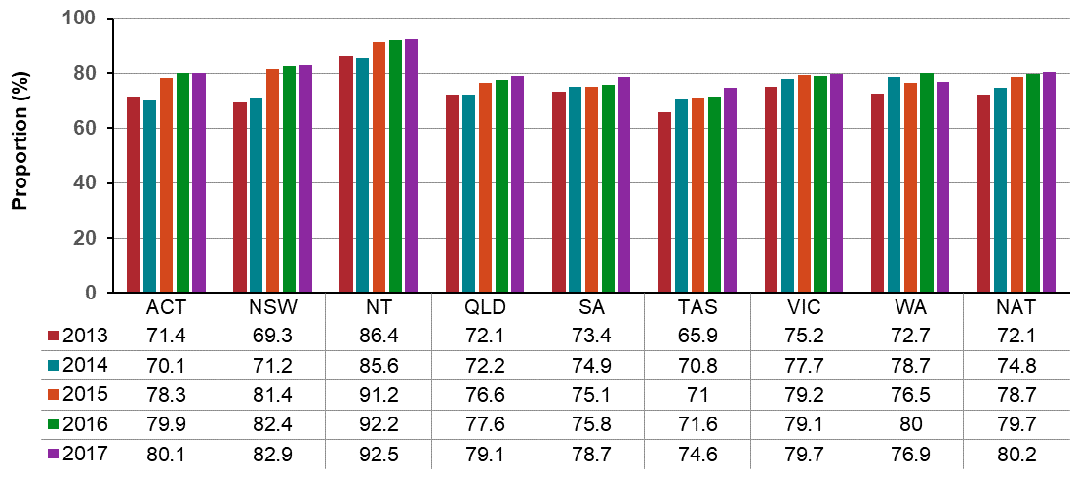
Source: National HPV Vaccination Program Register (Available from: http://www.hpvregister.org.au/research)
Note that from 1 November 2018, the National HPV Vaccination Program Register ceased accepting HPV vaccination records. Vaccination providers are now requested to submit HPV vaccination records to the Australian Immunisation Register, operated by the Commonwealth Department of Human Services.
Figure 10.1.1: HPV dose vaccination coverage for all males turning 15 years of age, by state/territory and year, 2013–2017
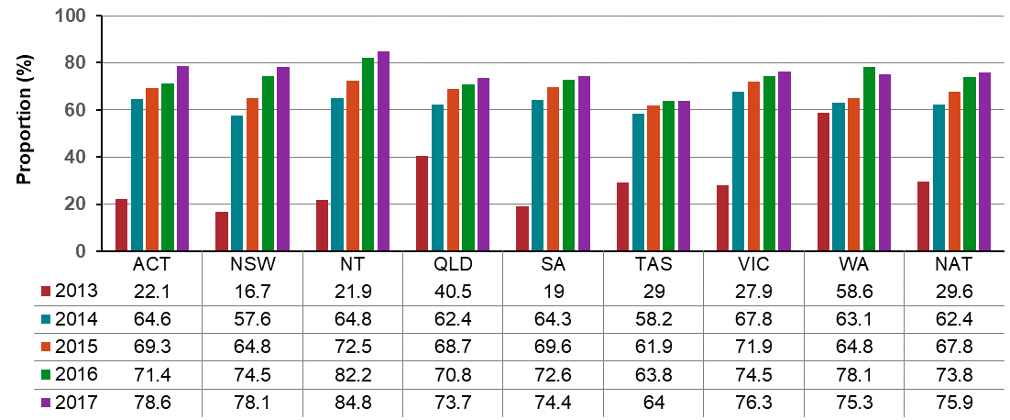
Source: National HPV Vaccination Program Register. (Available from: http://www.hpvregister.org.au/research)

Measure assessment
Traffic light rating: Amber (desired result not yet evident)
Overall trend: Moving in the right direction
Commentary: HPV is highly contagious and most commonly transmitted through sexual contact. More than 150 types of the virus exist, and it is estimated that four out of five people will have HPV infection at some point in their lives.
In Australia, all girls aged 12–13 years have been routinely offered three doses of HPV vaccination since 2007, as have boys of the same age since 2013. For this reason, 2013 was set as the baseline year for this measure.
Nationally in 2017, 80.2 per cent of girls aged 15 years were fully immunised against HPV, an increase from 72.1 per cent in 2013. Victoria had the fourth highest coverage (79.7 per cent) of girls aged 15 years fully immunised against HPV. This is an increase of 0.6 per cent from the previous year (79.1 per cent) but less than the national average of 80.2 per cent.
In boys aged 15 years, the national coverage with three HPV vaccine doses in 2017 was 75.9 per cent, a significant increase of 46.5 per cent from 2013. In 2017, Victoria had the fourth ranked proportion of boys aged 15 years fully immunised against HPV, and this is above the national average of 75.9 per cent.
Additional information
The HPV vaccine has traditionally been a three-dose course that prevents the four types of HPV that cause approximately 80 per cent of cancers. The program is delivered in Year 7 in Victorian secondary schools by local government immunisation providers. Traditionally a reduction in vaccination coverage is observed in vaccine coverage from dose one to dose three. In 2018, a new two-dose HPV was introduced that will prevent nine types of HPV and add a further 10 per cent protection against respective cancers, which in turn should result in an increase in fully vaccinated coverages rates.

Measure 10.2 – Notification rate of unspecified hepatitis B
Figure 10.2: Notification rate per 100,000 population of unspecified HBV, by state/territory and year, 2014–2018
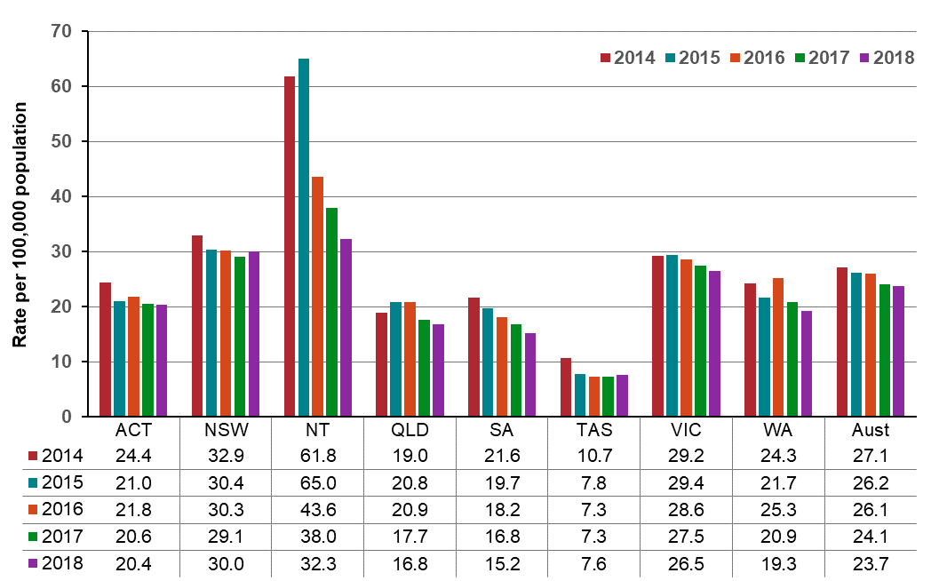
Source: National Notifiable Disease Surveillance System (accessed date: 28 August 2019)
Figure 10.2.1: Notification rate per 100,000 population of unspecified HBV, by sex and year, Victoria, 2014–2018
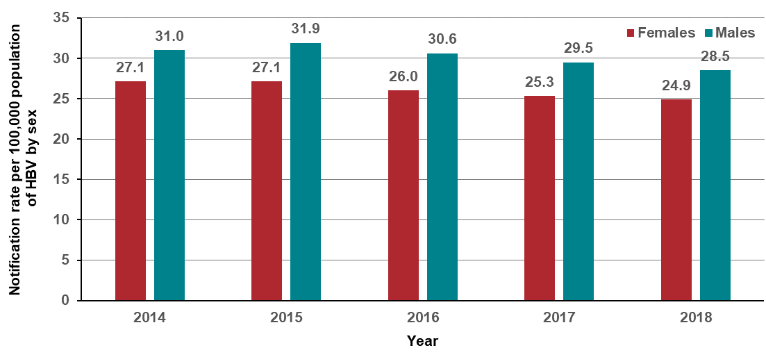
Figure 10.2.2: Notification rate per 100,000 population of unspecified HBV, by age group and year, Victoria, 2014–2018
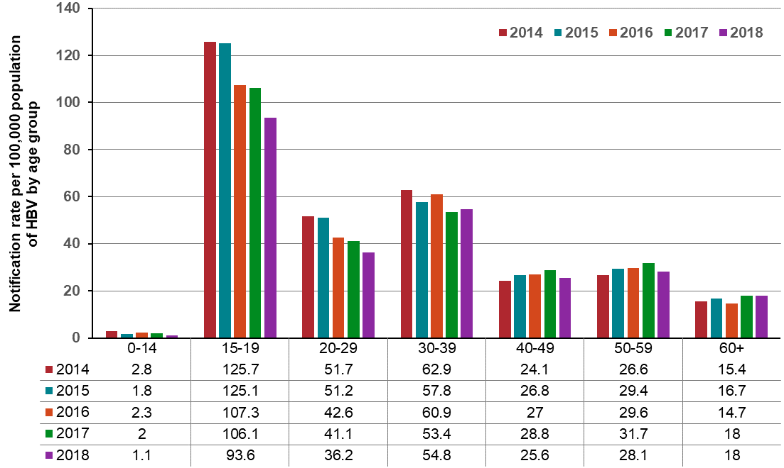
Note: This data excludes cases where age is unknown or not reported.
Figure 10.2.3: Notification rate per 100,000 population of unspecified HBV, by ICS and year, Victoria, 2014–2018
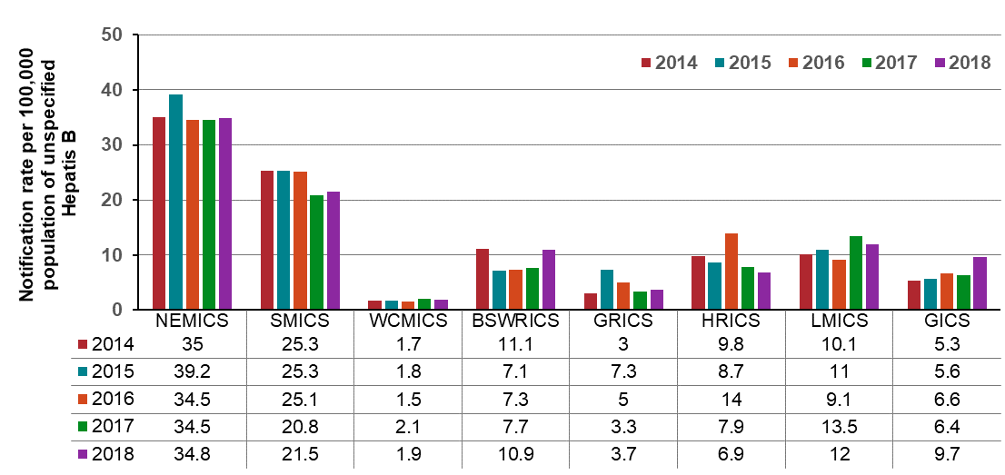
Note: Excludes cases where the postcode of residence was unknown or not reported.

Measure assessment
Traffic light rating: Amber (desired result not yet evident)
Overall trend: Moving in the right direction
Commentary: In Victoria, an estimated 55,000 people are living with hepatitis B (HBV). HBV is a viral infection that causes liver inflammation. Untreated chronic HBV is a leading cause of liver cancer, the fastest increasing cause of cancer deaths in Victorians.
In Victoria, HBV is a notifiable disease under the Public Health and Wellbeing Regulations 2009. Figure 10.2 shows that the notification rate of unspecified HBV in Victoria has reduced by two per cent from 29.2 cases per 100,000 population in 2014 to 26.5 cases per 100, 000 population in 2018. During the same period (2014–2018), the rate of HBV notification in Victoria was higher than the national rate (Figure 10.2). Rates have been consistently higher among males than females (Figure 10.2.1) and were 28.5 per 100,000 population and 24.9 per 100,000 population in 2018 respectively. Notification rates were significantly higher for those aged 15–19 years compared with other age groups (Figure 10.2.2). However, between 2014 and 2018 the rate of notification has decreased in this age category (125.7 per 100,000 population in 2014 to 93.6 per 100,000 population in 2018). In contrast, despite the much lower notification rates, rates for those aged 40–59 years increased between 2014 and 2017 but decreased in 2018. Rates were consistently low among those aged 0–14 years during the reporting period (Figure 10.2.2).
Figure 10.2.3 shows the distribution of HBV notification rates by ICS across Victoria between 2014 and 2018. ICSs with the highest rates tended to be the metropolitan ICS such as NEMICS and SMICS but not WCMICS, suggesting that the HBV burden is inequitably distributed across Victoria. Of note were the regional/rural ICSs, BSWRICS, GRICS and GICS, which all showed an increase between 2017 and 2018.
While no target has been set for this measure, the WHO global health sector strategy on viral hepatitis 2016–2021 sets a 2020 target of a 30 per cent reduction in the number of new HBV cases from 2015 as the baseline year. The Victorian hepatitis B strategy 2016–20 includes an overarching goal to eliminate HBV as a public health concern by 2030. This goal is underpinned by the following targets: reduce the number of new domestic transmission of HBV by 90 per cent; increase diagnosis rates by 90 per cent; and increase the treatment rate for HBV to 90 per cent.

Measure 10.3 – Notification rate of unspecified hepatitis C
Figure 10.3: Notification rate per 100,000 population of unspecified hepatitis C, by state/territory and year, 2014–2018
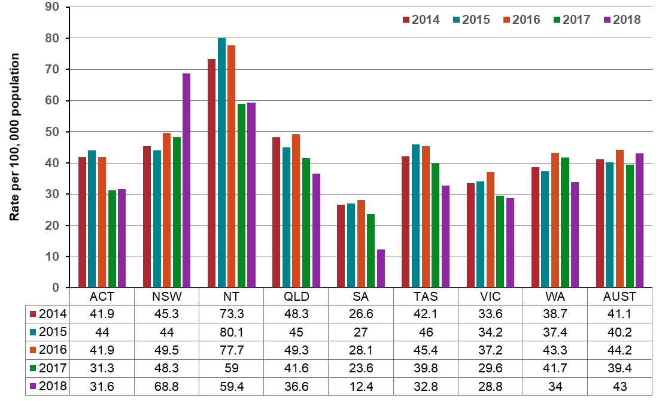
Source: National Notifiable Disease Surveillance System (accessed 28 August 2019)
Figure 10.3.1: Notification rate per 100,000 population of unspecified hepatitis C, by sex and year, Victoria, 2014–2018
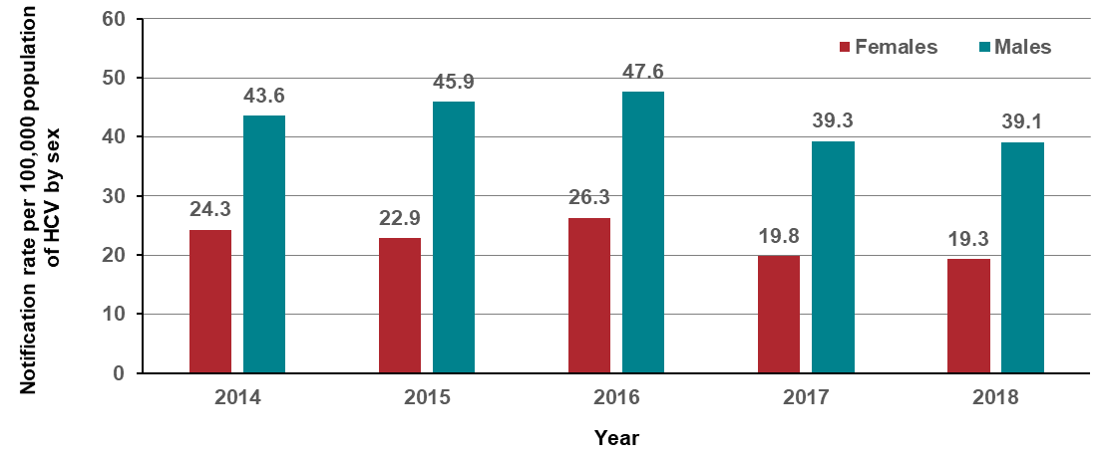
Figure 10.3.2: Notification rate per 100,000 population of unspecified hepatitis C, by age group and year, Victoria, 2014–2018
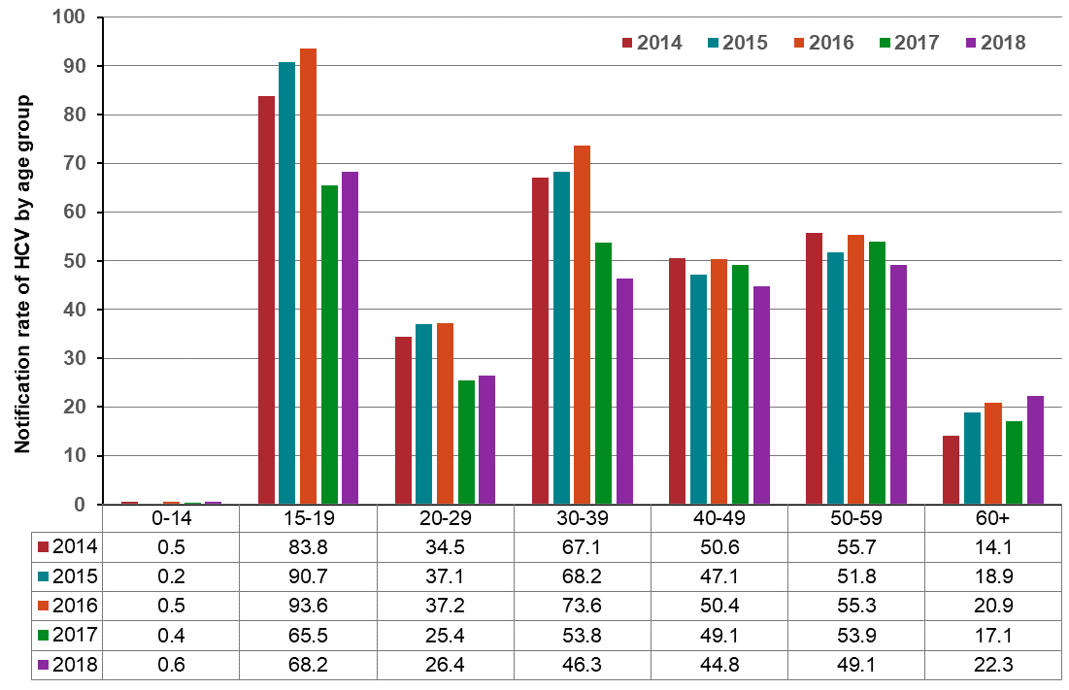
Note: This data excludes cases where age is unknown or not reported.
Figure 10.3.3: Notification rate of unspecified hepatitis C by ICS and year, Victoria, 2014–2018
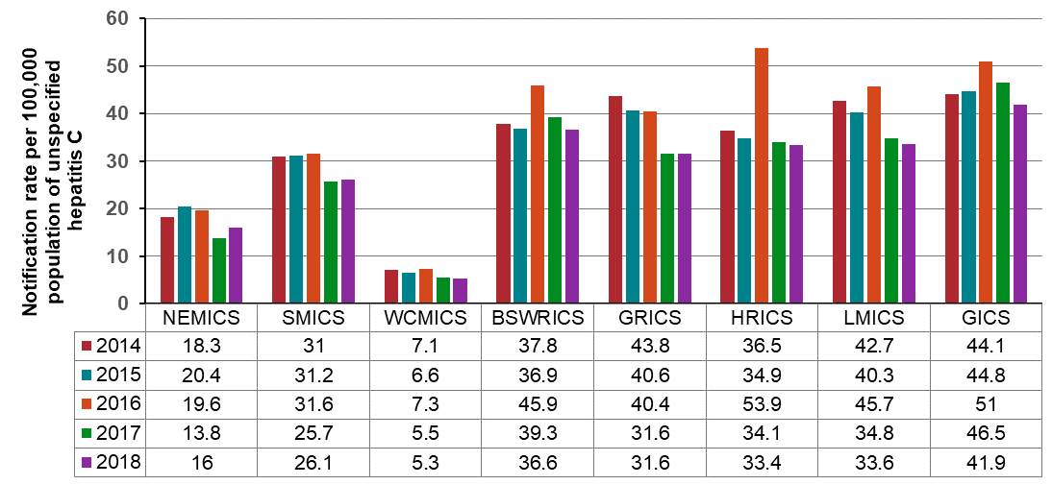
Note: Excludes cases where the postcode of residence was unknown or not reported.

Measure assessment
Traffic light rating: Amber (desired result not yet evident)
Overall trend: Moving in the right direction
Commentary: In Victoria, an estimated 65,000 people are living with hepatitis C (HCV). As with HBV, HCV is a virus that causes inflammation and damage to the liver and, if left untreated, chronic HCV can lead to liver cancer.
In Victoria, HCV is a notifiable disease under the Public Health and Wellbeing Regulations 2009. Figure 10.3 shows that the notification rate of unspecified HCV in Victoria has reduced by approximately four per cent from 33.6 cases per 100,000 in 2014 to 28.8 cases per 100,000 in 2018 and is lower than the overall notification rate for HCV in Australia. It is important to note that the increase in the Victorian notification rate in 2016 may reflect increased testing as a result of people accessing new direct-acting antiviral regimens subsidised by the Pharmaceutical Benefit Scheme from March 2016.
As with HBV, rates for HCV have been consistently higher among males than females and were 39.1 cases per 100,000 and 19.3 cases per 100,000 population in 2018 respectively (Figure 10.3.1). Because the primary route of HCV transmission is sharing injecting equipment, a practice that typically starts in late adolescence (15–19 years) or early adulthood, trends in the rate of notifications in those under 20 years that are injecting drug users can be a proxy for the notification of HCV infection in recent years. Among Victorian people aged under 20 years, there has been a decrease in the notification rate among 15–19-year age group between 2014 and 2018 from 83.8 cases per 100,000 population in 2014 to 68.2 cases per 100,000 population in 2018 (Figure 10.3.2). This is despite the higher rate in this age group compared to other age groups. The age group 30–39 years had the next highest rate of notification, although the rate of notification of HCV has declined from 62.9 cases per 100,000 population in 2014 to 54.8 cases per 100,000 population in 2018. Over the reporting period 2014–2018, a relatively steady pattern was observed among people aged 40 years or older.
Figure 10.3.3 shows the distribution of HCV notification rate by ICS within Victoria between 2014 and 2018. ICSs with the lower rates tended to be those that have large metropolitan areas such as Melbourne, suggesting that the HCV burden is inequitably distributed across Victoria. However, some ICSs that include outer regional areas, while having higher rates, show a declining gradient between 2014 and 2018 – for example, GRICS, HRICS, LMICS and GICS.
While no target has been set for this measure, the WHO global health sector strategy on viral hepatitis 2016–2021 sets a 2020 target of a 30 per cent reduction in the number of new HCV cases from 2015 as the baseline year. The Victorian hepatitis C strategy 2016–20 includes an overarching goal to eliminate HCV as a public health concern by 2030. This goal is underpinned by the following targets: reduce the number of new infections by 90 per cent; increase diagnosis rates by 90 per cent; and increase the treatment rate for HCV to 90 per cent.

Measure 10.4 – Proportion of people with a hepatitis B diagnosis with liver cancer, whose hepatitis B was diagnosed late
Table 10.4: Proportion of people in Victoria with HBV diagnosed with liver cancer, whose HBV was diagnosed late, 2010–2014
Years | Late diagnosis of HBV with liver cancer | People living with HBV diagnosed with liver cancer | Proportion (%)
2010–2013 | 41 | 169 | 24
2014 | 10 | 42 | 24
Source: Linked data from Public Health Events Surveillance System, Department of Health and Human Services and VCR, Cancer Council Victoria.
These data were derived from the Liver Cancer Prevention Study linking viral hepatitis diagnosis, treatment and outcomes conducted by the WHO Collaborating Centre for Viral Hepatitis, Victorian Infectious Diseases Reference Laboratory, The Peter Doherty Institute for Infection and Immunity. This study was funded by a Royal Melbourne Hospital Research Project Grant.
At the time of writing the Liver Cancer Prevention Study was exploring other data sources such as Victorian hospital data and the National Death Index to ascertain whether there are more people living with viral HBV who have been diagnosed with liver cancer who are not included in the VCR. A planned future round of data linkage for the Liver Cancer Prevention Study will be able to provide more precise data for this measure.

Measure assessment
Traffic light rating: Red (result is of concern)
Overall trend: Static or unchanging
Commentary: Chronic HBV infections may remain clinically silent for decades, and symptoms do occur at a late stage, often developing into liver cancer when untreated. Globally 770,000 cases of liver cancer (also known as hepatocellular carcinoma or HCC) occurred worldwide in 2012, of which 430,000 are estimated to be attributable to HBV. In Victoria, chronic HBV infection has been identified as a major contributor to rising liver cancer incidence.
Late diagnosis of HBV represents a missed opportunity to reduce the risk of liver cancer. While no target has been set for this measure, Table 10.4 shows that in Victoria from 2010–2014, 24 per cent of those people with HBV diagnosed with liver cancer were diagnosed with HBV in the two years before, at the same time as or after liver cancer diagnosis. People with better engagement with the healthcare system are more likely to be diagnosed earlier. Early diagnosis provides the opportunity for effective care and antiviral treatment which substantially reduces liver cancer risk.

Measure 10.5 – Proportion of people with a hepatitis C diagnosis with liver cancer, whose hepatitis C was diagnosed late
Table 10.5: Proportion of people in Victoria with HCV diagnosed with liver cancer, whose HCV was diagnosed late, 2010–2014
Years | Late diagnosis of HCV with liver cancer | People living with HCV diagnosed with liver cancer | Proportion (%)
2010–2013 | 66 | 379 | 17
2014 | 22 | 142 | 15
Source: Linked data from Public Health Events Surveillance System, Department of Health and Human Services and VCR, Cancer Council Victoria.
These data were derived from the Liver Cancer Prevention Study linking viral hepatitis diagnosis, treatment and outcomes conducted by the WHO Collaborating Centre for Viral Hepatitis, Victorian Infectious Diseases Reference Laboratory, The Peter Doherty Institute for Infection and Immunity. This study was funded by a Royal Melbourne Hospital Research Project Grant.
At the time of writing the Liver Cancer Prevention Study was exploring other data sources such as Victorian hospital data and the National Death Index to ascertain whether there are more people living with viral HBV who have been diagnosed with liver cancer who are not included in the VCR. A planned future round of data linkage for the Liver Cancer Prevention Study will be able to provide more precise data for this measure.

Measure assessment
Traffic light rating: Red (result is of concern)
Overall trend: Static or unchanging
Commentary: Chronic HCV infections may remain clinically silent for decades, and symptoms do occur at a late stage, often developing into liver cancer when untreated. Globally 770,000 cases of liver cancer occurred worldwide in 2012, of which 150,000 are estimated to be attributable to HCV. In Victoria, and as with chronic HBV, chronic HCV infection has been identified as a major contributor to rising liver cancer incidence and that the very low uptake of treatment (due in part to the systemic discrimination associated with the condition) is a contributing factor to this rise in the incidence of liver cancer.
Late diagnosis of HCV represents a missed opportunity to reduce the risk of liver cancer. While no target has been set for this measure, Table 10.5 shows that in Victoria between 2010–2013, 17 per cent of those people with HCV diagnosed with liver cancer were diagnosed with HCV in the two years before, at the same time as or after liver cancer diagnosis. In 2014 this figure was 15 per cent, a statistically insignificant difference compared to the previous time period. The Victorian HCV strategy reinforces the government’s commitment to eliminate the stigma and discrimination experienced by people living with HCV in Victoria, and to continue to increase the proportion of people living with hepatitis C who have been diagnosed and treated, in order to decrease their risk of liver cancer.

Outcome: Detect cancers early

Key result: Increase early-stage diagnosis

Measure 11.1 – Proportion of all cancers diagnosed at stages 1 or 2
Currently staging information is not captured for all cancers by the Victorian Cancer Registry (VCR). Refer to Appendix 1.

Measure 11.2 – Proportion of female breast cancers diagnosed at stages 1 or 2
Figure 11.2: Proportion of female breast cancers diagnosed at stages 1 and 2, by age, Indigenous status and language spoken at home, 2014–2016
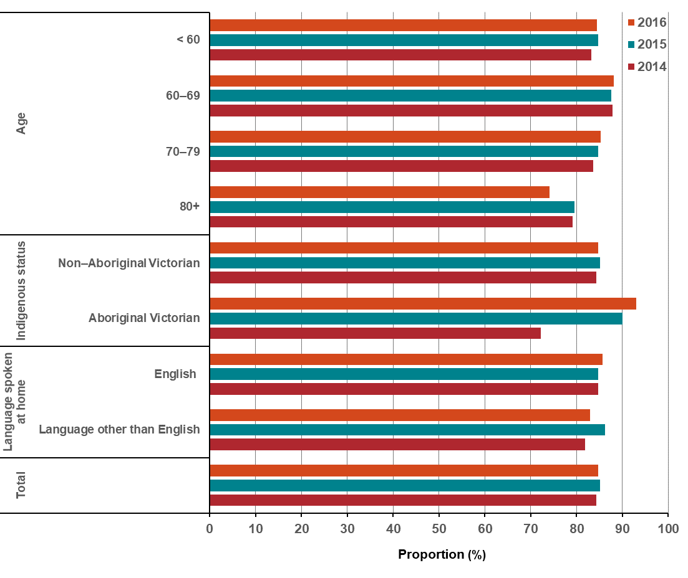
Note: The following was included:
- new diagnoses with stage recorded as 1–4 in the VCR, or with metastases recorded in the VCR (TNM = M1)
- patients diagnosed after neoadjuvant treatment
- for patients with multiple diagnoses within the year of interest, each diagnosis was included. Therefore, the number of new cancers does not necessarily equal the number of distinct patients.
The following was excluded: all cases of male breast cancer and all patients with unknown stage.
Appendix 2 provides the dataset.
Figure 11.2.1: Proportion of female breast cancers diagnosed at stages 1 and 2, by remoteness area, ICS and SES, 2014–2016
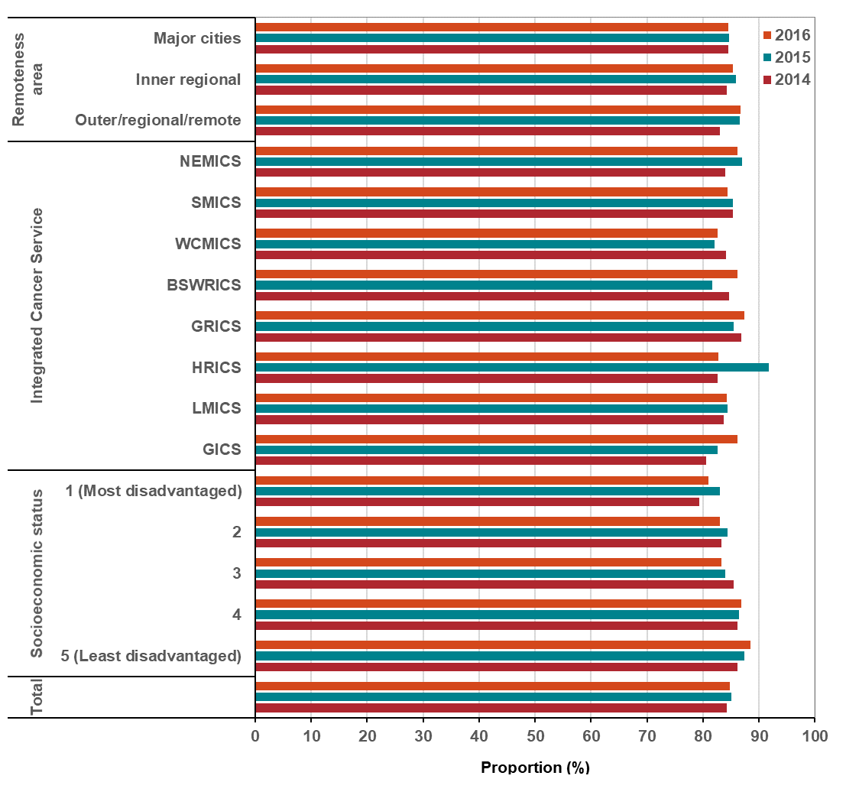
Note: Appendix 2 provides the dataset.

Measure assessment
Traffic light rating: Amber (desired result not yet evident)

Overall trend: Static or unchanging
Commentary: Cancers can be assigned a ‘stage’ that reflects how far the disease has spread. Stage ranges from 1 (best prognosis) to 4 (worst prognosis). At an international level it is important to note that due to differences in the scope of data collection, methodology and availability of information for staging, the distribution at a global stage at diagnosis will vary considerably. This measure presents, for the first time, state-specific stage 1 and 2 at diagnosis data for female breast cancer in Victoria, which has been identified as the second most common new cancer in Victoria. More than 84 per cent of cancers were diagnosed as early stage (stage 1 or stage 2) for breast (female) cancer and generally increased with age between 2014 (84.3 per cent) and 2016 (84.8 per cent) (Figure 11.2). The highest proportion of early-stage cancers were in females aged 60–69 years at around 88 per cent between 2014 and 2016. This trend may reflect an increase in the participation rate of breast cancer screening through BreastScreen Australia, which targets women aged 50–74 for two-yearly screening mammograms. New technologies such as magnetic resonance imaging (MRI) of the breast and increased breast cancer awareness may also have contributed to the increased diagnosis of breast cancer. The lower proportion of early-stage breast cancer detected in women 80 years of age or older may reflect lower rates of screening, high detection of cancers by mammography before 80 years of age, and/or incomplete detection.
Due to the small number of incident cancer cases in a single year over the three-year period (2014, 2015 and 2016), results of analysis by Aboriginal Victorian status should be interpreted with caution. Nevertheless, Figure 11.2 shows an increase in Aboriginal Victorian cases of female breast cancer being diagnosed at an earlier stage over the reporting period. It is recognised that groups in Victoria with the lowest participation rate in screening are women from Aboriginal and Torres Strait Islander and culturally diverse backgrounds (where the language spoken at home may be a language other than English) (Figure 11.2). As a result, these women are more likely to have later stage cancer diagnosis and therefore poorer outcomes. To reverse this trend, the Department of Health and Human Services, in collaboration with BreastScreen Victoria and cancer screening programs and key partners, has implemented a range of initiatives to reduce health disparities.
In the three-year period (2014–2016) there were similar stage (1 and 2) distribution patterns for female (breast) cancer across remoteness area and SES (Figure 11.2.1). There were also no notable differences in the high proportion of female breast cancers diagnosed at stages 1 and 2 across each of the ICS. While no target has been set for this measure, to enable the improvement in female breast cancer outcomes and survival, early diagnosis and screening remain critical.

Measure 11.3 – Proportion of colorectal cancers diagnosed at stage 1 or 2
Figure 11.3: Proportion of colorectal cancers diagnosed at stages 1 and 2, by age, sex, Indigenous status and language spoken at home, 2014–2016
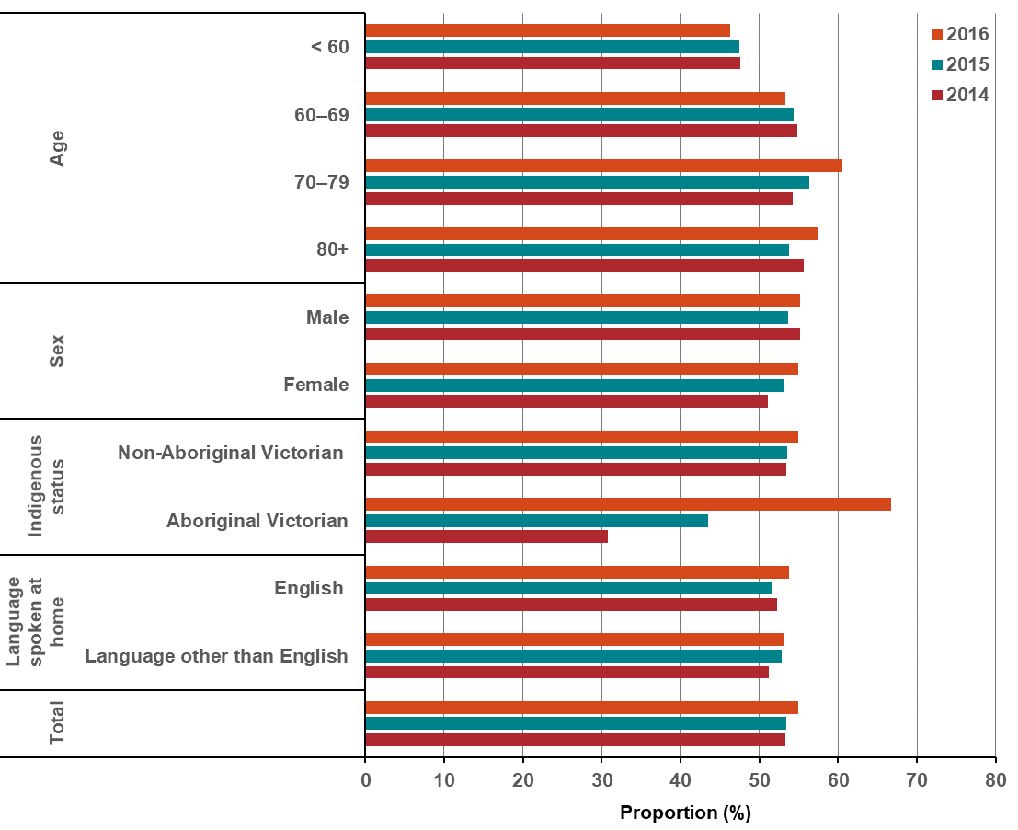
Note:
The following was included:
- new diagnoses with stage recorded as 1–4 in the VCR, or with metastases recorded in the VCR (TNM = M1)
- patients diagnosed after neoadjuvant treatment
- for patients with multiple diagnoses within the year of interest, each diagnosis was included. Therefore, the number of new cancers does not necessarily equal the number of distinct patients.
The following was excluded: all patients with unknown stage.
Appendix 2 provides the dataset.
Figure 11.3.1: Proportion of colorectal cancers diagnosed at stages 1 and 2, by remoteness area, ICS and SES, 2014–2016
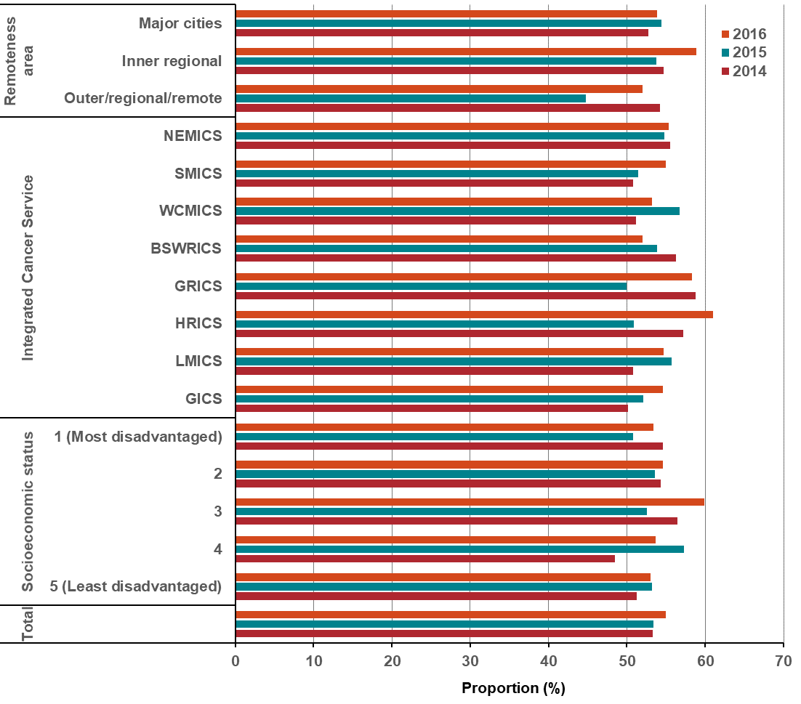
Note:
The following was included:
- new diagnoses with stage recorded as 1–4 in the VCR, or with metastases recorded in the VCR (TNM = M1)
- patients diagnosed after neoadjuvant treatment
- for patients with multiple diagnoses within the year of interest, each diagnosis was included. Therefore, the number of new cancers does not necessarily equal the number of distinct patients.
The following was excluded: all patients with unknown stage.
Appendix 2 provides the dataset.

Measure assessment
Traffic light rating: Amber (desired result not yet evident)
Overall trend: Moving in the right direction
Commentary: The distribution of cancer stage at diagnosis provides an indication of whether a particular cancer type is diagnosed earlier or later. At an international level it is important to note that due to differences in the scope of data collection, methodology and availability of information for staging, the distribution at a global stage at diagnosis will vary considerably. This measure presents the distribution pattern of statewide stage (1 and 2) at diagnosis data for colorectal cancer (CRC). Figure 11.3 shows that over half of all colorectal cases between 2014 (53.3 per cent) and 2016 (55 per cent) were diagnosed at an early stage (1 or 2). Early-stage CRC (stage 1 and stage 2) accounted for between 51 and 60 per cent of cancers for people aged 60 years or older. Slightly lower proportions of early-stage cancers were found in people aged under 60 years (46–47 per cent) between 2014 and 2016. As far as both sexes were concerned, between 2014 and 2016 there was a similar distribution of early stage (1 and 2) at diagnoses for both males and females, although the latter showed an increase from 51.1 per cent in 2014 to 54.9 per cent in 2016.
Due to the small number of incident cancer cases among Aboriginal Victorians in a single year over the three-year period (2014, 2015 and 2016), results of analysis by Indigenous status should be interpreted with caution. Figure 11.3 shows that Aboriginal Victorians had a lower proportion of CRCs diagnosed at stages 1 and 2 in 2014 and 2015 than non-Aboriginal Victorians, but the number of patients is very low (Table 11.3, Appendix 2); that is, 14–21 Aboriginal patients between 2014 and 2016 compared with more than 3,000 non-Aboriginal patients over the same time-period. The difference in numbers may reflect a lower uptake in screening for CRC for this population group.
People living in different socioeconomic groups had similar proportions of CRCs diagnosed at stages 1 and 2, which were generally over 50 per cent. This was also reflected in the proportion of CRCs diagnosed at stages 1 and 2 across the different ICSs, language spoken at home and remote areas.
While no target has been set for this measure, increasing participation in the National Bowel Cancer Screening Program is needed to reap the greatest benefits in terms of reducing illness and death from CRC in the target age group of people aged 50–74 years.

Measure 11.4 – Proportion of cervical cancers diagnosed at stages 1 or 2
This information is currently not captured by the VCR. Refer to Appendix 1.

Measure 11.5 – Proportion of lung cancers diagnosed at stages 1 or 2
This information is currently not captured by the VCR. Refer to Appendix 1.

Measure 11.6 – Proportion of all solid tumours diagnosed at metastatic stage
Figure 11.6: Proportion of all solid tumours diagnosed at the metastatic stage, by age, sex, Indigenous status and language spoken at home, 2014–2016
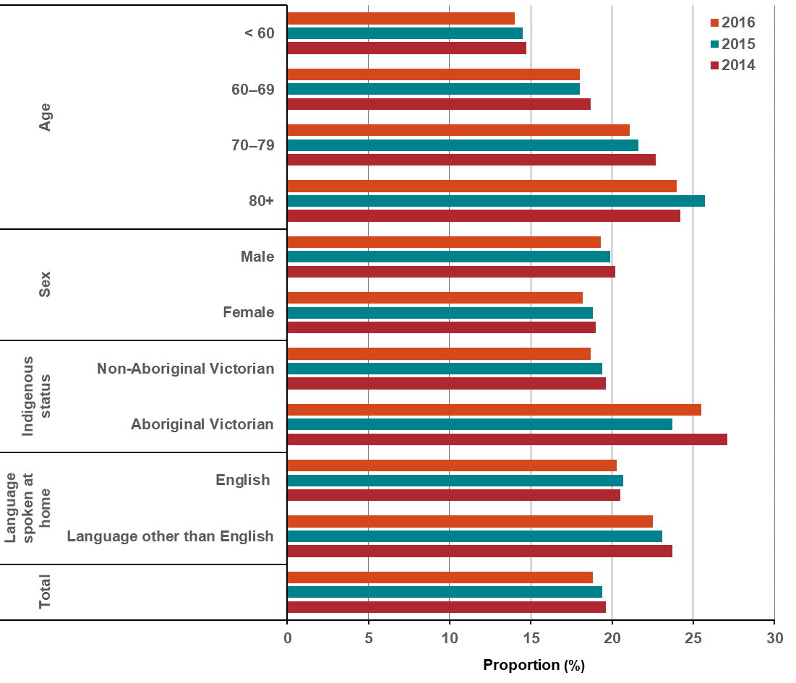
Note:
- Metastatic disease at diagnosis was determined by:
  - VCR TNM-M (M1)
  - admitted episodes in the VAED, between 30 days prior and four months after diagnosis date, which contained metastatic cancer diagnosis codes (neoplasm and morphology codes).
- Patients who did not have an admitted episode in the VAED in the allocated timeframe could not be reclassified as metastatic at diagnosis, and so some cases of metastatic disease may not have been captured.
- New tumours with a VCR diagnosis of C00–C80 (solid tumour at diagnosis) were included, but codes C70–C72 (brain and CNS) were excluded in accordance with the Victorian cancer plan monitoring and evaluation framework – Data dictionary.
Appendix 2 provides the dataset.
Figure 11.6.1: Proportion of all solid tumours diagnosed at the metastatic stage, by remoteness area, ICS and SES, 2014–2016
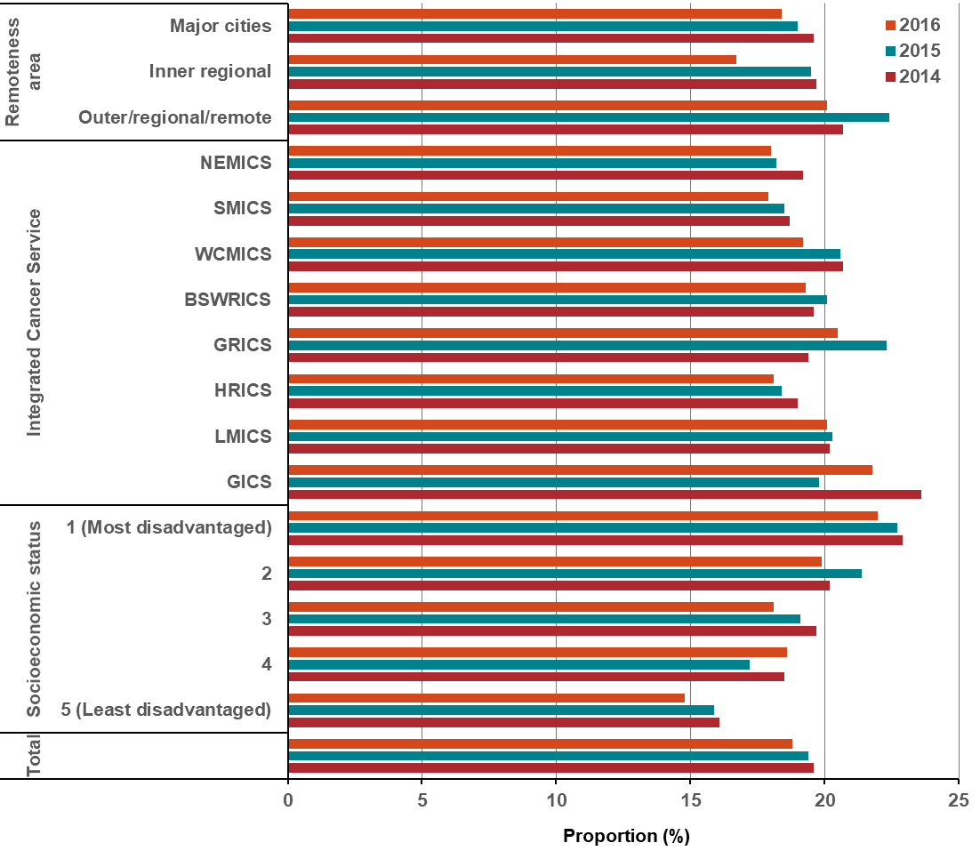
Note:
- Metastatic disease at diagnosis was determined by:
  - VCR TNM-M (M1)
  - admitted episodes in the VAED, between 30 days prior and four months after diagnosis date, which contained metastatic cancer diagnosis codes (neoplasm and morphology codes).
- Patients who did not have an admitted episode in the VAED in the allocated timeframe could not be reclassified as metastatic at diagnosis, and so some cases of metastatic disease may not have been captured.
- New tumours with a VCR diagnosis of C00–C80 (solid tumour at diagnosis) were included, but codes C70–C72 (brain and CNS) were excluded in accordance with the Victorian cancer plan monitoring and evaluation framework – Data dictionary.
Appendix 2 provides the dataset.

Measure assessment
Traffic light rating: Amber (desired result not yet evident)
Overall trend: Heading in the right direction
Commentary: The distribution of cancer stage at diagnosis provides an indication of whether a particular cancer type is diagnosed earlier (stage 1) or later (stage 4). The term ‘metastatic’ is used to describe cancers diagnosed at stage 4.
Figure 11.6 shows that the proportion of all solid tumours diagnosed at metastatic stage was consistent between 2014 (19.6 per cent) and 2016 (18.8 per cent). Figure 11.6 also shows a clear relationship between age and stage at diagnosis, with a greater proportion of patients over 80 years of age (24–25.7 per cent) presenting solid tumours compared with younger patients aged less than 60 years (14–14.7 per cent), although there was a slight decrease for all age categories between 2014 and 2016. Males accounted for a slightly higher proportion of all solid tumours diagnosed at metastatic stage than females, possibly in part because males may be more likely to delay reporting symptoms and are less likely to participate in screening programs (bowel). Nevertheless, overall this trend showed a slight decline for both sexes in the analysis period (Figure 11.6).
For all three reporting years, Aboriginal Victorians had higher proportions of solid tumours diagnosed at the metastatic stage compared with non-Aboriginal Victorians. A similar pattern was observed for those whose language spoken at home was not English. This suggests that Aboriginal Victorian and culturally diverse communities may be under-served in early diagnosis, making them more vulnerable during the cancer treatment phase (Figure 2.3).
Figure 11.6.1 shows there was no clear association between all tumours diagnosed at the metastatic stage from 2014 to 2016. However, there was clear associations between SES and patients diagnosed with tumours at a metastatic stage, with those in the lowest quintile having the greatest burden of all tumours being diagnosed at an advanced stage compared with those in the highest quintile. This could be driven by individual cancer types such as lung cancer, which is more prevalent in low socioeconomic groups, of which 50 per cent are metastatic at diagnosis. The distribution pattern by remoteness also showed some variability, with those living in inner regional and outer regional/remote areas compared with major cites more likely to have patients with tumours diagnosed at a metastatic stage (Table 11.6.1, Appendix 2).
While no target has been set for this measure, knowing the distribution of all solid tumours diagnosed at a metastatic stage is crucial to understanding variations in survival and can help inform where targeted cancer control strategies such as screening, and improved early detection/diagnosis of cancer can be applied to reduce the proportion of cancers diagnosed at an advanced stage (stage 4).

Outcome: Optimal diagnostics and treatment

Key result: Increase adherence to Optimal Care Pathways

Measure 12.1 – Median days from diagnosis to start of primary curative treatment
Figure 12.1: Median days (and interquartile range) from diagnosis to start of primary curative treatment (overall), by year, 2014 and 2016
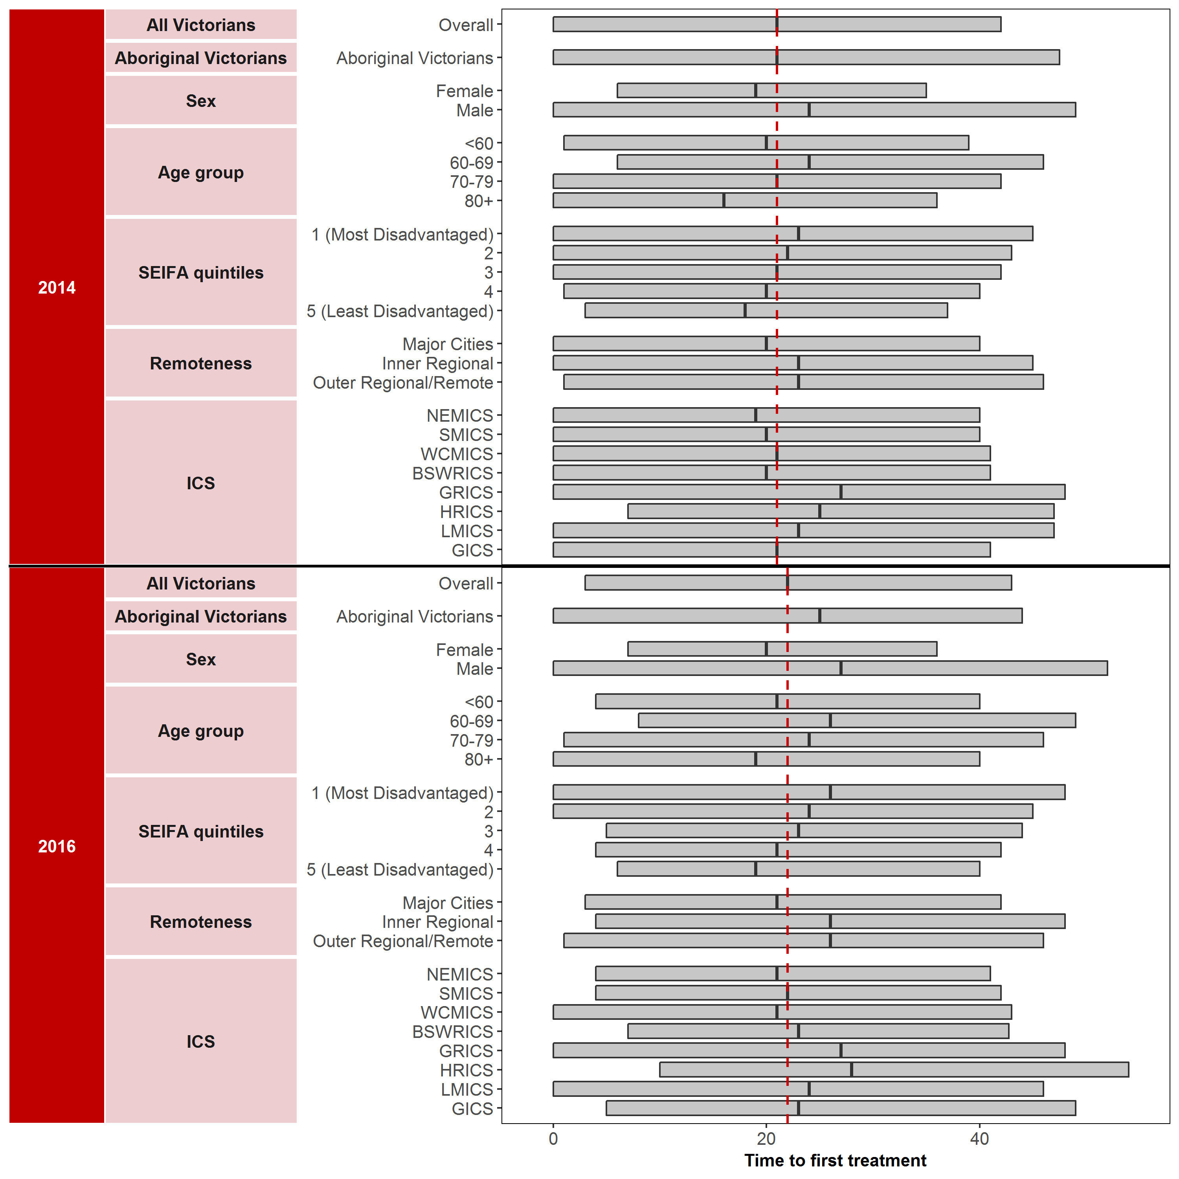

Note:
- Patients who had a diagnosis that did not fall within one of the major tumour streams were grouped together in a new grouping called ‘Other’.
- If a patient had more than one diagnosis within the same tumour stream (excluding ‘Other’ tumour stream) within the year of consideration, only the earliest diagnosis was retained.
- For patients in the ‘Other’ tumour stream, if a patient had more than one diagnosis with the same three-digit ICD10 code, the earliest diagnosis was retained.
- For patients who had a diagnosis within one of the major tumour streams, they were:
  - flagged as having had surgery if they had an admitted episode in the VAED with a tumour stream specific surgery code in one of the operation codes
  - flagged as having had chemotherapy if they had an admitted episode in the VAED with a chemotherapy code AND a tumour stream specific ICD10 code within the diagnosis codes
  - flagged as having had radiotherapy if they had radical radiotherapy with a primary site that matched any ICD10 codes within their tumour stream.
- For patients who had a diagnosis that did not fall within one of the major tumour streams (in the ‘Other’ grouping), they were:
- flagged as having had surgery if they had an admitted episode in the VAED with a surgery code related to any of the major tumour streams in the operation codes
- flagged as having had chemotherapy if they had an admitted episode in the VAED with a chemotherapy code
- flagged as having had radiotherapy if they had any radical radiotherapy.
- Metastatic disease at diagnosis was determined by:
- Patients with a metastatic diagnosis were excluded
- VCR TNM-M (M1)
- admitted episodes in the VAED, between 30 days prior and four months after diagnosis date, that contained metastatic cancer diagnosis codes (neoplasm and morphology codes).
Appendix 2 provides the dataset.
Figure 12.1.1: Median days from diagnosis to start of primary curative treatment (breast), by year, 2014 and 2016
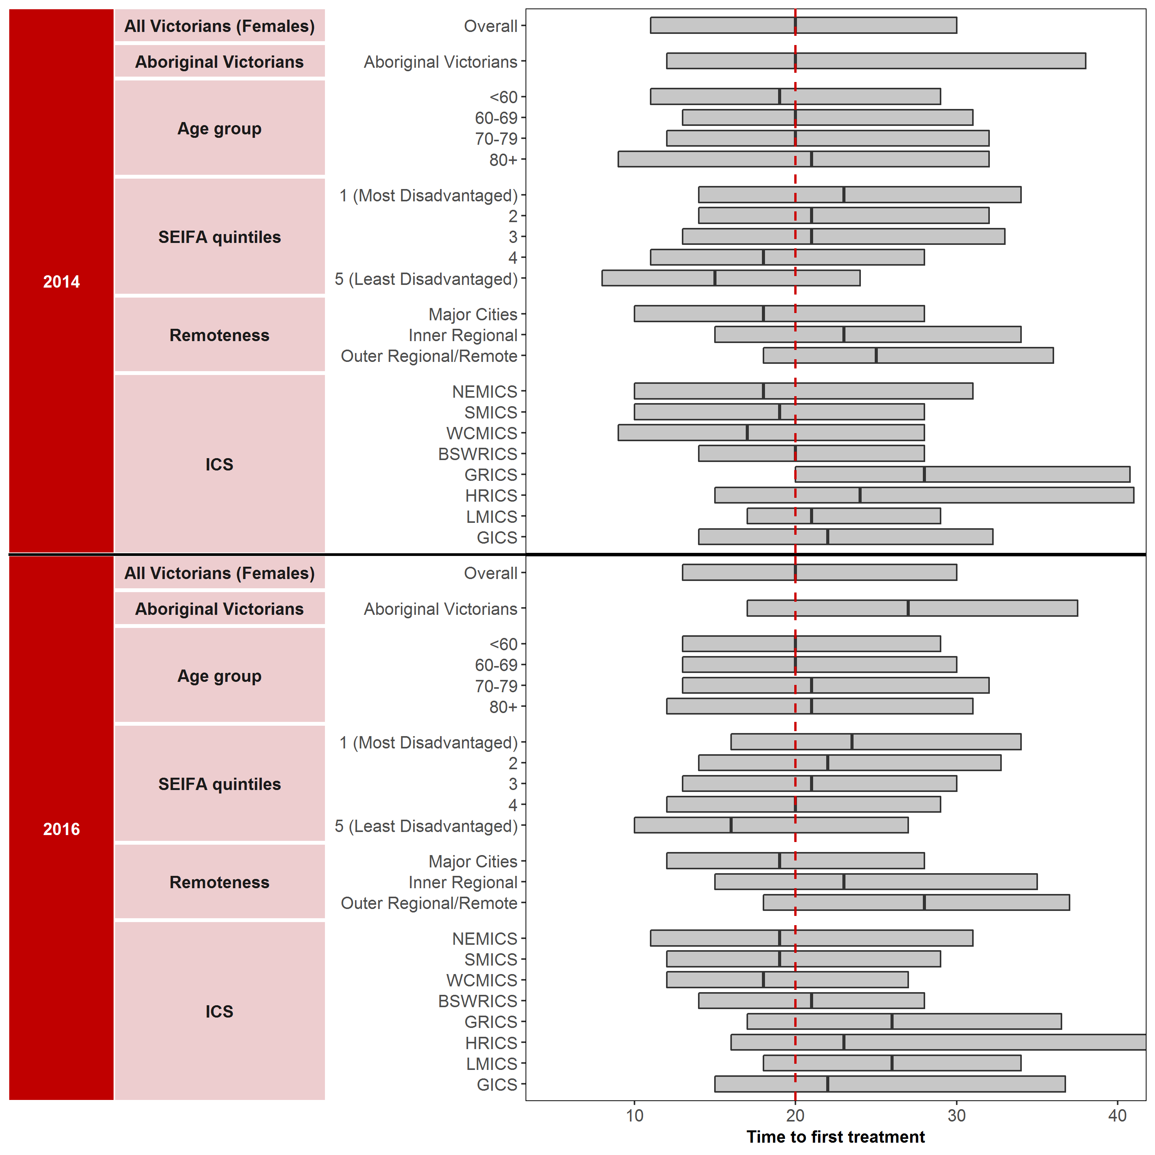
Note: Appendix 2 provides the dataset.
Figure 12.1.2: Median days from diagnosis to start of primary curative treatment (colorectal), by year, 2014 and 2016
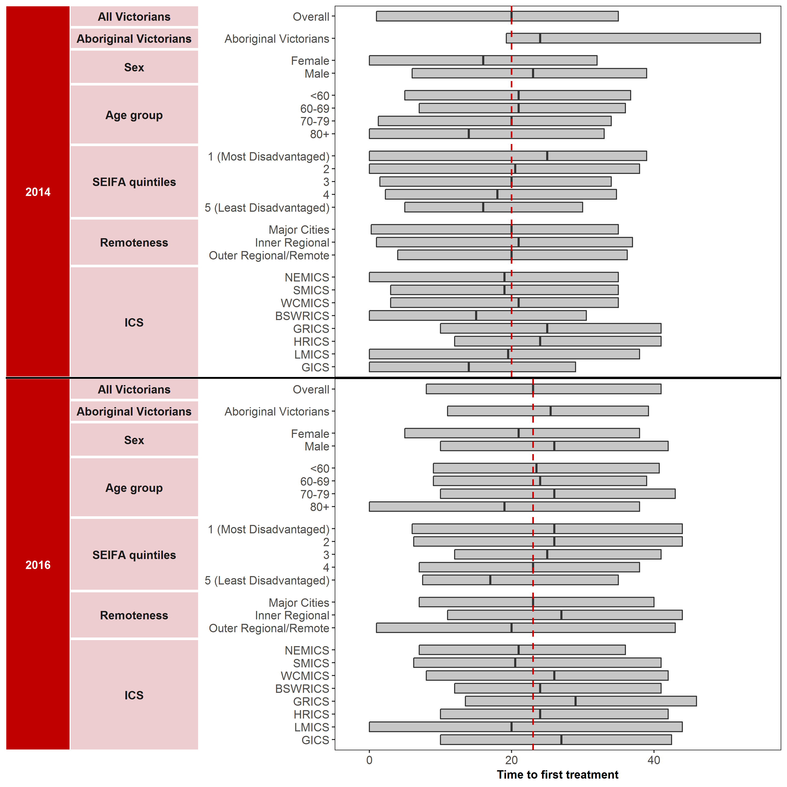
Note: Appendix 2 provides the dataset
Figure 12.1.3: Median days from diagnosis to start of primary curative treatment (genitourinary), by year, 2014 and 2016
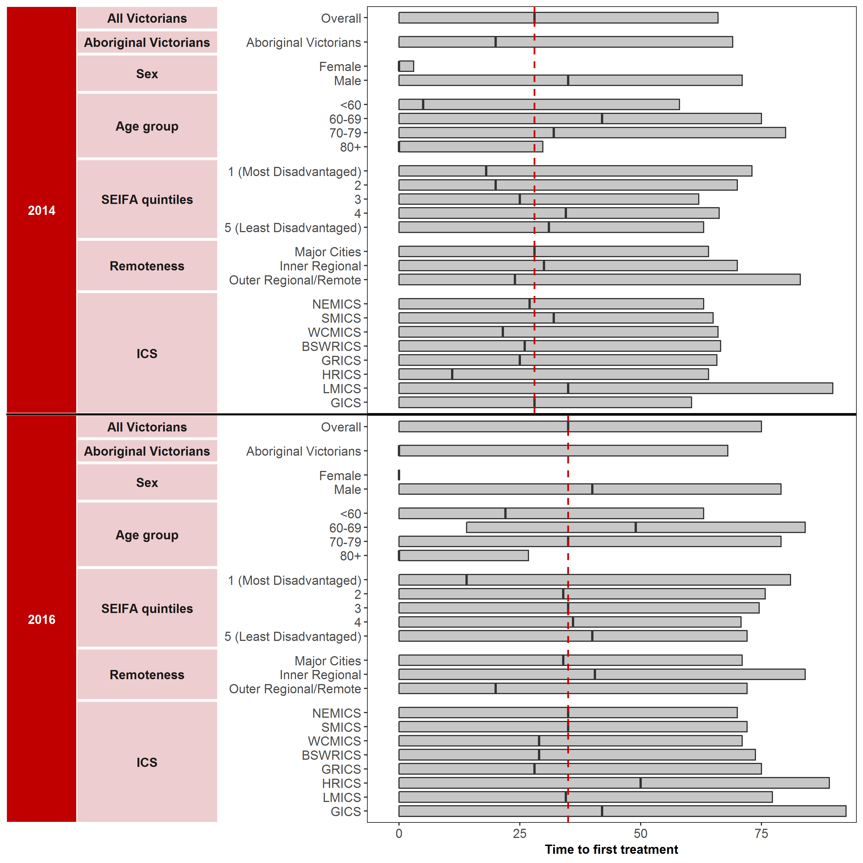
Note: Appendix 2 provides the dataset
Figure 12.1.4: Median days from diagnosis to start of primary curative treatment (haematological), by year, 2014 and 2016
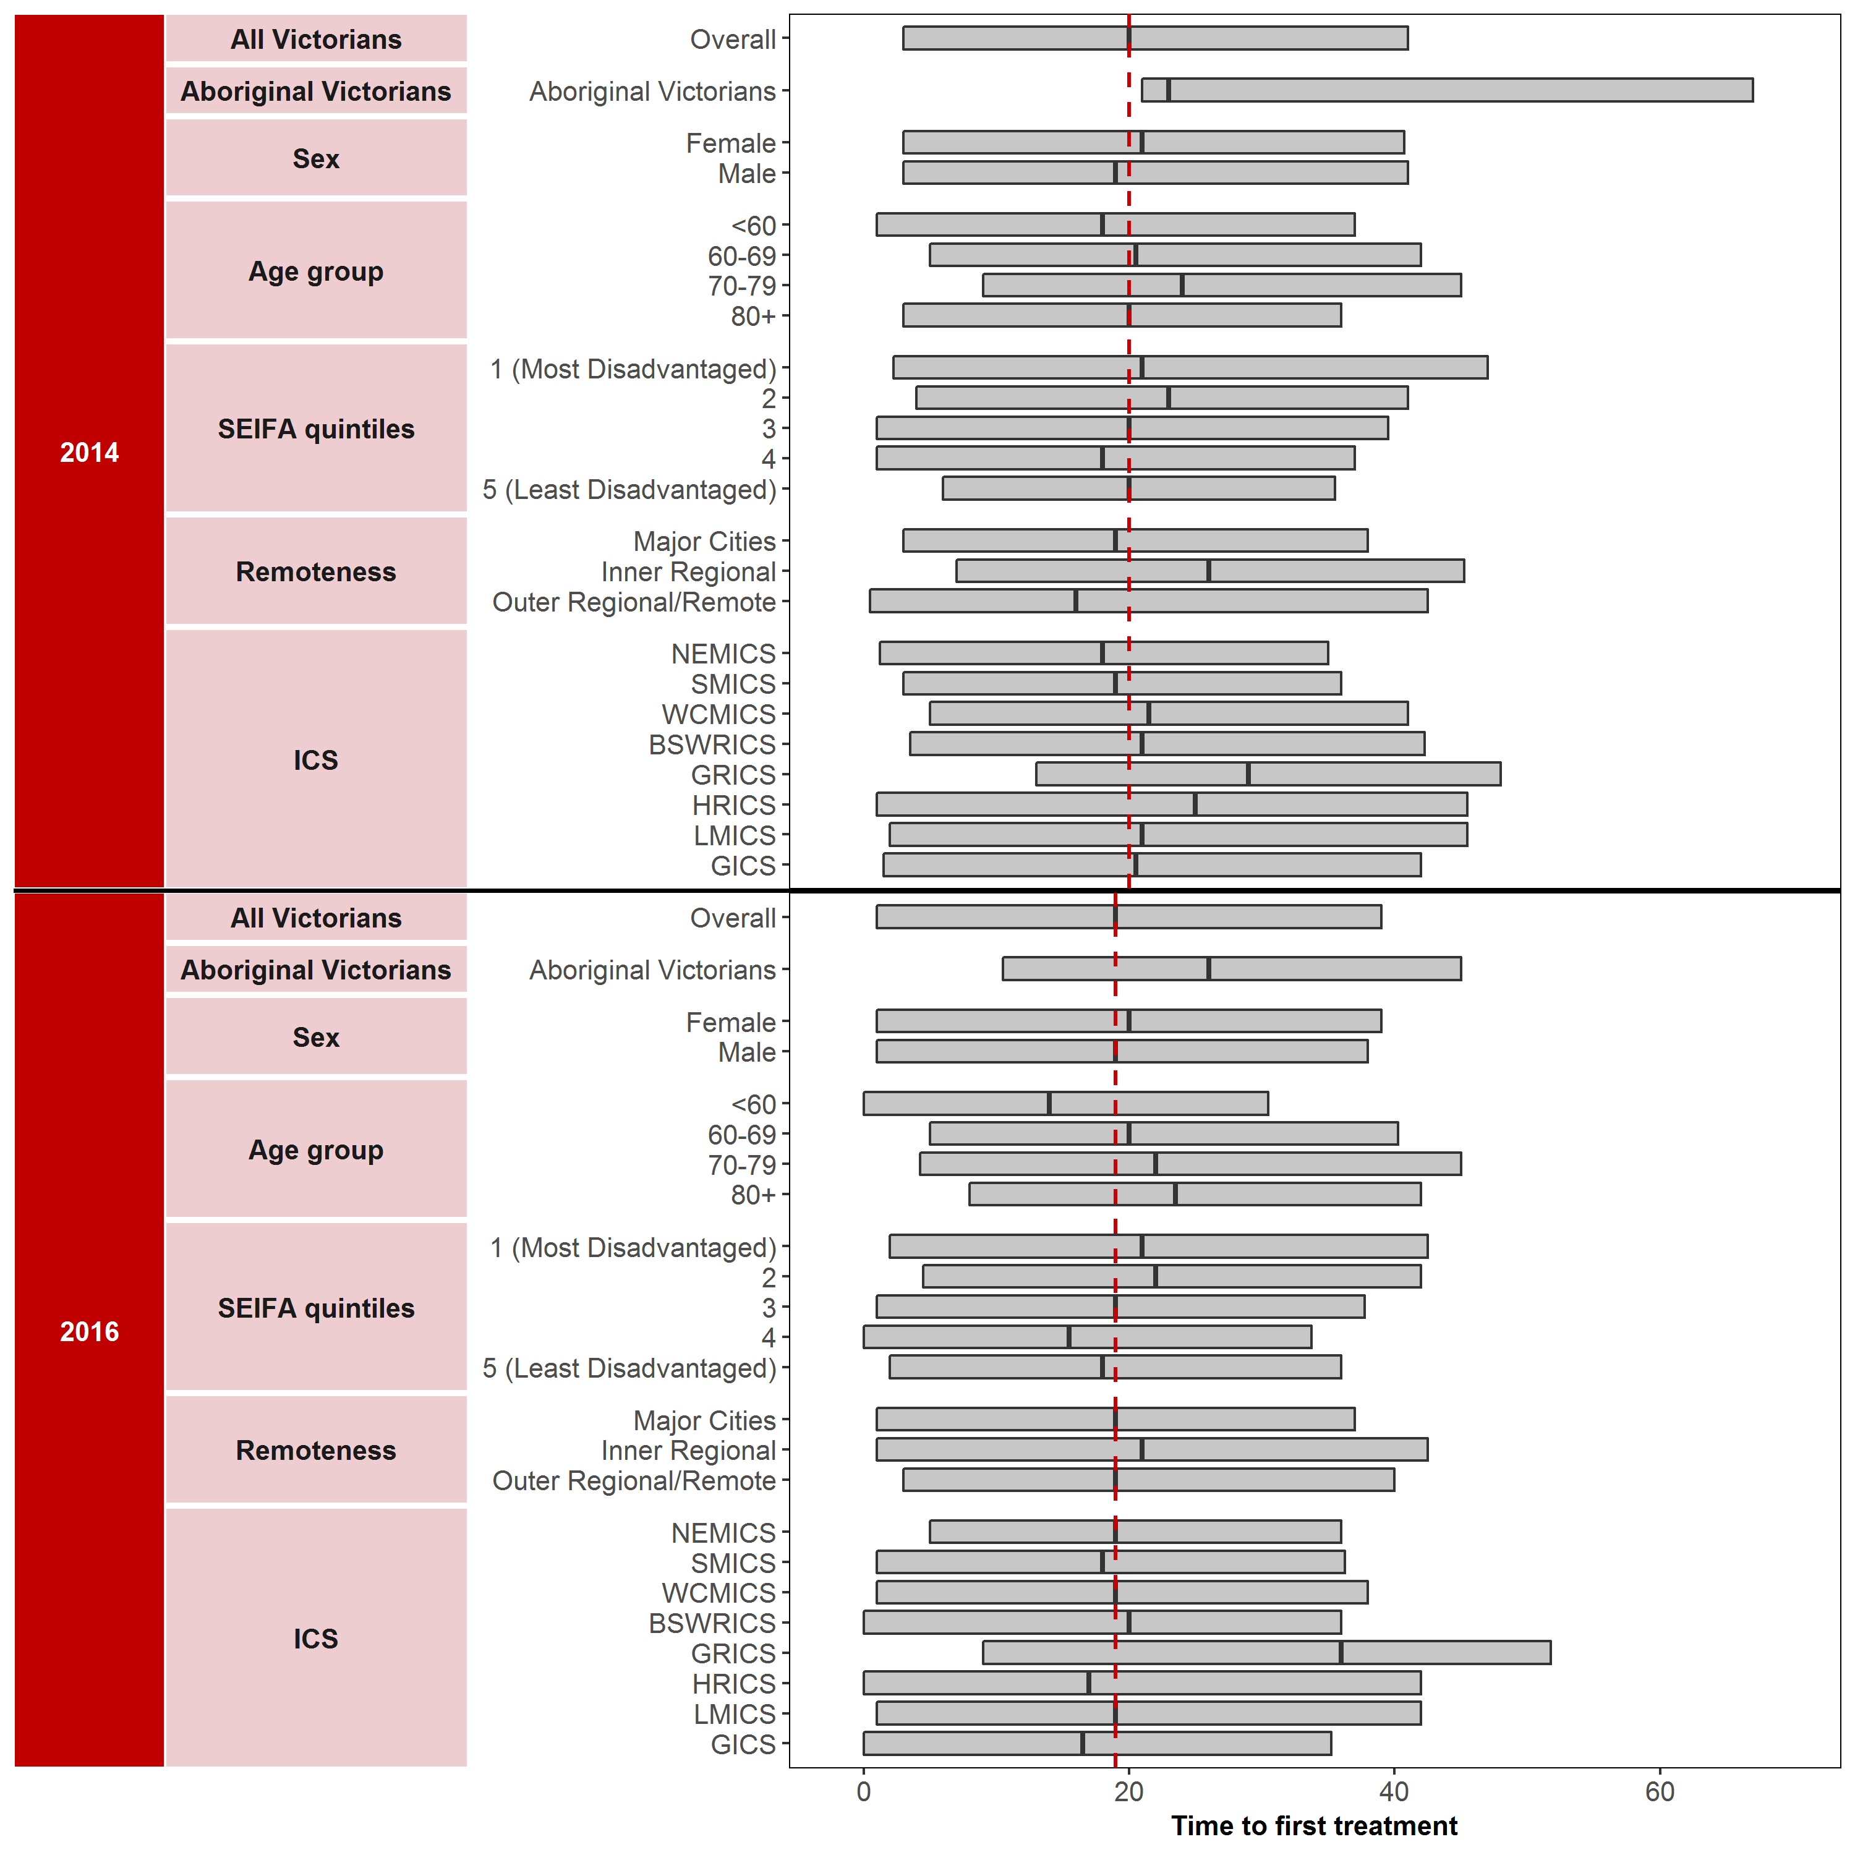
Note: Appendix 2 provides the dataset.
Measure assessment
Traffic light rating: Amber (desired result not yet evident)
Overall trend: Static or unchanging
Commentary: The time from a new diagnosis of cancer to starting treatment is a period of stress and anxiety for patients and their families. Delays in time to treatment have been associated with worsened survival in some cancers, particularly early-stage cancers. Hence, it is important that people are able to access timely treatment. For the purposes of this measure, primary curative treatment refers to surgery, radiotherapy or systemic anti-cancer therapy (SACT).
Figure 12.1 shows that overall median time to treatment initiation from diagnosis in 2014 and 2016 was 21 and 22 days, respectively. Aboriginal and Torres Strait Islanders, the most disadvantaged Victorians and rural/regional Victorians experienced longer times from diagnosis to start of treatment than the overall figures for both 2014 and 2016, suggesting inequitable access to care for these groups. Variation in the timeliness from diagnosis to the start of primary curative treatment between metropolitan and rural/remote ICS (for example, GRICS median days were 26 in 2014 rising to 27 in 2017) may indicate resource pressures in the public system or clinical variation by providers in ICSs in determining cancer treatment.
Figures 12.1.1 to 12.1.4 show that the median time to treatment initiation from diagnosis for the top four tumour streams that recorded the highest number of cases varied from no change (20 days) between 2014 and 2016 for breast cancer (Figure 12.1.1) to 24 days in 2014, rising to 32 days in 2016 for genitourinary cancer. The median time to treatment initiation from diagnosis for colorectal and haematological cancer was 20 days (2014), rising to 23 days in 2016 and 20 days (2014) and 19 days in 2016, respectively.
No specific target has been set for this measure rather the intent here is to align with the targeted approach set out in the Victorian optimal pathway for people with cancer; therefore, care should be taken when interpreting the results of this measure due to limitations outlined in the footnote below.

Measure 12.2 – Proportion of patients receiving PET prior to primary treatment where appropriate
This measure will be reported in a future report. Refer to Appendix 1.

Measure 12.3 – Proportion of patients receiving molecular diagnostics prior to primary treatment where appropriate
This measure will be reported in a future report. Refer to Appendix 1.

Measure 12.4 – Proportion of patients with non-metastatic lung, breast, rectal and oesophageal cancers receiving radical radiotherapy as part of their primary treatment
Figure 12.4: Proportion of patients with non-metastatic lung cancer receiving radical radiotherapy as part of their primary treatment, by age, sex, Indigenous status, language spoken at home, remoteness area, SES and ICS, 2014–2016
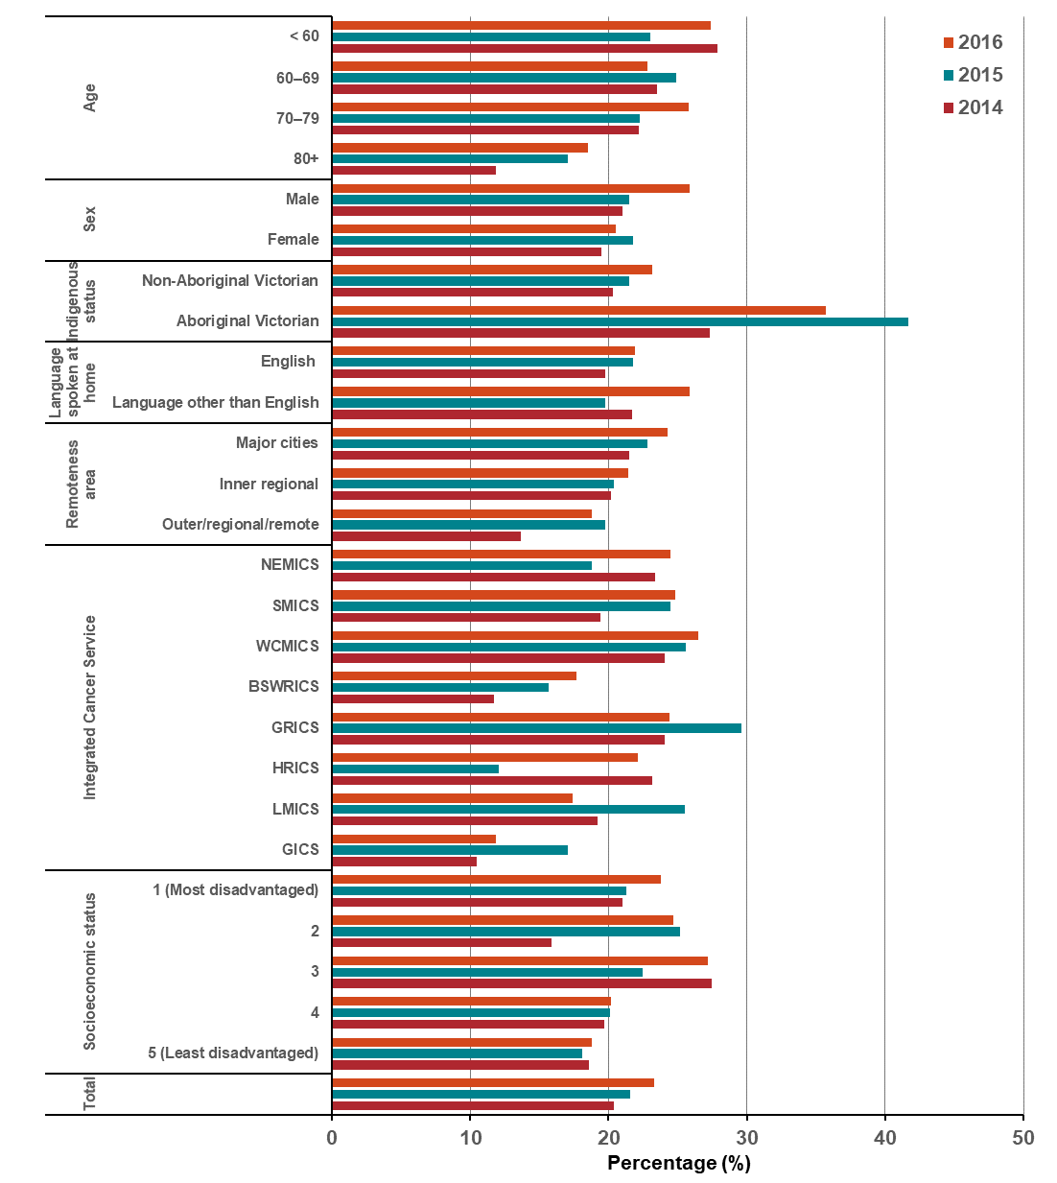
Appendix 2 provides the dataset.
Percentage (%)
Figure 12.4.1: Proportion of patients with non-metastatic breast cancer receiving radical radiotherapy as part of their primary treatment, by age, sex, Indigenous status, language spoken at home, remoteness area, SES and ICS, 2014–2016
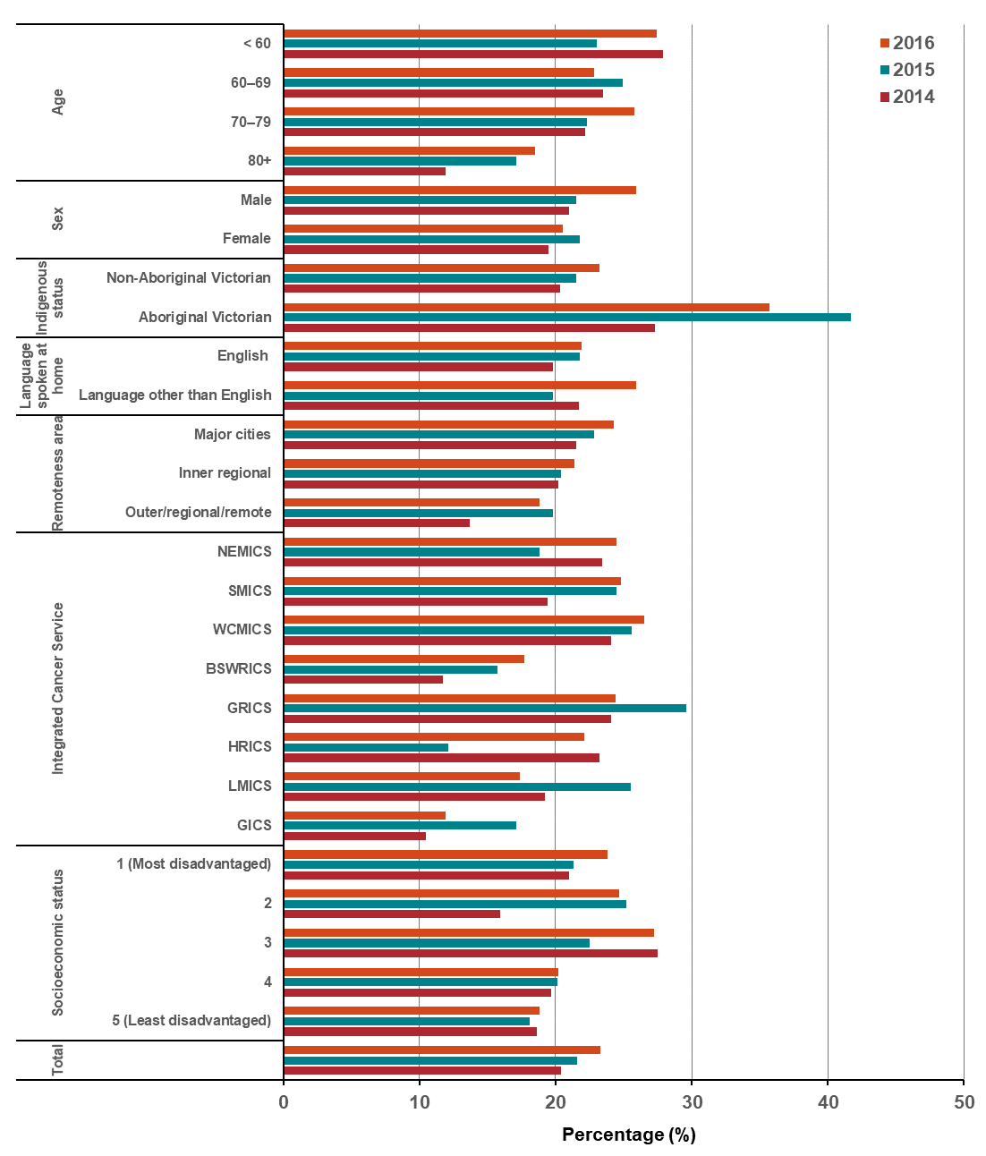
Appendix 2 provides the dataset.
Figure 12.4.2: Proportion of patients with non-metastatic colorectal cancer receiving radical radiotherapy as part of their primary treatment, by age, sex, Indigenous status, language spoken at home, remoteness area, SES and ICS, 2014–2016
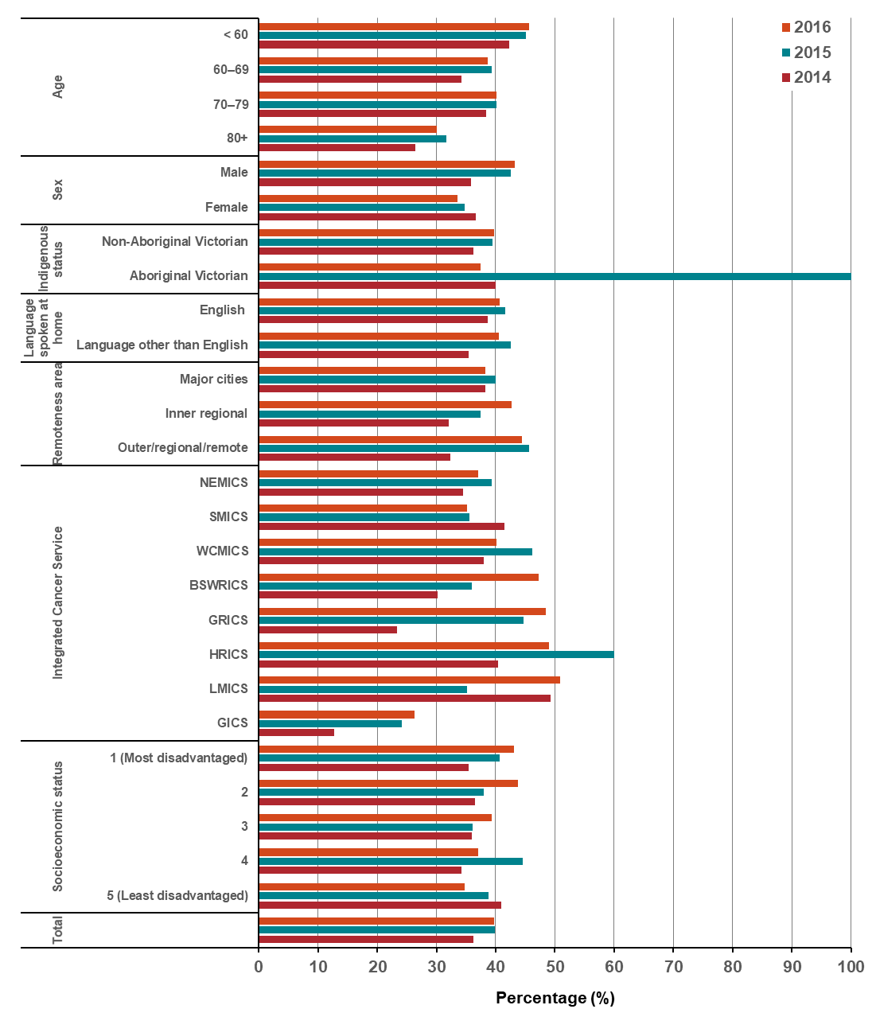
Appendix 2 provides the dataset.
Percentage (%)
Figure 12.4.3: Proportion of patients with non-metastatic oesophageal cancer receiving radical radiotherapy as part of their primary treatment, by age, sex, Indigenous status, language spoken at home, remoteness area, SES and ICS, 2014–2016
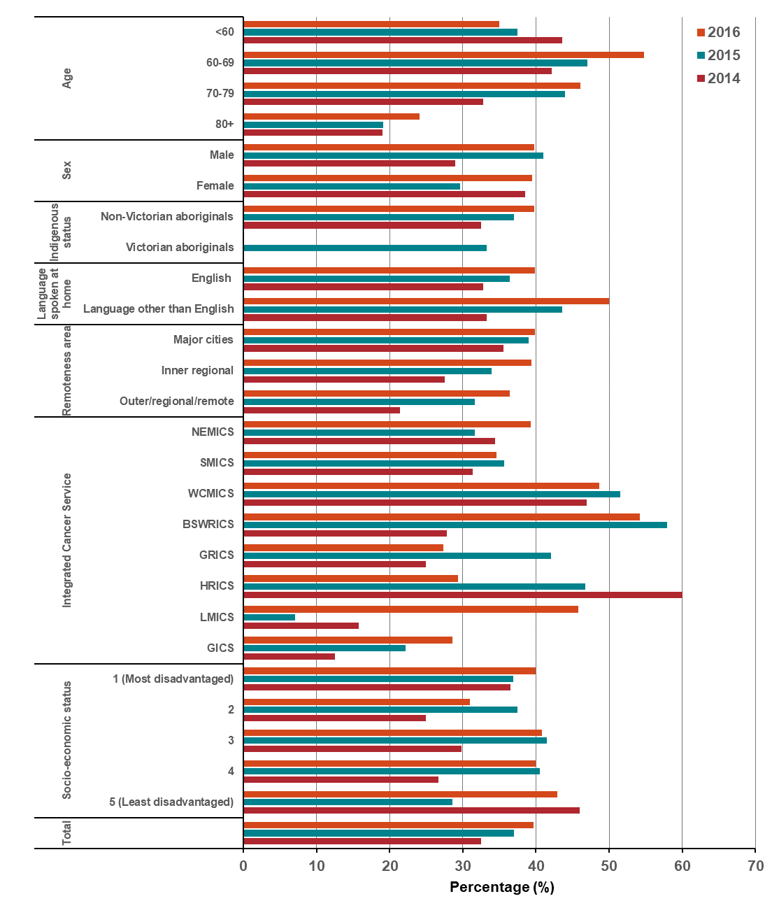
Appendix 2 provides the dataset.

Measure assessment
Traffic light rating: Amber (desired result not yet evident)
Overall trend: Static or unchanging
Commentary: Radical radiotherapy, also known as radiation therapy, is one of the main treatments for many cancers. It is also an area of health in which new technologies are emerging rapidly. This measure focuses on the proportion of patients with non-metastatic lung, breast, colorectal and/or oesophageal cancers who receive radiotherapy as part of their treatment. Of the four tumour streams, breast cancer (female and male) recorded the highest proportion of patients receiving radiotherapy at 63.6 per cent in 2014 rising to 64.6 per cent in 2016. By comparison colorectal recorded the next highest proportion of 36.2 per cent in 2014 and 39.7 per cent in 2016. This was followed by oesophageal cancer (32.5 per cent in 2014 and 37 per cent in 2016) and lung cancer (20.4 per cent in 2014 and 23.2 per and cent in 2016) (Figures 12.4, 12.4.1, 12.4.2 and 12.4.3).
No target has been set for this measure; however, as the population of Victoria ages, coupled with projected increase in cancer incidence (including age and gender profiles) this will likely see an increase in treatment volume as it relates to radical radiotherapy. Figures 12.4, 12.4.1, 12.4.2 and 12.4.3 show that the proportion of patients receiving radical radiotherapy treatment varies across ICS. A higher proportion of patients receiving radical radiotherapy as part of their primary treatment were reported for urban patients however proportions for inner and outer regional/remote areas showed a steady increase between 2014 and 2016 over all four tumour streams – an indication that radiotherapy services (Albury Wodonga Regional Cancer Centre and South West Regional Cancer Centre) established in 2015 has improved access to this service for rural patients. Of note, too, Figures 12.4, 12.4.1, 12.4.2 and 12.4.3 show an increase in the proportion of culturally diverse cancer patients who do not speak English as a first language receiving radical radiotherapy as part of their primary treatment between 2014 and 2016. Data as it relates to Aboriginal Victorians should be interpreted with caution for all four tumour streams because of the very low numbers of cases reported (refer to Appendix 2)

Measure 12.5 – Proportion of patients receiving systemic anti-cancer therapy within recommended timelines and where appropriate
Figure 12.5: Proportion of patients (overall) receiving systemic anti-cancer therapy within recommended timelines, by age (A), sex (B), Indigenous status (C), language spoken at home (D), remoteness area (E), SES (F) and ICS (G), Victoria, 2014–2016

    - Age
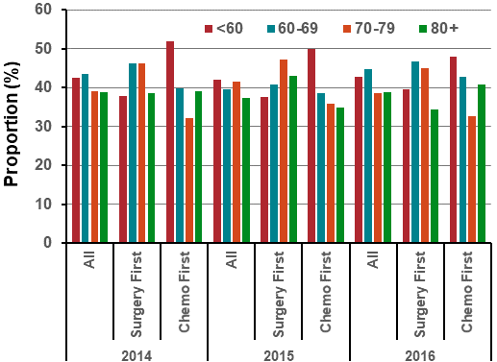
    - Sex
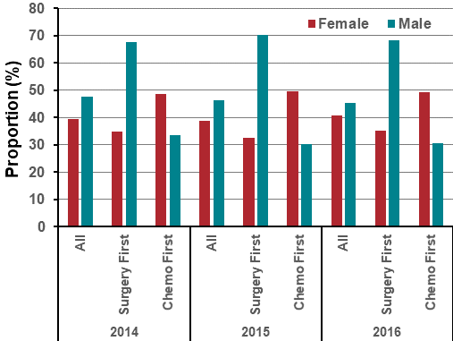

- Indigenous status
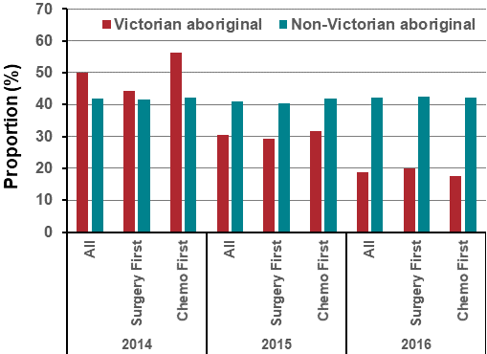
D. Language spoken at home
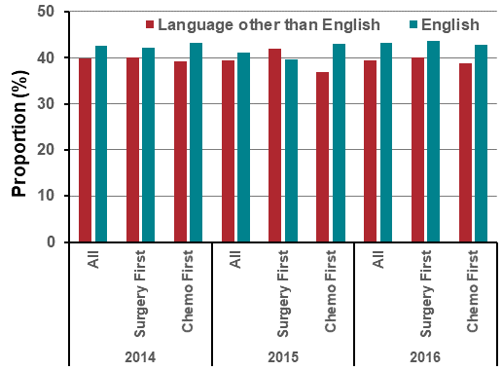

- Remoteness area
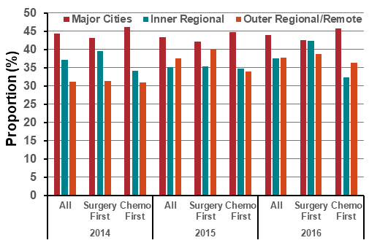
- Socioeconomic status
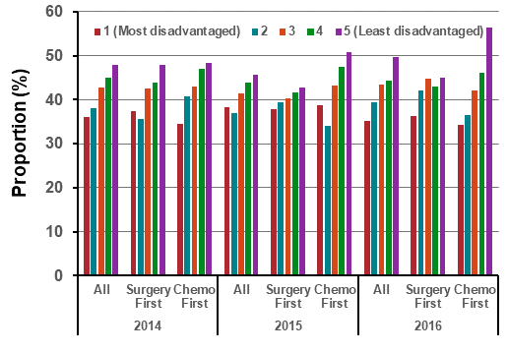

- Integrated Cancer Service
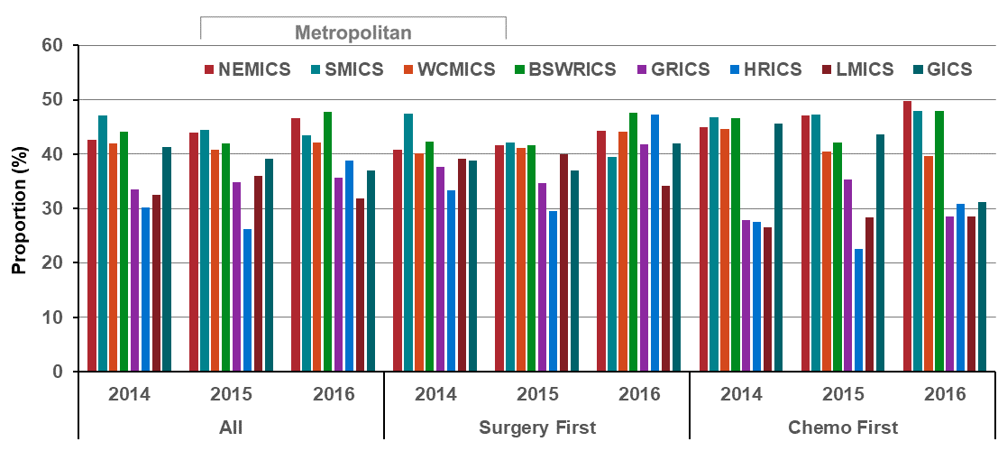
Notes:
The Department of Health and Human Services’ ‘Guidelines for timely initiation of chemotherapy: a proposed framework for access to medical oncology and haematology cancer clinics and chemotherapy services in Victoria’ (2015) describe the optimal timelines for treatment of colorectal, lung, breast and ovarian cancers in Victoria.
Victorians with cancer who live in HRICS may receive treatment in New South Wales (Albury) hospitals, which is not captured in the VAED. Therefore, variables in this report that are derived using the VAED (i.e. comorbidity count, distant metastases, surgery and chemotherapy) are likely to be underestimated for Victorians living in HRICS.
Appendix 2 provides the dataset.
Figure 12.5.1: Proportion of lung cancer patients receiving systemic anti-cancer therapy within recommended timelines, by age (A), sex (B), Indigenous status (C), language spoken at home (D), remoteness area (E), SES (F) and ICS (G), Victoria, 2014–201
- Age
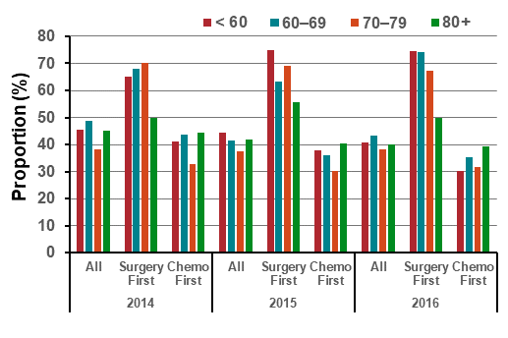
- Sex
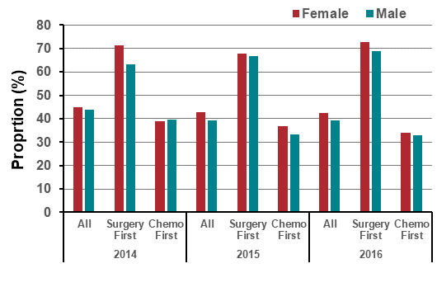

- Indigenous status
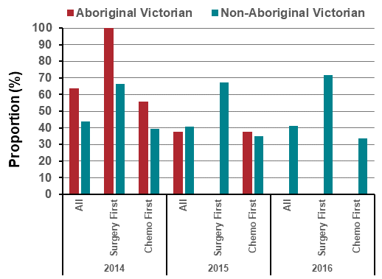
- Language spoken at home
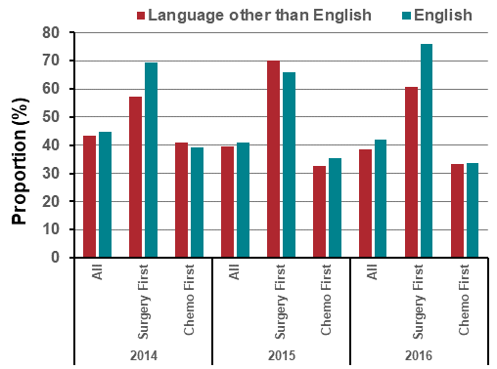

- Remoteness area
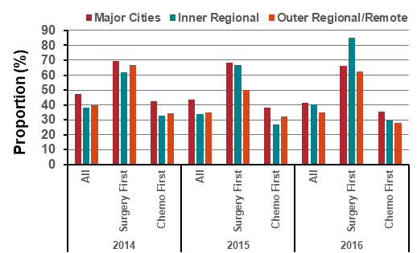
- Socioeconomic status
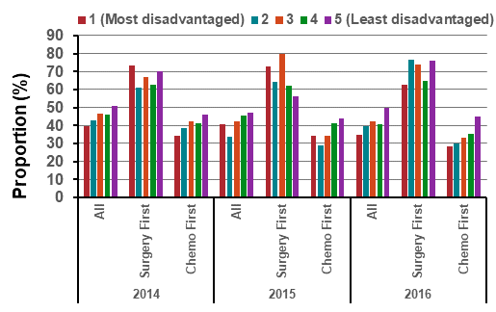

- Integrated Cancer Service
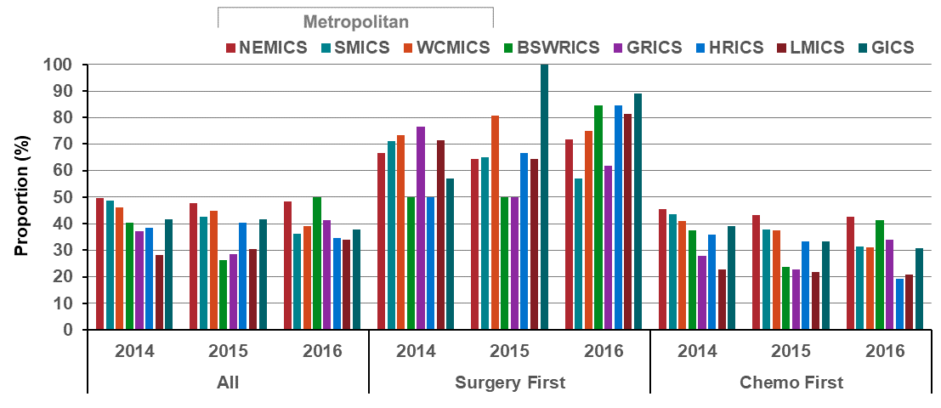
Note: Victorians with cancer who live in HRICS may receive treatment in New South Wales (Albury) hospitals, which is not captured in the VAED. Therefore, variables in this report that are derived using the VAED (i.e. comorbidity count, distant metastases, surgery and chemotherapy) are likely to be underestimated for Victorians living in HRICS.
Appendix 2 provides the dataset.
Figure 12.5.2: Proportion of breast cancer patients receiving systemic anti-cancer therapy within recommended timelines, by age (A), sex (B), Indigenous status (C), language spoken at home (D), remoteness area (E), SES (F) and ICS (G), Victoria, 2014–2016

- Age
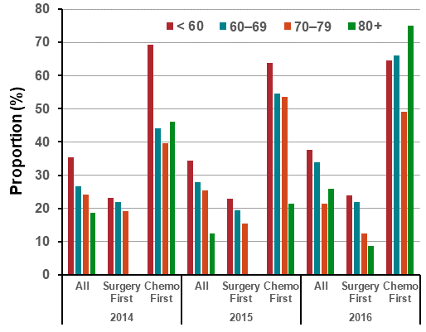
- Sex
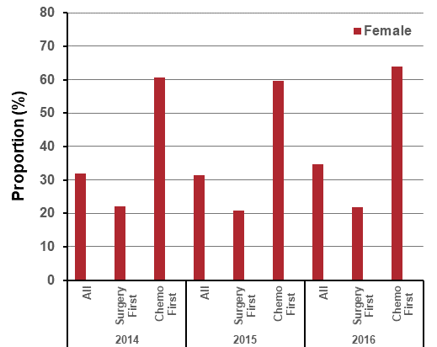

- Indigenous status
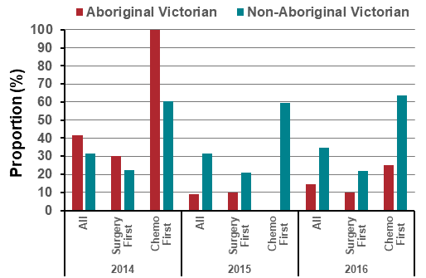
- Language spoken at home
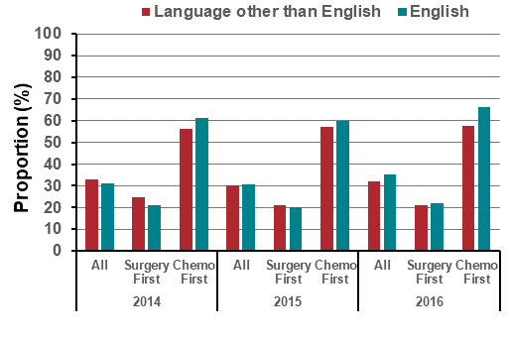

- Remoteness area
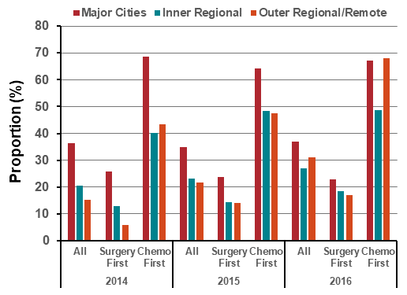
- Socioeconomic status
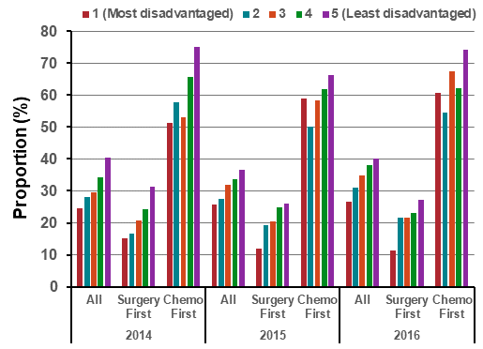

- Integrated Cancer Service
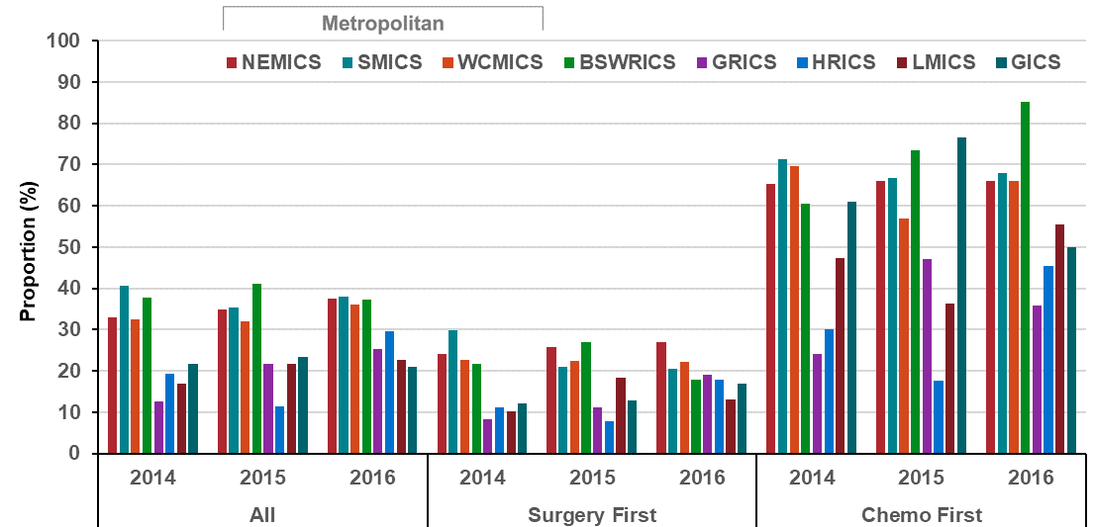
Note: Victorians with cancer who live in HRICS may receive treatment in New South Wales (Albury) hospitals, which is not captured in the VAED. Therefore, variables in this report that are derived using the VAED (i.e. comorbidity count, distant metastases, surgery and chemotherapy) are likely to be underestimated for Victorians living in HRICS.
Appendix 2 provides the dataset.
Figure 12.5.3: Proportion of colorectal cancer patients receiving systemic anti-cancer therapy within recommended timelines, by age (A), sex (B), Indigenous status (C), language spoken at home (D), remoteness area (E), SES (F) and ICS (G), Victoria, 2014–2016

- Age
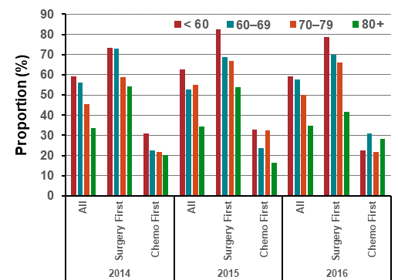
- Sex

- Indigenous status
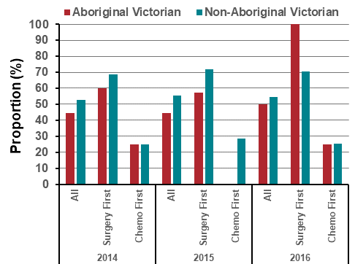
- Language spoken at home
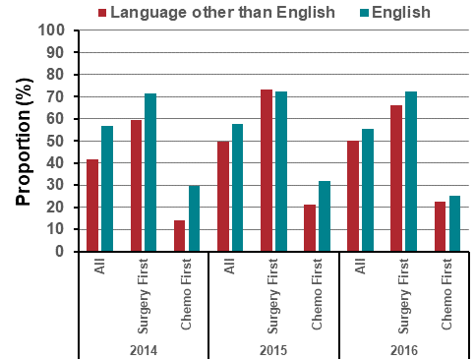

- Remoteness area
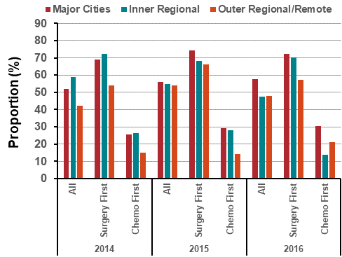
- Socioeconomic status
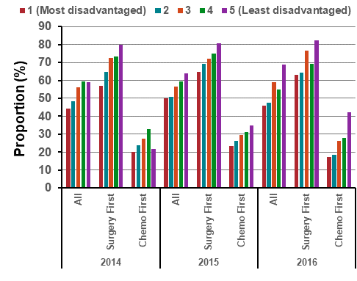

- Integrated Cancer Service
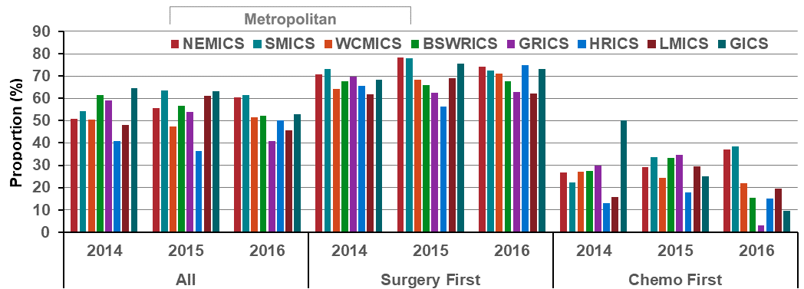
Note: Victorians with cancer who live in HRICS may receive treatment in New South Wales (Albury) hospitals, which is not captured in the VAED. Therefore, variables in this report that are derived using the VAED (i.e. comorbidity count, distant metastases, surgery and chemotherapy) are likely to be underestimated for Victorians living in HRICS.
Appendix 2 provides the dataset.
Figure 12.5.4 Proportion of ovarian cancer patients receiving systemic anti-cancer therapy within recommended timelines, by age (A), sex (B), Indigenous status (C), language spoken at home (D), remoteness area (E), SES (F) and ICS (G), Victoria, 2014–2016

Age
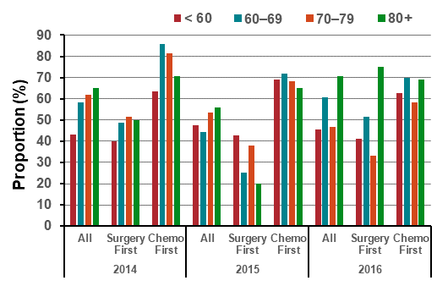
- Sex
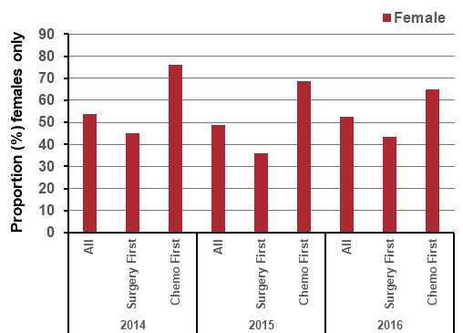

- Indigenous status
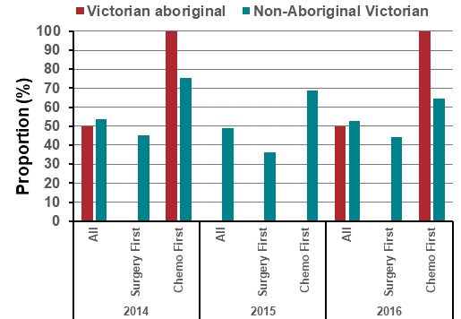
- Language spoken at home
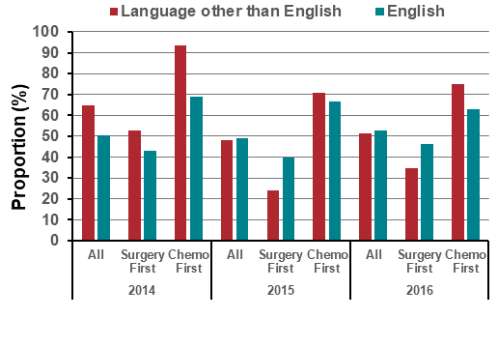

- Remoteness area
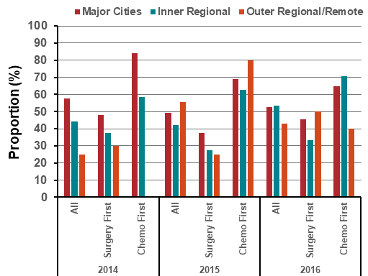
- Socioeconomic status
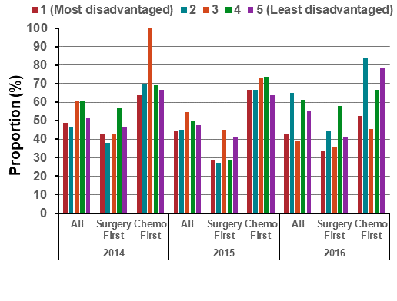

- Integrated Cancer Service
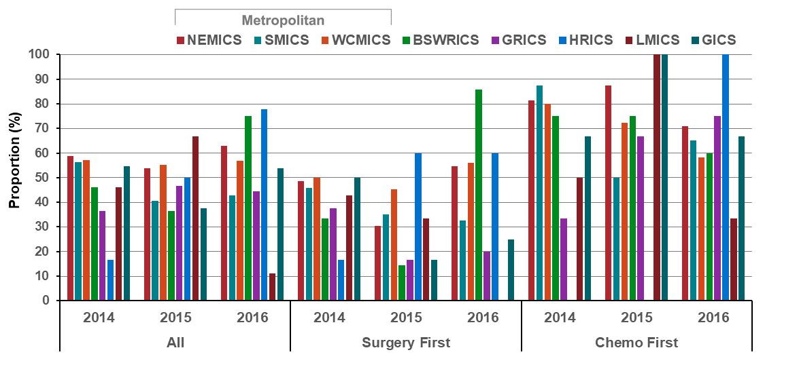
Note: Victorians with cancer who live in HRICS may receive treatment in New South Wales (Albury) hospitals, which is not captured in the VAED. Therefore, variables in this report that are derived using the VAED (i.e. comorbidity count, distant metastases, surgery and chemotherapy) are likely to be underestimated for Victorians living in HRICS.
Gaps in the data denote that no one was treated for ovarian cancer at that ICS for a particular year. For example, in 2018 (surgery first) LMICS and in 2014 (chemo first) HRICS
Appendix 2 provides the dataset.

Measure assessment
Traffic light rating: Amber (desired result not yet evident)
Overall trend: Static or unchanging
Commentary: For the purpose of this measure, SACTs include chemotherapy, targeted drugs and immunotherapy. The data presented here provides an overview of key systemic therapies (excluding oral therapies) for colorectal, lung, breast and ovarian cancers only because the evidence for timelines for delivering chemotherapy is stronger for these cancers.
In Victoria during the period 2014–2016, the proportion of people receiving SACTs within the recommended timeline overall remained largely unchanged (41.9 per cent in 2014; 42.2 per cent in 2016 – Table 12.5, Appendix 2) but was higher for those under the age of 69 years and for males (Figures 12.5 (A) and (B)). This trend was reversed for those patients receiving surgery first, who were more likely to be 60 years or older. However, there was a greater proportion of males compared with females who received surgery first, but this pattern changed for female patients for whom the proportion was higher than males for receiving chemotherapy first. Figure 12.5 (C) shows a disparity in timeliness across all three categories between those Aboriginal Victorians and non-Aboriginal Victorians, with the proportion decreasing significantly in 2015 and 2016 for Aboriginal Victorians. On the other hand, language spoken at home showed little variation between the three categories over the three reporting years (Figure 12.5 (D)).
Comparison of patterns of SACT use for all three categories across SES showed that patients living in the lowest SES areas (SES 1) were less likely to receive SACT within the recommended timelines during the period 2014–2016 (Figure 12.5 (F)). A comparison by remoteness showed that most patients who received these therapies within the recommended timelines overall were living in major cities (Figure 12.5 (E)). The proportion of people living in these areas who used all these therapies each year increased slightly from 44.4 per cent in 2014 to 45.7 per cent in 2016. This trend was also reflected in regions of Victoria when compared between ICS – metropolitan ICSs, namely NEMICS, SMICS and WCMICS, had a higher proportion of patients receiving SACTs across the three categories compared with regional/rural counterparts. This may reflect the spatial distribution of SACTs, which are likely to be concentrated in urban areas, particularly where there are tertiary centres that specialise in all types of cancer treatments including SACTs compared with smaller centres that provide a narrower range of services to rural and remote communities.
Figures 12.5.1, 12.5.2, 12.5.3 and 12.5.4 show similarities with Figure 12.5 as they relate to the different variables.
No target has been set for this measure; however, it does highlight the importance of cancer patients receiving SACT within recommended timelines to ensure improved overall survival in the metastatic setting.

Measure 12.6 – Proportion of cancer-related pancreatectomies and oesophagectomies taking place at appropriate volume facilities
Figure 12.6: Proportion and number of cancer-related oesophagectomies and pancreatectomies taking place at appropriate volume (facilities), by year, 2014–2016
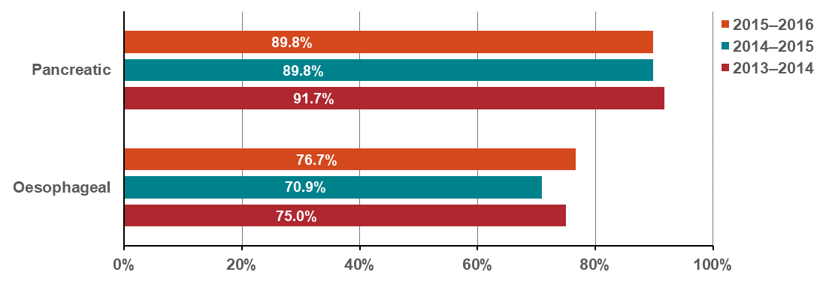
Table 12.6: Proportion and number of cancer-related oesophagectomies and pancreatectomies taking place at appropriate volume (facilities), by year, 2014–2016
Number of surgeries (n) | 2013–2014 | 2014–2015 | 2015–2016
Pancreatic | 253/276 | 273/304 | 281/313
Oesophageal | 180/240 | 188/265 | 211/275
Number of hospitals (n)
Pancreatic | 16/33 | 16/37 | 17/36
Oesophageal | 10/23 | 10/23 | 12/24

Source: Surgical data sourced from the Victorian Admitted Episodes Dataset (VAED)
Notes:
Hospital surgical volumes were calculated using admissions from the VAED; all oesophagostomies/pancreatectomies for cancer and non-cancer patients were included.
Admissions spanned a two-year interval (for example, if the year of interest is 2016, surgeries from across 2015–2016 will be included).
The proportion for oesophagectomies was calculated by restricting the dataset to those admissions where both an oesophagectomy surgery code was present and an oesophagus/stomach cancer diagnosis code was present. Similarly, the proportion for pancreatectomies was calculated by restricting the dataset to those admissions where both a pancreatectomy surgery code was present, and a pancreatic cancer diagnosis code was present in one of the 40 VAED diagnosis codes (C25).

Measure assessment
Traffic light rating: Amber (desired result not yet evident)
Overall trend: Static or unchanging
Commentary: Surgical procedures performed for pancreatic and oesophageal cancers are examples of complex surgery. Evidence shows that people who require complex surgery for these types of cancers are better to have this done at a hospital that performs these procedures often.,
It is recommended that hospitals treating people with these cancer types should perform a certain number of surgical resections each year. This is known as a ‘minimum suggested annual caseload’. For volume, this measure is based on the New South Wales performance indicator for cancer surgeries, which recommends the minimum suggested annual surgical caseload for a specialist centre is six procedures per year.
Figure 12.6 shows the proportion of resections for oesophageal and pancreatic cancers in Victorian hospitals (public and private) that performed these surgeries across the state above the minimum suggested annual caseloads. It also shows the number of hospitals that performed these surgeries between 2014 and 2016, with more pancreatic than oesophagectomy procedures reported. No target has been set for this measure; however, there is emerging evidence for a need to consolidate services.

Measure 12.7 – Proportion of patients aged less than 40 years referred to fertility preservation treatment as part of their primary treatment
This measure will be reported in a future report. Refer to Appendix 1.

Measure 12.8 – Proportion of admitted cancer separations with a length of stay (LOS) > 1 who have been coded as having malnutrition
Figure 12.8: Proportion of admitted cancer separations with a LOS > 1 who have been coded as having malnutrition, by year, 2012–2017
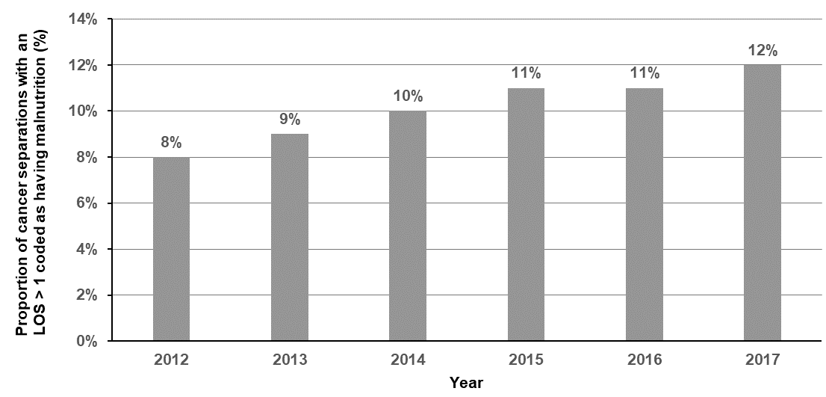
Notes:
The following ICD10 codes were used for flagging malnutrition: E43, E440, E441 and E46.
Separations were assigned to years based on VAED separation date and not admission date.

Measure assessment
Traffic light rating: Red (result is of concern)
Overall trend: Difficult to assess because the coding may have changed over the years, which may account for some of the increase in malnutrition separations and less underreporting in recent years
Commentary: Malnutrition in cancer patients is associated with poorer outcomes such as reduced response to treatments and increased healthcare costs as a result of increased complications, longer LOS and hospital admissions. Preventing and managing malnutrition is increasingly being recognised as a significant element of cancer care, particularly because malnutrition can occur in all tumour types and in all settings. A multi-centre point prevalence study undertaken in 2012 and 2014 that investigated practices relating to malnutrition in Victorian cancer services researchers, found that overall the prevalence of malnutrition was 26 per cent (501/1903) in 2014. This figure decreased to 23 per cent in 2016 (308/1340).
Figure 12.8 shows that the proportion of cancer separations with a LOS greater than one day who have been coded as having malnutrition increased by four per cent between 2012 and 2017. Care should be taken in interpreting this increase, which may be the result of malnutrition, although the VAED coding (which includes malnutrition), still has significant issues with data integrity, which means that malnutrition is being widely underreported in the coding.

Measure 12.9 – Proportion of patients who reported being involved in the decisions about their care and treatment as much as they wanted to
Figure 12.9: Proportion of cancer patients who reported being involved in decisions about their care and treatment as much as they wanted to in 2018
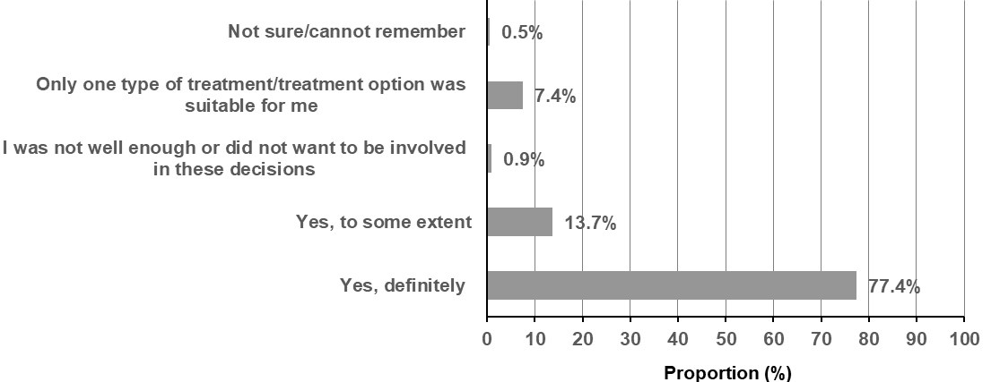

Note: These responses relate to the question, ‘Were you involved as much as you wanted to be in decisions about your care and treatment?’ in the Victorian Cancer Experience Patient Survey.

Measure assessment
Traffic light rating: Amber (desired result not yet evident)
Overall trend: Could not be calculated due to only one data point
Commentary: Shared decision making is recognised as a key component of patient-centred care. Studies of shared decision making in cancer patients have found that most patients prefer to play a role in treatment decisions.
A total of 3,916 people treated for cancer between January 2016 and March 2018 participated in the Victorian Cancer Experience Patient Survey in 23 Victorian health services across eight ICS (excluding paediatrics). This included 23 hospitals across the eight ICS (excluding paediatrics). The proportion of patients who reported being involved in decisions about their cancer care and treatment was 2,029. A large percentage (77.4 per cent) of patients reported they were definitely involved as much as they wanted to be in decisions about their care and treatment (Figure 12.9).
By comparison the statewide Victorian Healthcare Experience Survey also captures patient experience information from users of the Victorian public health services (including non-cancer health services). In 2018, 76 per cent of people (75 per cent is the target) reported positive responses to questions about their treatment before discharge. While no target has been set for this measure, the fact that 77.4 per cent of patients reported being definitely involved in decisions about their care highlights consistency in the result with other similar surveys.
Another statewide survey will be conducted in 2019 as part of the Victorian Cancer Patient Experience Survey.

Measure 12.10 – Proportion of newly diagnosed patients with evidence of multidisciplinary treatment plan in the patient records
Figure 12.10: Proportion of documented evidence of multidisciplinary team recommendations, 2014, 2015 and 2017
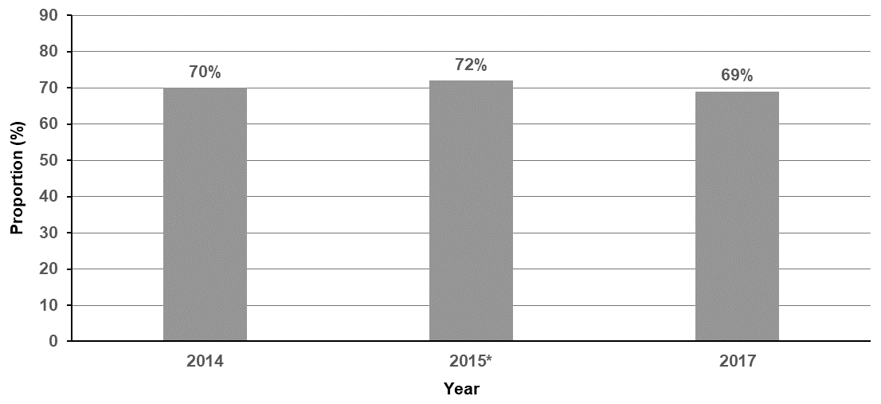
Source: Cancer Services Performance Indicators – 2017 audit (2018)
* There are no data for 2016.

Figure 12.10.1: Percentage of patients audited in 2017 with documented evidence of multidisciplinary team recommendations presented by ICS (all tumours streams combined)
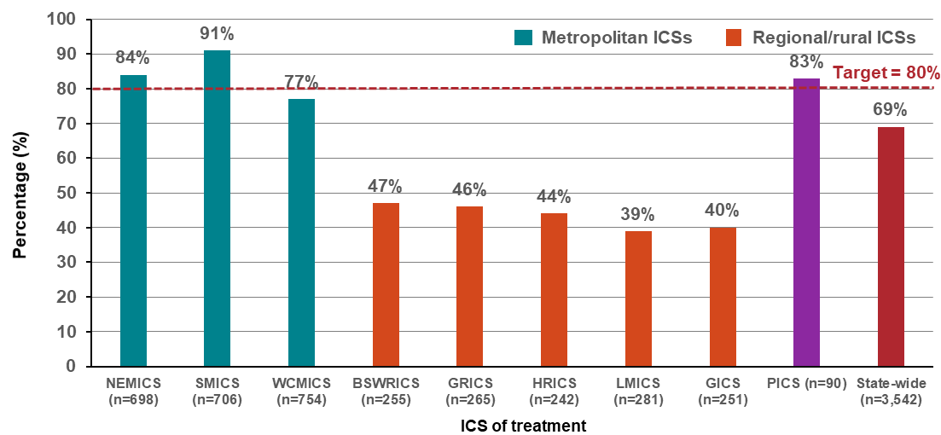
Source: Cancer Services Performance Indicators – 2017 audit (2018)
Figure 12.10.2: Number (and percentage) of audited patients who had documented evidence of multidisciplinary team presented by tumour stream (all ICSs combined) of Victorians diagnosed in 2017
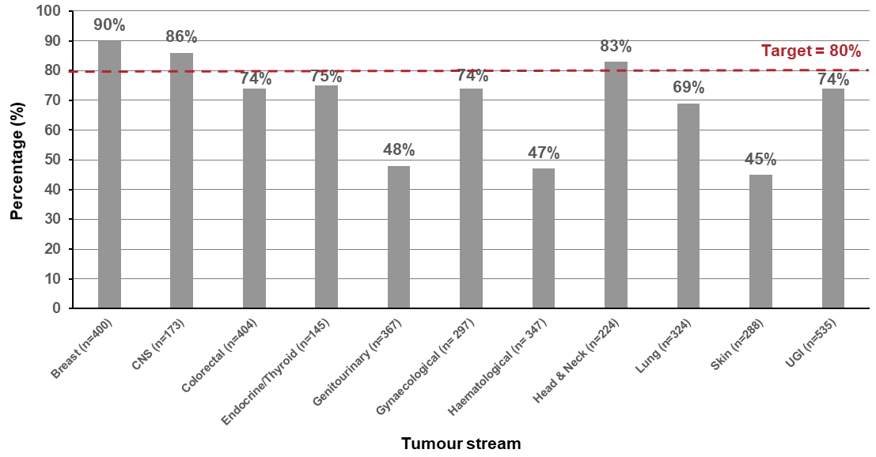
Source: Cancer Services Performance Indicators – 2017 audit (2018)

Measure assessment
Traffic light rating: Amber (desired result not yet evident)
Overall trend: Static or unchanging
Commentary: International studies have shown that patients overseen by a multidisciplinary cancer care team experience better outcomes after cancer treatment. The role of a multidisciplinary cancer care team is to bring together healthcare professionals from different specialties to discuss a patient’s cancer diagnosis and staging, and their treatment options.
Figure 12.10 provides a high-level summary of the statewide results from 2014 to 2017. Note that there was no data available for 2016. Although no target was set for this measure, the statewide performance of patients having documented evidence of multidisciplinary team (MDT) recommendations fell below the target of 80 per cent outlined in the Cancer Services Performance Indicators 2017 audit report, with 69 per cent of patients having documented evidence.
Figure 12.10.1 shows the percentage of patients audited in 2017 documented evidence of MDT recommendations presented by ICS shows that metropolitan ICSs were the highest performing ICSs, with SMICS reporting 91 per cent of audited patients having documented evidence of MDT recommendations. All regional/rural ICSs fell well below the target, with the highest performing regional/rural ICS, BSWRICS, having 47 per cent of audited patients having documented evidence of MDT recommendations.
Figure 12.10.2 shows the number (and percentage) of audited patients who had documented evidence of MDT recommendations and breaks down the results by tumour stream. The breast tumour stream had the highest performance, with 90 per cent of audited patients having documented evidence of MDT recommendations. Only three tumour streams were not within 20 per cent of the target – genitourinary (48 per cent), haematological (47 per cent) and skin (45 per cent).

Measure 12.11 – Proportion of patients with local recurrence of primary tumour within two years of surgical resection or curative radiotherapy of a primary tumour
This measure will be reported in a future report. Refer to Appendix 1.

Measure 12.12 – Proportion of patients receiving specialist palliative care within 12 months prior to death
Figure 12.12: Proportion of patients receiving specialist palliative care within 12 months prior to death, by ICS, 2014–2016
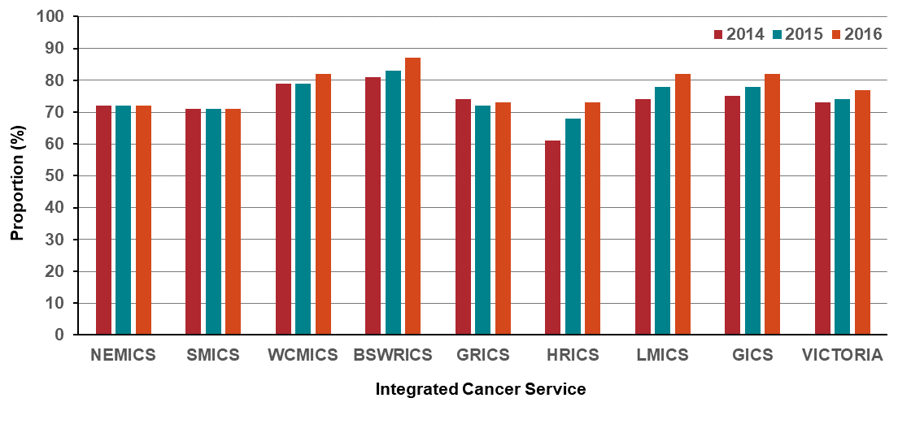
Table 12.12: Proportion and number of patients receiving specialist palliative care with 12 months prior to death, by ICS, 2014–2016
ICS | 2014 (Year of death)  (%) [n/No.] | 2015 (Year of death)  (%) [n/No.] | 2016 (Year of death)  (%) [n/No.]
NEMICS | (72) [1,451/2,016] | (72) [1,480/2,057] | (72) [1,499/2,069]
SMICS | (71) [1,671/2,365] | (71) [1,763/2,488] | (71) [1,753/2,455]
WCMICS | (79) [1,321/1,668] | (79) [1,342/1,692] | (82) [1,412/1,714]
BSWRICS | (81) [574/713] | (83) [671/804] | (87) [684/784]
GRICS | (74) [414/561] | (72) [464/648] | (73) [473/649]
HRICS | (61) [312/508] | (68) [373/551] | (73) [386/526]
LMICS | (74) [478/642] | (78) [525/670] | (82) [570/694]
GICS | (75) [338/451] | (78) [368/472] | (83) [395/474]
Victoria | (73) [6,559/8,926] | (74) [7,027/9,435] | (77) [7,346/9,575]
Notes:
Cases
- Those whose notification of cancer to the VCR was by death certificate only (DCO) have been excluded (~5.5 per cent of cancer deaths are DCO).
Palliative care (in the year prior to death)
- VAED – episodes with care type 8 or ‘Z515’ diagnosis code
- VINAH (public palliative care) – episodes in the community palliative care or hospital-based palliative care consultancy team streams. Note: All palliative care contacts included even if the care provided was indirect care, care provided to carer/relative only or a scheduled appointment where patient did not attend.

Measure assessment
Traffic light rating: Green (satisfactory result)
Overall trend: Moving in the right direction
Commentary: For the purposes of this measure the term ‘specialist palliative care’ refers to clinicians who have specialist qualifications in palliative care and the designated specialist palliative care sector funded to provide care for those with the most complex end-of-life and palliative care needs. In Victoria, palliative care is delivered through community, inpatient and consultancy services administered by public, private and non-government providers.
While no target has been set, this outcome measure reports responsiveness of palliative care services to patient needs between 2014 and 2016. Overall, Figure 12.12 and Table 12.12 show that, at the statewide level, all the ICSs have focused on improving the effectiveness of services. This is shown by the proportion of patients receiving specialist palliative care within 12 months prior to death having improved from 73 per cent to 77 per cent over the three-year period. Despite this upward trend the results should be interpreted with caution because palliative care provided by private hospitals in a community setting is not captured in the linked dataset because VINAH is specific to public institutions only.

Measure 12.13 – Proportion of patients receiving aggressive interventions within 30 days prior to death
Figure 12.13: Proportion of patients receiving aggressive interventions (SACT, radical radiation, ICU) within 30 days prior to death, by year, 2014–2016
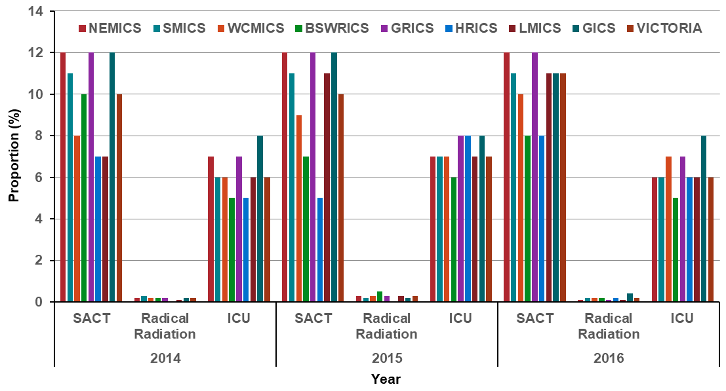
Note: Appendix 2 provides the dataset.

Measure assessment
Traffic light rating: Amber (desired result not yet evident)
Overall trend: Static or unchanging
Commentary: Aggressive care near death for patients with incurable cancers is recognised as an important end-of-life care quality indicator,, because aggressive care has been linked with worse quality of life for the patient and worse bereavement adjustment for their caregivers. For the purpose of this measure key indicators of aggressive care (interventions) in the last 30 days of life that were examined by ICS were patients receiving SACT, radical radiotherapy (curative intent) and acute inpatient/intensive care unit (ICU) admissions. Figure 12.5 shows that the proportion of patients still receiving chemotherapy within the last 30 days of life was high across all the ICSs, ranging from five to 12 per cent between 2014 and 2016. This is despite evidence that the use of chemotherapy near the end of life is not related to its likelihood of providing benefit. However, it cannot be excluded, since setting an a priori level of appropriate and inappropriate rate of chemotherapy near the end of life may hinder the aim of palliative care in oncology, which is to address the specific needs of each individual patient based not only on their illness trajectory or physical symptoms but also on their personal preferences and goals of care.
The proportion of patients admitted to intensive care within 30 days prior to death was similar across the ICSs (Figure 12.13 and Table 12.13.2) and was ranked the second highest in terms of key indicators of aggressive care reported via this measure.
Radiotherapy is an indispensable modality for cancer treatment as it can be an effective tool for palliation of symptoms arising from cancer, such as pain from bone metastases or neurologic compromise from brain or spinal metastases. Figure 12.13 and Table 12.13.1 show that radiotherapy use remained low across all ICSs within the last month of life in this analysis. Explanation for why the use of radiotherapy was low is beyond the scope of these data.
While no target has been set for this measure understanding this quality of care measure is the first and crucial step in identifying any shortcomings or variations of Victoria-wide current practice, which will then allow for opportunities for improvement in aggressive care delivery.

Measure 12.14 – Proportion of deaths due to cancer that occur in hospitals
Figure 12.14: Proportion of deaths due to cancer that occur in hospitals, by ICS and state, 2014–2016
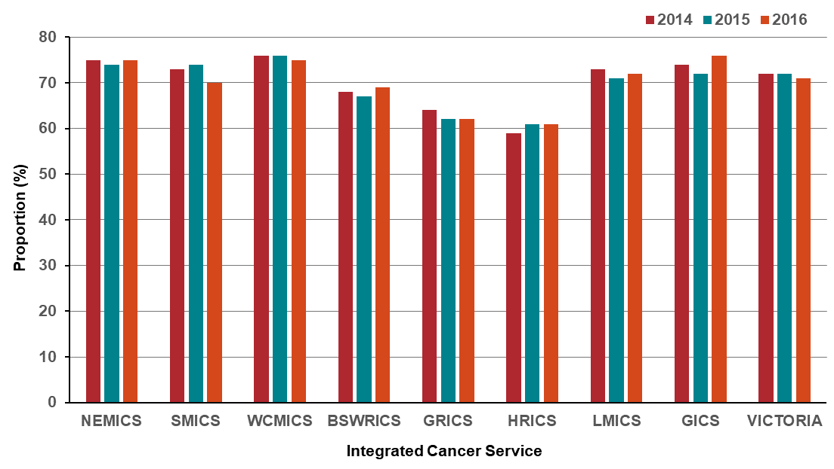
Table 12.14: Proportion/number of deaths due to cancer that occur in hospitals, by ICS, 2014–2016
ICS | 2014 (Year of death)  (%) [n/No.] | 2015 (Year of death)  (%) [n/No.] | 2016 (Year of death)  (%) [n/No.]
NEMICS | (75) [1,512/2,016] | (74) [1,525/2,057] | (75) [1,542/2,069]
SMICS | (73) [1,716/2,365] | (74) [1,833/2,488] | (70) [1,707/2,455]]
WCMICS | (76) [1,264/1,668] | (76) [1,289/1,692] | (75) [1,281/1,714]
BSWRICS | (68) [482/713] | (67) [538/804] | (69) [538/784]
GRICS | (64) [361/561] | (62) [404/648] | (62) [400/649]
HRICS | (59) [298/508] | (61) [334/551] | (61) [320/526]
LMICS | (73) [466/642] | (71) [477/670] | (72) [502/694]
GICS | (74) [335/451] | (72) [338/472] | (76) [360/474]
Victoria | (72) [6,435/8,926] | (72) [6,784/9,435] | (71) [6,804/9,575]

Measure assessment
Traffic light rating: Amber (desired result not yet evident)
Overall trend: Static or unchanging
Commentary: In 2016 the Victorian Government released the Victoria’s end-of-life and palliative care framework, which aims to move towards the delivery of a more person-centred approach that respects people and their preferences, considering the whole person and what they value as important. This includes consultancy to people who require symptom and pain management or end-of-life care within hospitals alongside other care.
Monitoring where people die due to cancer is key to ensuring that end-of-life care and palliative care is provided in a responsive and integrated way. The need for such appropriate care is important given that Victoria’s population is both growing and ageing. Figure 12.14 shows that, although a hospital is still the most common place of death due to cancer, the percentage of cancer patients who died in hospital between 2014 and 2016 reduced between most regions of Victoria when compared by ICS regions and for Victoria as a whole. There were a couple of exceptions, with GRICS and BSWRICS showing a slight increase. On the other hand, SMICS showed a slight decrease between 2015 and 2016. These differences in proportion of deaths due to cancer that occur in hospitals between ICSs may reflect variations in population composition and changes in palliative care that is meeting people’s wishes to die at home or in a more homelike environment rather than in a hospital. For Aboriginal Victorians in particular, the need to ‘return to country’ before the end of life, or at the end of life, can be both culturally and spiritually significant. Nevertheless, it is also important to note that the low percentage attributed to HRICS could be due to inpatient data for Albury (New South Wales) not included in the VAED and thus could be underestimated.

Key result: Increase one- and five-year survival
Survival from cancer is a key measure of cancer prognosis, control and treatment. It refers to the probability of being alive for a given amount of time after diagnosis and reflects the severity of a cancer diagnosis.
Globally there are two commonly recognised measures of cancer survival: relative survival and observed survival. For the purposes of this report, relative survival is used, which adjusts for normal life expectancy by comparing survival among cancer patients with that of the general population, controlling for age, sex and year of diagnosis. Survival trends are presented for all cancers and other tumour streams by single years (2010–2016) (Measures 13.1–13.8) and a five-year period (2010–2014) (Measures 13.9–13.16). One-year survival is an important measure as it may more closely reflect access to and quality of local care than five-year survival. It is also able to more quickly reflect changes in both access and quality of care, including new treatments.
This report does not focus on international trends as it relates to different cancer streams as survival differences may be attributable to differences in stage at diagnosis, reflecting delays in diagnosis or differences in staging procedures, or to differences in stage-specific survival, which could indicate differences in treatment, staging or co-morbidity.

Measure 13.1 – One-year survival from all cancers
Figure 13.1: Trends in one-year relative survival from all cancers (combined) overall (A) and by sex (B), age (C), remoteness (D) and ICS (E), Victoria, by year, 2010–2016

- Overall
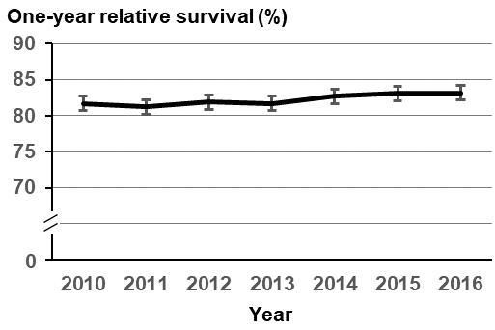
- Sex
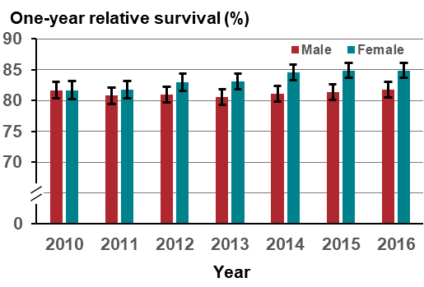

- Age
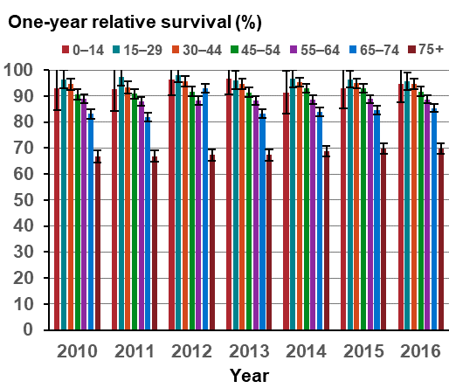
- Remoteness
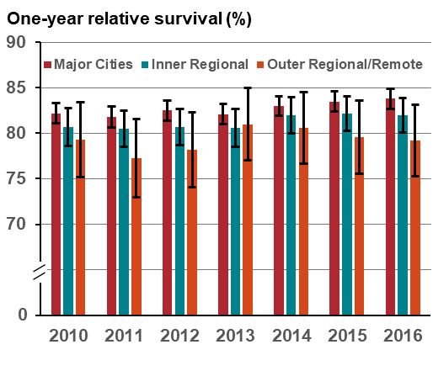
Year

- Integrated Cancer Service
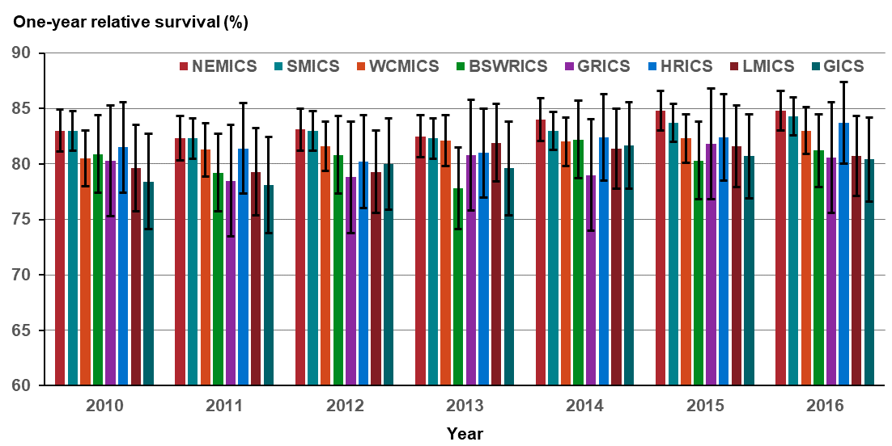
Note: Appendix 2 provides the dataset.
Measure assessment
Traffic light rating: Amber (desired result not yet evident)
Overall trend: Moving in the right direction
Commentary: Figure 13.1(A) shows that from 2010–2016, one-year relative survival for all cancers combined (C00–C97, D45–D46, D47.1, D47.3) increased slightly from 81.7 per cent in 2010 to 83.2 per cent in 2016. Females tended to have higher one-year relative survival rates than males overall, which is also widening (Figure 13.1 (B)). However, this varied with age. Figure 13.1 (C) shows that survival was highest for people under 30 years of age and decreased with age, so it was the lowest for those aged 75 years or older. This age-related pattern of survival is characteristic of most individual cancer streams presented in this baseline report. The reduction in survival with age was more pronounced in the second half of the life span – for almost all types of cancers, one-year survival was lowest in older people.
Figure 13.1 (D) shows that for each recorded year, one-year relative survival decreased with greater remoteness, although the differences were small, ranging from 82.2 per cent (2010) and 83.8 per cent (2016) in major cities compared with 79.3 per cent (2010) and 79.2 per cent (2016)in outer regional/remote Victorian areas. Similarly, there was a gradient of decreasing one-year relative survival rates by ICS region, with metropolitan ICSs such as NEMICS and SMICS reporting higher survival rates compared with rural and regional ICS such as GRICS and LMICS, which generally reported the lowest survival rate for each recorded year (Figure 13.1 (E)).
The target for this measure is to double the improvement in one-year survival by 2040 from the baseline (2010). The goal of doubling the improvement in one-year survival will be met if the improvement in relative survival between the periods 2030–2034 and 2035–2039 is twice that of the improvement between the periods 2005–2009 and 2010–2014. Figure 13.1 (A) shows that Victoria is moving in the right direction.

Measure 13.2 – One-year survival from lung cancer
Figure 13.2: Trends in one-year relative survival from lung cancer overall (A) and by sex (B), age (C), remoteness (D) and ICS (E), Victoria, by year, 2010–2016

- Overall
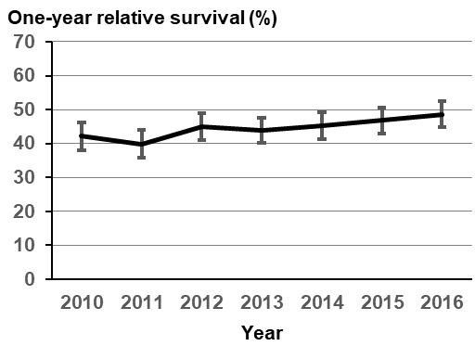
- Sex
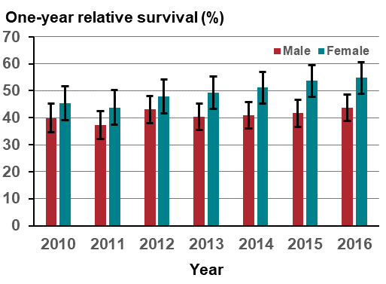

- Age
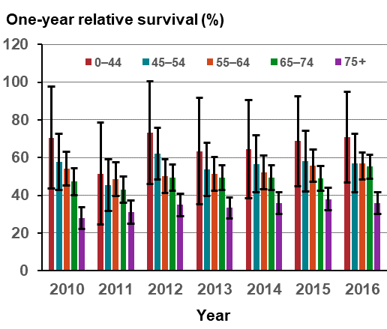
- Remoteness
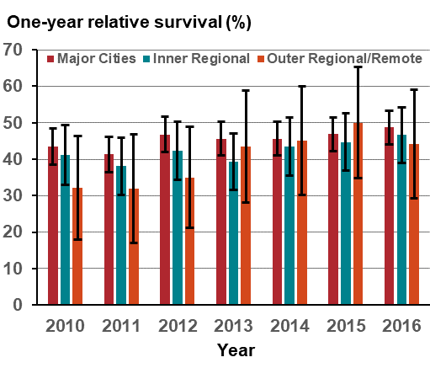

- Integrated Cancer Service
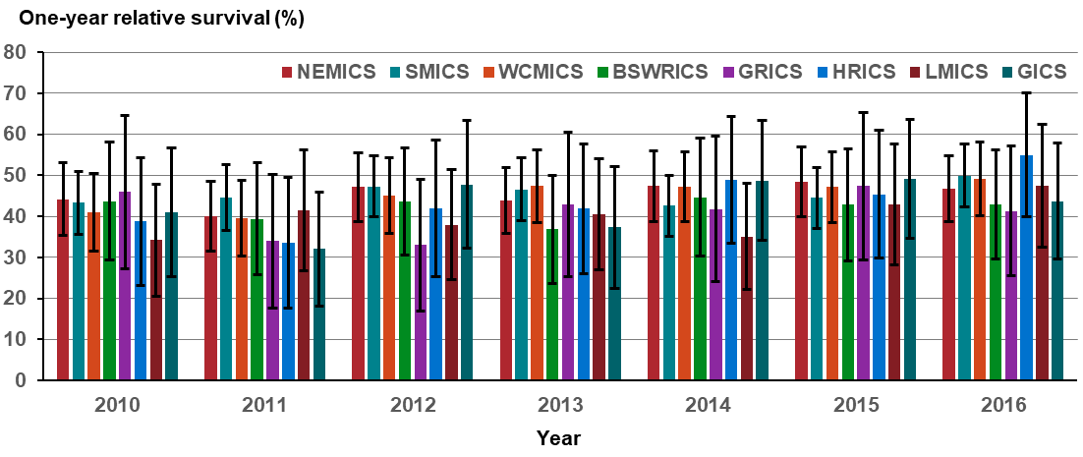
Note: Appendix 2 provides the dataset.
Measure assessment
Traffic light rating: Green (satisfactory result)
Overall trend: Moving in the right direction
Commentary: Relative to other tumour streams, lung cancer has a low survival rate nationally, with only 13 per cent of those diagnosed with lung cancer surviving five years after diagnosis. This poor survival rate is due in part to the relatively high number of cases diagnosed at an advanced stage (with late-stage disease) and because it is associated with other smoking-related comorbidities.
In Victoria, the one-year relative survival for lung cancer increased from 42.1 per cent in 2010 to 48.6 per cent in 2016 (Figure 13.2 (A)). Survival was higher for females than for males between 2010 and 2016, with the gender gap gradually widening (Figure 13.2 (B)). The one-year relative survival rate was significantly higher for those aged under 44 years compared with all older age groups (Figure 13.2 (C)). Survival fell sharply with age for those aged 75 years or older.
Survival varied by remoteness, with one-year survival generally higher in major cities for most years apart from 2012 where outer regional/remote areas had the highest survival rate by remoteness but complete overlap of confidence intervals. However, caution should be taken when interpreting this result because of the wide confidence intervals (Figure 13.3 (D)).
One-year survival rates did not vary between regions when compared by ICS between 2010 and 2016 and were generally higher in the metropolitan ICSs. Higher rates of survival observed for regional ICSs such as HRICS should be interpreted with caution because of the wide confidence interval.
While no target has been set for this measure, the one-year survival rate for those patients diagnosed with lung cancer between 2010 and 2016 shows there has been a temporal improvement in the proportion of those surviving the one-year period.

Measure 13.3 – One-year survival from pancreatic cancer
Figure 13.3: Trends in one-year relative survival from pancreatic cancer overall (A) and by sex (B), age (C), remoteness (D) and ICS (E), Victoria, by year, 2010–2016

- Overall
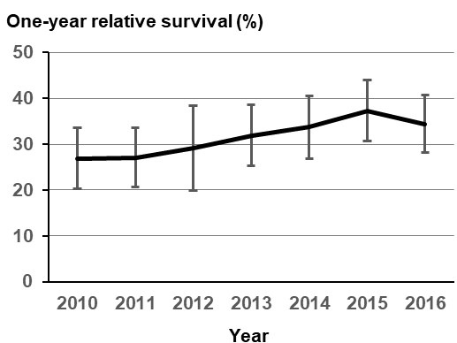
- Sex
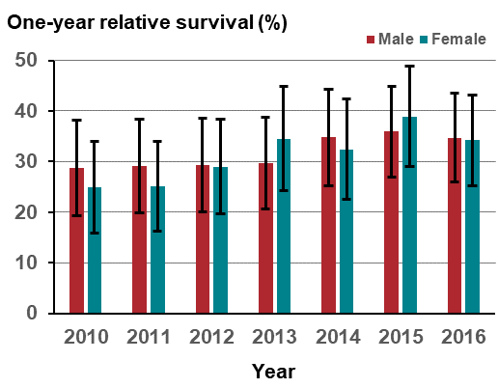

- Age
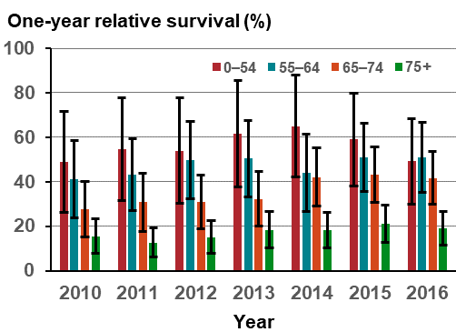
- Remoteness
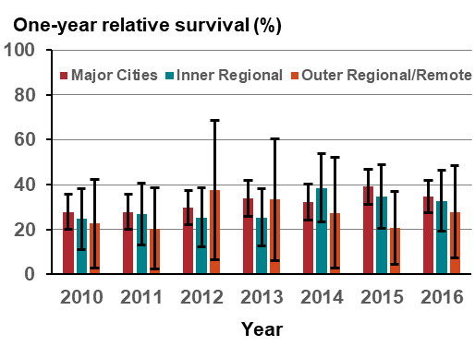

- Integrated Cancer Service
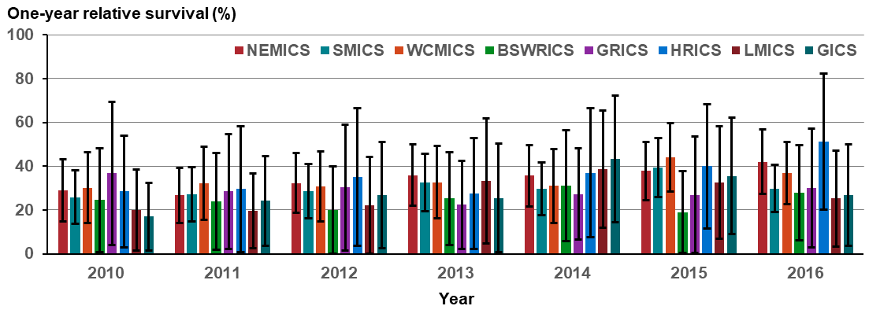
Note: Appendix 2 provides the dataset.

Measure assessment
Traffic light rating: Amber (desired result not yet evident)
Overall trend: Moving in the right direction despite the low one-year relative survival rate
Commentary: While pancreatic cancer survival rates have been improving from decade to decade, the disease is still considered largely incurable globally. In Australia, pancreatic cancer accounts for 2.2 per cent of all new cancer diagnoses. The poor survival rates for this cancer have only marginally improved in Australia over a 40-year period. This poor prognosis is directly related to late diagnosis, when the disease is often locally advanced or metastatic.
In Victoria, for people diagnosed with pancreatic cancer between 2010 and 2016, the one-year relative survival ranged from 26.9 per cent in 2010 to 34.4 per cent in 2016 (Figure 13.3 (A)). Survival showed very little variation between the genders (Figure 13.3 (B)), with the one-year relative survival rate generally higher for those aged under 54 years compared with all older age groups (Figure 13.3 (C)). Survival fell sharply with age for those aged 75 years or older.
Survival varied by remoteness, with one-year survival generally higher in major cities for most years apart from 2015 where outer regional-remote areas had the highest survival rate by remoteness. However, caution should be taken when interpreting this result due to the wide confidence intervals. The large 95 per cent confidence intervals reflect the confidence around the estimated value. It can still be representative to the population. The figure is large because there are few pancreatic patients living in Victorian outer regional/remote areas (Figure 13.2 (D)).
One-year survival rates varied between regions when compared by ICS between 2010 and 2016; they were generally higher in the metropolitan ICSs. Higher rates of survival observed for regional ICSs such as HRICS in 2016 should be interpreted with caution because of the wide confidence intervals (Figure 13.3 (E)).
While no target has been set for this measure, the one-year survival rate for those patients diagnosed with pancreatic cancer remains low despite a gradual improvement in the proportion of those surviving the one-year period during the analysis period. However, due to small numbers, survival rates for pancreatic cancer are unstable and should be interpreted with caution.

Measure 13.4 – One-year survival from ovarian cancer (C56)
Figure 13.4: Trends in one-year relative survival from ovarian cancer overall (A) and by age (B), remoteness (C) and ICS (D), Victoria, by year, 2010–2016

- Overall
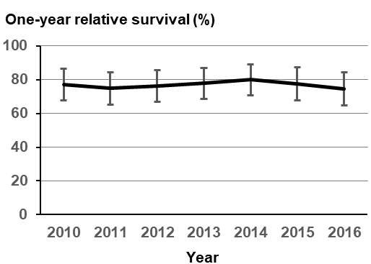
- Age
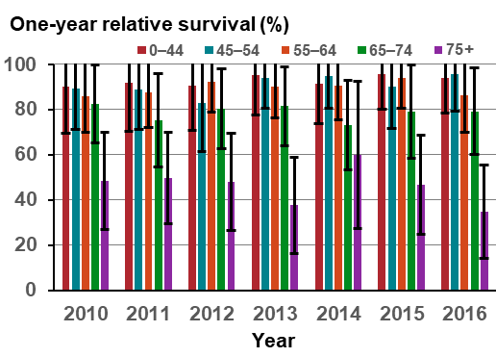

- Remoteness
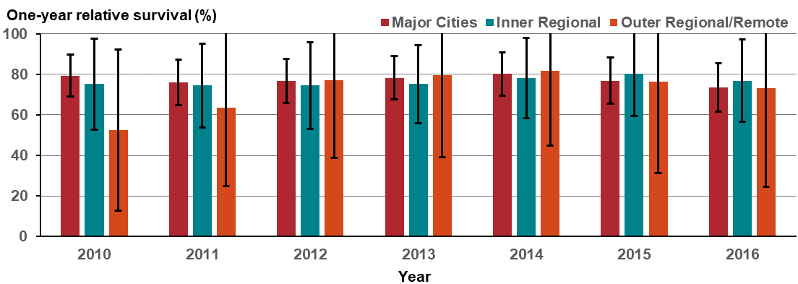
- Integrated Cancer Service
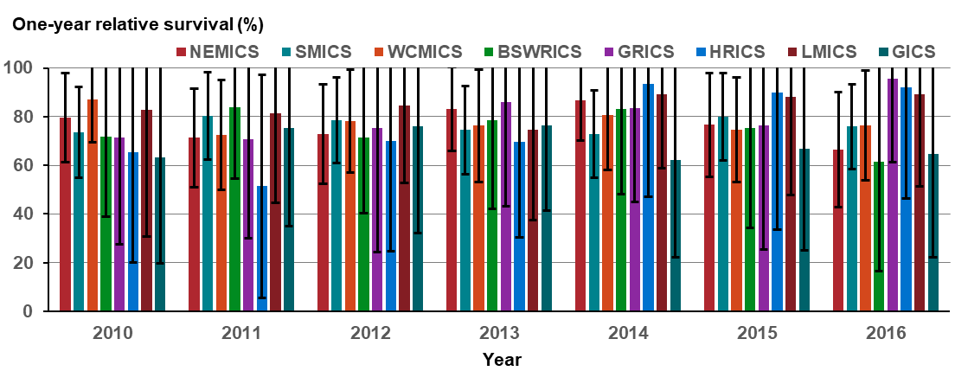
Note: Appendix 2 provides the dataset.

Measure assessment
Traffic light rating: Amber (desired result not yet evident)
Overall trend: Static or unchanging
Commentary: Ovarian cancer is a collective term for invasive cancers derived from different tissues. It is mainly a disease of postmenopausal women, the average age at diagnosis being 63 years and the risk of ovarian cancer increases with age. It is often diagnosed at a stage where the cancer has spread beyond the ovary, which in turn is associated with a poorer prognosis and treatment. In Australia, ovarian cancer has the lowest survival rate of any women’s cancer.
In Victoria, for people diagnosed with ovarian cancer between 2010 and 2016, the one-year relative survival ranged from 76.9 per cent in 2010 to 74.4 per cent in 2016 (Figure 13.4 (A)). Figure 13.4 (B) shows that survival dropped with each older age group but fell significantly for women aged 75 years or older.
There was no difference between survival and remoteness (Figure 13.4 (C)) and ICS (Figure 13.4 (D)), although caution should be taken when interpreting these results because the wide confidence intervals denote a small sample size that may not be well representative of the population.
While no target has been set for this measure, the one-year survival rate for those patients diagnosed with ovarian cancer between 2010 and 2016 decreased.

Measure 13.5 – One-year survival from colorectal cancer
Figure 13.5: Trends in one-year relative survival from colorectal cancer overall (A) and by sex (B), age (C), remoteness (D) and ICS (E), Victoria, by year, 2010–2016

- Overall
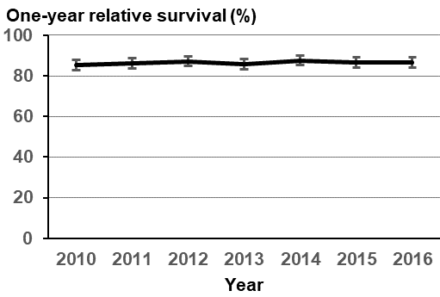
- Sex
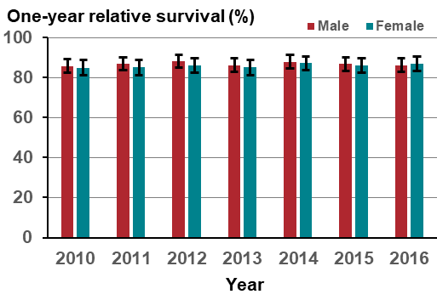

- Age
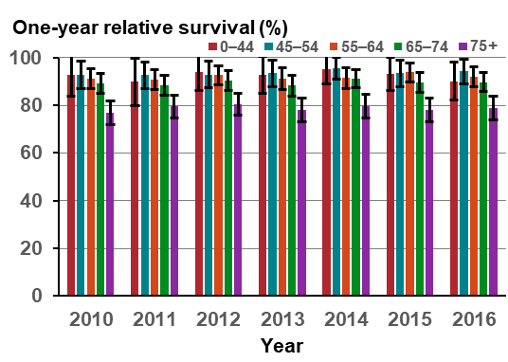
- Remoteness
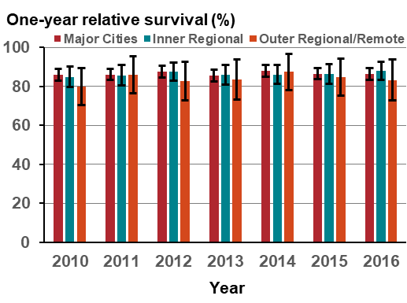

- Integrated Cancer Service
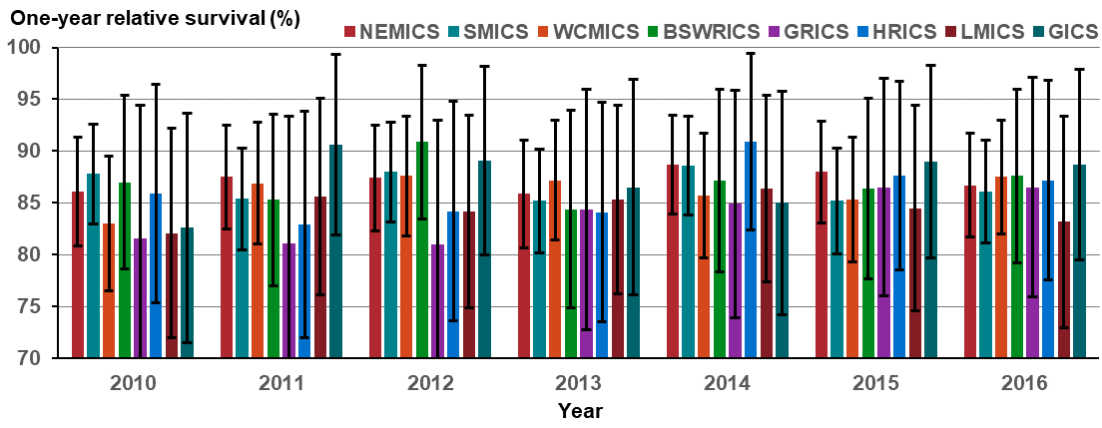
Note: Appendix 2 provides the dataset.

Measure assessment
Traffic light rating: Amber (desired result not yet evident)
Overall trend: Static or unchanging
Commentary: CRC is a disease characterised by abnormal cells that grow in the colon or rectum. Survival depends on the stage of the tumour at detection. However, because CRC often produces symptoms at an early enough stage that is treatable, survival rates are relatively high.
In Australia, survival for people diagnosed with CRC in 2011 was 86 per cent at one year from diagnosis. Figure 13.5 (A) shows that in Victoria the relative survival rate for CRC was similar to the national figure at one year following diagnosis ranging from 85.4 per cent (2010) to 86.8 per cent (2016). Survival did not vary between the genders, although in 2016 females had higher survival than males (Figure 13.5 (B)). Survival did not also vary much under the age of 74 years but decreased for those aged 75 years or older.
There was no difference between survival and remoteness (Figure 13.5 (C)) and ICS (Figure 13.5 (D)). However, caution should be taken when interpreting these results because the wide confidence intervals denote a small sample size that may not be well representative of the population.
While no target has been set for this measure, the higher one-year survival rates for those patients diagnosed with CRC between 2010 and 2016 compared with other cancers shows a gradual improvement in the proportion of those surviving the one-year period over time.

Measure 13.6 – One-year survival from brain cancer (C70–C72)
Figure 13.6: Trends in one-year relative survival from brain cancer overall (A) and by sex (B), age (C), remoteness (D) and ICS (E), Victoria, by year, 2010–2016

- Overall
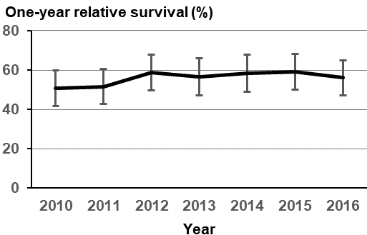
- Sex
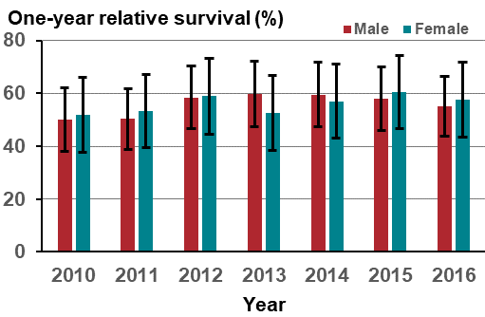

- Age
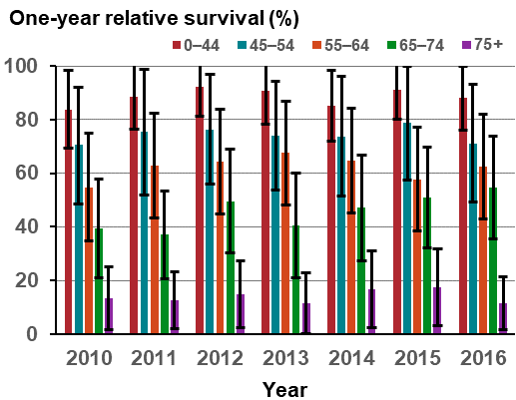
- Remoteness
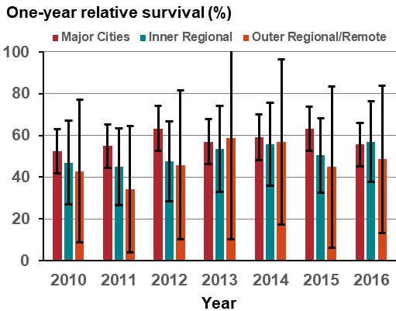

- Integrated Cancer Service
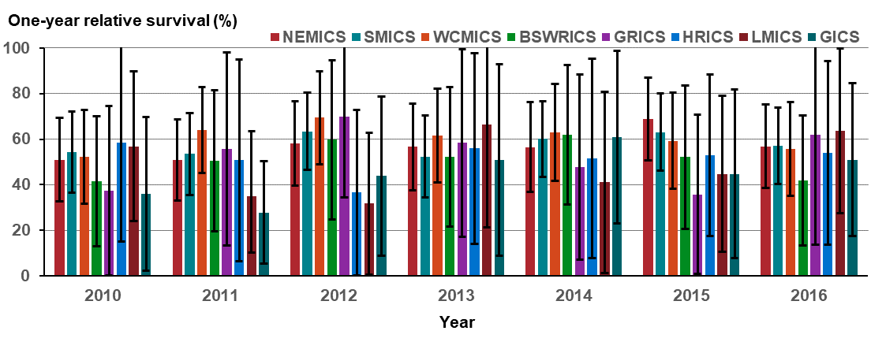
Note: Appendix 2 provides the dataset.

Measure assessment
Traffic light rating: Amber (desired result not yet evident)
Overall trend: Static or unchanging
Commentary: Brain cancers include primary brain tumours, which start in the brain and almost never spread to other parts of the body, and secondary tumours (or metastases), which are caused by cancers that have begun in another part of the body. In Australia, brain cancer accounts for 1.4 per cent of all cancers and is one of the most common cancers and leading causes of cancer death in young Australians. Brain cancer survival rates are low and have hardly changed for 30 years, despite significant increases in survival for Australians diagnosed with other types of cancer, such as prostate and breast cancer. Treatment is challenging because it affects the most vital human organ – the brain.
In Victoria, for people diagnosed with brain cancer between 2010 and 2016, the one-year relative survival ranged from 50.9 per cent in 2010 to 56.1 per cent in 2016 (Figure 13.6 (A)). Survival was slightly higher for females than for males during the analysis period (Figure 13.6 (B)). Survival fell sharply with all age categories but was more pronounced for those aged 75 years or older (Figure 13.6 (C)).
Survival varied by remoteness, with one-year survival higher in major cities for most years except for 2016 when inner regional areas had a slightly higher survival rate. As with other measures, caution should be taken when interpreting this result because the wide confidence intervals shown for one-year survival rates particularly as they relate to inner regional outer regional/remote areas denotes a small sample size that may not be well representative of the population (Figure 13.6 (D)).
One-year survival rates varied between regions when compared by ICS between 2010 and 2016. Higher rates of survival observed for regional and rural ICSs such as GRICS, LMICS and GICS should be interpreted with caution because of the wide confidence intervals due to small sample sizes (Figure 13.6 (E)).
While no target has been set for this measure, the one-year survival rate for those patients diagnosed with brain cancer between 2010 and 2016 shows a gradual improvement in the proportion of those surviving the one-year period over time.

Measure 13.7 – One-year survival from oesophagus cancer
Figure 13.7: Trends in one-year relative survival from oesophagus cancer overall (A) and by sex (B), age (C), remoteness (D) and ICS (E), Victoria, by year, 2010–2016

- Overall
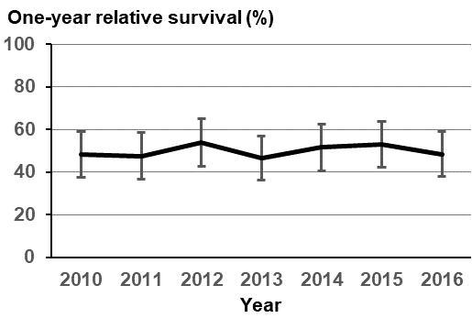
- Sex
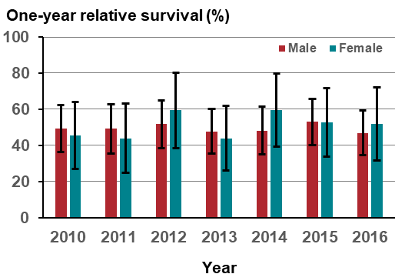

- Age
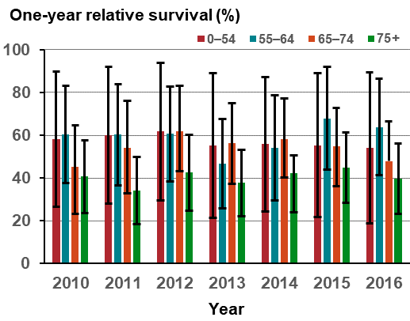
- Remoteness
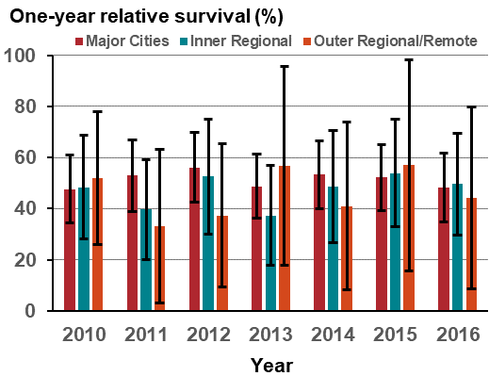

- Integrated Cancer Service
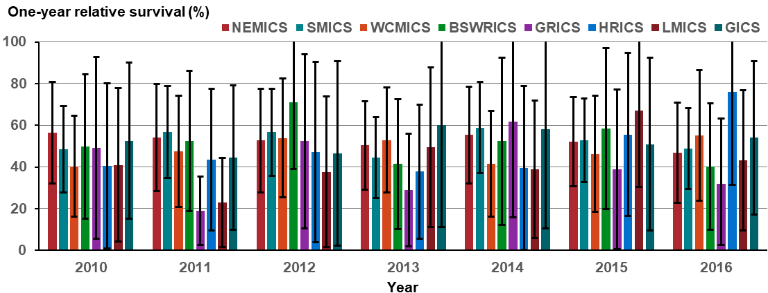
Note: Appendix 2 provides the dataset.

Measure assessment
Traffic light rating: Red (result is of concern)
Overall trend: Static or unchanging
Commentary: Cancer of the oesophagus (stomach cancer) is a relatively common cancer in Australia; however, the number of people diagnosed has been falling. Nationally it is rare in people under 50 years of age and affects more men than women.
In Victoria, for people diagnosed with oesophagus cancer between 2010 and 2016, the one-year relative survival showed very little change, ranging from 48.1 per cent in 2010 to 48.4 per cent in 2016 (Figure 13.7 (A)). Survival fluctuated between genders, although it was slightly higher for females than for males in 2012, 2014 and 2016 during the analysis period (Figure 13.7 (B)). Survival was generally higher for those aged under 65 years, although wide confidence intervals infer the likelihood of a small sample size that may not be well representative of the respective age categories (0–54 and 55–64). However, survival fell for those aged 75 years or older for each of the reporting years (Figure 13.7 (C)).
Survival varied by remoteness, with one-year survival generally higher in major cities for most years reported. However, as with other measures, caution should be taken when interpreting these results because the wide confidence intervals shown for one-year survival rates particularly as they relate to outer regional/remote areas denotes a small sample size that may not be well representative of the population (Figure 13.7 (D)).
One-year survival rates varied between regions when compared by ICS between 2010 and 2016, with higher rates generally observed in metropolitan ICSs such as NEMICS and SMICS. Survival rates observed for regional and rural ICSs should be interpreted with caution because of the wide confidence intervals due to small sample sizes for these categories (Figure 13.7 (E)).
While no target has been set for this measure, the one-year survival rate for those patients diagnosed with oesophagus cancer between 2010 and 2016 shows no improvement in the proportion of those surviving the one-year period.

Measure 13.8 – One-year survival from acute myeloid leukaemia
Figure 13.8: Trends in one-year relative survival from acute myeloid leukaemia overall (A) and by sex (B), age (C), remoteness (D) and ICS (E), Victoria, by year, 2010–2016

- Overall
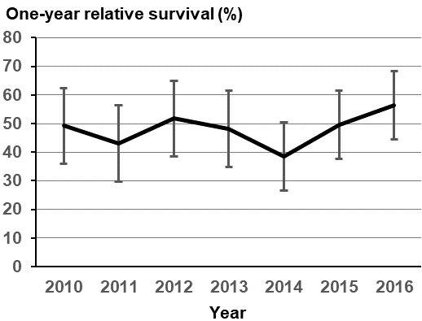
- Sex
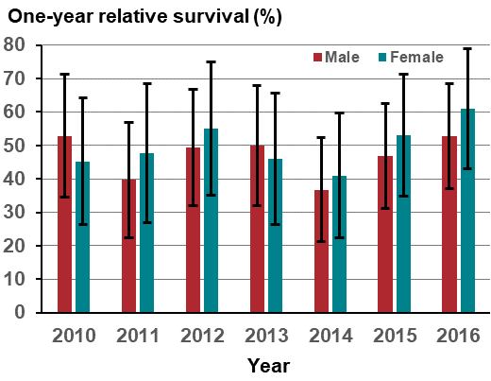

- Age
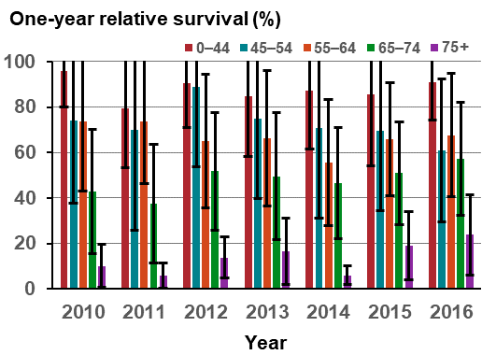
- Remoteness
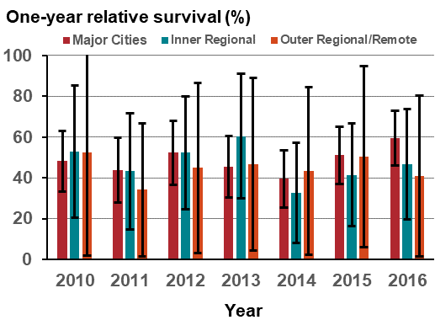

- Integrated Cancer Service
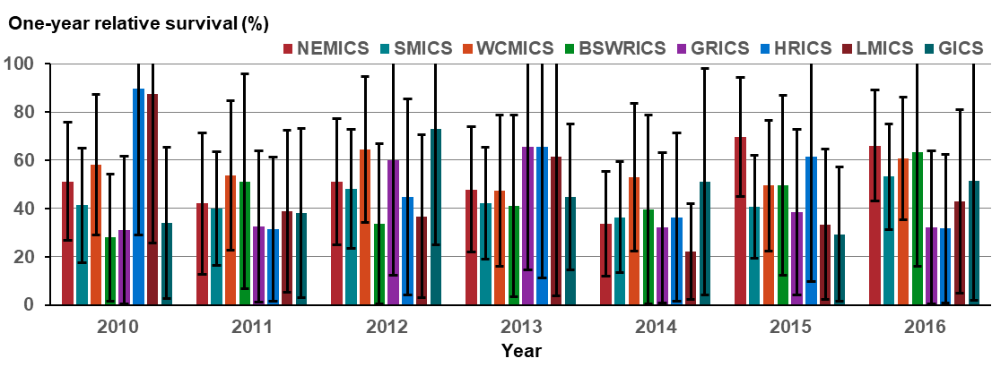
Note: Appendix 2 provides the dataset.

Measure assessment
Traffic light rating: Green (satisfactory result)
Overall trend: Moving in the right direction
Commentary: Acute myeloid leukemia (AML) is a cancer of the blood and bone marrow. It is a rare disease in Australia, accounting for 0.8 per cent of all cancer diagnosed nationally. Because AML is a heterogeneous disease with different treatments, survival outcomes depend on the genetic makeup of leukaemic cells (Milligan 2008).
In Victoria, for people diagnosed with AML between 2010 and 2016, the one-year relative survival increased from 49.2 per cent in 2010 to 56.3 per cent in 2016 (Figure 13.8 (A)). Survival fluctuated between genders but from 2014 was higher for females than for males. (Figure 13.8 (B)). Survival was higher for those aged under 44 years and decreased with age, although wide confidence intervals infer the likelihood of a small sample size that may not be well representative of the respective age categories (45–54 and 55–64). Figure 13.8 (C) shows that survival fell significantly for those aged 75 years or older for each of the reporting years.
Survival varied by remoteness, with one-year survival generally higher in major cities for most years reported. However, as with other measures, caution should be taken when interpreting these results because the wide confidence intervals shown for one-year survival rates particularly as they relate to outer regional/remote areas denotes a small sample size that may not be well representative of the population (Figure 13.8 (D)).
Figure 13.8 (D) shows no significant differences in one-year survival by remoteness or by ICS between 2010 and 2016 (Figure 13.8 (E)).
While no target has been set for this measure, the one-year survival rate for those patients diagnosed with AML between 2010 and 2016 shows some improvement in the proportion of those surviving the one-year period.

Measure 13.9 – Five-year relative survival from all cancers
Figure 13.9: Five-year relative survival from all cancers (nationally) combined and selected cancer types, by sex, 2010–2014
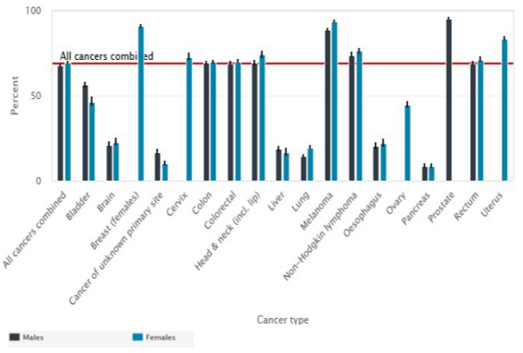
Source: AIHW Australian Cancer Database 2014

Figure 13.9.1: Five-year relative survival from all cancers (nationally) combined and selected cancer types, by age and sex, 2010–2014
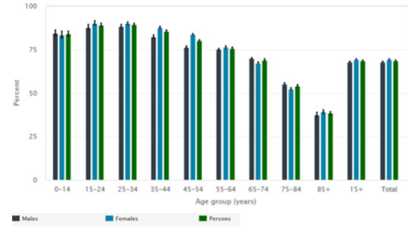
Source: AIHW Australian Cancer Database 2014
Notes:
Relative survival was calculated with the period method, using the period 2010–2014. Note that this period does not contain incidence data for 2014 for New South Wales because that data was unavailable.
Error bars indicate 95 per cent confidence intervals.
Figure 13.9.2: Five-year relative survival from all cancers combined, by age (A), remoteness (B), SES (C) and ICS (D), Victoria, 2010–2014

- Age
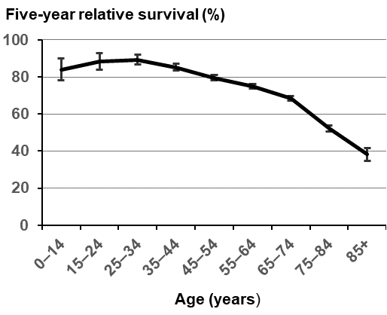
- Remoteness
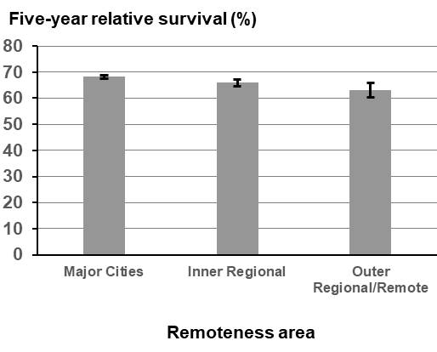

- Socioeconomic status
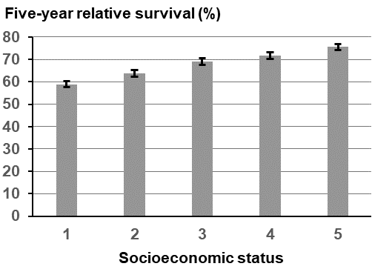
- Integrated Cancer Service
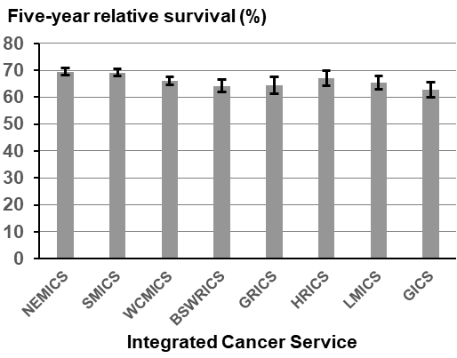

Notes:
Error bars indicate 95 per cent confidence intervals.
Remoteness is classified according to the Australian Standard Geographical Classification (ASGC) Remoteness Areas.
SES is classified according to the ABS Socioeconomic Indexes for Areas (SEIFA) Index of Relative Socio-economic Disadvantage – 1= lowest and 5 = highest.
Appendix 2 provides the dataset.

Measure assessment
Traffic light rating: Amber (desired result not yet evident)
Overall trend: Could not be calculated due to only one data point (2010–2014)
Commentary: Survival from cancer can be influenced by a variety of different factors including demographic characteristics, tumour type, stage of the cancer at diagnosis, other prognostic indicators and availability of treatment.
Information on survival from cancer provides an indication of a cancer prognosis and the effectiveness of treatment available. Relative survival of less than 100 per cent means that people with cancer had a lower chance of surviving for at least five years after diagnosis than the general population. In Australia, the national five-year relative survival was 69 per cent in 2010–2014 (Figure 13.9); that is, people diagnosed with cancer had a 69 per cent chance of surviving for at least five years compared with their counterparts in the general population. Females tended to have slightly higher survival than males overall. Five-year survival was 67 per cent for females compared with 65 per cent for males. Survival was highest for people aged under 40 (five-year survival of 86 per cent) and decreased with age so that it was lowest for those aged 80 or older (43 per cent) (Figure 13.9.1).
In 2010–2014, five-year relative survival in Victoria mirrored the national trend (67.4 per cent). As with the national trend and a recent Victorian study, females also tended to have slightly higher survival than males overall. Five-year survival was 68.1 per cent for females compared with 66.8 per cent for males. However, this varied with age: survival was highest for people aged 25–34 years (five-year survival of 89.3 per cent) and decreased with age so that it was lowest for those aged 85 or older (38.2 per cent). This age-related pattern of survival is characteristic of most individual cancer types presented in this report. The reduction in survival with age was more pronounced in the second half of the life span – for almost all types of cancers, survival was lowest in older people (Figure 13.9.2).
Survival decreased with greater remoteness, although the differences were small: five-year survival was 68.2 per cent in major cities, 65.9 per cent in inner regional areas and 63 per cent in outer regional and remote areas. There was also a gradient of decreasing survival with greater socioeconomic disadvantage (Figure 13.9.2). Similarly, there was a gradient of decreasing survival with ICSs that did not contain a large metropolitan area such as Melbourne: five-year survival was seven percentage points higher for people in the SMICS (69.2 per cent) and NEMICS (69.5 per cent) compared with those located in the HRICS (62.7 per cent) (Figure 13.9.2).

Measure 13.10 – Five-year relative survival from lung cancer (C33–34)
Figure 13.10: Five-year relative survival from lung cancer (nationally), by age and sex, 2010–2014
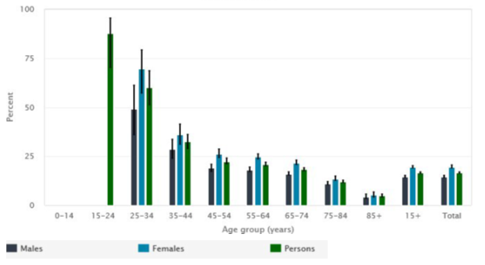
Source: AIHW Australian Cancer Database 2014
Notes:
Relative survival was calculated with the period method, using the period 2010–2014. Note that this period does not contain incidence data for 2014 for New South Wales because that data was unavailable.
Data for some categories that do not appear in the charts have been deliberately suppressed due to small numbers, confidentiality, and/or reliability concerns.
Figure 13.10.1: Five-year relative survival from lung cancer, by age (A), remoteness (B), SES (C) and ICS (D), Victoria, 2010–2014

- Age
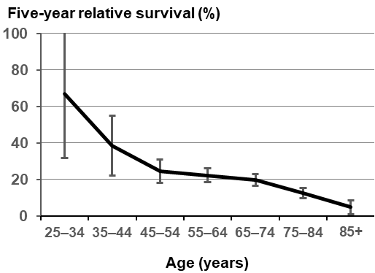
- Remoteness
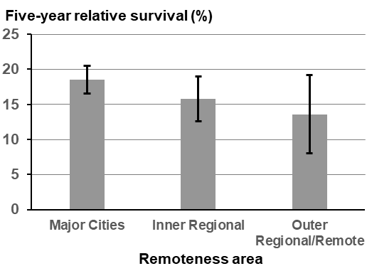

- Socioeconomic status
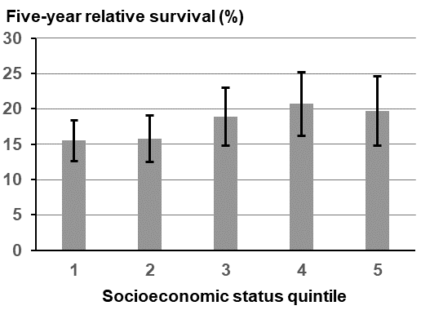
- Integrated Cancer Service
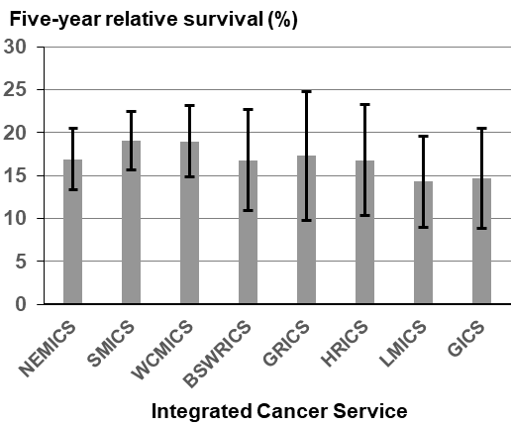

Notes:
Error bars indicate 95 per cent confidence intervals.
Analysis for the age groups 0–14 years and 15–24 years were excluded because there were no deaths recorded.
Remoteness is classified according to the Australian Standard Geographical Classification (ASGC) Remoteness Areas.
SES is classified according to the ABS Socioeconomic Indexes for Areas (SEIFA) Index of Relative Socio-economic Disadvantage – 1= lowest and 5 = highest.
Appendix 2 provides the dataset.

Measure assessment
Traffic light rating: Amber (desired result not yet evident)
Overall trend: Could not be calculated due to only one data point (2010–2014)
Commentary: Figure 13.10 shows that overall in 2010–2014, Australians diagnosed with lung cancer had a 17 per cent chance (15 per cent for males and 20 per cent for females) of surviving for five years compared with their counterparts in the general Australian population. This pattern was similar in Victoria where people diagnosed with lung cancer during the same period had a 17.6 per cent chance (16 per cent for males and 19.8 per cent for females) of surviving for five years compared with their counterparts in the general Victorian population.
Five-year survival was significantly higher for those aged 25–34 (67 per cent) compared with all older age groups. Survival fell sharply with age, dropping from 19.8 per cent for those in the 65–74 age group to 4.8 per cent for those aged 85 or older (Figure 13.10.1).
Survival varied by remoteness and SES. Five-year survival was higher in major cities (18.5 per cent) than in inner regional (15.8 per cent) and outer regional/remote areas (13.6 per cent). However, survival was greatest in the higher socioeconomic quintile (Q 4) (20.7 per cent) (Figure 13.10.1).
There was a gradient of decreasing survival with ICSs that did not contain a large metropolitan area such as Melbourne: five-year survival was five percentage points higher for people in SMICS (19.1 per cent) and WCMICS (19 per cent) compared with those located in LMICS (14.3 per cent) and GICS (14.7 per cent) (Figure 13.10.1).

Measure 13.11 – Five-year relative survival from pancreatic cancer (C25)
Figure 13.11: Five-year relative survival from pancreatic cancer (nationally), by age and sex, 2010–2014
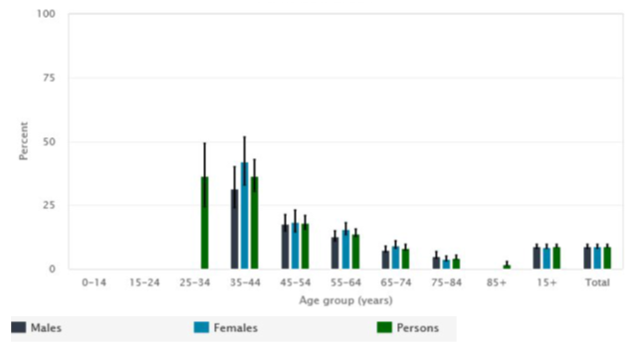
Source: AIHW Australian Cancer Database 2014
Notes:
Relative survival was calculated with the period method, using the period 2010–2014. Note that this period does not contain incidence data for 2014 for New South Wales because that data was unavailable.
Data for some categories that do not appear in the charts have been deliberately suppressed due to small numbers, confidentiality, and/or reliability concerns.
Figure 13.11.1: Five-year relative survival from pancreatic cancer, by age (A), remoteness (B), SES (C) and ICS (D), Victoria, 2010–2014

- Age
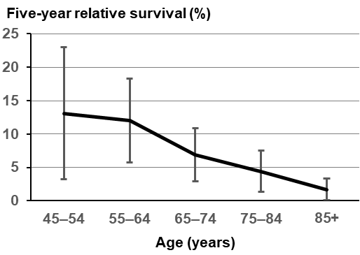
- Remoteness
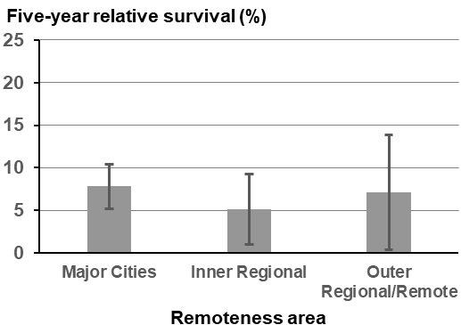

- Socioeconomic status
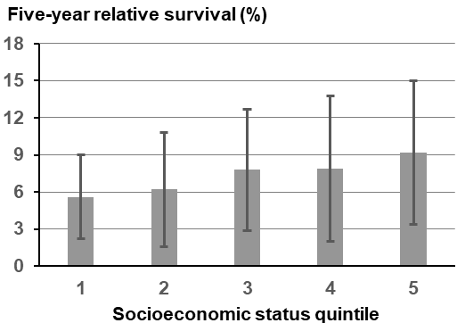
- Integrated Cancer Service
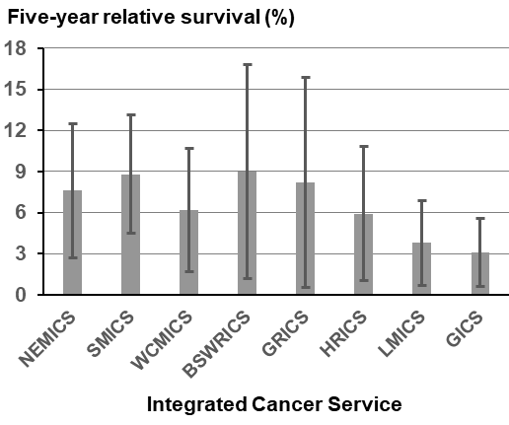

Notes:
Analysis for the age groups 0–14 years, 15–24 years, 25–34 years and 35–44 years were excluded because of low numbers.
Error bars indicate 95 per cent confidence intervals.
Remoteness is classified according to the Australian Standard Geographical Classification (ASGC) Remoteness Areas.
SES is classified according to the ABS Socioeconomic Indexes for Areas (SEIFA) Index of Relative Socio-economic Disadvantage – 1= lowest and 5 = highest.
Appendix 2 provides the dataset.

Measure assessment
Traffic light rating: Amber (desired result not yet evident)
Overall trend: Could not be calculated due to only one data point (2010–2014)
Commentary: In 2010–2014, Australians diagnosed with pancreatic cancer had a 8.7 per cent chance of surviving for five years compared with their counterparts in the general population, which decreased with age (Figure 13.11). Victoria’s overall rate for the same time period was less than the national trend – 7.3 per cent. In Victoria, the survival rate was similar for males (7.2 per cent) and females (7.3 per cent). Five-year survival was highest for those diagnosed in the 15–24 age group and decreased with age. Survival was less than 2.0 per cent for those aged 85 or older (Figure 13.11.1).
Five-year survival was similar between major cities (7.8 per cent) and outer regional/remote areas (7.1 per cent). The same pattern did not emerge between more urban-centric ICSs compared with rural ICSs. For example, BSWRICS, which includes Geelong, had the highest rate of nine per cent compared with rural GICS, which had a rate of only 3.1 per cent. However, these results should be interpreted with caution because of the wide confidence intervals due to small sample sizes.
There was a gradient of decreasing survival with greater socioeconomic disadvantage. Five-year survival was 9.2 per cent in the highest socioeconomic quintile (Q 5) compared with 5.6 per cent in the lowest (Q 1).

Measure 13.12 – Five-year relative survival from ovarian cancer (C56)
Figure 13.12: Five-year relative survival from ovarian cancer (nationally), by age, 2010–2014
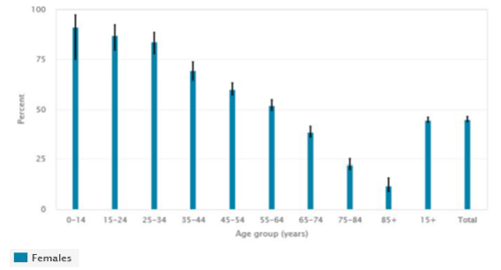
Source: AIHW Australian Cancer Database 2014
Note: Relative survival was calculated with the period method, using the period 2010–2014. Note that this period does not contain incidence data for 2014 for New South Wales because that data was unavailable.
Figure 13.12.1: Five-year relative survival from ovarian cancer, by age (A), remoteness (B), SES (C) and ICS (D), Victoria, 2010–2014

- Age
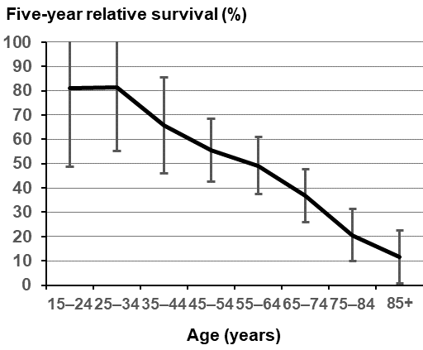
- Remoteness
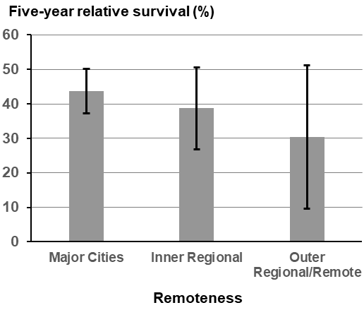

- Socioeconomic status
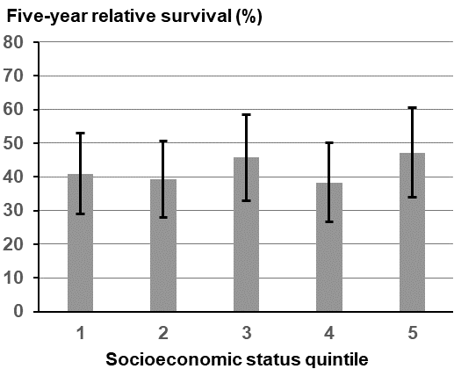
- Integrated Cancer Service
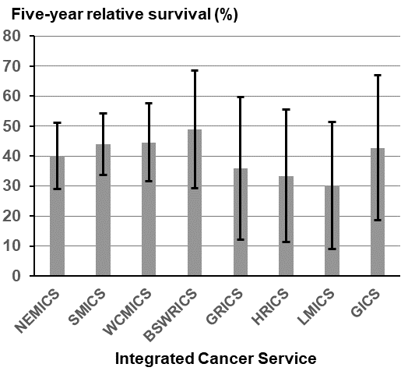

Notes:
Analysis for the age group 0–14 years was excluded because of low numbers.
Error bars indicate 95 per cent confidence intervals.
Remoteness is classified according to the Australian Standard Geographical Classification (ASGC) Remoteness Areas.
SES is classified according to the ABS Socioeconomic Indexes for Areas (SEIFA) Index of Relative Socio-economic Disadvantage – 1= lowest and 5 = highest.
Appendix 2 provides the dataset.

Measure assessment
Traffic light rating: Amber (desired result not yet evident)
Overall trend: Could not be calculated due to only one data point (2010–2014)
Commentary: In 2010–2014, Australian women diagnosed with ovarian cancer had a 44.8 per cent chance of surviving for five years compared with 41.9 per cent for Victorian women.
In Victoria, survival dropped steeply with age. Five-year survival was highest for women diagnosed in the 25–34 age range (81.4 per cent) but decreased with each older age group. It was 11.7 per cent for women aged 85 or older (Figure 13.12.1).
Five-year survival was 43.7 per cent in major cities, significantly higher than in outer regional/remote areas (30.3 per cent). The same pattern emerged for five-year survival within metropolitan ICSs. For example, five-year survival for metropolitan ICSs such as SMICS and WCMICS were higher (44 per cent and 44.6 per cent respectively) compared with their rural counterparts such as LMICS (30.1 per cent) (Figure 13.12.1).
There was a fluctuating gradient of survival with greater socioeconomic disadvantage. Five-year survival was 47.2 per cent in the highest socioeconomic quintile (Q 5) compared with 40.9 per cent in the lowest (Q 1) (Figure 13.12.1).

Measure 13.13 – Five-year relative survival from colorectal cancer (C18–20)
Figure 13.13: Five-year relative survival from colorectal cancer (nationally), by age and sex, 2010–2014
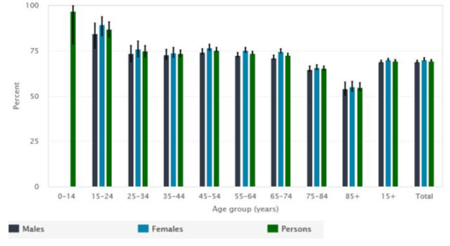
Source: AIHW Australian Cancer Database 2014
Note: Relative survival was calculated with the period method, using the period 2010–2014. Note that this period does not contain incidence data for 2014 for New South Wales because that data was unavailable.
Figure 13.13.1: Five-year relative survival from colorectal cancer, by age (A), remoteness (B), SES (C) and ICS (D), Victoria, 2010–2014

- Age
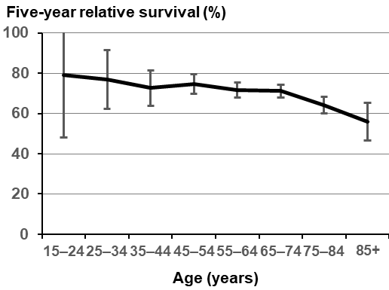
- Remoteness
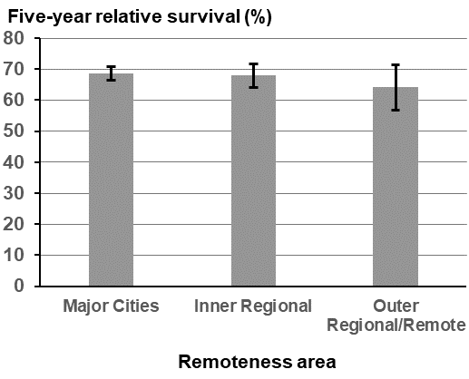

- Socioeconomic status
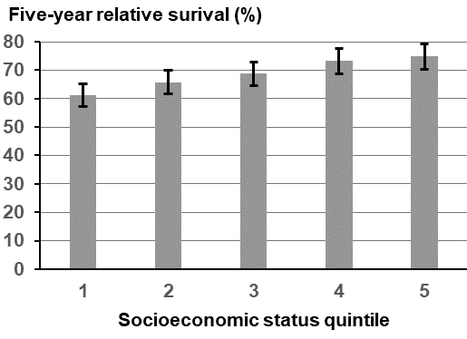
- Integrated Cancer Service
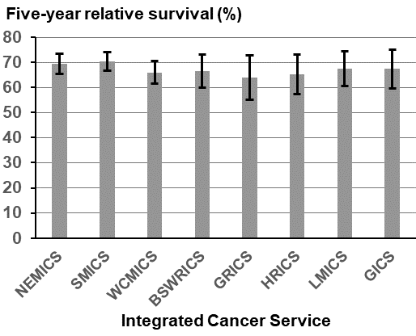

Notes:
Analysis for the age group 0–14 years was excluded because of low numbers.
Error bars indicate 95 per cent confidence intervals.
Remoteness is classified according to the Australian Standard Geographical Classification (ASGC) Remoteness Areas.
SES is classified according to the ABS Socioeconomic Indexes for Areas (SEIFA) Index of Relative Socio-economic Disadvantage – 1= lowest and 5 = highest.
Appendix 2 provides the dataset.

Measure assessment
Traffic light rating: Amber (desired result not yet evident)
Overall trend: Could not be calculated due to only one data point (2010–2014)
Commentary: In 2010–2014, Australians diagnosed with CRC had a 69 per cent chance of surviving for five years compared with their counterparts in the general population (Figure 13.13). This was the highest five-year relative survival rate of all digestive-tract cancers and was similar to all cancers combined (69 per cent – Measure 13.9). Males (69 per cent) and females (70 per cent) had similar five-year relative survival rates, which decreased with age (Figure 13.13).
Victorians diagnosed with CRC had a slightly lower chance of surviving five years compared with the Australian average (68.1 per cent). Five-year survival was 68.9 per cent for females compared with 67.5 per cent for males.
Five-year survival did not vary much under the age of 74 but dropped to 64.1 per cent for those aged 75–84 years and to 55.8 per cent for those aged 85 or older.
Survival varied by remoteness area: five-year survival was higher in major cities (68.6 per cent) than in inner regional (67.9 per cent) and outer regional/remote (64.1 per cent) areas. This was also reflected in the survival rates between ICS, with urban ICS such as NEMICS (69.7 per cent) and SMICS (70.5 per cent) higher compared with their rural counterparts such as GRICS (63.9 per cent) (Figure 13.13.1).
Five-year survival decreased with greater socioeconomic disadvantage; five-year survival was 74.9 per cent in the highest socioeconomic quintile and 61.2 per cent in the lowest socioeconomic quintiles (Figure 13.13.1).

Measure 13.14 – Five-year relative survival from brain cancer (C71)
Figure 13.14: Five-year relative survival from brain cancer (nationally), by age and sex, 2010–2014
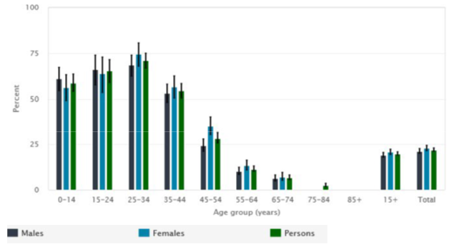
Source: AIHW Australian Cancer Database 2014
Notes:
Relative survival was calculated with the period method, using the period 2010–2014. Note that this period does not contain incidence data for 2014 for New South Wales because that data was unavailable.
Data for some categories that do not appear in the charts have been deliberately suppressed due to small numbers, confidentiality, and/or reliability concerns.
Figure 13.14.1: Five-year relative survival from brain cancer, by age (A), remoteness (B), SES (C) and ICS (D), Victoria, 2010–2014

- Age
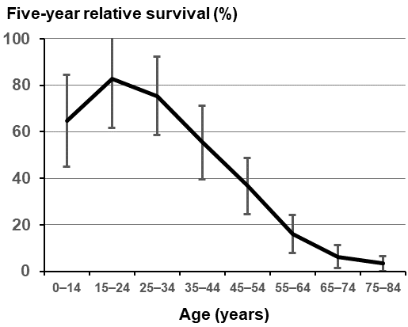
- Remoteness
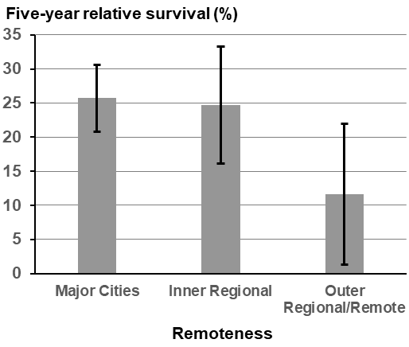

- Socioeconomic status
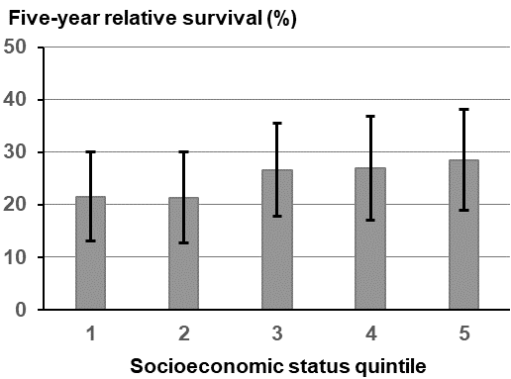
- Integrated Cancer Service

Notes:
Error bars indicate 95 per cent confidence intervals.
Remoteness is classified according to the Australian Standard Geographical Classification (ASGC) Remoteness Areas.
SES is classified according to the ABS Socioeconomic Indexes for Areas (SEIFA) Index of Relative Socio-economic Disadvantage – 1= lowest and 5 = highest.
Appendix 2 provides the dataset.

Measure assessment
Traffic light rating: Amber (desired result not yet evident)
Overall trend: Could not be calculated due to only one data point (2010–2014)
Commentary: At a national level, in 2010–2014 people with brain cancer had a 21.9 per cent chance of surviving for at least five years compared with the general population. Five-year survival was slightly higher for females (24 per cent) than males (20 per cent) (Figure 13.14).
In Victoria, people diagnosed with brain cancer had a higher chance (25.0 per cent) than the Australian average of surviving for at least five years in 2010–2014. Five-year survival was higher for females (27.9 per cent) than for males (22.6 per cent).
Five-year survival was highest for those aged 15–24 (82.8 per cent) and dropped steeply with age thereafter. Survival was less than seven per cent for those aged 65–74 or older.
Survival varied significantly by remoteness: five-year survival was significantly higher in major cities (25.7 per cent) and inner regional areas (24.8 per cent) compared with outer regional/remote areas (11.6 per cent). This disparity was also reflected in survival broken down by ICS, with urban ICSs such as WCMICS having the highest recorded survival rate in 2010–2014 of 32.8 per cent compared with GRICS (predominantly rural), which had a rate of 17.8 per cent). However, this trend was not always consistent because BSWRICS, which includes urban areas such as Geelong, also had a lower survival rate for the same period (17.8 per cent).
Five-year survival was highest for people in the highest socioeconomic quintile compared with those living in the lowest quintile (28.5 per cent (Q 5) and 21.5 per cent (Q 1) respectively).

Measure 13.15 – Five-year relative survival from oesophagus cancer (C15)
Figure 13.15: Five-year relative survival from oesophagus cancer (nationally), by age and sex, 2010–2014
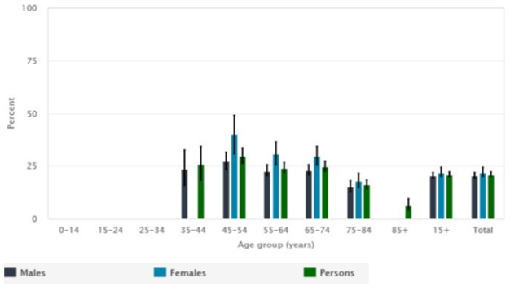
Source: AIHW Australian Cancer Database 2014
Notes:
Relative survival was calculated with the period method, using the period 2010–2014. Note that this period does not contain incidence data for 2014 for New South Wales because that data was unavailable.
Data for some categories that do not appear in the charts have been deliberately suppressed due to small numbers, confidentiality, and/or reliability concerns.
Figure 13.15.1: Five-year relative survival from oesophagus cancer, by age (A), remoteness (B), SES (C) and ICS (D), Victoria, 2010–2014

- Age
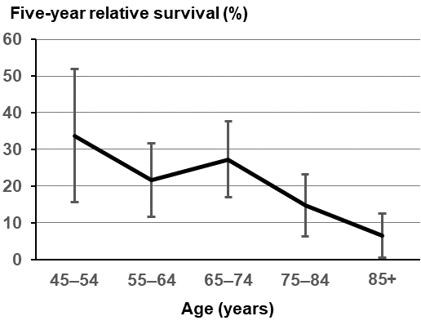
- Remoteness
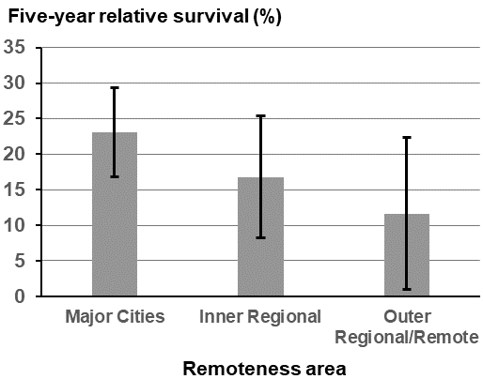

- Socioeconomic status
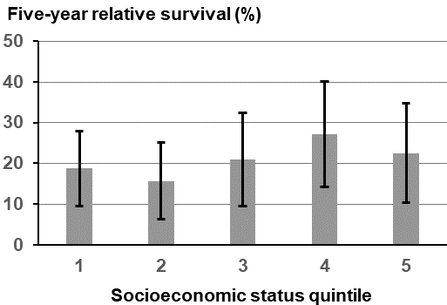
- Integrated Cancer Service
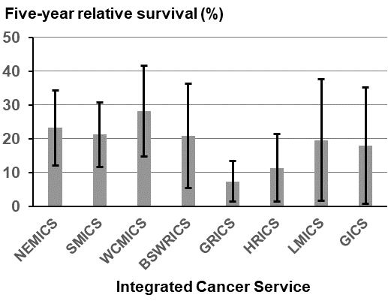

Notes:
Analysis for the age groups 0–14 years, 15–24 years, 25–34 years and 35–44 years were excluded because of low numbers.
Error bars indicate 95 per cent confidence intervals.
Remoteness is classified according to the Australian Standard Geographical Classification (ASGC) Remoteness Areas.
SES is classified according to the ABS Socioeconomic Indexes for Areas (SEIFA) Index of Relative Socio-economic Disadvantage – 1= lowest and 5 = highest.
Appendix 2 provides the dataset.

Measure assessment
Traffic light rating: Amber (desired result not yet evident)
Overall trend: Could not be calculated due to only one data point (2010–2014)
Commentary: Nationally, the five-year survival rate for oesophageal cancer in Australia in 2010–2014 was 21 per cent. Victoria mirrored the national trend, with a five-year survival rate of 20.7 per cent for the same period.
Five-year survival was similar for males (20.4 per cent) and females (21.3 per cent) overall. However, five-year survival was similar for age groups under 84 years, ranging from 27 per cent for those aged 35–44 years to 27.3 per cent for those aged 65–74 years. For those aged 85 years or older, the five-year survival dropped to 14.8 per cent (Figure 13.15.1).
Survival differed significantly by remoteness, with major cities having a higher five-year survival rate (23.1 per cent) than outer regional/remote areas (11.6 per cent). This trend was also mirrored between ICSs where the five-year survival rate was highest in urban ICSs such as WCMICS (28.2 per cent) compared with rural-centric ICSs, namely GRICS, which had a significantly lower survival rate of 7.4 per cent (Figure 13.15.1). However, these results should be interpreted with caution because of the wide confidence intervals due to small sample sizes.
There was no consistent association between survival and SES. Five-year survival was the highest in the fourth highest quintile (Q 4) (27.1 per cent) and lowest in the second quintile (Q 2) (15.7 per cent) (Figure 13.15.1).

Measure 13.16 – Five-year relative survival from acute myeloid leukaemia
Figure 13.16: Five-year relative survival from acute myeloid leukaemia, by age (A), remoteness (B), SES (C) and ICS (D), Victoria, 2010–2014

- Age
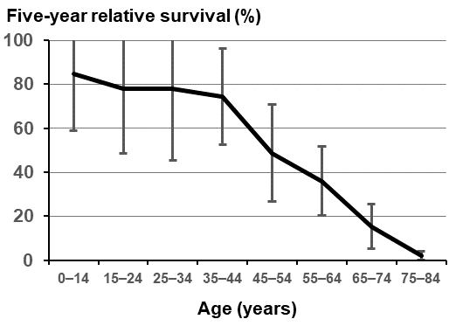
- Remoteness
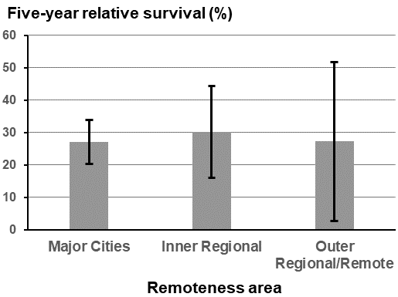

- Socioeconomic status
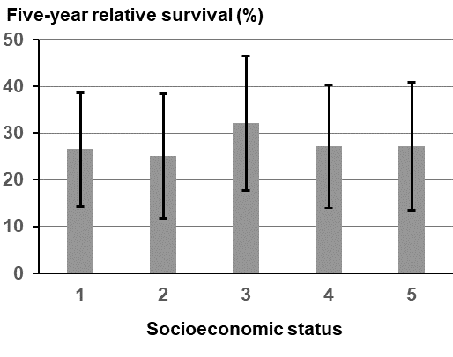
- Integrated Cancer Service
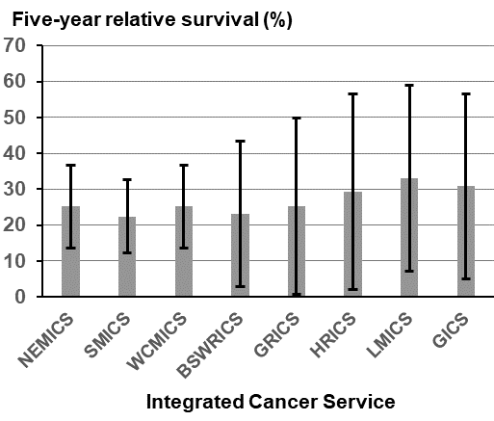

Notes:
Error bars indicate 95 per cent confidence intervals.
Remoteness is classified according to the Australian Standard Geographical Classification (ASGC) Remoteness Areas.
SES is classified according to the ABS Socioeconomic Indexes for Areas (SEIFA) Index of Relative Socio-economic Disadvantage – 1= lowest and 5 = highest.
Appendix 2 provides the dataset.

Measure assessment
Traffic light rating: Amber (desired result not yet evident)
Overall trend: Could not be calculated due to only one data point (2010–2014)
Commentary: In Victoria, at diagnosis, the probability of surviving from AML for at least five years was 27.7 per cent between the period 2010–2014. Survival did not differ significantly between the genders, with five-year survival being 27 per cent for males compared with 28.5 per cent for females. Figure 13.16 shows that older age at diagnosis was associated with lower survival, particularly from those aged 65 years or older compared with 78.3 per cent for those aged under 44 years.
There were no significant differences in survival by remoteness (Figure 13.16). Five-year survival was highest for people living in inner regional areas (30 per cent) compared with major cities and remote areas – both 27 per cent between 2010–2014. Figure 13.6 shows that the five-year relative survival rate by SES were similar. Five-year survival appeared to be highest for people in the third highest socioeconomic quintile (32.1 per cent) compared with other socioeconomic quintiles (25.1–27.1 per cent).
The five-year survival rate appeared to vary across Victoria as it related to ICSs, with the urban ICS SMICS having the lowest survival rate (22.4 per cent) compared with a predominantly rural ICS – LMICS’s rate of 33.2 per cent. WCMICS recorded the highest rate of 37 per cent (Figure 13.16). However, these results should be interpreted with caution because of the wide confidence intervals due to small sample sizes.

Measure 13.17 – Five-year survival from all cancers diagnosed at stages 1 and 2
Data as it relates to registry-derived stage are currently only available for some cancer tumour streams, namely breast, colorectal and prostate, rather than ‘all’ cancers. Refer to Appendix 1.
Measure 13.18 – Five-year survival from all cancers diagnosed at stages 3 and 4
Data as it relates to registry-derived stage are currently only available for some cancer tumour streams, namely breast, colorectal and prostate, rather than ‘all’ cancers. Refer to Appendix 1.

Key result: Improving quality of life

Measure 14.1 – Health-related quality of life following primary treatment
No data available. Refer to Appendix 1

Outcome: Best possible experience of care systems

Key result: Improve patient experience of health care

Measure 15.1 – Proportion of adults admitted to public hospitals due to cancer who report positive overall healthcare experience
Figure 15.1: Proportion of adults admitted to public hospitals due to cancer who reported being satisfied with the care received from all health professionals involved in their care in 2018
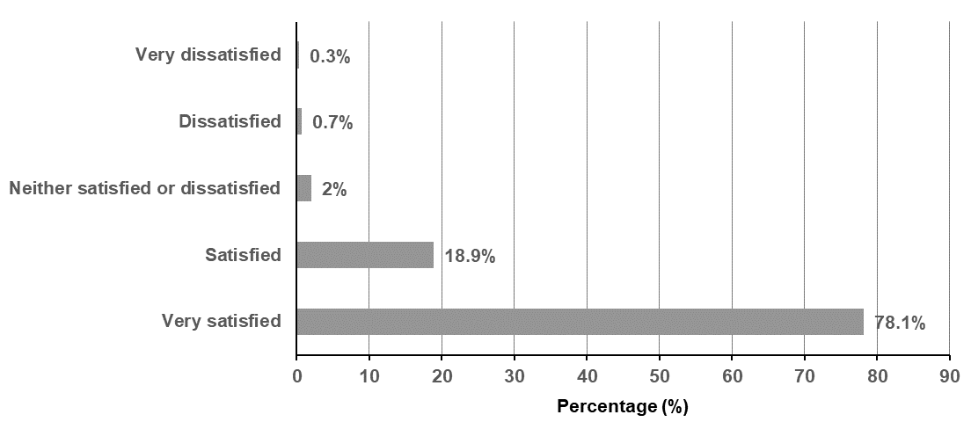
Notes:
Overall care Q12. How satisfied were you with the overall care you received from all health professionals involved in your treatment?
Total number of patients who answered question 12 = 3,673; total number of patients satisfied or very satisfied = 3,563

Measure assessment
Traffic light rating: Green (satisfactory result)
Overall trend: Unable to measure as this data relates to one year only but satisfactory result
Commentary: Understanding a patient’s experience throughout each stage of their cancer journey can enable more personalised care and help to improve the overall quality of the health system. The Victorian Cancer Patient Experiences of Care Survey asks adult inpatients how satisfied they are with the overall care they received from all health professionals involved in their treatment. This question highlights the importance of enabling people admitted to public hospitals due to cancer to give feedback about their experience, which in turn can lead to more personal care for others. This can assist in improving the safety and quality of care in health services and assist in focusing on aspects of concern to patients. Figure 15.1 shows that, in 2018, of the 3,673 patients who responded to the question, 97 per cent of patients were very satisfied or satisfied with the care they received from all health professionals involved in their care at each health service.

Measure 15.2 – Proportion of children and adolescents admitted to hospital due to cancer who report positive healthcare experience
Resources to resolve this outstanding measure in the future are yet to be confirmed. The measure is yet to be determined – refer to Appendix 1.

Measure 15.3 – Proportion of adults admitted to public hospitals due to cancer who report positive transition from care index score
Resources to resolve this outstanding measure in the future are yet to be confirmed. The measure is yet to be determined – refer to Appendix 1.

Measure 15.4 – Proportion of adults attending emergency departments due to cancer who report positive overall healthcare experience
It is proposed that a question be added to the department’s Experiences of Care Survey – Patient Experiences of Care Survey as it relates to emergency departments – refer to Appendix 1.

Measure 15.5 – Proportion of people attending hospital outpatients due to cancer who report positive healthcare experience
Resources to resolve this outstanding measure in the future are yet to be confirmed. The measure is yet to be determined – refer to Appendix 1.

Measure 15.6 – Proportion of people attending primary care due to cancer who report positive healthcare experience
Resources to resolve this outstanding measure in the future are yet to be confirmed. The measure is yet to be determined – refer to Appendix 1.

Key result: Improve patient experience of screening

Measure 16.1 – Proportion of women who have a mammogram by BreastScreen Victoria who rate the service as highly satisfactory
Figure 16.1: Overall satisfaction with the breast screening process, 2014–2016
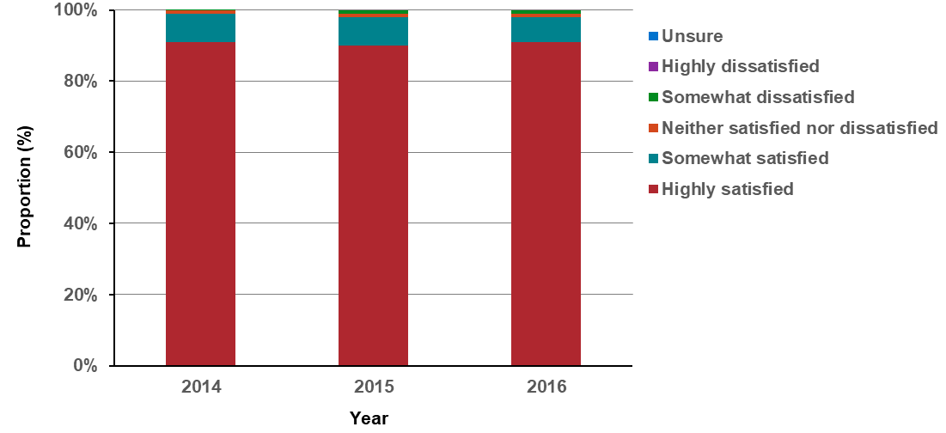
Notes:
Question 21: Overall, how satisfied were you with the entire breast screening process?
Total sample: 2014, n = 3,153; 2015, n = 3,976; 2016, n = 4,022; 2017, n = 6,447; 2018, n = 11,423
Table 16.1: Proportion of women who have a mammogram by BreastScreen Victoria who rate the service from highly satisfactory to unsure, 2014–2018
Question 21 | 2014 | 2015 | 2016 | 2017 | 2018
Highly satisfied | 91% | 90% | 91% | 92% | 93%
Somewhat satisfied | 8% | 8% | 7% | 7% | 6%
Neither satisfied nor dissatisfied | 1% | 1% | 1% | 1% | 1%
Somewhat dissatisfied | 1% | 1% | 1% | 0 | 0
Highly dissatisfied | 0 | 0 | 0 | 0 | 0
Unsure | 0 | 0 | 0 | 0 | 0

Measure assessment
Traffic light rating: Green (satisfactory result)
Overall trend: Moving in the right direction
Commentary: BreastScreen Victoria is part of a national breast cancer screening program inviting women aged 50–74 to have free breast screens every two years. The aim of this program is to reduce breast cancer deaths through early detection of the disease.
BreastScreen Victoria has a network of services around the state including eight regional assessment services, 39 screening clinics and its Mobile Screening Service that visits 29 communities every two years. BreastScreen Victoria has been conducting an annual client satisfaction survey since 2013 as a means of measuring and monitoring all aspects of service delivery received by women undergoing a breast screen including their intention to return for rescreening.
While no target has been set for this measure, overall satisfaction with the breast screening service continues to be very high. Since 2013, more than nine in 10 women are highly satisfied with their overall experience. Less than two per cent of women are neutral or dissatisfied with their experience, reinforcing that nearly all are extremely satisfied overall, particularly given that the sample size has grown significantly over the past five years (Figure 16.1 and Table 16.1).

Measure 16.2 – Proportion of women who are rescreened at BreastScreen Victoria within 27 months after the first screen
Figure 16.2: Age-adjusted proportion of women screened during 2014 who rescreened within 27 months, first screening round, by state and territory, women aged 50–72 years

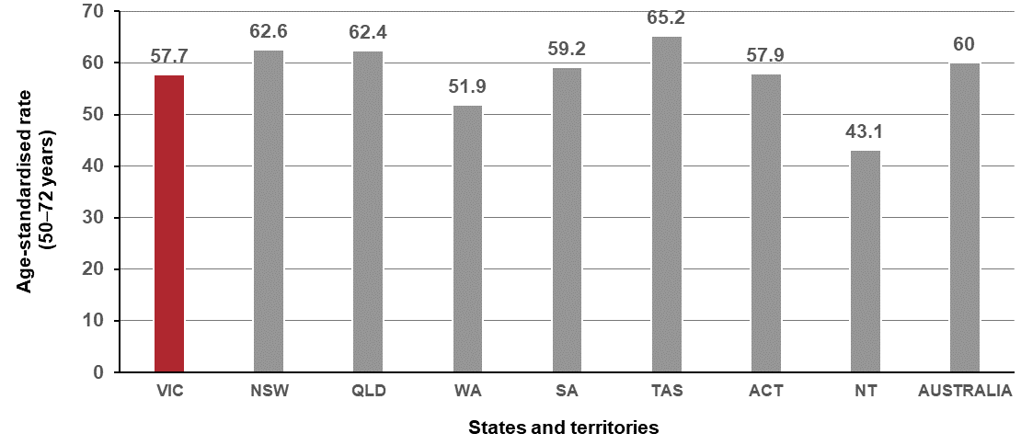
Source: Australian Institute of Health and Welfare 2018. BreastScreen Australia monitoring report 2018. Cancer series no. 112. Cat. no. CAN 116. AIHW, Canberra.
‘Age-standardised rate’ is the number of women rescreened within 27 months as a percentage of women screened, age-standardised to the population of women attending a BreastScreen Australia service in 2008.

Measure assessment
Traffic light rating: Amber (desired result not yet evident)
Overall trend: Moving in the right direction, but this measure will need to be revised in the future to account for change in rescreening age
Commentary: Although the recommended screening interval is two years (24 months), 27 months is used to allow a reasonable timeframe for women to respond to invitations. The latest rescreening data is for women screened in 2014. The target age group used for rescreening (prior to 2014) was 50–67 rather than 50–69 because women aged 68–69 at that time of their screen would be outside the target age group of 50–69 when they would be due for their rescreen. The target age group for women screened from 2014 onwards has changed and is now 50–72. The proportion of women screened during 2014 who rescreened within 27 months of their first screening around is shown in Figure 16.2.
While there is no target for this measure, there is a clear relationship between women’s satisfaction of their breast screening experience and their intention to return. Women who are dissatisfied are less likely to intend to return for another breast screen in future. A high rescreen rate is important to both increase the likelihood of breast cancers being detected early and to maintain overall participation.

Measure 16.3 – Proportion of women who are rescreened for cervical cancer within three months of receiving a 27-month cervical screening register reminder letter
Figure 16.3: Proportion and number of women aged 20–69 years who rescreened within three months of receiving a 27-month cervical screening register reminder letter sent in 2015, by state and territory
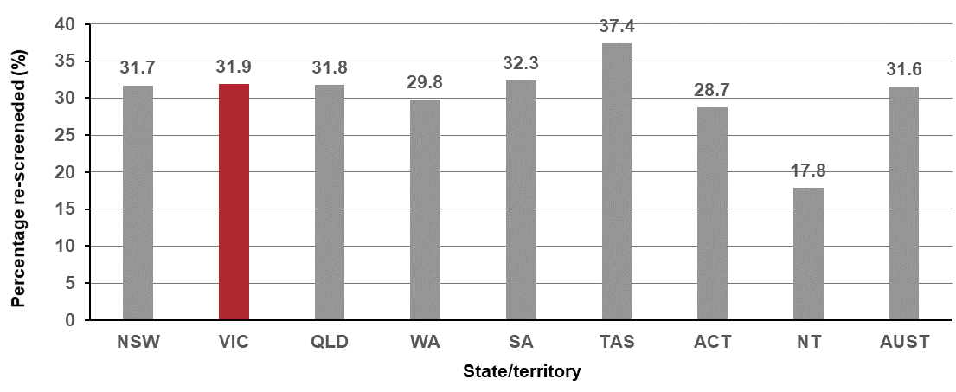
Table 16.3 Proportion of women sent a reminder letter to rescreen at 27 months after a negative Pap test and the number who re-screened, state and territory
States/Territories | NSW | VIC | QLD | WA | SA | TAS | ACT | NT | Australia
Number sent a 27-month reminder letter | 339,865 | 293,219 | 223,301 | 101,825 | 79,524 | 22,184 | 20,713 | 11,542 | 1,092,173
Number rescreened | 107,808 | 93,571 | 70,938 | 30,308 | 25,719 | 8,298 | 5,952 | 2,058 | 344,652
Source: AIHW analysis of state and territory cervical cytology
Notes:
Data is based on all women screened in each jurisdiction.
This data excludes women who have opted off the cervical cytology register.
Period covers letters sent 1 January 2015 to 31 December 2015.

Measure assessment
Traffic light rating: Amber (desired result not yet evident)
Overall trend: Static; however, this measure (and baseline year) will need to be amended from 2019–2020 to reflect the renewed National Cervical Screening Program (commenced 1 December 2017) with new test frequency and adjusted age range
Commentary: Figure 16.3 shows that a cervical screening register letter reminding women to rescreen sent at 27 months after a previous negative Pap test prompts many women to rescreen. The latest rescreening data indicates that 31.9 per cent of Victorians who were sent this reminder letter in 2015 presented for screening within three months. This was 0.3 per cent higher than for Australia (31.6 per cent) (Figure 16.3).
It will be possible to report three more years of data for 2016–2017, 2017–2018 and 2018–2019 using the current measure. However, a new baseline will be established for 2019–2020 to reflect changes under the renewed national cervical screening program. From 1 December 2017, changes were made to program policy, the test type and screening interval and the target age range.

Measure 16.4 – Proportion of adults who are rescreened by National Bowel Cancer Screening Program
Figure 16.4: Proportion of adults aged 50–74 who are rescreened (in subsequent rounds) by the National Bowel Cancer Screening Program, Victoria and Australia, 2014–2015 to 2016–2017
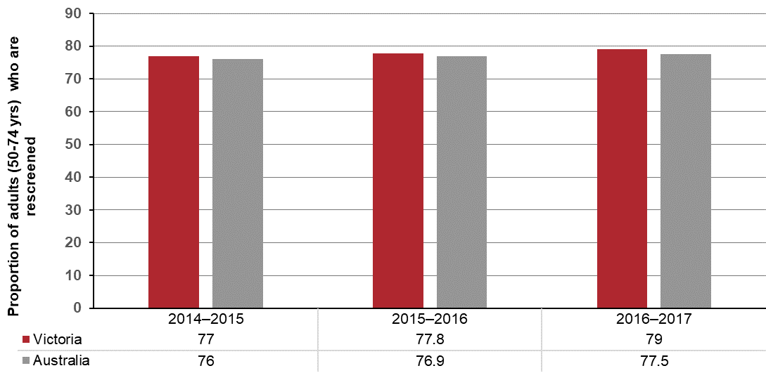
Source: AIHW National Bowel Cancer Screening Program monitoring report. Available from: http://www.aihw.gov.au/
Note: Figure 16.4 includes all first-round invitations
Participation data for 2014–2015 is based on the National Bowel Cancer Screening Program (NBCSP) Register as at 31 December 2016, participation data for 2015–2016 is based on the NBCSP Register as at 30 June 2017, and participation data for 2016–2017 is based on the NBCSP Register as at 30 June 2018.

Measure assessment
Traffic light rating: Amber (desired result not yet evident)
Overall trend: Static or unchanging
Commentary: While no target has been set for this measure, a high rescreen rate is important to increase the likelihood of CRCs being detected early and treated successfully. It also demonstrates the acceptability of the faecal occult blood test and the National Bowel Cancer Screening Program more broadly by program participants. Figure 16.4 shows that since 2014–2015 the proportion of Victorian adults (50–74 years) who are rescreened via the National Bowel Cancer Screening Program is slowly increasing and is slightly higher than the national rate. It is anticipated that this trend will continue to improve as the program expands. Currently people aged 50, 52, 54, 56, 58, 60, 62, 64, 66, 68, 70, 72 and 74 are invited to screen. By 2020 all Australians (including Victorians) aged between 50 and 74 years will be offered free screening every two years. When this point is reached it is recommended that the definition for this measure is reviewed.

Outcome: Integrated research systems

Key result: Innovations and improved evidence of best practice

Measure 17.1 – Number of new enrolments in cancer intervention clinical trials
Figure 17.1: Number of new enrolments in cancer interventions clinical trials in Victoria by year, 2014–2017
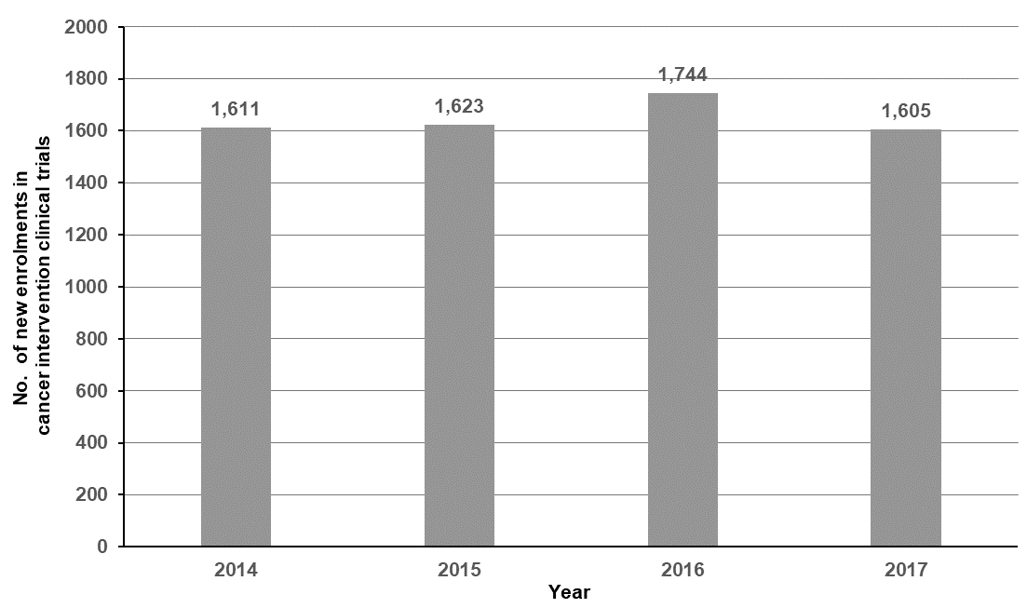
Source: Annual Cancer Trials Management Scheme (CTMS) data
Notes:
This analysis reports trials with a ‘treatment’ Common Scientific Outline (CSO) defined as a clinical trial according to World Health Organization criteria.
Interstate patients have been included in the number of new enrolments in cancer intervention clinical trials.

Figure 17.1.2: Proportion of new enrolments in cancer intervention clinical trials in Victoria stratified by tumour stream, by year, 2014–2017
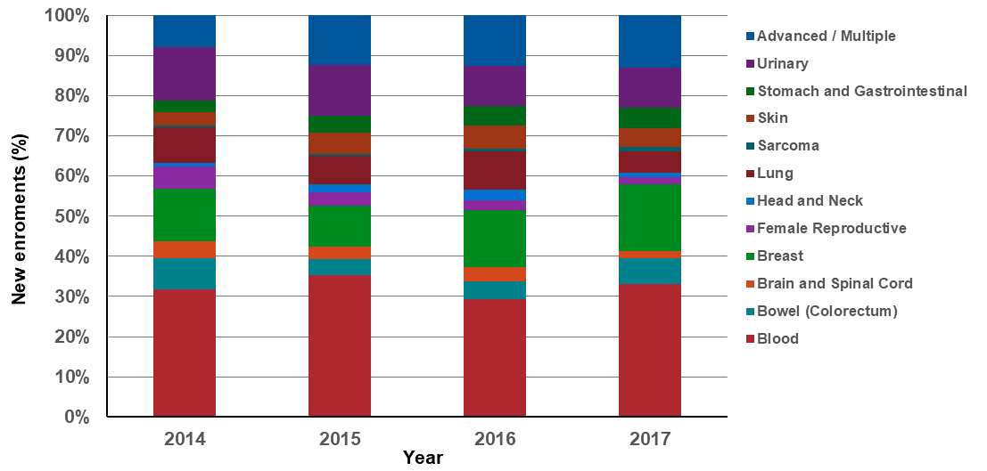
Note: Appendix 2 provides the dataset.

Measure assessment
Traffic light rating: Amber (desired result not yet evident)
Overall trend: Moving in the right direction, but numbers are very low
Commentary: Clinical trials are an important component of translational cancer research and are vital for advancing cancer breakthroughs by testing the latest treatments, drugs and medical devices that can deliver better patient outcomes and save lives. Recruiting patients into cancer clinical trials is an important measurement to determine the proportion of patients being treated in clinical trials compared with those who are not. However, direct comparison of recruitment activity occurring in Victoria compared with the rest of Australia is currently not possible because very few other jurisdictions collect recruitment and trial activity data and for the jurisdictions that do collect this data, the definitions, systems and investments being used to measure clinical trial activity are different to Victoria. For example, in 2015 Cancer Institute New South Wales reported 241 new enrolments in cancer intervention clinicals trials which was significantly less than Victoria.
Figure 17.1 shows that, overall, the number of new enrolments in cancer between 2014 and 2017 has not increased with time. This trend remains consistent, even when examined by metropolitan and rural populations (Table 17.1, Appendix 2). Despite this, the proportion of rural patients entering clinical trials, relative to metropolitan patients, has increased over time, reaching 26.5 per cent in 2017.
Overall the number of patients enrolled in clinical trials at sites within metropolitan ICS was higher than the number of patients enrolled in rural and regional ICS (Table 17.1, Appendix 2). The highest number of new enrolments was reported by WCMICS, which recorded 2,763 between 2014 and 2017. LMICS had the lowest number of new enrolments (30) over the four-year period. On the other hand, GRICS reported no clinical trial activity in the analysis period.
Blood cancer trials consistently recruited the highest number of new enrolments in each reporting period, with a total of 2,123. This was followed by breast (895) and advanced multiple (759) cancers, possibly reflecting that a number of these trials are run by private hospitals with specialist oncology research units in large metropolitan areas such as Melbourne. People with uncommon cancers such as sarcoma were the least likely to enrol in a clinical trial for each reporting period. For example, in 2017, only 1.1 per cent of patients enrolled in a clinical trial specific to sarcoma (Figure 17.1.2).
No target has been set for this measure, but research has shown that public education on the true value of clinical research and the reality of participating in a clinical trial is needed. Involving trained patient advocates at each step of the clinical research process, even in preclinical phases, could provide significant benefit in helping to design informative trials, as well as in recruiting patients to participate.

Measure 17.2 – Number of recruiting cancer intervention clinical trials
Figure 17.2: Number of recruiting cancer intervention clinical trials in Victoria, by year, 2014–2017
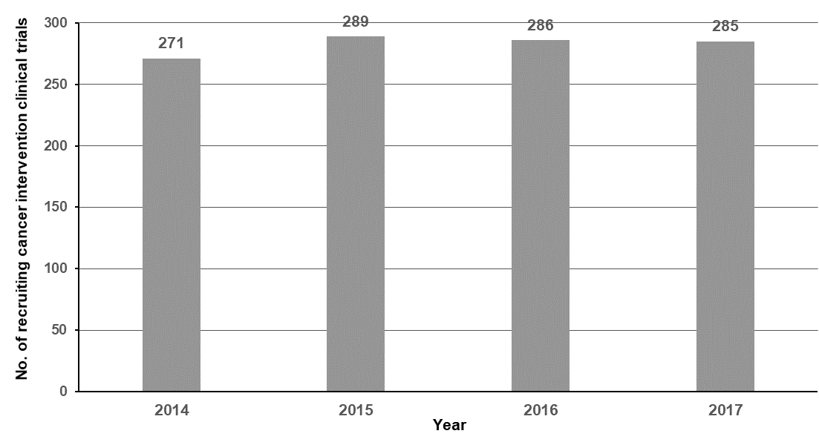
Source: Annual Cancer Trials Management Scheme (CTMS) data
Note: This analysis reports trials with a ‘treatment’ Common Scientific Outline (CSO) defined as a clinical trial according to World Health Organization criteria.
Figure 17.2.1: Proportion of recruiting cancer intervention clinical trials in Victoria, stratified by tumour stream by year, 2014–2017
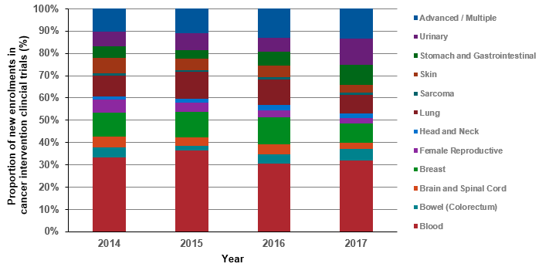
Note: Appendix 2 provides the dataset.

Measure assessment
Traffic light rating: Green (satisfactory result)
Overall trend: Moving in the right direction
Commentary: Clinical trials are studies that explore the impact of new or existing approaches to health care. Such trials are voluntary, are governed by strict rules and ethics, and are regarded as an important way to improve treatment for people with cancer. They are the only way to thoroughly evaluate the effects of a clinical intervention. Figure 17.2 shows that, overall, the number of recruiting cancer intervention trials between 2014 and 2017 fluctuated but did not increase with time. However, this trend did not remain consistent when broken down by metropolitan and rural populations (Table 17.2, Appendix 2) because the proportion of rural recruiting cancer intervention trials, relative to metropolitan trials, has increased slightly over time, reaching 9.3 per cent in 2017.
Overall the number of recruiting cancer intervention trials at sites with metropolitan ICS was higher than the number of recruitments in rural and regional ICS (Table 17.2, Appendix 2). The highest number of new recruiting cancer intervention trials was reported by WCMICS, which reported 676 trials between 2014 and 2017. LMICS had the lowest number of new recruiting cancer intervention trials (14) over the four-year period. On the other hand, as with Measure 17.1, GRICS also reported no clinical trial activity in the analysis period.
Like Measure 17.1, blood cancers had the highest proportion of recruiting cancer intervention trials in each reporting period (375) (Figure 17.2.1). This was followed by advanced multiple cancers (134) and breast (118). The tumour streams that attracted the fewest recruiting cancer intervention trials in the same period were sarcoma (10) and head and neck (21) cancers (Table 17.2, Appendix 2).
No target has been set for this measure; however, increasing the number of cancer intervention trials in Victoria will mean individual patients will have more treatment choices in the future.

Measure 17.3 – Number of human research ethics committee approved cancer-related studies
Figure 17.3: Number of human research ethics committee approved cancer-related studies, by year, 2014–2018
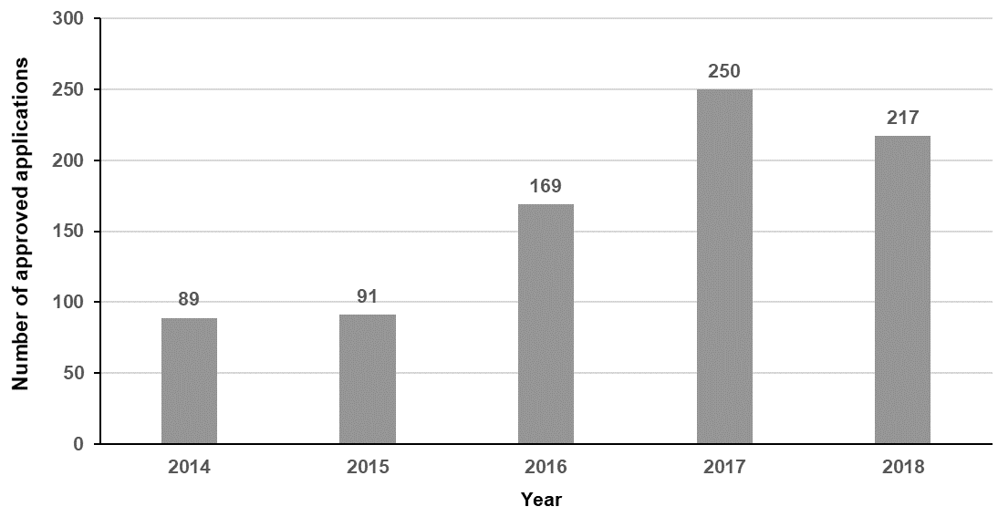
Source: Department of Health and Human Services Coordinating Office for Clinical Trial Research
Note: The data reported in Figure 17.3 above includes cancer-related clinical research (non-trials) and clinical trials
Measure assessment
Traffic light rating: Amber (desired result not yet evident)
Overall trend: Difficult to rate due to a change in the system for data capture for non-trials in 2015
Commentary: High-quality cancer research drives clinical practice improvements and underpins the department’s efforts in prevention, detection, treatment and support for cancer. Victoria’s cancer research system is supported by world-renowned medical researchers, institutes, hospitals and universities, which have made great strides in improving cancer outcomes.
The department has supported improved data capture and the commencement (in 2015) of single ethics review of multi-centre health and medical research (non-trials). This has led to more studies now captured under this measure,
While no target has been set for this measure, overall Figure 17.3 shows that there has been an increase in cancer-related research although there was a decrease in 2018.

Measure 17.4 – Ratio of eligible patients who receive new SACT medication within 12 months of listing on the PBS relative to cancer incidence
Measure in development (see Appendix 1).

Measure 17.5 – Quit ratio^ of rate of sustained ex-smokers to rate of ever smokers
Figure 17.5: Quit ratio of ever smokers, by year, 2015–2017
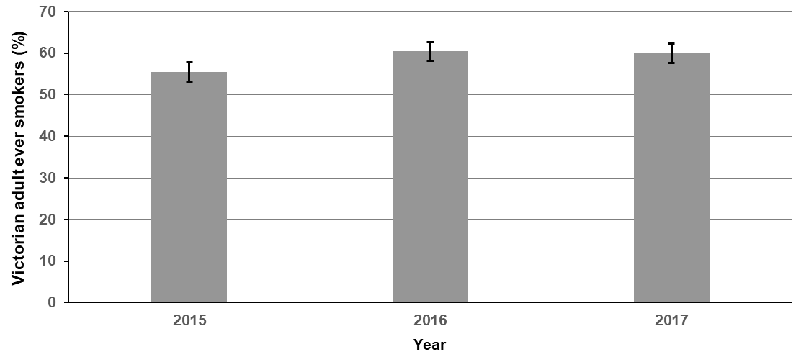
Table 17.5 Quit ratio of ever smokers, by year, 2015–2017
Year | 2015 | 2016 | 2017
Per cent | 55.4 | 60.4 | 59.9
(95% CI) | (± 2.3) | (± 2.3) | (± 2.3)
Source: unpublished Victorian Smoking and Health Survey, Cancer Council Victoria (2018)
Notes:
^The calculation of the quit ratio excluded those who did not state how long ago they had quit.
Number of Victorian ever smokers = 1,693–1,798

Measure assessment
Traffic light rating: Green (satisfactory result)
Overall trend: Moving in the right direction
Commentary: The Victorian Smoking and Health Survey is a cross-sectional, annual telephone survey of approximately 4,000 randomly sampled English-speaking Victorian adults. The quit ratio is the proportion of ever smokers (that is, current or former smokers) who stated that they had not smoked for at least one year at the time of the survey.
Figure 17.5 and Table 17.5 show that the quit ratio among Victorian ever smokers increased between 2015 and 2017 (up from 55.4 to 59.9 per cent).

Appendix 1: Measures identified for future reporting
This table lists measures identified for future reporting with next steps and an indicative reporting schedule.

Key result area: Improve survivorship quality of life
Measure reference number | Name of measure | Required next steps | Indicative reporting schedule
3.1 | Quality of life post active therapy | An evaluation got underway in January 2019 to explore the achievements of Phase II of the Victorian Cancer Survivorship Program. A key objective of this evaluation is to develop a measure definition. | Interim report, which is expected to include a recommendation to determine what the measure should be. Once a measure is developed, it is proposed that relevant data will be presented in a future report.

Key result area: Increase healthier eating and active living
Measure reference number | Name of measure | Required next steps | Indicative reporting schedule
7.7 | Mean number of times that adults eat red meat | The Commonwealth Department of Health has asked the Australian Bureau of Statistics to include a nutritional component in the next Australian Health Survey (2021–23). Red and processed meat consumption will be part of this survey. The department has recommended that it waits for this survey, which will inform the third state cancer plan. | Future report
7.8 | Mean number of times that adults eat processed meat | Same as above for Measure 7.7 | Future report

Key result area: Increase early-stage diagnosis
Measure reference number | Name of measure | Required next steps | Indicative reporting schedule
11.1 | Proportion of all cancers diagnosed at stages 1 or 2 | Currently staging is not extracted from pathology reports for all tumour streams such as cervical and lung cancers. The Victorian Cancer Registry (VCR) is due to implement Abrevio, a cancer document consolidation system that converts information embedded in various clinical documents, including pathology reports, into usable data. This system will enable the Victorian Cancer Registry to extract all staging information specific to cervix and lung cancers from pathology reports. | Future report
11.4 | Proportion of cervical cancers diagnosed at stages 1 or 2 | Same as above for Measure 11.1. | Future report
11.5 | Proportion of lung cancers diagnosed at stages 1 or 2 | Same as above for Measure 11.1. | Future report

Key result area: Increase adherence to optimal care pathways
Measure reference number | Name of measure | Required next steps | Indicative reporting schedule
12.2 | Proportion of patients receiving PET prior to primary treatment where appropriate | There are currently no Medical Benefits Scheme (MBS) data available for the cancer cohort, but it is expected this will be available in the future. | Future report
12.3 | Proportion of patients receiving molecular diagnostics prior to primary treatment where appropriate | Same as above for Measure 12.2. | Future report
12.7 | Proportion of patients aged less than 40 years referred to fertility preservation treatment as part of their primary treatment | Same as above for Measure 12.2. | Future report
12.11 | Proportion of patients with local recurrence or primary tumour within two years of surgical resection or curative radiotherapy of a primary tumour | Although date of recurrence is currently unavailable, it could probably be derived from the currently available linked data (VCR, VAED, VINAH). This requires an extensive validation process before it can be used to report against this measure in the future. | To be determined  Future report

Key result area: Increase one- and five-year survival
Measure reference number | Name of measure | Required next steps | Indicative reporting schedule
13.17 | Five-year survival from all cancers diagnosed at stages 1 and 2 | Data as it relates to registry-derived (RD) stage is currently only available for some cancer tumour streams, namely breast, colorectal and prostate. It is expected that the RD stage will be available for additional cancers in the future so that this measure, which specifies ‘all’ cancers at stages 1 and 2, can be reported on. | Future report
13.18 | Five-year survival from all cancers diagnosed at stages 3 and 4 | Data as it relates to RD stage is currently only available for some cancer tumour streams, namely breast, colorectal and prostate. It is expected that the RD stage will be available for additional cancers in the future so that this measure, which specifies ‘all’ cancers at stages 3 and 4, can be reported on. | Future report

Key result area: Improve quality of life
Measure reference number | Name of measure | Required next steps | Indicative reporting schedule
14.1 | Health-related quality of life following primary treatment | There is a population-wide dataset available based on supportive care screening (National Comprehensive Cancer Network distress monitor). This was undertaken in 2017. It is unclear what the local data may look like, which would necessitate the development of a statewide specific patient-reported outcome measure (PROM). | To be determined

Key result area: Improve patient experience of healthcare
Measure reference number | Name of measure | Required next steps | Indicative reporting schedule
15.2 | Proportion of children and adolescents admitted to hospital due to cancer who report positive healthcare experience | The resources needed to resolve these outstanding measures in the future are yet to be confirmed. The measures are yet to be determined. | To be determined
15.3 | Proportion of adults admitted to public hospitals due to cancer who report positive transition from care index score | Same as above for Measure 15.2. | To be determined
15.4 | Proportion of adults attending emergency departments due to cancer who report positive overall healthcare experience | It is proposed that one additional question will be added to the emergency department section of the next Experiences of Care Survey – Patient Experiences of Care Survey. This data will become available from 2020. | Future report
15.5 | Proportion of people attending hospital outpatients due to cancer who report positive healthcare experience | The resources needed to resolve these outstanding measures in the future are yet to be confirmed. The measures are yet to be determined. | To be determined
15.6 | Proportion of people attending primary care due to cancer who report positive healthcare experience | Same as above for Measure 15.5. | To be determined

Key result area: Innovations and improved evidence of best practice
Measure reference number | Name of measure | Required next steps | Indicative reporting schedule
17.4 | Proportion of eligible patients who receive medication within 12 months of listing on the Pharmaceutical Benefits Scheme (PBS) | Substantial work is required to identify data criteria (the most appropriate medication) and, obtain PBS data. | Future report

Abbreviations
ABS | Australian Bureau of Statistics
AIHW | Australian Institute of Health and Welfare
AML | acute myeloid leukemia
BMI | body mass index
BSWRICS | Barwon South Western Regional Integrated Cancer Service
CRC | colorectal cancer
CVDL | Centre for Victorian Data Linkage, Department of Health and Human Services
DCO | death certificate only
DET | Department of Education and Training (Victorian Government)
ERP | Estimated Resident Population
GICS | Grampians Integrated Cancer Service
GRICS | Gippsland Regional Integrated Cancer Service
HBV | hepatitis B
HCV | hepatitis C
HPV | human papillomavirus
HRICS | Hume Regional Integrated Cancer Service
IARC | International Agency for Cancer Research
ICD | International Classification of Diseases
ICS | Integrated Cancer Service
LGA | local government area
LMICS | Loddon Mallee Integrated Cancer Service
LOS | length of stay
MDT | multidisciplinary team
NEMICS | North Eastern Melbourne Integrated Cancer Service
OECD | Organization for Economic Co-operation and Development
PHESS | Public Health Event Surveillance System
PBS | Pharmaceutical Benefits Scheme
PICS | Paediatric Integrated Cancer Service
RD stage | registry-derived stage
SACT | systemic anti-cancer therapy
SEIFA | Socio-Economic Indexes for Areas
SES | socio-economic status (quintiles); it is an area-based measure not an individual measure
SMICS | Southern Melbourne Integrated Cancer Service
UV | ultraviolet
VAED | Victorian Admitted Episodes Dataset
VAHI | Victorian Agency for Health Information
VCR | Victorian Cancer Registry
VDI | Victorian Death Index
VEMD | Victorian Emergency Minimum Dataset
VHES | Victorian Healthcare Experience Survey
VINAH | Victorian Integrated Non-Admitted Health dataset
VPHS | Victorian Population Health Survey
VRMDS | Victorian Radiotherapy Minimum Data Set
WCMICS | Western and Central Melbourne Integrated Cancer Service

Figures
Figure 1: Outcomes framework logic model 6
Figure 2: Simplified example of how relative survival is calculated 27
Figure 1.1: Incidence of preventable cancers in Victoria per 100,000 standardised to the 2001 Australian population, by year of diagnosis, 2014 and 2017 28
Figure 1.1.1: Incidence of preventable cancers in Victoria per 100,000 standardised to the 2001 Australian population, by ICS and year, 2014 and 2017 29
Figure 1.1.2: Incidence of preventable cancers in Victoria per 100,000 standardised to the 2001 Australian population, by Victorian LGA, 2014 29
Figure 1.1.3: Incidence of preventable cancers in Victoria per 100,000 standardised to the 2001 Australian population, by Victorian LGA, 2017 30
Figure 1.2: Lifetime risk of cancer before the age of 85 years by year, 2014 and 2017 32
Figure 1.2.1: Lifetime risk of developing cancer before the age of 85 years, by ICS and year, 2014–2017 33
Figure 1.3: Incidence of lung cancer in Victoria per 100,000 standardised to the 2001 Australian population, by year of diagnosis, 2014 and 2017 34
Figure 1.3.1: Incidence of lung cancer in Victoria per 100,000 standardised to the 2001 Australian population, by ICS and year, 2014 and 2017 35
Figure 1.3.2: Incidence of lung cancer in Victoria per 100,000 standardised to the 2001 Australian population, by Victorian LGA, 2014 35
Figure 1.3.3: Incidence of lung cancer in Victoria per 100,000 standardised to the 2001 Australian population, by Victorian LGA, 2017 36
Figure 1.4: Incidence of colorectal cancer in Victoria per 100,000 standardised to the 2001 Australian population, by year of diagnosis, 2014 and 2017 38
Figure 1.4.1: Incidence of colorectal cancer in Victoria per 100,000 standardised to the 2001 Australian population, by ICS and year, 2014 and 2017 39
Figure 1.4.2: Incidence of colorectal cancer in Victoria per 100,000 standardised to the 2001 Australian population, by Victorian LGA, 2014 39
Figure 1.4.3: Incidence of colorectal cancer in Victoria per 100,000 standardised to the 2001 Australian population, by Victorian LGA, 2017 40
Figure 1.5: Incidence of melanoma in Victoria per 100,000 standardised to the 2001 Australian population, by year of diagnosis, 2014 and 2017 42
Figure 1.5.1: Incidence of melanoma in Victoria per 100,000 standardised to the 2001 Australian population, by ICS and year, 2014 and 2017 43
Figure 1.5.2: Incidence of melanoma in Victoria per 100,000 standardised to the 2001 Australian population, by Victorian LGA, 2014 43
Figure 1.5.3: Incidence of melanoma in Victoria per 100,000 standardised to the 2001 Australian population, by Victorian LGA, 2017 44
Figure 1.6: Incidence of female breast cancer in Victoria per 100,000 standardised to the 2001 Australian population, by year of diagnosis, 2014 and 2017 46
Figure 1.6.1: Incidence of female breast cancer in Victoria per 100,000 standardised to the 2001 Australian population, by ICS and year, 2014 and 2017 47
Figure 1.6.2: Incidence of female breast cancer in Victoria per 100,000 standardised to the 2001 Australian population, by Victorian LGA, 2014 47
Figure 1.6.3: Incidence of female breast cancer in Victoria per 100,000 standardised to the 2001 Australian population, by Victorian LGA, 2017 48
Figure 1.7: Incidence of cancer of the cervix in Victoria per 100,000 standardised to the 2001 Australian population, by year of diagnosis, 2014 and 2017 50
Figure 1.7.1: Incidence of cancer of the cervix in Victoria per 100,000 standardised to the 2001 Australian population, by ICS and year, 2014 and 2017 51
Figure 1.7.2: Incidence of cancer of the cervix in Victoria per 100,000 standardised to the 2001 Australian population, by Victorian LGA, 2014 51
Figure 1.7.3: Incidence of cancer of the cervix in Victoria per 100,000 standardised to the 2001 Australian population, by Victorian LGA, 2017 52
Figure 1.8: Incidence of liver cancer (primary) in Victoria per 100,000 standardised to the 2001 Australian population, by year of diagnosis, 2014 and 2017 54
Figure 1.8.1: Incidence of liver cancer (primary) in Victoria per 100,000 standardised to the 2001 Australian population, by ICS and year, 2014 and 2017 55
Figure 1.8.2: Incidence of liver cancer (primary) in Victoria per 100,000 standardised to the 2001 Australian population, by Victorian LGA, 2014 55
Figure 1.8.3: Incidence of liver cancer (primary) in Victoria per 100,000 standardised to the 2001 Australian population, by Victorian LGA, 2017 56
Figure 2.1: Global cancer death rate from all cancers combined per 100,000 population for both sexes, 2016 58
Figure 2.1.1: Victorian death rate for all cancers combined, by sex and year, 2010–2017 58
Figure 2.1.2: Forest plots comparing the age-adjusted mortality (death) rates (and 95% confidence intervals) for deaths by all cancers in the baseline year (2010) and the most recent year where mortality data is available (2017), standardised to the 2001 Australian population 59
Figure 2.1.3: Victorian death rate for all cancers combined, by LGA, 2010 60
Figure 2.1.4: Victorian death rate for all cancers combined, by LGA, 2017 60
Figure 2.1.5: Victorian death rate for all cancers combined, by ICS by year, 2010–2017 61
Figure 2.2: Global map presenting national ranking of all cancers (combined) as a cause of premature death (below 70 years) in 2015 63
Figure 2.2.1: Victorian premature death rate for all cancers combined, by sex and year, 2010–2017 63
Figure 2.2.2: Forest plots comparing the age-adjusted mortality (death) rates (and 95% confidence intervals) for Victorian premature deaths by all cancers in the baseline year (2010) and the most recent year where mortality data is available (2017), in those younger than 75 years of age at death, standardised to the 2001 Australian population 64
Figure 2.2.3: Victorian premature death rate for all cancers combined, by LGA, 2010 65
Figure 2.2.4: Victorian premature death rate for all cancers combined, by LGA, 2017 65
Figure 2.2.5: Victorian death rate for all cancers combined, by ICS by year, 2010–2017 66
Figure 2.3: Number of deaths averted in Victoria based on expected number of deaths by year, 2015–2017 67
Figure 4.1: Rate ratio of preventable cancer incidence in ICS of residence compared with the ICS of residence with the lowest adjusted incidence rate, grouped by year of diagnosis, 2014–2017 69
Figure 4.2: Rate ratio of preventable cancer incidence (with confidence intervals) for Victoria in SES quintiles 1–4 (where SES 1 is most disadvantaged) compared with the least disadvantaged SES (quintile 5), grouped by year of diagnosis, 2014–2017 71
Figure 4.3: Rate ratio of preventable cancer incidence (with confidence intervals) for Aboriginal Victorians relative to non-Aboriginal Victorians, by year of diagnosis, 2014–2017 73
Figure 5.1: Rate ratio of premature death (with confidence intervals) due to cancer in ICS of residence compared with the ICS of residence with the lowest premature death rate, grouped by year of diagnosis, 2014–2017 75
Figure 5.2: Rate ratio of premature death (with confidence intervals) due to cancer in SES quintiles 1–4 (where SES 1 is most disadvantaged) compared with the least disadvantaged SES, grouped by year of diagnosis, 2014–2017 77
Figure 5.3: Rate ratio of premature death (with confidence intervals) between Aboriginal and non-Aboriginal Victorians by year, 2014–2017 80
Figure 6.1: OECD adult population smoking daily, by gender, 2015 (or nearest year) 82
Figure 6.1.1: Proportion of Australian adults (aged 18 years or older) who smoke daily, by state/territory, 2014–15 83
Figure 6.1.2: Proportion of Victorian adults (aged 18 years or older) who smoke daily, by year, 2015–2017 83
Figure 6.3: Proportion of Victorian adults (aged 18 years or older) who consume alcohol at lifetime risk of harm, by year, 2014–2017 87
Figure 6.4: Proportion of Victorian adolescents aged 12–17 years (boys and girls) who consume alcohol at least monthly, by year, 2014 and 2016 88
Table 6.4: Proportion of Victorian adolescents aged 12–17 years (boys and girls) who consume alcohol at least monthly, by year, 2014 and 2016 88
Figure 7.1: Daily fruit consumption among OECD adults, 2015 (or nearest year) 89
Figure 7.1.1: Australian average daily fruit intake for adults aged 18 years or older, 2014–15 89
Figure 7.1.2: Mean daily serves of fruit in Victorian adults (aged 18 years or older), by year, 2011–2016 90
Figure 7.2: Proportion of Victorian adolescents aged 10–17 years (boys and girls) who eat the daily recommended serves of fruit, by year, 2014 and 2016 92
Figure 7.2.1: Proportion of Victorian adolescents aged 10–17 years (boys and girls) who eat the daily recommended serves of fruit, by remoteness area and gender, 2014 and 2016 93
Figure 7.3: Proportion of children aged 4–12 years who eat the daily recommended serves of fruit, by year, 2013 and 2017 94
Figure 7.3.1: Proportion of children aged 4–12 years who eat the daily recommended serves of fruit, by gender, age, remoteness areas and SES, 2013 and 2017 95
Figure 7.4: Daily vegetable consumption among OECD adults, 2015 (or nearest year) 96
Figure 7.4.1: Average daily vegetable intake for adults aged 18 years or older, 2014–15 96
Figure 7.4.2: Mean daily serves of vegetables in Victorian adults, by year, 2011–2016 97
Figure 7.5: Proportion of adolescents aged 10–17 years who eat the daily recommended serves of vegetables, 2014 and 2016 98
Figure 7.5.1: Proportion of adolescents aged 10–17 years who eat the daily recommended serves of vegetables, by remoteness area and gender, 2014 and 2016 98
Figure 7.6: Proportion of children aged 4–12 years who eat the daily recommended serves of vegetables, by year, 2013 and 2017 100
Figure 7.6.1: Proportion of children aged 4–12 years who eat the daily recommended serves of vegetables, by gender, age, remoteness area, SES and year, 2013 and 2017 101
Figure 7.9: Proportion of adults (18 years and older) who are sufficiently physically active, by year, 2015–2017 103
Figure 7.10: Proportion of Victorian adolescents aged 10–17 who are sufficiently physically active, 2014 and 2016 104
Figure 7.11: Proportion of children aged 5–12 years who are sufficiently physically active, 2013 and 2017 106
Figure 8.1: Proportion of overweight including obesity among OECD adults (aged 15 or older), 2015 (or nearest year) 107
Figure 8.1.1: Proportion of overweight/obesity (measured) in Australian adults, by state and territory, 2011–12 and 2014–15 107
Figure 8.1.2: Proportion of overweight including obesity (measured) among Victorian adults (aged 18 or older), by year, 2011–12 to 2014–15 108
Figure 8.2: Proportion of Victorian adults (aged 18 years or older) who are overweight or obese (self-report), by year, 2015–2017 109
Figure 8.3: Proportion of Australian children aged 5–17 years who are overweight or obese (measured), by year, 1995 to 2014–15 110
Figure 8.3.1: Proportion of Victorian children aged 5–17 years who are overweight or obese (measured), by year, 2011–12 and 2014–15 110
Figure 9.1: Adjusted prevalence estimates for weekend sunburn incidence among Victorian adults (18–69 years) in summers, 2013–14 and 2016–17 112
Figure 10.1: HPV three-dose vaccination coverage for all females turning 15 years of age, by state/territory and year, 2013–2017 116
Figure 10.1.1: HPV dose vaccination coverage for all males turning 15 years of age, by state/territory and year, 2013–2017 116
Figure 10.2: Notification rate per 100,000 population of unspecified HBV, by state/territory and year, 2014–2018 118
Figure 10.2.1: Notification rate per 100,000 population of unspecified HBV, by sex and year, Victoria, 2014–2018 118
Figure 10.2.2: Notification rate per 100,000 population of unspecified HBV, by age group and year, Victoria, 2014–2018 119
Figure 10.2.3: Notification rate per 100,000 population of unspecified HBV, by ICS and year, Victoria, 2014–2018 119
Figure 10.3: Notification rate per 100,000 population of unspecified hepatitis C, by state/territory and year, 2014–2018 121
Figure 10.3.1: Notification rate per 100,000 population of unspecified hepatitis C, by sex and year, Victoria, 2014–2018 121
Figure 10.3.2: Notification rate per 100,000 population of unspecified hepatitis C, by age group and year, Victoria, 2014–2018 122
Figure 10.3.3: Notification rate of unspecified hepatitis C by ICS and year, Victoria, 2014–2018 122
Figure 11.2: Proportion of female breast cancers diagnosed at stages 1 and 2, by age, Indigenous status and language spoken at home, 2014–2016 127
Figure 11.2.1: Proportion of female breast cancers diagnosed at stages 1 and 2, by remoteness area, ICS and SES, 2014–2016 128
Figure 11.3: Proportion of colorectal cancers diagnosed at stages 1 and 2, by age, sex, Indigenous status and language spoken at home, 2014–2016 130
Figure 11.3.1: Proportion of colorectal cancers diagnosed at stages 1 and 2, by remoteness area, ICS and SES, 2014–2016 131
Figure 11.6: Proportion of all solid tumours diagnosed at the metastatic stage, by age, sex, Indigenous status and language spoken at home, 2014–2016 134
Figure 11.6.1: Proportion of all solid tumours diagnosed at the metastatic stage, by remoteness area, ICS and SES, 2014–2016 135
Figure 12.1: Median days (and interquartile range) from diagnosis to start of primary curative treatment (overall), by year, 2014 and 2016 137
Figure 12.1.1: Median days from diagnosis to start of primary curative treatment (breast), by year, 2014 and 2016 139
Figure 12.1.2: Median days from diagnosis to start of primary curative treatment (colorectal), by year, 2014 and 2016 140
Figure 12.1.3: Median days from diagnosis to start of primary curative treatment (genitourinary), by year, 2014 and 2016 141
Figure 12.1.4: Median days from diagnosis to start of primary curative treatment (haematological), by year, 2014 and 2016 142
Figure 12.4: Proportion of patients with non-metastatic lung cancer receiving radical radiotherapy as part of their primary treatment, by age, sex, Indigenous status, language spoken at home, remoteness area, SES and ICS, 2014–2016 145
Figure 12.4.1: Proportion of patients with non-metastatic breast cancer receiving radical radiotherapy as part of their primary treatment, by age, sex, Indigenous status, language spoken at home, remoteness area, SES and ICS, 2014–2016 146
Figure 12.4.2: Proportion of patients with non-metastatic colorectal cancer receiving radical radiotherapy as part of their primary treatment, by age, sex, Indigenous status, language spoken at home, remoteness area, SES and ICS, 2014–2016 147
Figure 12.4.3: Proportion of patients with non-metastatic oesophageal cancer receiving radical radiotherapy as part of their primary treatment, by age, sex, Indigenous status, language spoken at home, remoteness area, SES and ICS, 2014–2016 148
Figure 12.5: Proportion of patients (overall) receiving systemic anti-cancer therapy within recommended timelines, by age (A), sex (B), Indigenous status (C), language spoken at home (D), remoteness area (E), SES (F) and ICS (G), Victoria, 2014–2016 150
Figure 12.5.1: Proportion of lung cancer patients receiving systemic anti-cancer therapy within recommended timelines, by age (A), sex (B), Indigenous status (C), language spoken at home (D), remoteness area (E), SES (F) and ICS (G), Victoria, 2014–201 151
Figure 12.5.2: Proportion of breast cancer patients receiving systemic anti-cancer therapy within recommended timelines, by age (A), sex (B), Indigenous status (C), language spoken at home (D), remoteness area (E), SES (F) and ICS (G), Victoria, 2014–2016 153
Figure 12.5.3: Proportion of colorectal cancer patients receiving systemic anti-cancer therapy within recommended timelines, by age (A), sex (B), Indigenous status (C), language spoken at home (D), remoteness area (E), SES (F) and ICS (G), Victoria, 2014–2016 154
Figure 12.5.4 Proportion of ovarian cancer patients receiving systemic anti-cancer therapy within recommended timelines, by age (A), sex (B), Indigenous status (C), language spoken at home (D), remoteness area (E), SES (F) and ICS (G), Victoria, 2014–2016 156
Figure 12.6: Proportion and number of cancer-related oesophagectomies and pancreatectomies taking place at appropriate volume (facilities), by year, 2014–2016 159
Figure 12.8: Proportion of admitted cancer separations with a LOS > 1 who have been coded as having malnutrition, by year, 2012–2017 162
Figure 12.9: Proportion of cancer patients who reported being involved in decisions about their care and treatment as much as they wanted to in 2018 163
Figure 12.10: Proportion of documented evidence of multidisciplinary team recommendations, 2014, 2015 and 2017 164
Figure 12.10.2: Number (and percentage) of audited patients who had documented evidence of multidisciplinary team presented by tumour stream (all ICSs combined) of Victorians diagnosed in 2017 165
Figure 12.12: Proportion of patients receiving specialist palliative care within 12 months prior to death, by ICS, 2014–2016 167
Figure 12.13: Proportion of patients receiving aggressive interventions (SACT, radical radiation, ICU) within 30 days prior to death, by year, 2014–2016 169
Figure 12.14: Proportion of deaths due to cancer that occur in hospitals, by ICS and state, 2014–2016 171
Figure 13.1: Trends in one-year relative survival from all cancers (combined) overall (A) and by sex (B), age (C), remoteness (D) and ICS (E), Victoria, by year, 2010–2016 173
Figure 13.2: Trends in one-year relative survival from lung cancer overall (A) and by sex (B), age (C), remoteness (D) and ICS (E), Victoria, by year, 2010–2016 175
Figure 13.3: Trends in one-year relative survival from pancreatic cancer overall (A) and by sex (B), age (C), remoteness (D) and ICS (E), Victoria, by year, 2010–2016 177
Figure 13.4: Trends in one-year relative survival from ovarian cancer overall (A) and by age (B), remoteness (C) and ICS (D), Victoria, by year, 2010–2016 179
Figure 13.5: Trends in one-year relative survival from colorectal cancer overall (A) and by sex (B), age (C), remoteness (D) and ICS (E), Victoria, by year, 2010–2016 181
Figure 13.6: Trends in one-year relative survival from brain cancer overall (A) and by sex (B), age (C), remoteness (D) and ICS (E), Victoria, by year, 2010–2016 183
Figure 13.7: Trends in one-year relative survival from oesophagus cancer overall (A) and by sex (B), age (C), remoteness (D) and ICS (E), Victoria, by year, 2010–2016 185
Figure 13.8: Trends in one-year relative survival from acute myeloid leukaemia overall (A) and by sex (B), age (C), remoteness (D) and ICS (E), Victoria, by year, 2010–2016 187
Figure 13.9: Five-year relative survival from all cancers (nationally) combined and selected cancer types, by sex, 2010–2014 189
Figure 13.9.2: Five-year relative survival from all cancers combined, by age (A), remoteness (B), SES (C) and ICS (D), Victoria, 2010–2014 190
Figure 13.10: Five-year relative survival from lung cancer (nationally), by age and sex, 2010–2014 193
Figure 13.10.1: Five-year relative survival from lung cancer, by age (A), remoteness (B), SES (C) and ICS (D), Victoria, 2010–2014 193
Figure 13.11: Five-year relative survival from pancreatic cancer (nationally), by age and sex, 2010–2014 195
Figure 13.11.1: Five-year relative survival from pancreatic cancer, by age (A), remoteness (B), SES (C) and ICS (D), Victoria, 2010–2014 195
Figure 13.12: Five-year relative survival from ovarian cancer (nationally), by age, 2010–2014 197
Figure 13.12.1: Five-year relative survival from ovarian cancer, by age (A), remoteness (B), SES (C) and ICS (D), Victoria, 2010–2014 197
Figure 13.13: Five-year relative survival from colorectal cancer (nationally), by age and sex, 2010–2014 199
Figure 13.13.1: Five-year relative survival from colorectal cancer, by age (A), remoteness (B), SES (C) and ICS (D), Victoria, 2010–2014 199
Figure 13.14: Five-year relative survival from brain cancer (nationally), by age and sex, 2010–2014 201
Figure 13.14.1: Five-year relative survival from brain cancer, by age (A), remoteness (B), SES (C) and ICS (D), Victoria, 2010–2014 201
Figure 13.15: Five-year relative survival from oesophagus cancer (nationally), by age and sex, 2010–2014 203
Figure 13.15.1: Five-year relative survival from oesophagus cancer, by age (A), remoteness (B), SES (C) and ICS (D), Victoria, 2010–2014 203
Figure 13.16: Five-year relative survival from acute myeloid leukaemia, by age (A), remoteness (B), SES (C) and ICS (D), Victoria, 2010–2014 205
Figure 15.1: Proportion of adults admitted to public hospitals due to cancer who reported being satisfied with the care received from all health professionals involved in their care in 2018 210
Figure 16.1: Overall satisfaction with the breast screening process, 2014–2016 212
Figure 16.2: Age-adjusted proportion of women screened during 2014 who rescreened within 27 months, first screening round, by state and territory, women aged 50–72 years 214
Figure 16.3: Proportion and number of women aged 20–69 years who rescreened within three months of receiving a 27-month cervical screening register reminder letter sent in 2015, by state and territory 215
Figure 16.4: Proportion of adults aged 50–74 who are rescreened (in subsequent rounds) by the National Bowel Cancer Screening Program, Victoria and Australia, 2014–2015 to 2016–2017 217
Figure 17.1: Number of new enrolments in cancer interventions clinical trials in Victoria by year, 2014–2017 218
Figure 17.1.2: Proportion of new enrolments in cancer intervention clinical trials in Victoria stratified by tumour stream, by year, 2014–2017 219
Figure 17.2: Number of recruiting cancer intervention clinical trials in Victoria, by year, 2014–2017 221
Figure 17.2.1: Proportion of recruiting cancer intervention clinical trials in Victoria, stratified by tumour stream by year, 2014–2017 221
Figure 17.3: Number of human research ethics committee approved cancer-related studies, by year, 2014–2018 223
Figure 17.5: Quit ratio of ever smokers, by year, 2015–2017 225

Tables
Table 2.1: Victorian death rate for all cancers combined by sex and year, 2010–2017 59
Table 2.1: Victorian premature death rate for all cancers combined, by sex and year, 2010–2017 64
Table 4.1: Rate ratio of preventable cancer incidence in ICS of residence compared with the ICS of residence with the lowest adjusted incidence rate, grouped by year of diagnosis from 2014 to 2017 70
Table 4.2: Rate ratio of preventable cancer incidence (with confidence intervals) for Victoria in SES quintiles 1–4 (where SES 1 is most disadvantaged) compared with the least disadvantaged SES, grouped by year of diagnosis, 2014–2017 72
Table 4.3: Rate ratio of preventable cancer incidence (with confidence intervals) between Aboriginal and non-Aboriginal Victorians, by year of diagnosis, 2014–2017 73
Table 5.1: Rate ratio of premature death (with confidence intervals) due to cancer in ICS of residence compared with the ICS of residence with the lowest premature death rate, grouped by year of diagnosis, 2014–2017 76
Table 5.2: Rate ratio of preventable cancer incidence (with confidence intervals) for Victoria in SES quintiles 1–4 (where SES 1 is most disadvantaged) compared with the least disadvantaged SES, grouped by year of diagnosis, 2014–2017 78
Table 5.3: Rate ratio of premature death (with confidence intervals) between Aboriginal and non-Aboriginal Victorians, by year, 2014–2017 80
Table 6.1: Proportion of Victorian adults (aged 18 years or older) who smoke daily, by year, 2015–2017 83
Table 6.2: Proportion of Australian and Victorian adolescents aged 12–17 years (boys and girls) who currently smoke, by age and sex, 2014 85
Table 6.3: Proportion of Victorian adults (aged 18 years or older) who consume alcohol at lifetime risk of harm, by year, 2014–2017 87
Table 7.1: Mean daily serves of fruit in Victorian adults (aged 18 years or older), by year, 2011–2016 90
Table 7.2: Proportion of Victorian adolescents aged 10–17 years (boys and girls) who eat the daily recommended serves of fruit, by year, 2014 and 2016 92
Table 7.3: Proportion of children aged 4–12 years who eat the daily recommended serves of fruit, by year, 2013 and 2017 94
Table 7.4: Mean daily serves of vegetables in Victorian adults, by year, 2011–2016 97
Table 7.5: Proportion of adolescents aged 10–17 years who eat the daily recommended serves of vegetables, 2014 and 2016 98
Table 7.6: Proportion of children aged 4–12 years who eat the daily recommended serves of vegetables, by year, 2013 and 2017 100
Table 7.9 Proportion of adults who are sufficiently active, by year, 2015–2017 103
Table 7.10: Proportion of Victorian adolescents aged 10–17 who are sufficiently physically active, 2014 and 2016 104
Table 7.11: Proportion of children aged 5–12 years who are sufficiently physically active, 2013 and 2017 106
Table 8.2: Proportion of Victorian adults (aged 18 years or older) who are overweight or obese (self-report), by year, 2015–2017 109
Table 10.4: Proportion of people in Victoria with HBV diagnosed with liver cancer, whose HBV was diagnosed late, 2010–2014 124
Table 10.5: Proportion of people in Victoria with HCV diagnosed with liver cancer, whose HCV was diagnosed late, 2010–2014 125
Table 12.6: Proportion and number of cancer-related oesophagectomies and pancreatectomies taking place at appropriate volume (facilities), by year, 2014–2016 159
Table 12.12: Proportion and number of patients receiving specialist palliative care with 12 months prior to death, by ICS, 2014–2016 167
Table 12.14: Proportion/number of deaths due to cancer that occur in hospitals, by ICS, 2014–2016 171
Table 16.1: Proportion of women who have a mammogram by BreastScreen Victoria who rate the service from highly satisfactory to unsure, 2014–2018 212
Table 16.3 Proportion of women sent a reminder letter to rescreen at 27 months after a negative Pap test and the number who re-screened, state and territory 215
Table 17.5 Quit ratio of ever smokers, by year, 2015–2017 225

Thursfield V, Farrugia H 2018. Cancer in Victoria: statistics and trends 2017. Cancer Council Victoria, Melbourne.
Ibid.
Ibid.
Department of Health and Human Services 2016. Victorian cancer plan 2016–2020: improving cancer outcomes for all Victorians. State Government of Victoria, Melbourne.
Ibid.
The cancer plan goals include a target to work together to save 10,000 lives by 2025, and that by 2040 we will: halve the proportion of Victorians diagnosed with preventable cancers; double the improvement in one- and five-year survival of Victorians with cancer; ensure Victorians have the best possible experience of the cancer treatment and care system; and achieve equitable outcomes for all Victorians.
Australian Institute of Health and Welfare 2019. Cancer in Australia 2019. Cancer series no.119. Cat. no. CAN 123. AIHW, Canberra.
Whiteman DC, Webb PM, Green AC, et al. 2015. Cancers in Australia in 2010 attributable to modifiable factors: summary and conclusions. Australian and New Zealand Journal of Public Health. Oct;39(5):477-84.
Department of Health and Human Services 2016. Victorian cancer plan 2016–2020. State Government of Victoria, Melbourne.
Australian Institute of Health and Welfare 2017. Cancer in Australia 2017. Cancer series no.101. Cat. no. CAN 100. AIHW, Canberra.
Australian Institute of Health and Welfare 2019. Cancer in Australia 2019. Cancer series no.119. Cat. no. CAN 123. AIHW, Canberra.
Australian Institute of Health and Welfare 2017. ACIM (Australian Cancer Incidence and Mortality) books. AIHW, Canberra. Available from: https://www.aihw.gov.au/reports/cancer/cancer-data-in-australia/acim-books
Thursfield V, Farrugia H 2018. Cancer in Victoria: statistics & trends 2017. Cancer Council Victoria, Melbourne.
Australian Institute of Health and Welfare & Cancer Australia 2011. Lung cancer in Australia: an overview. Cancer series no. 64. Cat. no. CAN 58. AIHW, Canberra.
World Health Organization 2018. Global Health Observatory. World Health Organization, Geneva. Available from: who.int/gho/database/en/
Feletto E, Yu XQ, Lew JB, et al. 2019. Trends in colon and rectal cancer incidence in Australia from 1982 to 2014: analysis of data on over 375,000 cases. Cancer Epidemiology and Prevention Biomarkers. Jan 1;28(1):83-90.
Thursfield V, Farrugia H 2018. Cancer in Victoria: statistics & trends 2017. Cancer Council Victoria, Melbourne.
See: https://www.cancer.org.au/about-cancer/types-of-cancer/skin-cancer/melanoma.html
Karimkhani C, Green AC, Nijsten T, et al. 2017. The global burden of melanoma: results from the Global Burden of Disease Study 2015. British Journal of Dermatology. Jul;177(1):134-40.
Ibid.
See: https://melanoma.canceraustralia.gov.au/statistics
Thursfield V, Farrugia H 2018. Cancer in Victoria: statistics & trends 2017. Cancer Council Victoria, Melbourne.
Ghoncheh M, Pournamdar Z, Salehiniya H 2016. Incidence and mortality and epidemiology of breast cancer in the world. Asia-Pacific Journal of Cancer Prevention. 17(S3):43-6.
See: https://breast-cancer.canceraustralia.gov.au/statistics
Thursfield V, Farrugia H 2018. Cancer in Victoria: statistics & trends 2017. Cancer Council Victoria, Melbourne.
Ibid.
Bray F, Ferlay J, Soerjomataram I, et al. 2018. Global cancer statistics 2018: GLOBOCAN estimates of incidence and mortality worldwide for 36 cancers in 185 countries. CA: a Cancer Journal for Clinicians. Nov;68 (6):394-424.
IARC Working Group on the Evaluation of Carcinogenic Risks to Humans. Human papillomaviruses 2007. IARC Monographs on the Evaluation of Carcinogenic Risks to Humans. 90: 1-636.
See: https://cervical-cancer.canceraustralia.gov.au/statistics
Hall MT, Simms KT, Lew JB, et al. 2019. The projected timeframe until cervical cancer elimination in Australia: a modelling study. The Lancet Public Health. 4(1): PE19-E27.
Bray F, Ferlay J, Soerjomataram I, et al. 2018. Global cancer statistics 2018: GLOBOCAN estimates of incidence and mortality worldwide for 36 cancers in 185 countries. CA: a Cancer Journal for Clinicians. Nov;68 (6):394-424.
See: https://liver-cancer.canceraustralia.gov.au/statistics
Ibid.
Supramaniam R, O’Connell D, Robotin M, et al. 2008. Future cancer trends to be influenced by past and future migration. Australia and New Zealand Journal of Public Health. 32:90-2.
Roser M, Ritchie H 2019. Cancer. Available from: https://ourworldindata.org/cancer
Thursfield V, Farrugia H 2018. Cancer in Victoria: statistics & trends 2017. Cancer Council Victoria, Melbourne.
Ibid.
Ibid.
Bray F, Ferlay J, Soerjomataram I, et al. 2018. Global cancer statistics 2018: GLOBOCAN estimates of incidence and mortality worldwide for 36 cancers in 185 countries. CA: A Cancer Journal for Clinicians. Nov;68(6):394-424.
Ibid.
Ibid.
Coory MD, Ho T, Jordan SJ 2013. Australia is continuing to make progress against cancer, but the regional and remote disadvantage remains. Medical Journal of Australia. Nov;199(9):605-8.
Kogevinas M, Pearce N, Susser M (eds) 1997. Social inequalities and cancer. International Agency for Research on Cancer, Lyon.
Cunningham J, Rumbold AR, Zhang X, et al. 2008. Incidence, aetiology, and outcomes of cancer in Indigenous peoples in Australia. The Lancet Oncology. Jun 1;9(6):585-95.
Condon JR, Barnes A, Cunningham J. Cancer in Indigenous Australians: a review. Cancer Causes & Control. 2003 Mar 1;14(2):109-21.
Cunningham J, Rumbold AR, Zhang X, et al. 2008. Incidence, aetiology, and outcomes of cancer in Indigenous peoples in Australia. The Lancet Oncology. Jun 1;9(6):585-95.
Valery PC, Coory M, Stirling J, et al. 2006. Cancer diagnosis, treatment, and survival in Indigenous and non-Indigenous Australians: a matched cohort study, Lancet. 367:1842-48.
OECD 2017. Adult population smoking daily by gender, 2015 (or nearest year), in ‘Risk factors for health’, OECD Publishing, Paris. Available from: https://doi.org/10.1787/health_glance-2017-graph31-en.
International Agency for Research on Cancer 2012. Personal habits and indoor combustions. Volume 100E. IARC Monographs on the evaluation of carcinogenic risks to humans. IARC, Lyon.
Stewart BW, Wild CP (eds) 2014. World cancer report. International Agency for Research on Cancer, Lyon.
Smoked in past seven days.
US Department of Health and Human Services 1994. Preventing tobacco use among young people. A report of the Surgeon General, 1994. Atlanta, Georgia: Public Health Service, Centers for Disease Control and Prevention, Office on Smoking and Health. Available from: http://www.cdc.gov/tobacco/data_statistics/sgr/sgr_1994/index.htm
Ibid.
Victorian Department of Health and Human Services 2016. Tobacco, alcohol, over-the-counter and illicit substance use among Victorian secondary school students 2014. Available from: https://www2.health.vic.gov.au/about/publications/researchandreports/australian-secondary-students-alcohol-and-drug-survey-victorian-report-2014
National surveys of smoking behaviours among Australian secondary students have been undertaken at three-yearly intervals since 1984.
Propel Centre for Population Health Impact 2017. Canadian Student Tobacco, Alcohol and Drugs Survey. University of Waterloo. Available from: https://uwaterloo.ca/canadian-student-tobacco-alcohol-drugs-survey/
Keane E, Gavin A, Perry C, et al. 2017. Trends in health behaviours, health outcomes and contextual factors between 1998–2014: Findings from the Irish health behaviour in school-aged children study National University of Ireland Galway: Health Promotion Research Centre. Available from: http://www.nuigalway.ie/media/healthpromotionresearchcentre/hbscdocs/nationalreports/HBSC-Trends-Report-2017-(web).pdf
White VM, Hayman J, Hill DJ 2008. Can population-based tobacco-control policies change smoking behaviours of adolescents from all socio-economic groups? Findings from Australia: 1987–2005. Cancer Causes Control. 19(6): 631-40.
White V, Williams T 2015. Australian secondary school students’ use of tobacco in 2014. Centre for Behavioural Research in Cancer, Melbourne. Available from: http://www.nationaldrugstrategy.gov.au/internet/drugstrategy/Publishing.nsf/content/BCBF6B2C638E1202CA257ACD0020E35C/$File/Tobacco%20Report%202014.PDF
WCRF/AICR 2007. Food, nutrition, physical activity and the prevention of cancer: a global perspective. AICR, Washington, DC.
National Health and Medical Research Council 2009. NHMRC Australian guidelines to reduce health risks from drinking alcohol. Commonwealth of Australia: National Health and Medical Research Council, Canberra.
Ibid.
Department of Education and Training 2016. Victorian Student Health and Wellbeing Survey, State Government of Victoria, Melbourne.
OECD 2017. Health at a glance 2017: OECD indicators, OECD Publishing, Paris. Available from: https://doi.org/10.1787/health_glance-2017-en
Cancer Council Australia 2007. Position statement: Fruit, vegetables and cancer prevention.
Begg S, Vos T, Barker B, et al. 2007.The burden of disease and injury in Australia 2003. PHE 82. AIHW, Canberra.
OECD 2015. Health at a glance 2015: OECD indicators, OECD Publishing, Paris. Available from: http://dx.doi.org/10.1787/health_glance-2015-en
National Health and Medical Research Council 2013. Australian dietary guidelines. National Health and Medical Research Council, Canberra.
Australian Bureau of Statistics 2015. 4364.0.55.001 National Health Survey: First results 2014–15, Australia, Australian Government, Canberra.
Peto J 2001. Cancer epidemiology in the last century and the next decade. Nature. 13:390–395. doi: 10.1038/35077256.
Takaoka Y, Kawakami N 2013. Fruit and vegetable consumption in adolescence and health in early adulthood: a longitudinal analysis of the statistics Canada’s National Population Health Survey. BMC Public Health. Dec;13(1):1206.
National Health and Medical Research Council 2013. Australian dietary guidelines. National Health and Medical Research Council, Canberra.
OECD 2017. Health at a glance 2017: OECD indicators, OECD Publishing, Paris. Available from: https://doi.org/10.1787/health_glance-2017-en
National Health and Medical Research Council 2013. Australian dietary guidelines. National Health and Medical Research Council, Canberra.
OECD 2015, Health at a glance 2015: OECD indicators, OECD Publishing, Paris. Available from: http://dx.doi.org/10.1787/health_glance-2015-en
Australian Bureau of Statistics 2015. 4364.0.55.001 National Health Survey: First results 2014–15, Australia, Australian Government, Canberra.
Takaoka Y, Kawakami N 2013. Fruit and vegetable consumption in adolescence and health in early adulthood: a longitudinal analysis of the statistics Canada’s National Population Health Survey. BMC Public Health. Dec;13(1):1206.
National Health and Medical Research Council 2013. Australian dietary guidelines. National Health and Medical Research Council, Canberra.
Department of Health (DoH) 2014. Australia’s physical activity and sedentary behaviour guidelines, DoH, Canberra, viewed 22 March 2016, <http://www.health.gov.au/internet/main/publishing.nsf/Content/healthpubhlth-strateg-phys-act-guidelines>.
Llewellyn A, Simmonds M, Owen CG et al. 2016. Childhood obesity as a predictor of morbidity in adulthood: a systematic review and meta-analysis. Obesity Reviews.17:56–67.
Department of Education and Training 2015. Victorian Students Health and Wellbeing Survey 2014. Available from: https://www.education.vic.gov.au/about/research/Pages/studenthealthsurvey.aspx
Department of Education and Training. 2017. Victorian Students Health and Wellbeing Survey (2016) https://www.education.vic.gov.au/about/research/Pages/studenthealthsurvey.aspx
Australia’s physical activity and sedentary behaviour guidelines changed in 2014.
OECD 2017. Health at a glance 2017: OECD indicators, OECD Publishing, Paris. Available from: https://doi.org/10.1787/health_glance-2017-en
Obese is defined as BMI ≥ 30kg/m².
Arriaga ME, Vajdic CM, Canfell K, et al. 2017. The burden of cancer attributable to modifiable risk factors: the Australian cancer-PAF cohort consortium. BMJ Open. Jun 1;7(6) e016178.
OECD 2017. Health at a glance 2017: OECD indicators, OECD Publishing, Paris. Available from: https://doi.org/10.1787/health_glance-2017-en
The aim of this campaign was to address the burden of chronic disease caused by overweight and obesity, poor diet and physical inactivity via a variety of initiatives including mass media, social media, community engagement, tools/resources and public relations to inform, encourage and support Western Australians to adopt healthier lifestyle behaviours.
Drieskens S, Demarest S, Bel S, et al. 2018. Correction of self-reported BMI based on objective measurements: a Belgian experience. Archives of Public Health. Dec;76(1):10.
Australian Institute of Health and Welfare 2017. A picture of overweight and obesity in Australia 2017. Cat. no.PHE 216. AIHW, Canberra.
Australian Bureau of Statistics 2018. National Health Survey: first results, 2017–18. ABS, Canberra. Available from: http://www.abs.gov.au/AUSSTATS/abs@.nsf/DetailsPage/4364.0.55.0012017-18?OpenDocument
Lopes DM, McMahon SB 2016. Ultraviolet radiation on the skin: a painful experience? CNS Neuroscience & Therapeutics. 22:118-26.
Better Health Channel 2019. Sunburn. Available from: https://www.betterhealth.vic.gov.au/health/conditionsandtreatments/sunburn
Two or more sun protective behaviours were defined as used sunscreen or headwear and at least one other sun protective behaviour (excluding sunglasses) by the respondent. The prevalence of adults who used two or more sun protective behaviours on summer weekends is presented among respondents outdoors in Melbourne in 2013–14 (25 November 2013 to 30 January 2014) and in 2016–17 (28 November 2016 to 31 January 2017).
Tabbakh T, Dobbinson S 2017. 2016–17 National Sun Protection Survey: Report 2 Sun protective behaviours and sunburn incidence on weekends among Australians in summer 2016–17 (unpublished). Centre for Behavioural Research in Cancer, Cancer Council Victoria, Melbourne.
SunSmart is the primary skin cancer prevention health promotion program in Victoria, operating the popular SunSmart Schools Program, as well as a host of other successful and valuable community, school and workplace programs. It plays a leading role in promoting the balance between the risks of skin cancer from too much sun exposure and maintaining adequate vitamin D levels.
Dobbinson SJ, Volkov A, Wakefield MA 2015. Continued impact of SunSmart advertising on youth and adults’ behaviours. American Journal of Preventive Medicine. 49(1): 20-8.
Department of Health 2012. Skin cancer prevention framework 2013–17. Australian Government, Canberra.
As the age of students in the first year of high school varies between justifications, age 15 is used as the age for routine review of vaccination coverage that provides the best comparison to allow for those varying ages in administration, as per World Health Organization recommendations.
Department of Health and Human Services 2016. Victorian hepatitis B strategy 2016–2020. State Government of Victoria, Melbourne.
Hepatitis B is classified into two categories: newly acquired and unspecified. Unspecified hepatitis B is defined as an infection acquired more than 24 hours prior to diagnosis or unknown duration. Unspecified hepatitis B is generally considered a chronic infection.
Public Health Event Surveillance System (PHESS), Department of Health and Human Services.
This target is also a goal of the WHO global health sector strategy on viral hepatitis 2016–2021 (2016). WHO has defined the elimination of viral hepatitis as a public health threat as achieving a 90 per cent reduction in new chronic infections and a 65 per cent reduction in mortality.
Department of Health and Human Services 2016. Victorian hepatitis B strategy 2016–2020. State Government of Victoria, Melbourne.
Hepatitis C is classified into two categories: newly acquired and unspecified. For the purposes of this report unspecified hepatitis C is defined as an infection acquired more than 24 months prior to diagnosis or unspecified period of time. Unspecified hepatitis C is generally considered a chronic infection.
Public Health Event Surveillance System (PHESS), Department of Health and Human Services.
Iversen J, Maher L 2015. Australian NSP survey: prevalence of HIV, HCV and injecting and sexual behaviour among needle and syringe program attendees: 20-year national data report 1995–2014. Kirby Institute, UNSW, Sydney.
This target is also a goal of the WHO global health sector strategy on viral hepatitis 2016–2021 (2016). WHO has defined the elimination of viral hepatitis as a public health threat as achieving a 90 per cent reduction in new chronic infections and a 65 per cent reduction in mortality.
Maucort‐Boulch D, de Martel C, Franceschi S, et al. 2018. Fraction and incidence of liver cancer attributable to hepatitis B and C viruses worldwide. International Journal of Cancer. Jun 15;142(12):2471-7.
Thursfield V, Farrugia H 2018. Cancer in Victoria: Statistics & trends 2017. Cancer Council Victoria, Melbourne.
Hepatitis B virus diagnosis relative to the detection of decompensated cirrhosis and hepatocellular carcinoma is an indicator of late hepatitis diagnosis.
Samji H, Yu A, Kuo M, et al. 2017. Late hepatitis B and C diagnosis in relation to disease decompensation and hepatocellular carcinoma development. Journal of Hepatology. 1;67(5):909-17.
Maucort‐Boulch D, de Martel C, Franceschi S, et al. 2018. Fraction and incidence of liver cancer attributable to hepatitis B and C viruses worldwide. International Journal of Cancer. Jun 15;142(12):2471-7.
Thursfield V, Farrugia H 2018. Cancer in Victoria: statistics & trends 2017. Cancer Council Victoria, Melbourne.
Department of Health and Human Services 2016. Victorian hepatitis C strategy 2016–2020. State Government of Victoria, Melbourne.
Hepatitis C virus diagnosis relative to the detection of decompensated cirrhosis and hepatocellular carcinoma is an indicator of late hepatitis diagnosis.
Department of Health and Human Services 2016. Victorian hepatitis C strategy 2016–2020. State Government of Victoria, Melbourne.
It is recognised that both males and females can develop breast cancer. However, the proportion of females who develop breast cancer is much higher than the proportion of males who do so. To present the proportion across the entire population (males and females) would not accurately reflect the burden of breast cancer in females. Hence for this measure, all cases of male breast cancer were excluded.
Australia’s health 2018. Available from: https://www.aihw.gov.au/getmedia/7c42913d-295f-4bc9-9c24-4e44eff4a04a/aihw-aus-221.pdf.aspx?inline=true
Thursfield V, Farrugia H 2018. Cancer in Victoria: statistics & trends 2017. Cancer Council Victoria, Melbourne.
Youlden DR, Cramb SM, Dunn NAM, et al. 2012. The descriptive epidemiology of female breast cancer: an international comparison of screening, incidence, survival and mortality. Cancer Epidemiology. 36:237-48.
Women aged 40–49 and 75 or older are also eligible to participate in the national breast screening program but are not actively targeted.
O'Hara J, McPhee, C, Dodson S, et al. 2018. Barriers to breast cancer screening among diverse cultural groups in Melbourne, Australia, International Journal of Environmental Research and Public Health. 15 (8): 1677: 1-13.
Metastasis is a term used to describe the spread of cancer.
Hansen RP, Vedsted P, Sokolowski I, et al 2011. Time intervals from first symptom to treatment of cancer: a cohort study of 2,212 newly diagnosed cancer patients. BMC Health Services Research. Dec;11(1):284.
Optimal care pathways in practice refer to targets measured from the referral date, but the data is unavailable. Therefore, the diagnosis date as recorded in the VCR is used to report against Measure 12.1.
There are limitations to reporting against this measure, namely: - Patients who could not be assigned to a tumour stream may have inaccurate treatment information in these results. These patients were flagged for surgery if they had an operation code that matched any of the surgery codes for any of the tumour streams. Operations unrelated to their diagnosis may have been counted as a treatment for these patients. Also, without specific surgery codes related to their diagnoses, some treatments may have been missed because the surgery code was not in the currently available list of surgery codes. Chemotherapy and radiotherapy admissions were not matched by VAED diagnosis codes or Victorian Radiotherapy Minimum Data Set primary site, meaning that some treatments not specific to the diagnosis may have been included. However, if specific matching had been used, some treatments may have been missed for these individuals. Due to the small percentage of all non-metastatic patients that these individuals account for (approximately three per cent), this is unlikely to affect the overall results. - It is not possible to tell whether the intent of surgery or chemotherapy was curative or palliative, and so some patients who were receiving palliative treatment may have been included. - Patients who did not have an admitted episode in the VAED in the allocated timeframe could not be reclassified as metastatic at diagnosis. Some of these patients may have had metastatic disease and were then incorrectly included in the cohort.
For example, for some cancers such as colorectal the risk of developing cancer in people under the age of 40 years is gradually increasing.
Chu QD, Hill HC, Douglass HO, et al. 2002. Predictive factors associated with long-term survival in patients with neuroendocrine tumors of the pancreas. Annals of Surgical Oncology. Nov 1;9(9):855-62.
Anderson O, Ni Z, Møller H, et al. 2011. Hospital volume and survival in oesophagectomy and gastrectomy for cancer. European Journal of Cancer. Nov 1;47(16):2408-14.
https://www.cancer.nsw.gov.au/getattachment/cancer-control/Cancer-Control-in-NSW-Statewide-Report-2017-Appendices.pdf?lang=en-AU
Duckett S, et al. 2016. Targeting zero Supporting the Victorian hospital system to eliminate avoidable harm and strengthen quality of care - Report of the Review of Hospital Safety and Quality Assurance in Victoria. Published by the Victorian Government, Melbourne. http://www.healthissuescentre.org.au/news/detail/targeting-zero-patient-safety-victoria
Marshall K, Loeliger J 2012. Investigating practices relating to malnutrition in Victorian cancer services – summary report, Department of Health, State Government of Victoria, Melbourne.
Marshall KM, Loeliger J, Nolte L, et al. 2019. Prevalence of malnutrition and impact on clinical outcomes in cancer services: a comparison of two time points. Clinical Nutrition; 38(9):644-651.
Ibid.
https://www.petermac.org/services/treatment/allied-health/nutrition/VCMC/cancer-malnutrition-point-prevalence-study-pps.
Schrager S, Phillips G, Burnside E 2017. Shared decision making in cancer screening. Family Practice Management. May;24(3):5.
Kehl KL, Landrum MB, Arora NK, et al. 2015. Shared decision making in cancer care: the association of actual and preferred decision roles with patient-reported quality. JAMA Oncology. Apr;1(1):50.
Prades J, et al. 2015. Is it worth reorganising cancer services on the basis of multidisciplinary teams (MDTs)? A systematic review of the objectives and organisation of MDTs and their impact on patient outcomes. Health Policy. 119(4):464-74
Department of Health and Human Services 2016. Victoria’s end-of-life and palliative care framework: a guide for high-quality end-of-life care for all Victorians. State Government of Victoria, Melbourne.
Earle CC, Park ER, Lai B, et al. 2003. Identifying potential indicators of the quality of end-of-life cancer care from administrative data. Journal of Clinical Oncology. 21(6):1133–1138.
Grunfeld E, Urquhart R, Mykhalovskiy E et al. 2008. Toward population-based indicators of quality end-of-life care: testing stakeholder agreement. Cancer. 112(10):2301–2308.
Wright AA, Zhang B, Ray A, et al. 2008. Associations between end-of-life discussions, patient mental health, medical care near death, and caregiver bereavement adjustment. JAMA. 300(14):1665–1673.
Emanuel EJ, Young-Xu Y, Levinsky NG, et al. 2003. Chemotherapy use among Medicare beneficiaries at the end of life. Annals of Internal Medicine. 138:639-43.
Rochigneux P, Raoul JL, Beaussant Y, et al. 2016. Use of chemotherapy near the end of life: what factors matter? Annals of Oncology. Dec 19;28(4):809-17.
Guadagnolo BA, Liao KP, Elting L, et al. 2013. Use of radiation therapy in the last 30 days of life among a large population-based cohort of elderly patients in the United States. Journal of Clinical Oncology. Jan 1;31(1):80.
Tracey EA, Chen S, Baker D, et al. 2006. Cancer in New South Wales: incidence and mortality 2004. Cancer Institute NSW, Sydney.
See: http://www.pancreaticcancer.net.au/patients-pancreatic-cancer/statistics/
Vaughan S, Coward JI, Bast Jr RC, et al. 2011. Rethinking ovarian cancer: recommendations for improving outcomes. Nature Reviews Cancer. Oct;11(10):719.
AIHW & NBOCC (National Breast and Ovarian Cancer Centre) 2010. Ovarian cancer in Australia: an overview, 2010. Cancer series no. 52. Cat. no. CAN 48. AIHW, Canberra.
See: https://ovariancancer.net.au/wp-content/uploads/2019/01/Ovarian-Cancer-Facts-_2019_-FINAL.pdf
World Cancer Research Fund / American Institute for Cancer Research 2011. Continuous update project report. Food, Nutrition, Physical Activity, and the Prevention of Colorectal Cancer.
See: https://ncci.canceraustralia.gov.au/outcomes/relative-survival-rate/relative-survival-stage-diagnosis-colorectal-cancer
See: https://www.cancer.org.au/about-cancer/types-of-cancer/brain-cancer.html
AIHW 2011. Cancer in adolescents and young adults in Australia. Cancer series no. 62. Cat. no. CAN 59. AIHW, Canberra.
See: https://www.curebraincancer.org.au/page/8/facts-stats
See: https://www.cancer.org.au/about-cancer/types-of-cancer/stomach-cancer.html.
Milligan DW 2008. Survival from adult leukaemia in England and Wales up to 2001. British Journal of Cancer. 99: S119–20.
See: https://ncci.canceraustralia.gov.au/outcomes/relative-survival-rate/5-year-relative-survival
Ibid.
Australian Institute of Health and Welfare 2017. Cancer in Australia 2017. Cancer series no.101.Cat. no. CAN 100. AIHW, Canberra.
See: https://www.aihw.gov.au/getmedia/7c42913d-295f-4bc9-9c24-4e44eff4a04a/aihw-aus-221.pdf.aspx?inline=true
Australian Institute of Health and Welfare 2012. Cancer survival and prevalence in Australia: period estimates from 1982 to 2010. Cancer Series no. 69. Cat. no. CAN 65. AIHW, Canberra.
Afshar N, English DR, Thursfield V, et al. 2018. Differences in cancer survival by sex: a population-based study using cancer registry data. Cancer Causes & Control. Nov 1;29(11):1059-69.
See: https://ncci.canceraustralia.gov.au/outcomes/relative-survival-rate/5-year-relative-survival
Cancer Australia. Lung cancer in Australia. Available from: https://lung-cancer.canceraustralia.gov.au/statistics
Ibid.
Ibid.
Ibid.
Australian Institute of Health and Welfare 2018. Colorectal and other digestive-tract cancers. Cancer series no. 114. Cat. no. CAN 117. AIHW, Canberra.
Ibid.
See: https://ncci.canceraustralia.gov.au/outcomes/relative-survival-rate/5-year-relative-survival
Ibid.
See: https://www.cancer.org.au/about-cancer/types-of-cancer/oesophageal-cancer.html.
Australian Commission on Safety and Quality in Health Care. 2015. Vital signs 2015: The State of Safety and Quality in Australian Health Care. Sydney.
Note that each dataset is reported two years later and relates to a two-calendar year period.
For example, it is anticipated that screening participation may increase due to invitations being issued to screen and the option for under-screened women to self-collect an HPV sample.
After a first cervical screening test, a negative result requires rescreening five years later. Pap tests were recommended every two years.
Target age range is now 25–74 years, changed from 18–69 years.
The National Bowel Cancer Screening Program offers screening via a faecal occult blood test, sent in a kit to eligible age groups through the mail. Participants with a positive test result are advised to discuss the result with their general practitioner, who will generally refer them for a colonoscopy. The program is operated by the Australian Department of Health, which is responsible for contracting the pathology provider, contracting the Program Register and program policy, quality and evaluation. The Victorian Government undertakes a number of initiatives to support the program’s Victorian implementation, including funding to support timely access to colonoscopies in public health services, delivering the Victorian Participant Follow-Up Function, undertaking research, supporting education and training for health professionals, and initiatives to improve community awareness, primary care engagement and participation in bowel cancer screening.
It is important to note that this measure is limited to research specific to intervention clinical trials only. Hence, it does not include research relating to prevention, screening, supportive care or to basic science research not involving humans.
See: https://www.clintrial.org.au/media/kunena/attachments/143/CancerInstituteNSW-2016CancerControlinNSWAnnualPerformanceReport.PDF
English RA, Lebovitz Y, Giffin RB, et al. 2010. Transforming clinical research in the United States: Challenges and opportunities: workshop summary. National Academies Press, Washington, DC.
Currently this measure has been identified in the Data dictionary (2018) as having ‘to be determined’.

