The Victorian Mental Health and Wellbeing Workforce Capability Framework

December 2021

The Victorian Department of Health (‘the Department’) acknowledges the Traditional Owners of country throughout Australia, and their continuing connections to land, sea and community, and pays respect to Aboriginal people and cultures, and to Elders past, present and emerging.
The Department recognises the strength of people living with trauma, neurodiversity, mental ill health and substance use or addiction, and their families, carers and supporters, and remembers those who have been lost to suicide.
The Department acknowledges the many individuals and organisations who contributed their time, stories, experience and wisdom to guide and contribute to the development of this Framework.

To receive this document in another format, phone 1300 650 172, using the National Relay Service 13 36 77 if required, or email Mental Health Workforce MentalHealthWorkforce@health.vic.gov.au.
Authorised and published by the Victorian Government, 1 Treasury Place, Melbourne.
© State of Victoria, Australia, Department of Health, December 2021.
Except where otherwise indicated, the images in this document show models and illustrative settings only, and do not necessarily depict actual services, facilities or recipients of services. This document may contain images of deceased Aboriginal and Torres Strait Islander peoples.
In this document, ‘Aboriginal’ refers to both Aboriginal and Torres Strait Islander people. ‘Indigenous’ or ‘Koori/Koorie’ is retained when part of the title of a report, program or quotation.
ISBN 978-1-76096-663-8 (online/PDF/Word)
Available at the Victorian Department of Health website https://www.health.vic.gov.au/strategy-and-planning/mental-health-workforce-strategy/.

The Victorian Mental Health and Wellbeing Workforce Capability Framework
The development of the Victorian Mental Health and Wellbeing Workforce Capability Framework (‘Capability Framework’) represents a critical milestone for Victoria’s mental health and wellbeing workforce. The first iteration of the Capability Framework aims to clearly articulate the knowledge, skills and ways of working that a diverse, multidisciplinary and evolving workforce needs in order to deliver care, support and treatment in the mental health and wellbeing system. It aims to provide a common language for all members of the mental health and wellbeing workforce in both direct care roles and support functions—regardless of professional discipline, background, role and setting.
The Capability Framework aims to support the Victorian mental health and wellbeing workforce to understand and respond to the needs of consumers, families, carers and supporters at every point of care, by drawing on shared Principles and Capabilities.
A diverse and multidisciplinary workforce is the foundation for delivering Victoria’s reformed mental health and wellbeing system.

Purpose
The Capability Framework is designed to sit alongside professional discipline and service-specific requirements and capability frameworks to support multidisciplinary and collaborative practice across roles and settings, ensuring that knowledge and skills are developed in more consistent ways across professional disciplines, teams and services. The Capability Framework is designed to:
- support individuals—regardless of professional discipline, background or setting—to understand what capabilities (knowledge, skills and attributes) they need to meet the responsibilities of their role;
- empower teams to consider their collective skills and expertise and how best to use them to support positive health and wellbeing outcomes for consumers, families, carers and supporters;
- support educators, managers and leaders to plan, develop and invest in professional development and learning;
- support educators, managers and leaders with workforce planning, recruitment and career development;
- inform strategic workforce planning, including recruitment, induction, and retention;
- inform and guide responses to research and gaps in workforce capabilities;
- support monitoring and evaluation of activities designed to develop and embed workforce capabilities; and
- support the design of balanced, multidisciplinary teams that meet the needs of consumers, carers, families, supporters, service settings and context.
Ultimately, the Capability Framework should support individual members of the workforce, teams and service providers to ensure that both individual and collective skills, expertise and experience are used to deliver more effective multidisciplinary practice across the Victorian mental health and wellbeing system.

Overview
The Capability Framework includes three core components of Safe and Supportive Working Environments, Principles, and Capabilities. At the centre of each of these are the needs of the individual consumers, and their families, carers and supporters, that the mental health and wellbeing system serves.

The three components of the Capability Framework

1. Safe and supportive working environments
The Capability Framework recognises that a safe and supportive working environment is the foundation and prerequisite for all members of the workforce to use their existing capabilities effectively. Safe and supportive working environments enable professionals, teams, managers and leaders to develop their knowledge, skills and ways of working to deliver high-quality, effective services to consumers, families, carers and supporters.

2. Principles
Members of the workforce share common values, approaches, attitudes and ways of working with consumers, families, carers, supporters and colleagues—both within and across services. The seven Principles guide the practice of all those who work in or interact with the mental health and wellbeing system—regardless of setting, role or level of specialisation.

3. Capabilities
Collectively, the 15 Capabilities outline the knowledge and skills required to deliver safe and effective care, support and treatment in the Victorian mental health and wellbeing system.
The diagram below displays the Capability Framework components in summary.
The Capability Framework is represented as a concentric circle with four layers. The central circle displays the consumer, families, carers, supporters and community, articulating that they are central to work in the mental health and wellbeing system. Three rings sit around this centre circle; the first showing simple icons that represent the seven Principles, the second showing icons representing the 15 Capabilities, and the third showing the importance of a safe and supportive working environment. The outer circle represents the importance of safe and supportive working environments, wrapping around all components of the Framework, in order to create cultures of curiosity and continuous learning, collaboration and communication, and care.
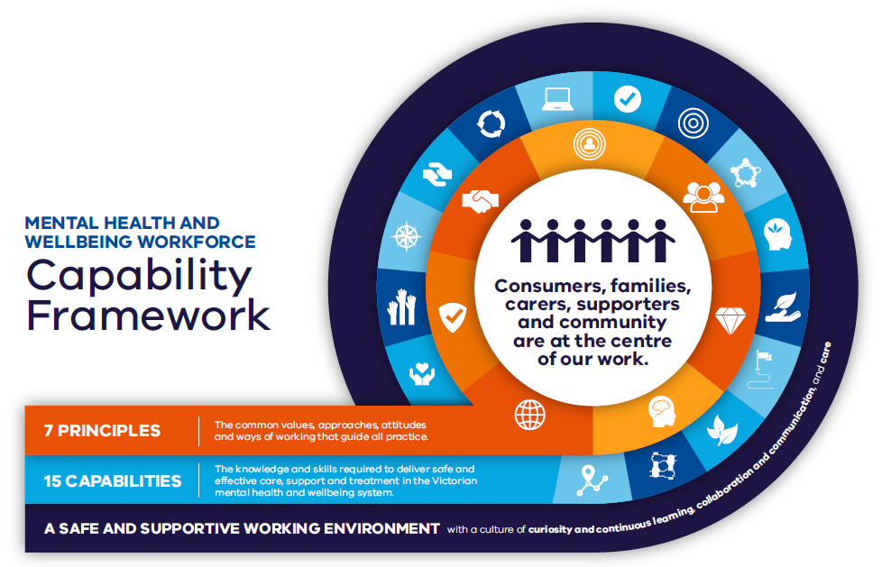

How to use this framework
The Capability Framework can be used in various ways at each of these levels:
- For members of the workforce, the Capability Framework guides reflective practice, supports a self‑assessment of knowledge and skills, and can be used as the basis for capability development discussions with peers, team leaders, supervisors and managers.
- For service leaders, the Capability Framework guides professional development priorities, the formation of diverse team composition, assessment of team capabilities to inform group learning opportunities, as well as approaches to professional practice supervision, and supports growth and career pathways.
- For organisations, the Capability Framework can support values-based recruitment, team composition and role descriptions, and career development. The framework sets out how individuals and organisations need to adapt, grow and continuously improve in order to achieve the highest standards of practice.
- For institutions, such as education and professional bodies, the framework guides development of education, training programs and curriculum. It complements or informs professional development requirements for formal or informal accreditation. The framework can be used to review standards of practice to provide another layer of insight and consistency.
The Capability Framework aims to support the Victorian mental health and wellbeing workforce to understand and respond to the needs of consumers, families, carers and supporters at every point of interaction with the system. The Capability Framework is intended to support practice, education, training, and quality improvement for anyone working in or interacting with the mental health and wellbeing system, regardless of role, setting or discipline.

Future directions
The Royal Commission was clear that the Framework will need to be reviewed and adapted throughout the reform journey towards the future integrated and responsive mental health and wellbeing system, noting that the Department of Health (the department) should over time ‘lead an inclusive and collaborative approach to keeping the framework and training priorities up to date in line with phases of reform, emergent workforce needs and contemporary research’.

Implementation
The Capability Framework will be supported by a suite of explanatory and supporting materials that will include detailed descriptions of principles and capabilities, and a set of outcome statements describing the experiences for consumers, families, carers and supporters, and the workforce.

Iteration
The Capability Framework will be reviewed to align with the development of the forthcoming State-wide Service Capability Framework. Further iteration will align with establishment of the Capability Entity within the Victorian Collaborative Centre for Mental Health and Wellbeing.

Principles
Principles are the common values, approaches, attitudes and ways of working required when working with consumers, families, carers, supporters and colleagues. The seven Principles guide the practice of all those who work in, or interact with, the mental health and wellbeing system—regardless of setting, role or level of specialisation.
The diagram below displays the seven Principles. The diagram has a circle in the centre with the heading ‘7 Principles. All practice is…’.
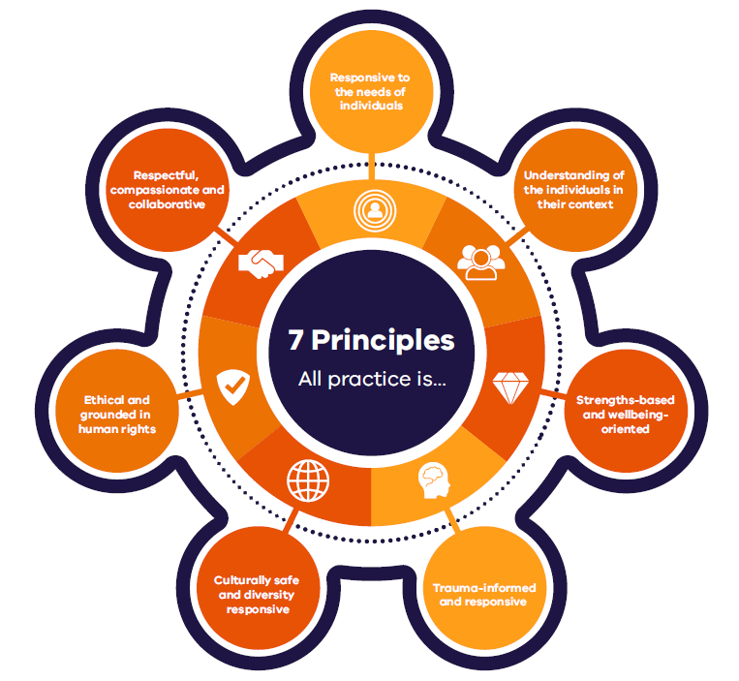This circle is surrounded by seven icons that point to each of the names of the seven Principles. The Principles are explained in detail below the diagram.
The following text provides an overview of the Principles and definitions.

Principle 1 – All practice is responsive to the needs of individuals.
Services, teams and practitioners engage in a person-centred way, placing the consumer, and their families, carers and supporters at the centre of practice and service delivery. All care, support and treatment adopts a holistic and comprehensive view of a person in order to form an understanding of their history, experiences, circumstances, presenting needs, current environment and relationships.

Principle 2 – All practice is understanding of individuals in their context.
Services, teams and practitioners consider the unique needs of individuals in their broader socio-economic, environmental and relational context in accordance with evidence-informed practice and consistent with the preferences and needs of the consumer and their families, carers and supporters.

Principle 3 – All practice is strengths-based and wellbeing-oriented.
Services, teams and practitioners engage collaboratively with consumers, including their families, carers and supporters to identify personal strengths to support recovery and wellbeing.

Principle 4 – All practice is trauma-informed and responsive.
Services, teams and practitioners understand and acknowledge trauma and its prevalence, demonstrating awareness and sensitivity to the neurological, biological, psychological and social effects of trauma, and its over representation in persons who engage with mental health services.
Care, support and treatment emphasises physical, psychological, and emotional safety for consumers, families, carers and supporters and creates opportunities to rebuild a sense of control and empowerment.

Principle 5 – All practice is culturally safe and diversity responsive.
Services, teams and practitioners understand and respond to each person’s unique background and needs, accounting for personal and cultural identity, values, beliefs, language and circumstances. All care, support and treatment is safe and inclusive for all people, incorporating principles of respect, inclusion, equity and compassion, and prioritising cultural safety and a commitment to shared respect, knowledge and learning. Care, support and treatment recognises that the Victorian population is diverse and that culture, language and a person’s background and identity can influence their needs and access to mental health services.

Principle 6 – All practice is ethical and grounded in human rights.
Services, teams and practitioners act ethically and with integrity in all interactions and aspects of service delivery and decision-making in accordance with the principles, objectives and specific provisions of relevant legislation.
Consumers, as well as families, carers, and supporters, are supported to actively engaged in decision-making about their own care, treatment and recovery through human rights-informed approaches, which will challenge stigma and discrimination and advocate for strengths-based recovery and wellbeing.

Principle 7 – All practice is respectful, compassionate and collaborative.
Services, teams and practitioners actively involve, value and respect all types of expertise–including lived experience expertise–across all functions and levels of the system. Relationships within the workforce and in relation to consumers, families, carers and supporters are characterised by mutual respect, compassion and collaboration.

Capabilities
The Capabilities in this Framework represent key areas of practice in the mental health and wellbeing sector. Collectively, the Capabilities aim to support the Victorian mental health and wellbeing workforce to meet the needs of consumers, families, carers and supporters. The 15 Capabilities articulate the knowledge and skills required of every professional, in addition to the specific capabilities required of care, support and treatment professionals, specialist and technical professionals, and service managers and leaders.
The diagram below shows the 15 Capabilities. The diagram has a circle in the centre with the heading ‘15 Capabilities. The mental health and wellbeing workforce is capable of…’ This is surrounded by 15 icons that link to the names of each of the 15 Capabilities.
The Capabilities and their definitions are explained in detail below the diagram.
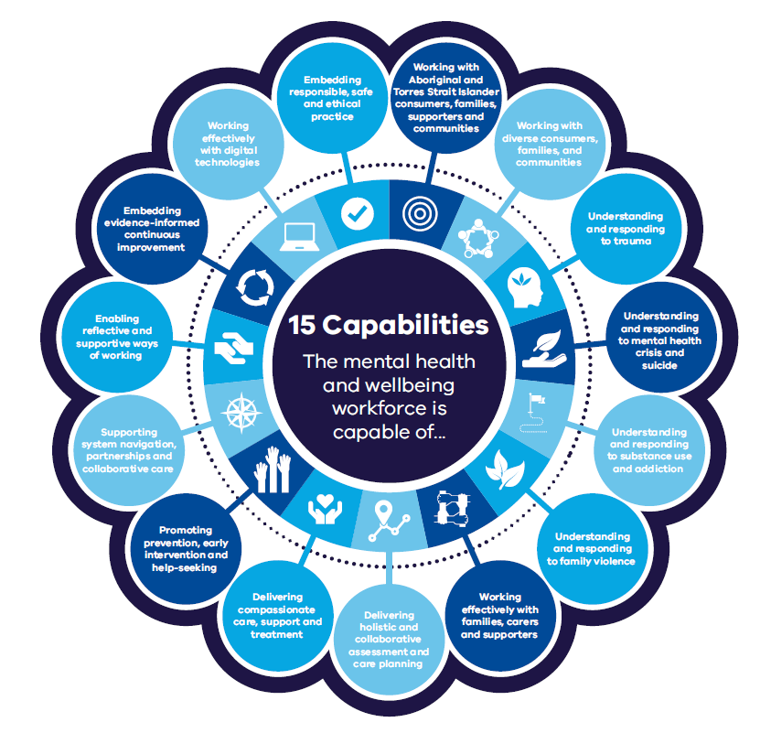The following text provides an overview of the Capabilities and definitions.

Capability 1 – Embedding responsible, safe and ethical practice
Care, support and treatment is consistent with professional, legal, and ethical codes of conduct and practice, and respects and protects the preferences and rights of consumers, families, carers and supporters. All interactions, including supported decision making, are consistent with human rights frameworks.

Capability 2 – Working with Aboriginal and Torres Strait Islander consumers, families, supporters and communities
Care, support and treatment enables Aboriginal consumers, families, supporters and communities to achieve resilience, self-determination and empowerment, as well as a sense of identity and belonging. Collaboration with Aboriginal people requires a holistic view of Aboriginal social and emotional wellbeing, that acknowledges and appreciates connection to Country and the spectrum of social, emotional, physical, cultural, spiritual factors that contribute to mental health and wellbeing.

Capability 3 – Working with diverse consumers, families, and communities
Care, support and treatment is culturally safe and welcoming for all persons, recognising and celebrating diversity. Culturally safe and diversity-responsive approaches extend to consumers, families, supporters and communities, acknowledging that diversity exists in many forms for people, including diverse cultural, linguistic and faith communities; people with a disability; lesbian, gay, bisexual, trans and gender diverse, intersex and queer/questioning (LGBTIQ) people and many other backgrounds.

Capability 4 – Understanding and responding to trauma
Care, support and treatment recognises the prevalence of trauma and aligns to trauma-informed approaches by adopting cultures and practices that empower consumers in their recovery by emphasising autonomy, collaboration and strength-based approaches. Care, support and treatment recognises the potential for traumatisation through engagement with a service or institution and potentially by the treatment offered, and takes action to minimise this at every point.

Capability 5 – Understanding and responding to mental health crisis and suicide
Care support and treatment recognises risk and protective factors and makes use of a range of strategies in responding to crisis and risk, including the involvement of the person's family, carers and supporters. The impact of grief following suicide on families, carers, supporters, communities and the workforce is understood and supported.

Capability 6 – Understanding and responding to substance use and addiction
Care, support and treatment recognises that experiencing psychological distress or mental illness places a person at increased risk of also experiencing a diversity of other concerns and intersecting care, support and treatment needs and preferences. Services, teams, and practitioners recognise the prevalence of co-occurring substance use and addiction amongst people experiencing mental health needs and ensure an integrated approach to mental health and substance use or addiction treatment.

Capability 7 – Understanding and responding to family violence
Services, teams and practitioners recognise that family violence is prevalent and occurs across the social spectrum. All care, support and treatment adopts a rights-based approach that prioritises safety, agency and empowerment through cross-sector and cross-discipline collaboration and team work.

Capability 8 – Working effectively with families, carers and supporters
Care, support and treatment recognises that the consumer lives within the context of family and/or other relationships. The involvement of family and other supportive people is offered through practice models that deliver benefits for the consumer and their families, carers and supporters.

Capability 9 – Delivering holistic and collaborative assessment and care planning
Care, support and treatment sensitively explores and actively engages with the person and their family, carers and supporters to understand people’s differing needs, by undertaking collaborative planning, decision-making and action.

Capability 10 – Delivering compassionate care, support and treatment
Care, support, and treatment is provided through a range of tailored approaches with demonstrated effectiveness. Care, support and treatment is delivered with empathy and compassion.

Capability 11 – Promoting prevention, early intervention and help-seeking
Care, support and treatment facilitates wellbeing and resilience through promoting prevention, early intervention and help-seeking. Engagement empowers individuals, families and communities to enhance strengths, and to develop resources to support personal health and wellbeing goals.

Capability 12 – Supporting system navigation, partnerships and collaborative care
Care, support and treatment requires a focus on navigating the mental health and wellbeing system, including service and referral options and pathways, to enable continuity of care and personal choice.

Capability 13 – Enabling reflective and supportive ways of working
Care, support and treatment is informed by critical reflection of one’s role, interpersonal dynamics, assumptions, and patterns that may arise in relation to consumers, families, carers and supporters.

Capability 14 – Embedding evidence-informed continuous improvement
Care, support and treatment is informed by current and emerging evidence regarding models of care and is underpinned by active, ongoing enquiry into the quality and effectiveness of care, support and treatment offered. Evidence is drawn from multiple sources, including lived experience expertise.

Capability 15 – Working effectively with digital technologies
Care, support and treatment uses online and other digital technologies to improve mental health and wellbeing, including access to information, service delivery, education, promotion and prevention. Services, teams and practitioners embrace digital technologies to enable accessible, holistic, person-centred and integrated care, through a range of technologies including apps, portals, social media, smartphones, augmented or virtual reality, wearables, activity tracking, e-referral, notifications and artificial intelligence.

