Electronic prescription Guide

Victoria Digital Health

December 2021

Copyright and confidentiality statement
This work is Copyright © Department of Health. Other than as permitted by law, no part of this document may be reproduced, stored in a retrieval system, or transmitted in any form or by any other process without prior written permission.
Department of Health and Human Services reserves all rights to the information and intellectual property contained herein. This document may contain information relating to the business, commercial, financial, clinical, and technical activities of Department of Health. This information is intended for the sole use of the recipient as the disclosure of this information to a third party may expose Department of Health to a considerable disadvantage. Except for the purpose of its intention, no part of this document may be reproduced, stored in a retrieval system, or transmitted in any form by any process without prior written permission

Contents
Copyright and confidentiality statement 2
Reference artefact(s) and Endorsement 5
1. Overview 6
2. Introduction 7
2.1. Definition 7
2.2. Background 7
2.3. Purpose of document 7
2.4. Benefits of ePrescribing 7
2.5. Scope 8
2.6. Assumptions 8
2.7. Audience/Stakeholders 8
3. Eco-system and practice in Victoria 9
3.1. ePrescribing eco-system 9
4. ePrescribing workflow 12
5. ePrescribing relevant documents 14
5.1. Electronic prescription conformance profile 3.0 14
5.2. New Drugs, Poisons and Controlled Substances Regulations 2017 14
5.3. Medications Management Interface 14
6. Key considerations and requirements 15
6.1. Principles 15
6.2. Assessments & preparations 15
6.3. Consent and confidentiality 15
6.4. Privacy and Security 16
6.5. Infrastructure and connectivity 16
6.6. Potential barriers and risks 16
7. Recommendation 17
Appendix A – Digital Health branch 18
Appendix B – Terms and Definitions 20

List of Tables

List of Figures
Figure 1: ePrescribing Eco-system 9
Figure 2: Open Electronic prescription pathway (Open PDS) 12
Figure 3: Direct Electronic prescription pathway (Direct PDS) 13

Reference artefact(s) and Endorsement
Referenced artefacts/publications: Excerpts, quotes, references, and other useful contents have been obtained from list of documents below:
Document Name | Owner /Author | Date
Virtual care standard and guide, Digital Health. Vic. Department of Health | Digital Health | July, 2021

Endorsements: This document has been endorsed by the following authorised group:
Authorised group: Digital Health Design and Standards reference group (DHDSR).
Support the department’s vision for digital health initiatives for the Victorian health sector. Examines, develops, and endorses standards and architecture guides, best practice, and strategic approaches for Victorian health services.
This document is hereby endorsed by ‘Digital Health Design and Standards Reference group’ (i.e., The Authorised group) at their meeting on 21 October 2021. Members of the group are listed below:
No. | Full Name | Title and organisation | DHDSR Role
1. | Terri Fiorenza | Director, Health Information Services, Northern Health. | Chair
2. | Paul Gladwell | Program Manager, Health Service ICT. Mercy Hospital. | Co-chair
3. | Claire Holt (SWARH) | Director, Health Informatics, Portland District Health, Portland. | Member
4. | Erica Tong | Chief Pharmacy Information Officer, Deputy Director of Pharmacy, Alfred Health. | Member
5. | Erminia Schiavone | Director, IMCT Peter MacCallum Cancer Centre. | Member
6. | Herbert Down | Branch Manager, CDHSG, ADHA | Member
7. | Michael Franco | Adjunct Associate Professor, Faculty of Medicine, Nursing and Health Sciences, Monash Health. Deputy Chief Medical Information Officer (EMR Program). | Member
8. | Philip Loya | Lead Solution Strategist, Australia IP Strategy, Cerner. | Member
9. | Stephen Oluyide | Principal information and Data Architecture Advisor, Digital Health. Department of Health. | DHDSR Coordinator
10. | Tony Hennessy | Solution Architect, Victoria Heart Hospital. VCCC. | Member
11. | Vineesh Khanna | Director, Digital Health. Department of Health. | Member

Overview
Electronic prescription allows for supply of prescription medications to patients without the presenting of a physical paper prescription prescribed by the patient’s medical practitioner. The initiative utilises electronic tokens provided to patients by medical practitioners which on dispensing are used to retrieve the prescription from a Prescription Delivery Service (PDS). Alternatively, the prescription can be sent directly by electronic message from prescribing software to dispensing software. Future developments will allow for patients to review and manage all their active prescriptions.
Historically, a paper prescription signed by a prescriber has been the only legal form by which medicines can be supplied, however electronic prescription was first used in Australia in 2020, largely to support contactless patient care resulting from the COVID-19 pandemic. This method of prescribing medications complies with all relevant commonwealth, state and territory legislation as well as being compliant with the Pharmaceutical benefits scheme requirements.
Electronic prescriptions are not mandatory, and patients have the choice between a paper or an electronic prescription where available. Electronic prescriptions can be implemented in both acute and primary care setting and implementation has been fast tracked in the primary care setting to support Telehealth measures implemented due to the COVID-19 pandemic.
VPHS’s are providing Virtual care services (i.e., Telehealth Services) including patient outpatient clinic appointments with hospital specialists moving to virtual platforms during the COVID-19 pandemic where electronic prescriptions are of the greatest need.
Electronic prescriptions can also be utilised in VPHS’s to generate prescriptions for patients presenting to Emergency Departments not requiring a hospital admission, and to inpatients upon discharge from a VPHS.
Electronic prescriptions and conformance requirements for implementation have been developed by Australian Digital Health Agency (ADHA) and these resources are available on their website.
This guide provides an overview of the different electronic prescribing models, example scenarios that may apply to a VPHS and a set of key considerations that may be encountered when implementing electronic prescribing in a VPHS setting. There are references throughout this document for further information related to specific implementation and conformance requirements and legislation specific to the state of Victoria.
It is important to note the scope of this document does not include the existing inpatient medications management workflows that are common to VPHS.

Introduction

Definition
Electronic prescriptions are an alternative to paper prescriptions which allow for the prescribing, dispensing and Pharmaceutical Benefits Scheme (PBS) claiming of medicines without the need for a wet-signed paper prescription.
The ADHA defines an electronic prescription as a digital version of a paper prescription. During your consultation, your healthcare provider can send your electronic prescription to you as an SMS or email. However, as stated in our Virtual care standard and guide, ‘The department does not support the use of email to share health information. However, if no other option is available then email(s) must be secured and be at the minimum standard detailed in the Information Security Manual (ISM)’.

Background
During the COVID-19 pandemic in 2020, the state of Victoria (similar to other states) issued a temporary Public Health Emergency Order in May 2020 to facilitate the supply of Schedule 4 medicines by a pharmacist on an electronically transmitted digital image of an original paper prescription, which has been transmitted directly from the prescribing practitioner to the pharmacist. This has allowed for patient care to continue via Telehealth and other contactless means throughout COVID-19 pandemic and prevent serious risk to public health.
This sudden change in how patient care was primarily delivered led to the fast-tracked implementation of electronic prescriptions into General Practice and community pharmacies in 2020, with the concept of electronic prescriptions previously around for several years. With the introduction of electronic prescriptions in 2020, there has been significant uptake of electronic prescriptions in the community setting into General Practices and community pharmacies facilitated by the Australian Digital Health Agency (ADHA) alongside states and territories, resulting in over 15 million original and repeat electronic prescriptions been issued already as at August 2021 (ADHA website: <https://www.digitalhealth.gov.au/initiatives-and-programs/electronic-prescriptions>, Electronic Prescriptions for Australia, 9th September 2021).

Purpose of document
The purpose of this document is:
- Act as an overview and starting guide to implement electronic prescriptions in VPHS.
- Provide a collection of resources for Health services to support their ePrescribing implementation in three scenarios – Emergency Department, on discharge and outpatient setting.
This document should be used in conjunction with national, state or locally developed clinical standards and protocols and state and federal legislation.

Benefits of ePrescribing
Some of the benefits of ePrescribing to Victoria public health service include:
- Improved medication safety – electronic prescriptions result in less manual entry and transcribing errors including illegibility of hand-written prescriptions reducing the potential for medication errors.
- Greater access to virtual and home care – Patients seen via Telehealth and other virtual care models can have an electronic prescription generated within an episode of care.
- Patient choice for prescriptions – patients already utilising electronic prescriptions from regular doctor and pharmacy will now be able to receive electronic prescriptions from their respective hospital ensuring all prescriptions for a patient are in one place, also reducing the time spent by the patient in the hospital, thereby reducing exposure to potential infections e.g., COVID-19

Scope

In Scope
VPHS’s electronic prescriptions described in this document can be applied to the following settings within a Health Service:
- Outpatient clinics (including clinics utilising Telehealth).
- Emergency departments where patients are not required to be admitted to hospital but require discharge medications.
- Inpatients discharge medication (both inpatient and day clinic).

Out of scope
Items out of scope in this document include:
- Implementation of prescribing and dispensing software required for electronic prescription implementation.
- Inpatient medication orders interfacing between prescribing and dispensing systems, this is covered in the Medications management interface < https://www.health.vic.gov.au/quality-safety-service/digital-health-standards-and-guidelines>.
- Pharmaceutical Benefits Scheme (PBS) invoicing or cost recovery.
- Existing inpatient medications management workflows that are common to VPHS).

Assumptions
VPHS referring to this document have an established electronic prescribing and dispensing system.
VPHS should take into consideration the suitability of electronic prescription workflows in settings such as Oncology, Dialysis and Day surgery procedures where PBS prescriptions may be used.

Audience/Stakeholders
Audience/stakeholders of the document include:
Primary:
- Medical and pharmacy clinical informatics specialists.
- ePrescribing business owners in VPHS.
- Directors of pharmacy.
Others:
- Medicines and poisons branch of Department of Health.
- Victorian public Health Service executive staff.
- Digital Health, Department of Health.

Eco-system and practice in Victoria

ePrescribing eco-system
ePrescribing eco-system describes the interaction of key elements including platforms, integrated systems, patient, and Health care providers. Below is a figure showing the interactions and description of the elements:
Figure 1: ePrescribing Eco-system
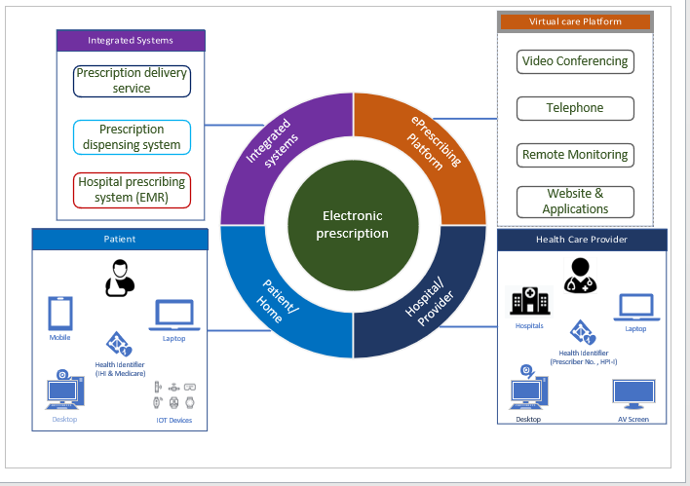

Integrated systems
- Prescription delivery service
The prescription delivery service can be applied either directly or indirectly as described in the figure below (DH-2988:2019. Electronic Prescribing Solution Architecture, 31 October 2019 v2.0, pp. 15):
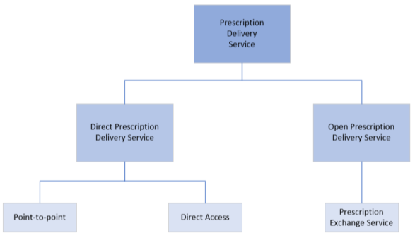

Direct Prescription Delivery Services (direct PDS)
The Direct Prescription Delivery Service (direct PDS) is a framework that allows for the communication of an electronic prescription to a nominated dispenser. Such a mechanism is only permitted under circumstances where a choice of dispenser is made before prescription.
- Point-to-point
This is an implementation pattern of the Direct prescription delivery services. This implementation is defined as a method of communicating between disparate prescription and dispensing systems which may or may not be produced by the same vendor.
- Direct Access
This is an implementation pattern of the Direct prescription delivery services. This implementation is defined as a method of communicating between a system where a user is within the same system to perform both prescribing and dispensing of medications.

Open Prescription Delivery Service (open PDS/oPDS)
The open Prescription delivery service (open PDS/oPDS) is a framework that allows for prescription exchange services (PES) to intercommunicate to grant access to subscribers of individual PES’ access to prescription and dispense data on alternate PES’.
- Prescription Exchange Service (PES)
An implementation pattern of an open PDS that provides a prescription store accessible to prescribers and dispensers. Electronic prescribing systems lodge electronic prescriptions into the store. Dispensers may access the electronic prescriptions in the store and lodge dispense information. At this time (September 2021) there are two PES’ certified for electronic prescribing (Medisecure and eRx script exchange (Fred IT)). The up-to-date list of conformant vendors published by Digital Health is available at <https://www.digitalhealth.gov.au/about-us/policies-privacy-and-reporting/registers>.
- Prescription dispensing system
An electronic system used for recording of medications dispensed by pharmacists to consumers, PBS claiming and stock management. These systems often provide interfaces to ancillary services such as Safe Scripts and Medicare for the purposes of reporting and billing.
- Hospital prescribing system (EMR)
An electronic prescribing system that allows for clinicians to electronically order medications for a consumer, these often provide access to clinical decision-making services and the output of such a system can be both electronic and paper based.
- Healthcare Identifiers
An umbrella term that is used to describe electronic identifiers that are specific to a given consumer or a clinician.
These include:
- Medicare
- Department of Veteran Affairs (DVA number)
- Individual Healthcare Identifier (IHI)
- Healthcare Provider Identifier – Individual (HPI-I)
- Healthcare Provider Identifier – Organisation (HPI-O)

Virtual care platforms
ePrescribing supports health care services provided through Virtual care platforms which are used to provide health services to patients. Instead of having to travel to a hospital be it in metropolitan or regional area, to see a specialist, an increasing number of patients are using virtual care delivery models. Further details of the listed relevant Virtual care platforms are described in previously published document namely – ‘Virtual care standard and guide’ located at < https://www.health.vic.gov.au/quality-safety-service/digital-health-standards-and-guidelines>.

ePrescribing workflow
Electronic prescription in Victoria can follow either of two pathways of (a) Open pathway and Direct pathway.
Below are some notes on the following diagrams:
NOTES: OP – Outpatient ED – Emergency department DC – Discharge
Meds – Medication Rx – Prescription PES - Prescription Exchange Service

- OPEN Pathway
Figure 2: Open Electronic prescription pathway (Open PDS)
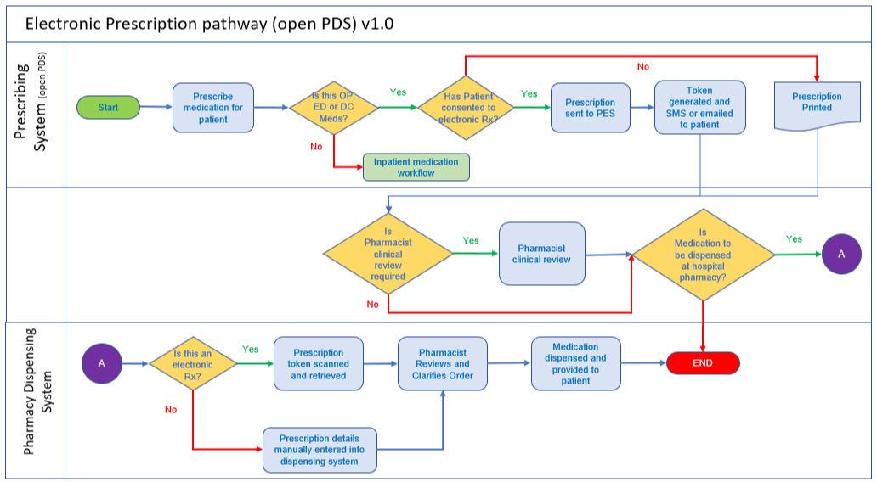

The summary overview of Open prescription pathway workflow is as below:
- Prescriber generates prescription for patient in a prescribing system.
- Should patient elect, this will be generated in the form of an electronic prescription.
- Each medication electronicaly prescribed for the patient will have a token delivered to the patient via SMS or email (dependent on system/patient).
- Patient takes the token(s) or forward them to their chosen pharmacy participating in electronic prescription for dispensing.
- DIRECT Pathway
Figure 3: Direct Electronic prescription pathway (Direct PDS)
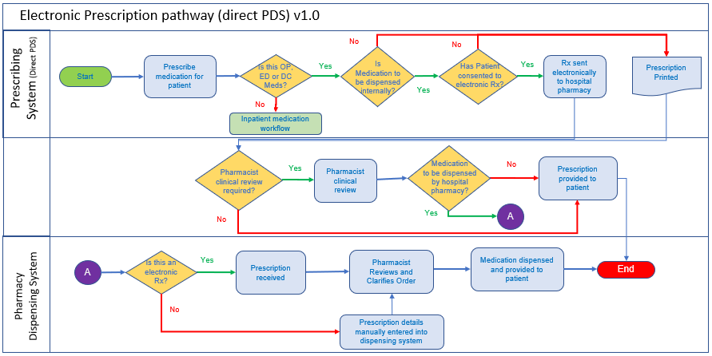

The summary overview of Direct prescription pathway workflow is as below:
- Prescriber generates prescription for patient in a prescribing system.
- Should patient elect this will be generated in the form of an electronic prescription.
- Each medication electronically prescribed for the patient will be sent directly to the pharmacy the prescribing vendor in that Health Service is conformant with for dispensing (e.g. hospital prescribing software will send the prescription to hospital dispensing software).

ePrescribing relevant documents
Below are key relevant standards and guides on ePrescribing:

Electronic prescription conformance profile 3.0
Author: Australian Digital Health Agency.
Year: 2021.
Source: Electronic prescribing conformance process
Overview: The conformance requirements outline required technical infrastructure to implement a particular model of electronic prescriptions. Conformance to this document must be obtained by vendors before implementing electronic prescriptions.

New Drugs, Poisons and Controlled Substances Regulations 2017
Author: Australian government
Year: 2017
Source: <https://www.health.vic.gov.au/drugs-and-poisons/new-drugs-poisons-and-controlled-substances-regulations-2017>
Overview: Outlines the requirements for medications management under the Pharmaceutical Benefits Scheme (PBS) includes the following amendment directly related to electronic prescriptions. National Health (Pharmaceutical Benefits) Amendment (Electronic Prescriptions) Regulations 2019 – amendment to include definitions for approved electronic communication and prescriptions.

Medications Management Interface
Author: Digital Health, Department of Health.
Year: 2021.
Source: <https://www.health.vic.gov.au/quality-safety-service/digital-health-standards-and-guidelines>
Overview: The document is a clinical system guide and standard for interfacing from an electronic prescribing system to a pharmacy application.

Key considerations and requirements
When implementing and providing an ePrescribing system, health services must plan for and understand key considerations and requirements to successfully establish and run the service, in line with ADHA conformance requirements.
Described below are key factors in play that will help to make right choices and apply appropriate cautions when making key decisions.

Principles
To promote consistency and standardisation of ePrescribing practice in Victoria public health services, health services must consider the following basic principles:
- VPHS must implement electronic prescription solutions only from vendors who have been listed as conformant by ADHA through the following link: conformant vendors.
- Understand key requirements from the following: Electronic prescribing – Participating Software Conformance Profile v3.0. As listed under section 5.1 above.
- It is important to note that once a prescription has been issued either via paper or electronically, there is no current facility for that prescription to be converted. i.e., a prescription written and issued on a prescription pad cannot be simultaneously issued electronically or vice versa, this is to prevent duplication of prescriptions.

Assessments & preparations
Software vendors (EMR and pharmacy dispensing vendors) cannot implement electronic prescriptions unless they have received ADHA conformance via demonstration of successful testing with ADHA. Pharmacies will not receive PBS reimbursements for electronic prescriptions dispensed from non-conformant software vendors.
Health Services should review the ADHA conformance documentation to ensure they implement a model of electronic prescriptions relevant to that Health Service. Currently most GP clinics and pharmacies are connected to the Open PDS model.
- Open PDS – this model enables Health Services to generate a prescription token which a patient can present at any pharmacy at any location with capabilities of dispensing electronic prescriptions.
- Direct PDS – this model enables Health Services to generate prescriptions and send them electronically to a singular pharmacy (e.g., the pharmacy within the hospital).
Vendors may not be conformant with all models of electronic prescriptions available for implementation, and this should be considered when discussing future state electronic prescription workflows.

Consent and confidentiality
Patients have the liberty to choose to receive either an electronic or a paper prescription and software vendors are required to have the ability to create paper and electronic prescriptions.
Health Services should consider and review if and how they will generate electronic prescriptions for patients who have a nominated carer or agent responsible for their care (e.g., patients residing in residential aged care facilities (RACF’s)) in line with the conformance requirements.
ADHA Conformance requirements ensure that systems responsible for transmitting and receiving electronic prescriptions have the appropriate ICT security measures in place to ensure safe transmission of sensitive patient medicines information. VPHS should consult with the department’s Cybersecurity team to ensure alignment.

Privacy and Security
VPHS’ must follow conformance requirements for both direct and open PDS models as provided by ADHA, for storage and transmission of patient identifiable data. Data should be stored in line with the organisations PROV guidelines (Public Record Office Victoria) and in an environment that adheres to the Victorian Government Cyber security standards and guidelines (<https://www.cyber.gov.au/sites/default/files/2021-09/Australian%20Government%20Information%20Security%20Manual%20%28September%202021%29.pdf>).
To ensure prescriptions remain secure throughout, their electronic transmission, electronic prescriptions must contain IHI of the patient and HPI-I of the prescriber, noting this does not replace the prescriber number.

Infrastructure and connectivity
Sizing Requirements:
The implementation of both direct and open Electronic Prescription models is not expected to adversely impact a standard VPHS in either network bandwidth, computer, or storage requirements. In case of implementation of direct model of electronic prescriptions, it is worth noting that some additional storage is required to store a copy of transactions between the prescribing and dispensing system if an ESB (Enterprise Service Bus) is part of the solution design.
Availability:
Availability of solution design in a VPHS should take into consideration expected and unexpected downtimes for either the direct or open PDS model. Delivery of prescriptions is important and a Business continuity plan that may be considered is the reversion to paper based processes.
Hardware connectivity:
If a VPHS is considering implementing the open PDS model, it should be noted that there must be a device/s capable of reading QR codes to retrieve the prescription from the PDS.

Potential barriers and risks
Health Identifiers – HPI-I and Individual Health Identifier (IHI)
Barriers: HPI-I and IHI widespread implementation and maintenance by health services.
The use of HPI-I and IHI for direct PDS has been relaxed through a letter provided in the Gazette by the Secretary of the Department of Health (Gazette Notice No. G 14 Thursday 9 April 2020 pages 13-14).
However, the use of HPI-I and IHI is a requirement for use of the open PDS model and health services should take this into consideration when starting the project.

Hospital Complex Authority Required (CAR) highly specialised drugs
Barrier: CAR medicines are not yet able to be prescribed in an electronic prescription format, and still require written authority approval prior to use. Workflows should accommodate this requirement.

Recommendation
To ensure Victoria health sector continue to provide complete safe, secure, and high-level virtual care services to Victorians through ePrescribing, they should adhere to conformance requirements as specified by ADHA and the key considerations described in this document.
Victorian Health services should reference this document as a starting point to implement their ePrescribing service.
Health services should review these key considerations against their current or planned activities to identify gaps and implement appropriate improvements to provide better ePrescribing service. As part of the review, it is necessary to align the existing paper-based process with digital workflow to minimise potential confusion.
This guide document will evolve as the sector’s digital maturity improves, the requirements of the national health sector develop, and expectations of healthcare recipients increase. Upgrades to this guide document will be done in consultation with Victoria public health services and subject matter experts.

Appendix A – Digital Health branch
The Digital Health branch is led by the Chief Digital Health Officer. As a branch in the Commissioning and System Improvement division, Digital Health collaborates closely with a wide range of stakeholders across the department, sector agencies and other jurisdictions to perform the following functions:
- Provides engagement, standards, policy advice, planning, and assurance functions across the health sector in the areas of digital health.
- Is responsible for the system management required to operationalise health sector reform.
- Provides outward-facing whole of health sector leadership in digital health enablement as well as commissioning of digital health and ICT functions.
- Maintain a close working relationship with other branches of the division which has the levers, relationships, and responsibilities across the health system to ensure digital projects are properly governed, resourced, and ensure all risks are well managed.
- Guide health ICT initiatives towards an interoperable future digital health environment using well-established standards, best practice guides, methodologies, and principles.
Digital Health utilises the people, process, and technology components, with a strong emphasis on transformational change elements when implanting new health systems and workflow processes.
Digital Health focus on four areas:
- Digital Health strategy, policy, and architecture standards for the Victorian health sector.
- Commissioning of digital health functions within VPHS.
- Sponsoring digital health programs to implement sector-wide health information sharing platforms including those at a national level (to which Victoria contributes) as well as sector-enabling capabilities sponsored by DH.
- Health service system management function including sector assurance (e.g., major program, operations, and cybersecurity).
Digital health program areas include:
- Directorate, which is responsible for providing high level and expert advice and support to the Chief Digital Health Officer and Digital Health management team on a broad range of issues and projects. The unit plays a key enabling role to ensure the branch is equipped to deliver on its strategic priorities.
- Research and Innovation which works in partnership with academia and industry to identify and implement health informatics and digital-enabled solutions for greater efficiency, productivity and quality and safety outcomes. The team also oversees the benefit realisation portfolio and the advanced use of healthcare data to support early intervention, system management and better patient outcomes
- Health Sector Assurance which provides assurance on all approved health service projects funded or co-funded by the government to ensure health services operate safely, securely, and cost-effectively.
- Health Sector Planning which provides planning and pipeline management for the health sector, managing concept proposals, business bases, funding bids and subsequently funding allocation and funding agreements.
- Health Sector Standards and Integrating of care which supports the Victorian public health sector by providing designs, standards, guides and advisory on digital health initiatives and programs of work.
- Health Technology Solutions (HTS), an operational unit, providing business applications, underpinning technical infrastructure, integration services, secure network services and service management to the Victoria public health sector.
Health Sector Standards and Advisory (HSSA) is committed to open, independent, and best practice view of healthcare Information and Communication Technology (ICT), application solution principles. HSSA can provide recommendations to the overarching enterprise application design and associated services to integrate healthcare applications. For this guide, HSSA will:
- Deliver guides and advice around interoperability across healthcare applications
- Define messaging standards for Victorian health applications
- Facilitate a higher level of integration knowledge and associated quality processes in the Victorian health sector
- Align innovation, efficiencies, and effective use of ICT within health to encourage and drive standards-based approaches that encourage a high level of interoperability

Appendix B – Terms and Definitions
Term | Description
ACHI | Australian Classification of Heath Interventions
ACK | HL7 positive acknowledgement message
ADHA | Australian Digital Health Agency
ADT | Admissions, Transfers and Discharges, relating the Patient Administration System
AIE | Health service/Agency Integration Engine
AMT | Australian Medicines Terminology, this information has been produced by ADHA as an extension to SNOMED-CT
AtoA | Sharing of Application information (Application functions) across multiple applications
B2B | Sharing of business information (Business functions) across business entities
BCP | Business Continuity Plan
CAR | Complex authority required
CIS | Clinical Information System
CMBS | Commonwealth Medicare Benefits Schedule
CMS | Client Management System for community health
CS | Clinical System
DH | Victorian Department of Health
DRG | Diagnostic Related Group
DoS | Denial of service
Dose Range Checking | Functional medications administration capability that:  - assists pharmacists to validate a patient’s dose based on age, weight and surface area, frequency and route of administration, and other patient criteria  - takes into consideration, dosing interval and duration of therapy  - enables decision support rules across atomic pathology and medication doses to be formed
EHR | Electronic Healthcare Record
EIPS | Enterprise Implementation Planning Study
ELS | Endpoint Locator Service
Electronic Prescribing (ePrescribing) | Process of generating an electronic prescription for a patient
Electronic Prescription | Prescription generated electronically for a patient
EMR | Electronic Medical Record
EMPI | Enterprise Master Patient Index. This can be implemented in a health service State-wide / Nationally
Event Message Set | A HL7 interface message that relates to a business function within an application. For example, the HL7 transfer message (A02).
eTP | Electronic Transfer of Prescriptions
GP | General Practitioner
HealthNET | Wide Area Network between various health services and OHIS
HPI-I/O | ADHA national provider and organisation index
HSD | Human Services Directory
HSIE | Health Systems Integration Engine
HSSA | Health Sector Standards and Advisory
HI | Healthcare Identifier
HL7 Data Extraction | The process used to gather HL7 information for loading into the Enterprise IPS phase of the Clinical System project
HL7 | Health Level 7 Message Standard
ICT | Information & Communication Technology
IHI | Individual Healthcare Identifier, national ADHA patient identifier
Integration Engine | An application-to-application integration solution toolset. The solution toolset resolves application-to-application protocol connectivity and synchronises logical sets of information
ICD | International Classification of Diseases
ICT | Information and Communication Technology
IDNT | International Dietetics and Nutrition Terminology
IOT | Internet of Things
IPS | Implementation Planning Study
ISM | Information Security Manual
JCAPS | Sun Interface Engine, Java Composite Architecture Platform. Previously named as SeeBeyond and eGate.
MBS | Medicare Benefit Scheme
MHR | My Health Record
NASH | National Authentication Service for Health
OUS | DH HL7 2.4 Unified Specification
OPD | Outpatient Department
PACS | Picture Archiving Communication System
PAS | Patient Administration System – a system used for the recording of patient and provider information to support management and coordination of service provision.
PDS | The Medicare Provider Directory Service
PHN | Primary Health Networks
PMI | Patient Master Index
PBS | Pharmaceutical Benefit Scheme
QoS | Quality of Service
RcA | Root Cause Analysis
RIMS/RIS | Radiology Information Management System
Secure Messaging | This is an asynchronous, written clinical encounter, typically without any visual input (Except for optional image attachments), accessible by patients via web browser or mobile application. Secure messaging provides safeguards, like patient authentication, that are not available with regular email and other unsecure forms of communication.
SHS | Shared Health Summary
SLA | Service Level Agreement
SME | Subject Matter Expert
SNOMED CT | SNOMED CT (Systematized Nomenclature of Medicine-Clinical Terms) is considered to be the most comprehensive, multilingual clinical healthcare terminology in the world
Third Party Application | An application supplied by a vendor other than Cerner. For example, Homer PAS, Kestral Imaging, etc.
TPN | Total Parenteral Nutrition’s. Nutrition’s/meals that are not ingested via the stomach.
URL | Uniform Resource Locator
VPHS or Health Service Agency | Victorian Public Health Services  Over 80 Victorian Public Health Services offering healthcare across the state
VEMD | Victorian Emergency Minimum Dataset
VAED | Victorian Admitted Episodes Data
WebRTC | Web Real Time Communication

To receive this document in another format, email <DigitalHealth@health.vic.gov.au>.
Authorised and published by the Victorian Government, 1 Treasury Place, Melbourne.
© State of Victoria, Australia, Department of Health, December 2021.

ISBN/ISSN number (online/PDF/Word) or (print)
Available at Digital Health standards and guidelines <https://www.health.vic.gov.au/quality-safety-service/digital-health-standards-and-guidelines>

https://www.pbs.gov.au/info/about-the-pbs#Who_is_eligible_for_the_PBS
https://www.digitalhealth.gov.au/initiatives-and-programs/electronic-prescriptions
https://www.digitalhealth.gov.au/initiatives-and-programs/electronic-prescriptions#elevator-1
https://www.health.vic.gov.au/quality-safety-service/digital-health-standards-and-guidelines

