Digital health capability framework for allied health professionals
OFFICIAL

Digital health capability framework for allied health professionals

To receive this document in another format, phone 1300 650 172 using the National Relay Service 13 36 77 if required, international and interstate callers phone (+613) 9096 9000, or email the Allied Health Workforce team <alliedhealthworkforce@health.vic.gov>.
Authorised and published by the Victorian Government, 1 Treasury Place, Melbourne.
© State of Victoria, Australia, Department of Health, December 2021.
In this document, ‘Aboriginal’ refers to both Aboriginal and Torres Strait Islander people.
ISBN 978-1-76096-689-8 (pdf/online/MS word)
Available from the department’s Digital Health webpage <https://www.health.vic.gov.au/quality-safety-service/digital-health>.

Foreword
Victoria’s digital health roadmap sets the direction for lifting the digital maturity of our public health services. It will improve the safety and experience of care for Victorians.
Digital health transformation requires a commitment to the ongoing development, readiness and leadership of Victoria’s healthcare workforce. An empowered workforce that can embrace the digital technology and innovation is essential to achieving better care for patients.
The Department of Health, in collaboration with Victorian health services, allied health professionals, peak allied health organisations and specialists in clinical informatics training and education, have developed this Digital health capability framework for allied health professionals.
This important framework outlines the knowledge, skills and behavioral attributes required for allied health professionals to provide safe and effective clinical care in digital health settings. It also articulates a pathway for allied health professionals interested in pursuing a career in digital health and clinical informatics.
Strengthening the allied health workforce capability in digital health will enable those professionals to deliver best practice health care and better health outcomes, consistently, for all Victorians.
The capability framework seeks to build allied health professional capability in:
- the digital workplace – ensuring safe and effective allied health practice in a digital work environment
- digital professionalism – requirements of allied health practice in a digital environment
- data and informatics – collecting and collating data, analysing results, and applying knowledge to inform allied health practice
- digital transformation – using technology to transform allied health practice, services and care.
Digital health care is transformative in its potential to shape a richer clinical practice landscape. This framework provides a foundation on which to expand Victoria’s workforce capability to create and deploy innovative digital solutions. A better-connected healthcare system wrapped around the patient awaits us.
I look forward to joining you in this exciting journey.
Neville Board
Chief Digital Health Officer
Contents
Foreword 4
Introduction 7
Purpose 7
Scope 8
Audience 8
Language statement 8
Alignment 8
Assumptions 9
Overview of the framework 10
Framework development 10
Structure of the framework 10
Using the framework 15
Further information 15
Action 15
Domain 1: The digital workplace 17
1.1 Technology and tools 18
1.2 Legislation and policies 21
1.3 Digital health governance 23
Domain 2: Digital professionalism 25
2.1 Digital profile 26
2.2 Professional and ethical responsibilities 28
2.3 Communication 30
2.4 Collaboration 31
2.5 Patient-centred care 33
2.6 Professional development 35
Domain 3: Data and informatics 39
3.1 Data concepts and characteristics 40
3.2 Data integrity and the data life cycle 42
3.3 Analytical concepts 44
3.4 Knowledge creation 45
Domain 4: Digital transformation 49
4.1 Digital innovation 50
4.2 Building and testing new technologies 51
4.3 Digital implementation 52
4.4 Evaluation 53
Appendix 1: Project governance committee, expert discussion panels and additional contributors 56
Project Governance Committee 56
Project Working Group 56
Additional contributors 56
Expert Discussion Panel 56
Appendix 2: Transcripts of figures and case examples 58
Figures 58
Case example: Domain 1 61
Case examples: Domain 2 61
Case examples: Domain 3 62
Case example: Domain 4 63
Glossary 65
References 67

Introduction
The digital age of health is in progress, and allied health professionals are using technology and digital processes in everyday practice. The COVID-19 pandemic significantly increased the uptake and implementation of digital systems and technologies, and digital health will continue to develop and progress to increase the efficiency and effectiveness of the Victorian health system.
Digital health is an umbrella term defined as the use of digital mobile and wireless technologies in health. It is also the application of data and information technology to gather, store, retrieve and study to improve processes, services, delivery of care and health outcomes (AIHW 2018). Digital health technologies collectively refer to electronic tools, systems, devices or resources that are used in providing care or to process or store health data (AIHW 2021).
The Australian Commission on Safety and Quality in Health Care (ACSQHC) (2019) endorses the safe and effective implementation of digital health in Australia. Effective implementation of digital health facilitates safe, effective and efficient care for patients and clients. To achieve this, allied health professionals have a duty of care to themselves and their patients to understand digital health.
The Digital health capability framework for allied health professionals provides guidance on core aspects of digital health for allied health professionals. This framework will guide the use of digital health technologies and clinical information systems to improve the coordination of patient care, safety and clinical outcomes, and to drive innovation of and research into new models of care.
‘Sooner rather than later we’re going to stop calling this digital health because it’s going to be [just] health. Technology is just a part of it.’
- Chief Allied Health Information Officer Victoria
‘Allied health professionals have a duty to themselves and their patients to be informed about digital health.’
- Allied health digital health expert

Purpose
The Digital health capability framework for allied health professionals aims to outline the knowledge and behaviours required to provide safe and effective allied health practice within the context of digital health environments. It also aims to articulate a pathway for allied health professionals interested in pursuing a career in digital health and clinical informatics.
The primary goal of this framework is to enable the development of allied health workforce capability in digital health, to influence and contribute to best practice and improve service and health outcomes.
Allied health professionals are committed to lifelong professional learning. Continuing professional development is a requirement for both registered and self-regulated allied health professionals. Allied health professionals must develop skills in digital health to build individual and systems-level capability.
This framework and the self-evaluation tool will support individual allied health professionals, teams and departments to evaluate digital health knowledge and skills and to implement learning and development plans to address identified gaps.

Scope
The framework can be applied to all allied health therapies and science professions and across career levels, from new graduates to experienced practitioners, educators and managers.
It has been developed for allied health professionals. However, aspects of the framework will also be relevant to allied health assistants.

Audience
Table 1 provides a summary of the target audiences for the framework and its application.
Table 1: Examples of different uses of the capability framework
Who is it for? | How can it be used?
Allied health professionals | As a self-assessment tool  To inform professional development  To guide career planning
Managers and employers | To benchmark team or department capability  To identify workforce needs and development opportunities  To inform position descriptions  To plan education and training packages
Educators | To guide the development of learning, education and training opportunities
Tertiary education providers | As a criterion-based guide for curriculum development

Language statement
Allied health professionals in Victoria provide care across a diverse range of services, with many terms used to describe the person receiving care.
For consistency, the term patient/consumer is used throughout the framework to describe the person who is receiving care.

Alignment
Allied health professionals increasingly require skills and expertise in clinical informatics and digital health technologies to support the planning, delivery and evaluation of clinical service and improvement activities across the Victorian health sector.
Clinical informatics is the application of informatics and information technology to deliver healthcare services (AMIA 2019). It is concerned with the resources, devices and methods required to optimise the acquisition, storage, retrieval and use of information in health and biomedicine. This is a multidisciplinary profession involving information in health that leads to informed and assisted health care.
This aligns with both Victorian and national digital health strategies. The Victorian Digitising health strategy (Department of Health and Human Services 2016b) outlines an ongoing commitment to digital technologies that help identify consumer healthcare needs to better position the Victorian health sector to meet future challenges. Australia’s national digital health strategy (Australian Digital Health Agency 2017) sets a priority to develop a workforce that is confident in using digital health technology to deliver care and services.
The framework aligns with the following legislation and standards:
- privacy laws and requirements, including the Privacy Act 1988 and the Health Records Act 2001
- Privacy and Data Protection Act 2014 (Vic)
- Ahpra National Boards – codes of conduct for registered allied health professions
- codes of conduct for self-regulated allied health professions.
The framework adds to existing allied health frameworks including:
- Allied health: credentialing, competency and capability framework (Department of Health and Human Services 2016a)
- Allied health career pathways blueprint (Department of Health and Human Services 2019).

Assumptions
The framework makes the following assumptions:
- Allied health professionals provide safe and effective high-quality care in their core roles and in the absence, disruption or failure of digital health technologies.
- The level of digital literacy will vary among individual allied health professionals.
- Access and availability of digital health technologies will differ between organisations and sectors.
- The health workplace is becoming increasingly digital.
- Allied health professionals must be able to use digital health technologies and data to provide safe and effective high-quality care and to adapt and improve service delivery and health outcomes.

Overview of the framework
‘Digital health is part of allied health service delivery now. We should be seeing everything through a digital lens.’
- Allied health digital health expert

Framework development
The framework was developed through the analysis of contemporary literature and existing frameworks (Australian Digital Health Agency 2020; Brunner et al. 2018; National Health Service 2017) and extensive consultation with Victorian allied health stakeholders and digital health experts.
A project governance committee was established and provided guidance, advice and strategic leadership. A project working group and expert discussion panels (see Appendix 1) were used to develop and refine a draft version of the framework. The working group helped create the domains and sub-domains, while the expert discussion panels informed capability statement development.
Further consultation and testing included an online survey of 164 allied health professionals across Victoria. This feedback was sought to ensure that the framework was relevant, clear and user-friendly.

Structure of the framework
The framework identifies four overarching domains.
The domains are divided into 17 sub-domains. Each sub-domain has several associated capabilities, with a total of 44 capabilities across the whole framework.
The domains and subsequent sub-domains are elements of allied health practice that are central to providing safe and effective high-quality patient care.
Capability development requires a combination of growing knowledge and the ability to demonstrate associated behaviours. Most capabilities will build on existing allied health professional knowledge, skills and behaviours, with a digital health lens.

Domains
The core theme of the framework is that allied health professionals provide safe and effective high-quality care.
The framework identifies four domains that are essential to providing safe and high-quality care in digital health (Figure 1):
- Domain 1: The digital workplace
- Domain 2: Digital professionalism
- Domain 3: Data and informatics
- Domain 4: Digital transformation.
Each domain has a summary statement to explain why it is important to allied health professionals (Figure 2).
Figure 1: Digital health domains
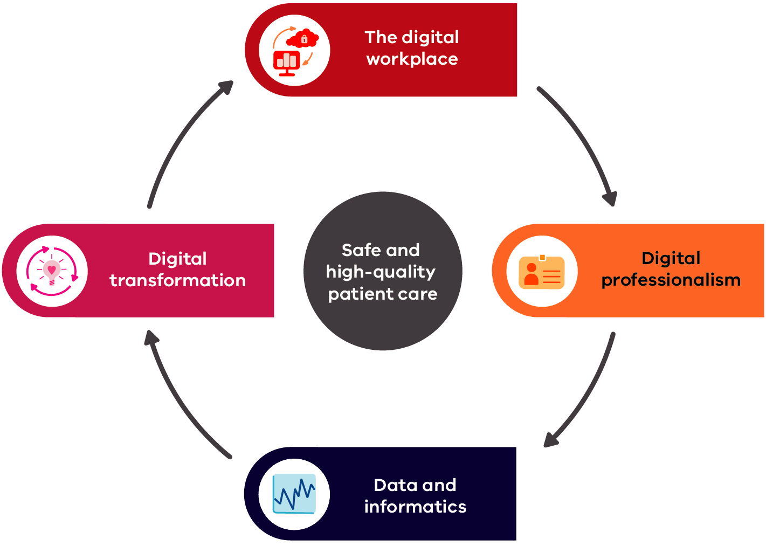

Figure 2: Digital health domain summary statements
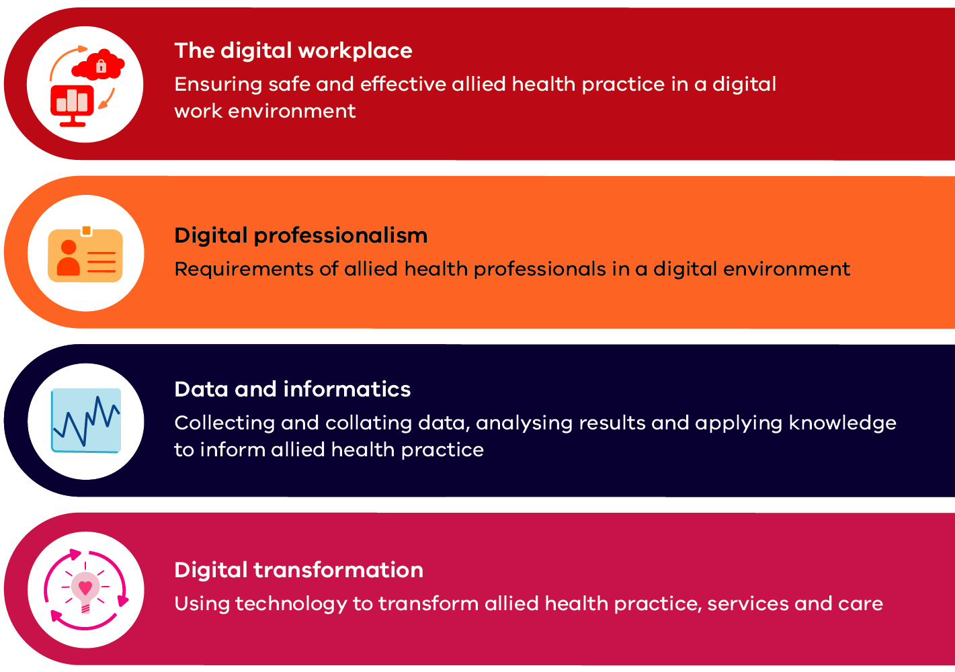

Sub-domains
Each domain is divided into sub-domains (Figure 3). Each sub-domain outlines the knowledge and behaviours that allied health professionals are expected to know and demonstrate in that area of digital health.
Figure 3: Domains and sub-domains
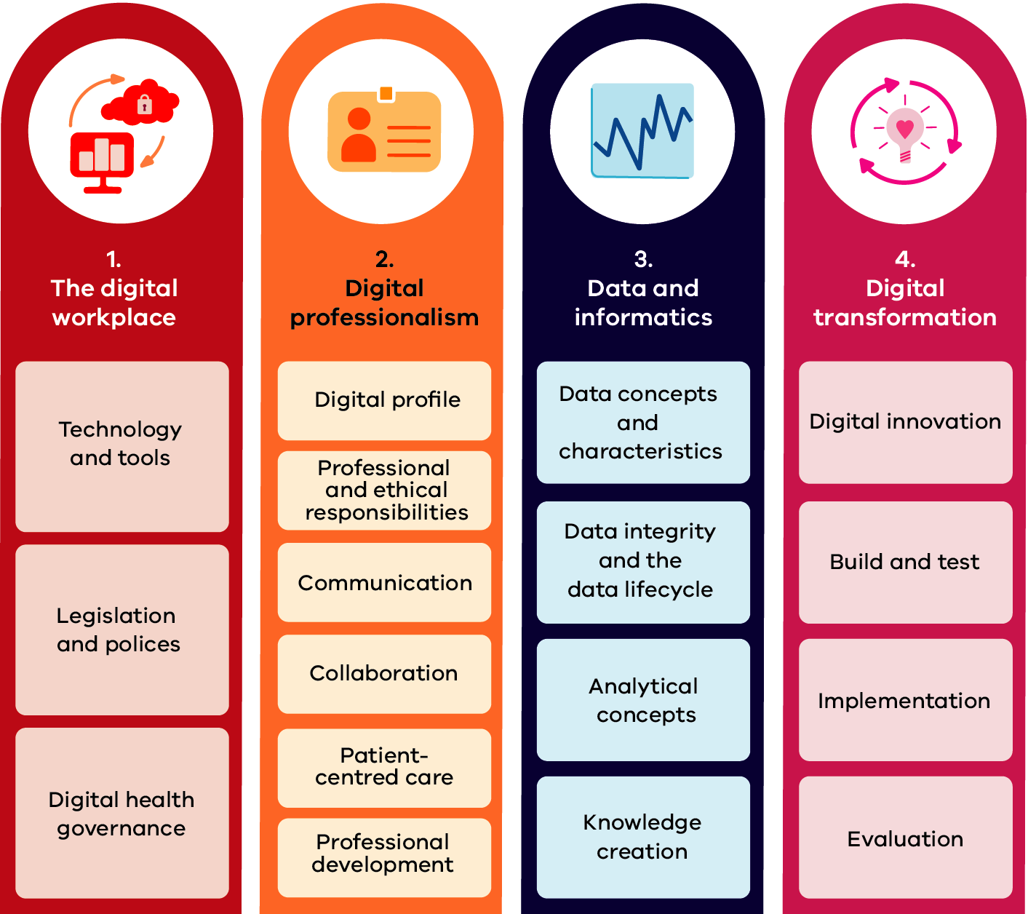
‘Focusing on what allied health already do well and how we can improve on that in a digital setting … the communication, the collaboration, the holistic viewpoint, the patient being front and centre of everything we do.’
- Allied health digital health expert

Capability levels
Capability is established by demonstrating specific actions or behaviours. As allied health professionals develop and build capability, the behaviours and actions required will change.
The capability levels relate to growth rings of increasing autonomy, task complexity, strategic awareness and level of influence (Figure 4). There are four capability levels used to describe increasing experience: foundation, consolidation, expert and leader, which are consistent with those used in the Allied health professional career pathway blueprint (Department of Health and Human Services 2019).
The capability levels do not relate to an allied health professional grade. Capability levels will vary across sub-domains depending on professional interests and experience.
Each sub-domain has a matrix of capability statements that apply to the knowledge and behaviours specified (Figure 5).
Figure 4: Capability growth rings
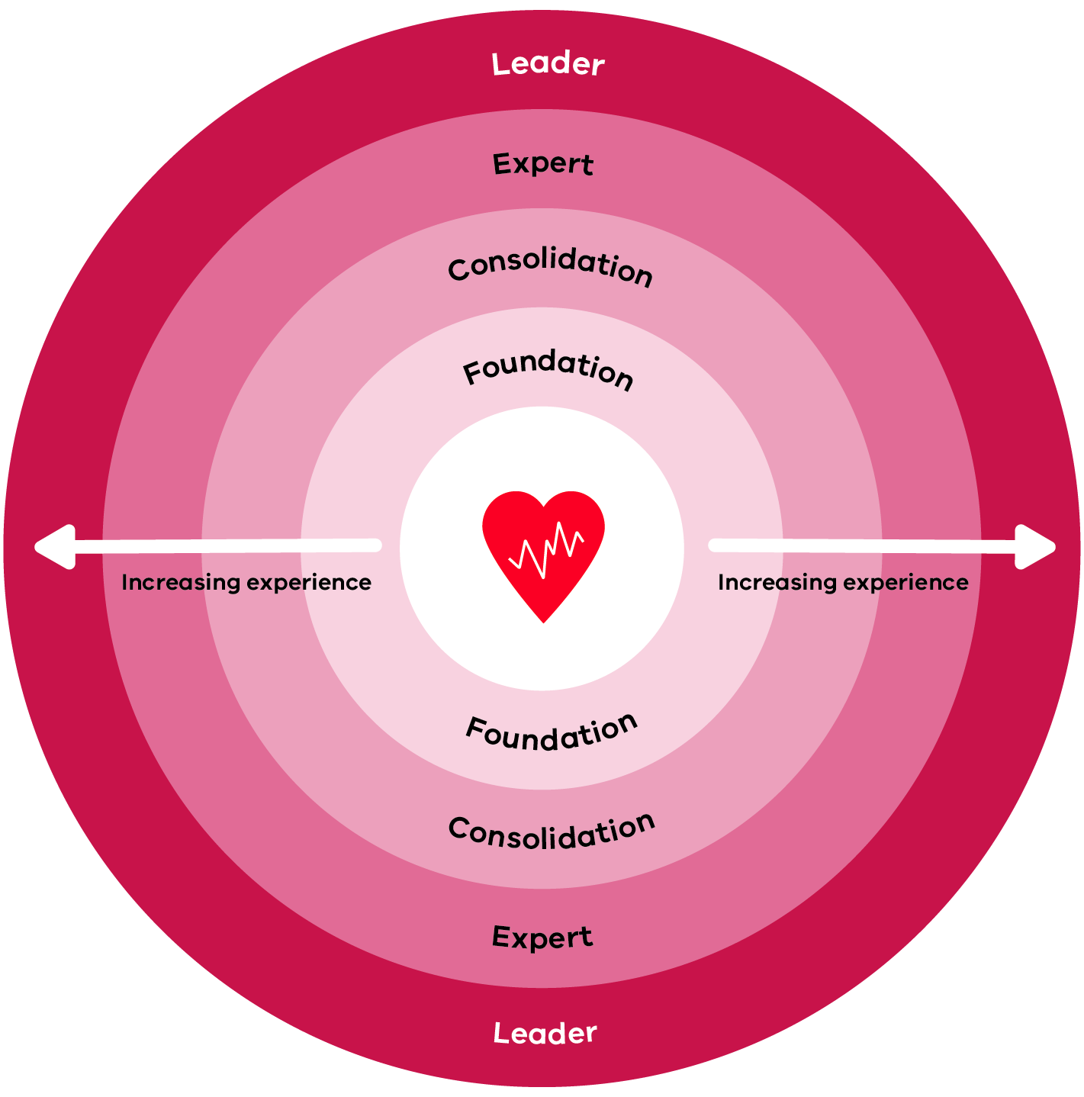
Figure 5: Capability level descriptions
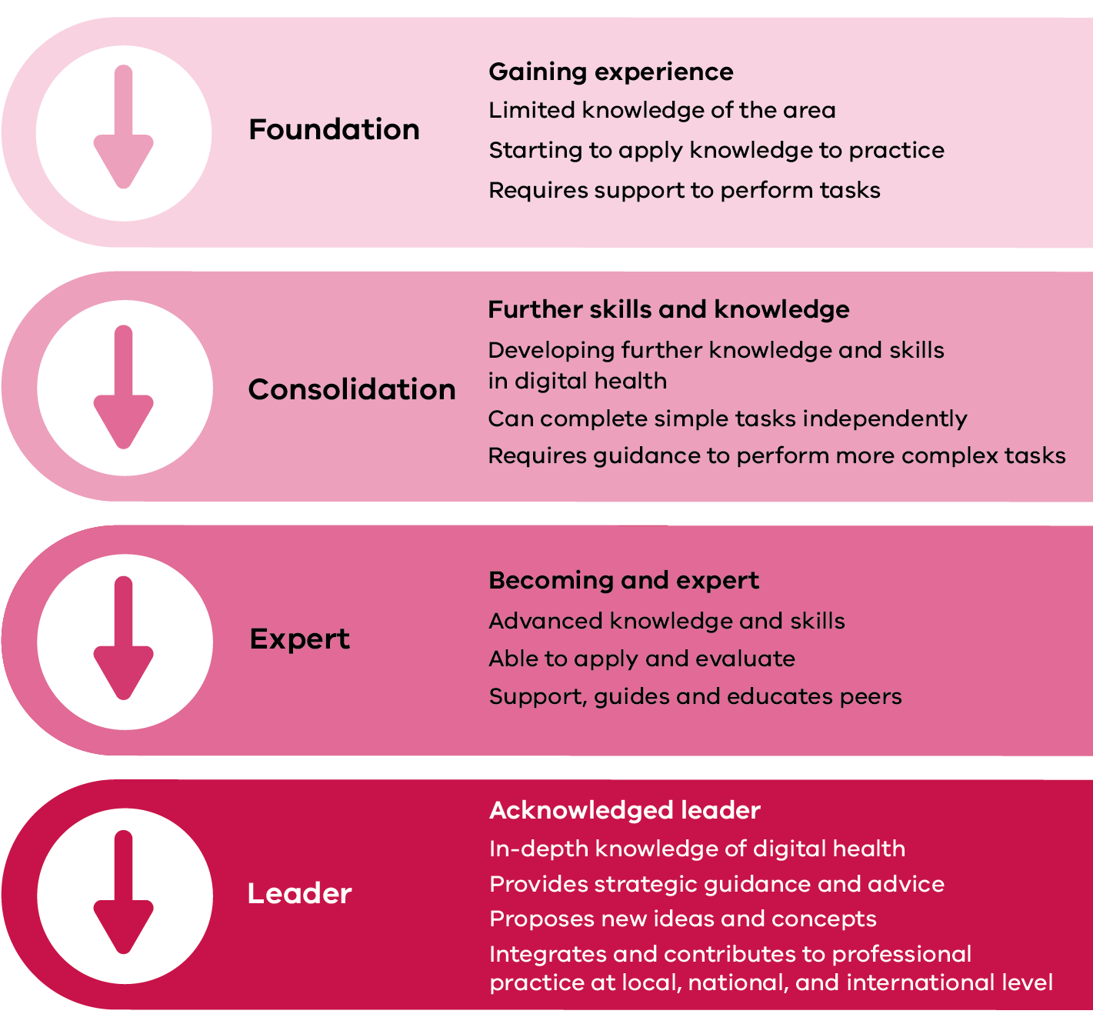

Using the framework
The Digital health capability framework for allied health professionals identifies the knowledge and behaviours required across a variety of digital health domains.
The self-evaluation tool can be used with the framework to assess your current level of ability. We recommend completing self-evaluation tool in stages rather than all at once – for example, by domain or sub-domain.

Further information
Any phrase in bold and italics has a definition in the glossary.

Action
Figure 6 explains how to use the framework to identify your capability level in different domains and sub-domains.
Figure 7 describes what should be recorded in the self-evaluation tool.
Figure 6: How to use the capability framework
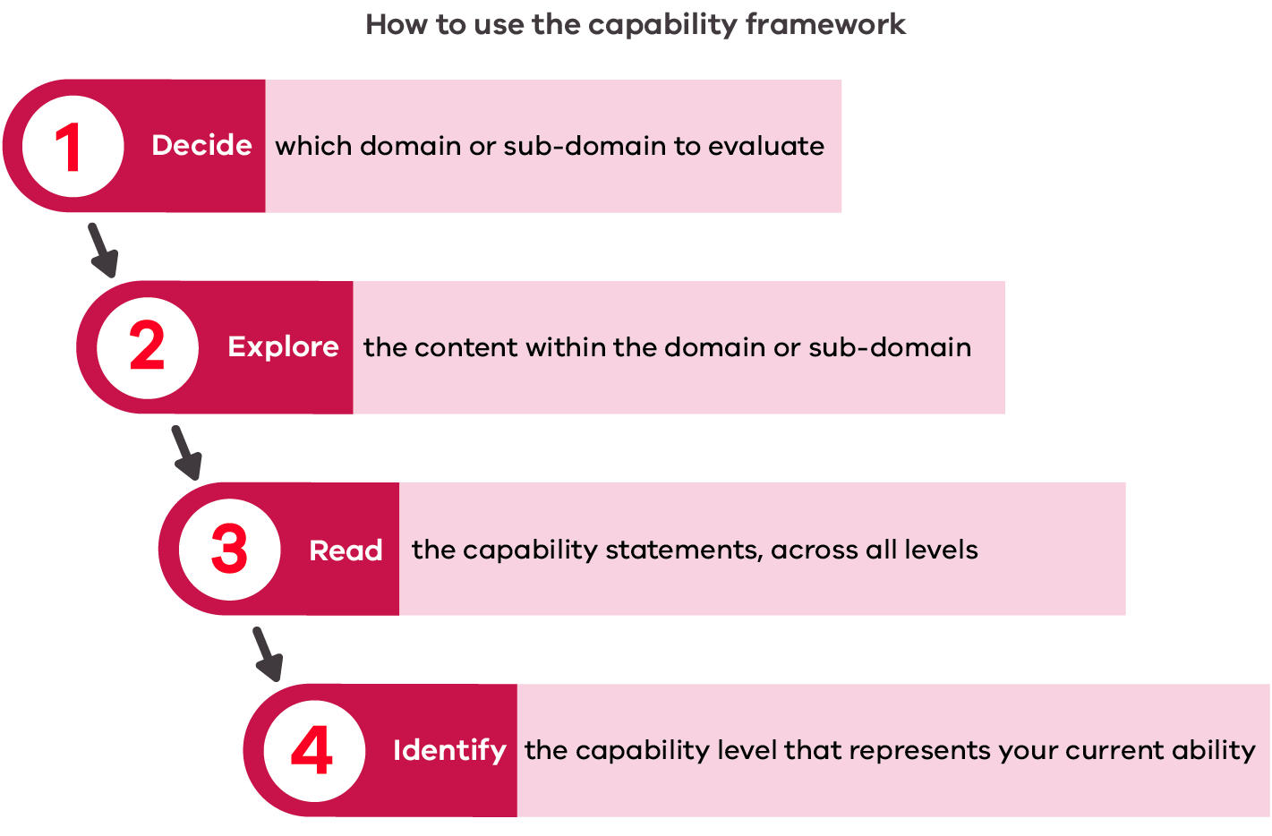
Figure 7: How to use the self-evaluation tool
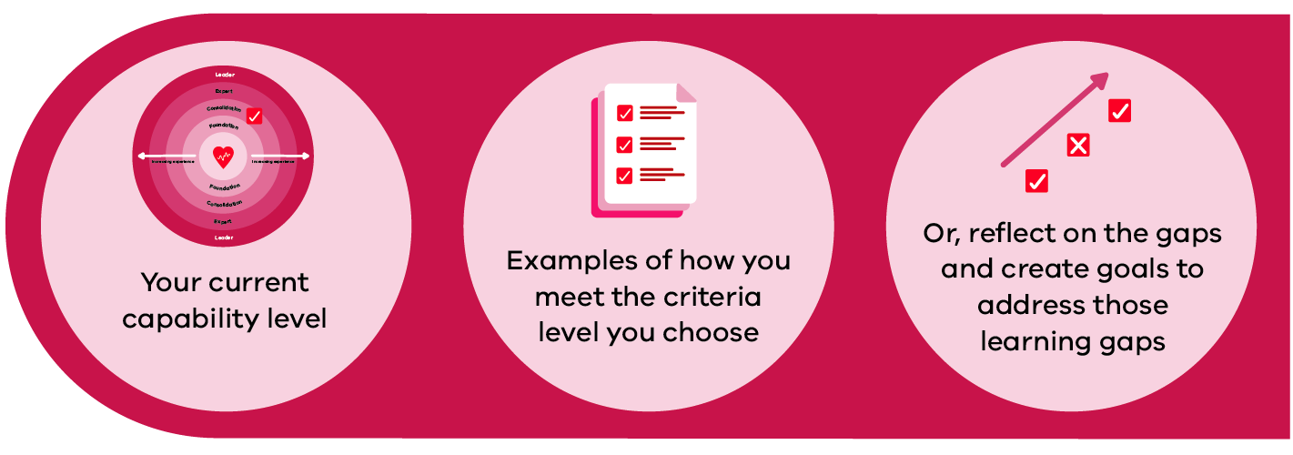
Note: If a user does not meet the foundation level for a statement, the comment section can be completed to identify the gap and set goals to achieve this level.

Domain 1: The digital workplace
Ensuring safe and effective allied health practice in a digital work environment
Technology is transforming the way that allied health professionals provide care. The digital workplace can be defined as the technology required to do your job. This includes technology in current operation and those yet to be implemented (Deloitte 2014).
Being able to competently use technology is only one aspect of the digital workplace. An understanding of the benefits, risks and challenges of digital health technologies is also necessary to ensure safe, appropriate and efficient use of resources.
As digital health technologies continue to evolve, there will be more opportunity for sharing information and interaction with patients/consumers. Allied health professionals must understand the legislation and policies around digital health to maintain privacy, confidentiality and security of health information.
The three sub-domains in Domain 1 are described in Figure 8.
Figure 8: The digital workplace sub-domains
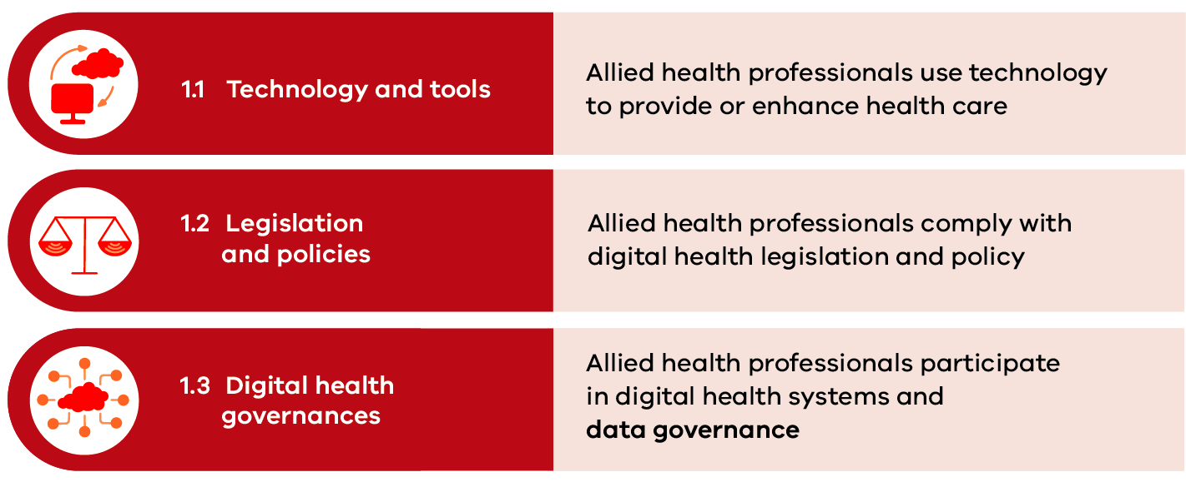
‘Understanding what the benefits, but also what the risks are to digital health innovation, so that we, as a group of professionals can get the most out of it.’
- Allied health digital health expert

1.1 Technology and tools
Allied health professionals select and use the digital health technologies and tools that are most appropriate to the needs of their patients
Digital health is an umbrella term referring to a range of technologies and tools used to provide clinical care and to collect, store and share personal health information. These include mobile health applications, electronic health records, telehealth and telemedicine, wearable devices, robotics and artificial intelligence (AIHW 2021).
The benefits of digital health technologies and tools include:
- better patient health literacy and participation in their healthcare decisions
- active monitoring of clinical symptoms, both within traditional healthcare environments and remotely within the community
- increased access to health information by health service providers to supports clinical decision making
- improved patient safety and continuity of care
- better connection and collaboration between different parts of the health system, leading to more integrated care approaches.
The purpose and function of digital technologies is to ensure accurate health information is available whenever and wherever needed and in a secure format. This supports digitally enabled models of care that drive improved accessibility, timeliness, efficiency, safety and coordination of care.
Allied health professionals require an understanding of:
- the range, purpose and function of different digital health technologies used in providing patient care
- factors that influence how to choose the most appropriate digital health technology for various clinical indications, including risk identification and mitigations
- strategies to optimise the performance of digital health technologies and resolve simple technical challenges.
Allied health professionals should demonstrate the following capabilities related to digital health technologies and tools:
Capability | Foundation | Consolidation | Expert | Leader
Use a variety of digital health technologies in providing care | I am aware of the wide variety of digital health technologies that can be used in providing care  With support and guidance, I can use different digital health technologies to provide care | I independently use a variety of digital health technologies in providing care | I provide support for others to use digital health technologies in providing care  I perform specialist tasks using a wide variety of digital health technologies in providing care  I participate in decision-making forums when choosing new digital health technologies | I contribute to and develop policies and guidelines in using digital health technologies to provide care  I provide leadership to evaluate use and provide opportunities to improve and optimise digital health technologies, including when planning new healthcare strategies and models of care  I represent allied health in decision-making forums when choosing new digital health technologies
Identify the appropriate digital health technologies for different clinical situations and associated risks | With support, I can identify the appropriate digital health technologies to use across different clinical situations  I am learning about risks to patient care or safety issues and how these can be escalated | I identify the appropriate digital health technologies to use across different clinical situations  I can identify and report risks to patient care or safety issues and I understand how to escalate  I am learning about risk management strategies | I educate and teach others to identify appropriate digital health technologies to use for different clinical situations  I support others to identify and report risks  I evaluate, report and propose solutions to mitigate risks | I advocate and lead development of training and resources for using digital health technologies, including identifying which can be used and the benefits and limitations  I lead the governance processes to ensure risks associated with digital health technologies are reported and evaluated  I create solutions and ensure risk mitigation strategies are implemented
Use technical knowledge to problem-solve and resolve technical challenges | I am aware there can be issues when using technology and I know how to seek assistance to resolve them  With guidance, I report technical issues to appropriate parties | I use technical knowledge to resolve basic technical problems and challenges  I identify and report technical issues and I understand how to escalate | I assist others to resolve technical challenges  I identify and design solutions, and provide feedback on complex technical problems and challenges | I organise, resource and prioritise solutions to technical challenges including liaising with vendors  I monitor and evaluate solutions implemented to resolve technical challenges
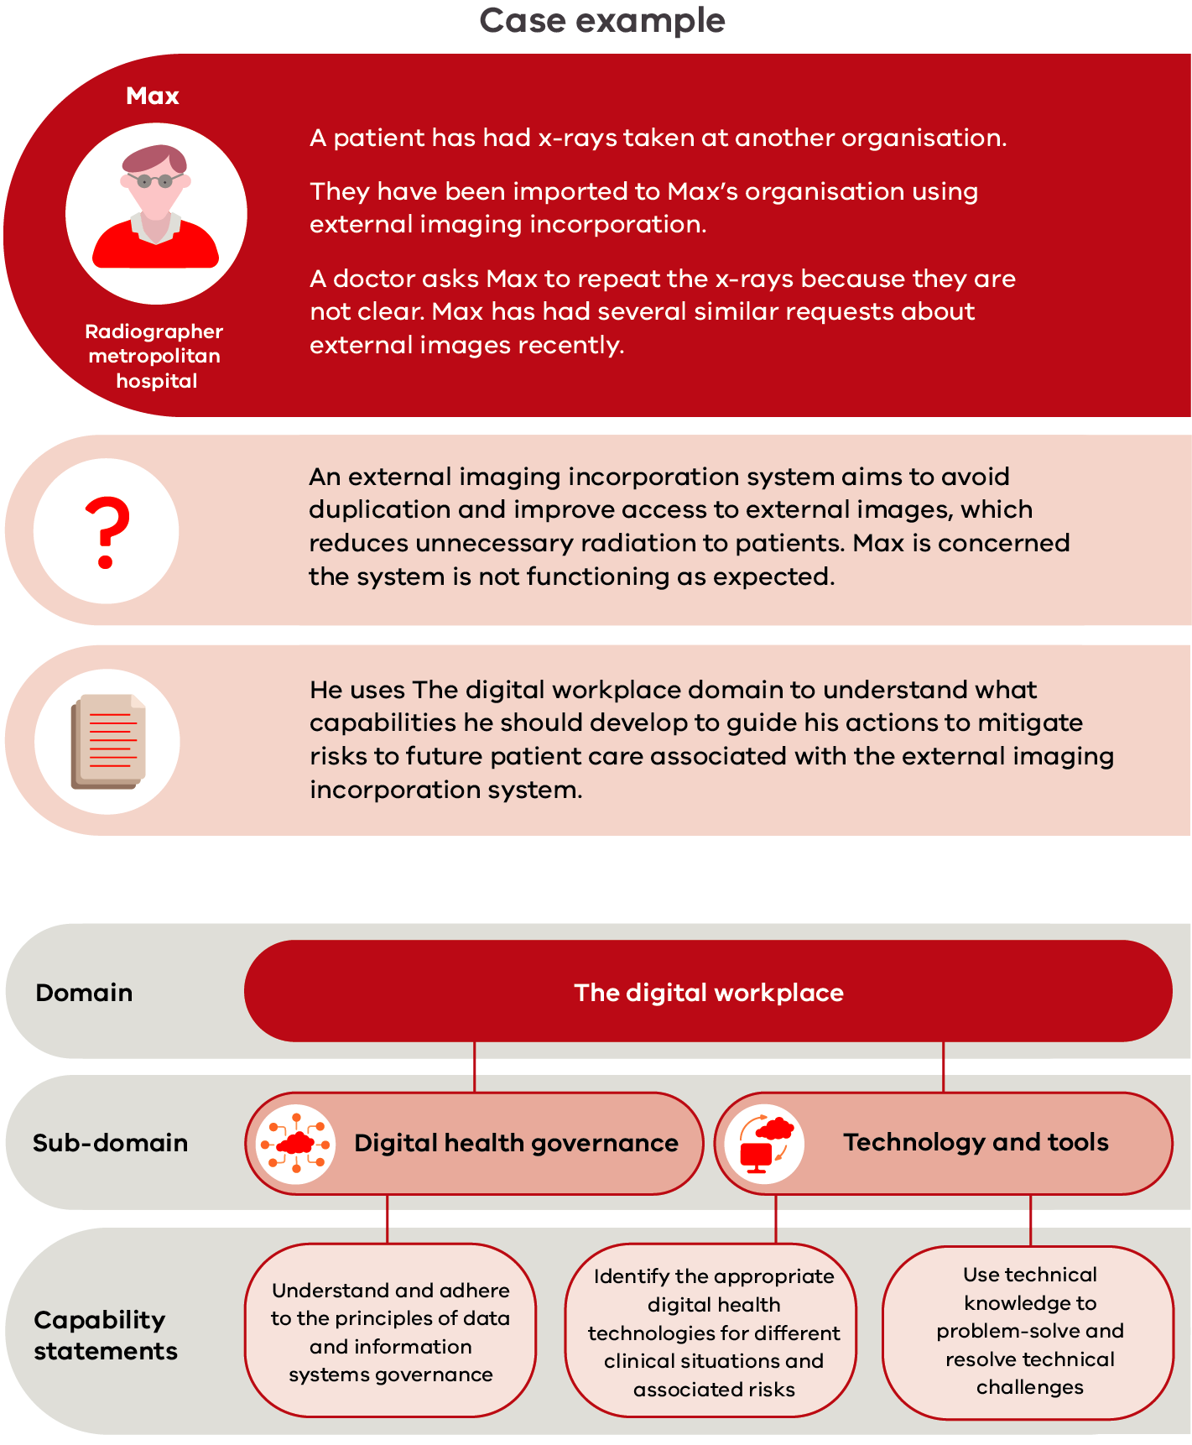

1.2 Legislation and policies
Allied health professionals comply with legislation and policy that govern the use of digital health technologies
Legislative requirements and organisation-level policies govern the use of digital health technologies and outline health service requirements for communicating and sharing confidential and sensitive patient information.
Relevant legislation governing digital health data usage includes:
- the Privacy Act 1988 <https://www.legislation.gov.au/Series/C2004A0371>, which promotes and protects the privacy of individuals and regulates how Australian Government agencies and organisations handle personal information
- the Health Records Act 2001 (Vic) <https://www.legislation.vic.gov.au/in-force/acts/health-records-act-2001/046>, which specifies Health Privacy Principles and health services’ obligations for data security
- the Privacy and Data Protection Act 2014 (Vic) <https://www.legislation.vic.gov.au/in-force/acts/privacy-and-data-protection-act-2014/027>, which establishes the Victorian protective data security framework for data security responsibilities of Victorian Government agencies including health services and Victorian Protective Data Security Standards for the consistent application of security practices (aligned to the Australian Government’s Protective security policy framework).
Health service information management policies and guidelines reflect relevant legislation and outline organisational standards for managing privacy, security and protections in relation to collecting information, consent to share information, de-identifying data and disclosing information across organisations.
Establishing and maintaining information security and privacy is an essential professional and legal requirement for allied health professionals to safely practice within the digital health environment. Allied health professionals must be aware of their privacy obligations, embed privacy protections within their practice and contribute to the health system’s commitment and culture of data privacy. This includes taking reasonable steps to protect and secure patient data and compliance with notification obligations should a data breach be identified.
Allied health professionals require an understanding of:
- relevant digital health legislation that intersects with using and applying digital health technologies
- organisational digital health policies and guidelines that support the appropriate use of digital health technologies
- digital copyright and intellectual property requirements specific to the clinical and non-clinical applications of health technologies.

Allied health professionals should demonstrate the following capabilities related to digital health legislation and policies:
Capability | Foundation | Consolidation | Expert | Leader
Comply with digital health legislation | With guidance, I can find relevant legislation about digital health  I am aware of and comply with digital health legislation | I know where to find relevant legislation about digital health  I understand and comply with digital health legislation | I support others to find information, understand and comply with digital health legislation  I create, review, update and contribute to policies and procedures to comply with digital health legislation | I ensure allied health services have up-to-date policies to facilitate compliance with digital health legislation  I can advise and contribute to digital health legislation
Comply with organisational digital health policies | With guidance, I can find relevant organisational digital health policies  I am aware of and comply with organisational digital health policies | I understand and comply with organisational digital health policies | I support others to understand and comply with organisational digital health policies  I measure, report and implement risk management strategies to ensure compliance with organisational digital health policies | I monitor governance strategies to ensure compliance with organisational digital health policies
Understand digital copyright and intellectual property rules and regulations | With guidance, I can locate relevant rules and regulations  I am aware of digital copyright laws and intellectual property rules and regulations | I understand digital copyright laws and intellectual property rules and regulations and comply with these | I advise, monitor and report on others’ compliance with digital copyright laws  I understand, advise and ensure compliance for intellectual property rules and regulations | I lead systems and processes that ensure digital copyright and intellectual property rules and regulations are met

1.3 Digital health governance
Allied health professionals understand the governance of their practice in the context of the broader digital health environment
Health services are accountable for implementing local health technology strategies, plans and activities (as per the Digital health roadmap for Victoria) and the governance of health service information and data. Through local information management frameworks, plans and strategies, health services outline policies, roles and responsibilities for the management and governance of their information and data. This is to ensure health service information is managed in line with legislative and regulatory requirements, and its intended purpose and associated risk profile.
Key principles of data information systems governance are:
- Clear responsibilities and data processes enable safe data use and improve healthcare quality and performance.
- Performance improvements and innovations drive better healthcare and patient outcomes.
- Patients/consumers and their families are informed about the collection and processing of personal health data and their right to access information.
- Data de-identification processes protect patient data privacy.
- Data security and management safeguards reduce the likelihood of breaches of IT infrastructure and information management practices.
An understanding of system and organisation-level governance enables allied health professionals to understand and comply with digital data collection and life-cycle management practices, data security and privacy practices, and the use, sharing and release of patient health information. Legal and ethical considerations are strongly aligned to good governance, and allied health professionals must develop strategies to:
- mitigate information security breaches
- embed data protections and privacy issues
- ensure informed consent for information sharing
- take responsibility for data ownership in their own practice.
Allied health professionals require an understanding of:
- the principles of data information systems governance
- legal and ethical considerations associated with using digital health technologies
- potential threats to organisational digital security, service continuity and reputation.
Allied health professionals should demonstrate the following capabilities related to digital health governance:
Capability | Foundation | Consolidation | Expert | Leader
Understand and adhere to the principles of data and information systems governance | I am learning about the principles of data and information systems governance | I understand and adhere to the principles of data and information systems governance | I confidently understand and apply the principles of data and information systems governance  I can represent allied health on governance groups or committees | I am accountable for ensuring governance of data and information systems for allied health professionals  I lead the governance processes to ensure the compliance of data and information systems is evaluated  I contribute to organisational digital health planning and strategy
Understand potential legal and ethical challenges associated with digital health technologies | I am learning about potential legal and ethical challenges associated with digital health technologies | I understand potential legal and ethical challenges associated with digital health technologies  I can identify and report risks to patient care or safety issues and I understand how to escalate  I am learning about risk management strategies | I support others to understand the potential legal and ethical challenges associated with digital health technologies  I support others to identify and report risks  I evaluate, report and propose solutions to mitigate risks | Lead in advocating the importance of understanding the potential legal and ethical challenges associated with digital health technologies  I lead the governance processes to ensure that risks associated with digital health technologies are reported and evaluated  I create solutions and ensure risk mitigation strategies are implemented
Recognise digital situations or events that compromise organisational security or reputation | With support, I can identify situations or events that compromise organisational security or reputation | I can identify when there are situations or events that compromise organisational security or reputation and I understand how to escalate | I act on and report any instances of situations or events that compromise organisational security or reputation | I propose solutions to digital situations or events that compromise organisational security or reputation that may have negative consequences for myself, others or the organisation

Domain 2: Digital professionalism
Requirements of allied health professionals in a digital environment
As a professional group, allied health has a holistic, patient-centred and evidence-based focus. The digital professionalism domain provides a digital lens to the collective skills of allied health professionals.
Allied health professionals consider the whole patient journey, not just the present episode. They are strong communicators and build good relationships with patients/consumers, team members and other healthcare providers. They work effectively in teams, collaborating and problem solving to ensure the best care and outcomes for patients/consumers.
Allied health professionals provide advice and education to patients/consumers. As technology use increases, allied health professionals will have a key role in building the health literacy of patients/consumers and in advocating for shared decision making.
By building on these existing strengths, allied health professionals can use digital health to improve the care and outcomes they provide.
There six sub-domains in Domain 2 are described in Figure 9.
Figure 9: Digital professionalism sub-domains
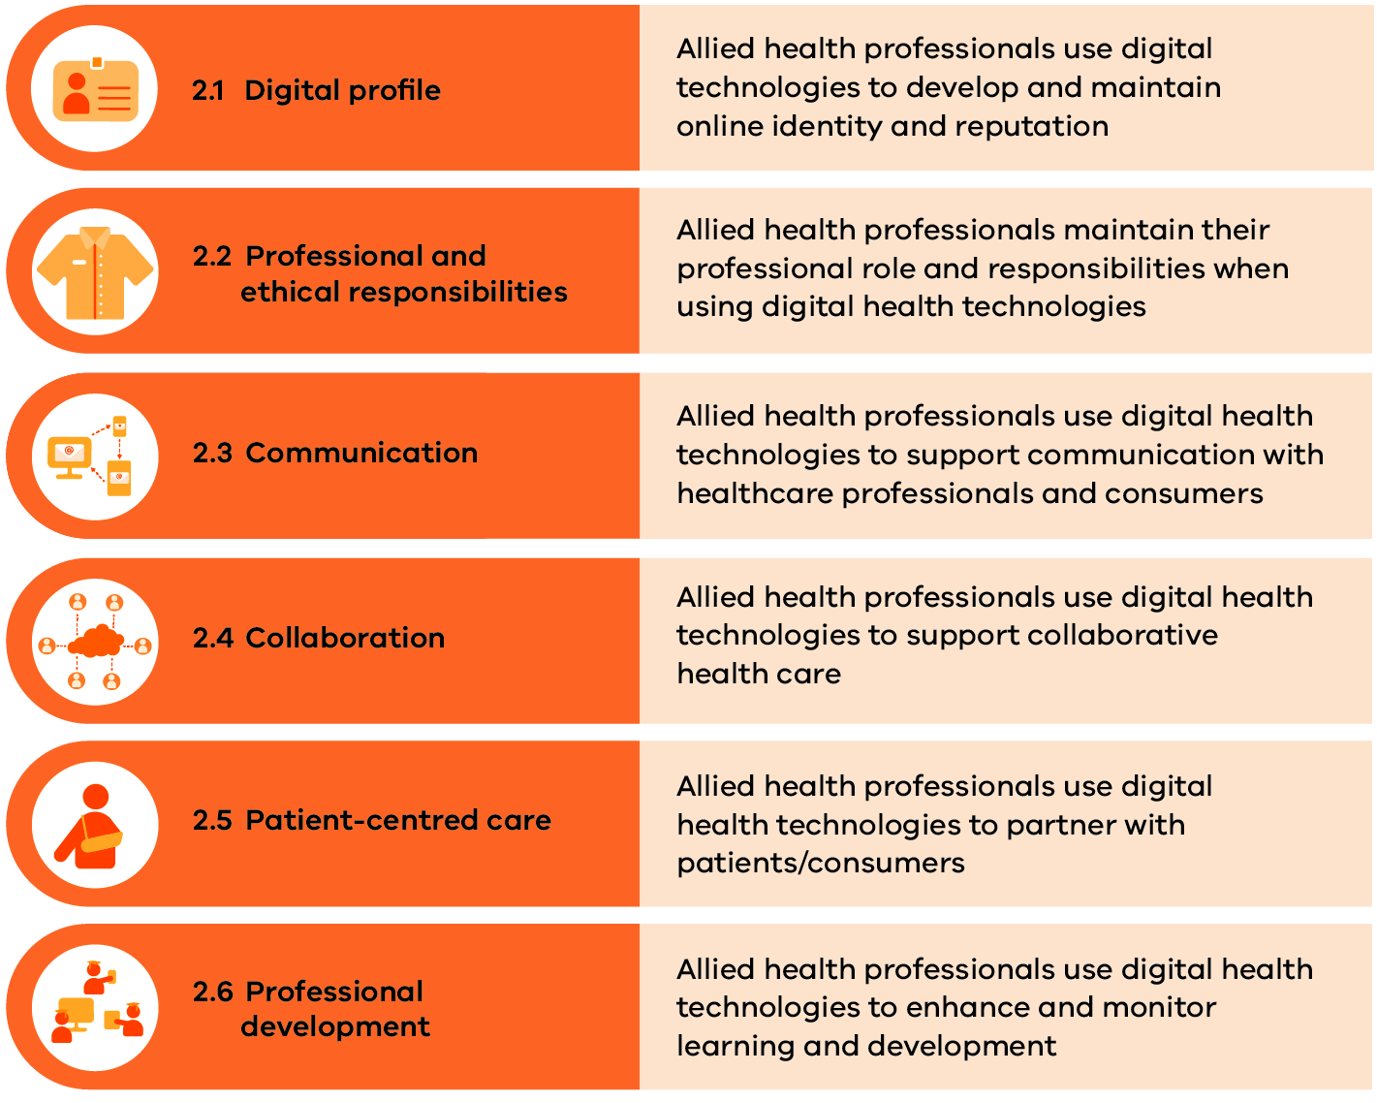
‘Allied health is unique in that it is the bringing together of multiple professions … each with a different care skill set and a different experience, that they then bring into the digital health space.’
- Allied health digital health expert

2.1 Digital profile
Allied health professionals use digital technologies and understand the importance of online identity and reputation
The ability to safeguard information and reduce security risk requires the ongoing protection of organisational and personal login credentials and an awareness of individual digital footprints. This includes understanding how both professional and personal digital activity intersect and impact a digital footprint and personal and professional reputations when moving between digital platforms.
Allied health professionals increasingly use multiple digital devices and channels within the healthcare setting. This means that every professional must securely use and manage their digital identity to protect their patients, themselves and the organisation. For example, maintaining clear separation and delineation between professional and personal online identities ensures personal viewpoints and opinions are not legitimised through either intentional or unintended alignment with a professional role or employer.
Allied health professionals require an understanding of:
- the function of a professional digital profile and the individual-level responsibilities of the profile holder
- the intersect between professional and personal digital profiles and the need for separation to ensure personal versus professional views are clearly identifiable and construed
- activities and actions that contribute to a digital footprint, and mechanisms to safeguard their professional digital identity.
Allied health professionals should demonstrate the following capabilities related to digital profiles:
Capability | Foundation | Consolidation | Expert | Leader
Understand and develop professional a digital identity (or identities) that positively represents the individual health professional and their organisation | I understand why it is important to create and maintain appropriate personal and professional digital identities and the impact this can have on myself and the organisation  I am learning how to develop a professional and personal digital identity | I can create and maintain a professional digital identity  I can contribute to my organisation’s digital identity and reputation | I support others to create positive and professional digital identities and I contribute to my organisation’s digital identity | I manage, monitor and promote a variety of personal, professional and organisational digital identities
Understand the benefits, potential risks and impacts of your digital footprint | I am learning that there are benefits and risks in presenting oneself online, and the potential personal and professional impact  I am aware of the contribution that writings, publications, posts and photos have on my digital footprint in the public domain | I understand the benefits and risks of presenting oneself online and can explain the potential impact at the personal and professional levels  I understand that online posts and activities contribute to my digital footprint, that they remain in the public domain, and I consider how these could affect my digital identity | I understand my organisation’s policies and support others to understand the benefits, risks and potential impacts of presenting oneself online  I propose structure and guidance to appropriately post online content | I adhere to and promote best practice in presenting oneself online, at the professional, organisational, and national levels  I contribute to risk management and governance strategies for issues that arise about online posts or material
Promote and safeguard digital identity, including protecting organisational and personal login credentials | I protect my own digital identity and that of my organisation and understand why this is important | I can identify when my digital identity(ies) may have been compromised and I understand how to escalate | I support others to protect their personal and organisational digital identity  I provide feedback and guidance on negative or inappropriate incidents | I lead and advise others in creating, maintaining, monitoring and promoting individual, team or organisational digital identities  I monitor compliance and oversee communication for any negative or inappropriate incidents  I contribute to policies and guidelines and integrate new strategies on safeguarding digital identity

2.2 Professional and ethical responsibilities
Allied health professionals maintain their professional role and responsibilities when using digital health technologies
The practice of all medical and health professions is governed by professional codes of ethical conduct and practice. With the increased adoption of digital health technologies across all facets of health care, it is important to recognise that professional and ethical responsibilities that apply to traditional practice are similarly applicable to digital health practice environments but may need to be contextualised to address new and emerging ethical issues posed by digital technologies.
The professional and ethical practice of allied health professionals within the digital realm builds on existing profession-specific codes of conduct, codes of ethics and other relevant practice standards such as the ACSQHC’s National Safety and Quality Health Service Standards.
Allied health professionals require an understanding of:
- the importance of maintaining professional ethics and practice standards in applying digital health technologies
- the broad scope of practice of their respective profession, and the fact that digital health technology does not in and of itself alter scope-of-practice boundaries.
Allied health professionals should demonstrate the following capabilities related to professional and ethical responsibilities:
Capability | Foundation | Consolidation | Expert | Leader
Maintain positive, respectful and ethical behaviour when using digital health technologies | I maintain positive, respectful and ethical behaviour when using digital health technologies | I can identify instances that compromise respectful or ethical behaviour and I understand how to escalate | I provide support to others in understanding and maintaining positive, respectful and ethical behaviours when using digital health technologies  I act on or report any instances of unethical behaviour | I lead in demonstrating positive, respectful and ethical behaviour in all interactions with digital health technologies  I monitor compliance and oversee communication when positive, respectful and ethical behaviour is not maintained  I contribute to guidelines, policies and training and orientation on respectful and ethical behaviours when using digital health technologies
Use digital health technologies appropriate to professional role, duties and scope of practice | I know digital health technologies should be used within the boundaries of my professional role, duties and scope of practice  I am aware of the implications of inappropriate use of digital health technologies | I use digital health technology, tools and devices appropriate to my professional role, duties and scope of practice  I understand the implications and report inappropriate professional use of digital health technologies | I support and educate others to use digital health technologies appropriate to their professional role, duties and scope of practice  I act on and report inappropriate professional use of digital health technologies | I lead and promote the use of digital health technologies appropriate to professional role, duties and scope of practice  I contribute to policy and guideline development on professional use of digital health technologies

2.3 Communication
Allied health professionals use digital health technologies to support communication with healthcare professionals and patients/consumers
The ability to communicate appropriately and professionally with service users is an important consideration when using digital technology – for example, the ability to demonstrate video ‘presence’ and convey empathy through body language and visual attention. Demonstrating an understanding of how technical presentation issues such as lighting and video quality affect communication, is important to maximise the benefits of digital technologies. Respecting unique needs, expectations, cultures and experiences is also crucial.
Allied health professionals use a range of digital technology solutions and platforms to accurately share information and ideas. This requires an understanding of the function of the modality and the context in which it is being used including:
- the intended audience (such as medical/health professionals, patients/consumers or family and carers)
- the form of communication and techniques used
- the characteristics of the users and the technologies employed.
Allied health professionals require an understanding of:
- the range, purpose and functions of digital helath technologies availble to support communication in health care
- methods and techniques to optimise professional communication via digitial technologies.
Allied health professionals should demonstrate the following capabilities related to communication:
Capability | Foundation | Consolidation | Expert | Leader
Use digital health technologies to provide accurate and timely communication | I know there are different methods of communication available using digital health technologies, and these will vary according to purpose and audience  I recognise the importance of using digital health technologies to provide accurate, timely and complete communication for clinical care, such as handover or when transferring care  With guidance, I can use digital health technologies to communicate with others | I employ different methods to communicate using digital health technologies according to purpose and audience  I recognise issues when using digital health technologies to communicate and I understand how to escalate  I use digital health technologies to provide accurate, timely and complete communication for clinical care | I support and educate others about different methods of communication using digital health technologies depending on purpose and audience  I propose solutions to reported issues with digital health technologies used for communication  I educate others on the importance of using digital health technologies to provide accurate, timely and complete communication for clinical care  I participate in decision-making forums when choosing new digital health technologies for communication | I ensure there are allied health guidelines to facilitate staff using the recommended method of communication for defined purposes and audiences  I promote the importance of using digital health technologies to provide accurate, timely and complete communication for clinical care  I evaluate the risks and benefits for allied health of new digital health technologies available for communication  I represent allied health in decision-making forums when choosing new digital health technologies for communication
Communicate using digital health technologies in an appropriate and professional manner, and recognise inappropriate or harmful communication | I act in an appropriate and professional manner when using digital health technologies to communicate  I am aware that communication can be inappropriate or harmful to others | I recognise inappropriate or harmful communication and I understand how to escalate | I support and guide others to communicate in an appropriate and professional manner when using digital health technologies  I recognise and act on inappropriate or harmful communication and support others to do the same | I contribute to policies and guidelines on inappropriate or harmful communication using digital health technologies  I encourage, support and lead in recognising and acting on inappropriate or harmful communication

2.4 Collaboration
Allied health professionals use digital health technologies to support collaborative health care
Digital technologies are used to collaborate, share and exchange information in an accurate and timely way in line with relevant laws, regulations and guidelines.
Allied health professionals actively participate in online networks and communities to engage with their patients, as well as to develop collaborative working relationships with other medical and health professionals both within and external to their organisation. Methods and tools that support online and digital collaboration include email, teleconferencing, virtual environments, cloud-based platforms and webinars.
Allied health professionals require an understanding of:
- digital health technologies that enable secure connection, collaboration and information sharing with other medical and health professionals
- the potential benefits of engaging in digital platforms and online networks
- digital health technologies that support collaborative relationships with individual patients/consumers and/or population groups.

Allied health professionals should demonstrate the following capabilities related to collaboration:
Capability | Foundation | Consolidation | Expert | Leader
Appropriately use digital health technologies to collaborate with other health professionals | I know there are a range of digital health technologies available for online/digital collaboration such as document sharing and cloud storage systems  With support and guidance, I can use digital health technologies to collaborate and share my knowledge and experience | I seek opportunities to collaborate and to share information with others (in my own profession and interdisciplinary) using digital health technologies | I initiate and manage digital collaborative work with other health professionals using a wide range of digital health technologies  I support others to use digital health technologies to collaborate with other health professionals | I encourage others and lead in initiating and supporting digital collaborative spaces and projects  I lead in ensuring sustainability and provide governance in collaboration projects
Actively participate in and across collaborative digital networks | I am aware of digital health networks and their key audiences | I participate in collaborative digital networks | I initiate and manage the content of collaborative digital networks  I advocate for changes to collaborative digital networks | I support others and lead in initiating and working across collaborative digital networks
Use digital health technologies to engage and collaborate with consumers and the public | I am aware that digital health technologies can be used to engage and support collaboration with consumers and the public  I am learning about the processes, resources and guidelines available to engage with consumers  With support, I can seek consumer reviews and input into projects using digital health technologies | I understand the processes, resources and guidelines available to engage and collaborate with consumers and the public  I can select appropriate digital health technologies to engage and collaborate with consumers and the public  With support, I can seek consumer reviews and input into projects using digital health technologies | I support and guide others to use digital health technologies to engage and collaborate with consumers and the public  I can seek consumer reviews and input into projects using digital health technologies  I use digital health technologies in co-design processes | I lead in contributing and developing policies and guidelines in using digital health technologies to engage and collaborate with consumers and the public  I actively participate in digital health communities of practice  I assist with planning and delivering digital events to engage and collaborate with consumers and the public

2.5 Patient-centred care
Allied health professionals use digital health technologies to partner with patients/consumers
Digital health technology enables the delivery of person-centred care that empowers patients/consumers to build their health literacy and take increased ownership of their personal health information.
Allied health professionals and patients/consumers (and their families and carers) are equal partners in the treatment planning process to ensure care is tailored to the individual’s clinical presentation and their personal preferences and values.
Allied health professionals require an understanding of:
- the application of digital health technologies to support patient/consumer choice, control and empowerment in healthcare decision making
- various digital resources that support patient/consumer access to high-quality healthcare information and build knowledge
- methods by which patient/consumer informed choice and health literacy may be fostered.
Allied health professionals should demonstrate the following capabilities related to patient-centred care:
Capability | Foundation | Consolidation | Expert | Leader
Appropriately use digital health technologies to provide patient care and assist patients or consumers to access and use these technologies | I am learning about different digital health technologies available to provide patient care  With support, I can use digital health technologies to provide patient care and assist patients or consumers to access and use these technologies | I use different digital health technologies to provide patient care  I assist patients or consumers to access and use digital health technologies  I can identify access or functionality issues that occur when using digital health technologies for patient care and know how to escalate | I use a wide range of digital health technologies to provide patient care and assist patients or consumers to access and use these technologies  I support others to use different digital health technologies to assist patients or consumers in their health care  I advocate for patient or consumer access to digital health technologies  I contribute to solutions to patient or consumer access or functionality issues | I lead and develop policies, guidelines, resources and educational material to assist patients or consumers to access and use digital health technologies  I advocate for and include patient or consumer access to digital health technologies in planning, strategy, budgets and project implementation  I monitor and guide on access or functionality issues that occur when using digital health technologies for patient care
Use digital health technologies to educate patients or consumers | I am aware of the digital resources available to access and use in educating patients or consumers  With support, I can use digital health technologies to educate patients or consumers | I use digital health technologies to educate patients or consumers  I access a range of digital resources to use in educating patients or consumers | I support and guide others to use digital health technologies to educate patients or consumers  I assess the quality and currency of a range of digital resources and recommend which to use to educate patients or consumers  I contribute to the digital resources available for patient or consumer education | I promote the use of digital health technologies to educate patients or consumers  I advocate for and lead in developing digital resources to educate patients or consumers
Facilitate health literacy and informed decision making in partnership with patients or consumers | I am aware of the need to consider the health and digital literacy, access to technology and preferences of patients or consumers when engaging them in healthcare decision making  I am learning about patient-generated data and the benefits, challenges and potential risks to patient care and patients or consumers | I understand the importance and need to consider the health and digital literacy, access to technology and preferences of patients or consumers when engaging them in healthcare decision making  I understand and can explain patient-generated data and the benefits, challenges and potential risks to patient care and patients or consumers | I educate others on the importance and need to consider the health and digital literacy, access to technology and preferences of patients or consumers when engaging them in healthcare decision making  I create resources and contribute to policy development on patient-generated data and the benefits, challenges and potential risks to patient care and patients or consumers | I promote the importance and need to consider health and digital literacy, access to technology and preferences of patients or consumers when engaging them in healthcare decision making  I lead in creating resources and developing strategic policies on using digital health to facilitate and improve health literacy and informed decision making in partnership with patients or consumers

2.6 Professional development
Allied health professionals use digital health technologies to enhance and monitor learning and development
A range of digital tools, platforms and technologies are used to teach, coach and mentor others, including learning management systems, collaboration platforms and portals, game-based learning apps and webcasts.
Continuing professional development for allied health professionals can and should incorporate new digital information-sharing approaches and platforms that enhance clinical practice capabilities, as well as using systems-level digital applications that manage and monitor self-development and learning outcomes.
Allied health professionals require an understanding of:
- available digital health technologies relevant to their professional discipline and/or practice context
- digital health technologies and tools available to support continuing professonal development and the efficient and effective adminstration of learning and development programs.
Allied health professionals should demonstrate the following capabilities related to professional development:
Capability | Foundation | Consolidation | Expert | Leader
Source relevant literature on current and emerging digital health technologies within professional and work contexts | I am aware of the importance of keeping up to date with current and emerging digital health technologies  With support and guidance, I can source relevant literature on current and emerging digital health technologies within my own professional and work contexts | I can source and review relevant literature on current and emerging digital health technologies within my own professional and work contexts | I guide and support others on how to find relevant literature on current and emerging digital health technologies within their own professional and work contexts  I source, review and critically evaluate relevant literature on current and emerging digital health technologies within my professional and work contexts and consider their suitability within my organisation | I lead in contributing to and promoting relevant literature on current and emerging digital health technologies within professional, organisational and wider health system contexts
Use digital or online resources to participate in, manage and monitor continuing professional development (CPD) | I am aware of the different digital or online resources available that can support learning and self-development or monitor CPD  With support, I can use digital or online resources to participate in and manage and monitor my learning and CPD | I use a range of digital or online resources to participate in and manage and monitor my learning and CPD  I am aware of the benefits and limitations to learning and self-development using digital or online resources | I use a wide range of digital or online resources to support and participate in my own personal and professional learning and self-development needs  I guide and teach others to use digital or online resources to participate in and manage and monitor their learning and CPD  I use digital or online resources to manage and monitor my own and others’ learning and CPD  I evaluate the appropriateness of different digital or online resources to deliver learning | I contribute to digital and online resources to support learning and development  I teach, coach, mentor and train using a wide and flexible range of digital or online resources suited to the needs of my learners  I understand the context of professional development technology applications and the cost-benefit in terms of patient outcomes and ensure risk minimisation strategies  I foster a positive culture to optimise or enhance digital or online professional development resources

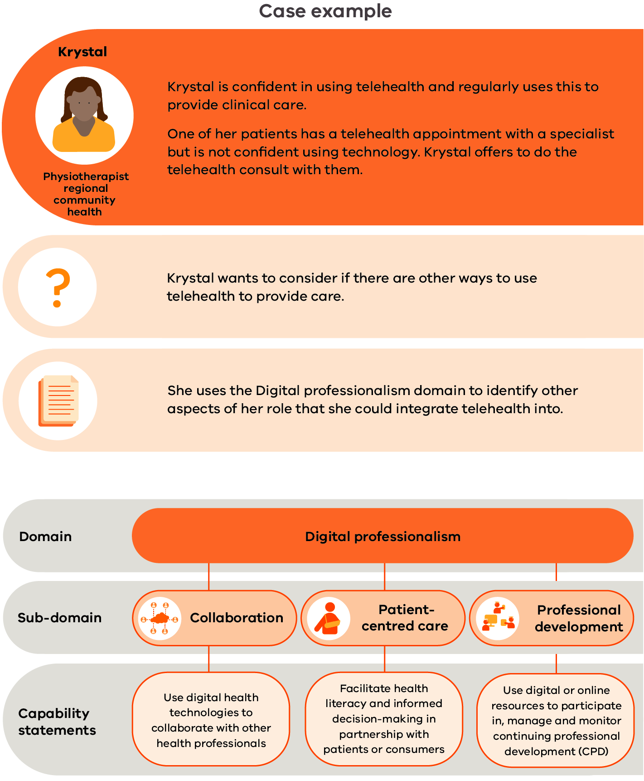

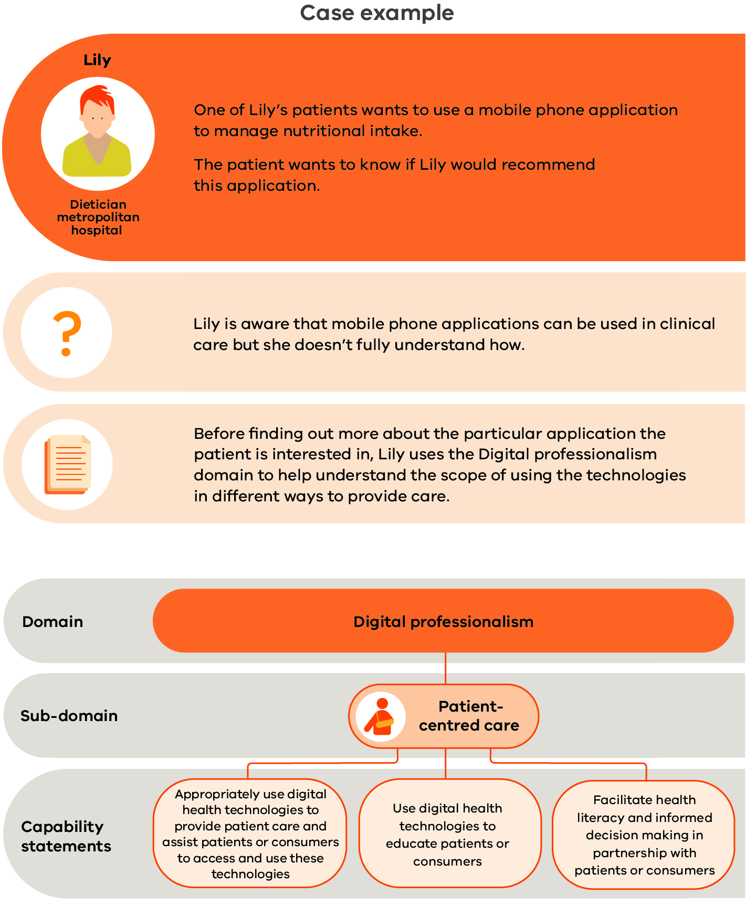

Domain 3: Data and informatics
Collecting and collating data, analysing results and applying knowledge to inform allied health practice
Data is essential to health care and improving health outcomes. Accessing data is routine practice in delivering care. Allied health professionals will also input data – for example, in an electronic medical record or when collecting clinical outcomes.
Clinical informatics is the collation and analysis of data and information from digital technologies to develop integrated approaches to improve health care (AMIA 2019). This can include patient care, patient outcomes and service delivery. To maximise the potential of technology, it is essential to analyse data and translate this information into knowledge.
Allied health professionals are already a data-driven group, using data for quality improvement activities and research to inform evidence-based practice.
Digital health increases the availability of data, the volume of data collected and the number of sources where it can be obtained. Allied health professionals need to recognise that data can be collected from many sources and that quality data input builds trust in the results of data analysis.
The five sub-domains in Domain 3 are described in Figure 10.
Figure 10: Data and informatics sub-domains
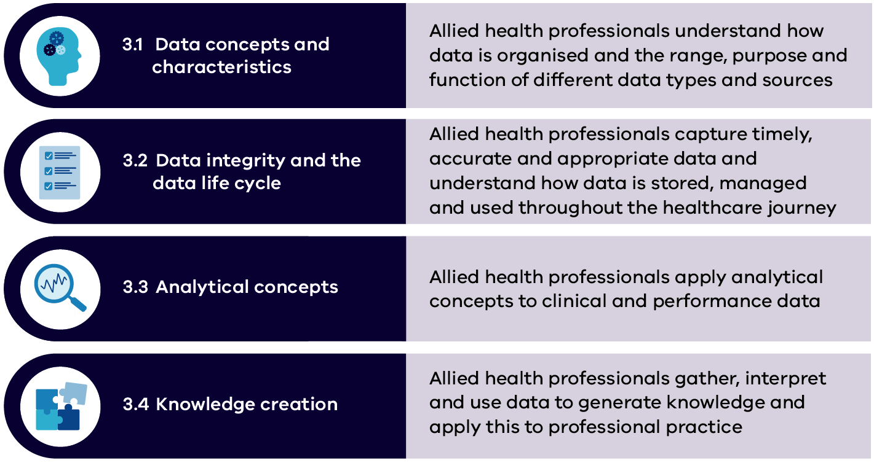
‘Collecting meaningful data to inform decision making and service delivery … and show the value of allied health.’
- Allied health digital health expert

3.1 Data concepts and characteristics
Allied health professionals understand how data is organised and the range, purpose and function of different data types and sources
Health services use a range of data sources for data collection and reporting such as data dictionaries, hospital data reporting, the Victorian Health Incident Management System minimum dataset, patient experience and outcomes data and clinical quality registries. The quality of data can be assessed in relation to key data characteristics: accuracy, completeness, reliability, relevance, and timeliness, which are indicators of data quality.
An understanding of the different data sources, structures and characteristics supports allied health professionals to effectively identify and analyse relevant data to draw clinical insights, inform decisions and develop appropriate treatment plans with greater acuracy, resulting in enhanced patient care.
Allied health professionals require an understanding of:
- the various uses and applications of high-quality data in clinical decision making and in healthcare service delivery and business operations
- different data sources and data structures and their respective benefits, risks and limitations.
Allied health professionals should demonstrate the following capabilities related to data concepts and characteristics:
Capability | Foundation | Consolidation | Expert | Leader
Understand why, how and when data is used in health care and the need for quality data input | I am learning about why, how and when data is collected in health care and its role in improving patient care and health service delivery  I am learning about the importance of quality data collection and its impact on health care | I understand why data is collected and that it is used in different ways, at different times and for different purposes across health care  I understand how to ensure data is of acceptable quality and the impact that data quality has on data collection in health care | I support others to understand the importance of entering quality data, why, how and when it is collected in health care and the role it plays in improving patient care and service delivery  I educate others on the importance of quality data and how to obtain high-quality input  I evaluate data input for quality and accuracy and provide feedback if there are issues | I provide leadership and guidance to others on the importance of entering quality data and its impact on data collection, why and how it is collected and when it is used across health care  I contribute to and lead in policy and guideline development on appropriate and professional accessing of data  I lead governance processes to ensure relevant and necessary data is collected
Understand and recognise different data sources and structures and their associated benefits, risks and limitations | I know there are different data sources  With support and guidance, I can access different data sources | I access data from a variety of data sources  I understand data structures and their benefits and limitations  I evaluate data quality from multiple sources and understand the implications of data reliability on planning, decision making and operations | I guide and support others to access a variety of data sources and to identify the right quality data source for the right circumstance  I design and develop data structures to collect high-quality data | I ensure the reliability, quality and integration of different data sources  I guide and contribute to data structure design and development

3.2 Data integrity and the data life cycle
Allied health professionals capture timely, accurate and appropriate data and understand how data is stored, managed and used throughout the healthcare journey
The data life cycle refers to the sequence of stages that a particular unit of data goes through from its initial generation or capture to its eventual archival and/or deletion at the end of its useful life. Various levels of security and privacy may be applied to different data sources and types (for example, public, personal, consumer or confidential information) and at different points of the data life cycle. Refer to sub-domains 1.1 and 1.2.
The ability to find, manage, organise, store and share data is an essential element for allied health professionals working within a digital context and requires an understanding of the data life cycle. Health service guidelines, regulations and safeguards are helpful resources to assist allied health professionals to meet the legal, ethical and security requirements within each data life cycle stage. Refer to sub-domain 2.2
Allied health professionals require an understanding of:
- the data life cycle, how data is created, stored, used, maintained, shared, linked across systems (interoperability), archived and destroyed
- data integrity and the importance of complete, timely, valid and accurate data.
Allied health professionals should demonstrate the following capabilities related to data integrity and the data life cycle:
Capability | Foundation | Consolidation | Expert | Leader
Understand the data life cycle | I am learning about the elements of the data life cycle and its role in health care  I gather and create data that contributes to the data life cycle | I understand the elements of the data life cycle | I teach others to understand the elements of the data life cycle  I create, access, evaluate, edit, monitor, manage and share data and information | I provide leadership and guidance on using, editing, storing and sharing of data and information that others create or are responsible for  I identify data requirements and support others to be responsible for data they create, manage and share
Understand and recognise the role of data integrity in health care | I am aware of my role in ensuring data entered is complete, timely, valid and accurate to ensure data integrity  With assistance, I can create data that is complete, timely, valid and accurate | I ensure the data I create is complete, timely, valid and accurate  I evaluate data integrity from other sources | I educate others on data integrity and the importance of ensuring data entered is complete, timely, valid and accurate  I evaluate data integrity and identify strategies to improve integrity or acknowledge limitations when using data | I lead and promote the importance of the data that others create or are responsible for being complete, timely, valid and accurate
Understand system interoperability and its impact on data in health care | I am learning about system interoperability and its impact on data | I understand system interoperability and its impact on data  I know which systems are linked and understand the benefits and risks of systems that are linked and those that are not | I guide and educate others on system interoperability and its impact on data  I consider potential data implications and the relationship with system interoperability when evaluating new digital health technologies | I lead in advocating the importance of system interoperability and its impact on data in procuring digital health technologies

3.3 Analytical concepts
Allied health professionals apply analytical concepts to clinical and performance data
Allied health practice is based on an evidence-based paradigm. Allied health professionals therefore need to develop skills in identifying, using and analysing complex data to inform care. This requires critical thinking skills, knowledge of data linkages, analytics tools and methods, and an understanding of how data informs and influences clinical decision making and the care provided.
Allied health professionals require an understanding of:
- common terminology that is used to describe data that has been analysed and underpins evidence-based practice
- data indicators and trends that suggest positive or negative patient outcomes and may influence clinical decision making and service delivery.
Allied health professionals should demonstrate the following capabilities related to analytical concepts:
Capability | Foundation | Consolidation | Expert | Leader
Understand data terminology and descriptive statistics | I understand the basics of data terminology and descriptive statistics | I can accurately use data terminology and understand descriptive statistics | I support others to understand data terminology and basic descriptive statistics  I guide, monitor and evaluate others’ use of data terminology and descriptive statistics | I provide advice and leadership in data analytics terminology and concepts
Use healthcare data and apply data analytics tools and methods to improve clinical care or service delivery | I am aware of the various tools and methods available to analyse data  I am aware of the purpose and importance of data analytics in health care and how it can be used to improve clinical care or service delivery | I understand the range and purpose of different data analytics tools and methods of data analytics  I can identify relevant data and I can appropriately use and apply data analytics tools and methods  I can edit and modify small to moderate datasets such as removing duplicates/outliers or identify incomplete datasets | I apply advanced data analytics tools and methods to complex datasets  I guide and teach others to use data analytics tools and apply data analytics methods  I monitor and evaluate how others use data analytics tools and methods  I can edit and modify large-scale data from multiple sources such as removing duplicates/outliers or identify incomplete datasets | I facilitate and provide access to descriptive statistical software and resources  I promote the use of data analytics to inform decision making  I provide advice and leadership in data analytics tools and methods

3.4 Knowledge creation
Allied health professionals gather, interpret and use data to generate knowledge and apply this to professional practice
Knowledge creation refers to the various methods of collating, explaining and understanding data to inform decision making. Data visualisation (the graphical representation of data and information) is an accessible way to communicate data trends, outliers and patterns to inform decision making. Visual elements such as charts, graphs, maps and dashboards can be created through a range of visualisation tools.
By gaining familiarity with health service data sources and content, allied health professionals may develop and enhance their digital literacy capabilities and more effectively use data to inform best practice.
Allied health professionals require an understanding of:
- available data sources and data types
- data analysis and synthesis methods to critically examine, interpret and/or evaluate existing information to generate new knowledge
- methods to support the uptake and translation of new knowledge to inform clinical practice change.
Allied health professionals should demonstrate the following capabilities related to digital data and knowledge creation:
Capability | Foundation | Consolidation | Expert | Leader
Access, interpret and critically evaluate data from various digital sources to apply in professional practice and service delivery | I know there are a wide range of data sources and that there may be limitations in the integrity of some data sources | I access and interpret data from a wide range of sources  I evaluate information and use it to inform changes to professional practice or service delivery | I support and teach others how to select, interpret and evaluate data to inform professional practice or service delivery | I provide leadership and guidance on the accuracy and reliability of the data that is created and how it is used to inform professional practice or service delivery
Use data to inform best practice | I am aware that data can be used to inform best clinical practice and drive research, education, quality improvement and innovation activities | I use data to help inform best clinical practice  I use data to inform and contribute to research, education, quality improvement and innovation activities | I support others to use data to inform best practice  I propose solutions, changes, improvements or innovative practice based on data analysis findings | I encourage and promote using data to inform best clinical practice  I provide leadership on how to best use data in the healthcare setting  I lead forums and committees on the review of data and its application to the healthcare setting
Display data in a visual way to communicate findings | I am aware that data can be displayed visually to communicate findings  I am learning about the benefits and limitations of displaying data visually | I know of a range of tools that can create visual displays of data  I can create visual displays to communicate data findings | I use a wide range of tools to present data in a visual way to communicate findings and enhance decision making  I support and teach others how to use a range of tools to display data visually | I encourage and promote the use of a wide range of tools to display data to communicate findings and enhance decision making  I provide leadership on how to best display data

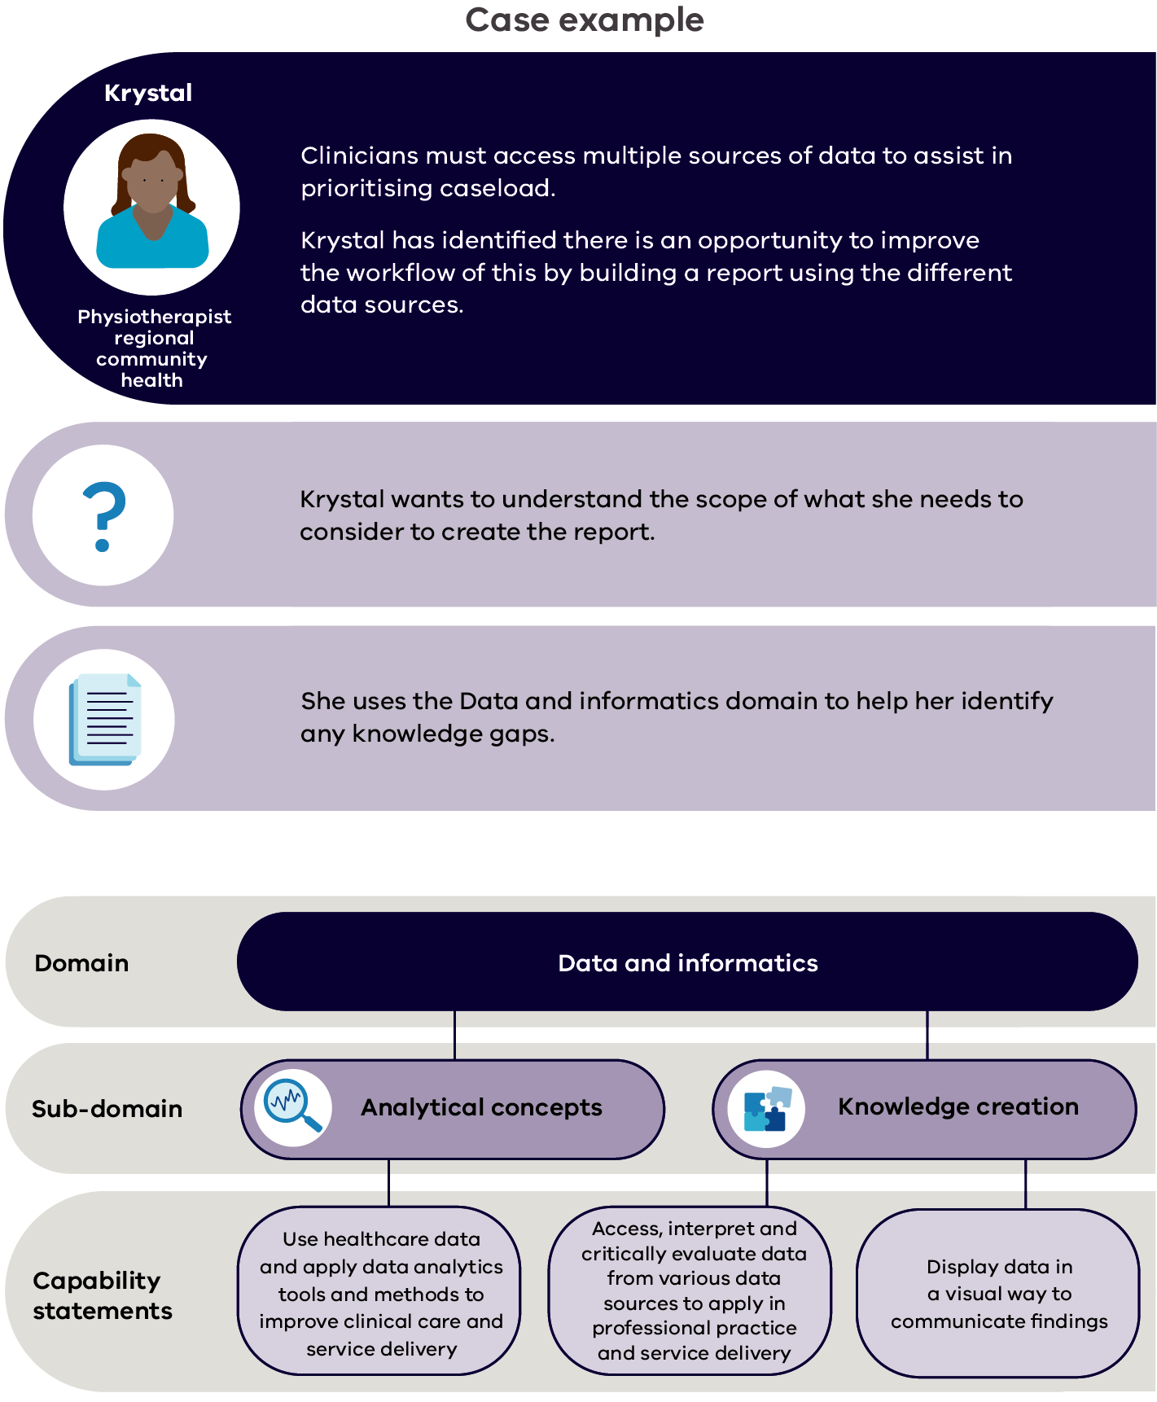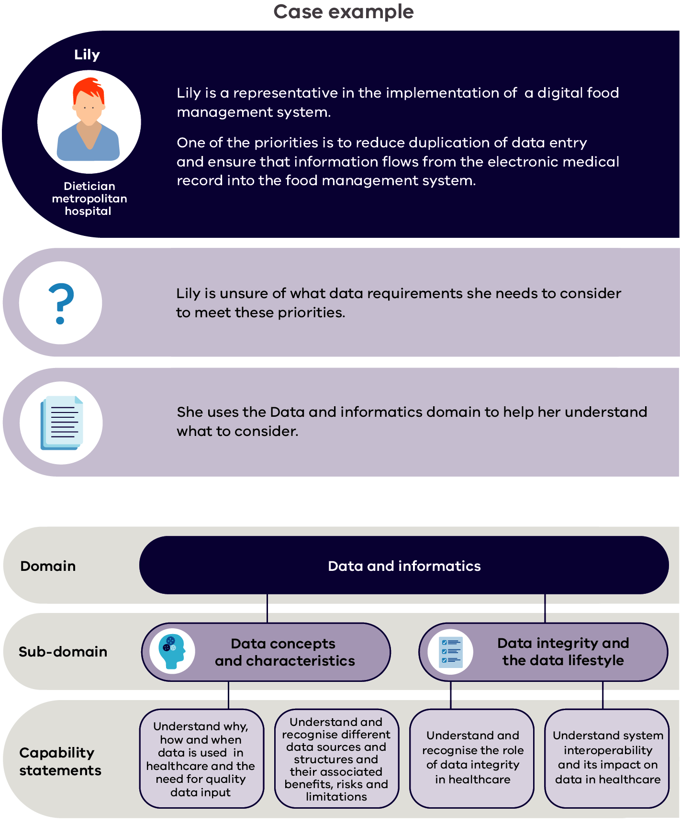

Domain 4: Digital transformation
Using technology to transform allied health practice, services and care
Digital health is often described as disruptive (Deloitte 2019; Manyika et al. 2013; Singal & Carlton 2019), as technology advances at an exponential rate and creates significant changes in work practices. This provides a huge opportunity to reimagine how allied health professionals provide care and deliver services. By using technology, processes and workflows can become more efficient.
Allied health professionals need to be curious about how they can use technology to enhance the services and care they provide. Smartphone applications and wearable technology are revolutionising opportunities to partner with patients/consumers and provide integrated services. Patients/consumers can be more involved in their health than ever before, and allied health can significantly contribute to this.
Digital transformation is not only about innovation. It is also about developing and building the right tools for allied health. It is key for allied health professionals to be engaged in generating ideas and designing and building systems and technology. This will ensure developments reflect the processes, workflows and interventions that are unique to allied health.
Once these tools are developed, allied health professionals must also be actively involved and engaged in implementation. Integrating these into usual business will ensure the benefits of optimising patient care or service delivery are met.
The four sub-domains in Domain 4 are described in Figure 11.
Figure 11: Digital transformation sub-domains
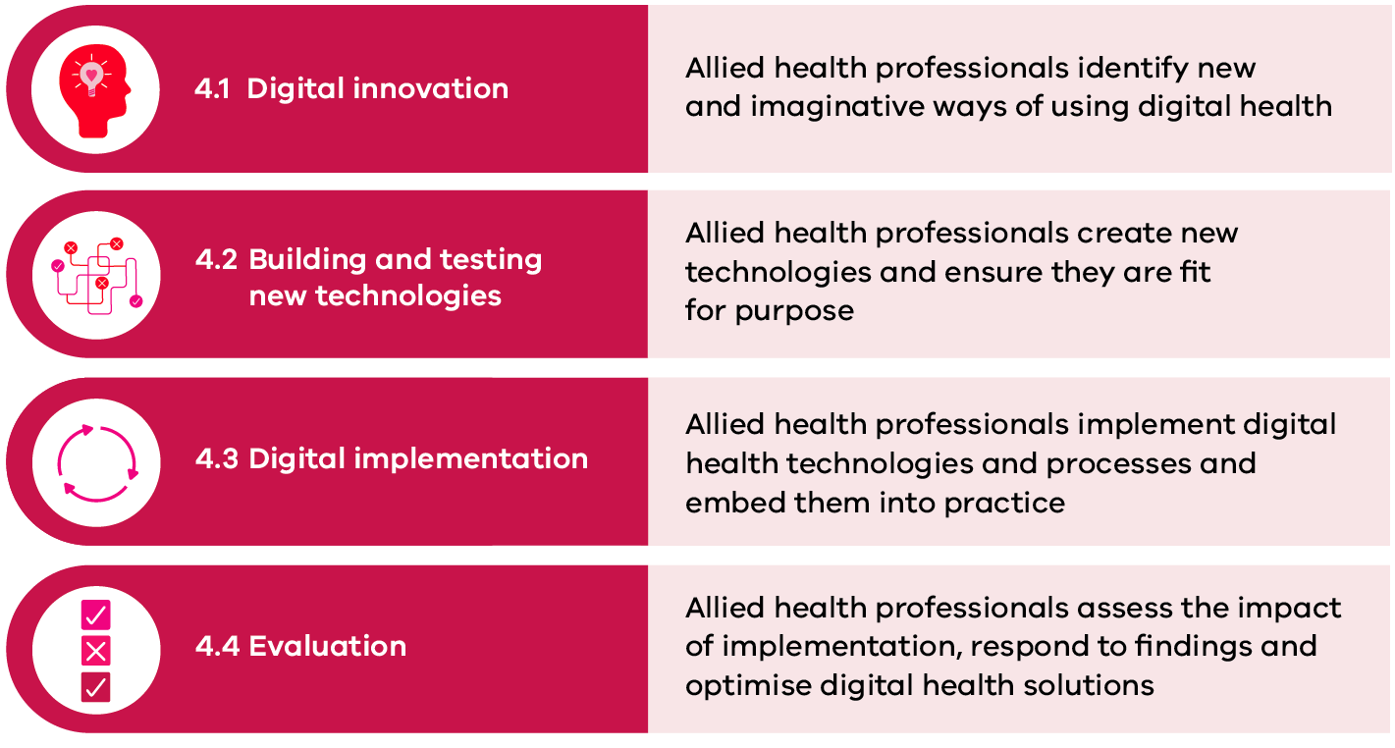

‘Allied health are really interested in doing things in different ways and are perfect for working out what the advantages of any new system are.’
- Allied health digital health expert

4.1 Digital innovation
Allied health professionals identify new and imaginative ways of working using digital health
Active engagement with contemporary digital health technologies and building an awareness of new and emerging developments in health technology helps allied health professionals to identify and explore new and innovative ways of thinking and working.
Allied health professionals understand the potential of new health technologies through analysing the comparative risks and benefits, the efficacy and clinical effectiveness, and through using clinical evidence to inform judgement about impacts on service quality and safety.
Allied health professionals require an understanding of:
- the impact of digital technologies on allied health clinical practice and clinical support functions, and the potential for improved timeliness, quality, safety, efficiency and effectiveness of care delivery.
Allied health professionals should demonstrate the following capabilities related to digital innovation:
Capability | Foundation | Consolidation | Expert | Leader
Recognise the potential of digital health technologies to improve current practice and enable new models of care | I am aware that digital health technologies can improve my current practice and enable new models of care | I recognise the potential of digital health technologies to improve my current practice and enable new models of care  I maintain an active, positive and curious attitude to my current practice and opportunities to use digital health technologies to improve my practice or implement new models of care  I provide feedback and ideas on areas for improvement | I identify gaps in current practice standards and propose digital solutions to improve efficiencies and service delivery  I assess and evaluate new digital health technologies to identify the benefits and limitations | I provide support, guidance and leadership in identifying potential improvements to current practice standards or new models of care using digital health technologies  I provide expertise and guidance in procuring digital health technologies  I participate and contribute to networks and forums on improving practice and service delivery using digital health strategies
Keep up to date with developments in current and emerging digital health technologies and innovations (including the risks and benefits) | I know that digital health technologies and innovations update regularly, and these may impact on how I provide care | I maintain a curious and positive approach to the benefits that new digital health technologies and innovations can bring  I learn about and use updates as they become available (such as new functions, version upgrades or new tools) | I actively research new developments in digital health technologies and innovations, including the benefits and risks  I support and inform the development of new and emerging digital health technologies | I actively engage in and support others in horizon-scanning activities for myself, field, team or organisation  I lead in the maintenance, development and use of new and emerging digital technologies while considering system life cycles

4.2 Building and testing new technologies
Allied health professionals create new technologies and ensure they are fit for purpose
An understanding of the practical application and intended benefits of available digital tools and technologies being used support allied health professionals to more effectively identify gaps and areas of improvement and to confidently engage in processes that adapt or create new digital health solutions.
Engagement in appropriate testing, co-design and co-production methodologies with the right people is important for ensuring digital health solutions developed meet the evolving needs of users and stakeholders and provide opportunities for enhanced interoperability across the health system.
Allied health professionals require an understanding of:
- digital technology options that may enhance the delivery of clinical care and services
- best practice principles that underpin the design, development and establishment of optimal and safe digital health technology solutions.
Allied health professionals should demonstrate the following capabilities related to building and testing new digital health technologies
Capability | Foundation | Consolidation | Expert | Leader
Adapt existing or create new evidence-based digital health resources | I am aware of the importance of evidence-based practice and that digital health resources may need to be updated to reflect new or emerging evidence | I adapt a range of existing digital health resources to reflect new or emerging evidence  I understand the process to create new digital health resources | I guide, support and teach others how to adapt existing digital health resources  I identify opportunities and advocate for creating new digital health resources | I encourage, promote and lead in adapting or creating a wide range of digital health resources  I inform the scope and scale of activities to create new resources
Consider system interoperability in the design of digital health solutions and its impact on clinical workflows | I am learning about digital health technologies and how they integrate with and impact on workflows | I understand the importance of digital health technologies being integrated and the impact that this can have on workflow  I consider system interoperability during the design of digital health solutions | I guide, support and teach others about system interoperability and consider opportunities for enhancing interoperability in the design of digital health solutions  I provide timely feedback on the impact to system integration or professional workflows with changes to digital health technologies | I always consider benefits and risks in choosing or designing digital health solutions and ensure these align with organisational strategies  I actively advocate and promote the impact on organisational workflow when choosing or designing digital health solutions
Work effectively with stakeholders to design, develop and test new digital health solutions | I am aware there are multiple stakeholders involved in designing, developing and testing new digital health solutions | I understand the roles and responsibilities of the multiple stakeholders involved in designing, developing and testing new digital health solutions  I actively participate in testing new digital health solutions | I identify and engage with relevant stakeholders involved in designing, developing and testing new digital health solutions  I actively participate in idea generation, design, development and testing of new digital health solutions | I represent other stakeholders and I participate and engage as a stakeholder in designing, developing and testing new digital health solutions  I support others to be a stakeholder in designing, developing and testing new digital health solutions

4.3 Digital implementation
Allied health professionals implement digital health technologies and processes and embed them into practice
Health care spans multiple sectors. It is imperative that the whole health workforce is appropriately supported to engage with and implement information-sharing platforms and digital health technologies.
Within a digital health environment, allied health professionals take advantage of innovative tools that are not only safe and secure but integrate with their workflow and improve efficiency and care. They collaborate with relevant stakeholders in a coordinated and structured way to provide clear information on processes and rules that support the transition and uptake of data exchange standards and system interoperability.
Allied health professionals require an understanding of:
- traditional allied health clinical workflows and how these translate to a digital health environment
- the direct and indirect risks of delivering traditional allied health assessments, treatments and interventions via digital platforms or using digital health technologies
- potential mitigation strategies to respond to anticipated risks associated with using digital health technologies.
Allied health professionals should demonstrate the following capabilities related to implementing digital health technologies and processes:
Capability | Foundation | Consolidation | Expert | Leader
Implement, use and adopt new digital health solutions | With guidance and support, I can participate positively in implementing and adopting new digital health solutions | I understand my role in implementing and adopting new digital health solutions and actively participate in the process | I actively and positively contribute and participate in planning and implementing new digital health solutions  I support and guide the translation from implementation to business as usual | I lead, support, guide and promote in planning and implementing new digital health solutions using expert change management skills  I monitor and ensure effective transition to new digital health solutions
Work effectively with stakeholders to implement new digital health solutions | I am aware of my role as a stakeholder and actively participate in implementing new digital health solutions | I understand my role as a stakeholder and actively participate in implementing new digital health solutions | I confidently identify and engage with relevant stakeholders involved in implementing new digital health solutions | I provide leadership and guidance in ensuring all relevant stakeholders are identified and engaged in implementing new digital health solutions
Identify and respond to implementation issues | I am aware there can be issues encountered when implementing new digital health solutions | I can identify issues involved in implementing new digital health solutions and provide timely and appropriate feedback | I support and guide others to identify and provide feedback on implementation issues  I identify and act to resolve issues in implementing digital health solutions | I provide leadership and expertise in identifying and resolving complex issues when implementing digital health solutions

4.4 Evaluation
Allied health professionals assess the impact of implementation, respond to findings and optimise digital health solutions
The ability to critically analyse, interpret and evaluate digital health solutions in relation to implementation impacts and the intended benefits is an important element of risk management and value optimisation. Allied health professionals contribute to evaluating digital health technology through a range of activities including monitoring and auditing compliance with data exchange and information-sharing standards, implementation of data tracking and feedback systems and the generation of evidence and knowledge translation that optimise digital health solutions.
Various methods used to evaluate specific aspects of digital health technologies include benefits realisation, barriers and facilitator analysis, program evaluation and end-user experience.
Allied health professionals require an understanding of:
- the importance of evaluating the outcomes and impacts of new digital health technologies to ensure best patient care and service delivery.
Allied health professionals should demonstrate the following capabilities related to assessing the impact of implementation and the optimisation of digital health solutions:
Capability | Foundation | Consolidation | Expert | Leader
Recognise the value of evaluating digital health solutions | I am aware of different methods to evaluate change and the importance of this | I understand there are different evaluation methods that can be used and the value of evaluating digital health solutions | I support and guide others to understand and use the best methods to evaluate digital health solutions  I understand the value of repeated evaluation and can develop an evaluation plan for digital health solution implementations | I actively lead and promote the value of evaluation to assess benefits by guiding and contributing evaluation plans for digital health solutions
Contribute to the evaluation and optimisation of digital health solutions | I am aware that I contribute to evaluating digital health solutions by completing timely and accurate data entry | I actively contribute to evaluation by completing timely and accurate data entry during the implementation of digital health solutions | I monitor and ensure compliance with relevant data collection for evaluation during the implementation of digital health solutions  I analyse evaluation findings, report on benefits and propose recommendations as required, to optimise digital health solutions and identify future innovations or opportunities | I provide guidance and access to system-level data  I lead in advocating and contributing to strategic proposals for further recommendations to optimise digital health solutions and future innovation based on evaluation findings

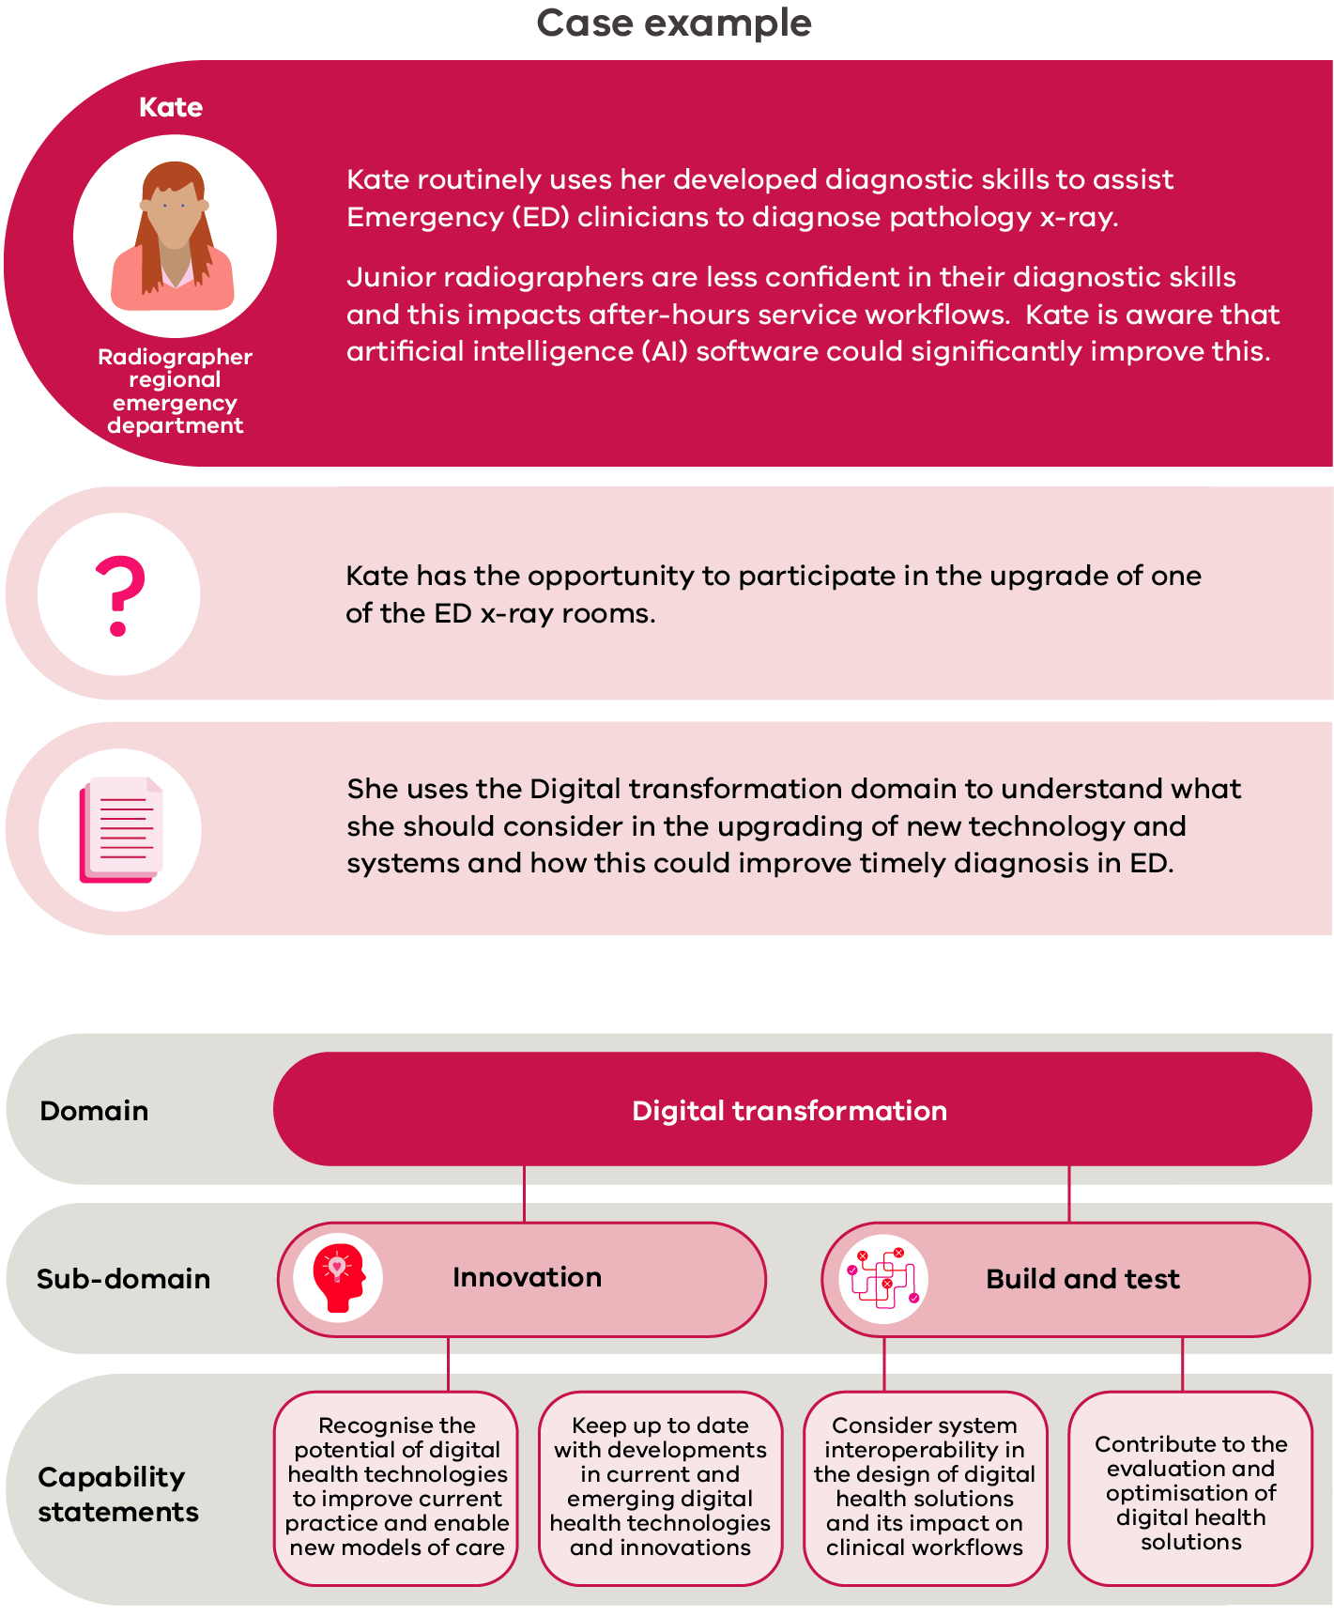

Appendix 1: Project governance committee, expert discussion panels and additional contributors

Project Governance Committee
Andrea Verde, Austin Health
Brit Gordon, Austin Health
Damien Lim, Austin Health
Graeme Hart, Austin Health
Kath Feely, The Precinct
Kenneth Ng, Austin Health
Lynne Keith, Austin Health
Mark Merolli, The University of Melbourne
Nicole Tierney, Latrobe Regional Hospital
Nikki Littlewood, Austin Health
Sharon Downie, Department of Health
Tom Churchward, Austin Health

Project Working Group
Andrea Verde, Austin Health
Damien Lim, Austin Health
Elizabeth Su, Austin Health
Joleen Rose, Austin Health
Tom Churchward, Austin Health

Additional contributors

Resource development
Aarthi Rao, The Royal Melbourne Hospital
Andrew Dao, The Royal Melbourne Hospital
Kathy Maggs, Austin Health
Natalie Shalit, Alfred Health
Natalie Simmance, St Vincent’s Hospital Melbourne
Tanya Gilliver, St Vincent’s Hospital Melbourne

Discussion panel and interview thematic analysis
Abbey Sawyer, The University of Melbourne

Expert Discussion Panel
Alan Pritchard, Austin Health
Alison Qvist, Western Health
Anita Wilton, Eastern Health
Brynn Lewin, Austin Health
Cathie Macmillan, Your Community Health
Christine Hennequin, Spiritual Health Association
David Berlowitz, Austin Health
Dhruv Goval, Northern Health
Doug McCaskie, Alfred Health
Graeme Hart, Austin Health
Heath Miller, Bendigo Health
Jim Sayer, Northern Health
Jo Wrench, Austin Health
Joan Leo, Mercy Health
John Stewart, Eastern Health
Kate Bailey, Austin Health
Kath Feely, The Precinct
Lauren Solomon, Alfred Health
Lynne Keith, Austin Health
Mark Merolli, The University of Melbourne
Mel Gregory, Austin Health
Melissa Fodera, Austin Health
Michael Hosking, Digital Health Consultant, New Zealand
Natalie Simmance, St Vincent’s Hospital Melbourne
Nicole Tierney, Latrobe Regional Hospital
Richard Wu, Eastern Health
Sally Harris, Bendigo Health
Tanya Gilliver, St Vincent’s Hospital Melbourne

Appendix 2: Transcripts of figures and case examples

Figures

Figure 1: Digital health domains
The core theme of the framework is that allied health professionals provide safe and effective high-quality care.
The framework identifies 4 digital health domains that are essential to providing safe and effective high-quality patient care in digital health:
- Domain 1: The digital workplace
- Domain 2: Digital professionalism
- Domain 3: Data and informatics
- Domain 4: Digital transformation.

Figure 2: Digital health domain summary statement
Domain summary statements explain the importance to allied health professionals.
- Domain 1: The digital workplace – Ensuring safe and effective allied health practice in a digital work environment
- Domain 2: Digital professionalism – Requirements of allied health professionals in a digital environment
- Domain 3: Data and informatics – Collecting and collating data, analysing results and applying knowledge to inform allied health practice
- Domain 4: Digital transformation – Using technology to transform allied health practice, services and care

Figure 3: Domains and sub-domains
Each domain is divided into sub-domains, which outline the knowledge and behaviours that allied health professionals are expected to know and demonstrate in that area of digital health.
Domain 1: The digital workplace
- Sub-domain 1: Digital health governance
- Sub-domain 2: Digital health legislation and polices
- Sub-domain 3: Technology and tools
Domain 2: Digital professionalism
- Sub-domain 1: Digital profile
- Sub-domain 2: Professional and ethical responsibilities
- Sub-domain 3: Communication
- Sub-domain 4: Collaboration
- Sub-domain 5: Patient-centred care
- Sub-domain 6: Professional development
Domain 3: Data and informatics
- Sub-domain 1: Data concepts and characteristics
- Sub-domain 2: Data integrity and the data lifecycle
- Sub-domain 3: Analytical concepts
- Sub-domain 4: Knowledge creation
Domain 4: Digital transformation
- Sub-domain 1: Digital innovation
- Sub-domain 2: Build and test
- Sub-domain 3: Implementation
- Sub-domain 4: Evaluation

Figure 4: Capability growth rings
This figure shows that, with increasing experience, allied health professionals work through the levels of foundation, consolidation and expert until they become leaders.

Figure 5: Capability level descriptors
Foundation level: Gaining experience
- Limited knowledge of the area
- Starting to apply knowledge to practice
- Requires support to perform tasks
Consolidation level: Further skills and knowledge
- Developing further knowledge and skills in digital health
- Can complete simple tasks independently
- Requires guidance to perform more complex tasks
Expert level: Becoming and expert
- Advanced knowledge and skills
- Able to apply and evaluate
- Support, guides and educates peers
Leader level: Acknowledged leader
- In-depth knowledge of digital health
- Provides strategic guidance and advice
- Proposes new ideas and concepts
- Integrates and contributes to professional practice at the local, national and international levels

Figure 6: How to use the framework
When using the framework, undertake the following steps to identify your capability level in different domains and sub-domains.
- Step 1: Decide which domain or sub-domain to evaluate.
- Step 2: Explore the content within the domain or sub-domain.
- Step 3: Read the capability statements, across all levels.
- Step 4: Identify the capability level that represents your current ability.

Figure 7: Self-evaluation tool documentation
Use the self-evaluation tool to assess your current level of ability. It is recommended that the self-evaluation tool is completed in the following stages:
- Stage 1: Identify your current capability level.
- Stage 2: Record examples of how you meet the criteria level you choose.
- Stage 3: Reflect on the gaps and create goals to address those learning gaps.

Figure 8: The digital workplace sub-domains
There are three sub-domains within the digital workplace (Domain 1):
- 1.1: Digital health technologies – allied health professionals use technology to provide or enhance health care
- 1.2: Digital health legislation and polices – allied health comply with digital health legislation and policy
- 1.3: Digital health governance – allied health professionals participate in digital health systems and data

Figure 9: Digital professionalism sub-domains
There are six sub-domains in digital profile (Domain 2):
- 2.1: Allied health professionals use digital technologies to develop and maintain online identity and reputation
- 2.2: Allied health professionals maintain their professional role and responsibilities when using digital health technologies
- 2.3: Communication – allied health professionals use digital health technologies to support communication with healthcare professionals and consumers
- 2.4: Collaboration – allied health professionals use digital health technologies to support collaborative health care
- 2.5: Patient-centred care – allied health professionals use digital health technologies to partner with patients/consumers
- 2.6: Professional development – allied health professionals use digital health technologies to enhance and monitor learning and development

Figure 10: Data and informatics sub-domains
There are five sub-domains within data and informatics (Domain 3):
- 3.1: Data concepts and characteristics – allied health professionals understand how data is organised and the range, purpose and function of different data types and sources
- 3.2: Data integrity and the data lifecycle – allied health professionals capture timely, accurate and appropriate data and understand how data is stored, managed and used throughout the healthcare journey
- 3.3: Analytic concepts – allied health professionals apply analytic concepts to clinical and performance data
- 3.4: Knowledge creation – allied health professionals gather, interpret and use data to generate knowledge and apply this to professional practice

Figure 11: Digital transformation sub-domains
There are four sub-domains in digital transformation (Domain 4):
- 4.1: Innovation – allied health professionals identify new and imaginative ways of working using digital health
- 4.2: Build and test – allied health professionals create new technologies and ensure they are fit for purpose
- 4.3: Implementation – allied health professionals implement digital health technologies and processes and embed into practice
- 4.4: Evaluation – allied health professionals assess the impact of implementation, respond to findings and optimise digital health solutions

Case example: Domain 1

Max
Max is a radiographer at a metropolitan hospital.
A patient has had x-rays taken at another organisation and they have been imported to Max’s organisation using external imaging incorporation.
A doctor asks Max to repeat x-rays because they are not clear. Max has had several similar requests about external images recently.
An external imaging incorporation system aims to avoid duplication and improve access to external images, reducing unnecessary radiation to patients.
Max is concerned the system is not functioning as expected.
Max uses The digital workplace domain to understand what capabilities he should develop to guide his actions to mitigate risks to future patient care.

Sub-domain capability statements

Digital health governance
- Understands the advantages, risks and potential challenges associated with digital health technologies

Technology and tools
- Identify the appropriate digital health technologies for different clinical situations
- Use technical knowledge to problem solve and resolve technical challenges

Case examples: Domain 2

Krystal
Krystal is a physiotherapist at a regional community centre and is confident using telehealth and regularly uses this to provide clinical care.
One of Krystal’s patients has a telehealth appointment with a specialist but is not confident using technology. Krystal offers to do the telehealth consultation with them.
Krystal wants to consider if there are other ways to use telehealth to provide care.
Krystal uses the Digital professionalism domain to identify other aspects of her role that she could integrate telehealth into.

Sub-domain capability statements

Collaboration
- Use digital health technologies to collaborate with other health professionals

Patient-centred care
- Facilitate health and literacy and informed decision making with patients

Professional development
- Use digital health technologies to participate in continuous professional development

Lily
Lily is a dietician at a metropolitan hospital and one of her patients wants to use a mobile phone application to manage their nutritional intake.
The patient wants to know if Lily would recommend this application.
Lily is aware that mobile phone applications can be used in clinical care but doesn’t fully understand how.
Lily uses the Digital professionalism domain to help understand the scope of using technologies in different ways to provide care.

Sub-domain capability statements
Patient-centred care
- Use digital health technologies to provide patent care and assist patients to access and use
- Use digital health technologies to educate patients
- Facilitate health literacy and informed decision making with patients

Case examples: Domain 3

Krystal
Krystal is a physiotherapist a regional community centre and must access multiple sources of data to assist in prioritising her caseload.
Krystal has identified an opportunity to improve the workflow by building a report using the different data sources.
Krystal uses the Data and informatics domain to help her identify any knowledge gaps.

Sub-domain capability statements

Analytic concepts
- Use healthcare data and apply data analytic tools and methods to improve clinical care or service delivery

Knowledge creation
- Access, interpret and critically evaluate data from various data sources to apply in professional practice and service delivery
- Display data in a visual way to communicate findings

Lily
Lily is a dietitian at a metropolitan hospital and is a representative in the implementation of a digital food management system.
One of her priorities is to reduce duplication of data entry and ensure that information flows from electronic medical record into the food management system.
Lily is unsure of what data requirements she needs to consider to meet these priorities.
Lily uses the Data and informatics domain to help her understand what to consider.

Sub-domain capability statements

Data concepts and characteristics
- Understand why, how and when data is used in health care and the need for quality data input
- Understand and recognise different data sources and structures and their associated benefits, risks and limitations.

Data integrity and data lifecycle
- Understand and recognise the role of data integrity in health care
- Understand system interoperability and its impact on data in healthcare

Case example: Domain 4

Kate
Kate is a radiographer at a regional emergency department (ED) and routinely uses her developed diagnostic skills to assist ED clinicians to diagnose pathology on x-ray.
Junior radiographers are less confident in their diagnostic skills and this impacts after-hours service workflows. Kate is aware that artificial intelligence (AI) software could significantly improve this.
Kate has the opportunity to participate in the upgrade of one of the ED x-ray rooms.
Kate uses the Digital transformation domain to understand what she should consider in the upgrading of new technology and systems and how this could improve timely diagnosis

Sub-domain capability statements

Innovation
- Recognise the potential of digital health technologies to improve current practice and enable new models of care
- Keep up to date with developments in current and emerging digital health technologies and innovations

Build and test
- Consideration of system interoperability in the design of digital health solutions and its impact on clinical workflows
- Work effectively with stakeholders to design, develop and test new digital health technologies

Glossary
Term | Definition
Change management | A structured approach to managing organisational change and the transition to a desired future state.
Clinical informatics | The application of informatics and information technology to improve health care. Clinical informatics is information used in health care by clinicians (AMIA 2019).
Collaborative digital network | Using digital technologies to connect and collaborate with a broader network of participants, potentially in different professions, organisations and geographic locations (Simon 2017).
Co-design | Active participation of stakeholders or users in the design of systems or processes.
Data | Information that is stored or used by a computer or program.
Data analytics | The analysis of raw data to identify trends or provide insightful information.
Data governance | The formal processes and practices that govern the management of data in an organisation.
Data integrity | Data integrity is the overall accuracy and consistency (validity) of data over its life cycle. Good data integrity requires that data be accurate, consistent, reliable and complete.
Data life cycle | The stages of data throughout its life; how it is created, stored, used and maintained, shared, archived and destroyed.
Data quality | The measure of how useful the data is for its intended purpose. Data quality includes completeness, uniqueness, validity, timeliness, accuracy and consistency.
Data source | Where data is generated/stored, such as electronic medical record, data warehouse, administrative data.
Data structures | A format to organise, process, retrieve and store data. Data structures can take many forms but should contain information about the data values, relationships between the data and functions that can be applied to the data.
Descriptive statistics | Terminology used to summarise data that has been analysed.
Digital copyright | Legal protection for any digital idea or concept (IP Australia 2021).
Digital footprint | The trail remaining from online activities and interactions, examples include websites viewed, social media posts, providing information online.
Digital health | The use of digital, mobile and wireless technologies in health. It is the application of data and information technology to gather, store, retrieve and study to improve processes, services, delivery of patient care and health outcomes.
Digital health legislation | Laws and regulations relating to digital health technologies.
Digital health technologies | A collective term to describe the tools, systems, devices or resources that are used in the provision of care, or to process or store health data.
Digital health policies | Organisational policies relating to digital health technologies such as privacy and confidentiality or social media use.
Digital health solutions | Using digital health technologies to address identified healthcare or health technology problems.
Digital identity | How you interact online, this can be for professional or personal purposes.
Digital situations or events | Any security breach that results in unauthorised access to computer data, applications, networks or devices. Examples of practices that can lead to digital situations are easily guessed passwords, unsafe downloads or phishing emails.
Digital workplace | The technology required to do your job, this includes technology in current operation and those yet to be implemented (Deloitte 2014).
Horizon-scanning activities | A systematic review of potential opportunities, risks and likely future developments in technology.
Intellectual property | The owner of any productive new idea that is created (IP Australia 2021).
Interoperability | The ability of computer systems to exchange information (Oxford Learner’s Dictionaries 2021).
Patient-generated data | Health-related data that is created, captured or recorded by a patient/consumer.
Systems governance | The formal processes and practices that govern the management of information systems or technologies in an organisation.
Telehealth | Healthcare delivery or related activities provided using information and communications technologies (Victorian State Government 2020).

References
American Medical Informatics Association (AMIA) 2019, Clinical informatics. Available from: https://www.amia.org/applications-informatics/clinical-informatics.
Australian Commission on Safety and Quality in Health Care (ACSQHC) 2019, e-Health safety. Available from: https://www.safetyandquality.gov.au/our-work/e-health-safety.
Australian Digital Health Agency 2017, Australia’s national digital health strategy: safe, seamless and secure, Australian Government, Canberra.
Australian Digital Health Agency 2020, National digital health capability framework for nurses and midwives, Australian Government, Sydney.
Australian Institute of Health and Welfare 2018, Australia’s health 2018. Australia’s health series no. 16. AUS 221, AIHW, Canberra.
Brunner M, McGregor D, Keep M, et al. 2018, ‘An e-health capabilities framework for graduates and health professionals: mixed-methods study’, Journal of Medical Internet Research, vol. 20, no. 5.
Deloitte 2014, The digital workplace: think, share, do transform your employee experience. Available from: https://www2.deloitte.com/be/en/pages/technology/enterprise-technology-and-performance/articles/the-digital-workplace.html.
Deloitte 2019, Closing the digital gap: shaping the future of UK healthcare, Deloitte, London.
Department of Health and Human Services (ed) 2016a, Allied health: credentialling, competency and capability framework (revised edition), State of Victoria, Melbourne.
Department of Health and Human Services 2016b, Digitising health, State of Victoria, Melbourne.
Department of Health and Human Services 2019, Allied health career pathways blueprint, State of Victoria, Melbourne.
IP Australia 2021, Copyright for digital products. Available from: https://www.ipaustralia.gov.au/ip-for-digital-business/develop/copyright.
Manyika J, Chui M, Bughin J, et al. 2013, Disruptive technologies: advances that will transform life, business and the global economy, McKinsey Global Institute.
National Health Service (NHS) 2017, Improving digital literacy, National Health Service, London.
Oxford Learner’s Dictionaries 2021, Interoperability. Available from: https://www.oxfordlearnersdictionaries.com/definition/english/interoperability?q=interoperability.
Simon B 2017, Collaboration networks: bringing together a team to accomplish your projects. Available from: https://www.smartsheet.com/collaboration-networks.
Singhal S, Carlton S 2019, The era of exponential improvement in healthcare? McKinsey & Company.
Victorian State Government 2020, About telehealth. Available from: https://www2.health.vic.gov.au/hospitals-and-health-services/rural-health/telehealth/about-telehealth.

