Nurse Practitioners prescribing blood and blood products
Guidance document

Contents
Background 1
Considerations 2
References 6
Appendix 1 – Nurse Practitioner Application Form for blood/blood product scope of practice authorisation 7
Appendix 2 – Portfolio of evidence 9
Appendix 3 – Audit of blood management and transfusion practice 16

Background
Nurse practitioners (NPs) are advanced practice nurses, which is a more autonomous role than that of Clinical Nurse Consultants or Nurse Specialists. NPs have a Master’s degree and are endorsed by the Nursing and Midwifery Board of Australia through AHPRA to provide complete episodes of care, using advanced nursing model of care. The Nurses (Amendment) Act 2000 protected the title ‘Nurse Practitioner’ and made provision for suitably experienced and qualified advanced clinical nurses to be authorised to prescribe a limited range of drugs and poisons under the Drugs Poisons and Controlled Substances Act 1981 (DPCS Act). This may include the prescription of blood and blood products for some NPs.
The Australian College of Nurse Practitioners (2019) stated that the NP scope of practice decisions are guided by the Nursing and Midwifery Board of Australia’s (NMBA) Decision-Making Framework (2019) and best available evidence, such as the Australian NP Metaspecialty Framework. Additionally, nurse practitioners are expected to undertake relevant education and clinical training in order to demonstrate competence in an expanded scope of practice in accordance with the NMBA.
Blood Management Committees, or equivalent, have been approached in some institutions to approve or endorse NP prescribing of blood and blood products within their scope of practice. Currently there is no standard for assessing the need, the quality and safety, or ability of the NP to prescribe blood and blood products and the associated patient management. This document is designed to assist health services and Blood Management Committees to assess these requests, help formulate the organisations standards for NP education to facilitate blood and blood product prescribing where approved.

Considerations
Questions | Assessment | Recommendations
- Is there a need to prescribe blood or blood products in the patient group being care for by the NP? | - How often does this patient group need blood or blood products?  - Which blood or blood products are needed?  - Will this improve the care of patients within the NP’s care? | If the requirement for blood is infrequent, prescribing of blood is not recommended.  Only blood component frequently used should be considered within the SOP.
- What does the scope of practice for prescribing of blood and blood products include? | - Pre-transfusion testing  - Prescribing/ordering  - Consent  - Adverse events and haemovigilence  - Supervising/mentoring others  - Documentation of the transfusion episode, including outcome of the transfusion  - Application of the principals of PBM to prevent unnecessary transfusion | Blood management is a broad area; clinicians who prescribe must also have adequate education to demonstrate their knowledge of all aspects of blood management from prevention of unnecessary transfusions, patient blood management (PBM), pre-transfusion testing and requests, prescribing, management of adverse events, reporting, consent and refusal of blood and adequate documentation of the transfusion episode.
- How will the NP be educated in blood management and transfusion practice (product specific, general)? | - What will be the role of their mentor?  - Is there specific information and special requirements re blood management and transfusion in this group of patients?  - What formal education in blood management and transfusion practice exists, beyond that expected of the registered nurse, and is relevant to the role? What other educational events / courses could assist?  - Is the NP aware of any guidelines that are applicable to this group of patients re blood management and transfusion requirements?  - Is the NP aware of PBM guidelines?  - Consider pre-transfusion testing, prescription and ordering of blood products e.g. IVIg and BloodSTAR.  - Is the NP aware of ANZSBT guidelines for:  - Transfusion and Immunohaematology Laboratory Practice  - Administration of Blood Products  - Prevention of Transfusion Associated Graft-versus-Host Disease? | The mentor(s) must be proficient in selecting appropriate blood products, use of best practice guidelines, administration of the products, recognition and management of potential side effects and adverse reactions.  The mentor must have demonstrated compliance with full prescription requirements.  PBM practices to prevent/reduce the need for unnecessary transfusion in this group of patients, must be included in the education provided and the NP should be assessed as proficient in this area.  The NP must be up-to-date with current national guidelines on blood administration (including relevant PBM modules) and local procedures and policies pertaining to blood product administration.
- How will the NP partner with consumers in their blood management/transfusion practice? | - Is the NP aware of the information available for patients regarding PBM; transfusion and any alternatives and how to access it?  - The NP must be able to obtain consent for blood and blood products in accordance with the organisation policy/procedure.  - The NP must be able to develop plans of care with the patient and include blood and blood products | The NP must understand the principals of obtaining informed consent.  Consent is a process not just a piece of paper. Consent for transfusing blood products includes a description of the intervention, an assessment of risk, benefits and alternatives, and the ability to further discuss options and answer all reasonable questions. The discussion should also include the risk of not transfusing. Written information is a useful adjunct to this process.  Local policies and procedures need to reflect the scope of practice of the NP regarding consent.  The NP must also be able to document and manage, including referral to other health care professionals, the care of patients who refuse consent for blood and blood products.
- Administration and risk reduction | - Understands the need for complete and accurate blood management activities and transfusion documentation and communication of needs to patient, laboratory staff preparing the product and nursing staff administering the product  - Understands the process for ordering blood and blood products  - Understands the requirements for blood testing/ cross matching  - Understands the risks and benefits of transfusion  - Understands the transfusion history and its relevance to risk reduction. | All documentation including the decision to transfuse, must be completed according to local policies and procedures.
- What is the NPs role in management of adverse events? | - Management of reactions and when to refer care (back) to the medical officer?  - Understands the process of reporting adverse events | The NP must take responsibility for adverse outcomes of transfusions which he/she has prescribed  The NP must be trained and demonstrate competency in assessing transfusion reactions and the initial medical management of an adverse transfusion event and know when to escalate provision of care.
- Is endorsement needed from other departments/areas? | - E.g. pharmacy, risk management, Medical unit. (Some manufactured blood products are S4 medications) | Endorsement is required from the head of the transfusion laboratory’ the blood management committee, the head of the parent medical unit and the hospital executive who should ensure that all medico legal ramifications have been adequately addressed. If the blood products are held in pharmacy or are S4 medications, pharmacy may also need to provide endorsement,
- How will ongoing assessment of need and risk be managed/monitored? | Data should be reviewed on a regular basis for:  - Frequency of prescribing  - Appropriateness of the prescriptions  - Use of PBM activities  - Adverse events and their management  Documentation and consent and management of patients who refuse blood | Currency of practice and continuing education are essential components of maintaining scope of practice. Annual review by the parent unit and blood management committee is recommended with documentation of same to maintain extended scope of practice. Assessment of volume of work, adverse events and participation in transfusion related educational events should be included.
- Do current health service policies support the NP to prescribe blood and blood products? | - Will policies/procedures/ guidelines need to be updated changed to support this practice? | Local policies and procedures must be updated to reflect changes in accepted practice

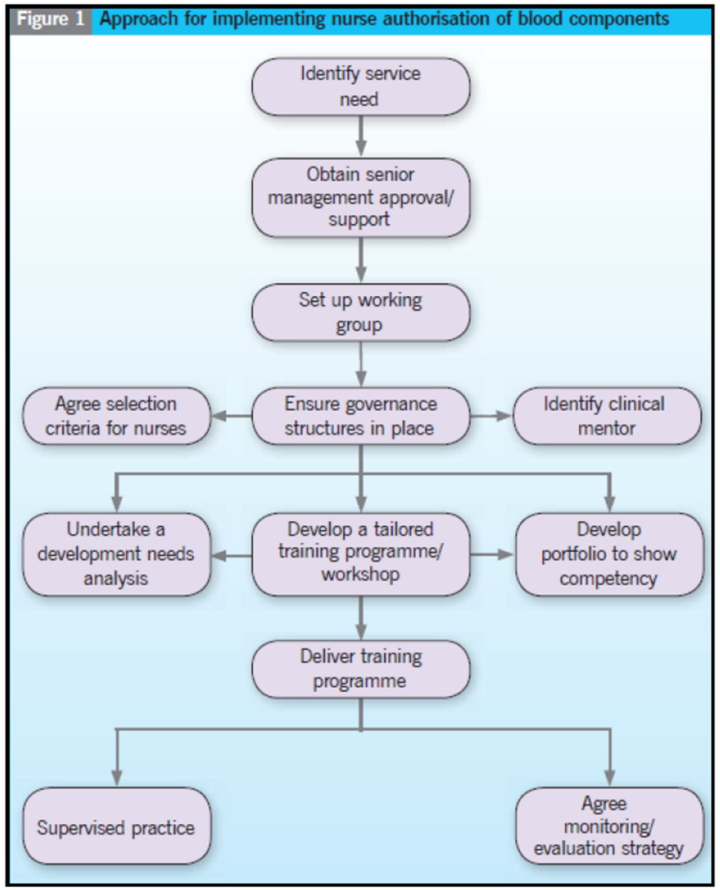
Reference: Kirsty Dalrymple, Jill Martin, Kerri Davidson and Elisabeth Pirie, 2011. Extending the role of a senior haematology or oncology nurse. Cancer Nursing Practice volume 10 number 8.
The above figure is one suggested approach to assess nurse authorisation in the UK. Not all steps may be useful or available to a health service in the Australian setting.

References
- Australian College of Nurse Practitioners position statement, Nurse practitioners scope of practice, 2019 ACNP Position Statement SOP Final 4 12 19
- Dalrymple K, Martin J, Davidson K and Pirie E, 2011. Extending the role of a senior haematology or oncology nurse. Cancer Nursing Practice volume 10 number 8.
- London and South East Regional Transfusion Committees Non-Medical Authorisation of Blood Components Working Group, 2014. Policy Template for the Authorisation of Blood Component Transfusion by Advanced / Specialist Nurses Caring for Adult and/or Paediatric Patients Requiring Transfusion
- Victorian Nurse Practitioner Program (VNPP) Evaluation of Phase 4. Nursing and Midwifery Workforce, Workforce Development (People in Health), Department of Health & Human Services, 2015

Appendix 1 – Nurse Practitioner Application Form for blood/blood product scope of practice authorisation
Section A: To be completed by the applicant
Applicant:
Name (Please print): ……………………………….…………………………
Ward/Department: …………………………………………………………
Area of practice: …………………………………………………………
Blood components/products to be prescribed by the applicant:

Date of Application: …………………………………………………………
Rationale: (Provide details of how this service development will improve patient care without compromising patient safety)

Signature of Applicant: ………………………………………………………

Section B: to be completed by Line Manager
I confirm that I support:
• this candidate as suitable for extended practice
• this application for a service development that will improve patient care without compromising patient safety

Name (Please print): ………………………………………………………….
Signature: …………………………… Date: …………………………..

Section C: to be completed by the Medical Mentor
Name (Please print): …………………………………………………………..……
Ward/Department: ……...…………………………………………………...……
I confirm that (Insert name of applicant) ……………………..........................……….......
has sufficient knowledge and competence in:
• history taking
• physical examination
• advanced communication
• clinical reasoning and decision making
I support this application for extended practice.

Signature: ……………………………………………… Date: ……………………….

Section D: to be completed by Transfusion Committee/Blood Management Committee Chair
Name…………………………………………………………………………………
I agree to the above nurse undertaking education and training for the authorisation of (insert product type) ………………………………………………….. transfusions.
Signature: …………………………… Date: …………………………..

Appendix 2 – Portfolio of evidence
Portfolio of evidence to support nurse practitioners making the clinical decision and providing the prescription for blood component transfusion
Candidate’s name: | Mentor’s name:
Job title: | Job title:
Health service: | Health service:
Ward/Department: | Ward/Department:
This evidence portfolio was based on the document: “A Framework to Support Nurses and Midwives Making the Clinical Decision and Providing the Written Instruction for Blood Component Transfusion,” September 2009.

Introduction:
This portfolio enables nurse practitioners to insert relevant evidence to support their candidacy in transfusion decisions, and blood/blood product prescription.
This evidence may take the form of;
- Training records
- Evidence of previous study covering the knowledge requirements in the attached framework
- Examples of clinical case reports and reflective practice
The evidence should be reviewed and signed by the practitioner’s medical mentor before submission to the appropriate committee to ratify the practitioner as authorised to prescribe [insert relevant blood/blood product] transfusion

Training requirements prior to the competency assessment being completed:
Note: This is not an exhaustive list. Organisation to decide requirements on a local basis and complete as appropriate.

- Must undertake annual mandatory updates on blood management and transfusion practice (as per the Organisation Mandatory Training requirements). For example, BloodSafe eLearning suite of education modules.
- Participate in study days/educational events e.g. webinars etc. as available. For example, the education offered by the Australian Red Cross Lifeblood via Transfusion.com.au located at: https://transfusion.com.au/education
- Undertake further study as deemed appropriate.
Note: The Knowledge and competencies section is a comprehensive list and may not be applicable to all specialist areas. The training requirements for the practitioner should be discussed with the consultant mentor at the start of the training process.

Understanding of | Knowledge and Competencies | Evidence Submitted | Signed
 |  |  | Practitioner |  | Mentor | Date
Patient Assessment and clinical decision making  How to take a patient history  Accounting for co-morbidity  Consent issues  Prescribing of concomitant drugs | Understand the requirement to accurately document all actions and conversations with the patient  Ability to make appropriate referral if the patient refuses blood transfusion or has an advance care directive  Ability to take a medical history  Ability to link the clinical picture with the interpretation of blood results  Understands how to explain the risks and benefits of transfusion and available alternatives  Know to provide patient information leaflets or other forms of information.  Can assess the patient is fit for transfusion i.e. take account of co-morbidities, day case or in-patient  Know which concomitant drugs may be required
Understanding of: | Knowledge and competencies | Evidence submitted | Signed
 |  |  | Practitioner |  | Mentor | Date
Interpreting blood results | Can demonstrate knowledge and understanding  Of normal, variations of normal and abnormal haemoglobin, platelet count, iron studies or any other relevant testing  Ability to interpret results and clinical picture to initiate treatment  Know if more tests and/or further evaluation is required
Ordering blood components | Has knowledge of local guidelines for ordering of blood components and the need to provide the following details:  Full patient identifiers  When the transfusion is to occur and where  How many units and any special requirements  Diagnosis  Indication  Contact name / number
Understanding of: | Knowledge and competencies | Evidence submitted | Signed
 |  |  | Practitioner |  | Mentor | Date
Writing the instruction to transfuse the blood component | Demonstrates knowledge that the written instruction includes  All appropriate patient identifiers in compliance with health service policy  The product type and any special requirements  The length of time the transfusion is to take place  The number of units (single unit transfusion policy where appropriate)  The route of administration  Concomitant drugs that need to be administered
Constituents of blood components | Gain insight into the production from whole blood of  Red cells  White cells  Platelets  Plasma  Has knowledge of  Storage  Safe handling  Temperature control/cold chain requirements
Understanding of: | Knowledge and competencies | Evidence submitted | Signed
 |  |  | Practitioner | Mentor |  | Date
Pre-transfusion testing process | Can demonstrate the requirements of the  Pre-transfusion sampling process  Sample labelling  ANZSBT guidelines for pre-transfusion testing  Time limits surrounding the validity of pre-transfusion samples (group and screen and crossmatch)  The laboratory processes for pre-transfusion testing including how long testing takes
Indications for the use of products to be prescribed | Demonstrates a clear understanding for the use of the product  Uses local policy and national guidelines to demonstrate appropriate use  Can demonstrate in which conditions use is not appropriate
Understanding of: | Knowledge and competencies | Evidence submitted | Signed
 |  |  | Practitioner | Mentor |  | Date
Special transfusion requirements | Demonstrates knowledge and understanding of  Which patient groups have special blood requirements and why  Understands the process to prevent relevant patient’s receiving the blood components that do not meet their specific needs  Understands the requirements for ordering of products with special requirements from the blood bank/pathology
Transfusion guidelines and protocols | Can demonstrate knowledge and understanding of  NBA patient blood management guidelines  ANZSBT Blood administration guidelines and Immunohaematology guideline  Local transfusion reaction and incident reporting systems  State and national requirements for traceability and documentation  Patient information leaflets  BloodSafe e-Learning modules
Understanding of: | Knowledge and competencies | Evidence submitted | Signed
 |  |  | Practitioner | Mentor |  | Date
Risks and adverse events associate with transfusion and how to deal with them | Demonstrates knowledge of the risks of transfusion and describe the management of a patient experiencing a potential reaction  Initial management steps  When to escalate care  Who to contact to escalate care  Communication of urgency of review  Reporting lines for reactions, including to the patient/carers  Consider specific reactions; acute and delayed e.g.  Fluid overload  Anaphylaxis/allergic  Iron overload

Appendix 3 – Audit of blood management and transfusion practice
Audit of blood management and transfusion practice should be undertaken, in line with the healthcare organisations blood management processes. This audit tool is a minimum requirement, specifically aimed at assisting the NP candidate and their mentor to reflect and report on their blood transfusion prescribing practices.
Audit record of prescribed Blood Components
Date | Patient  Medical record number | Component | Rationale for transfusion | Comments on review of transfusion episode | Mentor comments

To receive this publication in an accessible format phone (03) 96940102, using the National Relay Service 13 36 77 if required, or email Blood Matters <Bloodmatters@redcrossblood.org.au >.
Authorised and published by the Victorian Government, 1 Treasury Place, Melbourne.
© State of Victoria, Australia, Department of Health and Human Services June 2021
ISBN 978-1-76096-449-8 (pdf/online/MS word)
Available at Blood Matters < Blood Matters Program - health.vic>

