Contraception methods
Emergency contraception methods

The emergency contraceptive pill – a method used to reduce the chance of a pregnancy after unprotected sex
Method | Emergency contraceptive pill: ulipristal (UPA-EC)  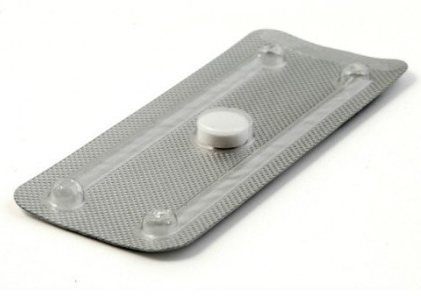 | Emergency contraceptive pill: levonorgestrel (LNG-EC) | The copper intrauterine device (IUD)  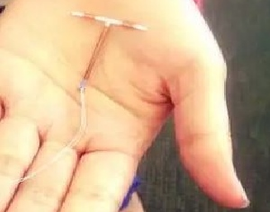
Effectiveness | - Not 100% effective  - More effective the earlier it is taken  - More effective than LNG-EC | - Not 100% effective  - More effective the earlier it is taken  - Less effective than UPA-EC | - 99% if inserted within 5 days of unprotected sex
What is it? | - Prevents or delays the ovaries releasing an egg | - Prevents or delays the ovaries releasing an egg  - May also change the lining of the uterus (womb) to prevent development of a pregnancy | - A small plastic and copper contraceptive device  - Stops sperm from reaching and fertilising an egg
How do you use it? | - Best taken as soon as possible after unprotected sex  - Intended to be taken up to five days (120 hours) after unprotected sex  - Not recommended if you are breastfeeding or taking certain medications. The pharmacist will advise you about this. | - Best taken as soon as possible after unprotected sex  - Intended to be taken up to three days (72 hours) after unprotected sex  - All women can take it regardless of age | - You book an appointment for this procedure, where the IUD will be placed in your uterus by a doctor or a specially trained midwife  - It can then be left in place for up to at least ten years
Where can you get it? | - Available at pharmacies without a prescription | - Available at pharmacies without a prescription | - At a medical appointment with a health professional trained to provide it
Considerations*  * Note: Only condoms protect against sexually transmissible infections (STIs). | - Should not be used as your usual method of contraception  - May cost more than LNG-EC | - Should not be used as your usual method of contraception | - Safe for most women, including young women and those who have never had children

Authorised and published by the Victorian Government, 1 Treasury Place, Melbourne. © State of Victoria, Department of Health and Human Services, January 2019.
Available at <http://healthtranslations.vic.gov.au/>

