A summary and analysis of the

Retail Fruit and Vegetable initiative in

Gippsland, Victoria, Australia. 2014

 |  |  | 

Report prepared by Raeleigh Harris and Claire Palermo

May 2014

Acknowledgements

The Retail Fruit and Vegetable project was made possible through the funding support of the Department of Health, Gippsland. Particular acknowledgement is given to Tim Owen, Lisa Barham-Lomax, Bruce Watson, Rhonda James, Miranda Blake, Breeana Gardiner, Stella Charaktis, and Carena Gee for their comments on this report and also to Christine Choong, Rebecca Lade, Laura Duff, Fiona Blake, Rachel Poh, Emma Armstrong, Amy Fitzgerald, Stephanie Day and Jessica Bruerton for their assistance with the evaluation of the project.

Suggested citation:
Palermo C, Harris R. Health Promoting Retail Outlets. A summary and analysis of the Retail Fruit and Vegetable project in Gippsland, Victoria, Australia. 2014.

Conference presentations and publications

The Retail Fruit and Vegetable project outcomes have been reported in the following conferences and publications:

Gardiner B, M Blake, Harris, R, Gee C, Charaktis S, Choong C, Lade R, Duff L, Palermo, C (2013). "Can small stores have a big impact? A qualitative evaluation of a store fruit and vegetable initiative." Health Promotion Journal of Aust 24: 192–198.

Gardiner B, Gee C, Charaktis S, Choong C, Lade R, Blake M, Duff L, Harris R, Skuja J, Murphy B, Smith B. Palermo, C (2013). "Proving small stores can have a big impact: A qualitative process evaluation.” Public Health Association of Australia National Conference. Melbourne September 2013.

Blake M, Owen T, Collins T, Harris R, Skuja J, Murphy B, Smith B. Palermo, C (2013). "Proving small stores can have a big impact: Program Logic.” Public Health Association of Australia National Conference. Melbourne September 2013.

James, R. “Proving that small stores can have a big impact – Buy Fresh Local” Latrobe Food Forum – Creating Connections with Latrobe’s Food System. Traralgon 4 December 2013.

Palermo C & Owen T – “Improving retail access to fresh fruit and vegetables in small rural communities Local Government demonstration projects” Gippsland Research and Practice Forum, Traralgon 4 February 2014.

Table of Contents

 | Page
Executive summary . . . . . . . . . . . . . . . . . . . . . . . . . . . . . . . . . . . . . . . . . . . . . . . . . . . . . . . . | 6
Setting . . . . . . . . . . .. . . . . . . . . . . . . . . . . . . . . . . . . . . . . . . . . . . . . . . . . . . . . . . . . . . . . . . . | 8
Program Logic . . . . . . . . . . . . . . . . . . . . . . . . . . . . . . . . . . . . . . . . . . . . . . . . . . . . . . . . . . . . . | 8
Project Implementation . . . . . . . . . . . . . . . . . . . . . . . . . . . . . . . . . . . . . . . . . . . . . . . . . . . . | 10
Evaluation methods . . . . . . . . . . . . . . . . . . . . . . . . . . . . . . . . . . . . . . . . . . . . . . . . . . . . . . . . | 22
Project Results and Discussion . . . . . . . . . . . . . . . . . . . . . . . . . . . . . . . . . . . . . . . . . . . . . . . | 25
Conclusions . . . . . . . . . . . . . . . . . . . . . . . . . . . . . . . . . . . . . . . . . . . . . . . . . . . . . . . . . . . . . . . | 43
Recommendations . . . . . . . . . . . . . . . . . . . . . . . . . . . . . . . . . . . . . . . . . . . . . . . . . . . . . . . . . | 44
References . . . . . . . . . . . . . . . . . . . . . . . . . . . . . . . . . . . . . . . . . . . . . . . . . . . . . . . . . . . . . . . | 45
Appendices . . . . . . . . . . . . . . . . . . . . . . . . . . . . . . . . . . . . . . . . . . . . . . . . . . . . . . . . . . . . . . . | 46

Project Executive Summary

The Retail Fruit and Vegetable Project was initiated in Gippsland Victoria, to address access to affordable fresh fruit and vegetables in small rural communities, which were identified as having poor geographical access to healthy food. At the time of the projects inception no other such project existed in Australia. This report has been compiled to describe the project in its entirety to assist health promotion practitioners, local government and health promoting organisations to conduct similar interventions in the future.

In 2011 the Victorian Healthy Food Basket Survey was conducted across the Gippsland region in Victoria, covering six Local Government Areas. The survey identified many small stores in rural towns across Gippsland that did not stock fresh and/or affordable fruit and vegetables, identifying a need to address this gap in the food system. In response to this, all Gippsland Local Government Areas were invited to apply for funding from the Department of Health, Gippsland region to implement the ‘Improving retail access to fresh fruit and vegetables’ project.

The Retail Fruit and Vegetable Project was modelled on two international initiatives that were found to increase sales of fresh fruit and vegetables. The project involved the appointment of a project worker to collaborate with retailers to improve in-store displays, and train retailers in the promotion, positioning and storage of fresh produce. This was augmented by a targeted social marketing strategy and offering material incentives to support retailers to improve their supply of fresh fruit and vegetables.

The project’s purpose was to increase the proportion of adults who consume the recommended two serves of fruit and five serves of vegetables per day in these targeted communities. The project focussed on improving the retail availability, display, price and sales of fresh fruit and vegetables in participating retail outlets through the provision of free and subsidised material incentives to retailers who serve these communities.

Bass Coast Shire Council and East Gippsland Shire Council were successful in each receiving grants of $171,000 to implement the initiative. The funding covered the engagement of a project coordinator to work two days per week for two years in each area. Identified retailers were offered a support package including free point of sale marketing materials, training, subsidised purchase of refrigeration units, ambient displays, in store support and other targeted incentives, all with the aim to improve the retailer’s capacity to increase availability, improve retail positioning and displays, decrease price or increase sales of fresh fruit and vegetables.

The purpose of the project evaluation was to determine how effective the intervention was in improving retail access to fresh fruit and vegetables in the participating stores. This was measured using a variety of tools and methods, and examined specifically availability, range, price, sales, demand, store choice, consumer knowledge and consumption of fresh fruit and vegetables as well as retailer capacity. The evaluation was supported by Monash University Department of Nutrition and Dietetics.

Of the 35 stores eligible to take part in the initiative 21 were engaged across both local government areas. The evaluation found that by offering a variety of customised incentives and social marketing to retailers, awareness and sales can be positively impacted, potentially leading to an increase in fruit and vegetable consumption. The number of stores stocking fresh fruit and vegetables increased from 16 at pre intervention to 21 post-intervention (although ten of the stores stocking fresh fruit and vegetables pre-intervention stocked very small quantities.) The average range of fresh fruit and vegetables increased from nine at pre-intervention to 17 post-intervention.

Substantial in-store retailer support, using only one social marketing message and collaborating with other community projects were strategies found to enhance success. The initiative assisted to promote small stores and communicated that fresh fruit and vegetables were available. The initiative also built the retailers capacity to do business development. It was also found that small stores often provide a community service supporting access to fruit and vegetables where there are no other retailers and were important for building community capacity. Retailers identified geographical distance to wholesalers, time, and lack of available store floor space as barriers to stocking and selling fruit and vegetables.

The findings of the project indicate the use of a settings based approach and fostering partnerships between government and the retail sector may be valuable in health promotion interventions focused on improving healthy eating.

Setting

The wider Gippsland region is a rural area located to the east of Melbourne, with a population of 255,700 people and consists of many townships and small communities(1). Two of the six Local Government Areas (LGA’s) in Gippsland include East Gippsland Shire Council (EGSC) and Bass Coast Shire Council (BCSC). East Gippsland Shire is one of the largest local government areas in Victoria with a population of approximately 43,000 people spread across 21,000 square kilometres(2). East Gippsland is a vast area consisting coastline, farm land and mountains. Bass Coast Shire is located to the south east of Melbourne, encompasses 865 square kilometres of land and has a permanent population of approximately 30,000 people with its unique coastline complemented by hinterland(3). For both regions, tourism and agriculture are major industries, with tourism drawing more than one million visitors each year to each area and the agri-food sector being of vital importance to both areas. In peak season some towns within each LGA can almost double in population. Similar to the rest of Australia, 85 per cent of the Gippsland population fail to consume the recommended number of servings of vegetables, while half do not consume the recommended number of servings of fruit per day(4).

Project Logic
A Project Logic was developed for the strategy. Its aim was to illustrate the association between the problem, intervention and intended outcomes (Figure 1). It served as a guide for the development of the project and evaluation strategies. These are described below.
Priority area: Healthy Eating
Target group: Communities with poor geographical access to fresh fruit and vegetables
Goal: To improve retail access to fresh fruit and vegetables in small rural communities identified as having poor geographical access to healthy food
Objective 1- supply: By December 2013, local participating retailers will offer improved access to fresh fruit and vegetables in small rural communities known to have poor geographical access by:
- Increasing the range and availability of fresh fruit and vegetables
- Reducing the price of fresh fruit and vegetables
- Increasing turn-over of fresh fruit and vegetables
- Improving retailer’s skills to merchandise and manage the fresh fruit and vegetable category

Objective 2- demand: By December 2013, increase demand for fresh fruit and vegetables in participating retailers by:
- Increasing shoppers knowledge of the recommended daily serves of fresh fruit and vegetables
- Increasing the proportion of adults who consume the recommended daily serves of fresh fruit and vegetables
- Increasing awareness of the provision of fresh fruit and vegetables at participating outlets

Target group: Communities with poor geographic access to healthy food in particular fruit and vegetables.
Goal: To increase the proportion of adults living in small rural communities identified to have poor geographic access to healthy food, who consume the recommended 2 serves of fruit and 5 serves of vegetables daily.
Objective 1: By April 2014, local participating retailers will have improved access to fresh fruit and vegetables in small rural communities known to have poor geographic access.
Objective 2: By April 2014 each participating retailer will have acquired the skills to merchandise and manage fresh fruit and vegetables in a manner that promotes sales.
Objective 3: By April 2014 shoppers at participating retailers will demonstrate increased knowledge and consumption of the recommended daily adult serves of fruit and vegetables.
Objective 4: By April 2014 shopper’s preference for purchasing fresh fruit and vegetables from local participating retailers will have increased.

Figure 1. Program logic for the ‘Improving retail access to fresh fruit and vegetables’ project.

Impacts (shorter-term)

Outputs
Activities
Inputs
Outcomes (longer-term)

% increase in the number of adults eating the recommended serves of fruit and vegetables

% of small rural communities (without supermarkets) with local retailers who sell FFV

% increase in the range of FFV available in participating retailers (availability)

% change in the price of FFV available in participating retailers (cost)

% increase in demand for FFV in participating retailers (sales)

% of retailers reported to have achieved improvements in merchandising and management of FFV, and extent of improvement (capacity)

% of shoppers who report increased knowledge of the recommended adult FFV (consumer knowledge)

% of shoppers who have changed their usage of participating retailers in response to local social marketing campaign(s) (behaviour change)

Satisfaction of retailers with the initiative (satisfaction)

Project Team engaged in the implementation of the intervention

Go for 2 and 5 materials and resources included in social marketing plan

Range of incentives made available

Number of non-binding commitments established with identified retailers to increase availability, improve retail positioning, or decrease price of FFV (adoption)

Intervention support package utilised by participating retailers (implementation)

Number of targeted clusters/settings that implement the social marketing campaign (implementation)

Number of participating retailers who purchase subsidised FFV display equipment or incentives (implementation)

Number of participating retailers that sell FFV (implementation)

Number of participating retailers that receive FFV management and merchandising training and support (implementation)

Number and proportion of targeted shoppers who recognise the social marketing campaign (reach)
Problem
Poor geographic access and range of fruit and vegetable available
Only 47.2% and 11.6% Gippsland adult population meeting fruit and vegetable requirements, respectively

Solution
Support small rural retailers through incentives package and social marketing campaign

Resources
Funds dedicated to the provision of point of sales materials and social marketing incentives to retailers

Staffing
- Project Co-ordinator
- Council economic/small business
- Health sector representatives working specifically to increase FFV consumption
- Department of Health representative

Formulation
Local Shire Council(s) to recruit project worker
Establishment of Project Team with membership consisting at a minimum of:
- Project Co-ordinator
- Council economic/small business
- Health sector representatives working specifically to increase fruit and vegetable consumption
- DH representative
- Evaluation academic expertise

Enactment
Staff at Local Shire Council(s) to:
- apply to WA Department of Health to use Go for 2 and 5 materials to support the scheme.
- identify an appropriate set of options for dedicated FFV display equipment, plus incentives.
- develop a package of support for retailers to assist them to implement the scheme, containing the following components:
- Explains the scheme
- Menu of available subsidised display equipment
- Point of sales materials
- Support services – to assist with the management and display of FFV.
Staff at Local Shire Council(s) to identify and recruit a minimum of 20 retailers that service small rural communities known to have poor access to FFV.

Consult and engage with community and Department of Health stakeholders

Implementation
Staff at Local Shire Council(s) to design and implement a local social marketing campaign targeting consumption of fresh fruit and vegetables, and promotion of the availability of FFV at participating retailers
Local Shire Council(s) to facilitate provision of training and ongoing support to participating retailers to improve their management and merchandising, or commence sale, of FFV

Project Implementation

The following section describes the process used to implement the project outlining the inputs and activities associated with the intervention.

Retailer engagement

Small rural towns in each LGA that had poor access to fresh fruit and vegetables were identified by council staff drawing on registered food premises databases. In addition, field trips were made to assess the retail environment in relation to the supply of fresh fruit and vegetables.

Stores were considered in scope if they were located in smaller communities with no supermarket or greengrocer selling fruit and vegetables. These stores were then introduced to the program via a letter explaining the overall goal of the project, the suite of options available for retailers, expectations/requirements of the store and approximate time lines. (Appendix A).

Each store was then contacted (either in person or over the phone) to set meetings to discuss the program in detail. At this meeting the project support package was discussed with opportunities for the retailers to ask questions. At this point in-principle agreements were established and incentives were selected by the retailer. An analysis was also undertaken to build a profile of the participating stores including strengths, weakness, opportunities and threats. Appendix B is an example of one of the analyses that was undertaken, while the Retailer Feedback form (Appendix C) was used to gather more detailed data regarding individual stores practice selling fresh fruit and vegetables.

Project team engagement and decision making

The Victorian Department of Health funding agreement required both LGAs to establish a project steering committee or advisory group. The steering committee membership was decided by the areas of expertise required to help steer the project. Expertise was gathered from a broad range of stakeholders including;
• Health promotion staff – from the Primary Care Partnership, Community Health and Regional Health organisation’s
- Victorian Department of Health
- East Gippsland Food Cluster
• Community planning staff - Transport connections officers to discuss transport and distribution
• Business Development staff– from council’s Economic Development department
• Food Safety and Environmental Health staff– from council’s Environmental Health team
- Monash University - senior lecturer Nutrition and Dietetics to support data collection
- Community Engagement staff– from council’s Social Planning department
• Council planning, permitting and policy staff - advising on council requirements for events, signage, planning etc. (from council’s Local Laws and planning departments)
• Other local stakeholders involved in the local food system such as producers or food networks

Steering committee members were linked to many projects and networks with similar objectives. It was important to inform these networks of the project activities for both promotion and planning purposes, enabling aligned initiatives to benefit from the Retail Fruit and Vegetable project activities. (An example of this was the BCSC Healthy Communities project linking a community Heart Foundation Walking group to one of the participating retailers for their weekly walks. The retailer offered walkers a post-walk morning tea and promoted the project cooking demonstrations and events to the group.)

In the initial implementation phase of the project, the steering committee provided guidance on the project progress through regular meetings. Once implementation was underway in the retail setting a large percentage of the project officer’s time shifted from leading steering committee meetings and planning the project to nurturing retailer relationships, facilitating retailer-supplier relationships, implementing in store interventions and building demand in the community via social marketing and community events.
Appendix D outlines the steering committee terms of reference as utilised by BCSC.

Social marketing (Go for 2&5 and other local branding)

The National “Go for 2&5” fruit and vegetable campaign was chosen for the project because the campaign had been used across most Australian states and as such had well developed collateral allowing it to be shared with retailers immediately. The message behind the “Go for 2&5” campaign was aligned with the initiative’s project logic. The suite of options available through the “Go for 2&5” license was flexible and comprehensive, including signage, promotional material and educational resources.

Each LGA was required to apply through the Western Australia Department of Health for their own licence to use the “Go for 2&5” social marketing materials.

Each LGA independently developed a second brand for the initiative to appeal to their local market and provide an option to augment the “Go for 2&5” branding for implementation. In BCSC the project developed the “Go Fresh Go Local” brand and in EGSC the “Buy Fresh Local” brand was developed.

Table 1 Examples of branding
 |  | 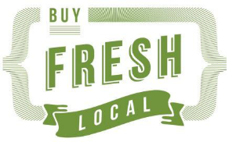
Project Branding | Bass Coast Shire Council | East Gippsland Shire Council

Implementation of in store incentives

In consultation with the Steering Committee and Victorian Department of Health, a suite of incentives was developed for the retailers to select from. These incentives were based on strategies used in previous work conducted in Scotland, the ‘HealthyLiving Neighbourhood Shops Project’(5) and in England, the‘Change4Life’ program (6, 7). A project worker was appointed to collaborate with retailers to improve in-store displays, negotiate with suppliers to overcome barriers and train retailers in the promotion, positioning and storage of fresh produce. Social marketing was also utilised to promote the initiative to the general public. Approximately half of the project budget was allocated to staffing and half to retailer incentives. The incentives were implemented according to each store’s specific needs and requests within broad guidelines provided by the department of health.

Some of the incentives that were devised in the projects’ original design proved to be less effective than hoped. An example of this was the lower than anticipated take up off subsidised refrigeration, with retailers providing feedback this incentive did not meet their business needs. This triggered a mid-stream formative review of the incentives to ensure the project objectives would still be achieved and ensure the key principles behind the incentives were uniform. It was reaffirmed that the incentives should only be provided where there was a direct relationship between the provision of the incentive and retailers capacity to:
- provide a wider variety of fresh fruit and vegetables (range of fresh fruit and vegetables)
- provide better quality fresh fruit and vegetables (quality and freshness)
- increase purchasing/turnover of fresh fruit and vegetables (increase sales)
- increase profit made from sales of fresh fruit and vegetables (profitability)
- increase community awareness/interest of fresh fruit and vegetables in stores(marketing)
- increase retailers skills in management of the fresh fruit and vegetable profit centre category (training)

The table of below describes the incentives’ strengths and weaknesses based on formative evaluation from in store visits and feedback from retailers. Appendix E outlines guidelines used to develop and implement the incentives.

Table 2 Incentives (listed in alphabetic order) describing strengths and weaknesses of each at implementation for BCSC and EGSC
Incentive listed in alphabetical order and associated aim (supply or demand) | Incentive strengths and weaknesses
A5 flyers - demand  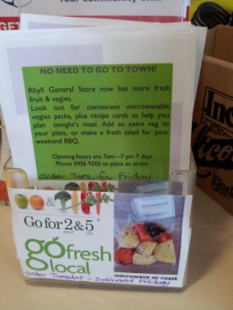 | Placed on counter tops to promote products, events, specials and produce availability  Strengths  Provided a point of focsu for retailers to talk to customers about in store promotions and initiatives  Promoted the “Go for 2&5” “Buy Fresh Local” and “Go Fresh Go Local” messages  Provided a resource that many stores distributed through post box drops  Weaknesses  For maximum impact, flyers should be handed to customers and an explanation provided which takes staff time
A Frames “Coming Soon” and “Here Now” signs - demand  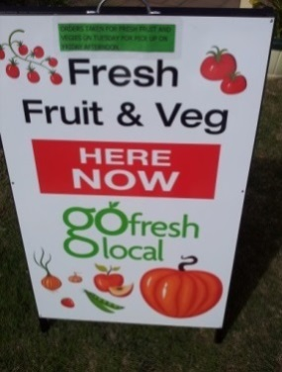 | Used both in front and inside stores depending on the store layout. The A frames were used in the initial phase of the project with “coming soon” to inform customers of the new products  Note - Most LGA’s will have a Footpath Trading Permit requirement enabling stores to place signage on Council land and should be explored prior to committing to this kind of signage  Strengths  Provided temporary and moveable signage for retailers to promote initial interest  Were very colourful and eye catching!  Weaknesses  Where a retailer had a permit for an A Frame there was no issue, however if the retailer did not have a permit, one was required, this then became a deterrent for the retailers. An option for some locations was to place the A frame on the stores land rather than council land or in the store as part of their internal marketing displays
Baskets /ambient displays- capacity  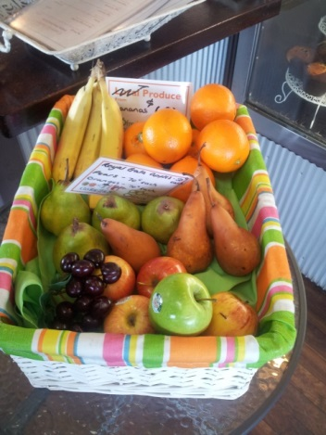 | Baskets were used by the majority of retailers and provided a uniform means for stores to display and promote awareness of their produce  Strengths  Unified the display in store  Eye catching  Unified the brand across all stores (all but one store uses these baskets in one BCSC)  Simple and eye catching  Inexpensive  Quick storage solution  3 sizes provide flexibility  Easy to handle and versatile  Stores purchased more if required  Weaknesses  Needed to be cleaned occasionally  With heavy use will need to be replaced eventually  Will not be ideal for all produce as some needs to be kept in the fridge – however even for a short time, if produce is returned to the fridge overnight, this can still be an effective way to provide ambient displays. The basket looked good in the fridge also.
Blender– capacity  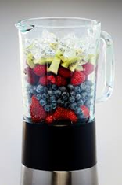 | To make fruit smoothies utilising fruit close to the end of its shelf life or when fresh local fruit was easy to access and cheap. To preserve the fruit at times it was frozen  Strengths  Minimised waste and maximised profit/return on purchase of fruit  Added another healthy line to the stores menu  Enabled store to buy local fruit when it was in abundance and cheap  Was a relatively cheap incentive  Weaknesses  The resulting product wasn’t always fresh fruit (rather frozen fresh fruit)
Branded Frisbees, aprons, seed sticks, pavement stencils, stickers, hats and water bottles - demand   | A variety of customer incentives that were easy to distribute, attractive to both adults and children and could be used as giveaways to promote the branding were developed. Promotional collateral was a key part of the branding strategy  Strengths  Flexible, fun and attractive ways to promote the program  Promoted the Go for 2&5 message to adults and their children  Weaknesses  Some of these items were reasonably costly  Required significant resources to develop and produce
Branded Shopping bags – demand and capacity | Jute bags branded with Go for 2&5 and the local campaigns (“Go Fresh Go local” or “Buy Fresh, Buy Local”) were given out at cooking demonstrations and in stores to customers who purchased fresh fruit and vegetables  Strengths  These provided a means for packing fresh produce  Promoted the social media message  Used at events for social media material / event take-away  Weaknesses  There was no obvious down side to these
Business Innovation sessions - capacity  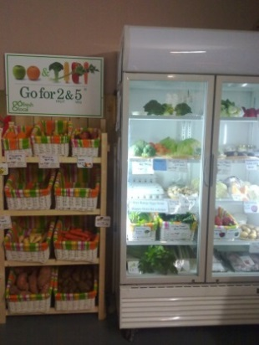 | Examined ways retailers could integrate the provision of fresh fruit and vegetables into their business models. This provided a platform for retailers to brainstorm with a business expert, set goals and follow a plan to achieve specific targets. The business innovation expert provided one initial consultation plus two additional follow up meetings to ensure the retailers were on track with their implementation plans  Strengths  Offered an opportunity to examine new ideas and strategies for the business  Enabled fruit and vegetables to be integrated into the business rather than stand alone  Provided additional (tailored) support beyond what the project officer could provide  Popular with retailers  Provided a mechanism to engage strategically with retailers to benefit their business beyond fresh fruit and vegetable provision  Weaknesses  Required a time commitment on behalf of the retailers  Required ongoing commitment to implement ideas for the follow up meetings  Reasonably costly
Energy Audit– capacity | Energy useage and maximisation was explored because it impacted on the viability of the business and hence the capacity to keep fresh produces at an affordable level. The energy audits examined electricity bills and breakdown of energy usage. The audits were undertaken by a private consultant  Strengths  These provided an alternative method of improving businesses capacity to store fresh fruit and vegetables  Weaknesses  The business owner was required to participate in the process, and make changes based on recommendations to improve energy usage costing time and money
Cooking demonstrations – demand  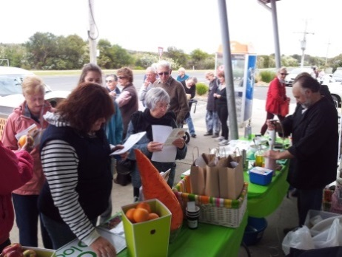 | These events were conducted in stores to both encourage shoppers into the store and to provide a platform for interaction and information exchange  Strengths  Engaged directly with community in their local setting  Opportunity to conduct shopper surveys with a larger sample  Provided opportunities for interaction with shoppers regarding healthy eating, local produce, supply available in the store, and other associated topics  Promoted the stores involvement in the project  Partnered with the Healthy Communities project to deliver healthy lifestyle messages  Increased awareness of Go for 2&5 message  Provided an opportunity for other store owners involved in the project to interact and support one another  Weaknesses  Bad weather was at times a deterrent - conducting these events indoors in the colder months or solely in the warmer months should be considered  Registrations were not required thus making catering and attendance difficult to predict  Collaboration note: In Bass Coast Shire the Living Healthy Bass Coast initiative partnered with the Retail Fruit and Vegetable project to build on the healthy living message regionally by offering and promoting opportunities to engage in locally run subsidised physical activity programs as well as increase awareness of healthy eating directly to the community.  Collaboration note: In East Gippsland Shire the Retail Fruit and Vegetable project partnered with the East Gippsland Primary Care Partnership and co presented a healthy eating strategy at cooking demonstration events
Colouring sheets– demand | Colouring sheets were used at events, given away in stores and used in produce packs  Strengths  Promoted the Go for 2&5 message to children and adults  Provided an interactive platform for adults to talk to children about “Go for 2&5”  Provided an opportunity for stores to promote the Go for 2&5 message by offering the children the opportunity to colour in while sitting in the café/restaurant  Weaknesses  There was no obvious down side to these
Free standing display units / ambient display - capacity | Movable units designed to display custom designed seasonality pocket guides, recipe cards and various ambient display boxes for fresh fruit and vegetables  Strengths  Movable  Educational  Links produce/ingredients to recipes  Attractive  Provides a long term solution for marketing produce  Developed in consultation with retailers to meet their needs  Weaknesses  Expensive  Take up floor space  Requires stock management for it to always be up to date and presentation up to standard
Fruit and Vegetable boxes / bags – demand and capacity  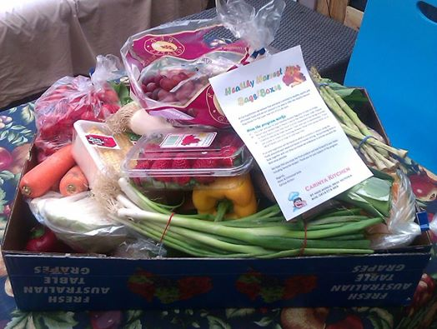 | Promoted in the stores as either a couples or family pack of pre ordered produce paid for in advance of delivery  Strengths  Minimised risk for the store as the sales were guaranteed and waste was negligible  Increased sales volume as it encouraged shoppers to purchase their staples not just their top up requirements  Used as a mechanism to promote recipe cards and other branded incentives such as hats, stickers etc.  By buying in bulk the stores were able to pass on the savings to customers  Weaknesses  Took time for the store to administer the ordering process and pack the produce  Boxes tended to be repetitious and little room for choice/flexibility for the customer due to having to buy cheaper in season produce to keep the price low
Loyalty Card - demand  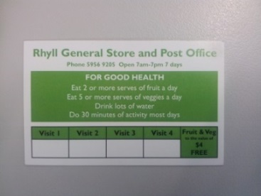  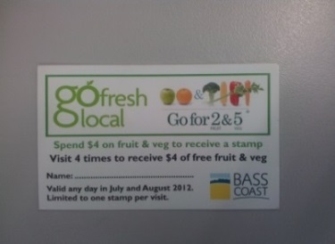 | Launched at cooking demonstrations  Placed in post boxes in stores that had the ability to distribute using this method  Offered to customers over the counter  A sample copy is displayed on the front counter encouraging people to ask questions! The cards had a validity period and were limited to one stamp per visit  Note - there was minimal take up of this incentive in the community  Strengths  Provided an opportunity for customers to purchase fruit and veg from the outlet at a reduced price  Encouraged repeat business to the outlet (4 x visits were required to populate the card and receive the discount)  Promoted local access to fruit and vegetables as were only valid for specific stores  Promoted the “Go for 2&5” “Buy Fresh Local” and “Go Fresh Go Local” messages  Weaknesses  Requires the retailer to explain the card and promote it face to face with customers for maximum exposure  Required the store to administer the card (sales data was recorded for evaluation purposes)
Newspaper articles, staff newsletters and network publications – demand | Events and programs being implemented through the project were advertised via a variety of print media.  Strengths  Reached the communities in which the intervention was being implemented  Increased communities awareness of the project  Raised the profile of the participating stores  Stores would not usually advertise through the newspaper  Newsletters could be customised to include promotions, project updates, store stories, and more  Weaknesses  Newspaper advertising can be expensive
Price & local produce tags–capacity  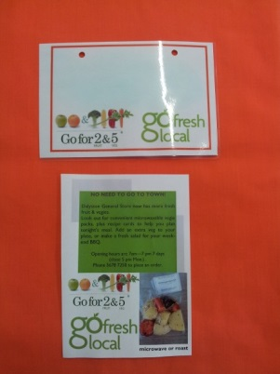 | Used in all displays where ever it could be encouraged to identify the price and source of produce  Strengths  Clarified the price for the customer and the retailer / staff  Gave store owners a way to manage stock pricing  Added to the ambient displays (the tags were colourful)  Promoted the “Go for 2&5” and “Go Fresh Go Local” Messages  Easy to change pricing (plastic tags and white board marker used to label)  Highlighted local produce  Shoppers would choose local produce over non local produce first often selling out first when labelled as such  Weaknesses  Requires management by the retailers to keep up to date. Although this seems simple, it is another task to include in the daily operational routine  Note; Price labelling was partially implemented across all stores initially and remained inconsistent throughout the project
Posters - demand  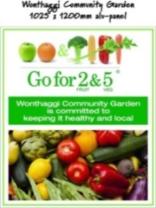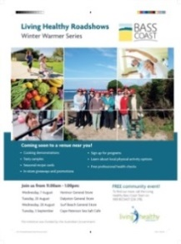 | Posters were used to promote events on a one off basis and were posted in community hubs / facilities and in stores  Strengths and weaknesses are same as for signage above
Produce packs – demand and capacity  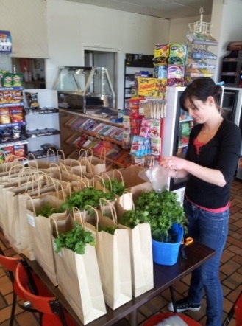 | Offered at the cooking demonstration and in stores as a follow up promotion afterward events. The contents of the packs included all the ingredients necessary to make a recipe with the recipe card included in the pack. For example guacamole, veggie soup or BBQ fruit skewers.  Strengths  Promoted the use of fresh produce  Made it easy for people to choose  Returned the store extra revenue  Promoted recipe cards  Encouraged people to cook healthy food at home  Weaknesses  Difficult to judge how many to make up  Needed to focus on seasonal produce to keep the price down
Recipe Cards – demand  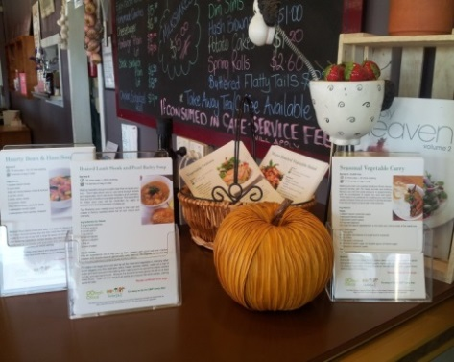 | Used to enhance ambient displays, during cooking demonstrations and in produce packs  Some recipes were supplied by outlets involved in the project. The cards included information about the serves of fruit and/or vegetables in the recipe and included the Go for 2&5 logo.  Strengths  Encouraged conversation about healthy eating and the value of sourcing seasonal produce  Could be uploaded to web in PDF  Encouraged people to cook healthy meals at home  Made cooking fun and interesting  Added to the visual display of fruit and vegetables in the stores  Were given away to customers creating good will between customers and retailers (people came back asking for more)  Encouraged people to buy produce listed in the recipes  Provided an opportunity for cross promotion of the stores (the retailers who designed recipes for the cards were acknowledged for doing so)  Promoted the “Go for 2&5” “Buy Fresh Local” and “Go Fresh Go Local” messages  Weaknesses  Took time for the retailers to provide recipes and proofs if they were askedto contribute a recipe
Refrigeration – capacity  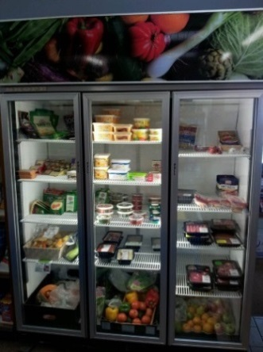 | Subsidised refrigeration units were utilised to increase the stores capacity to improve their range and size of their fruit and vegetables category. Varying sizes, including smaller bench top units were purchased depending on the individual stores layout  Strengths  Partially relieved the store of the capital cost to expand their fruit and vegetable category  Offered an opportunity to stores that previously did not consider it an affordable option to purchase more refrigeration space  Was flexible and customised to the individual store requirements  Improved the overall look of the fruit and vegetable displays  Provided flexibility in the way in which some stores displayed their produce – especially in the warmer months in stores that did not have very good temperature control  Weaknesses  Wasn’t possible for some stores as floor space was at a premium and/ or did not allow for it  Some stores were concerned with the extra cost of running an additional fridge
Scales for Fruit and Vegetable Sales - capacity  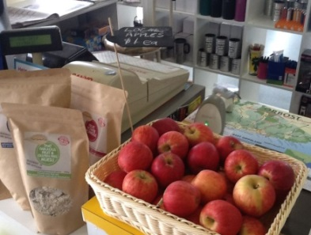 | Subsidised scales were provided as an incentive to small store to overcome customer complaints about fruit and vegetables being sold by the piece not by the kg and to make it easier for staff to manage price and larger quantities  Strengths  Empowered the store to sell fruit and vegetables by their weight  Transparency of cost  Attractive  Provided a long term solution  Solution established in consultation with retailer to meet their needs  Portable  Offered an opportunity to examine new ideas and strategies for the business  Enabled fruit and vegetables to be integrated into the business rather than stand alone  Provided additional (tailored) support beyond what the project officer could provide  Weaknesses  Large and took up counter space  Time required to up-skill staff to use the scales
Shelf banners- demand  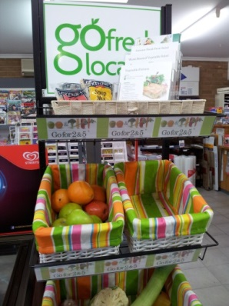 | Used on the front of ambient shelf displays and in refrigeration units  Strengths  Made the branding of the ambient and refrigerated displays uniform across the stores  Promoted the “Go for 2&5” “Buy Fresh Local” and “Go Fresh Go Local” messages  Weaknesses  Need to be customised to specific locations / displays in the stores
Signage - demand  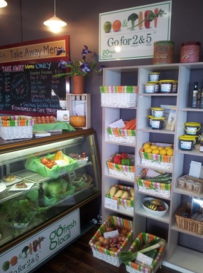 | Signage was placed in all stores in strategic locations to increase the profile of fruit and vegetables.  Strengths  Promoted the “Go for 2&5” and “Go Fresh Go Local” and “Buy Fresh Local” messages in a flexible way  Made the displays in and outside the stores uniform while still being specific to each stores requirements  Were installed so as not to impede on the store lay out and were rearranged if required  Weaknesses  Signage may need to be changed occasionally due to wear and tear, changing displays or changing floor layout

Supply

During initial discussions with retailers it was identified some stores purchased their fresh fruit and vegetables at a larger supermarket and re-sold the produce. This was perceived by the retailers as being a cheaper option than purchasing smaller quantities from a wholesaler. Other stores purchased produce from a variety of sources, or grew their own. In response to stores not having well established supply sources, a list of potential suppliers was given to the stores so they could establish contact and negotiate directly. Local suppliers were identified through desk top research, conversations with retailers, the project steering committee, Primary Care Partnership Food Policy Coalition network and local knowledge from within the Social Planning team of each LGA.

Implementation of in store support

In store support consisted of information sheets regarding sourcing and profitability of fruit and vegetables, stock handling training, mock sales training and facilitating the support of suppliers to assist retailers to purchase, store and handle fresh fruit and vegetables. In addition project officers worked directly with retailers to help expand their fruit and vegetable range. The table below lists all support services, inclusive of training offered to participating retailers to improve management and merchandising of fresh fruit and vegetables.

Table 3 In-store support services provided to retailers by project officers
Support Service | Description of support
“Profit in Fruit and Veg” information sheet | This was a two page information sheet addressing strategies and operational considerations to generate profit selling fresh fruit and vegetables.
Stock handling training | This was offered to all retailers by two of the supplying wholesalers. Knowledge on the best way to store, handle and price produce was shared on a casual basis in store. This was done when the supplier delivered produce to the store and often determined what lines were stocked in the store dependant on storage, season, staff and display space. The wholesalers knew a lot about this topic and were happy to share this information as it ultimately lead to greater sales.
Project officer in store support | This included stocking shelves, rearranging displays, installing signage, meeting with staff to review the stores Business Innovation Goals, and to establish a path forward as the project progressed.
“Mock” sales training | The project coordinator enacted a potential “customer scenario” enabling staff to practice handling and selling produce (including weighing of produce and packing it)
“Creating fruit and vegetable sales” Information sheet | Helped retailers identify opportunities to improve sales of fresh fruit and vegetables. Used to encourage retailers to implement some of their own ideas around affordability, education, seasonality, supply and shelf life.
Introducing growers to stores | Where local growers had the capacity to distribute locally the project officer linked local growers to participating outlets

Retailer training and capacity building opportunities

Establishing links between retailers, suppliers and growers was a critical aspect of the project. The figure below shows these three key segments of the food system, and their relationship to supply retail outlets with consistent quality produce.

Figure 1 Food system segments and their relationship to retail outlets to support consistent supply of quality produce

Specific opportunities for retailers to increase supply and range were progressively identified throughout the implementation of the project (Table 4). By addressing each of the specific training needs early, project officers were able to assist stores establish consistent supply of quality fresh fruit and vegetables that could be facilitated and sustained throughout the intervention and beyond.

Table 4 Potential areas for building capacity (gaps in knowledge or skills) identified throughout the implementation phase
Retail | Distribution / wholesale | Growers / producers
- Knowledge of supply sources (both local and non-local as they generally augment each other, and sourcing direct from small-hold producers and wholesalers)  - Knowledge of food handling and storing produce  - Knowledge of handling produce (including weighing)  - Knowledge of ordering produce to maintain a consistent supply of quality produce  - Knowledge of seasonality (and how it impacts on price and availability)  - Knowledge of stock control and minimising loss including value adding (e.g. making smoothies from frozen fruit and curries from fresh vegetables close to the end of its shelf life)  - Knowledge of marketing  - Knowledge of pricing and competition  - Staff training  - Growing their own fruit and vegetables to create a point of difference (as a strategy)  - Health promotion benefits  - Business development  - Sustainability as it relates to capacity to maintain the service/product profit centre  - Business development (overall)  - Knowledge of local government practices  - Working in partnership with stakeholders including schools, community centres and community events  - Customer Service | - Links to retail outlets and producers  - Working with retailers to maximise profits  - Value adding to service (e.g. produce packs, bulk specials)  - Working with lower turn-over of smaller stores  - Business development (overall)  - Minimising waste | - Making links to retail outlets  - Working with wholesalers to maximise profits (buying in bulk, buying in season)  - Promotion of product  - Marketing of local produce (creating a point of difference)  - Value adding to product

Increase availability

Retailers entered into a non-binding agreement to improve their supply of fresh fruit and vegetables. Increase in availability and stock levels was facilitated by the project worker through the provision of in store incentives, building relationships with suppliers, encouraging retailers to consider ways to improve visibility and displays in the store, and suggesting alternative supply sources to address range and cost.

Decrease price

An aim of the project was to decrease the price of fresh fruit and vegetables already stocked in stores and introduce fresh fruit and vegetables at an affordable price in stores where it is was non-existent. Strategies to decrease price included encouraging retailers to work closely with suppliers regarding seasonality of produce and market price, growing their own produce, use of websites to obtain price updates from wholesale markets, examining weather events effecting price, buying in bulk and buying grade two produce where appropriate. Some stores that had larger turnover, began travelling directly to the market themselves removing the middle transaction of purchasing through a wholesaler to help lower price, while for others simply minimising waste was a strategy used to keep prices as low as possible.

Positioning

Improving the visibility of fruit and vegetables in the stores required detailed consideration. The placement of fruit and vegetables and how it related to the overall floor plan and traffic flow in each store was carefully considered for each outlet. The fruit and vegetable category competed for space with high volume, high profit categories such as snack foods, bread and milk, newspapers, alcohol, and convenience items. In addition, in order to unify the displays, ideally the ambient and refrigerated fruit and vegetable displays were located along-side each other. This however was not always possible due to store configurations, operational requirements and cost implications. The main focus for implementing positioning strategies was to consolidate the displays, and make them more visible in the outlets, either by improving the visuals using branding or placing them in a more prominent position in the store, or both.

Research practice partnership

Monash University partnered with the Retail Fruit and Vegetable project to support the evaluation. Monash University were engaged during the design of the evaluation plan and were involved in all aspects of the evaluation and report findings. Discussion between the University, the Department of Health, and LGAs also provided opportunities for exchange of policy, best practice and research vision. The partnership guided the evaluation tools and methods, offering solutions to foreseeable challenges and interpretation of the findings. Monash University sought human research ethics approval. The University provided a total of 13 Bachelor of Nutrition and Dietetics students as part of their mandatory work-based public health placement. Students assisted with data collection and preliminary analysis. The university received no financial reimbursement for their involvement rather an informal understanding was established detailing outcomes for the university (student placement, peer reviewed publications, profile) and the project (evaluation capacity) as agreed in the planning stages. This resource was crucial for the evaluation’s capacity that would not have been possible otherwise.

The agreement meant both parties benefited from the partnership. The University was able to meet placement requirements, including supervision and had the opportunity to shape an innovative piece of research not previously reported on in Australia. Additional benefits included the project teams were supported in planning of, and collection of, vital evaluation data and did not need to allocate budget for additional external evaluation.

Evaluation methods

A Program Logic was developed for the intervention and included an evaluation framework (Figure 1.) The following section describes the methods of the evaluation as outlined in the program logic.

Sales

Sales, invoice or store turnover data aimed to provide information regarding volume, type/category, and fruit versus vegetable sales, waste, weight, and profit margin. This type of data has previously been used effectively to determine small community nutritional intake(8). This evaluation method placed a large administrative burden on the retailers to record and report data at this detailed level.

During early implementation project workers attempts to gather sales data revealed some planned evaluation methods did not work for all stores. Several options were developed by project officers based on formative feedback. The chosen method of data collection used wholesale purchases, that is, the total dollars spent by the outlet purchasing their fresh fruit and vegetables (Option 1 table 5 below). For evaluation consistency, the same method was used across all stores. Data was recorded on a weekly basis allowing for the irregularity of purchasing cycles between outlets. In addition comparative wholesale price was allocated for home grown produce, and added to the total wholesale volume. The table below also outlines two additional options that were explored but not chosen for collecting sales information.

Table 5 Sales data measurement options
Measurement option | Measurement point per week | Pros | Cons
- Total wholesale fruit and vegetable purchases | Total $ spent (wholesale purchases) | - Reduced administrative burden on retailers (they either completed the provided sales data spreadsheet manually or electronically, or provided copies of their wholesale invoices to the project coordinator for processing) | - Assumed changes in volume i.e. change in sales. This could be affected by improved wholesaler agreements, smarter purchasing, and seasonal price of produce. Was this reflected in the change or was the retailer simply purchasing larger volumes for the same cost?  - This assumed stores track all purchases (did not account for ad hock purchases or growing their own produce.)  - Did not allow for the use of fruit and vegetables used in the café/restaurant
- Total wholesale fruit and vegetable purchases categorised by product (A, B, C, etc….) | Total $ spent by category (wholesale purchases) | - As above, however required one extra step to record products by category. | - Assumed stores track all wholesale purchases (may not allow for ad hoc buying.)  - Varying suppliers may deliver on a different cycle to others (not in the same week)  - Did not allow for the use of fruit and vegetables used in the café/restaurant
- Total retail volume of fresh fruit and vegetables categorised by product (A, B, C, etc…) | Pieces or numbers of / kilograms sold (retail sales) | - Allowed for stores that sell product by the piece or weight to be compared.  - Enabled tracking regardless of purchasing arrangements, sourcing or availability of invoices | - Placed an extra administrative burden on the store to collect this level of information  - Relied on the store using scales for all retail sales  - Relied on the store using a detailed point of sale (POS) system

Shopper surveys

Shopper surveys were used to gather data regarding shopping habits, perceived quality and price, social marketing recall, and knowledge of recommended fruit and vegetable consumption (Appendix F). The shopper surveys were based on the UK Change For Life program (7). The majority of surveys were conducted at in-store events where numbers of shoppers were high while a small sample of surveys were conducted in stores (that did not hold events) over the duration of their opening hours. The shopper surveys required between seven and twelve minutes to complete. The majority of stores involved in the Retail Fruit and Vegetable Project had limited foot traffic during the day, with high levels of fast paced foot traffic early morning and late afternoon presenting a challenge to complete an adequate number of surveys. As a result most of the surveys were gathered during events where store attendance was high. This could have created bias in the results due to the level of interest in the project being high within the subject sample. Small incentives were offered to the shoppers who completed the surveys. These included a lucky door prize, a produce pack and other branded items such as shopping bags and water bottles.

Range
The A-Z audit tool was developed to gather data regarding range, cost ($/kg) and availability of range fresh fruit and vegetables in the outlets (Appendix G). The tool was developed from the Melbourne Markets – Market Fresh Produce Guide and included a list of 39 fruit and 45 vegetables. The frequency by which this tool was utilised differed between the two LGA’s predominantly due to the distance required to travel to some of the stores to populate the audit tool. The A-Z audits were used as to identify the number of lines (range) of fresh produce stocked in the outlets, however were not consistently used to gather price data due to many of the stores not pricing produce and store staff not being able to assist with pricing due to workload and/or lack of knowledge.

In addition to the A-Z audit tool, Victorian Healthy Food Basket survey data was used to compare pre and post intervention supply of fresh fruit and vegetables in communities where a participating retail outlet existed. For the purpose of the retail fruit and vegetable project, the survey examined the availability of the 10 Healthy Food Basket fruit and vegetable items available in participating stores.

Interviews – retailers

The retailer interviews covered retailer’s general attitude, understanding and capacity to deliver the project. It also explored their perception of their role as a retailer, current fruit and vegetable range and quality, own knowledge, understanding and involvement in the initiative, understanding of healthy eating and its effects on the community, and perceived success of the project. Retailers were asked to comment on the perceived implications (positive and negative) of the project, costs involved and note what barriers were presented(perceived and actual).The retailer’s knowledge of growers, suppliers, customer demand, motivators and ability to cope with changing industry demands were also discussed.

This line of questioning was taken to identify specific barriers that could be identified in the future and to identify strategies and models that had worked well for stores. Some of these could be transferred to other similar interventions influencing access to fresh fruit and vegetables.

Retailers who either, commenced the initiative and then became disengaged, or who were offered the initiative but declined to take part were also interviewed to identify barriers to participation that could be addressed in the future. Interviews enabled qualitative data to be collected regarding retailers’ involvement in the project that could not otherwise be collected with the amount of detail required utilising quantitative means. Interviews lasted between 10 and 40 minutes, were audio-recorded and transcribed for later thematic analysis.

Interviews - key stakeholders

Key stakeholders included project staff, steering committee members, the business innovation expert and funding body. These people were interviewed to establish stakeholder perceptions such as why they were involved in the project, their understanding of the purpose and goals of the project, personal expectations, experience, perceptions of project success, and working with other project staff, as well as suggested changes to the implementation for future application.

These interviews identified motivators for participation, development of incentives and data collection methods, barriers hindering participation and examined the likely sustainability of the project. The interviews enabled qualitative data to be collected. Interviews lasted between 20 and 60 minutes, were audio-recorded and transcribed for later thematic analysis.

Photo book
Over the duration of the project, photographs were taken before and after implementation with an emphasis on displays and strategies utilised in each outlet. This method of data collection enabled an accurate record of in store implementation to be logged in a non-invasive, time efficient manner. Each retailer signed a waiver releasing the rights to the photographs and agreeing to the photos being used for reporting and promotion purposes.

Project Results and Discussion

Reach

The Retail Fruit and Vegetable Project focused entirely on small rural communities proven to have limited access to fresh fruit and vegetables. The average population of the towns represented in the project was 578, ranging from as low as 223, and as high as 1222.

The in-store promotional events attracted 30-60 people. An example of reach in one community is a cooking demonstration held in store 8, with 60 participants attending, representing over 8% of the town’s population. The events were held in the stores, alongside displays of fresh fruit and vegetables, linking the produce source with the store. These events represented a targeted marketing opportunity to reach the community not only for the retailer but also for the project.

Store number | Population of town store located in | LGA location
1 | 694 | BCSC
2 | 226 | BCSC
3 | 738 | BCSC
4 | 414 | BCSC
5 | 674 | BCSC
6 | 606 | BCSC
7 | 630 | BCSC
8 | 718 | BCSC
9 | 710 | BCSC
10 | 321 | BCSC
11 | 585 | BCSC
12 | 1222 | EGSC
13 | 678 | EGSC
14 | 805 | EGSC
15 | 341 | EGSC
16 | 349 | EGSC
17 | 223 | EGSC
18 | 385 | EGSC
19 | 0 | ** EGSC
20 | 865 | EGSC
21 | 955 | EGSC
 | 12139 | Pop. Total
Figure 2 Population reach for the Retail Fruit and Vegetable Project across BCSC and EGSC. Population data sourced from Australian Bureau of Statistics, 2011 Census of Population and Housing, place of usual residence. **Store 19 has no assigned population but is accounted for in store 18 population

Retailer participation

A total of 35 stores across both LGA’s were identified in the initial project proposal submitted to the Department of Health. This comprised 20 stores in BCSC as potentially eligible and 15 stores in EGSC potentially eligible to participate. Twenty one stores across both LGA’s agreed to participate in the intervention by way of a non-binding agreement to increase availability, improve retail positioning, or decrease price of fresh fruit and vegetables over the duration of the project equivalent to 60% of the anticipated participation (11 in Bass Coast and 10 in East Gippsland). In addition EGSC engaged with two wholesalers and one grower, and BCSC engaged with two wholesalers while both LGA’s engaged with their formal local food producers’ network.

The difference in identified and actual retailers supporting the intervention was due to not wanting to be involved, stores closing down, stores being for sale, stores having changed their core business, and capacity of the project workers to travel to and support the stores identified. A thorough site specific evaluation conducted in the early planning phase of the project could have more clearly identified some of these barriers and determined a more realistic estimation of the potential involvementin the initiative.

Support package and options taken up by retailers

Of the twenty one stores implementing the intervention a variety of incentives were taken up by the retailers based on their specific needs. Table 6 outlines incentive uptake by retailers.

Table 6 Incentive uptake by stores across EGSC and BCSC
Incentive | EGSC uptake out of 10 stores | BCSC uptake out of 11 stores
- Refrigerator modifications / energy audits | 4 | Not offered
- Baskets | 8 | 10
- Refrigerator subsidy | 0 | 3
- In store signage | 9 | 10
- Cooking demonstration/tastings | 2 | 4
- Shopper giveaways including seed sticks, colouring-in sheets and Frisbees | 8 | 10
- Fresh fruit and vegetables boxes | 6 | Not offered
- Recipe cards | Not offered | 10
- Price / local produce tags | Not offered | 10
- Shelf banners / signage | 9 | 2
- Free standing A Frames | Not offered | 5
- A5 flyers | Not offered | 10
- Loyalty cards | Not offered | 3
- Business Innovation consultation | 7 | 8
- Project officer in store support | 11 | 10
- Free standing displays incorporating seasonality guides recipe cards and produce display space | Not offered | 3

Availability (increase in range of fresh fruit and vegetables)

In BCSC, an increase in range of fresh fruit and vegetables was achieved over the two year intervention. At pre-intervention across all stores that achieved full data sets, the mean (±standard deviation) number of fruit and vegetables stocked was (8.7±8.1). At 3 months, the stores stocked on average 15.1±4.3 lines, and at 6, 9 and 12 months an average of 18.8±3.6, 17.9±6.2, and 17.3±7.5 lines respectively. Upon final evaluation an average of 16.9±5.9 lines were stocked across all stores, being more than double the number of lines stocked at the beginning of the intervention (Figure 4).

These results indicate a consistently higher number of lines stocked in all stores at three and six months when compared to the pre-intervention data. The inter-store variance of lines stocked at nine months, twelve months and final evaluation remained well above that of pre-intervention indicating a greater availability of fresh fruit and vegetable supply across all stores.

Of all the retailers approached to be involved in the project, five retailers in Bass Coast did not stock fresh fruit and vegetables pre- intervention, all other retailers offered some fruit and vegetables for sale. The resulting 11 stores in BCSC participating to increase supply of fresh fruit and vegetables represents an increase of five stores stocking fresh fruit and vegetables. A total of 10 stores participated in the initiative in EGSC, all of which previously sold (in some cases minimal quantities) fruit and vegetables.

Figure 3 Average range stocked by stores over the duration of the intervention in three month intervals. (Using the A-Z audit tool based on stores with complete data sets in BCSC over the entire intervention n=9)

In EGSC the average number of lines stocked increased from 13 to 16 lines across the six stores with complete data (Figure 5).

Figure 4 Average range stocked by stores comparison of 2012 and 2103 A-Z audits conducted in EGSC n=6

An increase in availability was also demonstrated by the fresh fruit and vegetable items included in the Victorian Healthy Food Basket (VHFB) survey. Of the ten possible fresh fruit and vegetable items in the basket, the average number of fresh fruit and vegetable items went from three at pre intervention, to seven post intervention. When comparing the preliminary VHFB data used in the project proposals and the post intervention data collected in the field it was revealed six out of the seven stores surveyed demonstrated an increase in availability with one store maintaining availability at the same level. (Figure 6)

Figure 5 Availability of fresh fruit and vegetable items in the Victorian Healthy Food Basket. (Comparison of 2010 to 2013 data n=7) Note: Only those stores that participated in both the Retail Fruit and Vegetable project and the Healthy Food Basket Surveys in 2010 and 2013 could be analysed

A range of circumstances impacted on each retailer’s ability to implement the intervention exactly as the project logic prescribed. For example one store underwent a major refurbishment resulting in a dramatic reduction in the stores ability to stock fresh fruit and vegetables. In this case lines stocked went from nineteen to seven in a three month period, however once the store resumed normal operations lines increased to pre refurbishment levels. Another store was placed on the market for sale six months into the implementation of the Retail Fruit and Vegetable project, greatly impacting on the retailers focus and commitment level. Other stores began their involvement with the project with no experience stocking fresh fruit and vegetables and gradually built up their range over time. They also increased their floor space dedicated to fresh produce. Several of the stores on the other hand had to work with the seasonal tourist trade and had to adjust stocks accordingly resulting in significant fluctuations in range offered as they responded to demand. Although there were variations within each store, the overall trend was for an increase in range of fresh fruit and vegetables across all stores.

Cost (% decrease in cost of fresh fruit and vegetables)

Fruit and vegetable retail prices varied due to seasonality, wholesale pricing, quality, consumer choices and retailer determined profit margins. Produce was regularly not labelled with price and required staff to advise the data collectors, which was, at times, difficult to achieve in the field. As a consequence price was not measured as proposed in the project evaluation logic.

Sales

Five stores submitted complete sales data. These five stores tended to be more engaged with the project and more driven to achieve the desired outcomes of the intervention. Reported sales for most stores fluctuated and were at times very high and at times very low. The period over which data was collected at each store varies due to resources the retailers were able to dedicate to collating data and their willingness to share it for the purpose of the Retail Fruit and Vegetable Project. The graphs below demonstrate the changes in wholesale purchase over time for each of the five stores that submitted complete data throughout their involvement. In addition it was observed one of the most effective strategies for increasing impulse sales of fresh fruit was a basket placed on the counter or close to the cash register. Retailers commented it was difficult at times to keep the basket stocked. This strategy was not specifically evaluated for sales.

Figure 7 Store#4 wholesale purchases of total fruit and vegetables weekly average wholesale purchase by month

Store four started offering fresh fruit and vegetables at the start of winter 2012 and gradually built sales over time. February and March 2013 were quieter sales months, and with Easter and school holidays they increased sales again. Even with these variations, the overall trend was for an increase in sales, evolving from not offering fruit and vegetables upon implementation to purchasing an average of $91.45 wholesale per week (Figure 7).

Figure 8 Store #5 wholesale purchases of total fruit and vegetables weekly average wholesale purchase by month

Store five stocked fresh fruit and vegetables prior to the intervention. This store experienced dramatic peaks in demand throughout the year due to being located in an area experiencing tourist trade influx and growing their own produce during spring and summer. Their home grown produce was in high demand and often sold out before the non home grown produce (Figure 8).

Figure 9 Store #6 wholesale purchases of total fruit and vegetables weekly average wholesale purchase by month

Store six demonstrated an increase in sales over the duration of the project whilst also experiencing several peaks and troughs. The spike in April purchases reflects the retailer’s anticipation of higher sales during Easter holidays (Figure 9).

Figure 10 Store # 9 wholesale purchases of total fruit and vegetables weekly average wholesale purchase by month

Store nine experienced an overall increase in sales up to the end of May 2013. In June the store began refurbishments which were completed after the data collection period. After the refurbishments were complete, the store changed its model and started selling pre ordered fruit and vegetable boxes in addition to off the shelf sales. Over the subsequent period (August to November 2013) the store sold 374 bags of fruit and vegetables at $15 retail value each as part of another externally funded program aimed at increasing access to healthy and affordable food in transport disadvantaged communities, however these sales figures are not included in the above graph. (Figure 10).

Figure 11 Store # 11 wholesale purchases of total fruit and vegetables weekly average wholesale purchase by month

Store eleven experienced a gradual increase in sales over the duration of the intervention. This store placed an emphasis on visibility, and was able to dedicate staff to monitor/manage the fresh fruit and vegetable display (Figure 11).

Merchandising and management –utilisation of support services

Stores were provided with a suite of options for in-store support. Table 7 below outlines the retailer’s uptake of these different options.

Table 7 Uptake and outcome of retailer support services (See Table 2 for detailed description of support services.)
Support Service | Retailer Uptake | Outcome
“Profit in Fruit and Veg” information sheet (Appendix H) | All retailers were given this to use at their own discretion. Some took the opportunity to use it as part of their staff training/regular meeting updates to involve staff in the project. | Raised retailer’s awareness of how small adjustments can make a big difference in profitability with fruit and vegetables.
Stock handling training | All retailers utilised this opportunity to learn from wholesalers either in a formal meeting with the project coordinator or as part of their business innovation session. By working with wholesalers retailers were also able to learn about strategies to improve stock handling skills. | Retailers were gradually educated about the best way to handle fresh fruit and vegetables in order to increase shelf life and minimise waste. At times this was challenging for retailers, and this advice helped with day to day operations, often guiding stores on what to stock and when to stock it.
“Mock” customer sales training | One store asked for this specifically demonstrating how uncomfortable staff were handling fresh fruit and vegetables. | Staff became more confident with this process the more they practiced using the scales and calculated price, as well as dealing with customers watching them.

Social marketing and branding

One hundred and thirty six shopper surveys were completed in 2012 but not all respondents completed the entire shopper survey leading to a variation in the number of responses. The following data reports on these responses.
In 2012 complete shopper surveys conducted with 46 shoppers across BCSC and EGSC indicated 70% of the respondents reported noticing the Retail Fruit and Vegetable intervention. In 2013 with 61 shoppers surveyed 33% of respondents noticed the in store promotion. This difference in promotion recognition between the years could be due to the different sample group.

Figure 12 Shoppers who noticed the in store intervention (2012 data n=46, 2013 data n= 61)

In store shopper surveys conducted indicated fridge improvements were the most recognised aspect of the promotion, identified by 45% of respondents, with better signage being acknowledged by 20% of respondents. Improved range and giveaways were observed by 10% of respondents.

Both LGA’s decided to develop a second brand in addition to the “Go for 2&5” campaign prescribed by the department of health. Some retailers felt the “Go for 2&5” brand did not suit their store and there was a desire at the local level for the marketing to also place an emphasis on local produce. An alternative social marketing message with a focus on “local”, offered stores in both LGA’s an alternative to complement existing in store strategies allowing them to customise incentives. The customer surveys found that customers were confused by the multiple social marketing messages. There was also difficulty with the alignment between the brands which had an underling theme of local produce when the retailers were often unable to access local produce.

Action taken

Almost half of respondents acknowledged changing their fruit and vegetable intake as a result of the intervention. Of the 45% who did, the most common result was to talk about diet with family and friends, followed by equal proportions of people who either consciously thought about their fruit and vegetable consumption, increased the amount of fruit and vegetables their family eats, buying more vegetables when shopping or preparing recipes that use more fruit and vegetables.

Knowledge - shoppers increase in knowledge of the daily recommended serves of fresh fruit and vegetables

In 2012 shopper surveys indicated 28% of respondents knew the daily recommended serves of fruit (two serves), and 26% knew the daily recommended serves of vegetables (five serves). In 2013 both of these figures increased with knowledge of fruit consumption increasing to 51% and knowledge of vegetable consumption increasing marginally to 28%.

Pre-intervention surveys conducted with 136 shoppers indicated nearly 20% were not confident enough to state what they thought the daily recommended intake of fresh fruit and vegetables was. Post intervention 61 shoppers were surveyed indicating just above 10% of shoppers did not feel comfortable answering this question based on their knowledge. This suggests shoppers were more confident with their knowledge to provide an answer to this question post intervention (Figure 13).

Figure 13 Knowledge of recommended daily serves of fruit and vegetables post intervention (2013 data n= 61 respondents)

Consumption – shoppers eating the daily recommended serves of fresh fruit and vegetables

The results from the shopper surveys indicated a 10% decrease in numbers of people who report meeting the daily recommended intake of two serves of fruit, while consumption of vegetables remained almost the same when comparing 2012 results to 2013. This could be due to a smaller sample size in 2013 or the variation in actual sample candidates between years. (Figure 14).

Figure 14 Proportion of Shoppers meeting the recommended daily intake of fresh fruit and vegetables comparing 2012 with 2013 data (n 2012 data = 135, n 2013 data = 61 respondents). Recommended daily intake of Fruit & vegetable = 2 serves fruit/day and 5 serves vegetables/day)

Shopper rating of visual appeal, range, quality, and price pre and post intervention

The results from the shopper surveys indicated appeal, range and price were perceived by the majority of respondents to be of a lesser rating in 2013 than in 2012. Shoppers rated quality better in 2013 than in 2012 which is a reflection of the project succeeding at increasing access to good quality produce. The largest shift in perception was regarding price with a 25% shift to negative responses; in 2013 44% of shoppers surveyed disagreed that stores stocked fresh produce at prices they were willing to pay. It could be hypothesised that price of fruit and vegetables determines local demand, or why the majority of shoppers purchase fresh fruit and vegetables at supermarkets.

Figure 15 Shopper rating of fresh fruit and vegetable display at participating stores,2012 data compared to 2013 data (BCSC and EGSC n 2012=135respondents, n 2013 data = 61)

Increase in the number of adults eating the recommended daily intake of fresh fruit and vegetables

Shopper behaviour change was measured in 2012 and 2013 utilising the surveys to indicate change in consumption of fresh fruit and vegetables as a result of being exposed to the Retail Fruit and Vegetable Project. In 2012, 26% of respondents reported they attempted to increase their fruit consumption and 21% of respondents attempted to increase their vegetable consumption as a result of being exposed to the intervention. In 2013, 35% of respondents surveyed attempted to increase their fruit consumption while 27% attempted to increase their vegetable consumption as a result of being exposed to the intervention. The overall increase in attempted behaviour change in both fruit and vegetable consumption suggests more respondents are either contemplating or taking specific action to increase their consumption of fresh fruit and vegetables as a result of being exposed to the intervention (Figure 16).

Figure 16 Attempted behaviour change in consumption of fresh fruit and vegetables as a result of being exposed to the intervention n= BCSC and EGSC 2012=109, n 2013=55 (No change=no attempted change in consumption; Increase=attempted increase in consumption; Decrease=attempted decrease in consumption)

Shopper Survey Limitations

Shopper survey data should be interpreted with caution. Each shopper survey sample differed from year to year, the sample group was not the same pre and post intervention, rather the majority of respondents comprised a random sample of shoppers attending promotional events in the retail outlets. Each sample was a different size. Some stores customer flow did not allow for large sample sizes during normal business hours limiting the number of surveys completed. Retailers of this type (small and multifaceted general stores and convenience outlets) have limited resources to put towards data collection. As such large, consistent samples of shoppers were difficult to achieve.

Increase in retailer’s capacity to stock fresh fruit and vegetables – photo book

Store # | pre | mid-stream | mid- stream | post
1 | 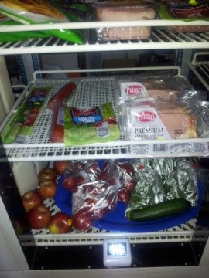 | 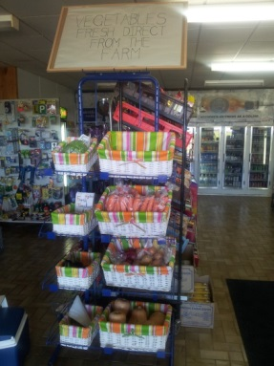 | 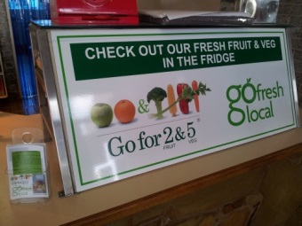 | 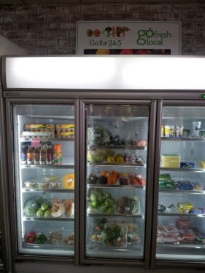
2 | Did not actively sell fresh fruit and vegetables | 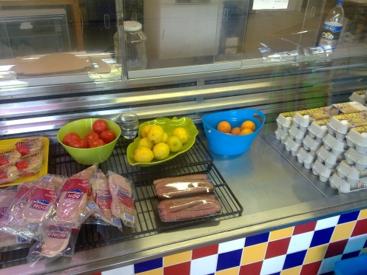 | 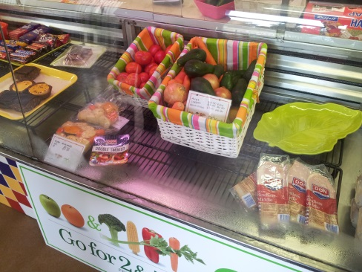 | Disengaged prior to end of intervention
3 | 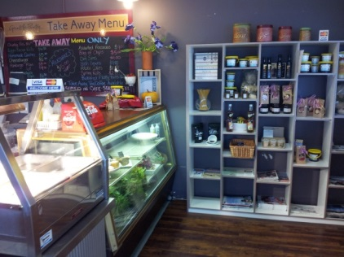 | 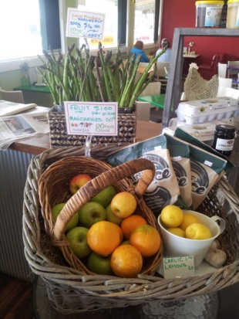 | 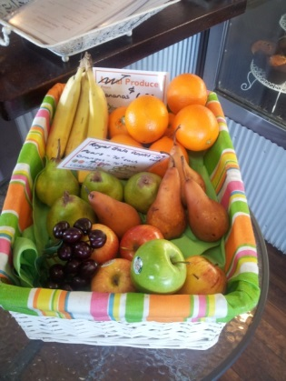 | 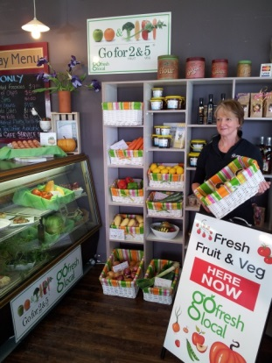
4 | Did not stock fresh fruit and vegetables pre intervention | 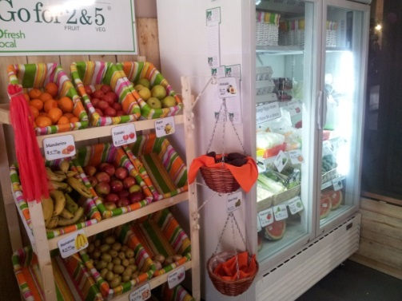 | 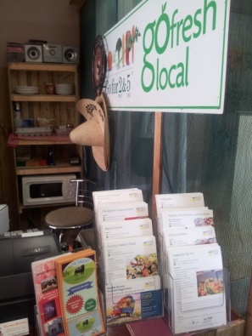 | 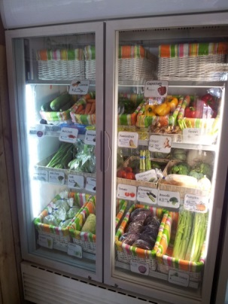
5 | 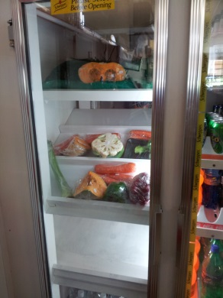 | 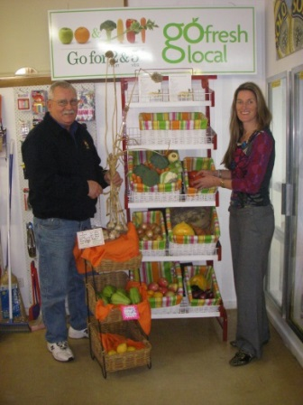 | 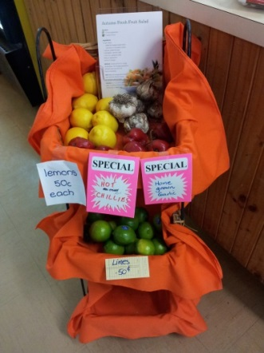 | 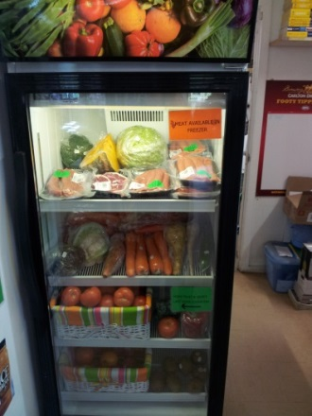
6 | Did not stock fresh fruit and vegetables pre intervention | 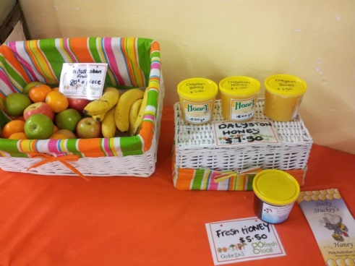 | 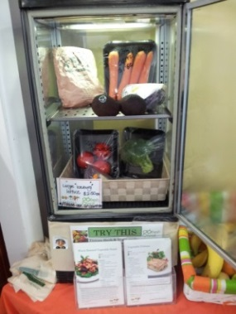 | 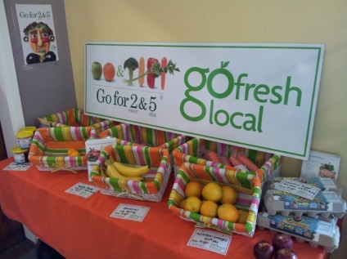
7 | 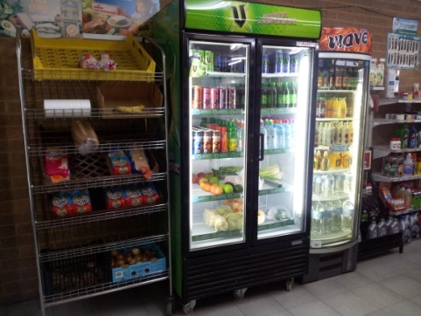 | 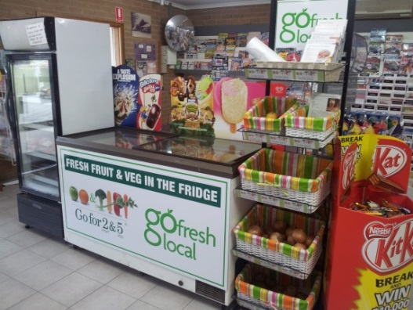 | 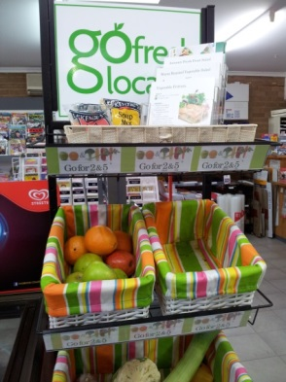 | 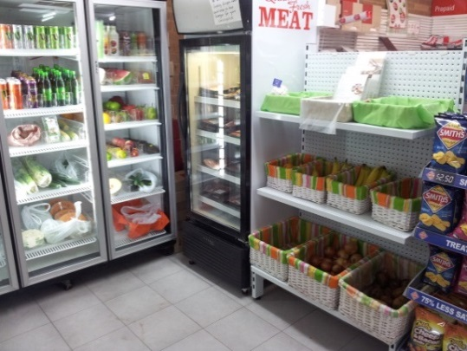
8 | Did not stock fresh fruit and vegetables pre intervention | 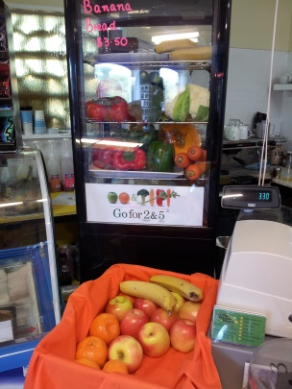 | 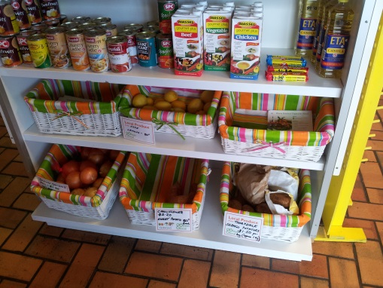 | 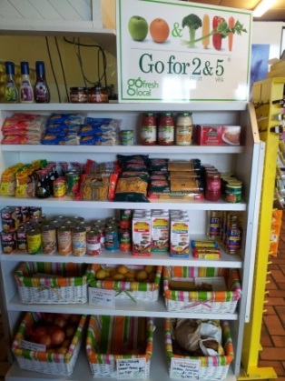
9 | 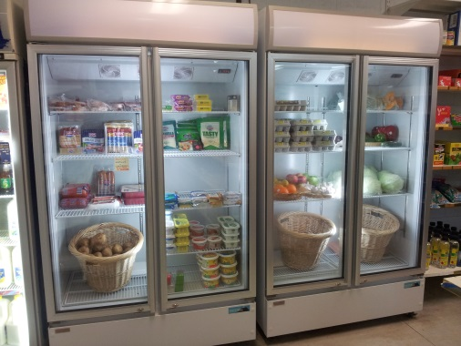 | 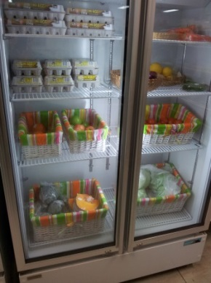 | 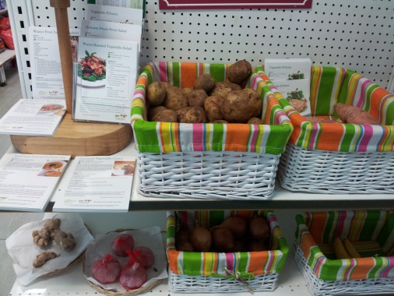 | Display remained unchanged for later part of intervention
10 | Did not stock fresh fruit and vegetables pre intervention | 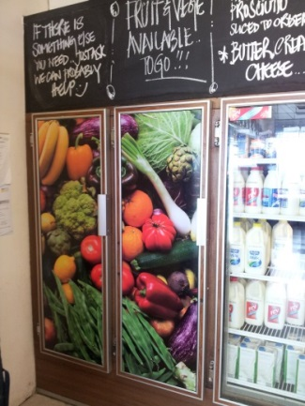 | 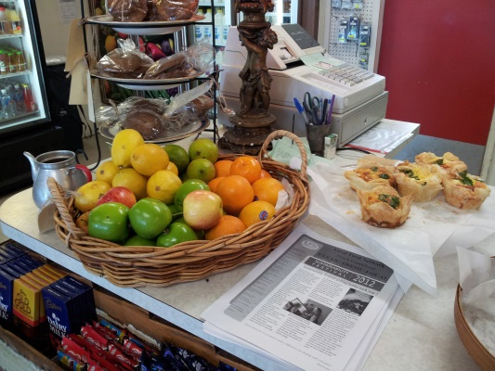 | 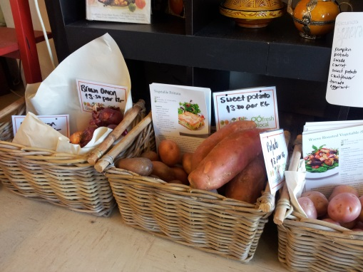
11 | 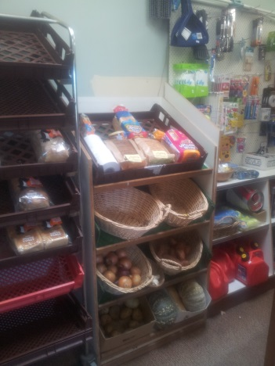 | 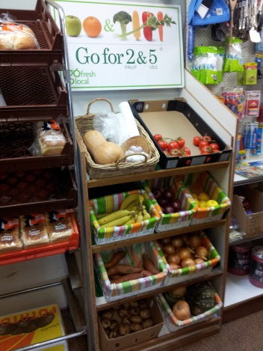 | 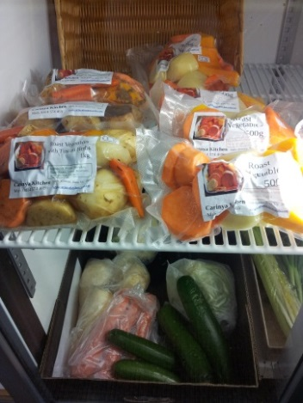 | 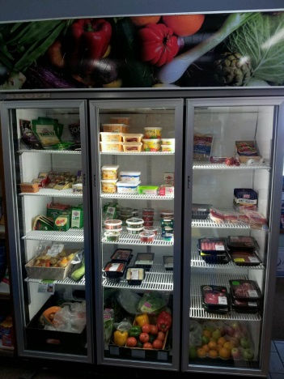
12 | Stocked fruit and vegetables but display area was small and not marketed | 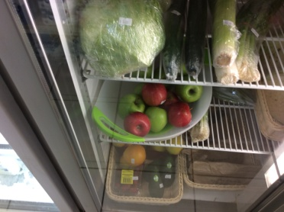 | 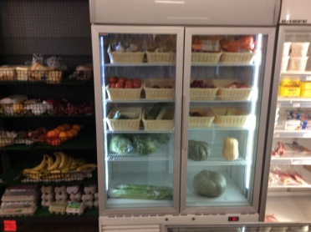
13 | Stocked fruit and vegetables but display area was small and not marketed |  | 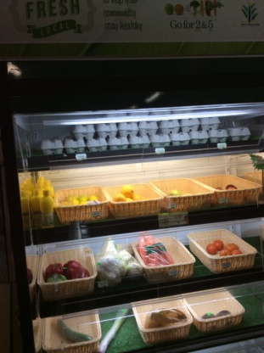 | 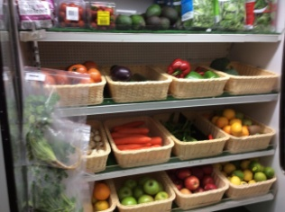
14 | Stocked fruit and vegetables but display area was small and not marketed | 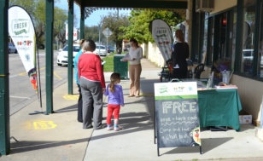  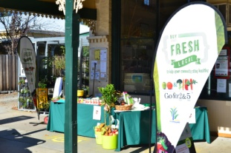

Interviews – retailers

Six retailers were interviewed 12 months into the initiative with 13 interviewed at the time of final evaluation. The interviews explored engagement, perceived success and barriers to the project. The focus for each interview was modified to account for their specific involvement in the project revealing areas of priority and focus for being involved in the project. Table 7 provides a summary of the themes identified through the interviews. This data has been reported elsewhere (9).

Table 7: Themes identified from retailer interviews
Enablers
Fiscal | - Financial gain and to remain financially viable in their overall business and with their fruit and vegetable centre  - Benefit from the Business Innovation expert helping with planning and development and encouraging implementation of new ideas  - Increase in sales and add on sales due to increase in foot traffic  - A new perspective on business  - Innovative ideas
Incentives | - Recipe cards  - Being part of an ‘innovative’, ‘exciting’ and ‘organised’ project
Community | - Increase access to fruit and vegetables for the community  - Engagement with community  - Community loyalty
Ease | - Don’t want to have to make any major changes to implement intervention (most stated they didn’t actually have to make major changes)  - Ability to enhance outcomes with minimal disruption to operations
Support | - The support provided by the project officer  - Education regarding produce handling and storage, knowledge of seasonality, and what and how much to order
Barriers
Communication | - Lack of clarity around specific interventions/strategies to implement in store
Marketing | - More emphasis on branding needed
Produce | - Consistent, reliable quality of supply  - Trusting supplier relationship  - Wastage of fresh produce

Interviews - key stakeholders

Eight stakeholders were interviewed revealing important considerations when delivering an innovative intervention and should be considered for future interventions focused on similar outcomes. The stakeholder interviews revealed three key themes, described in the table below.

Table 8 Themes derived from thematic analysis of stakeholder (n=8) interviews.
Theme | Descriptor | Quote
There has been an increase in access to fresh fruit and vegetables in participating stores | - A difference in the availability of fruit and vegetables in the store could be observed | “I couldn’t believe the total turn around, not just with fruit and veg, but the new layout of the shop, where they’ve taken lollies off the counter and put the fruit there… the produce is now being used in meals as opposed to [them selling] fish and chips”. (stakeholder 4)
The need to share common goals | - Retailer’s motivations are different to the health sector as they are driven by profit rather than purely health promotion. These two sectors need to work together to come to a common understanding for gain if access to healthy food is to be achieved.  - Business guidance was crucial for success in getting retailers to see fruit and vegetables value adding to business.  - Retailer perceptions of their role in the community. Retail stores may have role in supporting health of community. This is particularly the case when there is only one store in a community.  - Retailers had varied levels of interest in increasing access to fruit and vegetables for their communities.  - Partnerships, in particular the leadership from local government was instrumental for success.  - Timing is paramount. Retailers and their stores need to be in a position to take on business innovation such as this. | “they said they couldn’t do anything but they have” (stakeholder 4)
Improving access requires improvement to whole local food system | - Supporting access will fail if obtaining top quality, affordable supply of fruit and vegetable is not possible.  - Supply and demand go hand in hand. Increasing access needs to be accompanied by strategies to increase demand/purchase of fruit and vegetables.  - Social marketing messages are important in supporting demand.  - Impulse buying with fruit bowl at front counters was perceived to be effective in increasing sales. | “…at the end of the day if you haven’t got consistent, reliable suppliers, the project… the end result can’t happen” (stakeholder 1)
Project team engagement and decision making | - Networking at steering committee meetings was beneficial to the projects overall success  - The steering committee highlighted the opportunity organisations have to benefit from being involved in cross promotional activities for small output or investment  - Committee membership turn-over generated some inconsistency. This however also made way for new members offering a fresh perspective, understanding and commitment to the project.  - This also highlighted opportunities for Council to benefit from events being conducted in the community, offering a platform for information dissemination, engagement, positive representation, and ongoing conversation  - Project staff turn-over caused considerable loss of momentum for the project | “By providing a platform for networking over lunch …… members were inclined to offer ideas, and connect with one another. In order to truly engage partners it was very important to ensure there was something in it for all of the members” (Stakeholder 1)

Conclusion

Previous food system mapping identified many small stores in rural towns across Gippsland did not stock fresh and/or affordable fruit and vegetables. In response, the retail setting was targeted for the Retail Fruit and Vegetable project.

The retail fruit and vegetable project in Bass Coast and East Gippsland areas aimed to improve retail access to fresh fruit and vegetables in stores in small rural communities identified to have poor geographical access. Of the 35 stores eligible and approached to take on the initiative, 21 were engaged. A range of evaluation data attempted to measure the effectiveness of the initiative on the availability, range, price, sales, demand, store choice, consumer knowledge and consumption of fresh fruit and vegetables. The evaluation also aimed to determine retailer capacity to take on the initiative and reviewed enablers and barriers and unintended outcomes of the intervention.

The evaluation revealed that by offering a variety of customised incentives and social marketing to retailers, awareness, knowledge, range and sales may be positively impacted. While the limitations of the evaluation methods prevent conclusions from being drawn that this increase in sales translates into an increase in fruit and vegetable consumption for the target populations, the trends were promising. Substantial in-store retailer support, using only one social marketing message and collaborating with other community projects were found to enhance success. The initiative assisted in the promotion of small stores and communicated that fresh fruit and vegetables were available. The initiative also built the retailers capacity to develop their business and create links with suppliers. Small stores in rural communities were found to be important for building community capacity and have the potential to provide a community service supporting access to fruit and vegetables where they may not be available otherwise. Geographical distance to wholesalers, a lack of time and limited store floor space were found to be barriers to stocking and selling fresh fruit and vegetables. Using retailers as settings for health promotion through partnerships with local government and wholesaler and grower sectors may be an effective strategy for improving the population’s nutrition.

Recommendations

These three recommendations have been drawn from the findings of this initiative and the literature to support future initiatives that aim to increase access to and consumption of fresh fruit and vegetables.
- Work with retailers to promote access to and consumption of nutritious foods.
The role of settings in complex health promotion interventions are well established(10). This initiative provided evidence of the feasibility of the retail setting in the community to increase access to, and demand for fresh fruit and vegetables. Despite efforts in remote communities(11) there is little evidence of the ability of the retail sector to play a role in improving nutritional intake. This is an opportunity for further interventions to research and evaluate the impact of such initiatives on nutritional intake. Local government has a unique ability to build on existing partnerships, through environmental health mechanisms while working with food retailers. An award system for retailers offering healthy choices could be considered as well as building on the strategies outlined in this initiative to support small stores to sell fresh fruit and vegetables.

In order to support stores to sell fruit and vegetables it is recommended an interactive on line (or application based) training module be developed that focuses on sourcing, storing, stocking, displaying and handling produce, weighing, pricing and labelling of produce, profitability and value adding opportunities with a focus on seasonality and nutrition (benefits and challenges). The local and non-local supply chain and produce sourcing, health benefits and linking with your community/customer should also be considered. All these components would build a support package for retailers to empower, train and educate themselves. Tapping into established social marketing campaigns rather than create individualised or specific messages is also recommended.

- Support the establishment of a local food system
There is evidence to suggest that a robust local food system, whereby food is cultivated and sold mainly locally or regionally, can improve access to locally grown fruit and vegetables, enhancing community food access and improving nutritional intake(12). Supporting the cultivation and distribution of locally grown fruit and vegetables is important for future initiatives aimed at increasing access to and demand for fresh fruit and vegetables.

Resources to support knowledge of the local food supply and a system to facilitate access to wholesale fruit and vegetables is important for future endeavours. Partnership with fruit and vegetable wholesalers is essential. In order to minimise waste, retailers (with the assistance of producers and wholesalers) must be supported to think laterally and develop products to either lengthen shelf life or value add to produce to increase profit margins and preserve produce. This is paramount to the engagement and ongoing support of the retailers and should be addressed from the outset of such an intervention to improve retail access to fresh fruit and vegetables as one of multiple strategies to strengthen a local fresh food economy.

- Build research practice partnerships
Developing responsive systems-based approaches to population health issues often leads to innovative practice. Ensuring appropriate planning and evaluation occurs as part of new initiatives means that others can learn from new approaches. Universities are well placed to support evaluation. Students offer resource capacity to collect evaluation data. Regular and effective communication between partners will ensure evaluation methods and processes are adhered to for the entire project duration or are changed if required to ensure the best possible evaluation outcomes. The evaluation approaches used to measure the success of this initiative all had individual limitations. Combined they provided a more complete picture of the effect of the initiative. There is value in using multiple methods for evaluating complex interventions to triangulate results. This is particularly important when data collection is difficult and individual results are less reliable(13). The combined knowledge and experience of practitioners and researchers ensure evaluation plans are feasible yet effective in achieving desired results.

References
1. State of Victoria. Estimated Resident Population Gippsland 2011. Melbourne, Victoria: Victorian Department of Health 2012.
2. East Gippsland Shire Council. East Gippsland Community Well Being Plan 2009-2013. Bairnsdale, Victoria: East Gippsland Shire Council; 2009.
3. Bass Coast Shire Council. Council Plan 2013-17 with the inclusion of the Municipal Public Health and Wellbeing Plan. Wonthaggi: Bass Coast Shire Council; 2013 [updated 2013 2013; cited 2014 14 April]; Available from: http://www.basscoast.vic.gov.au/getmedia/d637e0f9-aa16-4dcb-9ae7-3a565125e3b9/ED13_46205_BC_Council_Plan_2013_v4.pdf.asp.
4. Department of Health Victoria. Size and distribution of the problem. Healthy eating. Victoria: State Government Victoria, ; 2009 [updated 2009; cited]; Available from: http://docs.health.vic.gov.au/docs/doc/F2DEB9500CE52253CA257A1D0025CB06/$FILE/HealthyEating.pdf.
5. Gibbs J, Christie I. Healthyliving Neighbourhood Shops Project. Scotland: Health Scotland, National Health Service; 2007.
6. Adams J, Halligan J, Burges Watson D, Ryan V, Penn L, Adamson A, et al. The Change4Life Convenience Store Programme to Increase Retail Access to Fresh Fruit and Vegetables: A Mixed Methods Process Evaluation. PLoS ONE. 2012;7(6):e39431.
7. Department of Health. Change4Life Convenience Stores Evaluation Report Promoting the purchase of fresh fruit and vegetables in deprived areas. United Kingdom; 2010.
8. Brimblecombe J, Mackerras D, Clifford P, O'Dea K. Does the store-turnover method still provide a useful guide to food intakes in Aboriginal communities? Australian and New Zealand Journal of Public Health. 2006;30(5):444-7.
9. Gardiner B, Blake M, Harris R, Gee C, Charaktis S, Choong C, et al. Can small stores have a big impact? A qualitative evaluation of a store fruit and vegetable initiative. Health Promotion Journal of Aust. 2013;24:192–8.
10. Whitelaw S, Baxendale A, Bryce C, MacHardy L, Young I, Witney E. Health Promot Int. 2001;16(4):339-53.
11. Brimblecombe J, Ferguson M, Liberato S, Ball K, Moodie M, Magnus A, et al. Stores Healthy Options Project in Remote Indigenous Communities (SHOP@RIC): a protocol of a randomised trial promoting healthy food and beverage purchases through price discounts and in-store nutrition education. BMC Public Health. 2013;13:744.
12. Carey R, Krumholz F, McConell K, Burns C, Lawrence M. Integrating agriculture and food policy to achieve sustainable peri-urban fruit and vegetable production in Victoria, Australia. Journal of Agriculture, Food Systems and Community Development. 2011;1(3):181–95.
13. Nutbeam D. Evaluating health promotion - progress, problems and solutions. Health Promot Int. 1998;13(1):27-44.

Appendix - Project resources and tools

Appendix A – Project introduction letter

Retail Fruit and Vegetable Project
Opportunity
Bass Coast Shire Council, supported by the Department of Health, is conducting a project to increase the retail supply and consumption of fresh fruit and vegetables in towns that have limited access. Within the scope of the project an opportunity exists to partner with you, one of our regional retail outlets to source, stock, and sell fresh fruit and vegetables.

Pilot Launch Site Opportunities
The “Go Fresh Go Local” project is in an exciting stage. We are extending an invitation to your business to be one of the benchmark locations for supply and uptake of fresh fruit and vegetables in the area.
The project offers the opportunity to select from a suite of support incentives including but not limited to:
- Assistance in sourcing and contacting suppliers, whilst considering season, shelf life and affordability
- Stock and supply evaluation from an independent Fresh Produce Expert
- Provision of promotional material such as recipe cards, posters, banners and A frames
- Subsidised ambient displays such as baskets, shelving, and containers considering layout and space available
- Subsidised refrigerated displays or shelving options
- Participation in a subsidised personalised work shop with a business development expert
- Promotional activities to be conducted at, or close to your outlet such as cooking demonstrations, seminars and fresh produce promotional activities all aimed at increasing demand for fresh produce in your store
- Advertising in local newspapers and newsletters promoting the range of fruit and vegetables available in your store
- In store support from the project coordinator to assist with layout, stock, promo materials etc.
- Other resources and activities to assist in the supply and uptake of fresh fruit and vegetables as deemed appropriate

Time Line
The project will ideally begin in your store as soon as possible whilst the ongoing in store support offered will continue as required for up to 6 months past the launch. An example time line including project evaluation may be:
Initial fruit and vegetable appraisal
Suppliers and stock requirements established
Retail consultation – in store lay out, displays selected and provided
In store promotional material in place
Supply in store
Launch event – cooking demo or guest speaker or other
Ongoing in store support
Evaluation

Your participation
In addition to free promotion for your store resulting from the project media produced, your store also poses to gain from business development consultation, overall improved sales of fruit and vegetables and improved add on sales resulting from consumers choosing your store. Bass Coast Shire Council and the Victorian Department of Health thank you for considering your involvement in this one of a kind project that focuses on improving the health and well-being of your community. We ask you be prepared to contribute sales data to the project for evaluation purposes (this may be as simple as your weekly wholesale purchase figures.)

Contact
Name, title, organisation, phone, e-mail

Appendix B - example of a Strengths, Weaknesses, Opportunities, Threats (SWOT) analysis

Store 6
Strengths | Weakness | Display characteristics, pricing, size etc. | Range | Supply (sourced, quality, reliability etc.) | Comments
This store is 6km from the closest supermarket and is located on a highway.  The Post Office is located in the store.  Do a large trade in fast food (fish and chips.)  Have a supplier for café produce (tomatoes, lettuce, onions.)  Are happy to sell things they stock for the café (as they know they can move the product one way or the other i.e. low risk.)  The main town is busy and parking is difficult for the older population so if the GS offered more F&V they may be able to capture some of that market. | Don’t stock any fruit and vegetables currently other than if customers ask for basics and don’t actively promote this availability.  The store gets very hot in summer which could present problems with ambient display of fruit and veggies going bad quickly on the shelf and don’t have a lot of extra space for a new fridge or ability to rearrange existing fridges and floor plan. | NIL display  Tomato .50c  Potato .50c  Lettuce $1.50  Onions .50c  Store owner commented would stock fruit and veggies if could address storage, display, point of sale issues, find a good quality supply and build demand to move the product but was unsure of where to start. | Tinned veggies (carrots, peas, beans, potatoes, beetroot, corn, mushrooms, tomato, potatoes) Fresh onions, lemons, lettuce, tomatoes. This is stocked to provide a low risk high profit option for healthy food (according to the store owner.) | Sometimes get lemons from community for free  Get large locally grown potatoes for potato cakes (supply sometimes difficult to secure.) | Would like to sell apples, bananas, oranges, mandarins, zucchini, cabbage, etc. but don’t because of storage and don’t have the confidence to handle it and price it. Customers do ask for it – especially campers (fruit mostly)  Opportunity to promote local produce when available.  Likes the idea of a fruit basket. Will move the bread to open up space to display fruit and veggies.  Will start small and build the range.

Appendix C - Retailer Feedback form

This tool is designed to build an store profile regarding experience and opinions regarding stocking fresh produce. It could otherwise be called a SWOT analysis and is completed in consultation with the retailer.

Outlet name ____________________________ Outlet code _________________ Date ___ / ____ / ____

1. What do you currently stock in the fruit and vegetable range?
______________________________________________________________________________________________________________________________________________________________________

2. What sells the best? (Please list up to top 10 in order of sales from highest to lowest.)
______________________________________________________________________________________________________________________________________________________________________

3. What suppliers do you currently use (to source fresh fruit and vegetables?)
______________________________________________________________________________________________________________________________________________________________________

4. Please list items you would like to sell but currently don’t? Please state why.
______________________________________________________________________________________________________________________________________________________________________

5. Do your shoppers ask for things you don’t/cant stock? What are these items? Please state why you can’t/don’t stock them.
______________________________________________________________________________________________________________________________________________________________________

6. What items do you stock as a direct result of your customers specifically asking for them?
______________________________________________________________________________________________________________________________________________________________________

7. Why do you stock the items you stock?

☼ Demand ☼ Shelf life ☼ Storage
☼ Space ☼ Labour / Time ☼ Sells quickly ☼ Availability
☼ Season ☼ Profitable / price ☼ Service to public
☼Other _____________________________________________________________________________

8. Are there any obstacles / challenges to stocking fresh fruit and vegetables in your store?

☼ Demand ☼ Shelf life ☼ Storage
☼ Space ☼ Labour / Time ☼ Sells quickly ☼ Availability
☼ Season ☼ Profitable / price ☼ Service to public ☼ Affordability
☼Other _________________________________________________

9. What would encourage you to stock (more) fruit and vegetables in your store?
______________________________________________________________________________________________________________________________________________________________________

10. Do you have any other comments or ideas to add?
______________________________________________________________________________________________________________________________________________________________________

11. What price do you sell the following for when in stock and in season? Approx. is OK (Victorian Healthy Food Basket items)

Apples Oranges Bananas
Tomatoes Potatoes Pumpkin
Cabbage Lettuce Carrots Onions

NOTES:

Appendix D - Steering committee terms of reference

1. Purpose of the Steering Committee

To provide the Fruit and Vegetable Project coordinator with information enabling them to improve and promote provision of, and access to, retail fresh fruit and vegetables. The Steering Committee will act as a resource to the project coordinator on issues affecting the supply and uptake of retail fresh fruit and vegetables. It will advise on issues pertaining to Health Promotion, General Stores, Transport, Distribution, Supply, Business Development, Environmental Health, Food Handling, Reporting, Data Collection and Engagement, which may affect supply and uptake of fresh fruit and vegetables in the Bass Coast Shire.

2. Steering Committee responsibilities
Provide advice and expertise in the areas of Health Promotion, Transport, Distribution, Supply, Business Development, Environmental Health, Food Handling, Reporting, Data Collection, and Engagement issues as they pertain to stake holder policy and strategies on request.
Take responsibility for nominated actions resulting from Steering Committee meetings.
Maintain an awareness of current trends and changes in supply and uptake of fresh fruit and vegetables in the community of Bass Coast Shire Council and beyond.
Assist the project coordinator to identify practical solutions to supply and access to fresh fruit and vegetables in the Bass Coast Shire.
Be representative of the community, with particular focus on those with limited access to affordable fresh fruit and vegetables.
Nominate self or members to represent the Committee in community engagement activities and relevant Council forums.
Committee members must ensure that sensitive or confidential information associated with the project remains within the membership of the Steering Committee.

3. Areas outside the Committee’s responsibility
The Retail Fruit and Vegetable Project Steering Committee is not responsible for involvement in day-to-day operational issues related to the coordination of the Fruit and Vegetable project. Members of the Committee have the same right as all community members to raise issues of concern through the appropriate Council system. This is the recommended method of resolving day-to-day issues which are outside the scope of the Steering Committee.
The Retail Fruit and Vegetable Project Steering Committee have no responsibility for Council budget.
Members of the Committee do not have media responsibility unless specifically requested by the Project Supervisor.

4. Membership

Membership of the Retail Fruit and Vegetable Project steering Committee covers the requirements as prescribed by the Department of Health outlined in the Project Outline documentation. As per the Project Outline the membership will comprise:
Project coordinator and Chair (1)
Line Manager to the project coordinator in Council (Project Supervisor) (1)
Department of Health Representative (2)
Council Economic Development Representative (1)
Health Sector Representative (2)
Environmental Health Representative (1)
In addition to the above, the following will be included due to their corresponding areas of expertise and their relationship with the priority areas of the project:
Transport Representative (1)
Community Planning Facilitator Representative (1)
Adult Learning and Education Representative (1)

5. Term of Office
The term of office for each Committee member will be two-years beginning February 2012.
At the end of the two year term, all positions will be declared vacant as the project will be complete.
Members who do not attend three meetings in a calendar year without apology will be deemed to have resigned from the Committee and a casual vacancy will result.
If a casual vacancy occurs, it will be filled at the discretion of the project supervisor and project coordinator.

6. Method of nomination
As prescribed by the Project Outline and Application Guide (Department of Health.)

7. Meetings
Meetings will be held every second month (odd numbered months being May, July, September and November in 2012, and January, March, May, July, September, November in 2013.) Meetings will run for 1.5 hours on a day to be agreed upon by the Steering Committee. Lunch will be provided at the end of the meeting.
Members of the Committee will be notified of the meeting through the agenda in advance of the meeting and requested to provide apologies if unable to attend.
Minutes will be circulated to all members.
Members must submit agenda items prior to the meeting where possible.

8. Pecuniary interests/conflict of interest
Members of the Committee must disclose any pecuniary interests to ensure there is no conflict of interest.
Agency representatives must ensure they represent the interests of people with limited access to retail supply of fresh fruit and vegetables rather than (purely) the interests of their agency.
Where members believe a conflict of interest exists they should abstain from voting on an issue.

9. Support
Administrative support for the meetings will be provided by Council.
Refreshments for meeting attendees will be provided by Council and will cater for special diets where requested.
Disability-related support required by members of the Committee and their guests will be provided by Council.
Committee members may request additional support which they believe will improve their ability to fulfil their role on the Committee.

Appendix E - Retailer incentive guidelines

Improving Retail Access to Fruit and Vegetables:
Incentives to retailers

Preamble

Some components of the incentives that were conceived in the original design of this initiative have proven to be ineffective (e.g. refrigeration subsidies). It is therefore prudent to review the approach to the incentive design and implementation.

Councils are at the front line of negotiating with retailers and making judgements about what type of incentives are appropriate, and whether they should be supported in full, or by way of a partial subsidy.

The following (draft) principles seek to capture the considerations that are appropriate in making these judgements.

Principles

1. Incentives should only be supported where there is a direct relationship between the provision of the incentive and retailers capacity to provide
- a wider variety of fresh fruit and vegetables (range of fresh fruit and vegetables)
- better quality fresh fruit and vegetables (quality and freshness)
- increase purchasing/turnover of fresh fruit and vegetables (increase sales)
- increase profits made from sales of fresh fruit and vegetables (profitability)
- increase community awareness/interest of fresh fruit and vegetables in retailers (marketing)
- increase retailers skills in management of the fresh fruit and vegetable category (training)

2. The incentive needs to create a positive response/outcome that can be sustained, either through a capital item that has a long useful life, or through a sustained change in the business model.

3. The level of subsidy offered for a specific item needs to reflect judgements about:
- the predicted impact on the outcomes identified in Principle 1
- whether the incentive supports other business objectives unrelated to the project objectives outlined in Principle 1 (i.e. will the item be used for the sole purposes of increasing fruit and veg sales, or will it be used for other things)

4. The total value of subsidies offered to any individual retailers needs to consider:
- the population reach of the retail outlet incorporating equity considerations
- the distribution of the available budget over the 20 stores

Learning

As we are discovering what incentives are attractive to retailers and the effectiveness of incentives as we implement, it is critical to capture these learnings in project reporting and evaluation activities.

Appendix F - Shopper Surveys

Shopper Survey
Date:
Store:

Fruit and Vegetable Purchasing Habits
- In your household, are you the person that does most of the grocery shopping?
0 |  | No
1 |  | Yes
2 |  | Shared

- How often do you visit this store?
0 |  | Never
1 |  | Not often
2 |  | Once a week
3 |  | A few times a week
4 |  | Everyday

- What do you use the store to purchase:
1 |  | All of your groceries
2 |  | Most of your groceries
3 |  | Items you forgot/run out of
4 |  | Convenience items (mail, newspaper, milk, bread, coffee, takeaway, cigarettes)

- How often do you buy fresh fruit and vegetables?
0 |  | Never
1 |  | Once a fortnight
2 |  | Once a week
3 |  | A few times a week
4 |  | Everyday

- Have you ever purchased fresh fruit and vegetables from this store?
0 | No
1 | Yes

- Where do you buy most of your fresh fruit and vegetables?
1 |  | Chain Supermarket
2 |  | Independent Supermarket
3 |  | Fruit and Vegetable Shop
4 |  | Farmers Market
5 |  | This store
6 |  | Grow your own

- Of the last three times you bought fresh fruit and vegetables, how many were at this store?
0 |  | None
1 |  | One
2 |  | Two
3 |  | Three
- How would you rate the quality of the fresh fruit and vegetables available here compared to where you normally purchase them?
1 |  | Much poorer
2 |  | Not quite as good
3 |  | About the same
4 |  | A little better
5 |  | Much better

- I’m going to read you some statements about this store, I would like you to tell me if you strongly agree, agree, disagree, strongly disagree with them
This store… | Strongly Disagree | Disagree | Neutral | Agree | Strongly Agree
This store… | 1 | 2 | 3 | 4 | 5
Stocks the fresh fruit & vegetables that you want to buy (Meeting needs)
Displays fresh fruit & vegetables in an appealing way (Display)
Has good range of fresh fruit & vegetables (Variety)
Stocks high quality fresh fruit & vegetables (Quality)
Displays fresh fruit and veg so they are hard to see (Display/Negative trick question)
I would recommend this as a place to shop for fresh fruit & vegetables (Meeting needs)
Has fresh fruit & vegetables at a price your willing to pay (Price)
Focuses on consumer needs (Meeting needs)

- Does anything put you off buying fresh fruit and vegetables from this store? (try not to prompt)
0 |  | Nothing
1 |  | Poor selection
2 |  | Mainly shop at supermarket
3 |  | Price (Expensive/can buy cheaper)
4 |  | Quality (Poor/old)
5 |  | Don’t eat many fruits or vegetables
6 |  | Forget (they have fruit and vegetables)
7 |  | Unattractive display, not obvious
8 |  | Store does not stock them
9 |  | Inconvenient (don’t think of it as a place to buy fruit & vegetables)

Demographics
‘If there is anything that you’d prefer not to answer, that’s fine just let me know.’
- Where do you live?
Where

- Gender
0 |  | Refused
1 |  | Male
2 |  | Female

- Age Group
0 |  | Refused
1 |  | ≤24 years
2 |  | 25-34 years
3 |  | 35-44 years
4 |  | 45-54 years
5 |  | 55-64 years
6 |  | 65-74 years
7 |  | 75-84 years
8 |  | ≥85 years

- Does your household consist of:
1 |  | Couple with child/children
2 |  | Couple without children
3 |  | One parent family
4 |  | Lone person
5 |  | Group household (not related)
6 |  | Other (specify)

- Highest Level of Education
1 |  | Year 10 or below
2 |  | Year 11/12
3 |  | Apprenticeship
4 |  | TAFE Certificate
5 |  | Diploma
6 |  | Undergraduate Degree
7 |  | Postgraduate Degree

- Employment Status
1 |  | Full-time
2 |  | Part-time
3 |  | Self-employed
4 |  | Unemployed
5 |  | Retired
6 |  | Home Duties
7 |  | Student
8 |  | Volunteer

- Household Annual Income
0 |  | Refused
1 |  | Less than $40K
2 |  | Between $40-80K
3 |  | Over $80K
4 |  | Don’t know

- Main language spoken at home
1 |  | English
2 |  | Other (specify)

- Aboriginal or Torres Strait Islander background
0 |  | No
1 |  | Yes
2 |  | Refused

Social Marketing
Pre-intervention (Q1-8 only)
Fruit
- How many serves of fruit do you usually eat each day? A ‘serve’ is 1 medium piece or 2 small pieces of fruit or 1 cup of diced pieces, ½ cup of juice or 1.5 tablespoons of dried fruit.
0 |  | Don’t know
 |  | Record number of serves PER DAY

- Do you think you should be eating more or less, or is that about right?
0 |  | Less
1 |  | About right
2 |  | More

- To maintain good health, how many serves of fruit do you think you should eat every day? A ‘serve’ is 1 medium piece or 2 small pieces of fruit or 1 cup of diced pieces, ½ cup of juice or 1.5 tablespoons of dried fruit.
0 |  | Don’t know
 |  | Record number of serves PER DAY

- In the last couple of months, have you tried to change the amount of fruit that you or your family eats?
IF YES: Is that increase or decrease?
0 |  | No
1 |  | Yes, decrease
2 |  | Yes, increase

Vegetables
- How many serves of vegetables do you usually eat each day? A ‘serve’ is ½ cup of cooked vegetables or 1 cup of salad vegetables.
0 |  | Don’t know
 |  | Record number of serves PER DAY

- Do you think you should be eating more or less, or is that about right?
0 |  | Less
1 |  | About right
2 |  | More

- To maintain good health, how many serves of vegetables do you think you should eat every day? A ‘serve’ is 1 medium piece or 2 small pieces of fruit or 1 cup of diced pieces, ½ cup of juice or 1.5 tablespoons of dried fruit.
0 |  | Don’t know
 |  | Record number of serves PER DAY

- In the last couple of months, have you tried to change the amount of vegetables that you or your family eats?

IF YES: Is that increase or decrease?
0 |  | No
1 |  | Yes, decrease
2 |  | Yes, increase

- Have you noticed the ‘Go Fresh, Go Local’/’Buy Fresh Local’ promotion in store?
0 | No
1 | Yes

If Yes, what in particular have you noticed? (try not to prompt)
1 |  | Fridge improvements
2 |  | Signage
3 |  | Storage Baskets
4 |  | Bags
5 |  | Giveaways
6 |  | Fresh Fruit & Vegetables boxes available to order
7 |  | Improved range
8 |  | Better quality produce
9 |  | Better display
10 |  | Cheaper produce
11 |  | Other

- What do you think the store is trying to do with this promotion? What is the key message of the campaign?
__________________________________________________________________________________________________________________________________________________________________________________________________________________________________________________________________

- Has the ‘Go Fresh, Go Local’/’Buy Fresh Local’ promotion prompted you to take any action?
0 | No
1 | Yes

If yes, what action did you take?
1 |  | Talk about diet with family/friends
2 |  | Think about the amount of fruit and vegetables I/my family eats
3 |  | Buy more fruit when shopping
4 |  | Buy more vegetables when shopping
5 |  | Add an extra serve of vegies to my meals
6 |  | Try to increase the amount of fruit I/my family eats
7 |  | Try to increase the amount of vegetables I/my family eats
8 |  | Use recipes using fruit and vegetables
9 |  | Other (specify)

Appendix G: A-Z audit tool

A-Z List of Fruit and Vegetables Adapted From: http://www.marketfresh.com.au/produce_guide/fruit_veg_all.asp?CategoryID=0&ID=0

Available or
Apple
Apricot
Artichoke
Asparagus
Avocado
Banana
Bean (green)
Beetroot (Beet)
Broccoli
Cabbage
Cantaloupe (Rockmelon)
Capsicum (Peppers)
Carrot
Cauliflower
Celeriac (Celery root)
Celery
Cherry
Chinese Chard (Buk Choy)
Choi Sum
Choko (Chayote)
Coconut
Cucumber
Custard Apple
Dragon Fruit
Durian (Civet Fruit, Thurian)
Eggplant (Aubergine)
Feijoa (Guavasteen, Pineapple guava)
Fig
Gooseberry
Grape
Grapefruit
Guava
Honeydew melon
Kiwifruit (Chinese gooseberry)
Leek
Lemon
Lettuce
Lime
Lychee
Mandarin
Mango
Mangosteen
Mushroom
Nashi (Apple-Pear)
Nectarine
Okra
Onion
Orange
Pak Choy
Parsnip
Passionfruit
Paw Paw (Papaya)
Pea Green
Pea Snow
Pea Sugar-snap
Peach
Pear
Persimmon (Kaki)
Pineapple
Plum
Pomegranate
Potato
Prickly Pear (Indian Fig)
Pumpkin
Radish
Raspberry
Rhubarb
Shallot (Eschallot)
Silverbeet (Swiss Chard)
Spinach
Spring Onion
Sprout (Alfalfa, Bean Sprouts)
Squash (Button Squash)
Star Apple
Swede
Sweet Corn (Corn)
Sweet Potato (Kumara)
Taro
Tomato
Turnip Uvilla (Amazon tree grape)
Water Chestnut
Watercress
Watermelon
Zucchini (Courgette)

Appendix H - Profit in fruit and vegetables information sheet

Profit in Fruit & Vegetables


Consider this
What if you could get an extra 10 cents from the sale of an item that turns 20 times a day, that one item could produce an extra $728 a year in additional gross profits. If you could duplicate that technique and apply it to 10 items, it would translate to $7,280 in increased profits annually. That puts a new light on a $1.20 apple! Beer and milk are not the only items where cents matter!
Another example may be a store that currently turns over 2% of their annual sales in fresh fruit and vegetables. By increasing the range by utilising point of sale (POS) incentives and marketing opportunities, sales in this often neglected profit centre may increase. For example if this resulted in fruit and vegetables turning over 5% of total sales, an overall increase of 3% of income is generated. What is 3% of your sales? This is an opportunity to be seized!

Why Fruit and Vegetables?
- An increase in range brings more consumers into your store thus increasing the reasons why people choose to shop with you.
- You are geographically located at the centre of the community and are already engaging in your community and offering a healthy community service - Fruit and Vegetables are good for your communities’ health.
- By taking advantage of POS marketing and special promotion events, you can gradually build your range based on sales and available space with minimal risk.
- Promotion of seasonal events and products can tie in with other in store lines. For example offer a lunch special that packs a juice, sandwich and apple together!

Handling & stock control
Stocking every-day items in your store brings in more foot traffic so always keep your display looking fresh and plentiful.
- Assign a staff member to be the Stores Fruit and Veg Champion. Their role is to check the produce every day and make sure it is looking its best.
- Set up procedures in store for checking and re-stocking shelves. For example a 3 point check list that is attended to each morning and afternoon.
- Ovoid overfilling baskets and displays too much as it causes bruising, but keep it looking abundant.
- Promote incentives to your community through the Fruit and Vegetable project.
- Ovoid direct sun light, control ambient temperatures as much as possible, rotate stock and handle with care!
- Never put potatoes, onions or bananas in the fridge.
- Although it is not preferred, it is better to discard than sell inferior product. Record waste. If it’s towards the end of its shelf life maybe you can add it to a soup or stew, make a smoothie or freeze it.
- Keep the display clean.

Fruit and Veg Strategies
Place fruit and veg in a prominent position in your store, preferably at the front, within easy reach by the shopper. This increases visibility, but most importantly if the produce looks fresh and vibrant impulse buying increases.
- Always use price tags. Consumers like to know what the price is before they buy.
- Utilise the POS materials to promote certain lines and specials.
- Vary your display. As with the rest of your store, line items and profit centres need seasonal change or one off changes as opportunities allow.
- Ensure your pricing is competitive whilst also considering the convenience you offer your customers.
- Always have a promotion going on in store. Consider offering a two for one special, a special of the week, buy 6 and pay for 5 etc. The only limit is your imagination.
- Run seasonal events or run in store promotions that revolve around events or holidays. For example Christmas Cheer, BBQ packs, breakfast packs salad ideas and recipe cards for seasonal produce.
- Know your market. Stock top selling products appropriate to your clientele. This is your core market. Survey customers to find out what they want
- Group similar product lines together. For example salad ingredients look great together as they are mostly bright coloured items such as capsicums and tomatoes.
- According to the Change For Life program run by the Scottish Government (2009), successful promotion of fruit and veg can drive sales by up to 500%
- Keep a balance between pre-packaged and loose products. In some lines people like to choose their own i.e. tomatoes, while pre-packaged potatoes are fine.

Remember - you don’t stock fruit and veg, you sell it!

Appendix I - Buy Fresh Buy local tool created from one of the business innovation sessions for staff training

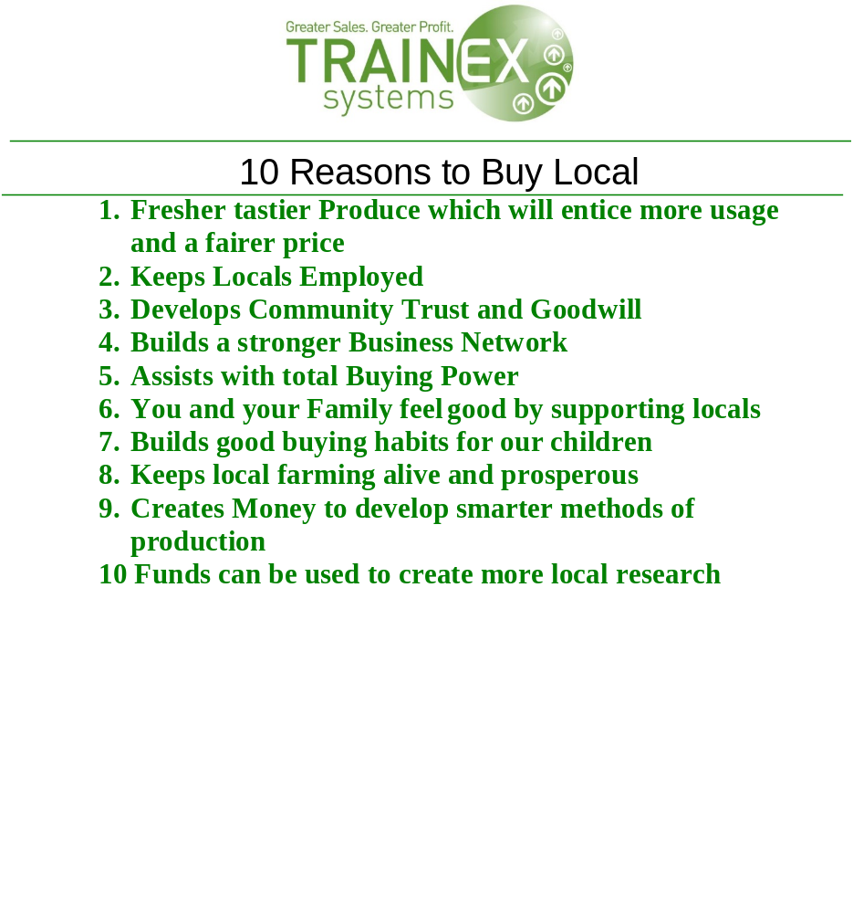

Appendix J - Strategies to consider when supporting retailers to be Health Promoting outlets

All these strategies can work together or in isolation to help lengthen shelf life or value add to produce so as to increase profit margin and preserve produce for longer

Appendix K - Store stories’

The following offers an insight into the operational circumstances of each store in Bass Coast Shire Council and how they related to availability and range.

Store one
Three months after implementation of the project, the store underwent a major refurbishment. This resulted in a temporary dramatic drop in the stores ability to stock fresh fruit and vegetables whereby lines stocked went from nineteen to seven in a three month period. Once the refurbishment was complete the range was increased and averaged 18 lines each quarter for the remainder of the intervention without significant seasonal dips in range. It should also be noted that when this store was first approached it was the height of the summer tourist season, when turn over for this store was at its greatest.

Store two
This store only sold what they were asked for and offered only lines stocked for the café. Six months after implementation of the project the store was put on the market and sold. A resulting reduction in lines stocked was due to the store closing in this time frame.

Store three
This store did not stock fresh fruit and vegetables pre-intervention, however once a consistent supply was in place (supplied from a variety of sources) the store averaged 17 lines of fresh fruit and vegetables with the two highest volumes being stocked in the warmer, busier tourist season.

Store four
This store did not stock fresh fruit and vegetables at the beginning of the intervention. Store four’s strategy was to gradually build the number of lines up and focus on seasonality as the determinant for what they stocked whilst considering being price competitive. As a result, this stores number of lines gradually went up and peaked at 26 lines twelve months after the intervention was initiated.

Store five
Store five focused on increasing visibility in the store as produce was located at the rear of the store in two separate locations. This store utilised all the incentives to attract customers to the back of the store to the fresh produce. They also consolidated the display. Starting at twelve lines, this store consistently stocked lines in the high teens, with an average of nineteen lines. One of the main strategies this store employed was growing their own, which saw number of lines peak around the six to nine month stages of implementation at nineteen to twenty five lines during the summer growing season.

Store six
This store did not stock fresh fruit and vegetables in the first instance. This store focused on offering a range of local and non-local produce, sourcing produce when they knew it could be retailed at a competitive price. This store went from not offering any fresh fruit and vegetables to stocking an average of fifteen lines with a drop in lines in the winter.

Store seven
This store had been stocking fresh produce for several years, but only focused on what they described as the staples. By focusing on increasing the range, the average number of lines stocked throughout the intervention was 18, with spikes in numbers observed during the warmer months.

Store eight
From offering no fresh fruit and vegetable this store’s aim was to slowly increase the range so as to minimise risk. The café was made available to the local walking group as a meeting place utilising this opportunity to promote their fresh fruit by catering a healthy morning tea for walkers after each walk. This store, like many others, experienced an increase in tourist numbers over summer and consequently an increase in range of fresh fruit and vegetables was sustainable with a dip in lines experienced over the winter months when store flow and demand was lower.

Store ten
Initially store ten offered only what they could to customers who asked for it, limiting the range to what was available in excess from the café kitchen. The improved range was based only on what the café needed for the kitchen, and was actively promoted with ambient displays as part of the intervention, however as local foot traffic into the store was limited in the colder months, and staffing became an issue, less effort was put into promoting the fresh produce lines and a resulting reduction in lines was observed.

Store eleven
Store eleven had sixteen lines in stock at the beginning of the intervention, and gradually increased the number of lines available. The average number of lines stocked over the duration of the project was twenty two, an increase of 35%.

