
Victorian cancer plan 2020–2024
Improving cancer outcomes for all Victorians

Department of Health
Victorian cancer plan 2020–2024
Improving cancer outcomes for all Victorians

To receive this publication in an accessible format phone (03) 9096 2136, using the National Relay Service 13 36 77 if required, or email Cancer and Aged Care <cancerplanning@dhhs.vic.gov.au>.
Authorised and published by the Victorian Government, 1 Treasury Place, Melbourne.
© State of Victoria, Department of Health and Human Services, September 2020.
Except where otherwise indicated, the images in this publication show models and illustrative settings only, and do not necessarily depict actual services, facilities or recipients of services. This publication may contain images of deceased Aboriginal and Torres Strait Islander peoples.
Where the term ‘Aboriginal’ is used it refers to both Aboriginal and Torres Strait Islander people. Indigenous is retained when it is part of the title of a report, program or quotation.
ISBN 978-1-76069-433-3 (print)
ISBN 978-1-76069-434-0 (pdf/online/MS word)
Available from the department’s website <www.health.vic.gov.au/cancer>.
Printed by Hornet Press, Knoxfield (1912579)

Foreword
This Victorian cancer plan 2020–2024 is the second plan released under the Improving Cancer Outcomes Act 2014. It builds on the breadth of work delivered over the past four years to reduce risk and to improve early detection and cancer care for Victorians.
Cancer is a word that describes multiple diseases that place a great burden on the community. One in three men and one in four women will be diagnosed with cancer by the age of 75.
The battle to overcome this burden of disease is a long-term goal that requires a constancy of purpose to ensure we continue to make progress across time. I am heartened to see that we are improving cancer survival rates for one- and five-year survival. We are on track to save 10,000 lives by 2025.
Prevention and early detection is where we have the best chance to alter long-term outcomes.
All Victorians have the right to access the care they need, and this plan focuses on inequities in the system. For Aboriginal Victorians, there is a focus on equity of access and outcomes and moving towards self-determination to recognise the importance of services that meet their needs. For regional Victorians, there is a focus on reforms that deliver access to the same quality of care found in metropolitan areas.
The voices of Victorians have informed this plan through a consultation process and ongoing data collection. Data sources include the Victorian Cancer Registry, the Victorian Cancer Patient Experience Survey and the Victorian cancer plan monitoring and evaluation framework.
This plan is also influenced by the COVID-19 pandemic. We have learnt the importance of social isolation and its impact on our ability to access health care. We know that cancer screening and diagnosis has been delayed for some Victorians. This is concerning because it will result in later stage cancer diagnoses which will be more difficult to treat.
The Victorian health care system is working towards recovery, including a program of catch up for those who present for cancer screening and care. All patients are encouraged to seek timely care for symptoms and attend screening when due. The speed of recovery is confined within the physical constraints of the system, however it will be agile so that it can deliver catch up, and respond to further outbreaks to reduce the unwanted impact on access to care across the system.
There are cancer prevention and health reform options now being implemented and new ones planned, that will deliver a better health system based on research and best evidence. This includes new ways of delivering care closer to home and in-home (home-based cancer care and telemedicine), and that ensure safety and quality. Planning is increasingly at scale across regions, across care types and across primary and acute health care. Decisions about investment in this recovery phase and beyond will deliver a responsive health care system that meets the needs of all Victorians, especially in times of uncertainty.
This plan will only be successful if it has widespread support based on a common purpose. That purpose is to help others and ourselves in our health goals and in building momentum to overcome challenges to achieve what we deserve and need from our health system. The plan is a continued path forward for better cancer outcomes for all Victorians.
I look forward to the next progress report that measures our collective efforts to reduce the burden of cancer on us individually, our family and friends, and the broader Victorian community.

Jenny Mikakos MP
Minister for Health
Minister for Ambulance Services

Acknowledgement of Aboriginal Victoria
The Victorian Government proudly acknowledges Victoria’s Aboriginal communities and their rich culture and pays respect to their Elders past and present. We acknowledge Aboriginal people as Australia’s first peoples and as the Traditional Owners and custodians of the land and water on which we live, work and play. We recognise and value the ongoing contribution of Aboriginal people and communities to Victorian life and how this enriches our society more broadly. We embrace the spirit of self-determination and reconciliation, working towards equality of outcomes and ensuring an equitable voice.
Victorian Aboriginal communities and peoples are culturally diverse, with rich and varied heritages and histories both pre- and post-invasion. The impacts of colonisation – while having devastating effects on the traditional life of Aboriginal Nations – have not diminished Aboriginal people’s connection to country, culture or community. Aboriginal Nations continue to strengthen and grow with the resurgence of language, lore and cultural knowledge. These rich and varied histories need to be understood and acknowledged by all Victorians, to truly understand the resilience and strength of previous generations, as well as the history of the fight for survival, justice and country that has taken place across Victoria and around Australia.
As we work together to ensure Victorian Aboriginal communities continue to thrive, the government acknowledges the invaluable contributions of generations of Aboriginal warriors that have come before us, who have fought tirelessly for the rights of their people and communities towards Aboriginal self-determination. We are now honoured to be part of that vision.

Contents
Foreword v
Acknowledgement of Aboriginal Victoria vi
Contents viii
About this plan 1
Burden of cancer in Victoria 3
Incidence and mortality 4
Survival 4
Poorer outcomes 4
Progress towards achieving our goals 6
Victorian cancer plan monitoring and evaluation framework 6
Patient care 8
Earlier diagnoses 8
Research 8
Goals 8
A comprehensive, inclusive and equitable approach 10
Advancing Aboriginal self-determination 10
Life course approach 10
Local solutions 10
Fostering gender equity 10
Addressing socioeconomic disadvantage 11
Responding to the needs of our diverse population 11
COVID-19 recovery and cancer care reform 13
Regionalised delivery of health care 14
Alternative models of care 15
Health workforce 17
Plan on a page: Victorian cancer plan 2020–2024 18
Principles 18
System supports 18
Optimal care pathways 20
Action area 1: Primary prevention 23
Reduce risk factors related to lifestyle and environmental hazards 23
Prevent cancers related to viral infections 29
Action area 2: Screening and early detection 32
Equitable and increased participation in population cancer screening programs 32
Increase early detection of cancers through improved health literacy and primary care capacity to support early diagnosis 38
Action area 3: Treatment 42
Consistent quality through optimal care pathways 42
Improve patients’ experience of care 45
Optimise infrastructure, data and system design for better access, safety and quality 46
Action area 4: Wellbeing and support 50
Strengthen supportive care and self-management 50
Support cancer survivors to recover and thrive 53
Maintain quality of life through palliative care and end-of-life care 56
Action area 5: Research 58
Improve access to clinical trials 58
Accelerate translation of research into improved clinical outcomes 61
Support equity and collaboration in cancer research 64
Implementing the cancer plan 69
Appendix 1: Building on our achievements 70
Primary prevention 70
Screening and early detection 70
Treatment 71
Wellbeing and support 71
Research 71
Appendix 2: Policy context 72
Appendix 3: Consultations 73
Glossary 74
References 76

About this plan
Under the Improving Cancer Outcomes Act 2014 the Victorian Government is committed to preparing a statewide cancer plan every four years. The Act requires each cancer plan to:
- report on the status and burden of cancer in Victoria
- establish Victoria’s objectives and policy priorities with respect to cancer
- state how these objectives will be achieved based on available evidence
  - specify how the state intends to work with other parties to achieve these objectives and policy priorities.
The Victorian cancer plan 2016–2020 was the first plan under the Act. We have made major progress towards achieving the goals of that plan, yet there is more to be done to achieve fair outcomes for all Victorians. The Victorian cancer plan 2020–2024 continues the momentum towards the long-term vision of improving cancer outcomes for all Victorians. It will provide continuity for the action areas and priorities of the 2016–2020 plan, including the long-term goals established in the 2016–2020 plan.
The plan aims to address the inequities identified in the Victorian cancer plan monitoring and evaluation framework: baseline report (Department of Health and Human Services 2020a). It will address areas for improvement discovered through the 2019 Victorian Cancer Patient Experience Survey.
The plan will also address health reforms arising from the COVID-19 pandemic. It has been shown that care can be delivered closer to home and across regions safely; this reform work will build on changes more broadly within the system including changes to models of care, a regional approach to service delivery and best use of the health workforce.
The plan aligns with other key strategies including:
- Victorian public health and wellbeing plan 2019–2023
- Better, safer care: delivering a world-leading healthcare system
- Korin Korin Balit-Djak: Aboriginal health, wellbeing and safety strategic plan 2017–2027
  - Victorian carer strategy 2018–2022.
Table 1 provides a roadmap of goals for this four-year period through to the long term.
Table 1: Victorian cancer plan goals for 2020–2024 and beyond
Short-term goals  (2020–2024) | Medium-term goals  (2030) | Long-term goals²  (2040)
At least 80 per cent of hospitals and health services’ retail outlets and vending machines meet recommended Victorian Government food and nutrition standards  Encourage an additional 10,000 under-screened¹ women to have a cervical screen through the self-collection pathway  Increase access by 20 per cent for symptom and urgent review clinics for chemotherapy patients, to avoid emergency presentations for vulnerable patients  Increase by 50 per cent, in people who have metastatic cancer, the proportion of people with an advance care directive  Increase the overall number of new clinical trial enrolments in rural and regional areas in Victoria by 30 per cent | Save 10,000 lives by 2025²  90 per cent reduction in the number of new infections of hepatitis B and C  Eliminate cervical cancer as a public health problem in Victoria  Increase the number of women who rescreen for breast cancer to more than 75 per cent  90 per cent of cancer patients receiving specialist palliative care within 12 months prior to death | Halve the proportion of Victorians diagnosed with preventable cancers  Achieve equitable outcomes for all Victorians  Ensure Victorians have the best possible experience of the cancer treatment and care system  Increase one- and five-year survival of Victorians with cancer
Notes:
1. Under-screened: never screened or more than two years overdue
2. Unchanged from 2016–2020 plan

Burden of cancer in Victoria
Cancer imposes a sizable burden on the Victorian community.
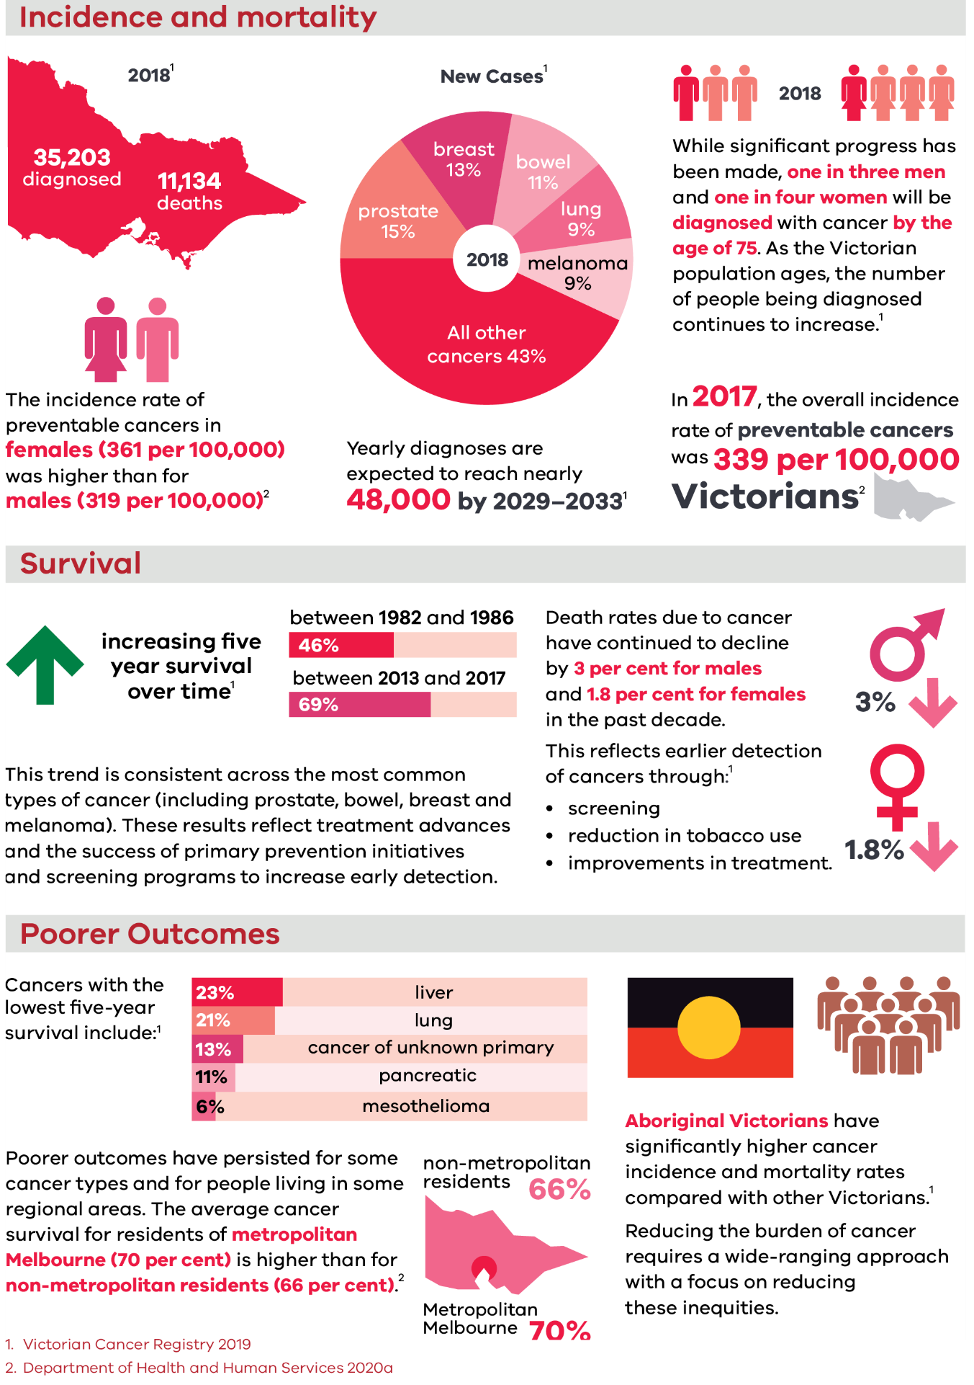

Incidence and mortality
In 2018, another 35,203 Victorians were diagnosed with cancer, and 11,134 died from the disease. Five cancer types accounted for over half of all these new cases (Victorian Cancer Registry 2019):
- prostate (15 per cent)
- breast (13 per cent)
- bowel (11 per cent)
- lung (9 per cent)
  - melanoma (9 per cent).
While significant progress has been made, one in three men and one in four women will be diagnosed with cancer by the age of 75. As the Victorian population ages, the number of people being diagnosed continues to increase.
The incidence rate of preventable cancers in females (361 per 100,000) was higher than for males (319 per 100,000) (Department of Health and Human Services 2020a).
Yearly diagnoses are expected to reach nearly 48,000 by 2029–2033 (Victorian Cancer Registry 2019).
In 2017, the overall incidence rate of preventable cancers was 339 per 100,000 Victorians (Department of Health and Human Services 2020a).

Survival
Overall five-year survival for cancers increased from 46 per cent (between 1982 and 1986) to 69 per cent (between 2013 and 2017).
This trend is consistent across the most common types of cancer (including prostate, bowel, breast and melanoma). These results reflect treatment advances and the success of primary prevention initiatives and screening programs to increase early detection.
Death rates due to cancer have continued to decline by 3 per cent for males and 1.8 per cent for females in the past decade.
This reflects earlier detection of cancers through (Victorian Cancer Registry 2019):
- screening
- reduction in tobacco use
  - improvements in treatment.

Poorer outcomes
Cancers with the lowest five-year survival include (Victorian Cancer Registry 2019):
- liver (23 per cent)
- lung (21 per cent)
- cancer of unknown primary (13 per cent)
- pancreatic (11 per cent)
  - mesothelioma (6 per cent).
Poorer outcomes have persisted for some cancer types and for people living in some regional areas. The average cancer survival for residents of metropolitan Melbourne (70 per cent) is higher than for non-metropolitan residents (66 per cent) (Department of Health and Human Services 2020a).
Aboriginal Victorians have significantly higher cancer incidence and mortality rates compared with other Victorians (Victorian Cancer Registry 2019).
Reducing the burden of cancer requires a wide-ranging approach with a focus on reducing these inequities.

Progress towards achieving our goals
This plan is a proud extension from the Victorian cancer plan 2016–2020. The previous plan established ambitious but realistic goals including long-term goals to 2040 to:
- halve the proportion of Victorians diagnosed with potentially preventable cancers
- increase one- and five-year survival of Victorians with cancer
- ensure Victorians have the best possible experience of the cancer treatment and care system
  - achieve equitable outcomes for all Victorians.
The plan also established a medium-term goal to save 10,000 lives by 2025.
The state has met or is making progress towards several goals from the 2016–2020 plan. However, it will take years to see real improvements in many cancer outcomes at the population level. Research drives clinical improvements and behaviour change. It also underpins our efforts in prevention, detection, treatment and support. Reflecting this timeframe, we will continue to monitor progress of the 2025 and 2040 goals.
Appendix 1 lists several key achievements made under the priorities of the 2016–2020 plan.

Victorian cancer plan monitoring and evaluation framework
The Victorian cancer plan monitoring and evaluation framework page <https://www2.health.vic.gov.au/about/health-strategies/cancer-care/victorian-cancer-plan-monitoring-and-evaluation> provides a clear and objective approach to monitoring and reporting on the impact of the sector to improve cancer outcomes. The framework helps us to see emerging trends and potential problems early and to monitor inequalities in cancer outcomes.
We report against the framework in the third year of each four-year cancer plan cycle. The framework uses population outcomes to monitor the cancer sector’s achievements. These are tracked across the continuum of:
- prevention
- early detection
- treatment
- wellbeing and support for people affected by cancer
  - research.
The Victorian cancer plan monitoring and evaluation framework: baseline report (Department of Health and Human Services 2020a) presents the most up-to-date information on trends in the state’s progress against the outcomes.
The baseline report reveals that between 2015 and 2017, 2,815 lives have been saved from cancer. It shows we are on target to save 10,000 Victorians by 2025. The baseline report also confirms there are priority areas that need more attention to prevent cancer and to address gaps in outcomes.

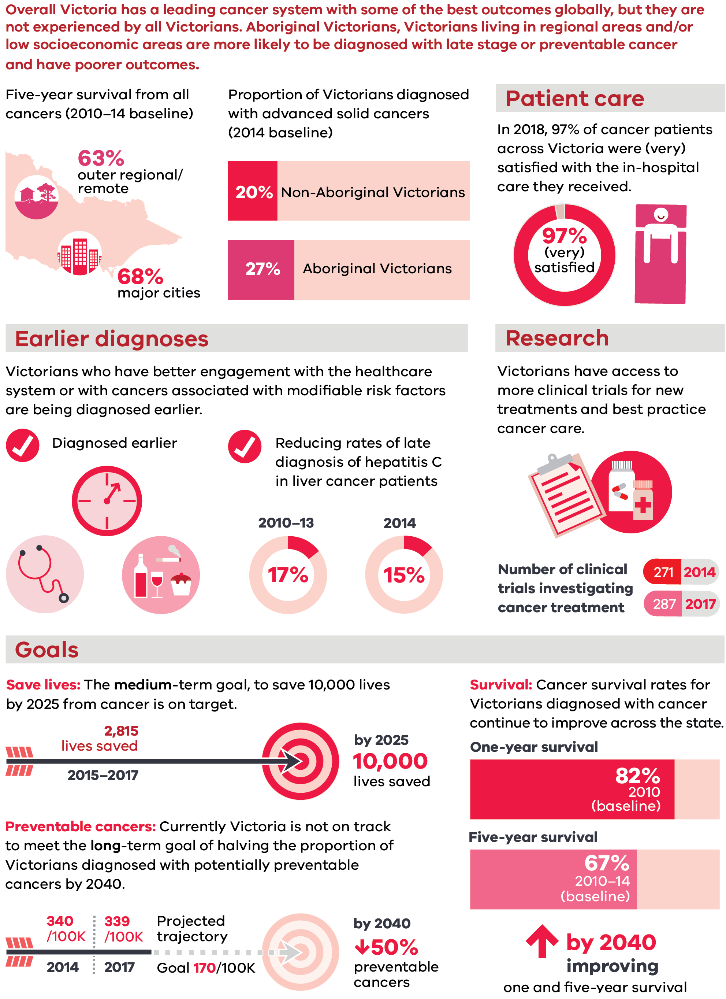

Overall Victoria has a leading cancer system with some of the best outcomes globally, but they are not experienced by all Victorians. Aboriginal Victorians, Victorians living in regional areas and/or low socioeconomic areas are more likely to be diagnosed with late stage or preventable cancer and have poorer outcomes.
Five-year survival from all cancers (2010–14 baseline):
Five-year survival is 63% in outer regional/remote areas compared to 68% in major cities
Proportion of Victorians diagnosed with advanced solid cancers (2014 baseline):
20 per cent of Non-Aboriginal Victorians were diagnosed with advanced solid cancers compared to 27 per cent in Aboriginal Victorians

Patient care
In 2018, 97% of cancer patients across Victoria were (very) satisfied with the in‑hospital care they received:
97% of cancer patients were very satisfied with the in-hospital care they received

Earlier diagnoses
Victorians who have better engagement with the healthcare system or with cancers associated with modifiable risk factors are being diagnosed earlier.

Diagnosed earlier:
Cancer screening and early detection, and modifiable risk factors including quitting smoking, reducing alcohol consumption and health eating be changed to improve cancer outcomes
Reducing rates of late diagnosis of hepatitis C in liver cancer patients:
Late diagnosis of hepatitis C in liver cancer patients reduced from 17 per cent in 2010–13 to 15 per cent in 2014

Research
Victorians have access to more clinical trials for new treatments and best practice cancer care.
Number of clinical trials investigating cancer treatment:
The number of clinical trials investigating cancer treatment increased from 271 in 2014 to 287 in 2017

Goals
Save lives: The medium-term goal, to save 10,000 lives by 2025 from cancer is on target:
2,815 lives were saved in 2015–2017 and we are on track to save 10,000 lives by 2025
Preventable cancers: Currently Victoria is not on track to meet the long-term goal of halving the proportion of Victorians diagnosed with potentially preventable cancers by 2040:
- In 2014, 340/100K Victorians were diagnosed with potentially preventable cancers compared to 339/100K in 2017
- The projected trajectory goal is 170/100K in 2040, which is a decrease of 50%

Survival:
Cancer survival rates for Victorians diagnosed with cancer continue to improve across the state.
One-year survival
- 82% in 2010 (baseline)
Five-year survival
67% 2010–14 (baseline)
  - We are increasing the number of Victorians with one and five-year cancer survival by 2040
(Department of Health and Human Services 2020a)

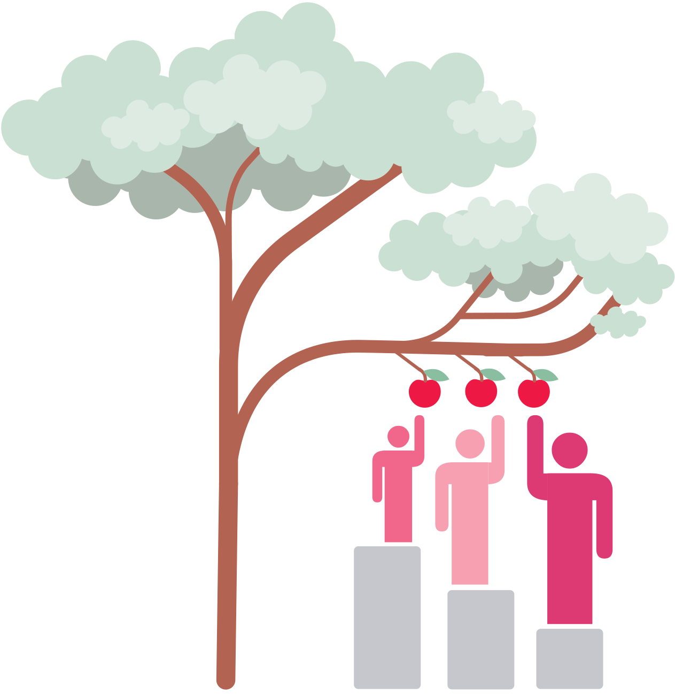

A comprehensive, inclusive and equitable approach
The Victorian cancer plan will help ensure health equity across the cancer system. This is so Victorians are not disadvantaged by who they are, where they live or what resources they have. The plan recognises that every person has unique needs and experiences.

Advancing Aboriginal self-determination
The Victorian Government is committed to improving health, wellbeing and safety outcomes for Aboriginal Victorians. At the very heart of this change is self-determination. This is whereby Aboriginal people take ownership, carriage and responsibility for policy and services on their own terms. This includes policy and service design, delivery and follow-up.
When services are designed, developed and delivered by, and for, Aboriginal people, their health and wellbeing improves (Department of Health and Human Services 2017a).

Life course approach
Nearly half of all Victorians diagnosed with cancer are over 70 years of age. Cancer treatment in older patients can be complicated by co-occurring illnesses. These illnesses may require active management and affect health outcomes. Importantly, geriatric assessments inform the right treatment and care based on each patient’s health and fitness rather than their age.
Cancer affects people at all ages and stages of life. Children, adolescents and young adults with a cancer diagnosis face unique challenges. Cancer treatment can have lifelong impacts for children and adolescents. When a young person is treated for cancer, the whole family is affected.

Local solutions
People living in regional and rural Victoria do not always experience the same access to care as other Victorians. The reasons for this include:
- issues of distance and available transport
- workforce variations
- socioeconomic status
  - infrastructure differences.
The government is committed to ensuring regional Victorians receive the same world-class care as close to home as possible.

Fostering gender equity
Cancer incidence and mortality is higher among men than women (Australian Institute of Health and Welfare [AIHW] 2019a; Victorian Cancer Registry 2019). There is emerging research to suggest that men are less likely than women to seek help from health professionals (AIHW 2019c; Australian Men’s Health Forum 2019). This may contribute to these differences.
The Victorian Government’s vision for gender equality is for all Victorians to (Department of Premier and Cabinet 2016):
- live in a safe and equal society
- have equal access to power, resources and opportunities
  - be treated with dignity, respect and fairness.
Women are under-represented in senior leadership roles in Victoria’s cancer research sector.

Addressing socioeconomic disadvantage
Cancer survival is lower for people living in Victoria’s low socioeconomic regions (Afshar et al. 2020). Finding and addressing the reasons for this difference will help increase survival for lower income Victorians.

Responding to the needs of our diverse population

Culturally diverse Victorians
Nearly half of all Victorians were either born overseas or have a parent born overseas. Delivering cancer services safely and effectively requires sensitivity to cultural and linguistic diversity. Diversity affects the needs, behaviours and experience of people using our cancer system.

LGBTIQ+ Victorians
Members of the lesbian, gay, bisexual, trans and gender diverse, intersex, and queer and/or questioning (LGBTIQ+) community have poorer health and wellbeing outcomes compared with other Victorians. The stigma and bias that LGBTIQ+ people can experience in their everyday lives can prevent them from:
- openly discussing care needs
- seeking routine care
  - taking part in cancer screening.
Care that is appropriate for LGBTIQ+ people includes (Lisy et al. 2018):
- avoiding heterosexual assumptions
- using inclusive language
- providing tailored information
  - involving partners in care.
Work under this plan will build on a series of initiatives that began under the Victorian cancer plan
2016–2020.

People with disability
There are more than one million people with disability living in Victoria. The health status of people with disability is worse than for the general population in ways that are not always directly related to an individual’s disabilities. Discrimination and a lack of inclusion have a negative effect on a person’s health, both directly and indirectly.

Aboriginal Cultural Safety Grants
In 2018, 12 services received Victorian Cancer Cultural Safety Grants. The grants funded safe, welcoming and inclusive environments for Aboriginal people with cancer to undertake treatment. Initiatives included:
- NAIDOC and Reconciliation events
- cultural safety training programs
- reconciliation action plans
- culturally sensitive spaces
- flagpoles
commissioning of artwork and acknowledgement plaques.
Bairnsdale Regional Health created a yarning garden next to its oncology unit. The garden is culturally welcoming and easily accessible for people undergoing cancer treatment and their families. Custom-made seating incorporates animal images of the local community totem or ‘creation animals’. The garden has a collection of panels featuring the five Gunai Kurnai clan.

BreastScreen Victoria achieves Rainbow Tick accreditation
In March 2019, BreastScreen Victoria (BSV) reached a major milestone in its ongoing commitment to diversity, inclusion and accessible screening for LGBTIQ+ Victorians. The BSV Coordination Unit and Mobile Screening Service achieved Rainbow Tick accreditation for its commitment to safe and inclusive practice – a first for a breast screening service in Australia. Achieving the tick is the result of years of work to better understand the needs of LGBTIQ+ people.
To encourage screening, BSV holds regular LGBTIQ+ community screening sessions called Rainbow Rose. The sessions create a safe space for people to screen individually or as a group among other LGBTIQ+ people. Rainbow Tick accreditation reassures LGBTIQ+ clients that they will receive a respectful and inclusive service. It also confirms that BSV meets comprehensive national standards for managing safety, risk and quality.

Being OK … Being You: A guide for young people who identify as LGBTIQ+ and have cancer
The ONTrac at Peter Mac Victorian Adolescent and Young Adult (AYA) Cancer Service collaborated with young people to develop this guide. The resource provides information to support young people who identify as LGBTIQ+ and have cancer so they feel safe, seen, heard and know that they matter.
The content is based on interviews with LGBTIQ+ young people who have had a cancer diagnosis or who are still working out their sexuality and gender identity. The interviews showed that LGBTIQ+ young people lacked information and support in the cancer system.
The guide also provides information to support health professionals to work with young people with cancer who identify as sexually and/or gender diverse.

COVID-19 recovery and cancer care reform
The disruption caused by COVID-19 is a catalyst for change to improve prevention capacity and access to quality care for all users of the Victorian health system. The sector has demonstrated that clinical prevention and care can be delivered differently and closer to home, and system efficiencies will allow reinvestment to ensure the health system can evolve over time to better serve the community, patients and their families.
It is known that cancer screening and diagnosis has been delayed as a direct result of COVID-19 and restrictions in our community. The Victorian Cancer Registry have reported a drop of some 20 per cent in the number of new cancer cases during this initial wave of COVID-19 (unpublished data). This may result in later-stage cancer diagnoses which will be more difficult to treat. All Victorians are being reassured that care is available for usual follow-up and for the management of any health concerns – hospitals are working hard to ensure the safety of all patients and staff, including providing a program of catch-up for all who present for care over the recovery period.
The Victorian cancer plan 2020–2024 sets the direction for the healthcare sector for managing cancer. It will be supported by a more detailed implementation plan. We know that Victoria currently has some of the best cancer outcomes in the world, but the Victorian cancer plan monitoring and outcomes framework: baseline report (Department of Health and Human Services 2020a) identified that not all communities and users of the Victorian health system enjoy those outcomes. These include Aboriginal people and those living in regional areas. Importantly, the rate of preventable cancers between Integrated Cancer Services highlights the regional–metropolitan variations. Data also confirm higher cancer rates and mortality burden for regional Victorians and also for Aboriginal Victorians.
At the heart of this plan is a focus on reducing the disparities in cancer incidence, care and outcomes. Optimal care pathways show where to identify gaps for the focus of reforms and local action. A population-based Victorian study showed that by combining the right optimal care processes, survival rates in bowel cancer were improved (te Marvelede et al. 2019). For all cancers, important early measurable elements of cancer optimal care include:
- the time between phases of care, such as time from referral to diagnosis, and time from diagnosis to treatment
  - access to multidisciplinary care for tailored treatment decision recommendations.
This Victorian cancer plan 2020–2024 will embed broader health reforms that help cancer patients. During COVID-19 the health system has adapted at short notice to deliver patient care differently, and this flexibility will be built into the system for ongoing responsiveness to challenges. The way forward includes:
- more regionalised delivery of health care where planning occurs at a larger scale, across primary and acute health care, with role clarity for health providers and patients on how and where to access cancer-related prevention, treatment, supports and specialty services, including novel therapies in clinical trials
- increased use of alternative models of care (including telehealth, home-based and community-based care, shared care and self-management)
  - more flexible use of the highly trained health workforce (such as role substitution, shared use of workforce expertise including through tele-mentoring and increased use of technology to support multidisciplinary case conferencing).
Uneven cancer outcomes cannot be fixed by doing things the way they have always been done – we must introduce new ways of reaching and meeting the needs of population groups with poorer outcomes. The work planned under the three reform categories will build on whole-of-health-sector reforms whilst also focusing on these needs.
The actions and reforms identified in this plan reinforce each other, including that adoption of virtual technology supports alternative models of care. It is through this matrix approach that the plan will deliver improved cancer outcomes for all Victorians. The following are some examples of work planned for 2020-2024.

Regionalised delivery of health care
To address the excess cancer burden on regional Victorians we need to strengthen our regionalised delivery of prevention and treatment services and leverage a cluster-wide approach to improving population health outcomes.
To do this we will build on the existing work of the integrated cancer services and the regional cancer centres to operate across primary and acute providers by region and sub-region.
- Stronger partnering with Primary Health Networks to embed effective prevention, early detection and treatment models. This partnering could include co-commissioning with health services in a region to promote substitution of subacute/specialist care with primary care.
- Explore opportunities to improve waitlist management and timely access to diagnostic services following a positive cancer screening test through collaboration between health services.
- Support multidisciplinary case conferencing through implementation of QOOL-VIC, a management software solution. This virtual platform supports regional access to specialist medical, nursing and allied health professionals anywhere in Victoria.
- Implement service capability frameworks for cancer in Victoria across regions and sub-regions to promote specialisation at specific sites where necessary for good care, and to support other aspects of the care pathway closer to home including supportive care.
- Implement testing, treatment and (where feasible) cervical cancer elimination targets by geographic clusters including the establishment of reporting requirements and service linkages.
  - Develop a rural and regional community mobilisation program aligned with clusters. These will work with health and community services, peak and peer organisations to address issues of cancer awareness, education and literacy for priority populations to promote prevention actions, access to screening, pathways to treatment and recovery.

Enabling virtual multidisciplinary care regionally
The importance of virtual access to care has been confirmed by the COVID-19 pandemic. Victoria is implementing a multidisciplinary team meeting software platform that will allow health providers from different health services across the state to more accurately, quickly and in real-time, collaborate, ensuring access to best clinical advice for cancer treatment decisions. For example, currently a regional hospital can access specialist cancer advice at another hospital (often metropolitan) by compiling and sending clinical information (diagnostic radiology and pathology, medical history) for review and then wait for decisions of the multidisciplinary group to be provided. The QOOL-VIC software platform enables the regional hospital to upload information directly to a shared platform, participate in multidisciplinary team meetings (for across-region peer mentoring) and have immediate access to specialist knowledge and decisions. Virtual information sharing across sites is already happening in a limited way, but the QOOL-VIC model will deliver a communication reform across the state that improves the quality of care for regional patients, and delivers system efficiencies.

Delivering care differently and closer to home will help us address barriers to access optimal care and support system efficiencies. Harnessing the resources we have and organising them within a regionalised system will help meet the needs of patients and communities. This plan will help drive alternative models of care and the best use of our health workforce.

Alternative models of care
- Explore new models of prevention and care, including home-based models, along the cervical cancer screening pathway, including a focus on self-collection in under-screened groups and potential delivery of colposcopy outside of the acute setting.
- Address barriers for vulnerable clients to uptake of virtual care to ensure they are accessible, acceptable and equitable, including by supporting peer-led navigators and community outreach workers.
- Partner with Aboriginal organisations to effectively implement the Optimal care pathway for Aboriginal and Torres Strait Islander people with cancer. Following the principle of self-determination, this discovery process will ensure adoption of models of care that work. It may include virtual delivery (telehealth), community-based care, and shared care involving primary and specialist health providers and other carers.
- Implement the Home-based cancer care: framework and toolkit to provide care closer to home for chemotherapy patients across regions and sub-regions.
- Progress the state-wide use of nurse-led Symptom and Urgent Review Clinics to better support and triage vulnerable patients receiving systemic anti-cancer therapy, avoiding acute emergency presentations and delivering return on investment for the health system.
- Implement models of shared care between specialists and primary health for both cancer prevention and care.
- Implement community-based self-management models to enable better care across the optimal care pathway.

Telehealth model of care: an ongoing cancer reform
Telehealth is an important enabler for access to care, and uptake has increased during the COVID-19 pandemic.
The Telehealth for Supportive Survivorship Care project 2019 developed, piloted and assessed a telehealth model for the sustainable delivery of a comprehensive survivorship education, exercise and wellness program in Victorian rural and regional health services. This program was successfully delivered across two regions in five health services to 110 participants.
Figure 1: Telehealth for Supportive Survivorship Care – Model of Care Patient Pathway
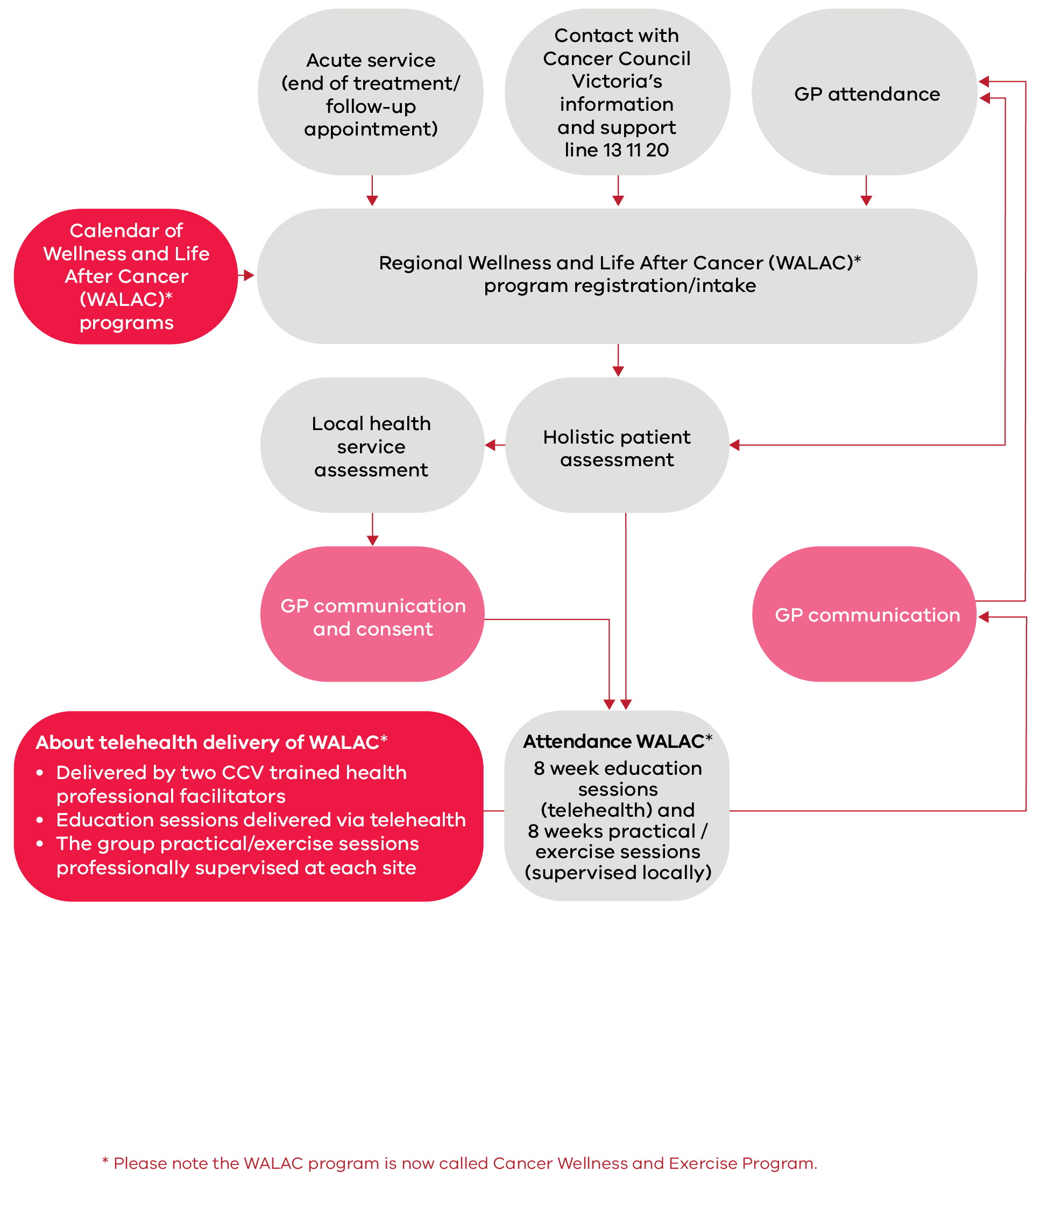

Health workforce
- Upskill workforce across service providers and for a focus on care for underserved groups. This may include using telehealth to access other professional craft groups, for direct health provision or mentoring.
- Establish shared and multidisciplinary workforce models to enable alternative models of care, support and follow-up along the prevention, early detection and cancer screening pathway, to improve participation and support early detection of cancer.
- Support and communicate more effectively with carers via region-based programs.

Plan on a page: Victorian cancer plan 2020–2024

Principles
There are five core principles underpinning all action areas and priority focus areas to ensure Victorians have the best outcomes and experiences of cancer care:
- Person-centred care with equity of access and outcomes
- Prevention across the care pathway
- Quality and safe care
- Evidence-informed
- Sustainable system.

System supports
- Workforce: Ensuring a workforce that can meet the future needs of cancer prevention and care
- Intelligence: Better access to and use of data and information to assure safety and drive continuous improvements
- Infrastructure: Outcome-focused service models and research platforms that align with health reforms
- Innovation & Reform: Supporting and systematic scaling-up of innovative practice across regions and for priority groups
  - Integration: Working together to deliver optimal care pathways

Primary prevention
- Embed support to quit smoking as routine care across the health and human services system and continue tobacco reform activities
- Reduce the risk of developing skin cancer by increasing awareness and promoting sun protective behaviours
- Reduce the risk relating to environmental and workplace hazards
- Improve the uptake of healthy eating and physical activity to reduce cancer risk
- Reduce hepatitis-related cancers through ongoing vaccination and improving surveillance and follow-up treatment
  - Increase HPV vaccinations to vulnerable groups of adolescents and those who miss vaccinations

Screening and early detection
- Work with cancer screening partners to increase participation in population cancer screening programs
- Implement strategies to improve access to and participation in population cancer screening programs for Aboriginal Victorians and under-screened groups
- Improve access to services and care across the cancer screening pathway
- Improve public awareness of cancer symptoms to help early detection
  - Support health professionals to improve early diagnosis of cancers and strengthen referral pathways to specialist care, including familial cancer centres for inheritable cancers

Treatment
- Implement the optimal care pathway for Aboriginal people with cancer
- Implement and monitor performance against the optimal care pathways
- Monitor and assess patients’ experiences of care in a culturally safe way
- Implement service capability frameworks to support better, safer care
  - Support Victoria’s regional cancer centres to deliver appropriate, accessible, high-quality and safe cancer care close to home

Wellbeing and support
- Improve access to supportive care and help people manage some aspects of their own care
- Implement the Victorian carer strategy 2018–2022 to recognise and support the important role of carers
- Build workforce knowledge and skills in survivorship care across cancer care systems
- Support early access to palliative care to manage symptoms and improve quality of life
  - Expand end-of-life care and palliative care skills and advance care planning education across the cancer workforce

Research
- Improve participation and reduce inequities in access to clinical trials
- Promote equitable access to emerging therapies, technologies and platforms
- Assist services to conduct and implement research across the cancer pathway
- Leverage funding to build a more inclusive cancer research workforce
- Support Aboriginal self-determination in the cancer research sector
  - Promote effective collaboration across research organisations, health services, consumers and industry

Optimal care pathways
All people diagnosed with cancer should receive the best care, regardless of where they live or receive cancer treatment. The optimal care pathways (OCPs) promote quality cancer care and define the critical steps in a cancer patient’s journey (Figure 2).
Figure 2: The critical steps in a cancer patient’s journey
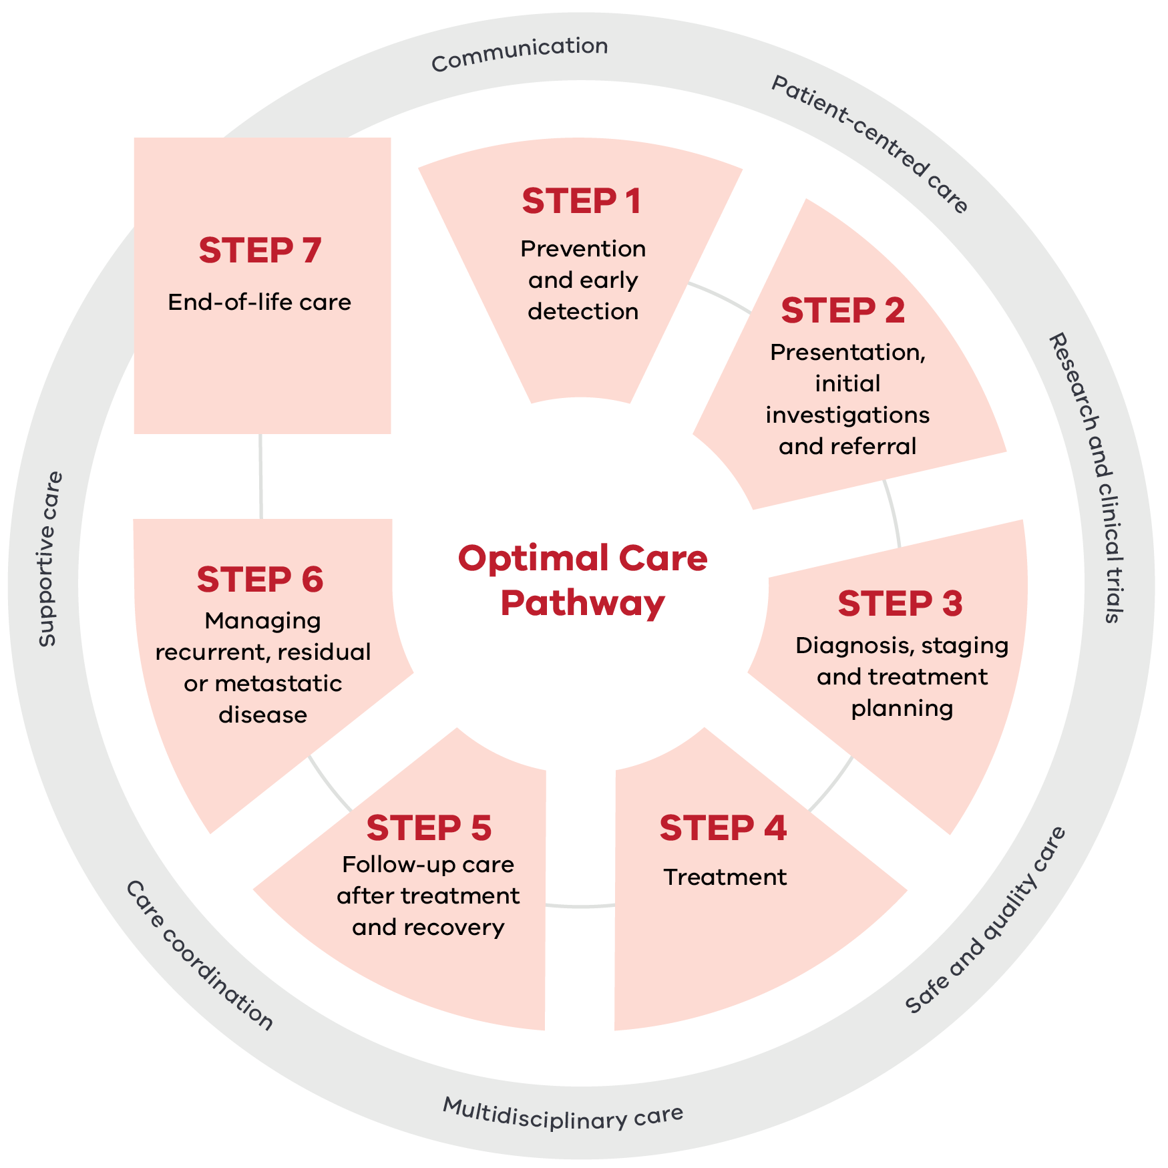

This table contains the steps and principles from Figure 2 information graphic.
Steps and Principles | Details
Step 1 | Prevention and early detection
Step 2 | Presentation initial investigations and referral
Step 3 | Diagnosis, staging and treatment planning
Step 4 | Treatment
Step 5 | Follow-up care after treatment and recovery
Step 6 | Managing recurrent, residual or metastatic disease
Step 7 | End-of-life care
Principles surrounding the steps | Multidisciplinary care, Care coordination, Safe and quality care, Supportive care Communication, Patient-centred care, Research and clinical trials
The principles underpinning OCPs focus on the patient. They prompt the healthcare system to deliver coordinated care and improve patient experience and outcomes. The COVID-19 pandemic has been a catalyst for health reforms that can make a positive difference for patients, such as care closer to home and in-home. These reforms will continue in cancer to help deliver more accessible and seamless care across the patient’s cancer pathway. The next Victorian cancer plan monitoring and evaluation report in 2023 will include a special section to describe the short and medium term impacts of COVID-19 for delayed care, later stage disease presentation and outcomes.
OCPs have been developed in consultation with people affected by cancer and the clinical community to:
- reflect emerging areas of practice
- help deliver optimal care at critical points throughout the patient journey including:
    - optimal timeframes for referral to treatment
    - optimal communication between the specialist and primary practitioner, and between people affected by cancer
  - provide value to health systems through:
    - identifying gaps in current cancer services
    - bringing about quality improvement initiatives
      - improving the way services are planned and coordinated.
Delivery of optimal cancer care using the principles of the OCPs is confirmed in Cancer care in the time of COVID-19: a conceptual framework for the management of cancer during a pandemic (Cancer Australia 2020).
There are national pathways for 18 types of cancer and for Aboriginal people with cancer. Each pathway has three resources:
- the optimal care pathway (comprehensive version)
- the quick reference guide for health professionals
  - a guide for patients, carers and families.

Benefits of consistent and optimal cancer care in bowel cancer
OCPs outline the optimal processes of clinical care for cancer. A Victorian population-based study shows that combining these processes leads to positive outcomes including better survival rates (te Marvelde et al. 2019).
The impact of pre-diagnostic care in primary health settings for bowel cancer is significant. This emphasises the need to coordinate primary health care and cancer services. It also shows the benefit of embedding practices as described in the OCPs.

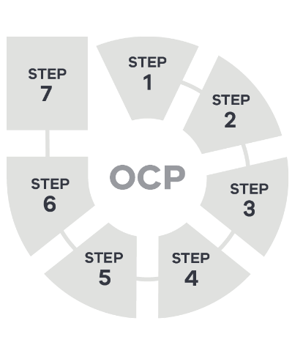
The five action areas of this plan cover one or more of the seven steps within an OCP. The OCP graphic shown here is used throughout the document to advise readers of the steps that relate to each action area.

Action area 1: Primary prevention
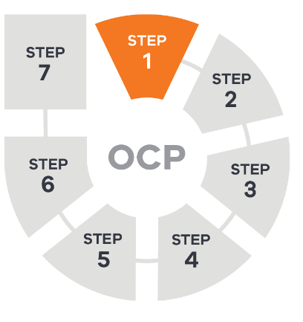
Primary prevention provides the best chance to alter long-term trends in cancer rates and burden. Addressing modifiable risk factors can improve population health and reduce inequities. This can have a flow-on effect to reduce the risk of other chronic disease. It can also improve overall general health and wellbeing.
The leading preventable and modifiable risk factors for cancers are:
- tobacco smoking
- obesity
- alcohol consumption
- diet
- workplace risks such as asbestos and second-hand smoke
- physical inactivity
- viral infections
  - exposure to ultraviolet (UV) radiation.
The effect of these risk factors can be higher in some groups.
It is important to recognise that the COVID-19 pandemic has changed the way Victorians work and live. The introduction of social distancing measures and restriction on daily activities have presented unique challenges to public health and wellbeing, including the ability to maintain physical activity and a healthy lifestyle. The pandemic has also shown that people with modifiable risk factors are vulnerable to the effects of the virus.
In Victoria, the Public health and wellbeing plan 2019–2023 is the main policy driver of change in primary prevention. Therefore, to address these new and emerging challenges, the actions to support primary prevention of cancer will need to align with the broader public health approach and be responsive to Victoria’s diverse population.

Reduce risk factors related to lifestyle and environmental hazards
The following are priority actions for the next four years.

1.1 Embed support to quit smoking as routine care across the health and human services system and continue tobacco reform activities
Tobacco smoking remains the leading preventable cause of cancer. It is responsible for more than 80 per cent of lung cancer cases (AIHW 2018). It is also a contributory risk factor for cancers of the head and neck, breast, cervix, kidney, bone marrow, liver and bowel (AIHW 2019a). Exposure to second-hand tobacco smoke is a cancer risk factor for the wider population. For people already diagnosed with any cancer, quitting smoking can improve general wellbeing and treatment outcomes.
Victoria has a history of delivering a successful tobacco control program. This has included new laws to introduce smoke-free areas and to restrict the sale, display and advertising of tobacco products. These reforms have contributed to a steady decline in smoking rates. In 2016, only 12.3 per cent of Victorians smoked daily (Department of Health and Human Services 2017b). However, the smoking rate has plateaued in recent years and remains high. This is particularly the case among:
- disadvantaged population groups
- Aboriginal Victorians
  - people experiencing mental illness.
The Victorian Government is already working to embed support to quit smoking as part of routine care in health services including:
- the public hospital system
- mental health
  - primary care.
This systematic approach will overlap with place and setting-based stop-smoking activities. It will also involve quit-smoking initiatives co-designed with population groups with high smoking rates.
Activity in the next four years will:
working with the Commonwealth and states and territories to strengthen national laws around the use of e-cigarettes and the safety of liquid nicotine products
implementing routine best practice smoking cessation support in health settings to strengthen referral and treatment pathways to support people to quit smoking by using telehealth, electronic prescribing and new home-based models of care
working with professional colleges and training bodies to establish smoking cessation support as a core professional competency
improving the routine collection of data on smoking status and e-cigarette use and brief interventions for smoking cessation delivered.

Embedding prevention in routine care: tobacco-free living
Quit Victoria leads the ‘Embedding prevention in routine care: tobacco-free living’ initiative, with support from Alfred Health and the department. The initiative shows how smoking cessation care can be included as part of routine practice in health services. This approach uses the potential for hospital stays to be a timely, teachable moment for patients who smoke to make a quit attempt. Patients who keep smoking after a cancer diagnosis may have worse treatment side effects and poorer results.
The initiative centres on a three-step brief advice model - Ask, Advise, Help:
- Ask all patients about smoking status and document this in their medical record.
- Advise all patients who smoke to quit in a clear, friendly and personalised way.
Help all patients who smoke by referring to Quitline for behavioural help and by prescribing (or giving access to) medications.
Figure 3: Elements of smoking cessation care
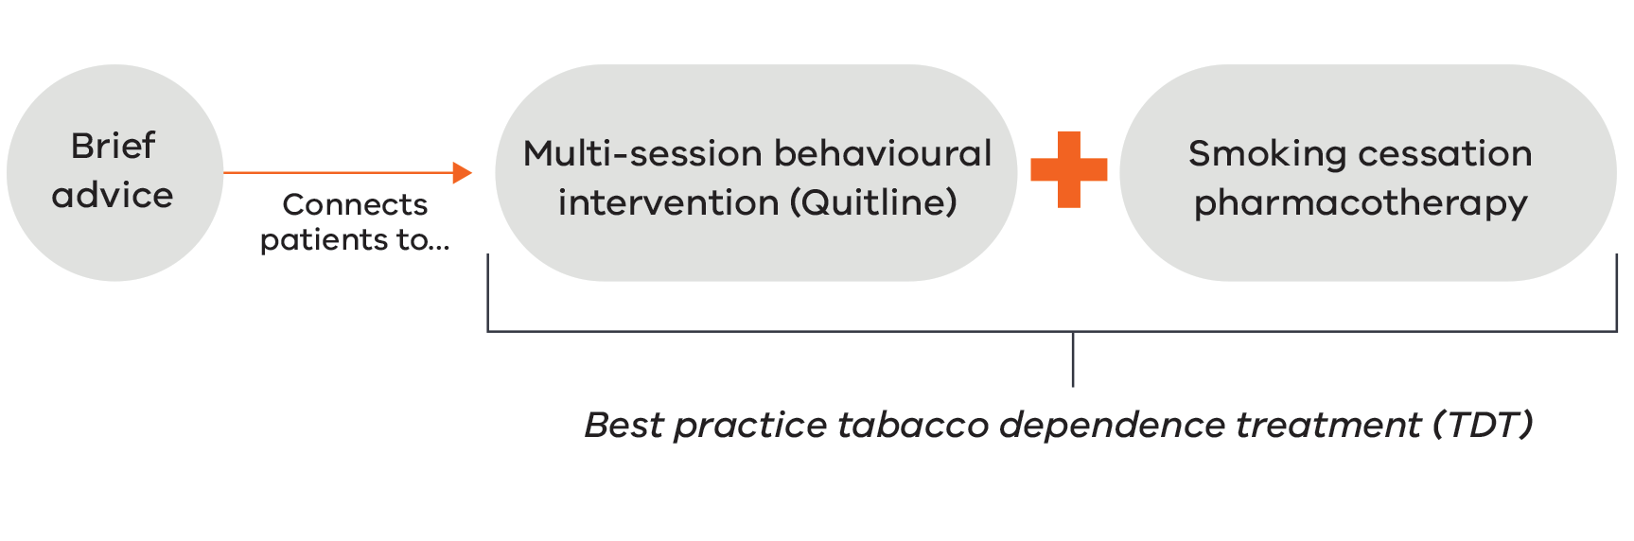
As part of the initiative, Quit and Alfred Health are working with four health services: NorthWestern Mental Health, Western District Health Service, Seymour Health and Northeast Health Wangaratta.
A broad range of resources have been co-developed:
- online training and resources for staff
- clinical guidelines
smoke-free policy templates.
These are available to all Victorian health services from the Quit website, Training and resources for health services page <https://www.quit.org.au/resources/health-professionals/training-and-resources-health-services/>.
The initiative will conclude in 2021, with evaluation findings shared when complete.

1.2 Reduce the risk of developing skin cancer by increasing awareness and promoting sun protective behaviours
Overexposure to UV radiation can lead to skin cancer. Fortunately, most skin cancers can be prevented by adopting sun protective behaviours that reduce exposure to UV radiation. Measures include:
- seeking shade
- using sunscreen
  - wearing protective clothing, a hat and sunglasses.
Skin cancer remains very common, with two in three Australians diagnosed by the age of 70. Melanoma, the most serious type of skin cancer, is the fifth most common cancer in Victoria. While cases of melanoma continue to increase in older Victorians, the rate has stabilised or decreased in younger age groups (Victorian Cancer Registry 2019).
Shade, used with other measures, provides the best protection when spending time outdoors. Targeted prevention and early detection programs have been delivered through Cancer Council Victoria’s SunSmart program. The program aims to effect changes in knowledge, attitudes and environments to improve sun protective behaviour. This work spans community education campaigns and programs for early childhood, schools and workplaces.
Continuing to increase awareness of skin cancer risk and the importance of adopting sun protective behaviours is essential to reduce the burden of disease. This is particularly important in priority groups such as:
- men over 40
- outdoor workers
  - people living in rural and regional communities.

Activity in the next four years will:
increase access to shade and public places through the Shade Grants Program
improve awareness and understanding of skin cancer risks though SunSmart community education, including through the Achievements program for workplaces, schools and early childhood development

The Shade Grants Program
The Shade Grants Program aims to reduce Victorians’ exposure to UV radiation. It does this by increasing shade in public places across the state and by promoting uptake of sun protective practices.
In the first three rounds of the program, the Victorian Government awarded 1,084 grants worth over $10 million. Funding has been used to:
- install permanent shade structures
- repair existing shade
- purchase portable shade
- plant natural shade
purchase sun protective items such as sunscreen, hats and protective clothing.
These grants have made a difference for many Victorian primary and secondary schools, sporting clubs, social groups and early learning centres.

1.3 Reduce the risk relating to environmental and workplace hazards
Limiting exposure to some substances in the natural environment or workplace is a preventable risk factor for some cancers. These include mesothelioma and cancer of the lung, nasal passage and bladder.
Exposure to cancer-causing agents at work adds to the burden of lung cancer, mesothelioma and leukaemia. These agents include:
- asbestos
- diesel engine exhaust
- second-hand smoke
  - silica (silicon dioxide, found in rocks and soils).
Laryngeal, ovarian, mouth and pharyngeal cancers are also linked to workplace exposures. Steps to reduce these preventable risks include:
- banning all forms of asbestos since 2003
  - banning smoking in public places from 2017.

Activity in the next four years will:
improve awareness of workplace carcinogens and implementing workplace standards
monitor the incidence of exposure to cancer-causing risk factors in the environment by working with key partners such as the Environmental Protection Authority Victoria and WorkSafe Victoria.

1.4 Improve the uptake of healthy eating and physical activity to reduce cancer risk
Maintaining a healthy lifestyle can protect against a range of cancers. Modifiable lifestyle factors that increase cancer risk include an unhealthy diet, physical inactivity and excess weight.
A healthy and balanced diet containing recommended serves of dietary fibre can protect against cancers of the bowel, oesophagus and stomach. Reducing alcohol consumption can lower the risk of various types of cancer including liver and breast (AIHW 2019a).
Being active can protect against cancer of the breast, bowel and uterus (AIHW 2019a). Maintaining a healthy body weight further reduces overall cancer risk. This needs to start early in life if we are to have the biggest impact on preventable cancers.
It is extremely important that we focus on the next generation, ensuring our children grow into healthy, happy and successful adults. To this end, we are developing a childhood obesity prevention plan focusing on making sure children and their families have access to healthy food and drink options, and opportunities to be active throughout the day, in the places where they spend their time.
A range of supports are offered to help schools, early years services and workplaces, including health services and hospitals, to create healthy environments. This includes the Healthy Choices guidelines that help organisations to promote and provide healthy foods and drinks. It has led to a clear reduction in the supply of sugary drinks and an increase in healthy food options in several health services. The Victorian public health and wellbeing plan 2019–2023 highlights the important role the healthcare sector plays in counselling and referring people to physical activity options.
The Victorian Government funds a range of alcohol initiatives that intervene at different stages to reduce preventable harms. These include:
- the P.A.R.T.Y Program for 16–25-year-olds
- the SayWhen tool, which provides information and resources to help people make decisions about their drinking
  - Ready2Change, which offers telephone support to people with alcohol issues.

Activity in the next four years will:
embed existing guidance and information into practice, including healthy food and drink supply policies across the public health care system
rolling out initiatives to boost healthy eating and active living among children and their families
strengthen preventive health messages in primary care, cancer screening programs and health services
provide information on healthier lifestyles and habits to participants in cancer screening programs

Prevent cancers related to viral infections

1.5 Reduce hepatitis-related cancers through ongoing vaccination and improving surveillance and follow-up treatment
Hepatitis B and C are viral infections that cause liver inflammation. When left untreated, chronic hepatitis can occur – the leading cause of liver cancer (Department of Health and Human Services 2016b).
Around 63,000 Victorians are living with hepatitis B and 32 per cent are not aware of their condition (WHO Collaborating Centre for Viral Hepatitis et al. 2019). A quarter of people living with chronic hepatitis B infection will die from liver cirrhosis or liver cancer (Cancer Council Victoria 2020a). Treatment for chronic hepatitis B can reduce the risk of liver cancer by up to 75 per cent. However, only 5 per cent of people diagnosed with hepatitis are receiving treatment (Cancer Council Victoria 2020a).
Immunisation is the best protection against hepatitis B infection. A course of vaccination is recommended for all babies and people in high-risk groups. The current vaccination rate for hepatitis B is over 90 per cent in children and 20–50 per cent for at-risk populations (Department of Health and Human Services 2016b).
Around 46,700 Victorians are living with hepatitis C. However, only 32 per cent have started direct acting antiviral treatment (The Kirby Institute 2019). This treatment can cure 95–97 per cent of cases (Department of Health and Human Services 2016c). For those with a chronic infection, up to 5 per cent will develop liver cancer (Cancer Council Victoria 2020a).
With effective treatment available for hepatitis C, the challenge is in finding the one in six people who are undiagnosed. Some people may not show symptoms. Community campaigns and education for GPs focuses on increasing awareness and reducing stigma (Department of Health and Human Services 2016c).
The hepatitis prevention strategies will focus on (Department of Health and Human Services 2016b):
- reducing the risk of hepatitis B and C infection
- increasing testing to confirm viral status
  - improving access to prompt treatment and care.

Activity in the next four years will:
increase hepatitis B vaccination in priority populations, including through primary and community health settings and community education
decrease the proportion of people living with undiagnosed hepatitis B by improving testing across primary and community care, allied health and antenatal care settings
implement a community engagement program to improve referral pathways between local services and specialist viral hepatitis care
establish an integrated hepatitis B and C workforce to increase screening, prevention, treatment and engagement in care
increase the proportion of people living with hepatitis C who know their status
increase the proportion of people living with hepatitis C who access newly available direct-acting antiviral drugs for cure
use data and surveillance strategies to identify groups at risk of contracting hepatitis and manage treatment of hepatitis B and C
improve practitioner awareness of hepatitis C treatment options and availability
engage the Victorian and Tasmanian Primary Health Network Alliance to update the hepatitis B and C HealthPathways and provide training to doctors, nurses and pharmacists by service cluster or Primary Health Network region.

1.6 Increase HPV vaccinations to vulnerable groups of adolescents and those who miss vaccinations
Human papillomavirus (HPV) is a highly contagious sexually transmitted virus that can cause cancer if not detected. According to Cancer Council Victoria (2020b), HPV causes:
- almost all cases of cervical cancer
- 90 per cent of anal cancers
- 65 per cent of vaginal cancers
- 50 per cent of vulvar cancers
  - 60 per cent of oropharyngeal cancers.
Vaccinating adolescents before they become sexually active is the most effective way to reduce HPV-related cancers. In Victoria, the HPV vaccine Gardasil is available to all adolescents aged 12–13 years under the National Immunisation Program. This vaccine protects against seven types of HPV. Two of these are responsible for over 90 per cent of cervical cancers in women and over 90 per cent of HPV-related cancers in men (Better Health Channel 2020).
The uptake of HPV vaccines during the period of eligibility is not equitable for all Victorians. Those at risk of not being vaccinated include:
- adolescents in out-of-home care
- medically at-risk people
- Aboriginal people
  - refugees and asylum seeker adolescents.
Recent analysis at the Young Person’s Health Service in Melbourne revealed that 46 per cent of adolescents seeking support were overdue for their HPV vaccination. Other studies have shown that fewer Aboriginal adolescents complete their HPV vaccination course than the general population. A recent analysis of refugees and asylum seekers settling in Victoria showed that only 56 per cent of those aged 10–19 years had completed their vaccination courses including HPV vaccine.
Increasing vaccination in these priority groups and continuing to build awareness in adolescents more broadly is essential to reducing the burden of cancer. This requires coordinated efforts between primary care, secondary schools and local councils to inform students, their parents and teachers about the vaccine.
Activity in the next four years will:
improve the consistency and accuracy of data collection
improve community understanding of the importance of HPV and other vaccinations in reducing cancer risk
promote and increase adolescent vaccination rates through local government and secondary schools
work with the Commonwealth Government to create and send reminders directly to adolescents at a certain age point (14 years) when they have missed vaccinations.

Action area 2: Screening and early detection
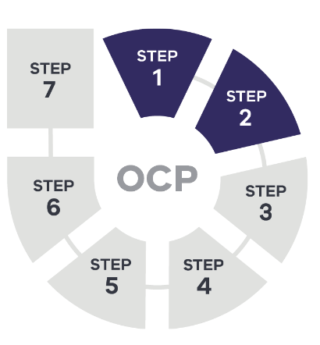
Population cancer screening programs have an important role in reducing the burden of cancer. They do this through:
- early detection
- early diagnosis
  - treatment.
The greatest benefit is realised when high numbers in the target age group take part.
Primary care has an important role in ensuring that opportunities to prevent cancer and assess risk are part of routine care. Improving early diagnosis and treatment of cancer relies on clear referral pathways and links to specialist care.
The COVID-19 pandemic presents new challenges for early detection of cancer in primary care and participation in cancer screening programs. The acute stages of the pandemic impacted the everyday life of Victorians and changed health seeking behaviour – this means fewer people went to the GP and participation in cancer screening programs declined. For some Victorian’s this may have implications for cancer diagnosis, referrals to specialist cancer services and treatment.
As part of the pandemic recovery phase, the Victorian Government will work with cancer screening partners to respond to challenges arising from COVID-19. Victorians must be confident that they are safe to use these services and understand that seeking health advice is still important. Initiatives to increase participation in cancer screening programs and their success must be considered in the context of COVID-19 and broader health reform.

Equitable and increased participation in population cancer screening programs

2.1 Work with cancer screening partners to increase participation in population cancer screening programs
Many Victorians already take part in population screening programs for breast, bowel and cervical cancer. Since 2016, Victoria has increased participation in all three programs (AIHW 2020):
- Women using BSV services increased from 53.2 per cent in 2015–16 to 54.5 per cent in 2016–17. In 2018–19, the program screened 267,589 women, which is the largest number of women ever screened in the program.
- Cervical screening in 2016–17 reached 57.7 per cent, which was 0.8 per cent above the national average of 56.9 per cent.
  - Bowel screening increased from 43.2 per cent in 2016–17 to 45.2 per cent in 2017–18.
The increasing participation rates across all three cancer screening programs has been possible because of more Victorian Government investment to:
- provide additional screens
- expand existing programs to all eligible age groups
  - remove the barriers to taking part for under-screened groups.
These increases in participation have been significantly impacted by the COVID-19 pandemic. During this period, participation in cancer screening programs declined because fewer people visited their GP and the capacity of some screening services was reduced. For some Victorian’s, this may have resulted in delayed cancer diagnosis, treatment and care.
The Victorian Government has committed to a cancer screening catch-up program. This program aims to increase service capacity so Victorian’s can follow up on missed screening appointments and be on time for future screening. The time-frame for recovery in cancer screening participation rates will depend on the capacity of the service system. However, we will aim to ensure equity of access for all Victorians.
Under a new cancer screening partnership model, Victoria will work through this recovery period in collaboration with its key stakeholders. It is important that Victorians feel safe to use these services and understand that seeking health advice is still important.
Reform strategies will be developed to identify new service delivery models that will:
- improve recruitment and participation
- improve service delivery and data collection
  - achieve alignment with national policy.

Activity in the next four years will:
work towards cervical cancer elimination by implementing strategies to improve screening participation in priority populations
increase the bowel screening take-up rate to 60 per cent, with a focus on priority populations
increase cervical screening and HPV vaccination, especially among Aboriginal communities and priority populations
reduce the gap in participation rate between young people and the national average by increasing cervical cancer participation for 25–35-year-olds
improve health literacy across screening programs
improve rates for re-screening for breast cancer.

A new model to address barriers to cervical screening
Cervical self-collection is a culturally appropriate, alternative pathway to cervical screening for under-screened women under the National Cervical Screening Program. Since December 2017, women who are under-screened and have declined a traditional cervical screening test are offered the option to do a cervical screening self-collected test. This model was based on a successful pilot in 2016–17 that showed the ease and convenience of the test, and the privacy that it offers.
Cancer Council Victoria and VCS Foundation collaborated to increase the uptake of cervical screening self-collection among eligible women. Together, they delivered a suite of tools, training, resources and a clinical audit activity within general practice, community health and Aboriginal health services. VCS Foundation is assessing the success of these initiatives through analysing multiple data measures.
Data shows that more than half of women accessing a cervical self-collection test have either never had a screen or had their last screen at least 10 years ago. The highest number of samples collected were in the 60–64 and 30–34 age groups. In late 2019, interviews with health professionals and women who had the test showed high acceptability levels from both groups.
The cervical screening self-collection test is a major step in improving equity in cervical screening. It is reaching women who were reluctant to have a conventional screening test that required a device-assisted examination by a health professional. This is critical in reducing cervical cancer incidence given most women diagnosed had never been screened or are under-screened.

2.2 Implement strategies to improve access to and participation in population cancer screening programs for Aboriginal Victorians and under-screened groups
The health and wellbeing gains from improvements in cancer control are not shared evenly across the population. Under-screened groups for breast, bowel and cervical cancer have poorer mortality and survival outcomes.
In Victoria, the priority under-screened groups include:
- Aboriginal communities
- culturally diverse communities
- communities affected by social and economic disadvantage
- people who identify as LGBTIQ+
- people with disabilities
  - rural and regional communities.
For Aboriginal Victorians, breast and bowel cancer are among the most common cancers. Furthermore, the rate of cervical cancer in Aboriginal women is more than twice that of non-Aboriginal women. The mortality rate is more than three times the non-Aboriginal rate (AIHW 2019b). These higher mortality rates are likely to be linked with diagnoses occurring at more advanced disease stage. They also reflect issues of participation in cancer screening programs and timely access to treatment (Department of Health and Human Services 2017a).
Through the Under-screened Program, targeted initiatives to increase screening include:
- more mobile breast-screening services at Aboriginal community-controlled organisations
- alternative pathways for Aboriginal communities to take part in the bowel screening program
- targeted primary care support in under-screened areas
- self-collect cervical screening
  - improving access to screening for people with a disability.
These initiatives have reinforced that participation in cancer screening programs can improve by:
- embedding culturally responsive approaches across the cancer screening pathway
- removing barriers to accessing services
  - building workforce capacity.
These key learnings will provide the basis for future work, particularly through co-designed initiatives.
In addition, the Victorian Government’s commitment to advancing Aboriginal self-determination supports the Victorian Aboriginal Community Controlled Health Organisation (VACCHO) to lead all Aboriginal cancer screening initiatives. This will help close the gap in cancer screening rates for Aboriginal people and non-Aboriginal people.
As seen across all cancer screening programs, the COVID-19 pandemic has impacted participation in under-screened groups. Through a cancer screening catch-up program, the Victorian Government will ensure that it continues to reach these priority groups. This catch-up program will require stronger collaboration with VACCHO, Primary Health Networks and community health services at a regional level to ensure the services delivered are appropriate and responsive to the community’s needs.
Activity in the next four years will:
implement a VACCHO-led Aboriginal cancer screening strategy that prioritises how they want Aboriginal cancer screening outcomes and activities to be conducted in the future including delivering culturally responsive screening in partnership with mainstream service providers
implement strategies for participation, recruitment and primary care to increase participation and improve access to culturally safe services for priority groups
develop regional approaches to increase uptake of cervical self-collection in under-screened women
increase use of data and surveillance to expand and monitor the priority under-screened groups. Additional cohorts include:
bowel screening in men 50–59 years of age
fast-growing and emerging multicultural communities
people with a disability
people experiencing socioeconomic disadvantage
people living in certain geographical areas.

Online Cancer Screening Hub for under-screened communities
Cancer Council Victoria has launched several resources to encourage under-screened groups to take part in cancer screening.
An online Cancer Screening Hub provides a central source for a variety of tools and resources on the Cancer Council Website, Cancer Screening Hub page https://screeningresources.cancervic.org.au>. These tools target health professionals and health/community organisations seeking to improve cancer screening participation in under-screened communities. Practical information on implementing projects, finding translated resources, even screening data for relevant under-screened groups is readily available.
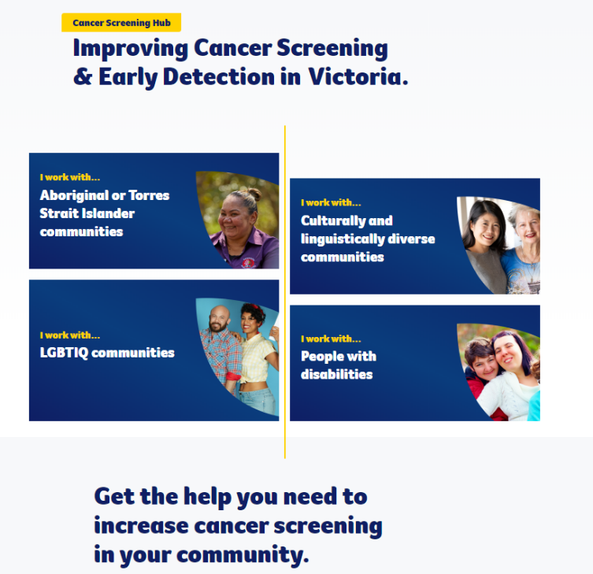

Cultural breast screening shawl and mobile screening for Aboriginal women
BSV and VACCHO are collaborating with Aboriginal health organisations to improve the breast cancer screening experience for Aboriginal women.
BSV’s mobile screening service visits select Aboriginal Community Controlled Health Organisations (ACCHOs) to screen Aboriginal women in the community. Aboriginal women are given a cultural shawl adorned with local Aboriginal artwork, which can be worn during their breast screen. The shawl is a strengths-based Aboriginal community-led initiative that responds to challenges that BSV faces in providing a culturally safe service to Aboriginal women.
The Victorian Aboriginal Health Service in Melbourne trialled the cultural shawl in 2018. It was shown to help Aboriginal women feel more culturally safe and comfortable when screening. Since then, it has been made available to many Aboriginal women through ACCHOs around Victoria, attracting many first-time screeners and women who had not returned to screen.

2.3 Improve access to services and care across the cancer screening pathway
Participation across Victoria’s three cancer screening programs varies for different population groups. This difference adds to the inequity seen in the stage of cancer diagnosis, timeliness of treatments and health outcomes. To create equity across the cancer screening pathway, every Victorian should have access to prompt, culturally appropriate, acceptable and responsive screening services.
In the case of a positive cancer screen, follow-up testing and confirmation of cancer need to occur within recommended timeframes. This will ensure appropriate and timely treatment can be provided. Timely referral and access to quality diagnostic services is essential. Access to high-quality healthcare services, including cancer services, is an issue for people living in rural communities. This has an impact on cancer outcomes and survival rates.
In Victoria, the OCPs provide guidance to health practitioners on the appropriate pathways for high-quality cancer care. This includes expected timeframes for assessment, diagnosis and treatment. Timely referral and treatment require knowledge on using these pathways within local health services and capacity for these services to meet demand.
The challenges posed by the COVID-19 pandemic have presented an opportunity for health services to explore alternative operating models at a regional level, including home-based models for screening and the delivery of diagnostic services outside of the acute setting. These approaches could improve waitlist management and timely access to diagnostic services following a positive cancer screening test.

Activity in the next four years will:
ensure effective implementation of OCPs by supporting health services to establish collaborative relationships between Integrated Cancer Services, Primary Health Networks and the primary carer to ensure effective use of OCPs
explore workforce models that can meet the high demand for follow-up testing and diagnosis after a positive cancer screen
explore opportunities to consolidate services at a regional level to reduce wait times for diagnostic testing following a positive cancer screen
monitor emerging evidence and add to national policy throughout the life of this cancer plan with a focus on:
potentially introducing a targeted lung cancer screening program for high-risk groups
developing risk stratification approaches
potentially applying genomics in screening.

Increase early detection of cancers through improved health literacy and primary care capacity to support early diagnosis

2.4 Improve public awareness of cancer symptoms to help early detection
Improving health literacy plays a vital role in a person’s ability to:
- receive and interpret information
- make effective decisions about their health
  - take appropriate action.
Victoria has invested in initiatives that promote the importance of cancer prevention and screening. Other campaigns help people recognise the early signs of cancer and what action to take. For example:
- The ‘It’s Time to Test’ men’s health awareness program seeks to improve men’s health knowledge and behaviours.
- SunSmart community education campaigns and programs for early childhood, schools and workplaces promote the importance of using sun protection to reduce the risk of skin cancer.
  - The Oral Cancer Screening and Early Detection initiative provides education via dental clinics across Victoria.
To build on these efforts, broader strategies will ensure every Victorian is provided with the best information about cancer. This information will be tailored to the way they will best receive it to help them to make decisions and manage their own health.
Activity in the next four years will:
implement regional approaches to improve health literacy about cancer risk factors and symptoms, local pathways for seeking appropriate medical advice and navigating the cancer pathway
deliver information using existing channels and virtual services where it will best reach people such as through primary care, community services, allied health and community events.

Screening and early detection of oral cancer in dental visits
In 2018, around 746 Victorians were diagnosed with oral cancer – that’s more than 14 people every week. With the rate of oral cancer rising in Victoria, Dental Health Services Victoria implemented a pilot training program for oral health professionals on the Dental Health Services Victoria website, Exciting page <https://www.dhsv.org.au/oral-health-programs/oral-cancer-screening-and-prevention> to help reduce the impact of the disease. With departmental funding, Dental Health Services Victoria partnered with The University of Melbourne, Latrobe University and the Australian Dental Association Victorian Branch.
More than 170 oral health professionals across 16 community dental agencies and private dental practices took part in the pilot. Dental clinicians screen patients without symptoms as part of a full or periodic oral cancer exam, improving the early detection of cancer.
The pilot program assesses oral health professionals’ knowledge of oral cancer before and after training. Findings from the pilot will help develop training and resources for Victorian clinicians. The resources will help clinicians to confidently detect, record and refer suspicious lesions at an early stage. This is when treatment for oral cancer will be most effective.
This program will also empower oral health professionals to discuss modifiable risk factors with patients and support them to make healthy lifestyle changes.

2.5 Support health professionals to improve early diagnosis of cancers and strengthen referral pathways to specialist care, including familial cancer centres for inheritable cancers
Primary care has an important role in ensuring that opportunities to prevent cancer and assess risk are integrated into routine care. These opportunities include immunisation, modifiable risk factors and assessment of family history.
Effective primary care also involves recognising early symptoms of cancer and the point at which specialist referral is required for diagnosis, treatment and management. Some people are at a higher risk of inheritable cancer. Access to genetic counselling and advice is important for those affected to manage their risks in conjunction with their care team.
To improve early diagnosis and treatment of cancer, the primary care sector must:
- be well informed
- receive evidence-based cancer education and training
  - have access to systems, resources and innovative tools.
The Victorian Government is also working with the Victorian and Tasmanian Primary Health Network Alliance to develop HealthPathways. This is an online portal that will help adopt the OCPs into primary health for early cancer diagnoses.
The OCPs offer guidance on referral processes for timely referral and treatment. HealthPathways help local health systems to apply these processes. Collaborative relationships between Integrated Cancer Services, Primary Health Networks and the primary care workforce are addressing this. The collaborative model across clustered services, enables new models of care for prevention and early diagnosis, including use of different health providers across primary and acute health. Alongside HealthPathways, the Cancer Council Victoria has produced resource packs to support early diagnosis in primary care.
Activity in the next four years will:
continue education for oral cancer screening
embed the OCPs into existing primary health triage and referral systems
develop clear guidelines on when a patient should be referred for further testing such as persistent abnormal symptoms
provide quality improvement feedback to GPs about ways to reduce late diagnosis of cancer
develop a health workforce training strategy to support education and early detection of skin cancer in primary care, with a focus on regional Victoria
expand the Dermoscopy for Victorian General Practice Program, which provides dermatoscopes and training to improve:
diagnosis
access to equipment
management of skin cancer across Victoria
continue to develop and implement resources and tools including HealthPathways to support early diagnosis
support two Aboriginal Victorians to undertake tertiary training in genetic counselling.

Resources and tools to support early diagnosis in primary care
Victorian Primary Health Networks have partnered with the Victorian Government to implement OCPs in primary health through HealthPathways. HealthPathways will lead to better, more timely cancer care and quality referrals to acute services and clinicians consistent with the OCPs.
The HealthPathways portal offers clinical and referral pathways and resources for primary care clinicians at the point of care. This helps with assessing, managing and referring patients.
Cancer Council Victoria and the University of Melbourne led the Implementing Pathways for Cancer Early Diagnosis Multimodal Education (I-PACED ME) project. Conducted between 2017 and 2019, the project trialled a suite of education strategies to the primary care sector on the prostate and oesophagogastric cancer OCPs. This included webinars, forums and academic detailing sessions in general practice. The tools delivered prostate and oesophagogastric OCP content to more than 1,500 GPs working in primary care in Victoria.
Resource packs for early diagnosis of bowel, prostate, lung, oesophageal, endometrial, ovarian, pancreatic and head and neck cancers are being developed and implemented for general practice education.

Improving skin cancer detection in general practice
The Dermoscopy for Victorian General Practice Program aims to improve skin cancer detection among Victorian GPs. The program is delivered by Cancer Council Victoria’s SunSmart program and supported by the Australasian College of Dermatologists. It aims to create more accurate diagnoses of skin cancer through providing dermoscopy equipment and training.
With appropriate training, dermoscopy in primary care is more accurate than naked-eye examination, with improvements in sensitivity and specificity. Moreover, the use of dermoscopy leads to fewer unnecessary referrals and excisions.
Early skin cancer detection in rural and regional areas relies heavily on GPs. In 2018 and 2019 combined, the program reached 209 GPs. Of these, 146 (70 per cent) were located in rural and regional Victoria.
Victorian GPs commented on the impact this program has on skin cancer detection:
‘The program has made an immediate difference to my practice with tangible results. While I was examining a patient with a chest infection, I noticed a lesion on his back that looked suspicious. I used my recently acquired dermatoscope to confirm my diagnosis. An immediate biopsy came back as a level 2 melanoma.’ – GP from Bright.
‘I'd like to thank you and the team again for a thoroughly enjoyable and educational course. I’m happy to report that the first opportunistic skin check I completed identified a stage 2 melanoma thanks to the dermatoscope.’ – GP from Ballarat.

Action area 3: Treatment
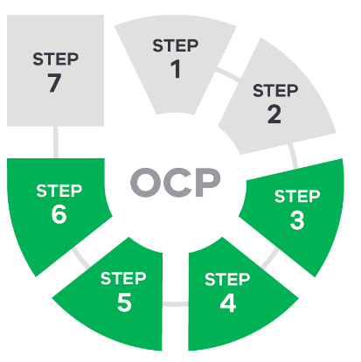
Following a cancer diagnosis, all Victorians should get the best treatment and care, regardless of where they live or who they are. This is critical to ensure we achieve equitable cancer outcomes for all Victorians.
The COVID-19 pandemic has changed behaviour (reduced presentations and referrals, and treatment delays) which may have delayed diagnosis and treatment for cancer. Using the principles of optimal cancer care allows individuals and the health system to adjust and reduce the impact of COVID-19 (Cancer Australia 2020). This plan strengthens the use of the optimal care pathways, and includes telemedicine and home-based care as helpful ways for treatment to be delivered.

Consistent quality through optimal care pathways

3.1 Implement the optimal care pathway for Aboriginal people with cancer
Cancer incidence and mortality rates are significantly higher for Aboriginal Victorians compared with non-Aboriginal Victorians. Aboriginal Victorians are more likely to be diagnosed with late-stage or preventable cancers.
The Optimal care pathway for Aboriginal and Torres Strait Islander people with cancer guides delivery of culturally appropriate treatment and services. It helps patients and their carers understand their cancer care, empowering them to ask questions of their treatment team (Cancer Australia, Cancer Council Australia 2018).
Key elements of optimal care for Aboriginal people include (Chynoweth et al. 2020):
- addressing the cultural appropriateness of the healthcare environment
- improving cross-cultural communication
- relationship building with local community
- optimising health literacy
- recognition of men’s and women’s business
  - the need to use culturally appropriate resources.
Aboriginal people with cancer may need more support following a cancer diagnosis to achieve optimal outcomes. This will be realised through self-determined programs and services to improve communication, navigation and coordination of cancer care. This should be consistent with Korin Korin Balit-Djak (Department of Health and Human Services 2017a) and the Aboriginal and Torres Strait Islander cultural safety framework (Department of Health and Human Services 2019).
The Victorian and Tasmanian Primary Health Network Alliance provides a statewide platform to support the OCP for Aboriginal people with cancer in primary health. This is mostly organised via the HealthPathways portal.
Activity in the next four years will:
partner with Aboriginal organisations to implement the Optimal care pathway for Aboriginal and Torres Strait Islander people with cancer
partner with the Victorian and Tasmanian Primary Health Network Alliance to embed the Optimal care pathway for Aboriginal and Torres Strait Islander people with cancer into HealthPathways.

3.2 Implement and monitor performance against the optimal care pathways
Implementation of the OCPs has been supported through activities undertaken by:
- the Integrated Cancer Services and partner health services
  - professional associations and programs in the primary care sector.
Further OCP implementation will improve the consistency and quality of cancer care across Victoria.
The OCPs emphasise the right of patients to receive all the information they need to make informed choices about their care. This includes information about treatment costs. Also, multidisciplinary care is key to optimal cancer care from diagnosis through to palliative care. Multidisciplinary care aims to ensure that members of the treatment and care team can discuss and cover all aspects of a patient’s physical, supportive care needs and other impacting factors. Early referral to palliative care can improve the quality of life for people with cancer. In some cases, it may be linked with survival benefits (Haines 2011).
Performance monitoring of cancer services helps deliver consistent care to people with cancer to ensure the best outcomes. Looking beyond current practices to adapt to the uncertainties of COVID-19, an ageing population and workforce and other challenges, is key to providing best patient care.
High-quality, accurate, accessible data and information helps implement the OCPs. The Statewide Cancer Indicator Platform (SCIP) has been developed to support health services with accessible performance information for clinical and process activities. Integrated Cancer Services and their clinician and consumer partners can use the SCIP to identify unwarranted variation and drive improvement.
Activity in the next four years will:
continue and strengthen focus on monitoring use of OCPs at scale across Victoria
support Integrated Cancer Services and their partners to use the SCIP for reforms that deliver quality and safety.

Victorian Tumour Summits
Victorian Tumour Summits are multidisciplinary clinician-led forums. They identify and address unwarranted variations in tumour-based clinical practice and cancer outcomes. The Summits review the current state of tumour-based care, population trends and clinical outcomes.
The Summits provide a way for clinicians to analyse variations in care. They then recommend activities and outcomes to address variations during the rollout of the OCPs. Using this priority approach, the Summits enable improvements at scale for the benefit of more people using Victorian health services.
Summits on prostate, oesophagogastric, colorectal (bowel), lung, pancreatic and head and neck cancers have already informed OCP rollout. Importantly, they have identified quality improvement activities to reduce unwarranted variation in care.

Improve patients’ experience of care

3.3 Monitor and assess patients’ experiences of care in a culturally safe way
Understanding a patient’s experience of treatment and care is essential to understanding how to improve cancer care services and systems. It ensures each patient has access to optimal care.
The Victorian Cancer Patient Experience Survey asks respondents about their experience with different aspects of their care from diagnosis to follow-up. It asks about different treatments they may have received including surgery, radiotherapy and chemotherapy.
The survey has been translated into Arabic, Italian, Greek, Vietnamese and Chinese. This increases accessibility to culturally diverse populations.
The survey provides valuable feedback that helps to improve the care and treatment provided by each health service. It recognises the economic and social burdens of cancer and the factors that affect the quality of life of patients.
Patient-reported outcome measures (PROMs) help to assess how health services and treatments have affected aspects of care that only patients can know (ACSQHC 2016). These include quality of life, daily functioning and symptom severity. The experiences of care survey provides an opportunity to collect PROMs and to link patient outcomes to healthcare experience.
Activity in the next four years will:
monitor and assess patients’ experiences of care
pilot collecting PROMs through the patient experience survey
adopt a revised culturally appropriate cancer patient experience survey.

Patient experiences of care
Nearly 5,000 people completed the Victorian Cancer Patient Experience Survey in 2019. Respondents received cancer treatment in a Victorian public hospital in the year prior. Overall, 97 per cent of patients were satisfied or very satisfied with the care they received.
Further analysis evaluated the experiences related to supportive care. This indicated some inequality in the extent to which supportive care was provided. It also confirmed that some patients have a greater need for supportive care than others.
The information from the survey will inform quality improvement initiatives.

Culturally appropriate patient experience surveys for Aboriginal people
Capturing the healthcare experiences of Aboriginal people is essential to (Green et al. 2017):
- lowering high mortality rates
- improving survivorship outcomes
tailoring the OCPs.
In past years, the proportion of respondents to the experiences of care survey who identified as Aboriginal has been low. To address this, Monash University was engaged to adapt the survey and administration protocol to be more culturally appropriate for Aboriginal people.
A revised survey was developed through statewide consultation with Aboriginal health professionals and communities. These stakeholders were either involved in providing health services for those with cancer or were affected by cancer.
A revised survey will be adopted to improve response rates and ensure high-quality data collection from Aboriginal people with cancer.

Optimise infrastructure, data and system design for better access, safety and quality

3.4 Implement service capability frameworks to support better, safer care
The OCPs emphasise the importance of integration and coordination of care across service settings and locations. The complex service needs of each person with cancer reflect (Victorian Government 2016):
- the characteristics of the individual
- the type of cancer
- likely care pathways
  - progression of the disease.
Clarity on the role of various parts of the health system to care for patients will deliver safer care. This includes strong referral pathways and coordination.
The staged introduction of a role delineation framework for the Victorian health system is a key action of the Statewide design, service and infrastructure plan for Victoria’s health system 2017–2037 (Department of Health and Human Services 2017c). Service capability frameworks for cancer will complement existing frameworks. They will also define the criteria and capabilities required for health services to achieve safe and effective cancer care. The frameworks will outline minimum standards and requirements for:
- workforce
- equipment and infrastructure
  - clinical support services.
This will help plan for coordinated and integrated service delivery across settings and locations.
As capability frameworks are developed, they will create ways to ensure high-complexity and/or low-volume procedures are undertaken in centres where they can be performed safely. For example, new statewide cancer services provide some treatment options via the Victorian MRI-Linac at Austin Health and Gamma Knife services at the Peter MacCallum Cancer Centre. If patients are transferred to a larger centre for more complex care, ongoing care should be provided as close to home as possible, and may include care at home. This might include recovery and palliative care and/or use telemedicine.
Activity in the next four years will:
develop and implement service capability frameworks for cancer in Victoria
work with health services to implement the Home-based cancer care: framework and toolkit (Department of Health and Human Services 2020b) and greater use of telemedicine
develop and implement a statewide radiotherapy service and new technology plan, to deliver care safely and where possible, closer to home.

Cancer care at home
Increasing cancer diagnoses and scientific developments in biological therapies has resulted in more demand for day oncology services. An alternative to hospital-based care is delivering systemic anti-cancer therapies (SACT) in the patient’s home or close to home. Home-based care is an established and safe alternative. In addition to relieving pressure on services and resources in hospitals, it offers eligible patients more choice about how, when and where they are treated. Patients benefit from:
- being closer to family and friends
- more privacy
less time needed for travel, waiting and discharge.
The Home-based cancer care: framework and toolkit outlines governance, models of care and funding structures. It also:
- provides a set of evidence-based best practice tools and templates for treatment
- describes patient eligibility criteria to promote consistency of access and to reduce variation of service across the state
outlines a program monitoring and evaluation structure.
Cancer services are exploring how to incorporate home-based care as part of their COVID-19 response.

3.5 Support Victoria’s regional cancer centres to deliver appropriate, accessible, high-quality and safe cancer care close to home
Victorians living in regional areas are more likely to be diagnosed with late-stage or preventable cancer and have poorer outcomes.
Victoria’s state-of-the-art regional cancer centres:
- support best practice models of care
- coordinate services across regions to ensure patients receive safe and appropriate cancer care as close to home as possible
  - address the gaps in survival between metropolitan and regional residents.
Victoria has led a range of reform initiatives to improve treatment quality and patient experiences of care. These initiatives include:
- the symptom and urgent review clinic (SURC) model to better manage patients receiving chemotherapy who have symptoms related to their cancer or treatment
- the RapidPlan automated planning model for radiotherapy
- a multidisciplinary team meeting management software solution (QOOL-VIC)
- electronic pathology reporting (e-path) for reporting cancer notifications to the Victorian Cancer Registry
  - the Victorian Therapeutics Advisory Group’s Chemotherapy audit toolkit to help monitor off-protocol prescribing.
These initiatives will be adopted or applied at scale to create system-level improvements in cancer care.
Activity in the next four years will:
implement and expand the use of statewide infrastructure to deliver safe, quality care, including statewide use of the e-path reporting solution and mandated use of QOOL-VIC for regionalised access to virtual care
strengthen the role of regional cancer centres in clinical care, support services, education and research, including cluster-wide access to care closer to home, a focus on underserved groups and the voice of the community, and workforce development for timely access to quality care
strengthen the use of SURCs to support patients receiving SACT, including a focus on vulnerable populations.

Facilitating multidisciplinary meetings across Victorian health services
QOOL-VIC is an oncology multidisciplinary team meeting management software solution. It provides a central view of patient multidisciplinary team meeting data for multiple users and can be accessed from multiple locations. The software will receive data from the Victorian Cancer Registry, improving the availability of data for tracking quality and outcomes.
QOOL-VIC has been fully implemented at Ballarat Health Services, where it has decreased preparation time for multidisciplinary team meetings. The software will be rolled out across Victoria and enable virtual care delivery across organisations and regions, including greater metropolitan and regional linkages.

Symptom and urgent review clinic – an innovative model of care
The nurse-led SURC model of care is a new approach to managing patients receiving ambulatory SACT. This model supports patients and carers to recognise and manage adverse symptoms early. This can avoid the need to visit an emergency department or to reschedule treatment.
Experienced cancer nurses provide structured patient education before the first cycle of chemotherapy. The clinic functions as a telephone/walk-in clinic for patients with treatment-related side effects.
SURC was initially piloted at Western Health and has since been adopted across Victoria at four metropolitan sites (Austin Health, Eastern Health – Box Hill, Monash Health – Dandenong, The Royal Children’s Hospital) and four regional sites (Albury Wodonga Health, Bendigo Health, Goulburn Valley Health, Latrobe Regional Hospital).
An economic assessment of the SURC program showed that it relieves and partially replaces emergency department visits related to cancer therapy (Shih et al. 2020). Other reported benefits included:
- improved patient understanding of toxicities
- improved self-management capability
increased patient confidence.
During COVID-19 this alternative model of care at existing sites was extended to more patients. This included increased hours of operation and/or increased staffing. It was a response that enabled greater use of cancer nursing workforce to safely support patients anxious about the COVID-19 impact on their health. Also, while the model already provided telephone support, the telehealth consultations were increased to reduce face-to-face contact.

Action area 4: Wellbeing and support
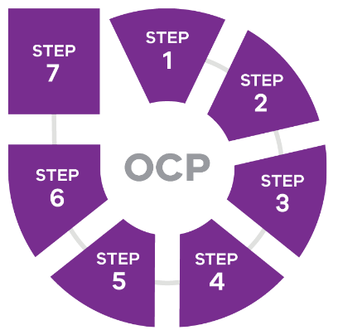

Strengthen supportive care and self-management
Providing supportive care is vital to delivering quality cancer care. People with cancer have diverse supportive care needs across the care pathway. These needs could be:
- physical
- emotional
- social
- psychological
- informational
- spiritual
  - practical.
Supportive care means the services, information and resources a person may need:
- before and after a cancer diagnosis
- during treatment
  - after treatment.
Supportive care complements cancer treatment and is a key principle in the OCPs. All members of the multidisciplinary team have a role in providing supportive care along the care pathway. Special attention should be paid at transition points. The Optimal care pathway for Aboriginal and Torres Strait Islander people with cancer guides delivery of culturally appropriate supportive care.
An audit of supportive care screening in Victorian cancer services has shown differences in screening practices between and within hospitals. It showed that few patients have a supportive care screen completed more than once. Also, the audit noted that supportive care screening using a proven tool was more likely to reveal emotional and physical problems than a discussion without a screen (Weber et al. 2018). The audit found opportunities to build capacity for optimal supportive care through developing a statewide supportive care implementation plan.
It is expected that the impact on individuals of changes and uncertainty due to the COVID-19 pandemic will vary. This is a timely reminder of the importance of identifying the supportive care needs of each patient and providing support to meet those needs, including through the use of new virtual models.

4.1 Improve access to supportive care and help people manage some aspects of their own care
Finding the right support when needed most is important to the overall wellbeing of people affected by cancer. This is the case as they manage the news of a diagnosis, throughout treatment and living with or after cancer. Through the process of supportive care screening, health professionals can identify and prioritise the supportive care needs of their patients. They can then progress appropriate treatments or referrals to address these needs. A wide range of services exist to support people affected by cancer across sectors including:
- treatment centres
- primary care
- allied health
- community-based support
- not-for-profit organisations
- cancer foundations
  - community health.
To improve the supportive care outcomes for Victorians affected by cancer, strategies must ensure resources are used in the right way. They must ensure equity in how supportive care services are provided to those affected by cancer.
To reduce the financial burden related to cancer, people should receive all the information they need to make informed decisions about their diagnosis and treatment including the costs involved.
Ensuring that individuals and communities can access, understand and use information and services to make decisions about their health and care will enhance their ability to self-manage. Health professionals must enable patients to make informed choices according to their preferences, needs and values. An informed patient has more confidence and competence to manage their cancer journey.
Activity in the next four years will:
integrate WeCan supportive care resources into the routine models of care for acute and primary health settings and non-government organisations
develop and pilot quality criteria for supportive care to enable measurement of practice
refresh workforce skills and competency in supportive care approaches including communication skills, motivational interviewing and telemedicine.

Supportive care resources
The WeCan resource arose from a statewide project to refresh resources and approaches to delivering supportive cancer care. WeCan resources can help people find the information, resources and support services they may need after a diagnosis of cancer. Resources include:
- an online navigation portal <https://wecan.org.au/>
- learning modules
- videos
- social media pages
promotional materials.
WeCan offers health professionals a vital resource to navigate patients and families to well-regarded, evidence-informed information, resources and support services. These can be accessed no matter where they work or where their patients live.
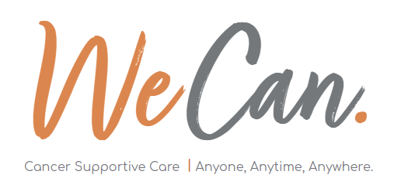

4.2 Implement the Victorian carer strategy 2018–2022 to recognise and support the important role of carers
Carers play an integral role in the cancer care team. The carer role can be hugely rewarding and meaningful for the carer, but it can also be challenging. Carers often face stressors and challenges including:
- a lack of training
- disjointed care
- not feeling valued and included in the care team
  - economic and personal health issues.
Carers do not all have the same needs, and supports need to be tailored. For example, carers of adolescents and young adults with cancer have specific needs. Also, there may be expectations of care by family and community for Aboriginal and culturally diverse people.
It can be difficult to make sure carers get access to the help they need to look after themselves and feel supported. The Victorian Government is committed to supporting a wide range of programs and services for Victorian carers.
Through the Victorian carer strategy 2018–2022, carers will be supported to have:
- their health, wellbeing and social needs met
- flexibility in their education and employment
- access to better services and support programs
  - recognition and respect for the role they play.

Activity in the next four years will:
conduct region-based programs across Victoria to improve communication with and support for carers.

Support cancer survivors to recover and thrive

4.3 Build workforce knowledge and skills in survivorship care across cancer care systems
Many Victorians are living with or beyond their cancer diagnosis thanks to:
- advances in early detection
- better treatments
  - healthier ageing.
Many of these people go on to lead normal lives, while for some cancer has a lasting impact. This can include (Vardy et al. 2019):
- ongoing side effects of treatment
- fear of a cancer relapse
  - other physical, emotional, financial and social concerns.
Survivorship provides a focus on the health and wellbeing of people living with and beyond cancer. It aims to reduce and manage the effects of treatment and to sustain recovery.
Since 2016, the Victorian Cancer Survivorship Program has funded 24 projects. These projects have successfully addressed system gaps in:
- exercise and rehabilitation
- the role of GPs in cancer survivorship
  - specific unmet needs of survivors.
Projects funded through the program have resulted in new resources to address survivorship needs. They have created new programs proven to improve the health and wellbeing of people affected by cancer.
Primary and community-based services are important in providing post-treatment care. Through implementing the survivorship program, the capacity of allied health, cancer specialists, GPs and practice nurses is supported to deliver:
- the best survivorship care
- education
  - access to resources.
Access to that information and support enables patients to self-manage.
A quality survivorship framework will define and measure optimal survivorship care. It will help implement best practice models of care and monitor results.

Activity in the next four years will:
develop and implement a framework to define and measure the quality elements of survivorship care
implement models of shared care and community-based self-management, with a focus on coordination of care across regional clusters
build skills in the allied health workforce to understand cancer specific needs, with a focus on regional Victoria and rehabilitation care
promote and embed equitable use of survivorship care plans in cancer services and primary and community care services, with a focus on underserved patient groups.

Exercise in cancer
Being physically active and exercising regularly is important for the health, function, quality of life and survival of people with cancer (Cormie 2018).
The EX-MED Cancer program was established through the Victorian Cancer Survivorship Program. It addresses the chronic and late effects of cancer and its treatment through delivering individualised exercise programs in the community. Program participants saw profound impacts to their physical and mental wellbeing as well as their work, family, social life and community engagement.
‘I have found EX-MED Cancer a motivating and empowering initiative. I am already feeling physically stronger and have noticed improvement in my emotional resilience. I am certain I will have all the motivation I need to continue under my own steam.’ – Andrew
‘Who’d have thought that hard work in the gym would have been something to look forward to at 65? I’m feeling the benefits of the workouts, both physically and mentally, and being with people who’ve been in a similar situation to me is no doubt a part of that benefit. The encouragement from the exercise physiologist and the constant feedback, is of great benefit. I’d personally be lost without it and it has already given me the confidence to think about what I’ll do once the program is complete.’ – Mike
‘Absolutely fabulous to get cancer patients out in the real world and show them they can do it. On my own I would have been too scared to join a gym because of the cancer and explaining it to staff. This program started us exercising with someone who knew about us and could get us going with care and supervision. Inspired us to now join the gym on our own because we know we can do it. Hooray!’ – Barbara

Addressing fear of cancer returning
Fear of cancer recurrence describes the fear, worry or concern relating to the possibility that cancer will come back. Fear of cancer recurrence has negative effects on cancer survivors’ day-to-day functioning, work, mood and quality of life.
The Fear-Less initiative was a collaborative project funded through the Victorian Cancer Survivorship Program. It was designed to identify and treat this fear in survivors with stage IV melanoma who were treated with immunotherapies or targeted therapies. The program was implemented across Peter Mac and The Alfred melanoma outpatient clinics. Fear-Less improved identification, access to self-management or supported programs and outcomes for program participants.

Maintain quality of life through palliative care and end-of-life care

4.4 Support early access to palliative care to manage symptoms and improve quality of life
Early referral to palliative care can improve quality of life for people with cancer. In some cases, it increases survival rates. This is particularly true for poor-prognosis cancers (Haines 2011).
Healthcare workers should emphasise the value of palliative care in improving symptom management and quality of life to people affected by cancer.
All Victorians are entitled to quality palliative care that relieves pain and suffering. Compassionate support should be provided to family, friends and carers. The treatment team should share the principles of a palliative approach to care when making decisions with people affected by cancer.
The OCPs describe the requirements for palliative care. The goal is to ensure patients receive timely and appropriate referral to palliative care services. The timeliness of referral to palliative care for people with metastatic cancer was noted as an area for improvement through the Lung and Pancreatic Tumour Summits.
Activity in the next four years will:
identify and address variation from optimal care for timeliness and appropriateness of referrals to palliative care
identify trigger points to align palliative interventions and treatments with patients’ wishes.

4.5 Expand end-of-life and palliative care skills and advance care planning education across the cancer workforce
Advance care planning allows a person to express their preferences about future medical treatment if they become unable to later. It puts the person at the centre of care, involving them, their family (if appropriate) and the clinicians responsible for their care. Advance care planning improves the quality of care people receive at the end of their lives, and helps that care to culturally safe.
Care at the end of life can be provided in a range of settings including:
- in hospitals
- at home
  - in aged care services.
It can also be provided by a range of different health practitioners including:
- GPs
- medical specialists
- nurses
  - social workers.
Advance care planning is important for all patients with a cancer diagnosis but especially those with metastatic disease. Every person with metastatic cancer should be supported to have access to advance care planning when they choose to take up this voluntary process. This may include an advance care directive, and/or appointment of a medical treatment decision maker or a support person.
The OCPs and Victoria’s advance care planning strategy (Department of Health 2014) describe the requirements for advance care planning. They promote that a discussion about advance care planning should take place with the patient and carer (where appropriate).
Even with the best care, some people near the end of their life go through suffering that is unacceptable to them and may want to ask for help to die. On 19 June 2019, the Voluntary Assisted Dying Act 2017 came into effect. Voluntary assisted dying provides choice about the manner and timing of death for people at the end of their life.
Activity in the next four years will:
identify and address variation from optimal care for advance care planning discussions
improve identification of the medical treatment decision maker on admission
support education of the cancer workforce in end-of-life care, palliative care and advance care planning.

Action area 5: Research
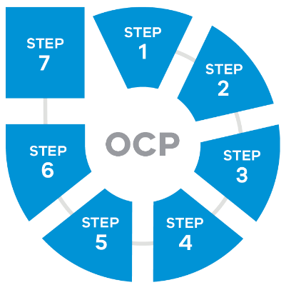
Research and innovation are essential to:
- reducing the burden of cancer
- improving treatment outcomes
  - the quality of life of people affected by cancer.
Research leads to new prevention programs, diagnostics, treatment discoveries and new models of care.
During the COVID-19 pandemic some cancer clinical trials have been suspended or not initiated. Yet there has also been greater collaboration to support cancer research (Cancer Australia 2020). This emphasis on collaboration to find ways to better manage cancer in the future will be actioned through this plan.
The Victorian Cancer Agency was established in 2006 to sustain and enhance Victoria’s track record in cancer research. The agency:
- sets strategic priorities for cancer research
- builds cancer research capacity and capability
- builds collaborative relationships between key stakeholders
  - provides strategic advice to government on cancer research.
The Victorian Cancer Agency has so far invested more than $225 million in cancer research.

Improve access to clinical trials
Clinical trials advance cancer breakthroughs by testing the latest treatments, drugs and medical devices. The OCPs recommend that, where practical, patients should be offered the opportunity to take part in research or clinical trials. This can happen at any stage of the care pathway.
From 2014 to 2017, the average annual number of new enrolments of Victorian cancer patients in intervention clinical trials was 1,645 (range: 1,605 to 1,742). As cancer incidence is increasing, the number of patients taking part in clinical trials must also increase.

5.1 Improve participation and reduce inequities in access to cancer clinical trials
Certain groups of people are under-represented in cancer clinical trials including:
- patients with low-survival cancers
- regional Victorians
- Aboriginal Victorians
- culturally diverse Victorians
- adolescents and young adults with cancer
  - adults aged over 65 years with cancer.
Blood cancers show the highest clinical trial participation rates (2,123 new enrolments between 2014 and 2017) compared with brain (206 new enrolments between 2014 and 2017) (Department of Health and Human Services 2020a). On average, rural patients make up 27 per cent of all patients recruited into cancer clinical trials. Most (84.5 per cent in 2015) need to travel to a metropolitan cancer service to access the trial. There are now easier ways for patients living outside of major metropolitan centres to access cutting-edge treatments. These include:
- local clinical trials
  - teletrials.
Currently, clinical trial data systems do not capture data on Aboriginal and culturally diverse Victorians taking part in trials. Also, only treatment intervention trials are recorded. Other types of clinical trials, such as supportive and palliative care trials, are not captured. This limits patient and clinician awareness about other research options. More work is needed to improve the data collection system and reporting to inform priority research areas.
Activity in the next four years will:
improve understanding of the barriers to taking part in trials and better consider the needs of patients, carers, clinicians and the community
support interventions that enhance clinical trial enrolment among under-represented groups (including novel trial design, telehealth, educational tools and community support)
improve awareness and education about clinical trials among under-represented groups and the health professionals treating them
strengthen the collaboration across regions to support access to clinical trials, including greater use of virtual technology
improve clinical trial data collection and reporting.

Enabling regional and rural patients to access trials close to home – two complementary models
Teletrials model
To improve access to clinical trials for country patients, the Victorian Comprehensive Cancer Centre alliance established a teletrials program. Teletrials enable patients on clinical trials to take part in trials at smaller regional and rural health centres through partnering with a larger lead site. In addition to increasing equity of access, the program aimed to:
- increase opportunities for recruitment to clinical trials
- support collaboration between regional and metropolitan centres
develop capability and workforce in regional Victoria.
Through the teletrials program, Australia’s first investigator-initiated teletrial opened in November 2018. With a metropolitan primary site and two regional satellite sites, this teletrial has recruited 38 regional patients. This is an eight per cent increase in the number of rural patients on a trial in Victoria. It is a 43 per cent increase on patients accessing a trial at a site near their home.

Regional Trials Network
The Regional Trials Network was established with support from Cancer Council Victoria and the Victorian Cancer Agency. Its role is to improve patient access to cancer clinical trials at regional trial sites. In Victoria, the Regional Trials Network aims to:
- increase the number of available cancer clinical trials
- increase participation rates
- reduce duplication of effort
improve efficiency in processes for cancer clinical trials.
Through the Regional Trials Network, various health services and Cancer Trials Australia have partnered to cover an area of 1.4 million people where there are 7,200 new cancer diagnoses every year. These include:
- Ballarat Regional Integrated Cancer Service
- Barwon Health (Geelong)
- Bendigo Health
- Border Medical Oncology (Albury/Wodonga)
- Goulburn Valley Health (Shepparton)
South West Healthcare (Warrnambool).
The number of patients enrolled in a clinical trial at a Regional Trials Network site increased by 49 per cent between 2017 and 2019.

Accelerate translation of research into improved clinical outcomes

5.2 Promote equitable access to emerging therapies, technologies and platforms
Knowledge and technologies for cancer care are evolving. We need to continually assess current and new treatments and adopt those that deliver the best results.
Emerging medicines such as cancer immunotherapy have shown benefits for patients in multiple cancers. They can produce long-lasting remissions that span many years.
We need more evidence to implement genomic testing into routine clinical practice. This will enable equitable and appropriate access to personalised cancer therapies. There also needs to be ongoing education of the workforce to build skills and knowledge in genomics.
Researchers are investigating personalised treatment approaches such as cellular therapies, including chimeric antigen receptor (CAR) T-cell therapy, for a variety of cancers.
Supporting research infrastructure such as the Victorian Cancer Biobank is essential to enable Victorian researchers to speed up their research.
Activity in the next four years will:
build the evidence base and workforce education to help adopt personalised cancer therapies and genomic testing
invest in critical infrastructure to support the cancer research sector.

Enabling access to precision oncology in Melbourne’s south-east
Monash Partners Comprehensive Cancer Consortium (MPCCC) partners care for more than 19,000 cancer patients across south-eastern Victoria every year.
The Victorian Cancer Agency funds the MPCCC Precision Oncology Program to coordinate research and clinical care for patients with rare, advanced stage and therapy-resistant cancers.
The program supports analyses of comprehensive genome profiling data to identify genetic variations within a patient’s cancer and match them to available cancer therapies. This could provide individualised treatment plans for patients, rather than a ‘one size fits all’ approach.
MPCCC’s Molecular Tumour Boards provide meetings for health professionals to discuss and interpret the results of genome profiling. This guides decision-making around treatment options for individual patients for the best possible outcomes.
Since September 2018, when the program was established, several board meetings have focused on haematological malignancies. Future boards are being set up for aggressive and low survival cancers. These include:
- pancreatic and upper gastrointestinal cancers
- rare cancers and cancers of unknown primary site
- prostate cancer
thyroid cancer.
In addition, local, interstate and international guest speakers are invited to present at Precision Oncology Seminars held across MPCCC partner health services on topics such as:
- genetic sequencing of solid tumours
- novel therapies for high risk childhood cancers
- cancer biomarker research and discovery in immunotherapy
- the Australian Genomic Cancer Medicine Program: a national precision oncology initiative
- cancers of unknown primary
- health economics of comprehensive genome profiling compared with ‘standard of care’ genetic testing
- clinical bioinformatics
circulating tumour DNA (‘liquid biopsies’) for molecular disease monitoring.
Both the Molecular Tumour Board meetings and the Precision Oncology Seminars provide educational opportunities to prepare the workforce to apply precision oncology in ways that support excellence in patient care.

5.3 Assist services to conduct and implement research across the cancer pathway
Growing pressures on the cancer care system include increasing demand and treatment costs. To ensure a sustainable system, treatment decisions need to be based on thorough evidence of clinical benefit. Health services research and implementation science helps translate research findings from the laboratory to effective, efficient and equitable clinical practice. It also promotes the systematic uptake of research findings.
There are inequities in the amount of cancer research funding in Australia towards prevention research (two per cent) and health services research (eight per cent) compared with basic biology (35 per cent) and treatment (28 per cent) (Cancer Australia 2015).
Research that identifies factors that can influence cancer risk leads to important advances in cancer prevention and screening. Benefits of health services research in prevention and screening include:
- improving and evaluating cancer prevention strategies
- understanding barriers to screening
- developing new approaches to improve screening participation
  - developing and evaluating risk-stratification tools.
The evaluation of the Victorian Cancer Survivorship Program identified a series of research questions and opportunities to increase the evidence base for best practice survivorship care (Coughlan 2019). Building capacity in the health services research sector will lead to improvements in the quality of life of cancer patients. This includes the areas of:
- supportive care
- palliative care
  - survivorship care.
Extensive data are collected from Victorian cancer patients. However, these data are not being used to their full potential to improve patient care and outcomes. Implementing electronic medical records in health services creates an opportunity to answer research questions. The introduction of e-Path (electronic reporting of pathology results) and artificial intelligence software to the Victorian Cancer Registry allows researchers to access an expanded cancer dataset. What’s more, linking the Victorian Cancer Biobank with the Victorian Cancer Registry enables better access to annotated biospecimens. This in turn increases opportunities to translate research into care.
Activity in the next four years will:
build capacity in health services research, prevention, screening, supportive care, palliative care and survivorship research
improve the quality of the data and enhance access to and linkage of existing cancer datasets.

Support equity and collaboration in cancer research

5.4 Leverage funding to build a more inclusive cancer research workforce
The Medical Research Future Fund (MRFF) is a $20 billion investment established by the Commonwealth Government. The fund aims to increase the growth of our health and medical research while creating jobs, economic growth and export potential. There are opportunities to leverage MRFF funding through co-funding Victorian applications that meet areas of local importance.
Philanthropic organisations support the cancer research sector in Victoria and Australia. To date, the Victorian Cancer Agency has co-funded research projects with:
- Cancer Council Victoria
- Children’s Cancer Foundation
- National Breast Cancer Foundation
- Snowdome Foundation
  - Maddie Riewoldt’s Vision.
New and ongoing partnerships with philanthropy are critical to supporting cancer research in Victoria.
Cancer researchers in regional areas do not have the same access to infrastructure and resources as larger metropolitan research centres. On top of this, there are barriers for Aboriginal and female researchers to achieve senior leadership positions in their field. This under-representation is cause for social concern and is likely to inhibit research that aligns with Victoria’s views and needs. Removing barriers and improving opportunities for a greater diversity of cancer researchers will help to realise the potential of the workforce and address sustainability (Bell & Yates 2015).
Low-survival cancers, such as lung and pancreatic cancer, receive proportionally less research funding than cancers with higher than average survival (Cancer Australia 2016). Prioritising funding for low-survival cancers will lead to improved care and increased survival rates for these cancers.
Activity in the next four years will:
build partnerships with philanthropic organisations and the Commonwealth to leverage research funding
improve the diversity of the cancer research workforce and opportunities for career progression
support research focused on low-survival cancers.

Investing in low-survival cancer research
The Victorian Government awarded $10 million in 2018–19 to the Olivia Newton-John Cancer Research Institute. The funding includes establishing a Centre of Research Excellence in brain cancer as part of the Australian Brain Cancer Mission. Its aim is to double the five-year survival rates by 2027 and improve the quality of life of people living with brain cancer.
The Victorian Cancer Agency launched a targeted funding scheme in 2018. The scheme awarded around $3.7 million to joint research projects focusing on upper gastrointestinal (GI) tract cancers. Upper GI cancers have a particularly poor survival rate.
One of these awards supports Dr Daniel Croagh at Monash University. Dr Croagh is using next-generation sequencing to improve the speed and accuracy of diagnosis in pancreatic cancer.
The Victorian Cancer Agency also invested $1.5 million in partnership with Cancer Council Victoria to fund five research projects investigating low-survival cancers. The five projects are currently looking at cancers of the lung, oesophageal, stomach, liver and myeloproliferative neoplasms.

5.5 Support Aboriginal self-determination in the cancer research sector
Research designed, developed and delivered by Aboriginal people has much higher engagement with Aboriginal communities. It leads to greater translational health outcomes.
The Victorian Government has committed to developing an Aboriginal Medical Research Accord. Consultation with community showed general support for the Aboriginal Health and Medical Research Accord to build on the National Health and Medical Research Council guidelines. The Accord will promote best practice by adopting a strategic and coordinated approach. It will ensure research is undertaken in line with guidelines at the local level. The Accord aims to:
- ensure research addresses Aboriginal priorities
- ensure research outcomes are meaningful and beneficial to Aboriginal communities
- increase the number and capacity of Aboriginal researchers
- formalise Aboriginal input to ethics reviews
- promote Aboriginal data sovereignty
- increase Aboriginal participation in clinical trials
- ensure research outcomes are shared with participants promptly in an accessible format without charge
- ensure systematic health program and health service delivery evaluation is undertaken
  - ensure consultation with Aboriginal stakeholders at the start and throughout the research process.
The Optimal care pathway for Aboriginal and Torres Strait Islander people with cancer emphasises that patients should be offered the chance to take part in research or clinical trials at any stage of the care pathway. This needs to be conducted in a culturally appropriate way. It must also ensure that opting not to take part in research will not affect the standard of care.
Activity in the next four years will:
implement the Victorian Aboriginal Health and Medical Research Accord within the cancer research sector
support Aboriginal participation in clinical trials and research
support a culturally competent and inclusive cancer research workforce.

Reducing cervical cancer in Aboriginal women
The incidence of cervical cancer among Aboriginal women is significantly higher than the rate for other Victorians (Department of Health and Human Services 2020a). In 2018 the Victorian Cancer Agency’s inaugural Improving Cancer Outcomes for Aboriginal Victorians Collaborative Research Grant was awarded to Professor Margaret Kelaher at the University of Melbourne. The project is conducted in partnership with VACCHO, VCS Foundation and Victorian Comprehensive Cancer Centre.
The research project aims to improve cervical cancer outcomes for Victorian Aboriginal women by:
establishing a mixed-method evaluation framework to monitor the rollout of the human papillomavirus nucleic acid testing (HPV screening) program to Aboriginal women in Victoria
improving the rollout of the HPV screening program through co-design strategies to support screening uptake, the implementation of self-collection and specialist care.
The HPV screening program will include a self-collection pathway for women who are never- or under-screened and who decline clinician sampling. Effective rollout of this new pathway could make a critical difference for equity in the program. The HPV screening program provides opportunities to improve outcomes for Aboriginal women.

5.6 Promote effective collaboration across research organisations, health services, consumers and industry
Collaboration between disciplines and organisations will increase the quality, capacity and sustainability of cancer research in Victoria. The collective impact through sharing of knowledge, ideas, experience and technology will lead to improved outcomes for all Victorians.
Initiatives are required to increase joint work across institutions including metropolitan and regional partnerships and with industry. The Victorian Comprehensive Cancer Centre alliance and the Monash Partners Comprehensive Cancer Consortium enable cancer research across academia, health services and research institutions. The Victorian Cancer Agency will work with these consortiums to support cancer research in Victoria.
People affected by cancer make an important contribution to cancer research. Using the patient and carer perspective helps prioritise outcomes that are respectful of and responsive to the needs of the community. Evidence suggests that meaningful involvement of consumers in cancer research and policy creation leads to better health outcomes and experiences for those affected by cancer (Cancer Australia and Cancer Voices Australia 2011). Bringing the knowledge and experience of cancer as a person diagnosed with cancer, a carer, a family member or survivor allows firsthand learning for researchers.
The Victorian Cancer Agency will require active consumer engagement in all funded research grants and fellowships. The agency will support training and education for researchers and consumers to promote consumer engagement. In addition, consumers will be involved in evaluating grant applications to ensure public funding is given to projects that are valuable to the community.
Activity in the next four years will:
support collaboration across institutions including metropolitan and regional partnerships and industry
implement consumer engagement and evaluation in all funded research grants and fellowships
support training and education for researchers and consumers to promote consumer engagement.
Working together to prevent liver cancer – a regional and metropolitan partnership
Most cases of liver cancer are preventable. If people who are living with hepatitis B or C have access to good health care to manage their condition, their risk of getting liver cancer later in life is greatly reduced. For this to happen, people who are affected by hepatitis need to be offered testing. They then need to receive follow-up from clinicians and the right treatment.
The Victorian Cancer Agency has supported Professor Ben Cowie from the Royal Melbourne Hospital and the Doherty Institute to discover the best tools to support doctors to do this. Professor Cowie’s work will help people living with hepatitis increase their understanding of how to reduce their risk of liver cancer.
The project is being collaboratively designed with key stakeholders and affected communities. It is being undertaken in partnership with three Primary Health Networks (South Eastern Melbourne, Eastern Melbourne, and Gippsland). These networks will enable links with GP clinics and support them to take part in the research. This project adopts a novel partnership model to support primary care to prevent liver cancer in Victoria.

Consumer engagement in research
In 2018, the Victorian Cancer Agency used consumer evaluation panels (people with lived experience of cancer) to help assess applications for project grants through the annual funding round. After the success of these panels, consumers were again involved in assessing grants in 2019.
The Victorian Comprehensive Cancer Centre alliance developed a consumer engagement toolkit that built on the work of Cancer Australia’s National framework for consumer involvement in cancer control. The toolkit includes resources that can be adapted for any organisation to enable best practice consumer and community engagement (Figure 3). The alliance also conducted workshops for cancer researchers to build skills on engaging consumers in all aspects of research.
Figure 3: Victorian Comprehensive Cancer Centre Model of Consumer Engagement
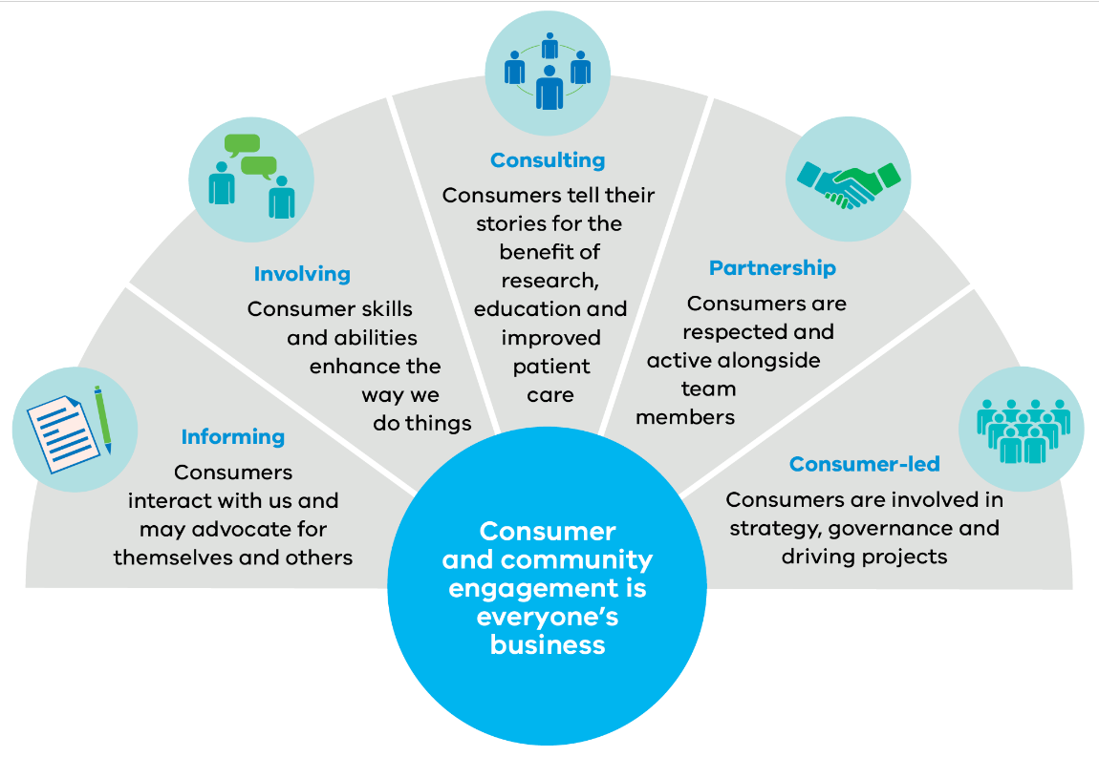

This table contains content from Figure 3 information graphic.
Category | Consumer and community engagement is everyone’s business
Informing | Consumers interact with us and may advocate for themselves and others
Involving | Consumer skills and abilities enhance the way we do things
Consulting | Consumers tell their stories for the beneﬁt of research, education and improved patient care
Partnership | Consumers are respected and active alongside team members
Consumer-led | Consumers are involved in strategy, governance and driving projects

Implementing the cancer plan
Implementing the cancer plan will be a collaborative effort. It will require continued and ongoing action from all partners and stakeholders across Victoria.
To support the rollout and tracking of the cancer plan we will:
- work with partners and stakeholders to develop an implementation plan every two years to monitor progress and to inform objectives and policy priorities
- report against the goals and targets of the Victorian cancer plan monitoring and evaluation framework every four years (Figure 5).
Figure 4: Timeline for implementing the cancer plan
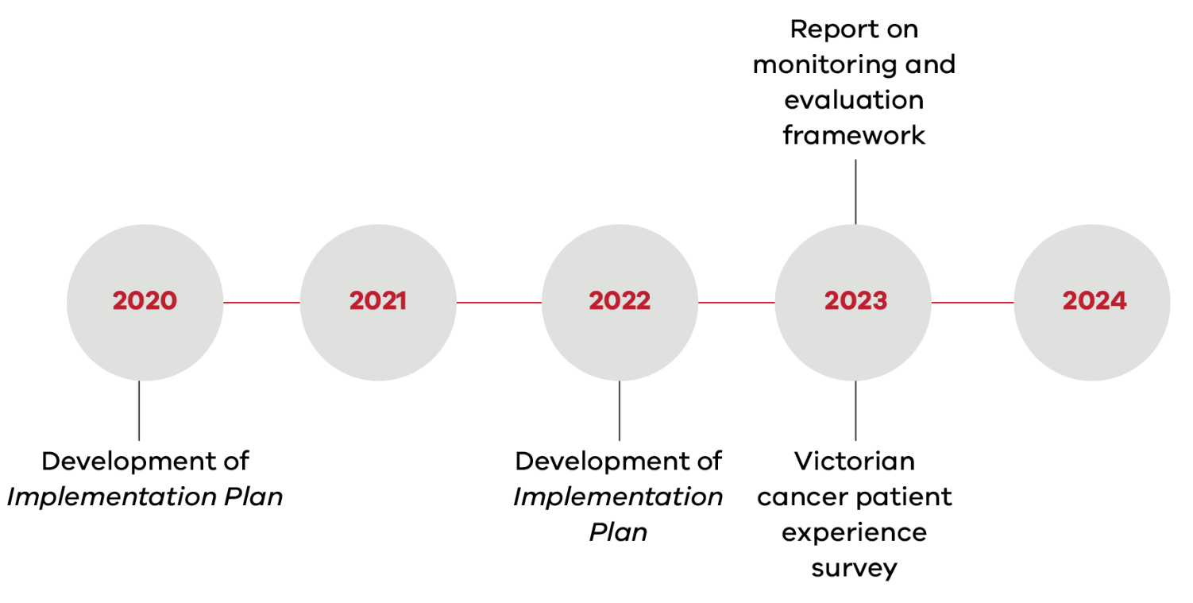
This table contains content from Figure 4.
Year | Development
2020 | Development of Implementation Plan
2021
2022 | Development of Implementation Plan
2023 | Report on monitoring and evaluation framework  Victorian cancer patient experience survey
2024

Appendix 1: Building on our achievements
A number of key achievements have been made under the priorities of the Victorian cancer plan 2016–2020. As of January 2020, these include the following.

Primary prevention
- Embedded reforms to Victoria’s Tobacco Act 1987 to ban smoking in outdoor dining areas and to regulate e-cigarettes and shisha tobacco.
- Awarded 1,084 grants worth over $10 million to provide shade and sun protection items to schools and community groups.
- Increased the reach of SunSmart programs to 90 per cent of early childhood services and primary schools and over 5,000 outdoor workers.
- Continued education for GPs in early detection and treatment for skin cancers.
- Ran the ‘UV. It All Adds Up’ campaign from 2015 to 2019 to maintain awareness of developing skin cancer through incidental UV exposure and to promote using sun protection when outdoors.
- Reduced the environment and workplace hazards associated with exposure to radiation through enforcing the ban on commercial tanning and implementing quality assurance processes for using radiation in the workplace.
- Increased the number of adults undertaking sufficient physical activity to meet national guidelines
- Reduced the number of adults who consume excess alcohol.
- Delivered the Healthy Eating Advisory Service (HEAS), which provided support services to more than 2,000 Victorian organisations to help them improve the supply and promotion of healthy foods and drinks.
- Prevented potential cancer-causing viral infections by increasing the number of people vaccinated against hepatitis B and HPV.
- Almost halved the number of young Victorian women (under 18 years) with high-grade cervical abnormalities (Better Health Channel 2020) since the introduction of the HPV vaccine for girls in 2007; exceeded the national benchmark for vaccination coverage at 79 per cent.
- Exceeded the national benchmark for young Victorian men who entered the vaccination program in 2013, with a vaccination coverage rate of 76 per cent.

Screening and early detection
- Increased participation across all three population cancer screening programs.
- Increased the number of Aboriginal women screened in the BreastScreen program by 10 per cent.
- Invested more than $2 million for state-of-the-art technology (tomosynthesis) in BreastScreen assessment services.
- Added 10,000 screens per year for both the breast and bowel screening programs.
- Implemented the cervical screening self-collection pathway for under-screened people.
- Implemented a new HPV primary screening test to the cervical screening program.
- Transitioned the Victorian Cervical Screening Register to the National Cancer Screening Register.
- Completed the expansion of the National Bowel Cancer Screening Program to all eligible people aged 50–74.
  - Developed HealthPathways online resources to help implement optimal care pathways in primary care and support earlier referral and diagnosis.

Treatment
- Implemented the optimal care pathways for lung, colorectal (bowel), prostate, pancreas, head and neck and oesophagogastric cancer across acute health services and primary care; monitored for variations in timeliness, consistency and quality of care.
- Expanded the symptom and urgent review clinic model to better manage patients receiving systemic anti-cancer therapy who experience symptoms related to their cancer or treatment.
- Developed the Victorian Therapeutics Advisory Group’s Chemotherapy audit toolkit to help monitor potentially inappropriate off-protocol prescribing.
- Helped employ radiation oncology medical physics registrars and radiotherapy educators to address workforce shortages.
- Expanded treatment options through the Victorian MRI-Linac and Gamma Knife services at Austin Health and the Peter MacCallum Cancer Centre, respectively.
- Redeveloped and expanded regional cancer centres in Barwon South West, Grampians, Loddon Mallee, Hume and Gippsland regions.
  - Established new radiotherapy shared care arrangements at Shepparton and continued to support existing service arrangements throughout Victoria.

Wellbeing and support
- Delivered the Victorian Cancer Survivorship Program grants scheme, funding 24 projects focused on survivorship capacity building, general cancer survivorship and primary and community health.
- Codesigned the WeCan.org.au resources in partnership with people affected by cancer to help people find the information, resources and support services they may need following a diagnosis of cancer and to support clinicians in delivering supportive care.
  - Supported projects focused on reducing cancer malnutrition prevalence from 31 per cent in 2012 to 15 per cent in 2018.

Research
- Co-funded competitive grants with Cancer Council Victoria to help people take part in cancer clinical trials.
- Supported 56 cancer researchers at different stages of their career across multiple disciplines, including clinician, biomedical and non-biomedical researchers with funded fellowships.
- Supported research projects addressing cancers with low survival rates and to improve cancer outcomes for Aboriginal Victorians.
- Committed funding towards the Victorian Comprehensive Cancer Centre alliance’s Strategic research plan 2017–20 to support research and collaboration in cancer, deliver cancer education and workforce development programs, and support clinical trials activity. This included establishing the Centre for Cancer Immunotherapy within the Victorian Comprehensive Cancer Centre to enable collaborative research in immune-based cancer therapies and developing the Master of Cancer Sciences to support education and training of the cancer workforce.
- Established the Centre of Research Excellence in Brain Cancer at the Olivia Newton-John Cancer Research Institute as part of the Australian Brain Cancer Mission to double the five-year survival rates by 2027.
- Ensured people with lived experience contribute towards the awarding of research grants through consumer evaluation panels.

Appendix 2: Policy context
Advance care planning: have the conversation – a strategy for Victorian health services 2014–2018
Delivering for diversity: Cultural diversity plan 2016–2019
Healthier lives, stronger economy: Victoria’s Health and Medical Research Strategy 2016–2020
Korin Korin Balit-Djak: Aboriginal health, wellbeing and safety strategic plan 2017–2027
Recognising and supporting Victoria’s carers: Victorian carer strategy 2018–22
Safe and strong: A Victorian gender equality strategy
Statewide design, service and infrastructure plan for Victoria’s health system 2017–2037
Victoria’s end-of-life and palliative care framework: a guide for high-quality end-of-life care for all Victorians
Victoria’s 10-year mental health plan
Victorian hepatitis B strategy 2016–2020
Victorian hepatitis C strategy 2016–2020
Victorian public health and wellbeing plan 2019–2023
Voluntary Assisted Dying Act 2017

Appendix 3: Consultations
The Department of Health and Human Services undertook public consultation to help develop the Victorian cancer plan 2020–2024. This included a series of guided workshops and online consultation via the Engage Victoria platform.
Between 7 October and 31 October 2019, face-to-face workshops were held in Warrnambool, Geelong, Mildura, Ballarat, Albury, Shepparton, Bendigo, Traralgon and Melbourne. Close to 300 people attended the workshops, representing:
- the cancer control sector
- the prevention and population health sectors
- researchers
- people affected by cancer
  - interested community members.
Between 7 October and 4 November 2019, 199 online survey responses were received through the Engage Victoria platform. In addition, 14 email submissions were received during the consultation period.
The department would like to acknowledge and thank the many people and organisations that took part in the consultation. All feedback received through the consultation process has been carefully considered in developing the Victorian cancer plan 2020–2024.

Glossary
Advance care directives – Voluntary person-led documents that focus on an individual’s values and preferences for future health and medical treatment decisions, preferred outcomes and care. Advance care directives are completed and signed by a competent person. They are recognised by the Medical Treatment Planning and Decisions Act 2016 (Vic). They can also appoint medical treatment decision-makers who can make decisions about health or personal care on the individual’s behalf. Advance care directives focus on the future health care of a person, not on the management of his or her assets. They come into effect when an individual loses decision-making capacity.
Advance care plans – Documents that capture an individual’s beliefs, values and preferences in relation to future health treatment decisions, but which do not meet the requirements for a statutory recognition due to a person’s diminished and total lack of decision-making capacity or lack of formalities (such as inadequate person identification, signature and date). An advance care plan or statement of choices for a non-competent person are often helpful in providing information for healthcare practitioners, and may guide medical treatment decisions but are not legally binding.
Advance care planning – A process of planning for future health and personal care whereby the person’s values, beliefs and preferences are made known to guide decision-making at a future time when that person cannot make or communicate their decisions.
Carer – Someone (usually a family member or friend) who provides care to a person (usually at home). The carer may or may not live with the person, and the carer may be aged or have their own health issues.
Clinical trial – Any research study that assigns human participants to one or more health-related treatments to evaluate the effects on health.
End-of-life care – The care delivered to people with progressive, incurable illness to live as well as possible until they die. It allows the supportive and palliative care needs of both the patient and their family to be identified and met using the palliative approach to care.
Equity – The absence of avoidable or remediable differences among groups of people, whether those groups are defined socially, economically, demographically or geographically. The World Health Organization acknowledges that health inequities therefore involve more than inequality with respect to health determinants, access to the resources needed to improve and maintain health or health outcomes. They also include a failure to avoid or overcome inequalities that infringe on fairness and human rights norms.
Health practitioner – A range of different health practitioners, both registered under the Health Practitioner Regulation National Law (for example, GPs, specialists, nurses, psychologists, physiotherapists, occupational therapists) and unregistered, including speech pathologists and social workers.
Human papilloma virus (HPV) – A viral risk factor for cervical cancer. Vaccines are available to prevent infection and help prevent cervical cancer.
Incidence – Number of cases or episodes in a defined population within a given time period.
Integrated Cancer Services (ICS) – Services that form the Victorian cancer improvement network. The role of this network is to:
- promote system integration across structural boundaries
- encourage collaborative approaches to evidence-based service development
  - encourage quality improvement at the local level to deliver better patient outcomes.
Multidisciplinary care – A team approach where health professionals work together to plan treatment and care for individual cancer patients.
Optimal care pathways (OCPs) – A clear description of the cancer care pathway, identifying the critical points along the pathway and optimal model of care required. They are intended to improve patient outcomes by enabling consistent care based on evidence and best practice across the state.
Palliative care – Care that improves the quality of life of patients and their families facing life-threatening or life-limiting illness. Palliative care prevents and relieves suffering through early identification and high-quality assessment and treatment of pain and other problems – physical, psychosocial and spiritual (World Health Organization 2019).
Patient-reported outcome measures (PROMs) – Measures that capture a person’s perception of their own health through questionnaires. PROMs enable patients to report on their quality of life, daily functioning, symptoms and other aspects of their health and wellbeing.
Person-centred care – Where the client is involved in all planning and decision making and care is aligned with their priorities.
Prevalence – Proportion of individuals in the population with a particular disease. In cancer, it refers to the number of cases of cancer that are present in a particular population at a given time.
Supportive care – Services used by patients to assist with needs beyond treatment. Supportive care includes self-help and support, information, psychological support, symptom control, social support, rehabilitation, spiritual support, palliative care and bereavement care.
Survival rate – The percentage of people still alive at a measured number of years after they have been diagnosed with cancer. The interval most commonly referred to in this cancer plan is a five-year survival rate.
Survivorship – A phase of care that follows primary treatment for cancer and involving:
- support for rehabilitation
- help to detect and prevent new or recurrent cancers
  - psychosocial and community-based support.
Translational research – A general term encompassing research that focuses on clinical outcomes and quality research principles. It is carried out by multi- and inter-disciplinary teams that explicitly address how knowledge created from the research will be used to drive advances in an area of patient clinical need.

References
ACSQHC 2016. PROMS literature review. [Online] Available at the Australian Commission on Safety and Quality in Health Care website, resource page: <https://www.safetyandquality.gov.au/publications-and-resources/resource-library/patient-reported-outcome-measures-literature-review> [Accessed 2 January 2020].
Afshar N, English DR, Blakely T, Thursfield V, Farrugia H, Giles GG, et al. 2020. Differences in cancer survival by area-level socio-economic disadvantage: a population-based study using cancer registry data. PLoS One, 15(1): e0228551
Australian Institute of Health and Welfare (AIHW) 2018. Smoking: About. [Online] Available a the AIHW website, Smoking page: <https://www.aihw.gov.au/reports-data/behaviours-risk-factors/smoking/about> [Accessed 6 January 2020].
Australian Institute of Health and Welfare (AIHW) 2019a. Cancer in Australia 2019, Canberra: AIHW.
Australian Institute of Health and Welfare (AIHW) 2019b. Cervical screening in Australia 2019. Cancer series no. 123 Cat. no. CAN 124, Canberra: AIHW.
Australian Institute of Health and Welfare (AIHW) 2019c. The health of Australia’s males. [Online] Available a the AIHW website, The health of Australia’s males page: <https://www.aihw.gov.au/reports/men-women/male-health> [Accessed 2 January 2020].
Australian Institute of Health and Welfare (AIHW) 2020. National cancer screening programs participation data. [Online] Available at the AIHW website National cancer screening programs participation data page: <https://www.aihw.gov.au/reports/cancer-screening/national-cancer-screening-programs-participation/data> [Accessed 11 January 2020].
Australian Men’s Health Forum 2019. Men’s health report card 2019. [Online] Available at the Australian Men’s Health Forum website, resource page: <https://www.amhf.org.au/report_card> [Accessed 2 January 2020].
Bell S, Yates L 2015. Women in the science research workforce: identifying and sustaining the diversity advantage, Melbourne: L.H. Martin Institute, The University of Melbourne.
Better Health Channel 2020. Human papillomavirus (HPV) – immunisation. [Online] Available at the Better Health Channel website, Human papillomavirus (HPV) – immunization page: <https://www.betterhealth.vic.gov.au/health/HealthyLiving/human-papillomavirus-hpv-immunisation> [Accessed 3 January 2020].
Cancer Australia and Cancer Voices Australia 2011. National framework for consumer involvement in cancer control, Canberra, ACT: Cancer Australia.
Cancer Australia, Cancer Council Australia 2018. Optimal care pathway for Aboriginal and Torres Strait Islander people with cancer. [Online] Available at The Cancer Council website, Optimal cancer care pathways page: <https://www.cancer.org.au/health-professionals/optimal-cancer-care-pathways> [Accessed 12 February 2020].
Cancer Australia 2015. Cancer Research in Australia: an overview of funding initiatives to support cancer research capacity in Australia 2006 to 2011, Surry Hills, NSW: Cancer Australia.
Cancer Australia 2016. Cancer Research in Australia 2016 to 2018 – Opportunities for strategic research investment – highlights, Surry Hills, NSW: Cancer Australia.
Cancer Australia 2020. Cancer care in the time of COVID-19: A conceptual framework for the management of cancer during a pandemic. [Online] Available at the Cancer Australia website, Cancer Australia Publications page: <https://canceraustralia.gov.au/publications-and-resources/cancer-australia-publications/cancer-care-time-covid-19-conceptual-framework-management-cancer-during-pandemic> [Accessed 31 May 2020]
Cancer Council Victoria 2020a. Hepatitis and liver cancer. [Online] Available at the CCV website, Hepatitis and liver cancer page: <https://www.cancervic.org.au/for-health-professionals/community-health-professionals/hepatitis-b-and-liver-cancer> [Accessed 10 January 2020].
Cancer Council Victoria 2020b. What is HPV? [Online] Available at the HPV Vaccine website, What is HPV page: <http://www.hpvvaccine.org.au/parents/parents-what-is-hpv.aspx?link=home> [Accessed 3 January 2020].
Chynoweth J, McCambridge MM, Zorbas HM, Elston JK, Thomas RJS, Glasson WJH, et al. 2020. Optimal cancer care for Aboriginal and Torres Strait Islander people: a shared approach to system level change. JCO Global Oncology, 6: 108–114.
Cormie P 2018. Clinical Oncology Society of Australia position statement on exercise in cancer care. Medical Journal of Australia, 209(4): 184–187.
Coughlan A 2019. Victorian cancer survivorship program II evaluation report. [Online] Available at the Peter MacCallum Cancer Centre website, Victorian Cancer Survivorship Program page: <https://www.petermac.org/services/support-services/cancersurvivorship/health-professionals/victorian-cancer-survivorship> [Accessed 19 February 2020].
Department of Health and Human Services 2016a. Better, safer care: delivering a world-leading healthcare system. [Online] Available at the Health.vic website, Review of hospital safety and quality assurance in Victoria page: <https://www2.health.vic.gov.au/hospitals-and-health-services/quality-safety-service/hospital-safety-and-quality-review> [Accessed 4 June 2020].
Department of Health and Human Services 2016b. Victorian hepatitis B strategy 2016–2020, Melbourne: Victorian Government.
Department of Health and Human Services 2016c. Victorian hepatitis C strategy 2016–2020, Melbourne: Victorian Government.
Department of Health and Human Services 2017a. Korin Korin Balit-Djak Aboriginal health, wellbeing and safety strategic plan 2017–2027, Melbourne: Victorian Government.
Department of Health and Human Services 2017b. Victorian Population Health Survey 2017. [Online]
Available at the Health.vic website, Victorian Population Health Survey 2017 page: <https://www2.health.vic.gov.au/public-health/population-health-systems/health-status-of-victorians/survey-data-and-reports/victorian-population-health-survey/victorian-population-health-survey-2017> [Accessed 3 January 2020].
Department of Health and Human Services 2017c. Statewide design, service and infrastructure plan. [Online] Available at the Health.vic website, Statewide Design, Service and Infrastructure Plan page: <https://www2.health.vic.gov.au/hospitals-and-health-services/health-system-design-planning/statewide-plan> [Accessed 27 February 2020].
Department of Health and Human Services 2019. Aboriginal and Torres Strait Islander cultural safety framework. [Online] Available at the Department’s website, Aboriginal and Torres Strait Islander cultural safety framework page: <https://www.dhhs.vic.gov.au/publications/aboriginal-and-torres-strait-islander-cultural-safety-framework> [Accessed 24 May 2020].
Department of Health and Human Services 2020a. Victorian cancer plan monitoring and evaluation framework: baseline report. [Online] Available at the Health.vic website, Victorian cancer plan monitoring and evaluation framework page: <https://www2.health.vic.gov.au/about/health-strategies/cancer-care/victorian-cancer-plan-monitoring-and-evaluation> [Accessed 26 February 2020].
Department of Health and Human Services 2020b. Home-based cancer care: framework and toolkit. [Online] Available at Health.vic website, Home Based Cancer Care page: <https://www2.health.vic.gov.au/about/health-strategies/cancer-care/home-based-cancer-care> [Accessed 30 May 2020].
Department of Health 2014. Advance care planning: have the conversation: a strategy for Victorian health services 2014–2018, Melbourne: State of Victoria.
Department of Premier and Cabinet 2016. Safe and strong: a Victorian gender equality strategy. [Online] Available at the Victorian Government website, Safe and strong: A Victorian Gender Equality Strategy page: <https://www.vic.gov.au/safe-and-strong-victorian-gender-equality> [Accessed 3 February 2020].
Green M, Cunningham J, O’Connell D, Garvey G 2017. Improving outcomes for Aboriginal and Torres Strait Islander people with cancer requires a systematic approach to understanding patients’ experiences of care. Australian Health Review, 41(2): 231–233.
Haines IE 2011. Managing patients with advanced cancer: the benefits of early referral for palliative care. Medical Journal of Australia, 194(3): 107–108.
Lisy K, Peters MD, Schofield P, Jefford M 2018. Experiences and unmet needs of lesbian, gay, and bisexual people with cancer care: a systematic review and meta-synthesis. Psychooncology, 27(6): 1480–1489.
Shih S, Mellerick A, Akers G, Whitfield K, Moodie M 2020. Economic assessment of a new model of care to support patients with cancer experiencing cancer- and treatment-related toxicities. American Society of Clinical Oncology. [Online] Available at the JCO Oncology Practice website, Economic Assessment of a New Model of Care to Support Patients With Cancer Experiencing Cancer- and Treatment-Related Toxicities page: <https://ascopubs.org/doi/full/10.1200/JOP.19.00702> [Accessed 4 June 2020].
te Marvelde L, McNair P, Whitfield K, Autier P, Boyle P, Sullivan R, et al. 2019. Alignment with indices of a care pathway is associated with improved survival an observational population-based study in colon cancer patients. EClinicalMedicine, 15: 42–50.
The Kirby Institute 2019. Monitoring hepatitis C treatment uptake in Australia, Sydney: The Kirby Institute, UNSW.
Vardy JL, Chan RJ, Koczwara B, Lisy K, Cohn RJ, Joske D, et al. 2019. Clinical Oncology Society of Australia position statement on cancer survivorship care. Australian Journal of General Practice, 48(12): 833–836.
Victorian Cancer Registry 2019. Cancer in Victoria: statistics & trends 2018, Melbourne: Cancer Council Victoria.
Victorian Government 2016. Targeting zero: report of the review of hospital safety and quality assurance in Victoria. [Online] Available at Health.vic website, Review of hospital safety and quality assurance in Victoria page: <https://www2.health.vic.gov.au/hospitals-and-health-services/quality-safety-service/hospital-safety-and-quality-review> [Accessed 4 June 2020].
Weber J, Marshall K, Reed M, Whitfield K 2018. Investigating practices relating to supportive care screening in Victorian cancer services: full technical report, Melbourne: Department of Health and Human Services, State Government of Victoria.
WHO Collaborating Centre for Viral Hepatitis, The Peter Doherty Institute & ASHM 2019. Viral Hepatitis Mapping Project: National Report 2017, Darlinghurst NSW: Australasian Society for HIV, Viral Hepatitis and Sexual Health Medicine.
World Health Organization 2019. [Online] Available at the WHO website, Cancer, WHO Definition of Palliative Care page: <https://www.who.int/cancer/palliative/definition/en/> [Accessed 14 October 2019].

