

|  |
| --- |
| HealthLinks Chronic Care evaluation  Summary of implementation and outcomes for 2016–17 |
|  |

|  |
| --- |
|  |
| To receive this publication in an accessible format phone (03) 9096 2769 using the National Relay Service 13 36 77 if required, or [email Integrated Chronic Care](mailto:integratedchroniccare@dhhs.vic.gov.au) <integratedchroniccare@dhhs.vic.gov.au>.  Authorised and published by the Victorian Government, 1 Treasury Place, Melbourne.  © State of Victoria, Department of Health and Human Services, March 2019.  ISBN 978-1-76069-866-9 (pdf/online/MS word)  Available from [health.vic HealthLinks: Chronic Care](https://www2.health.vic.gov.au/hospitals-and-health-services/patient-care/healthlinks) < https://www2.health.vic.gov.au/primary-and-community-health/integrated-care/healthlinks> |
|  |

Contents

Executive summary 1

1. Introduction and context 4

1.1 Environmental context 4

1.2 HealthLinks background 5

1.3 Communities of Practice 6

2. HealthLinks: chronic care model 8

2.1 The model 8

2.2 Funding arrangements 8

2.3 Target patient cohorts 9

2.4 Interventions adopted under HealthLinks 9

3. Evaluation findings 14

3.1 Methodology 14

3.2 Summary of quantitative findings 18

3.3 Summary of qualitative findings 28

4. Conclusion 36

Appendix 1: Parameters of the HealthLinks episode scoring algorithm 37

Appendix 2: Parameters defining HealthLinks ineligibility (exclusions) 39

Appendix 3: Other ambulatory services 41

# Executive summary

In 2016 the Department of Health and Human Services (the department) began the HealthLinks Chronic Care (HealthLinks) trial to determine whether more flexible funding arrangements would incentivise health services to deliver a more integrated and innovative mix of service for people with chronic and complex health conditions. HealthLinks’ primary aim is to reduce unplanned hospital admissions.

The Commonwealth Scientific and Industrial Research Organisation (CSIRO) entered into a partnership with the department to evaluate the HealthLinks trial. The evaluation is being conducted as a prospective study and includes quantitative and qualitative analysis to determine:

* the impact of flexible funding on hospital utilisation
* the health outcomes and experience of patients
  + the experience of the workforce.

This is the first annual report summarising the impacts of HealthLinks. It draws on the findings and results of 2016–17, being the first year of the trial, as reported by CSIRO.[1] It also includes additional background and contextual information on HealthLinks provided by the department.

The summary report seeks to analyse data collected for three control health services – Austin Health, Melbourne Health and St Vincent’s Hospital – and the four participating (flexibly funded) health services – Barwon Health, Monash Health, Northern Health and Western Health. Of the participating services, only Northern Health participated for the full 12 months. Monash Health and Western Health began in November 2016, participating for seven months. Barwon Health started in March 2017, participating for three months. The staggered health service commencement dates, coupled with the limited number of patients enrolled in HealthLinks and HealthLinks interventions at the time of the writing, has had a significant impact on the results and analysis contained in this report. It is difficult to draw significant conclusions from the quantitative analysis at this stage, particularly in terms of patient outcomes and hospital utilisation. Furthermore, the report does not include information about the experience of patients because this is being collected through a patient survey that began in 2018. Initial results from this component of the evaluation will be provided once six-month follow-up surveys are received.

This report provides a summary of the various interventions that have been adopted by the participating health services. The intervention models are quite different and include: redesigning existing services; implementing new interventions such as care coordination services delivered through third-party service providers; using remote patient monitoring technologies to manage patients in their own homes; and establishing an alternative workforce that can provide navigation and early support for patients who are deteriorating.

The report also includes an overview of the HealthLinks patient characteristics including the number of enrolled patients across different age brackets, the diversity of enrolled patients in terms of their preferred language, the main reasons for admission to hospital and the socioeconomic status of enrolled patients.

To understand the impact of the interventions on patient outcomes, two key outcome measures were examined:

* readmission to hospital and re-presentation to an emergency department within 30 days
  + patient length of stay in emergency and as an inpatient.

These two key outcome measures were further examined to assess for any differences by health service participation status (flexible funding vs control sites) and patient intervention status (intervention vs usual care).

At this early stage, there are very few significant differences in the health service outcome measures between flexibly funded health services and controls or between intervention patients and usual care patients. The analysis is provided to illustrate the measures being examined and to provide a baseline against which results can be compared over time. It is expected that as more evidence is collected, it will be possible to gain a greater understanding of the impact of interventions.

It is expected that comparisons between each flexibly funded health service will be included in future evaluation results. This analysis has not been included in this report due to the paucity of evidence for those services that did not participate for a full year. Comparing the data across sites will provide further insight into the effectiveness of different types of interventions.

A series of interviews and focus groups were held with staff at three health services that were delivering HealthLinks interventions (Northern Health, Monash Health and Barwon Health). This qualitative component of the study provided nurses, medical specialists and other clinicians involved in patient care (healthcare providers) as well as executive, program and clinical team managers (healthcare managers) an opportunity to reflect on their perceptions of the critical factors for successfully implementing HealthLinks interventions and the impact of HealthLinks on patient care.

Interviews with the managers and staff engaged in delivering HealthLinks identified a number of early observations about the models and the process of implementation. Initial feedback suggests that the HealthLinks model, and the potential for health services to use their funding more flexibly, has enabled a more holistic approach to patients’ needs and provides staff with the opportunity to engage with patients who might otherwise not be receptive to receiving support. Feedback also suggests that the program provides the opportunities for integrated and coordinated service delivery (which is particularly important for patients who are engaged across multiple services), and that models of care delivered as part of the program have contributed to patient empowerment and their capacity to self-manage their chronic condition(s) at home.

Initial insights from staff on the key factors that need to be considered with the HealthLinks model are summarised below. Experiences at different health services meant that, for some, a key factor represented an enabler, whereas for others it posed a challenge:

| Key factor | Summary description |
| --- | --- |
| Executive support and leadership | Health service executive support and leadership from the department is essential when implementing alternative arrangements. |
| Funding arrangements | More flexible funding arrangements provide health services with the freedom and ability to better address the behavioural and social determinants of health of those living with chronic conditions.  Concerns over remaining within the agreed funding or local budget affects the commitment to support implementation. |
| Planning, systematic approaches and evaluation | Careful planning and a systematic approach, along with ongoing evaluation throughout program rollout, enables program refinement and therefore potentially greater success.  The initiative has also been a mechanism for health services to review current practice and assess new processes to build efficiencies and effectiveness in their patient management. |
| Clear communication | A clear communication strategy for implementation builds understanding of the program at an early stage and ensures services involved in patient care communicate and interact cohesively. |
| Workforce capability and skill | Building workforce capability, skill and understanding of the new model supports the delivery of alternative services and helps to manage staff resistance to change. |
| Collaborative relationships | Building collaborative relationships across and within sectors is time consuming but important, particularly for improved engagement with general practitioners and the wider Primary Health Networks. |
| Information technology | Information technology systems that underpin patient identification, risk stratification and support patient management are essential. |
| Patient identification | Correctly identifying HealthLinks patients, especially at the early stage of the HealthLinks program, can be a challenge. |
| Understanding patients’ needs | Considerable diversity in the needs of HealthLinks patients, determining support services they would benefit from, and how to engage with different patients is a challenge. |
| Financial risk arrangements | Shared financial risk arrangements can impede executive support for investing in new models of care. |
| Longer term view | Prospective evaluation is important because feedback during implementation can help raise staff confidence, given the potential benefits are not necessarily realised in the short term. |
| Managing change | There is a need to manage resistance to change in delivering alternative models of care in different settings. |

Integrating HealthLinks into existing practice is still at an early stage, and the potential benefits may not be easily demonstrated over a short term. By drawing further on workforce perspectives over time it is expected that subsequent reports will include further insights into changes resulting from HealthLinks and provide richer information for other health services to draw on, and learn from, as HealthLinks expands.

Three Communities of Practice were established to co-design the HealthLinks trial: Clinical Collaborative Group; HealthLinks Data and Analysis; and Operations. Each played a critical role in shaping the design and implementation of HealthLinks in the lead-up to, and first year of, the trial.

The Communities of Practice maintained a strong commitment to working together during the trial. Key achievements of the Communities of Practice were: refining the case-finding algorithm; understanding the patient cohort and the models of care that better suited their needs; and establishing cooperative environments for sharing knowledge and experiences. Much valuable experience and knowledge has been co-created through the Communities of Practice. It is vital that the same commitment and spirit of cooperation is sustained as the trial continues to fully realise the potential of the flexible funding model.

# Introduction and context

In 2016 the Department of Health and Human Services (the department) began implementing the HealthLinks Chronic Care (HealthLinks) trial as part of its approach to public hospital funding reform and its objective of delivering person-centred and integrated care.

In the same year the department entered into a partnership with the Commonwealth Scientific and Industrial Research Organisation (CSIRO) to assess the impacts of HealthLinks at the system level and to determine whether more flexible funding arrangements enable health services to deliver more effective and patient-centred care at no additional cost to the system.

This report, the first of three planned annual reports, provides an overview of the findings from the first 12 months of the trial (2016–17). It combines CSIRO’s evaluation findings to date with additional background and contextual information provided by the department. With limited quantitative data available for the first year, the report: outlines the intervention models adopted; profiles the characteristics of enrolled patients; and, where possible, draws initial findings from the available data about the impacts on hospital utilisation, providing a baseline for future comparison.

The report also reflects on the perspectives of health service staff who are involved in HealthLinks and distils key early learnings from implementation. It aims to provide a potential guide to other health services in terms of early successes and learnings from implementation.

## 1.1 Environmental context

Close to half of the Australian population have a chronic disease and 20 per cent have at least two comorbidities.[2] Research also shows that a relatively small subset of total patients admitted to hospitals account for a large proportion of readmissions and consume a significant number of hospital resources, both in terms of bed days and costs over a 12-month period. Similar trends are seen in Victoria and confirm that these patients have chronic and complex healthcare needs. In Victoria, around 15 per cent of patients admitted to hospital are reported as having more than two chronic conditions (based on the 2009 Victorian Admitted Episode Data (VAED) collection).

It is generally well accepted that integrated community-based care and active management can result in better outcomes for people living with chronic conditions and may help reduce their need for inpatient care. Many people with complex and chronic diseases require long-term, proactive and systemic care approaches; however, current models of care and funding systems are still largely designed to be responsive to episodic care for issues such as infectious disease and trauma. Furthermore, the overlapping role and responsibility of ambulatory and inpatient care services, separate funding streams and models of care, as well as activity-based funding for acute care, can create barriers to integrated care.

HealthLinks has been designed as a first step in removing the funding barriers to delivering more integrated alternative models of care for patients with complex chronic care needs.

## 1.2 HealthLinks background

HealthLinks seeks to deliver a more integrated and innovative mix of services for people with chronic and complex health conditions that can reduce unplanned hospital admissions.

The HealthLinks trial encourages and enables participating health services to develop innovative models of integrated care that are supported by an alternative funding model. This funding model provides health services with greater flexibility in how they use existing activity-based funding for patients with a range of chronic and complex health conditions.

Nine metropolitan health services and Barwon Health were invited to participate in HealthLinks through an expression of interest process. Four health services began active participation in 2016–17 and have implemented unique models of care that range from redesigning existing services to implementing new interventions. The design of these models of care have been informed by each health service’s operating model, their propensity to adopt alternative arrangements and local patient characteristics.

The HealthLinks evaluation aims to determine if flexible funding enables health services to develop and implement alternative models (to inpatient acute care) that provide better experiences and outcomes for patients with chronic conditions, at equal or lower cost.

It was agreed that the following measures would be used to evaluate the impact of the trial:

* length of stay (LOS) in an emergency department and/or in acute inpatient care for patients enrolled in HealthLinks and those enrolees who receive the HealthLinks intervention model of care
* inpatient readmission or emergency department re-presentation within 30 days of discharge from hospital
* patient experience of care for enrolled and intervention patients
* consumption of (state-funded) healthcare resources by enrolled and intervention patients
* cost of services delivered by flexibly funded services to enrolled and intervention patients
  + experience of the workforce involved in delivering alternative models of care.

The evaluation involves a mixed-methods design (quantitative and qualitative) based on a range of measures collected to determine the impact of the trial. A comprehensive analysis of routinely collected hospital data, questionnaires and semi-structured interview methods were agreed as the core components of the evaluation. Factors such as the type of intervention, specialties involved and hospital/community healthcare context were also taken into consideration to adapt the evaluation framework to specific local settings.

The evaluation is being conducted over a three-year period, with CSIRO developing annual reports on findings and outcomes as the HealthLinks trial rolls out. This report seeks to provide a summary of the information that CSIRO has collected and presented from the first year (2016–17) of the HealthLinks trial. The department has included additional information that provides the background and context of HealthLinks, which was not part of CSIRO’s detailed report.

Due to the staggered commencement dates for health services participating in HealthLinks it is difficult to draw significant conclusions from the limited quantitative data available at this early stage, particularly in terms of patient outcomes and hospital utilisation. Information about the experience of patients is being collected through a patient survey that began in 2018 and is therefore not included in this report. Initial results from this component of the evaluation will be provided once six-month follow-up surveys are received.

## 1.3 Communities of Practice[3]

Three Communities of Practice were established to co-design the HealthLinks trial:

* Clinical Collaborative Group – comprised clinical leads (evaluation site principal investigators), project managers and HealthLinks staff from each of the 10 HealthLinks health services. The group focused on the details of the HealthLinks design and implementation, including intervention strategies. The group also guided the evaluation.
* HealthLinks Data and Analysis – membership comprised health service analysts. The group focused on data items and departmental reports that health services required to administer HealthLinks and replicate the HealthLinks patient selection algorithm across the range of analytic software and feeder systems.
* Operations – membership was predominantly project and operational managers. The group focused on the mechanics of executing the trial at the health service level.

The Communities of Practice have been critical in shaping the design and implementation of HealthLinks in the lead-up to, and first year of, the trial. They offered a forum for the department and health services to work collaboratively in developing the model as well as to share implementation experiences. A departmental secretariat supported the communities, and CSIRO were invitees to the Communities of Practice meetings.

Key achievements for the Communities of Practice included the following:

* + Refining the case-finding algorithm – The lag in departmental data meant patients had often been discharged from hospital by the time they were identified as enrolled. Furthermore, medical record reviews at individual hospitals indicated that patients at high risk of multiple unplanned admissions were often admitted a number of times in very short succession.

The department and the Data and Analysis Community of Practice worked collaboratively on the highly complex task of designing a version of the algorithm that could be replicated by health services using the hospital’s own dataset. The new algorithm enabled health services to better identify patients using their own patient information systems. The new algorithm was issued at the beginning of 2017.

The new algorithm development period posed a number of challenges, particularly for those health services that had begun implementation in 2016; however, enabling health services to operationalise the algorithm at the local level, and to intervene earlier, was enormously valuable and a major implementation achievement for the trial.

* Understanding the patient cohort and developing models of care – Early expectations of which types of patients would become enrolled in HealthLinks centred around frail elderly people. Early analysis showed that while frail elderly people, typically over the age of 75 years, did feature in the patients who became enrolled in HealthLinks, the range of patient types was broader and included:
  + - patients with a single chronic disease, complicated by anxiety
    - patients who experience a major health event (for example, a heart attack) and have a range of social issues and some unhealthy lifestyle factors
      * people diagnosed with alcohol and drug and mental health issues (dual diagnosis).

The differences in the characteristics of patients who became enrolled necessitated rethinking some aspects of the HealthLinks intervention models of care and the breadth of services required to best address the needs of enrolled patients, particularly the importance of social support services.

* + The Operations Community of Practice provided a supportive environment for information sharing and the exchange of practical strategies on implementing new and quite different models of care for different patient cohorts.

Despite the challenges of taking on the complex and difficult task of trialling a new funding model and service models, the Communities of Practice maintained a strong commitment to working together and implementing the trial. The Communities of Practice havealsofacilitated numerous site visits between HealthLinks sites and a broader range of stakeholders interested in integrated care for patients with complex and chronic healthcare needs.

Much valuable experience and knowledge has been co-created through the Communities of Practice. It is vital that the same commitment and spirit of cooperation is sustained as the trial continues to fully realise the potential of the flexible funding model.

# HealthLinks: chronic care model

## 2.1 The model3

HealthLinks enables health services to use funding for a specific cohort of patients (in this case, those with chronic and complex health needs) to more flexibly deliver a different suite of services to better meet their needs.

It is intended that the funding will enable health services to deliver a broader range of patient-centred services within hospital but also in different settings including in their homes and in the community to prevent people (where possible) from deteriorating and requiring hospital services. Hospital services are still available when patients need them, and subsequently the model aims to use these services in a planned way, supporting better management of the patient’s health needs outside of hospital. Figure 1 shows the simple but effective dynamics of the HealthLinks model.

Figure 1: The HealthLinks model

This figure shows that the HealthLinks model focuses on keeping people outside of the hospital setting (via flexible funding) while still offering hospital care when it is needed.

## 2.2 Funding arrangements3

HealthLinks funding arrangements provide the flexibility for health services to deliver an alternative suite of services that may, over time, reduce hospital activity while not impacting on the financial stability of health services.

The model seeks to overcome the limitations that are inherent in activity-based funding models, which have focused on throughput and effectively dis-incentivise health services from implementing more integrated models of care that are likely to reduce overall activity, and therefore hospital revenue.

Under the HealthLinks funding arrangements, health services are able to convert a specific portion of the acute inpatient funding (weighted inlier equivalent separation, WIES) to a capitated grant that can be used more flexibly to deliver alternative services to patients. These services would otherwise be unlikely to attract activity-based revenue.

The size of the capitation grant depends on the number of patients who are identified as ‘enrolled’ in HealthLinks. Enrolment is determined by individual patient characteristics and hospital utilisation, as recorded in Victorian hospital datasets.

The amount converted directly relates to the number of patients enrolled at a specific health service. For each ‘average’ patient enrolled as a HealthLinks patient, an amount of funding is converted to the capitation grant. The funding to be converted to capitation is derived from modelled data that quantifies the amount of funding these patients typically use before any interventions have been implemented.

In 2016–17, across the four flexibly funded health services, just over $40 million was converted from acute inpatient funding to HealthLinks capitation grants.

Health services can use the HealthLinks capitation grant to fund any alternative interventions for the enrolled cohort. However, health services must also ensure that the HealthLinks grant can continue to cover the costs of acute inpatient activity for enrolled patients in the event that they do return to hospital.

## 2.3 Target patient cohorts3

The patients that are the target of HealthLinks are those with a range of chronic and complex health conditions and at risk of three or more unplanned hospital admissions.

HealthLinks patients are identified and become enrolled because of their specific characteristics and previous hospital use. They are identified as ‘enrolled’ by an algorithm that is applied to linked Department of Health and Human Services datasets: the VAED and the Victorian Emergency Minimum Dataset (VEMD).

The algorithm ‘flags’ patients who are ‘enrolled’. Health services have also embedded the algorithm into their local business intelligence systems to identify HealthLinks enrolled patients in their own local data, as close as possible to ‘real time’.

A patient becomes ‘enrolled’ in HealthLinks upon an ‘eligible[4] unplanned medical episode’[5] (Appendix 1), as long as the patient has not had an episode in the past 365 days meeting exclusion criteria (Appendix 2) and the current eligible unplanned medical episode achieves a total score of 11 or more.

Patients who become enrolled typically have a range of chronic conditions and have been admitted to hospital at least once over the preceding six-month period. There is more information included in the findings section of this report that shows the composition of the patients who enrolled in HealthLinks in 2016–17.

## 2.4 Interventions adopted under HealthLinks

Participating health services have the flexibility to implement models of care that align with their health service operating model, the local patient characteristics and their organisation’s current propensity to adopt alternative arrangements. In the first year of the trial, the flexibly funded health services have adopted quite different approaches to implementing HealthLinks. These are summarised below, in order of commencement.

### 2.4.1 Northern Health – streamlining access to existing services

Northern Health began participating in HealthLinks on 1 July 2016 and was the first health service to join the program.

In its first year, Northern Health focused on identifying eligible patients, redesigning existing services within the Health Independence Program (HIP) and introduced the Medibank CarePoint program with a subset of the enrolled patients.

Northern Health focused on improving its existing processes and ensuring that HealthLinks patients were being streamed into available services, as opposed to creating new services. All patients who became enrolled in HealthLinks received a comprehensive discharge plan and the Discharge Planning Support Service followed up with patients by telephone 48 hours following discharge. Actions that typically followed included:

* ensuring that the patient had an appointment with their general practitioner (GP) and that the patient was able to attend
* checking the patient’s Northern Health follow-up appointments had been booked and that the patient was able to attend
* assessing current symptomatology and coping at home
* assessing whether the patient needed further follow-up contact with the hospital
  + escalating the patient to a further medical review if required.

Northern Health also introduced a screening process for HealthLinks enrolled patients. The LACE Index Scoring Tool for Risk Assessment of Hospital Readmission (LOS, acuity of admission, comorbidities, emergency department visits) was used to identify patients who were ‘at risk’, and these patients underwent an initial needs identification.

Patients who, as a result of their initial needs identification, were likely to benefit from disease-specific education or case management were referred to the HIP, and the HealthLinks patients were prioritised for the HIP program. Patients who were streamed into HIP included those with heart failure, chronic obstructive pulmonary disease (COPD), diabetes and those with frailty or complex social situations. Participation of HealthLinks enrolees in HIP services was expected to increase as a consequence of this prioritisation.

Northern Health also began a small trial with HealthLinks enrolled patients who lived in a particular geographic area to trial the Medibank CarePoint care coordination program. Northern Health brokered the CarePoint package for 50 patients in the Hume region, with a further 40 HealthLinks enrolled patients being provided with CarePoint packages funded by Medibank Private and the Eastern Melbourne Primary Health Network.

The CarePoint program provides care-coordination services to patients to streamline access to primary and secondary services as well as coordinating social support services. The CarePoint team works closely with the patient’s GP to help patients access the right support and resources they need. The package includes care coordination, care navigation, hospital liaison, 24/7 nurse triage, health coaching, home nursing and community care.

Northern Health allocated one full-time role to help introduce the HealthLinks program, which was split between a program manager (0.8 EFT) and a geriatrician (0.2 EFT). There are a further three CarePoint coordinators employed by Medibank Private to deliver the CarePoint program to HealthLinks enrolled patients at Northern Health.

Many Northern Health clinical and managerial staff members provided in-kind support to implement the program.

Northern Health also created its own‘HealthLinks Brainstrust’. This consisted of staff from across the organisation where HealthLinks patients may be receiving care. The purpose of the brains trust was to review selected HealthLinks enrolees with aims of: ensuring appropriate referrals were made; identifying common themes to presentation and clustering cases; and identifying gaps in standard care and service provision.

### 2.4.2 Western Health – a partnership approach with Silver Chain

Western Health began its active participation in HealthLinks in November 2016.

Western Health has a different model from the other flexibly funded services in that the health service has collaborated with a third-party not-for-profit community service provider that operates in a number of Australian jurisdictions: the Silver Chain Group.

All HealthLinks enrolled patients are identified internally and offered an opportunity to receive an additional care service that is delivered by Silver Chain. Patients have the choice to receive this intervention. If the patient declines the intervention they continue to receive usual care by the health service even though they remain enrolled as a HealthLinks enrolee.

Following an admission and enrolment as a HealthLinks patient, Western Health and Silver Chain assess the patient’s care needs using a risk screening tool developed by Western Health. This is a series of nine additional questions that elicit additional information on their condition and psychosocial situation. Depending on the response to these questions, the patient will be risk stratified into either a high, medium or low-risk care group. The interventions differ depending on the level of risk, with the features of the different responses as follows.

#### High care intervention

Patients are called within 24 hours following discharge from hospital, and a home visit is arranged with a Silver Chain care navigator within seven days of discharge. The Silver Chain navigator will also ensure the scheduled post-discharge supportive services are received in addition to referring to other services as per needs assessments. All patients are either reconnected to their GP within 14 days of discharge or supported to find a suitable GP to establish a supportive relationship. Following the reconnection or new connection, the Silver Chain navigator supports the patient with weekly visits to their GP while patients continue to be seen in their home by a Silver Chain navigator. All high-risk intervention group patients have their risk stratification reviewed at each home visit or whenever they return to hospital or seek support through the telephone service. Any high or medium patient who readmits is automatically re-risk stratified into the high-risk care intervention group until a home visit occurs, enabling further assessment of their risk level.

#### Medium care intervention

The medium-risk intervention group is provided with an initial phone call within 48 hours of discharge. Each patient receives a number of home visits to determine their specific needs and establish a chronic disease management plan, and each month the patient receives a fortnightly home visit and fortnightly phone support. As with the high-risk group, the medium-risk intervention group patients have their risk stratification reviewed at each home visit or whenever they return to hospital or seek support through the telephone service. Any medium-risk patient who readmits is automatically re-risk stratified into the high-risk care intervention group until a home visit occurs, enabling further assessment of their risk level.

#### Low care intervention

Following an initial phone call within 48 hours of discharge, the low-risk intervention group receive two home visits to determine their needs and to complete a chronic disease management plan. With this in place, the patient is instructed and educated to call the 24/7 phone support number to seek support from either the Silver Chain navigator or to enact a Priority Response and Assessment (PRA) episode should they need to. Low-risk intervention group patients can have their risk re-stratified following a call to the 24/7 support number in addition to any calls that result in triggering a PRA episode. Any low-risk intervention group patients who readmit to Western Health are automatically risk stratified in the high-risk group and reassessed following a home visit as above.

#### Activation into the Silver Chain service

All patients who become ‘activated’ into the Silver Chain service receive a care plan, which is developed with the support of a multidisciplinary team, in addition to having a comprehensive pharmacy review including the pharmacy reconciliation process. The care plan is communicated to the patient’s GP, Silver Chain and Western Health’s community partners.

All patients are also allocated a Silver Chain navigator to help them continue their care journey. The patient and carer are provided access to a 24/7, 1300 phone service supported by a registered nurse team. The navigator schedules an appointment with the patient’s GP as soon as this is available and supports the patient’s GP to lead the patient’s health journey.

If a patient calls the support service, a registered nurse assesses the patient and, if required, will activate a PRA. The PRA operates between 7.00 am and 9.00 pm and, should the patient be identified as requiring additional support, a nurse will visit the patient at home, where possible notifying the patient’s GP or in consultation with a Silver Chain GP. The goal is to work with the patient, clinically intervening if required and supporting the patient to remain in their home. Outside of these hours, the phone-based registered nurse will support the patient to make the most appropriate choice regarding their care requirements; this includes calling triple zero (000) if required.

Western Health has also developed its Western HealthLinks clinical portal. The clinical portal is a web-based product to store the patient’s clinical information such as clinical notes, observations and appointment schedule. The patient has access to this information, and the carer, GP and other key workers can also be provided access following the patient’s consent.

Clinical care to support chronic conditions such as chronic heart failure, COPD, diabetes and renal failure is provided by Western Health’s Health Independence Team. Additional care provision to support the patients’ needs with allied health, home-based support and behavioural health support is provided by Western Health’s HIP and Western Health’s community partners.

Patients living in a residential aged care facility are supported by Western Health’s Aged Care Liaison Service (ACLS), which includes a rapid response team for clinical deterioration and interventions such as PEG tube reinsertion and complex dressing management. Western Health’s Community Service Geriatric team provides ongoing telephone support for Western HealthLinks patients, including clinical review via the Rapid Access Clinic.

Staff engaged in supporting the Western HealthLinks model include a program director (one EFT), a part-time medical director and a research assistant. The Silver Chain staffing model includes one clinical lead, one director of clinical operations, 15 navigators and a range of administrative support staff. Western Health also engages volunteers to undertake data entry.

### 2.4.3 Monash Health’s MonashWatch

Monash Health began its active participation in the HealthLinks program on 1 November 2016 and developed a new model of care known as ‘MonashWatch’. MonashWatch started on 1 December 2016, with the first patient intervention occurring on 20 December 2016.[6] In the first year of the program, it was expected that between 300 and 400 patients would become enrolled in MonashWatch.

On a daily basis Monash Health identifies patients who are enrolled as a HealthLinks patient. This allows for early identification of patients and is used to search for enrolled patients who are in hospital. Once these patients are identified and located, the MonashWatch team engage with these patients to offer a MonashWatch intervention.

Patients must agree to participate in the MonashWatch intervention and can withdraw at any time. Once a patient has been identified as suitable for MonashWatch, a MonashWatch health coach visits the patient at home, or in another setting if preferred, to explain the MonashWatch service and formalises the offer via an agreement to participate and consent to share information with specified providers. A video is used to support patient understanding, in addition to the explanatory documentation and agreement. Often a carer or family member is present during the visit.

MonashWatch operates during business hours. A team of ‘tele-care guides’ has been created to provide telephone-based monitoring and support to HealthLinks patients. Tele-care guides are trained non-clinical operators who make the regular monitoring calls to MonashWatch patients one to three times a week and ask a simple set of self-rated health questions. A self-rated health phone and coaching model has been adapted for MonashWatch, and a decision support application dynamically rates patients on near-term risk of hospitalisation using the self-rated health call responses.[7] This provides alerts to identify health decline and triggers follow-up. The intent of MonashWatch is to detect health decline early, enabling more timely access to existing health and social services and, as a consequence, reduce avoidable hospitalisation.

Working alongside the tele-care guides is a team of health coaches. The health coaches are nursing or allied health clinicians who respond to alerts and help as needed. Depending on what the patient needs, this can include home visits, helping to organise medications or medical appointments or providing other support.

The patient’s GP remains the conductor of care in the community and is advised of the patient’s enrolment in MonashWatch. MonashWatch makes referrals to other services inside and outside Monash Health where appropriate. The clinical health coach frequently consults with GPs and other health professionals before making or suggesting referrals.

The MonashWatch staffing profile includes three tele-care guides and three health coaches. A full-time EFT provides overarching management to the model.

### 2.4.4 Barwon Health approach – improving access to existing services

Barwon Health began its active participation in HealthLinks on 1 March 2017.

Barwon Health has established a daily process of identifying those patients who meet the criteria for HealthLinks enrolment, which allows for early identification of patients during an inpatient admission (including during admissions to short stay units). Clinical staff use this list daily to make contact with the patient and consider the best model of care for these patients.

Barwon Health undertook a review of its community health services to identify opportunities to improve existing services and improve integration across the different service streams. This review resulted in a range of improvements to the service model including: a stronger working arrangement between different types of services to improve information sharing and to develop more integrated approaches; identifying the need for more timely pathways for referrals to allied health services; developing stratified service responses for patients who were identified as requiring an intense short-term intervention as opposed to longer term interventions; and identifying a new community rehabilitation intervention.

A comprehensive HealthLinks model of care is under development for full implementation in 2017–18.

Staffing arrangements to support HealthLinks included allocating 0.5 of an existing EFT for 12 months to manage implementation, supported by a range of other internal resources.

# Evaluation findings

This report is the first of three planned HealthLinks annual evaluation reports. It summarises the CSIRO evaluation findings from the HealthLinks implementation during 2016–17 and includes additional background and contextual information provided by the department. The analysis in this section is provided as a baseline and illustrates the different measures that will be used over the course of the evaluation to demonstrate the impact of HealthLinks and measure-related outcomes.

## 3.1 Methodology

Both quantitative and qualitative approaches to analysis have been used.

The following evaluation components are included in this report:

* patient enrolments
* patient characteristics
* impacts of the intervention on hospital utilisation
* funding used on HealthLinks enrolled patients
  + health service and patient[8] impacts.

Table 1 provides a summary of the analysis undertaken to provide the preliminary findings in this report.

Table 1: Summary of the HealthLinks evaluation methodology

| No. | Component | Data source(s) | Analysis type | Description |
| --- | --- | --- | --- | --- |
| 1 | Patient enrolments | VAED  VEMD  VINAH  VDI | Quantitative | HealthLinks eligible and enrolled patient episodes identified from July 2013 to June 2016 were then linked if relevant to the VAED, VEMD and VDI datasets for enrolled patients only.  HealthLinks eligible and enrolled patient episodes identified from July 2016 to June 2017 were then linked if relevant to the VAED, VEMD, VINAH and VDI datasets for enrolled patients only. |
| 2 | Patient characteristics | SEIFA[9]  IRSAD9  Matched case control cohort (created dataset)  VAED  Health service reported evaluation data | Quantitative | VAED data was augmented by using Statistical Local Area to merge with the Australian Bureau of Statistics’ SEIFA and IRSAD as a measure of patient index of advantage/disadvantage.  Intervention status of HealthLinks enrolled patients as reported by the flexibly funded health services. To support analysis of health service interventions versus usual care, a matched case-control cohort was created.[10] |
| 3 | Hospital utilisation | VAED  VEMD  VINAH | Quantitative | The outcome metrics investigated were the likelihood of readmission to hospital or re-presentation at an emergency department within 30 days of inpatient discharge, as well as LOS for inpatient episodes and emergency department episodes.  To examine the utilisation of non-admitted services by enrolled patients, the VINAH dataset was analysed. For the purposes of the report. service utilisation was constrained to using episode program/stream for categorising outpatient contacts. |
| 4 | Funding utilisation | VAED  Health service reported evaluation data | Quantitative | Relative costs in terms of actual WIES utilisation by all health services was calculated and compared with the predicted WIES. Actual WIES utilisation combined with health service set-up and ongoing costs will be the basis for preliminary cost-benefit analysis. |
| 5 | Health service experiences | Focus groups and semi-structured interviews | Qualitative | The perspective of health professionals involved in the HealthLinks program were drawn from executive managers, program managers, clinical team managers, nurses, medical specialists and other clinicians involved in patient care.  Participants were asked to elaborate on their views, experiences, observations or reflections in relation to the introduction and early stage implementation of HealthLinks.  They were asked questions about interventions introduced, or that were still to be introduced, and provided their perceptions on the critical factors for success and challenges to the successful implementation of HealthLinks, and the potential impacts of the interventions. |

IRSAD = Index of Relative Socio-economic Advantage and Disadvantage; SEIFA = Socio-Economic Index for Areas; VAED = Victorian Admitted Episode Dataset; VDI = Victorian Death Index; VEMD = Victorian Emergency Minimum Dataset; VINAH = Victorian Integrated Non-Admitted Health

### 3.1.1 Quantitative methodology

The quantitative analysis included in this report is based on preliminary and very limited data. In 2016–17 the four health services participating in HealthLinks started at different times, with only one health service (Northern Health) participating for a complete 12-month period.

#### Comparative analysis

For this initial report there is no comparative analysis across health services due to the limited observation period at flexibly funded sites. There is, however, an overall comparison between HealthLinks flexibly funded sites and control sites. Within flexibly funded sites, patients receiving interventions are also compared with those receiving usual care.

The two main comparisons are:

1. HealthLinks **flexible funding** (hospitals converting activity-based funding to the HealthLinks capitation grant) compared with **control sites**(hospitals receiving activity-based funding). The health services within each category are identified below:

| HealthLinks flexible funding sites | Control sites |
| --- | --- |
| Barwon Health (from March 2017)  Monash Health (from November 2016)  Northern Health (from July 2016)  Western Health (from November 2016) | Austin Health  Melbourne Health  St Vincent’s Hospital Melbourne |

1. **Intervention patients** (patients receiving the HealthLinks model of care as defined by their health service) compared with **usual care patients** (patients not receiving the health service’s HealthLinks model of care) within HealthLinks flexibly funded services.

As the evaluation progresses and more data is available over longer time periods it will be possible to conduct more in-depth comparisons across and between different health services that are participating in the trial. It is also expected that future reports will contain patient survey data, which will enable analysis of the experiences of patients enrolled in HealthLinks.

### 3.1.2 Qualitative methodology

To determine the impacts of HealthLinks on the participating health services as perceived by the workforce, the evaluators conducted 10 focus group sessions and 16 semi-structured interviews with health professionals involved in the HealthLinks program at the Barwon, Monash and Northern Health services in July/August 2017.

Participants in the focus groups and interviews included staff who had already been involved or would potentially be involved in HealthLinks. HealthLinks program officers at each health service identified the participants. This included executive managers, program managers, clinical team managers, nurses, medical specialists and other clinicians involved in patient care.

Focus groups lasted 45–75 minutes, and interviews ranged between 14 and 50 minutes. The focus groups and interviews were audio recorded and professionally transcribed after data collection. For the analysis of each health service data, themes were reviewed by and discussed among the researchers.

Focus group and interview participants were asked to elaborate on their views, experiences, observations or reflections in relation to the introduction and early stage implementation of HealthLinks. They were asked questions about HealthLinks interventions that were already introduced at their sites, or were still to be introduced, and the potential impacts and challenges they perceived to successfully implementing HealthLinks.

It is intended that towards the end of the trial, or when a health service discontinues active participation in HealthLinks, a further round of focus group sessions will be conducted to determine the perceived impact over time.

## 3.2 Summary of quantitative findings

The following summarises the key findings of the quantitative analysis. As outlined above, this is a very preliminary summary report into the effectiveness or otherwise of the HealthLinks funding model and associated health service models of care.

### 3.2.1 HealthLinks patient characteristics

#### Age group

HealthLinks enrolled patients are more likely to be in the older age brackets, although there is still a proportion who are in the middle age brackets of between 40 years and 59 years. (Note: Patients less than 18 years of age are excluded from HealthLinks.)

Figure 2 shows there are more older people who become enrolled as a HealthLinks patient in the control sites compared with the flexible funding sites. This may reflect the characteristics of the health service populations.

Figure 2: HealthLinks enrolled patients within age categories: HealthLinks control sites vs flexible funding sites, 2016–17

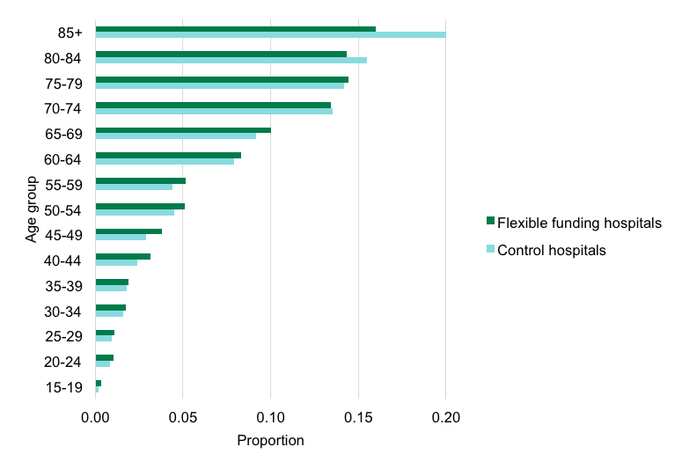

Source: VAED 2016–17, Department of Health and Human Services

#### Marital status

The majority of HealthLinks enrolled patients across flexible funding sites and control sites were married, as shown in Figure 3, with slightly more married patients attending flexible funding hospitals.

Figure 3: HealthLinks enrolled patients’ marital status: HealthLinks control sites vs flexible funding sites, 2016–17

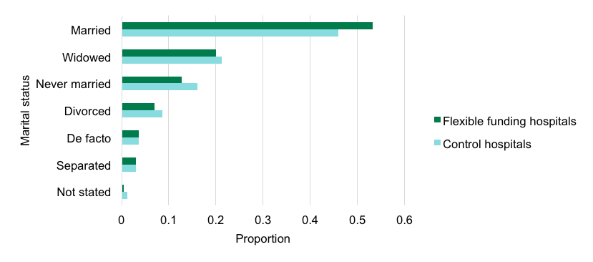

Source: VAED 2016–17, Department of Health and Human Services

#### Preferred language

The majority of HealthLinks enrolled patients across flexible funding sites and control sites indicated that their preferred language was English. As shown in Figure 4, there is a higher number of enrolled patients who have a preferred language as other than English in the flexible funding sites compared with the control sites.

Figure 4: HealthLinks enrolled patients’ preferred language: HealthLinks control sites vs flexible funding sites, 2016–17

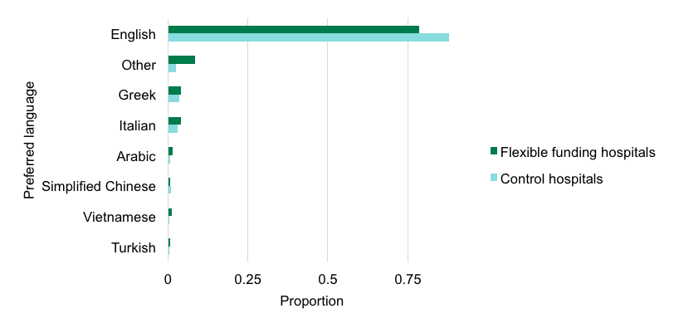

Source: VAED 2016–17, Department of Health and Human Services

#### Socioeconomic status

There is a higher proportion of patients in the control health services who are in the higher socioeconomic groups than at the HealthLinks flexible funding sites. Conversely, there is a high proportion of patients who are in the lowest socioeconomic group at the HealthLinks flexible funding sites, as shown in Figure 5. This may reflect the characteristics of the communities and suburbs in which the health services are located.

Figure 5: HealthLinks enrolled patients’ socioeconomic status: HealthLinks control sites vs flexible funding sites, 2016–17

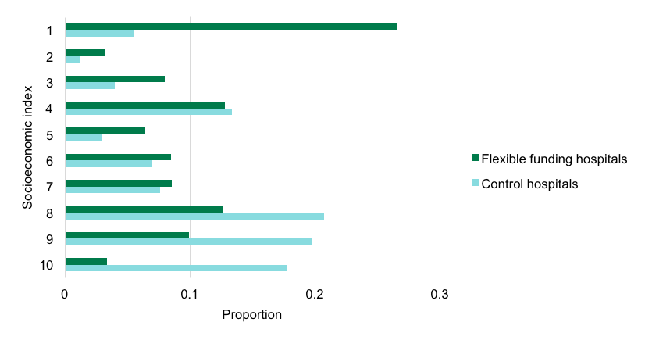

Sources: SEIFA, IRSAD, Australian Bureau of Statistics

#### Major diagnosis groups

HealthLinks enrolled patients fall into some broad diagnosis groups including:

* chest pain
* heart failure
* respiratory infection
  + COPD.

Noting that the largest grouping is ‘other’, this demonstrates how the HealthLinks algorithm can enrol patients with a range of different chronic and complex health conditions that are not disease-specific (Figure 6).

Figure 6: HealthLinks enrolled patients’ diagnosis groupings: HealthLinks control sites vs flexible funding sites, 2016–17

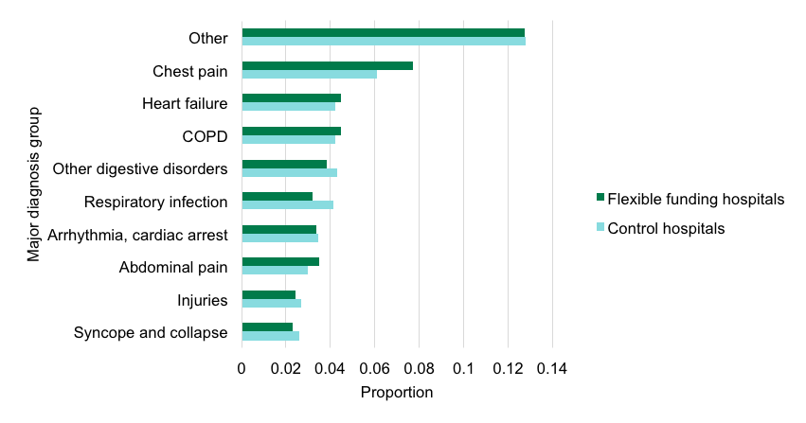

Source: VAED 2016–17, Department of Health and Human Services

### 3.2.2 Patients who become excluded from HealthLinks

HealthLinks enrolled patients can become excluded from HealthLinks for a number of reasons, including if their disease or circumstances become more complex. Figure 7 shows the main reasons that enrolled patients were excluded or ineligible to remain as a HealthLinks enrolled patient during 2016–17. It shows that there were a number of enrolled patients who were diagnosed with cancer or had an admission for a mental health diagnosis that excluded them from HealthLinks participation. There was also a considerable proportion of patients who died.

Figure 7: HealthLinks enrolled patient’s main reason for becoming excluded

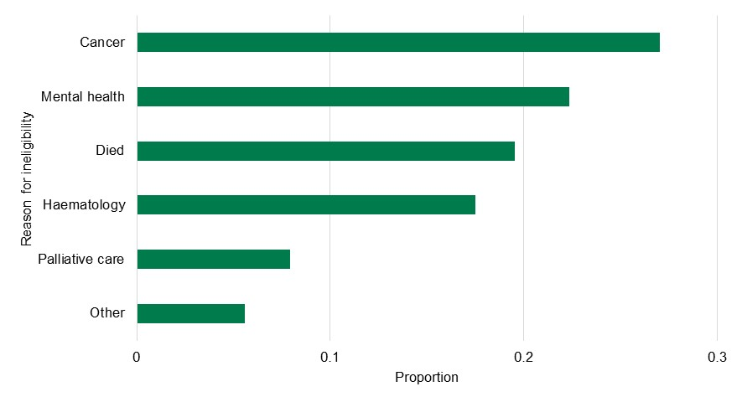

Source: VAED 2016–17, Department of Health and Human Services

### 3.2.3 Hospital utilisation

This section summarises the outcomes from the first year of the HealthLinks trial (2016–17), comparing the outcomes for HealthLinks flexible funding sites with control sites. It also compares HealthLinks enrolled patients who received an intervention with enrolled patients who did not receive an intervention.

#### Readmission to hospital within 30 days

A key measure of the effectiveness of services that seek to reduce avoidable hospital admissions is whether these patients return to hospital after becoming enrolled as a HealthLinks patient. Two different measures are used: readmission[11] to hospital within 30 days or re-presentation to an emergency department within 30 days.

Figure 8 compares 30-day readmissions between HealthLinks flexible funding sites and control sites. The data shows that HealthLinks enrolled patients are significantly more likely to be readmitted to hospital within 30 days at a flexible funding health service compared with a control service. Similarly, HealthLinks enrolled patients are significantly more likely to return to an emergency department within 30 days after the trigger admission at a flexible funding site compared with patients at a control site.

In comparing the intervention patients and usual care patients who are enrolled at a flexible funding site, there is no statistically significant difference between the number of readmissions to hospital or to an emergency department within 30 days between the two groups.

Figure 8: Readmission to hospital and re-presentation to an emergency department: comparing sites and patient groups, 2016–17

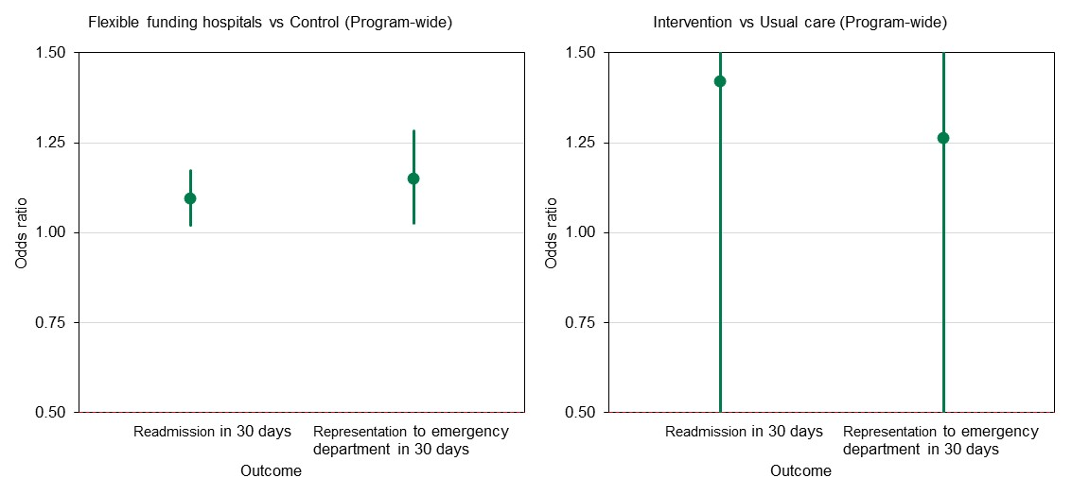

Source: VAED 2016–17, Department of Health and Human Services

Note: Where the error bars cover the horizontal line at 1, there is no statistically significant difference in the probability of 30-day readmission or re-presentation for patient episodes following the start of flexible funding.

#### Length of stay in hospital or in an emergency department

A proxy measure of a patient’s acuity level is the length of time that they stay in hospital. A shorter LOS could indicate that the patient has received more timely treatment and that their health is less deteriorated at the time that they are admitted to hospital.

The analysis undertaken for this report includes comparing the LOS in hospital and LOS in an emergency department for HealthLinks enrolled patients between: (i) HealthLinks flexible funding sites and control sites; and (ii) HealthLinks intervention and usual care patient groups.

As shown in Figure 9, LOS in hospital did not significantly differ by patient group or site. Regarding LOS in an emergency department, there was no significant change in emergency department LOS for patients at HealthLinks flexible funding sites compared with control sites (Figure 10). However, the actual increase in length of stay equates to approximately 73 seconds on average. No overall effect on emergency department LOS between intervention and usual care patient groups was evident.

The data that is available to undertake this analysis is very limited and at this stage it is not possible to draw any significant conclusions from this analysis.

Figure 9: HealthLinks enrolled patient length of stay (LOS) in hospital (inpatient): comparing patient groups and sites, 2016–17

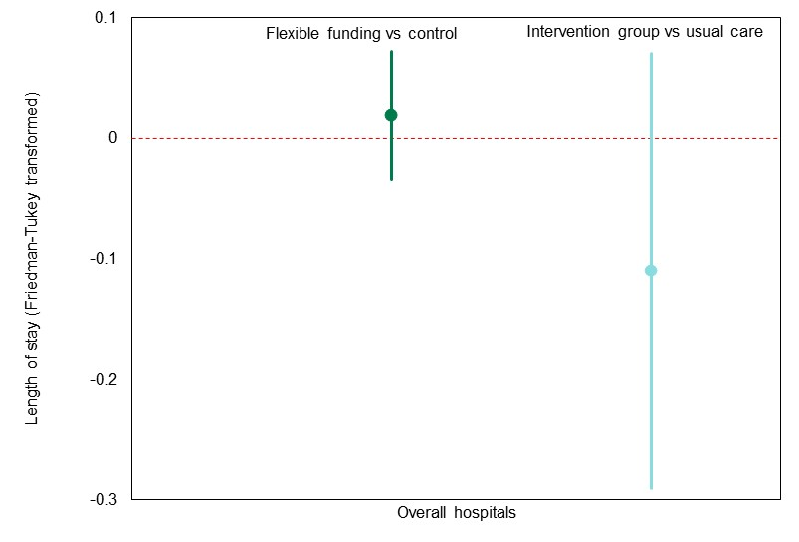

Source: VAED 2016–17, Department of Health and Human Services

Note: Where the error bars cover the horizontal line at 0, there is no statistically significant difference in the length of stay following the start of flexible funding.

Figure 10: HealthLinks enrolled patient length of stay (LOS) in an emergency department: comparing patient groups and sites, 2016–17

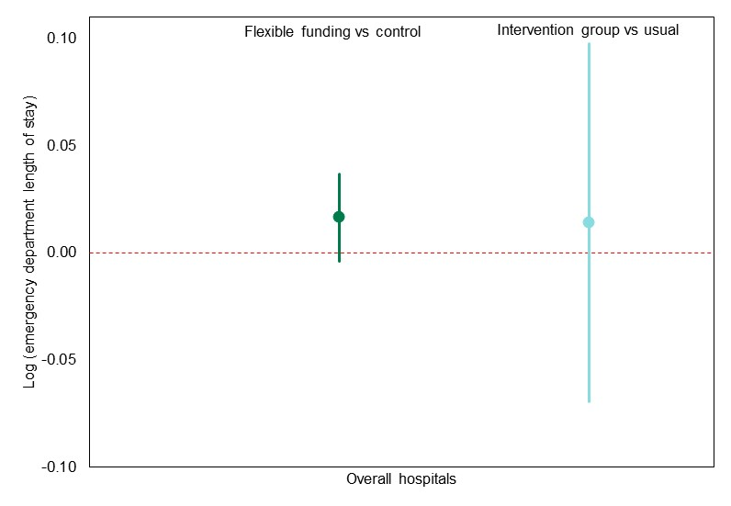

Source: VEMD 2016–17, Department of Health and Human Services

Note: Where the error bars cover the horizontal line at 0, there is no statistically significant difference in the length of stay following the start of flexible funding.

#### Ambulatory services

The evaluation considered the health service utilisation of non-admitted health services in the enrolled cohort, taking into consideration utilisation of the following programs:

* Hospital Admission Risk Program[12]
* Post Acute Care[13]
* Residential In-Reach[14]
* specialist clinics (outpatients)[15]
  + subacute ambulatory care services.[16]

Across all four flexible funding health services, Figure 11 shows no significant difference between intervention patients and usual care patients in the utilisation of specialist services.

Figure 11: HealthLinks enrolled patients use of non-admitted services: patients receiving an intervention vs patients receiving usual care, 2016–17

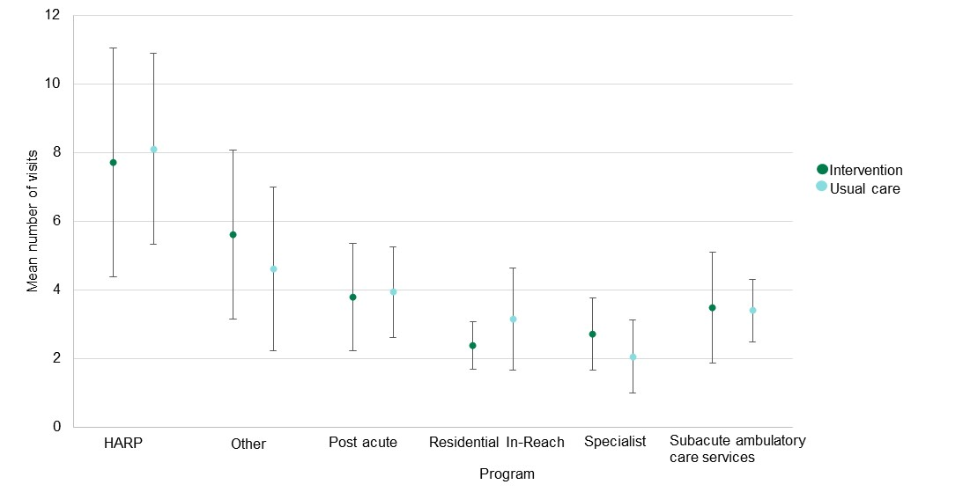

Services contained in ‘other’ are listed in Appendix 3.

Source: VINAH 2016–17, Department of Health and Human Services

### 3.2.4 Funding utilisation

The evaluation considers the health services’ cost to manage HealthLinks enrolled patients and compares these costs between flexible funding and control sites and between intervention patients and control patients.

Funding utilisation is measured in WIES funding. WIES represents a cost-weighted (W, weight) separation, where the diagnostic-related group (DRG) cost weight is adjusted for time spent in hospital (IES, inlier equivalent separation).

The average funding (WIES) expended by a health service was calculated by summing up all the cumulative WIES for each patient and dividing by the months they were enrolled in HealthLinks. Figures for monthly WIES are based on the month of a patient’s trigger admission.

It has been suggested that patients accumulate WIES at a higher rate in the first few months after their trigger admission, leading to potential biases in the actual versus predicted WIES calculation for patients only enrolled for part of the financial year.

Figure 12 shows the relationship between the total WIES accumulated by a patient by the number of months they are enrolled. A natural cubic spline was fitted to a simple linear model to explore this relationship. It can be seen that, in general, patients use slightly more WIES in the first four to five months post enrolment and again towards the later months of a 12-month period. However, the difference between the spline and a simple linear relationship, as shown in red in Figure 12, is slight.

Figure 12: WIES utilised by HealthLinks enrolled patients by months enrolled, 2016–17

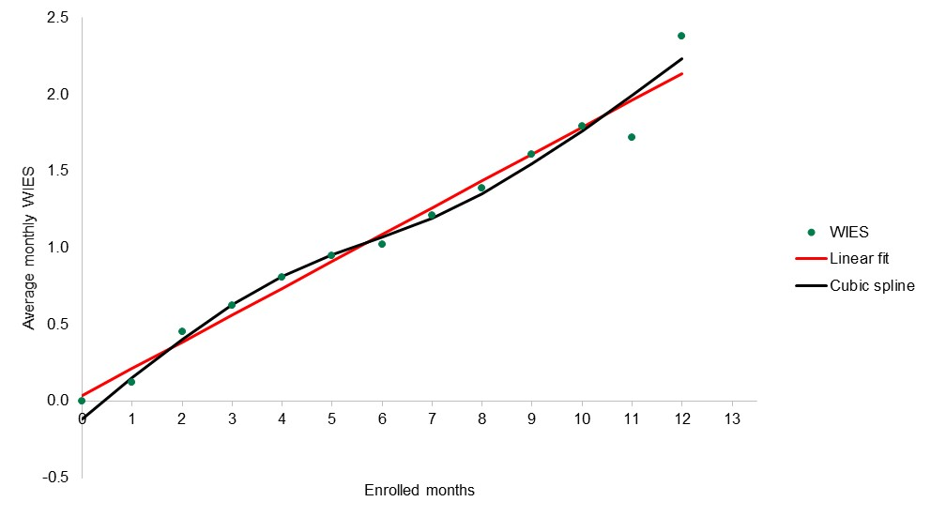

Source: VAED 2016–17, Department of Health and Human Services

As shown in Figure 13, the control sites expended more funding on the enrolled patients than was predicted. By comparison the flexible funding health services reduced the WIES utilisation on the enrolled patient cohort by just under 5 per cent. However, it is still too early in the trial to draw a definitive conclusion from this data.

Figure 13: WIES utilisation on HealthLinks enrolled patients: HealthLinks control sites vs flexible funding sites, 2016–17

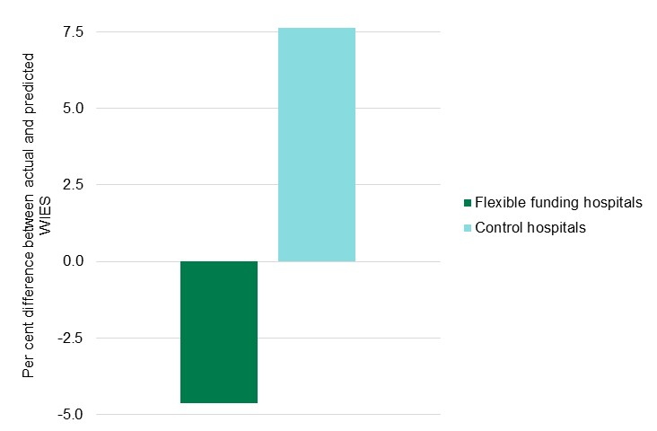

Source: VAED 2016–17, Department of Health and Human Services

When comparing the HealthLinks intervention patients and the usual care patients at the flexibly funded health services, Figure 14 shows that the intervention patients used more WIES than the usual care patients. As already noted it is still too early in the trial to draw conclusions from this data.

Figure 14: WIES utilisation on HealthLinks enrolled patients: patients receiving an intervention vs patients receiving usual care, 2016–17

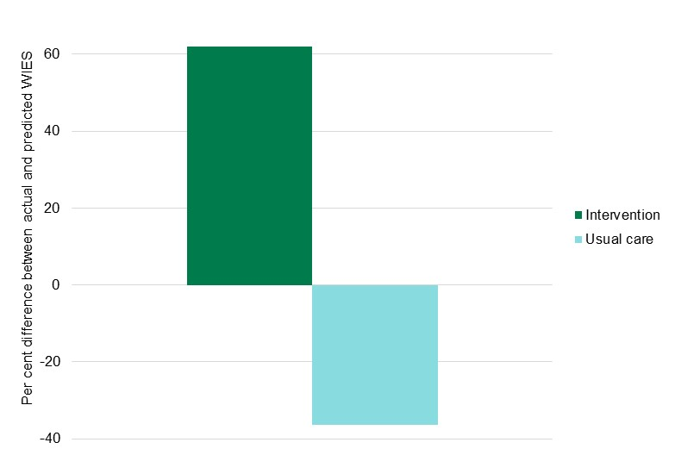

Source: VAED 2016–17, Department of Health and Human Services

## 3.3 Summary of qualitative findings

The following is a summary of findings from interviews and focus groups conducted at Barwon Health, Northern Health and Monash Health. Interviews and focus groups with Western Health staff had not been conducted at the time of writing so have not been included in this report.

A series of interviews and focus groups were held with staff involved in implementing HealthLinks offering them an opportunity to reflect on their perceptions of the critical factors for successful implementation and the impact of HealthLinks on patient care. Interviews were held with nurses, medical specialists and other clinicians involved in patient care (healthcare providers) as well as executive, program and clinical team managers (healthcare managers).

Overall, the three health services that were delivering HealthLinks interventions and participated in the interviews and focus groups considered that the HealthLinks model, and the potential for health services to use their funding more flexibly, enabled a more holistic approach to patient care. Some of the common themes arising from the health service workforce regarding the implementation of HealthLinks interventions and perceived impact on patients are discussed below.

### 3.3.1 Implementation of HealthLinks interventions – perceptions on enablers and barriers

This section considers some of the key factors that have supported implementation of HealthLinks and learnings arising from the experience. This information draws from the focus group sessions and individual interviews with the health service workforce. Executive support and systematic approaches to the program rollout were found to be crucial in enabling the implementation of HealthLinks. At the same time, challenges and barriers to implementation included issues of staff awareness and engagement, information systems, budgets and resourcing. These are explored below.

#### Health service executive support and department leadership

The majority of the workforce participants viewed support and confidence at this senior level as integral to successful implementation. Examples of executive support included their willingness to manage the financial risk, providing decision latitude to the project team and a general commitment to support the project team.

‘Our CEO is very supportive of HealthLinks and was very keen to sign up, and that’s why we were able to enrol patients really quickly, and we got on board.’ *Healthcare manager*

Leadership and stewardship from the department was cited as important for HealthLinks’ success. The collaborative approach to design and implementation of the program, as facilitated by the department, was viewed positively by the participants.

‘None of that would’ve been possible without the health department of Victoria making some changes that have enabled us to invest some of the existing inpatient revenue in the pilot. So that funding model shift and the collaboration we’re having with them has been fundamental…’ *Healthcare manager*

Some participants suggested that involving staff with a medical background in executive-level decision-making groups could potentially better support planning, design and implementation of HealthLinks.

An additional macro-level positive impact mentioned by the participants was that the pilot was viewed as a potential model for wider organisational change.

‘I think what it's done is started to shift people’s thinking about what's possible at a senior level as well.’ *Healthcare manager*

#### Flexible funding model at the system level and freedom of budget at the local level

The flexible funding arrangements, and the fact that health service staff could use their funding more flexibly in designing interventions, was viewed very positively and was seen as important for successfully rolling out new interventions.

‘Like we have a free budget but, you know, we don’t have to push things up to a certain point of money to them to be approved, so we can actually respond a lot quicker to our patients than some of the other services that have multiple layers of jurisdiction for sign off and stuff.’ *Healthcare provider*

Participants indicated that the flexible funding model at the system level and the freedom of budget at the local level enabled them to respond to their patients’ needs in a more timely way, thus enabling provision of care to patients at the right place and at the right time.

‘Some of the challenges [are] … it is a statewide program, so the department are trying to coordinate 11 different health services, which is extremely challenging … and we’re all different and we all think that we’re different and special, so they’ve got quite a challenge.’ *Healthcare manager*

#### Careful planning, systematic approach and evaluation

Careful program planning was cited as a potential critical factor for success.

Action plans and a systematic approach to the program rollout were considered important. Participants indicated that they thought ongoing evaluation throughout program rollout would allow them to adjust their programs accordingly to enable even greater success.

‘We really need that more systems approach … and the integration of systems across different programs, whether it's IT systems or whether it's referral processes or all that sort of stuff, it all needs to be integrated and sustainable.’ *Healthcare manager*

#### Workforce capability and skill

The knowledge and skillset of individual team members, and the skill mix of the overall team, was commonly cited as integral to the success of the program. Role clarity, decision latitude and excellent supervisor support were endorsed as important for the success of the program.

In working with these complex clients, interpersonal skills, empathy, compassion, friendliness and excellent verbal communication skills were viewed as integral to program success.

‘I think it’s important that [staff] have a really robust understanding of what each service provides, and that they are engaging the client and not just ticking referral boxes … because otherwise you get a floodgate of referrals that are to the wrong place and for clients that have no desire to do it … training of the staff is really important.’ *Healthcare manager*

Enhancing the multidisciplinary clinical skill set of the team was commonly endorsed as an area for improvement. Professional skill sets of experienced nurses, pain specialists, social workers, psychiatrists, counsellors and other mental health practitioners were considered important.

Most of the participants interviewed indicated that existing clinical staff would be an asset to the program. High-level clinical skill sets and a motivation to really help this client cohort were commonly mentioned. Staff members’ willingness to work outside professional boundaries was also mentioned by some participants as potentially enabling great program success.

#### Communication and information sharing between services

Ensuring that the different services involved in a patient’s care are communicating and interacting cohesively was commonly endorsed as a potential critical factor for success. In particular, providing clients with consistent messages from the different services was cited as potentially important for program success.

Health services devised governance arrangements to ensure consistent communication, information sharing and agreed approaches to managing patients across different settings.

‘In some ways it’s really communication between the services as much as anything, to make sure that we’ve got really clear pathways that we know we’re talking to the right people, we know we’ve got the right services involved, that we’re able to update each other really well, efficiently, so that we’re not duplicating things as well.’ *Healthcare manager*

Appropriate branding and widespread awareness of the HealthLinks program, both internally and externally to the organisation, was viewed as a potential enabler for program success. Building understanding of the program at an early stage was identified by healthcare providers and healthcare managers as essential.

Ensuring a clear communication strategy for implementation was also cited as important – one that clearly outlines what the program is aiming to achieve, and what services are being offered.

‘And I suppose the communication side of things through the different services, and helping our staff to really understand the process and why we’re doing what we’re doing and what we’re hoping to achieve … I think that’s also going to be a bit abstract and a little bit challenging for the staff to really get the grasp of, and plus, you know, it’s a pilot project so we’re learning as we go along as well.’ *Healthcare manager*

#### Patient identification[17]

Correct definition of HealthLinks patients was considered a challenge, especially at the early stage of the HealthLinks program.

Some health service staff raised concerns with the algorithm approach to identifying patients who are suitable for HealthLinks, and whether HealthLinks was enrolling those patients who needed support. Participants’ views on this varied. Some felt the algorithm was accurate and some felt that it may have missed some patients who could have benefited from the program.

‘So I’m not sure in the end if that’s the right group to focus on – they’re very attention grabbing, so it’s very hard not to focus on them, but I don’t know whether actually for the department and for the health service and for the consumers themselves, they are not a middle layer that actually we would be better off focusing on in terms of service provision – and maybe that will unfold over the three years. It’ll be interesting to see that.’ *Healthcare manager*

‘I think it’s pretty effective actually. I do get the impression that the algorithm and the LACE identify people who are at risk of re-presentation and who have an increased likelihood or need for post-discharge support and follow-up. So I do think it does a reasonable job, yeah. Nothing’s perfect, never will be.’ *Healthcare manager*

#### Managing change

Effective communication and information sharing across services was not only a key enabler but was recognised as a challenge for implementing HealthLinks.

‘Other services aren’t geared to think like us yet. They’re still very rigid and still very protocol-based and all those sorts of things, so when we come in and try to interface with them to provide a little bit more of a flexible service, we hit a lot of brick walls. And sometimes it can get frustrating to sort of push back against that.’ *Healthcare provider*

Participants indicated that there was some resistance to delivering alternative models of care in different settings, with rigid systems and the protocol-based approach to patient care within some settings cited as a barrier to successfully implementing the program.

This was in some ways offset by having executive champions who reduced the organisational resistance from some individuals and services.

#### Building collaborative relationships across and within sectors

Engagement with GPs and the wider Primary Health Networks, though noted as a challenge by many participants, was considered a positive impact of the program. According to participants, the GPs they collaborated with viewed the program and its aims positively. The collaborative and integrated approach patient care was viewed positively.

‘I think the more important thing around that relationship with the GPs is, you know, if we’re really thinking about the best outcomes for this client group, is about that partnership … and the working together. And the GP remains that key person from a medical perspective in that patient’s life, and we work to enable that and not provide barriers’. *Healthcare manager*

The need for stronger communication mechanisms with GPs was highlighted as an area for further improvement.

‘Primary care is going to have to be the key in this with the patient … I think that relationship between the GP and us needs to be a lot stronger. So we historically haven’t had a very strong relationship there, and we need to build that.’ *Healthcare manager*

Not engaging the acute health services as a partner and vice versa in program rollout was cited as a potential barrier by participants. Although conversations had been held with different health professionals and teams within the health service to make sure they understood the HealthLinks program, it was not an easy process because there are other similar-sounding programs that caused confusion.

‘I think that there’s still some confusion about what HealthLinks is. You know, I think often you’re explaining it to the medical teams … the Allied Health teams know because they’ve had some education and we discuss [it] in our multidisciplinary team meetings so these are HealthLinks patients, so I think that, yeah, I’m not sure that there’s a lot of knowledge out in the community still about HealthLinks – in the wider medical community.’ *Healthcare manager*

#### Developing an understanding of patients’ needs

Staff identified the considerable diversity in needs of the patients who were being enrolled in HealthLinks was a challenge for the program.

In particular, working with those patients who have drug and alcohol problems, lower health literacy or mental health issues was a challenge in determining what sort of support services they would benefit from, and how to engage with these patients. Patient resistance was mentioned by some of the participants as a particular challenge, as well as being able to determine which patients would be willing to address their health issues.

Service provision for culturally diverse patients was cited as a challenge for the program. A number of issues were identified, including difficulty in coordinating a teleconference with an interpreter and, as a consequence, difficulty with ongoing engagement and maintaining regular contact.

‘The clients need to be willing and accepting of change, and willing to be educated, and even have the ability to take on that education, because obviously we’re dealing in a lot of areas with poor health literacy.’ *Healthcare provider*

#### Funding arrangements and financial risk for health services

A number of staff raised the funding arrangements as a challenge for adopting HealthLinks.[18]

Participants raised concerns that the risk the health service would expend more than the agreed funding, or that the health service would be at risk of incurring unfunded work due to exceeding their overall activity targets, would affect the commitment from health service executive to supporting implementation.

‘[They] haven’t set aside some kind of investment for us to trial – we have been quite proactive at enrolling patients and getting things up and running quite quickly, but haven’t really been backed for some innovation.’ *Healthcare manager*

Furthermore, with no additional funding being available to support the implementation of new models of care, health services reflected that there were concerns about staff and the level of resourcing required to support a new HealthLinks intervention. The problem of lack of funding at the local level, growing number of patients in the existing program, working with existing staff resources and training required were highlighted by some participants.

#### Need for a longer term view

A challenge to the program has been that the potential benefits are not necessarily realised in the short term. It was agreed that undertaking prospective evaluation is important because feedback will be raised during implementation, which could help raise staff confidence.

‘But I think it’s very reactive on feedback and data that comes back that tells us about what’s successful and not, and we need that data now to actually give them the confidence to do things like approve ongoing innovations and ongoing opportunities and business cases to better support perhaps the teams already in place.’ *Healthcare manager*

#### Health service information technology systems

It was noted that there were some challenges in communication and information sharing as a result of having multiple and non-centralised IT systems across the health service (and across Victoria). In particular, non-centralised systems were viewed as a barrier to information sharing between services. The engagement of the IT and data teams from the beginning is considered an important enabler for the smooth implementation of the HealthLinks program.

‘I do think our technology interface could be better. We’ve talked about that in our project as well … our systems don’t talk well to each other, community system doesn’t talk well to inpatients, and there’s patient duplication of information in multiple areas and those sort of things.’ *Healthcare provider*

### 3.3.2 Impact of HealthLinks interventions – perceptions of positive and negative impacts

This section summarises the key perceptions of the impact of HealthLinks interventions. This information draws from the focus group sessions and individual interviews with the health service workforce.

The majority of participants were positive about the potential impact of the HealthLinks program. Some participants mentioned that early positive feedback from patients has been received. Participants felt that the potential impact of HealthLinks could be interrelated to the benefits of the existing programs that may have been demonstrated. Some participants believed that the benefits of the enhancement to existing programs will need to be evaluated when the HealthLinks program is carried out for a longer period of time and embedded into practices. These are explored below.

#### Holistic approach to patients’ needs

HealthLinks has enabled a more holistic model of patient care. Participants commented that the culmination of non-medical determinants (such as those related to socioeconomic status, mental health, drug and alcohol use, and low social capital) frequently resulted in unplanned admissions.

‘Having the clinicians that are allowed to think outside the box and implement things outside the box, rather than being confined to how we’ve always done it. Because I guess if we don’t try something different we’ll never know’. *Healthcare provider*

Having the flexibility to use funding to deliver different services offered health services the opportunity to address the behavioural and social determinants of health of those living with chronic conditions. Participants suggested that the care they could provide HealthLinks patients is more customised to the individual patient’s needs and that they were not confined by rigid protocols. Further to this, social support was identified as a potential mechanism that has enhanced patients’ sense of wellbeing and ultimately reduces rates of admission to hospital. Staff articulated the need of involving psychology and medical specialists in HealthLinks program support.

Healthcare providers’ willingness to work outside professional boundaries, being less protocol-based, while working at creative problem solving to address patient’s individual needs were endorsed as important for program success.

‘We can’t fit square pegs in round holes, so we have to be a bit more flexible and I think that’s what I pride myself in doing is to try and flex the system a little bit to accommodate these patients.’ *Healthcare provider*

Providing operational and non-medical support to patients and the positive impact this has for patients was commonly endorsed. This was particularly relevant for patients with low social capital.

‘If you look at the model of the HARP program, the difference between that and the potential of HealthLinks is being able to access some services more quickly because there’s a bit of financial backing. So it’s other than being able to use the usual services which we try to do, if they needed particular support around getting quick access to services, then maybe an ability to be able to support people to do that.’ *Healthcare manager*

The approaches adopted under HealthLinks was also seen to improve response times for patients after they had been discharged.

Health services perceived that the HealthLinks model enabled more navigational services to be offered to direct patients to the right care at the right time. Much of this was due to the navigational support services that were available as a result of having more flexibility in how funding is used.

#### Flexible service models and modality of patient engagement

Introducing alternative service models was seen as a way to engage patients who might otherwise not be receptive to receiving support. The extended hours of operation introduced under one of the intervention programs improved the capacity of the team to engage with younger patients, many of whom work full time. The capacity to use alternative service models – in particular, a digital interface – was also identified as a way to improve engagement with the younger patient cohort.

Videoconferencing capability with patients and telehealth capabilities were suggested as areas for future development to enhance the timeliness of care and to contribute to the program’s sustainability.

The potential for staff to undertake home visits to their patients was also seen as a benefit for patients as well as staff, who gain a greater understanding of the patient’s needs and the issues that a patient is dealing with.

‘… seeing this person’s house, this tiny little rundown ramshackle housing commission house, but the grandkids are all over the walls and seeing the love in this house, when they write supportive family on my referral, I don’t know whether really it’s supportive … Just from seeing the house I got a real sense of the person …’ *Healthcare provider*

#### Patient empowerment and capacity to self-manage

Patient motivation to engage with the service and participate in programs was seen as a potential barrier to program efficacy. While patient noncompliance was cited by some participants, other health service participants suggested that one of the benefits of HealthLinks has been improved patient self-efficacy in managing their chronic condition(s) at home.

A challenge cited by some staff was the potential for patients to become dependent on the HealthLinks program. A number of staff noted that it is important for health services to encourage patients to be in control of their own health and to engage them in decision making regarding their health.

Participants commonly mentioned building resilience in patients for coping with life stressors.

‘We try to help them take their own ownership of their problems, so we teach them how to also be resilient in that sense I suppose … to take control of their illness and then teach them how to take control of themselves as well.’ *Healthcare provider*

The HealthLinks funding arrangements also enabled health services to offer more support for patients to navigate the system, and this was seen as particularly important for patients with low health literacy.

‘What I would hope is that people feel more confident in navigating the healthcare system … So I would hope that it would empower patients and/or their relatives to advocate for treatment that’s in their best interests, and in good discharge planning, and also educate people in their own, and lead to better self-efficacy in terms of managing their medical illnesses and so on.’ *Healthcare provider*

Other processes developed through the HealthLinks model, including a greater emphasis on comprehensive discharge planning and education, were seen as improving patient confidence in navigating the healthcare system, better efficacy in managing their conditions, and improved health outcomes and quality of life, especially for chronic disease patients.

#### Integrated and coordinated service delivery

Providing greater integrated care for HealthLinks patients was perceived as having the potential to provide a positive impact. It was suggested that services have traditionally operated in silos, and HealthLinks has facilitated the breakdown of this siloed model of care. This is particularly important for patients who are engaged across multiple services.

It was suggested that one of the advantages of HealthLinks interventions was improvements to the existing coordination process such as referrals, discharge processes, communication between the HARP streams and communication with ward doctors. The interventions enable staff to engage and build a relationship with patients when they are in hospital and are then more likely to participate in programs that are offered.

#### Improved identification for patients who need support

It was generally perceived that HealthLinks has enabled health services to better identify patients who need support, including those patients who do not interact with health services or those who have slipped through the cracks because of psychosocial or behavioural issues or low health literacy.

‘Probably the impact on patients will be an increased sense of support through our health services, probably more timely access to the services that they need, because we’ve got a lot of services in our community but a lot of people don’t know about them … so having a key worker or a HARP worker being linked with those people will really help to navigate the services a lot more expediently.’ *Healthcare manager*

#### Better service utilisation

The HealthLinks program has been a mechanism for health services to review current practice and assess new processes to build efficiencies and effectiveness in their patient management.

‘So we know that people, a lot of people, bounce in and out of short stay … with monotonous frequency, but again we haven’t recognised that in the past because the stay is so short we haven’t seen that that’s what’s happening … so we can also see now it’s identified some patterns of use that we weren’t aware of before in terms of our whole service utilisation.’ *Healthcare manager*

By looking at service provision through a different lens (for example, the pattern of use in short stay units), some health services made changes to how patients were streamed into different services, which has enabled better service utilisation.

### 3.3.3 Patient experiences of care

An important component of the HealthLinks evaluation is understanding the impact of being enrolled as a HealthLinks patient on a patient’s experience of their care.

At the time of preparing this report there is no information available from the patient survey data to determine how patients are experiencing their care. This data will be included in future reports after the patient six-month follow-up surveys are completed.

# Conclusion

This is the first report arising from the prospective evaluation of the HealthLinks trial. It draws on a range of qualitative and quantitative data collected by CSIRO to determine the impact of alternative, more flexible funding arrangements on the outcomes and experiences of patients with chronic and complex conditions.

There is very limited data upon which to draw any conclusions at this stage. This report demonstrates that, based on available data, the outcomes for patients who are receiving services in health services that have adopted flexible funding or an intervention model of care are not significantly different from other health services. Over time, as more data is collected, it will be possible to draw out the impacts on patients across different health services with alternative interventions to reflect on what models of care are improving patient outcomes and experiences.

At this early stage, executive support, systematic approaches to the program rollout and holistic approaches to patient care have been found to be crucial in enabling the HealthLinks implementation. At the same time, challenges and barriers to implementation included issues of staff awareness and engagement, information systems, patient noncompliance, budgets and resourcing.

It is encouraging that the workforce involved in implementing HealthLinks perceive a range of benefits to patients and also to participating health services in trialling new funding arrangements and developing alternative models of care. Workforce insights regarding the challenges to implementation and the factors that are likely to support participation in HealthLinks will inform program changes in the future.

# Appendix 1: Parameters of the HealthLinks episode scoring algorithm

A patient becomes enrolled upon an eligible[19] unplanned medical episode,[20] if the following conditions are met:

* The patient has **not** had an episode in the past 365 days that meets the exclusion criteria.
  + The current eligible unplanned medical episode achieves a total score of 11 or more.[21]

Variable: Patient age group as at the current unplanned medical episode

| Parameters | Assigned score |
| --- | --- |
| 30–39 vs 18–29 | 1 |
| 40–49 vs 18–29 | 2 |
| 50–59 vs 18–29 | 3 |
| 60–69 vs 18–29 | 5 |
| 70–79 vs 18–29 | 6 |
| 80+ vs 18–29 | 6 |

Variable: Number of unplanned admissions in the 183 days prior to the end of the current unplanned medical episode

| Parameters | Assigned score |
| --- | --- |
| 1 vs 0 | 3 |
| 2 vs 0 | 5 |
| 3 vs 0 | 8 |
| 4+ vs 0 | 11 |

Variable: ED visits in the 90 days prior to the start of the current unplanned medical episode

| Parameters | Assigned score |
| --- | --- |
| 1+ vs 0 | 2 |

Variable: An acute inpatient separation in the 183 days prior to the end of the current unplanned medical episode included a principal diagnosis for selected conditions

|  |  |
| --- | --- |
| Parameters | Assigned score |
| Symptom/sign of digestive system Tdiag1 = R10x–19x  Asthma  Tdiag1 = J45x–46x or J82x  Kidney disease Tdiag1 = I12x, N00x-N19x, I131–32, I139  Diabetes Tdiag1 = E10x–14x  Disorder of pancreas Tdiag1 = K85x–86x  COPD Tdiag1 = J40x–44x | 3 |
| Non-infective enteritis and colitis Tdiag1 = K50x–52x  Rheumatoid arthritis Tdiag1 = M05x–06x, M45x, M080  Cirrhosis/alcoholic hepatitis Tdiag1 = K701, K703, K746 | 8 |

Variable: Smoking status, as at the current unplanned medical admission

| Parameters | Assigned score |
| --- | --- |
| Current/ex-smoker last month vs non-smoker  TDiag{x} = Z720x or Z8643x | 1 |
| Tobacco dependent vs non-smoker  TDiag{x} = F17x | 2 |

Variable: Patient residence, as at the current unplanned medical admission

| Parameters | Assigned score |
| --- | --- |
| Aged care vs other | –3 |

Notes:

1. Diagnosis codes exclude the full stop (‘.’).

2. TDiag1 represents the principal diagnosis.

3. ‘x’ at the end of a diagnosis or VicDRG code is a wildcard (can be any value).

4. TDiag{x} reflects a diagnosis code that can be present anywhere in the code string.

5. COPD = chronic obstructive pulmonary disease; ED = emergency department

# Appendix 2: Parameters defining HealthLinks ineligibility (exclusions)

Episodes excluded from consideration for the (enrolment) trigger admission and subsequent WIES utilisation

| Parameter | Definition |
| --- | --- |
| Private hospitals | Private hospital VAED file |
| Compensable patients – TAC/DVA/WorkCover | Patient type = S or V  Account class = JN, JP, V-, W-, T-, A-, S-, C-, O- |
| Medicare ineligible | Patient type = X  Account class = ME, MF, XX, XN |
| Renal dialysis | VicDRG = ‘L61x’ or ‘L68x’  Note: Renal dialysis treatment is excluded from the algorithm. However, a patient is not excluded by virtue of receiving renal dialysis treatment. |

Patient level exclusions. These exclusions are applied to the 12 calendar months of data prior to the enrolment month.

| Parameter | Definition |
| --- | --- |
| Children | Age ≤ 17 years in any episode in the previous 12 months |
| Maternity | VicDRG = O0x, O6x |
| Cancer | VicDRG = J62, R62–R64  or TDiag{x} = Cxx, D0x, D37–D48 |
| Haematology | VicDRG = Q60, Q61, Q62, R60, R61 |
| Palliative care | Caretype = 8 or TDiag{x} = Z515 |
| Trauma patients:  Acquired brain injury (ABI)  Burns | Injury and poisoning as principal diagnosis = S00–T98 with ≥ 1 hour of mechanical ventilation  VicDRG = Wxx or Y00 to Y62 |
| Mental health interventions | Caretype = 5, or  VicDRG = B63–64, U40, U60–68, V60–64 |
| Human immunodeficiency virus (HIV) | TDiag{x} = B20–B24 |
| Poliomyelitis | TDiag{x} = A80x |
| Victorian Respiratory Support Service (VRSS) | VicDRG = A06 |
| Spinal cord injury (SCI) | VicDRG = B60–B61 |
| Cystic fibrosis (CF) | TDiag{x} = E84x or VicDRG = E60 |
| Thalassaemia | TDiag{x} = D560–D569 or TDiag{x} = D572 |
| Transplant patients | VicDRG = A01, A03, A05, A07, A08 or A09 |
| Rehabilitation in acute care | DRG is ‘Z60’ and Care type ‘0’, ‘4’ or ‘U’ |
| Inpatient death | Sepmode = ‘D’ |

Notes:

1. Diagnosis codes exclude the full stop (‘.’);

2. ‘x’ at the end of a diagnosis or VicDRG code is a wildcard (can be any value)

3. TDiag{x} reflects a diagnosis code that can be present anywhere in the code string.

# Appendix 3: Other ambulatory services

Allied health – stand-alone

Assessment

Assessment/terminal (end of life) care

Cardiology

Cardiothoracic surgery

Community palliative care

Dental

Dermatology

Discharge planning

Discharge planning / assessment

Ear, nose and throat

Endocrinology, includes diabetes

Gastroenterology

General medicine

General surgery

Generic access/referral point

Gynaecology

Haematology

Hepatobiliary and pancreas

Hospital based palliative care consultancy team

Immunology, includes allergy

Infectious diseases

Nephrology

Neurology

Neurosurgery

Obstetrics

Oncology

Ophthalmology

Orthopaedic applications

Orthopaedics/musculoskeletal

Plastic surgery

Pre-admission

Psychiatry and behavioural disorders, includes alcohol and drug

Rehabilitation

Reproductive medicine and family planning

Respiratory

Rheumatology

Symptom control/pain management

Symptom control/pain management/assessment

Symptom control/pain management/discharge planning

Symptom control/pain management/terminal (end of life) care

Terminal (end of life) care

Transition care program

Urology

Vascular

Victorian respiratory support service

1. CSIRO reports:

   *HealthLinks: Chronic Care (HealthLinks) evaluation, annual report 2016–17*, 29 May 2018.

   *Addendum to: HealthLinks: Chronic Care (HealthLinks) evaluation, annual report 2016–17*, 6 June 2018.

   *HealthLinks Chronic Care – Evaluation: first year results*. Presented at the Victorian Integrated Care Forum, 20 June 2018.
2. [Australian Institute of Health and Welfare](http://www.aihw.gov.au/media-release-detail/?id=60129552034) <http://www.aihw.gov.au/media-release-detail/?id=60129552034>
3. Additional information not part of CSIRO report.
4. An unplanned medical admission that does not meet any of the exclusion criteria or is part of an episode that includes a subacute care type.
5. One or more contiguous separations within a health service are grouped into episodes. Contiguous separations are when the:

   • admission date of the second separation is less than or equal to 12 hours of the discharge date of the first separation, or

   • admission date of the second separation is greater than 12 hours and less than or equal to 24 hours of the discharge date of the first separation, and the separation mode of the first separation or the admission source of the second separation contain either transfer or statistical separation codes.

   Additional information not part of CSIRO report.
6. The time between beginning HealthLinks participation and intervention intake was due to staff recruitment and training and meeting local ethics requirements.
7. Martin CM, Vogel C, Grady D, Zarabzadeh A, Hederman L, Kellett J, et al. 2012, ‘Implementation of complex

   adaptive chronic care: the Patient Journey Record system (PaJR)’, *Journal of Evaluation in Clinical*

   *Practice*, vol. 18, no. 6, pp. 1226–1234
8. Because the patient survey component of the evaluation began in January 2018, there is no data available on patient-reported experiences of HealthLinks.
9. Source: Australian Bureau of Statistics.
10. A cohort was created for each of the four intervention health services separately, along with one combining patients from all four intervention health services. This was necessary because of the way in which control patients are divided and associated with intervention patients. The matching process entailed matching each intervention patient to control patients, based on 5-year age group, sex and number of comorbidities at the trigger admission. The matching process cycled through intervention patients, matching each to a suitable control patient, without replacement.
11. Planned and unplanned admissions.
12. This is a government initiative established to address sustained increases in demand on the hospital system.
13. This is a government program that assists people of all ages to be safely discharged from Victorian public hospitals by purchasing and coordinating services they need to assist with recuperation at home.
14. This program provides hospital-type care where appropriate and safe to people living in residential aged care services. It is staffed by nurses and doctors from the hospital.
15. Specialist clinics provide planned, non-admitted services for people who need the focus of an acute setting. They provide an interface between primary care and acute inpatient services and include: medical, nursing, midwifery and allied health professionals for assessment, diagnosis and treatment; ongoing specialist management of chronic and complex conditions in collaboration with community providers; pre and post-hospital care; and related diagnostic services such as pathology and imaging.
16. This is a government program that provides person-centred, interdisciplinary care support via flexible service delivery in a range of settings. It is directed at improving and maintaining a person’s functional capacity and maximising their independence.
17. Enrolment as a HealthLinks patient is determined through an algorithm that is run through departmental administrative datasets to identify patients who meet a certain number of criteria (algorithm score). The lag in the departmental data means patients had often been discharged by the time they were identified as enrolled.

    As a result of these issues, at the beginning of 2017 the department released a new algorithm that can be implemented at the local level to enable health services to identify patients when they present to the hospital. There are still a number of challenges; however, enabling health services to identify patients at the time of admission, and to intervene early, has been seen as a positive outcome from implementing a new algorithm. (Additional information not part of CSIRO’s report.)
18. In adopting the HealthLinks model, health services agreed to a conversion of a portion of their acute inpatient funding to capitation. The per-average-patient amount was based on the statewide average costs of these patients, as determined through an analysis of administrative departmental data. There was no additional funding for health services to support the model. (Additional information not part of CSIRO’s report.)
19. An unplanned medical admission that does not meet any of the exclusion criteria or is part of an episode that includes a subacute care type.
20. One or more contiguous separations within a health service are grouped into episodes. Contiguous separations are when the:

    admission date of the second separation is less than or equal to 12 hours of the discharge date of the first separation, or

    admission date of the second separation is greater than 12 hours and less than or equal to 24 hours of the discharge date of the first separation, and the separation mode of the first separation or the admission source of the second separation contain either transfer or statistical separation codes.
21. Based on the SQL algorithm the current unplanned medical episode is included in the scoring algorithm. Hence, the total score of 11+. This differs from the original SAS-based algorithm, which did not score the current episode.