Food Safety Reform Program
Progress made in 2018 and 2019

Food Safety Reform Program
The Small Business Regulation Review (Retail) is a key component of the Victorian Government’s commitment to reduce unnecessary regulatory burden on small business. The review sought to understand small business experience in terms of starting a business, particularly the regulatory requirements imposed on business. The review involved broad engagement with the small business sector including surveys, industry round tables, written submissions, individual meetings, and interviews. To support small businesses, the review identified three key objectives:
- make it easier and faster to comply with relevant regulation
- provide confidence and certainty in the regulatory system
  - ensure unique regulatory compliance needs are met.
The review outcomes recommended several reforms to assist food businesses and local governments to better understand and apply food safety regulation and their obligations under the Victorian Food Act 1984 (the Act). These recommendations led to the creation of the Food Safety Reform Program (the program) by the Department of Health and Human Services’ Food Safety Unit.
The program is implementing changes over the next few years to make it simpler, clearer and quicker for food businesses to operate in Victoria. The program manages a group of interrelated projects under four main themes, each aligned to the key objectives of the Review (see Figure 1).
Figure 1: Food Safety Reform Program objectives
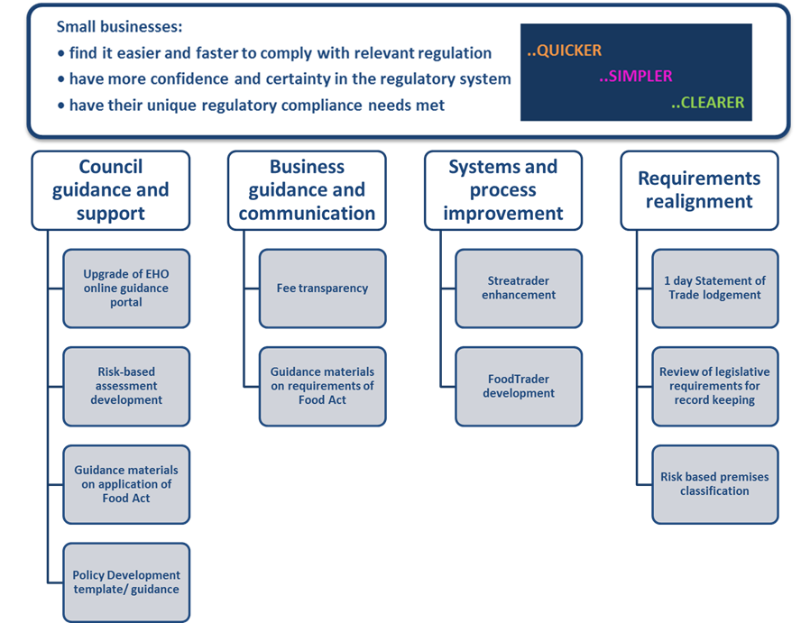

Key achievements during 2018 and 2019
The program, which was officially launched June 2018, has engaged extensively with local councils, food businesses and the food industry to plan, scope, develop and deliver on its objectives. Over 2018 and 2019 the program has worked with businesses and local councils to progress and complete key undertakings via meetings and forums with stakeholders and with regular website updates, newsletters and flyers.

...clearer
The program has been working with local councils and food businesses to develop clearer guidance material on how to interpret and apply the Act. Priorities have been identified through engagement with councils and food businesses; ascertaining where there are gaps in guidance and what the greatest priorities are. As a consequence, in 2018 and 2019, guidance for councils about the various enforcement tools available to them under the Act, including a comprehensive enforcement guide and a prosecution tool kit made up of case studies, an animation, podcasts and templates, has been developed.
Professional development and training for local council staff to assist them with their work has also been a priority. The program has organised regular workshops to encourage dialogue and peer-to-peer learning among council environmental health officers (EHOs). For example, theoretical and practical training on risk-based assessments to EHOs has been delivered across the state. The training has been designed to provide EHOs with the requisite skills to promote, embed and deliver a consistent, risk-based approach to food safety assessments of Victorian food businesses. This was further strengthened by the development of a guide and training program that aims to address inconsistencies across Victorian councils by providing a uniform approach to risk-based food safety assessments. At the end of 2019, half of all 79 local councils in Victoria had completed the training.
In addition to the training program and risk-based assessment guide, a food safety management policy template and associated guidance material is being developed to support local councils. This will assist local councils draft and implement a food safety management policy, which in turn will provide clarity around each council’s approach to food safety for both the wider community and local food businesses. The documents are currently being developed through a working group that comprises senior local council environmental health officers and officers from the department.
Providing greater transparency on the range of fees that councils charge food businesses has also been identified as a key area for improvement. The program has commenced preliminary work with local councils to provide greater transparency and will provide councils with a template that they can use to draft information for food businesses about their fees and how they relate to regulated activities under the Act. In addition, the program has been working with the Australian Business License and Information Service (ABLIS) that provides information about fees, guidelines and standards to assist small businesses, including food businesses.

...quicker
Making it quicker for both food businesses and councils to manage the registration of food premises is a key goal for the program. To reach this goal the program is enhancing and developing better IT platforms to support food businesses and councils. Work has commenced on developing an online registration platform for food businesses to enable food premises to register through a one-stop, online application service.
Streatrader, the Food Safety Unit’s online registration system for temporary and mobile food businesses, is being enhanced to ensure that it less administratively burdensome for local councils, quicker for businesses and community groups to participate in events at short notice, and easier for organisers to quickly access and manage their event registrations. Since May 2019, mobile and temporary food businesses can lodge a statement of trade one business day prior to an event with their principal and/or trading council. This is a change from the previous five business day requirement and is providing greater flexibility for businesses to trade at short notice.
Guidance, though workshops, videos and written material, has also been produced to support local councils to understand the changes to Streatrader.

... simpler
Preliminary work has commenced on simplifying record keeping requirements for some types of food premises and working with councils to review and improve the way food premises are assessed and classified. The aim of this work is to develop an improved classification system that accurately classifies food premises based on the level of risk their activities may pose to public health.
By implementing system changes to Streatrader, the way assessments of mobile and temporary food premises are recorded on Streatrader has been simplified. These changes make it easier for EHOs to capture the information in the system and analyse their data in real time.
Work has commenced to make it simpler for local councils to access relevant information and guidance materials by creating a new, online information hub for EHOs and other council staff. The goal is to put all relevant food safety information and resources for EHOs in one, easily accessed place. Discussions with other public health units in the department are being held with a view to including their EHO information and resources on dedicated pages on the new hub.
Figure 2: Program timeline and key projects
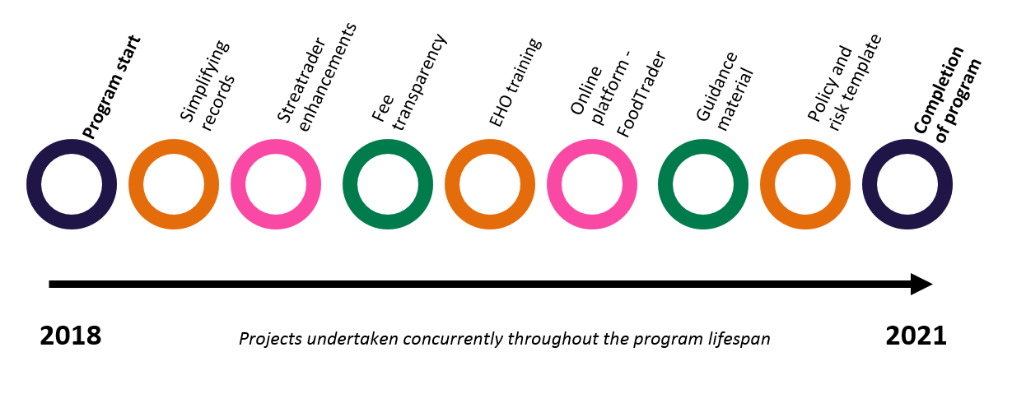

Project deliverables and outputs
During 2018 and 2019, program produced and delivered a broad range of materials and resources (see Figure 2), including:
- an animated video about the prosecution process under the Act
- a comprehensive guide on the available enforcement tools under the Act
- a detailed guide on section 40 in the Act
- five detailed prosecution case studies and self-tests for EHOs
- templates to assist councils manage and compile evidence for prosecution
- a public health portal for councils
- updated website content
- four newsletters to councils about the progress made
- a flyer to food businesses about the program
- inspections pads for EHOs that align directly with Streatrader
- development of a common inspection framework for council officers, driving a consistent approach to managing food safety risk
- five podcasts about topics related to the program and the Act, including allergen management, risk assessment and Streatrader enhancements.
Figure 3: Sample of products and material produced
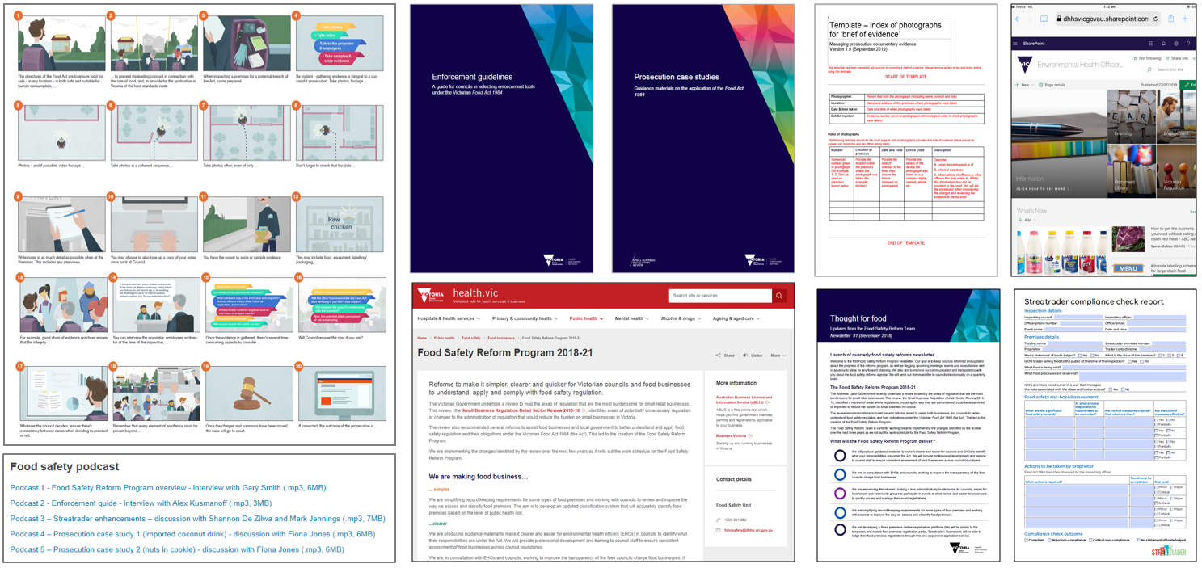

Stakeholder engagement
A comprehensive engagement and communication strategy was developed to ensure the representation of industry, food businesses and councils in the program’s work (see Figure 3 for an overview).

Working groups and co-design
Several working groups were established with representatives from local councils focusing on specific areas of the program. These working groups vary in size and timespan depending on the content areas. They have been well received, with strong participation and engagement.
In December 2019, a workshop for 25 council environmental health leaders on the Food Safety Risk Management Policy Working Group was held. The aim of the workshop was to expose the group to conceptual thinking in the development and implementation of the policy and guidance documents. In 2020, the working group will complete the co-drafting of the guidance documentation for state-wide distribution, aiming for all councils to implement a food safety management policy that reflects the framework of a risk-based approach.
In 2021, an online registration portal for Victorian food businesses, with an associated database for use by local councils in managing the compliance of those businesses, will be implemented. In preparation, from June to December 2019, over 40 co-design sessions were held with councils and food businesses across Victoria, enabling the compiling of comprehensive system requirements for the new state-wide registration portal and database. All 79 local councils participated in the co-design process. The resulting requirements will inform a system build which is due to commence in 2020.

Stakeholder forums
Multiple ‘roadshows’ have been conducted covering the five main geographical areas in Victoria (metropolitan Melbourne, and south, east, west and north regional areas) meeting with representatives from all Victorian local councils. During these roadshows, EHOs were consulted about the program activities and were provided with updates about the program so as to be able to inform their councils and local food businesses.
To ensure that key stakeholders in local government remain engaged, quarterly forums have been held with EHO managers across the state to discuss progress and development of the program. At these fora participants are encouraged to network and establish new contacts that they can draw on for their work and are given the opportunity to provide input on current projects. These occasions promote all the work and objectives of the program. Overall, participants have indicated in the feedback that they find these fora highly relevant to their work and appreciate the opportunity to engage, share and discuss their experiences with their peers.

Co-design reference group
From the beginning of the program, a co-design reference group was established to ensure that the objectives of the program met both council and industry needs. The co-design reference group comprise members from industry association groups, local government, academia and the Victorian Government (Business Victoria and Department of Health and Human Services). The group meets bi-annually to discuss recent developments in the program and to ensure that the output continues to meet the expectations and needs of the food service industry, local government and the objectives of the review.

Outcomes
As a direct result of the engagement with both local government and industry, a high level of awareness of the program across the state has been created. Positive feedback has been received about the frequency and relevance of the engagement strategy, notably regarding how stakeholders are involved in the development of projects and deliverables. Anecdotally, feedback from EHOs has been that they have never previously felt so engaged and involved as they have during these two initial years of the program.
Figure 4: Example of feedback received from councils following an event

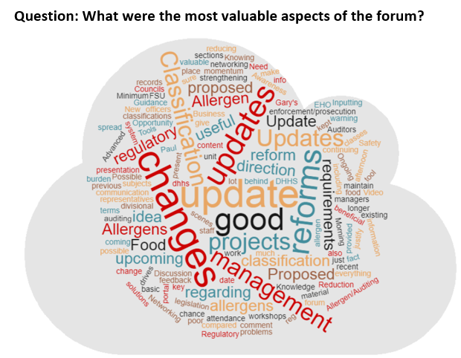

Figure 5: Stakeholder engagements in 2018 and 2019
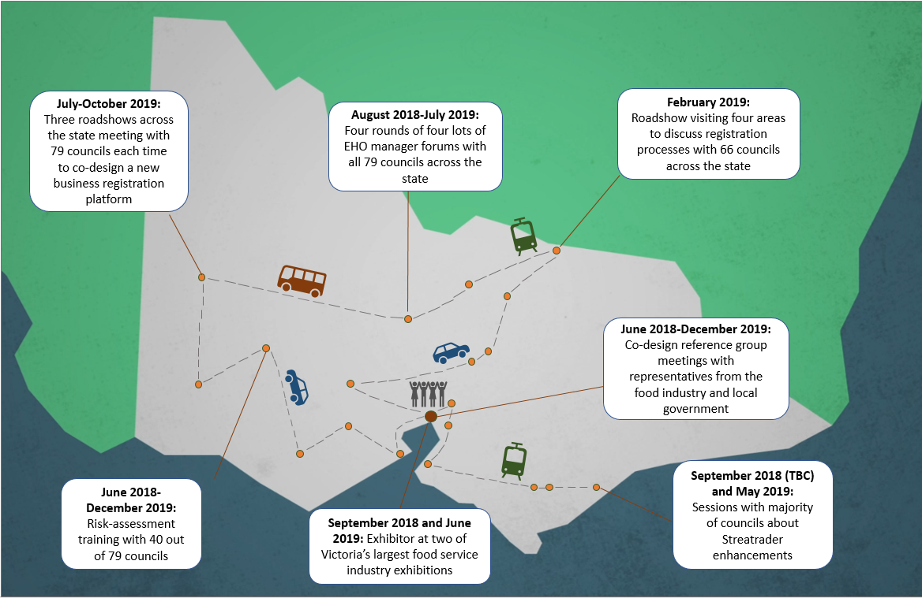
To receive this publication in an accessible format phone <1300 364 352>, using the National Relay Service 13 36 77 if required, or email <foodsafety@health.vic.go.au>
Authorised and published by the Victorian Government, 1 Treasury Place, Melbourne.
© State of Victoria, Department of Health and Human Services 2019.
Available from the Food Safety Unit, Department of Health and Human Services

