Completing your environmental management plan and checklist
Guidance for hospitals and health services

Overview
The following information has been prepared to assist your health service develop its environmental management plan:
- environmental management plan template
- sample environmental management actions template
- health service environmental sustainability requirements.

What’s new?
The environmental management plan template emphasises leadership, strategic goals, governance and reporting on outcomes of action plans. It is based on reviews of environmental management plans and feedback from health service staff.
The second part of the template includes an extensive list of possible actions your health service can choose to include in your action plan. The action plan can also be used to maintain a list of actions already undertaken and track progress in delivering actions.
Actions that are mandatory (M), either via legislation, policy etc, as well as those recommended (R) as a minimum have been pre-selected to ensure health services are meeting the minimum standard. The action plan includes indicators (see Figure 1) to provide an easy reference for your health service to rank actions according to their level of environmental maturity, with one being basic to 4 being optimised and embedded.
Maturity level | Maturity descriptor
1 | Action is assisting in developing awareness of environmental issues and the scale of the environmental impact. These actions are generally no, or low cost, and have minimal impact to business practices.
2 | Action is integrating environmental practices into business as usual processes. These actions are generally no, or low cost, or deliver quick tangible benefits. They often require a change in business practice.
3 | Action is integrating environmental practices into business as usual processes. These actions generally have a cost and deliver tangible and non-tangible benefits but over a longer time-frame.
4 | Action is leading practice and constantly being improved to drive organisations objectives.
Figure 1: Maturity index
On pages 3–4, you will find a step by step guide to completing your EMP template, action plan, and a checklist.

Statement of Priorities – environmental performance
The 2019–20 Statement of priorities, signed by all public hospitals and health services, includes a priority of supporting environmental sustainability.
Each health service will have identified how they intend to address the requirement. Access individual hospital and health service Statement of priorities <https://www2.health.vic.gov.au/hospitals-and-health-services/funding-performance-accountability/statement-of-priorities> on the department’s website.

Climate change adaptation planning
The Climate Change Act 2017 requires the Victorian Government to develop and prepare climate change adaptation action plans including the health and human services system by November 2020. Ahead of the legislated targets, the Victorian Government has developed two pilot adaptation action plans for sectors including the health and human services sector.
The health and human services pilot included five health service workshops in metropolitan, regional and rural regions.
The department will be working with health services over the next few years to support adaptation planning across the health system.
Relevant climate change adaptation actions can be included in the action plan and/or referenced to other related health service documents/plans, such as emergency management, or business continuity.
See the Health Service Environmental Sustainability requirements section on the Sustainability in Healthcare webpages <https://www2.health.vic.gov.au/hospitals-and-health-services/planning-infrastructure/sustainability/planning-reporting> for more information and check for updates.
Information on health and climate change for the public, including an informative video is available on the Better Health channel <https://www.betterhealth.vic.gov.au/health/healthyliving/climate-change-and-health>.
Information on tackling climate change and health with actions in health and human services is also available on the department’s ‘Tackling climate change’ website <https://www2.health.vic.gov.au/about/health-strategies/public-health-wellbeing-plan/tackling-climate-change>.

Sustainable Development Goals
The Sustainable Development Goals (SDGs) are a collection of 17 global goals set by the United Nations General Assembly in 2015 for the year 2030. The Victorian Health and Human Services Building Authority is aligning its reporting against the environmental sustainability strategy to the SDGs. There are a number of goals that health services are able to influence via their environmental management plans.
Individual actions in the action plan template are aligned with the SDGs, to assist health services who may wish to voluntarily align their environmental management plan and public reporting to the SDGs. Other SDGs may be relevant for other parts of the organisations plans and activities.
Further information is available on the UN SDG website <https://www.un.org/sustainabledevelopment/sustainable-development-goals/>.
You can also download the SDG icons <https://www.un.org/sustainabledevelopment/news/communications-material/>.
Figure 2: The United Nations 17 Sustainable Development Goals
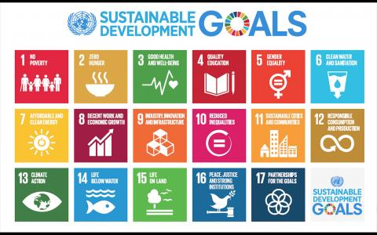

The process for completing your environmental management plan
- Compile all relevant documents, including previous environmental management plans, environmental data management system, public environment report and other relevant environmental data, annual environmental or sustainability reports, procedures and any previous environmental impacts/materiality mapping.
- Review the materials and data to provide an initial snapshot of past actions, current impacts and trends.
- Bring together representatives from key areas across the organisation to discuss outputs of step 2. Ensure that multi campuses are covered and include any staff that may have had previous responsibilities such as, green champions.
- Using the information from steps 1 and 2, undertake an assessment of environmental impacts and identify next actions. The following questions can help with this process:
    - What are the biggest impact areas?
    - What actions has your organisation completed previously?
      - Have any of the previous achievements lost traction and need adding to the action plan?
    - Are there opportunities for easy wins? Some actions may not have a big material impact, but may be worth doing if the actions are easy, low cost, engage staff, or in cumulation add up to a material improvement?
    - What are the next areas for your health service to address?
      - Have you included areas outside of the key focus areas of energy, water and waste? Are there specific opportunities and related actions in a particular area, team, process?
    - Are there actions which promote collaboration between different areas, or innovation?
    - Are there other stakeholders that should be involved that might be able to assist with the implementation of actions, or provide further input before the action plan is finalised?
- Use the sample actions template to select items to include in your action plan. Modify, or add to any as required.
- Establish regular reporting mechanisms, including public reporting, internal reporting of progress and a review date for the action plan and environmental management plan / strategy.
- Sign-off the checklist as appropriate to confirm all the relevant steps have been included.

Instructions for completing your health service action plan using the sample action plan template

Selecting your actions
- Select items you wish to include in the plan, by placing a Y in the select column.
- All mandatory (M) and recommended (R) items have been pre-selected. If there are any items that are recommended that you do not wish to include, you can deselect them by deleting the Y and leaving the cell blank. Do not deselect mandatory items.
- If you wish to include new actions not included in sample actions template or modify example actions, you can add a Y in the select column so they appear in the filtered list.
- If you wish to track completed actions, you can add a C in the select column for completed actions.

Sorting the categories into order
- Once you have selected all the items you wish to include, select all the rows and columns within the actions rows and columns and excluding any rows and columns that are blank.
- Select ‘Custom sort’, which should contain a preselected sort in the correct order (See figure 3).
- This will sort all the items into the correct order by category heading, level of maturity, mandated and recommended.
- Use the filter (ensuring the filter is switched on) to display your health service custom actions by filtering by Y. This will display all the items selected. You can also include the completed actions by selecting Y and C and or in the custom sort.

Tips
Save a back-up, especially if you are unfamiliar with sorting. If your actions end up under the wrong sections or out of order, just re-run the sort, and this should put them back into the correct order.
Consider using the spreadsheet as a master sheet and hide rows as necessary but do not delete any contents. There are hidden action references in column A, so that when we produce a new edition, any previous actions can be referred to.
If you wish to create your own internal references, we suggest you create this in column 2 or 3 but do not delete any hidden rows.
Figure 3: Screenshot of custom sort in Excel
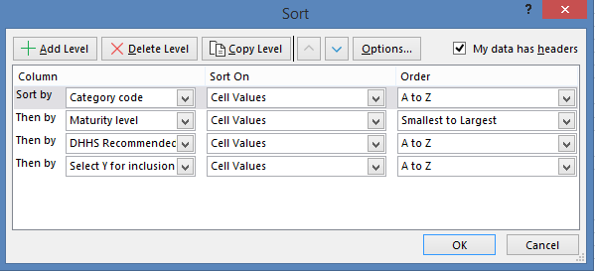

Environmental management planning checklist

Action | Completed yes/no | Comments
Gather then review previous strategies/ to inform the next plan
Set baseline data
Review key impacts (also known as materiality assessment)
Identify and engage key staff/ units, including any green champions
Establish governance arrangements for overseeing and reviewing environmental management plan
Align strategic goals with:
- Statement of priorities
- VHHSBA environmental sustainability strategy directions
- Sustainable Development Goals (optional)
Set targets ensuring they align with the goals and action plan
Identify actions to be implemented over the life of the EMP
Ensure all key sections are included in the plan:
- CEO statement
- strategic goals
- governance and reporting
- policy
- targets
- baseline data
- communications plan

Completed by:
Next review date:

To receive this publication in an accessible format phone 03 9096 2119, using the National Relay Service 13 36 77 if required, or email the Sustainability team <sustainability@dhhs.vic.gov.au>
Authorised and published by the Victorian Government, 1 Treasury Place, Melbourne.
© State of Victoria, Australia, Victorian Health and Human Services Building Authority January 2020.
ISBN 978-1-76069-179-0 (pdf/online/MS word)
Available at Health.vic website <https://www2.health.vic.gov.au/hospitals-and-health-services/planning-infrastructure/sustainability/planning-reporting>.

