Child Development Information System process guidance for information sharing – workaround 2019–20
Victorian Maternal and Child Health (MCH) Child Development Information System (CDIS)
Contents
Terms and definitions 1
Process 1

Terms and definitions
Abbreviation | Meaning
CISS | Child Information Sharing Scheme
CRAF | Common Risk Assessment Framework
FVISS | Family Violence Information Sharing Scheme
ISE | Information Sharing Entity
ISS or IS | Information Sharing Schemes; Information Sharing
MARAM Framework | Multi-Agency Risk Assessment and Risk Management Framework
RAE | Risk Assessment Entity

Process
- First ensure ISE is verified and, if it is also a RAE, if request is for assessment purpose by:
    - immediate call back to confirm Organisation; or
    - requesting an email from ISE to verify Organisation credentials in email signature
- If correspondence is in writing, complete appropriate IS Correspondence Template and select from:
    - Making a request template
    - Responding to information request template
    - Update to responder post sharing template
    - Proactively sharing template
- Complete and Save template as PDF in temporary Desktop location and proceed to next step.

- Open CDIS Client Health Record to document information sharing:
    - Open client screen, open Clinical Activity menu and select ‘Client Not Present’
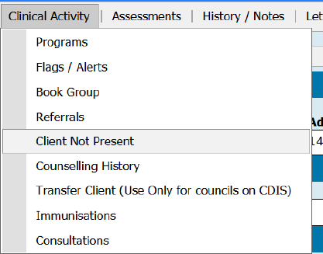
- Select the type of information sharing
    - For Agency, select ‘Information Sharing Schemes – ISS’
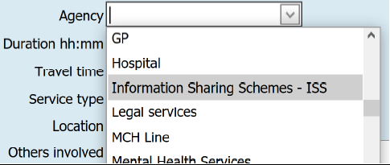
- Complete information sharing details
    - Service type: select information sharing format
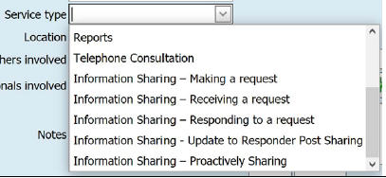
    - Others involved: record the ISE or RAE requesting or sharing information.
- For receiving request: Record received information sharing detail in notes section – ‘Information sharing request received as per [attached or notes] – and then create a new client entry for responding to a request
    - Written request: attach any received templates and in notes record ‘refer to attached [filename].docx’
    - Verbal request: Fill out request detail in notes section

- For making a request, responding to a request, proactively sharing or update to responder: Upload complete IS correspondence template into CDIS client record:
    - From the Client screen, open the ‘History/Notes’ menu and select Attachments
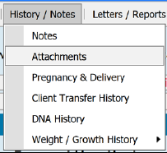
    - Select ‘Add Attachment’ button
    - Under ‘Type’, select ‘Information Sharing’
    - Select ‘Browse’ to find and upload the required file
    - Complete and select ‘Save’
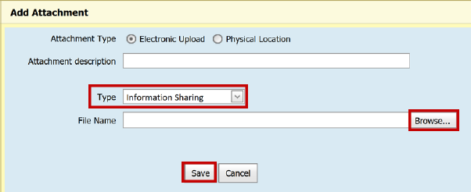
- Attach template PDF to email and send email
- Delete template PDF
    - Find the saved PDF file and delete it
    - If you have any problems finding or deleting the file, request IT assistance.
To receive this publication in an accessible format phone 1300 650 172, using the National Relay Service 13 36 77 if required, or email Commissioning Performance and Improvement Aged and Community Based Health Care and Cancer Services <mch@dhhs.vic.gov.au>
Authorised and published by the Victorian Government, 1 Treasury Place, Melbourne.
© State of Victoria, Australia, Department of Health and Human Services June 2020.
ISBN 978-1-76096-028-5 (pdf/online/MS word)
Available at health.vic – Child Development Information System <https://www2.health.vic.gov.au/primary-and-community-health/maternal-child-health/child-development-information-system>

