Forensic Leave Panel
Annual report 2019

To receive this document in an another format phone 1800 222 987, using the National Relay Service 13 36 77 if required, or email the Forensic Leave Panel <flp@dhhs.vic.gov.au>.
Authorised and published by the Victorian Government, 1 Treasury Place, Melbourne.
© State of Victoria, Department of Health and Human Services, September 2020
ISSN 2206-5962 (Online/PDF/Word)
Available from the Forensic Leave Panel’s webpage <https://www2.health.vic.gov.au/mental-health/mental-health-services/services-by-type/forensic-mental-health-services/forensic-leave-panel>
(2008785 – cover and figures)

Forensic Leave Panel
Annual report 2019

15 September 2020

The Hon. Jill Hennessy MP
Attorney-General
Level 26, 121 Exhibition Street
Melbourne VIC 3000

Dear Attorney-General
In accordance with s. 63 of the Crimes (Mental Impairment and Unfitness to be Tried) Act 1997 (Vic), I am pleased to submit the annual report on the operations of the Forensic Leave Panel for the year ending 31 December 2019 for tabling in parliament.
A copy of this report has also been provided to the Minister for Mental Health, the Hon. Martin Foley MP, and the Minister for Disability, Ageing and Carers, the Hon. Luke Donnellan MP, who are also responsible in part for the operation of the Act.
Yours sincerely
The Hon. Justice Terry Forrest
President
Forensic Leave Panel
Contents
President’s report 7
Forensic Leave Panel Reform Project 7
Royal Commission into Victoria's Mental Health System 7
Professional development 7
Crimes (Mental Impairment and Unfitness to be Tried) Amendment Bill 8
Statistical data 8
Acknowledgements 8
Definitions 9
The Forensic Leave Panel 10
Who we are 10
What we do 10
How we do it 10
Our people 11
Membership 11
Changes to our membership 12
The leave framework 13
On-ground leave and limited off-ground leave 13
Criteria for granting leave 13
Conditions attached to leave 13
Purpose of leave 14
Progression of leave 14
Suspension of on-ground and limited off-ground leave 14
The hearing process 15
Hearings 15
Applications for leave 15
Supporting documentation 15
Conduct of hearings 16
Decisions about leave 16
Operational report 17
The year in review 17
Our finances 19
Appendix 1: The legal framework 20
Legal framework for progression under the Act 21
Appendix 2: Membership as at 31 December 2019 22
Supreme Court judges 22
County Court judges 22
Chief Psychiatrist and nominees 23
Psychiatrist members 23
Psychologist members 24
Community members 24
Appendix 3: Historical data 26
General information 26
Type of leave applications 26
Leave requests granted, suspended, appealed and revoked 27
Applicant demographics 28
Sentencing information 28
Appendix 4: Figure description 29
Figure 2: Legal framework for progression under the Act Crimes (Mental Impairment and Unfitness to be Tried) Act 1997 29

President’s report

I am pleased to present the annual report of the Forensic Leave Panel for 2019 – my first annual report as president of the panel.
I would like to thank my predecessor, the former Justice Kevin Bell AM QC, for his outstanding stewardship of the panel over the past five years. Justice Bell joined the FLP in April 2014 and became its president in February 2015. It was a pleasure working with him, and I admire the vision and initiative with which he led the panel throughout his time as president.
I would also like to thank Judge Frank Saccardo, who recently retired from the County Court, for his tireless commitment to the panel. I wish Judge Saccardo all the best.

Forensic Leave Panel Reform Project
The panel is committed to continuously improving its operations. In late 2018 the Forensic Leave Panel Reform Project was initiated in partnership with the Department of Health and Human Services and Forensicare.
The project aims to modernise the operations of the panel, improve understanding of the panel's processes, promote engagement by forensic patients and residents in forensic leave processes and support panel members in their work through professional development.
As part of the project, forensic leave processes and procedures have been reviewed and new and improved hearing processes, leave application forms and panel member induction processes have been implemented. Informative resources, such as brochures and posters, have been developed for forensic patients and residents and their carers and families, which will be available shortly. This work has been informed by the views and experiences of key stakeholders including forensic patients and residents. The project is now in its final stages and is due to be completed in late 2020.

Royal Commission into Victoria's Mental Health System
On 24 October 2018 the Premier, Daniel Andrews, announced the Royal Commission into Victoria's Mental Health System, and the terms of reference were finalised in February 2019. Public hearings were held throughout July 2019, with an interim report released in October. The royal commission is considering the forensic mental health system as part of its remit. We await the final report, which is due in February 2021.

Professional development
In August 2019 we held a professional development session for our members titled ‘Treatment, Rehabilitation and the Role of the Forensic Leave Panel’. In this session we heard from the senior consumer consultant at Forensicare, Julie Dempsey, and the general manager at the Disability Forensic Assessment and Treatment Service, Dr Matt Frize. The session provided information on the role of forensic leave in the recovery and rehabilitation of both forensic patients and forensic residents. It was interesting to see the differences across the mental health and disability services and how leave is used to assist forensic patients and forensic residents on their journey towards reintegration into the community.
The annual Forensic Leave Panel Members Forum was held on 3 December 2019 and included a presentation by two former consumers of Thomas Embling Hospital titled ‘The Consumer Voice’. Both consumers had previously resided at Thomas Embling Hospital, and forensic leave was part of their recovery and return to the community. It was a fascinating session that highlighted the importance of the decisions the panel makes while also providing insight into how consumers feel when coming before the panel, how it feels to have an application for leave denied, and their reflections on the process.

Crimes (Mental Impairment and Unfitness to be Tried) Amendment Bill
On 17 March 2020 the government introduced the Crimes (Mental Impairment and Unfitness to be Tried) Amendment Bill 2020 to parliament.
Subject to passage through Parliament, this Bill will transfer the functions of the panel to the Mental Health Tribunal, creating a new Forensic Division of the tribunal. The Forensic Division will comprise a legal member (providing the legal expertise previously provided by the judicial members on the panel), a psychiatrist or psychologist member, and a community member. The position of the Chief Psychiatrist and nominees on the panel will not be transitioned to the tribunal; however, the Chief Psychiatrist will continue to oversee mental health services and provide clinical leadership.
I acknowledge that this presents a significant period of change for the panel and I thank panel members for their support. The panel is committed to doing everything we can to support the smooth transition of the panel's functions to the tribunal.

Statistical data
This annual report shows that during 2019 the panel conducted 30 hearings (five for forensic residents and 25 for forensic patients) over 26 hearing days. This is the highest number of hearings in a year for the panel and reflects our decision to implement a maximum number of applications to be heard on any one day while scheduling more hearings to ensure forensic patients and forensic residents can still be seen by the panel in a timely manner. By managing the number of applications for each hearing we ensure hearing days are of a reasonable length and decision making is not affected by fatigue brought on by long days.
There was an increase in the number of forensic patients and residents making applications for on-ground and limited off-ground leave from 92 in 2018 to 103 in 2019. This is the highest number in the panel’s history.
The panel considered 216 applications for on-ground and limited off-ground leave and granted 96 per cent of those applications.
The data contained in this report shows that the rates of grant and refusal of applications have been fairly consistent since 2010 (see Appendix 3: Historical data).

Acknowledgements
I would like to acknowledge the expertise and skill of the members of the panel and thank them for their invaluable contribution to the operation of the panel. In particular, I would like to thank our three members who finished up in 2019: Her Honour Judge Elizabeth Gaynor, Ms Kathleen Bragge and Mr John Leatherland, who have served a combined 25 years on the panel. Such dedication and commitment is what makes this panel unique.
I wish to acknowledge the important role of the lawyers from Villamanta Disability Rights Legal Service Inc. and Victoria Legal Aid in providing legal representation and advice to applicants at panel hearings.
I also wish to express my appreciation of the work and commitment of the staff of the Disability Forensic Assessment and Treatment Service, the Long-Term Residential Program, the Thomas Embling Hospital and the Mental Health and Drugs Branch of the Department of Health and Human Services.
The Hon. Justice Terry Forrest
President
Forensic Leave Panel

Definitions

Throughout this report, unless otherwise specified:
- ‘the Act’ refers to the Crimes (Mental Impairment and Unfitness to be Tried) Act 1997
- ‘the panel’ refers to the Forensic Leave Panel
- ‘forensic patient’ or ‘patient’ is a person remanded in or committed to custody in a designated mental health service under the Mental Health Act 2014
- ‘forensic resident’ or ‘resident’ is a person remanded in or committed to custody in a residential treatment facility or a residential institution under the Disability Act 2006
- ‘types of leave’ refers to on-ground and limited off-ground leave
- ‘purpose of leave’ refers to activities undertaken while a forensic patient or resident is on leave
- ‘DFATS’ refers to the Disability Forensic Assessment and Treatment Service, which is a part of the Victorian Department of Health and Human Services
- ‘Forensicare’ refers to the Victorian Institute of Forensic Mental Health, which is a statutory body established by the Mental Health Act.

The Forensic Leave Panel

Who we are
The panel is an independent statutory tribunal established under the Act to support the rehabilitation of forensic patients and residents and assist with their reintegration into the community.
The panel comprises members of the judiciary, the Chief Psychiatrist and nominees, psychiatrists, psychologists and members from the community.

What we do
The main role of the panel is to hear applications for on-ground and limited off-ground leave from patients and residents to enable them to participate in a range of activities in the community to aid their rehabilitation. The panel also hears appeals from patients and residents regarding refusal of special leave and transfers from one designated mental health service to another.

How we do it
The panel conducts hearings at the Thomas Embling Hospital campus of Forensicare and at DFATS in Fairfield to consider applications for on-ground and limited off-ground leave from forensic patients and residents.
The panel considers applications from forensic patients and residents over the duration of their custody or detention.
Over time, the panel may grant incremental increases to a person’s leave into the community when it is appropriate to do so. Leave is granted for a maximum period of six months at any one time.
Appendix 1: The legal framework provides an overview of how a patient or resident may progress under the Act. It also identifies the panel’s responsibilities in the detention, management and release framework.

Our people

Membership
As at 31 December 2019, the panel comprised:
- seven judicial members from the Supreme Court of Victoria
- five judicial members from the County Court of Victoria
- the Chief Psychiatrist
- four nominees of the Chief Psychiatrist
- seven registered medical practitioners with experience in forensic psychiatry
- three registered psychologists with experience in intellectual disability and forensic psychology
- seven members to represent the views and opinions of the community.
The panel is supported by an executive officer, who works from the Mental Health and Drugs Branch of the Victorian Department of Health and Human Services.
The structure of the panel is outlined in Figure 1.

Figure 1: Panel membership
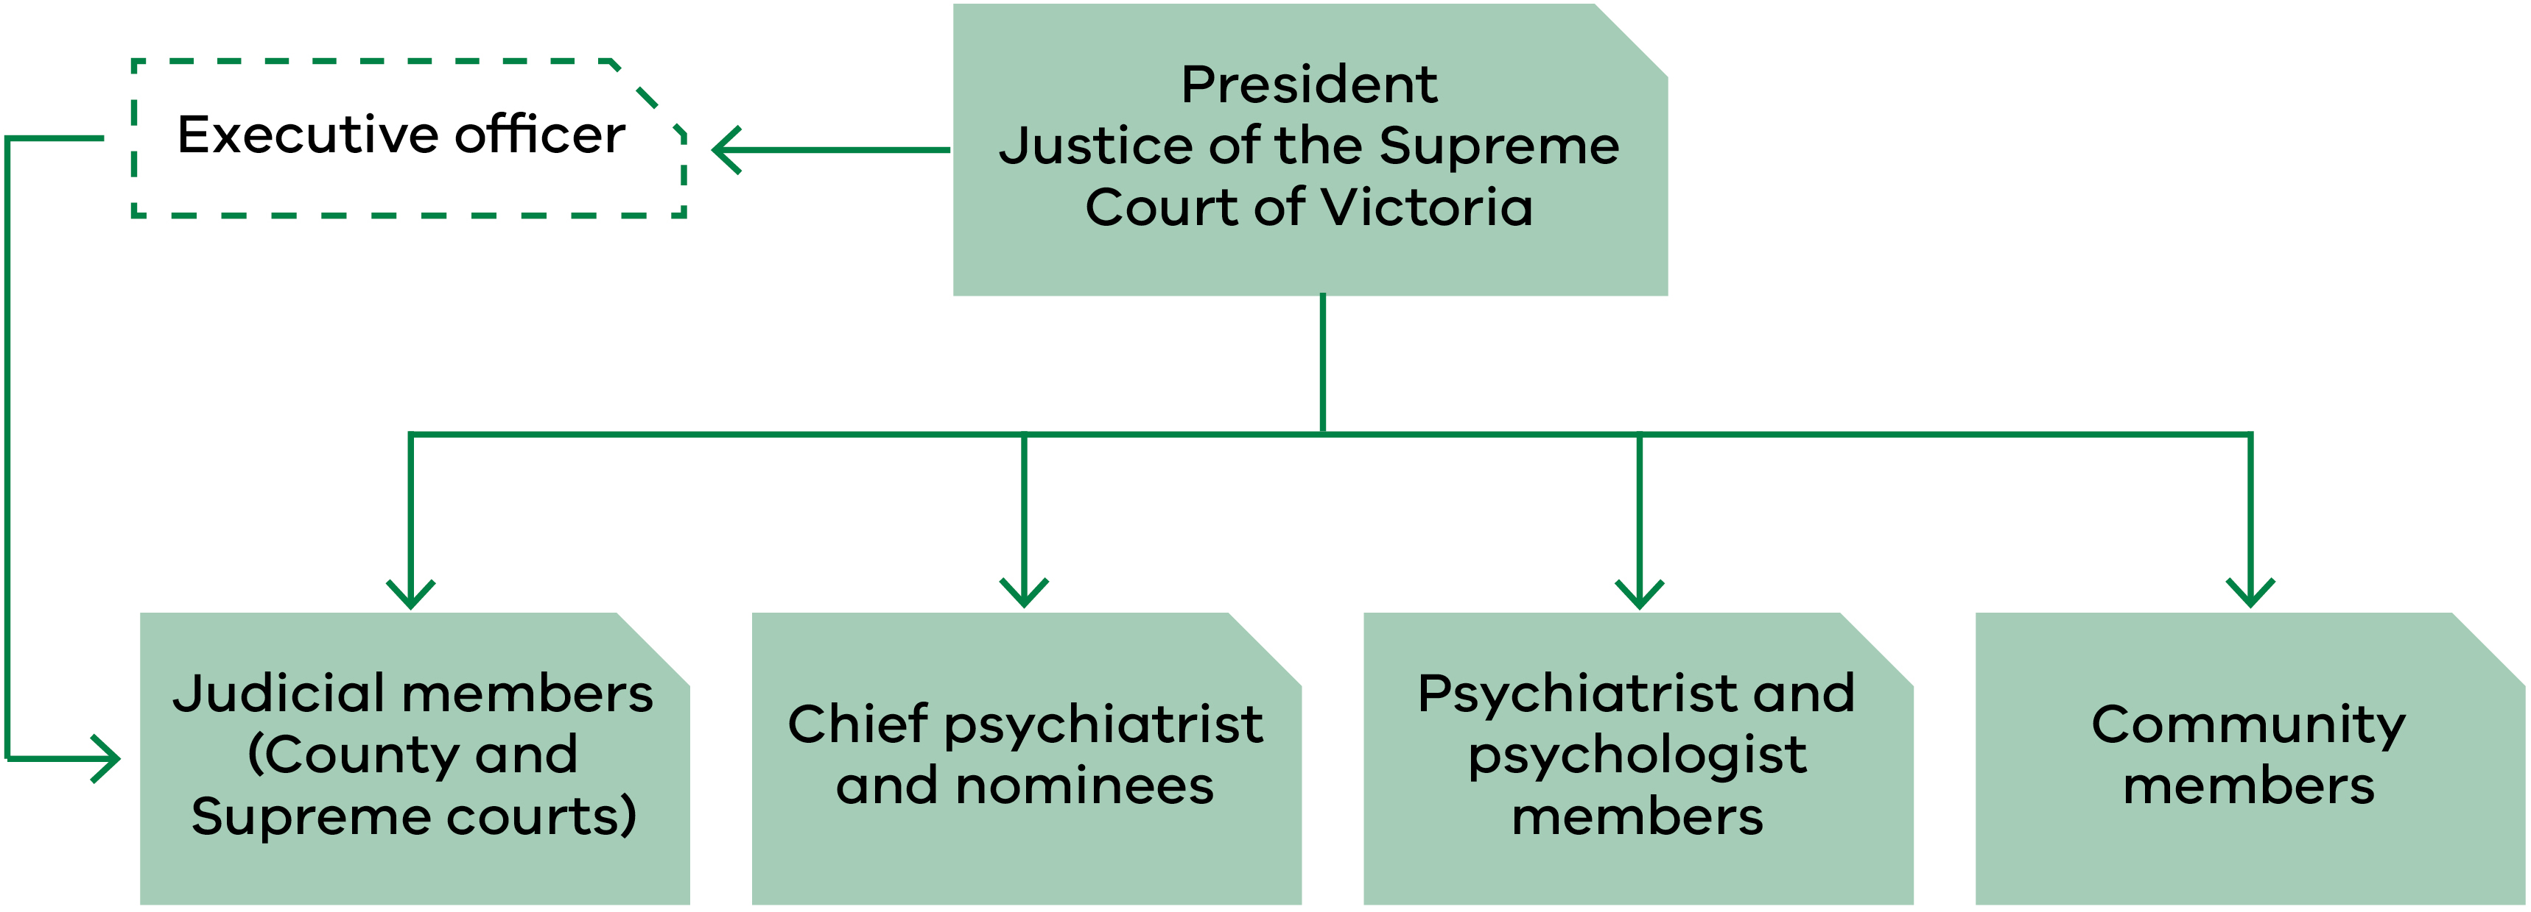
‘Appendix 2: Membership as at 31 December 2019’ contains a complete list of members, including their terms of appointment.

Changes to our membership

Supreme Court judicial members
- Justice Rita Incerti began her first term on 28 May 2019.

County Court judicial members
- Judge Elizabeth Gaynor resigned on 13 June 2019 after serving two and a half terms.

Psychiatrist members
- Dr Jennifer Torr was reappointed for her second term on 2 June 2019.

Psychologist members
- Dr Marilyn McMahon was reappointed for her second term on 30 August 2019.

Community members
- Dr Leslie Cannold began her first term on 30 August 2019.
- Mr Paul Newland was reappointed for his seventh term on 30 August 2019.
- Ms Patricia Harper was reappointed for her third term on 30 August 2019.
- Dr Genevieve Grant was reappointed for her fourth term on 30 August 2019.
- Ms Kathleen Bragge finished on 29 August 2019 after serving four terms.
- Mr John Leatherland finished on 29 August 2019 after serving two terms.

The leave framework

On-ground leave and limited off-ground leave
The panel has jurisdiction under the Act to grant on-ground and limited off-ground leave to forensic patients and forensic residents.
The maximum period for which on-ground and limited off-ground leave can be granted is six months. At the end of this period, a patient or resident may reapply to the panel.

On-ground leave
On-ground leave allows forensic patients and residents to be absent from the place of custody but within a defined area around the place of custody, known as ‘the surrounds’.
Forensic residents at the Long-Term Residential Program in Bundoora make extensive use of on-ground leave. Forensic patients at the Thomas Embling Hospital campus of Forensicare and forensic residents at DFATS do not require on-ground leave because there are sufficient grounds within the secure perimeter. Accordingly, no grounds have been declared under s. 52 of the Act in relation to Thomas Embling Hospital or DFATS.

Limited off-ground leave
Limited off-ground leave permits patients and residents to be absent from the place of custody between 6.00 am and 9.00 pm, or outside those hours for a maximum of three days in any seven-day period.

Criteria for granting leave
The panel may grant on-ground or limited off-ground leave if it is satisfied that both:
- the proposed leave will contribute to the patient’s or resident’s rehabilitation
- the safety of the person or members of the public will not be seriously endangered as a result of the patient or resident being allowed leave.
In determining whether to grant an application for leave or variation of leave, the panel must consider:
- the person’s current mental condition or pattern of behaviour
- the person’s clinical history and social circumstances
- the person’s applicant profile and leave plan or statement, prepared in accordance with the Act.

Conditions attached to leave
The panel can place any conditions on leave that it considers appropriate. Conditions commonly relate to:
- how many, if any, escorts are required
- the duration and frequency of leave
- where a patient or resident may go (or where they may not go)
- the people a patient or resident can meet while on leave
- how a patient or resident is to travel to their leave destination
- drug and alcohol testing following leave.

Purpose of leave

The purpose of leave is to assist the rehabilitation process and provide a gradual progression towards a return to community living that is consistent with the needs of the individual and with community safety.
Patients and residents can apply to the panel to participate in a broad range of activities. All leave must form part of an overarching treatment and recovery plan. Common purposes of leave granted include leave to:
- attend medical, legal, dental or allied health appointments
- undertake activities of daily living such as personal shopping, banking and exercise
- build or maintain relationships with family and friends in the community
- participate in therapeutic and rehabilitation groups, activities or programs
- attend educational and vocational activities, groups or courses
- participate in or seek voluntary and/or paid employment.

Progression of leave
The panel takes a graduated approach to granting leave. Initially, a patient or resident is granted a small amount of leave and is escorted by two or three staff members. This could include leave to attend medical appointments or may allow a patient or resident to attend a nearby facility (such as a park or a café) for one hour a week.
If a patient or resident can successfully participate in leave over a sustained period, the panel may decrease the number of escorts and increase the number of approved locations and purposes, as well as the duration, of further leave. This process allows patients or residents to gradually increase their participation in a wide variety of activities that form part of everyday living in order to prepare them for release back into the community. This slow approach to leave allows for a steady reintroduction into the community and provides staff with a valuable opportunity to monitor how the person copes and adapts in a community setting.
A patient’s or resident’s progression depends entirely on individual circumstances. The progression outlined above may not be the path followed by all patients and residents, and some may move backwards and forwards between various stages of this process, depending on their progress and response to treatment.

Suspension of on-ground and limited off-ground leave
Regular monitoring and review of leave take place to ensure the safety of each patient or resident and members of the public are not seriously endangered. Before forensic residents or patients may access leave granted by the panel, they are subject to clinical assessment.
The Act contains provisions that allow the Chief Psychiatrist (in the case of patients) and the Secretary to the Department of Health and Human Services (in the case of residents) to suspend leave granted by the panel if they are satisfied that the safety of the person or members of the public will be seriously endangered if leave is not suspended. The panel is required to record and report any suspensions of leave.
In 2019 there were no leave suspensions for residents by the Secretary. There were nine instances of leave being partially or wholly suspended by the Chief Psychiatrist during 2019.

The hearing process

Hearings
The panel must conduct its hearings at the place where the patient or resident is detained to enable the person to attend and participate fully in the proceedings, unless the president determines otherwise.
Patient hearings are held at Thomas Embling Hospital and the panel is made up of:
- a judge from the Supreme or County Court (depending on the patient’s original court of disposition)
- the Chief Psychiatrist or nominee
- a registered medical practitioner with experience in forensic psychiatry
- a community member.
Resident hearings are held at DFATS in Fairfield and the panel is made up of:
- a judge from the Supreme or County Court (depending on the resident’s original court of disposition)
- a registered psychologist with experience in intellectual disability and forensic psychology
- a community member.

Applications for leave
A forensic patient or resident may apply to the panel for on-ground and limited off-ground leave. Each type of leave can include one or more purposes of leave.
All applications must specify:
- the type of leave
- the purpose(s) of leave (for example, grocery shopping)
- the duration and frequency of each purpose (for example, two hours, once per week)
- the destination for each purpose (for example, the name of the shopping centre)
- the relationship to the person’s rehabilitation (for example, to build or maintain daily living skills).

Supporting documentation
Other documentation that must be submitted to the panel includes:
- an applicant profile
- a report from the consultant psychiatrist or psychologist
- a detailed leave plan prepared by the patient’s or resident’s treating team.
These are described below.

Applicant profile
The profile must contain the following information:
- the person’s impairment, condition or disability
- the relationship between the impairment, condition or disability and the offending conduct
- the person’s clinical history and social circumstances
- the person’s current mental state or pattern of behaviour
- the offence that led to the supervision order being made
- the date of the supervision order, its nominal term and the day from which the nominal term had been declared to run.

Report from the consultant psychiatrist or psychologist
This report provides information on the person’s current mental state, medication, a risk assessment and any conditions that the clinician recommends should be placed on the leave. The clinician will also indicate if they support all or some of the purposes of leave being applied for by the patient or resident.

Detailed leave plan
This plan is intended to demonstrate how any previous leaves have progressed and how the present leave applied for may contribute to the person’s rehabilitation goals. The plan also allows the person’s treating team to recommend any leave conditions or to recommend that leave should not be granted.

Conduct of hearings
Hearings are closed to the public, unless the panel directs otherwise on the basis that it is in the best interest of the person or is in the public interest. Open hearings rarely occur, although the panel may occasionally allow an observer to be present for training or professional development purposes. No open hearings were conducted in 2019.
The panel must act according to equity and good conscience and is bound by the rules of natural justice.
The panel is not required to conduct its hearings in a formal manner. It is not bound by rules or practice relating to evidence and may inform itself on matters as it sees fit. This may include requests for additional information or, by way of summons, request that another party attend.
During the hearing the panel discusses the leave application with the patient or resident and their treating team. Discussions focus on such things as the person’s current mental state and pattern of behaviour, any notable achievements or incidents since the person’s last panel hearing and how any previous leaves granted by the panel have progressed.
If the patient or resident requires assistance during a hearing, the panel will engage an interpreter or other specialist, as necessary. During the year, the panel engaged an interpreter on 16 occasions, in the following languages:
- Arabic
- Auslan
- Italian
- Mandarin
- Turkish
- Vietnamese.
Applicants have a right to legal representation at hearings. One patient and nine residents chose to be legally represented over the course of the year on 11 separate occasions. One applicant was represented twice, and nine applicants were represented once.

Decisions about leave
At the end of each hearing the panel advises the patient or resident of its decision and gives verbal reasons. A written determination is issued to the patient or resident after the hearing outlining the leave that was granted or refused and any conditions attached to the leave.
A patient or resident has the right to request a written statement of reasons for the decision. In 2019 no requests were made for a written statement of reasons.

Operational report

The year in review

Forensic patients
Measure | 2019 | 2018 | Change
Applicants | 93 | 85 | +8
Male applicants | 77 | 70 | +7
Female applicants | 16 | 15 | +1
Applicants on Supreme Court orders | 56 | 53 | +3
Applicants on County Court orders | 37 | 32 | +5
First-time applicants | 10 | 9 | +1
Hearings | 25 | 23 | +2
Applications received | 200 | 203 | –3
Individual leave purposes requested | 883 | 939 | –56
Applications for on-ground leave | 0 | 0 | 0
Applications for limited off-ground leave | 200 | 203 | –3
Leave granted without modification | 87% | 90% | –3%
Leave granted with modification | 9% | 7% | 2%
Total leave granted | 95% | 97% | –2%
Leave refused | 5% | 4% | 1%
Leave suspensions by the Chief Psychiatrist | 9 | 9 | 0
Leave suspensions by the Secretary to the Victorian Department of Health and Human Services | N/A | N/A | 0
Times a patient or resident was assisted by an interpreter | 12 | 10 | +2
Languages used | 5 | 5 | 0
Legal representation | 1 | 4 | –3
Appeals against refusal of special leave | 0 | 0 | 0

Forensic residents
Measure | 2019 | 2018 | Change
Applicants | 10 | 7 | +3
Male applicants | 10 | 7 | +3
Female applicants | 0 | 0 | 0
Applicants on Supreme Court orders | 3 | 3 | 0
Applicants on County Court orders | 7 | 4 | +3
First-time applicants | 4 | 0 | +4
Hearings | 5 | 4 | +1
Applications received | 16 | 13 | +3
Individual leave purposes requested | 91 | 86 | +5
Applications for on-ground leave | 5 | 4 | +1
Applications for limited off-ground leave | 16 | 13 | +3
Leave granted without modification | 99% | 99% | 0%
Leave granted with modification | 1% | 1% | 0%
Total leave granted | 100% | 100% | 0%
Leave refused | 0% | 0% | 0%
Leave suspensions by the Chief Psychiatrist | N/A | N/A | N/A
Leave suspensions by the Secretary to the Victorian Department of Health and Human Services | 0 | 0 | 0%
Times a patient or resident was assisted by an interpreter | 4 | 4 | 0
Languages used | 1 | 1 | 0
Legal representation | 10 | 8 | +2
Appeals against refusal of special leave | 0 | 0 | 0

The panel’s statistical information has remained relatively constant over recent years. Although variations occur in the number of hearings, applicants and applications, these differences are consistent with changes in the forensic patient and resident population.
Individual applications for leave remained the same at 216 in both 2018 and 2019, although the number of applicants requesting leave increased from 92 in 2018 to 103 in 2019. While it would be expected that the number of applications would increase with more applicants, this did not occur because of changes to the way leave plans are developed at Thomas Embling Hospital. There has been a greater focus on preparing leave applications that are designed to cover a longer period and do not require applicants to return as regularly for amendments.
Requests for distinct leave purposes decreased from 1,025 in 2018 to 974 in 2019. The number of leave applications per person varied from one to five, with an average of 2.1 leave applications by each forensic patient or resident. Out of the 103 applicants over the calendar year:
- Sixteen made one application.
- Sixty-three made two applications.
- Twenty-three made three applications.
- One made five applications.
‘Appendix 3: Historical data’ contains more information on the number of patients and residents, hearings, leave applications and other demographic data for the period from 2010 to 2019.

Our finances
The Health and Wellbeing Division of the Department of Health and Human Services provided all operational support to the panel, managed the panel’s budget and maintained accounts and records. The department’s audited financial statements include the panel’s expenditure, which is reported in the department’s annual report.

Appendix 1: The legal framework

The Crimes (Mental Impairment and Unfitness to be Tried) Act 1997 provides for the management, supervision and release of persons found unfit to stand trial or not guilty of an offence because of mental impairment.
Under the Act, a court can impose several different supervision orders if it finds a person unfit to plead or not guilty because of mental impairment:
- custodial supervision orders (CSOs), which commit a person to custody in a designated mental health service under the Mental Health Act 2014 or to a residential treatment facility or residential institution under the Disability Act 2006
- CSOs, which commit a person to custody in a prison but only if the court is satisfied that no practicable alternative exists
- non-custodial supervision orders (NCSOs), which allow the person to live in the community, subject to conditions decided by the court and specified in the order.
The court also has the discretion to release a person unconditionally.
Figure 2 presents a brief overview of how a person may progress through the system under the Act and demonstrates where the panel is situated within this framework.

Legal framework for progression under the Act
Figure 2: Legal framework for progression under the Act Crimes (Mental Impairment and Unfitness to be Tried) Act 1997
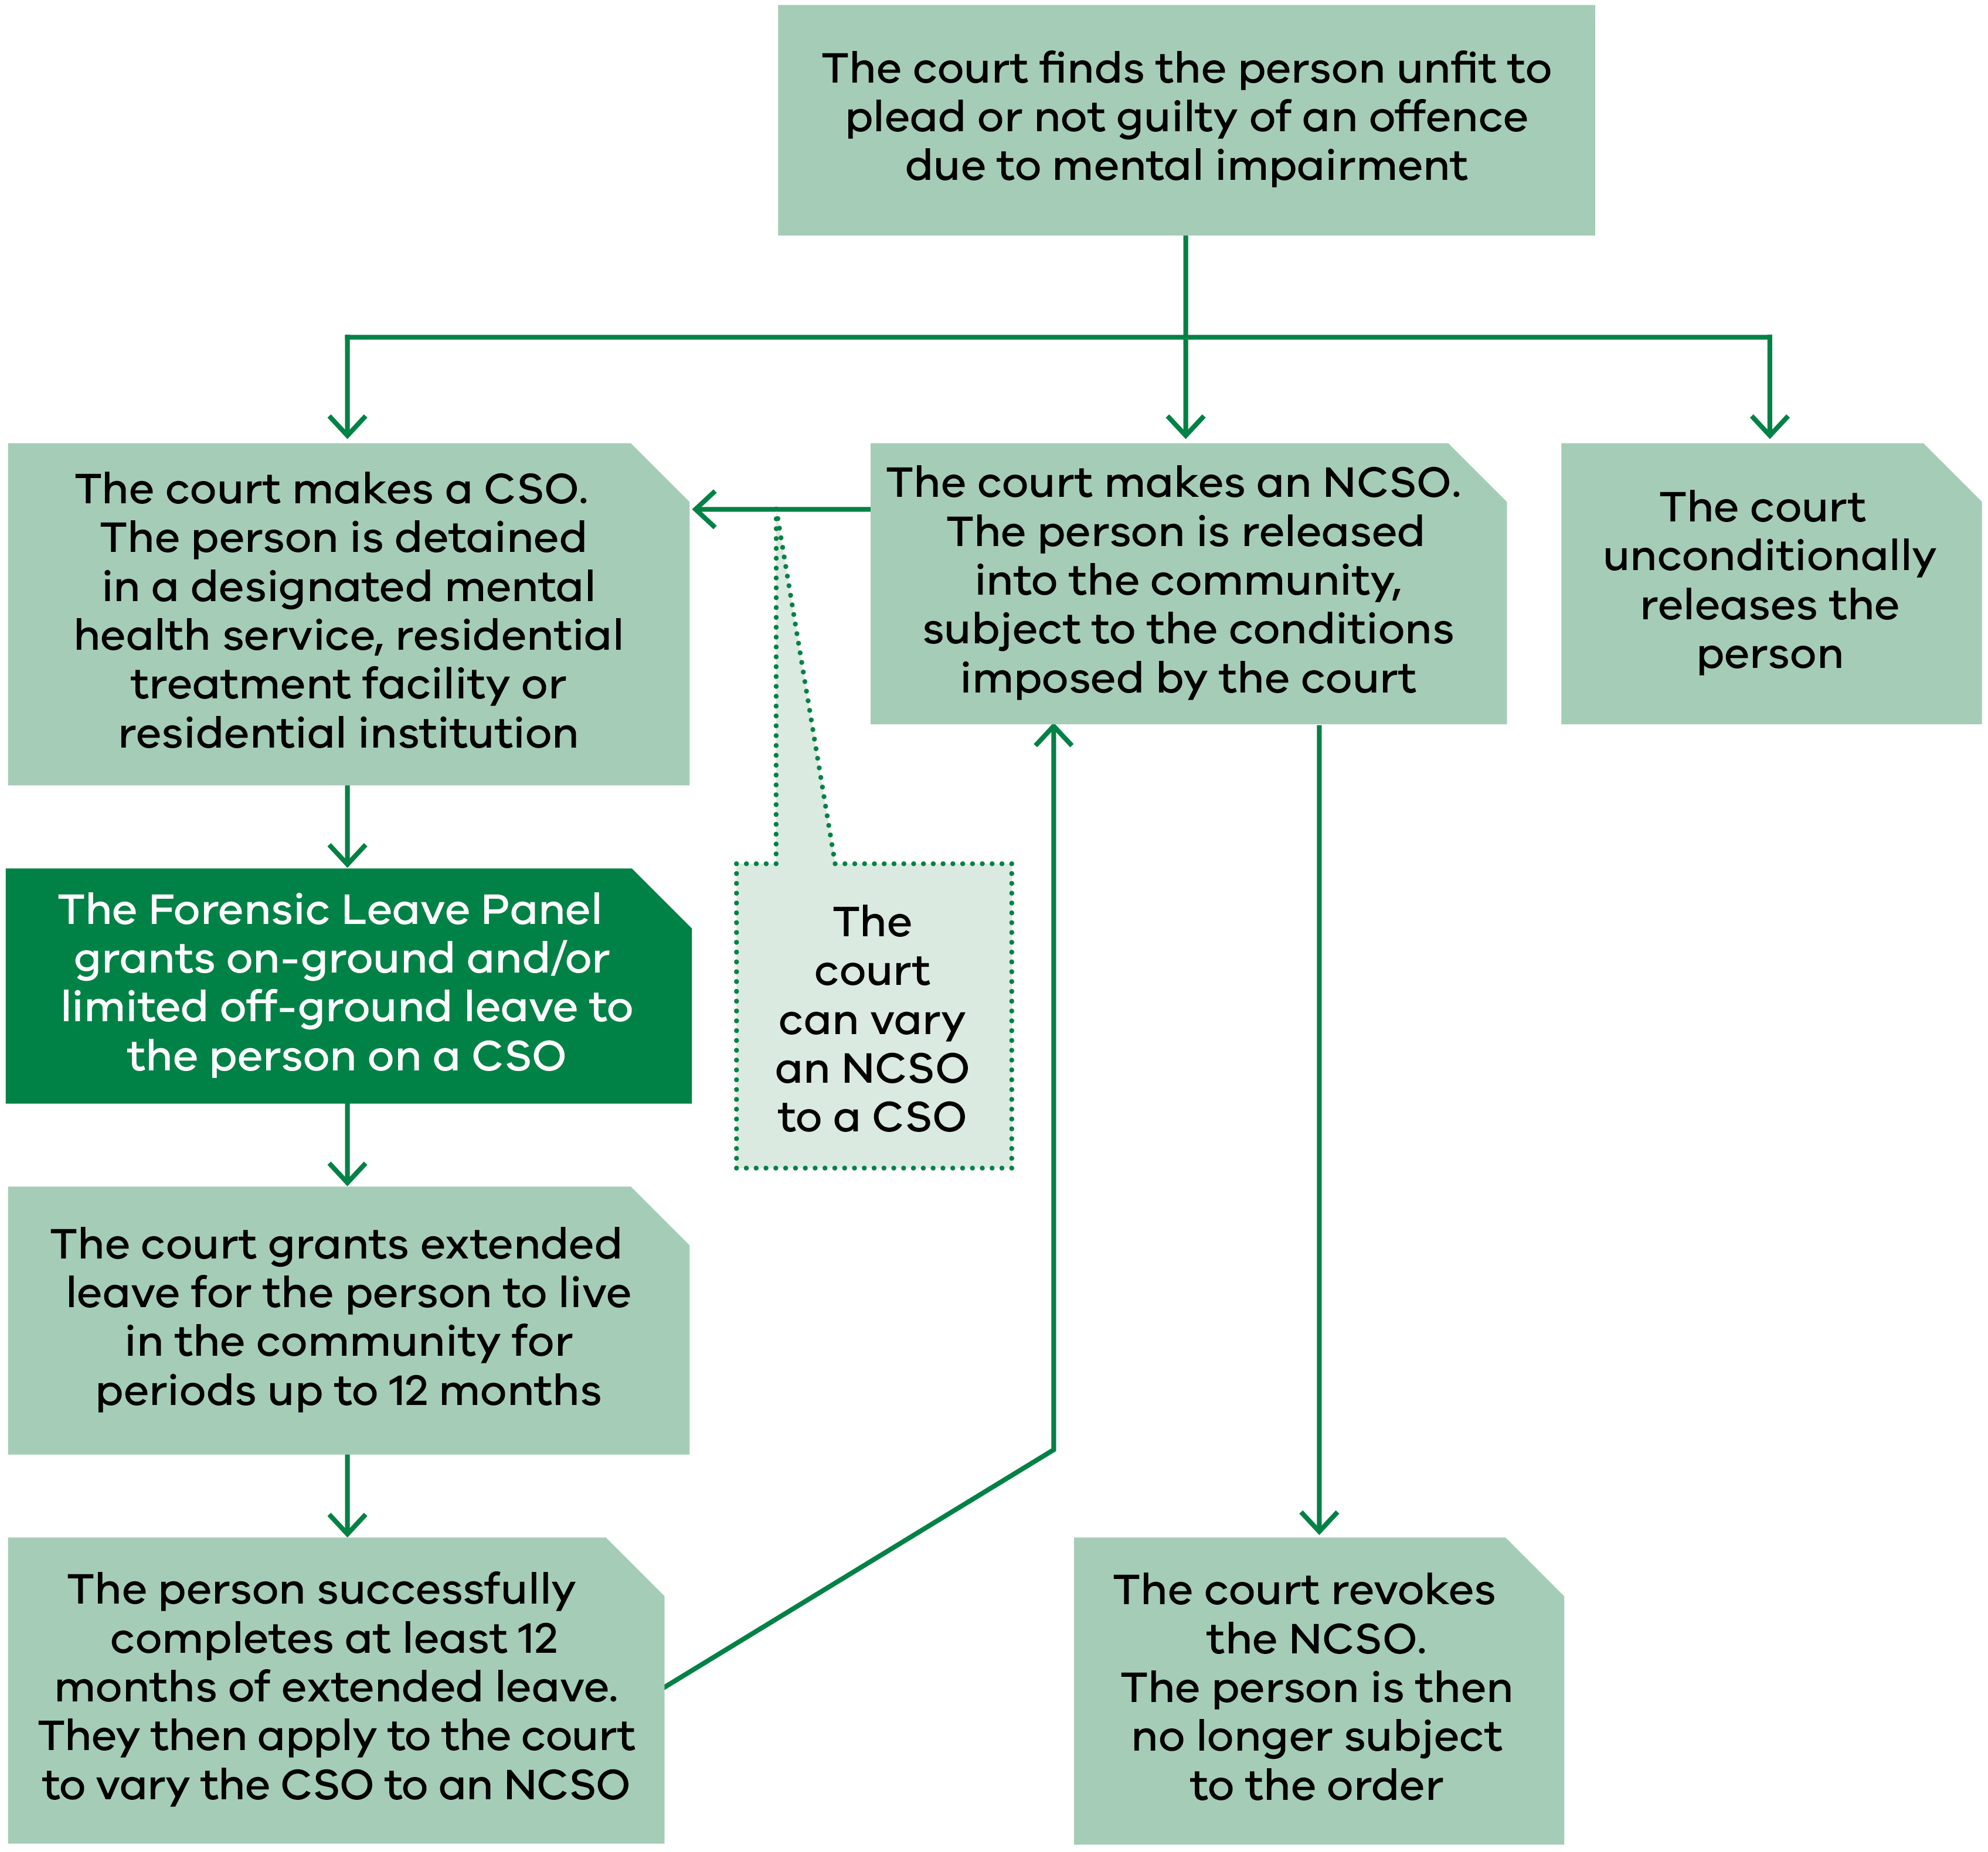

Appendix 2: Membership as at 31 December 2019

Supreme Court judges
Panel member | Current appointment | Previous term(s) of appointment
The Hon. Justice Kevin Bell  President of the panel from February 2015 | 1 April 2019  to 31 March 2024 | 1 April 2014  to 31 March 2019
The Hon. Justice Terry Forrest | 17 April 2018  to 16 April 2023 | 26 February 2013  to 25 February 2018
The Hon. Justice Christopher Beale | 17 February 2015  to 16 February 2020
The Hon. Justice Michael Croucher | 17 February 2015  to 16 February 2020
The Hon. Justice Andrew Keogh | 25 July 2017  to 24 July 2022
The Hon. Justice Jane Dixon | 25 July 2017  to 24 July 2022
The Hon. Justice Rita Incerti | 28 May 2019  to 27 May 2024

County Court judges
Panel member | Current appointment | Previous term(s) of appointment
Her Honour Judge Sandra Davis | 4 October 2016  to 3 October 2021 | 4 October 2011  to 3 October 2016  5 September 2006  to 4 September 2011
Her Honour Judge Susan Pullen | 20 November 2017 to 20 November 2022 | 20 November 2012  to 19 November 2017  20 November 2007  to 19 November 2012
His Honour Judge Frank Saccardo | 31 October 2017  to 30 October 2022 | 1 May 2012  to 30 April 2017
His Honour Judge Douglas Trapnell | 31 October 2017  to 30 October 2022
His Honour Judge James Parrish | 17 April 2018  to 16 April 2023

Chief Psychiatrist and nominees
Panel member | From | To
Dr Neil Coventry (Chief Psychiatrist) | 20 November 2014 | Ongoing
Dr Steve Macfarlane | 9 November 2012 | Ongoing
Assoc. Prof. Peter Burnett | 18 December 2015 | Ongoing
Dr Daniel O’Connor | 27 April 2016 | Ongoing
Dr Vinay Lakra | 18 July 2016 | Ongoing

Psychiatrist members
Panel member | Current appointment | Previous term(s) of appointment
Dr Michael Epstein | 1 July 2018  to 30 June 2022 | 24 October 2014  to 30 June 2018  24 October 2010  to 23 October 2014  24 October 2006  to 23 October 2010  10 September 2002  to 9 September 2006  21 April 1998  to 20 April 2002
Dr Diane Neill | 1 July 2018  to 30 June 2022 | 6 July 2014  to 30 June 2018  6 July 2010  to 30 June 2014
Dr Teresa Flower | 27 March2018  to 26 March 2022 | 30 August 2013  to 29 August 2017  30 August 2009  to 29 August 2013
Dr Jennifer Torr | 2 June 2019  to 1 June 2023 | 2 June 2015  to 1 June 2019
Assoc. Prof. John Fielding | 27 March 2018  to 26 March 2022
Dr Leon Turnbull | 27 March 2018  to 26 March 2022
Dr Ahmed Mashhood | 1 July 2018  to 30 June 2022

Psychologist members
Panel member | Current appointment | Previous term(s) of appointment
Ms Janina Tomasoni | 1 July 2018  to 30 June 2022 | 24 October 2014  to 30 June 2018  24 October 2010  to 23 October 2014  24 October 2006  to 23 October 2010  10 September 2002  to 9 September 2006
Dr Michelle Noon | 1 July 2018  to 30 June 2022
Dr Marilyn McMahon | 30 August 2019  to 29 August 2023 | 30 August 2017  to 29 August 2019

Community members
Panel member | Current appointment | Previous term(s) of appointment
Mr Paul Newland | 30 August 2019  to 29 August 2023 | 30 August 2017  to 29 August 2019  30 August 2013  to 29 August 2017  30 August 2009  to 29 August 2013  30 August 2005  to 29 August 2009  12 December 2000  to 11 December 2004  21 April 1998  to 20 April 2000
Mr Jack (Kyriakos) Nalpantidis | 1 July 2018  to 30 June 2022 | 24 October 2014  to 30 June 2018  24 October 2010  to 23 October 2014  24 October 2006  to 23 October 2010
Ms Patricia Harper AM | 30 August 2019  to 29 August 2023 | 30 August 2017  to 29 August 2019  30 August 2013  to 29 August 2017  30 August 2009  to 29 August 2013
Dr Genevieve Grant | 30 August 2019  to 29 August 2023 | 30 August 2017  to 29 August 2019  30 August 2013  to 29 August 2017  30 August 2009  to 29 August 2013
Mr Jie (George) Jiang | 1 July 2018  to 30 June 2022 | 15 July 2014  to 30 June 2018
Dr Patricia Mehegan | 1 July 2018  to 30 June 2022
Dr Leslie Cannold | 30 August 2019  to 29 August 2023

Appendix 3: Historical data
The table below provides information on the number of patients and residents, hearings, leave applications and other demographic data for the period from 2010 to 2019.

General information
Application information | 2019 | 2018 | 2017 | 2016 | 2015 | 2014 | 2013 | 2012 | 2011 | 2010
Forensic patients | 93 | 85 | 88 | 74 | 74 | 76 | 75 | 69 | 67 | 65
Forensic residents | 10 | 7 | 8 | 6 | 4 | 3 | 3 | 2 | 2 | 3
Hearings | 30 | 27 | 27 | 26 | 26 | 21 | 24 | 18 | 22 | 19
Hearing days | 26 | 24 | 23 | 21 | 21 | 18 | 18 | 18 | 19 | 18
Total leave applications made to the panel | 216 | 216 | 228 | 201 | 180 | 227 | 216 | 181 | 184 | 182
Average leave applications made per hearing | 7.2 | 8 | 8.4 | 7.7 | 6.9 | 10.8 | 9 | 10 | 8.4 | 9.6
Average leave applications by each forensic patient or resident | 2.1 | 2.3 | 2.4 | 2.5 | 2.3 | 2.9 | 2.8 | 2.5 | 2.6 | 2.6
Average leave purposes per application | 4.5 | 4.8 | 4.9 | 4.9 | 4.8 | 5 | 4.7 | 5 | 5.2 | 4.3

Type of leave applications
Type of leave | 2019 | 2018 | 2017 | 2016 | 2015 | 2014 | 2013 | 2012 | 2011 | 2010
On-ground | 5 | 4 | 17 | 12 | 7 | 6 | 6 | 5 | 4 | 5
Off-ground | 216 | 216 | 211 | 189 | 173 | 221 | 210 | 176 | 180 | 177
Combined on-ground and limited off-ground leave | 5 | 4 | 17 | 12 | 7 | 6 | 6 | 5 | 4 | 5
Leave purposes | 974 | 1025 | 1,107 | 980 | 874 | 1,139 | 1,023 | 913 | 962 | 786

Leave requests granted, suspended, appealed and revoked
Leave measure | 2019 | 2018 | 2017 | 2016 | 2015 | 2014 | 2013 | 2012 | 2011 | 2010
Granted | 96% | 90% | 85% | 86% | 91% | 90% | 85% | 86% | 87% | 87.7%
Modified and granted | 8% | 7% | 9% | 7% | 4% | 4% | 6.7% | 5.4% | 4.5% | 3.3%
Refused | 5% | 4% | 6% | 7% | 5% | 6% | 7.3% | 7.8% | 5.5% | 9%
Times applicants were assisted by interpreters | 16 | 14 | 9 | 7 | 8 | 18 | 13 | 14 | 11 | 13
Times applicants were legally represented | 11 | 11 | 20 | 29 | 14 | 36 | 11 | 7 | 6 | 2
Number of occasions patients or residents had on-ground or limited off-ground leave suspended | 9 | 9 | 17 | 10 | 14 | 10 | 12 | 16 | 9 | 11
Appeals against refusal to grant special leave by the authorised psychiatrist or the Secretary to the Department of Health and Human Services | 0 | 0 | 0 | 0 | 1 | 0 | 0 | 0 | 0 | 0
Appeals against the transfer of a forensic patient from one designated mental health service to another | 0 | 0 | 0 | 0 | 0 | 0 | 0 | 0 | 0 | 0
Patients and residents granted extended leave by a court | 4 | 11 | 10 | 9 | 6 | 6 | 8 | 9 | 4 | 4
Revocation of extended leave by the court | 2 | 1 | 1 | 0 | 1 | 0 | 1 | 1 | 1 | 0

Applicant demographics
Demographic | 2019 | 2018 | 2017 | 2016 | 2015 | 2014 | 2013 | 2012 | 2011 | 2010
Male | 87 | 77 | 81 | 67 | 64 | 67 | 65 | 57 | 58 | 59
Female | 16 | 15 | 15 | 13 | 14 | 12 | 13 | 12 | 11 | 9
Average age of applicants (years) | 43.6 | 44.7 | 43 | 43.1 | 42.5 | 42.7 | 41.9 | 41.3 | 40 | 40

Sentencing information
Sentencing court/period | 2019 | 2018 | 2017 | 2016 | 2015 | 2014 | 2013 | 2012 | 2011 | 2010
County Court | 44 | 36 | 37 | 26 | 24 | 24 | 21 | 17 | 20 | 21
Supreme Court | 59 | 56 | 59 | 54 | 54 | 55 | 57 | 52 | 49 | 47
Average length of custody (years) | 7.9 | 8.6 | 8.4 | 9.0 | 9.0 | 8.2 | 8.6 | 8.2 | 7.1 | 7.2
Longest period of custody (years) | 30 | 29.4 | 41.4 | 40.4 | 39.4 | 38.4 | 40.4 | 39.4 | 38 | 37

Appendix 4: Figure description

Figure 2: Legal framework for progression under the Act Crimes (Mental Impairment and Unfitness to be Tried) Act 1997
The diagram demonstrates what happens once the court finds a person unfit to plead or not guilty of an offence due to mental impairment, and how they progress through the system under the Act.
The court can make a custodial supervision order, which sees the person detained in a designated mental health service, residential treatment facility or residential institution. While detained, the Forensic Leave Panel grants on-ground and/or limited off-ground leave to that person until such time as the person applies for, and the court grants, extended leave for the person to live in the community for periods up to 12 months. Once the person successfully completes at least 12 months of extended leave they apply to the court to vary the custodial supervision order to a non-custodial supervision order.
The court can make a non-custodial supervision order, which sees the person released into the community, subject to the conditions imposed by the court. The court can revoke the non-custodial supervision order, meaning the person is no longer subject to the order. The court can also vary a non-custodial supervision order to a custodial supervision order.
The court can unconditionally release the person.

The percentage of leaves granted, modified or refused by the panel may not always total 100 per cent because at hearings applicants may withdraw leave requests, the panel may grant modified leave requests or, on occasion, grant additional leave requests.
Forensic residents made 13 applications for the year; of that four were a combination of on-ground and limited off-ground leave.
The number of hearings held for forensic residents and the number of hearings held for forensic patients.
Hearings at Thomas Embling Hospital and DFATS are scheduled (when possible) to coincide so that relevant members of a division of the panel can attend both hearings.
Forensic residents made the on-ground leave applications as part of an application, which included limited off-ground leave. In practice, forensic patients do not require on-ground leave because Thomas Embling Hospital has sufficient grounds within the secure perimeter.
The percentage of leaves granted, modified or refused by the panel may not always total 100 per cent because at hearings applicants may withdraw leave requests, the panel may grant modified leave requests or, on occasion, grant additional leave requests.
The reference date used to calculate the average length of custody was 31 December in each year. Prior to 2012, the reference date is likely to have been the undefined year, accounting for the percentage increase in 2012.
The decrease in 2018 is due to a long-term forensic patient receiving extended leave.

