Stakeholder pack
2024 Victorian Public Healthcare Awards
OFFICIAL

Introduction
Nominations for the 2024 Victorian Public Healthcare Awards are now open!

The Victorian Public Healthcare Awards present an opportunity to celebrate and acknowledge the achievements of our healthcare workers, public health services and health volunteers.

The awards reflect priority areas in healthcare identified by the government and focus on the sector’s ability to drive change and improve health outcomes for all Victorians.

They recognise leadership and excellence in the provision of publicly funded healthcare in response to established and emerging community needs.

This pack includes content you can share within your organisation to generate excitement around the awards and encourage team members to reach out with their stories of innovation, excellence and achievement to help you prepare an award entry.

All resources mentioned below are available at our stakeholder pack page: <https://www.health.vic.gov.au/recognition-and-awards/victorian-public-healthcare-awards-stakeholder-pack>

Email/newsletter copy
The following copy may be adapted for use in emails or newsletters to encourage internal staff to suggest content to consider for your award entry or entries. The person(s) coordinating your organisation’s award entry is referred to below as the Award Entry Contact.

Suggested text
Tell us your award-winning stories!
The Victorian Public Healthcare Awards are open – and we want to hear your stories!
The awards are an opportunity to acknowledge the achievements of Victoria’s healthcare workers, volunteers and public health services, and we want to celebrate and honour the incredible hard work and dedication that you have delivered over the past year.
This recognition is important, especially as we continue to face unprecedented demand on our healthcare system.
There are many examples of healthcare excellence that have been demonstrated in the past year across our organisation, and we need your help identifying and bringing those stories to life.
If you have a story of healthcare innovation, excellence or achievement that occurred between April 2023 and April 2024, please get in contact with [insert your Award Entry Contact’s name] via [insert your Award Entry Contact’s details] by [insert your internal deadline].
Entries close on Friday 31 May 2024.

Digital banners

We have a range of digital banners that you can use in your internal communications, which can be downloaded as a package from our stakeholder pack resources page: <https://www.health.vic.gov.au/recognition-and-awards/victorian-public-healthcare-awards-stakeholder-pack>

These can be linked to our awards website for further information: www.health.vic.gov.au/VPHAwards

Downloads

 |  |  | Digital banner – 733 x 260px
 |  |  | Digital banner – 620 x 354px
 |  |  | Digital banner – 800 x 145px
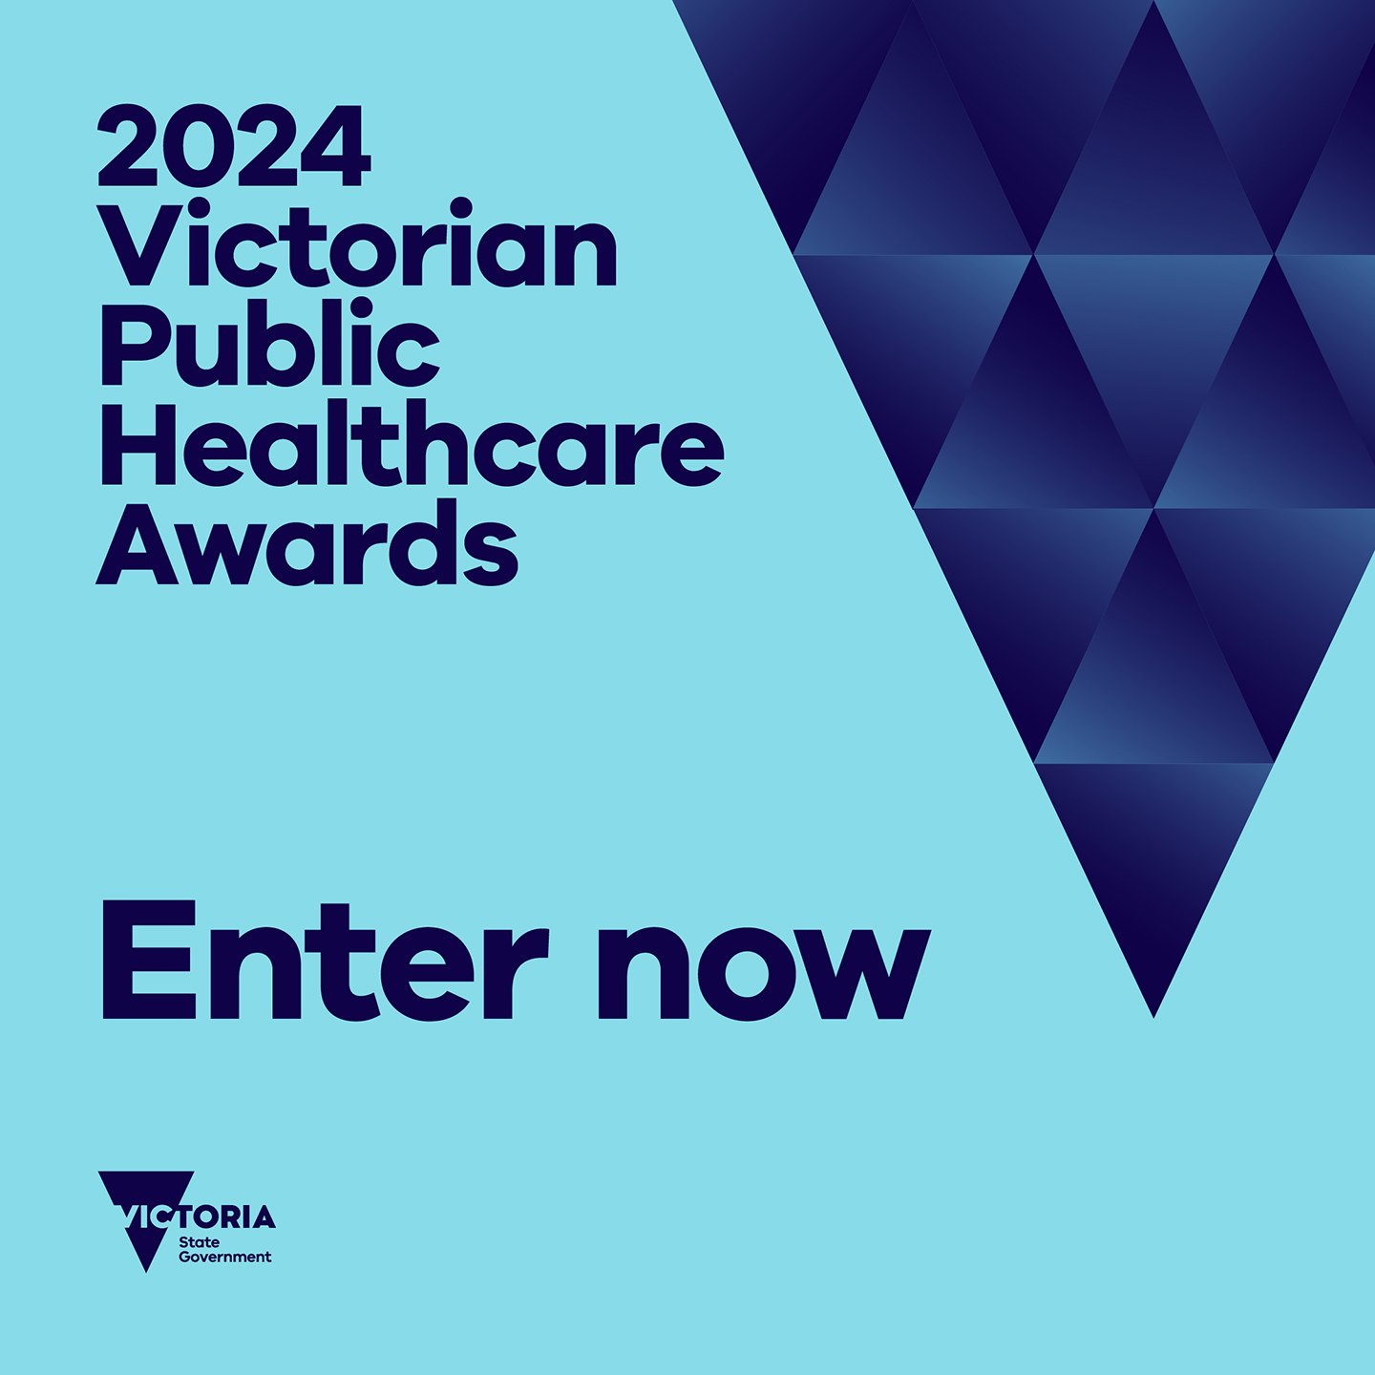 |  |  | ‘Enter now’ social media tile
 |  |  | Email signature

Thank you
We appreciate your help in spreading the word that nominations are open for the Victorian Public Healthcare Awards.
If you have any questions about this pack or the awards, contact healthcareawards@health.vic.gov.au or visit the Victorian Public Healthcare Awards webpage: www.health.vic.gov.au/VPHAwards

To receive this document in another format, email the Victorian Public Healthcare Awards Team <healthcareawards@health.vic.gov.au>.
Authorised and published by the Victorian Government, 1 Treasury Place, Melbourne.
© State of Victoria, Australia, Department of Health, March 2024.
Available at the Victorian Public Healthcare Awards website <https://www.health.vic.gov.au/VPHAwards>.

