Smoke-free and vape-free outdoor dining
Factsheet for businesses

Under the Tobacco Act 1987, smoking and the use of e-cigarettes (vaping) is banned in outdoor dining areas.
This factsheet provides general guidance on the smoking and vaping ban in outdoor dining areas.
Further detailed information is available in the Smoke-free outdoor dining guide available on the tobacco reforms website <www.health.vic.gov.au/public-health/tobacco-reforms>.

Outdoor dining areas
An outdoor dining area is an outdoor area that a business owner or manager permits to be used for the consumption of food provided on commercial basis.
This means during times food provided on a commercial basis is:
- actually being eaten, or
- available to be purchased and eaten in the area (regardless of whether anyone is actually eating).
Examples of outdoor dining areas include footpath dining, courtyards, balconies, and beer gardens that form part of, or are attached to, cafes, restaurants, take-away outlets, pubs, licensed premises and other similar businesses.
Outdoor dining areas also include outdoor food courts provided for customers of multiple take-away outlets.

Snacks and drinks
For the purpose of the smoking and vaping ban, food does not include snacks and drinks.
A snack is a pre-packaged shelf-stable food that:
- is sealed in the container or package in which the manufacturer intended it to be sold, and
- does not require any preparation prior to serving.
Shelf-stable is generally taken to mean food that can be stored safely for long periods (months) at room temperature.
Examples of snacks include pre-packaged potato crisps, nuts, and chocolate bars. Snacks also include uncut and unpeeled fruit.
Pre-packaged sandwiches and hot chips are not snacks.
Drinks include alcoholic and non-alcoholic beverages such as coffee.

Separating outdoor drinking areas from indoor eating areas
To minimise diners’ exposure to smoke-drift and the aerosol from e-cigarettes that may drift, an outdoor drinking area (where smoking and vaping is permitted under certain conditions) must be separated from an outdoor dining area by either:
- a 4-metre smoke-free zone, or
  - a wall of at least 2.1 metres high (which could be a plastic cafe blind).
The venue that operates the outdoor drinking area is responsible for the separation of the two areas.
This requirement applies to areas at the same venue, as well as to neighbouring venues (a different venue that is located next to your venue).
If the separation requirements are not met, smoking and vaping is banned in the outdoor drinking area.

Complying with law
The following is general guidance about how to comply with the law.

Permanent outdoor dining
You can have a permanent outdoor dining area, in which food is permitted to be eaten at all times. In this case, the outdoor area must be smoke-free and vape-free at all times, as shown in Figure 1.
Figure 1: Permanent outdoor dining
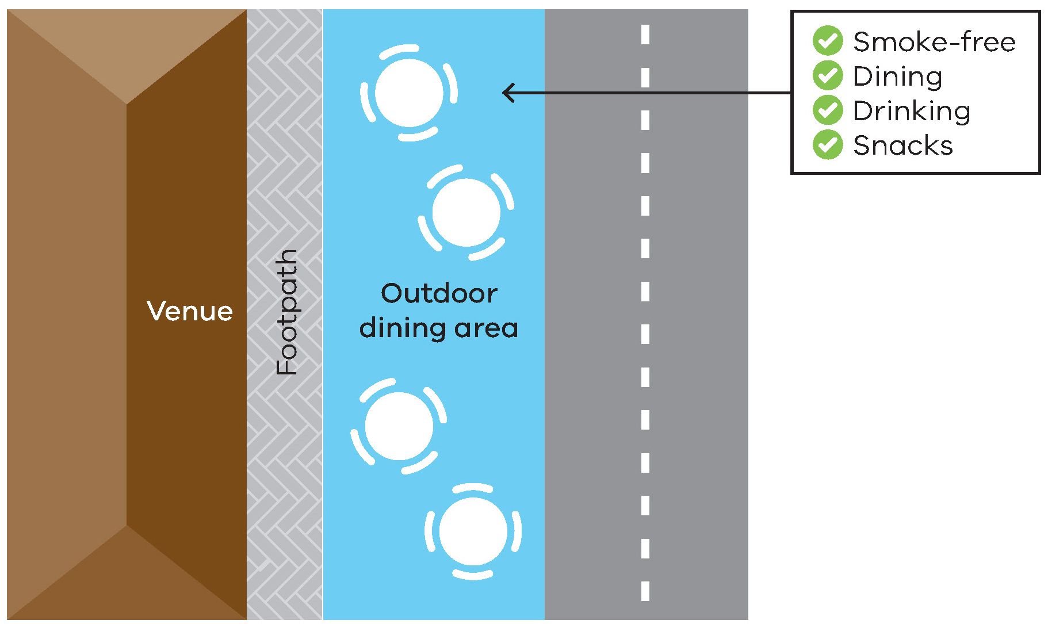

Time-limited outdoor dining
You can permit food to be eaten in an outdoor area during certain times of the day, such as set lunch and dinner times. In this case, the outdoor area must be smoke-free during these times, as shown in Figure 2.
Figure 2: Time-limited outdoor dining
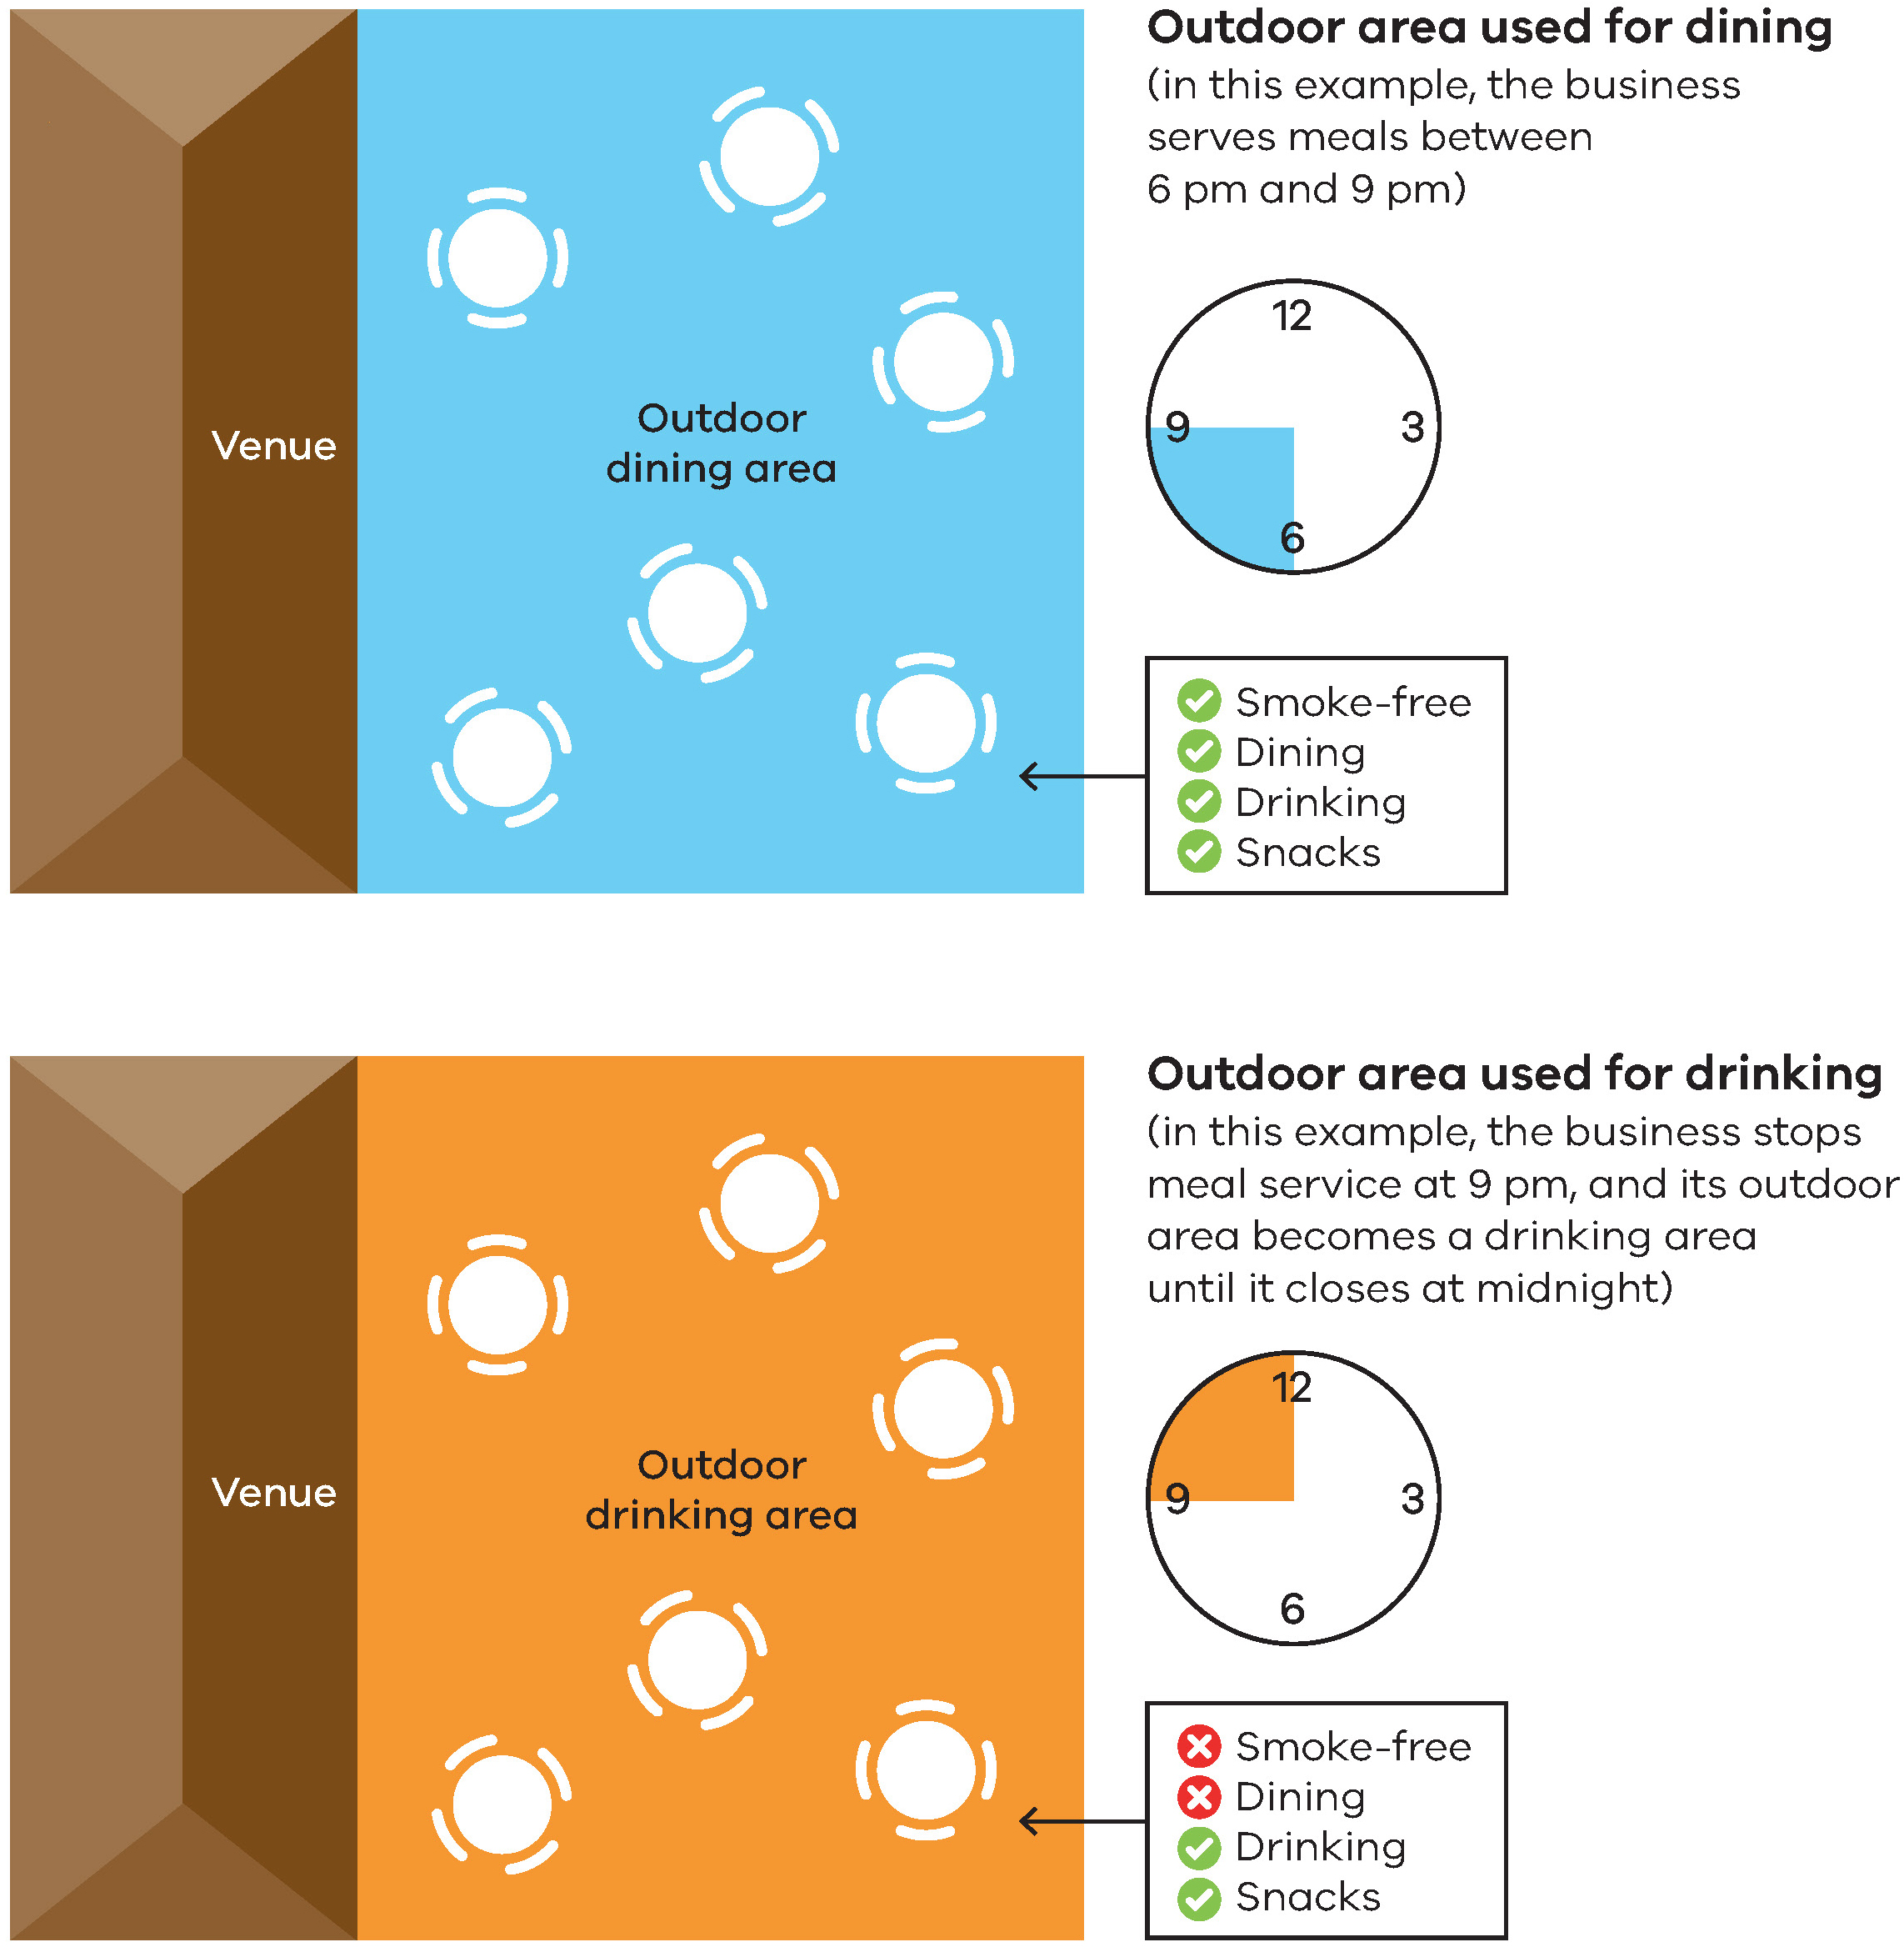

Separating outdoor dining and outdoor drinking areas
You may be able to separate an outdoor drinking area (where smoking and vaping is permitted under certain conditions) from an outdoor dining area. The two areas must be separated by either:
- a 4- metre buffer zone, or
  - a wall of at least 2.1 metres high.
Figures 3 and 4 below show examples of the separation requirements at the same venue.
Figure 3: Separation by a 4-metre buffer zone
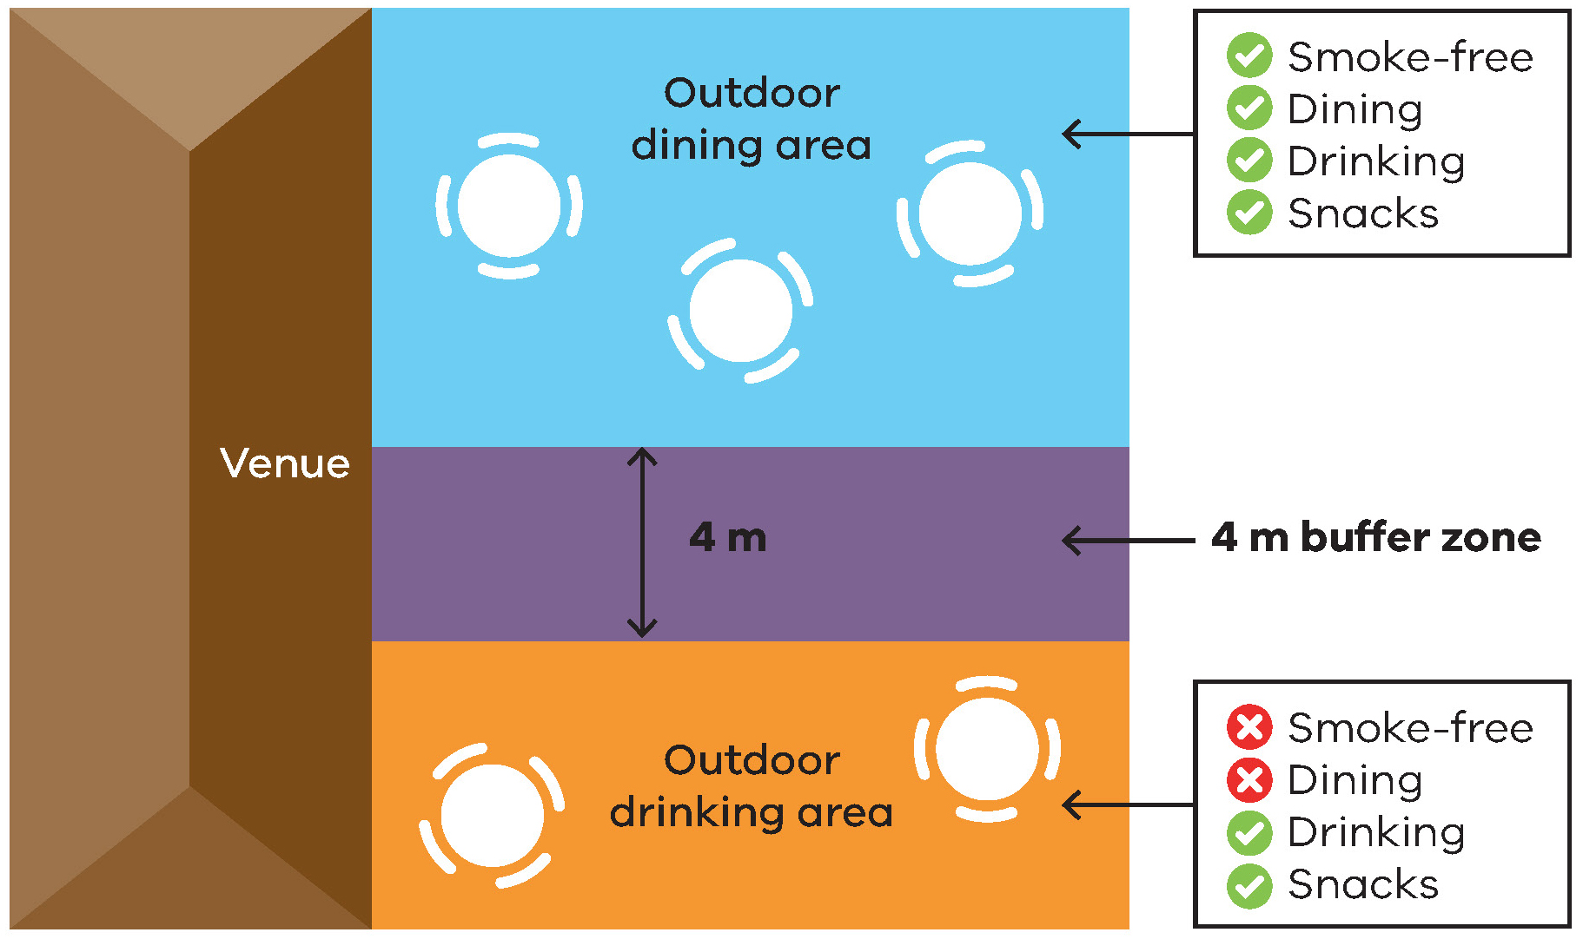
Figure 4: Separation by a wall of 2.1 metres
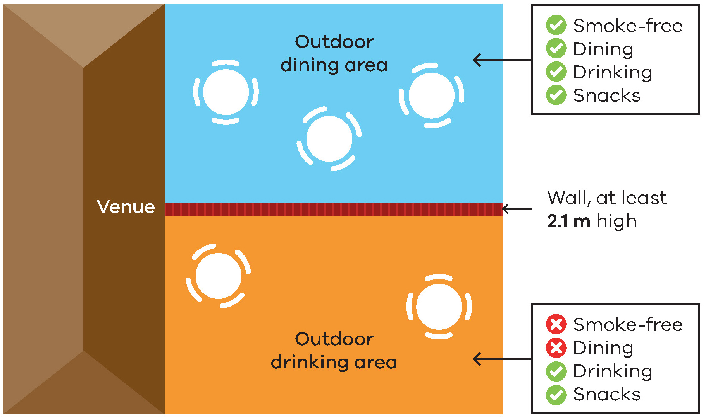

Go totally smoke-free and vape-free
You can choose to make your venue totally smoke and vape free. This will reduce the risk of non-compliance with the law. It is also the most effective way to protect customers and staff from smoke-drift and the aerosol from e-cigarettes that may drift.

Smoking and vaping restrictions in outdoor dining areas
Further information about the smoking and vaping restrictions in outdoor drinking areas is available in the Smoking restrictions in outdoor drinking areas guide.

Signage required
Venues must display acceptable ‘No smoking’ signage to indicate smoke-free and vape-free areas. The signs must be displayed so customers can see a sign when entering, or within, the outdoor dining area.
Signs can be ordered free of charge from the tobacco reforms website <www.health.vic.gov.au/public-health/tobacco-reforms>.

Enforcement
There is strong community support for banning smoking and vaping in outdoor dining areas. This means most people will voluntarily comply with the smoking and vaping ban and expect others to do so.
Inspectors, authorised under the Tobacco Act 1987, may provide information about the ban and enforce it when necessary. The first priority of the inspector is to make sure smokers, vapers and venues understand the ban.
Inspectors may not be able to respond to every complaint but, where circumstances allow, may attend in response.
Both the person in charge of the venue at the time and the individual smoker and vaper can be fined.
An on-the-spot fine of one penalty unit may apply to an individual who smokes or vapes in an outdoor dining area. The maximum court penalty is five penalty units.
An on-the-spot fine of two penalty units may apply to the person in charge of the venue at the time. The maximum court penalty is 10 penalty units for an individual or 50 penalty units for a company.

Reasons for smoke-free and vape-free outdoor dining
There is compelling rationale and strong support for smoke-free and vape-free outdoor dining.
Smoke-free and vape-free outdoor dining will:
- protect the community from the harmful effects of second-hand smoke and the aerosol from e-cigarettes
- de-normalise smoking and vaping behaviours, which is particularly important for discouraging children from taking up smoking and vaping
- support people who have recently quit smoking and vaping, or who are trying to quit by removing smoking and vaping visual cues and triggers
  - improve Victorians’ outdoor dining experience.

Further information and resources
Businesses can request signs, posters and brochures to help educate and inform staff and customers of the ban.
To access these materials and for more information:
- visit the tobacco reforms website <www. health.vic.gov.au/public-health/tobacco-reforms>
- call the Tobacco Information Line on 1300 136 775.
To view the exact wording of the law, visit the Victorian Government’s legislation website <www.legislation.vic.gov.au> and search Tobacco Act 1987.
To receive this document in another format, phone 1300 136 775, using the National Relay Service 13 36 77 if required, or email tobacco.policy@health.vic.gov.au.
Authorised and published by the Victorian Government, 1 Treasury Place, Melbourne.
© State of Victoria, Australia, Department of Health, November 2023.
Except where otherwise indicated, the images in this document show models and illustrative settings only, and do not necessarily depict actual services, facilities or recipients of services.
Please note that any advice contained in this publication is for general guidance only. The Department of Health does not accept any liability for any loss or damage suffered as a result of reliance on the advice contained in this publication. Nothing in this publication should replace seeking appropriate legal advice.
ISBN 978-1-76131-101-7 (pdf/online/MS word)
Available at tobacco reforms website <www.health.vic.gov.au/public-health/tobacco-reforms>.

Penalty units are indexed annually. For current penalty unit values, visit the Department of Treasury and Finance website <www.dtf.vic.gov.au/financial-management-government/indexation-fees-and-penalties>

