Ban on smoking and vaping at public swimming pool complexes
Information for public swimming pool operators

Under section 5RC(1) of the Tobacco Act 1987, smoking and the use of e-cigarettes (vaping) is banned within the outdoor areas of all public swimming pool complexes in Victoria.
The ban applies to outdoor drinking areas that are situated within the perimeter of a public swimming pool complex.
This diagram below shows an example of where the smoking and vaping ban applies.
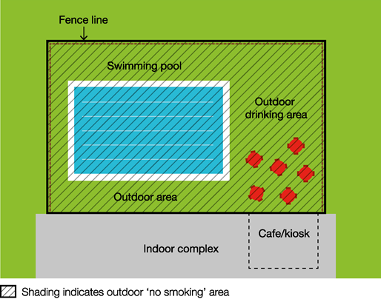
Workplace smoking and vaping laws apply to indoor areas of the public swimming pool complex.
This ban is part of a range of measures to reduce the exposure of children and young people to second-hand tobacco smoke, the aerosol from e-cigarettes and smoking and vaping behaviours. Bans also apply within 10 metres of outdoor children’s playground equipment, skate parks and at sporting venues during an underage sporting event.
Why does the ban exist?
Public swimming pools attract a wide variety of patrons, including families with children and young people.
This ban creates a smoke-free and vape-free environment where children and young people can enjoy sporting and recreational activities without being exposed to harmful second-hand tobacco smoke and the aerosol from e-cigarettes. Second-hand tobacco smoke exposure is particularly dangerous for children and young people due to their smaller airways and undeveloped immune systems compared to those of adults.
Children and young people are impressionable and are more likely to view smoking and vaping as socially acceptable when they regularly see people smoking and vaping in different settings. Banning smoking and vaping in areas frequented by children and young people will help to de-normalise smoking and vaping behaviour and discourage children and young people from taking up smoking and vaping.

Am I or my staff expected to enforce the ban?
No. Swimming pool staff, managers and operators are not expected to enforce the ban and are not empowered to do so.
Compliance with the ban is expected to occur through a public education and awareness campaign and changed community expectations.
Consultation undertaken by the Department of Health shows strong community support for banning smoking at public places regularly attended by children. These factors are likely to result in high levels of voluntary compliance with the smoking and vaping ban.
Inspectors, authorised under the Tobacco Act 1987, may provide information about and, when necessary, enforce the ban. The maximum penalty for an individual breaching this law is five penalty units, with an infringement penalty of one penalty unit.
Inspectors may not be available to respond to every complaint, but where circumstances allow, may attend in response.
The primary goal of inspectors is to make sure smokers and e-cigarettes users understand that smoking and vaping is banned within the outdoor areas of all public swimming pool complexes in Victoria.
You and your staff can assist to raise awareness of the ban by providing your patrons access to promotional resources.
Swimming pool complex operators will not be liable if smoking and vaping occurs in outdoor areas of their complex.
Smoking and vaping will continue to be banned in enclosed areas of public swimming pool complexes under the enclosed workplace smoking and vaping provisions in the Tobacco Act 1987.

What resources are available to promote the ban?
Posters, brochures and palm cards
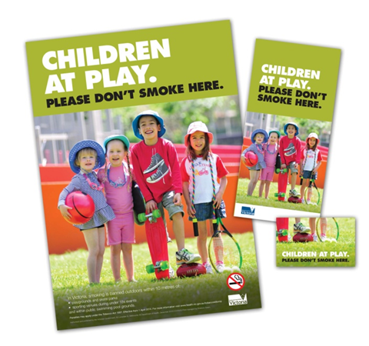
Public swimming pool operators can request posters, brochures and palm cards to help educate and inform patrons of the new ban. Order the free resources online from tobacco reforms website <www.health.vic.gov.au/public-health/tobacco-reforms>
Signage
Public swimming pool operators and local councils may choose to install metal ‘No smoking’ signs. To order free signs email: tobacco.policy@health.vic.gov.au.
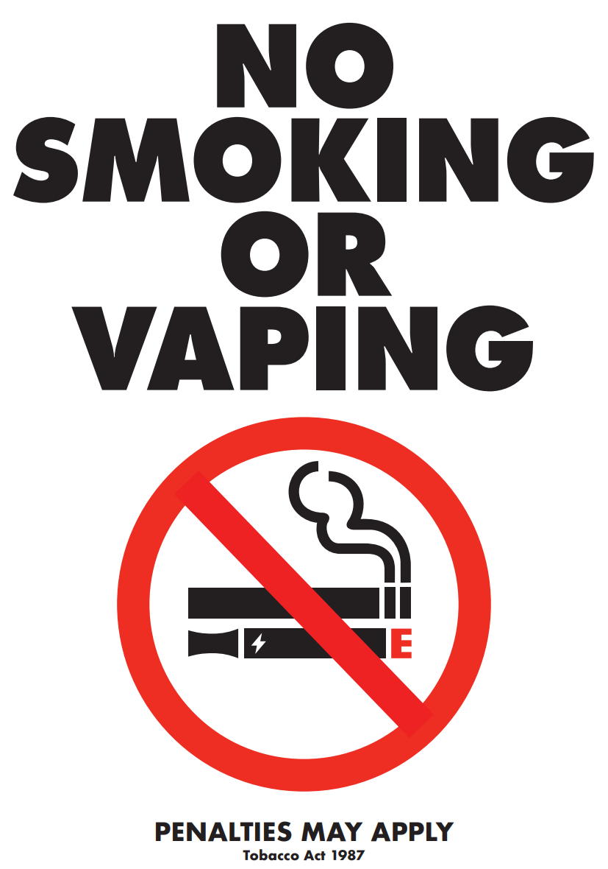
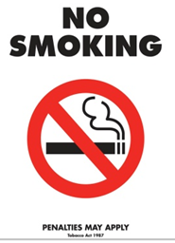
Templates for paper signs can also be downloaded from the tobacco reforms website <www.health.vic.gov.au/public-health/tobaccoreforms>.

What if my swimming pool complex already has a smoke-free and vape-free policy?
The bans are intended to complement and provide legislative support to any existing smoke-free and vape-free policies at public swimming pool complexes.
If a swimming pool complex has its own smoking and vaping ban in place, the statewide ban will act as a minimum standard, with any further requirements put in place by the public swimming pool complex applying in addition to the legislative ban.

How can I find out more?
For more information:
- visit the tobacco reforms website <www. health.vic.gov.au/public-health/tobacco-reforms>
- call the Tobacco Information Line on 1300 136 775
To view the legislation visit the Victorian Government’s legislation website <www.legislation.vic.gov.au> and search Tobacco Act 1987.

To receive this document in another format, phone 1300 136 775, using the National Relay Service 13 36 77 if required, or email tobacco.policy@health.vic.gov.au
Authorised and published by the Victorian Government, 1 Treasury Place, Melbourne.
© State of Victoria, Australia, Department of Health, November 2023.
Except where otherwise indicated, the images in this document show models and illustrative settings only, and do not necessarily depict actual services, facilities or recipients of services.
DISCLAIMER: Please note that any advice contained in this factsheet is for general guidance only. The Department of Health does not accept any liability for any loss or damage suffered as a result of reliance upon the advice contained in this factsheet. Nothing in this factsheet should replace seeking appropriate legal advice.
ISBN 978-1-76131-093-5 (pdf/online/MS word)
Available at tobacco reforms website <www.health.vic.gov.au/public-health/tobacco-reforms>

For current penalty unit values, visit the Department of Treasury and Finance website <www.dtf.vic.gov.au/financial-management-government/indexation-fees-and-penalties>

