Notification of reportable deaths to the Chief Psychiatrist
Chief Psychiatrist’s reporting directive – September 2023
OFFICIAL

To receive this document in another format, phone 1300 767 299, using the National Relay Service 13 36 77 if required, or email the Office of the Chief Psychiatrist <ocp@health.vic.gov.au>.
Authorised and published by the Victorian Government, 1 Treasury Place, Melbourne.
© State of Victoria, Australia, Department of Health, September 2023.
ISBN/ISSN 978-1-76131-237-3 (online/PDF/Word)
Available at Reportable deaths < https://www.health.vic.gov.au/chief-psychiatrist/reportable-deaths-mental-health-and-wellbeing-act-2022>.

Contents
Introduction and background 4
Purpose 4
Relevant legislation 4
Role of the Chief Psychiatrist 4
Reportable deaths 5
Health services that must report 5
Deaths that must be reported 5
Chief Psychiatrist procedures required in the event of a reportable death 6
Contacts 9
Office of the Chief Psychiatrist 9
Coroners Court of Victoria 9
Appendix 1: Reportable deaths – Chief Psychiatrist reporting process 10
Appendix 2: Legislative definitions related to reportable deaths 11
Coroners Act 2008 11
Mental Health and Wellbeing Act 2022 – notification of reportable deaths 12

Introduction and background
This reporting guideline is for clinical mental health service providers, specialist custodial mental health services and, in the future, mental health community support service providers who are brought in through regulations, in the event of a death of a person who was receiving, had received, or sought mental health services.
Mental health community support services, who have reported under the Mental Health Act 2014, are encouraged to continue to follow this reporting practice as the new Mental Health and Wellbeing Act 2022 (the Act) commences on 1 September 2023.
The guideline defines a ‘reportable death’ and outlines the reporting procedures.

Purpose
Under the Act, the Chief Psychiatrist must be notified of all reportable deaths within the meaning of the Coroners Act 2008.
The Chief Psychiatrist provides clinical leadership and expert clinical advice to Victorian mental health service providers. Central to the role of the Chief Psychiatrist is to promote continuous quality improvement and promote the rights of people receiving mental health services.
Monitoring and reviewing circumstances relating to reportable deaths is one way the Chief Psychiatrist ensures quality mental health services are provided.
This information is analysed for the monitoring, governance and quality and safety functions of the Chief Psychiatrist. The information provided in this reporting directive is general and not intended as legal advice. Mental health and wellbeing service providers should obtain independent legal advice if they have queries about individual cases or their obligations under the Act.

Relevant legislation
The legislation governing the notifying of a reportable death is detailed in s 741 of the Mental Health and Wellbeing Act 2022 and s 4 of the Coroners Act 2008. Excerpts of these Acts are included in Appendix 2 of this reporting directive.

Role of the Chief Psychiatrist
In relation to reportable deaths, the Chief Psychiatrist:
- receives and reviews MHWA 125 notice of death forms
- maintains a database of reportable deaths of clients of Victorian mental health services
- routinely requests the findings of coronial investigations and contributes to coronial processes if requested to do so by the coroner
- reviews the contents of the clinical reports forwarded by services, with the aim of identifying systemic or management issues
- requests additional information, including copies of clinical files, to review individual treatment and care and broader systemic and management issues
- undertakes an investigation pursuant to s 278 of the Act, or conducts a clinical review pursuant to functions detailed in s 286 of the Act
- identifies statewide issues and provides guidance to mental health services.

Reportable deaths

Health services that must report
All clinical mental health service providers, including specialist mental health services in custodial settings, must report deaths to the Chief Psychiatrist.
Under the Act, s 3 defines clinical mental health service providers as:
- a designated mental health service; or
- a mental health and wellbeing service provider that provides mental health and wellbeing services in a custodial setting; or
- any other prescribed entity or prescribed class of entity

Deaths that must be reported
The authorised psychiatrist or the person in charge of a clinical mental health service must notify the Chief Psychiatrist in writing in the event of the death of the following people.

1. Inpatient
Any inpatient death at a designated mental health service or a bed-based mental health unit in a custodial setting is to be reported, regardless of legal status, cause or location of death. This will help the Chief Psychiatrist understand the level of morbidity and mortality related to inpatient treatment and care in Victoria.
A person who dies while on leave, who has absconded, who has been admitted to a medical ward during the admission to the mental health unit, or who has been discharged from a mental health inpatient unit within the previous 24 hours, is considered an inpatient and the death must be reported to the Chief Psychiatrist.

2. Patients under the Mental Health and Wellbeing Act 2022
The death of a patient under the Act must be reported to the Chief Psychiatrist.
This includes all compulsory, security and forensic patients, as defined in s 4 of the Coroners Act 2008.
Compulsory patients are those subject to:
- an assessment order
- a court assessment order
- a temporary treatment order
- a treatment order.
Forensic patients include those subject to a custodial supervision order under the Crimes (Mental Impairment and Unfitness to be Tried) Act 1997.
A security patient is a person detained in a designated mental health service (regardless of whether they are absent with or without leave) and who is subject to:
- a court secure treatment order
- a secure treatment order.

3. Persons on non-custodial supervision orders
The death from any cause of a person in the community on a non-custodial supervision order under the Crimes (Mental Impairment and Unfitness to be Tried) Act 1997 must also be reported to the Chief Psychiatrist.

4. Non-inpatient and non-compulsory consumer deaths
The Chief Psychiatrist requires all unexpected, unnatural or violent deaths (including suspected suicides) to be reported if:
- a person was assessed by a clinical mental health service providers and was not provided with treatment, or
- a person sought clinical mental health service providers from a mental health provider and was not provided with mental health services.

4.1 Current registered mental health consumers
People are considered to be consumers of a mental health and wellbeing service until their case is formally closed and they are notified of this closure. If it is not possible to inform a person that their case has been closed, the service can be considered to have done so if it made all reasonable attempts to contact the consumer.

4.2 Non-registered persons who sought mental health and wellbeing services from a mental health and wellbeing service provider and were not provided with a face-to-face assessment
This includes presentations to emergency departments, telephone triage and community mental health and wellbeing services within seven days preceding their death (or longer if relevant).

5. Previous consumers
If a person’s death is unexpected, unnatural or violent and occurs within three months of being a clinical mental health service providers consumer, it must be reported to the Chief Psychiatrist.

Chief Psychiatrist procedures required in the event of a reportable death

Inpatient deaths
All health services will have policy and local procedures for reportable deaths that includes the following:
- The body should be disturbed as little as possible.
- Promptly inform relevant parties (authorised psychiatrist, next of kin/carers) of the death.
- Contact the Coroners Court of Victoria. If the death is reportable to the coroner, the coroner’s assistant will contact and inform local police, who will attend. The coroner’s assistant will require details of the deceased, the circumstances of death and whether a death certificate can be completed. They are responsible, with the police or funeral director, for removing the body.
- The Chief Psychiatrist should be notified within 24 hours of any inpatient death including those in bed-based prison and youth justice settings. The Chief Psychiatrist can be contacted outside of business hours through the authorised psychiatrist or person in charge.
Note: Where the death has occurred in a prison or youth justice setting, local procedures should be followed.
If the person is under treatment as an inpatient, regardless of legal status, you must notify the Chief Psychiatrist within 24 hours by phone. Out-of-hours contact with the Chief Psychiatrist can be made through each health service’s appointed authorised psychiatrist, chief executive or delegate.
In addition, the MHWA 125 notice of death should be forwarded to the Chief Psychiatrist as soon as practicable, but no later than three days.
The authorised psychiatrist or person in charge of a mental health community support service is also required to forward a detailed clinical report to the Chief Psychiatrist within 14 days or sooner if specifically requested by the Chief Psychiatrist.

Compulsory patient deaths
There is no requirement to notify within 24 hours if immediately before their death the person was a compulsory patient living in the community or was in the community on a non-custodial supervision order.
However, an MHWA 125 notice of death should be forwarded to the Chief Psychiatrist as soon as practicable, but no later than three days.
For people on a non-custodial supervision order, the clinical mental health service providers, and the Victorian Institute of Forensic Health (Forensicare) must provide an MHWA 125 notice of death and a detailed clinical report to the Chief Psychiatrist.
If the person was also receiving mental health and wellbeing services from a mental health community support service, that service must also submit an MHWA 125 notice of death form.

Non-inpatient and non-compulsory consumer deaths
In the case of all other reportable deaths, a MHWA 125 notice of death form should be forwarded to the Chief Psychiatrist as soon as practicable, but no later than three days.
There is no need to forward a detailed clinical report unless requested by the Chief Psychiatrist.

Incident review
The clinical mental health service provider should conduct a review of the person’s treatment and management if the death is a reportable death or where there are any concerns about clinical practices, procedures or systemic issues.
Health services should establish a structured incident management review process consistent with best practice and reflective of their clinical governance policy.
The Chief Psychiatrist may request the outcomes of the review. If relevant, health services may also provide the Chief Psychiatrist with a review of outcomes.
Health services should be aware of their obligations regarding the Coroners Court of Victoria and Safer Care Victoria including statutory duty of candour and the sentinel event program.
For more information refer to:
- the Coroners Court webpage on reportable deaths <https://www.coronerscourt.vic.gov.au/report-death-or-fire/reportable-deaths>
- the Coroners Court webpage on how to report a death <https://www.coronerscourt.vic.gov.au/report-death-or-fire/how-report-death>
- Safer Care Victoria’s webpage on sentinel events <www.safercare.vic.gov.au/notify-us/sentinel-events>
- Safer Care Victoria’s webpage on duty of candour < https://www.safercare.vic.gov.au/support-training/adverse-event-review-and-response/duty-of-candour>.

Mental Health and Wellbeing Act 125 notice of death
A mental health clinician or practitioner who was working with the person before their death and can accurately provide information may complete a MHWA 125 notice of death form.
The authorised psychiatrist of the clinical mental health service providers, or the person in charge of the community mental health support service, should approve the report.
The MHWA 125 notice of death form should be written and approved by a different person, if possible. For example, if the authorised psychiatrist was also the treating psychiatrist, it would be reasonable for a senior manager to authorise the form after the treating psychiatrist completes it.
As per the instructions on the MHWA 125 notice of death form, the circumstances surrounding death section must contain an outline of:
- the events or circumstances leading up to and surrounding the death
- the treatment and/or clinical mental health service providers that were being provided to the person in the period leading up to their death including:
  - details of treatment (including any medication) being provided
  - names and designation of treating staff, including case manager, treating psychiatrist, mental health clinician and practitioner
  - presentation or mental state on last contact
  - frequency of contacts or service usage and next scheduled appointment
  - identified risks and measures taken to address these
  - known medical conditions and monitoring and treatment in relation to these or a recent medical examination and healthcare plan
  - contact made with carers and/or next of kin
  - contact made with the Coroners Court of Victoria
  - any other relevant information.
If a person has had contact in the preceding three months with multiple mental health service providers, each service provider must complete a MHWA 125 notice of death form and may be asked to provide a detailed clinical report to the Chief Psychiatrist.
The Chief Psychiatrist’s reporting requirements for reportable deaths cannot be fulfilled through any other requirement – for example, reporting to the Department of Health or the coroner.

Contacts

Office of the Chief Psychiatrist
Phone: 1300 767 299 (business hours – Monday to Friday except public holidays)
After-hours contact with the Chief Psychiatrist can be made through each designated mental health service’s authorised psychiatrist or the person in charge of the mental health community support service.
The MHWA 125 notice of death form and any other clinical information should be submitted to the Chief Psychiatrist by uploading documents to the Office of the Chief Psychiatrist’s Data Sharing Portal on SharePoint.
Staff from clinical mental health service providers requiring access to the OCP’s Data Sharing Portal need to provide written approval from their authorised psychiatrist
To access the OCP’s Data Sharing Portal, please email the Office of the Chief Psychiatrist <ocp@health.vic.gov.au>.

Coroners Court of Victoria
Phone: 1300 309 519 (24 hours)

Appendix 1: Reportable deaths – Chief Psychiatrist reporting process
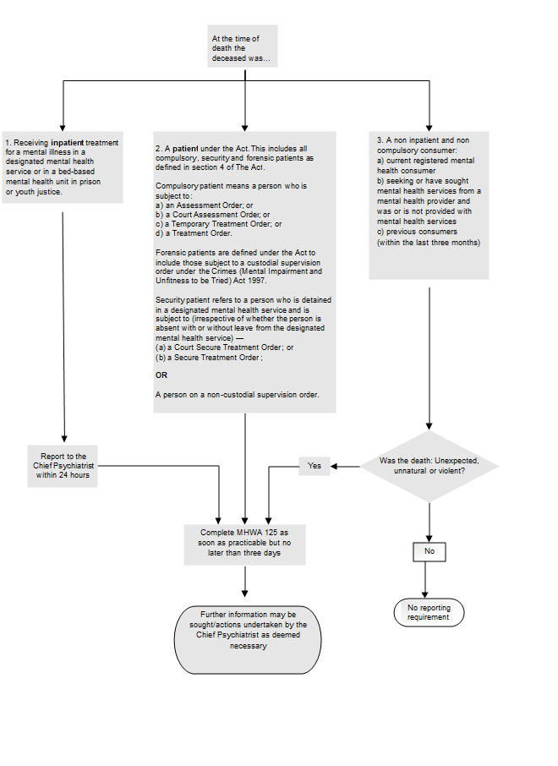

Appendix 2: Legislative definitions related to reportable deaths

Coroners Act 2008
Section 4 of the Coroners Act 2008 includes the following:
Reportable death
(1) In this Act, a death of a person is a reportable death if—
(a) the body is in Victoria; or
(b) the death occurred in Victoria; or
(c) the cause of the death occurred in Victoria; or
(d) the person ordinarily resided in Victoria at the time of death—
and the death was a death specified in subsection (2).
(2) For the purposes of subsection (1), the deaths are—
(a) a death that appears to have been unexpected, unnatural, or violent or to have resulted, directly or indirectly, from an accident or injury; or
(b) a death that occurs—
(i) during a medical procedure; or
(ii) following a medical procedure where the death is or may be causally related to the medical procedure—
and a registered medical practitioner would not, immediately before the procedure was undertaken, have reasonably expected the death; or
(c) the death of a person who immediately before death was a person placed in custody or care; or
(d) the death of a person who immediately before death was a patient within the meaning of the Mental Health Act 1986; or
(e) the death of a person under the control, care, or custody of the Secretary to the Department of Justice or a member of the police force; or
(f) the death of a person who is subject to a non-custodial supervision order under section 26 of the Crimes (Mental Impairment and Unfitness to be Tried) Act 1997; or
(g) the death of a person whose identity is unknown; or
(h) a death that occurs in Victoria if a notice under section 37(1) of the Births, Deaths and Marriages Registration Act 1996 has not been signed and is not likely to be signed; or
(i) a death that occurs at a place outside Victoria if the cause of death is not certified by a person who, under the law in force in that place, is authorised to certify that death and the cause of death is not likely to be certified by a person who is authorised to certify in that place; or
(j) a death—
(i) of a prescribed class of person;
(ii) that occurs in prescribed circumstances.

Mental Health and Wellbeing Act 2022 – notification of reportable deaths

Section 741
Chief psychiatrist to be notified of reportable deaths.
(1) The person in charge of a clinical mental health service provider must ensure that the chief psychiatrist is notified in writing of the death of any person receiving mental health services from the clinical mental health service provider that is a reportable death within the meaning of section 4 of the Coroners Act 2008 as soon as practicable after the person in charge becomes aware of the death.
(2) A notice under subsection (1) must specify—
(a) the name of the deceased; and
(b) the date of the death; and
(c) any other information required by the chief psychiatrist.

Section 742
Notification of death of security patient or forensic patient
(1) An authorised psychiatrist, by written notice, must advise whoever of the following is relevant in the circumstances of the death of any security patient who receives treatment from the designated mental health service—
(a) the Justice Secretary
(b) the Health Secretary
(c) the Chief Commissioner of Police.
(2) The notice under subsection (1) must specify—
(a) the name of the security patient; and
(b) the date of the death
(3) An authorised psychiatrist, by written notice, must advise the Health Secretary of the death of any forensic patient who receives treatment from the designated mental health service and specify—
(a) the name of the forensic patient; and
(b) the date of the death.

