CMI/ODS
Information Sheet
OFFICIAL

Contents
CMI/ODS 1
CMI 1
ODS 1
Purpose 2
CMI/ODS system diagram 2
Data recording timeframes 4
CMI/ODS Support and Services 4
Software- Mental Health Applications, Applications & Services Team 4
Data - Mental Health and Community Services Data Team 4
Reports - Victorian Agency for Health Information (VAHI) 4

CMI/ODS
CMI/ODS is the Victorian public mental health client information management system managed and maintained by the Department of Health.
The CMI/ODS has two components.
- Client Management Interface (CMI) application and
- Operational Data Store (ODS)

CMI
The CMI is the local client information management system used by each public mental health service.

ODS
The ODS is a state-wide database that receives and sends data from/to all local CMI databases across the state in real-time. The ODS is used to share select clinical client-level data between Victorian Public Designated Mental Health Services (DMHS) to support continuity of treatment and care as well as support the activities of the Mental Health Tribunal (MHT) and Office of the Chief Psychiatrist (OCP).
The CMI/ODS combined are designed to ensure that Victorian public mental health services can meet all reporting obligations including those under the Mental Health & Wellbeing Act 2022. The functionality of the system aligns with lawful information sharing processes as specified in the Mental Health & Wellbeing Act 2022.

Purpose
The primary purpose of the CMI/ODS is to:
- support the identification of registered consumers through the allocation of a unique state-wide identifier for new consumers
- store and provide access to a subset of data from local CMI’s that are accessible state-wide
- provide state-wide search functionality to support continuity of treatment and care
- ensure that the legal basis for providing treatment on a compulsory basis is evident to all services
- meet the department’s various reporting requirements
- support the statutory functions of the Chief Psychiatrist and the Mental Health Tribunal as described in the Mental Health & Wellbeing Act 2022

The CMI/ODS collection is a critical source of business intelligence for the Mental Health sector. CMI/ODS is not a medical records management system. It complements the local medical record system of public mental health services and provides a way to share statutory data with the department and other services.

CMI/ODS system diagram
Instances of CMI application are deployed locally at all public mental health services. There are currently 18 CMI databases accessed by 19 designated mental health services across Victoria.

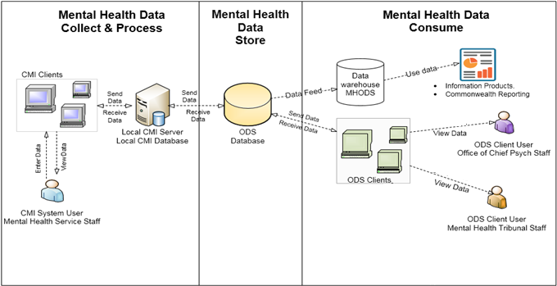

Data recording timeframes
The state-wide ODS is simultaneously updated from the local CMI systems as data are captured, providing a live 24-hour, seven day a week state-wide view of the transactional history of mental health services. Services are expected to use the CMI/ODS for data collection, which includes outcome measurement and client-related activity. Data recording timeframes are published in the Policy & Funding Guidelines each year. The table below is taken from the Policy & Funding Guidelines 2022-23:
Data entry | Rationale | Due date
Compulsory order/legal status | Timely information regarding compulsory/forensic/security client status | Twice daily, seven days per week
Admissions, transfers and separations | Statutory reporting  Maintenance of statewide bed register | Twice daily, seven days per week
Client registration and episode creation | Informational continuity of care | Daily, within 24 hours following mental state assessment
Contacts | Statutory reporting | On tenth of the month following the contact
Outcome measures | Statutory reporting | On tenth of the month following the measure collection
Electroconvulsive therapy procedures | Statutory reporting | As soon as practicably possible
Seclusion and restraint | Statutory reporting | On tenth of the month following the period of seclusion/restraint
Diagnosis | Statutory reporting | On tenth of the month following the diagnosis event

Community mental health consumers should have diagnoses recorded in accordance with the Program Management Circular: Recording diagnoses in CMI/ODS.

CMI/ODS Support and Services

Software- Mental Health Applications, Applications & Services Team
The Mental Health Applications, Applications & Services team provide third level technical support to mental health services that use CMI/ODS, and software development.
All support requests are required to be logged through Alemba data portal: https://ehvaccess.prod.services/logon/LogonPoint/tmindex.html
For assistance with setting up Alemba access please contact HTS Service desk on 1300 551 690 or
email Health Technology Solutions Service Desk - servicedesk@htsv.org.au

Data - Mental Health and Community Services Data Team
The Mental Health and Community Services Data team provides dataset governance functions to the mental health data set collected in CMI/ODS. For questions about mental health data collections or this factsheet please email MHDReporting@health.vic.gov.au.

Reports - Victorian Agency for Health Information (VAHI)
VAHI produces mental health reports from data collected in CMI/ODS. Publicly accessible quarterly performance reports are available at https://www.health.vic.gov.au/research-and-reporting/mental-health-performance-reports
Requests for mental health data can be logged here: Home – VAHI Data Request Hub (freshdesk.com) and will be responded to by VAHI.

For further information or to receive his publication in an accessible format please email: MHDReporting@health.vic.gov.au
Authorised and published by the Victorian Government, 1 Treasury Place, Melbourne.
ISBN 978-1-76131-235-9 (pdf/online/MS word)
© State of Victoria, Department of Health and Human Services, August 2023
CMI/ODS (health.vic.gov.au) <https://www.health.vic.gov.au/research-and-reporting/cmiods>

