The HIV treatment program: Access to HIV treatment for people in Victoria who are not eligible for Medicare
For Victorian public hospitals and health services
OFFICIAL

To receive this document in another format, email <VICHIVTP@health.vic.gov.au>.
Authorised and published by the Victorian Government, 1 Treasury Place, Melbourne.
© State of Victoria, Australia, Department of Health, July 2023
ISBN 978-1-76131-203-8 (pdf/online/MS word)
Available at < https://www.health.vic.gov.au/preventive-health/sexual-health >

Contents
Summary 4
Patient eligibility 4
Prescribing clinicians 5
Clinician responsibilities 6
Covered Pharmaceutical Benefits Scheme medicines 6
Dispensing at public hospital pharmacies 7
Co-payments 7
Reimbursement 7
Reporting requirements 7
Evaluation 8
Appendix 1 9

This document sets out the eligibility criteria, prescribing, dispensing and reimbursement requirements for s100 prescribers, pharmacies and public health services under the Federation Funding Agreement (FFA) – Health – Schedule for communicable diseases of public health concern – Access to HIV treatment for people who are not eligible for Medicare.

Summary
Human immunodeficiency virus (HIV) can weaken the immune system to the point that it is unable to fight simple infections. In Australia, HIV is most commonly transmitted through anal or vaginal sex without a condom. There is no cure or vaccine for HIV. Antiretroviral treatments are available to reduce a person’s viral load and symptoms of HIV. People with HIV who are on treatment and have an undetectable viral load cannot transmit HIV to others.
The Victorian HIV Plan 2022-30 < https://www.health.vic.gov.au/publications/victorian-hiv-plan-2022-30> aims for virtual elimination of new HIV transmission by 2025. To achieve this, the 2025 targets for people diagnosed, accessing appropriate treatment and on treatment with an undetectable viral load must also be met.
The Victorian HIV Treatment Program (the program) provides access for people living with HIV without Medicare to antiretroviral therapy (ART) and is subsidised through public hospital pharmacies. The program is exclusive to ART medicines used for the purpose of HIV treatment of the specified individual for the duration of their stay in Australia and while they are ineligible for Medicare.
This program replaces compassionate access schemes previously operated by pharmaceutical companies. It is a jointly funded program by the Commonwealth Department of Health and Aged Care and the Department of Health, Victoria. It ensures access to ART to every Victorian who needs it.
Public hospital pharmacies will be reimbursed for the commercial cost of Pharmaceutical Benefits Scheme listed ART medications dispensed under this program.

Patient eligibility
To be eligible under the program, a person must:
- be ineligible for Medicare
- report that they are currently residing in Australia beyond a short-term stay
- report that they do not have private health that covers HIV ART or prefer not to use it
- be receiving appropriate specialist medical care as:
  - a patient of an s100 community prescriber, or
  - an outpatient in a public health service, or
  - a day patient, a patient on discharge, or
  - a non-admitted patient of a public hospital.
People who are visiting from interstate or who have recently moved interstate are eligible to receive HIV ART medications under this program if they meet the above criteria. The program excludes short-stay visitors to Australia or international tourists.
Prescribers must annotate the script with ‘VICHIVTP’ to endorse the patient’s eligibility. This will ensure the patient is not charged for the HIV ART medication at dispensing.

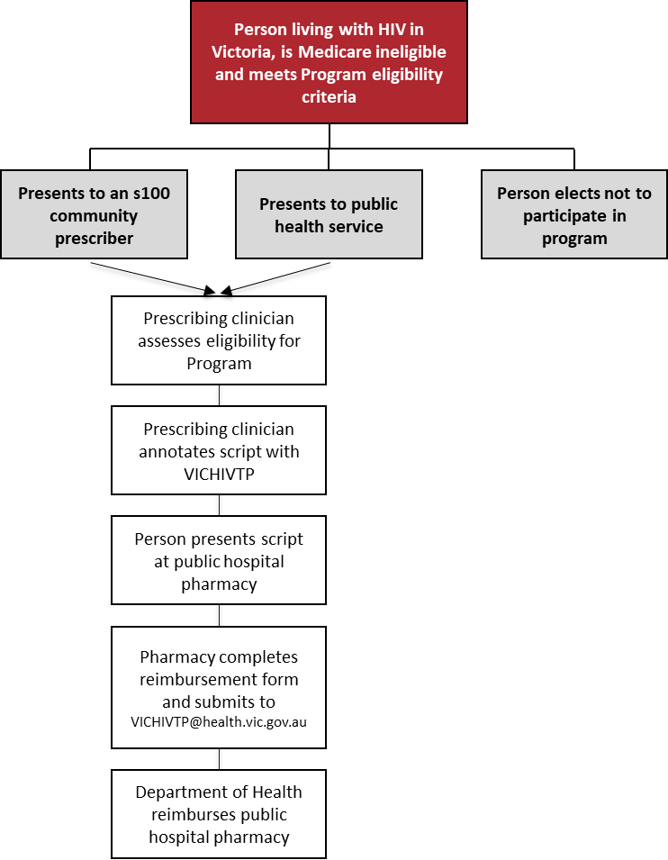
Figure 1: Flowchart for prescribing and dispensing medication under the program

Prescribing clinicians
Clinicians prescribing HIV medications must be accredited s100 prescribers under section 100 of the National Health Act 1953 (Cth). Prescribing s100 clinicians may be employed at a public health service or any s100 prescriber, including a community s100 general practitioner.
The s100 prescriber endorses the script for patients who meet the eligibility criteria by annotating ‘VICHIVTP’ on the script.
Clinicians can only prescribe ART under this program. Other HIV related medications are out of scope of this program.
The Victorian HIV and Hepatitis Integrated Training And Learning (VHHITAL) program delivers comprehensive education and training for the primary health care workforce for the diagnosis, treatment and management of HIV, hepatitis B, hepatitis C and sexually transmitted infections (STI). <https://nwmphn.org.au/about/partnerships-collaborations/vhhital/>

Clinician responsibilities
Assess the patient and write a prescription for the ART endorsed as above.
Prescribers are to advise the patient that only the cost of the ART is covered and that any additional care or treatment related to HIV, such as prophylactic and therapeutic anti-infectives, are out of scope of this program.
Prescribers must advise the patient that medication can only be dispensed from a public hospital pharmacy, and encourage patients to return to the same pharmacy throughout their treatment.
Prescribers must ensure anyone with English as a second language has access to an interpreter if required, can understand the information being provided, and can engage in treatment with informed consent.

Covered Pharmaceutical Benefits Scheme medicines
HIV ART dispensed under this program are restricted to Pharmaceutical Benefits Scheme listed medications.
Pharmaceutical Benefits Scheme listed injectable ART is available under the HIV treatment program for people who:
- have difficulty maintaining a daily oral regime
- have difficulty storing medication
- would benefit from using injectable ART for privacy reasons
- can commit to the administration regime of the medication.
HIV ART medications that have been removed from the Pharmaceutical Benefits Scheme will be available under Supply Only guidelines. Medications under Supply Only guidelines are available for dispensing but not for prescribing, for a period of up to 12 months after being removed from the Pharmaceutical Benefits Scheme list. Pharmacists must honour valid prescription, however prescriptions written after the date where medicines are removed from the Pharmaceutical Benefits Scheme will be considered invalid for dispensing.
HIV ART medications can be prescribed up to the Pharmaceutical Benefits Scheme authorised maximum quantity and number of repeats under the program.

Dispensing at public hospital pharmacies
Scripts that have been annotated with ‘VICHIVTP’ by the s100 prescriber, are endorsed for inclusion. Pharmacists can also obtain verbal endorsement from the s100 prescriber as an alternative to the annotation.
The pharmacist must dispense the medication as a non-Pharmaceutical Benefits Scheme normal prescription using commercially traded stock.
A list of public hospitals can be found at <https://www.health.vic.gov.au/hospitals-and-health-services/public-hospitals-in-victoria>

Co-payments
A co-payment is a charge issued to a patient when a prescription is dispensed. Co-payments may be waived for patients at the discretion of the hospital. Collection of co-payments is the responsibility of each individual hospital. A hospital is under no obligation to collect a co-payment.
Visit the Department of Health and Aged Care website for the current co-payment amount and Safety Net levels. <http://www.pbs.gov.au/info/healthpro/explanatory-notes/front/fee>

Reimbursement
The Department of Health (the department) will reimburse public hospital pharmacies for the commercial cost of Pharmaceutical Benefits Scheme listed ART medications dispensed under this program. Pharmacies must email the department <VICHIVTP@health.vic.gov.au> the reimbursement form on a quarterly basis and meet the reporting requirements outlined below.

Reporting requirements
Public hospital pharmacies will provide the following data on a quarterly basis, to be submitted with their reimbursement forms.

Data requested | Input
Total number of people who received antiretroviral therapy (ART) medications for the treatment of HIV under this program for the quarter | <Total number of people>
Total cost of ART medications for the treatment of HIV under this program for the financial year for the quarter | <Total expenditure – no rounding>
Types of ART medications dispensed under this program for the for the quarter; and if possible, number of scripts dispensed per medication type | <Provide a list as an attachment >
Total number of scripts dispensed under this program for the quarter | <Total number of scripts dispensed>
Total number of sites dispensing HIV treatment to people who are not eligible for Medicare at execution | <Total number of clinics/sites>

The Department of Health will collate the information and provide to the Australian Government Department of Health and Aged Care on an annual basis.

Submission dates:
- 15 October 2023 for period 1 July 2023 to 30 September 2023
- 15 January 2024 for period 1 October 2023 to 31 December 2023
- 15 April 2024 for period 1 January 2024 to 31 March 2024
- 15 July 2024 for period 1 April 2024 to 30 June 2024

Evaluation
Health services and public hospital pharmacies will be asked to provide annual feedback about the program including:
- issues encountered or suggested improvements
- activities undertaken to promote the initiative.

Appendix 1

Flowchart for prescribing and dispensing medication under the Program (text version)
A person living with HIV in Victoria, who is Medicare ineligible and meets the Program eligibility criteria can either present to an s100 community prescriber or a public health service to access the program.
The Prescribing clinical will assess the person for eligibility for the program.
If the person meets the criteria, the prescribing clinician with annotate the script with VICHIVTP.
The person presents the annotated script at a public hospital pharmacy.
The pharmacy supplies the medication and completes the reimbursement form and submits it to ,VICHIVTP@health.vic.gov.au>
The Department of Health reimburses the public hospital pharmacy.

