Check you are using the correct vaccine brand for age
National Immunisation Program childhood and adolescent schedule vaccine recommendations
July 2023
Always check that vaccines are prepared and administered appropriately in accordance with product instructions and recommendations in the Australian Immunisation Handbook <https://immunisationhandbook.health.gov.au/>.
Use this resource in conjunction with the Immunisation schedule Victoria and vaccine eligibility criteria <https://www.health.vic.gov.au/immunisation/immunisation-schedule-victoria-and-vaccine-eligibility-criteria>.

2 months (from 6 weeks) and 4 months of age
Vaccine brand | Packaging
Infanrix hexa® or Vaxelis®  Diphtheria-tetanus-acellular pertussis-poliomyelitis-hepatitis B-Hib | 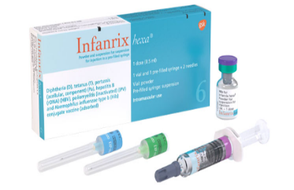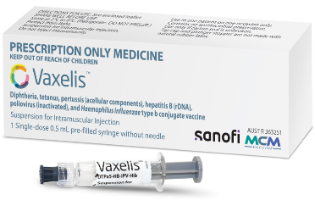
Prevenar 13®  Pneumococcal | 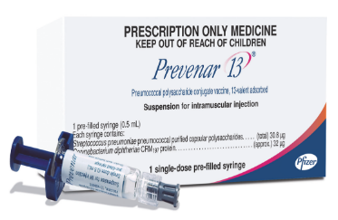
Rotarix®  Rotavirus | 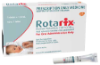
Aboriginal and Torres Strait Islander children only  Bexsero®  Meningococcal B | 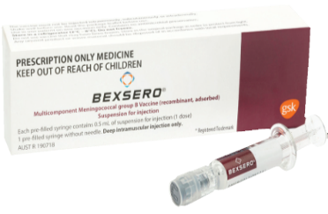

6 months of age
Vaccine brand | Packaging
Infanrix hexa® or Vaxelis®
Diphtheria-tetanus-acellular pertussis-poliomyelitis-hepatitis B-Hib

Influenza vaccine  Annually for all children aged 6 months to <5 years | Vaccine brand supplied annually  - administer the age-appropriate NIP funded vaccine brand
Prevenar 13®
Pneumococcal
Risk condition: see Risk conditions for pneumococcal disease <https://immunisationhandbook.health.gov.au/resources/handbook-tables/list-risk-conditions-for-pneumococcal-disease>

12 months of age
Vaccine brand | Packaging
M-M-R-II® or Priorix®  Measles-mumps-rubella | 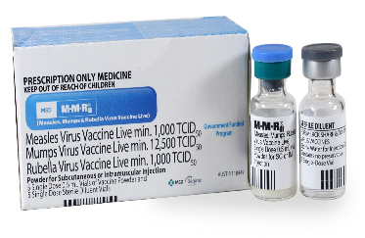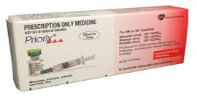
Prevenar 13®
Pneumococcal
Nimenrix®  Meningococcal ACWY | 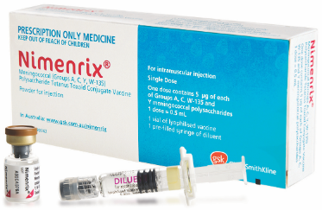
Aboriginal and Torres Strait Islander children only
Bexsero®
Meningococcal B

Engerix B® paediatric or H-B-VAX® II paediatric  Paediatric Hepatitis B  Risk condition: premature born <32 weeks or birth weight <2000g | 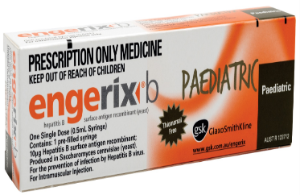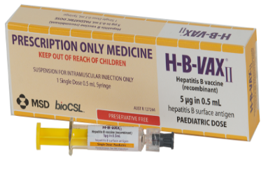

18 months of age
Vaccine brand | Packaging
Act-HiB®  Haemophilus influenzae type b | 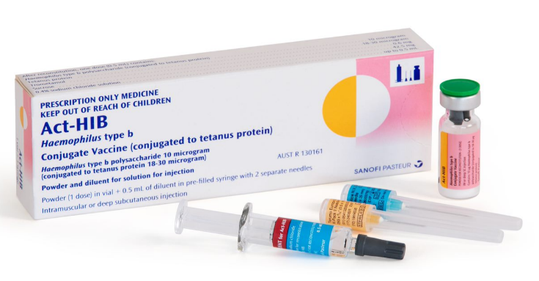
Priorix-Tetra®  Measles-mumps-rubella-varicella | 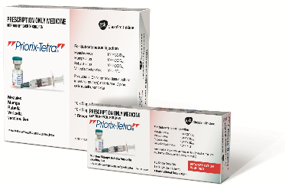
Infanrix® or Tripacel®  Diphtheria-tetanus- pertussis | 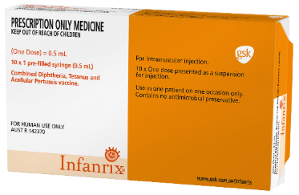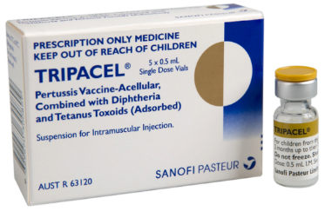

4 years of age
Vaccine brand | Packaging
Infanrix IPV® or Quadracel®  Diphtheria-tetanus-pertussis-poliomyelitis | 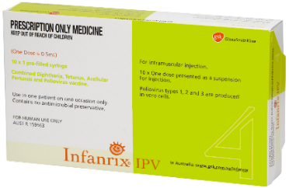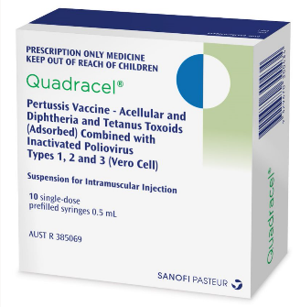
Pneumovax23®  Pneumococcal  Risk condition: see Risk conditions for pneumococcal disease <https://immunisationhandbook.health.gov.au/resources/handbook-tables/list-risk-conditions-for-pneumococcal-disease> | 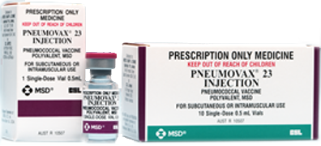

Year 7 of secondary school or 12 to 13 years of age
Vaccine brand | Packaging
Gardasil® 9  Human papillomavirus | 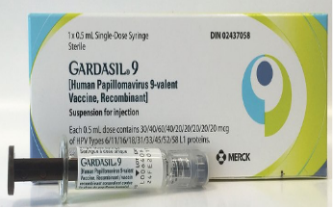
Adacel® or Boostrix®  Diphtheria-tetanus- pertussis reduced antigen formulation | 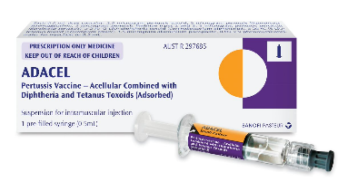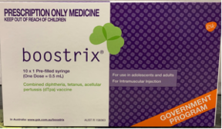

Year 10 of secondary school or 15 to 16 years of age
Vaccine brand | Packaging
Nimenrix®
Meningococcal ACWY

To receive this document in another format or email the Immunisation Unit <immunisation@health.vic.gov.au>.
Authorised and published by the Victorian Government, 1 Treasury Place, Melbourne.
© State of Victoria, Australia, Department of Health, July 2023.
Available on Immunisation factsheets, consent templates and mature minor information
<https://www.health.vic.gov.au/immunisation/immunisation-fact-sheets-consent-templates-and-mature-minor-information>.

