

|  |
| --- |
| Healthy choices: policy directive for Victorian public health services – Short summary – 2022 results |

## Introduction/Background

This document is a summary of the achievement of the Healthy choices: policy directive for Victorian public health services (Healthy choices: policy directive / Policy directive) for the Phase 1 (2022) drinks targets.

As healthcare facilities with a high profile within the community, health services have an important leadership role in providing their staff, visitors and patients/residents with healthy food and drink options.

As public health services are government funded, it is important that funding from the Department of Health aligns with the promotion of health, and the prevention of disease. Poor diet is a leading risk factor to a range of diseases, including cardiovascular disease, type 2 diabetes, some cancers, obesity, as well as poor oral health and poor mental health.

The Healthy choices: policy directiveapplies to in-house managed retail, all catering and all vending, and was announced in April 2021 and introduced on 3 August 2021. It aims to improve the opportunity for staff and visitors of public health services to access a variety of healthy food and drinks options.

Health services were given time to meet this Policy directive, with it being phased in over two years, and a supportive and flexible approach taken with policy implementation.

Since the release of the Policy directive, the Healthy Eating Advisory Service (HEAS) have been providing intensive support to all health services to assist them meet and report on the Policy. This has included one-on-one meetings, facilitation of communities of practice, and development of a wide range of implementation tools, videos and resources to assist with implementation and reporting. HEAS is delivered by experienced nutritionists and dietitians at Nutrition Australia Vic Division, with support from the Victorian Government.  Visit the HEAS website at: <[heas.health.vic.gov.au](https://heas.health.vic.gov.au/)> for more information.

### Summary of Policy directive scope and requirements

The Policy directive applies to all public health services across all of their sites and facilities (hospitals, integrated community health services, public sector residential aged care services (PSRACS) and some mental health services) and covers:

* in-house managed retail food outlets, such as cafes, kiosks, restaurants (as well as items purchased by staff and visitors from patient/resident menus)
* **all** vending machines
* **all** catering provided by the service to staff and visitors (includes catering ordered through both in-house or commercial providers).

**Note***:* Whist privately/commercially managed outlets are not in scope of the Policy directive, health services are encouraged to apply this policy to **all** retail food outlets (in order to help meet the Victorian Cancer Plan 2020-2024 state-wide target)[1].

The Policy directive **does not** apply to inpatient/resident meals (except those for staff/visitors to purchase) and food/drinks that staff/visitors bring from outside the facility to share or for their own consumption.

Policy directive requirements:

| Timeline | Target |
| --- | --- |
| Phase 1: 30 Sept 2022 | **Drinks:**   * **Vending and in-house retail food outlets:** No RED drinks to be available or promoted/advertised. At least 50% GREEN drinks, and no more than 20% drinks containing artificial or intense sweeteners (classified AMBER) are available. * **Catering:** No RED drinks are provided (with majority of options to be GREEN). |
| Phase 2:  30 Sept 2023 | **Food:**   * **Vending and in-house food retail food outlets:** At least 50% GREEN foods and no more than 20% RED foods are available. No RED foods to be promoted/advertised. * **Catering:** No RED foods are provided (with majority of options to be GREEN). |

Health services are also encouraged to have free drinking water (for example, water fountains, jugs of tap water) readily available and promoted.

More information on the Policy directive is available on the Health services page at: <[heas.health.vic.gov.au](https://heas.health.vic.gov.au/)>.

## A picture of the retail food services within health services

Overall, **81** Victorian public health services with **495** individual sites/services were “in-scope” for the Healthy choices: policy directive as of 2022.

**Number and type of food services**

* There were 51 (63%) health services, with 102 sites (21%) sites with an ‘in scope’* food service, as follows:
* 30 (37%) health services / 39 (8%) sites with one or more in-house retail outlets
* 27 (33%) health services / 46 (9%) sites with one or more drinks only vending machines
* 24 (30%) health services / 49 (10%) sites with one or more combined food and drink vending machines.
* There were 337 total ‘in scope’ food services (281 vending machines and 56 in-house outlets) (excluding privately/commercially managed outlets).

**Note: \***In-house retail outlets, drinks only and combined food and drink vending machines were ‘in scope’ for Phase 1. For the Phase 2 food targets, staff ordering off the patient/resident menu, as well as food-only vending machines will also be in scope.

**Location of food services**

* Nearly half (45%) of rural/regional health services have in-house retail outlets, whereas only one metropolitan health service did (some metropolitan and rural/regional health services also have privately/commercially managed outlets – see below).
* More metropolitan health services are likely to have ‘in scope’ vending machines compared to rural/regional health services.

**Table 1 - Food service type by location**

|  |  |  |
| --- | --- | --- |
|  | **Metro (n = 17)** | **Rural/regional (n = 64)** |
| Have in-house managed retail outlets | 1 (6%) | 29 (45%) |
| Have drinks vending machines | 11 (65%) | 17 (27%) |
| Have combined food/drink vending machines | 12 (71%) | 12 (19%) |

**Food service type by health service type**

There were:

* 153 hospital sites (representing 31% of sites), and 36 (24%) of them had in-house managed retail outlets, and 69 (46%) of them had vending machines.
* 179 PSRACS sites (representing 36% of sites), and only 2 (1%) of them had in-house outlets.
* 111 integrated community health service sites (representing 22% of sites), and only 1(1%) of them had in-house retail outlets.
* 52 mental health sites (representing 11% of sites), and only 3 (6%) of them had vending machines. They did not have in-house retail outlets.

Whilst PSRACS and integrated community health services were less likely to have in-house managed retail outlets and vending machines on site, they often accessed these food services on other sites.

**Privately/commercially managed retail outlets**

According to self-reported data, as of 2022, there were 86 privately/commercially managed retail food outlets located across 58 sites/26 Victorian public health services (16 metropolitan and 12 rural/regional). However,this could be an under-estimation of privately/commercially managed retail outlets.

## State-wide results

### Overall results

Overall, in 2022, 88% (71/81) of health services (in scope) implemented and achieved the first phase of the Healthy choices: policy directive, meeting the requirements for drinks (providing and promoting healthier drinks, and not selling or promoting sugary (RED category) drinks in their in-house managed food outlets, vending machines and staff/visitor catering).

More specifically:

* 93% (28/30) of health services with in-house managed retail outlets met the requirements for drinks.
* 81% (30/37) of health services with ‘in scope’ vending machines met the requirements for drinks.
* 91% (74/81) of health services reported that they do not offer sugary (RED) drinks for staff/event catering across their organisation.

See Figures below, and Tables 2 – 4 for further detail.

Further to this:

* 95% (77/81) of health services reported having an organisational healthy catering policy, or one in development.
* 99% (80/81) of health services reported having free drinking water available (e.g., through water fountains or catering) to visitors at each of their sites/services.

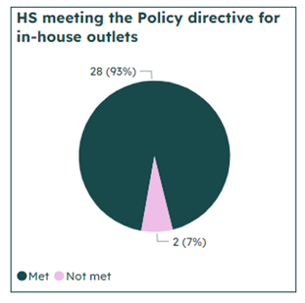 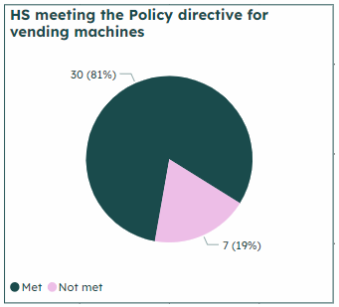 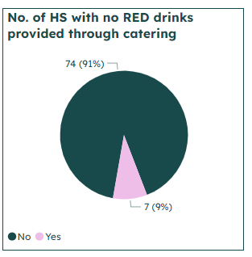

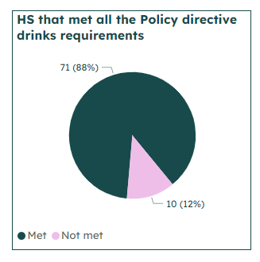

Further detail

* Table 2 provides further detail on the number of sites that have in-house retail outlets/’in scope’ vending machines that met the Policy directive for drinks. It also demonstrates that the potential reach of these retail outlets and vending machines is greater than indicated in food service site numbers, as they are reported to be often accessed by residents/staff/visitors of other nearby sites.
* Table 3 indicates that the majority of the 337 in-house retail outlets and ‘in scope’ vending machines met the Policy directive for drinks.
* Table 4 outlines the percentage of GREEN (best choices); AMBER (choose carefully), including AMBER artificially sweetened drinks; and RED (limit) drinks offered across all food service types, and compares this with the Policy directive requirements (targets).

**Table 2: Heath services and sites with in-house retail outlets/vending machines that met the Policy directive** **for drinks**

|  |  |  |  |
| --- | --- | --- | --- |
|  | **Health services (in scope)** (n=81) | **Sites (where the outlet located)** | **Sites (that access the outlet but not located on that site)** |
| **That met the Policy directive for drinks* for:** |  |  |  |
| In-house retail outlets | 28/30** (93%)  **No. health services with in-house retail | 36/39** (92%)  **No sites with in-house retail | 54 |
| Vending machines (VM)  (Drinks only and combined) | 30/37** (81%)  **No. health services with VM | 73/81** (90%)  **No sites with VM | 33 |
| In-house retail and VM combined | 49/51** (96%)  **No. health services with VM and/or in-house retail | 94/102** (92%)  **No. sites with VM and/or in-house retail | 73 |

* **Met the PD for drinks** - do not sell or promote sugary drinks, sell no more than 20% AMBER artificially sweetened drinks and 50% or more GREEN across their in-house retail outlets and all vending, and provide no RED drinks via their catering.

**Table 3: Number and percentage of in-house retail outlets/vending machines that met the Policy directive for drinks**

|  |  |
| --- | --- |
| **Food service type** | **No. / % Met** |
| In-house retail outlets (n=56) | 52 (93%) |
| Vending machines (n=281) | 266 (95%) |
| **Overall (n=337)** | **318 (94%)** |

**Table 4: Average percentage of GREEN, AMBER and RED drinks**

|  |  |  |  |  |  |  |  |  |
| --- | --- | --- | --- | --- | --- | --- | --- | --- |
| **Food service type** | **Average % GREEN drinks** | **Target** | **Average % AMBER drinks** | **Target** | **Average % AMBER artificially sweetened drinks** | **Target** | **Average % RED drinks** | **Target** |
| Vending machines – drinks only | 64 | At least 50% | 17 | 0-50% | 18 | No more than 20% | 0 | 0% |
| Vending machines – food and drinks combined | 74 | At least 50% | 8 | 0-50% | 13 | No more than 20% | 4 | 0% |
| In-house retail outlets | 73 | At least 50% | 15 | 0-50% | 9 | No more than 20% | 3 | 0% |

## Summary and discussion

The Healthy choices: policy directive built on the Healthy choices: policy guidelines for hospitals and health services. The Department of Health has taken a flexible and supportive approach to policy implementation, with it being phased in over two years; and extensive resources, tools and support provided by the Healthy Eating Advisory Service (HEAS).

It has been extremely pleasing, that with the hard work and commitment of health services, and the support provided by HEAS, that all services reported on the directive, and the majority of services met the Phase 1 drinks targets in the majority of their in-house retail outlets, vending machines and for their catering.

With a high sugary drink intake being associated with tooth decay, overweight and obesity, Type 2 diabetes and a range of associated diseases, this transformation of the retail environment of health services has the potential to make a significant impact on Victorian population health. It also supports ‘healthy choices being the easy choices’.

As the Policy directive applies to in-house retail outlets, with health services strongly encouraged to implement the directive/Healthy choices across all their retail outlets, health services were not required to report on their privately/commercially managed retail outlets. As such, only a small number of health services reported on these retail outlets. It is hoped that a greater number of health services will aim to implement Healthy Choices across all retail outlets, and report on their privately/commercially managed outlets later in 2023, in the interests of providing and promoting healthier food and drinks choices across their whole service, as well as help services contribute to the Cancer Plan 2020-24 target of ‘at least 80 per cent of health services’ retail outlets and vending machines meeting Healthy Choices by 2024’.

While health services celebrate their success with removing sugary drinks, they are also working on increasing healthy food options through their in-house retail outlets, vending and catering, in order to meet the Phase 2 food targets. Reporting on progress against these targets will be open in September 2023.

The HEAS team will continue to provide support to health services with policy implementation and reporting.

|  |
| --- |
| To receive this document in another format, phone 9096 9000, using the National Relay Service 13 36 77 if required, or [email](mailto:healthychoices@health.vic.gov.au) <healthychoices@health.vic.gov.au>.  Authorised and published by the Victorian Government, 1 Treasury Place, Melbourne.  © State of Victoria, Australia, Department of Health, May 2023.  **ISBN** 978-1-76131-149-9 **(pdf/online/MS word)**  Available at [Healthy Choices: policy directive and guidelines for health services](https://www.health.vic.gov.au/publications/healthy-choices-policy-directive-and-guidelines-for-health-services)  <https://www.health.vic.gov.au/publications/healthy-choices-policy-directive-and-guidelines-for-health-services> |

1. The [Victorian Cancer Plan 2020-2024](https://www2.health.vic.gov.au/about/health-strategies/cancer-care/victorian-cancer-plan) target: “at least 80 per cent of hospitals and health services’ retail outlets and vending machines to meet the recommended Victorian Government food and nutrition standards (Healthy choices) by 2024.”