COVID-19 medications for at risk people who do not require oxygen
Updated 17 November 2022
OFFICIAL

Background
There are a range of Therapeutic Goods Administration (TGA) approved COVID-19 medications available in Victoria for at risk people with COVID-19. The purpose of this document is to:
- support clinical decision making in the selection of medications for eligible adults with COVID-19 who do not require oxygen – see COVID-19 medications in adults
- provide referral details for access to early therapies through the hospital system – see Referral information for access to early therapies
- outline eligibility for and prioritisation of early therapies through the hospital system – see Medication eligibility and prioritisation
This document will be reviewed and updated as required based on:
- emerging evidence and efficacy of medications
- access and availability to new medications
- changes to pathways of care.
This document has been developed by an expert working group of Victorian clinicians and includes consideration of recommendations from the National COVID-19 Clinical Evidence Taskforce.
For advice on the management of children with symptomatic COVID-19 refer to the Royal Children’s Hospital guidelines <https://www.rch.org.au/uploadedFiles/Main/Content/clinicalguide/guideline_index/RCH-COVID-clinical-management-guidelines-package.pdf>
The Request to Access form for remdesivir (VekluryTM) can be found here
<https://www.health.vic.gov.au/request-to-access-covid-19-medications>
PBS prescribing information can be found at PaxlovidTM eligibility criteria <https://www.pbs.gov.au/medicine/item/12996B> and LagevrioTM eligibility criteria <https://www.pbs.gov.au/medicine/item/12910L>.
For information on the clinical evidence supporting the use of each medication refer to the National COVID-19 Clinical Evidence Taskforce <https://covid19evidence.net.au/> and Drug treatments for at risk adults with COVID-19 who do not require oxygen decision tool <https://covid19evidence.net.au/wp-content/uploads/DECISION-TOOL-DT-FOR-ADULTS.pdf>

COVID-19 medications in adults
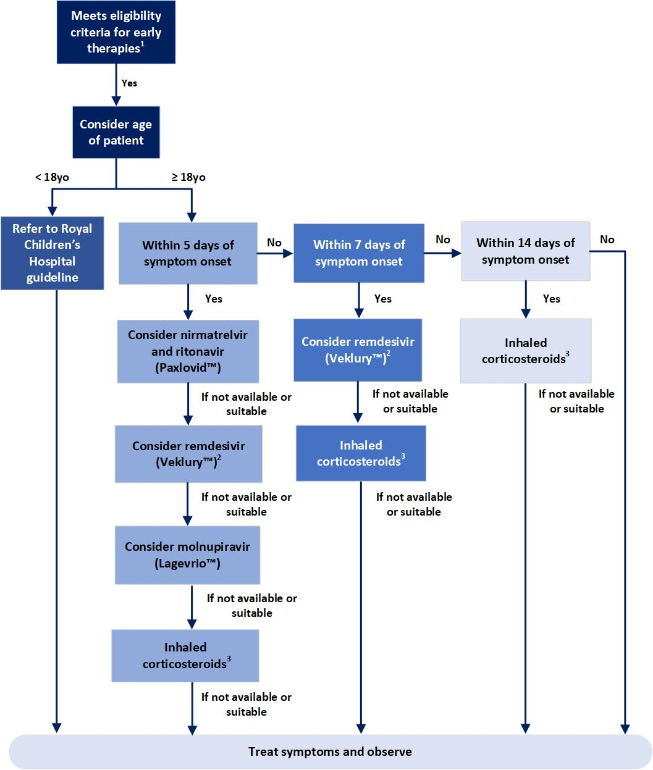
Figure 1. Overview of medication selection for adults with COVID-19 who do not require oxygen
- In exceptional circumstances, access to medications may be considered for patients who do not fit within the eligibility requirements if:
- the patient’s case has been discussed with two senior physicians experienced in the management of COVID-19 (at least one of which is an infectious disease physician where available) and
- there is consensus that the treatment is clinically indicated.

- Remdesivir (VekluryTM) may be reserved as an option for outpatients who are in the highest priority group(s) e.g. priority 1-2 and for inpatients of all priority groups of the Prioritisation Table.

- Inhaled corticosteroids budesonide (PulmicortTM) or ciclesonide (AlvescoTM) can be considered as either a standalone therapy or as an additional therapy in patients already prescribed another early therapy.

FOR ELIGIBLE PATIENTS FIRST CONSIDER

nirmatrelvir and ritonavir (PaxlovidTM)
Timeframe: Within five days of symptom onset
Administration: 300 mg nirmatrelvir (two 150 mg tablets) with 100 mg ritonavir (one 100 mg tablet), with all three tablets taken together twice daily for five days.
If eGFR 30-60 ml/min then reduce dose to 150 mg nirmatrelvir (one 150 mg tablet) with 100mg ritonavir (one 100 mg tablet), with both tablets taken together twice daily for five days. eGFR testing prior to prescription is not routine. Clinicians to determine need based on an individual’s risk of renal impairment.
Contraindications:
- Severe renal (eGFR < 30 ml/min) or hepatic impairment (Child-Pugh Class C)
- Co-administration with drugs highly dependent on CYP3A4, 2D6, p-glycoprotein and specific transporter proteins for which elevated concentrations are associated with serious and/or life threatening reactions (unless the medication can be stopped for 8 days after commencing PaxlovidTM). Co-administration with potent CYP3A4 inducers where significantly reduced nirmatrelvir or ritonavir plasma concentrations may be associated with the potential for loss of virologic response and possible resistance.
- Hypersensitivity to active ingredients or other components of the product
- Weight < 40 kg
- Category B3 - do not use in pregnant women and in women of childbearing potential not using contraception. Women should avoid becoming pregnant during treatment and until 7 days after treatment ceases.
- Do not use in breastfeeding women. Breastfeeding can commence 7 days after treatment ceases.
Precautions:
- HIV viral load > 400 copies/ml
- Significant drug interactions are expected with the concomitant use of nirmatrelvir and ritonavir (PaxlovidTM) and many other drugs. An accurate medication history must be complied to ensure that drug-drug interactions can be managed appropriately and the plan communicated clearly to the patient. Potential drug interactions must be reviewed by both the clinician when considering prescribing the medication and also a pharmacist reviewing potential interacting medications.
- Preference is to be able to swallow tablets whole. Tablets can be crushed where necessary where it is deemed appropriate.
- Patients should be informed of the risk of rebound, and to re-isolate if symptoms reoccur.
Further information:
University of Liverpool COVID-19 Drug Interactions resource <https://www.covid19-druginteractions.org/> (also available as an app on mobile devices – search for ‘COVID-19 iChart’ on App Store or Google Play)
Administering Paxlovid as Crushed Tablets <https://www.covid19-druginteractions.org/prescribing_resources/paxlovid-crushing-tablets>
Australian guidelines for the clinical care of people with COVID-19
<https://app.magicapp.org/#/guideline/L4Q5An/section/LA6kkM>
IDSA Management of Drug Interactions With Nirmatrelvir/Ritonavir (Paxlovid®): Resource for Clinicians <https://www.idsociety.org/globalassets/idsa/practice-guidelines/covid-19/treatment/idsa-paxlovid-drug-interactions-resource-5-6-22-v1.1.pdf>
Product information <https://www.tga.gov.au/sites/default/files/paxlovid-pi.pdf>
Consumer information <https://www.ebs.tga.gov.au/ebs/picmi/picmirepository.nsf/pdf?OpenAgent&id=CP-2022-CMI-01050-1&d=20221021172310101>
Lexicomp Interaction Checker or Australian Medicines Handbook Interaction Checkers (accessible via Clinicians Health Channel for list of CYP3A4 & 2D6 substrates/inducers) <https://www.clinicians.vic.gov.au/>
Flow chart based on University of Liverpool Assessing a patient for treatment with Paxlovid <https://www.covid19-druginteractions.org/prescribing_resources/paxlovid-patient-assessment> flow chart (March 2022) and The Northern Hospital Treatment of patients with mild/early COVID-19 flow chart.
Figure 2. Nirmatrelvir and ritonavir (PaxlovidTM) prescribing considerations
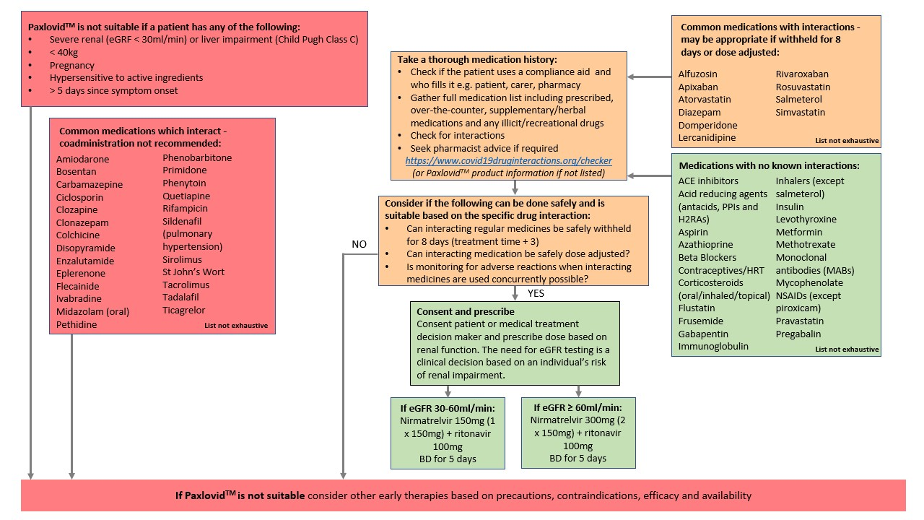
.
IF nirmatrelvir and ritonavir (PAXLOVIDTM) IS NOT AVAILABLE OR SUITABLE, THEN CONSIDER

remdesivir (VekluryTM)
Timeframe: Within seven days of symptom onset
Administration: remdesivir (VekluryTM) IV for three days (200 mg dose on day one, then 100 mg daily on days two and three)
Contraindications:
- Hepatic dysfunction (ALT > 5 x upper limit of normal, or ALT > 3 x upper limit of normal and bilirubin > 2 x upper limit of normal)
- Severe renal impairment (eGFR < 30 ml/min) – unless receiving dialysis treatment
- Hypersensitivity to active ingredients or other components of the product
- Weight < 40 kg (Note. dosed in mg/kg in patients < 18 years old see Royal Children’s Hospital guidelines) <https://www.rch.org.au/uploadedFiles/Main/Content/clinicalguide/guideline_index/RCH-COVID-clinical-management-guidelines-package.pdf>
Precautions:
- Category B2 - requires assessment of risks verus benefits and specialist advice for use in pregnant women. Women should avoid becoming pregnant during treatment.
- Breastfeeding requires assessment of risks verus benefits and specialist advice
- Consider logistics of patient accessing the healthcare setting for IV infusion for three consecutive days
- Co-administration with chloroquine phosphate or hydroxychloroquine sulphate may reduce metabolic activation and antiviral activity of remdesivir (VekluryTM)
Further information:
Australian guidelines for the clinical care of people with COVID-19
<https://app.magicapp.org/#/guideline/L4Q5An/section/no6vGL>
Product information <https://www.tga.gov.au/sites/default/files/auspar-remdesivir-200720-pi.pdf>
Consumer information <https://www.ebs.tga.gov.au/ebs/picmi/picmirepository.nsf/pdf?OpenAgent&id=CP-2020-CMI-01929-1>

IF REMDESIVIR (VekluryTM) IS NOT AVAILABLE OR SUITABLE, THEN CONSIDER

molnupiravir (LagevrioTM)
Timeframe: Within five days of symptom onset
Administration: molnupiravir (LagervrioTM) 800 mg (four 200mg capsules), taken twice daily for 5 days
Contraindications:
- Category D - do not use in pregnant women. Women should avoid becoming pregnant during treatment and until four days after treatment ceases. Men should use adequate contraception during and 3 months after treatment ceases.
- Do not use in breastfeeding women. Breastfeeding can commence four days after treatment ceases.
- Hypersensitivity to active ingredients or other components of the product
Precautions:
- There are some concerns about poorer efficacy of molnupiravir (LagevrioTM) compared to nirmatrelvir and ritonavir (PaxlovidTM) or remdesivir (VekluryTM), but may be appropriate when other options are not suitable or available
- Evidence from a Victorian study in individuals aged 70 or older from July to October 2022 has demonstrated real world evidence of benefit. The study found that individuals who did not receive either PaxlovidTM or LagevrioTM were between 26% and 32% more likely to be hospitalised than those who received either drug. The study also found that individuals who received PaxlovidTM or LagevrioTM were 72% and 54% less likely to die, respectively, compared to individuals who did not receive either treatment.
- Whilst the PANORAMIC trial showed no evidence of a difference between LagevrioTM compared to usual care alone in reducing deaths or hospitalisations, less than 15% of participants were aged 70 or older.
Further information:
Australian guidelines for the clinical care of people with COVID-19
<https://app.magicapp.org/#/guideline/L4Q5An/section/jboz6G>
Product information <https:\www.tga.gov.au\sites\default\files\lagevrio-pi.pdf>
Consumer information <https://www.ebs.tga.gov.au/ebs/picmi/picmirepository.nsf/pdf?OpenAgent&id=CP-2022-CMI-01048-1>

IF MOLNUPIRAVIR (LAGEVRIOTM) IS NOT AVAILABLE OR SUITABLE, THEN CONSIDER

Inhaled corticosteroids: budesonide (PulmicortTM) or ciclesonide (AlvescoTM)
Timeframe: Within 14 days of symptom onset
Administration:
- Budesonide (PulmicortTM) 800 μg inhaled twice daily for up to 14 days. Ciclesonide (AlvescoTM) 320 μg inhaled twice daily for up to 14 days.
- Inhaled corticosteroids can be considered as either a standalone therapy or as an additional therapy in patients already prescribed another early therapy.
Contraindications:
- Hypersensitivity to active ingredients or other components of the product
Precautions:
- Inhaled corticosteroids are considered to be safe for use during pregnancy and breastfeeding. In pregnancy, budesonide (PulmicortTM) which is Category A is the preferred option over ciclesonide (AlvescoTM) which is Category B3.
- If patients are already prescribed inhaled corticosteroids for other indications continue usual medications and do not add budesonide (PulmicortTM) or ciclesonide (AlvescoTM).
- Budesonide (PulmicortTM) is only available in Australia as a Dry Powder Inhaler (DPI) which requires a patient to inhale deeply and quickly. If patients are unable to do this, use ciclesonide (AlvescoTM) which is available as a Metered Dose Inhaler (MDI) and can be used with a spacer.
- Inhaled corticosteroids have a conditional recommendation by the National COVID-19 Clinical Evidence Taskforce. There is currently some uncertainty as to clinical benefit for both standalone inhaled corticosteroids or use as an additional therapy.
- Budesonide (PulmicortTM) and ciclesonide (AlvescoTM) are not listed on the PBS for a COVID-19 indication, however are not cost prohibitive on a private script.
Further information:
Australian guidelines for the clinical care of people with COVID-19
<https://app.magicapp.org/#/guideline/L4Q5An/section/EKeMKy>
Budesonide (PulmicortTM) product information
<https://www.ebs.tga.gov.au/ebs/picmi/picmirepository.nsf/pdf?OpenAgent&id=CP-2010-PI-04678-3>
Budesonide (PulmicortTM) consumer information
<https://www.ebs.tga.gov.au/ebs/picmi/picmirepository.nsf/pdf?OpenAgent&id=CP-2010-CMI-04677-3&d=20220605172310101>
Ciclesonide (AlvescoTM) product information
<https://www.ebs.tga.gov.au/ebs/picmi/picmirepository.nsf/pdf?OpenAgent&id=CP-2021-PI-01896-1&d=20220605172310101>
Ciclesonide (AlvescoTM) consumer information
<https://www.ebs.tga.gov.au/ebs/picmi/picmirepository.nsf/pdf?OpenAgent&id=CP-2021-CMI-01897-1>

SOTROVIMAB (XEVUDYTM) AND CASIRIVIMAB PLUS IMDEVIMAB (RONAPREVETM) ARE NOT RECOMMENDED IN THE CONTEXT OF THE CURRENT VARIANTS CIRCULATING IN VICTORIA DUE TO SIGNIFICANTLY DECREASED EFFICACY.

Referral information for access to early therapies
Contact details for access to NMS therapies through the hospital system in Victoria are provided below in Table 1.
Prior to making a referral, clinicians should:
- Consider whether they can prescribe patients medications directly via the PBS (PaxlovidTM and LagevrioTM) or privately (inhaled corticosteroids) which are considered to be a suitable therapy option. PBS prescribing information can be found at PaxlovidTM eligibility criteria <https://www.pbs.gov.au/medicine/item/12996B> and LagevrioTM eligibility criteria <https://www.pbs.gov.au/medicine/item/12910L>.
- Consider contacting the Victorian COVID-19 therapies PBS prescriber helpline 7 days a week between 8 to 5pm on 03 8290 3801 for support in prescribing these medications.
- Note that health services may not be providing an early therapies service for all levels of priority as described below in Medication eligibility and prioritisation based on local case numbers, Victorian stock availability and workforce capacity to support prescription and administration of therapies. Remdesivir (VekluryTM) may be reserved as an option for outpatients who are in the highest priority group(s) e.g. priority 1-2.

Table 1. Key hospital contacts for NMS therapies across the state

North East Metro | Remdesivir available for community patients | NMS oral antivirals for non-Medicare card holders
Northern Health  Email: ED.VirtualET@nh.org.au  9am-5pm, 7 days per week | Y | Y
St Vincent’s Hospital  Phone: (03) 9231 3817  Email: HITHCOVIDTherapies.svhm@svha.org.au  9am-6pm, 7 days per week | Y | Y
South East Metro | Remdesivir available for community patients | NMS oral antivirals for non-Medicare card holders
Monash Health - external referrals via COVID-19 therapies PBS prescriber helpline (03) 8290 3801  Website: https://monashhealth.org/patients-visitors/coronavirus/satellite-clinic/ | Y | Y
Alfred Health  Email: CCPclinical@alfred.org.au | Y | Y
Peninsula Health – via Monash Health Satellite Clinic (referral details above) | Y | Y
West Metro | Remdesivir available for community patients | NMS oral antivirals for non-Medicare card holders
Royal Melbourne Hospital  Phone: (03) 8387 2856  Email: RMH-COVIDInfusionReferral@mh.org.au  8am-6pm, 7 days per week | Y
Western Health  Phone: (03) 8345 6164  8am-5pm, Monday – Friday | Y
Werribee Mercy Hospital  Phone: 0419 389 127  Email: covidnotification@mercy.com.au  8am–8pm, 7 days per week | Y
Royal Children’s Hospital  Intake number: 03 9345 5522 (ask for Infectious Diseases Fellow) | Y
Gippsland | Remdesivir available for community patients | NMS oral antivirals for non-Medicare card holders
Latrobe Regional Hospital  Phone: (03) 5173 5479  Email: C19casemonitoring@lrh.com.au  8.30am–5pm, 7 days per week | Y | Y
Bass Coast Health (Bass Coast and South Gippsland LGA)  Phone: (03) 5671 3439  Email: hith@basscoasthealth.org.au  8.30am-5pm; 7 days per week | Y
Central Gippsland Health Service  Phone: (03) 5143 8720  Email: surgical.unit@cghs.com.au  8.30am-5pm; 7 days per week | Y
Bairnsdale Regional Health Service  Phone: 0439 803 198 / 5150 3285  Email: covid.home@brhs.com.au  8.30am-4pm; 7 days per week | Y | Y
Loddon Mallee | Remdesivir available for community patients | NMS oral antivirals for non-Medicare card holders
Bendigo Health  Phone: (03) 5454 7270  Email: covidpositivepathway@bendigohealth.org.au  8am-5pm, 7 days per week | Y | Y
Barwon South West | Remdesivir available for community patients | NMS oral antivirals for non-Medicare card holders
Barwon Health  Phone: 0481 456 965  Email: covid.daystay@barwonhealth.org.au  8am–4.30pm, 7 days per week | Y | Y
Hume | Remdesivir available for community patients | NMS oral antivirals for non-Medicare card holders
Goulburn Valley Health  Phone: 1800 490 590  Email: COVIDMonitoring@gvhealth.org.au  8am-4.30pm, 7 days per week | Y | Y
Albury-Wodonga Health  Phone: 0456 809 574  Email: covid19consult@awh.org.au  8.30am–5:00pm, 7 days per week | Y | Y
Grampians | Remdesivir available for community patients | NMS oral antivirals for non-Medicare card holders
Grampians Health  Phone: 0477 988 870  Fax: 03 5330 5111  8.30am-4pm, 7 days per week | Y | Y
East Grampians Health Lead  Phone: (03) 5352 9475  Email: covidmonitor@eghs.net.au  9am-3pm, 7 days per week | Y
West Wimmera Health Service Lead  Phone: (03) 5391 4292  Email: covidcareteam@wwhs.net.au  8am-5pm, Mon-Fri; 8am-4.30pm, Sat-Sun (closed between 10.30am-2.30pm) | Y

Medication eligibility and prioritisation
- The PBS criteria are used for people being prescribed oral antivirals in the community e.g. general practice and respiratory clinics.
- The NMS criteria are used for people who are being managed by a hospital (for COVID or non-COVID related conditions) and can be used for IV or oral antivirals intended as early therapy for people not yet requiring oxygen.
- The NMS criteria are broader and more inclusive than the PBS criteria. This enables more people to be considered for therapy if deemed appropriate by their treating clinicians in consultation with the affected person.
- Table 2 outlines the differences between the NMS and PBS eligibility criteria.
- In times of high demand, hospitals may need to prioritise the highest risk people for access to early therapies. In these circumstances, Table 3 can be used to help guide prioritisation.
- Early therapies are single agent use, with the exception of inhaled corticosteroids which may be used as an additional therapy.
- Current clinical advice does not support withholding the prescription of early therapies to eligible patients who are reinfected with COVID-19.
- For up-to-date advice on the management of children with symptomatic COVID-19 refer to the Royal Children’s Hospital guidelines <https://www.rch.org.au/uploadedFiles/Main/Content/clinicalguide/guideline_index/RCH-COVID-clinical-management-guidelines-package.pdf>

Table 2. Comparison between NMS and PBS eligibility criteria

Category:  Age (years) | Eligibility criteria – NMS (all early therapies) | Eligibility criteria – PBS (oral antivirals only)
≥ 70 | All eligible including if asymptomatic (irrespective of vaccination status) | As per NMS
≥ 50 | If not up-to-date with vaccinations¹ | N/A
> 13 weeks pregnant | If not up-to-date with vaccinations¹ | N/A
≥ 18 | COVID+ patients in an outbreak setting (irrespective of vaccination status) | N/A

Category:  Age (years) | Eligibility criteria – NMS (all early therapies) | Eligibility criteria – PBS (oral antivirals only)
≥ 12 | One of the following risk factors (irrespective of vaccination status):  - The patient is in residential aged care  - The patient has disability with multiple comorbidities and/or frailty  - Neurological conditions, including stroke and dementia and demyelinating conditions  - Respiratory compromise, including COPD, moderate or severe asthma (required inhaled steroids), and bronchiectasis, or caused by neurological or musculoskeletal disease  - Heart failure, coronary artery disease, cardiomyopathies  - Obesity (BMI greater than 30 kg/m²)  - Diabetes type I or II, requiring medication for glycaemic control  - Renal impairment (eGFR < 60mL/min)  - Cirrhosis  - The patient has reduced, or lack of, access to higher level healthcare and lives in an area of geographic remoteness classified by the Modified Monash Model as Category 5 or above²  - Paediatric complex chronic conditions (PCCC) | ≥ 50 with two risk factors, or  ≥ 30 with one risk factor if Aboriginal  Risk factors as per NMS (minus PCCC)
≥ 12 | One of the following risk factors (irrespective of vaccination status):  - Any primary or acquired immunodeficiency including:  a. Haematologic neoplasms: leukaemias, lymphomas, myelodysplastic syndromes, multiple myeloma and other plasma cell disorders,  b. Post-transplant: solid organ (on immunosuppressive therapy), haematopoietic stem cell transplant (within 24 months),  c. Immunocompromised due to primary or acquired (HIV/AIDS) immunodeficiency  - Any significantly immunocompromising condition(s) where, in the last 3 months the patient has received:  a. Chemotherapy or whole body radiotherapy  b. High-dose corticosteroids (at least 20 mg of prednisone per day, or equivalent) for at least 14 days in a month, or pulse corticosteroid therapy  c. Biological agents and other treatments that deplete or inhibit B cell or T cell function (abatacept, anti-CD20 antibodies, BTK inhibitors, JAK inhibitors, sphingosine 1-phosphate receptor modulators, anti-CD52 antibodies, anti-complement antibodies, anti-thymocyte globulin)  d. Selected conventional synthetic disease-modifying anti-rheumatic drugs (csDMARDs) including mycophenolate, methotrexate, leflunomide, azathioprine, 6-mercaptopurine (at least 1.5mg/kg/day), alkylating agents (e.g. cyclophosphamide, chlorambucil), and systemic calcineurin inhibitors (e.g. cyclosporin, tacrolimus)  - Any significantly immunocompromising condition(s) where, in the last 12 months the patient has received rituximab  - Others with very high-risk conditions including Down Syndrome, cerebral palsy, congenital heart disease, thalassemia, sickle cell disease and other haemoglobinopathies  - The patient has disability with multiple comorbidities and/or frailty  1. Refer to ATAGI vaccination status definitions. Also consider people who have been recommended additional boosters as not-up-to-date.  2. See https://www.health.gov.au/sites/default/files/documents/2019/12/modified-monash-model-mmm-suburb-and-locality-classification-home-care-subsidy-modified-monash-model-suburb-and-locality-classification-home-care-subsidy_0.pdf | ≥ 18 with one risk factor  Risk factors as per NMS

Table 3. Prioritisation of patients for COVID-19 medications

 |  | Prioritisation
Risk factors: | Category:  Age (years) | Priority Group 1 | Priority Group 2 | Priority Group 3 | Priority Group 4
Immunosuppressed | ≥12
Vaccination status: Not up-to-date | ≥80
 | 50-79
 | 12-49 |  |  | At least one risk factor
Vaccination status: Up-to-date | ≥65 |  |  | At least one risk factor
 | 18-64 |  |  |  | At least one risk factor
Pregnancy
(>13 weeks)

Vaccination status: Not up-to-date

If Aboriginal  Vaccination status: Not up-to-date | ≥65
 | 50-64
 | 12-49 |  |  | At least one risk factor
If Aboriginal  Vaccination status: Up-to-date | ≥50 |  |  | At least one risk factor
 | 18-49 |  |  |  | At least one risk factor
Note. Coloured boxes with specific criteria within them outline additional considerations for that priority group e.g. to meet this priority patients must have comorbidities in addition to meeting the age and vaccination status criteria. Coloured boxes without additional criteria within them indicate that age and vaccination status or age and immunosuppression are the primary factors determining priority.

Remdesivir (VekluryTM) may be reserved as an option for outpatients who are in the highest priority group(s) e.g. priority 1-2 and for inpatients of all priority groups.

To receive this document in another format phone 1300 651 160 using the National Relay Service 13 36 77 if required, or email COVID Positive Pathways <covid+pathways@health.vic.gov.au>.
Authorised and published by the Victorian Government, 1 Treasury Place, Melbourne.
© State of Victoria, Australia, Department of Health, November 2022.
Available at: Medications for patients with COVID-19 <https://www.health.vic.gov.au/covid-19/vaccines-and-medications-in-patients-with-covid-19>

