Example transport access guide
4.2 – Sustainable transport in health care
Contents
Royal North Shore Hospital transport access guide 1
Note 1
Your guide to using active transport to get to Royal North Shore Hospital 2
Local area map 4

Royal North Shore Hospital transport access guide

Note
This is an accessible version of Royal North Shore Hospital’s transport access guide brochure. It is intended as an example to demonstrate the kind of content that is usually included. As such, the specific information in the maps has not been described in depth (such as specifying the particular bus numbers or including the locations of bus stops).
Figure 1: Cover of brochure
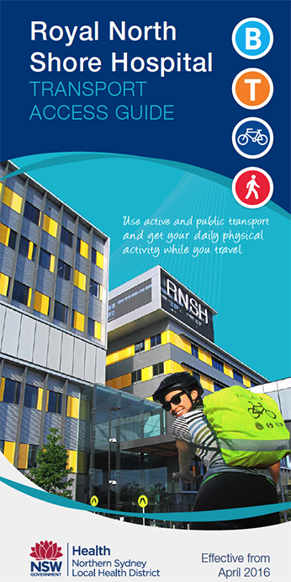

Your guide to using active transport to get to Royal North Shore Hospital

Walking
Suggested walking routes are shown overleaf on the map. Please note walking times are approximate only and are calculated from the main hospital entrance.

Cycling
Suggested cycling routes are shown overleaf on the map. For detailed cycling maps:
- staff can visit the Go Active Hub (P2 visitor car park) or search ‘Go Active’ on the intranet.
- visitors can search online for the ‘Northern Sydney Cycling Map’.

Bicycle parking
Bike racks are located in the P1 car park, outside the Kolling Building, at the front of and in the car park below the Community Health Centre on Herbert St. Staff bike racks (and other facilities) are also located in the P2 car park.

Bus
The nearest bus stop to the hospital’s main entrance is on Reserve Road and is serviced by Route 144 only. For all other routes, the nearest bus interchange is located on Pacific Highway, outside St Leonard’s Station.
For up-to-date timetables and maps, visit transportnsw.info or call 131 500.

Train
The hospital is a 10-minute walk from nearby St Leonards Station (T1 North Shore, Northern and Western Line). The station is wheelchair accessible. For up-to-date timetables and maps, visit transportnsw.info or call 131 500.

Community transport
The Artarmon Loop is a free shuttle service travelling between St Leonards and Artarmon, Monday to Friday. See map overleaf for more details. For service information search ‘Artarmon Loop’ online.

Taxi
Taxi pick up and drop off is available at the main entrance. The nearest taxi rank is located on Reserve Rd, approximately 2 minutes’ walk from the main hospital entrance.

Parking
Parking facilities are available on the hospital campus. Fees apply, so please check signage.
Disabled parking is available at all on-street paid parking areas and multi-storey car parks. A valid disabled parking permit must be displayed when parking in a disabled bay.
A 15-minute drop off and pick up point is located outside the main entry, on French’s Place.
Figure 2: Campus map
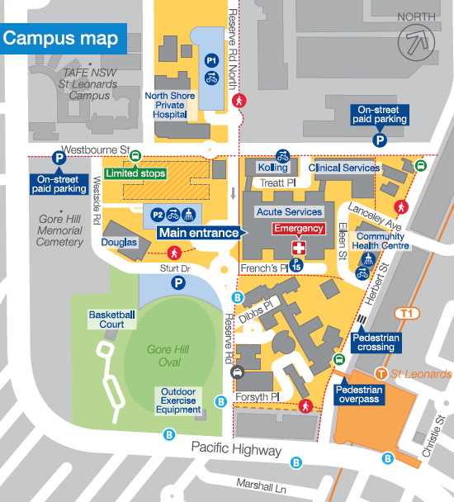
- A: Royal North Shore Hospital, Reserve Road, St Leonards NSW 2065
- T: 02 9926 7111
- W: nslhd.health.nsw.gov.au/Hospitals/RNSH

Local area map
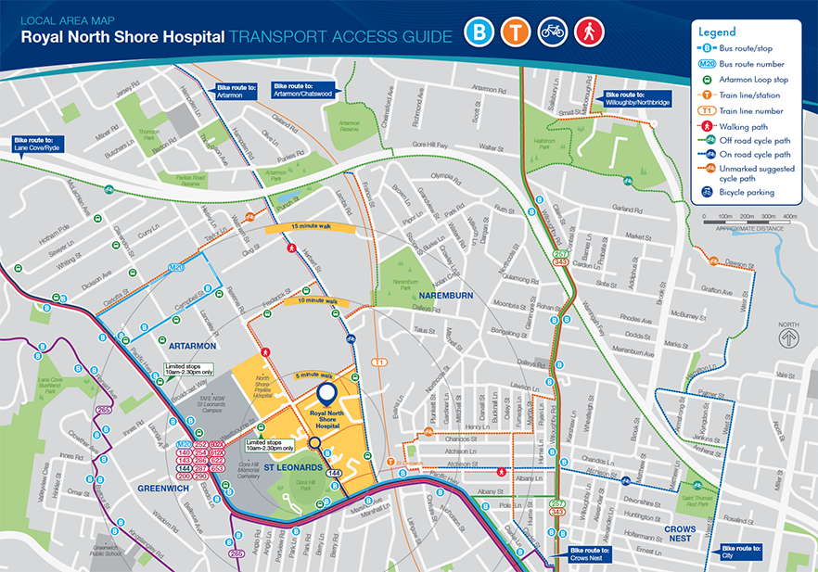

To receive this document in another format, phone 9595 2898, using the National Relay Service 13 36 77 if required, or email sustainability <sustainability@health.vic.gov.au>.
Authorised and published by the Victorian Government, 1 Treasury Place, Melbourne.
© State of Victoria, Australia, Department of Health, August 2022.
Refer to the main reference document ISBN 978-1-76096-951-6 (pdf/online/MS word)
Available at Department of Health website <www.health.vic.gov.au/sustainability>

