Rise at DHHS Program – Recruitment and Support Framework
Recruitment, Selection and Support of staff to the Rise at DHHS Program
August 2020

Introduction
In 2017, the Victorian Department of Health and Human Services, in partnership with Specialisterne Australia, launched the Rise at DHHS program, a unique recruitment and support initiative to enable people on the autism spectrum to enter the Victorian Public Service.
So far, the program has enabled 20 people on the spectrum to enter the public service and remain employed in careers across government.
The program was initially focused on providing Data Entry Services in a records management environment. Many people on the autism spectrum are uniquely qualified to provide data entry, administration, digitisation and related services due to their high level of accuracy, self-motivation and ability to absorb and retain large amounts of information. Autistic employees are also typically honest and have a strong sense of morality.
The traditional recruitment process can make it difficult for people on the autism spectrum to enter the workplace. Moreover, a poor understanding of autism and a lack of support for autistic employees can create barriers to maintaining employment. The employment rate for autistic people in Australia is only 27%. The Rise program is one proven way to open career opportunities for people on the autism spectrum at a larger scale. The unique value of the Rise program for Victoria is that it focuses on non-IT business roles and aims to ensure the participants entering the program are the best possible people for any requirement at hand.
The objectives of the program are to:
- Provide meaningful employment opportunities for autistic people.
- Evaluate the impact of participation in the program on the health and wellbeing of the autistic people.
- Identify organisational factors contributing to the perceived effectiveness of the program.
- Identify barriers and enablers informing future implementations.
Since early 2020, the department has been working on an expansion of the program from providing Data Entry Services to also providing Digitisation and Printing Services.
The Digitisation Office was launched in February 2020 as part of the department’s COVID-19 Response. By September, it had already digitised over 100,000 pandemic-related documents. High-volume scanners are used to digitise 1,000 mail items and over 1,000 hardcopy files a day in accordance with Public Records Office guidelines.
This framework was developed by the Rise at DHHS management team in consultation with 14 stakeholders within Australia, the United Kingdom and the United States. Stakeholders included autistic employees within the Victorian State Government, autistic self-advocates, representatives of peak autism bodies, human resources professionals, disability advocates, autism and employment professionals and academic researchers who study autism and employment. Relevant academic literature was also sourced to inform the development of the framework.

Recruitment and Support Framework

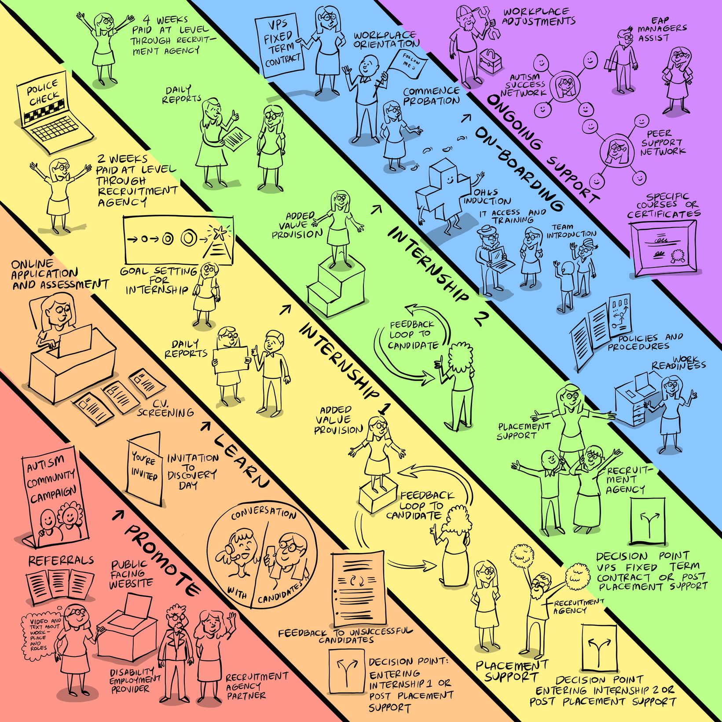

STOP-C: Stop and consider your communication

The STOP-C tool is used at each stage of the Rise Recruitment and Support framework (Promote, Learn, Internship, Offer, Onboarding, Support). It promotes the crucial factors that must be taken into consideration to ensure equity, respect and clarity. Here’s what you need to know about the five STOP-C factors:
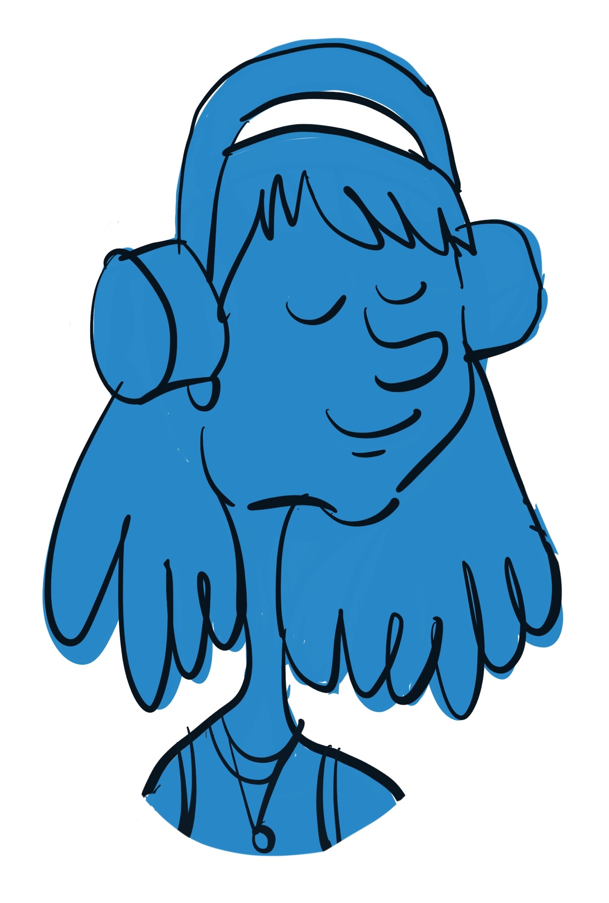

Sensory: It is common for people on the autism spectrum to have hyper- and/or hypo-sensitivities to one or more senses. Sensitivities relevant to the workplace can be to light, smell, sound, touch or movement. It is important that these sensitivities are known and accommodated. Simple accommodations can prevent sensory over-stimulation and pain, and ensure a comfortable working environment for autistic employees.

For example, check the workspace is not too bright (light), ensure the workspace is not near a bin (smell), allow noise-cancelling headphones (sound), allow uniform modifications (touch) and ensure movement of others is out of sight from an autistic person’s workspace (movement).

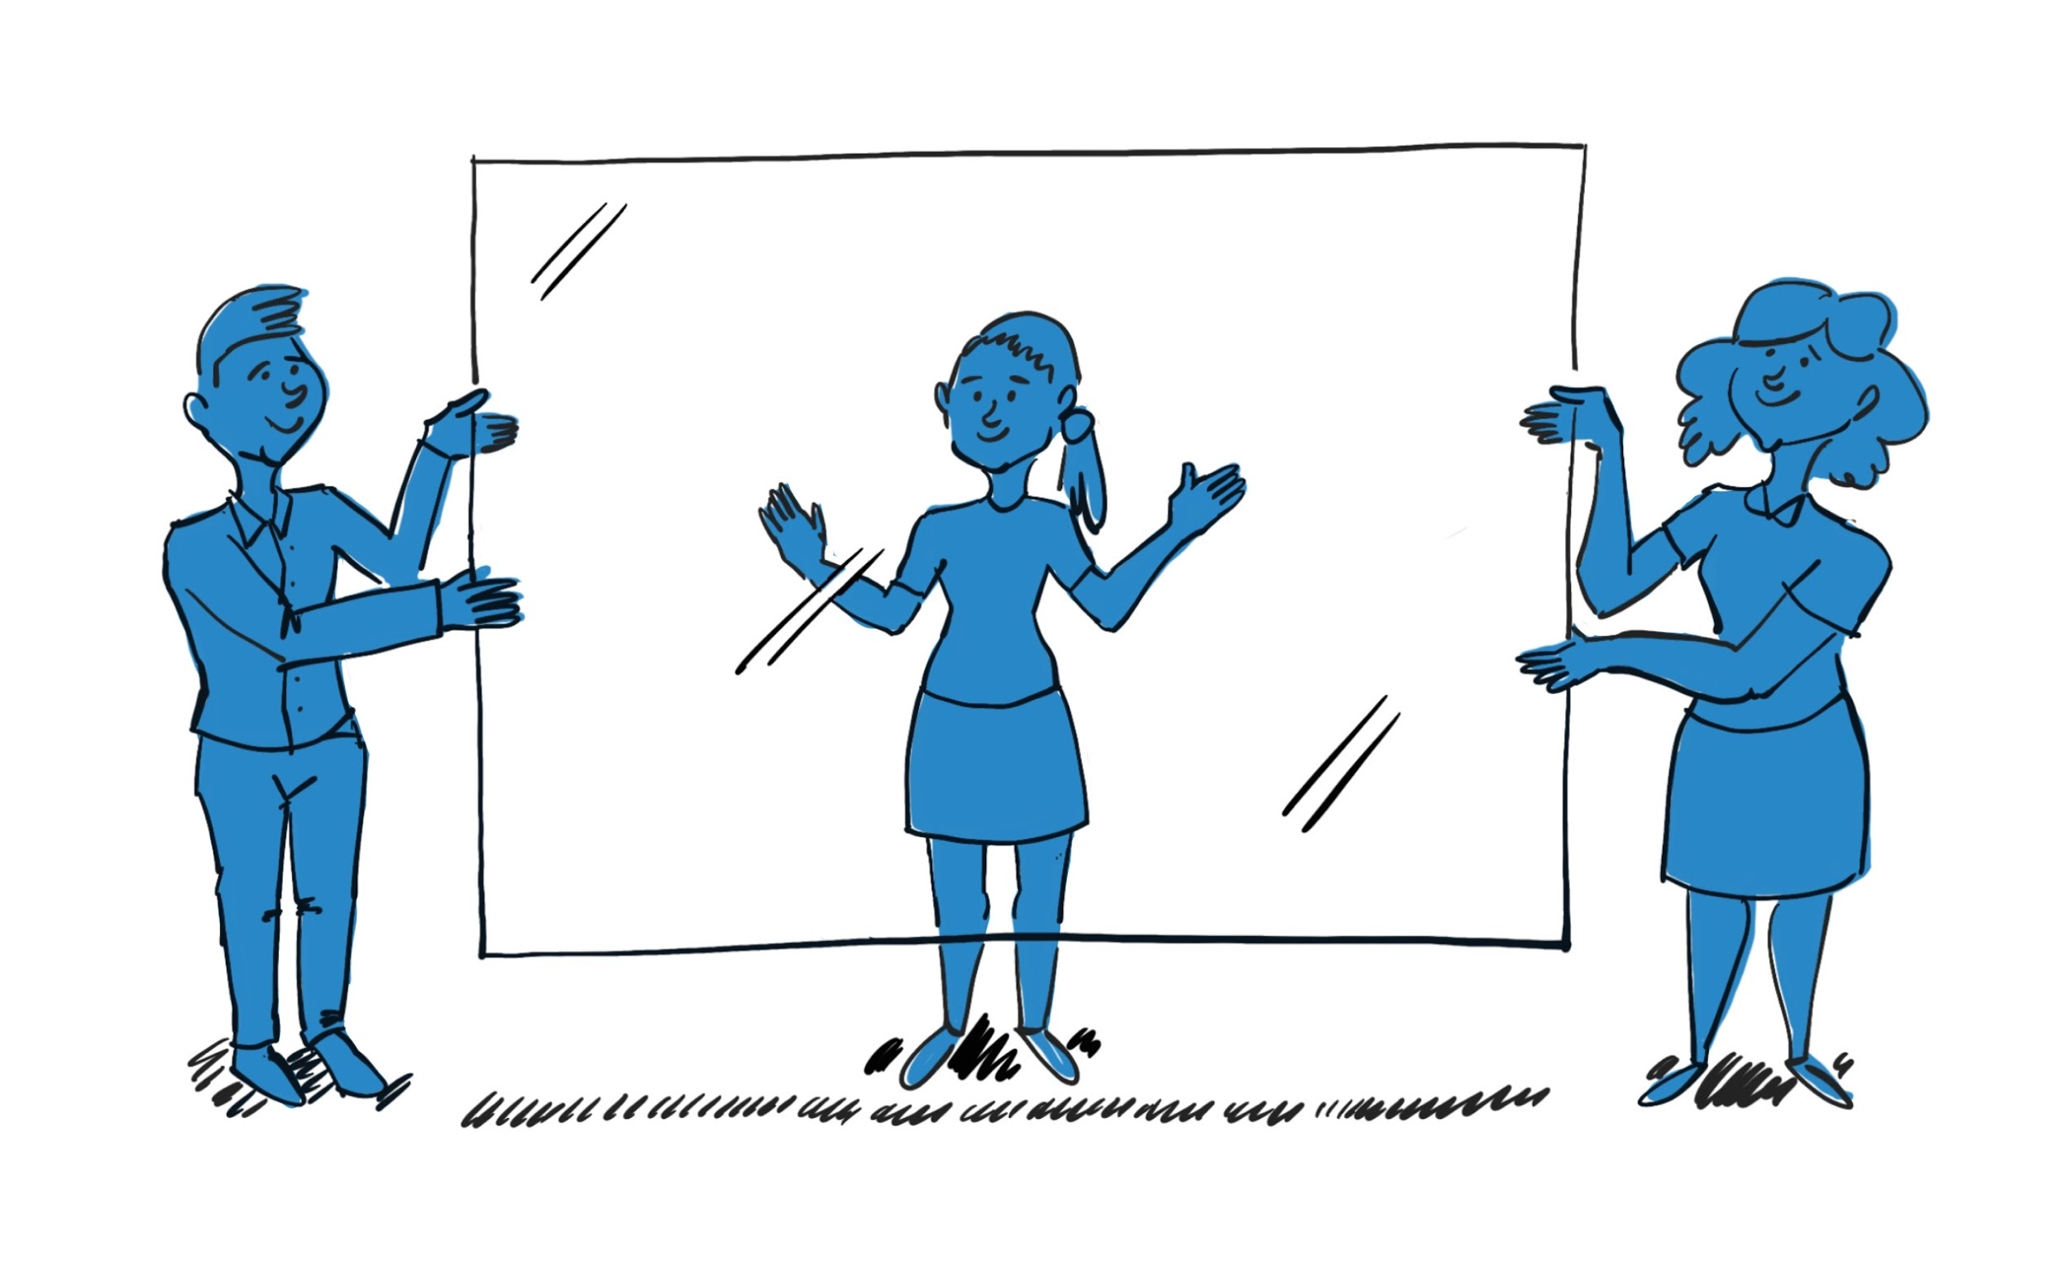
Transparency: There are many unwritten and unstated rules within each workplace. Industry jargon, metaphors, acronyms and non-literal language are common. Together, these things can create uncertainty and stress for autistic people, who may not have been exposed to typical working environments due to barriers to employment. Further, autistic people are logical, literal thinkers, who benefit from explicit clarity. All employees will benefit from improved transparency, but this is particularly important for autistic employees.

Organisational culture: Organisational culture is particularly important for autistic employees, as it determines whether they feel safe enough within the work environment to discuss their autism, request accommodations to meet their needs and be their true selves at work. Autistic people are also vulnerable to increased stress and mental health challenges. A respectful, supportive environment is key.,

Predictability: Similar to the importance of clarity, it is vital that processes are predictable and autistic candidates and employees have a sense of what to expect. This is true for each stage of the recruitment process, and in ongoing support. For example, changes to meetings should be made a week in advance, or 24 hours at a minimum.

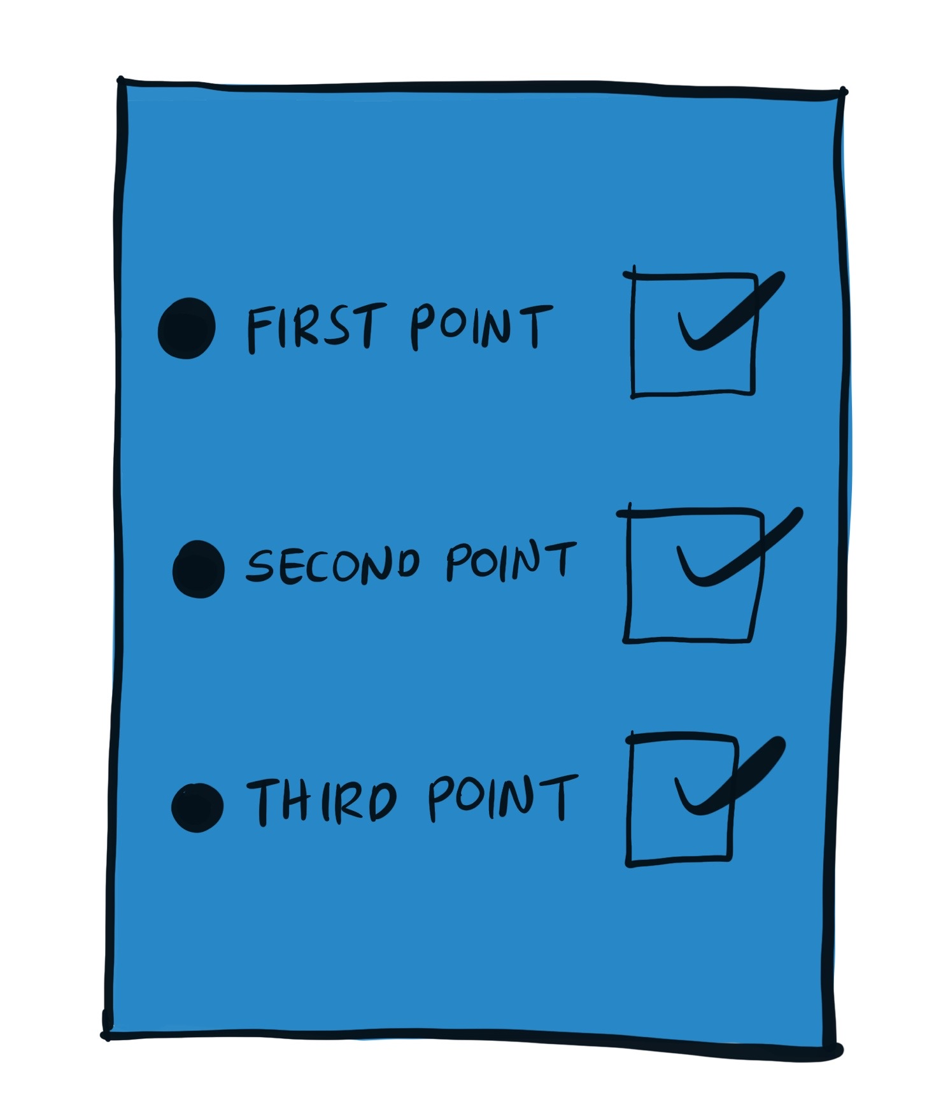

Communication: Autistic people communicate differently to non-autistic people. As such, communication should also be adjusted to ensure it is delivered in a way that suits the needs of the individual employee or candidate. Clear communication has been cited as a facilitator to employment retention for autistic people⁶. It is vital that autistic people are not expected to behave in a non-autistic way.

The five stages of the Rise employment framework

Promote

Description
The Promote stage is the initial stage of the employment framework, where the roles available within the organisation are promoted. The initial promotion of the Rise at DHHS program will occur on a public-facing website or portal account. It will include comprehensive information about the opportunities in the Rise team and the environment in which the team operates. This information will be shared in written text, images and videos. The application form for the Rise team will be hosted on the portal page.

Factors taken into consideration in the Rise at DHHS program that are key to any autism hiring initiative are described below.

Sensory
Before applying for roles, interested people should be able to get a sense of the environment. They should know whether the adjustments they need to work comfortably within the environment can be accommodated.
- Where possible, candidates should be made aware of what the work area looks like and sounds like. Images and videos (with audio reflective of the daily environment) can achieve this.
- Candidates should be made aware of the kinds of adjustments that could be made to accommodate sensory sensitivities. For example, if noise-cancelling headphones are allowed within occupational health and safety guidelines for the role/s, or if adjustments to lighting are possible in some or all spaces in which the person would work as an employee.

Transparency
Provide clarity on the roles available. The more information provided, the better, so that potential employees can consider whether they might like the role. If there are multiple roles available, make this clear and explain what the differences are between them. Include information on the roles in lay, literal language. Avoid corporate jargon where possible. Include information on:
- The expectations and responsibilities of the role/s.
- The days of the week and times the employee would be expected to be at work (and whether there is any flexibility in these).
- The location of the work (and whether there is any flexibility in location).
- The skills required to do the work.
- Remuneration for the role.
- The length of the contract.
- What a typical day in the role/s looks like, if possible (for example, consider creating videos of staff completing tasks in the role/s, interviews with staff who work in the role/s and/or who supervise those the role/s).
- Whether any specific related experience is needed. If so, be clear about the required experience. For example, consider whether the skill could be developed by completing a personal project rather than in past paid employment (this means that those who may not have had past employment due to barriers for autistic people would be less disadvantaged).
- Whether any specific evidence of skill is required (being specific about evidence required might help interested people determine whether they can show evidence of this skill, even in the absence of related paid employment).
- Make clear the type of individual sought as an employee. Consider including if a wide age range is sought so that potential applicants do not make assumptions about the ideal age sought by the organisation.
  - Explain what is meant by the terms used to describe the ideal employee. However, take care to avoid terms like team player.
- How an individual can seek more information about the role/s. Include clear information on who can be contacted for questions, when this person/people can be contacted (days, dates, times, time period), and how they can be contacted (e.g. phone, email).

Organisational Culture
It is essential to make it clear that the recruitment process is a genuine attempt at diversity and inclusion, and not a marketing exercise. This can be achieved in the ‘Promote’ stage by:
- Being clear that the team conducting the application and selection process welcome questions and feedback.
- Being clear that requesting support and accommodations is encouraged from applicants
- Including information on the internal supports available within the organisation (e.g. if there is an employee wellbeing and support program).
- Including information from other autistic and/or neurodivergent staff already employed within the organisation.
- Being mindful of the language around autism that is used in the promotional material. Some people have strong preferences around identity-first (i.e. ‘autistic’) and person-first (i.e. ‘person with autism’) language. It can be helpful to include a statement about the language used in the application documentation – what it is, why it was chosen and if there is a process for providing feedback about it.
- Using inclusive and clear wording to describe the opportunity. Consider how the company/initiative might look from an external point of view, and whether the information provided would encourage people to feel welcome and open about who they are and their needs as an employee.

Predictability
Provide information about the selection process so that potential applicants can get a sense for what lies ahead, should they choose to apply for the role. Include:
- What the selection process will involve (e.g. time commitment, location, tasks, remuneration). State whether it is an autism-specific process or the same process for all candidates applying to the organisation.
- What skills will be assessed during the selection process (and why these skills are important to the role).
- How candidate skills will be evaluated during the selection process.
- Who will be conducting the assessment (their name, role and a photo of the people conducting the assessment). It can be beneficial to allow candidates to contact this person/people to become familiar with them before the assessment.
- Where the assessment will take place (address, photo, directions to building and meeting location). If possible, provide candidates with an opportunity to see this location in advance of the assessment.
- Whether feedback will be provided to candidates throughout the assessment process, and when this feedback will be provided.

Communication
There are small changes that can be made to make the advertisement clear and attractive. For example:
- Ensure that communication is presented in lay language that does not require previous experience within the same industry to make sense (unless industry-specific experience is a requirement of the position).
- Use plain and specific language. Words chosen should be literal and corporate jargon and acronyms should be avoided.
- Information should be presented in a consistent and straightforward format, and should not include large chunks of text.
- Dot points and colour coding may be helpful to break up text into smaller/separated sections.
- Videos and images can also be used to communicate key messages. Videos should include captions where possible.

Learn

Description
The purpose of the Learn stage is to provide candidates with an opportunity to learn more about the role, the environment and DHHS as an employer. In turn, the stage allows the Rise at DHHS management team to learn more about the skills of candidates and whether they might be a good fit for the role. The Learn stage will include two components: a) an online application form, and b) a half-day onsite introduction to the working environment (‘Discovery Day’).

Factors taken into consideration in the Rise at DHHS Program that are key to any autism hiring initiative are described below.

Sensory
Candidates should be invited to attend a worksite for a Discovery Day during the Learn stage, unless the role is performed remotely or from home. It is important to ask if there is a need to accommodate any sensory needs. For example:
- Appropriate accommodations can then be arranged (e.g. if the candidate is sensitive to light, seek a meeting room with natural light rather than fluorescent light).
- Inform candidates about any loud noises that might be expected (e.g. if there will be building works occurring during the Discovery Day).
- Inform candidates that they can bring with them resources that help them manage their sensory sensitivities, including those used for stimming. Unless expressly stated, candidates will not know these resources will be accepted within the workplace.

Transparency
- Application form: Ask clear and specific questions in the initial application form.
  - Consider offering candidates the opportunity to respond to questions in alternative formats such as images, audio recordings or video.
  - Ensure there is not a time limit on the response to questions as some autistic people need additional time to process questions and consider their responses.
- Assessment within the application form and Discovery Day: Skills relevant to the role/s must be measured in all aspects of the Learn stage. Including work-related assessment allows candidates to gain insight into the skills required to conduct the role. It also allows the organisation to learn about the candidate’s skills relevant to the role.
  - For example, consider including a work sample as a part of the initial application.
  - In most cases, traditional employment assessments are not suitable for autistic people. Traditional assessments have not been validated for use among autistic people, may not be measuring role-related skills and may introduce bias that presents a barrier for autistic people. For example, a traditional interview relies on the ability to ‘sell oneself’ through verbal communication rather than demonstrate skills; something that can be a barrier for autistic people in gaining employment).
- Discovery Day: The Discovery Day should serve as an introduction to the organisation, worksite, team and role. It is crucial that:
  - Candidates can view the working environment as it appears and sounds during a typical working day.
  - Candidates are exposed to the role/s and can view the role being conducted (e.g. job shadowing).
  - If candidates are asked to complete aspects of the role, instructions are made clear (e.g. verbal and written step-by-step instructions, colour-coded), and staff are available to answer questions.
- Communicating outcomes:
  - Make clear from the outset the process by which outcomes will be communicated with candidates (the date and mode of communication).
  - Make clear from the outset whether feedback will be provided to candidates who do not progress to the Internship stage.
  - Make clear from the outset the dates/times the Internship stage will be conducted for successful candidates.

Organisational Culture
A positive organisational culture is particularly important in the Learn stage, as candidates get the chance to view the organisation in operation. It is also essential to recognise that many autistic people have had negative employment-related experiences, which may lead to mistrust and uncertainty about being open about who they are and their workplace needs. Positive steps to take include:
- Including autistic people in the process:
  - Having autistic people involved in the process can improve the chances that the process is neurodivergent-friendly.
  - Having autistic people speak to candidates openly about their experiences at the organisation can help build trust that the organisation values inclusion and diversity.
- Offering flexibility by allowing candidates to choose whether they attend the Discovery Day in one day or across two. This allows candidates the flexibility to meet their needs and can be beneficial for both parties (e.g. if a candidate is nervous, attending across two days may mean that they are more able to focus on the second day to gather needed information).
- Ensuring all staff involved in the Learn process:
  - Are aware why all aspects of the hiring initiative are important.
  - Are aware of how to be supportive and respectful of autistic people. Autistic candidates should be made to feel equal and not ‘other’.

Predictability
- Ensure information explaining the application process is provided prior to the application form, for example:
  - The number of questions.
  - The estimated time to complete the form.
  - An explanation of any assessment tasks and why they are included.
- Provide all information about the Discovery Day at least 48 hours in advance of the day (one week or longer is optimal).
- Offer candidates the opportunity to view the prospective worksite in advance of the onsite component. This can make candidates feel more comfortable in the lead up to the Discovery Day.

Communication
- Use plain language in communicating instructions for the application form and Discovery day. Dot points, colour coding, images and videos can assist.
- Ensure that non-autistic communication is not expected from autistic candidates. For example:
  - Do not expect candidates will make eye contact when attending Discovery Day.
  - Do not expect autistic candidates to ‘sell’ themselves verbally as optimal employees.
  - Do not make assumptions based on verbal or non-verbal communication. If you are unsure how to interpret an exchange, ask the candidate for clarity. Discuss with them what you were uncertain about and why, and plan together how similar misunderstanding/confusion can be prevented in future.
- Communicate sensitively. Consider that those not progressing have likely faced rejection previously. If there are recommendations, resources or other supports that can be provided, include these.

Internship

Description
The purpose of the Internship stage is to offer candidates full exposure to the role. In the initial implementation of the Rise at DHHS program, vocational experience was key to success. Further, job-person-environment fit is vital for autistic employees, and the Internship stage allows candidates to sample the role to evaluate fit. In the Rise at DHHS program, there are two paid internship components. The first is a two-week Internship One. This is followed by a four-week Internship Two for successful candidates who are both interested in continuing and who meet goals set together in Internship One). Having two internships offers candidates an early exit should the role not be suitable and allows six weeks’ paid exposure to the role; allowing sufficient time for adjustment.

Internships One and Two both begin with a one-on-one discussion of strengths. The candidate is encouraged to identify their strengths (and continue to consider these over time). Clear and realistic goals are discussed and established for the internship period, so candidates are aware of role and output expectations, and how and why these are being measured. Workplace expectations (e.g. etiquette, conduct, attire) are made explicit. Throughout the internships, candidates are provided with sensitive, direct and specific feedback on performance and are given encouragement. Candidates are also made aware of DHHS internal supports (e.g. employment wellbeing and support program) and can access these as needed. At all times, a supervisor is available for clarification and support, and sensory needs are met.

Sensory
The Internship stage provides an opportunity to have an open discussion with interns to understand and meet their sensory requirements. For example, to start the conversation, a supervisor might enquire how sensory concerns can be mitigated for the employee, or if anything in the environment is causing discomfort or distraction. Sensory needs must be taken seriously and accommodated to avoid sensory overstimulation (which can be painful, distracting, and draining). Sometimes only minor changes are needed, and these can have a significant impact on autistic (and non-autistic) employees. Other strategies include:
- Having a quiet, low sensory room/environment available for use when needed.
- Collaborating with autistic employees to making adjustments to create sensory-friendly spaces.

Transparency
Clarity and transparency in all expectations are vital. The Internship stage should offer interns insight into the role, expectations and team. During this time, interns should have the opportunity to work alongside the team/managers they would work with if successful in securing a role.

The following should be made clear in verbal and easily accessible written format:
- All workplace expectations. For example, be explicit about culture, attire, etiquette, code of conduct, privacy/confidentiality, professional expectations and hygiene.
  - Having a discussion as a team at the commencement of the internship, and determining rules together, can be helpful (e.g. establishing team communication rules).
  - Candidates should also have the opportunity to check their understanding of the expectations and to ask questions.
- Role responsibilities and expectations (and rationale provided).
  - Information on role descriptions should be available in a central location for reference.
- Task instructions. Provide explicit instructions for all tasks.
  - Templates can help.
  - Build up the number of tasks to be completed and/or assessed during the internships over time. Interns will likely require time to adjust to the new environment, especially those who have not worked previously in a similar environment.
- What to do if unsure. Provide clear guidelines and instructions on what interns can or should do they are unsure or need help.
  - Include who to contact, how they can be contacted and when they can be contacted.
  - This information should be easily accessible.
  - Visuals on the walls with clear steps can assist.
- Chain of command/organisational hierarchy.

Organisational Culture
- Interns should be made to feel welcome, supported and included.
- Supports available to interns should be promoted positively and made clear. Ensure staff know that asking questions and asking about accommodations is encouraged (i.e. that they will not be perceived negatively for this). For example:
  - To whom they can go with questions, and for support.
  - An ‘open door’ policy can be helpful so that staff know they can always ask questions. Or, set specific check-in/consultation times throughout the week for questions.
  - Clear, kind feedback. A channel for regular feedback and assurance for the individual to ask questions and check they are meeting expectations.
  - Internal organisational supports (e.g. employment wellbeing and support program).
- Spend time getting to know the person.
  - A ‘Biodex’ (document about the individual’s needs, preferences and habits) can be a useful tool for both the intern and management team. If used, all team members (including the management team and non-autistic staff members) should complete, as the aim of the tool is to encourage understanding of all team members and how to work effectively together.
- Provide an opportunity for interns to engage in skills development. For example:
  - Managing money. Autistic people may not have been exposed to money management, tax, forms, superannuation, etc.
  - Professional development. If there is a skill that the interns can learn during the internship, they can take this away from the internship regardless of progression.
    - If candidates can leave the internship with something tangible like a letter or video describing tasks they completed during the internship, how they contributed, and what their strengths are, this can be used in future job applications. Providing the candidate with language that can be translated to other roles/industries may assist them with future applications.
- Educate all staff on autism from a strengths-based neurodiversity perspective. Learning from autistic people is also important. It is important that all non-autistic staff understand that accommodations and variations to employment processes are about equity rather than favouritism.

Predictability
Interns should know what to expect in advance of each day of the internships.
- Provide a clear schedule for the day or week.
  - If any changes occur, give at least 24 hours’ notice.
- Quantify communication in the internship – the outcome may be uncertain, but things like who will contact them at what stage during the internship period can be made certain and predictable.

Communication
- Provide easily accessible instructions in written, visual and verbal format. Don’t assume knowledge. The following can be beneficial:
  - Colour coding.
  - Numbered bullet points.
  - Images.
- Autistic staff should be treated the same as non-autistic staff, but others should be mindful that they may respond in different ways. For example:
  - Some people may take longer to process questions and provide a response. Be patient, wait and don’t interrupt the person.
  - Some people are not comfortable with eye contact. Eye contact should not be expected or required.
- Take the time to communicate with interns and understand their unique strengths and needs, and how these can be leveraged in their role.
  - Ask them what they are good at (strengths they know).
  - Ask someone else what they believe the intern is good at (strengths others can identify).
- Provide meaningful feedback throughout the internship periods.
  - Ask each intern about their preferred mode of feedback.
    - Oral and written is good practice. This also means people can return to these things for reflection with others. If the feedback is written, provide an opportunity for verbal discussion on the same day (to avoid rumination).
  - Use plain language and be specific. Avoid general praise such as “Good job”.
  - Provide reasoning behind the feedback.
    - If the internship began with clear expectations of goals, then outcomes can be mapped to goals achieved and areas for improvement (this will help reduce the risk of the intern perceiving feedback about areas for improvement as a personal flaw).
  - Provide specific strategies (e.g. “I would like to see you focus on …”).
  - List their strengths. This can help interns know and understand their strengths, improve self-esteem and allow them to see their value and contribution.
  - Make people aware of any unintentional inappropriate behaviour they might not be aware of (wording like ‘this may not be conducive to future employment opportunities’ or ‘other people may not respond well’ may assist as it puts it on how other people will respond, not on the individual).
    - Provide ideas about how the intern could improve in the areas noted.
  - Sandwich areas for improvement between strengths so that the final point is positive.

Offer and Onboarding

Description
The Offer and Onboarding stage involves offering successful candidates roles within the organisation, and getting them started in the workplace. Within the Rise at DHHS program, this stage includes:
- Reviewing and signing the fixed-term contract and providing the Department with all the information required to set up payroll.
- IT and system access provisioning and training.
- Introductions to team members and the Public Service.
- Introduction and training into relevant policies and procedures.
- Agreement on a Probation Plan.

Sensory
Where possible, offer flexibility with the format by which candidates can complete required documentation.
- For example, sighting documents onsite rather than asking for certified copies of documents means that candidates are not required to attend another location for document certification (locations, such as police stations, where document certification takes place are often environments with a lot of sensory stimulation).

Transparency
- Ensure the process for receiving the Onboarding offer is clear and consistent (including information coming from other departments such as Human Resources).
  - If candidates will be sent documentation via an external system, ensure candidates are forewarned about this, and instructions for navigating the system are explained.
  - If candidates are required to complete standardised forms that cannot be changed, explain why the forms are needed and what they are used for.
- It should be made clear:
  - What is required of the candidate (e.g. what documents need to be provided).
  - The date by which documentation needs to be completed and returned.
  - To whom the documentation should be returned.
  - The start date for the role (providing all required steps have been completed beforehand).
  - To whom the candidate can direct questions if needed.
- If the new employee is working in a different team than during the Internship stage, follow the same guidelines as in the Internship stage as they adjust.
- Training should be provided for all software/equipment/systems that weren’t used in the Internship stage.
  - It should be made clear who to approach with questions for each new system (e.g. the IT Department, a colleague, a supervisor).
- The new employee/s should be made aware of any policies/procedures that they were not exposed to during the Internship stage.

Organisational Culture
Be mindful of language in the documentation used in the Offer and Onboarding stage. If the documentation mentions autism, it should do so respectfully (considering issues such as person-first and identity-first language). Any additional clarity provided alongside the offer documentation should apply to autistic and non-autistic staff (rather than being an autism program-specific exercise).

Predictability
Make clear in advance when candidates will receive the required documentation and, once signed forms have been returned, when they can expect to hear from the organisation and begin the role.

Communication
Clear language is essential in all employment documentation. This is particularly important for autistic candidates as they may not be familiar with employment contracts. Consider how key communication can be made clearer.
- Language used should be lay and straightforward (no knowledge of what specific employment terms mean should be assumed).
- Jargon should be removed or explained.
- Acronyms should be explained.
- A contact person should be identified to whom candidates can direct questions.
- Consider whether it is feasible within the context to create a video and/or tip sheet explaining the process for completing all required documentation.

Ongoing Support

Description
The ongoing support that is required is an extension of the support offered during the Internship stage. Generally, autistic staff need the most support during the first 12 weeks of employment. It is important to allow time for adjustment, although this may have occurred through Internship One and Two.

Sensory
Ensure sensory needs are met. This can be an ongoing discussion, as sensory accommodation needs may change over time. Changes made to ensure the working environment is more sensory-friendly are also likely to positively impact non-autistic employees.

Transparency
As in the Internship stage, all expectations should be made clear. Employees should be made aware of role expectations in addition to expectations regarding culture, attire, etiquette, code of conduct, privacy/confidentiality, professional expectations and hygiene.
- Ensure any differences in expectations between the Internship periods and employment contract are made clear.
- If new tasks emerge, provide clarity around which tasks need to be prioritised.
- Provide clarity about deadlines for tasks, and what a completed task looks like. Check back to confirm that your communication has been clear and understood.

Organisational Culture
- Continue to educate staff about autism and inclusive working environments. Learning from autistic people and taking a strengths-based perspective is important.
  - Be open that you are all on a learning journey together. This may encourage dialogue and openness about how the working environment can continue to be inclusive and respectful.
- An autism-positive culture includes having autistic people in leadership and decision-making positions. Visibility is important. While many people have heard of autism, many do not understand the nuances of autism and how to foster an inclusive environment.
  - Providing opportunities for advocacy and professional development (for those who desire it) is also important.
  - Foster an environment where inclusive behaviour is expected, and the benefits of inclusion and diversity are understood by all staff.
- Managers and supervisors are crucial to success.
  - Managers and supervisors should be self-aware. They need to know how to support themselves and appropriately support staff.
  - Managers and supervisors should have a good, practical understanding of autism and be open to continuous learning and improvement.
  - Managers and supervisors should know where to go to seek help (to ask questions, improve knowledge, seek support).
  - Managers should be non-confrontational, reliable, logical, consistent, empathetic, kind, and understanding of the reasonable adjustments for a neurodiverse team.
- Be mindful and supportive of employee health and wellbeing. The experience of autism is not static. Life circumstances, needs and strengths change for each person, depending on their mental health, exhaustion/burn out and context. Individual experiences and needs will change day by day.
  - Offer a range of health and wellbeing supports, but don’t force participation. Not all employees will want or need support.
  - Recognise people may not be very good at asking for help. Building trust is essential so that employees feel comfortable to ask for support when needed.
  - Have a consistent routine for checking on support needs for the whole team (managers and employees).
  - Be mindful of the number of neurodivergent staff in a team. If there is only one person, and they receive additional support, they may feel guilty for receiving support others are not getting. A balance of neurodivergent/non-neurodivergent staff can be helpful.
- Build additional supports or leverage existing supports.
  - Peer support: Identify a peer support staff member for new employees. This is an existing employee within the same team/area (or external to the team/area if this is most logical within the organisation) that the new employee can speak with/check-in with to ask questions or debrief a situation as a source of informal support.
  - Mentor: Ideally, a mentor is someone external to the new employee’s immediate team, and in a more senior position. The mentor can help the new employee understand the organisation, and they can discuss anything that the employee might not want to raise with their manager/supervisor. A mentor may also help the new employee consider workplace strategies and help them find professional development opportunities. The relationship can be formal or might simply be casual coffee catch-ups. Either way, it serves as a source of support for employees outside of their immediate team.
  - Human resources/Employee wellbeing and support program staff: Ensure these staff are aware of autism and how to support autistic employees.

Predictability
As in the Internship stage, information should be provided to employees in advance. For example:
- Discuss with the team and/or individuals how far in advance they like to know about changes and new tasks.
  - While some people may not mind change, others may need their week planned the prior week or earlier.
  - Some people may need at least 24 hours’ advance notice of events, changes to schedules, etc.
- If the role or aspects of the role will change, give plenty of advance notice (e.g. if minor, one working week would be optimal as a rule of thumb. However, ‘optimal’ depends on the person).
- Provide an agenda for meetings at least 24 hours in advance.

Communication
- Provide employees with support if needed. This may include:
  - Task order/steps needed to complete tasks.
  - Prioritising deadlines.
  - Strategies for focus.
- Have visual supports available when explaining tasks and during meetings. This may include:
  - PowerPoint slides.
  - Images.
  - Drawing concepts/writing concepts out on a whiteboard.
  - Clear, step-by-step instructions.
- Discuss with the employee their preferred method of communication. For example, this may be one or a combination of verbal (only), verbal and demonstration, written (email), written (paper).
- Allow employees time to process new information and ensure there is an opportunity immediately and at later stages for questions and clarification.
- Do not expect employees to communicate as if they are non-autistic. For example:
  - Do not expect eye contact.
  - Understand needs and allow different forms of communication.
- Ask employees about their social preferences at work. Some people may want to attend work-related social activities, and others may not wish to.
  - Be mindful that some people may feel uncomfortable in social situations. Allow an option to opt-out of highly social events. Do not force social participation.
  - If feasible in the role, allow the opportunity to minimise social contact in the workplace if desired.
  - Ensure autistic staff are given the opportunity to participate in workplace social conversations and events if desired.

To receive this document in another format email Records Service Centre <RecordsService.Centre@dhhs.vic.gov.au>
Authorised and published by the Victorian Government, 1 Treasury Place, Melbourne.
© State of Victoria, Australia, Department of Health and Human Services, September 2020.
Except where otherwise indicated, the images in this document show models and illustrative settings only, and do not necessarily depict actual services, facilities or recipients of service

Throughout this report the terms ‘on the autism spectrum’ and ‘autistic’ are used as these have been identified as preferred terms within the autism community. Bury, S. M., Jellett, R., Spoor, J. R., & Hedley, D. (2020). “It Defines Who I Am” or “It’s Something I Have”: What Language Do [Autistic] Australian Adults [on the Autism Spectrum] Prefer?. Journal of Autism and Developmental Disorders, 1-11.
Scott, M., Milbourn, B., Falkmer, M., Black, M., Bӧlte, S., Halladay, A., ... & Girdler, S. (2019). Factors impacting employment for people with autism spectrum disorder: A scoping review. Autism, 23(4), 869-901.
Australian Bureau of Statistics. (2019). 4430.0: Autism in Australia [Press release].
American Psychiatric Association (2013). Diagnostic and Statistical Manual of Mental Disorders (Fifth Edition). Arlington, VA: American Psychiatric Association.
Hedley, D., Cai, R., Uljarevic, M., Wilmot, M., Spoor, J. R., Richdale, A., & Dissanayake, C. (2018). Transition to work: Perspectives from the autism spectrum. Autism, 22(5), 528-541.
Dreaver, J., Thompson, C., Girdler, S., Adolfsson, M., Black, M. H., & Falkmer, M. (2020). Success factors enabling employment for adults on the autism spectrum from employers’ perspective. Journal of Autism and Developmental Disorders, 50(5), 1657-1667.
Hayward, S. M., McVilly, K. R., & Stokes, M. A. (2019). Autism and employment: What works. Research in Autism Spectrum Disorders, 60, 48-58.
‘Stimming’ is self-stimulatory behaviour. This may include but is not limited to moving an object in one’s hand or moving a body part repetitively. Stimming can help autistic individuals self-regulate and communicate, and must not be discouraged in the workplace and should be normalised. Kapp, S. K., Steward, R., Crane, L., Elliott, D., Elphick, C., Pellicano, E., & Russell, G. (2019). ‘People should be allowed to do what they like’: Autistic adults’ views and experiences of stimming. Autism, 23(7), 1782-1792.
Strickland, D. C., Coles, C. D., & Southern, L. B. (2013). JobTIPS: A transition to employment program for individuals with autism spectrum disorders. Journal of Autism and Developmental Disorders, 43, 2472-2483
Flower, R. L., Hedley, D., Spoor, J. R., & Dissanayake, C. (2019). An alternative pathway to employment for autistic job-seekers: A case study of a training and assessment program targeted to autistic job candidates. Journal of Vocational Education & Training, 71(3), 407-428.
Nicholas, D., Mitchell, W., Zulla, R., Solomatin, E., & Qi, S. (2019). A review of CommunityWorks Canada®: Toward employability among high school-age youth with autism spectrum disorder. Global Pediatric Health, 6, 1-12. https://doi.org/10.1177/2333794X19885542
Remington, A., & Pellicano, E. (2019). 'Sometimes you just need someone to take a chance on you': An internship programme for autistic graduates at Deutsche Bank, UK. Journal of Management and Organization, 25(4), 516-534. https://doi.org/10.1017/jmo.2018.66

