Guide for EHOs and food businesses
Remote monitoring of temperatures in food storage units

Department of Health
To receive this publication in an accessible format phone 1300 364 352, using the National Relay Service 13 36 77 if required, or email foodsafety@dhhs.vic.gov.au
Authorised and published by the Victorian Government, 1 Treasury Place, Melbourne.
© State of Victoria, Department of Health and Human Services April 2019.
Available at https://www2.health.vic.gov.au/public-health/food-safety/food-businesses/food-how-to-keep-it-safe/remote-temperature-monitoring-food

Contents
Purpose 4
Background 4
Requirements 4
Evidence outcome 5
Systems 6
Newly installed systems 6
Existing systems 6
Example: 6
Additional information 7
System validation 8
Outline of process for system validation 8
Newly installed and existing systems 8
Records explained 9
Records – RMS 11
Record 1: Installation certificate(s) of the RMS (attach) 12
Record 2: Food premises map of units 13
Record 3: Hot spot and thermocouple unit map 14
Record 4: Calibration record for probe thermometers 15
Record 5: Calibration record for RMS 16
Record 6: Daily temperature and location record 17
Record 7: Alarm exception report 18
Record 8: Corrective actions log 19
Record 9: Report 20

Purpose
This document is for Victorian class 2 fixed food premises using, or intending to use, a remote temperature monitoring system. A remote temperature monitoring system uses air temperature readings to control the temperature of one or more refrigeration and/or freezer units in a food premises. This guide will assist with the development of monitoring system records as evidence, showing how the system has been validated for use and how it is maintained to keep food within safe food temperatures. This evidence is additional to the requirements of a business’ food safety program (FSP) .

Background
A class 2 food premises may use an independent FSP developed for the business, or a template registered with the Department of Health and Human Services (the department). When a business chooses to use an independent FSP, an audit by a department-approved food safety auditor is required at least once a year. If you choose to use a department-registered FSP template, the registering council will conduct an assessment of the premises at least once during the registration period (12 months). The most widely used of the FSP templates is the department-developed FSP template (No.1 version 3). This FSP template is for use by class 2 retail and food service businesses whose food handling activities are adequately addressed within the FSP template.
The FSP template contains sections on practices to keep food safe, support programs to achieve this, and records to be used to document these activities. The records section provides examples and will help you to develop your own record-keeping system, including remote temperature monitoring systems, providing they meet the outcomes of the record-keeping requirement. As advised in the FSP template, you must satisfy your registering council that your business meets this outcome.
This guide will support the use of a business’ FSP and, when using remote monitoring for temperature control, of food storage units. It will provide the registering council or food safety auditor evidence of how the remote monitoring system (RMS) has been established and maintained.
Remote monitoring of temperatures is becoming common in many food businesses to ensure food is being kept at safe temperatures. However, validation and verification of this system should occur on a regular basis to demonstrate that food safety requirements are being met. Validation is the documented act of demonstrating that a procedure, process and activity will consistently lead to the expected results.
To ensure food safety and maintain compliance with the Food Act 1984 (the Act), refrigeration and freezer units must hold potentially hazardous food at the correct temperatures. These are:
- chilled food must be held below 5 °C
  - frozen food must be kept frozen hard. A temperature for frozen food has not been specified by the Australia New Zealand Food Standards Code, but food businesses should follow food manufacturer’s storage instructions to maintain product quality and shelf life where they are provided.
Hot food units must keep food above 60 °C or you may use the two-hour / four-hour rule for holding food under 60 °C. The scope of this guide is for chilled and freezer units; therefore, hot holding units will not be addressed in this guide.

Requirements
An RMS must consist of:
- monitoring and reporting showing (at a minimum) twice daily temperature readings
- triggering of alarms when a refrigeration/freezer unit is not holding food within the set temperature limits. A time buffer of up to 30 minutes may be in place to prevent brief temperature fluctuations from triggering the system alarm
- documented corrective actions that were taken when temperature control issues occurred
- thermocouple accuracy of +/- 1 °C
- validation of the system to demonstrate that the system produces consistently accurate results
- annual calibration of the system – thermocouples and alarms
  - a maintenance program in place to ensure continuous operation of the system.

Evidence outcome
Evidence should demonstrate that:
- the RMS is reliable
- food stored in the unit is continuously held within the safe temperature range
- when the food held in the unit exceeds set temperature limits the system alarm is triggered
- the system produces consistently accurate results
  - system results have been validated.

Systems

Newly installed systems
An RMS that has been installed within the previous three months is considered a newly installed system.
This system will require manual temperature recording in conjunction with automated monitoring to build up a history of its operation. Taking manual temperature measurements will verify that the RMS is working as intended. Manual temperature recording is performed using a calibrated probe thermometer only. Other methods of temperature recording, including infrared devices, are not suitable.
This system validation should occur over 30 days; however, this may be extended if ongoing issues prevent corrective actions being closed. In this time the physical temperature of random food items at different locations in the storage or display unit will be recorded twice a day using a probe thermometer and at any time an alarm is triggered by the RMS. The RMS records are to be reviewed against the records generated by the physical temperature recording. Any out-of-specification temperatures must be justified with appropriate corrective actions.
The aim of this validation is to provide evidence that the temperatures recorded by the RMS are reliable and repeatable, and that they accurately reflect the actual temperatures of the food stored in the unit.

Existing systems
An RMS that has been in operation for three months or longer is considered an existing system.
Store logbooks or records must be available at any time and should show the documented corrective action for any issues regarding temperature control, and whether these issues have been resolved. They should also show how the system has been validated in the past.

Example:
The store manager was doing spot checks of food temperatures on 12 April 2018 using a probe thermometer. The manager found several items of food in the deli fridge were at 6 °C. The manager checked the system records, which showed it was operating at 4.8 °C, so the alarm has not triggered. The alarm had been set to sound after 30 minutes at 5 °C or higher. After checking the system was not operating poorly due to mechanical reasons, the manager decided the system, when operating at 4.8 °C, was not holding food consistently below 5 °C. The manager changed the deli fridge temperature to 3 °C and set the alarm to sound at 4 °C instead of 5 °C, keeping the 30-minute buffer. Daily monitoring over the next week showed the food was consistently held below 5 °C. The store manager changed the standard operating procedure (SOP) for the deli fridge so it was clear to all users that the temperature was always set at 3 °C and when it alarmed at 4 °C, the usual corrective actions would be undertaken. The FSP was updated to reflect this, and staff advised at the next weekly staff meeting of the change.
Date | Issue | Corrective action | Outcome
12 April 2018 | Deli fridge not holding food below 5 °C when set at 4.8 °C. The manually taken temperature was 6 °C. Alarm is set to sound when deli fridge is above 5 °C for 30 minutes or longer. | Discarded any food where safety may have been compromised.  Tested system operating at 3 °C for seven days. Food consistently held below 5 °C (see records). Changed the SOP to reflect deli fridge will be set permanently at 3 °C and to trigger alarm at 4 °C. | Resolved. Food is consistently held below 5 °C in the deli fridge. All documentation updated to reflect change to procedure. All staff advised of change to procedure.

An existing system, while likely to be operating as intended, still needs to provide evidence it is doing so. These records are intended to show an auditor or environmental health officer that the system is working correctly, is being maintained and calibrated, and is being actively monitored.

Additional information
The following factors, including results affected by one or more of these factors, must be addressed in the RMS records.
- Testing should be performed under ‘worst-case scenarios’, for example, when the fridge is full of weekly or monthly deliveries.
- A food proxy, or one food that replicates another, can be used for physical probe temperature readings, but should be located in hot spots. Ensure records clearly state what type of reading is taken.
- A probe thermometer is used to probe a food proxy. Alternatively, the temperature of actual food can be taken by placing two items together and holding the probe thermometer between them to take a reading.
- Temperature readings by an RMS will ideally be every 30 minutes to hourly; however, the defrost cycle of the unit may trigger an alarm for exceeding the set temperature. The frequency of temperature recording that the system performs is at the discretion of the system owner.
- A person with the appropriate authority in the business must be responsible for establishing the testing regime, approving corrective actions, and approving the reporting documents. This may be the store manager or food safety supervisor and it must be done in conjunction with the person responsible for the FSP.
  - RMSs will produce electronic records. All information needs to be recorded or attached on the nominated records in this guide.

System validation

Outline of process for system validation
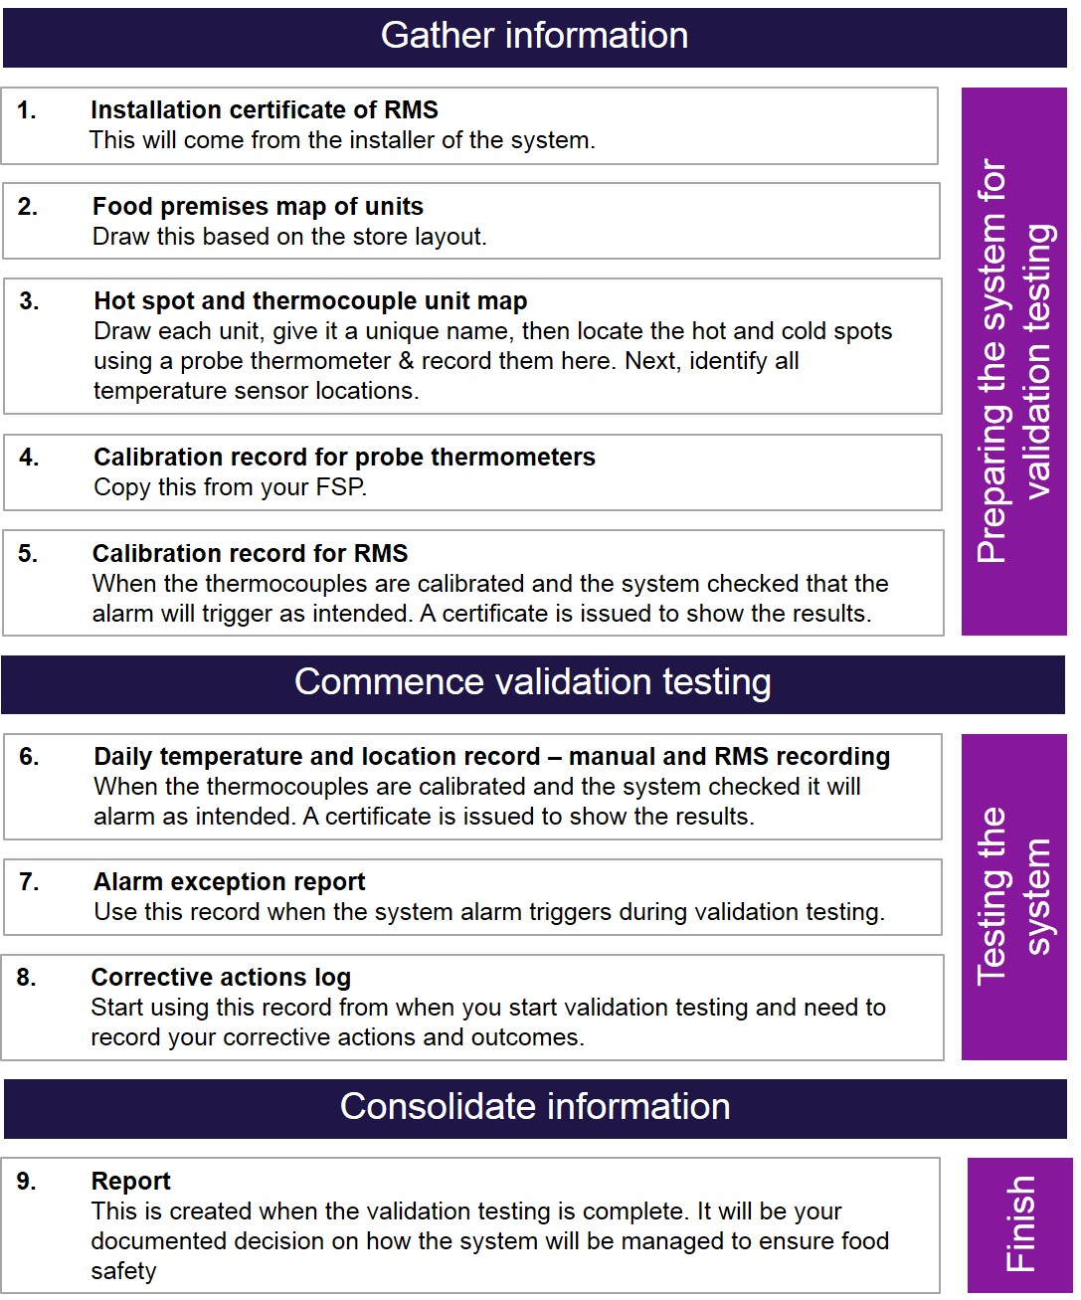

Newly installed and existing systems
All records generated by this validation process should be kept for two years. When validation is conducted, previously generated validation records are archived, and the latest suite of documents are valid to produce as evidence of the system operation. Records may be stored electronically but must be available immediately upon request and stored with the FSP.

Records explained

Record 1: System installation
When systems are installed they are approved for use by the installers and by the store manager or project manager. This approval document is a necessary record showing the system has been installed correctly and verified as working as intended. This will be Record 1 and should be stored with your FSP.

Record 2: Food premises map of units
Creating a map of units that are to be validated ensures any individual, from the records alone, can view the testing regime. The store manager may always be on site; however, staff changes, illness and other factors can lead to gaps in information. Record 2 is designed to provide a note of any units that are not linked to the RMS and that will require manual temperature checks. This will also provide clarity to those outside the business.

Record 3: Variation
Hot spots and cold spots will occur in refrigerated storage units and identifying where these are occurring prior to commencing the validation process is important. This can be done by spot checking the temperature of food items in multiple locations using a probe thermometer and recording the location of the item and the temperature. This validates each unit and the information can be used to guide temperature recording when you commence validation testing (Records 6, 7 and 8),
Hot spots will vary depending on the load type and stacking formation in a unit. If the map of hot spots needs to be altered, an additional Record 3 can be made and should be dated accordingly. Once the hot and cold spots have been mapped, identification of where the thermocouples are located in each unit should occur. The thermocouple location is important for temperature monitoring because it may be influenced by air flow, obstructions, ice build-up and so on. It is important thermocouples are not placed in front of cold air flows, as it may invalidate results.

Record 4 and Record 5: Calibration
Calibration is essential for the correct operation of RMSs (Record 5) and also for the probe thermometer being used (Record 4). If the RMS or probe thermometer has not been calibrated within the past 12 months, it must be done for every thermocouple linked to the system before commencing validation. Calibration must be performed either during or post installation – not during manufacture of the system. During the 30-day validation period, calibrate the probe thermometer weekly. If temperature inaccuracies are recurrent, consider increasing probe calibration to daily to ensure the records are accurate. Certificates for calibration should be stored in the same format as the rest of the validation records.

Record 6: Daily temperature and location
For newly installed systems, use the 30-day record for each unit to be validated. For existing systems with adequate records, use the seven-day record. It is important for morning and afternoon temperatures to be taken using a probe thermometer to show how activity during the day, such as doors being opened by staff and customers, impacts on the RMS and food temperatures.

Record 7: Alarm exceptions
Record 7 documents alarms generated by the RMS and provides correlating evidence of the actual food temperatures in the unit. A buffer time period can be incorporated into most systems to prevent the alarm triggering. This allows for short temperature fluctuations caused by operations such as opening a coolroom door or packing fresh deliveries into cold storage. The time period should be recorded on Record 7 and, if it is set differently for different units, noted.

Record 8: Corrective actions log
Record 8 documents evidence of actions undertaken when manual temperature monitoring of food shows the RMS temperature monitoring is not correlated. This may be due to undetected issues, or other factors. This documentation will assist the store manager to resolve any issues throughout the validation period and ultimately ensure a well performing RMS backed up with documented evidence.

Record 9: Report
Record 9 confirms for the store manager that the RMS is working as intended, and the evidence contained in the records generated throughout the validation processes support this claim. The store manager must not sign off the report before all documentation is completed.

Records – RMS
- Installation certificate of RMS
- Food premises map of units
- Hot spot + thermocouple location unit map
- Calibration record for probe thermometers
- Calibration record for RMS
- Daily temperature and location record – manual and RM recording
- Alarm exception report
- Corrective actions log
- Report

Record 1: Installation certificate(s) of the RMS (attach)

Record 2: Food premises map of units
Draw the location of the units to be tested identifying orientation in the store and unit ‘name’. Copy this page if needed.
GRID | 1 | 2 | 3 | 4 | 5 | 6 | 7 | 8 | 9 | 10 | 11 | 12 | 13 | 14 | 15 | 16 | 17 | 18 | 19 | 20
A
B
C
D
E
F
G
H
I
J

Record 3: Hot spot and thermocouple unit map
Unit name:_________________________________________________________ Date: __________________Signature:__________________________
Draw the unit to be tested, one per sheet, identifying orientation of the doors, the motor (if applicable), location of thermocouples and any other relevant detail.
GRID | 1 | 2 | 3 | 4 | 5 | 6 | 7 | 8 | 9 | 10 | 11 | 12 | 13 | 14 | 15 | 16 | 17 | 18 | 19 | 20
A
B
C
D
E
F
G
H
I

Record 4: Calibration record for probe thermometers
Include records from the past 12 months. Attach a copy of the record from your FSP – keep the original in your FSP or conduct a new calibration test.

Record 5: Calibration record for RMS
Attach a copy of the documentation showing calibration of thermocouples within the past 12 months. Every thermocouple in an RMS must be validated.

Record 6: Daily temperature and location record

Manual and RM recording Unit name:
Date  DD/MM/YYYY | Food item | Manual temperature °C/____am | RMS temperature  °C/____am | Food item | Manual temperature  °C /____pm | RMS temperature  °C/____pm | Cause and corrective action  (use Record 8 Corrective action log for detailed records) | Tester initials
12/05/2018 | Spinach dip | 5.9 °C /  10.15 am | 4.5 °C /  10.15 am | Smoked salmon | 4.9 °C /  6.45 pm | 3.5 °C /  6.45 pm | System 1.4 °C below food temp. Set system to alarm at 3.6 °C | R.H
 |  | °C/ am | °C/ am |  | °C/ pm | °C/ pm
 |  | °C/ am | °C/ am |  | °C/ pm | °C/ pm
 |  | °C/ am | °C/ am |  | °C/ pm | °C/ pm
 |  | °C/ am | °C/ am |  | °C/ pm | °C/ pm
 |  | °C/ am | °C/ am |  | °C/ pm | °C/ pm
 |  | °C/ am | °C/ am |  | °C/ pm | °C/ pm
 |  | °C/ am | °C/ am |  | °C/ pm | °C/ pm
 |  | °C/ am | °C/ am |  | °C/ pm | °C/ pm
 |  | °C/ am | °C/ am |  | °C/ pm | °C/ pm
 |  | °C/ am | °C/ am |  | °C/ pm | °C/ pm
 |  | °C/ am | °C/ am |  | °C/ pm | °C/ pm
 |  | °C/ am | °C/ am |  | °C/ pm | °C/ pm
 |  | °C/ am | °C/ am |  | °C/ pm | °C/ pm
 |  | °C/ am | °C/ am |  | °C/ pm | °C/ pm
 |  | °C/ am | °C/ am |  | °C/ pm | °C/ pm
 |  | °C/ am | °C/ am |  | °C/ pm | °C/ pm
 |  | °C/ am | °C/ am |  | °C/ pm | °C/ pm
 |  | °C/ am | °C/ am |  | °C/ pm | °C/ pm
 |  | °C/ am | °C/ am |  | °C/ pm | °C/ pm
 |  | °C/ am | °C/ am |  | °C/ pm | °C/ pm

Record 7: Alarm exception report
When the RMS alarms, record the information below
Alarm time/date | Unit/temperature reported by the RMS °C | Food type/manual temperature °C (measure at hotspot) | Cause | Corrective action (use Record 8 Corrective action log for detailed records) | Resolved?  Date
10.15am, 11/05/2018 | Deli fridge/ 5.6 °C | Tiramisu/8.6 °C | Fan in refrigeration unit has broken blade, reducing air circulation | Refrigeration mechanic called. All stock moved to Fridge 2. Fan replaced at 2 pm and system returned to pre-set temperatures. | Yes  11/05/2018

Record 8: Corrective actions log
These corrective actions are taken when manual food temperatures are above the safe food temperatures. Use Record 6: Daily temperature and location record to link the issue with the corrective action and outcome.
Unit name:
Corrective action log number | Unit (use the name of the unite given on Record 3) | Issue | Action | Resolved? Yes/No  If not, log in report.  Date
1 | 1 – Sylvester fridge | Temperature reported on system has approximately 1.4 °C difference to actual food temperature. | Set RMS to alarm at 3.6 °C to compensate for difference. | Yes – food tested over next week  Completed  19/05/2018

Record 9: Report
The following units have been tested and records are held for each:
Unit | Temperature records complete? Y/N | Alarms from the RMS correlate to manual food temperatures? Y/N | Corrective actions resolved alarm cause? Y/N
If you answered ‘No’ in the ‘Resolved’ column on Record 7 Alarm exception report or Record 8 Corrective actions log, provide evidence on how your food business will ensure food is accurately monitored to ensure food safety. This may be by monitoring manually to support the remote monitoring system. This justification must satisfy any food safety questions the environmental health officer may ask in enforcing the Act. For example, if a unit set at 3 °C holds food at 4.5 °C in the hottest spot, address this by updating the manual for staff and set alarms for 3.1 °C and above. Use weekly manual monitoring with a probe thermometer to show this works or implement further corrective actions.

Completed by (signature) | Date
Name (printed) | Position
Verified by (signature) | Date
Name (printed) | Position

A hot spot is an area within a refrigeration unit where the temperature is higher than other locations in the same unit. This can occur due to a wide range of reasons, such as where food items are located on shelves, items stacked against the unit wall preventing effective airflow, overstocking units, location of the unit, and design. The risk is that food items in one or more hot spots are held above 5 °C while items tested for core temperature from cooler parts of the unit will indicate the RMS is holding food below 5 °C, producing inaccurate evidence of the unit’s efficacy. Hot spots may be temporary or permanent; they may multiply depending on the cause.
For each newly installed system, use this record for 30-day validation. For existing systems with adequate records, use this for seven-day validation.

