Dual Diagnosis Residential Rehabilitation
Information about this new specialist treatment option

The Victorian drug treatment system
Alcohol and other drug problems are complex, affecting not just individuals but their families, their friends and their communities.
People accessing drug treatment in Victoria go through intake, comprehensive assessment and treatment as part of their recovery journey.
A range of state-funded community-based and residential treatment options are available, including counselling, withdrawal, rehabilitation, care and recovery coordination and pharmacotherapy.

What is dual diagnosis?
Dual diagnosis refers to the relationships between a person’s mental health and alcohol and other drug use concerns (see figure below). Examples may include:
- a mental health problem or disorder leading to or associated with problematic substance use
  - a substance use concern or disorder leading to or associated with a mental health concern or disorder.
Importantly, people who experience dual diagnosis are affected in different ways and therefore have individual needs. Dual diagnosis adds complexity to assessment, diagnosis, treatment and recovery, and can be associated with increased incidences of relapse.
The Victorian Government is rapidly expanding access to residential rehabilitation services across the state to create more treatment spots, reduce pressure on the system, and improve access to treatment for people who may struggle to attend community-based services.
The expansion includes establishing a specialist service for people with co-occurring alcohol and other drug and mental health needs (dual diagnosis), to be delivered at two new residential rehabilitation facilities.
Read on to find out how this service differs to standard residential rehabilitation and how you can make a referral.

What is dual diagnosis residential rehabilitation?
Residential rehabilitation is a treatment option for people who have already started their journey to recover from drug issues.
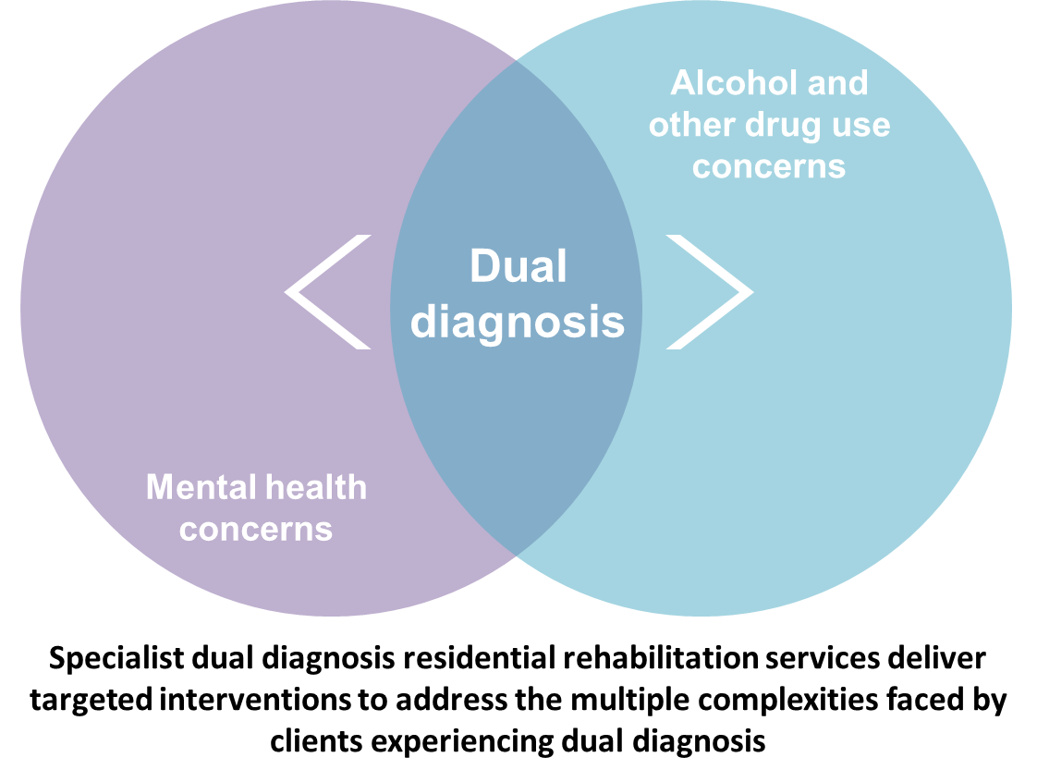
For many individuals with dual diagnosis, standard residential rehabilitation services offer a structured and therapeutic live-in environment, emphasising self-help and peer work to support reintegration into community living (see the About Residential Rehabilitation factsheet for more information).
However, some individuals experiencing multiple complexities related to dual diagnosis are not well accommodated in standard services – these clients may require a higher level of clinical support and targeted intervention to meet their treatment needs.
To address this treatment gap, a new specialist dual diagnosis service will be established and delivered across two new facilities in 2018 – eight beds at Bendigo Health and 20 beds at Western Health.
Read on for client suitability and referral pathways.

Who is dual diagnosis residential rehabilitation suitable for?
This service seeks to address the needs of adults experiencing dual diagnosis who are not well accommodated in standard residential rehabilitation services.
This service may be suitable for people who experience problems with alcohol and other drugs and:
- have mental health symptoms that need active treatment, such as unresolved anxiety or depression, or low-level active positive psychotic symptoms
- have mental health symptoms that need overnight support, such as low-level active post-traumatic stress disorder (PTSD) symptoms such as nightmares and sleep problems, or people who need regular or ‘as needed’ medication overnight
- need additional assistance to manage cognitive problems, such as with executive functioning or memory
- have poor impulse or emotional control
  - have a history of frequent drop-out from alcohol and other drugs, mental health or other treatment.

Who is not suitable?
Individuals with lived experience of dual diagnosis who have the capacity to manage the involvement and responsibility associated with being a resident of standard residential programs are best served in those services and are less suitable for this specialist service.
People typically excluded from standard residential rehabilitation who are also not suitable for this service include people who experience problems with alcohol and other drugs and:
- have a history of extreme antisocial behaviours such as violence, arson, sexual assault, paedophilia – they are better supported in specialised forensic and community services where eligible
  - are experiencing active and acute suicidal thinking and are at high risk of acting on their suicidal thoughts – they should be stabilised in an acute mental health service prior to entry
- are experiencing active and acute positive symptoms of psychosis or mania – they should be stabilised in an acute mental health service prior to entry
- are still using drugs or who are going through acute withdrawal – they should be referred to an existing withdrawal service prior to entry
- have a very low body mass index that requires medical care or who are actively bingeing, purging or restricting their diet – this group is better supported in a mental health, medical or specialist eating disorders service
  - meet the criteria for intellectual disability as outlined in the Disability Act 2006 (Vic) – this group is better supported in intellectual disability services.

How do people access dual diagnosis residential rehabilitation?
Referral into this service is similar to referral pathways for standard residential rehabilitation – see Client pathways and Catchment-based intake later in this document.
Client eligibility is responsive to symptoms’ severity rather than specific mental health conditions or diagnoses – see also Screening tool for referrers.
Pathways into the service include referral by catchment-based intake services, other drug or mental health services (noting that people suitable for this service will likely already be accessing such services). People may also be referred through primary care or other community services or may self-refer.

Admission assessment
The service provider will undertake an admission assessment of client suitability prior to accepting a referral.
Where a client is deemed not suitable (e.g. unstable mental health symptoms that may not be sufficiently addressed by the service), the service provider will advise the referring agency about a more suitable service.
Where appropriate, the service provider will provide assertive follow-up to facilitate admission into the service to support that client’s recovery journey.
Screening tool for referrers (Department of Health and Human Services, Service Guidelines v.01)
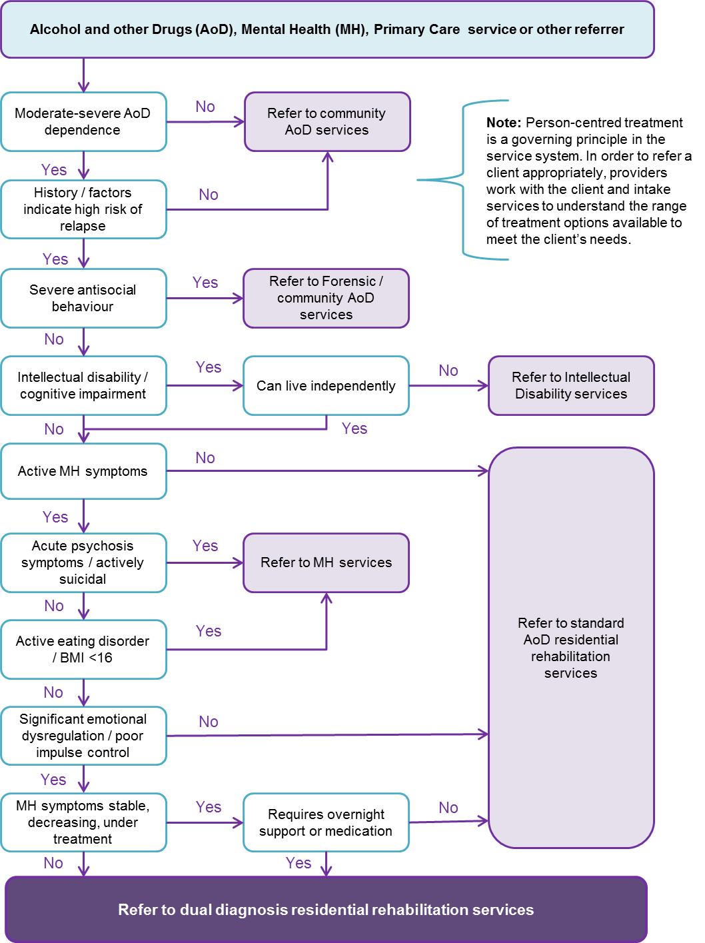

Client pathways through the drug treatment system
The figure below illustrates client pathways through the state-funded alcohol and other drugs treatment system.
Delivered as a statewide service, people may access the dual diagnosis services from anywhere in Victoria, and are assisted to return to their community with assertive aftercare and relapse prevention supports in place.
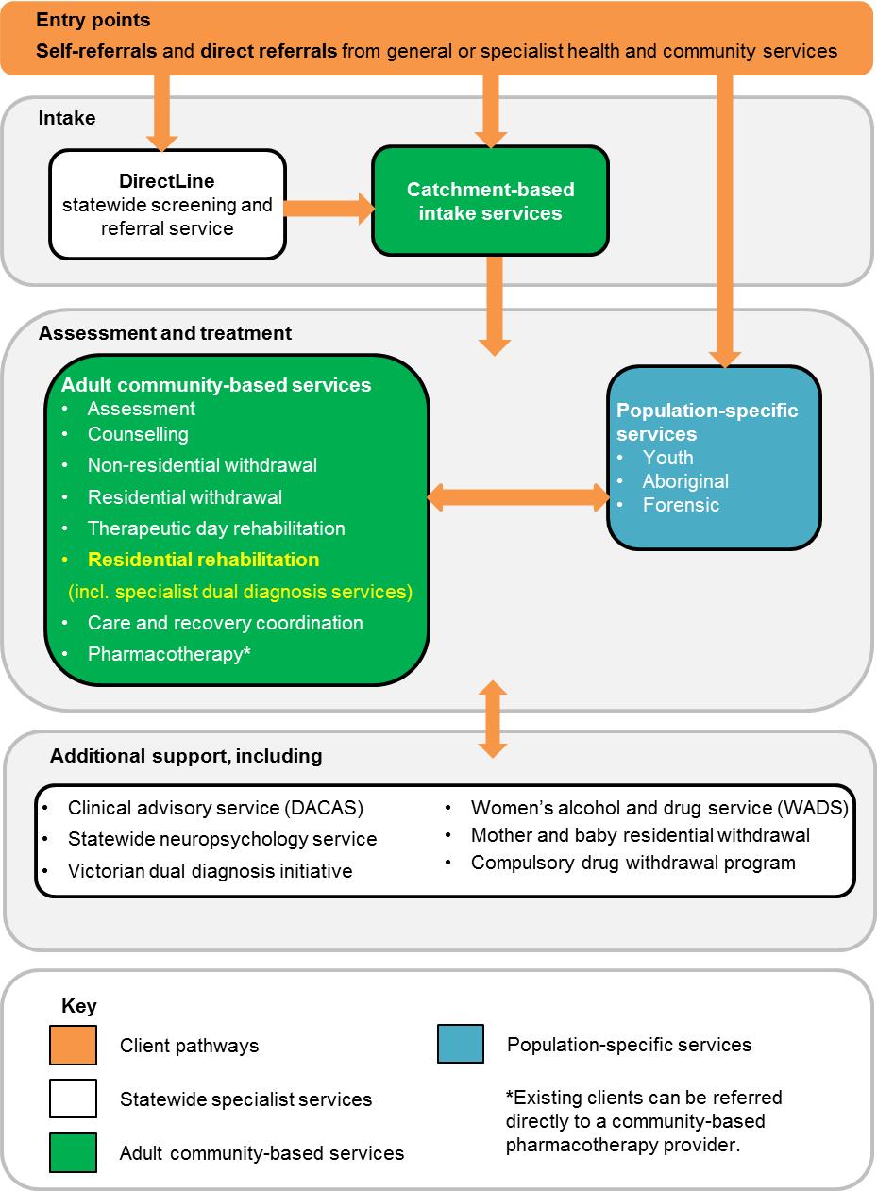

Where do I go for more information?

If you have any questions about Victorian alcohol or other drug treatment services, please:
- speak with your local catchment-based intake service (see below)
  - contact the statewide drug treatment information and referral service, DirectLine on 1800 888 236 or at <www.directline.org.au>.

Catchment-based intake services
Intake services are the critical point of entry into the alcohol and other drug treatment system. They provide local knowledge to support client pathways to all Victorian state-funded services, including residential rehabilitation.
Working closely with DirectLine, and other treatment providers, intake services facilitate client intake, triage, and referral to drug treatment, including the use of brief interventions and bridging support as required. They also support families and significant others of people with alcohol and other drug issues.
The table below provides the contact details for catchment-based intake providers.
Provider / consortium | Contact | Local government area | Catchment
Bayside Integrated Services | 1800 229 263  9690 9778 | Cities of: Port Phillip, City of Glen Eira, Bayside, Stonnington, Kingston | Bayside
South Eastern Consortium of AOD Agencies (SECADA) | 1800 142 536 | Cities of: Greater Dandenong, Casey, Cardinia Shire | South East Melbourne
Frankston and Mornington Drug and Alcohol Services (FaMDAS) | 1300 665 781 | City of Frankston  Mornington Peninsula Shire | Frankston-Mornington Peninsula
Eastern Health Turning Point AOD Consortium | 1800 778 278 | Cities of: Boroondara, Manningham, Whitehorse, Monash | Inner East
EACH SURE Consortium | 1300 007 873 | Cities of: Knox, Maroondah  Shire of Yarra Ranges | Eastern Melbourne
UnitingCare ReGen and Odyssey House Victoria:  North and West Metro Alcohol and Other Drug Service | 1800 700 514 | Cities of: Moreland, Moonee Valley, Melbourne, Yarra | Inner North
 |  | Cities of: Whittlesea, Darebin, Banyule  Shire of Nillumbik | North Melbourne
 |  | Cities of: Brimbank, Hume, Maribyrnong  Shire of Melton | North West Melbourne
 |  | Cities of: Hobsons Bay, Wyndham | South West Melbourne
Barwon AOD Consortium | 1300 094 187  Colac area:  1300 763 254 | City of Greater Geelong  Shires of Colac-Otway, Surf Coast  Borough of Queenscliff | Barwon
Australian Community Support Organisation (ACSO) | 1300 022 760 | Shires of: Bass Coast, South Gippsland, Baw Baw, Wellington, East Gippsland  City of LaTrobe | Gippsland
 |  | Rural Cities of: Wodonga, Wangaratta, Benalla  Shires of: Indigo, Towong, Mansfield, Alpine | Hume
 |  | Shires of: Moira, Strathbogie, Mitchell, Murrindindi  City of Greater Shepparton | Goulburn Valley
 |  | Shires of: Moorabool, Golden Plains, Pyrenees, North Grampians, West Wimmera, Hindmarsh, Yarriambiack, Hepburn  Rural Cities of: Ararat, Horsham  City of Ballarat | Grampians
 |  | Rural Cities of: Mildura, Swan Hill  Greater City of Bendigo  Shires of: Buloke, Gannawarra, Loddon, Campaspe, Central Goldfields, Mount Alexander, Macedon Ranges | Loddon-Malle
 |  | Shires of: Glenelg, Southern Grampians, Moyne, Corangamite  City of Warrnambool | Great South Coast

The DirectLine service finder is also accessible at <www.directline.org.au/service-finder>.
Other important statewide contacts are listed below.
Service | Contact | Provider
Youth Drug and Alcohol Advice (YoDAA) | 1800 458 685 | Youth Support and Advocacy Service (YSAS)
Family Drug Help | 1300 660 068 | Self Help Addiction Resource Centre (SHARC)
Tandem | 03 8803 5501 | Tandem Mental Health Carers in Victoria

Department resources online
The Department of Health and Human Services’ Alcohol and other drugs program guidelines describe the objectives and functions of the Victorian alcohol and other drug treatment system, and are available for download from the department’s website at <www2.health.vic.gov.au/alcohol-and-drugs/aod-service-standards-guidelines/aod-program-guidelines>.
A factsheet About Residential Rehabilitation is available at <www2.health.vic.gov.au/alcohol-and-drugs/aod-treatment-services/aod-residential-treatment>.
To receive this publication in an accessible format phone 9096 0000 using the National Relay Service 13 36 77 if required, or email aod.enquiries@dhhs.vic.gov.au
Authorised and published by the Victorian Government, 1 Treasury Place, Melbourne.
© State of Victoria, Department of Health and Human Services, April 2018.
Available at www2.health.vic.gov.au/alcohol-and-drugs/aod-treatment-services/aod-residential-treatment
The Victorian Dual Diagnosis Initiative is a cross-sector initiative funded by the department to contribute to the further development of mental health and drug and alcohol clinicians, agencies and sector’s capacity to recognise and respond effectively to people with dual diagnosis. More information about dual diagnosis is available at <https://www2.health.vic.gov.au/mental-health/practice-and-service-quality/specialist-responses/dual-diagnosis>.

