CDIS internal referral process
Victorian Maternal and Child Health (MCH) Child Development Information System (CDIS)
December 2020
Contents
Making an internal referral from client (child) consultation 1
Internal referral from client (child) consultation 3
Completed internal referral in client (child) consultation 4
Editing and completing internal referrals in the client (child) referral screen 5
Editing internal referral notes in Client Notes 6
Add referral letters and forms as attachments to client history 8
View, edit and delete attachments in client history 10
Add a ‘referral follow-up’ blue alert flag for internal referrals 12
Status of internal referrals 13
Remove a ‘referral follow-up’ blue alert flag 14

Making an internal referral from client (child) consultation
Important Note:
All referrals except Enhanced MCH and Sleep and settling outreach are recorded from child history.
Referrals are counted for reporting purposes from child history.
For information on EMCH and Sleep and settling outreach internal referral processes please see the specific guidance documents for those programs.
- In ‘Client History’, open the ‘Clinical Activity’ menu and select ‘Consultations’
- Select and start the relevant consultation
- Complete the consultation
- Select ‘Internal Referral’
Figure 1: Referrals from this assessment
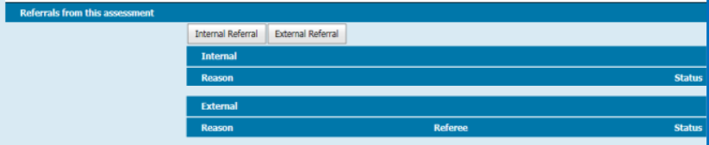
If the referral is relevant to someone other than the child (such as the mother, father or caregiver):
- Enter referral in ‘Child History’
- in ‘Additional Comments’ add ‘attachments in [relevant client’s] history’
- add ‘Referral Follow-up Blue Alert Flag’
- Ensure that the relevant client is open (such as the mother, father or caregiver)
- In the ‘Notes’ of the relevant client history, document:
- date referral made
- name of referee
- brief referral reason
- attachment of relevant documents/referral letter –.attach any relevant documents or referral letter
- add ‘Referral Follow-up Blue Alert Flag’
- Document follow-up on status of referral in:
- relevant client history
- child history
- On closure of the referral, remove ‘Referral Follow-up Blue Alert Flag’ from:
- relevant client history
- child history
- Close relevant client history if referral closed and no further action is required

Internal referral from client (child) consultation
Figure 2: Internal Referral pop-up box interface
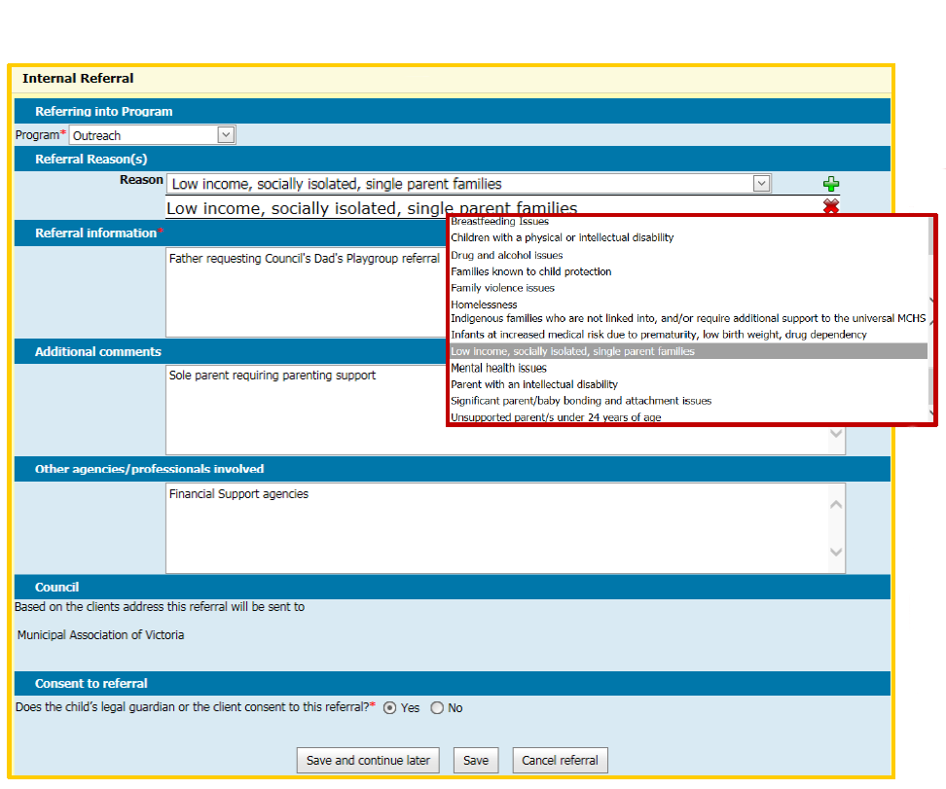
In the Internal Referral pop-up box:
- Program (required): Select from look-up list
Figure 3: Referring into program options
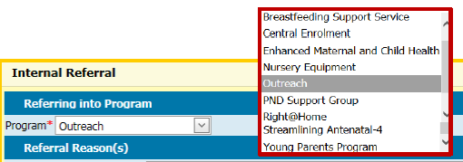
- Referral reason(s) (required): Select from look-up list – more than one reason can be selected by selecting the add green plus button and picking the next reason
Figure 4: Referral reason options
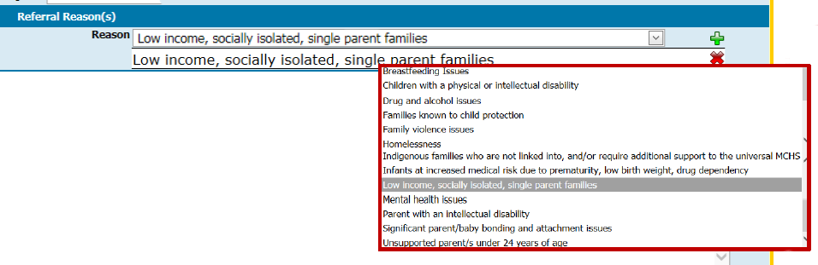
- Referral Information (required): Enter details in free text field
- Additional comments: Enter details if relevant
- Other agencies or professionals involved: Enter details if relevant
- Consent to referral (required): Confirm whether or not the Primary Caregiver/legal guardian has consented to the referral by selecting the Yes or No radio button
- Select the Save button or use the ‘Save and continue later’ button to allow further editing.

Completed internal referral in client (child) consultation
In the client consultation screen, ‘Draft’ will be displayed in the ‘Referrals from the assessment’ section if the ‘Save and continue’ button was selected when adding an internal referral. Draft means the internal referral can be edited and completed via Referrals (in the ‘Clinical Activity’ menu).
Figure 5: Draft referral status
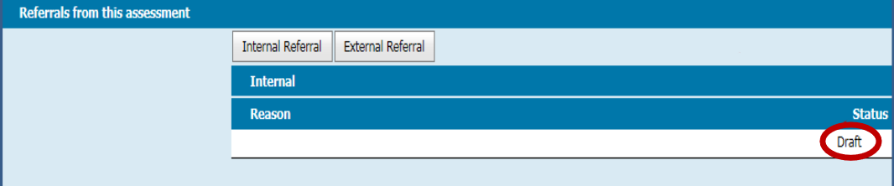
The status will be ‘Completed’ if the ‘Save’ button was selected. This internal referral cannot be edited. Only the client notes associated with this internal referral can be edited by going to ‘Notes’ under ‘History/Notes’.
Figure 6: Completed referral status
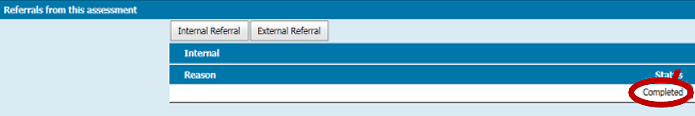

Editing and completing internal referrals in the client (child) referral screen
- In Client History, open the Clinical Activity menu and select Referrals
- Under ‘Incomplete Pending Referrals’, select the ‘Open’ button for the referral to be edited or saved (see Figure 2 for the ‘Internal Referral’ pop-up box interface)
- ‘Incomplete Pending Referrals’ lists incomplete referrals
- ‘Referral Status’ lists all complete referrals with their referral status as either pending, active, completed or declined
Figure 7: Incomplete pending referrals
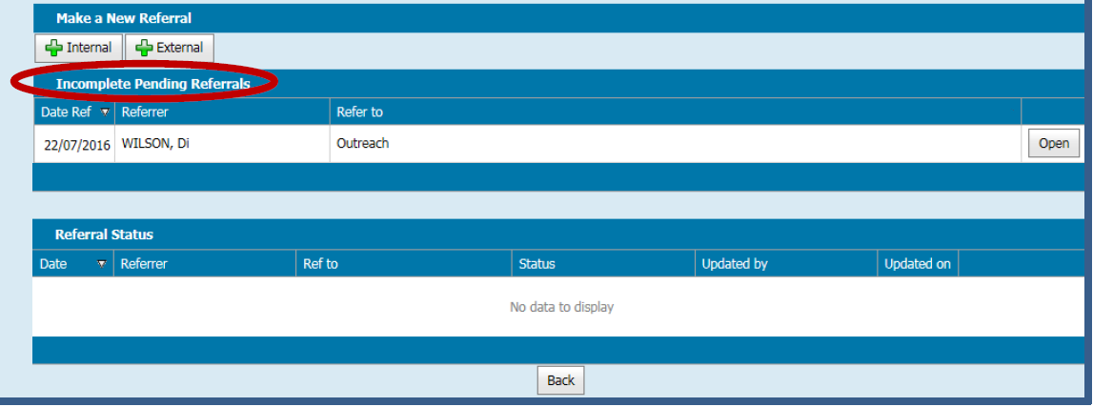
- Edit Program (required field) from look-up list
- Edit Reason (required field) from look-up list – more than one reason can be selected
- select one reason at a time and select the green plus button to add
- a reason can be removed by selecting the red X button to delete
- Edit Referral Information (required field)
- Enter or edit additional comments if relevant
- Enter or edit ‘Other agencies/professionals involved’ if relevant
- Consent to referral (required): Confirm whether or not the child’s Primary Caregiver/legal guardian has consented to the referral by selecting the Yes or No radio button
- Select Save –no further editing will be possible
The completed referral will be displayed in the Referrals interface. Referral status may be either pending, active, completed or declined.
Figure 8: Pending referral status
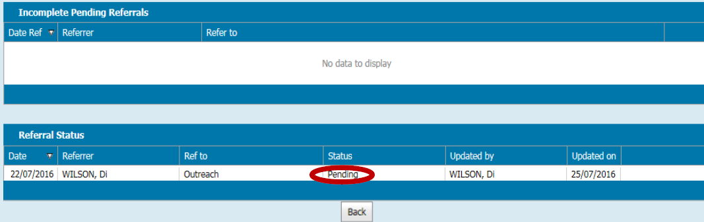

Editing internal referral notes in Client Notes
Note: While there is the option to edit an internal referral in the client notes section, this only edits the notes and not the internal referral itself.
- In the Client History screen, open the ‘History/Notes’ menu and select ‘Notes’.
- Select the Edit button for the referral note you wish to edit
- remember that this will only edit what has been documented in client notes and not the internal referral.
- In the ‘Add/Edit Progress Note’ box:
- add or edit the note
- under ‘Edit reason’, select either ‘Incorrect Entry’ or ‘Incomplete Entry’
- Select ‘Save’.
Figure 9: Add or Edit Progress Note box
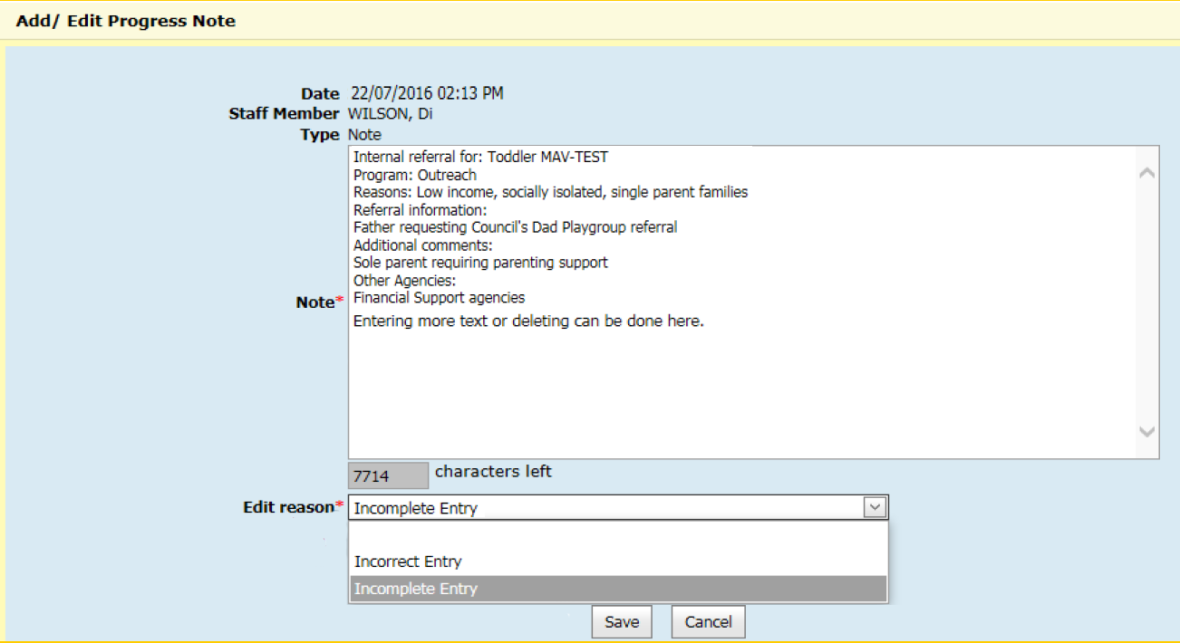

Example of completed internal referral notes
If internal referral notes have been edited from client notes, the edited entry will be shown with the heading, ‘Supersedes Progress note previous entered on [date of original]’.
The original internal referral note will have the heading, ‘Superseded by note entered on [date of edited version]’.
Figure 10: Internal referral progress notes
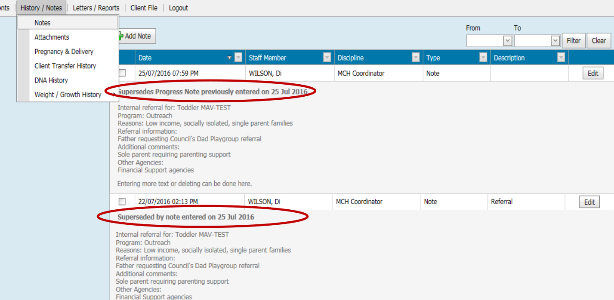

Add referral letters and forms as attachments to client history
- In the Client History screen, open the ‘History/Notes’ menu and select ‘Attachments’
- Select the ‘Add Attachment’ button
Figure 11: Attachments screen
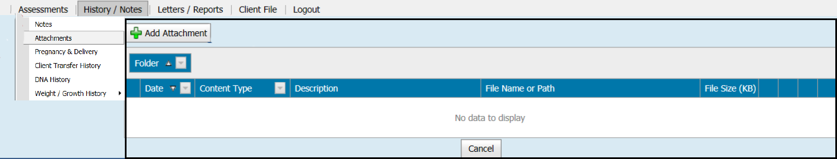
- Under attachment type, select either ‘Electronic Upload’ or ‘Physical Location’ – the default is electronic upload
- Enter an ‘Attachment description’
- Under ‘Type’, select the kind of attachment from the list
Figure 12: Add Attachment pop-up box
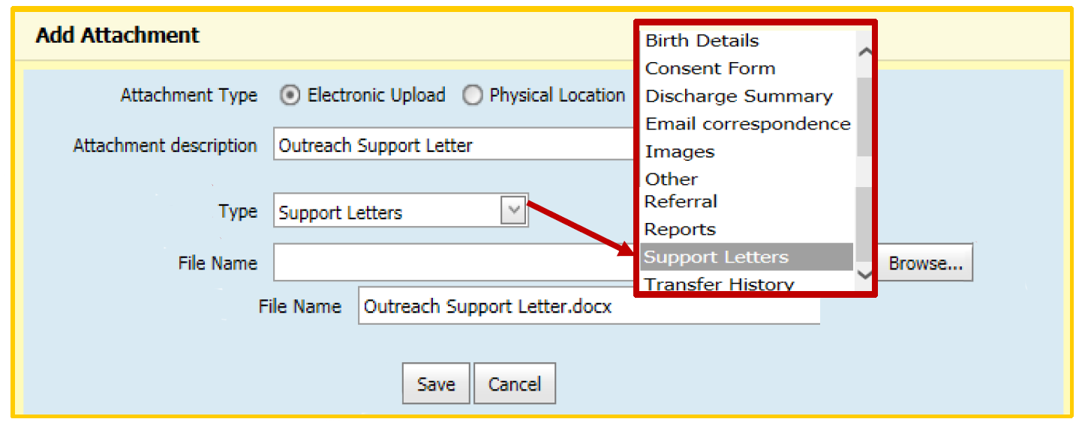
- Select the Browse button to pick the file to upload

- Find where the relevant file was saved, pick the file and select the Open button
- the file name will then be displayed in ‘File Name’ field
- best practice is to save the file in your personal drive and then delete the file once attached
Figure 13: Choose file to upload
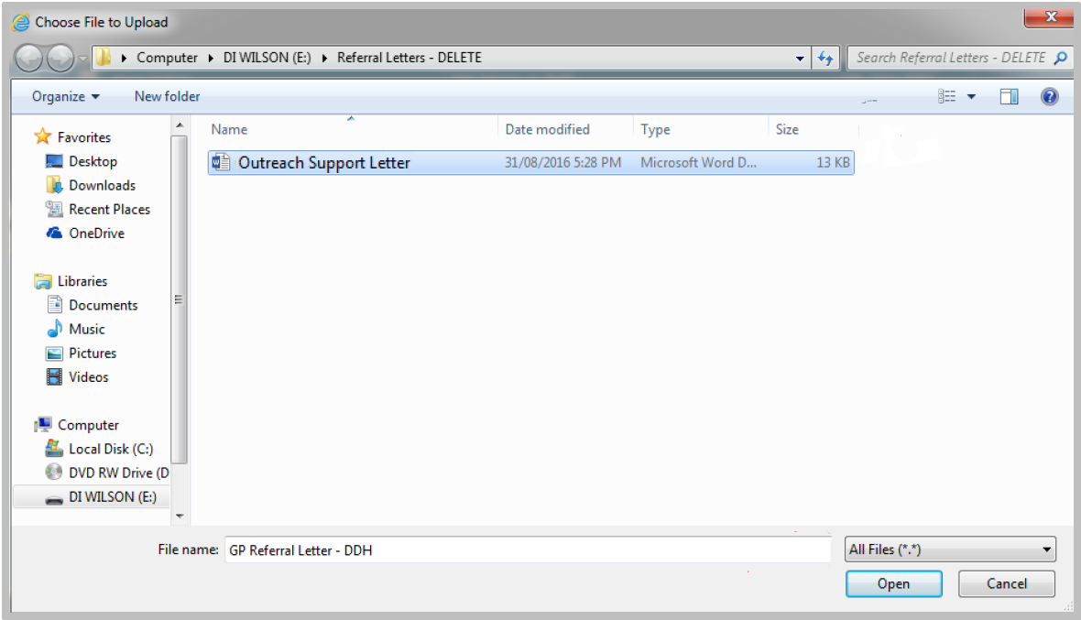
- Select Save
The referral letters and forms will be displayed in the table on the Attachments screen.
Figure 14: Updated Attachments screen
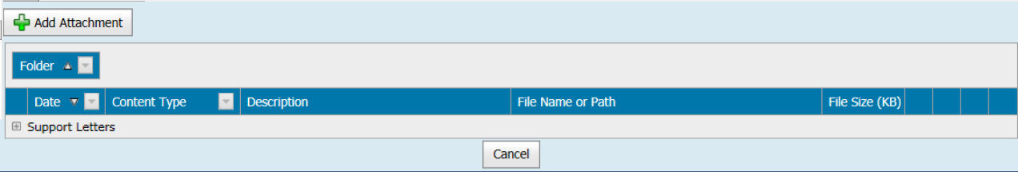

View, edit and delete attachments in client history
- In the Client History screen, open the ‘History/Notes’ menu and select ‘Attachments’
- Select the Expand button (plus sign in a square)
Figure 15: Attachments screen
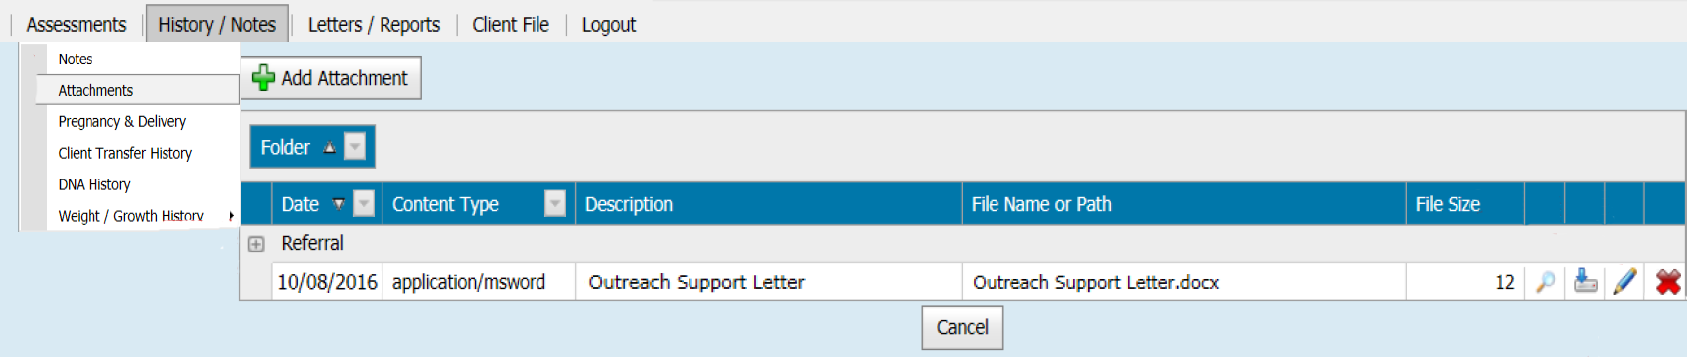
- View attachment details by selecting the view button (magnifying glass icon) – you can view attachment details or open or save files
Figure 16: View Attachment Details box
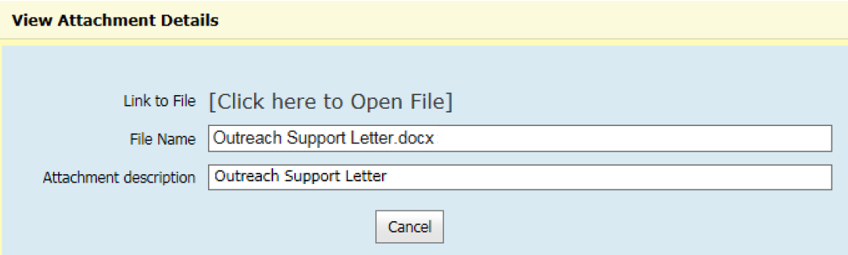
- Select the download button (icon of a drive with a down arrow) to download an attachment – select either Open or Save
Figure 17: Open or save message

- Select the edit button (pencil icon) to edit attachment details – you can edit the file name, attachment description and type
Figure 18: Edit Attachment Details box
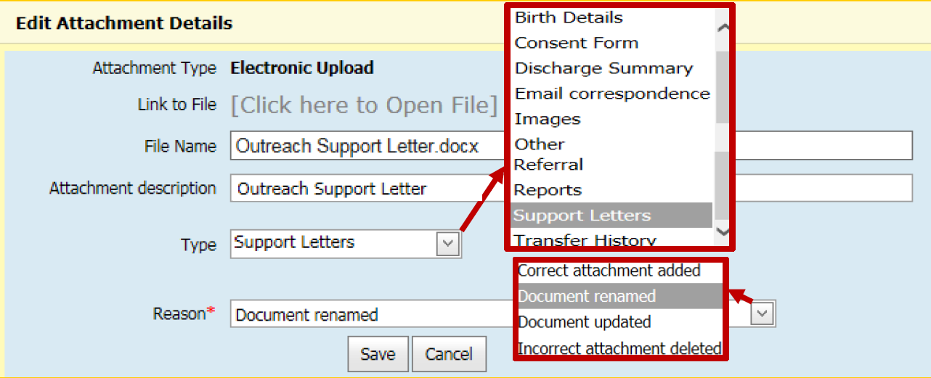
- Select the delete button (red X icon) to delete an attachment
Note
- only management can delete
- include a reason for deleting the attachment
Figure 19: Delete Attachment box
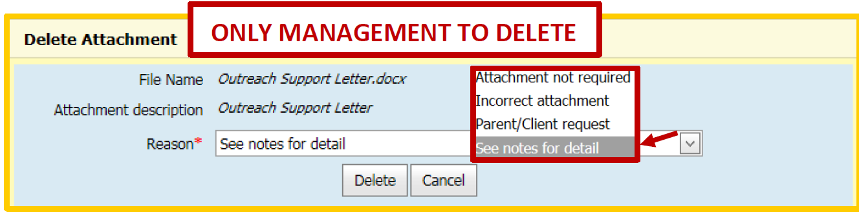
Figure 20: Notes for deleted attachments
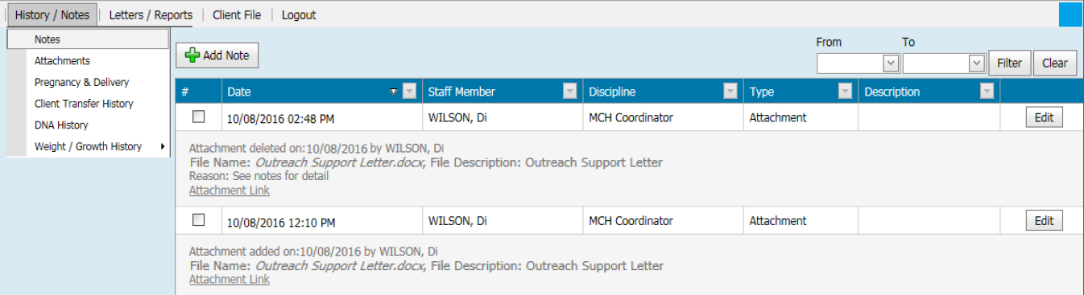

Add a ‘referral follow-up’ blue alert flag for internal referrals
- In Child History, open the Clinical Activity menu and select ‘Flags/Alerts’
- Select ‘Add’ to add a flag or an alert
Figure 21: Flags/Alerts screen
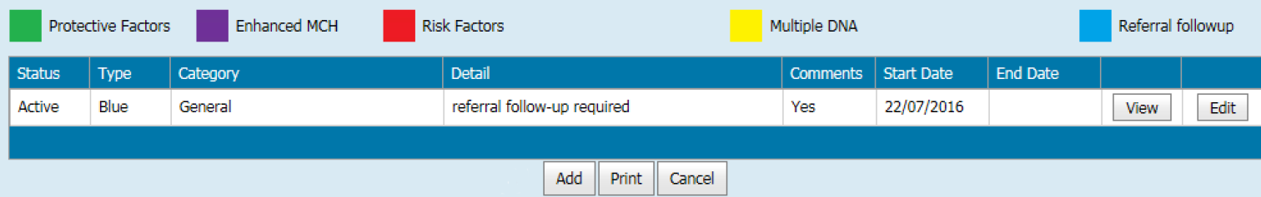
- In the ‘Add Flags/Alerts’ pop-up box:
- under ‘Category’, select ‘General’
- under ‘Details’, select ‘referral follow-up required’
- enter the ‘Start Date’ by using digits or calendar box – the default is today’s date
- enter comments if relevant
- select the Confirm button
Figure 22: Add Flag/Alert box
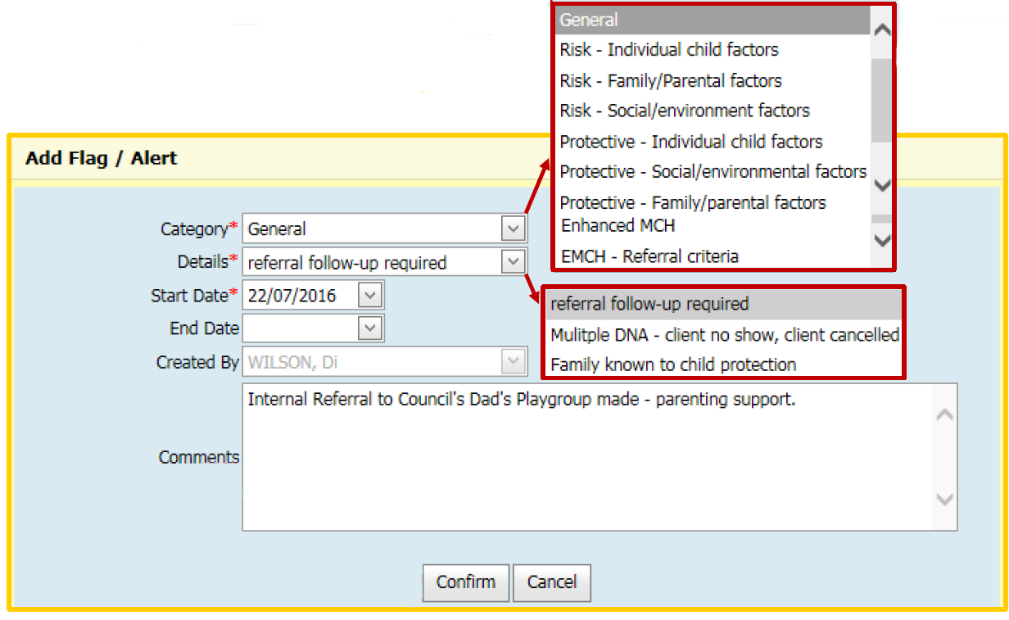
A blue alert flag is now displayed in Child History.
Figure 23: Blue alert flag
Repeat steps for relevant client history if appropriate.

Status of internal referrals
The status of internal referrals can be either pending, active, assigned, completed or declined.
In the client Referrals screen (open the Clinical Activity menu and select Referrals), the referral status may be:
- pending – referred but not yet accepted or declined
- active – being currently actioned or receiving service
- completed – episode of care has ended or been closed
- declined – referral declined.
Figure 24: Referral status on Referrals screen
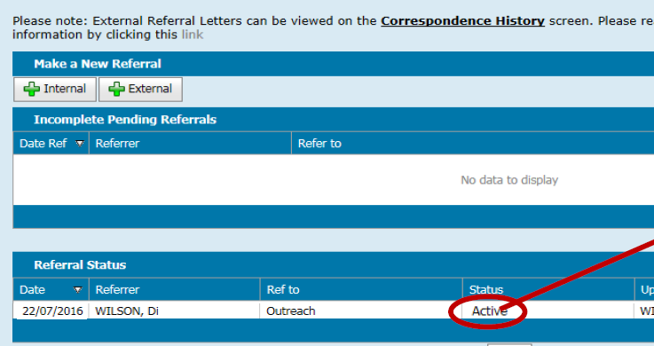
On the client summary page (open the Client Details menu and select ‘Summary Page’), displaying
- program name means the referral has been accepted
- start date means the date the referral was accepted
- end date means the date the program was closed or ended.
Figure 25: Summary Page
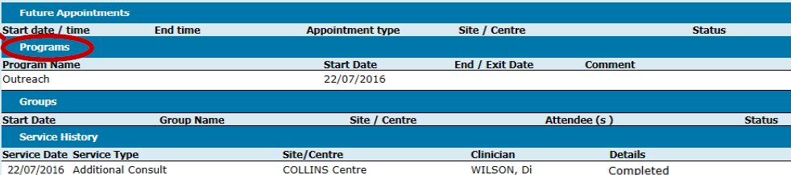

In ‘Programs Active List’ and client notes:
- active – accepted but not assigned to a worker
- assigned – assigned to a worker
- declined – referral declined.
Figure 26: Client notes
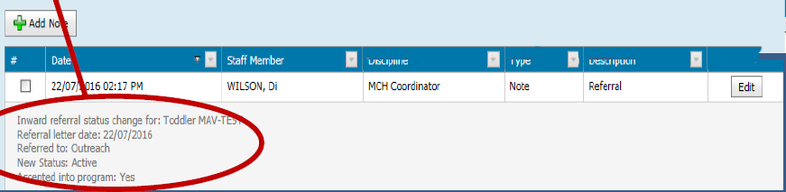

Remove a ‘referral follow-up’ blue alert flag
Note: Referral follow-up blue alert flags need to be reviewed at each consultation and removed if required. This is from both the child history and relevant client history.
- In child history, open the Clinical Activity menu and select ‘Flags/Alerts’
- Select Edit on relevant blue referral follow-up flag
Figure 27: Flag/Alerts screen
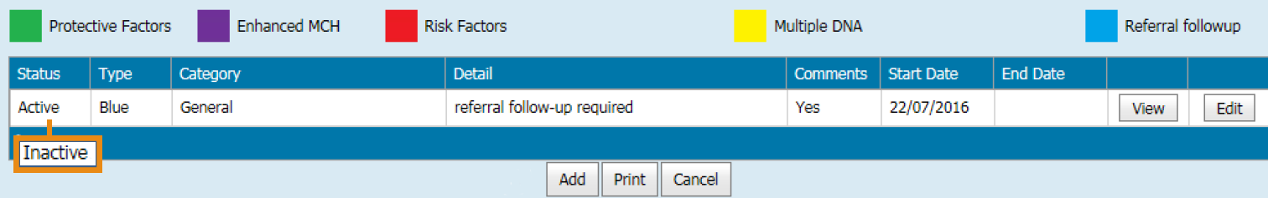
- In the ‘Edit Flag/Alert’ pop-up box:
- check that the category and details are correct – these should be ‘General’ and ‘referral follow-up required’ (these fields are already filled)
- End Date: enter by using digits or calendar box (defaults to today’s date)
- Comments: enter if relevant (such as outcome and recommendations)
Figure 28: Edit Flag/Alert box
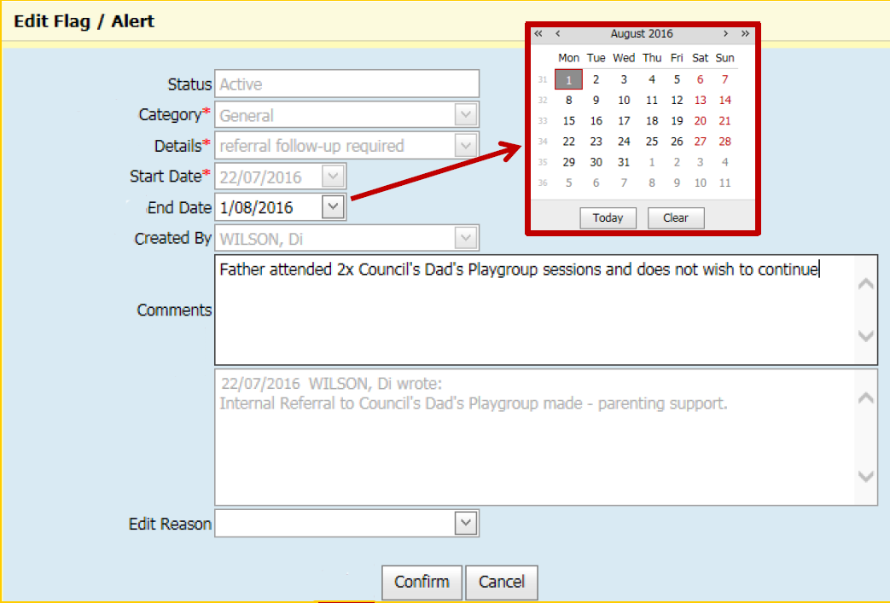
- Select the Confirm button to save.
Client history will now display:
- blue alert flag box with one less number or replaced with a light blue triangle
- inactive status in child ‘Flags/Alerts’
- end date in child ‘Flags/Alerts’.
Figure 29: Triangle flag
Note: Repeat steps for relevant client history if appropriate.
To receive this publication in an accessible format phone 1300 650 172, using the National Relay Service 13 36 77 if required, or email Commissioning Performance and Improvement Aged and Community Based Health Care and Cancer Services <mch@dhhs.vic.gov.au>
Authorised and published by the Victorian Government, 1 Treasury Place, Melbourne.
© State of Victoria, Australia, Department of Health and Human Services June 2020.
ISBN 978-1-76096-022-3 (pdf/online/MS word)
Available at health.vic – Child Development Information System <https://www2.health.vic.gov.au/primary-and-community-health/maternal-child-health/child-development-information-system>

