Victorian Health Services Performance Monitoring Framework 2023-24
OFFICIAL

The Victorian Health Services Performance Monitoring Framework (the Framework) is an annually published document that details the approach, rationale and operationalisation of the performance monitoring and support of our Victorian health services.
The Framework is complemented by the Victorian Health Services Performance Monitoring Framework Indicator Business Rules (the Business Rules), which is updated throughout the year. The Business Rules outlines business rules for each performance measure, by summarising the list of Key Performance Measures and Underlying Risk Factors, with their corresponding temporal elements and technical specifications, that support the Framework.
The most recent version of the Business Rules is available from the: Funding, Performance and Accountability webpage <https://www.health.vic.gov.au/funding-performance-accountability/performance-monitoring-framework>.
Throughout the Framework, the term ‘health services’ refers to the ‘public hospitals’, ‘public health services’ and ‘multi-purpose services’ listed in the Health Services Act 1988 (Vic), unless otherwise specified.
To receive this publication in an accessible format phone 9096 7120 using the National Relay Service 13 36 77 if required, or email Accountability <accountability@health.vic.gov.au>
Authorised and published by the Victorian Government, 1 Treasury Place, Melbourne.
© State of Victoria, Department of Health, August 2023.
This publication is copyright. Apart from any use permitted under the Copyright Act 1968 (Cth), no part may be reproduced by any process, nor may any other exclusive right be exercised, without the permission of the Department of Health, 2023.
ISSN 2209-4172 – Online (pdf / word)
Available at Funding, performance and accountability webpage <https://www.health.vic.gov.au/hospitals-and-health-services/funding-performance-and-accountability>

Contents
The Framework 1
About the Framework 3
Performance Strategy 3
2023-24 Framework 3
Coverage 4
Key Changes for 2023–24 5
The Framework’s Performance Objectives 7
The Four Performance Domains 8
The Performance Improvement Approach 9
Key Considerations 10
The Performance Improvement Process – Step-by-step 11
Step 1 – Identify Performance Risk 12
Step 2 – Analyse Performance 14
Step 3 – Assess Monitoring, Support and Intervention Level 17
Step 4 – Addressing Performance Concerns 19
How is a Health Service’s Monitoring, Support and Intervention Level Changed? 20
Risk Identification and Departmental Support 21
Operationalising Performance Monitoring 22
Role and Responsibilities 22
Performance Meetings 23
Performance Monitoring and Reporting 24
Specific Events – Breaches 25
Force Majeure 25
Appendix: Text-equivalent descriptions of figures 27

The Framework
The Victorian Health Services Performance Monitoring Framework (the Framework) articulates the Government’s performance monitoring of our Victorian public health services and hospitals. The Framework promotes transparency and shared accountability for performance improvement across the system and helps inform future policy and planning strategies.
The Framework describes the contextual, strategic and operational aspects of monitoring and improving health services’ performance. It also describes the various roles the Department of Health (the department), Safer Care Victoria (SCV) and the Victorian Agency for Health Information (VAHI) have in building, designing and monitoring best practice indicators to assist with the implementation of health services’ performance strategies.
Extensive revision of the Framework occurred in 2017-18, following the Review of Hospital Safety and Quality Assurance in Victoria (Targeting Zero). The 2019-20 Framework further built on Targeting Zero’s foundation by strengthening health service performance monitoring in Victoria; assisting our health services in continuing to deliver safe, high-quality care and experiences to Victorians.
The Framework’s structure remains unchanged in 2023-24 and continues to operate in accordance with the Health Services Act 1988 (HSA) and other contextual elements (see Figure 1), including:
- the Government’s commitment to making real and measurable contribution to making Victorians the healthiest people in the world, and
- service delivery targets guided by the current Department of Health’s Operational Plan <https://www.health.vic.gov.au/about/our-operational-plan>, as set out by each health service’s Statement of Priorities (SOP), the conditions of funding as outlined in the Policy and Funding Guidelines.

- The Framework – Key contextual elements
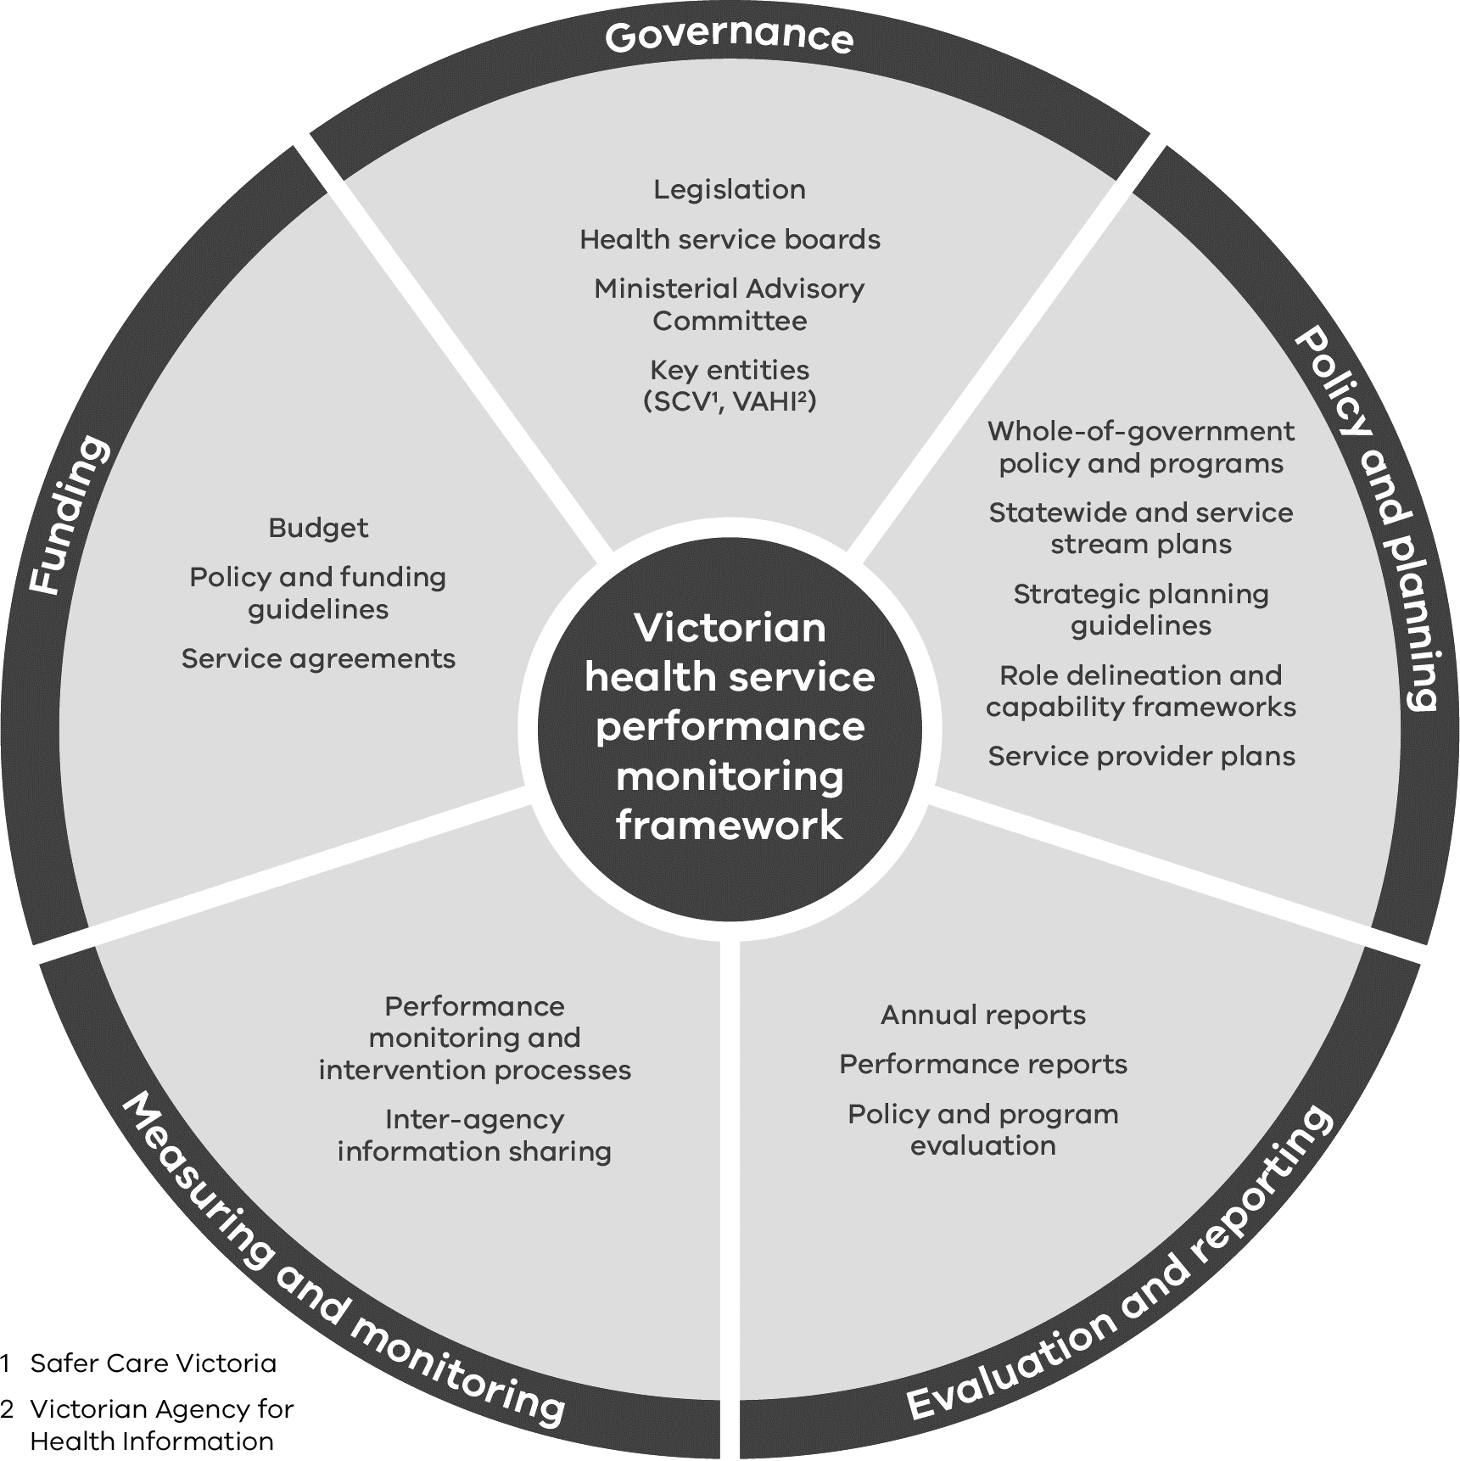
Text-equivalent description of Figure 1 in the Appendix

About the Framework

Performance Strategy
The Framework outlines how the department, as the system steward of Victoria’s public health system, takes a risk-based approach to overseeing health service performance. The Framework is designed to assess the level of performance risk posed to each health service in relation to the delivery of safe, high quality, accessible and sustainable health care for Victorian patients and communities. Further, the Framework uses targets and other intelligence to identify areas of risk and poor performance, but also considers trends in performance, whether a health service is improving over time in relation to those targets.
It therefore considers:
- a health service’s current performance and trends against targets of the Key Performance Measures within each performance domain; and
- the Underlying Risk Factors, third party reports and other intelligence that may indicate emerging or underlying risks to future performance (i.e. contextual factors).
These considerations demonstrate how the Framework allows the department to assess the level of performance risk, and identify the type and focus of support required. In addition, the department provides advanced support to those services with greater risks to the safety, accessibility or sustainability of their service, and takes contextual factors into consideration that help provide early indications of issues that can impact patient outcomes. Examples include:
- the strength of financial, corporate, and clinical governance and leadership;
- leading indicators that may reveal underlying potential risks to the quality and safety of care; and
- qualitative measures from a variety of sources that can reveal performance issues before they become performance failures.
The Framework will continue to evolve over time, drawing on a broader range of factors that impact the performance of health services, and outcomes they provide for patients and the community. The results from the Targeting Zero report <https://www.health.vic.gov.au/quality-safety-service/review-of-hospital-safety-and-quality-assurance-in-victoria> are an example of a driver in evidence based change. The findings in Targeting Zero provided a catalyst to focus on the proficiency of ‘performance domains’.

2023-24 Framework
Performance monitoring of Victorian health services involves a process of continual improvement to ensure that measurements are relevant to both system managers and health services, while remaining aligned to contemporary methods of service delivery. Looking beyond current practices and identifying opportunities for future improvement is a key component of this process.
The 2023-24 Framework is published as two interconnected but separate documents as follows:
- Framework – outlines the department’s risk-based approach; and
- Victorian Health Services Performance Monitoring Framework Indicator Business Rules (the Business Rules). The Business Rules contain the list of Key Performance Measures and Underlying Risk Factors, as well as their temporal elements and technical specifications, that support the Framework.
Separate publications allow for amendment of the Business Rules indicators and metrics that support the Framework, as and when necessary, throughout the year. This reflects a simpler and more flexible approach to performance monitoring.

Coverage
In exercising its role as the system steward, the department is the leader of the health system improvement agenda. In doing so, the department acknowledges the leadership and contribution of, and strong collaboration with, health services and other relevant entities, including private healthcare providers.
The Framework captures all publicly funded health service providers including:
- metropolitan health services, and Dental Health Services Victoria
- regional health services
- subregional health services
- local health services
- small rural health services
- multi-purpose services
- denominational hospitals
- Ambulance Victoria
- Health Purchasing Victoria trading as HealthShare Victoria (HealthShare)
- the Victorian Institute of Forensic Mental Health (Forensicare) and
- Youth Mental Health and Wellbeing Victoria (YMHWV)
The metropolitan and regional health services are defined under the HSA as ‘public health services’. Together with Dental Health Services Victoria, they are governed by boards of directors as set out under section 65S of the HSA.
Subregional, local and small rural health services are defined under the HSA as ‘public hospitals’ and are governed by boards of directors as set out under section 33 of the HSA.
Multi-purpose services are established under Part 4A of the HSA and are governed by boards of directors as set out under section 115E of the HSA. They are subject to similar governance and performance policies as public hospitals.
Three denominational hospitals, Calvary Health Care Bethlehem Limited, Mercy Public Hospitals Incorporated and St Vincent’s Hospital (Melbourne) Limited, are subject to similar performance and oversight provisions as public hospitals, as set out in Part 3 and Part 3A of the HSA.
Ambulance Victoria is established under section 23 of the Ambulance Services Act 1986 (ASA) and is governed by a board of directors as set out under section 17 of the ASA.
Health Purchasing Victoria is established under section 129 of the HSA (Part 6 Division 1). Health Purchasing Victoria trading as HealthShare Victoria is governed by a board of directors as set out under section 134D of the HSA (Part 6 Division 4).
Forensicare is established under section 328 of the Mental Health Act 2014 which will transition to the Mental Health and Wellbeing Act 2022 (MHWA) on September 1 2023 under section 610. Forensicare is governed by a board of directors pursuant to provisions in the MHWA (Part 14.2).
YMHWV is to be established under section 673 of the Mental Health and Wellbeing Act 2022 (MHWA) and governed by a board pursuant to provisions in the MHWA Part 16.1, Division 2). The relevant functions in the Act are expected to be consistent with the operation of this framework and will be clarified with the entity upon its establishment.

Key Changes for 2023–24
The overall risk-based approach of the Framework remains unchanged and builds on the progress made thus far. It retains the emphasis on four domains of performance: high quality and safe care; strong governance, leadership and culture; timely access to care; and effective financial management.
The department continues to learn from the initial experience of implementing the Framework, leading to improvements in the performance monitoring process, and providing greater clarity about the roles and responsibilities of health services, the department, SCV and VAHI.
New measures that have been incorporated into the Framework for 2023-24 include:
- Two new measures will be included in the Statement of Priorities to support the 'Closer at Home' DH operational priority:
  - Percentage of admitted bed days delivered at home
  - Percentage of admitted episodes delivered at least partially at home.
- And three measures to prioritise workforce well-being:
  - Percentage of workers reporting nil or low/mild work-related stress
  - Percentage of workers not experiencing occupational violence and aggression
  - Percentage of workers not reporting symptoms of fatigue
Two existing Aboriginal health measures (‘Percentage of admitted patients who left against medical advice for Aboriginal and non-Aboriginal patients’​ and ‘Percentage of patients that did not wait for treatment for Aboriginal and non-Aboriginal patients presenting to hospital emergency departments’​) have also been added to the Statement of Priorities.
The target compliance rate with the Hand Hygiene Australia program has been changed from 85% to 80% to bring the target in line with national targets and recommendations.
Three patient experience measures have been expanded to now include the primary informal carer for patients who are unable to report:
- Percentage of patients who reported positive experiences of their hospital stay
- Percentage of adult patients who reported positive experiences of their discharge from hospital
- Percentage of adult patients who reported they were involved as much as they wanted to be in making decisions about their care.
Three measures that have been identified as no longer fit for purpose will be removed. They are:
- Rate of patients with surgical site infection (aggregate)
- Percentage of closed community cases re-referred within six months: CAMHS, adults and aged persons
- Proportion of urgent maternity patients referred for obstetric care to a level 4, 5 or 6 maternity service who were booked for a specialist clinic appointment within 30 days of accepted referral
The department, including Safer Care Victoria and VAHI, will work on developing more appropriate measures to replace them in the next cycle of the PMF.
The certification to the ISO Standard ISO 9001:2015 which is a SOP measure specific to Ambulance Victoria has also been removed.
Details of the 2023-2024 changes to the Key Performance Measures and Underlying Risk Factors are located in the Business Rules. The Business Rules are available from the Funding, performance and accountability webpage <https://www.health.vic.gov.au/funding-performance-accountability/performance-monitoring-framework>.

The Framework’s Performance Objectives
The Framework is structured around four performance domains that provide a cross-linking and mutually-supporting view of health service performance. The domains are:
- High quality and safe care
- Strong governance, leadership and culture
- Effective financial management and
- Timely access to care.
Each performance domain is informed by several strategic goals, which in turn are supported by relevant qualitative and quantitative measures (outlined in Figure 2).
- Performance objectives and the four performance domains
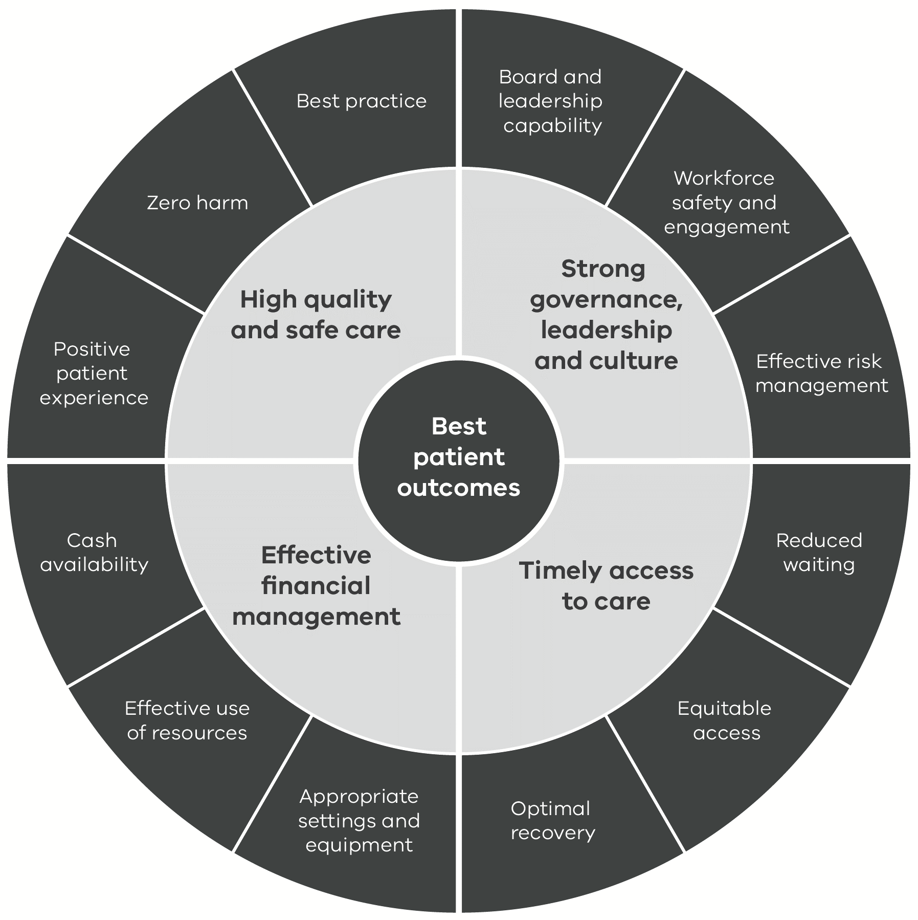
Text-equivalent description of Figure 2 in the Appendix

The Four Performance Domains
High quality and safe care
The domain assesses the ability of health services to deliver safe and high-quality care that improves patient outcomes. It includes several clinical indicators and an increased focus on patient experience.
The domain also considers factors that impact the ability of services to develop and maintain a high performing clinical workforce.
Strong governance, leadership and culture
The domain assesses the strength of the organisation’s governance, leadership and culture, which are key attributes of high performing and safe health services. Optimising both corporate and clinical governance is essential in creating a high performing health service.
Organisational culture can significantly influence patient safety through its impact on effective communication, collaboration and engagement across the organisation.
The domain includes assessment of the strength of clinical and corporate governance in health services, and their ability to nurture safe cultures and positive clinical engagement.
Effective financial management
The ability of health services to manage the effective and efficient allocation of resources to deliver safe and cost-effective services is fundamental to their performance.
The domain addresses the diligence with which health services manage their finances and seek to identify risks to financial stability and viability.
Timely access to care
The domain refers to the ability of health services to efficiently manage supply and demand by providing the right care, in the right place, at the right time. This reflects operational capacity and delivery of services and programs. Typically, indicators within this domain are leading indicators with a time-based component that, when delivered appropriately, result in improved patient outcomes.
The domain focuses on equitable and timely access as well as service efficiency.

The Performance Improvement Approach
The goal of the Framework is to ensure health services are performing effectively to deliver the best patient outcomes, and to keep patients safe from harm. To achieve this the Framework identifies issues and concerns, and opportunities for improvement that feed into a continuous cycle of performance improvement (see Figure 3).
Under the Framework, the department works collaboratively with health services and other stakeholders to:
- identify performance concerns and factors that may impact on health service performance
- analyse performance issues and the opportunities for improvement
- determine appropriate interventions and
- ensure that action is taken to address performance concerns and support ongoing improvement.
- The performance improvement process
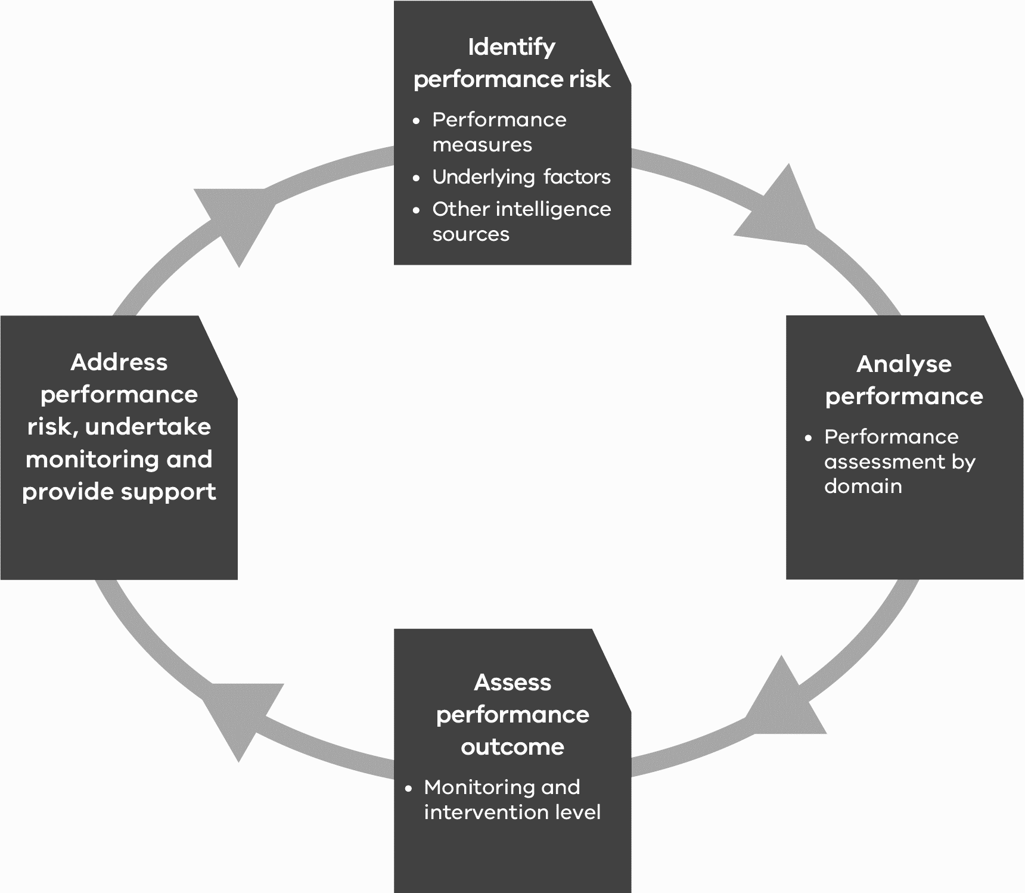
Text-equivalent description of Figure 3 in the Appendix
The performance improvement cycle is supported by performance risk assessment tools that draw together information from the four domains of performance and assist in documenting outcomes at each step in the cycle. These tools are usually completed quarterly for each health service and are used to inform the performance conversation.
There are several key considerations to take into account in relation to the risk assessment tools and the broader performance improvement cycle, as described on the next page.

Key Considerations

The performance risk assessment approach is not a ‘technical’ risk management approach
While it seeks to identify risks to performance, the Framework is not a technical risk management approach. The department, agencies and health services have their own internal risk management processes that operate separately from the Framework.

The approach is intended to support performance conversations
The approach provides the basis for a collaborative conversation about performance and should not be viewed as a means to an end. Rather, it should capture the stage the performance conversation has reached at a point in time, as well as the actions needed to move the conversation forward.

The approach is not intended to be punitive
Risk flags and performance concerns identified in the department’s performance risk tools are not intended to be punitive or to highlight failings of health services. They are intended to raise issues for discussion, and to guide and support the way to potential actions for strengthening or improving performance.

The department and health services have a shared responsibility to address performance issues
This approach to performance monitoring represents a shared responsibility between health services and the department in understanding and addressing the issues that can affect the performance of a health service.

The Performance Improvement Process – Step-by-step
The following sections describe each step in the Framework’s performance improvement process, including how the department’s performance risk assessment tools support the process.

Step 1 – Identify Performance Risk
Performance concerns, inherent vulnerabilities and emerging performance concerns are identified by using quantitative and qualitative data from a range of sources.

Key Performance Measures – Provide quantitative analysis
Risk flags are identified for each measure where targets have not been met and performance is deteriorating.

Underlying Risk Factors – Provide performance context
Risk flags are identified for each measure where targets have not been met and performance is deteriorating.

Third party reports and other intelligence – Provide performance context
Performance issues are triangulated against third party sources. Areas of concern are flagged.

Step 2 – Analyse Performance
Once performance flags have been identified they are evaluated.

A risk rating is determined for each performance input category against each of the four performance domains:
- Key Performance Measures not met in each domain and evidence of deterioration
- Underlying Risk Factors
- Third party reports and other intelligence and the presence and magnitude of any concerns identified from third party reports and other intelligence.

Assign a risk level to each performance domain
Analysis is undertaken for each of the three performance input categories to identify performance risk across each of the four performance domains.

Step 3 – Assess monitoring, support and intervention level
The Framework has three levels of monitoring, support and intervention with a level assigned pursuant to corresponding criteria.

Step 4 – Addressing performance concerns
Once performance flags have been raised, the department and health services discuss the identified issues at formal performance meetings and where relevant work together in developing and implementing a performance improvement plan.

Step 1 – Identify Performance Risk
In this step, performance issues, inherent vulnerabilities and emerging performance concerns are identified by using quantitative and qualitative data from a range of sources. Using various sources provides a more robust understanding of a health service’s performance risks and issues, as well as highlighting the opportunities for performance improvement.
Example – Organisational culture
Risks relating to organisational culture are taken very seriously. Using bullying as an example, performance flags from the People Matter Survey are triangulated with other available information to better understand the extent of the issue and its impact on staff engagement, reporting culture and management response.
Unusually low reporting rates of patient or staff safety concerns may flag potential fear of reporting within the organisation. Such concerns, compounded by a higher than average rate of sick leave and staff turnover rates, could be suggestive of more systemic cultural issues.
The department acknowledges that performance flags may not pose a concern on their own and may easily be explained by other mitigating factors. However, in combination, they can help paint a sufficient and compelling picture to support a more detailed inquiry by the respective health service.
Drawing on a wide variety of sources of information, including qualitative data, encourages early identification of potential performance issues before they become performance failures. It also supports a more transparent information exchange between the department, health services and other entities. This ensures a common understanding of the challenges and opportunities for improvement at the health service level and across the sector.
This information is used to build the performance picture within each domain, which is structured into the following three performance input categories:
- Key Performance Measures: Capture quantifiable data on the indicators comprising this input category
- Underlying Risk Factors: Arise from the contextual assessment of governance, culture and other qualitative assessments of the health service’s performance management capability
- Third Party reports and Other Intelligence: Arise from cross-agency information and other external reviews/reports.
Each performance input category provides a risk rating for each of the four performance domains.

1. Key Performance Measures – Provide Quantitative Analysis
These are the key list of indicators used to inform performance risk.
Risk flags are identified for each indicator where targets have not been met and performance is deteriorating.
Improvement or deterioration trends are indicator dependent, and the method used to establish these trends are outlined in the Business Rules. General trends are based on comparisons to the same time last year, last quarter, to a baseline or through statistical analysis.
The Business Rules are updated progressively throughout the year to reflect changes to current, and incorporation of new, Key Performance Measures, which includes ‘shadow indicators’ (those indicators that are reported but do not impact a health service’s final performance monitoring level). This is discussed in detail in the Business Rules.
The most up to date Key Performance Measures, including their technical specifications, can be reviewed within the Business Rules at the Performance monitoring framework webpage < https://www.health.vic.gov.au/funding-performance-accountability/performance-monitoring-framework>.

2. Underlying Risk Factors – Provide Performance Context
Targeting Zero identified a range of factors that can impact on the ability of a health service to deliver safe, high-quality outcomes for patients. The Framework includes a set of underlying performance risks intended to assess the contextual aspects of performance for each health service.
Example of underlying performance risk factors are:
- workforce availability, capacity and capability
- ability to respond to community needs
- clinical leadership
- management of complex care or changes in capability
- board governance
- leadership
- competing strategic priorities
- culture
- workforce sustainability
- service sustainability
- financial performance

While some areas of underlying performance risk may not be in the direct control of health services (for example, the size of the local recruitment pool for clinicians), they must still be acknowledged in the performance risk assessment. This ensures health services are minimising concerns where possible, and to explore new or additional opportunities to understand the impact of these concerns (including work required at the system level).
Example – Geographical impacts
Health services in rural areas face significant challenges in attracting and retaining skilled staff as well as board directors. There may also be a higher risk of professional isolation for practitioners with limited career options, no back-up cover and no succession planning. Management may find it difficult to manage contracts or performance of clinicians who are difficult to replace.
Recognising these challenges provides a better appreciation of the contextual environment various health services operate in, the impact this has on service delivery, and the type of strategies required by the department (at a system level) and the health service (at a local level) to support improved performance.

Underlying Risk Factor example – Culture
Poor organisational culture can significantly impact patient safety and is known as a recurring feature of serious failings in care. For example, negative culture is directly linked to communication, collaboration and engagement breakdown, which are lead indicators of increased harm and poor patient outcomes. Ineffective governance and leadership further compound the risk through failure to identify and remediate issues early and successfully.
Monitoring weaknesses in culture allows for early identification of risks to patient safety before they begin manifesting in patient outcomes.
The ‘culture’ factor is informed primarily by data from the People Matter Survey as well as feedback from the Health Complaints Commissioner and SCV. This is particularly so where concerns relate to a low reporting culture, poor management of complaints or general lack of interest in feedback from consumers.

3. Third Party Reports and Other Intelligence – Provide Performance Context
The department continues to build formal arrangements to support cross-agency sharing and as these formal relationships mature, additional third party information will be introduced into the performance conversation.
These arrangements will increasingly add depth and breadth to performance monitoring, providing additional layers of advice on risks and other concerns relating to patient safety, governance and culture.
Recommendations from independent reviews initiated by the department including specialist areas such as the Office of Chief Psychiatrist (OCP), SCV, the Victorian Auditor General’s Office, the Independent Broad-based Anti-Corruption Commission and Worksafe are also used where available to fill out the picture of performance for each health service. Reports of IT security risks from the department’s Digital Health Branch will also be considered.
Further, relevant outcomes or performance measures within specialist reports may also be captured as part of this process. This includes the Victorian Perinatal Services Performance Indicators report, the reports of the consultative councils for obstetric and paediatric, surgical and anaesthetic mortality, the Victorian Audit of Surgical Mortality, and other specialist VAHI reports.

Step 2 – Analyse Performance
Once performance flags have been identified they are evaluated in terms of the:
- number of Key Performance Measures not met in each domain and evidence of improvement or deterioration
- presence and magnitude of any of the Underlying Risk Factors and
- presence and magnitude of any concerns identified from third party reports and other intelligence. that feed into the performance conversation
The metrics that feed into the performance conversation involve both objective and subjective performance factors as well as interpretation of those factors.

On that basis, clear communication and supporting rationale of the interpretation is essential to a productive and supporting performance conversation. Performance flags are prompts to begin a conversation with health services regarding performance issues and concerns.

A risk rating is determined for each performance input category against each of the four performance domains
Analysis is undertaken for each of the three performance input categories to identify performance risk across each of the four performance domains.
This results in the determination of 12 sub-performance risk ratings.

Rating determination of input category 1: Key Performance Measures
Higher ratings are assigned where a larger proportion of the measures are not met and have deteriorating trends. For example, a ‘high risk’ rating is applied to any domain where over 30 percent of measures were not met, and performance is deteriorating.
As such, only measures that have not been met, and are showings signs of deterioration, are captured by the percentage thresholds described in Table 1. This approach acknowledges the effort of health services to maintain or improve performance, rather than focusing exclusively on whether a target has been met in any given quarter.
- Key Performance Measures analysis
Description | Risk rating
< 10% of KPIs are not met and have deteriorated | Low
10–30% of KPIs are not met and have deteriorated | Medium
> 30% of KPIs are not met and have deteriorated | High

Rating determination of input categories 2 and 3: Underlying Risk Factors, and third party and other intelligence
The assigned rating for each performance domain increases where there is evidenced presence of significant Underlying Risk Factors, or outstanding concerns from third party reports and other intelligence (see Table 2 and Table 3).
- Underlying Risk Factors analysis
Description | Risk rating
No concerns | Low
Some underlying risk factors present | Medium
Significant underlying risk factors present | High
- Third party reports and other intelligence analysis
Description | Risk rating
No concerns | Low
Some concerns | Medium
Significant outstanding concerns | High
There is a degree of judgement that must be exercised in determining the significance of particular performance concerns and issues. It is vital any assumptions are made explicit and communicated clearly in discussion with health services. Additionally, any reasoning used to assign a level of concern to quantitative and qualitative factors, and third-party sources must be clearly documented in the department’s relevant performance risk assessment tools.

Assign a risk level to each performance domain
To determine the risk level for each performance domain, the risk rating is considered from each of the performance input categories. Please note, if one input category is rated as ‘high risk’, the risk level of the entire domain is elevated to high, as shown in Table 4.

- Aggregated risk ratings of performance input categories and corresponding performance domain risk level
Description | Risk level
All low ratings | Low
Any medium rating AND no high ratings | Medium
Any high rating | High

It is the aggregation of the three performance input categories (for a single performance domain) that provides the proportionate low, medium or high risk level.
Example – Domain risk levels
If a health service met the ‘Key Performance Measures’ of the Timely Access to Care performance domain (all low risk ratings), it would be assigned a level of ‘low risk’ against that performance input category.
However, if a high risk rating was applied to either of the other performance input categories in that domain, ‘Underlying Risk Factors’ or ‘third party reports and other intelligence’, due to significant contextual issues relating to timely access, the risk level of the entire domain is automatically elevated to high.
Commentary outlining the assessment rationale are captured in the department’s performance risk assessment tools and validated further in consultation with the respective health service. This also includes consultation with other relevant stakeholders such as SCV and departmental program areas.
The department decides the overall performance risk level for each domain.

Step 3 – Assess Monitoring, Support and Intervention Level
The Framework includes three levels of monitoring, support and intervention:
- standard (with/without an agreed action plan)
- performance support
- intensive monitoring
In determining the level of monitoring, support or intervention required, the department considers the risk levels for each performance domain and progress towards agreed action plans.
Table 5 summarises the criteria used to guide this determination (for example, the higher the ratings across the domains and the lesser the progress to mitigate the concern, the higher the requirement for monitoring, support or intervention).

- Criteria for determining the level of monitoring, support and intervention
Monitoring level | Description
Standard  (with/without agreed action plan) | Low risk levels across all domains OR  Domain(s) with a medium risk level AND working performance improvement / mitigation plan(s)
Performance support | High risk level on any domain OR  Any domain with a medium risk level with action plan not working OR  any actions or interventions identified in previous quarters not undertaken
Intensive | High risk level on two or more domains  Health service review may be required to address performance concerns

Performance levels are determined quarterly unless serious concerns or emerging issues require more immediate escalation and intervention.
The department determines the risk level for each domain and the associated level of monitoring, support and intervention (see Figure 4). In making this determination the department will consult with the health service’s executives and seek input from experts, such as SCV and the OCP.
The rationale for the assigned level of monitoring, support or intervention must be documented in the department’s performance risk assessment tools alongside any agreed actions associated with these issues as well as timelines for remediation.
At a minimum, these actions should specify who is responsible for undertaking the action, what action is required, and when the action should be completed or otherwise reviewed. This is described in more detail in Step 4 ‘Addressing performance concerns’.
- Example of performance monitoring level determination
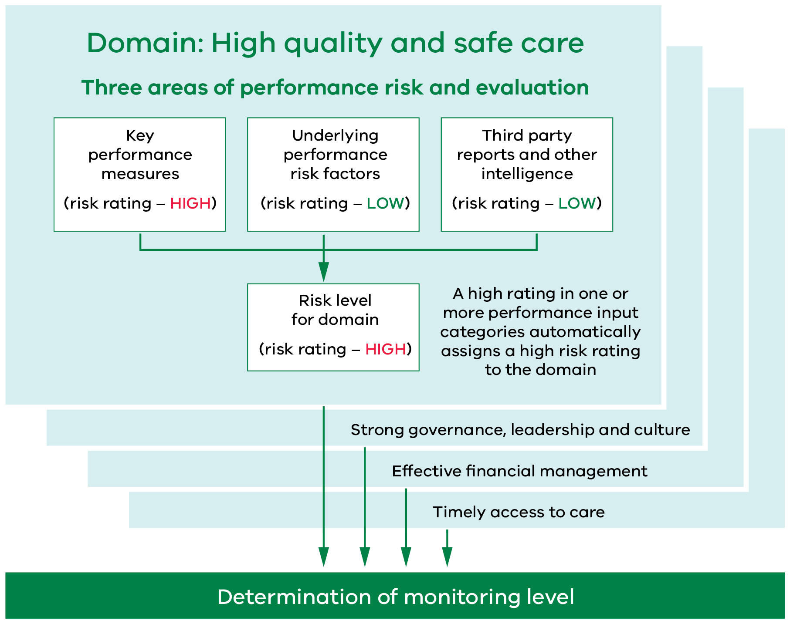
Text-equivalent description of Figure 4 in the Appendix

Step 4 – Addressing Performance Concerns
Once performance flags have been raised, the department and health services discuss the identified issues at formal performance meetings and where relevant work together in developing and implementing a performance improvement plan, and will monitor health services according to their determined monitoring, support and intervention level.
As outlined in Table 6, monitoring, support and intervention levels intensify proportionate to the health service’s identified underperformance and safety concerns. Increasing levels of consultation, support and intervention strategies are tailored depending on the level of monitoring required.
Such decisions are dependent on the magnitude of underperformance, the capacity or demonstrated level of remediation as well as any significant issues relating to governance and culture, given their risk to achieving and supporting sustained improvement.
The department will consider evidence supporting the steps taken and progress made by the health service, and adjust the monitoring, support and intervention level accordingly. This varies from case to case and can result in either a level increase (e.g. through an independent report indicating systemic clinical risk) or level decrease (e.g. through verification of an effective remediation action). This is discussed in more detail below.
- Monitoring, support and intervention levels with corresponding meeting frequency and improvement strategies
Level | Meeting frequency | Performance improvement strategies
Standard | Quarterly  (or as determined by the department) | - Routine performance risk assessment.  - Progress update on agreed action plans, where applicable or relevant.
Performance Support | Every 6 weeks (or as determined by the department) | - Closer monitoring of performance, and development and progression of action plan(s) until performance concerns resolved.  - Support to undertake and sustain improvement that may include, but not limited to:  - engaging an independent expert to review clinical practice, governance or financial concerns and make recommendations for improvement  - seeking SCV’s input and support with further improvement  - appointing an independent expert to the health service’s safety and quality committee
Intensive | Monthly  (or as determined by the department) | - May include discussions between the department and the board chairperson regarding strategies related to organisational issues and capability that may have an impact on performance improvement goals.  - More direct intervention, which can include an independent, external health service review and appointment of a delegate to the board of the health service

What is the ‘Intensive’ level of monitoring, support and intervention?
This level of monitoring applies to health services with significant areas of under-performance, including major patient safety or service delivery concerns. In this instance, departmental intervention intensifies by increasing the frequency of performance interactions, escalating the range of interventions and support to achieve the required improvement.
Key features:
- Inherent vulnerabilities (for example, significant workforce shortages, high reliance on locums and international medical graduates, and rapid population growth or decline)
- Demonstrated pattern of poor care outcomes including significant incidents, complaints and repeated failure to meet the Key Performance Measures
- Weak governance or leadership including ineffective performance risk identification and/or mitigation strategies and poor financial management
- Poor safety culture, including low incident reporting, evidence of bullying and staff disengagement.

How is a Health Service’s Monitoring, Support and Intervention Level Changed?

The process (escalation and de-escalation)
Should the department assess there are apparent performance concerns, it may propose escalation of a health service’s monitoring level as well as the proportionate response required.
A discussion is subsequently undertaken between the department and the relevant health service executives to discuss the concerns. Post the performance meeting, the department will then consider whether the proposed escalated monitoring level should be formalised.
This process also applies in the case of a proposed de-escalation of monitoring level. Should a health service improve its performance and rectify any concerns, the department will propose the health service’s monitoring level be reduced, catering for its current performance.

The options to rectify performance concerns
Where risks or performance concerns result in a higher level of monitoring and intervention, the department will work with the relevant health service to ensure appropriate action is taken to address said concerns to minimise the risk to patients or service delivery. The department may:
- assign individuals to work with the health service to develop and implement a performance improvement strategy and
- commission independent reviews of the health service’s operational effectiveness and sustainability.
More serious concerns may necessitate drastic action, including an independent review of the health service’s governance and management capability. Such actions may include, but are not limited to:
- the board chairperson demonstrating the health service can achieve rectification of the performance concern within a reasonable timeframe
- a change to directorship of the board of the health service or
- appointment of an administrator or delegate to the board of the health service.
The list of rectification options available to the Minister, Secretary and department are set out at Figure 5.
The HSA details the powers of the Minister and Secretary regarding inadequate health service performance, which includes ensuring services provided are safe, appropriate and patient-centred.
Where a ministerial delegate has been appointed to a health service board, the health service will remain on ‘Intensive’ level of monitoring until the end of the delegate’s appointment.
In the circumstances of an entire health service board being removed and an administrator appointed, the health service will remain on ‘Intensive’ level of monitoring until a new board is appointed.
- Indicative options for escalating actions in response to performance issues
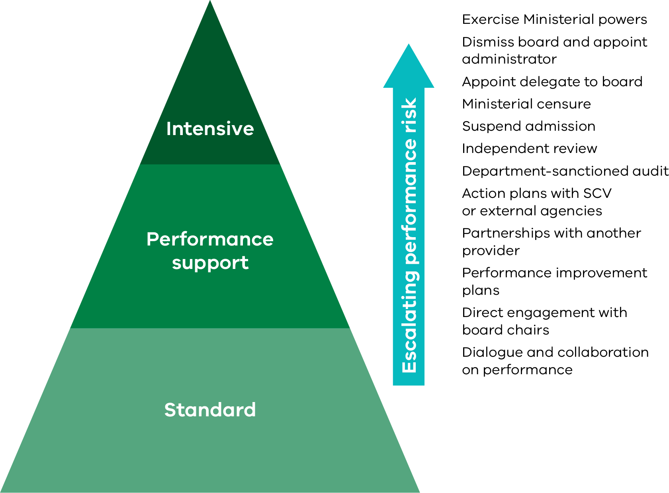
Text-equivalent description of Figure 5 in the Appendix

Risk Identification and Departmental Support
The department supports open dialogue with health services to discuss and address performance concerns as soon as they are identified.
The department’s expectation is that issues are investigated by the health service in the first instance. Evidence of improvement should be provided to the department as part of the routine performance review meetings or separate correspondence.
Where relevant, input from SCV, respective program areas and other experts may be obtained to support health services in developing and implementing targeted improvements.
As discussed above, depending on the level of concern and nature of under-performance, a plan for remediation may be agreed between the health service and the department. SCV will provide expert input in the development and progress of actions relating to quality and safety improvement plans.
Where performance improvement involves implementing new models of care or service redesign, program areas, SCV, and the OCP (as appropriate) will work with health services to reorient care provision to meet acceptable standards of care.

Operationalising Performance Monitoring

Role and Responsibilities

Department of Health
The department is the system manager of the Victorian health care system. It advises government on health strategy, policy, planning, funding allocation and performance oversight of health services. Its vision is to help Victorians stay healthy and safe and deliver a world-class healthcare system that leads to better health outcomes for all Victorians.
The department carries out its performance oversight role by:
- implementing the Framework and associated risk assessment and performance improvement tools
- partnering with health services to identify and address performance concerns early and effectively
- supporting or intervening to ensure long term and sustained performance improvement
- facilitating sector consultation and communication, including providing information on departmental policy directions and sharing with other relevant agencies
- making use of available data and third-party intelligence to maximise the depth and breadth of performance information used to assess health service performance
- maximising input from SCV, and other experts/clinical leaders
- enhancing board skills and capabilities in clinical governance and other information required to ensure high quality and safe care
- providing staff with training and mentoring in performance management and quality improvement, and the tools to enable them to have an effective performance improvement role.
The department relies on SCV, VAHI and the OCP as key partners to help manage and improve sector-wide performance.

Safer Care Victoria
SCV is the peak state authority for leading quality and safety improvement in healthcare. Its role is to oversee and support Victorian health services to provide safe, high-quality care.
As well as monitoring the standards of care provided, SCV partners with consumers and their families, clinicians and health services to support continuous improvement in healthcare. There is a strong focus on listening to patients’ voices, and ensuring patients and patient outcomes remain at the centre of safety and quality conversations. In terms of quality and safety performance, SCV sets expectations and leads improvement efforts across the sector.
One of SCV’s aims is to provide patients, clinicians and hospitals with tools and resources to improve quality and safety in the health system.
SCV works closely with the department on improving the performance of health services and participates in key performance conversations with health services, particularly where concerns exist about safety and quality of care.

Office of the Chief Psychiatrist
The Chief Psychiatrist provides system-wide oversight of Victoria’s public mental health services. Supported by the Office of the Chief Psychiatrist (OCP), the role supports quality and safety in services provided to some of Victoria’s most vulnerable people. The role and functions of the Chief Psychiatrist are set out under the MHWA.
Responsibilities under the MHWA include clinical leadership and quality and safety oversight across Victoria’s public mental health system. The activities undertaken by the OCP are far ranging and include assisting services in developing and implementing clinical best practice approaches and advice to the sector, undertaking reviews, audits and investigations as required, and promoting continuous improvement in areas of quality and safety.

Victorian Agency for Health Information
VAHI is responsible for analysing and sharing information across the health system. To discharge this responsibility, it develops relevant and meaningful measures of patient care and outcomes for public reporting, oversight and clinical improvement. Accordingly, VAHI plays a key a role in data management, standards and integrity.
VAHI’s key functions include:
- collecting, analysing and sharing data so that the community is better informed about health services and health services receive better information about their performance
- providing boards, health executives and clinicians with the information they need to best serve their communities and provide better, safer care
- providing patients and carers with meaningful and useful information about care in their local community
- improving researchers’ access to data to create evidence that informs the provision of better, safer care.
To achieve its objectives, VAHI relies on obtaining timely, accurate and high-quality data from public and private providers of health services. VAHI is vital to the effective functioning of the Framework through its provision of performance measures data and its work on developing additional robust measures of performance.

Public Hospitals and Health Services
- Victoria’s public hospitals and health services are independent legal entities established under the HSA, ASA and MHWA (where applicable to the respective hospital and health service). They are governed by boards of directors, who are appointed by the Governor-in-Council on recommendation of the Minister for Health. The board oversees the health service on behalf of the Minister for Health and in accordance with government policy and its legal obligations.
- Public hospitals and health services discharge their obligations under the Framework by:
  - partnering with the department and other agencies to improve health service and system wide performance
  - promptly reporting to the department any emerging risks or potential performance issues including immediate action taken
  - establishing and maintaining a culture of safety and performance improvement within the health service
  - ensuring accurate and timely submission of data and other information, including implementing agreed action plans and status update reports
  - collaborating with other health services and system partners to maintain and improve their performance and to meet the needs of their communities.

Performance Meetings
Performance meetings are usually undertaken on a quarterly basis and include a mid- and end of- year review of the SOP Part A actions.
The department’s performance risk assessment tools provide the baseline for analysing performance at the performance meeting. The performance meeting is used to finalise the health service’s performance risk and document the monitoring, support and intervention level for each health service, as determined by the department.
Progress updates on the development and implementation of agreed action plans or recommendations from third-party reports are considered as part of the performance discussion, as well as emerging performance concerns or trends that may affect future performance.
Required representation from the department and health services will depend on the level and areas of performance concern. Attendance is kept to a minimum, involving only the core performance group required to ensure coverage of each aspect of performance. SCV representatives feature regularly at performance review meetings where quality and safety concerns are apparent.
The abovementioned approach to performance monitoring represents a shared responsibility between health services and the department in understanding and addressing the issues that can impact health service performance.

Frequency of formal performance meetings and departmental discretion
The frequency of formal performance meetings usually increases proportionate to a monitoring level increase, per the Framework’s principles. This applies for all health services.
The department, and health services are in constant, informal contact. On that basis, and in some circumstances, even though a hospital can be on an increased monitoring level, this may not translate to a proportionate increase in the frequency of formal performance meetings.
In unique circumstances, the frequency of formal performance meetings (such as for some small rural health services) may be altered to allow for flexibility for that health service and the department, regardless of monitoring level. The rationale for this flexibility ensures strategic discussion based on best practice for that health service versus simply relying on a prescriptive calendar of formal meetings that may not necessarily lend themselves to better performance outcomes.
However, risk identification and mitigation will remain a priority for health services, the department and other performance agencies (such as SCV), when determining frequency. The department will still implement performance improvement plans and interventions as, and when, necessary but informally.
Similarly, the department can initiate additional meetings when emerging issues have been identified, performance escalation initiated or at the request of the health service.
It is at the department’s discretion as to the frequency of formal performance meetings, however frequency should be reasonably agreed with the health service.

Performance Monitoring and Reporting
As determined by legislation, the SOP is the key service delivery and accountability agreement between health services and the department. It outlines key deliverables and performance targets to be achieved by the health services within the allocated annual budget. Performance against these is monitored in monthly reports produced by VAHI.
The department’s performance risk assessments extend beyond the measures set out in the SOP. This is to ensure other concerns (emerging or otherwise) are considered.

Statement of Priorities (Part A)
Performance against the actions and deliverables committed to in Part A of the SOP are formally reported in health services’ annual reports at the end of the financial year, as consistent with the annual report guidelines (report of operations). Health services are expected to also provide a half yearly progress report on achieving Part A action items and associated deliverables.

Specific Events – Breaches
Should the following events be realised, this event is recorded as a breach and requires immediate escalation to the department:
- Emergency Care Triage Category 1 failure
- Emergency Department 24 hours waiting time failure
- Elective Surgery Category 1 admissions
- Colonoscopy Category 1 not treated within recommended time
- Non-compliance with the National Safety and Quality Health Service standards and
- Non-compliance with Aged Care Standards.
For all breaches apart from 24 hour emergency department breaches, health services are required to notify the department (via the health performance Director for the relevant geographic catchment) within 24 hours of a breach or becoming aware of a breach. Notification will include the circumstances and response to the breach, including whether patient safety has been compromised.
In the case of 24 hour emergency department breaches, health services are required to report the breach via standard VEMD process within 24 hours of a breach or becoming aware of a breach. When a health service experiences extended episodes of 24 hour breaches, the department will also seek periodic reporting on operational factors contributing to breaches via a standardised reporting template.
In 2018, Victoria introduced statewide risk stratified guidelines for the categorisation of colonoscopy procedures for all public hospitals. Patients who are considered a category one patient (the most urgent category) are those most at risk of having a suspected colorectal cancer. It is for this reason that the department needs to be notified immediately. Please refer to the relevant section in the Business Rules for more details.
‘Specific events’ breaches will be included as a separate item for discussion at performance meetings.

Force Majeure
In some circumstances, unforeseen events may occur that adversely impact on a health service’s performance. In these instances, it is important to consider bona fide concerns, which were extraordinary and genuinely unforeseen events beyond the control of the health service that impacted service delivery or reporting requirements.
Where such circumstances have a significant impact on performance, a health service may request that the department consider a ‘force majeure’ claim. The process should not be applied to ad-hoc operational difficulties or for planned service interruptions such as capital works or information technology upgrades.
When a health service is reliant on services provided by a third party, the health service is responsible for ensuring that, as far as practicable, the service is of an acceptable quality and delivered in a timely manner. The failure of a third party to deliver a service is not in itself regarded as acceptable grounds for a force majeure.
In applying the force majeure policy, the monitoring level of a health service will not change, but the department will consider adjusting its assessment, and any required actions, depending on the circumstances.

Submitting a Request
Individual health services may make a formal request for consideration to the health performance Executive Director for the relevant geographic catchment. The request should clearly indicate the event(s) impacting performance and include supporting evidence.
The department will only consider issues of force majeure retrospectively. Health services should not apply for a force majeure in anticipation of poor results.

Appendix: Text-equivalent descriptions of figures
Figure 1 The Framework – Key contextual elements
The Framework consists of the following key contextual elements.

Governance
- Legislation
- Health service boards
- Ministerial Advisory Committee
- Key entities (Safer Care Victoria, Victorian Agency for Health Information)

Policy and planning
- Whole-of-government policy and programs
- Statewide and service stream plans
- Strategic planning guidelines
- Role delineation and capability frameworks
- Service provider plans

Evaluation and reporting
- Annual reports
- Performance reports
- Policy and program evaluation

Measuring and monitoring
- Performance monitoring and intervention processes
- Inter-agency information sharing

Funding
- Budget
- Policy and Funding Guidelines
- Service agreements
Return to text following Figure 1
Figure 2 Performance objectives and the four performance domains
Four performance domains, and their associated performance objectives, are utilised to provide a whole-of-health-service performance view.

Strong governance, leadership and culture
- Board and leadership capability
- Workforce safety and engagement
- Effective risk management

Timely access to care
- Reduced waiting
- Equitable access
- Optimal recovery

Effective financial management
- Cash availability
- Effective use of resources
- Appropriate settings and equipment

High quality and safe care
- Best practice
- Zero harm
- Positive patient experience
Return to text following Figure 2
Figure 3 The performance improvement process
The performance improvement process is a continuous cycle comprising four steps:
- Identify performance risk
  - Performance measures
  - Underlying factors
  - Other intelligence sources
- Analyse performance
  - Performance assessment by domain
- Assess performance outcome
  - Monitoring and intervention level
- Address performance risk, undertake monitoring and provide support
Return to text following Figure 3
Figure 4 Example of performance monitoring level determination
The example depicts how a final risk level is determined for each domain (e.g. High quality and safe care), and ultimately the final monitoring level for the health service.
In the example, the risk rating for:
- ‘Key performance measures’ is high
- ‘Underlying performance risk factors’ is low
- ‘Third party reports and other intelligence is low.
A high rating in one or more performance input categories automatically assigns a high risk rating to the performance domain. In the example, the risk level for the ‘High Quality and Safe Care’ performance domain is high due to the ‘key performance measures’ risk rating being high.
This performance risk evaluation is replicated for the three other performance domains:
- Strong governance, leadership and culture
- Effective financial management
- Timely access to care.
The combined ‘risk levels’ of the four performance domains determine the final monitoring level.
Return to text following Figure 4
Figure 5 Indicative options for escalating actions in response to performance issues
With escalating performance concerns (and the corresponding monitoring levels) there are various options, proportionate to the monitoring level, that can be used to rectify performance issues.
The three monitoring levels are:
- Standard
- Performance support
- Intensive.
Escalating performance risk can correlate to the following increasing levels of interventions, listed from least to most significant (theoretically):
- Dialogue and collaboration on performance
- Direct engagement with board chairs
- Performance improvement plans
- Partnerships with another provider
- Action plans with SCV or external agencies
- Department-sanctioned audit
- Independent review
- Suspend admission
- Ministerial censure
- Appoint delegate to the board
- Dismiss board and appoint administrator
- Exercise Ministerial powers.
Return to text following Figure 5

The Mental Health and Wellbeing Act 2022 (MHWA) replaces the existing Mental Health 2014 (MHA) from 1 September 2023.
Further work will be undertaken on leave event measures terminology that better captures patient experience and Aboriginal community’s holistic understanding of health and wellbeing.
The effective date of the target change from 85% to 80% conditional on pending changes to BP3 requirements.
The Mental Health and Wellbeing Act 2022 (MHWA) replaces the existing Mental Health 2014 (MHA) from 1 September 2023.

